Name of Journal: World Journal of Orthopedics
Manuscript NO: 86313
Manuscript Type: CASE REPORT

Vancomycin flushing syndrome in orthopaedic practice: A case report

Al-Anii FM et al. VFS in orthopaedic practice

Fawaz M Al-Anii, Mir Sadat-Ali, Khalid Waleed Al-Tabash, Ahmad I AlMulhim, Sulaiman A AlMousa, Abdulaziz M AlHawas

Fawaz M Al-Anii, Mir Sadat-Ali, Khalid Waleed Al-Tabash, Ahmad I AlMulhim, Sulaiman A AlMousa, Abdulaziz M AlHawas, Orthopaedic Surgery, Imam AbdulRahman Bin Faisal University and King Fahd Hospital of the University, AlKhobar 31952, Saudi Arabia

Author contributions: Al-Anii FM, Sadat-Ali M, Al-Tabash KW, AlMulhim AI, AlMousa SA, and AlHawas AM participated in the study of the case, review of the literature, and the writing of the manuscript.

Corresponding author: Mir Sadat-Ali, FRCS, FRCS (Gen Surg), MBBS, MS, Full Professor, Professor, Senior Scientist, Orthopaedic Surgery, Imam AbdulRahman Bin Faisal University and King Fahd Hospital of the University, Pobox 40071, AlKhobar 31952, Saudi Arabia. drsadat@hotmail.com

Received: June 13, 2023
Revised: August 16, 2023
Accepted: September 7, 2023
Published online: October 18, 2023

Abstract
BACKGROUND
Vancomycin flushing syndrome (VFS), also known as red man syndrome, is an allergic reaction to vancomycin. It typically presents as a rash on the face, neck, and upper torso after intravenous administration of vancomycin. VFS is blamed on rapid intravenous infusion of vancomycin during management and rarely happens after local use. A review of the literature showed that in the last 23 years, 4 such cases have been reported. Here, we add another case of VFS developed after slow local absorption of vancomycin in cement beads.

CASE SUMMARY
A 44-year-old male with a known case of hypertension, no history of allergies to medications, and a history of chronic osteomyelitis of the right tibia with discharging sinus over the anterolateral aspect of the leg. The pus culture grew Staphylococcus aureus, which was sensitive to clindamycin and vancomycin. The patient underwent irrigation and debridement with the placement of vancomycin cement beads made from 4 g of vancomycin powder and 40 g of polymethyl methacrylate. Three hours postoperatively, the patient developed a pruritic, erythematous, macular rash predominantly on his face, neck, chest, and lower extremities and to a lesser extent his upper extremities. A diagnosis of VFS was made and was successfully treated with cetirizine (10 mg, oral) and methylprednisolone sodium succinate (125 mg, intravenous). The patient continued to have itching with a facial rash for 12 h with gradual improvement. A decision was made to not remove the beads as the patient continued to improve. Gradually, the rash disappeared after 96 h with no further sequela.

CONCLUSION
VFS can occur not only after rapid intravenous injection of vancomycin but also with local release, as in our case. As orthopaedic surgeons routinely use vancomycin with polymethyl methacrylate in chronic osteomyelitis and revision arthroplasty, they should be aware of such a complication occurring.

Key Words: Vancomycin; Anaphylactic reactions; Red man syndrome; Vancomycin flushing syndrome; Case report

©The Author(s) 2023. Published by Baishideng Publishing Group Inc. All rights reserved.

Citation: Al-Anii FM, Sadat-Ali M, Al-Tabash KW, AlMulhim AI, AlMousa SA, AlHawas AM. Vancomycin flushing syndrome in orthopaedic practice: A case report. World J Orthop 2023; 14(10): 771-775
URL: https://www.wjgnet.com/2218-5836/full/v14/i10/771.htm
DOI: https://dx.doi.org/10.5312/wjo.v14.i10.771

Core Tip: Vancomycin-related allergic skin reactions are not uncommon and are typically reported to occur after rapid intravenous infusion. However, this complication can also occur when vancomycin is implanted for slow release. Since orthopaedic surgeons routinely use vancomycin with polymethyl methacrylate, they should be aware of this complication occurring despite its rarity.

INTRODUCTION
Vancomycin inhibits cell wall synthesis of bacteria, making it a potent bactericidal against the majority of Gram-positive cocci^{[1]}. Even though it has its own complications of resistance and other allergic reactions, it is still in use. One of the serious complications of using vancomycin is vancomycin flushing syndrome (VFS), also known as Red man syndrome (RMS), which is an anaphylactoid reaction. It presents as a pruritic, erythematous rash on the face, neck, and upper torso, hypotension, angioedema, and cardiac arrest^{[2-5]}. The initial reports of this complication were reported due to rapid infusion of vancomycin at 1000 mg over 1 h^{[6]}. Later reports did suggest it can happen even after slow infusion as well^{[7]}.
Vancomycin is routinely used in orthopaedic practice preoperatively as a prophylactic antibiotic and postoperatively to treat bone and joint infections^{[8,9]}. Serious allergic reactions like VFS can occur. VFS developed in our patient with chronic osteomyelitis after the insertion of vancomycin-impregnated beads. A review of the literature on VFS in orthopaedic patients showed that 4 cases of VFS occurring after local implantation have been reported in the last 23 years (Table 1)^{[10-13]}.

CASE PRESENTATION
Chief complaints
A 44-year-old male presented with chronic osteomyelitis of the right tibia. The patient presented to the orthopaedic clinic due to right leg pain and swelling, the inability to bear weight, and multiple attacks of subjective fever. The right leg pain suddenly progressed over the prior 3 mo, without a history of recent trauma. The pain increased at night and later became constant even during rest. The pain was located mainly on the proximal right tibia with radiation to the right knee and middle third of the right leg. The patient also experienced multiple attacks of fever and night sweats.

History of present illness
The patient had an open fracture 22 years ago with an infection and was diagnosed with chronic osteomyelitis with a discharging sinus. The sinus had closed, but the pain continued. He was treated with evacuation of the abscess and courses of antibiotics.

History of past illness
The patient had a history of hypertension.

Personal and family history
No personal or family history relevant to the presentation. No history of allergy to medications was reported.

Physical examination
On inspection, there was swelling of the right leg and skin redness on the anterior aspect of the proximal third of the right leg. We observed a skin scar with thin scar tissue over the tibia directly. There was no underlying soft tissue on the anterior aspect of the proximal right tibia with massive swelling and tenderness around this area. The patient had an intact neurovascular examination.

Laboratory examinations
Laboratory findings included slightly increased leukocytes (12.3 × 10⁹/L; normal range: 4.5-11.0 × 10⁹/L), haematocrit (40.2%; normal range: 41%-50%), platelets (522,000 mcL; normal range: 150,000 to 450,000 mcL), elevated erythrocyte sedimentation rate (95 mm/h, normal range: < 20 mm/h), and high C-reactive protein (133 mg/L; normal range: 0-10 mg/L). The patient had a discharging sinus on the anterior proximal third of the right leg in the centre of the previous scar. Culture from the sinus grew Staphylococcus aureus.

Imaging examinations
Anteroposterior and lateral X-ray views showed multiple opacities, and magnetic resonance imaging showed a collection with high signal intensity in the proximal right tibia. The radiological studies revealed an intramedullary collection of the proximal right tibia with the impression of subacute osteomyelitis with multiple Brodie’s abscesses of the proximal right tibia (Figure 1).

FINAL DIAGNOSIS
Chronic osteomyelitis of the right tibia.

TREATMENT
The patient underwent irrigation and debridement with the placement of vancomycin cement beads made from 4 g of vancomycin powder and 40 g of cement (1 g of vancomycin for each 10 g of cement) attached to size 1 proline and was placed intramedullary in the cavity through the two bone windows on the proximal and mid right tibia. Three hours postoperatively, the patient developed a pruritic, erythematous, macular rash predominantly on his face, neck, chest, and lower extremities and to a lesser extent his upper extremities. There were no signs of vital instability observed at the time (maximum area of skin rash was the infected, right lower limb and the patient’s face and chest) (Figure 2). The patient started to become agitated due to itchiness. However, he remained clearly conscious, and the fine oxygen saturation was 98% in room air. The patient remained stable.
Urgent consultation of the on-call medical and infectious disease teams was completed; they examined the patient and recommended starting the patient immediately on cetirizine (10 mg, oral) and methylprednisolone sodium succinate (125 mg, intravenously). The patient continued to experience itching with a facial rash for 12 h with gradual improvement after therapy. He remained on close observation with close monitoring of respiration and other vital signs. The orthopaedic team made the decision to remove the antibiotics beads only if the patient hemodynamically deteriorated. The patient showed marked improvement 18 h after starting the medications; gradually, the rash started to decrease until it completely disappeared after around 96 h with no further sequela.

OUTCOME AND FOLLOW-UP
The beads were removed 4 mo postoperatively. The patient also received progressive irrigation and debridement with bone graft to the distal metaphyseal bone defect (window). The patient completed the antibiotics course according to the infectious disease team’s recommendation (2 wk parenteral and 10 wk oral).

DISCUSSION
Our patient who developed VFS due to vancomycin exposure during after a prolonged release was contrary to the initial reports of rapid infusion being the cause of VFS. Only 4 other orthopaedic cases in the last two decades have been reported where the complication occurred due to the slow release of vancomycin. It is believed that the side effects are due to impurities. However, even after increasing the purity, the side effects still occur. At present, it is recommended that vancomycin should be infused at a rate no faster than 1 g/h or 10 mg/min^{[13,14]}.
There are two issues that need to be addressed. Vancomycin induces allergic reactions due to its activation of mast cells, which release histamine independent of preformed immunoglobin E or complement. The side effects range from pruritis to angioedema to cardiac arrest. It is prudent that antihistamines are started at the same time as vancomycin to avoid the reactions.
Secondly, the term “RMS” needs to be retired from the medical language as this term has racial implications relating to native American nations. Because reactions to vancomycin are not known to be race dependent and occur in children and women, RMS is a misnomer. Hence the term VFS should be used.

CONCLUSION
In conclusion, VFS can occur either through rapid infusion or slow release of vancomycin, as in our patient. Since vancomycin-impregnated cement beads and spacers are routinely used in orthopaedic service, orthopaedic surgeons and trainees should be aware of such complications and should be ready to recognize and treat them early.

REFERENCES
1 Moellering RC Jr. Vancomycin: a 50-year reassessment. Clin Infect Dis 2006; 42 Suppl 1: S3-S4 [PMID: 16323117 DOI: 10.1086/491708]
2 Crumpton MW, Thornton JB, Mackall LL. Anaphylactoid reaction to vancomycin during general anesthesia in a child patient. Pediatr Dent 1983; 5: 276-279 [PMID: 6587333]
3 Symons NL, Hobbes AF, Leaver HK. Anaphylactoid reactions to vancomycin during anaesthesia: two clinical reports. Can Anaesth Soc J 1985; 32: 178-181 [PMID: 3986655 DOI: 10.1007/BF03010047]
4 Markman M, Lim HW, Bluestein HG. Vancomycin-induced vasculitis. South Med J 1986; 79: 382-383 [PMID: 2937155 DOI: 10.1097/00007611-198603000-00033]
5 Khakurel S, Rawal S. Vancomycin induced cardiac arrest: a case report. J Med Case Rep 2021; 15: 77 [PMID: 33593409 DOI: 10.1186/s13256-020-02639-8]
6 Polk RE, Healy DP, Schwartz LB, Rock DT, Garson ML, Roller K. Vancomycin and the red-man syndrome: pharmacodynamics of histamine release. J Infect Dis 1988; 157: 502-507 [PMID: 2449506 DOI: 10.1093/infdis/157.3.502]
7 Arroyo JC, Rosansky SJ, Rosenzweig PN. Red neck syndrome with slow infusion of vancomycin. Am J Kidney Dis 1986; 7: 511 [PMID: 2424306 DOI: 10.1016/s0272-6386(86)80194-9]
8 Kanj WW, Flynn JM, Spiegel DA, Dormans JP, Baldwin KD. Vancomycin prophylaxis of surgical site infection in clean orthopedic surgery. Orthopedics 2013; 36: 138-146 [PMID: 23379827 DOI: 10.3928/01477447-20130122-10]
9 Molinari RW, Khera OA, Molinari WJ 3rd. Prophylactic intraoperative powdered vancomycin and postoperative deep spinal wound infection: 1,512 consecutive surgical cases over a 6-year period. Eur Spine J 2012; 21 Suppl 4: S476-S482 [PMID: 22160172 DOI: 10.1007/s00586-011-2104-z]
10 Hinarejos P, Guirro P, Puig-Verdie L, Torres-Claramunt R, Leal-Blanquet J, Sanchez-Soler J, Monllau JC. Use of antibiotic-loaded cement in total knee arthroplasty. World J Orthop 2015; 6: 877-885 [PMID: 26716084 DOI: 10.5312/wjo.v6.i11.877]
11 Chen CT, Ng KJ, Lin Y, Kao MC. Red man syndrome following the use of vancomycin-loaded bone cement in the primary total knee replacement: A case report. Medicine (Baltimore) 2018; 97: e13371 [PMID: 30572442 DOI: 10.1097/MD.0000000000013371]
12 Juyal A, Khurana G, Maheshwari R. Red man syndrome: an unusual complication of vancomycin beads. Bangladesh J Med Sci 2015; 14: 290-291 [DOI: 10.3329/bjms.v14i3.17955]
13 Harper KD, Incavo SJ. Drug reaction with eosinophilia and systemic symptoms syndrome after total knee arthroplasty infection and placement of antibiotic spacer. Arthroplast Today 2019; 5: 148-151 [PMID: 31286034 DOI: 10.1016/j.artd.2019.04.005]
14 Alvarez-Arango S, Ogunwole SM, Sequist TD, Burk CM, Blumenthal KG. Vancomycin Infusion Reaction - Moving beyond "Red Man Syndrome". N Engl J Med 2021; 384: 1283-1286 [PMID: 33830710 DOI: 10.1056/NEJMp2031891]

Footnotes
Informed consent statement: Informed consent was obtained from the patient to publish the photographs and the data.

Conflict-of-interest statement: All authors declare there are no conflicts of interests.

CARE Checklist (2016) statement: The authors have read the CARE Checklist (2016), and the manuscript was prepared and revised according to the CARE Checklist (2016).

Open-Access: This article is an open-access article that was selected by an in-house editor and fully peer-reviewed by external reviewers. It is distributed in accordance with the Creative Commons Attribution NonCommercial (CC BY-NC 4.0) license, which permits others to distribute, remix, adapt, build upon this work non-commercially, and license their derivative works on different terms, provided the original work is properly cited and the use is non-commercial. See: https://creativecommons.org/Licenses/by-nc/4.0/

Provenance and peer review: Unsolicited article; Externally peer reviewed.
Peer-review model: Single blind

Peer-review started: June 13, 2023
First decision: August 16, 2023
Article in press: September 7, 2023

Specialty type: Orthopedics
Country/Territory of origin: Saudi Arabia
Peer-review report’s scientific quality classification
Grade A (Excellent): 0
Grade B (Very good): 0
Grade C (Good): C
Grade D (Fair): 0
Grade E (Poor): 0

P-Reviewer: Surani S, United States S-Editor: Chen YL L-Editor: Filipodia P-Editor: Chen YL

Figure Legends
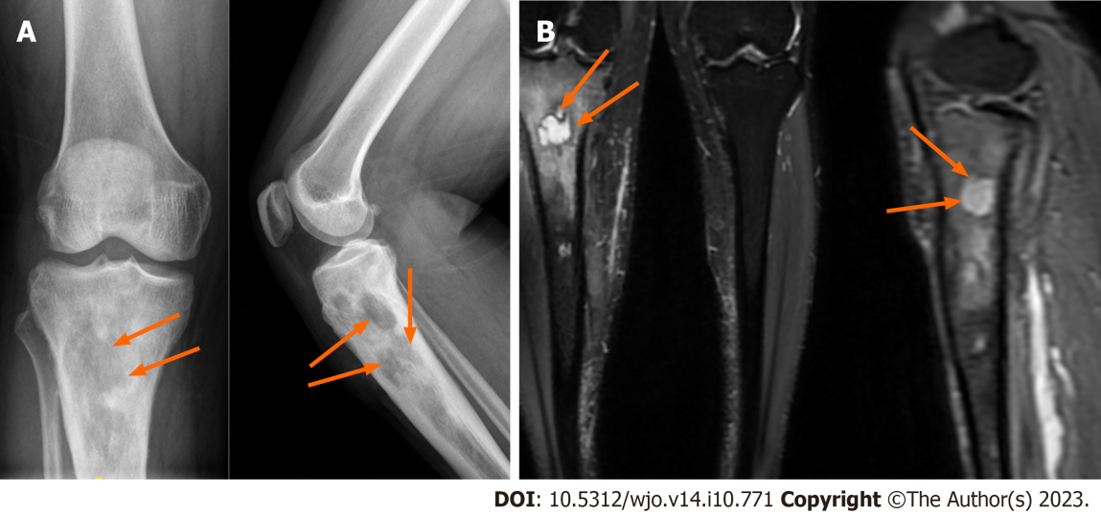
Figure 1 Imaging examinations. A: An X-ray showed changes of chronic osteomyelitis in the right upper tibia; B: Magnetic resonance imaging showed changes of chronic osteomyelitis with abscess formation in the right upper tibia. The arrows indicate cavitation and changes due to chronic osteomyelitis.

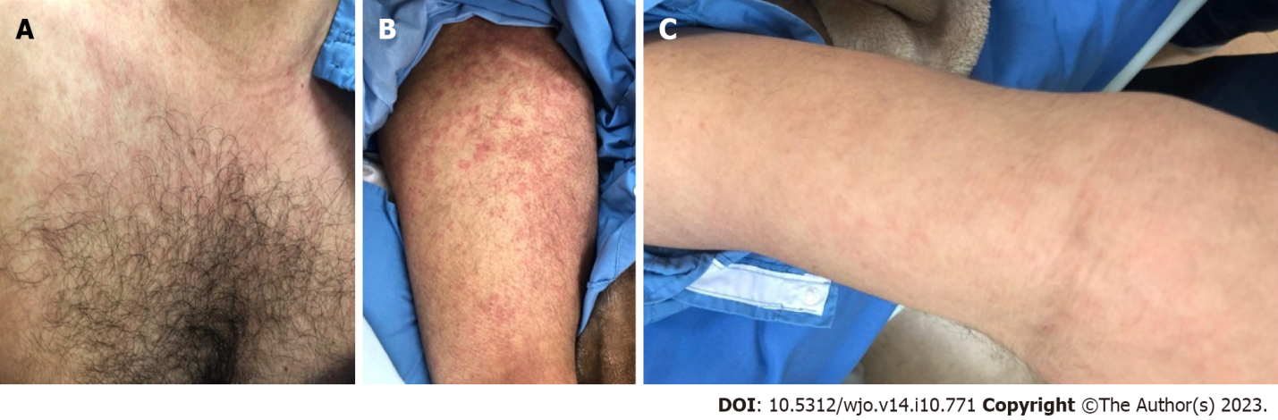
Figure 2 Allergic reactions due to vancomycin. A: Chest; B: Legs; C: Forearm.

Table 1 Review of literature of vancomycin flushing syndrome after local implantation of vancomycin
Ref. | Vancomycin used | Outcome
Hinarejos et al^{[10]}, 2015 | Bone cement | Recovered
Juyal et al^{[12]}, 2015 | Bone cement beads | Recovered
Chen et al^{[11]}, 2018 | Cement spacer | Recovered
Harper and Incavo^{[13]}, 2019 | Cement spacer | Recovered
Present case, 2023 | Bone cement beads | Recovered

Published by Baishideng Publishing Group Inc
7041 Koll Center Parkway, Suite 160, Pleasanton, CA 94566, USA
Telephone: +1-925-3991568
E-mail: bpgoffice@wjgnet.com
Help Desk: https://www.f6publishing.com/helpdesk
https://www.wjgnet.com

© 2023 Baishideng Publishing Group Inc. All rights reserved.

