Name of Journal: World Journal of Gastroenterology
Manuscript NO: 84842
Manuscript Type: ORIGINAL ARTICLE

Retrospective Study
Comparison and development of machine learning for thalidomide-induced peripheral neuropathy prediction of refractory Crohn’s disease in Chinese population

Mao J et al. Predicting neurotoxicity using machine learning

Jing Mao, Kang Chao, Fu-Lin Jiang, Xiao-Ping Ye, Ting Yang, Pan Li, Xia Zhu, Pin-Jin Hu, Bai-Jun Zhou, Min Huang, Xiang Gao, Xue-Ding Wang

Jing Mao, Fu-Lin Jiang, Ting Yang, Pan Li, Bai-Jun Zhou, Min Huang, Xue-Ding Wang, Institute of Clinical Pharmacology, School of Pharmaceutical Sciences, Sun Yat-sen University, Guangzhou 510006, Guangdong Province, China

Jing Mao, Ting Yang, Pan Li, Min Huang, Xue-Ding Wang, Guangdong Provincial Key Laboratory of New Drug Design and Evaluation, Sun Yat-sen University, Guangzhou 510006, Guangdong Province, China

Kang Chao, Xia Zhu, Pin-Jin Hu, Xiang Gao, Department of Gastroenterology, The Sixth Affiliated Hospital, Sun Yat-sen University, Guangzhou 510006, Guangdong Province, China

Xiao-Ping Ye, Department of Pharmacy, Guangdong Women and Children Hospital, Guangzhou 510000, Guangdong Province, China

Author contributions: Mao J, Chao K, Zhu X, and Wang XD designed the study; Mao J and Zhou BJ performed the experiments; Chao K, Gao X, Yang T and Li P enrolled the patients and collected the clinical data; Mao J and Ye XP performed the machine learning analyses; Huang M and Hu PJ supervised the study; Mao J and Wang XD wrote the manuscript.

Supported by National Natural Science Foundation of China, No. 81973398, No. 81730103, No. 81573507 and No. 82020108031; The National Key Research and Development Program, No. 2017YFC0909300 and No. 2016YFC0905001; Guangdong Provincial Key Laboratory of Construction Foundation, No. 2017B030314030 and No. 2020B1212060034; Science and Technology Program of Guangzhou, No. 201607020031; National Engineering and Technology Research Center for New Drug Druggability Evaluation (Seed Program of Guangdong Province), No. 2017B090903004; The 111 Project, No. B16047; China Postdoctoral Science Foundation, No. 2019M66324, No. 2020M683140 and No. 2020M683139; and Natural Science Foundation of Guangdong Province, No. 2022A1515012549 and No. 2023A1515012667.

Corresponding author: Xue-Ding Wang, PharmD, Professor, Teacher, Institute of Clinical Pharmacology, School of Pharmaceutical Sciences, Sun Yat-sen University, No. 132 Waihuan Dong Road, Guangzhou 510006, Guangdong Province, China. wangxd@mail.sysu.edu.cn

Received: April 5, 2023
Revised: May 7, 2023
Accepted: May 23, 2023
Published online: June 28, 2023

Abstract
BACKGROUND
Thalidomide is an effective treatment for refractory Crohn’s disease (CD). However, thalidomide-induced peripheral neuropathy (TiPN), which has a large individual variation, is a major cause of treatment failure. TiPN is rarely predictable and recognized, especially in CD. It is necessary to develop a risk model to predict TiPN occurrence.

AIM
To develop and compare a predictive model of TiPN using machine learning based on comprehensive clinical and genetic variables.

METHODS
A retrospective cohort of 164 CD patients from January 2016 to June 2022 was used to establish the model. The National Cancer Institute Common Toxicity Criteria Sensory Scale (version 4.0) was used to assess TiPN. With 18 clinical features and 150 genetic variables, five predictive models were established and evaluated by the confusion matrix receiver operating characteristic curve (AUROC), area under the precision-recall curve (AUPRC), specificity, sensitivity (recall rate), precision, accuracy, and F1 score.

RESULTS
The top-ranking five risk variables associated with TiPN were interleukin-12 rs1353248 [P = 0.0004, odds ratio (OR): 8.983, 95% confidence interval (CI): 2.497-30.90], dose (mg/d, P = 0.002), brain-derived neurotrophic factor (BDNF) rs2030324 (P = 0.001, OR: 3.164, 95%CI: 1.561-6.434), BDNF rs6265 (P = 0.001, OR: 3.150, 95%CI: 1.546-6.073) and BDNF rs11030104 (P = 0.001, OR: 3.091, 95%CI: 1.525-5.960). In the training set, gradient boosting decision tree (GBDT), extremely random trees (ET), random forest, logistic regression and extreme gradient boosting (XGBoost) obtained AUROC values > 0.90 and AUPRC > 0.87. Among these models, XGBoost and GBDT obtained the first two highest AUROC (0.90 and 1), AUPRC (0.98 and 1), accuracy (0.96 and 0.98), precision (0.90 and 0.95), F1 score (0.95 and 0.98), specificity (0.94 and 0.97), and sensitivity (1). In the validation set, XGBoost algorithm exhibited the best predictive performance with the highest specificity (0.857), accuracy (0.818), AUPRC (0.86) and AUROC (0.89). ET and GBDT obtained the highest sensitivity (1) and F1 score (0.8). Overall, compared with other state-of-the-art classifiers such as ET, GBDT and RF, XGBoost algorithm not only showed a more stable performance, but also yielded higher ROC-AUC and PRC-AUC scores, demonstrating its high accuracy in prediction of TiPN occurrence.

CONCLUSION
The powerful XGBoost algorithm accurately predicts TiPN using 18 clinical features and 14 genetic variables. With the ability to identify high-risk patients using single nucleotide polymorphisms, it offers a feasible option for improving thalidomide efficacy in CD patients.

Key Words: Thalidomide-induced peripheral neuropathy; Refractory Crohn’s disease; Neurotoxicity prediction models; Machine learning; Gene polymorphisms

©The Author(s) 2023. Published by Baishideng Publishing Group Inc. All rights reserved.

Citation: Mao J, Chao K, Jiang FL, Ye XP, Yang T, Li P, Zhu X, Hu PJ, Zhou BJ, Huang M, Gao X, Wang XD. Comparison and development of machine learning for thalidomide-induced peripheral neuropathy prediction of refractory Crohn’s disease in Chinese population. World J Gastroenterol 2023; 29(24): 3855-3870
URL: https://www.wjgnet.com/1007-9327/full/v29/i24/3855.htm
DOI: https://dx.doi.org/10.3748/wjg.v29.i24.3855

Core Tip: Thalidomide-induced peripheral neuropathy (TiPN) is a life-threatening condition in Crohn's disease and has a high incidence in Asia. However, there are no effective medical interventions for TiPN. Here, we established a predictive model using machine learning and identified genes closely related to TiPN occurrence. We have found that extreme gradient boosting algorithm can sensitively identify patients who are prone to TiPN, which is useful for doctors to adjust the thalidomide therapy.
INTRODUCTION
Thalidomide is widely used in refractory Crohn’s disease (CD) patients, with a remission rate of 40%-70%^{[1,2]}. However, the clinical application of thalidomide is limited by its side effects, especially peripheral neuropathy. A large individual difference (20%-75%) was found in the incidence of peripheral nerve lesions^{[3]}. If neurotoxicity occurs during the treatment, reduction or cessation is needed to avoid further neurotoxicity. This may lead to treatment failure^{[4]}. The nerve lesions after withdrawal may worsen for several months, recovery can be slow and incomplete, and the resulting neurotoxicity profoundly affects quality of life^{[5]}. Hence, developing a predictive model for thalidomide-induced peripheral neuropathy (TiPN) and identifying related factors that can accurately predict peripheral neuropathy are important.
Thalidomide is a small molecule with immunomodulatory activity^{[4]}. Numerous clinical studies have confirmed that thalidomide is effective for treatment of CD, especially in patients with hormone intolerance, lack of efficacy of azathioprine/6-mercaptopurine, and biological treatment failure^{[6,7]}, It brings hope to patients with refractory CD, which can reduce economic and healthcare costs because of its low price from the perspective of pharmacoeconomics. A retrospective multicenter observational study showed that the proportion of adults with refractory CD from whom thalidomide was withdrawn because of toxicity alone was up to 46% at 2 years^{[7]}, which affected maintenance of remission in nearly half of patients treated with thalidomide. TiPN may appear primarily as sensory peripheral nerve lesions and may differ in symptoms, including paralysis, sensory disturbance, sensory abnormalities, hyperalgesia and severe pain^{[8]}. The empiric identification of agents and interventions to mitigate TiPN has been disappointing, and presently there is no intervention available for prevention except dose management. Although electrophysiological monitoring has been used in patients prescribed thalidomide, it provides no clear benefit for the occurrence of neuropathy compared to clinical assessment^{[3,9]}.
Few researchers have studied risk factors related to TiPN^{[10,11]}, and most studies have been conducted in chemotherapy patients. Szudy-Szczyrek et al^{[12]} used serum brain-derived neurotrophic factor (BDNF) concentration as an indicator of polyneuropathy, which did not accurately reflect nerve damage and the results could not be generalized due to small number of patients. Only a limited number of molecular genetic studies in TiPN have been conducted, but none has discussed the association between genetic factors and TiPN in patients with CD. TiPN is thought to be a dose-limiting toxicity^{[13]}, and the therapeutic dose of thalidomide between chemotherapy and CD patients can differ by up to 10 times^{[14]}. Thus, the existing findings are probably not fully representative of patients with CD.
The neurotoxic mechanism of thalidomide is still unclear^{[15]}. Some hypotheses and treatment directions for TiPN have appeared. Thalidomide exhibits an antiangiogenic effect, which is considered to cause secondary ischemia and hypoxia of nerve fibers, which may lead to ischemia-related neuropathy. Vascular endothelial growth factor gene therapy in animals with TiPN led to obvious improvement in vascular recovery^{[16,17]}. In addition, neuronal susceptibility can be increased by the dysregulation of neurotrophic factors through immunomodulatory mechanisms^{[18]}. Tonello et al^{[19]} analyzed dorsal root ganglion tissues from their animal experiments. Matrix metalloproteinase (MMP)9 monoclonal antibody significantly decreased oxidative stress and affected the expression of neuroinflammatory mediators, suggesting that MMP9 acts on peripheral nerve lesions. Thalidomide metabolites are considered to cause neuronal damage through reactive oxidative species causing damage to DNA^{[20]}. BDNF is the only neurotrophic factor expressed during most peripheral damaged sensory neurons. It has been proven to be an effective regulator of regeneration-related gene expression in the peripheral and central nervous systems^{[21,22]}. Additionally, Navia-Pelaez et al^{[23]} observed the induction of mouse neuralgia by ATP binding cassette transporter (ABC)A1/ATP binding cassette transporter (ABC)G1 knockdown, which prevented apolipoprotein A-I binding protein from reversing peripheral neuropathy allodynia^{[23]}. Johnson et al^{[9]} reported that gene polymorphisms of ABCA1 had a significant association with thalidomide-related neuropathy^{[9]}. Interleukin (IL)-12 was upregulated in MPTP-intoxicated mice^{[24]}. In the patients who received CTL019, IL-2 level in those with neurotoxicity was higher than in those without neurotoxicity^{[25]}. Zhang et al^{[26]} supported IL-12 cytokine profiles as indicators of neurotoxicity^{[26]}. Few studies have demonstrated a relationship between cumulative dose and TiPN^{[27,28]}. The gene polymorphisms of transcriptional regulators, inflammatory cytokines and transporters may have an important impact on individual differences in TiPN. These genetic factors may adequately explain the neurotoxicity with clinical variables.
Therefore, an accurate model for identifying TiPN with comprehensive clinical and genetic variables is required in patients with CD. In recent years, powerful data mining and computing have encouraged a growing use of machine learning in the medical field, including diagnosis, treatment, prognostic data classification, and regression^{[29-31]}. Tao et al^{[32]} generated a predictive model for clinical response in patients with rheumatoid arthritis using a multiomics approach and machine learning, with a predictive accuracy > 85%^{[32]}. Mo et al^{[33]} developed a Tacrolimus nephrotoxicity predictive model in nephrotic syndrome using machine learning algorithms with clinical and genetic variables, and 78% were accurately identified^{[33]}. To date, there is no predictive model for CD patients generated by machine learning.
The aim of this study was to develop a sensitive and accurate TiPN predictive model based on clinical and genetic variables, which is beneficial for the treatment of thalidomide.

MATERIALS AND METHODS
Study population
A total of 164 CD patients diagnosed according to the criteria of Lennard-Jones were randomly recruited from the Sixth Affiliated Hospital of Sun Yat-sen University from January 2016 to June 2022. The patients treated with thalidomide at any course of their disease were considered eligible for the study. The inclusion criteria were: (1) diagnosis of CD; (2) CD activity index > 150 points, with endoscopically active lesions; and (3) refractory or intolerant to immunosuppressive drugs or biological agents which are used in current treatment. The exclusion criteria were: (1) fiber stenosis caused by gastrointestinal obstruction symptoms; (2) fistula, excluding anal fistula; (3) pregnancy or lactation; (4) fertility program during the study; (5) less than eight weeks of biologic treatment after last IFX; (6) central or peripheral nervous disease; (7) abnormal liver and renal function; (8) heart dysfunction; (9) malignant tumor; and (10) active tuberculosis.
Ethical approval was obtained by the Ethics Committee of the Sixth Affiliated Hospital of Sun Yat-Sen University, Guangzhou, China. This study was registered at the Clinical Trial Registry (Registration Number: NCT02956538). Written informed consent was obtained from all participants. Blood samples were collected from all recruited patients.

Assessment of neurotoxicity
For the neurophysiological assessment, the same methods were used throughout the whole process of observation to minimize any potential bias. For the clinical assessment, the National Cancer Institute Common Toxicity Criteria Sensory Scale (version 4.0, 2009) was used. Details of thalidomide administered to each patient were acquired directly from the medical records of the patients. Meanwhile, patients without blood samples or intact clinical data were excluded.

Clinical variables
In order to adjust the influence of clinical variables on TiPN, 18 types of baseline clinical variables were collected, including demographic data (weight, age, etc.), inflammatory indexes (C-reactive protein, erythrocyte sedimentation rate, etc.), hepatic function (alanine aminotransferase, aspartate aminotransferase, etc.), and routine blood examination. Supplementary Table 1 shows the full names and local abbreviations of clinical characteristics.

Single nucleotide polymorphism selection and genotyping
We performed comprehensive detection of genetic variables (single nucleotide polymorphisms; SNPs), including genes related to thalidomide pharmacokinetic/pharmacodynamic pathways, metabolic enzymes, transcriptional regulators, nerve growth factors, inflammatory cytokines, etc. Details of the selection steps of these genes (SNPs) were as follows. (1) The physical position of these genes was obtained through the human Ensembl GRCh37 database (http://asia.ensembl.org/Homo_sapiens/Info/Index). In the VCF to PED Converter window (http://grch37.ensembl.org/Homo_sapiens/Tools/VcftoPed), positions of genes were entered, the Chinese Han population in Beijing was selected, and then, PED and info file for the SNPs of these genes were download; and (2) Haploview software for entry criterion was set (minor allele frequency > 5%, r² < 0.8, min genotype > 75%, and Hardy–Weinberg equilibrium > 0.05) to obtain the tag-SNP. Ultimately, 150 genetic variables met the above standards. DNA analysis was performed by collecting 5-mL peripheral blood samples. DNA extraction from whole blood was performed using Genomic Blood DNA Extraction Kit (DP304, Tiangen, Beijing, China). Nanodrop 2000C (Thermo Scientific, Fitchburg, WI, United States) was used for the detection of DNA concentration.
The published polymerase chain reaction-restriction fragment length polymorphism method was used for the detection of all SNPs^{[34,35]}, and 150 SNPs were detected by Agena Bioscience MassARRAY (Agena Bioscience, San Diego, CA, United States).

Machine learning
Single-sample Kolmogorov-Smirnov tests were carried out to test the distribution of continuous variables. Data were shown as median (range) or mean ± SD, according to the data type.
Based on clinical and genetic variables, a predictive model for TiPN in CD patients was developed using a series of machine learning methods. We implement machine learning as a three-step process, data preprocessing, feature selection, and model generation and verification. To evaluate the performance of the model generation, a fivefold cross-verification was performed. The evaluation indicators used included confusion matrix, receiver operating characteristic (ROC) curve, precision recall (PR) curve, specificity, sensitivity, precision, accuracy and F1 core. Figure 1 shows the workflow for machine learning.
The t-test and nonparametric Mann-Whitney U test were used to analyze continuous variables while categorical variables were analyzed by X² test. Machine learning techniques were performed in Python 3.7.13. GraphPad Prism version 8 (GraphPad, San Diego, CA, United States) was used for graphic analysis. P < 0.05 was considered to be a statistically significant difference.

Data preprocessing
Features with missing rates > 30% were removed after the collection of variables was finished. The missing value of a continuous variable was filled with an average value, and the classification variable was processed by removing the missing value. The continuous variables were uniform quantized by minimum-maximum normalization, and the categorical variables were represented using dummy variables. The range of each clinical data set is shown in Supplementary Table 1.

Feature selection
Univariate analysis was used to evaluate the relationship between each variable and TiPN. SNPs with weak effects (P > 0.1) were eliminated. In order to reduce the model complexity, clinical variables were uniformly quantified into 11 categorical variables [0, 0.1, 0.2, ..., 1], since the dataset included both categorical variables (e.g. gender, polymorphisms and outcomes) and continuous variables (e.g. drug dose, age and clinical tests). To improve robustness and accuracy of the prediction of our approach, the dataset was reiterated 1000 times, resulting in different test sets, which were used to select model hyperparameters. Five models were established to predict TiPN development, named extreme gradient boosting (XGBoost), gradient boosting decision tree (GBDT), extremely random tree (ET), random forest (RF) and logistic regression (LR) model. The paramount variables of all these models are ranked by information gain^{[36]}.

Model development and validation
One hundred and sixty-four patients were randomly divided into training (80%) and testing (20%) data sets^{[37,38]}. The Synthetic Minority Oversampling Technique (SMOTE) algorithm was combined in the training set and the test set to deal with the data imbalance. The five predictive models were trained using k folder cross-validation (k = 5). Through implementation and comparison, we avoided merging plans and improved the generalization performance of these models.
XGBoost, ET, GBDT, RF and LR algorithms were used to analyze the feature set and to generate neurotoxicity prediction models. To guarantee the robust stability of these computational models, the dataset was randomly divided 1000 times to obtain different training sets to test the hyperparameter for each group. Taking XGBoost as an example, the main hyperparameter included learning rate, maximum depth, estimators, and eta. The performance of the tested classification algorithm was evaluated and compared based on the area under the ROC curve, area under the PR curve, specificity, sensitivity (recall), precision, accuracy, and F1 score.

Bioinformatics analysis
The effects of expression quantitative trait loci (eQTLs) on the top-four gene expressions were examined with the Genotype-Tissue Expression (GTEx) database. https://www.gtexportal.org/home/.

RESULTS
Patient characteristics
A total of 164 patients with CD were collected in this study, including 119 men and 45 women. The average age of the patients was 34.3 ± 12.7 years. Median dose of thalidomide was 1.5 mg/kg/d (range 0.3-2.9). TiPN was observed in 59 patients (36%) during follow-up. Median duration of thalidomide treatment was 17.2 mo (range 1-60). We collected 18 baseline variables and 150 genetic variables (Supplementary Table 2) of the patients. Table 1 shows the baseline characteristics of the patients. The genotype coincided with Hardy Weinberg equilibrium.

Feature selection
In the univariate analysis, variables that had a significant impact on TiPN included IL-12 rs1353248 (P = 0.0004), BDNF rs2030324 (P = 0.001), BDNF rs6265 (P = 0.001), and dose (P = 0.002), ABCA1 rs10991419 (P = 0.002). After removing genetic variables with low correlation (P > 0.1), 14 SNPs and 18 clinical variables were included in the following analysis (Table 2 and Supplementary Table 1).
Identification of appropriate biomarkers that distinguished the neurotoxic symptom group from the well-tolerated group was deemed important, which helped in exploring disease biomarkers and understanding pathogenesis. After the data transformation, models were generated using ET, GBDT, RF, XGBoost and LR, and the feature importance scores were used to rank all the features. The higher the information gain value, the more significant the variable became (Figure 2). By ranking each feature, the top five ranked features were IL-12 rs1353248, dose (mg/d), BDNF rs6265, BDNF rs2030324 and BDNF rs11030104. IL-12 rs1353248 was found to have the highest predictive variable importance for TiPN, followed by thalidomide daily dose, rs6265, rs2030324 and rs11030104. Figure 3 shows the four genetic variables and the occurrence of TiPN. Patients with BDNF rs2030324_AG, BDNF rs6265_CT, BDNF rs11030104_AG, and IL-12 rs1353248_TT genotypes were more likely to have TiPN; patients with BDNF rs2030324_AG genotype had more neurotoxicity than patients with AA+GG; CT genotype carriers of BDNF rs6265 had higher neurotoxicity than CC+TT carriers; neurotoxicity in carriers of BDNF rs11030104_AG was more than in patients with AA+GG genotype; and patients with IL-12 rs1353248_TT genotype had more neurotoxicity than those who carried CT+CC. Additionally, we noticed that there were three SNPs derived from the same gene, which suggested that BDNF played a significant role in neurotoxicity.

Functional consequences of the top four SNPs
The GTEx eQTL database was used to examine the functional consequences of the top four SNPs. The results suggested that four variants, rs1353248 (chr3_159905770, P = 8.52 × 10⁻⁴), rs6265 (chr11_27658369, P = 1.07 × 10⁻⁴), rs2030324 (chr11_27705368, P = 9.2 × 10⁻¹¹), rs11030104 (chr11_27662970, P = 2.76 × 10⁻⁵) could affect IL-12 and BDNF gene expression on human nerve tibial tissue (Figure 4). The expression levels of the BDNF gene were reduced in rs6265CT and rs11030104AG, with a significant reduction in the rs6265CT genotype. Additionally, the expression levels of the IL-12 gene were significantly decreased in the rs1353248TT. The results showed a similar trend, indicating that these four loci may play an important biological role in peripheral neurotoxicity and have potential for the prediction of TiPN (Figure 3). Further investigation into their biological functions is warranted.

Comparison of five algorithms in the training set
Using k-fold cross-validation (k = 5) in the training set, we identified all possible parameter combinations identified by random grid search. The evaluation indicators used included confusion matrix, ROC curve, PR curve, specificity, sensitivity, precision, accuracy and F1 core. The average ROC curve, PR curve and 95% confidence interval (CI) are shown in Figure 5. Here, the ROC curves of four models were > 0.90, the PR curve of the LR model was 0.874, and the remainder were > 0.97. In addition, these models exhibited different performances (Table 3). The ET model obtained the highest ROC curve (0.999) but had the lowest specificity rate of 0.471. The RF model obtained a high ROC curve (0.996) and a common precision (0.769) compared with XGBoost and GBDT. The results indicated that XGBoost and GBDT had superior performance, and the precision, specificity, accuracy and F1 scores were above 0.90, 0.82, 0.88 and 0.87, respectively.
To evaluate the importance of genetic variables or clinical features in five models, we used 14 SNPs, 18 clinical features, and three top five ranked features included in five models of the other three round workouts with similar analytic approach. The results indicated that by including 18 clinical features, ROC curves were 0.759–0.999, and PRC curves were 0.602–0.998 (Supplementary Figure 1). The ET model showed the best sensitivity (1.0) but had the lowest precision (0.431) and specificity rate (0.262). The precision, specificity, accuracy, and F1 were low for LR and RF models (Supplementary Table 3). Additionally, with only input of the 14 SNPs, the models achieved better performance than the clinical features. The ROC curve and PR curve of XGBoost, ET, GBDT, and RF models were > 0.90 (Supplementary Figure 2); the precision, sensitivity, specificity, accuracy and F1 score of XGBoost and GBDT were > 0.90 (Supplementary Table 4). These results indicated that genetic variables were more important in predicting TiPN than clinical features.
When including the top five ranked features, the ROC curve for the four models was > 0.82, The LR model only achieved a low value (0.72). The PRC curve of the LR model was 0.578, and the remainders were > 0.72. The XGBoost showed the highest PR curve (0.803, 95%CI: 0.697–0.871) and accuracy (0.718). The GBDT obtained the highest ROC curve (0.88, 95%CI: 0.804-0.956). However, F1 score was < 0.70 for all models (Supplementary Figure 3 and Supplementary Table 5). The findings indicated that integration with genetic features and clinical data may be refining the performance of prediction models.

Validation of the five algorithms in the test set
Five algorithms in the test set were verified based on training results. The performance of five prediction models based on the 18 clinical features and 14 SNPs were: Precision 0.625-0.8, sensitivity 0.667-1.0, specificity 0.667-0.889, accuracy 0.733-0.818, and F1 score 0.714-0.8 (Table 4). The average area of the ROC and PR curves was 0.741-0.907 and 0.718-0.864, respectively (Figure 6). The models generated by the XGBoost algorithm had the best overall predictive power and the highest specificity (0.857), accuracy (0.818) and PR curve (0.864, 95%CI: 0.828-1.011); the ROC curve was (0.889, 95%CI: 0.757-1.021), and the remaining values for precision, sensitivity and F1 score were > 0.75. The RF acquired the highest ROC curve (0.907, 95%CI: 0.731-1.084), and the ET and GBDT achieved the best F1 score, but all three had the lowest specificity (0.667).
We validated only 14 genetic variables, 18 clinical variables and the top five ranked features in five models. All these models behaved poorly with the 18 clinical features (Supplementary Table 6), while the sensitivity score was > 0.83 for four models (XGBoost, ET, GBDT and RF). The performance of the overall value of the ROC curve (0.528-0.718) was higher than the PR curve (0.359-0.556) (Supplementary Figure 4).
When only 14 SNPs were considered, the ROC curve of XGBoost and RF were up to 0.802 and 0.907; the PRC curve was > 0.70 for the four models (XGBoost, ET, GBDT and RF) (Supplementary Figure 5), with accuracy, precision, sensitivity, specificity and F1 score above 0.73, 0.66, 0.66, 0.77 and 0.66, respectively (Supplementary Table 7). The LR had the lowest ROC curve (0.722) and PR curve (0.601).
Considering only the top five ranked features, the ROC and PR curves were > 0.79 and > 0.73 for all these models, respectively (Supplementary Figure 6). XGBoost had the best overall predictive power and highest specificity (0.857), sensitivity (0.833), accuracy (0.848) and F1 score (0.8). The LR had the lowest accuracy (0.552), specificity (0.316) and precision (0.435) (Supplementary Table 8).

DISCUSSION
Thalidomide leads to well-documented adverse effects in some patients, and drug discontinuation derived from neurotoxicity alone was up to 46%^{[2,36]}. However, it is still unclear to predict TiPN risk in Chinese people by combining genetic polymorphism and clinical factors.
So far, there have been few studies on the risk factors of TiPN in patients with CD. As far as we know, only Bramuzzo et al^{[28]} developed a model to identify genetic variables using LR to predict the occurrence of TiPN in children. They found that polymorphisms in ICAM1 and SERPINB2 were protective factors. However, genetic tests were used only in a few patients and the survey variables were not sufficient. The LR method also reduced the predictive performance of the model^{[28]}.
In comparison with traditional statistical methods, based on the previous studies, machine learning can generate models of higher predicted performance by handling more complex data, which may achieve higher accuracy and improved generalization^{[37,38]}. With the rapid increase in artificial intelligence, machine learning methods are widely applied in the field of disease diagnosis and prediction^{[39-41]}. Not only this, the method based on machine learning no longer requires strong assumptions about basic mechanisms such as image classification^{[40]} and speech recognition^{[42]}, which have achieved cutting-edge predictive capabilities.
We developed a model for predicting TiPN in Chinese people using machine learning (XGBoost, ET, GBDT, RF and LR) based on genetic and clinical variables for the first time. As a result of the comprehensive evaluation, the model generated by the XGBoost algorithm reached the optimum prediction ability, which could accurately distinguish 88.9% of patients (Table 4), this was consistent with the results of other relevant studies^{[43,44]}. By ranking each feature, rs1353248, rs6265, rs2030324 and rs11030104, and drug dose had the top five effects on TiPN. We showed that machine learning methods were superior to traditional statistical methods, and compared with two recently published studies on other diseases^{[45,46]}, our XGBoost model yielded higher ROC-AUC and PRC-AUC scores. Furthermore, the significant aspect of the XGBoost model is that TiPN can be identified at a high probability early in the disease course and may significantly improve the treatment outcome.
We applied an additional analysis by inputting SNPs, clinical variables, and the top five ranked features investigate whether there was any impact on model performance. As a result, all the models performed well when including SNPs and the top five features, near the level of all features combining 18 clinical variables and 14 SNPs in the models. Taken together with the ROC and PR curves, these results showed that genetic variables had a more important role than clinical variables in predicting TiPN occurrence, while in combination with clinical data, they markedly improved the model, suggesting that integration with genetic features and clinical data refined the predictive models.
Among the four SNPs, we focused mainly on BDNF and IL-12 according to the ranked results. So far, the relationship between SNPs of the IL-12 gene and the risk of TiPN has not been studied. To our knowledge, only one genome-wide association study has reported that IL-12 rs1353248 had strong relevance to celiac disease^{[47]}. In our study, IL-12 rs1353248 had distinct relevance to TiPN, indicating a new and genetically relevant connection between genetic determinants of IL-12 and TiPN risk.
BDNF plays a significant role in neuronal differentiation, survival, and synaptic plasticity. BDNF protein levels in fibromyalgia patients are significantly elevated. Similar to our research, Park et al^{[48]} found that BDNF rs11030104_GG had a protective effect against fibromyalgia compared with BDNF rs11030104_AG in a multicenter prospective study of the Korean population^{[46]}. In addition, BDNF rs6265 SNP has been widely studied for its role in the regulation of neuronal survival, differentiation, and plasticity^{[49-52]}. Xie et al^{[53]} revealed that rs2030324_CT and rs6265_AG were associated with amnestic mild cognitive impairment^{[53]}. The effects of BDNF rs6265 polymorphism have been widely studied in animal models. In adult male mice, the BDNF Val66Met polymorphism impaired sports training-induced synaptic plasticity and beneficial behavior^{[54]}. We reported similar findings, with BDNF rs6265_CT and BDNF rs2030324_AG being risk factors for TiPN. We suggest that heterozygotes for this gene impair neuronal activity, which is potentially involved in the perception of neuropathy symptoms. It can be speculated that mutation of the T allele of rs6265, G allele of rs2030324 and rs11030104 has a major impact on the expression levels of this gene according to the GTEx databases, and the mechanism of action merits further, in-depth investigation. In the Israeli population with lymphoma and myeloma, the severity and persistence of chemotherapy-induced peripheral neuropathy were markedly higher in the carriers of the Val/Val genotype than in patients with the Val/Met and Met/Met genotypes^{[50]}, which is different from our results. This difference may be due to the fact that the two research results are inherently different and difficult to compare directly. However, it suggests that the risk of neurotoxicity differs in different human populations according to the National Center for Biotechnology Information (NCBI, https://www.ncbi.nlm.nih.gov/) and China Metabolic Analytics Project (http://www.mbiobank.com/). It is noteworthy that the mutation rate of rs6265 and rs11030104 in Asian populations is as high as 49%, while in European and American populations, the mutation rate of these loci does not exceed 22%. This indicates that a higher number of individuals in Asian populations may be susceptible to TiPN, and these two loci are of predictive significance in Asian populations.
In addition to SNP-based correlation analysis, we considered 18 clinical features that may be related to the development of TiPN. In the training set, five models (LR, RF, ET, GBDT and XGBoost) were constructed to predict the TiPN risk including 14 SNPs and 18 clinical features. Considered collectively, the XGBoost model obtained the optimum performance in all functional training and test sets. As a result of predicting the characteristic importance using the XGBoost model, the dose was found to be the second most important factor. This finding was in line with previous reports^{[13,55]}. In addition, the prospective study on 135 patients with skin disease showed that the incidence rate of TiPN was 11% (4/35) with a dose of 25-50 mg/d, 29% (11/38) with 50-75 mg/d, and 48% (19/40) with 75-100 mg/d. The incidence of neurotoxicity was three times higher in patients taking higher doses than in those taking lower doses. Similar trends were found in this study, the incidence rate of TiPN was 18% (9/49) with 25-50 mg/d, 33% (14/43) with 50-75 mg/d, and 49% with > 75 mg/d.
There were some limitations to our study. First, the sample size was small because it was a single-center trial. To improve the generalization and robustness of our predictive model, we reiterated this random procedure 1000 times. Second, clinical measures like peripheral nerve injury severity, presence of current therapy, duration and cumulative dose were not specified by the initial protocol design. Third, a limited number of SNPs and genes were selected for examination because of cost constraints, and more SNPs remain to be found.
Interventions may be a key adjunct to reducing the incidence of TiPN in future treatment. This is the first study to use cutting-edge machine learning to establish and validate a TiPN predictive model using comprehensive genetic and clinical variables. Genes encoding inflammatory cytokines, growth of nerve fibers, and enzymes involved in ubiquitination were also screened out. These SNPs are closely related to the occurrence and development of TiPN. The results suggest that SNPs are important to fully predict TiPN. Through the prediction of this model, physicians can assess the possibility of TiPN in CD patients, which contributes to the rational use, timely intervention after administration, and avoidance of peripheral nerve damage. These findings are important for the management of CD patients with thalidomide.

CONCLUSION
In this study, the XGBoost algorithm exhibited a high degree of accuracy in predicting TiPN by utilizing 18 clinical features and 14 genetic variables. Furthermore, it can identify high-risk patients through SNPs. This suggests that XGBoost may offer a feasible option for improving thalidomide efficacy in CD patients.

ARTICLE HIGHLIGHTS
Research background
Thalidomide-induced peripheral neuropathy (TiPN), a life-threatening condition in Crohn's disease (CD), has a high incidence in Asia. However, there are no effective medical interventions for TiPN.

Research motivation
Can we develop a predictive model of TiPN combining genetic and clinical variables? Which variable affects TiPN more?

Research objectives
To establish an optimal model using clinical variables and genotypes to predict TiPN and improve the safety for the thalidomide treatment.

Research methods
A total of 164 patients diagnosed with CD at the Sixth Affiliated Hospital of the Sun Yat-Sen University were included in this study. Peripheral blood was collected from the patients to detect the genotypes at School of Pharmaceutical Sciences, Sun Yat-Sen University. The X² method or Single-sample Kolmogorov–Smirnov test was used to determine the association of TiPN with 18 clinical features and 150 genetic variables. Five predictive models were established and evaluated by the confusion matrix receiver operating characteristic curve (AUROC), area under the precision-recall curve (AUPRC), specificity, sensitivity (recall rate), precision, accuracy, and F1 score.

Research results
TiPN was observed in 59 individuals. Among the five models, extreme gradient boosting (XGBoost) algorithm exhibited the best predictive performance with the highest specificity (0.857), accuracy (0.818), AUPRC (0.86) and AUROC (0.89) after evaluation. The top-ranking five risk variables associated with TiPN were interleukin-12 rs1353248 [P = 0.0004, odds ratio (OR): 8.983, 95% confidence interval (CI): 2.497-30.90), dose (mg/d, P = 0.002), brain-derived neurotrophic factor (BDNF) rs2030324 (P = 0.001, OR: 3.164, 95%CI: 1.561-6.434), BDNF rs6265 (P = 0.001, OR: 3.150, 95%CI: 1.546-6.073) and BDNF rs11030104 (P = 0.001, OR: 3.091, 95%CI: 1.525-5.960).

Research conclusions
The XGBoost algorithm accurately predicts TiPN using 18 clinical features and 14 genetic variables. It is able to identify high-risk patients using single nucleotide polymorphisms.

Research perspectives
Applying the machine learning to adjust thalidomide therapies based on these specific genotypes is recommended before the thalidomide treatment.

ACKNOWLEDGEMENTS
We thank the physicians and nurses from department of gastroenterology for their cooperation in this study.

REFERENCES
1 Lazzerini M, Martelossi S, Magazzù G, Pellegrino S, Lucanto MC, Barabino A, Calvi A, Arrigo S, Lionetti P, Lorusso M, Mangiantini F, Fontana M, Zuin G, Palla G, Maggiore G, Bramuzzo M, Pellegrin MC, Maschio M, Villanacci V, Manenti S, Decorti G, De Iudicibus S, Paparazzo R, Montico M, Ventura A. Effect of thalidomide on clinical remission in children and adolescents with refractory Crohn disease: a randomized clinical trial. JAMA 2013; 310: 2164-2173 [PMID: 24281461 DOI: 10.1001/jama.2013.280777]
2 Peng X, Lin ZW, Zhang M, Yao JY, Zhao JZ, Hu PJ, Cao Q, Zhi M. The efficacy and safety of thalidomide in the treatment of refractory Crohn's disease in adults: a double-center, double-blind, randomized-controlled trial. Gastroenterol Rep (Oxf) 2022; 10: goac052 [PMID: 36284737 DOI: 10.1093/gastro/goac052]
3 Mileshkin L, Stark R, Day B, Seymour JF, Zeldis JB, Prince HM. Development of neuropathy in patients with myeloma treated with thalidomide: patterns of occurrence and the role of electrophysiologic monitoring. J Clin Oncol 2006; 24: 4507-4514 [PMID: 16940275 DOI: 10.1200/JCO.2006.05.6689]
4 Franks ME, Macpherson GR, Figg WD. Thalidomide. Lancet 2004; 363: 1802-1811 [PMID: 15172781 DOI: 10.1016/S0140-6736(04)16308-3]
5 Selvy M, Kerckhove N, Pereira B, Barreau F, Nguyen D, Busserolles J, Giraudet F, Cabrespine A, Chaleteix C, Soubrier M, Bay JO, Lemal R, Balayssac D. Prevalence of Chemotherapy-Induced Peripheral Neuropathy in Multiple Myeloma Patients and its Impact on Quality of Life: A Single Center Cross-Sectional Study. Front Pharmacol 2021; 12: 637593 [PMID: 33967771 DOI: 10.3389/fphar.2021.637593]
6 Yang C, Singh P, Singh H, Le ML, El-Matary W. Systematic review: thalidomide and thalidomide analogues for treatment of inflammatory bowel disease. Aliment Pharmacol Ther 2015; 41: 1079-1093 [PMID: 25858208 DOI: 10.1111/apt.13181]
7 Simon M, Pariente B, Lambert J, Cosnes J, Bouhnik Y, Marteau P, Allez M, Colombel JF, Gornet JM. Long-term Outcomes of Thalidomide Therapy for Adults With Refractory Crohn's Disease. Clin Gastroenterol Hepatol 2016; 14: 966-972.e2 [PMID: 26598226 DOI: 10.1016/j.cgh.2015.10.034]
8 Mlak R, Szudy-Szczyrek A, Mazurek M, Szczyrek M, Homa-Mlak I, Mielnik M, Chocholska S, Jankowska-Łęcka O, Małecka-Massalska T, Hus M. Polymorphisms in the promotor region of the CRBN gene as a predictive factor for peripheral neuropathy in the course of thalidomide-based chemotherapy in multiple myeloma patients. Br J Haematol 2019; 186: 695-705 [PMID: 31115923 DOI: 10.1111/bjh.15972]
9 Johnson DC, Corthals SL, Walker BA, Ross FM, Gregory WM, Dickens NJ, Lokhorst HM, Goldschmidt H, Davies FE, Durie BG, Van Ness B, Child JA, Sonneveld P, Morgan GJ. Genetic factors underlying the risk of thalidomide-related neuropathy in patients with multiple myeloma. J Clin Oncol 2011; 29: 797-804 [PMID: 21245421 DOI: 10.1200/JCO.2010.28.0792]
10 Felipez LM, Gokhale R, Tierney MP, Kirschner BS. Thalidomide use and outcomes in pediatric patients with Crohn disease refractory to infliximab and adalimumab. J Pediatr Gastroenterol Nutr 2012; 54: 28-33 [PMID: 21681114 DOI: 10.1097/MPG.0b013e318228349e]
11 García-Sanz R, Corchete LA, Alcoceba M, Chillon MC, Jiménez C, Prieto I, García-Álvarez M, Puig N, Rapado I, Barrio S, Oriol A, Blanchard MJ, de la Rubia J, Martínez R, Lahuerta JJ, González Díaz M, Mateos MV, San Miguel JF, Martínez-López J, Sarasquete ME; GEM (Grupo Español de MM)/PETHEMA (Programa para el Estudio de la Terapéutica en Hemopatías Malignas) cooperative study group. Prediction of peripheral neuropathy in multiple myeloma patients receiving bortezomib and thalidomide: a genetic study based on a single nucleotide polymorphism array. Hematol Oncol 2017; 35: 746-751 [PMID: 27605156 DOI: 10.1002/hon.2337]
12 Szudy-Szczyrek A, Mlak R, Bury-Kamińska M, Mielnik M, Podgajna M, Kuśmierczuk K, Mazurek M, Homa-Mlak I, Szczyrek M, Krawczyk J, Małecka-Massalska T, Hus M. Serum brain-derived neurotrophic factor (BDNF) concentration predicts polyneuropathy and overall survival in multiple myeloma patients. Br J Haematol 2020; 191: 77-89 [PMID: 32567687 DOI: 10.1111/bjh.16862]
13 Stage TB, Hu S, Sparreboom A, Kroetz DL. Role for Drug Transporters in Chemotherapy-Induced Peripheral Neuropathy. Clin Transl Sci 2021; 14: 460-467 [PMID: 33142018 DOI: 10.1111/cts.12915]
14 Islam B, Lustberg M, Staff NP, Kolb N, Alberti P, Argyriou AA. Vinca alkaloids, thalidomide and eribulin-induced peripheral neurotoxicity: From pathogenesis to treatment. J Peripher Nerv Syst 2019; 24 Suppl 2: S63-S73 [PMID: 31647152 DOI: 10.1111/jns.12334]
15 Zajączkowska R, Kocot-Kępska M, Leppert W, Wrzosek A, Mika J, Wordliczek J. Mechanisms of Chemotherapy-Induced Peripheral Neuropathy. Int J Mol Sci 2019; 20 [PMID: 30909387 DOI: 10.3390/ijms20061451]
16 Bartlett JB, Dredge K, Dalgleish AG. The evolution of thalidomide and its IMiD derivatives as anticancer agents. Nat Rev Cancer 2004; 4: 314-322 [PMID: 15057291 DOI: 10.1038/nrc1323]
17 Kirchmair R, Tietz AB, Panagiotou E, Walter DH, Silver M, Yoon YS, Schratzberger P, Weber A, Kusano K, Weinberg DH, Ropper AH, Isner JM, Losordo DW. Therapeutic angiogenesis inhibits or rescues chemotherapy-induced peripheral neuropathy: taxol- and thalidomide-induced injury of vasa nervorum is ameliorated by VEGF. Mol Ther 2007; 15: 69-75 [PMID: 17164777 DOI: 10.1038/sj.mt.6300019]
18 Keifer JA, Guttridge DC, Ashburner BP, Baldwin AS Jr. Inhibition of NF-kappa B activity by thalidomide through suppression of IkappaB kinase activity. J Biol Chem 2001; 276: 22382-22387 [PMID: 11297551 DOI: 10.1074/jbc.M100938200]
19 Tonello R, Lee SH, Berta T. Monoclonal Antibody Targeting the Matrix Metalloproteinase 9 Prevents and Reverses Paclitaxel-Induced Peripheral Neuropathy in Mice. J Pain 2019; 20: 515-527 [PMID: 30471427 DOI: 10.1016/j.jpain.2018.11.003]
20 Wani TH, Chakrabarty A, Shibata N, Yamazaki H, Guengerich FP, Chowdhury G. The Dihydroxy Metabolite of the Teratogen Thalidomide Causes Oxidative DNA Damage. Chem Res Toxicol 2017; 30: 1622-1628 [PMID: 28745489 DOI: 10.1021/acs.chemrestox.7b00127]
21 Kobayashi NR, Fan DP, Giehl KM, Bedard AM, Wiegand SJ, Tetzlaff W. BDNF and NT-4/5 prevent atrophy of rat rubrospinal neurons after cervical axotomy, stimulate GAP-43 and Talpha1-tubulin mRNA expression, and promote axonal regeneration. J Neurosci 1997; 17: 9583-9595 [PMID: 9391013 DOI: 10.1523/JNEUROSCI.17-24-09583.1997]
22 Wu Y, Shen Z, Xu H, Zhang K, Guo M, Wang F, Li J. BDNF Participates in Chronic Constriction Injury-Induced Neuropathic Pain via Transcriptionally Activating P2X(7) in Primary Sensory Neurons. Mol Neurobiol 2021; 58: 4226-4236 [PMID: 33963520 DOI: 10.1007/s12035-021-02410-0]
23 Navia-Pelaez JM, Choi SH, Dos Santos Aggum Capettini L, Xia Y, Gonen A, Agatisa-Boyle C, Delay L, Gonçalves Dos Santos G, Catroli GF, Kim J, Lu JW, Saylor B, Winkels H, Durant CP, Ghosheh Y, Beaton G, Ley K, Kufareva I, Corr M, Yaksh TL, Miller YI. Normalization of cholesterol metabolism in spinal microglia alleviates neuropathic pain. J Exp Med 2021; 218 [PMID: 33970188 DOI: 10.1084/jem.20202059]
24 Birla H, Rai SN, Singh SS, Zahra W, Rawat A, Tiwari N, Singh RK, Pathak A, Singh SP. Tinospora cordifolia Suppresses Neuroinflammation in Parkinsonian Mouse Model. Neuromolecular Med 2019; 21: 42-53 [PMID: 30644041 DOI: 10.1007/s12017-018-08521-7]
25 Gofshteyn JS, Shaw PA, Teachey DT, Grupp SA, Maude S, Banwell B, Chen F, Lacey SF, Melenhorst JJ, Edmonson MJ, Panzer J, Barrett DM, McGuire JL. Neurotoxicity after CTL019 in a pediatric and young adult cohort. Ann Neurol 2018; 84: 537-546 [PMID: 30178481 DOI: 10.1002/ana.25315]
26 Zhang B, Kopper TJ, Liu X, Cui Z, Van Lanen SG, Gensel JC. Macrolide derivatives reduce proinflammatory macrophage activation and macrophage-mediated neurotoxicity. CNS Neurosci Ther 2019; 25: 591-600 [PMID: 30677254 DOI: 10.1111/cns.13092]
27 Cavaletti G, Beronio A, Reni L, Ghiglione E, Schenone A, Briani C, Zara G, Cocito D, Isoardo G, Ciaramitaro P, Plasmati R, Pastorelli F, Frigo M, Piatti M, Carpo M. Thalidomide sensory neurotoxicity: a clinical and neurophysiologic study. Neurology 2004; 62: 2291-2293 [PMID: 15210898 DOI: 10.1212/wnl.62.12.2291]
28 Bramuzzo M, Stocco G, Montico M, Arrigo S, Calvi A, Lanteri P, Costa S, Pellegrino S, Magazzù G, Barp J, Ghione S, Lionetti P, Zuin G, Fontana M, Di Chio T, Maggiore G, Lazzerini M, Lucafò M, Udina C, Pellegrin MC, Chicco A, Carrozzi M, Decorti G, Ventura A, Martelossi S. Risk Factors and Outcomes of Thalidomide-induced Peripheral Neuropathy in a Pediatric Inflammatory Bowel Disease Cohort. Inflamm Bowel Dis 2017; 23: 1810-1816 [PMID: 28817461 DOI: 10.1097/MIB.0000000000001195]
29 Tang J, Liu R, Zhang YL, Liu MZ, Hu YF, Shao MJ, Zhu LJ, Xin HW, Feng GW, Shang WJ, Meng XG, Zhang LR, Ming YZ, Zhang W. Application of Machine-Learning Models to Predict Tacrolimus Stable Dose in Renal Transplant Recipients. Sci Rep 2017; 7: 42192 [PMID: 28176850 DOI: 10.1038/srep42192]
30 Alabi RO, Mäkitie AA, Pirinen M, Elmusrati M, Leivo I, Almangush A. Comparison of nomogram with machine learning techniques for prediction of overall survival in patients with tongue cancer. Int J Med Inform 2021; 145: 104313 [PMID: 33142259 DOI: 10.1016/j.ijmedinf.2020.104313]
31 Lu RY, Bagdasarova Y, Lee AY. Machine Learning-Based Anomaly Detection Techniques in Ophthalmology. JAMA Ophthalmol 2022; 140: 189-190 [PMID: 34967861 DOI: 10.1001/jamaophthalmol.2021.5555]
32 Tao W, Concepcion AN, Vianen M, Marijnissen ACA, Lafeber FPGJ, Radstake TRDJ, Pandit A. Multiomics and Machine Learning Accurately Predict Clinical Response to Adalimumab and Etanercept Therapy in Patients With Rheumatoid Arthritis. Arthritis Rheumatol 2021; 73: 212-222 [PMID: 32909363 DOI: 10.1002/art.41516]
33 Mo X, Chen X, Ieong C, Zhang S, Li H, Li J, Lin G, Sun G, He F, He Y, Xie Y, Zeng P, Chen Y, Liang H, Zeng H. Early Prediction of Clinical Response to Etanercept Treatment in Juvenile Idiopathic Arthritis Using Machine Learning. Front Pharmacol 2020; 11: 1164 [PMID: 32848772 DOI: 10.3389/fphar.2020.01164]
34 Li JL, Wang XD, Chen SY, Liu LS, Fu Q, Chen X, Teng LC, Wang CX, Huang M. Effects of diltiazem on pharmacokinetics of tacrolimus in relation to CYP3A5 genotype status in renal recipients: from retrospective to prospective. Pharmacogenomics J 2011; 11: 300-306 [PMID: 20514078 DOI: 10.1038/tpj.2010.42]
35 Zhang Y, Li JL, Fu Q, Wang XD, Liu LS, Wang CX, Xie W, Chen ZJ, Shu WY, Huang M. Associations of ABCB1, NFKB1, CYP3A, and NR1I2 polymorphisms with cyclosporine trough concentrations in Chinese renal transplant recipients. Acta Pharmacol Sin 2013; 34: 555-560 [PMID: 23503472 DOI: 10.1038/aps.2012.200]
36 Noh B, Yoon H, Youm C, Kim S, Lee M, Park H, Kim B, Choi H, Noh Y. Prediction of Decline in Global Cognitive Function Using Machine Learning with Feature Ranking of Gait and Physical Fitness Outcomes in Older Adults. Int J Environ Res Public Health 2021; 18 [PMID: 34769864 DOI: 10.3390/ijerph182111347]
37 Kruppa J, Ziegler A, König IR. Risk estimation and risk prediction using machine-learning methods. Hum Genet 2012; 131: 1639-1654 [PMID: 22752090 DOI: 10.1007/s00439-012-1194-y]
38 Seo H, Badiei Khuzani M, Vasudevan V, Huang C, Ren H, Xiao R, Jia X, Xing L. Machine learning techniques for biomedical image segmentation: An overview of technical aspects and introduction to state-of-art applications. Med Phys 2020; 47: e148-e167 [PMID: 32418337 DOI: 10.1002/mp.13649]
39 Ksenofontov AA, Lukanov MM, Bocharov PS. Can machine learning methods accurately predict the molar absorption coefficient of different classes of dyes? Spectrochim Acta A Mol Biomol Spectrosc 2022; 279: 121442 [PMID: 35660154 DOI: 10.1016/j.saa.2022.121442]
40 Alam M, Le D, Lim JI, Chan RVP, Yao X. Supervised Machine Learning Based Multi-Task Artificial Intelligence Classification of Retinopathies. J Clin Med 2019; 8 [PMID: 31216768 DOI: 10.3390/jcm8060872]
41 Chen J, Remulla D, Nguyen JH, Dua A, Liu Y, Dasgupta P, Hung AJ. Current status of artificial intelligence applications in urology and their potential to influence clinical practice. BJU Int 2019; 124: 567-577 [PMID: 31219658 DOI: 10.1111/bju.14852]
42 Zhang L, Zhao Z, Ma C, Shan L, Sun H, Jiang L, Deng S, Gao C. End-to-End Automatic Pronunciation Error Detection Based on Improved Hybrid CTC/Attention Architecture. Sensors (Basel) 2020; 20 [PMID: 32218379 DOI: 10.3390/s20071809]
43 Mo X, Chen X, Li H, Li J, Zeng F, Chen Y, He F, Zhang S, Li H, Pan L, Zeng P, Xie Y, Li H, Huang M, He Y, Liang H, Zeng H. Early and Accurate Prediction of Clinical Response to Methotrexate Treatment in Juvenile Idiopathic Arthritis Using Machine Learning. Front Pharmacol 2019; 10: 1155 [PMID: 31649533 DOI: 10.3389/fphar.2019.01155]
44 Lee HC, Yoon SB, Yang SM, Kim WH, Ryu HG, Jung CW, Suh KS, Lee KH. Prediction of Acute Kidney Injury after Liver Transplantation: Machine Learning Approaches vs. Logistic Regression Model. J Clin Med 2018; 7 [PMID: 30413107 DOI: 10.3390/jcm7110428]
45 Mo X, Chen X, Ieong C, Gao X, Li Y, Liao X, Yang H, Li H, He F, He Y, Chen Y, Liang H, Huang M, Li J. Early Prediction of Tacrolimus-Induced Tubular Toxicity in Pediatric Refractory Nephrotic Syndrome Using Machine Learning. Front Pharmacol 2021; 12: 638724 [PMID: 34512318 DOI: 10.3389/fphar.2021.638724]
46 Ma X, Wu Y, Zhang L, Yuan W, Yan L, Fan S, Lian Y, Zhu X, Gao J, Zhao J, Zhang P, Tang H, Jia W. Comparison and development of machine learning tools for the prediction of chronic obstructive pulmonary disease in the Chinese population. J Transl Med 2020; 18: 146 [PMID: 32234053 DOI: 10.1186/s12967-020-02312-0]
47 Trynka G, Hunt KA, Bockett NA, Romanos J, Mistry V, Szperl A, Bakker SF, Bardella MT, Bhaw-Rosun L, Castillejo G, de la Concha EG, de Almeida RC, Dias KR, van Diemen CC, Dubois PC, Duerr RH, Edkins S, Franke L, Fransen K, Gutierrez J, Heap GA, Hrdlickova B, Hunt S, Plaza Izurieta L, Izzo V, Joosten LA, Langford C, Mazzilli MC, Mein CA, Midah V, Mitrovic M, Mora B, Morelli M, Nutland S, Núñez C, Onengut-Gumuscu S, Pearce K, Platteel M, Polanco I, Potter S, Ribes-Koninckx C, Ricaño-Ponce I, Rich SS, Rybak A, Santiago JL, Senapati S, Sood A, Szajewska H, Troncone R, Varadé J, Wallace C, Wolters VM, Zhernakova A; Spanish Consortium on the Genetics of Coeliac Disease (CEGEC); PreventCD Study Group; Wellcome Trust Case Control Consortium (WTCCC), Thelma BK, Cukrowska B, Urcelay E, Bilbao JR, Mearin ML, Barisani D, Barrett JC, Plagnol V, Deloukas P, Wijmenga C, van Heel DA. Dense genotyping identifies and localizes multiple common and rare variant association signals in celiac disease. Nat Genet 2011; 43: 1193-1201 [PMID: 22057235 DOI: 10.1038/ng.998]
48 Park DJ, Kim SH, Nah SS, Lee JH, Kim SK, Lee YA, Hong SJ, Kim HS, Lee HS, Kim HA, Joung CI, Kim SH, Lee SS. Association between brain-derived neurotrophic factor gene polymorphisms and fibromyalgia in a Korean population: a multicenter study. Arthritis Res Ther 2018; 20: 220 [PMID: 30285822 DOI: 10.1186/s13075-018-1726-5]
49 Huang R, Huang J, Cathcart H, Smith S, Poduslo SE. Genetic variants in brain-derived neurotrophic factor associated with Alzheimer's disease. J Med Genet 2007; 44: e66 [PMID: 17293537 DOI: 10.1136/jmg.2006.044883]
50 Azoulay D, Giryes S, Nasser R, Sharon R, Horowitz NA. Prediction of Chemotherapy-Induced Peripheral Neuropathy in Patients with Lymphoma and Myeloma: the Roles of Brain-Derived Neurotropic Factor Protein Levels and A Gene Polymorphism. J Clin Neurol 2019; 15: 511-516 [PMID: 31591840 DOI: 10.3988/jcn.2019.15.4.511]
51 Egan MF, Kojima M, Callicott JH, Goldberg TE, Kolachana BS, Bertolino A, Zaitsev E, Gold B, Goldman D, Dean M, Lu B, Weinberger DR. The BDNF val66met polymorphism affects activity-dependent secretion of BDNF and human memory and hippocampal function. Cell 2003; 112: 257-269 [PMID: 12553913 DOI: 10.1016/s0092-8674(03)00035-7]
52 Ng T, Teo SM, Yeo HL, Shwe M, Gan YX, Cheung YT, Foo KM, Cham MT, Lee JA, Tan YP, Fan G, Yong WS, Preetha M, Loh WJ, Koo SL, Jain A, Lee GE, Wong M, Dent R, Yap YS, Ng R, Khor CC, Ho HK, Chan A. Brain-derived neurotrophic factor genetic polymorphism (rs6265) is protective against chemotherapy-associated cognitive impairment in patients with early-stage breast cancer. Neuro Oncol 2016; 18: 244-251 [PMID: 26289590 DOI: 10.1093/neuonc/nov162]
53 Xie B, Liu Z, Liu W, Jiang L, Zhang R, Cui D, Zhang Q, Xu S. DNA Methylation and Tag SNPs of the BDNF Gene in Conversion of Amnestic Mild Cognitive Impairment into Alzheimer's Disease: A Cross-Sectional Cohort Study. J Alzheimers Dis 2017; 58: 263-274 [PMID: 28387675 DOI: 10.3233/JAD-170007]
54 Ieraci A, Madaio AI, Mallei A, Lee FS, Popoli M. Brain-Derived Neurotrophic Factor Val66Met Human Polymorphism Impairs the Beneficial Exercise-Induced Neurobiological Changes in Mice. Neuropsychopharmacology 2016; 41: 3070-3079 [PMID: 27388329 DOI: 10.1038/npp.2016.120]
55 Bastuji-Garin S, Ochonisky S, Bouche P, Gherardi RK, Duguet C, Djerradine Z, Poli F, Revuz J; Thalidomide Neuropathy Study Group. Incidence and risk factors for thalidomide neuropathy: a prospective study of 135 dermatologic patients. J Invest Dermatol 2002; 119: 1020-1026 [PMID: 12445187 DOI: 10.1046/j.1523-1747.2002.19502.x]

Footnotes
Institutional review board statement: This study was reviewed and approved by the Ethics Committee of the Sixth Affiliated Hospital (No. E2016022), Sun Yat-Sen University, Guangzhou, China.

Informed consent statement: All study participants or their legal guardian provided informed written consent about personal and medical data collection prior to study enrolment.

Conflict-of-interest statement: The authors declare that the research was conducted in the absence of any commercial or financial relationships that could be construed as a potential conflict of interest.

Data sharing statement: Technical appendix, statistical code, and dataset available from the corresponding author at wangxd@mail.sysu.edu.cn consent was not obtained but the presented data are anonymized and risk of identification is low.

Open-Access: This article is an open-access article that was selected by an in-house editor and fully peer-reviewed by external reviewers. It is distributed in accordance with the Creative Commons Attribution NonCommercial (CC BY-NC 4.0) license, which permits others to distribute, remix, adapt, build upon this work non-commercially, and license their derivative works on different terms, provided the original work is properly cited and the use is non-commercial. See: https://creativecommons.org/Licenses/by-nc/4.0/

Provenance and peer review: Unsolicited article; Externally peer reviewed.

Peer-review model: Single blind

Peer-review started: April 5, 2023
First decision: April 21, 2023
Article in press: May 23, 2023

Specialty type: Gastroenterology and hepatology
Country/Territory of origin: China
Peer-review report’s scientific quality classification
Grade A (Excellent): 0
Grade B (Very good): B, B
Grade C (Good): 0
Grade D (Fair): 0
Grade E (Poor): 0

P-Reviewer: Muneer A, Malaysia; Patel J, United States S-Editor: Fan JR L-Editor: A P-Editor: Fan JR
Figure Legends
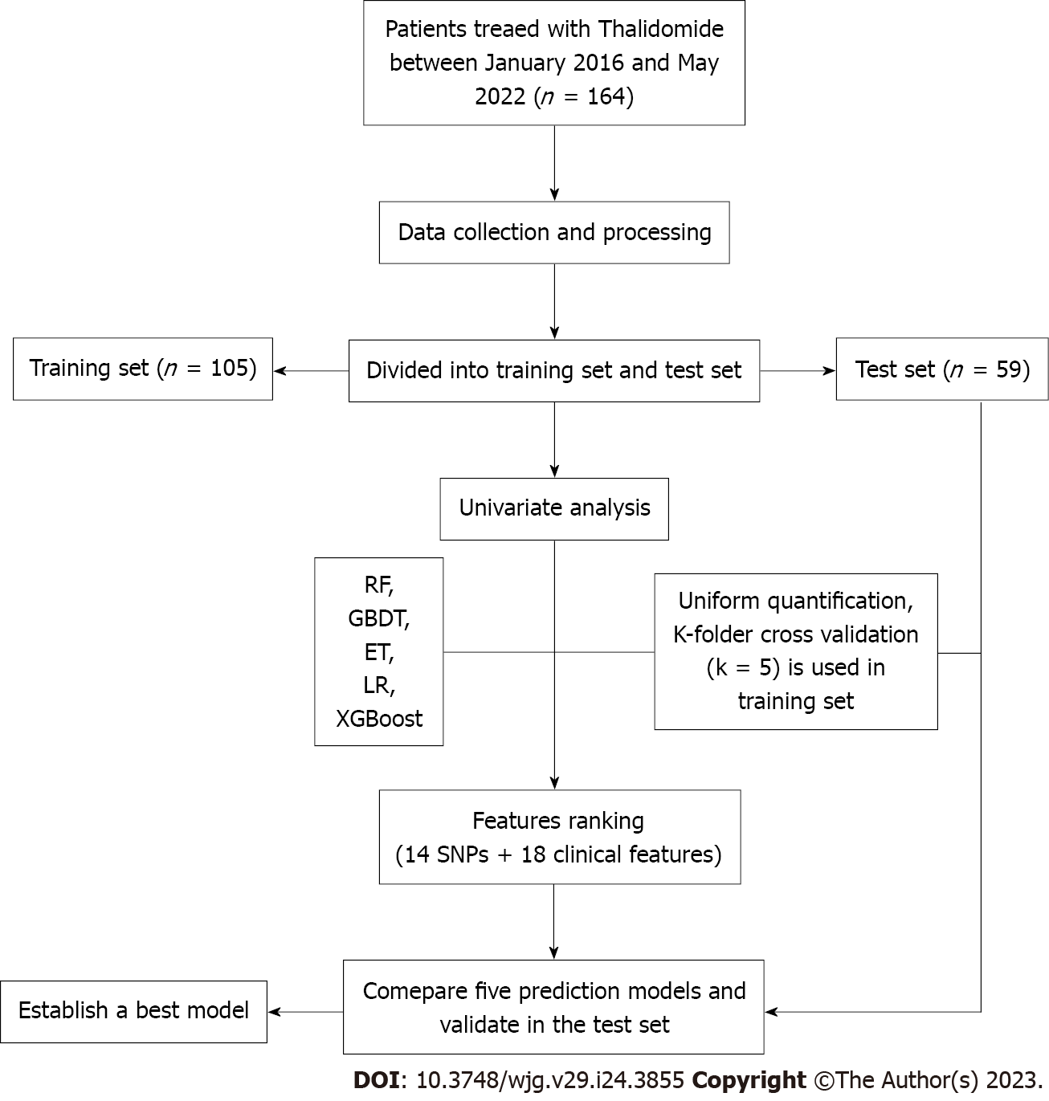
Figure 1 Flow chart display. Flow chart showing the process of model generation validation of the model. RF: Random forest; GBDT: Gradient boosting decision tree; ET: Extremely randomized trees; LR: Logistic regression; XGBoost: Extreme gradient boosting.
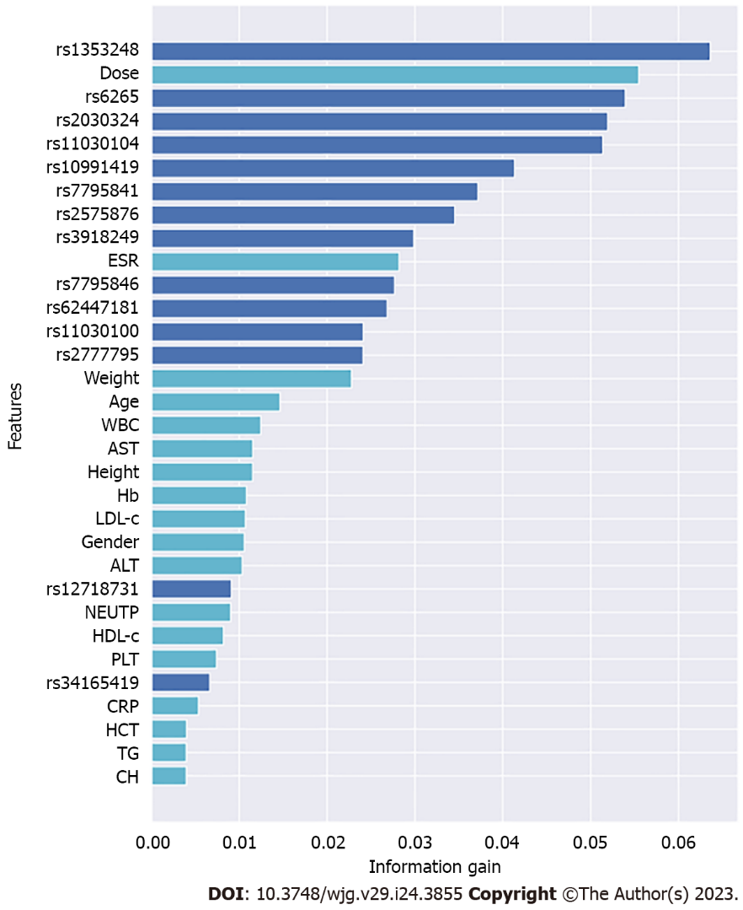
Figure 2 Information gain values of the features. The higher the information gain value, the more important the variable. Therefore, these five variables (rs1353248, dose, rs6265, rs2030324, rs11030104) are the optimal feature set.
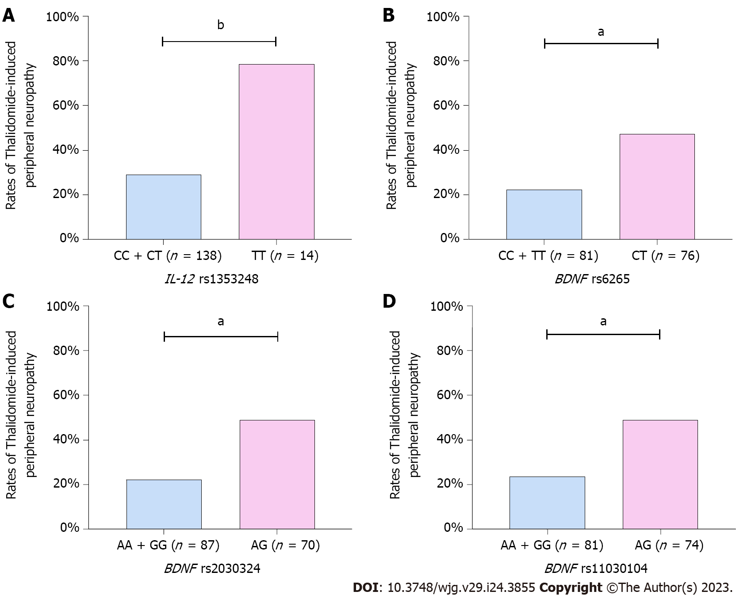
Figure 3 The correlation between the optimal variables and thalidomide-induced peripheral neuropathy. Illustrate patients with interleukin-12 rs1353248_TT, brain-derived neurotrophic factor (BDNF) rs2030324_AG, BDNF rs6265_CT, and BDNF rs11030104_AG, genotypes are more likely to have thalidomide-induced peripheral neuropathy than non-carriers. A: IL-12; B-D: BDNF. ªP < 0.01, ^{b}P < 0.001. BDNF: Brain-derived neurotrophic factor; IL: Interleukin.
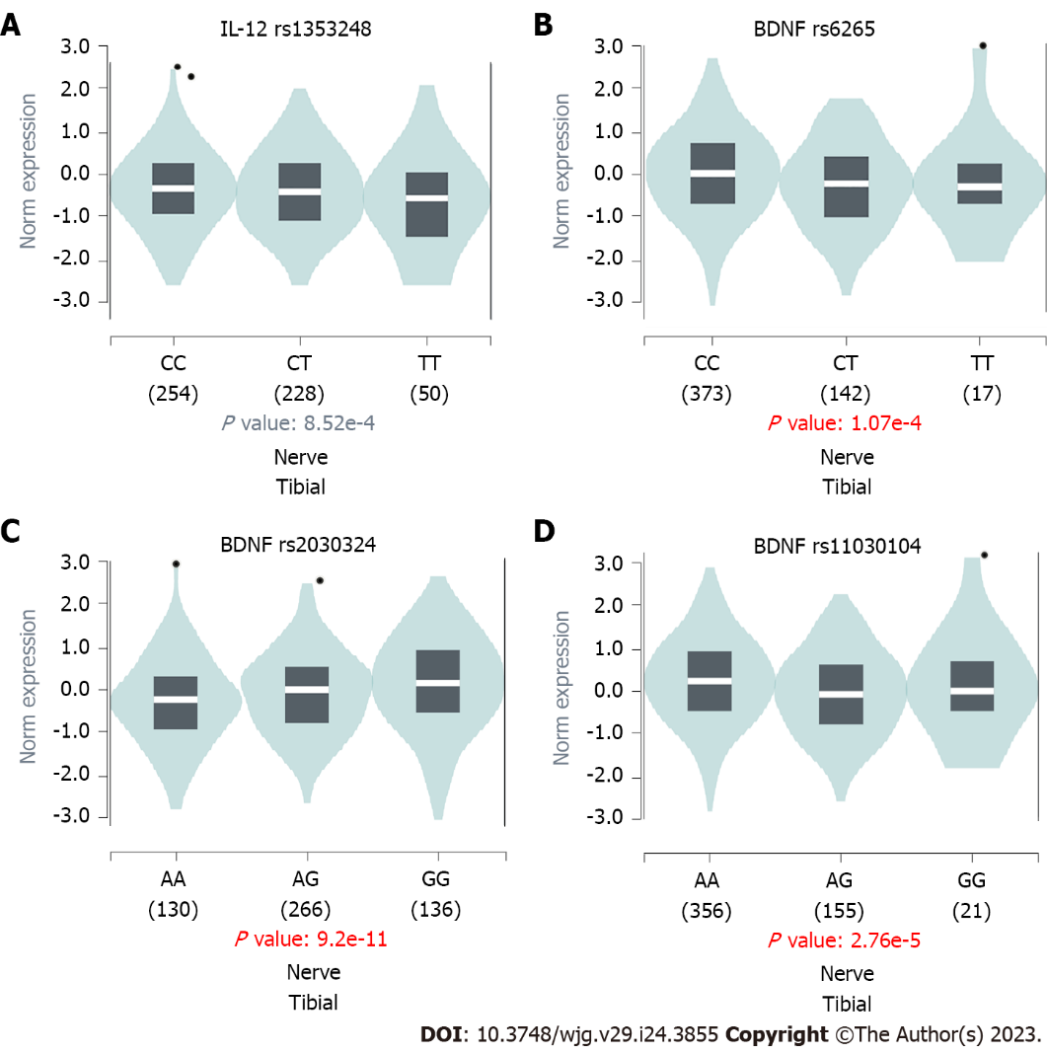
Figure 4 Examination of consequences between the top four single nucleotide polymorphisms and gene expression in nerve tibial tissue. Patients with interleukin (IL)-12 rs1353248_TT (chr3_159905770, P = 8.52 × 10⁻⁴), brain-derived neurotrophic factor (BDNF) rs6265_CT (chr11_27658369, P = 1.07 × 10⁻⁴) BDNF rs2030324_AG (chr11_27705368, P = 9.2 × 10⁻¹¹), and BDNF rs11030104_AG (chr11_27662970, P = 2.76 × 10⁻⁵). A: IL-12; B-D: BDNF. The expression levels of the BDNF gene were reduced in rs6265CT and rs11030104AG. Additionally, the expression levels of the IL-12 gene were significantly decreased in the rs1353248TT. BDNF: Brain-derived neurotrophic factor; IL: Interleukin.
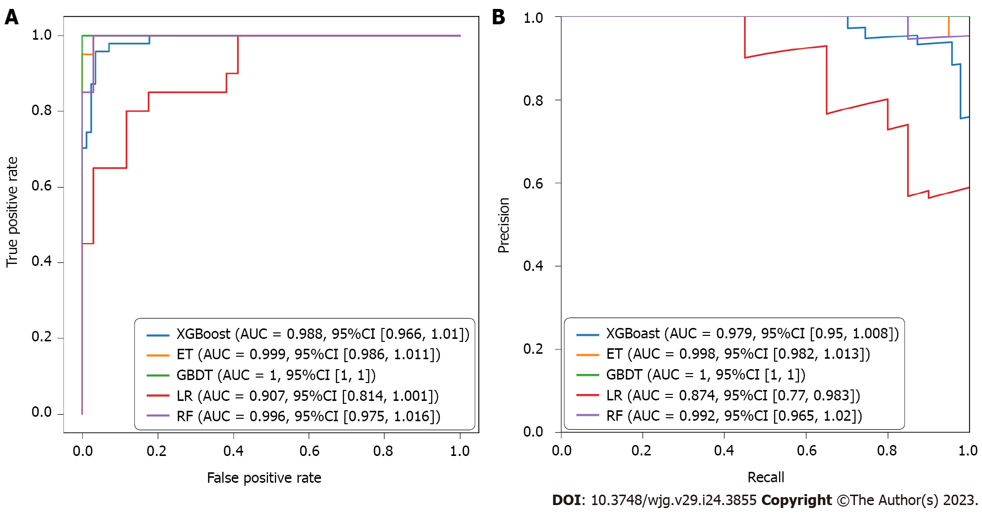
Figure 5 Evaluation of the predictive models. Average area under the receiver operating characteristic curve and precision recall curve of the five models in the training set. A: Receiver operating characteristic curve (training set); B: Precision-recall curve (training set). Average area and 95% confidence intervals of different predictive models are displayed in the box. XGBoost: Extreme gradient boosting; ET: Extremely random trees; GBDT: Gradient boosting decision tree; LR: Logistic regression; RF, random forest; CI: Confidence interval.
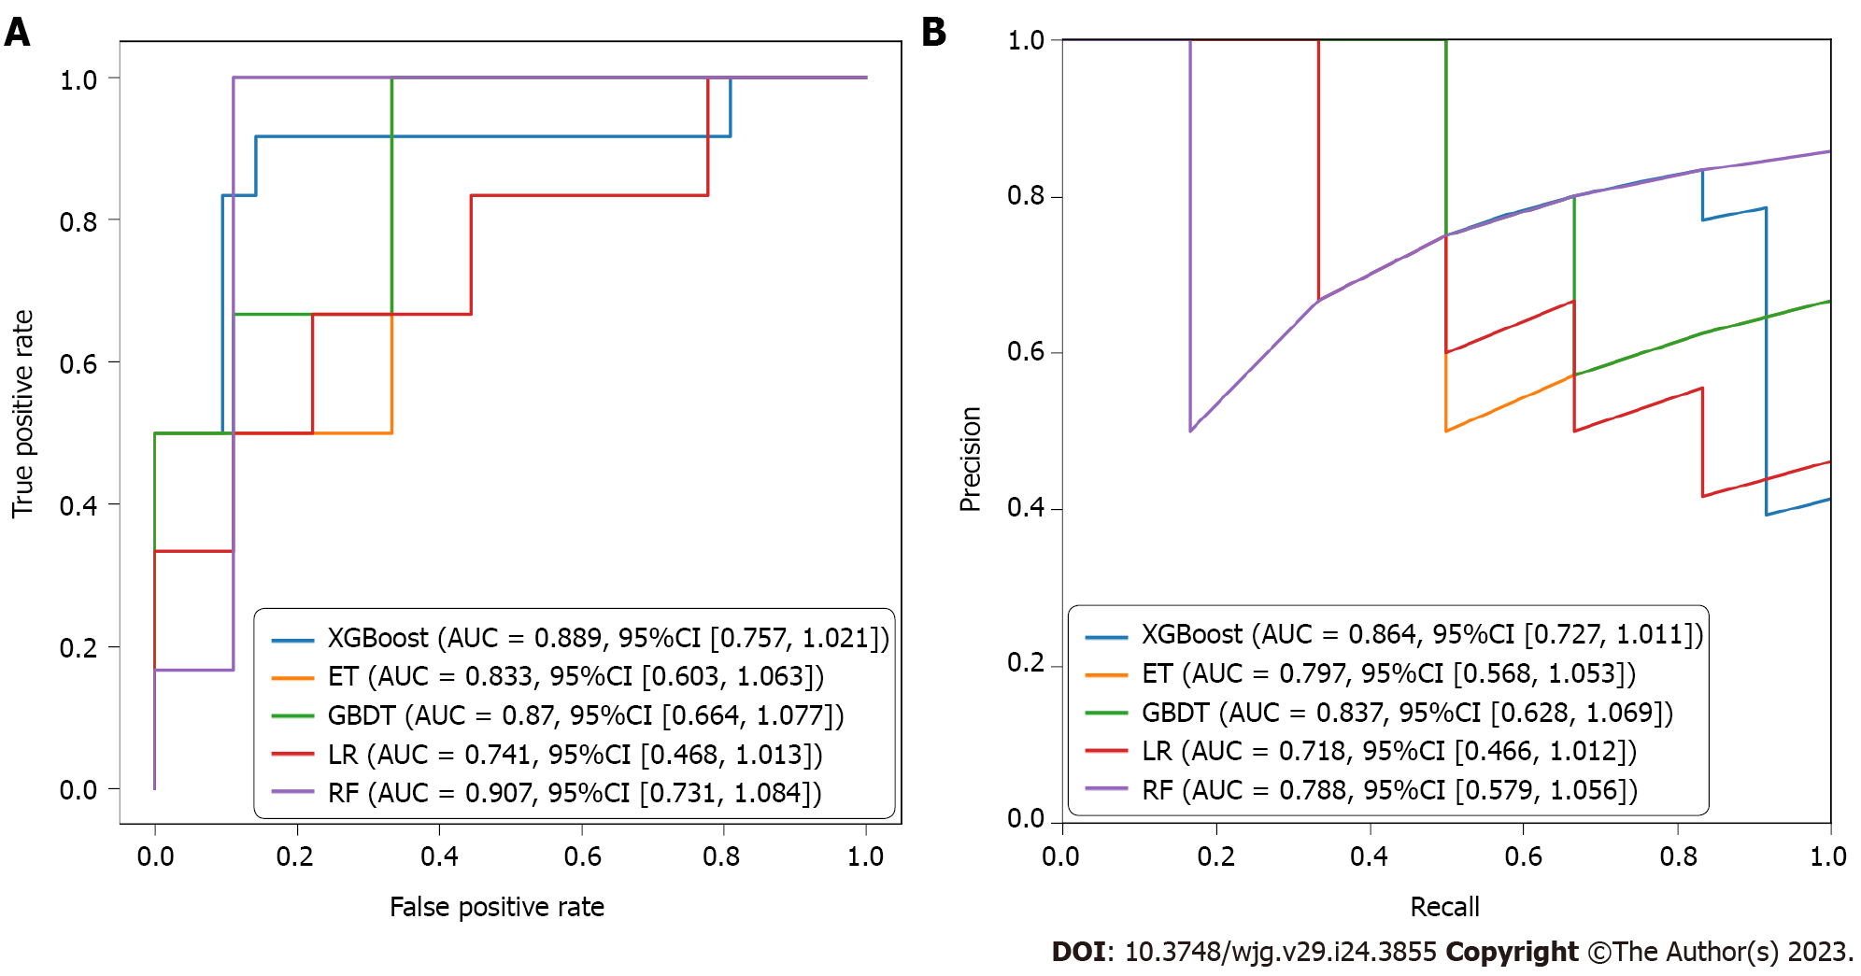
Figure 6 Validation of the training set. The picture shows average area under the receiver operating characteristic curve and precision recall curve of the five models in the test set. A: Receiver operating characteristic curve (testing set); B: Precision-recall curve (testing set). AUC: Area under the curve; CI: Confidence interval; XGBoost: Extreme gradient boosting; ET: Extremely random trees; GBDT: Gradient boosting decision tree; LR: Logistic regression; RF: Random forest; CI: Confidence interval.
Table 1 Patients characteristics
Characteristics | Values (n = 164)
Male/Female | 119/45
Age (yr) | 34.3 ± 12.7
Thalidomide dosage mg/kg/d | 1.5 (0.3-2.9)
White blood cell (× 10⁹/L) | 6.2 ± 2.7
Peripheral neuropathy | 59 (36%)
Duration of thalidomide treatment (m) | 17.2 (1-60)
Data are presented as median with range, mean ± SD or amount.
Table 2 Univariate analyses of factors associated with thalidomide-induced peripheral neuropathy
SNP | Gene | Minor allele | Main allele | OR | 95%CI | P value
rs1353248 | IL-12 | T | C | 8.983 | 2.497-30.90 | 0.0004
rs6265 | BDNF | T | C | 3.150 | 1.546-6.073 | 0.001
rs2030324 | BDNF | G | A | 3.164 | 1.561-6.434 | 0.001
rs11030104 | BDNF | G | A | 3.091 | 1.525-5.960 | 0.001
rs10991419 | ABCA1 | T | C | 3.833 | 1.521-8.926 | 0.002
rs7795841 | ABCB1 | G | T | 4.333 | 1.371-13.39 | 0.014
rs2575876 | ABCA1 | A | G | 2.559 | 1.306-5.209 | 0.007
rs3918249 | MMP9 | T | C | 3.800 | 1.208-10.50 | 0.016
rs7795846 | ABCB1 | A | G | 3.690 | 1.155-10.25 | 0.020
rs62447181 | IKZF1 | A | G | 2.933 | 0.763-9.514 | 0.096
rs11030100 | BDNF | G | T | 2.205 | 1.074-4.430 | 0.030
rs2777795 | ABCA1 | A | G | 1.830 | 0.793-4.114 | 0.09
rs12718731 | IKZF1 | G | A | 2.471 | 0.686-8.328 | 0.1
rs34165419 | ABCA1 | T | C | 2.564 | 0.664-10.41 | 0.1
CI: Confidence interval; OR: Odds ratio; TiPN: Thalidomide-induced peripheral neuropathy; BDNF: Brain-derived neurotrophic factor; IL: Interleukin; SNP: Single nucleotide polymorphisms.
Table 3 Performance of the models for training set (all features)
Model | Precision | Sensitivity | Specificity | Accuracy | AUROC | F1 score
XGBoost | 0.904 | 1 | 0.94 | 0.962 | 0.988 | 0.949
ET | 0.526 | 1 | 0.471 | 0.667 | 0.999 | 0.69
GBDT | 0.952 | 1 | 0.971 | 0.981 | 1 | 0.976
LR | 0.613 | 0.95 | 0.647 | 0.759 | 0.907 | 0.745
RF | 0.769 | 1 | 0.824 | 0.889 | 0.996 | 0.87
AUROC: Area under the receiver operating characteristic; XGBoost: Extreme gradient boosting; ET: Extremely random trees; GBDT: Gradient boosting decision tree; LR: Logistic regression; RF: Random forest.

Table 4 Performance of the models for testing set (all features)
Model | Precision | Sensitivity | Specificity | Accuracy | AUROC | F1 score
XGBoost | 0.75 | 0.75 | 0.857 | 0.818 | 0.889 | 0.75
ET | 0.667 | 1 | 0.667 | 0.8 | 0.833 | 0.8
GBDT | 0.667 | 1 | 0.667 | 0.8 | 0.87 | 0.8
LR | 0.8 | 0.667 | 0.889 | 0.8 | 0.741 | 0.727
RF | 0.625 | 0.833 | 0.667 | 0.733 | 0.907 | 0.714
AUROC: Area under the receiver operating characteristic; XGBoost: Extreme gradient boosting; ET: Extremely random trees; GBDT: Gradient boosting decision tree; LR: Logistic regression; RF: Random forest.

Published by Baishideng Publishing Group Inc
7041 Koll Center Parkway, Suite 160, Pleasanton, CA 94566, USA
Telephone: +19253991568
Email: bpgoffice@wjgnet.com
Help Desk: https://www.f6publishing.com/helpdesk
https://www.wjgnet.com

© 2023 Baishideng Publishing Group Inc. All rights reserved.

