Name of Journal: World Journal of Clinical Cases
Manuscript NO: 71424
Manuscript Type: CASE REPORT

Acute pancreatitis as a rare complication of gastrointestinal endoscopy: A case report

Dai MG et al. Acute pancreatitis complication of gastrointestinal endoscopy

Mu-Gen Dai, Li-Fen Li, Hai-Yan Cheng, Jian-Bo Wang, Bin Ye, Fei-Yun He

Mu-Gen Dai, Jian-Bo Wang, Bin Ye, Department of Gastroenterology, The Fifth Affiliated Hospital of Wenzhou Medical University, Lishui 323000, Zhejiang Province, China

Mu-Gen Dai, Li-fen Li, Department of Gastroenterology, Liandu District People's Hospital, Lishui 323000, Zhejiang Province, China

Hai-yan Cheng, Department of nursing, Liandu District People's Hospital, Lishui 323000, Zhejiang Province, China

Fei-Yun He, Department of Gastroenterology, Lishui Chinese medicine hospital, Lishui 323000, Zhejiang Province, China

Author contributions: Dai MG and Li LF contributed equally to this work; Dai MG, Li LF, Cheng HY, Wang JB, Ye B, and He FY designed the research study; Dai MG, Li LF, Cheng HY, Wang JB, Ye B, and He FY performed the research; Dai MG, Li LF, Cheng HY, Wang JB, Ye B, and He FY analyzed the data and wrote the manuscript; all authors have read and approved the final manuscript.

Supported by Medical Health Science and Technology Project of Zhejiang Provincial Health Commission, No. 2020ZH080; and the Medical and Health Care Project of Lishui, No. 2021SJZC059.

Corresponding author: Fei-Yun He, MD, Chief Physician, Doctor, Department of Gastroenterology, Lishui Chinese medicine hospital, No. 800 Zhongshan Street, Liandu District, Lishui 323000, Zhejiang Province, China. 408252097@qq.com

Received: September 13, 2021
Revised: October 27, 2021
Accepted: March 27, 2022
Published online:

Abstract
BACKGROUND
Acute pancreatitis is an uncommon complication of gastrointestinal endoscopy, especially if the patient has none of the common risk factors associated with pancreatitis; such as alcoholism, gallstones, hypertriglyceridemia, hypercalcemia or the use of certain drugs.

CASE SUMMARY
A 56-year-old female patient developed abdominal pain immediately after the completion of an upper gastrointestinal endoscopy. The pain was predominantly in the upper and middle abdomen and was persistent and severe. The patient was diagnosed with acute pancreatitis. Treatment included complete fasting, octreotide injection prepared in a prefilled syringe to inhibit pancreatic enzymes secretion, ulinastatin injection to inhibit pancreatic enzymes activity, esomeprazole for gastric acid suppression, fluid replacement and nutritional support. Over the next 3 d, the patient's symptoms improved. The patient remained hemodynamically stable throughout hospitalization and was discharged home in a clinically stable state.

CONCLUSION
Pancreatitis should be considered in the differential diagnosis of abdominal pain after upper and lower gastrointestinal endoscopy.

Key Words: Acute pancreatitis; Gastrointestinal endoscopy; Complication; Bile reflux; Case report

Dai MG, Li LF, Cheng HY, Wang JB, Ye B, He FY. Acute pancreatitis as a rare complication of gastrointestinal endoscopy: A case report. World J Clin Cases 2022; In press

Core Tip: Acute pancreatitis is an uncommon complication of gastrointestinal endoscopy, especially when the patient has none of the common risk factors associated with pancreatitis; such as alcoholism, gallstones, hypertriglyceridemia, hypercalcemia or the use of certain drugs. We report an unusual case of acute pancreatitis related to gastrointestinal endoscopy. It is important to recognize this complication in order that appropriate treatment can be undertaken quickly for an optimal outcome.
INTRODUCTION
Endoscopy is a widely used diagnostic and therapeutic procedure and is usually well tolerated by patients. Potential complications include perforation, bleeding, postoperative polyps and side effects associated with sedation and analgesia^{[1-3]}. Rare complications have also been reported in the literature including spleen trauma, infection, diverticulitis and appendicitis^{[4]}. Acute pancreatitis is a well-documented complication of endoscopic retrograde cholangiopancreatography^{[5]}, but not as a complication of upper digestive endoscopy^{[6]}. To our knowledge, only a few cases of acute pancreatitis as a complication of digestive endoscopy have been reported in the English literature. These cases were due to colonoscopy. Here, we report a case of acute pancreatitis as a rare complication after gastrointestinal endoscopy.

CASE PRESENTATION
Chief complaints
A 56-year-old woman underwent non-sedation gastrointestinal endoscopy for early cancer screening. It was the first gastrointestinal endoscopy for the patient. She had a sharp abdominal pain approximately 2 h after completion of the procedure once she had arrived home.

History of present illness
She presented with severe nausea and vomiting 2 h after the procedure. The patient did not have obvious abdominal pain immediately after the procedure. The pain was predominantly in the upper and middle abdomen, was persistent, severe and with no radiation. Pain was accompanied by nausea and non-projectile vomiting of stomach contents. Flatulence was reduced. The patient had a mild fever without chills, diarrhea, chest tightness, chest pain or any other discomfort.

History of past illness
Her past medical history included hepatitis B. She had no history of alcoholism, gallstones or pancreatitis.

Personal and family history
Her birth history and feeding history were uneventful. There was no history of similar illness in the family.

Physical examination
On initial evaluation, vital signs revealed a temperature of 37.3°C, pulse rate of 77 bpm, blood pressure of 147/77 mmHg; and respiration rate of 15breaths/min. The patient was conscious and oriented. No yellowing of the skin or eyes was observed. Both lungs were clear, no dry or moist crackles (rales) were heard. The patient had tenderness in the upper and middle abdomen, no rebound pain or muscle tension was noted. Murphy’s sign, McBurney’s sign, and shifting dullness were all negative, and bowel sounds were heard at a rate of 3/min. No edema in the lower extremities was observed. No pathological signs were found.

Laboratory examinations
Laboratory examination results were as follows: CRP 61.6 mg/L; white blood cells 15.5 x 10⁹ cells/L; amylase level 1022 IU/L (normal 23-184 IU/L); lipase level 4264 U/dL (normal 1-35 U/dL); arterial blood gas findings pH 7.36, HCO₃ 22 mmol/L; hepatobiliary enzyme and blood lipids were normal; serum calcium 2.0 mmol/L; hepatitis B (HB) surface antigen positive, HBeAg positive, HB core antibody positive; erythrocyte sedimentation rate 95 mm/h.

Imaging examinations
The patient's upper gastrointestinal endoscopy was normal. A contrast-enhanced abdominal computed tomography scan after admission suggested acute pancreatitis with peripancreatic fluid collection (Figure 1). Two incidental renal cysts and uterine fibroids were also detected. Magnetic resonance cholangiopancreatography revealed no structural changes and no gallstones in the pancreaticobiliary duct system (Figure 2).

FINAL DIAGNOSIS
Acute pancreatitis.

TREATMENT
Treatment included complete fasting, octreotide injection prepared in a prefilled syringe to inhibit pancreatic enzymes secretion, ulinastatin injection to inhibit pancreatic enzymes activity, esomeprazole for gastric acid suppression, fluid replacement and nutritional support.

OUTCOME AND FOLLOW-UP
Over the next 3 d, the patient's symptoms improved, and serum amylase levels decreased to 104 IU/L within the normal range. The patient remained hemodynamically stable throughout hospitalization and was discharged home in a clinically stable state.

DISCUSSION
Although upper gastrointestinal endoscopy has not yet been demonstrated to be associated with an increased risk of pancreatitis and the relationship between endoscopy and pancreatitis may have been coincidental, both occurred within a short time and may explain the causality. In addition, the patient had no risk factors related to pancreatitis, such as alcoholism, trauma (including iatrogenic trauma), drugs, or infections^{[7]}. Moreover, the patient had previously been tested for autoimmune pancreatitis, but the results were negative and lipid levels were normal. Therefore, we consider that gastrointestinal endoscopy may have played a role in the development of acute pancreatitis. In the literature, only one case of pancreatitis secondary to upper gastrointestinal endoscopy was reported in 1982^{[8]}. This is the first case of pancreatitis secondary to gastrointestinal endoscopy reported in China.
Endoscopy is an essential procedure for gastroenterologists. The number and technical difficulties of endoscopies have increased over the past few decades and quality and safety remain important. The complication of pancreatitis caused by upper and lower gastrointestinal endoscopy is uncommon. Four cases of acute pancreatitis following upper and lower gastrointestinal endoscopy were considered to be caused by mechanical trauma due to manipulation of the colonoscope^{[6,9-11]}. The potential mechanisms involved in the pathogenesis of pancreatitis include the following three factors: bile reflux due to high pressure^{[12]}; mechanical trauma during the procedure^{[4,11,13]}; and asymptomatic hyperamylasemia^{[14-17]}.
Since the development of acute necrotizing pancreatitis caused by upper gastrointestinal endoscopy has no relationship with previous pancreatic injury, the most probable etiology in this patient was severe vomiting and excessive pressure in the abdominal cavity, causing bile reflux into the pancreatic ducts, consequently activating trypsinogen to trypsin, which led to self-digestion of the pancreas. Bile reflux due to high pressure is considered an important cause of pancreatitis in clinical practice. In a previous study, hyperamylasemia was reported in 12% of patients undergoing endoscopy, but it was thought to be secondary to increased secretion of the salivary amylase isoenzyme^{[18]}. Apart from the causes described above, we have been unable to find any other associations.

CONCLUSION
Whether it was a result of direct local trauma or an undetermined release of inflammatory mediators, clinically symptomatic acute pancreatitis is unusual among the complications of conventional endoscopic procedures. The diagnosis of acute pancreatitis is complex. It may be suspected clinically, but biochemical, radiological, and sometimes histological evidence is needed to confirm the diagnosis. Pancreatitis should be considered in the differential diagnosis of abdominal pain after upper and lower gastrointestinal endoscopy, when the most common explanations for such pain are excluded. Therefore, it is important to recognize this emergency in order that appropriate treatment can be undertaken for an optimal outcome.

REFERENCES
1 Ghazi A, Grossman M. Complications of colonoscopy and polypectomy. Surg Clin North Am 1982; 62: 889-896 [PMID: 6981859 DOI: 10.1016/s0039-6109(16)42839-2]
2 Vernava AM, Longo WE. Complications of endoscopic polypectomy. Surg Oncol Clin N Am 1996; 5: 663-673 [PMID: 8829325]
3 Palmer KR. Complications of gastrointestinal endoscopy. Gut 2007; 56: 456-457 [PMID: 17369377 DOI: 10.1136/gut.2006.105577]
4 Thomas AW, Mitre RJ. Acute pancreatitis as a complication of colonoscopy. J Clin Gastroenterol 1994; 19: 177-178 [PMID: 7963371 DOI: 10.1097/00004836-199409000-00024]
5 Bilbao MK, Dotter CT, Lee TG, Katon RM. Complications of endoscopic retrograde cholangiopancreatography (ERCP). A study of 10,000 cases. Gastroenterology 1976; 70: 314-320 [PMID: 1248697]
6 Nevins AB, Keeffe EB. Acute pancreatitis after gastrointestinal endoscopy. J Clin Gastroenterol 2002; 34: 94-95 [PMID: 11743255 DOI: 10.1097/00004836-200201000-00019]
7 Imrie CW, McKay AJ, Benjamin IS, Blumgart LH. Secondary acute pancreatitis: aetiology, prevention, diagnosis and management. Br J Surg 1978; 65: 399-402 [PMID: 656756 DOI: 10.1002/bjs.1800650609]
8 Deschamps JP, Allemand H, Janin Magnificat R, Camelot G, Gillet M, Carayon P. Acute pancreatitis following gastrointestinal endoscopy without ampullary cannulation. Endoscopy 1982; 14: 105-106 [PMID: 7075561 DOI: 10.1055/s-2007-1021593]
9 Kulling D, Sahai AV, Knapple WL, Cunningham JT, Hoffman BJ. Diagnostic endoscopic ultrasound of the pancreas may cause acute pancreatitis. Endoscopy 1998; 30: S7-S8 [PMID: 9548054 DOI: 10.1055/s-2007-1001227]
10 Limb C, Ibrahim IA, Fitzsimmons S, Harper AJ. Recurrent pancreatitis after unremarkable colonoscopy, temporalised by CT imaging: an unusual case. BMJ Case Rep 2016; 2016 [PMID: 26746831 DOI: 10.1136/bcr-2015-213192]
11 Ko HH, Jamieson T, Bressler B. Acute pancreatitis and ileus post colonoscopy. Can J Gastroenterol 2009; 23: 551-553 [PMID: 19668799 DOI: 10.1155/2009/357059]
12 Fischer M, Hassan A, Sipe BW, Fogel EL, McHenry L, Sherman S, Watkins JL, Schmidt S, Lazzell-Pannell L, Lehman GA. Endoscopic retrograde cholangiopancreatography and manometry findings in 1,241 idiopathic pancreatitis patients. Pancreatology 2010; 10: 444-452 [PMID: 20720445 DOI: 10.1159/000264675]
13 Khashram M, Frizelle FA. Colonoscopy--a rare cause of pancreatitis. N Z Med J 2011; 124: 74-76 [PMID: 22072170 DOI: 10.14309/00000434-201110002-00567]
14 Köhler H, Lankisch PG. Acute pancreatitis and hyperamylasaemia in pancreatic carcinoma. Pancreas 1987; 2: 117-119 [PMID: 2437571 DOI: 10.1097/00006676-198701000-00018]
15 Blackwood WD, Vennes JA, Silvis SE. Post-endoscopy pancreatitis and hyperamylasuria. Gastrointest Endosc 1973; 20: 56-58 [PMID: 4754275 DOI: 10.1016/s0016-5107]
16 Kopácová M, Rejchrt S, Tachecí I, Bures J. Hyperamylasemia of uncertain significance associated with oral double-balloon enteroscopy. Gastrointest Endosc 2007; 66: 1133-1138 [PMID: 17892875 DOI: 10.1016/j.gie.2007.03.1085]
17 Matsushita M, Shimatani M, Uchida K, Okazaki K. Association of hyperamylasemia and longer duration of peroral double-balloon enteroscopy: present and future. Gastrointest Endosc 2008; 68: 811; author reply 811-811; author reply 812 [PMID: 18926192 DOI: 10.1016/j.gie.2008.02.082]
18 Kobayashi T, Fukuchi S, Sawano S, Yamada N, Ikenaga T, Sugimoto T. Changes in serum isoamylase activities after fibergastroduodenoscopy and colonoscopy. Isoamylase after FGDS and FCS. Endoscopy 1979; 11: 133-137 [PMID: 446426 DOI: 10.1055/s-0028-1098338]

Footnotes
Informed consent statement: Consent was obtained from the patient for publication of this report and any accompanying images.

Conflict-of-interest statement: The authors declare that they have no conflicts of interest.

CARE Checklist (2016) statement: The authors have read the CARE Checklist (2016), and the manuscript was prepared and revised according to the CARE Checklist (2016).

Open-Access: This article is an open-access article that was selected by an in-house editor and fully peer-reviewed by external reviewers. It is distributed in accordance with the Creative Commons Attribution NonCommercial (CC BY-NC 4.0) license, which permits others to distribute, remix, adapt, build upon this work non-commercially, and license their derivative works on different terms, provided the original work is properly cited and the use is non-commercial. See: https://creativecommons.org/Licenses/by-nc/4.0/

Provenance and peer review: Unsolicited article; Externally peer reviewed.
Peer-review model: Single blind

Peer-review started: September 13, 2021
First decision: October 18, 2021
Article in press:

Specialty type: Gastroenterology and hepatology
Country/Territory of origin: China
Peer-review report’s scientific quality classification
Grade A (Excellent): 0
Grade B (Very good): 0
Grade C (Good): C
Grade D (Fair): 0
Grade E (Poor): E

P-Reviewer: Ardengh JC, Brazil; Hirai R, Japan S-Editor: Ma YJ L-Editor: Filipodia P-Editor: Ma YJ

Figure Legends
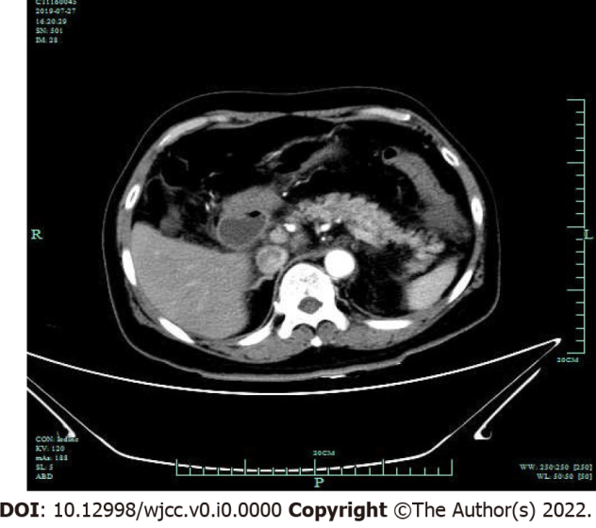
Figure 1 Computed tomography of the abdomen showing pancreatic inflammation without significant dilatation of the pancreatic ducts.

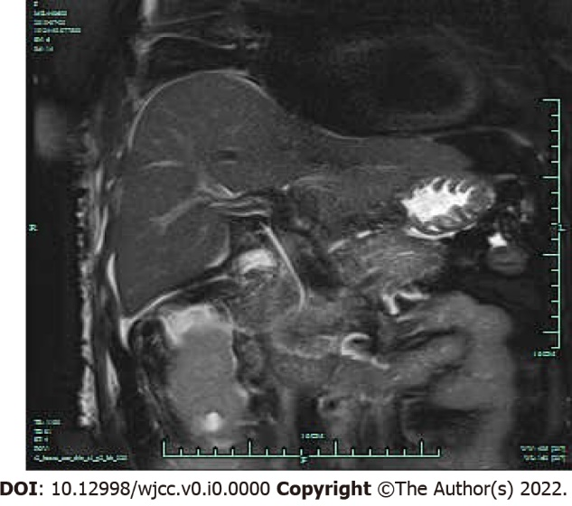
Figure 2 Magnetic resonance cholangiopancreatography revealed no structural changes and no gallstones in the pancreaticobiliary duct system.

