Name of Journal: World Journal of Gastrointestinal Oncology
Manuscript NO: 89678
Manuscript Type: REVIEW

Unraveling the enigma: A comprehensive review of solid pseudopapillary tumor of the pancreas

Xu YC et al. Solid pseudopapillary tumor of the pancreas

Ye-Cheng Xu, De-Liang Fu, Feng Yang

Ye-Cheng Xu, De-Liang Fu, Feng Yang, Department of Pancreatic Surgery, Pancreatic Disease Institute, Huashan Hospital, Fudan University, Shanghai 200040, China

Author contributions: Xu YC and Yang F contributed to data acquisition, and drafting the article; Fu DL and Yang F contributed to the conception and design of this paper; all authors contributed to the final approval of the version to be published.

Corresponding author: Feng Yang, MD, PhD, Doctor, Surgeon, Department of Pancreatic Surgery, Pancreatic Disease Institute, Huashan Hospital, Fudan University, No. 12 Central Urumqi Road, Shanghai 200040, China. yffudan98@126.com

Received: November 9, 2023
Revised: December 28, 2023
Accepted: January 16, 2024
Published online:

Abstract
Solid pseudopapillary tumor of the pancreas (SPTP) is a rare neoplasm predominantly observed in young females. Pathologically, CTNNB1 mutations, β-catenin nuclear accumulation, and subsequent Wnt-signaling pathway activation are the leading molecular features. Accurate preoperative diagnosis often relies on imaging techniques and endoscopic biopsies. Surgical resection remains the mainstay treatment. Risk models, such as the Fudan Prognostic Index, show promise as predictive tools for assessing the prognosis of SPTP. Establishing three types of metachronous liver metastasis can be beneficial in tailoring individualized treatment and follow-up strategies. Despite advancements, challenges persist in understanding its etiology, establishing standardized treatments for unresectable or metastatic diseases, and developing a widely recognized grading system. This comprehensive review aims to elucidate the enigma by consolidating current knowledge on the epidemiology, clinical presentation, pathology, molecular characteristics, diagnostic methods, treatment options, and prognostic factors.

Key Words: Pancreas; Solid pseudopapillary tumor; β-catenin; Endoscopic ultrasound; Surgery; Recurrence; Liver metastasis; Prognostic prediction

Xu YC, Fu DL, Yang F. Unraveling the enigma: A comprehensive review of solid pseudopapillary tumor of the pancreas. World J Gastrointest Oncol 2024; In press

Core Tip: Solid pseudopapillary tumor of the pancreas (SPTP) is a rare neoplasm predominantly affecting young females. Pathologically, CTNNB1 mutations, β-catenin nuclear accumulation, and Wnt signaling pathway activation are key molecular features. Accurate preoperative diagnosis relies on imaging and endoscopic biopsies. Surgical resection is the main treatment, and prognostic models like Fudan Prognostic Index aid in prognosis assessment. Challenges in understanding its etiology, establishing treatments for unresectable/metastatic disease, and developing a standardized grading system persist. This comprehensive review aims to consolidate current knowledge on epidemiology, clinical presentation, pathology, molecular features, and treatment options for SPTP.

INTRODUCTION
Solid pseudopapillary tumor of the pancreas (SPTP), also known as solid pseudopapillary neoplasm (SPN) or solid pseudopapillary epithelial neoplasm (SPEN)^{[1]}, is a rare, low-grade malignant neoplasm that primarily affects young females^{[2,3]}. Initially described by Frantz in 1959 as “papillary cystic tumors of the pancreas”^{[4]}, the World Health Organization (WHO) later adopted the term “SPTP” in 1996 to better reflect the tumor’s histological characteristics^{[5]}. SPTP has limited malignant potential, and typically results in localized disease. Most cases are asymptomatic and are incidentally detected during routine imaging studies or investigations of other conditions.
Although the exact cause of SPTP is unknown, evidence suggests that it originates from pluripotent cells within the pancreas^{[6]}. It typically presents as a combination of solid and cystic areas, with a central pseudopapillary structure formed by cell accumulation around blood vessels^{[7]}. The disease is associated with a favorable prognosis, with a 5-year survival rate exceeding 95%^{[8]}. Surgical resection is the preferred treatment, and complete tumor removal is curative in most cases^{[8-13]}. In rare situations where the tumor is unresectable or has metastasized, chemotherapy or other anti-cancer therapies may be considered. Predicting the risk of postoperative recurrence can aid clinicians in identifying and closely monitoring patients who may benefit from adjuvant therapy.
In this comprehensive review, we delve into recent advances in understanding SPTP to unravel this enigma.

Epidemiology
The epidemiology of SPTP remains poorly defined due to lack of large-scale population-based studies. The exact global incidence varies depending on the region and population studied but is estimated to be less than one in a million per year. SPTP can affect individuals of all races^{[14]}. It is important to note that available data on the geographic and ethnic distribution is limited. Further studies are needed to obtain a more accurate understanding of its distribution. However, due to its rarity, conducting large-scale epidemiological studies is very challenging, and even considered impossible.
There are no established risk factors or predisposing conditions associated with the development of SPTP. The gender and age predilection may be related to sex hormones^{[6]}. Studies have suggested that progesterone may be involved in its pathogenesis^{[15]}. Differential expression of estrogen and androgen receptors have also been observed, although these associations are not definitive^{[16-18]}. Further research is needed to identify the underlying mechanisms.

Pathogenetic Features
Several molecular and genetic alterations that contribute to pathogenesis and malignant potential have been identified. The most common genetic alteration is a mutation in exon 3 of CTNNB1^{[7,19-23]}, which encodes β-catenin, a crucial component of the Wnt-signaling pathway. Activation of β-catenin has been shown to induce pancreatic tumorigenesis^{[24]}. The Wnt/β-catenin pathway promotes carcinogenesis by influencing gene transcription in a regulated or deregulated manner^{[25,26]}. It also interacts with the Hedgehog and androgen receptor signaling pathways, which trigger epithelial–mesenchymal transition^{[21]}. The mechanism underlying its limited malignant potential is unclear, but may be related to the significant downregulation of BCL9/9L, a crucial transcriptional co-activator of β-catenin^{[25]}, and high expression of the cyclin D1 inhibitors p21 and p27^{[27]}.
In addition to β-catenin, which has been identified as a positive molecular marker for SPTP^{[28-30]}, negative markers such as KRAS, GNAS, RNF43, and chr18 Loss of heterozygosity have also been identified^{[28]}; however, their implications remains poorly understood. Based on these complex molecular mechanisms, SPTP is typically characterized by slow growth and low malignant potential^{[31]}. It is usually well-circumscribed, rarely invades neighboring structures or metastasizes to distant sites, and has a high R0 resection rate. However, an aggressive growth pattern with local infiltration and distant metastasis occurs in approximately 15% of the cases^{[32]}.

Clinical Presentation
An analysis of 1,072 cases of SPTP cases from several large cohort studies have shown that abdominal pain and discomfort were the most common symptoms, accounting for 43.5% of cases. More than 40% of patients had no symptoms, making it difficult to detect this tumor. An abdominal mass was the first finding in 14.8% of patients. Other clinical manifestations, with a prevalence of more than 1%, include dyspepsia, nausea, vomiting and back pain. Rare symptoms (< 1%) include obstructive jaundice, anorexia, fever, weight loss, and sinusoidal hypertension^{[3,9,11-13,32]}. It is worth noting that the mechanism by which obstructive jaundice and sinistral portal hypertension occur in SPTP is different from that involved in pancreatic ductal adenocarcinoma. In SPTP, these symptoms are caused by external pressure on the surrounding structures, whereas in pancreatic ductal adenocarcinoma, they result from invasion of the biliary tract and portal vein system^{[12]}. Due to advances in imaging techniques and increased health-consciousness, the proportion of asymptomatic cases has gradually increased in recent years as more people become aware of their health and undergo regular check-ups^{[3,13]}. Nevertheless, the nonspecific symptoms and the absence of specific laboratory tests and tumor markers present difficulties in the accurate diagnosis of SPTP^{[26]}.

Imaging techniques for detection and characterization
Ultrasonography is often the initial test used for symptomatic patients and is also used for screening. Ultrasonically, an SPTP appears as a well-defined hypo-echoic cystic mass with few internal flow signals. Contrast-enhanced ultrasonography shows enhanced capsular boundaries with a nonenhanced central area. Additionally, iso/hypo-enhancement can be observed during the early and delayed parenchymal perfusion phases^{[33,34]}.
Computed tomography (CT) is the most widely used and sensitive test for the evaluation of pancreatic tumors. Multi-detector CT (MDCT) is recommended as the primary method for detecting SPTP and for assessing its resectability. Li et al^{[35]} classified SPTP into five types based on their solid–cystic ratio. Types III, IV, and V were more common in females. The most prevalent type was type III (29.4%), which appeared as a well-circumscribed mass with mixed solid and cystic components, with no clear boundary between the cystic and solid regions. Interestingly, the solid–cystic ratio may decrease as the SPTP grows. Smaller SPTPs (less than 3 cm) tend to be predominantly solid, while larger SPTPs (more than 3 cm) show more cystic components^{[36]}. On contrast-enhanced CT, noticeable enhancement of the solid area is observed during the arterial and portal venous phases, although it is lower than that of the pancreatic tissue^{[37]}. Peripheral enhancement due to a fibrous pseudo-capsule is also a characteristic feature of SPTP^{[38]}. Enhancement of fibrous components within cystic fluid resembles a “floating cloud” appearance^{[39]}. Hemorrhage, necrosis, and calcification are important features^{[35]}.
SPTP exhibits greater heterogeneity on magnetic resonance imaging (MRI). MRI often reveals T2 hyperintensity and T1 hypointensity, as well as heterogeneous enhancement on contrast-enhanced T1-weighted images^{[35,40]}. Although the role of MRI in SPTP has been less extensively studied than that of compared to CT scans, MRI is crucial for its detection due to its non-invasiveness and high diagnostic accuracy^{[41]}.
Endoscopic techniques provide methods for the preoperative pathological diagnosis of SPTP. Similar to abdominal ultrasound, SPTP appears as solid, cystic, or solid–cystic on endoscopic ultrasound (EUS)^{[42]}. The application of artificial intelligence, such as the deep learning analysis of EUS images, has the potential to improve the diagnostic value of endoscopic techniques^{[43]}. EUS-guided fine needle aspiration (EUS-FNA) is increasingly utilized in pancreatic tumor diagnosis, with both sensitivity and specificity exceeding 80%^{[44]}. In addition to biopsy, EUS-FNA allows for the minimally-invasive collection of fluid samples, including pancreatic juice and cyst fluid^{[42,45]}. Table 1 summarizes the results of cyst fluid analysis for various pancreatic cystic diseases^{[45-47]}. Considering the predominant solid component in SPTP and the limited diagnostic accuracy of cyst fluid analysis, EUS-guided fine needle biopsy (EUS-FNB) can be a more valuable diagnostic tool. This method often provides a larger tissue sample for possible immunostaining needed for diagnosis and to exclude other tumors with different management such as pancreatic neuroendocrine tumor (PNET). A recent retrospective multi-center study showed an impressive preoperative diagnostic accuracy of 97.2% (103/106) for SPTP using EUS-guided biopsy^{[48]}. However, EUS-guided biopsy demands specialized endoscopic skills and expertise, which may limit its availability on a global scale. Moreover, the learning curve is long, and low cellularity in sometimes encountered, which may limit its clinical utility. Additionally, the probability of biopsy-induced inflammation and needle tract seeding, while extremely low, does exist^{[42,49-51]}. Additionally, EUS-guided needle-based confocal laser endomicroscopy (EUS-nCLE) has emerged as a novel diagnostic method, exhibiting high diagnostic accuracy^{[52,53]}. The typical features of SPTP on EUS-nCLE include tiny round dark cellular clusters with white stroma bands^{[52,54]}.
Positron emission tomography/CT (PET/CT) complements routine imaging tests and provides insights into the histopathological composition of SPTP. One characteristic finding is the presence of strong focal fluorodeoxyglucose (FDG) uptake, which is indicative of metabolic activity^{[55]}. Recent reports have suggested that fibroblast activation protein inhibitor (FAPI) activity can also be observed in cases where FDG uptake is negative^{[56]}. This highlights the potential of FAPI as an alternative tracer in certain situations. Additionally, the standard uptake value, a quantitative measure of FDG uptake, has been shown to correlate with pathological features such as tumor cellularity, proliferative index, and histological malignancy^{[57]}. PET/MRI is relatively rare used in the evaluation of SPTP. It combines the benefits of both PET and MRI, and provides detailed anatomical and functional information in a single imaging session. Similar to PET/CT, PET/MRI can also show focal FDG uptake, allowing for identification and localization of active tumor regions^{[58]}. Both aid in staging, prognostication, and early detection of recurrence, and assist in treatment planning^{[59]}. However, despite their clinical value, high costs may restrict their widespread application.

Diagnosis
Age and sex are essential factors to consider when diagnosing SPTP. If a solid pancreatic cystic tumor is detected in a young female, SPTP should be considered first. A definitive diagnosis is typically made using a combination of imaging studies. In cases where the differential diagnosis is difficult, a multidisciplinary approach, involving radiologists, gastroenterologists, and surgeons, is usually required to make an accurate diagnosis. Definitive diagnosis before surgery relies on biopsy and histopathological examinations. In the era of guidelines and EUS, the misdiagnosis rate of SPTP is markedly low, at only 6%, making it the lowest among pancreatic cystic neoplasms^{[60]}. A flowchart of the SPTP diagnosis is shown in Figure 1.
Macroscopically, the majority of SPTPs appears as a well-circumscribed mass^{[61,62]}. They often have a fine peripheral capsule, and hemorrhage and necrosis may also be visible^{[61]}. Microscopically, SPTPs typically display characteristic histological features, including pseudopapillary structures, and areas of hemorrhage and necrosis^{[62]}. Tumor cells usually have large round nuclei, with abundant eosinophilic or clear cytoplasm that can be vacuolated^{[63]}. Wang et al^{[64]} identified key cytological features of SPTP, such as myxoid stroma surrounding fibrovascular cores and discohesive epithelioid cells with deficient cytoplasm, pale chromatin, longitudinal nuclear grooves, and small nucleoli closely associated with the nuclear membrane. However, a definitive diagnosis cannot rely solely on morphological features. Immunohistochemistry helps to confirm the diagnosis and differentiate SPTP from other tumor types^{[63]}. Several immunohistochemistry markers, such as CD56, CD10, and β-catenin, have been shown to be commonly expressed in SPTP^{[65,66]}. Table 2^{[18,26,31,65,66,73-80]} provides a list of useful immunohistochemical markers for SPTP. Although SPTP possesses distinct features, it has similarities and overlaps with other tumors, such as non-functional PNET^{[67]} and acinar cell carcinoma^{[37]}. A comprehensive differential diagnosis of SPTP is presented in Table 3^{[68-72]}.

Malignant SPTP
Until now, there has been no unified standard for defining malignant SPTP. Certain features, such as cell pleomorphism, prominent necrosis, perineural invasion, and the presence of multiple mitotic figures, may indicate malignant potential^{[81,82]}. The 2010 WHO classification of tumors of the digestive system considered SPTP as a low-grade malignancy^{[83]}. However, the updated system in 2019 introduced the concept of high-grade malignant SPTP, characterized by tumor cells exhibiting high levels of atypia and extensive mitotic figures throughout the tumor^{[84]}. Previous studies defined malignant SPTP based on various criteria including lymph node or distant metastases, cellular atypia, capsule invasion, parenchymal infiltration, perineural or lymphovascular infiltration, or extrapancreatic infiltration in 18.3% of cases^{[31]}. Fleming et al^{[85]} defined malignant SPTP based on the American Joint Committee on Cancer (AJCC) 8th edition staging system, classifying T4 stage, lymph node metastasis, and distant metastasis as malignant, accounting for 13.4%^{[85]}. Further research and collaboration are needed to establish a consensus for diagnosing malignant SPTP, which may require more aggressive treatments.
Liver metastasis of SPTP can occur synchronously or metachronously. Chen et al^{[9]} showed that synchronous metastasis rates ranged from 0% to 4.3%, while metachronous metastasis rates ranged from 1.5% to 4.5%. Metachronous liver metastasis can be classified into three types: classical, indolent, and aggressive. In the classical type, metastases grow at a relatively slow rate. Small lesions appear as low-density on CT scan and may be single or multiple. As the lesions increase in size, peripheral enhancement may occur during the arterial and venous phase. With further growth, cystic degeneration and hemorrhagic necrosis may develop. Multiple lesions can even merge to form a larger lesion (Figure 2). The classical type aligns with the natural growth pattern of the primary SPTP lesion^{[86]}. The indolent type exhibits a very slow growth rate, and the lesions are often small (less than 1 cm) when detected. During follow-up, these lesions typically only grow a few millimeters per year (Figure 3). It can be challenging to detect this type, and enhanced MRI has relatively high sensitivity. Treatment options for the indolent type may include observation or radiofrequency ablation (RFA). The aggressive type is usually asymptomatic and discovered incidentally during follow-up. If the metastases are unresectable, they may progress rapidly despite adjuvant therapy. In this condition, surrounding vessels such as splenic vein, portal vein, superior mesenteric vein, and even inferior vena cava can be involved, leading to tumor thrombus formation (Figure 4). The factors contributing to this type are unclear but may be associated with abdominal trauma^{[87,88]}. The prognosis for the aggressive type is generally poor, and surgical intervention is often not possible.

Treatment Approaches
Observation is typically not recommended for SPTP because of its malignant potential^{[89]}. However, a recent study examined 994 cases from the National Cancer Database between 2004 and 2018 and found that the incidence of lymph node metastasis was 0.5% in tumors ≤ 4 cm and 0% in those ≤ 2 cm^{[90]}. This suggests that patients with cT1N0 Lesions should be closely monitored rather than undergoing immediate surgery. The benefit of observation is the avoidance of the morbidity and mortality associated with pancreatic resection^{[91]}. With advancements in interdisciplinary approaches, EUS-guided RFA (EUS-RFA) has emerged as a potential treatment option for pancreatic tumors^{[92]}. In a study by Choi et al^{[93]}, two patients with SPTP underwent EUS-RFA without experiencing any procedure-related adverse events, and one patient achieved a complete response. Coupier et al^{[94]} subsequently reported on three SPTP patients who received EUS-RFA, and none of them experienced recurrence during a 2-year follow-up period. However, it should be noted that EUS-RFA is only suitable for individuals who are not eligible for surgical interventions, despite being less invasive. For T1N0 tumors, this treatment option can be discussed, but further data collection is necessary. Currently, R0 resection is the mainstay of treatment for SPTP.
It has been shown that the type of surgery has a limited impact on long-term survival^{[95]}. Generally, for SPTP in the pancreatic head, enucleation, duodenum-preserving pancreatic head resection (DPPHR), and pancreaticoduodenectomy can be performed^{[96-98]}. For tumors in the pancreatic body and tail, enucleation, central pancreatectomy, and distal pancreatectomy (with and without splenectomy) are available^{[3,31,32]}. As depicted in Table 4, parenchyma-preserving pancreatectomies such as enucleation, central pancreatectomy, and DPPHR are increasingly performed^{[99-104]}. They have been reported to reduce the incidence of pancreatic endocrine and exocrine insufficiencies without compromising short- and long-term outcomes^{[99]}. Minimally invasive techniques, including laparoscopic and robotic surgery, may also be considered in both traditional and parenchyma-preserving procedures^{[32,104-107]}.
To date, no consensus on the optimal approach for the treatment of SPTP metastasis has been established^{[31,98]}. Lymph node metastasis is relatively rare, occurring in approximately 1.0% to 7.9% of cases^{[8-10,32]}. This finding indicates that extended lymphadenectomy may be unnecessary in most patients^{[108]}. Liver-directed therapies, including metastasectomy, RFA, proton beam radiotherapy, chemosaturation, and liver transplantation, can be considered for liver metastasis^{[109-116]}. Although not yet documented, EUS-RFA might prove to be effective for treating small recurrent metastases that are not amenable to surgical resection. It is important to note that the available information regarding therapy for metastasis is predominantly derived from case reports and lacks robust evidence. However, every effort should be made to perform curative resection, even in cases of vascular invasion or distant metastasis. The surgical algorithm that guides the treatment decisions is summarized in Figure 5.
In addition to surgical resection, other treatment options are available for malignant SPTP. Although chemotherapy was shown not to improve overall survival (OS) for both resected and unresected SPTP^{[85]}, several reports have shown that oxaliplatin- and gemcitabine-based chemotherapies are applicable for malignant SPTP^{[117,118]}. Other antitumor methods included targeted therapy (mTOR inhibitor)^{[119-121]} and endocrine treatment (tamoxifen)^{[122]}, both of which have been reported in individual cases; however, more data are needed to validate these approaches. A multidisciplinary approach should be adopted to develop individualized treatment plans for patients with metastatic SPTP.

Prognostic Factors and Grading Systems
The prognosis of SPTP is generally favorable due to its low malignant potential^{[32]}. Previous studies have shown a 10-year recurrence-free survival (RFS) rate of 94.8% and an OS rate of 97.6%^{[8]}. These results are consistent with other large-scale studies and meta-analysis^{[10-12,32,123]}. Even in cases of relapse, the survival rate remains acceptable. In recent years, several risk factors for recurrence have been identified, including male gender, incomplete capsule, young age, high neutrophil-to-lymphocyte ratio, large tumor size, R1 resection, high Ki-67 index, lymphovascular invasion, and synchronous metastasis^{[9,31,108,124-128]}.
The traditional TNM staging system has limitations in predicting the prognosis of SPTP^{[8]}. SPTP rarely invades surrounding arteries and has a low incidence of lymph node metastasis, resulting in few cases classified as T4 or N1/N2 tumors. No significant survival differences were reported between stage I and II^{[8,9]}. The European Neuroendocrine Tumor Society staging system shares similar limitations^{[8]}. However, the Fudan Prognostic Index (FPI), which takes into account tumor size and Ki-67 index, has been recently developed^{[8]}. This index categorizes SPTP into three risk groups (Table 5) and shows that each group has a significantly different RFS^{[8]}. The FPI outperforms other staging systems in predicting RFS^{[8]}, as demonstrated in both the Huashan and historical cohorts. It represents a groundbreaking study and is the first to report a novel grading system for SPTP^{[129]}. Subsequent studies have further confirmed the value of FPI in predicting the prognosis of SPTP^{[9,61]}. Based on the FPI, the Peking Union Medical College Hospital (PUMCH) risk model was developed by including lymphovascular invasion as an additional factor (Table 5)^{[9]}. This model categorizes patients into low- and high-risk groups, and predicts RFS with an area under the curve of 0.791.
Both models have significantly enhanced clinicians’ understanding of prognosis for SPTP. Nevertheless, there is a difference in the distribution of patients in the intermediate/high risk groups between the two models. In the FPI cohort, only 21.2% of patients were classified as intermediate/high risk, while the PUMCH cohort had 64.1% classified as high-risk patients^{[8,9]}. This suggests that the PUMCH risk model may result in overtreatment and excessive follow-up, potentially burdening patients psychologically. Additionally, the model poses challenges for pathologists due to the heavy workload for assessing lymphovascular invasion^{[9]}. The FPI model allows for more detailed risk stratification. However, both models require further studies for external validation due to the relatively short follow-up time.
With the emergence of radiomics, big data and artificial intelligence, more predictive models are expected to be developed. To achieve this, it is crucial to establish standardized reporting criteria for radiology, histopathology, and immunohistochemistry to ensure accurate identification of predictive factors. Furthermore, large-scale, multicenter, and even multinational studies are necessary, along with the creation of big data cohorts. These efforts will contribute to advancing the development of more precise predictive models for SPTP.

Postoperative follow-up strategy
Due to the lack of guidelines, there is currently no consensus for postoperative follow-up for SPTP. Traditionally, patients undergoing SPTP surgery are advised to have regular check-ups every 3 to 6 months for the first two years, followed by 6-month to yearly intervals as necessary. However, with the availability of predictive models, follow-up protocols can be customized based on a patient’s risk profile. For low-risk patients, the follow-up period can be extended to minimize unnecessary use of medical resources. One the other hand, high-risk patients may require a more intensive and personalized follow-up protocol to detect any recurrence. Although there is limited data specifically on SPTP, enhanced CT and MRI scans are considered the optimal methods for identifying recurrence. In cases where routine imaging fails to define lesions, PET-CT or PET-MRI scans may be reasonable alternative options (Figure 6). With the increasing use of parenchyma-preserving pancreatectomy in managing SPTP, it is important to consider the possibility of pancreatic endocrine and exocrine insufficiency after traditional pancreatectomy. Therefore, regular follow-up for these patients should include monitoring of blood glucose level, glycated hemoglobin, and quality of life.

CONCLUSION
SPTP is characterized by distinct molecular and genetic changes, including mutations in CTNNB1, which activates the Wnt-signaling pathway and promotes tumor growth. Although biomarkers, such as beta-catenin, CD10, and CD56 can assist in diagnosis, they are not specific to SPTP. When evaluating pancreatic tumors, particularly in young women, SPTP should be considered in the differential diagnosis. This tumor is typically associated with favorable long-term outcomes, with low rates of recurrence and metastasis. Surgical resection is the preferred approach, even in patients with recurrence and metastasis. Factors such as large tumor size, high Ki-67 index, and lymphovascular invasion may affect RFS, and patients with these risk factors should undergo more frequent follow-ups. Further research is needed to gain a better understanding of the relationships among clinicopathological, molecular, and genetic factors and their impact on prognosis of patients with SPTP.

REFERENCES
1 Chaudhari VA, Pradeep R, Ramesh H, Bhandare MS, Dhar P, Pal S, Palaniswamy S, Jeswanth S, Menon RN, Singh AN, Sabnis S, Rao GV, Shrikhande SV. Surgery for cystic tumors of pancreas: Report of high-volume, multicenter Indian experience over a decade. Surgery 2019; 166: 1011-1016 [PMID: 31543321 DOI: 10.1016/j.surg.2019.07.013]
2 You L, Yang F, Fu DL. Prediction of malignancy and adverse outcome of solid pseudopapillary tumor of the pancreas. World J Gastrointest Oncol 2018; 10: 184-193 [PMID: 30079144 DOI: 10.4251/wjgo.v10.i7.184]
3 Yang F, Fu DL, Jin C, Long J, Yu XJ, Xu J, Ni QX. Clinical experiences of solid pseudopapillary tumors of the pancreas in China. J Gastroenterol Hepatol 2008; 23: 1847-1851 [PMID: 18752561 DOI: 10.1111/j.1440-1746.2008.05526.x]
4 Frantz V. Tumors of the pancreas. In: Blumberg CW, editors. Atlas of Tumor Pathology. Washington, DC: Armed Forces Institute of Pathology, 1959: 32-33
5 Klöppel DG, Solcia DE, Sobin DLH, Longnecker DS, Capella DC. Histological Typing of Tumours of the Exocrine Pancreas. Proceedings of the World Health Organization International Histological Classification of Tumours, 1996
6 Naar L, Spanomichou DA, Mastoraki A, Smyrniotis V, Arkadopoulos N. Solid Pseudopapillary Neoplasms of the Pancreas: A Surgical and Genetic Enigma. World J Surg 2017; 41: 1871-1881 [PMID: 28251269 DOI: 10.1007/s00268-017-3921-y]
7 Kao CS, Ulbright TM. A Morphologic and Immunohistochemical Comparison of Nuclear β-Catenin Expressing Testicular Sertoli Cell Tumors and Pancreatic Solid Pseudopapillary Neoplasms Supporting Their Continued Separate Classification. Am J Surg Pathol 2020; 44: 1082-1091 [PMID: 32604170 DOI: 10.1097/PAS.0000000000001527]
8 Yang F, Wu W, Wang X, Zhang Q, Bao Y, Zhou Z, Jin C, Ji Y, Windsor JA, Lou W, Fu D. Grading Solid Pseudopapillary Tumors of the Pancreas: the Fudan Prognostic Index. Ann Surg Oncol 2021; 28: 550-559 [PMID: 32424583 DOI: 10.1245/s10434-020-08626-z]
9 Chen J, Zong L, Wang P, Liu Y, Zhang H, Chang X, Lu Z, Li W, Ma Y, Yu S, Chen J. Solid Pseudopapillary Neoplasms of the Pancreas: Clinicopathologic Analysis and a Predictive Model. Mod Pathol 2023; 36: 100141 [PMID: 36813115 DOI: 10.1016/j.modpat.2023.100141]
10 Chen H, Huang Y, Yang N, Yan W, Yang R, Zhang S, Yang P, Li N, Feng Z. Solid-Pseudopapillary Neoplasm of the Pancreas: A 63-Case Analysis of Clinicopathologic and Immunohistochemical Features and Risk Factors of Malignancy. Cancer Manag Res 2021; 13: 3335-3343 [PMID: 33883945 DOI: 10.2147/CMAR.S304981]
11 Guo T, Wang L, Xie P, Zhang Z, Yu Y. Diagnosis and Surgical Treatment and Pathological Findings of Solid Pseudopapillary Tumor of the Pancreas: A Single-Institution Experience. Cancer Manag Res 2020; 12: 581-588 [PMID: 32158262 DOI: 10.2147/CMAR.S238527]
12 Kumar NAN, Bhandare MS, Chaudhari V, Sasi SP, Shrikhande SV. Analysis of 50 cases of solid pseudopapillary tumor of pancreas: Aggressive surgical resection provides excellent outcomes. Eur J Surg Oncol 2019; 45: 187-191 [PMID: 30228023 DOI: 10.1016/j.ejso.2018.08.027]
13 Wang P, Wei J, Wu J, Xu W, Chen Q, Gao W, Jiang K, Miao Y. Diagnosis and treatment of solid-pseudopapillary tumors of the pancreas: A single institution experience with 97 cases. Pancreatology 2018; 18: 415-419 [PMID: 29548800 DOI: 10.1016/j.pan.2017.12.012]
14 Antoniou EA, Damaskos C, Garmpis N, Salakos C, Margonis GA, Kontzoglou K, Lahanis S, Spartalis E, Patsouras D, Kykalos S, Garmpi A, Andreatos N, Pawlik TM, Kouraklis G. Solid Pseudopapillary Tumor of the Pancreas: A Single-center Experience and Review of the Literature. In Vivo 2017; 31: 501-510 [PMID: 28652415 DOI: 10.21873/invivo.11089]
15 Zou Y, Huang Y, Hong B, Xiang X, Zhou B, Wei S. Comparison of the clinicopathological features of pancreatic solid pseudopapillary neoplasms between males and females: gender does matter. Histol Histopathol 2020; 35: 257-268 [PMID: 31478554 DOI: 10.14670/HH-18-156]
16 Wei G, Luo Q, Fang J, Li X, Shi Y, Li Y, Sun L. The Sex Features of Patients With Solid Pseudopapillary Neoplasms of the Pancreas: A Retrospective Study. Front Oncol 2022; 12: 844182 [PMID: 35252013 DOI: 10.3389/fonc.2022.844182]
17 Tognarini I, Tonelli F, Nesi G, Martineti V, Galli G, Gozzini A, Colli E, Zonefrati R, Paglierani M, Marini F, Sorace S, Cavalli T, Cavalli L, Tanini A, Brandi ML. In vitro effects of oestrogens, antioestrogens and SERMs on pancreatic solid pseudopapillary neoplasm-derived primary cell culture. Cell Oncol 2010; 32: 331-343 [PMID: 20364070 DOI: 10.3233/CLO-2010-0522]
18 McHugh KE, Stelow EB, Harrison GP, Policarpio-Nicolas MLC. The usefulness of lymphoid enhancer-binding factor 1 and androgen receptor in diagnosing solid pseudopapillary neoplasm of the pancreas on cytopathology. Cancer Cytopathol 2019; 127: 700-707 [PMID: 31584754 DOI: 10.1002/cncy.22186]
19 Guo M, Luo G, Jin K, Long J, Cheng H, Lu Y, Wang Z, Yang C, Xu J, Ni Q, Yu X, Liu C. Somatic Genetic Variation in Solid Pseudopapillary Tumor of the Pancreas by Whole Exome Sequencing. Int J Mol Sci 2017; 18 [PMID: 28054945 DOI: 10.3390/ijms18010081]
20 Selenica P, Raj N, Kumar R, Brown DN, Arqués O, Reidy D, Klimstra D, Snuderl M, Serrano J, Palmer HG, Weigelt B, Reis-Filho JS, Scaltriti M. Solid pseudopapillary neoplasms of the pancreas are dependent on the Wnt pathway. Mol Oncol 2019; 13: 1684-1692 [PMID: 30972907 DOI: 10.1002/1878-0261.12490]
21 Park M, Kim M, Hwang D, Park M, Kim WK, Kim SK, Shin J, Park ES, Kang CM, Paik YK, Kim H. Characterization of gene expression and activated signaling pathways in solid-pseudopapillary neoplasm of pancreas. Mod Pathol 2014; 27: 580-593 [PMID: 24072181 DOI: 10.1038/modpathol.2013.154]
22 Wu J, Jiao Y, Dal Molin M, Maitra A, de Wilde RF, Wood LD, Eshleman JR, Goggins MG, Wolfgang CL, Canto MI, Schulick RD, Edil BH, Choti MA, Adsay V, Klimstra DS, Offerhaus GJ, Klein AP, Kopelovich L, Carter H, Karchin R, Allen PJ, Schmidt CM, Naito Y, Diaz LA Jr, Kinzler KW, Papadopoulos N, Hruban RH, Vogelstein B. Whole-exome sequencing of neoplastic cysts of the pancreas reveals recurrent mutations in components of ubiquitin-dependent pathways. Proc Natl Acad Sci U S A 2011; 108: 21188-21193 [PMID: 22158988 DOI: 10.1073/pnas.1118046108]
23 Kubota Y, Kawakami H, Natsuizaka M, Kawakubo K, Marukawa K, Kudo T, Abe Y, Kubo K, Kuwatani M, Hatanaka Y, Mitsuhashi T, Matsuno Y, Sakamoto N. CTNNB1 mutational analysis of solid-pseudopapillary neoplasms of the pancreas using endoscopic ultrasound-guided fine-needle aspiration and next-generation deep sequencing. J Gastroenterol 2015; 50: 203-210 [PMID: 24700283 DOI: 10.1007/s00535-014-0954-y]
24 Heiser PW, Cano DA, Landsman L, Kim GE, Kench JG, Klimstra DS, Taketo MM, Biankin AV, Hebrok M. Stabilization of beta-catenin induces pancreas tumor formation. Gastroenterology 2008; 135: 1288-1300 [PMID: 18725219 DOI: 10.1053/j.gastro.2008.06.089]
25 Hallas C, Phillipp J, Domanowsky L, Kah B, Tiemann K. BCL9L expression in pancreatic neoplasia with a focus on SPN: a possible explanation for the enigma of the benign neoplasia. BMC Cancer 2016; 16: 648 [PMID: 27539223 DOI: 10.1186/s12885-016-2707-1]
26 La Rosa S, Bongiovanni M. Pancreatic Solid Pseudopapillary Neoplasm: Key Pathologic and Genetic Features. Arch Pathol Lab Med 2020; 144: 829-837 [PMID: 31958381 DOI: 10.5858/arpa.2019-0473-RA]
27 Tiemann K, Heitling U, Kosmahl M, Klöppel G. Solid pseudopapillary neoplasms of the pancreas show an interruption of the Wnt-signaling pathway and express gene products of 11q. Mod Pathol 2007; 20: 955-960 [PMID: 17632456 DOI: 10.1038/modpathol.3800902]
28 Springer S, Wang Y, Dal Molin M, Masica DL, Jiao Y, Kinde I, Blackford A, Raman SP, Wolfgang CL, Tomita T, Niknafs N, Douville C, Ptak J, Dobbyn L, Allen PJ, Klimstra DS, Schattner MA, Schmidt CM, Yip-Schneider M, Cummings OW, Brand RE, Zeh HJ, Singhi AD, Scarpa A, Salvia R, Malleo G, Zamboni G, Falconi M, Jang JY, Kim SW, Kwon W, Hong SM, Song KB, Kim SC, Swan N, Murphy J, Geoghegan J, Brugge W, Fernandez-Del Castillo C, Mino-Kenudson M, Schulick R, Edil BH, Adsay V, Paulino J, van Hooft J, Yachida S, Nara S, Hiraoka N, Yamao K, Hijioka S, van der Merwe S, Goggins M, Canto MI, Ahuja N, Hirose K, Makary M, Weiss MJ, Cameron J, Pittman M, Eshleman JR, Diaz LA Jr, Papadopoulos N, Kinzler KW, Karchin R, Hruban RH, Vogelstein B, Lennon AM. A combination of molecular markers and clinical features improve the classification of pancreatic cysts. Gastroenterology 2015; 149: 1501-1510 [PMID: 26253305 DOI: 10.1053/j.gastro.2015.07.041]
29 Dinarvand P, Wang WL, Roy-Chowdhuri S. Utility of SOX11 for the diagnosis of solid pseudopapillary neoplasm of the pancreas on cytological preparations. Cytopathology 2022; 33: 216-221 [PMID: 34816516 DOI: 10.1111/cyt.13080]
30 Manfrin E, Parisi A, Stefanizzi L, D'Onofrio M, Bernardoni L, Crino SF, Pelosi G, Pancione M, Giordano G, Sina S, Remo A. Bcl-10, trypsin and synaptophysin helps recognize acinar cell and mixed acinar neuroendocrine cell carcinoma of the pancreas on both preoperative cytological samples and needle biopsy specimens. Pathol Res Pract 2021; 226: 153593 [PMID: 34481211 DOI: 10.1016/j.prp.2021.153593]
31 Yang F, Yu X, Bao Y, Du Z, Jin C, Fu D. Prognostic value of Ki-67 in solid pseudopapillary tumor of the pancreas: Huashan experience and systematic review of the literature. Surgery 2016; 159: 1023-1031 [PMID: 26619927 DOI: 10.1016/j.surg.2015.10.018]
32 Liu Q, Dai M, Guo J, Wu H, Wang W, Chen G, Hu Y, Han X, Xu Q, Zhang X, Yang S, Zhang Y, Kleeff J, Liao Q, Wu W, Liang Z, Zhang T, Zhao Y. Long-term Survival, Quality of Life, and Molecular Features of the Patients With Solid Pseudopapillary Neoplasm of the Pancreas: A Retrospective Study of 454 Cases. Ann Surg 2023; 278: 1009-1017 [PMID: 37036095 DOI: 10.1097/SLA.0000000000005842]
33 Fan Z, Li Y, Yan K, Wu W, Yin S, Yang W, Xing B, Li X, Zhang X. Application of contrast-enhanced ultrasound in the diagnosis of solid pancreatic lesions--a comparison of conventional ultrasound and contrast-enhanced CT. Eur J Radiol 2013; 82: 1385-1390 [PMID: 23727375 DOI: 10.1016/j.ejrad.2013.04.016]
34 Xu M, Xie XY, Liu GJ, Xu HX, Xu ZF, Huang GL, Chen PF, Luo J, Lü MD. The application value of contrast-enhanced ultrasound in the differential diagnosis of pancreatic solid-cystic lesions. Eur J Radiol 2012; 81: 1432-1437 [PMID: 21477957 DOI: 10.1016/j.ejrad.2011.03.048]
35 Li DL, Li HS, Xu YK, Wang QS, Chen RY, Zhou F. Solid pseudopapillary tumor of the pancreas: clinical features and imaging findings. Clin Imaging 2018; 48: 113-121 [PMID: 29073488 DOI: 10.1016/j.clinimag.2017.10.006]
36 De Robertis R, Marchegiani G, Catania M, Ambrosetti MC, Capelli P, Salvia R, D'Onofrio M. Solid Pseudopapillary Neoplasms of the Pancreas: Clinicopathologic and Radiologic Features According to Size. AJR Am J Roentgenol 2019; 213: 1073-1080 [PMID: 31310181 DOI: 10.2214/AJR.18.20715]
37 Cai J, Liu Y, Wang C, Yin X. Differentiation between solid pseudopapillary tumor and acinar cell carcinoma of the pancreas based on computed-tomography features. Asian J Surg 2023; 46: 1587-1589 [PMID: 37020365 DOI: 10.1016/j.asjsur.2022.10.013]
38 Hu S, Zhang H, Wang X, Sun Z, Ge Y, Yan G, Zhao C, Chen K. Asymptomatic vs symptomatic solid pseudopapillary tumors of the pancreas: clinical and MDCT manifestations. Cancer Imaging 2019; 19: 13 [PMID: 30845987 DOI: 10.1186/s40644-019-0198-4]
39 Maimaijiang A, Wang H, Li W, Wang Y. Diagnosis and treatment of solid pseudopapillary neoplasm of the pancreas in children: A report of 18 cases. Front Pediatr 2022; 10: 899965 [PMID: 36061381 DOI: 10.3389/fped.2022.899965]
40 Yu CC, Tseng JH, Yeh CN, Hwang TL, Jan YY. Clinicopathological study of solid and pseudopapillary tumor of pancreas: emphasis on magnetic resonance imaging findings. World J Gastroenterol 2007; 13: 1811-1815 [PMID: 17465471 DOI: 10.3748/wjg.v13.i12.1811]
41 Law JK, Ahmed A, Singh VK, Akshintala VS, Olson MT, Raman SP, Ali SZ, Fishman EK, Kamel I, Canto MI, Dal Molin M, Moran RA, Khashab MA, Ahuja N, Goggins M, Hruban RH, Wolfgang CL, Lennon AM. A systematic review of solid-pseudopapillary neoplasms: are these rare lesions? Pancreas 2014; 43: 331-337 [PMID: 24622060 DOI: 10.1097/MPA.0000000000000061]
42 De Moura DTH, Coronel M, Ribeiro IB, Farias GFA, Choez MA, Rocha R, Toscano MP, De Moura EGH. The importance of endoscopic ultrasound fine-needle aspiration in the diagnosis of solid pseudopapillary tumor of the pancreas: two case reports. J Med Case Rep 2018; 12: 107 [PMID: 29695287 DOI: 10.1186/s13256-018-1585-3]
43 Kuwahara T, Hara K, Mizuno N, Haba S, Okuno N, Kuraishi Y, Fumihara D, Yanaidani T, Ishikawa S, Yasuda T, Yamada M, Onishi S, Yamada K, Tanaka T, Tajika M, Niwa Y, Yamaguchi R, Shimizu Y. Artificial intelligence using deep learning analysis of endoscopic ultrasonography images for the differential diagnosis of pancreatic masses. Endoscopy 2023; 55: 140-149 [PMID: 35688454 DOI: 10.1055/a-1873-7920]
44 Banafea O, Mghanga FP, Zhao J, Zhao R, Zhu L. Endoscopic ultrasonography with fine-needle aspiration for histological diagnosis of solid pancreatic masses: a meta-analysis of diagnostic accuracy studies. BMC Gastroenterol 2016; 16: 108 [PMID: 27580856 DOI: 10.1186/s12876-016-0519-z]
45 Takano S, Fukasawa M, Enomoto N. Molecular assessment of endoscopically collected pancreatic juice and duodenal fluid from patients with pancreatic diseases. Dig Endosc 2023; 35: 19-32 [PMID: 35665966 DOI: 10.1111/den.14371]
46 Singhi AD, McGrath K, Brand RE, Khalid A, Zeh HJ, Chennat JS, Fasanella KE, Papachristou GI, Slivka A, Bartlett DL, Dasyam AK, Hogg M, Lee KK, Marsh JW, Monaco SE, Ohori NP, Pingpank JF, Tsung A, Zureikat AH, Wald AI, Nikiforova MN. Preoperative next-generation sequencing of pancreatic cyst fluid is highly accurate in cyst classification and detection of advanced neoplasia. Gut 2018; 67: 2131-2141 [PMID: 28970292 DOI: 10.1136/gutjnl-2016-313586]
47 Singhi AD, Nikiforova MN, Fasanella KE, McGrath KM, Pai RK, Ohori NP, Bartholow TL, Brand RE, Chennat JS, Lu X, Papachristou GI, Slivka A, Zeh HJ, Zureikat AH, Lee KK, Tsung A, Mantha GS, Khalid A. Preoperative GNAS and KRAS testing in the diagnosis of pancreatic mucinous cysts. Clin Cancer Res 2014; 20: 4381-4389 [PMID: 24938521 DOI: 10.1158/1078-0432.CCR-14-0513]
48 Pawlak KM, Tehami N, Maher B, Asif S, Rawal KK, Balaban DV, Tag-Adeen M, Ghalim F, Abbas WA, Ghoneem E, Ragab K, El-Ansary M, Kadir S, Amin S, Siau K, Wiechowska-Kozlowska A, Mönkemüller K, Abdelfatah D, Abdellatef A, Lakhtakia S, Okasha HH. Role of endoscopic ultrasound in the characterization of solid pseudopapillary neoplasm of the pancreas. World J Gastrointest Endosc 2023; 15: 273-284 [PMID: 37138939 DOI: 10.4253/wjge.v15.i4.273]
49 Rothermel LD, Strosberg C, Centeno BA, Malafa MP. Case Report of Isolated Gastric Metastasis of Pancreatic Cancer From a Diagnostic Biopsy: Management of a Rare Oncologic Entity. Cancer Control 2020; 27: 1073274820904042 [PMID: 32107943 DOI: 10.1177/1073274820904042]
50 Dahl S, Mortensen MB. Endoscopic ultrasound-guided fine-needle aspiration can lead to nonresectability of pancreatic cancer due to severe biopsy-induced inflammation. Endoscopy 2008; 40 Suppl 2: E96 [PMID: 19085713 DOI: 10.1055/s-2007-966607]
51 Ngamruengphong S, Xu C, Woodward TA, Raimondo M, Stauffer JA, Asbun HJ, Wallace MB. Risk of gastric or peritoneal recurrence, and long-term outcomes, following pancreatic cancer resection with preoperative endosonographically guided fine needle aspiration. Endoscopy 2013; 45: 619-626 [PMID: 23881804 DOI: 10.1055/s-0033-1344216]
52 Khalyfa AA, Kapur U, Ayub K. The role of confocal endomicroscopy for diagnosis of solid pseudopapillary tumor of the pancreas. Endoscopy 2022; 54: E943-E944 [PMID: 35835152 DOI: 10.1055/a-1881-3609]
53 Machicado JD, Napoleon B, Lennon AM, El-Dika S, Pereira SP, Tan D, Pannala R, Girotra M, Kongkam P, Bertani H, Feng Y, Sijie H, Zhong N, Valantin V, Leblanc S, Hinton A, Krishna SG. Accuracy and agreement of a large panel of endosonographers for endomicroscopy-guided virtual biopsy of pancreatic cystic lesions. Pancreatology 2022; 22: 994-1002 [PMID: 36089484 DOI: 10.1016/j.pan.2022.08.012]
54 Okuno N, Hara K, Obata M. Novel method of diagnosing solid pseudopapillary neoplasms of the pancreas: Needle-based confocal laser endomicroscopy. Dig Endosc 2019; 31: 461 [PMID: 30861213 DOI: 10.1111/den.13396]
55 Schick V, Franzius C, Beyna T, Oei ML, Schnekenburger J, Weckesser M, Domschke W, Schober O, Heindel W, Pohle T, Juergens KU. Diagnostic impact of 18F-FDG PET-CT evaluating solid pancreatic lesions vs endosonography, endoscopic retrograde cholangio-pancreatography with intraductal ultrasonography and abdominal ultrasound. Eur J Nucl Med Mol Imaging 2008; 35: 1775-1785 [PMID: 18481063 DOI: 10.1007/s00259-008-0818-x]
56 Liu W, Gong W, Zhang J, Ma J, Zhang C. 68Ga-FAPI-04 PET/CT in the Detection of Non-FDG-Avid Solid Pseudopapillary Neoplasm of the Pancreas. Clin Nucl Med 2023; 48: 100-102 [PMID: 36469072 DOI: 10.1097/RLU.0000000000004489]
57 Dong A, Wang Y, Dong H, Zhang J, Cheng C, Zuo C. FDG PET/CT findings of solid pseudopapillary tumor of the pancreas with CT and MRI correlation. Clin Nucl Med 2013; 38: e118-e124 [PMID: 23354028 DOI: 10.1097/RLU.0b013e318270868a]
58 Cavaliere A, Giraudo C, Zuliani M, Cecchin D, Quaia E. 18F-FDG PET/MR in an Atypical Pediatric Solid Pseudopapillary Pancreatic Tumor. Clin Nucl Med 2019; 44: e522-e523 [PMID: 31274565 DOI: 10.1097/RLU.0000000000002671]
59 Kim JS, Hao EI, Rho SY, Hwang HK, Lee WJ, Yoon DS, Kang CM. Clinical Pattern of Preoperative Positron Emission Tomography/Computed Tomography (PET/CT) Can Predict the Aggressive Behavior of Resected Solid Pseudopapillary Neoplasm of the Pancreas. Cancers (Basel) 2021; 13 [PMID: 33925678 DOI: 10.3390/cancers13092119]
60 Salvia R, Burelli A, Nepi A, Caravati A, Tomelleri C, Dall'Olio T, Casciani F, Crinò SF, Perri G, Marchegiani G. Pancreatic cystic neoplasms: Still high rates of preoperative misdiagnosis in the guidelines and endoscopic ultrasound era. Surgery 2023; 174: 1410-1415 [PMID: 37758634 DOI: 10.1016/j.surg.2023.07.016]
61 Yang J, Tan CL, Long D, Liang Y, Zhou L, Liu XB, Chen YH. Analysis of invasiveness and tumor-associated macrophages infiltration in solid pseudopapillary tumors of pancreas. World J Gastroenterol 2022; 28: 5047-5057 [PMID: 36160642 DOI: 10.3748/wjg.v28.i34.5047]
62 Liu BA, Li ZM, Su ZS, She XL. Pathological differential diagnosis of solid-pseudopapillary neoplasm and endocrine tumors of the pancreas. World J Gastroenterol 2010; 16: 1025-1030 [PMID: 20180245 DOI: 10.3748/wjg.v16.i8.1025]
63 Tostes FT, de Carvalho PFDC, Araújo RLC, Ribeiro RC, Apodaca-Torrez FR, Lobo EJ, Gomes DBD, Callegaro-Filho D, Schvartsman G, Moura F, Schraibman V, Goldenberg A, de Lima FT, Segatelli V, Uson Junior PLS. Clinical Course, Genetic, and Immunohistochemical Characterization of Solid Pseudopapillary Tumor of the Pancreas (Frantz Tumors) in a Brazilian Cohort. Genes (Basel) 2022; 13 [PMID: 36292694 DOI: 10.3390/genes13101809]
64 Wang Q, Reid MD. Cytopathology of solid pancreatic neoplasms: An algorithmic approach to diagnosis. Cancer Cytopathol 2022; 130: 491-510 [PMID: 35594486 DOI: 10.1002/cncy.22597]
65 Burford H, Baloch Z, Liu X, Jhala D, Siegal GP, Jhala N. E-cadherin/beta-catenin and CD10: a limited immunohistochemical panel to distinguish pancreatic endocrine neoplasm from solid pseudopapillary neoplasm of the pancreas on endoscopic ultrasound-guided fine-needle aspirates of the pancreas. Am J Clin Pathol 2009; 132: 831-839 [PMID: 19926573 DOI: 10.1309/AJCPVT8FCLFDTZWI]
66 Notohara K, Hamazaki S, Tsukayama C, Nakamoto S, Kawabata K, Mizobuchi K, Sakamoto K, Okada S. Solid-pseudopapillary tumor of the pancreas: immunohistochemical localization of neuroendocrine markers and CD10. Am J Surg Pathol 2000; 24: 1361-1371 [PMID: 11023097 DOI: 10.1097/00000478-200010000-00005]
67 Liu F, Li J, Fang X, Meng Y, Zhang H, Yu J, Feng X, Wang L, Jiang H, Lu J, Bian Y, Shao C. Differentiation of Solid Pseudopapillary Tumor and Non-Functional Neuroendocrine Tumors of the Pancreas Based on CT Delayed Imaging: A Propensity Score Analysis. Acad Radiol 2022; 29: 350-357 [PMID: 33731286 DOI: 10.1016/j.acra.2021.02.020]
68 Klimstra DS, Wenig BM, Adair CF, Heffess CS. Pancreatoblastoma. A clinicopathologic study and review of the literature. Am J Surg Pathol 1995; 19: 1371-1389 [PMID: 7503360 DOI: 10.1097/00000478-199512000-00005]
69 Montemarano H, Lonergan GJ, Bulas DI, Selby DM. Pancreatoblastoma: imaging findings in 10 patients and review of the literature. Radiology 2000; 214: 476-482 [PMID: 10671596 DOI: 10.1148/radiology.214.2.r00fe36476]
70 Illyés G, Luczay A, Benyó G, Kálmán A, Borka K, Köves K, Rácz K, Tulassay T, Schaff Z. Cushing's syndrome in a child with pancreatic acinar cell carcinoma. Endocr Pathol 2007; 18: 95-102 [PMID: 17917000 DOI: 10.1007/s12022-007-0018-4]
71 Orditura M, Petrillo A, Ventriglia J, Diana A, Laterza MM, Fabozzi A, Savastano B, Franzese E, Conzo G, Santini L, Ciardiello F, De Vita F. Pancreatic neuroendocrine tumors: Nosography, management and treatment. Int J Surg 2016; 28 Suppl 1: S156-S162 [PMID: 26708853 DOI: 10.1016/j.ijsu.2015.12.052]
72 Fu M, Yu L, Yang L, Chen Y, Chen X, Hu Q, Sun H. Gender differences in pancreatic neuroendocrine neoplasms: A retrospective study based on the population of Hubei Province, China. Front Endocrinol (Lausanne) 2022; 13: 885895 [PMID: 36004340 DOI: 10.3389/fendo.2022.885895]
73 Lawlor RT, Daprà V, Girolami I, Pea A, Pilati C, Nottegar A, Piccoli P, Parolini C, Sperandio N, Capelli P, Scarpa A, Luchini C. CD200 expression is a feature of solid pseudopapillary neoplasms of the pancreas. Virchows Arch 2019; 474: 105-109 [PMID: 30132130 DOI: 10.1007/s00428-018-2437-7]
74 Jahangir S, Loya A, Siddiqui MT, Akhter N, Yusuf MA. Accuracy of diagnosis of solid pseudopapillary tumor of the pancreas on fine needle aspiration: A multi-institution experience of ten cases. Cytojournal 2015; 12: 29 [PMID: 26884802 DOI: 10.4103/1742-6413.171140]
75 Shen Y, Wang Z, Zhu J, Chen Y, Gu W, Liu Q. α-Methylacyl-CoA racemase (P504S) is a useful marker for the differential diagnosis of solid pseudopapillary neoplasm of the pancreas. Ann Diagn Pathol 2014; 18: 146-150 [PMID: 24675392 DOI: 10.1016/j.anndiagpath.2014.02.006]
76 Jiang Y, Xie J, Wang B, Mu Y, Liu P. TFE3 is a diagnostic marker for solid pseudopapillary neoplasms of the pancreas. Hum Pathol 2018; 81: 166-175 [PMID: 30030118 DOI: 10.1016/j.humpath.2018.07.005]
77 Guo Y, Yuan F, Deng H, Wang HF, Jin XL, Xiao JC. Paranuclear dot-like immunostaining for CD99: a unique staining pattern for diagnosing solid-pseudopapillary neoplasm of the pancreas. Am J Surg Pathol 2011; 35: 799-806 [PMID: 21566515 DOI: 10.1097/PAS.0b013e318219c036]
78 El-Bahrawy MA, Rowan A, Horncastle D, Tomlinson I, Theis BA, Russell RC, Stamp G. E-cadherin/catenin complex status in solid pseudopapillary tumor of the pancreas. Am J Surg Pathol 2008; 32: 1-7 [PMID: 18162763 DOI: 10.1097/PAS.0b013e31813e0676]
79 La Rosa S, Franzi F, Marchet S, Finzi G, Clerici M, Vigetti D, Chiaravalli AM, Sessa F, Capella C. The monoclonal anti-BCL10 antibody (clone 331.1) is a sensitive and specific marker of pancreatic acinar cell carcinoma and pancreatic metaplasia. Virchows Arch 2009; 454: 133-142 [PMID: 19066953 DOI: 10.1007/s00428-008-0710-x]
80 Zou C, Yang F, Wu W, Fu D. Ki-67 and malignancy in solid pseudopapillary tumor of the pancreas: A systematic review and meta-analysis. Pancreatology 2020; 20: 683-685 [PMID: 32247627 DOI: 10.1016/j.pan.2020.03.015]
81 Hao EIU, Hwang HK, Yoon DS, Lee WJ, Kang CM. Aggressiveness of solid pseudopapillary neoplasm of the pancreas: A literature review and meta-analysis. Medicine (Baltimore) 2018; 97: e13147 [PMID: 30544374 DOI: 10.1097/MD.0000000000013147]
82 Kim MJ, Choi DW, Choi SH, Heo JS, Sung JY. Surgical treatment of solid pseudopapillary neoplasms of the pancreas and risk factors for malignancy. Br J Surg 2014; 101: 1266-1271 [PMID: 25052300 DOI: 10.1002/bjs.9577]
83 Bosman FTCF, Hruban RH. WHO classification of tumours of the digestive system, 4th ed. Lyon: International Agency for Research on Cancer, 2010
84 Lokuhetty DWV, Watanabe R, Cree I. WHO classification of tumours of the digestive system. Lyon: International Agency for Research on Cancer, 2018
85 Fleming AM, Hendrick LE, Yakoub D, Abdelhafeez H, Deneve JL, Langham MR Jr, Glazer ES, Davidoff AM, Merchant NB, Dickson PV, Murphy AJ. Malignant Solid Pseudopapillary Neoplasm of the Pancreas: An Orthogonal Analysis. Ann Surg Oncol 2024; 31: 475-487 [PMID: 37768414 DOI: 10.1245/s10434-023-14343-0]
86 Yang F, Jin C, Fu D. Evolution of liver metastasis from solid pseudopapillary tumor of the pancreas. Surgery 2017; 161: 1739-1740 [PMID: 27302102 DOI: 10.1016/j.surg.2016.05.001]
87 Yang F, Jin C, Long J, Yu XJ, Xu J, Di Y, Li J, Fu de L, Ni QX. Solid pseudopapillary tumor of the pancreas: a case series of 26 consecutive patients. Am J Surg 2009; 198: 210-215 [PMID: 19268906 DOI: 10.1016/j.amjsurg.2008.07.062]
88 Zou C, Yang F, Fu D. Meta-analysis of Ki-67 expression for recurrence in patients with solid pseudopapillary tumor of the pancreas. HPB (Oxford) 2020; 22: 631-632 [PMID: 31668755 DOI: 10.1016/j.hpb.2019.09.018]
89 Del Chiaro M, Verbeke C, Salvia R, Klöppel G, Werner J, McKay C, Friess H, Manfredi R, Van Cutsem E, Löhr M, Segersvärd R; European Study Group on Cystic Tumours of the Pancreas. European experts consensus statement on cystic tumours of the pancreas. Dig Liver Dis 2013; 45: 703-711 [PMID: 23415799 DOI: 10.1016/j.dld.2013.01.010]
90 Standring O, Benitez Sanchez S, Pasha S, Demyan L, Lad N, Ruff SM, Anantha S, Karpeh M, Newman E, Nealon W, Talamini M, Coppa G, Deutsch G, Weiss M, DePeralta DK. Potential Role for Observation in Small Solid Pseudopapillary Neoplasm (SPN). Ann Surg Oncol 2023; 30: 5105-5112 [PMID: 37233954 DOI: 10.1245/s10434-023-13496-2]
91 Coelho JCU, da Costa MAR, Ramos EJB, Torres AR, Savio MC, Claus CMP. Surgical Management of Solid Pseudopapillary Tumor of the Pancreas. JSLS 2018; 22 [PMID: 30740012 DOI: 10.4293/JSLS.2018.00032]
92 Khoury T, Sbeit W, Napoléon B. Endoscopic ultrasound guided radiofrequency ablation for pancreatic tumors: A critical review focusing on safety, efficacy and controversies. World J Gastroenterol 2023; 29: 157-170 [PMID: 36683710 DOI: 10.3748/wjg.v29.i1.157]
93 Choi JH, Seo DW, Song TJ, Park DH, Lee SS, Lee SK, Kim MH. Endoscopic ultrasound-guided radiofrequency ablation for management of benign solid pancreatic tumors. Endoscopy 2018; 50: 1099-1104 [PMID: 29727904 DOI: 10.1055/a-0583-8387]
94 Coupier A, Khoury T, Gincul R, Fumex F, Lisotti A, Leblanc S, Napoléon B. Endoscopic ultrasound-guided radiofrequency ablation for solid pseudopapillary neoplasm of the pancreas. Endoscopy 2023; 55: E951-E952 [PMID: 37604456 DOI: 10.1055/a-2127-4890]
95 Jutric Z, Rozenfeld Y, Grendar J, Hammill CW, Cassera MA, Newell PH, Hansen PD, Wolf RF. Analysis of 340 Patients with Solid Pseudopapillary Tumors of the Pancreas: A Closer Look at Patients with Metastatic Disease. Ann Surg Oncol 2017; 24: 2015-2022 [PMID: 28299507 DOI: 10.1245/s10434-017-5772-z]
96 Shyr BS, Wang SE, Chen SC, Shyr YM, Shyr BU. Pancreatic head sparing surgery for solid pseudopapillary tumor in patients with agenesis of the dorsal pancreas. J Chin Med Assoc 2022; 85: 981-986 [PMID: 35801950 DOI: 10.1097/JCMA.0000000000000771]
97 Huang TT, Zhu J, Zhou H, Zhao AM. Solid pseudopapillary neoplasm of pancreas in pregnancy treated with tumor enucleation: Case report and review of the literature. Niger J Clin Pract 2018; 21: 1234-1237 [PMID: 30156213 DOI: 10.4103/njcp.njcp_39_18]
98 Hao CY, Lu AP, Xing BC, Huang XF, Gao F, Ji JF. Solid pseudopapillary tumor of the pancreas: report of 8 cases in a single institution and review of the Chinese literature. Pancreatology 2006; 6: 291-296 [PMID: 16636602 DOI: 10.1159/000092691]
99 Gao Y, Guo F, Lu Z, Xi C, Wei J, Jiang K, Miao Y, Wu J, Chen J. Perioperative safety and prognosis following parenchyma-preserving surgery for solid pseudopapillary neoplasm of the pancreas. World J Surg Oncol 2023; 21: 119 [PMID: 37004027 DOI: 10.1186/s12957-023-03003-y]
100 Li YQ, Pan SB, Yan SS, Jin ZD, Huang HJ, Sun LQ. Impact of parenchyma-preserving surgical methods on treating patients with solid pseudopapillary neoplasms: A retrospective study with a large sample size. World J Gastrointest Surg 2022; 14: 174-184 [PMID: 35317543 DOI: 10.4240/wjgs.v14.i2.174]
101 Tjaden C, Hassenpflug M, Hinz U, Klaiber U, Klauss M, Büchler MW, Hackert T. Outcome and prognosis after pancreatectomy in patients with solid pseudopapillary neoplasms. Pancreatology 2019; 19: 699-709 [PMID: 31227367 DOI: 10.1016/j.pan.2019.06.008]
102 Cho YJ, Namgoong JM, Kim DY, Kim SC, Kwon HH. Suggested Indications for Enucleation of Solid Pseudopapillary Neoplasms in Pediatric Patients. Front Pediatr 2019; 7: 125 [PMID: 31001506 DOI: 10.3389/fped.2019.00125]
103 Wang X, Chen YH, Tan CL, Zhang H, Xiong JJ, Chen HY, Ke NW, Liu XB. Enucleation of pancreatic solid pseudopapillary neoplasm: Short-term and long-term outcomes from a 7-year large single-center experience. Eur J Surg Oncol 2018; 44: 644-650 [PMID: 29525465 DOI: 10.1016/j.ejso.2018.01.085]
104 Chen XM, Zhang Y, Sun DL. Laparoscopic central pancreatectomy for solid pseudopapillary tumors of the pancreas: our experience with ten cases. World J Surg Oncol 2014; 12: 312 [PMID: 25307540 DOI: 10.1186/1477-7819-12-312]
105 Zhang W, Qiu J, Bian W, Sun D, Shi Y, Qin L, Xue X. Clinical characteristics, surgical strategies, and outcome of solid pseudopapillary tumor of the pancreas: retrospective analysis in a single center. Wideochir Inne Tech Maloinwazyjne 2022; 17: 163-169 [PMID: 35251402 DOI: 10.5114/wiitm.2021.108804]
106 Jin JB, Qin K, Yang Y, Shi YS, Wu ZC, Deng XX, Chen H, Cheng DF, Shen BY, Peng CH. Robotic pancreatectomy for solid pseudopapillary tumors in the pancreatic head: A propensity score-matched comparison and analysis from a single center. Asian J Surg 2020; 43: 354-361 [PMID: 31327550 DOI: 10.1016/j.asjsur.2019.05.016]
107 Dokmak S, Aussilhou B, Paci M, Ftériche FS, Cros J, Maire F, Soubrane O, Sauvanet A. Extended Laparoscopic Central Pancreatectomy with Clamping of the Mesentericoportal Vein and Resection of the Splenic Vessels for a Large Solid Pseudopapillary Tumor. Ann Surg Oncol 2019; 26: 3709-3710 [PMID: 31407182 DOI: 10.1245/s10434-019-07689-x]
108 Machado MC, Machado MA, Bacchella T, Jukemura J, Almeida JL, Cunha JE. Solid pseudopapillary neoplasm of the pancreas: distinct patterns of onset, diagnosis, and prognosis for male vs female patients. Surgery 2008; 143: 29-34 [PMID: 18154930 DOI: 10.1016/j.surg.2007.07.030]
109 Kodama R, Koh Y, Midorikawa H, Yokota Y, Saegusa H, Ushimaru H. A case of recurrence of a solid pseudopapillary neoplasm of the pancreas effectively treated with proton beam radiotherapy. Clin J Gastroenterol 2021; 14: 375-381 [PMID: 33052580 DOI: 10.1007/s12328-020-01262-w]
110 Wang WB, Zhang TP, Sun MQ, Peng Z, Chen G, Zhao YP. Solid pseudopapillary tumor of the pancreas with liver metastasis: Clinical features and management. Eur J Surg Oncol 2014; 40: 1572-1577 [PMID: 24961631 DOI: 10.1016/j.ejso.2014.05.012]
111 Dixon M, Cannon J, Kagedan D, Rowsell C, Milot L, Ko YJ, Coburn N. Management of Metastatic Solid Pseudopapillary Cancer of the Pancreas: A Case Report. World J Oncol 2013; 4: 201-204 [PMID: 29147356 DOI: 10.4021/wjon692w]
112 Yoon HJ, Lim JH. Solid pseudopapillary tumor of the pancreas with hepatic metastasis: spontaneous regression over 10-year follow-up period. Korean J Radiol 2012; 13: 648-651 [PMID: 22977335 DOI: 10.3348/kjr.2012.13.5.648]
113 Li JX, Wu H, Huang JW, Prasoon P, Zeng Y. Synchronous intraoperative radiofrequency ablation for multiple liver metastasis and resection of giant solid pseudopapillary tumors of the pancreas. Chin Med J (Engl) 2012; 125: 1661-1663 [PMID: 22800840]
114 Sumida W, Kaneko K, Tainaka T, Ono Y, Kiuchi T, Ando H. Liver transplantation for multiple liver metastases from solid pseudopapillary tumor of the pancreas. J Pediatr Surg 2007; 42: e27-e31 [PMID: 18082688 DOI: 10.1016/j.jpedsurg.2007.08.056]
115 Hassan I, Celik I, Nies C, Zielke A, Gerdes B, Moll R, Ramaswamy A, Wagner HJ, Bartsch DK. Successful treatment of solid-pseudopapillary tumor of the pancreas with multiple liver metastases. Pancreatology 2005; 5: 289-294 [PMID: 15855828 DOI: 10.1159/000085285]
116 Hofmann H, von Haken R, Werner J, Kortes N, Bergmann F, Schemmer P, Jäger D, Radeleff B, Schulze-Bergkamen H. Unresectable isolated hepatic metastases from solid pseudopapillary neoplasm of the pancreas: a case report of chemosaturation with high-dose melphalan. Pancreatology 2014; 14: 546-549 [PMID: 25280592 DOI: 10.1016/j.pan.2014.08.006]
117 Maffuz A, Bustamante Fde T, Silva JA, Torres-Vargas S. Preoperative gemcitabine for unresectable, solid pseudopapillary tumour of the pancreas. Lancet Oncol 2005; 6: 185-186 [PMID: 15737835 DOI: 10.1016/s1470-2045(05)01770-5]
118 Honore C, Goere D, Dartigues P, Burtin P, Dumont F, Elias D. Peritoneal carcinomatosis from solid pseudopapillary neoplasm (Frantz's tumour) of the pancreas treated with HIPEC. Anticancer Res 2012; 32: 1069-1073 [PMID: 22399634]
119 Wang X, Zhu D, Bao W, Li M, Wang S, Shen R. Case Report: Targeted Therapy for Metastatic Solid Pseudopapillary Neoplasm of the Pancreas With CTNNB1 and PTEN Mutations. Front Oncol 2021; 11: 729151 [PMID: 34733780 DOI: 10.3389/fonc.2021.729151]
120 Jorgensen MS, Velez-Velez LM, Asbun H, Colon-Otero G. Everolimus Is Effective Against Metastatic Solid Pseudopapillary Neoplasm of the Pancreas: A Case Report and Literature Review. JCO Precis Oncol 2019; 3: 1-6 [PMID: 35100684 DOI: 10.1200/PO.18.00304]
121 Cuglievan B, Subbiah V, Wang H, Morani A, Meric-Bernstam F, Holla V, Herzog CE. Response to Mammalian Target of Rapamycin-Based Therapy and Incidental Finding of Lynch Syndrome in a Patient With Solid Pseudopapillary Neoplasm of the Pancreas With AKT1_E17K Mutation. JCO Precis Oncol 2018; 2 [PMID: 31650099 DOI: 10.1200/PO.18.00182]
122 Kornietskaya A, Evdokimova S, Kachmazov A, Fedenko A, Bolotina L, Sidorov D, Volchenko N, Goeva N, Govaleshko A, Kaprin A. Endocrine therapy for metastatic solid pseudopapillary neoplasm of the pancreas: A case report. Front Oncol 2022; 12: 970142 [PMID: 36176411 DOI: 10.3389/fonc.2022.970142]
123 Mazzarella G, Muttillo EM, Coletta D, Picardi B, Rossi S, Rossi Del Monte S, Gomes V, Muttillo IA. Solid pseudopapillary tumor of the pancreas: A systematic review of clinical, surgical and oncological characteristics of 1384 patients underwent pancreatic surgery. Hepatobiliary Pancreat Dis Int 2023 [PMID: 37236826 DOI: 10.1016/j.hbpd.2023.05.004]
124 Song H, Dong M, Zhou J, Sheng W, Zhong B, Gao W. Solid Pseudopapillary Neoplasm of the Pancreas: Clinicopathologic Feature, Risk Factors of Malignancy, and Survival Analysis of 53 Cases from a Single Center. Biomed Res Int 2017; 2017: 5465261 [PMID: 29094047 DOI: 10.1155/2017/5465261]
125 Irtan S, Galmiche-Rolland L, Elie C, Orbach D, Sauvanet A, Elias D, Guérin F, Coze C, Faure-Conter C, Becmeur F, Demarche M, Galifer RB, Galloy MA, Podevin G, Aubert D, Piolat C, De Lagausie P, Sarnacki S. Recurrence of Solid Pseudopapillary Neoplasms of the Pancreas: Results of a Nationwide Study of Risk Factors and Treatment Modalities. Pediatr Blood Cancer 2016; 63: 1515-1521 [PMID: 27186826 DOI: 10.1002/pbc.25986]
126 Butte JM, Brennan MF, Gönen M, Tang LH, D'Angelica MI, Fong Y, Dematteo RP, Jarnagin WR, Allen PJ. Solid pseudopapillary tumors of the pancreas. Clinical features, surgical outcomes, and long-term survival in 45 consecutive patients from a single center. J Gastrointest Surg 2011; 15: 350-357 [PMID: 20824369 DOI: 10.1007/s11605-010-1337-1]
127 Lee SE, Jang JY, Hwang DW, Park KW, Kim SW. Clinical features and outcome of solid pseudopapillary neoplasm: differences between adults and children. Arch Surg 2008; 143: 1218-1221 [PMID: 19075175 DOI: 10.1001/archsurg.143.12.1218]
128 Yang F, Bao Y, Zhou Z, Jin C, Fu D. Preoperative neutrophil-to-lymphocyte ratio predicts malignancy and recurrence-free survival of solid pseudopapillary tumor of the pancreas. J Surg Oncol 2019; 120: 241-248 [PMID: 31041808 DOI: 10.1002/jso.25484]
129 Yang F, Fu D. ASO Author Reflections: A Novel Classification System to Predict Outcome in Solid Pseudopapillary Tumor of the Pancreas. Ann Surg Oncol 2020; 27: 757-758 [PMID: 32424590 DOI: 10.1245/s10434-020-08628-x]

Footnotes
Conflict-of-interest statement: We declare no conflicts of interest.

Open-Access: This article is an open-access article that was selected by an in-house editor and fully peer-reviewed by external reviewers. It is distributed in accordance with the Creative Commons Attribution NonCommercial (CC BY-NC 4.0) license, which permits others to distribute, remix, adapt, build upon this work non-commercially, and license their derivative works on different terms, provided the original work is properly cited and the use is non-commercial. See: https://creativecommons.org/Licenses/by-nc/4.0/

Provenance and peer review: Invited article; Externally peer reviewed.
Peer-review model: Single blind

Peer-review started: November 9, 2023
First decision: December 18, 2023
Article in press:

Specialty type: Gastroenterology & hepatology
Country/Territory of origin: China
Peer-review report’s scientific quality classification
Grade A (Excellent): 0
Grade B (Very good): B
Grade C (Good): 0
Grade D (Fair): 0
Grade E (Poor): 0

P-Reviewer: Okasha H, Egypt S-Editor: Yan JP L-Editor: A P-Editor:

Figure Legends
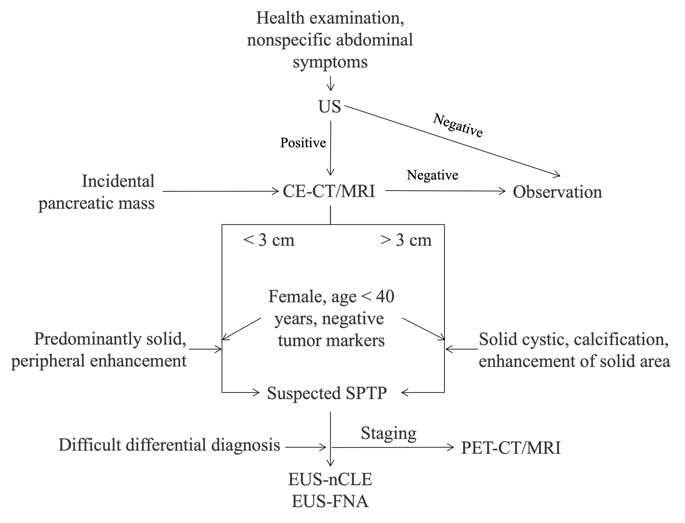
Figure 1 Diagnosis algorithm for solid pseudopapillary tumor of the pancreas. US: Ultrasound; CE-CT: Contrast enhanced computed tomography; MRI: Magnetic resonance imaging; SPTP: Solid pseudopapillary tumor of the pancreas; EUS-FNA: Endoscopic ultrasound guided fine-needle aspiration; EUS-nCLE: Endoscopic ultrasound guided needle-based confocal laser endomicroscopy; PET-CT: Positron emission tomography-computed tomography; PET-MRI: Positron emission tomography-magnetic resonance imaging.

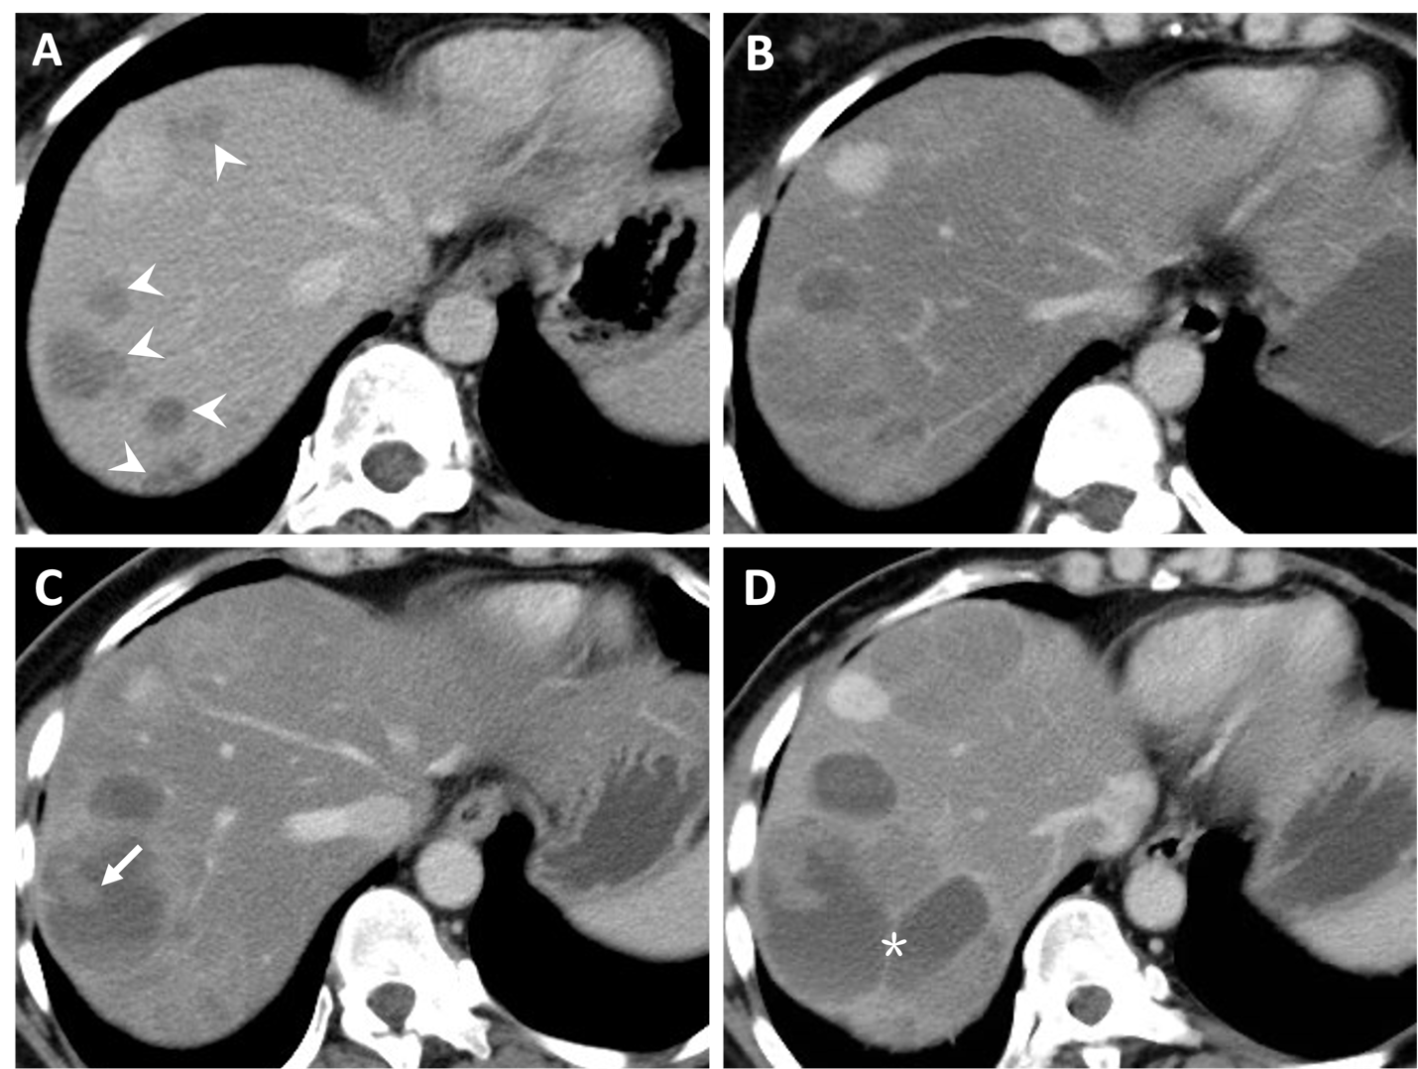
Figure 2 Natural history (classical type) of liver metastasis from solid pseudopapillary tumor of the pancreas. A and B: Multiple liver metastases (A, arrowheads) were detected 38 months after surgery. Five months later, the lesions increased in size gradually (B); C and D: Cystic change of the lesion with solid component (C, arrow) was shown after 10 months. Seventeen months later, the lesions continued increasing with septum-like structure detected (D, asterisk).

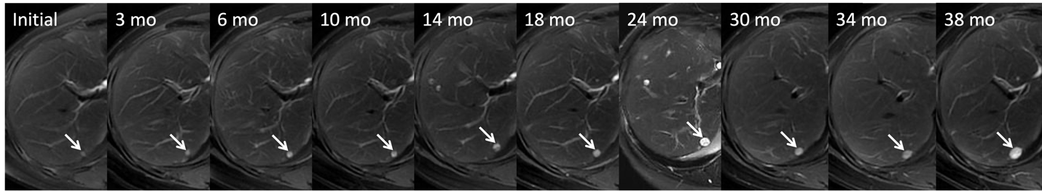
Figure 3 Indolent type of liver metastasis from solid pseudopapillary tumor of the pancreas. A 46-year-old woman, who had a history of surgery for malignant solid pseudopapillary tumor of the pancreas with Ki-67 of 1%, received serial magnetic resonance imaging scans as surveillance. T2WI showed a new-onset homogeneous high signal nodule in the liver segment 7 (arrows). During the 3-year follow-up, the lesion grew slightly.

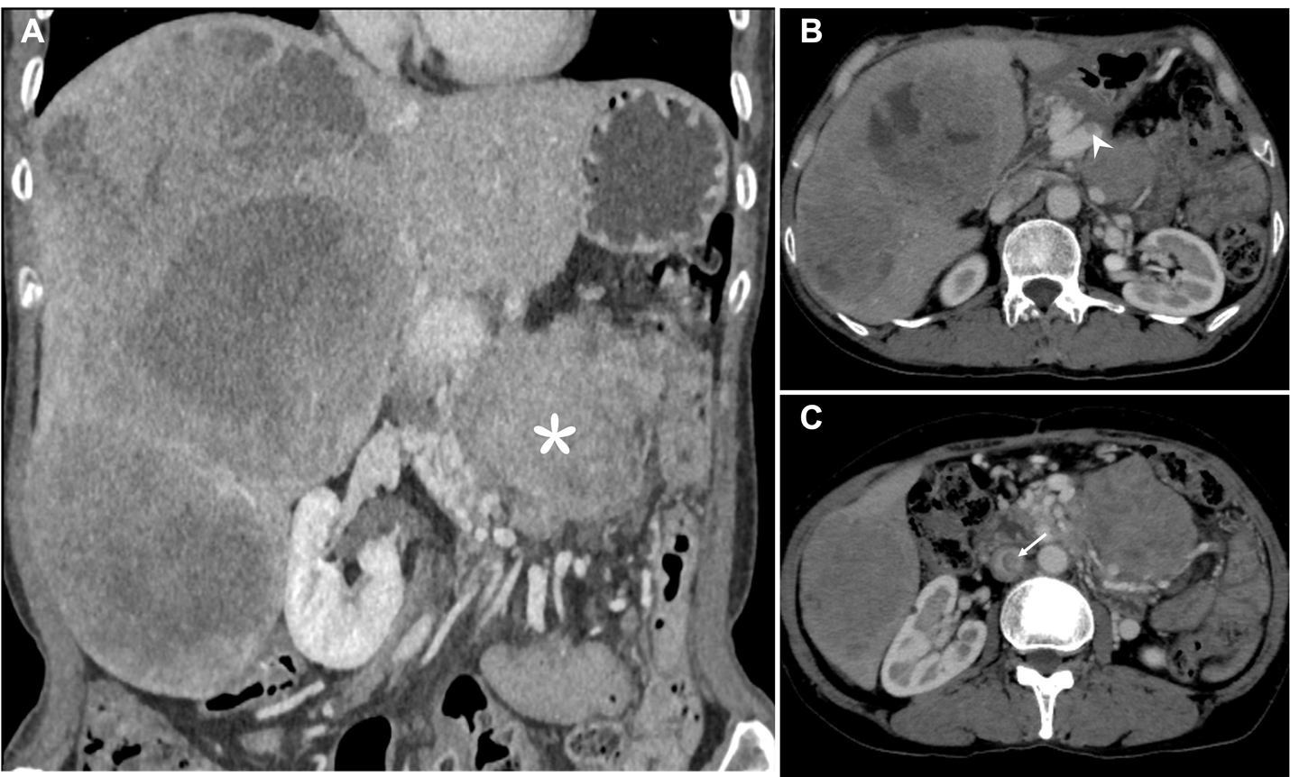
Figure 4 Aggressive type of liver metastasis from solid pseudopapillary tumor of the pancreas. A 55-year-old woman, who underwent surgery for solid pseudopapillary tumor of the pancreas 6 years ago, presented with incidental detection of abdominal masses after abdominal blunt trauma due to an accidental fall. Computed tomography scan showed multiple heterogeneously enhancing masses with extensive central necrosis fused in the right liver, with a size of 26 cm × 17 cm. A-C: A retroperitoneal mass (A, asterisk) invading the superior mesenteric vein (SMV) was detected, with presence of collateral circulation, and tumor thrombi filling the SMV (B, arrowheads) and inferior vena cava (C, arrow).

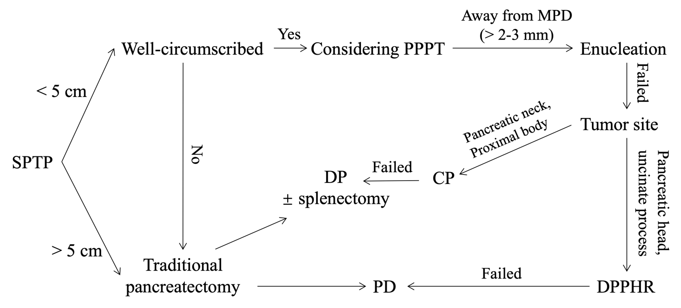
Figure 5 The algorithm for surgical treatment of solid pseudopapillary tumor of the pancreas. SPTP: Solid pseudopapillary tumor of the pancreas; PPPT: Parenchyma-preserving pancreatectomy; MPD: Main pancreatic duct; CP: Central pancreatectomy; DP: Distal pancreatectomy; PD: Pancreaticoduodenectomy; DPPHR: Duodenal-preserving pancreatic head resection.

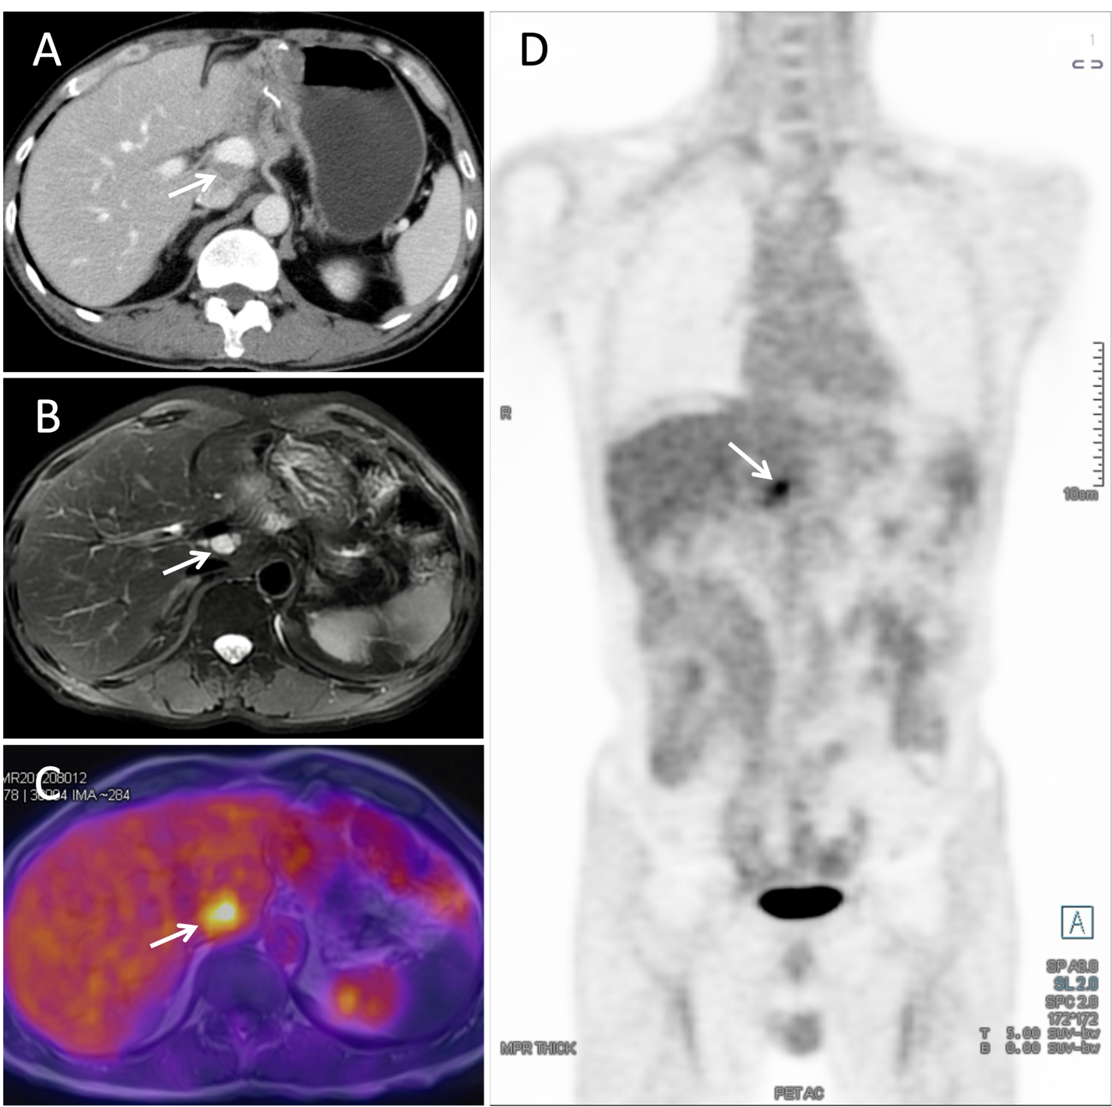
Figure 6 Detection of recurrence in solid pseudopapillary tumor of the pancreas. A: Abdominal enhanced computed tomography scan revealed a hypodense mass between the portal vein and inferior vena cava; B: T2WI magnetic resonance imaging (MRI) demonstrated a high signal mass located at the hepatic hilum; C and D: Axial-fused (C) and coronal-fused (D) positron emission tomography/MRI showed that the lesion had increased fluorodeoxyglucose uptake.

Table 1 Pancreatic cyst fluid analysis based on endoscopic ultrasound-fine needle aspiration
Type | SCN | MCN | IPMN | SPTP | Pseudocyst
Viscosity | Low | High | High | NA | Low
Mucin | Low | High | High | NA | Low
Amylase | < 250 U/L | < 250 U/L | High | Low | High
Cytology | Negative or Glyogen containing cuboid cells | Mucin containing column cells | Papillary clusters of mucin column cells, atypia | Branching papillae cuboid or cylindric cells, high cellularity, myxoid stroma | Dirty material, macrophages, inflammatory cell
NGS | VHL; chr3 LOH | CEA | KRAS; GNAS; TP53; PTEN; CEA | CTNNB1 | NA
SCN: Serous cystadenoma; MCN: Mucinous cystadenoma; IPMN: Intraductal papillary mucinous neoplasm; SPTP: Solid pseudopapillary tumor of the pancreas; NGS: Next-generation sequencing; LOH: Loss of heterozygosity; CEA: Carcinoembryonic antigen; NA: Not available.

Table 2 Markers for diagnosing solid pseudopapillary tumor of the pancreas on immunohistochemistry analysis
Markers | Positive rate | Mechanisms/implications
β-catenin^{[26,65]} | almost 100% (nuclear) | Activating the Wnt-signaling pathway
CD200^{[73]} | 100% (focal) | Marker of stem cell status
CD10^{[65,66,74]} | 100% | Marker of SPTP; expressed in immature lymphocyte
CD56^{[66]} | 100% | Marker of SPTP
AMACR^{[75]} | 96.2% | Marker of SPTP
LEF1^{[18]} | 94.7% | Regulating the Wnt-signaling pathway
TFE3^{[76]} | 94.7% | Activating and regulating the Wnt-signaling pathway
CD99^{[77]} | 78.4% (paranuclear dot-like) | Differentiating from PNET
E-cadherin^{[65,78]} | 0% | Differentiating from PNET
CgA^{[26]} | 0% | Differentiating from PNET
Trypsin^{[26,79]} | 0% | Differentiating from ACC
BCL10^{[26,79]} | 0% | Differentiating from ACC
Ki-67^{[31,80]} | Mostly 1-2% | Predicting prognosis
CD: Cluster of differentiation; PNET: Pancreatic neuroendocrine tumor; SPTP: Solid pseudopapillary tumor of the pancreas; LEF1: Lymphoid enhancer-binding factor 1; TFE3: Transcription factor E3; AMACR: α-methylacyl-CoA racemase; CgA: Chromogranin A; ACC: Acinar cell carcinoma; BCL10: B-cell lymphoma-10.

Table 3 Differential diagnosis of solid pseudopapillary tumor of the pancreas
Disease | Female | Age (yr) | Marker | Clinicopathological features
SPTP | 90% | 20-40 | β-catenin | Well-circumscribed; < 3 cm: Mainly solid; > 3 cm: Solid-cystic; myxoid stroma enveloping fibrovascular cores; discohesive epithelioid cells
Non-functional PNET | 50% | 50-60 | CgA | Solid: Obviously enhanced with capsule ring-like enhancement; solid-cystic: Mural nodule, uneven wall; high rate of G2 and G3
ACC | < 50% | 60 | AFP | Enhanced solid with large mass having hypodense areas; heterogeneous enhancement; full of large polygonal cells with background necrosis, zymogen-rich and granular cytoplasm, cherry-red nucleoli
SCN | 75% | 55-70 | NA | Honeycomb appearance, central scar; stellate scar in the center of the cyst cavity; clear serous fluid
MCN | > 95% | 40-60 | NA | Mucin secretion; disconnection from pancreatic duct; ovarian-like stroma; intracellular mucin
IPMN | 50% | 60-80 | NA | Communication with pancreatic duct; absence of ovarian-like stroma; mucin
Pseudocyst | ≤ 25% | Any | NA | History of pancreatitis or pancreatic trauma; high amylase in pancreatic juice
PBL | NA | < 10 | AFP | Hypodense mass; central mass; squamous nest; well-defined margin; heterogeneous; enhanced; circumscribed, plump spindly cell whorls with squamous morules
SPTP: Solid pseudopapillary tumor of the pancreas; PNET: Pancreatic neuroendocrine tumor; CgA: Chromogranin A; ACC: Acinar cell carcinoma; AFP: Alpha-fetoprotein; SCN: Serous cystic neoplasms; MCN: Mucinous cystic neoplasms; IPMN: Intraductal papillary mucinous neoplasms; PBL: Pancreatoblastoma; NA: Not available.

Table 4 Reported parenchyma-preserving pancreatectomy for solid pseudopapillary tumor of the pancreas
Ref. | Country | F/M | Median/mean age (yr) | Surgery type | Median/mean follow-up (mo, range) | R/M
Li et al^{[100]} | China | 129/37 | 32.5 (10-68) | 11 EN, 22 CP | 49 (24-102) | 2
Wang et al^{[103]} | China | 84/17 | 31.7 (10-65) | 31 EN | 46.1 (12-101) | 0
Tjaden et al^{[101]} | Germany | 44/8 | 29 (8-71) | 4 EN, 5 CP | 54 (2-230) | 2
Cho et al^{[102]} | Korea | 56/10 | 14.5 ± 5.8 | 15 EN, 4 CP | 24.9 (10-76) | 1
Gao et al^{[99]} | China | 49/13 | 31.76 ± 10.19 | 15 EN, 47 CP | 31 (3-69) | 0
Chen et al^{[104]} | China | 8/2 | 44.6 (32-57) | 10 CP | 22.9 (3-48) | 0
Guo et al^{[11]} | China | 71/16 | 31.3 ± 13.1 | 6 EN, 4 CP | 46 (13-97) | 0
Wang et al^{[13]} | China | 85/12 | 31.6 ± 13.92 | 15 EN, 20 CP, 2 DPPHR | 54 (7-121) | 0
F: Female; M: Male; EN: Enucleation; CP: Central pancreatectomy; R/M: Recurrence/metastasis; LR: Local resection; DPPHR: Duodenal-preserving pancreatic head resection.

Table 5 Current models to predict the risk of recurrence of solid pseudopapillary tumor of the pancreas
 | Tumor size | Ki-67 index | LVI (extratumoral) | Classification
Fudan Prognostic Index^{[8]} | ≤ 10 cm | < 3% | - | Low risk
 | > 10 cm | < 3% | - | Intermediate risk
 | Any | 3-20% | -
 | Any | > 20% | - | High risk
PUMCH risk model^{[9]} | ≤ 9 cm | ≤ 1% | Negative | Low risk
 | > 9 cm | Any | Any | High risk
 | Any | > 1% | Any
 | Any | Any | Positive
LVI: Lymphovascular invasion; PUMCH: Peking Union Medical College Hospital.

