Name of Journal: World Journal of Gastroenterology
ESPS Manuscript NO: 32354
Manuscript Type: ORIGINAL ARTICLE

Retrospective Study
Ling classification describes the progressive process of achalasia under endoscopy and successful peroral endoscopy myotomy seems to have the ability to prevent endoscopic progression of achalasia

Zhang WG et al. Ling classification describes achalasia progressive process

Wen-Gang Zhang, En-Qiang Linghu, Ning-Li Chai, Hui-Kai Li

Wen-Gang Zhang, En-Qiang Linghu, Ning-Li Chai, Hui-Kai Li, Department of Gastroenterology, PLA General Hospital, Beijing 100853, China

Author contributions: Zhang WG analyzed the data and wrote the manuscript. Chai NL acquired the data; Linghu EQ and Li HK made a classification for all the achalasia patients in the present study according to Ling classification.

Institutional review board statement: The study was carried out under the ethics committee approval from the Chinese PLA General Hospital (Beijing China).

Informed consent statement: Informed consent was waived due to the retrospective nature of this study.

Conflict-of-interest statement: We declare that we have no financial and personal relationships with other people or organizations that can inappropriately influence our work.

Data sharing statement: No additional data was available.

Open-Access: This article is an open-access article which was selected by an in-house editor and fully peer-reviewed by external reviewers. It is distributed in accordance with the Creative Commons Attribution Non Commercial (CC BY-NC 4.0) license, which permits others to distribute, remix, adapt, build upon this work non-commercially, and license their derivative works on different terms, provided the original work is properly cited and the use is non-commercial. See: http://creativecommons.org/licenses/by-nc/4.0/

Manuscript source: Unsolicited manuscript

Correspondence to: En-Qiang Linghu, MD, Department of Gastroenterology, PLA General Hospital, No. 28, Fuxing Road, Haidian District, Beijing 100853, China. linghuenqiang@vip.sina.com
Telephone: +86-13501233558
Fax: +86-10-66937485

Received: January 4, 2017
Peer-review started: January 5, 2017
First decision: January 19, 2017
Revised: February 1, 2017
Accepted: March 30, 2017
Article in press:
Published online:

Abstract
AIM
To verify the hypothesis that the Ling classification describes the progressive process of achalasia under endoscopy and determine the ability of successful peroral endoscopic myotomy (POEM) to prevent endoscopic progression of achalasia.

METHODS
We retrospectively reviewed the endoscopic findings, symptom duration, and manometric data in patients with achalasia. A total of 359 patients (197 women, 162 men) with a mean age of 42.1 years (range, 12-75 years) were evaluated. Symptom duration ranged from 2 to 360 months, with a median of 36 months. Patients were classified as type Ling I (n = 119), Ling IIa (n = 106), Ling IIb (n = 60), Ling IIc (n = 60), or Ling III (n = 14), according to the Ling classification. Of the 359 patients, 349 underwent POEM, among whom, 21 had an endoscopic follow-up after more than two years. Pre-treatment and post-treatment Ling classifications of these 21 patients were compared.

RESULTS
Symptom duration increased significantly for every increase in Ling classification (from I to III) (p < 0.05), whereas lower esophageal sphincter pressure decreased for every increase in Ling type (from I to III) (p < 0.05). There were no differences in sex ratio and onset age among the Ling types, although the age at time of diagnosis was higher in Ling type IIc and Ling type III than those in Ling types I, IIa, and IIb. Of the 21 patients, 19 had HRM both before and after treatment. The mean preoperative and postoperative LESP’s were 34.6 (range, 15.3-59.4) and 15.0 (range, 2.1-21.6), respectively, indicating a statistically significant decrease after POEM. All of the 21 patients were treated successfully by POEM (post-operative Eckardt score ≤ 3) and remained the same Ling type during a mean 37.8 mo (range, 24-51 mo) follow-up.
Conclusion
The Ling classification represents the progressive process of achalasia under endoscopy and may be able to serve as endoscopically-assessed criteria for achalasia. Successful POEM (Eckardt score ≤ 3) seems to have the ability to prevent endoscopic evolvement of achalasia, However, confirmatory studies with larger populations are warranted.

Key words: Ling classification; Achalasia; Peroral endoscopic myotomy; progression; Endoscopy

© The Author(s) 2017. Published by Baishideng Publishing Group Inc. All rights reserved.

Core tip: Achalasia is a progressive disease, as verified by manometric and radiographic findings. Thus, we speculated this progressive process could be visualized under endoscopy. We have proposed the Ling classification for achalasia on the basis of the morphological severity of esophagus under endoscopy. This study supports the hypothesis that the Ling classification portrays the progressive process of achalasia. Preliminarily evidence suggests that successful peroral endoscopic myotomy (POEM) has the ability to prevent endoscopic progression of achalasia. Moreover, this study suggests that the Ling classification may serve as criteria for endoscopic assessment for achalasia and will be useful for long-term endoscopic follow-up of post-POEM achalasia.

Zhang WG, Linghu EQ, Chai NL, Li HK. Ling classification describes the progressive process of achalasia under endoscopy and successful peroral endoscopy myotomy seems to have the ability to prevent endoscopic progression of achalasia. World J Gastroenterol 2017; In press

INTRODUCTION
Achalasia is a rare esophageal motility disorder characterized by symptoms of dysphagia, regurgitation, weight loss, and chest pain^{[1,2]}. Achalasia is a progressive disease, as demonstrated by manometric and radiographic findings^{[3]}. Thus, it can be inferred that there is also a progressive process of achalasia under endoscopy. Dr. En-Qiang Linghu has proposed the Ling classification for achalasia based on the morphological severity of the esophagus under endoscopy. We hypothesized that the Ling classification could be used to describe the progressive process of achalasia under endoscopy.
Peroral endoscopic myotomy (POEM) has been shown to be an effective and safe procedure for achalasia and is quickly becoming one of the first-line therapies of achalasia^{[4-6]}. However, it remains unclear whether this procedure can prevent endoscopic progression of achalasia. Criteria to assess long-term endoscopic follow-up of post-POEM achalasia is still lacking. The present study aimed to verify the hypothesis that the Ling classification depicts the progressive process of achalasia under endoscopy and to determine the ability of successful POEM to prevent the endoscopic evolvement of achalasia.

MATERIALS AND METHODS
Patients
A total of 359 patients (197 women and 162 men) with a mean age of 42.1 years (range, 12-75 years) were evaluated. High-resolution manometry (HRM), endoscopy, and barium swallow were performed to confirm the diagnosis of achalasia. The duration of symptoms ranged from 2 to 360 mo, with a median of 36 months. Patients were classified as Ling type I, Ling type IIa, Ling type IIb, Ling type IIc, or Ling type III, according to the Ling classification^{[7]}. Duration of symptoms and lower esophageal sphincter pressure (LESP) were compared among the five Ling types. Of the 359 patients, 349 underwent POEM, among whom, 21 had an endoscopic follow-up after more than two years. Pre-treatment and post-treatment Ling types of the 21 patients with long-term follow-up were compared.

Ling classification
Dr. Linghu proposed the Ling classification in 2011 and published it in 2013^{[7]}. The Ling classification includes three types: type I, smooth without multi-ring, crescent-like structure or diverticulum structure; type II, with multi-ring or crescent-like structure but without diverticulum structure; and type III, with diverticulum structure. Type II was further classified into three subtypes: Ling IIa, Ling IIb and Ling IIc. The criteria for classifying subtypes of Ling type II were as follows: Ling IIa, with multi-ring structure; Ling IIb, with crescent-like structure and the midpoint of its inner edge not larger than 1/3 of the esophageal lumen; Ling IIc, with crescent-like structure and the midpoint of its inner edge over 1/3 of the esophageal lumen (Figure 1). The endoscopy reports of all 359 patients were collected and classified according to the diagnostic information by two endoscopists (Li HK and Linghu EQ), according to the criteria mentioned above. Of note, both endoscopists were blinded to the other data collected from each patient.

Duration of symptoms
The duration of symptoms for each of the 359 patients was collected from outpatient records. The definition used for the appearance of symptoms was dysphagia or chest pain for greater than or equal to 4 days of the week. All patients had been inquired case history based on the definition mentioned above.

HRM
HRM was performed using the following protocol: a 36-channel, solid-state catheter system with high-fidelity circumferential sensors at 1-cm intervals (Manosacn; Sierra Scientific Instruments Inc, LosAngeles, CA, United States) was advanced through the nasal canal. Studies were performed with patients in a supine position after at least a 6-h fast. Pressure data of 10 wet swallows was recorded and analyzed using a dedicated computerized analysis system.

POEM procedure and follow-up
During the procedure, patients were kept in the supine position with the right shoulder elevated. General anesthesia was administered while the patient’s respirations, blood pressure, oxygen saturation, and electrocardiogram were monitored. An additional cap attached at the top of the endoscope was required. Then, POEM was performed as follows. First, a submucosal injection of methylene blue saline solution (1:10000) was administered, and a mucosal incision was made at the right posterior esophageal wall, approximately 6-10 cm from the gastroesophageal junction (GEJ). Then, a submucosal tunnel was established, passing over the GEJ and about 2-3 cm into the proximal stomach. Myotomy started at 2 cm distal to the incision and extended 2-3 cm into the stomach. After complete hemostasis and ensuring that an endoscope could easily pass the cardia of the stomach, the mucosal incision was sutured with approximately 5 hemostatic clips.
Patients were scheduled for a follow-up visit at 3 months, 6 months, and 1 year postoperatively, and yearly afterwards. Endoscopy, HRM, and 24-h esophageal pH monitoring was required at each follow-up.

Statistical analysis
All statistical analyses were performed using SPSS software version 17.0. Variables are expressed as mean or median. The Kruskal-Wallis test or single factor analysis of variance were used to compare the onset age, age at time of diagnosis, duration of symptoms, and LESP among the five Ling types. Chi-squared test was used to compare the sex ratio among the five Ling types. All reported p-values are two-tailed; p-values of < 0.05 were considered statistically significant.

RESULTS
As shown in Table 1, a total of 359 patients (197 women and 162 men) with a mean age of 42.1 years (range, 12-75 years) were evaluated. The duration of symptoms ranged from 2 to 360 months, with a median of 36 months. Of the 359 patients, 119 were classified as Ling I, 106 as Ling IIa, 60 as Ling IIb, 60 as Ling IIc, and 14 as Ling III.
The duration of symptoms increased significantly at every type when the Ling classification increased (from I to III) (p < 0.05), as shown in Figure 2. LESP decreased with increasing Ling classification (from I to III) (p < 0.05) as shown in Figure 3. There were no differences in sex ratio and onset age among the Ling types, although the age at time of diagnosis was higher in Ling type IIc and Ling type III than those in Ling types I, IIa, and IIb (Table 2).
Of the 359 patients, 349 underwent POEM, among whom, 21 had an endoscopic follow-up of longer than two years. The demographics and treatment outcomes of the 21 patients (9 women, 12 men) with a post-POEM follow-up of more than 2 years are shown in Table 3. Of the 21 patients, 8 were classified as Ling type I preoperatively, 7 as Ling type IIa, 5 as Ling type IIb, and 1 as Ling type III. Of the 21 patients, 19 had HRM both before and after treatment. The mean preoperative and postoperative LESP’s were 34.6 (range, 15.3-59.4) and 15.0 (range, 2.1-21.6), respectively, indicating a statistically significant decrease after POEM. All of the 21 patients were treated successfully by POEM (post-operative Eckardt score ≤ 3) and remained the same Ling type during a mean 37.8 mo (range, 24-51 mo) follow-up.

DISCUSSION
Achalasia is a progressive disorder as measured by manometric and radiographic findings^{[3]}. Thus, there should exist a progressive process of achalasia as visualized with endoscopy. We have previously proposed the Ling classification for achalasia based on the morphological severity of the esophagus under endoscopy^{[7]}. Therefore, we hypothesized that the Ling classification can be used to assess the progressive process of achalasia under endoscopy. The present study supports this hypothesis by comparing the duration of symptoms and LESP among the different Ling types.
Shiino et al^{[3]} published a study in which patients with achalasia were divided into four groups according to the duration of symptoms: patients with symptoms for less than 5 years, patients with 5 to 10 years of symptoms, patients with 10 to 15 years of symptoms, and patients with symptoms for 15 years or longer. This study found that the tortuosity of the esophagus, as measured by the maximal angle of the esophageal axis on radiography, was significantly greater in patients with a longer duration of symptoms (p < 0.02). Henderson^{[8]} classified achalasia into three stages according to the degree of esophageal dilatation on x-ray. Stage 1 is a diameter less than 4 cm, stage 2 is 4-6 cm, and stage 3 is greater than 6 cm. A greater degree of esophageal dilation was shown to be related to a duration of symptoms. The present study found that duration of symptoms increased significantly for every type using the Ling classification (from I to III) (p < 0.05). Given that morphological severity of the esophagus increases from Ling type I to Ling type III, the results of the present study are compatible with both Yutaka’s and Henderson’s studies. However, while these previous studies were based on radiography, the present study was able to evaluate the progressive process of achalasia under endoscopy and therefore direct visualization.
LESP decreased with increasing Ling classification (from I to III) (p < 0.05). Shiino et al^{[3]} reported that the LESP decreased as the duration of symptoms increased, although the results were not significant. Given that the present study confirmed the association between longer duration of symptoms and increasing Ling classification (from I to III) (p < 0.05), the results of the present study and Yutaka’s support each other. However, evaluation of the association between decreasing LESP with increasing symptom duration still requires a further prospective study to confirm.
POEM was first reported as a treatment for achalasia in 2010^{[9]} and has developed rapidly since then. Despite the evidence that POEM is effective and safe, it still remains unclear whether the esophageal morphology of achalasia patients changes postoperatively. In the present study, a total of 21 patients had an endoscopic follow-up more than two years after POEM. All 21 patients had their achalasia successfully treated (Eckardt score ≤ 3) and remained the same Ling type throughout a mean 37.8 mo (range, 24-51 mo) follow-up, suggesting that POEM may prevent the endoscopic progression of achalasia. However, the sample size (21 patients) included in our analysis was relatively small because most of the 349 patients who underwent POEM in our hospital did not undergo endoscopic follow-up beyond two years postoperatively. Thus, a prospective study with a larger sample is required to further draw conclusions based on the results above. Another limitation is there is a lack of criteria to assess endoscopic follow-up of post-POEM achalasia. Furthermore, given that POEM has been utilized for only 6 years, the long-term (≥ 7 years) efficacy, especially in regards to esophageal morphology changes, remain uncertain. The Ling classification may be a good choice of criteria to endoscopically assess post-POEM achalasia.
Performing POEM for advanced achalasia, such as Ling types IIc-III or sigmoid-type achalasia, is more challenging. Thus, those with achalasia should undergo POEM soon after diagnosis because of the progressive nature of the disease, which has been confirmed in the previous and the present studies^{[3]}.
One limitation to our study was the retrospective nature of our methods; however, the Ling classification, duration of symptoms, and LESP were recorded prospectively. Another limitation was that only 21 patients had an endoscopic follow-up after more than two years. To the best of our knowledge, this was the first study reporting the long-term postoperative esophageal morphology changes under endoscopy in patients with achalasia.
In conclusion, the Ling classification captures the progressive process of achalasia under endoscopy and might be able to serve as criteria to assess achalasia endoscopically. Successful POEM may prevent the endoscopic evolvement of achalasia. However, future longitudinal studies with larger samples are warranted.

COMMENTS
Background
It has been proved that achalasia is a progressive disease, as verified by manometric and radiographic findings. Based on this knowledge, it could be speculated that there also was a progressive process of achalasia under endoscopy.

Research frontiers
The authors have proposed the Ling classification for achalasia in 2011, based on the morphological severity of esophagus under endoscopy. Therefore, they speculated that ling classification represents the progressive process of achalasia under endoscopy.

Innovations and breakthrough
The authors confirmed that the Ling classification describes the progressive process of achalasia under endoscopy. Moreover, to the best of our knowledge, this was the first study reporting the long-term postoperative esophageal morphology changes under endoscopy in patients with achalasia.

Applications
After being confirmed the ability to represent the progressive process of achalasia under endoscopy, Ling classification might be able to serve as criteria to assess achalasia endoscopically.

Terminology
Ling classification - A endoscopic classification for achalasia, based on the morphological severity of esophagus, was proposed by Professor Linghu in 2011. POEM - Peroral endoscopic myotomy, a recently developed endoscopic therapeutic technique, was performed for achalasia. peroral endoscopic myotomy.
Peer-review
The present manuscript is related to Ling classification and the progressive process of achalasia under endoscopy. Besides, the treatment-success POEM seems to have the ability to prevent the endoscopic evolvement of achalasia. The manuscript demonstrated that the Ling classification does work.

REFERENCES
1 Richter JE. Oesophageal motility disorders. Lancet 2001; 358: 823-828 [PMID: 11564508 DOI: 10.1016/s0140-6736(01)05973-6]
2 Boeckxstaens GE, Zaninotto G, Richter JE. Achalasia. Lancet 2014; 383: 83-93 [PMID: 23871090 DOI: 10.1016/s0140-6736(13)60651-0]
3 Shiino Y, Houghton SG, Filipi CJ, Awad ZT, Tomonaga T, Marsh RE. Manometric and radiographic verification of esophageal body decompensation for patients with achalasia. J Am Coll Surg 1999; 189: 158-163 [PMID: 10437837]
4 Familiari P, Gigante G, Marchese M, Boskoski I, Tringali A, Perri V, Costamagna G. Peroral Endoscopic Myotomy for Esophageal Achalasia: Outcomes of the First 100 Patients With Short-term Follow-up. Ann Surg 2016; 263: 82-87 [PMID: 25361224 DOI: 10.1097/sla.0000000000000992]
5 Shiwaku H, Inoue H, Yamashita K, Ohmiya T, Beppu R, Nakashima R, Takeno S, Sasaki T, Nimura S, Yamashita Y. Peroral endoscopic myotomy for esophageal achalasia: outcomes of the first over 100 patients with short-term follow-up. Surg Endosc 2016; 30: 4817-4826 [PMID: 26932548 DOI: 10.1007/s00464-016-4813-1]
6 Von Renteln D, Fuchs KH, Fockens P, Bauerfeind P, Vassiliou MC, Werner YB, Fried G, Breithaupt W, Heinrich H, Bredenoord AJ, Kersten JF, Verlaan T, Trevisonno M, Rösch T. Peroral endoscopic myotomy for the treatment of achalasia: an international prospective multicenter study. Gastroenterology 2013; 145: 309-311.e1-3 [PMID: 23665071 DOI: 10.1053/j.gastro.2013.04.057]
7 Li HK, Linghu EQ. New endoscopic classification of achalasia for selection of candidates for peroral endoscopic myotomy. World J Gastroenterol 2013; 19: 556-560 [PMID: 23382636 DOI: 10.3748/wjg.v19.i4.556]
8 Henderson RD. Esophageal motor disorders. Surg Clin North Am 1987; 67: 455-474 [PMID: 3109043]
9 Inoue H, Minami H, Kobayashi Y, Sato Y, Kaga M, Suzuki M, Satodate H, Odaka N, Itoh H, Kudo S. Peroral endoscopic myotomy (POEM) for esophageal achalasia. Endoscopy 2010; 42: 265-271 [PMID: 20354937 DOI: 10.1055/s-0029-1244080]
P-Reviewer: Chow WK, Lee CL S-Editor: Gong ZM
L-Editor: E-Editor:
Specialty type: Gastroenterology and hepatology
Country of origin: China
Peer-review report classification
Grade A (Excellent): A
Grade B (Very good): 0
Grade C (Good): C
Grade D (Fair): 0
Grade E (Poor): 0

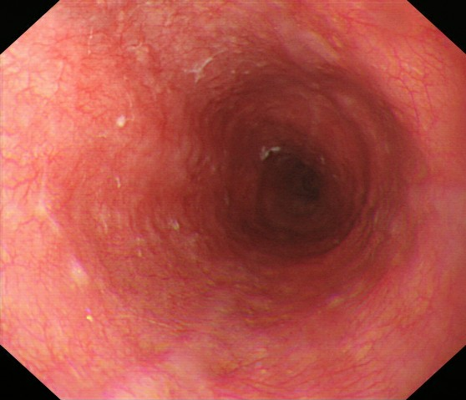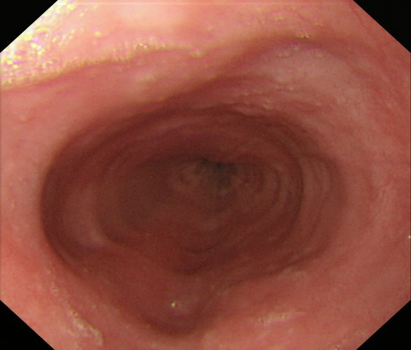
B
A
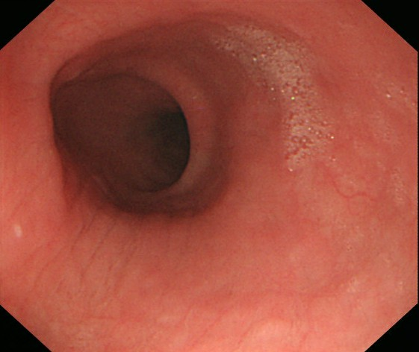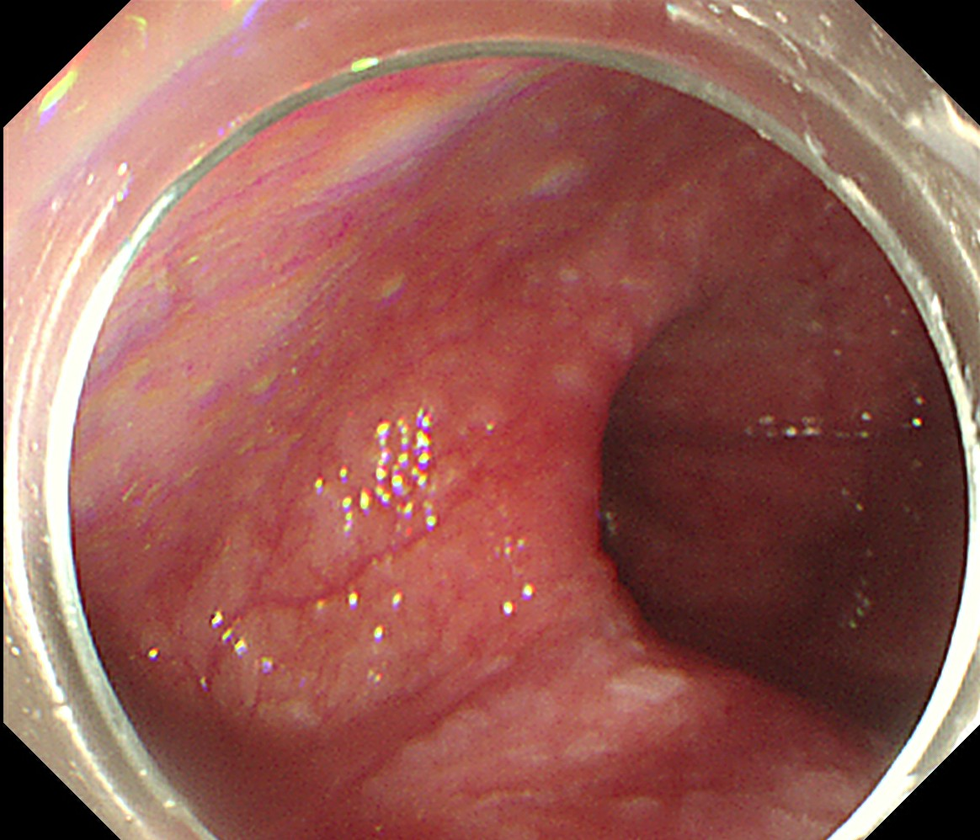
D
C
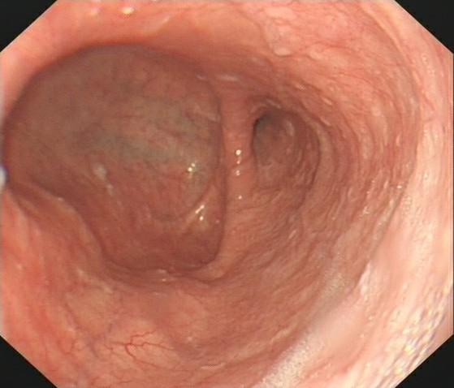
E
Figure 1 Typical pictures of Ling classification. A: Ling I; B: Ling IIa; C: Ling IIb; D: Ling IIc; E: Ling III.
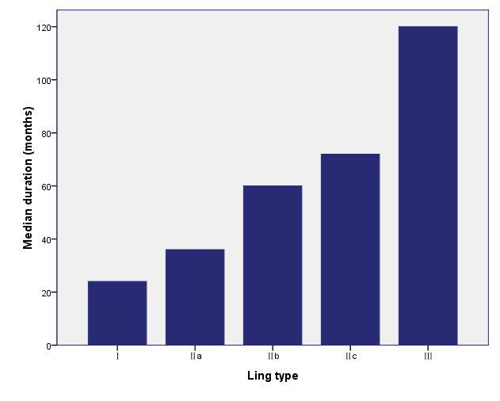
Figure 2 Symptom duration increased significantly when the Ling classification increased (from I to III) (p < 0.05).

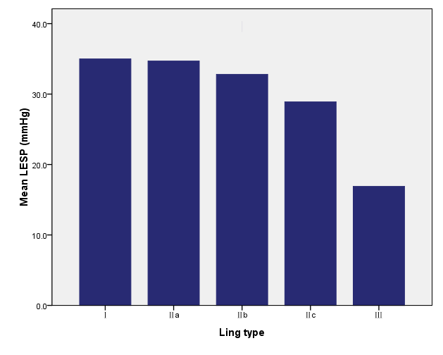
Figure 3 Lower esophageal sphincter pressure decreased when the Ling classification increased (from I to III) (p < 0.05). LESP: Lower esophageal sphincter pressure.

characteristics | value
Sex, female/male (n) | 197/162
Age (yr), mean (range) | 42.1 (12-75)
Duration of symptoms (mo), median (range) | 36 (2-260)
Lower esophageal sphincter pressure (mmHg), mean (range) | 33.0 (0.7-72.4)
Ling classification
Ling type I | 119 (33.1)
Ling type IIa | 106 (29.5)
Ling type IIb | 60 (16.7)
Ling type IIc | 60 (16.7)
Ling type III | 14 (3.9)
Table 1 Demographic characteristics of patients presenting with achalasia n (%)

Ling type | I | IIa | IIb | IIc | III | p value
n | 119 | 106 | 60 | 60 | 14
Onset age (yr), mean | 35.3 | 38.9 | 36.1 | 36.4 | 32.9 | > 0.05
Age at time of diagnosis (yr), mean | 38.5 | 42.8 | 43.8 | 46.4 | 45.4 | < 0.05
Sex (female/male) | 65/54 | 60/46 | 32/28 | 35/25 | 5/9 | > 0.05
Duration (months), median | 24 | 36 | 60 | 72 | 120 | < 0.05
LESP (mmHg), mean | 35.0 | 34.7 | 32.8 | 28.9 | 16.9 | < 0.05
Table 2 Comparison of symptom duration, lower esophageal sphincter pressure, and dysphagia score among Ling classifications
LESP: Lower esophageal sphincter pressure.

characteristics | value
Sex, female/male (n) | 9/12
Age (yr), mean (range) | 43.8 (16-62)
Duration of symptoms (mo), median (range) | 36 (6-120)
Endoscopic follow-up (mo), mean (range) | 37.8 (24-51)
Manometry follow-up rate | 19 (90.5)
Lower esophageal sphincter pressure (mmHg), mean (range)
Pre-treatment | 34.6 (15.3-59.4)
Post-treatment | 15.0 (2.1-21.6)
Ling classification
Ling type I | 8 (38.1)
Ling type IIa | 7 (33.3)
Ling type IIb | 5 (23.8)
Ling type IIc | 0 (0)
Ling type III | 1 (4.8)
Treatment success rate (Eckardt score ≤ 3) | 21 (100)
Table 3 Demographics and treatment outcomes of the 21 patients with a post-peroral endoscopic myotomy follow-up of more than 2 years n (%)

