Name of Journal: World Journal of Pharmacology
Manuscript NO: 87821
Manuscript Type: ORIGINAL ARTICLE

Basic Study
Natural isothiocyanates of the genus Capparis as potential agonists of apoptosis and antitumor drugs

Hanuš L et al. Natural isothiocyanates

Lumír Hanuš, Tuvia Naor, Tatyana Gloriozova, Valery M Dembitsky

Lumír Hanuš, Institute for Drug Research, School of Pharmacy, Faculty of Medicine, Hebrew University, Ein Kerem Campus, Jerusalem 91120, Israel

Tuvia Naor, Food Chemistry, Kibbutz, Yotvata 8882000, Israel

Tatyana Gloriozova, Department of Bioinformatics, Institute of Biomedical Chemistry, Moscow 119121, Russia

Valery M Dembitsky, Centre for Applied Research and Innovation, Lethbridge College, Lethbridge AB T1K 1L6, Canada

Co-corresponding authors: Lumír Hanuš and Valery M Dembitsky.

Author contributions: Hanuš L carried out the extraction and analysis of volatile components of yellow and green fruits, seeds, and jam from the scrambling shrub Capparis cartilaginea; Naor T grew the material and provided it for analysis; Gloriozova T determined the biological activity of volatile components; Dembitsky VM prepared the article for publication and also wrote and reviewed this article; and all authors read and approved the final version of the manuscript. In addition, the co-corresponding authors contributed equally to the accompanying manuscript, such as describing the methods, their application to the analysis, and writing the discussion.

Corresponding author: Lumír Hanuš, Institute for Drug Research, School of Pharmacy, Faculty of Medicine, Hebrew University, Ein Kerem Campus, Jerusalem 91120, Israel. lumirh@ekmd.huji.ac.il

Received: August 28, 2023
Revised: October 12, 2023
Accepted: November 24, 2023
Published online: December 22, 2023

Abstract
BACKGROUND
Using gas chromatography-mass spectrometry (GC/MS) analysis, we examined the composition of volatile components present in the yellow and green fruits, seeds, and jam of the scrambling shrub Capparis cartilaginea (C. cartilaginea). These plant samples were collected from Kibbutz Yotvata in Israel. In all the tested samples, isothiocyanates were identified. Utilizing the PASS program, we ascertained the biological activity of these isothiocyanates present in the Capparis genus. The study results highlighted that all isothiocyanates could potentially act as apoptosis agonists, making them strong candidates for antitumor drugs. This information holds significant value for the fields of medicinal chemistry, pharmacology, and practical medicine.

AIM
To investigate the volatile components present in the yellow and green fruits, seeds, and jam of the C. cartilaginea shrub using GC/MS analysis, to detect isothiocyanates in all the analyzed plant samples, and to assess the biological activity of these isothiocyanates utilizing the PASS program.

METHODS
We utilized two primary methods to analyze the volatile compounds present in the yellow and green fruits, seeds, and jams of the C. cartilaginea, native to Israel. We identified biologically active isothiocyanates in these samples. Their anticipated biological activities were determined using the PASS program, with the most dominant activities being apoptosis agonist, anticarcinogenic, and antineoplastic specifically for genitourinary cancer.

RESULTS
Fruits, seeds, and jams containing isothiocyanates, which exhibit antineoplastic and anticarcinogenic activities, could be suggested for cancer prevention and management. Specific isothiocyanates, with therapeutic potential in this realm, could be recommended as potent anticancer agents in practical medicine following clinical trials.

CONCLUSION
The discovery that isothiocyanates exhibit potent antineoplastic and anticarcinogenic activities was unexpected. Additionally, certain isothiocyanates demonstrated antifungal, antiviral (specifically against arbovirus), and antiparasitic properties.

Key Words: Capparis cartilaginea; Fruits; Seeds; Isothiocyanates; Apoptosis; Anticancer

©The Author(s) 2023. Published by Baishideng Publishing Group Inc. All rights reserved.

Citation: Hanuš L, Naor T, Gloriozova T, Dembitsky VM. Natural isothiocyanates of the genus Capparis as potential agonists of apoptosis and antitumor drugs. World J Pharmacol 2023; 12(4): 35-52
URL: https://www.wjgnet.com/2220-3192/full/v12/i4/35.htm
DOI: https://dx.doi.org/10.5497/wjp.v12.i4.35

Core Tip: Using gas chromatography-mass spectrometry analysis, we examined the composition of volatile components present in the yellow and green fruits, seeds, and jam of the scrambling shrub Capparis cartilaginea. Fruits, seeds, and jams containing isothiocyanates, which exhibit antineoplastic and anticarcinogenic activities, could be suggested for cancer prevention and management. Specific isothiocyanates, with therapeutic potential in this realm, could be recommended as potent anticancer agents in practical medicine following clinical trials.

INTRODUCTION
The genus Capparis, part of the Capparidaceae family, comprises approximately 250 species^{[1-3]}. The Cartilage caper is notably prevalent across tropical and subtropical regions in Asia, America, and Africa^{[4-6]}. Recent findings suggest that the genus Capparis encompasses about 400 compounds, including glycosides, glucosinolates, flavonoids, terpenoids, tannins, steroids, and isothiocyanates^{[7,8]}. There is substantial evidence indicating the therapeutic potential of these phytochemicals in treating and preventing various ailments such as inflammation, cancer, bacterial infections, ulcers, and diabetes^{[9-11]}.
This study explored the volatile compounds present in the yellow and green fruits, seeds, and jam of Capparis cartilaginea (C. cartilaginea), a species native to Israel. Furthermore, we were keen to examine the distribution of isothiocyanates in the essential oils of the Capparis genus from various global regions. Included is a table detailing the isothiocyanates identified within the Capparis genus, along with their anticipated biological activities as determined using the PASS software.

MATERIALS AND METHODS
Plant materials and extraction
The scrambling shrub C. cartilaginea, grown in Kibbutz Yotvata in Israel, was the source of the yellow and green fruits (Figure 1) harvested in 2019 for component analysis. The aromatic, juicy pulp of the fruit was available at the Kibbutz store, labeled as “Jam of Tuvia Naor”. Samples were taken from shrubs reaching heights of up to 3 meters. The fruit is globose-ellipsoid in shape, with a reddish hue, measuring (3-6) cm × (1.6-4) cm. Fresh biological materials underwent head space and solid phase microextraction gas chromatography-mass spectrometry (GC-MS) analysis, following the methods that we have previously detailed^{[12-14]}.

General experimental procedures
For the GC/MS analysis, we employed an Agilent 7890B GC combined with an Agilent 5977B MSD and a PAL 3 (RSI 85) chromatograph. The columns used were HP-5MS UI, 30 m × 0.25 mm with a film thickness of 0.25 μm, provided by Agilent Technologies, Inc. The analytical conditions were set with the column initially held at 35 °C for 5 min. Subsequently, the temperature was programmed to rise from 35 °C to 150 °C at a rate of 5 °C/min, then increasing by 15 °C/min to 250 °C, with a hold time of 90 min. The specific settings were as follows: Inlet temperature at 250 °C, detector temperature at 280 °C, split injection ratio of 1:5, initial temperature at 100 °C, and initial time set to 4.0 min. Helium was used as the carrier gas with a flow rate of 1 mL/min.
For compound detection and identification, we referenced various standards, retention times, and retention indices (Table 1). Additionally, we consulted multiple libraries: NIST/EPA/NIH Mass Spectral Library 2017, Wiley Registry of Mass Spectral Data 11th Edition, FFNSC3, © 2015, and the Adams EO library, Mass Spectral Library, containing 2205 compounds. In total, 58 volatile compounds were detected, with 42 of them being positively identified. This identification was based on a comparison of their mass spectra and retention times, along with their Kovats retention indices, either to those of injected standards or by referencing the National Institute of Standards and Technology’s Mass Spectral Library database.

Comparison of biological activities of natural isothiocyanates
The principle that the chemical structure of natural or synthetic molecules dictates their biological activity has been recognized for over 150 years and is referred to as structure-activity relationships (SAR). This concept was first introduced by Brown and Fraser^{[15]} in 1868. However, according to alternate sources^{[16]}, the SAR notion was earlier employed in the realm of toxicology. In this context, Cros determined the correlation between the toxicity of primary aliphatic alcohols and their water solubility as early as 1863.
In this particular study, we sourced PASS predictions for approximately 28 isothiocyanates derived from various plants. These PASS estimates are represented as Pa values. Each Pa value signifies the likelihood of a compound being categorized under “actives” for a given predicted biological activity. A higher Pa value denotes greater confidence in the anticipated biological activity^{[17,18]}.

RESULTS
Various components from leaves, buds, stems, aerial parts, and seeds of different plant species within the Capparis genus have been documented in the literature. Yet, no literature data was found pertaining to the study of yellow and green fruits or jam derived from C. cartilaginea. Based on our GC/MS findings, the primary constituents of the yellow fruits were identified as 2-butyl isothiocyanate (49.43%) and isopropyl isothiocyanate (48.74%), as visualized in the chromatogram (Figure 2A). A similar compositional profile was observed for the green fruits, with the dominant components being 2-butyl isothiocyanate (49.76%) and isopropyl isothiocyanate (46.68%), as shown in Table 2 and illustrated in the chromatogram (Figures 2B and 3).
The GC/MS analysis of the seeds from C. cartilaginea revealed dimethylsulfide as the predominant component, constituting 55.82%, while the content of 2-butyl isothiocyanate was notably lower at just 6.8%. These findings can be referenced in Table 3 and visualized in the chromatogram (Figure 2C). Furthermore, the GC/MS analysis of jam derived from C. cartilaginea indicated that its primary components were hexanedioic acid bis(2-ethylhexyl) ester at 61.99%, limonene (covering both isomers) at 8.51%, dimethyl sulfide at 3.85%, 2-butyl isothiocyanate at 3.29%, dodecanoic acid 1-methylethyl ester at 2.16%, and pentanoic acid, 2-ethylhexyl ester at 2.01% (Figures 2D and Table 4). The molecular structures of these identified compounds are depicted in Figure 4. Tuvia Naor jam consists of the fruits of C. cartilaginea (or Capparis inermis, or a synonym for Capparis sinaica). Homemade jam Tuvia capparis Jam from the fruits of C. cartilaginea contains 36% fruit, sugar, apple, lemon, and flavors.

DISCUSSION
The experimental data reveals that all parts of plants from the Capparis genus contain isothiocyanates in varying concentrations. It was intriguing to discern which specific isothiocyanates were present in this genus. This curiosity stems from the fact that isothiocyanates are invaluable plant metabolites known for their broad spectrum of biological activities. Notably, certain isothiocyanates are incorporated into Tibetan and Chinese medicinal practices^{[19-21]}. These naturally occurring molecules originate from glucosinolate precursors found in cruciferous vegetables^{[19,22-25]}.
Tables 5 and 6 provide a quantitative breakdown of the distribution of isothiocyanates across different plant species within the Capparis genus, collected from various global regions. While many articles discuss isothiocyanates, not all provide specific percentages, hence we have refrained from citing such articles. The molecular structures of isothiocyanates extracted from various Capparis species are illustrated in Figure 5.
Isothiocyanates, which originate from glucosinolate precursors in cruciferous plants, are recognized as some of the most potent chemoprophylactic agents. Numerous studies affirm that both natural and synthetic isothiocyanates possess anticarcinogenic properties, as they not only diminish the activation of carcinogens but also augment their detoxification^{[44-48]}. Moreover, they demonstrate antitumor capabilities, influencing a myriad of pathways such as apoptosis, MAPK signaling, oxidative stress, and cell cycle progression^{[47-51]}.
The process through which natural isothiocyanates are formed via the hydrolysis of glucosinolates, facilitated by the enzyme β-thioglucosidase (known as myrosinase), is depicted in Figure 6. This biosynthetic mechanism is well-established, with isothiocyanates being identified in both plants and fungi^{[52-54]}. Utilizing the PASS computer program, we computed the activity of natural isothiocyanates extracted from plants within the Capparis genus. The ensuing data is outlined in Table 7. As the table reveals, the primary properties pertaining to biological activity encompass apoptosis agonist, chemoprotective, chemosensitizer, and antineoplastic functions.
Benzyl isothiocyanate (9) has been extracted from Capparis spinosa (C. spinosa) components. Traditionally, fresh parts of this plant, particularly the flower buds, have been consumed as accompaniments to olives, cheese, and nuts. This plant stands out as one of the most cherished aromatic varieties native to the Mediterranean region. The fermentation of different parts of C. spinosa not only renders the capers consumable but also shapes their distinct taste, along with their organoleptic and nutritional attributes^{[54]}. The biological activity of benzyl isothiocyanate is depicted in a 3D graph, as illustrated in Figures 7 and 8A.
Advanced ovarian cancer cannot be cured by surgery alone; chemotherapy is vital for its treatment. While isothiocyanates have been shown to inhibit carcinogen-induced tumorigenesis in animal models, their therapeutic potential in advanced ovarian cancer remains unexplored. Kalkunte et al^{[55]} demonstrated that benzyl isothiocyanate, commonly found in cruciferous vegetables like broccoli, cabbage, and watercress, suppresses the proliferation of advanced ovarian cancer cells and triggers apoptosis. Preliminary studies indicate its potential in both preventing and treating various cancers. Given this evidence, more research is essential to confirm its efficacy in humans and to advance its potential as a prophylactic or therapeutic agent, maximizing therapeutic outcomes while minimizing toxicity in cancer treatments^{[47]}.
In our study, we examined the volatile components of yellow and green fruits from the scrambling shrub C. cartilaginea. Additionally, we delved into the composition of seeds and jam derived from C. cartilaginea using GC/MS analysis. We detected isothiocyanates in all plant samples studied. This research presents a comprehensive overview of isothiocyanates identified in the Capparis genus, gathered from various global regions. Through the PASS program, we ascertained the biological activities of these isothiocyanates. Our findings revealed that these compounds are promising apoptosis agonists with potential as potent antitumor agents. Furthermore, we identified additional biological activities. The insights provided in this study hold substantial practical relevance and could pave the way for medical applications. The term “chemoprotective” refers to the properties of a substance that helps protect cells and tissues from the toxic effects of chemicals or against the DNA damage that can lead to cancer. In other words, chemoprotective agents help prevent or reduce the risk of chemically induced diseases, including various forms of cancer. Chemoprotective properties can arise from a variety of mechanisms: (1) Antioxidant activity: Many chemoprotective agents can neutralize free radicals, reducing oxidative stress, which can cause DNA damage and potentially lead to cancer; (2) Detoxification: Certain substances can enhance the body’s detoxification processes, helping to remove or neutralize potential carcinogens before they can cause harm; (3) Enhancement of DNA repair: Some agents can boost the mechanisms that repair damaged DNA; (4) Inhibition of carcinogen activation: Some chemicals need to be activated in the body to become carcinogenic. Chemoprotective agents can inhibit the enzymes responsible for this activation; (5) Suppression of carcinogen binding to DNA: By preventing carcinogens from binding to DNA, chemoprotective agents can reduce the risk of mutations that might lead to cancer; and (6) Inhibition of tumor growth: Some agents can slow or stop the growth of tumors by affecting cell cycle progression, inducing apoptosis (programmed cell death) or suppressing the blood supply to tumors (anti-angiogenesis).
Natural foods, especially fruits, vegetables, and spices, are rich sources of chemoprotective compounds. Examples include the isothiocyanates from cruciferous vegetables, polyphenols from green tea, curcumin from turmeric, and resveratrol from grapes, among many others. In the context of cancer, chemoprotection can also refer to strategies or agents used to protect normal tissues from the harmful side effects of chemotherapy while allowing the drugs to act on cancer cells.
Ethyl-(2), allyl-(14), and 3-methyl-3-butenyl-isothiocyanates (17) exhibited a pronounced apoptosis agonist activity, with confidence levels exceeding 95%. The associated 3D graph (Figure 8B) visually represents their activities. Another visual representation can be observed in Figure 8C, where three specific isothiocyanates stand out due to their robust anti-Helicobacter pylori activity, which exhibits over 80% confidence. Among these, anticancer properties are the most prominent.
Furthermore, isothiocyanates labeled as 26, 27, and 28 provide compelling data, as illustrated in Figure 8D. Not only do these compounds demonstrate potent apoptosis agonist activity, surpassing 93% confidence, but they also show promise in treating periodontitis with a confidence level exceeding 70%.
“Anti-Helicobacter pylori activity” refers to the ability of a substance to inhibit or eradicate Helicobacter pylori bacteria. Helicobacter pylori is a type of bacteria that can infect the stomach and is known to be a main cause of peptic ulcers, and its persistent infection has also been linked to stomach cancer. Therefore, substances with anti-Helicobacter pylori activity may help in preventing or treating these conditions.
Substances with anti-Helicobacter pylori activity might function through various mechanisms, such as: (1) Inhibiting the growth or reproduction of the bacteria; (2) Killing the bacteria directly; and (3) Disrupting the mechanisms by which the bacteria cause disease (for instance, by neutralizing toxins produced by the bacteria).
Anti-Helicobacter pylori activity can be exhibited by antibiotics, as well as various other natural and synthetic compounds, and is an area of interest in pharmacology and medicinal chemistry due to the importance of managing infections by this bacterium. Research into substances with anti-Helicobacter pylori activity may yield new treatments for infections and possibly for preventing stomach ulcers and cancer.
Periodontitis refers to a serious gum infection that damages the soft tissue and destroys the bone that supports your teeth. It can lead to tooth loss or worse, if not treated. Periodontitis is common but largely preventable. It is usually the result of poor oral hygiene. Key points about periodontitis include: (1) Cause: It is primarily caused by bacteria that adhere to and grow on the tooth’s surfaces, along with an aggressive immune response against these bacteria; (2) Symptoms: Red or swollen gums, tender or bleeding gums, painful chewing, loose teeth, sensitive teeth, bad breath that does not go away, and receding gums or longer appearing teeth; (3) Risk factors: Periodontitis can be influenced by several factors including poor oral hygiene, tobacco use, diabetes, age, genetics, certain medications, and other conditions like decreased immunity; (4) Complications: If left untreated, periodontitis can result in tooth loss. It can also increase the risk of stroke, heart attack, and other health problems; and (5) Treatment: Treatment usually involves good dental hygiene practices, scaling, and root planning (deep cleaning) to remove the plaque and tartar, and in more severe cases, surgical treatments. Regular dental checkups and good oral hygiene can help prevent periodontal disease.

CONCLUSION
In our study, we examined the volatile components of yellow and green fruits from the scrambling shrub C. cartilaginea. Additionally, we delved into the composition of seeds and jam derived from C. cartilaginea using GC/MS analysis. We detected isothiocyanates in all plant samples studied. This research presents a comprehensive overview of isothiocyanates identified in the Capparis genus, gathered from various global regions. Through the PASS program, we ascertained the biological activities of these isothiocyanates. Our findings revealed that these compounds are promising apoptosis agonists with potential as potent antitumor agents. Furthermore, we identified additional biological activities. The insights provided in this study hold substantial practical relevance and could pave the way for medical applications.

ARTICLE HIGHLIGHTS
Research background
In the realm of medicinal chemistry, isothiocyanates are characterized by the -N=C=S functional group, which results from substituting the oxygen atom in the isocyanate group with sulfur. These compounds are predominantly found in plants and arise from the enzymatic conversion of metabolites, specifically glucosinolates. Notably, numerous plant-derived isothiocyanates have demonstrated anticarcinogenic properties. Their mechanism of action involves inhibiting the activation of carcinogens and bolstering their detoxification processes.

Research motivation
Our motivation to undertake this study stemmed from the noticeable lack of extensive literature regarding isothiocyanates in food sources. While some health research has touched upon the use of isothiocyanates, comprehensive investigations into their potential benefits remain limited. Consequently, we embarked on an in-depth in silico study of isothiocyanates to assess their preliminary therapeutic properties.

Research objectives
To investigate the composition of fruits, seeds, and jam derived from the scrambling shrub Capparis cartilaginea (C. cartilaginea) utilizing gas chromatography-mass spectrometry (GC-MS) analysis, and to conduct an in silico examination of the biological activity associated with the isolated isothiocyanates.

Research methods
For our investigation, we employed the following methods: GC/MS analysis: This technique allowed us to accurately identify and quantify the volatile components present in the samples from the scrambling shrub C. cartilaginea; PASS computer program: We utilized the PASS software, which boasts a comprehensive database of over one million natural and synthetic compounds, paired with more than 10000 documented biological activities. As per data from its official website, this German-developed program is a popular tool among the scientific community, with over 26000 researchers from 34 different countries using it on an annual basis.

Research results
Our investigation revealed that isothiocyanates exhibit a significant anticancer potential. Additionally, these compounds display other potential biological activities, including antiviral, antibacterial, and antifungal properties.

Research conclusions
The findings from our investigation are promising. We identified the presence of isothiocyanates in jams, seeds, and fruits, which demonstrated potential anti-cancer properties. Nevertheless, further in vitro and in vivo studies are essential to validate these preliminary results.

Research perspectives
Moving forward, the intention is to conduct more in-depth GC/MS and PASS in silico analyses on individual isothiocyanates extracted from jams, seeds, and fruits of the Capparis genus. This will provide a clearer understanding of the properties and potential therapeutic applications of these compounds.

REFERENCES
1 Shahrajabian MH, Sun W, Cheng Q. Plant of the Millennium, Caper (Capparis spinosa L.), chemical composition and medicinal uses. Bull Natl Res Cent 2012; 45: 131-142 [DOI: 10.1186/s42269-021-00592-0]
2 Tlili N, Elfalleh W, Saadaoui E, Khaldi A, Triki S, Nasri N. The caper (Capparis L.): ethnopharmacology, phytochemical and pharmacological properties. Fitoterapia 2011; 82: 93-101 [PMID: 20851750 DOI: 10.1016/j.fitote.2010.09.006]
3 Mohammad SM, Kashani HH, Azarbad Z. Capparis spinosa L. propagation and medicinal uses. Life Sci J 2012; 9: 684-686
4 Jacobs M. The genus Capparis (Capparaceae) from the Indus to the Pacific. Blumea: Biodiversity, Evolution and Biogeography of Plants 1964; 12: 385-541
5 Cornejo X. New combinations in South American Capparaceae. Harvard Papers in Botany 2008; 13: 117-120 [DOI: 10.3100/1043-4534(2008)13[117:NCISAC]2.0.CO;2]
6 Ge SX, Hu SJ, Shi HL, Han FY, Li MJ, Ren LL. The first record of the genus Belenois (Lepidoptera: Pieridae) from China. Biodivers Data J 2021; 9: e61332 [PMID: 33519265 DOI: 10.3897/BDJ.9.e61332]
7 Nabavi SF, Maggi F, Daglia M, Habtemariam S, Rastrelli L, Nabavi SM. Pharmacological Effects of Capparis spinosa L. Phytother Res 2016; 30: 1733-1744 [PMID: 27406313 DOI: 10.1002/ptr.5684]
8 Annaz H, Sane Y, Bitchagno GTM, Ben Bakrim W, Drissi B, Mahdi I, El Bouhssini M, Sobeh M. Caper (Capparis spinosa L.): An Updated Review on Its Phytochemistry, Nutritional Value, Traditional Uses, and Therapeutic Potential. Front Pharmacol 2022; 13: 878749 [PMID: 35935860 DOI: 10.3389/fphar.2022.878749]
9 Kdimy A, El Yadini M, Guaadaoui A, Bourais I, El Hajjaji S, Le HV. Phytochemistry, Biological Activities, Therapeutic Potential, and Socio-Economic Value of the Caper Bush (Capparis Spinosa L.). Chem Biodivers 2022; 19: e202200300 [PMID: 36064949 DOI: 10.1002/cbdv.202200300]
10 Omara T, Kagoya S, Openy A, Omute T, Ssebulime S, Kiplagat KM, Bongomin O. Antivenin plants used for treatment of snakebites in Uganda: ethnobotanical reports and pharmacological evidences. Trop Med Health 2020; 48: 6 [PMID: 32071543 DOI: 10.1186/s41182-019-0187-0]
11 Kulisic-Bilusic T, Schmöller I, Schnäbele K, Siracusa L, Ruberto G. The anticarcinogenic potential of essential oil and aqueous infusion from caper (Capparis spinosa L.). Food Chem 2012; 132: 261-267 [PMID: 26434289 DOI: 10.1016/j.foodchem.2011.10.074]
12 Abu-Lafi S, Dembicki JW, Goldshlag P, Hanuš LO, Dembitsky VM. The use of the 'Cryogenic' GC/MS and on-column injection for study of organosulfur compounds of the Allium sativum. J Food Comp Anal 2004; 17: 235-245 [DOI: 10.1016/j.jfca.2003.09.002]
13 Dembitsky VM, Goldshlag P, Srebnik M. Occurrence of p-nonylphenol isomers in wild species of Cichorium endivia subsp. divaricatum. J Chem Ecol 2002; 28: 1623-1628 [PMID: 12371814 DOI: 10.1023/A:1019980513949]
14 Dembitsky VM, Abu-Lafi S, Hanuš LO. Occurrence of sulfur-containing fatty acids in Allium sativum. Nat Prod Common 2007; 2: 771-774 [DOI: 10.1177/1934578X0700200713]
15 Brown AC, Fraser TR. The connection of chemical constitution and physiological action. Trans Roy Soc Edinburg 1868; 25: 224-242 [DOI: 10.1017/S0080456800028155]
16 Cros AFA. Action de l'Alcohol Amylique Sur l'Organisme. University of Strasbourg. 1863
17 Dembitsky VM. Microbiological aspects of unique, rare, and unusual fatty acids derived from natural amides and their pharmacological profile. Microbiol Res 2022; 13: 377-417 [DOI: 10.3390/microbiolres13030030]
18 Dembitsky VM. Hydrobiological aspects of fatty acids: Unique, rare, and unusual fatty acids incorporated into linear and cyclic lipopeptides and their biological activity. Hydrobiology 2022; 1: 331-432 [DOI: 10.3390/hydrobiology1030024]
19 Dinkova-Kostova AT, Kostov RV. Glucosinolates and isothiocyanates in health and disease. Trends Mol Med 2012; 18: 337-347 [PMID: 22578879 DOI: 10.1016/j.molmed.2012.04.003]
20 Guerrero-Alonso A, Antunez-Mojica M, Medina-Franco JL. Chemoinformatic Analysis of Isothiocyanates: Their Impact in Nature and Medicine. Mol Inform 2021; 40: e2100172 [PMID: 34363333 DOI: 10.1002/minf.202100172]
21 Palliyaguru DL, Yuan JM, Kensler TW, Fahey JW. Isothiocyanates: Translating the Power of Plants to People. Mol Nutr Food Res 2018; 62: e1700965 [PMID: 29468815 DOI: 10.1002/mnfr.201700965]
22 Vanduchova A, Anzenbacher P, Anzenbacherova E. Isothiocyanate from Broccoli, Sulforaphane, and Its Properties. J Med Food 2019; 22: 121-126 [PMID: 30372361 DOI: 10.1089/jmf.2018.0024]
23 Abbaoui B, Lucas CR, Riedl KM, Clinton SK, Mortazavi A. Cruciferous Vegetables, Isothiocyanates, and Bladder Cancer Prevention. Mol Nutr Food Res 2018; 62: e1800079 [PMID: 30079608 DOI: 10.1002/mnfr.201800079]
24 Esteve M. Mechanisms Underlying Biological Effects of Cruciferous Glucosinolate-Derived Isothiocyanates/Indoles: A Focus on Metabolic Syndrome. Front Nutr 2020; 7: 111 [PMID: 32984393 DOI: 10.3389/fnut.2020.00111]
25 Kołodziejski D, Koss-Mikołajczyk I, Abdin AY, Jacob C, Bartoszek A. Chemical Aspects of Biological Activity of Isothiocyanates and Indoles, the Products of Glucosinolate Decomposition. Curr Pharm Des 2019; 25: 1717-1728 [PMID: 31267852 DOI: 10.2174/1381612825666190701151644]
26 Gramosa NV, Lemos TLG, Braz-Filho R. Volatile constituents isolated from Capparis flexuosa of Brazil. J Essential Oil Res 1997; 9: 709-712 [DOI: 10.1080/10412905.1997.9700819]
27 Rahnavard R, Razavi N. A review on the medical effects of Capparis spinosa L. Adv Herbal Med 2016; 2: 44-53
28 Al-Shayeb A. Chemical composition of essential oil and crude extract fractions and their antibacterial activities of Capparis spinosa L. and Capparis cartilaginea Decne from Jordan. 2012
29 Bakr RO, EI Bishbishy MH. Profile of bioactive compounds of Capparis spinosa var. aegyptiaca growing in Egypt. Rev Bras Farmacogn 2016; 26: 514-520 [DOI: 10.1016/j.bjp.2016.04.001]
30 Hamed AR, Abdel-Shafeek KA, Abdel-Azim NS, Ismail SI, Hammouda FM. Chemical Investigation of Some Capparis Species Growing in Egypt and their Antioxidant Activity. Evid Based Complement Alternat Med 2007; 4: 25-28 [PMID: 18227928 DOI: 10.1093/ecam/nem110]
31 Alipour F, Nabigol A, Nabizadeh E. Variation in volatile organic compounds in fruits of Iranian Capparis spinosa L. accessions. Saudi J Biol Sci 2021; 28: 4664-4667 [PMID: 34354453 DOI: 10.1016/j.sjbs.2021.04.077]
32 El-Naser Z. Analysis of essential oil of Capparis spinosa L. leaves and interaction between Pieris brassicae L. (Lepidopteran) which attack caper and natural enemy Cotesia glomerata (L.). Int J Chem Tech Res 2016; 9: 477-485
33 Moharram BA, Al-Mahbashi HM, Saif-Ali R, Ali Aqlan F. Phytochemical, anti-inflammatory, antioxidant, cytotoxic and antibacterial study of Capparis cartilaginea Decne fromyemen. Int J Pharm Pharm Sci 2018; 10: 38-44 [DOI: 10.22159/ijpps.2018v10i6.22905]
34 Júnior UL, Ali A, Rehman R, Nisar S. A comprehensive review on phytochemistry and biological activities of Della (Capparis decidua). 2019
35 Grimalt M, Sánchez-Rodríguez L, Hernández F, Legua P, Carbonell-Barrachina AA, Almansa MS, Amorós A. Volatile profile in different aerial parts of two Caper cultivars (Capparis spinosa L.). J Food Quality 2021: 1-9 [DOI: 10.1155/2021/6620776]
36 Alkhaibari AM, Alanazi AD. Chemical Composition and Insecticidal, Antiplasmodial, and Anti-Leishmanial Activity of Capparis spinosa Essential Oil and Its Main Constituents. Evid Based Complement Alternat Med 2022; 2022: 6371274 [PMID: 35154348 DOI: 10.1155/2022/6371274]
37 Mugo NW. Anti-ulcerogenic activity of leaf extract of Capparis cartilaginea Decne on ethanol and indomethacin-induced peptic ulcers in Wistar rats. Jomo Kenyatta University of Agriculture and Technology, Thesis, Juja, Kenya. 2012
38 Rajesh E, Sankari LS, Malathi L, Krupaa JR. Naturally occurring products in cancer therapy. J Pharm Bioallied Sci 2015; 7: S181-S183 [PMID: 26015704 DOI: 10.4103/0975-7406.155895]
39 Iranshahi M. A review of volatile sulfur-containing compounds from terrestrial plants: biosynthesis, distribution and analytical methods. J Essential Oil Res 2012; 24: 393-434 [DOI: 10.1080/10412905.2012.692918]
40 Marcinkowska MA, Jeleń HH. Role of Sulfur Compounds in Vegetable and Mushroom Aroma. Molecules 2022; 27 [PMID: 36144849 DOI: 10.3390/molecules27186116]
41 Lucarini E, Micheli L, Di Cesare Mannelli L, Ghelardini C. Naturally occurring glucosinolates and isothiocyanates as a weapon against chronic pain: potentials and limits. Phytochem Rev 2022; 21: 647-665 [DOI: 10.1007/s11101-022-09809-0]
42 Fahey JW, Zalcmann AT, Talalay P. The chemical diversity and distribution of glucosinolates and isothiocyanates among plants. Phytochemistry 2001; 56: 5-51 [PMID: 11198818 DOI: 10.1016/s0031-9422(00)00316-2]
43 Brown KK, Hampton MB. Biological targets of isothiocyanates. Biochim Biophys Acta 2011; 1810: 888-894 [PMID: 21704127 DOI: 10.1016/j.bbagen.2011.06.004]
44 Traka M, Mithen R. Glucosinolates, isothiocyanates and human health. Phytochem Rev 2009; 8: 269-282 [DOI: 10.1007/s11101-008-9103-7]
45 Wu X, Zhou QH, Xu K. Are isothiocyanates potential anti-cancer drugs? Acta Pharmacol Sin 2009; 30: 501-512 [PMID: 19417730 DOI: 10.1038/aps.2009.50]
46 Mitsiogianni M, Koutsidis G, Mavroudis N, Trafalis DT, Botaitis S, Franco R, Zoumpourlis V, Amery T, Galanis A, Pappa A, Panayiotidis MI. The Role of Isothiocyanates as Cancer Chemo-Preventive, Chemo-Therapeutic and Anti-Melanoma Agents. Antioxidants (Basel) 2019; 8 [PMID: 31003534 DOI: 10.3390/antiox8040106]
47 Dinh TN, Parat MO, Ong YS, Khaw KY. Anticancer activities of dietary benzyl isothiocyanate: A comprehensive review. Pharmacol Res 2021; 169: 105666 [PMID: 33989764 DOI: 10.1016/j.phrs.2021.105666]
48 Coscueta ER, Sousa AS, Reis CA, Pintado MM. Phenylethyl Isothiocyanate: A Bioactive Agent for Gastrointestinal Health. Molecules 2022; 27 [PMID: 35164058 DOI: 10.3390/molecules27030794]
49 Tarar A, Peng S, Cheema S, Peng CA. Anticancer Activity, Mechanism, and Delivery of Allyl Isothiocyanate. Bioengineering (Basel) 2022; 9 [PMID: 36135016 DOI: 10.3390/bioengineering9090470]
50 Kyriakou S, Trafalis DT, Deligiorgi MV, Franco R, Pappa A, Panayiotidis MI. Assessment of Methodological Pipelines for the Determination of Isothiocyanates Derived from Natural Sources. Antioxidants (Basel) 2022; 11 [PMID: 35453327 DOI: 10.3390/antiox11040642]
51 El Omari N, Bakrim S, Bakha M, Lorenzo JM, Rebezov M, Shariati MA, Aboulaghras S, Balahbib A, Khayrullin M, Bouyahya A. Natural Bioactive Compounds Targeting Epigenetic Pathways in Cancer: A Review on Alkaloids, Terpenoids, Quinones, and Isothiocyanates. Nutrients 2021; 13 [PMID: 34835969 DOI: 10.3390/nu13113714]
52 Plaszkó T, Szűcs Z, Vasas G, Gonda S. Effects of Glucosinolate-Derived Isothiocyanates on Fungi: A Comprehensive Review on Direct Effects, Mechanisms, Structure-Activity Relationship Data and Possible Agricultural Applications. J Fungi (Basel) 2021; 7 [PMID: 34356918 DOI: 10.3390/jof7070539]
53 Poveda J, Díaz-González S, Díaz-Urbano M, Velasco P, Sacristán S. Fungal endophytes of Brassicaceae: Molecular interactions and crop benefits. Front Plant Sci 2022; 13: 932288 [PMID: 35991403 DOI: 10.3389/fpls.2022.932288]
54 Sonmezdag AS, Kelebek H, Selli S. Characterization of Aroma-Active Compounds, Phenolics, and Antioxidant Properties in Fresh and Fermented Capers (Capparis spinosa) by GC-MS-Olfactometry and LC-DAD-ESI-MS/MS. J Food Sci 2019; 84: 2449-2457 [PMID: 31476250 DOI: 10.1111/1750-3841.14777]
55 Kalkunte S, Swamy N, Dizon DS, Brard L. Benzyl isothiocyanate (BITC) induces apoptosis in ovarian cancer cells in vitro. J Exp Ther Oncol 2006; 5: 287-300 [PMID: 17024969]

Footnotes
Institutional review board statement: The study was conducted in silico and did not include humans or animals, so a statement from the Institutional Review Board was not necessary.

Conflict-of-interest statement: All the authors report no relevant conflicts of interest for this article.

Data sharing statement: The study was conducted only in a computational environment and the data and three-dimensional structures used are available in public online databases.

Open-Access: This article is an open-access article that was selected by an in-house editor and fully peer-reviewed by external reviewers. It is distributed in accordance with the Creative Commons Attribution Non-Commercial (CC BY-NC 4.0) license, which permits others to distribute, remix, adapt, build upon this work non-commercially, and license their derivative works on different terms, provided the original work is properly cited and the use is non-commercial. See: https://creativecommons.org/Licenses/by-nc/4.0/

Provenance and peer review: Unsolicited article; Externally peer reviewed.
Peer-review model: Single blind

Peer-review started: August 28, 2023
First decision: September 19, 2023
Article in press: November 24, 2023

Specialty type: Pharmacology and pharmacy
Country/Territory of origin: Israel
Peer-review report’s scientific quality classification
Grade A (Excellent): A
Grade B (Very good): 0
Grade C (Good): C
Grade D (Fair): 0
Grade E (Poor): 0

P-Reviewer: Gupta S, Brazil; Zhang J, China S-Editor: Wang JJ L-Editor: Wang TQ P-Editor: Yu HG

Figure Legends
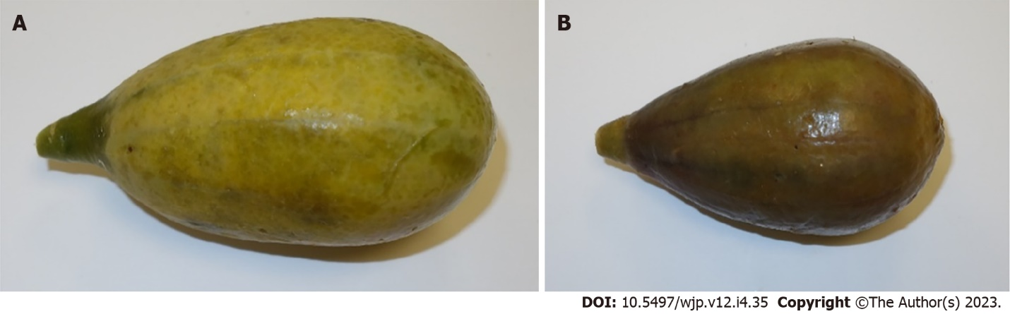
Figure 1 Yellow and green fruits harvested from the scrambling shrub Capparis cartilaginea contain a different set of components. A: Yellow fruit; B: Green fruit.

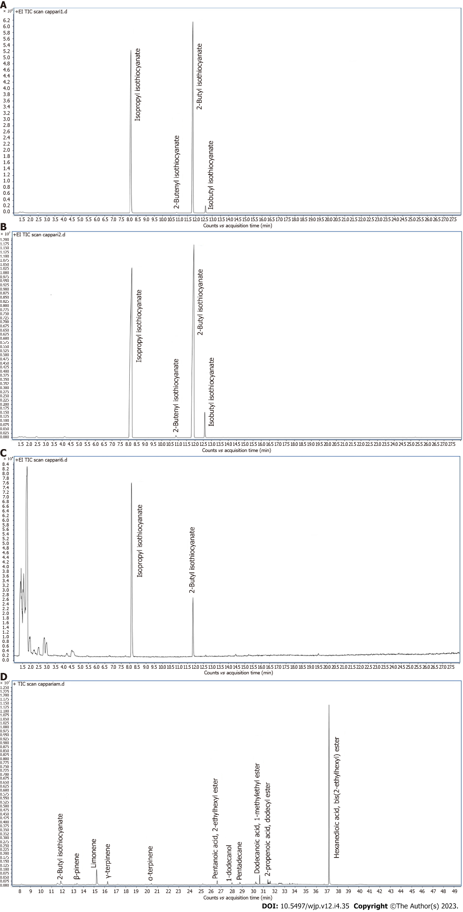
Figure 2 Gas chromatography-mass spectrometry chromatogram of compounds which were identified from yellow and green fruits, seeds, and jam of Capparis cartilaginea. A: Yellow fruits; B: Green fruits; C: Seeds; D: Jam.

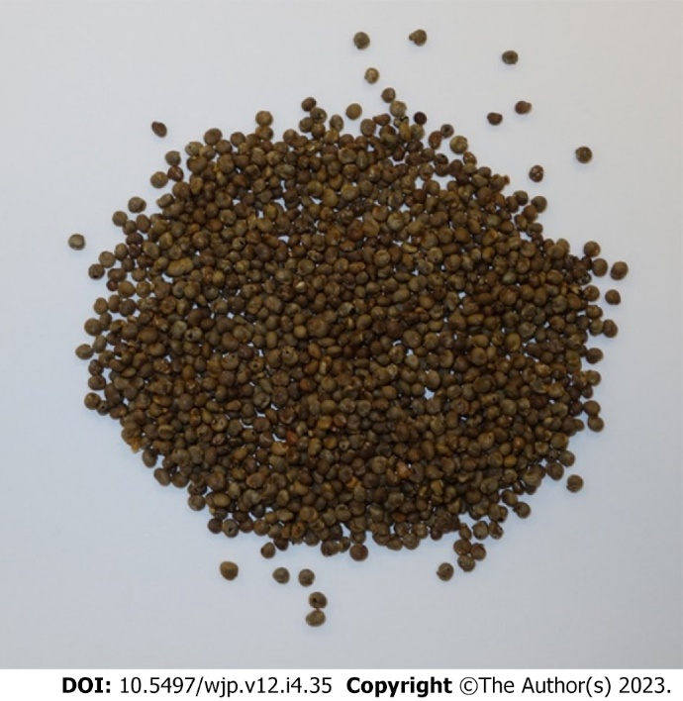
Figure 3 Seeds of the scrambling shrub Capparis cartilaginea.

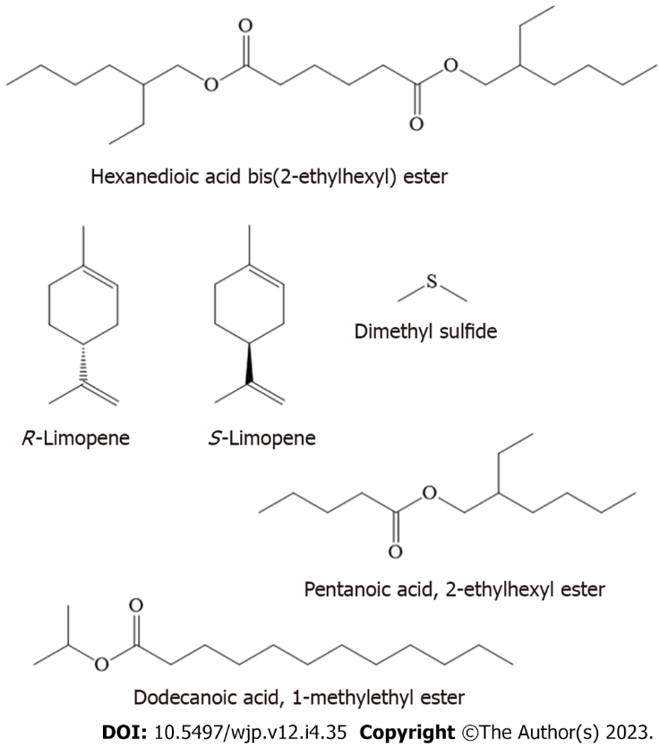
Figure 4 Major metabolites that have been identified in Capparis cartilaginea jam.

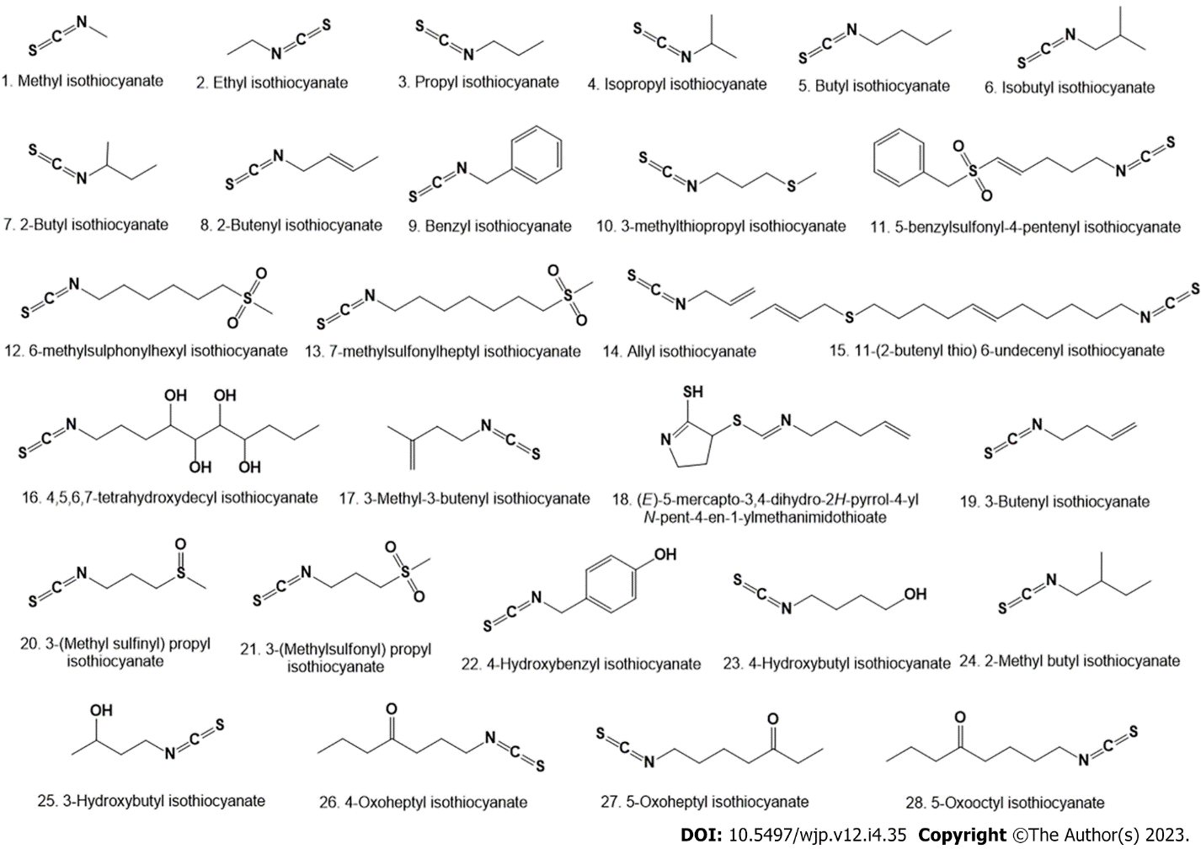
Figure 5 Isothiocyanates found in plant extracts of the genus Capparis. These compounds were identified by gas chromatography-mass spectrometry and other physical-chemical methods^{[26-43]}.

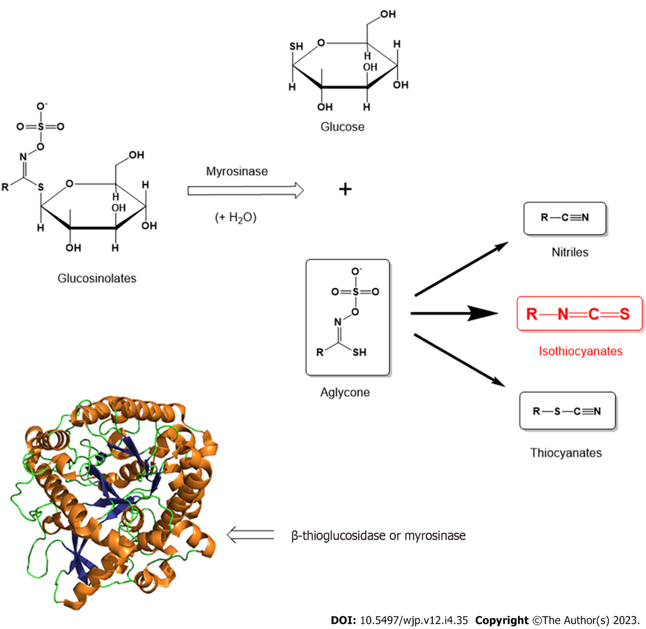
Figure 6 Myrosinase (or β-thioglucosidase) which catalyzes the hydrolysis of glucosinolates to isothiocyanates, thiocyanates, nitriles, and other metabolites.

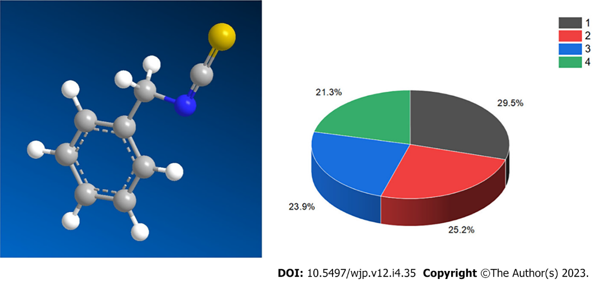
Figure 7 3D model (left) and percentage distribution of the dominant biological activity on the example benzyl isothiocyanate (9), which has a wide range of anticancer properties. Where activities are indicated under the numbers: (1) Apoptosis agonist (29.5%); (2) Antineoplastic (25%); (3) Chemoprotective (23.9%); and (4) Chemosensitizer (21.3%). The nitrogen atom is highlighted in blue, and sulfur atom is highlighted in brown.

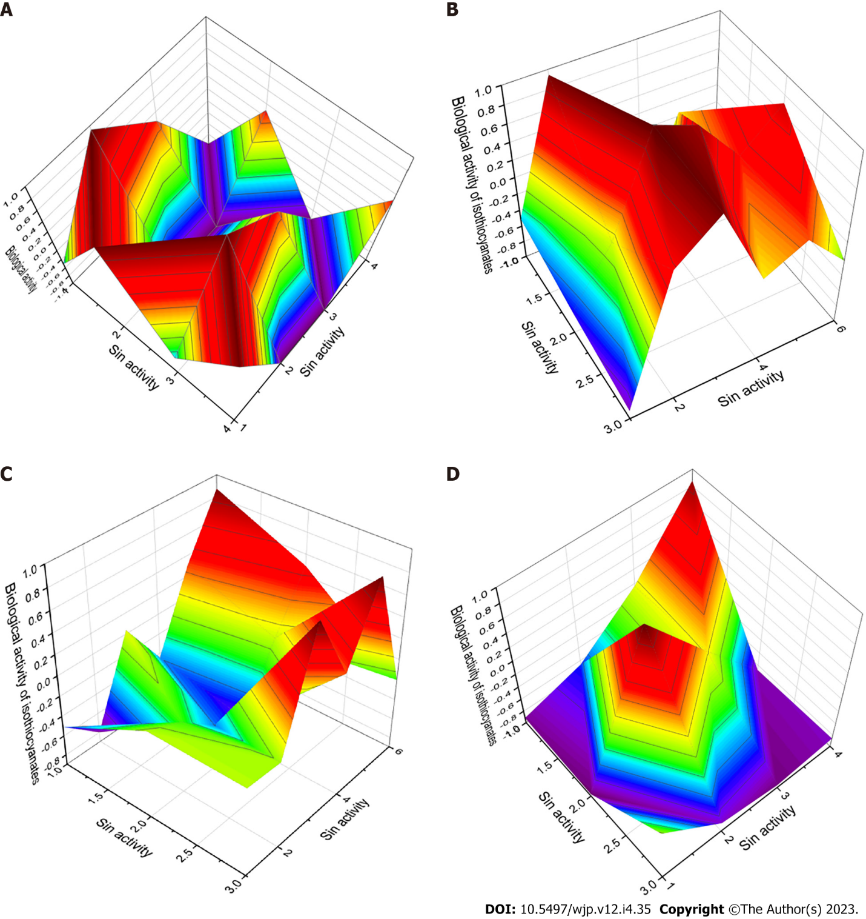
Figure 8 3D graphs. A: 3D graph shows a wide range of biological activities and predicted pharmacological activities of benzyl isothiocyanate (9). This compound is characterized as an agonist of apoptosis. In addition, it exhibits antitumor properties and is an inhibitor of the development of the Gram-negative microaerophilic helical bacterium Helicobacter pylori (H. pylori). The H. pylori infection is known to be an important public health problem worldwide, with a prevalence of 45% to 84%. The H. pylori bacteria enter the digestive tract and can cause ulcers in the lining of the stomach or in the upper part of the small intestine, and patients can develop chronic gastritis, atrophic gastritis, intestinal metaplasia, dysplasia, stomach cancer, or peptic ulcer disease. Amoxicillin is commonly used to treat this infection, and it appears that isothiocyanates may be a potential drug for H. pylori infection; B: 3D graph shows the predicted and calculated biological activity of isothiocyanates (compound numbers: 2, 14, and 17) showing the highest degree of confidence. All presented natural isothiocyanates have a dominant activity as an apoptosis agonist with a confidence of more than 96%. The second activity that characterizes these isothiocyanates is chemoprotective; C: 3D graph shows the predicted and calculated anti-H. pylori activity of isothiocyanates (compound numbers: 5, 8, and 20) showing the highest degree of confidence, more than 82.2%; D: 3D graph shows the predicted and calculated activity of isothiocyanates against periodontitis (compound numbers: 26, 27, and 28) showing the highest degree of confidence, more than 73%.

Table 1 Composition of components that were identified from yellow fruits of Capparis cartilaginea
Peak | RT | Area | % | Compound | RI
1 | 2.477 | 67563.26 | 0.16 | Isopropylnitrile | 623
2 | 4.145 | 48903.53 | 0.11 | N-methylene-ethenamine | 727
3 | 8.089 | 20864469.13 | 48.74 | Isopropyl isothiocyanate | 837
4 | 10.846 | 55386.82 | 0.13 | 2-butenyl isothiocyanate | 887
5 | 11.832 | 21159669.73 | 49.43 | 2-butyl isothiocyanate | 920
6 | 12.578 | 597488.12 | 1.40 | Isobutyl isothiocyanate | 926
7 | 25.268 | 17767.47 | 0.04 | Benzyl isothiocyanate | 1359
RT: Retention time; RI: Retention index.

Table 2 Composition of components that were identified from green fruits of Capparis cartilaginea
Peak | RT | Area | % | Compound | RI
1 | 1.756 | 283022.83 | 0.19 | Dimethylsulfide | 520
2 | 2.453 | 308033.24 | 0.21 | Isobutyronitrile | 626
3 | 3.864 | 23282.6 | 0.02 | Sec-butyl cyanate | 689
4 | 4.145 | 284696.04 | 0.19 | N-methylene-ethenamine | 727
5 | 6.991 | 10973.58 | 0.01 | Ethyl isothiocyanate | 796
6 | 8.193 | 68423753.03 | 46.68 | Isopropyl isothiocyanate | 837
7 | 10.59 | 6355.8 | 0.00 | Propyl isothiocyanate | 881
8 | 10.854 | 393825.2 | 0.27 | 2-butenyl isothiocyanate | 887
9 | 11.929 | 72938834.61 | 49.76 | 2-butyl isothiocyanate | 920
10 | 12.586 | 3848951.24 | 2.63 | Isobutyl isothiocyanate | 926
11 | 25.276 | 70246.54 | 0.05 | Benzyl isothiocyanate | 1359
RT: Retention time; RI: Retention index.

Table 3 Composition of components that were identified from seeds of Capparis cartilaginea
Peak | RT | Area | % | Compound | RI
1 | 1.779 | 557486.8 | 55.82 | Dimethylsulfide | 520
2 | 2.493 | 18043.82 | 1.81 | Isobutyronitrile | 626
3 | 2.822 | 41394.08 | 4.14 | 3-methylbutanal | 652
4 | 2.958 | 31612.69 | 3.17 | 2-methyl-butanal | 662
5 | 8.112 | 280745.6 | 28.11 | Isopropyl isothiocyanate | 837
6 | 11.84 | 67963.7 | 6.80 | 2-butyl isothiocyanate | 920
7 | 12.618 | 1561.57 | 0.16 | Isobutyl isothiocyanate | 926
RT: Retention time; RI: Retention index.

Table 4 Composition of components that were identified from jam of Capparis cartilaginea
Peak | RT | Area | % | Compound | RI
1 | 1.788 | 272484.92 | 3.85 | Dimethyl sulfide | 520
2 | 2.453 | 59609.49 | 0.84 | Isobutyronitrile | 626
3 | 2.814 | 96185.08 | 1.36 | 3-methyl-butanal | 652
4 | 2.926 | 34760.26 | 0.49 | 2-methyl-butanal | 662
5 | 4.161 | 145138.02 | 2.05 | N-methylene-ethenamine | 727
6 | 8.113 | 85740.89 | 1.21 | Isopropyl isothiocyanate | 837
7 | 11.824 | 232997.63 | 3.29 | 2-butyl isothiocyanate | 920
8 | 12.61 | 6608.49 | 0.09 | Isobutyl isothiocyanate | 926
9 | 13.347 | 77903.33 | 1.10 | β-pinene | 979
10 | 13.981 | 7385.93 | 0.10 | β-myrcene | 991
11 | 14.806 | 8950.21 | 0.13 | α-terpinene | 1018
12 | 15.079 | 5640.69 | 0.08 | P-cymene | 1025
13 | 15.215 | 601965.53 | 8.51 | Limonene | 1030
14 | 15.296 | 13202.57 | 0.19 | Eucalyptol | 1032
15 | 16.249 | 112624.11 | 1.59 | γ-terpinene | 1060
16 | 17.219 | 7218.34 | 0.10 | Terpinolene | 1088
17 | 20.402 | 11884.14 | 0.17 | α-terpineol | 1189
18 | 25.261 | 57235.71 | 0.81 | 2-(2-butoxyethoxy)-ethanol acetate | 1366
19 | 26.638 | 142269.27 | 2.01 | Pentanoic acid, 2-ethylhexyl ester | 1404
20 | 28.014 | 76710.10 | 1.08 | 1-dodecanol | 1473
21 | 28.59 | 25321.22 | 0.36 | Pentadecane | 1500
22 | 30.152 | 13471.82 | 0.19 | Diphenyl sulfide | 1552
23 | 30.264 | 83985.94 | 1.19 | Hexadecane | 1600
24 | 30.45 | 11616.10 | 0.16 | Octadecanal | 1357
25 | 30.636 | 152595.56 | 2.16 | Dodecanoic acid 1-methylethyl ester | 1618
26 | 31.408 | 80674.69 | 1.14 | 2-propenoic acid dodecyl ester | 1675
27 | 31.473 | 41016.71 | 0.58 | Heptadecane | 1700
28 | 31.547 | 53606.2 | 0.76 | (1-methyldecyl)-benzene | 1708
29 | 31.64 | 73991.74 | 1.05 | (1-methyldecyl)-benzene | 1735
30 | 32.189 | 9636.895 | 0.14 | 2-methyl-octadecane | 1863
31 | 32.449 | 27402.23 | 0.39 | Nonadecane | 1900
32 | 33.491 | 19861.16 | 0.28 | Hexadecanoic acid methyl ester | 1926
33 | 33.732 | 28833.81 | 0.41 | Hexadecanoic acid | 1968
34 | 34.021 | 9930.393 | 0.14 | Heneicosane | 2100
35 | 37.182 | 4384622 | 61.99 | Hexanedioic acid bis(2-ethylhexyl) ester | 2398
RT: Retention time; RI: Retention index.

Table 5 Production of main isothiocyanates in essential oils of the genus Capparis collected in different world regions
Species, tissues | Collected place | 1 | 2 | 4 | 5 | 6 | 7 | 8 | 12 | 13 | 17 | Ref.
C. flexuosa, leaves | Brazil |  |  |  | 11.2 |  |  |  |  |  | 79.3 | [26]
C. spinosa, leaves and flower buds | Croatia | 92.1 |  |  | 0.4 |  | 0.3 |  |  |  |  | [11,27]
C. spinosa, leaves | Jordan | 25.6 |  | 28.9 |  |  |  |  |  |  |  | [28]
C. cartilaginea, leaves | Jordan | 31.8 | 2.5 | 18.2 |  | 5.4 |  |  |  |  |  | [28]
C. spinosa var. aegyptiaca | Egypt | 24.7 |  | 12.4 | 3.2 |  |  |  |  |  |  | [29]
C. cartilaginea, leaves | Egypt |  |  |  | 65.0 |  |  |  | 29.9 |  |  | [30]
C. deserti, leaves | Egypt |  |  |  | 68.7 |  |  |  | 20.0 |  |  | [30]
C. spinosa, fruits | Iran |  |  | 13.7 | 10.6 |  |  |  |  | 15.6 |  | [31]
C. cartilaginea, yellow fruits | Israel |  |  | 48.7 |  | 1.4 | 49.4 | 0.1 |  |  |  | This study
C. cartilaginea, green fruits | Israel |  | 0.1 | 46.7 |  | 2.6 | 49.8 | 0.3 |  |  |  | This study
C. cartilaginea, seeds | Israel |  |  | 28.1 |  | 0.2 | 6.8 |  |  |  |  | This study
C. cartilaginea, jam | Israel |  |  | 1.2 |  | 0.1 | 3.3 |  |  |  |  | This study
C. spinosa, leaves | Syria | 25.6 |  | 28.9 |  | 16.6 |  | 2.2 |  |  |  | [32]
C. ovata, buds | Turkey | 4.5 | 1.5 |  | 0.1 | 0.2 |  |  |  |  |  | [33]
C. ovata, leaves | Turkey | 20.0 | 1.6 |  | 0.5 | 0.3 |  |  |  |  |  | [33]
C. cartilaginea, leaves | Yemen |  |  | 69.4 | 26.9 | 3.3 |  |  |  |  |  | [34]

Table 6 Production of main isothiocyanates in essential oils of the genus Capparis collected in different world regions
Species, tissues | Collected place | 1 | 4 | 5 | 6 | Ref.
C. decidua, leaf | Pakistan |  | 11.0 | 6.3 |  | [34]
C. spinosa, leaves | Spain | 87.2 |  | 0.1 | 0.8 | [35]
C. spinosa, stems | Spain | 86.6 |  | 0.1 | 0.4 | [35]
C. spinosa, flower buds | Spain | 65.3 |  |  |  | [35]
C. spinosa, aerial parts | Saudi Arabia | 31.6 |  | 1.1 |  | [36]
C. cartilaginea, leaves | Kenya | 31.8 |  |  | 3.2 | [37]

Table 7 Predicted biological activity of isothiocyanates derived from essential oils of the genus Capparis
No | Anticancer properties. Pa¹ | Anti-infectives properties. Pa¹
1 | Apoptosis agonist (0.963) | Anti-schistosomal (0.759)
 | Chemoprotective (0.871) | Antiviral (arbovirus) (0.638)
 | Antineoplastic (0.794) | Anti-seborrheic (0.614)
2 | Apoptosis agonist (0.965) | Anti-Helicobacter pylori (0.853)
 | Chemoprotective (0.890) | Anti-seborrheic (0.749)
 | Chemosensitizer (0.798) | Anti-schistosomal (0.711)
 | Antineoplastic (0.789) | Antiparasitic (0.537)
3 | Apoptosis agonist (0.956) | Anti-Helicobacter pylori (0.816)
 | Chemoprotective (0.866) | Anti-seborrheic (0.690)
 | Chemosensitizer (0.779) | Antiviral (arbovirus) (0.635)
 | Antineoplastic (0.743) | Anti-schistosomal (0.612)
4 | Apoptosis agonist (0.914) | Anti-Helicobacter pylori (0.720)
 | Chemoprotective (0.819) | Anti-schistosomal (0.687)
 | Chemosensitizer (0.726) | Anti-seborrheic (0.684)
5 | Apoptosis agonist (0.956) | Anti-Helicobacter pylori (0.816)
 | Chemoprotective (0.858) | Antiviral (arbovirus) (0.690)
 | Chemosensitizer (0.778) | Anti-schistosomal (0.594)
 | Antineoplastic (0.751) | Antiparasitic (0.570)
6 | Apoptosis agonist (0.951) | Anti-Helicobacter pylori (0.804)
 | Chemoprotective (0.850) | Anti-seborrheic (0.731)
 | Chemosensitizer (0.765) | Anti-schistosomal (0.665)
 | Antineoplastic (0.720) | Antiparasitic (0.524)
7 | Apoptosis agonist (0.867) | Antiviral (arbovirus) (0.654)
 | Chemoprotective (0.782) | Anti-seborrheic (0.650)
 | Chemosensitizer (0.694) | Anti-Helicobacter pylori (0.624)
8 | Apoptosis agonist (0.955) | Anti-Helicobacter pylori (0.822)
 | Chemoprotective (0.839) | Antiparasitic (0.680)
 | Antineoplastic (0.833) | Anti-helmintic (0.632)
 | Chemosensitizer (0.791) | Antifungal (0.568)
9 | Apoptosis agonist (0.965) | Anti-Helicobacter pylori (0.629)
 | Antineoplastic (0.825) | Anti-schistosomal (0.598)
 | Chemoprotective (0.782)
 | Chemosensitizer (0.696)
10 | Apoptosis agonist (0.933) | Anti-Helicobacter pylori (0.739)
 | Chemoprotective (0.847)
 | Antineoplastic (0.728)
 | Chemosensitizer (0.722)
11 | Apoptosis agonist (0.884) | Anti-Helicobacter pylori (0.679)
 | Chemoprotective (0.812)
 | Antineoplastic (0.714)
 | Chemosensitizer (0.661)
12 | Apoptosis agonist (0.956) | Anti-Helicobacter pylori (0.703)
 | Chemoprotective (0.825)
 | Chemosensitizer (0.741)
 | Antineoplastic (0.740)
 | Antineoplastic (genitourinary cancer) (0.581)
13 | Apoptosis agonist (0.856) | Anti-Helicobacter pylori (0.703)
 | Chemoprotective (0.825)
 | Chemosensitizer (0.741)
 | Antineoplastic (0.740)
 | Antineoplastic (genitourinary cancer) (0.581)
14 | Apoptosis agonist (0.959) | Anti-Helicobacter pylori (0.792)
 | Chemoprotective (0.867) | Antiparasitic (0.609)
 | Chemosensitizer (0.787) | Anti-helmintic (0.581)
 | Antineoplastic (0.775) | Antis-chistosomal (0.574)
15 | Apoptosis agonist (0.923) | Anti-Helicobacter pylori (0.659)
 | Chemoprotective (0.817) | Antifungal (0.658)
 | Antineoplastic (0.771) | Antiparasitic (0.560)
 | Chemosensitizer (0.728)
16 | Apoptosis agonist (0.919) | Anti-Helicobacter pylori (0.752)
 | Chemoprotective (0.821) | Antiviral (arbovirus) (0.730)
 | Antineoplastic (0.751) | Antifungal (0.678)
 | Chemosensitizer (0.747) | Antiparasitic (0.672)
17 | Apoptosis agonist (0.953) | Anti-Helicobacter pylori (0.753)
 | Chemoprotective (0.830) | Antifungal (0.533)
 | Antineoplastic (0.781)
 | Chemosensitizer (0.754)
18 | Antineoplastic (myeloid leukemia) (0.805) | Anti-eczematic (0.606)
 | Chemosensitizer (0.742)
19 | Apoptosis agonist (0.952) | Anti-Helicobacter pylori (0.769)
 | Chemoprotective (0.847) | Anti-eczematic (0.610)
 | Chemosensitizer (0.764) | Antifungal (0.575)
 | Antineoplastic (0.753) | Anti-schistosomal (0.502)
20 | Apoptosis agonist (0.955) | Anti-Helicobacter pylori (0.901)
 | Chemoprotective (0.911) | Anti-ulcerative (0.611)
 | Antineoplastic (0.781)
 | Chemosensitizer (0.694)
 | Anticarcinogenic (0.573)
 | Chemopreventive (0.559)
21 | Apoptosis agonist (0.851) | Anti-Helicobacter pylori (0.691)
 | Chemoprotective (0.839)
 | Chemosensitizer (0.747)
 | Antineoplastic (0.733)
 | Antineoplastic (genitourinary cancer) (0.627)
22 | Apoptosis agonist (0.951) | Anti-seborrheic (0.775)
 | Antineoplastic (0.820) | Antifungal (0.543)
 | Chemoprotective (0.752) | Anti-Helicobacter pylori (0.542)
 | Chemosensitizer (0.673)
 | Preneoplastic conditions treatment (0.559)
23 | Apoptosis agonist (0.929) | Anti-Helicobacter pylori (0.780)
 | Chemoprotective (0.832) | Antiviral (arbovirus) (0.626)
 | Chemosensitizer (0.771) | Antiparasitic (0.589)
 | Antineoplastic (0.762) | Anti-helmintic (0.559)
 | Preneoplastic conditions treatment (0.515)
24 | Apoptosis agonist (0.932) | Anti-Helicobacter pylori (0.736)
 | Chemoprotective (0.819) | Anti-schistosomal (0.579)
 | Chemosensitizer (0.742) | Antifungal (0.550)
 | Antineoplastic (0.675) | Antiviral (arbovirus) (0.531)
 | Preneoplastic conditions treatment (0.541) | Antiparasitic (0.529)
25 | Apoptosis agonist (0.930) | Anti-Helicobacter pylori (0.715)
 | Chemoprotective (0.828) | Antiviral (arbovirus) (0.639)
 | Antineoplastic (0.792) | Antifungal (0.620)
 | Chemosensitizer (0.754)
26 | Apoptosis agonist (0.938) | Periodontitis treatment (0.752)
 | Chemoprotective (0.827) | Anti-Helicobacter pylori (0.739)
 | Antineoplastic (0.740) | Antifungal (0.622)
 | Chemosensitizer (0.736) | Antiviral (arbovirus) (0.599)
 | Preneoplastic conditions treatment (0.593)
27 | Apoptosis agonist (0.937) | Periodontitis treatment (0.727)
 | Chemoprotective (0.820) | Anti-Helicobacter pylori (0.718)
 | Antineoplastic (0.742) | Antifungal (0.644)
 | Chemosensitizer (0.728) | Antiviral (arbovirus) (0.563)
 | Preneoplastic conditions treatment (0.563)
28 | Apoptosis agonist (0.934) | Periodontitis treatment (0.751)
 | Chemoprotective (0.823) | Anti-Helicobacter pylori (0.733)
 | Antineoplastic (0.740) | Antifungal (0.639)
 | Chemosensitizer (0.732) | Antiviral (arbovirus) (0.621)
 | Preneoplastic conditions treatment (0.613)
¹Only activities with Pa > 0.5 are shown.

Published by Baishideng Publishing Group Inc
7041 Koll Center Parkway, Suite 160, Pleasanton, CA 94566, USA
Telephone: +1-925-3991568
E-mail: bpgoffice@wjgnet.com
Help Desk: https://www.f6publishing.com/helpdesk
https://www.wjgnet.com

© 2023 Baishideng Publishing Group Inc. All rights reserved.

