Name of Journal: World Journal of Clinical Cases
Manuscript NO: 73709
Manuscript Type: CASE REPORT

Novel compound heterozygous mutation of SLC12A3 in Gitelman syndrome co-existent with hyperthyroidism: A case report and literature review

Qin YZ et al. Novel SLC12A3 mutation in Gitelman syndrome

Yong-Zhang Qin, Yan-Ming Liu, Yang Wang, Cong You, Long-Nian Li, Xue-Yan Zhou, Wei-Min Lv, Shi-Hua Hong, Li-Xia Xiao

Yong-Zhang Qin, Yang Wang, Xue-Yan Zhou, Wei-Min Lv, Shi-Hua Hong, Li-Xia Xiao, Department of Endocrinology, The First Affiliated Hospital of Gannan Medical University, Ganzhou 341000, Jiangxi Province, China

Yan-Ming Liu, Department of Endocrinology, The First People’s Hospital of Nankang District, Ganzhou 341400, Jiangxi Province, China

Cong You, Long-Nian Li, Department of Dermatology and Venereology, The First Affiliated Hospital of Gannan Medical University, Ganzhou 341000, Jiangxi Province, China

Author contributions: Qin YZ, Liu YM, and Wang Y contributed equally to this work; Qin YZ and Xiao LX contributed to the design and conception of the study; Wang Y, You C, Li LN, Zhou XY, and Lv WM contributed to data collection; Qin YZ and Liu YM contributed to writing the original draft; Hong SH and Xiao LX revised the manuscript; and all the authors approved the final version of the manuscript.

Supported by the Science and Technology Plan of Health Commission of Jiangxi Province, No. 202130648; and the Science and Technology Research Project of Department of Education of Jiangxi Province, No. GJJ201522.

Corresponding author: Li-Xia Xiao, MD, Associate Chief Physician, Department of Endocrinology, The First Affiliated Hospital of Gannan Medical University, No. 128 Jinling Road, Ganzhou 341000, Jiangxi Province, China. xlx981107@163.com

Received: December 4, 2021
Revised: January 27, 2022
Accepted: May 27, 2022
Published online: July 26, 2022

Abstract
BACKGROUND
Gitelman syndrome (GS) is a rare inherited autosomal recessive tubulopathy, characterized clinically by hypokalemia, hypomagnesemia, hypocalciuria, and metabolic alkalosis, and is caused by an inactivating mutation in SLC12A3. GS is prone to misdiagnosis when occurring simultaneously with hyperthyroidism. It is important to consider the possibility of other diseases when hyperthyroidism is combined with hypokalemia, which is difficult to correct.

CASE SUMMARY
A female patient with hyperthyroidism complicated with limb weakness was diagnosed with thyrotoxic hypokalemic periodic paralysis for 4 mo. However, the patient’s serum potassium level remained low despite sufficient potassium replacement and remission of hyperthyroidism. GS was confirmed by whole exome and Sanger sequencing. Gene sequencing revealed compound heterozygous mutations of c.488C>T (p.Thr163Met), c.2612G>A (p.Arg871His), and c.1171_1178dupGCCACCAT (p.Ile393fs) in SLC12A3. Protein molecular modeling was performed to predict the effects of the identified missense mutations. All three mutations cause changes in protein structure and may result in abnormal protein function. All previously reported cases of GS coexisting with autoimmune thyroid disease are reviewed.

CONCLUSION
We have identified a novel compound heterozygous mutation in SLC12A3. The present study provides new genetic evidence for GS.

Key Words: SLC12A3; Gitelman syndrome; Hyperthyroidism; Hypokalemia; Gene sequencing; Case report

©The Author(s) 2022. Published by Baishideng Publishing Group Inc. All rights reserved.

Citation: Qin YZ, Liu YM, Wang Y, You C, Li LN, Zhou XY, Lv WM, Hong SH, Xiao LX. Novel compound heterozygous mutation of SLC12A3 in Gitelman syndrome co-existent with hyperthyroidism: A case report and literature review. World J Clin Cases 2022; 10(21): 7483-7494
URL: https://www.wjgnet.com/2307-8960/full/v10/i21/7483.htm
DOI: https://dx.doi.org/10.12998/wjcc.v10.i21.7483

Core Tip: In the present study, we report a patient with hyperthyroidism who was diagnosed with Gitelman syndrome (GS) through genome sequencing. We identified a novel compound heterozygous mutation in SLC12A3. Protein molecular modeling was performed to predict the effects of the identified missense mutations, which cause changes in protein structure and may result in abnormal protein function. All previously reported cases of GS coexisting with autoimmune thyroid disease are reviewed.

INTRODUCTION
Gitelman syndrome (GS) is a rare, inherited, autosomal recessive, salt-losing tubulopathy, characterized clinically by hypokalemia, hypomagnesemia, hypocalciuria, and metabolic alkalosis. It is associated with an inactivating mutation in the SLC12A3 (OMIM: 600968) gene, which is located on chromosome 16q13 and encodes the thiazide-sensitive sodium chloride cotransporter (NCCT)^{[1,2]}. Thyrotoxic hypokalemic periodic paralysis (THPP) is characterized by recurrent episodic hypokalemia and muscle weakness, and is associated with hyperthyroidism^{[3]}. GS occurring simultaneously with hyperthyroidism is prone to misdiagnosis. Here, we report the case of a young Chinese woman with hyperthyroidism complicated with GS caused by novel compound heterozygous variants of SLC12A3.

CASE PRESENTATION
Chief complaints
A 29-year-old woman was admitted to the Department of Endocrinology with a complaint of weakness in her lower limbs for 4 mo.

History of present illness
The patient had a nearly 1-year history of bilateral lower limb weakness. In August 2020, she was diagnosed with hyperthyroidism and THPP at a local hospital. The symptoms of her lower limb weakness were not relieved after 4 mo of antithyroid drug treatment and intermittent potassium supplementation. She presented to our hospital for evaluation in December 2020.

History of past illness
The patient had no history of long-term vomiting or diarrhea and did not use diuretics, laxatives, or glycyrrhizin.

Personal and family history
No history of genetic diseases in the family was reported.

Physical examination
The patient was 163.0 cm tall and weighed 49.0 kg (body mass index 18.4 kg/m²). She had grade I thyroid gland enlargement, and the muscle strength in her lower limbs was grade IV^{[4]}. The limb muscle tone was normal and vital signs were as follows: Body temperature, 36.4 °C; pulse rate, 102 beats per minute; respiratory rate, 18 breaths per minute; and blood pressure, 112/78 mmHg.

Laboratory examinations
The biochemical parameters of the patient are shown in Table 1. Biochemical tests revealed hyperthyroidism [thyroid stimulating hormone < 0.005 μU/mL, free triiodothyronine (FT3) 13.46 pmol/L, and FT4 37.15 pmol/L], and hypokalemia (serum potassium, 3.09 mmol/L). In addition, the patient had hypomagnesemia, hypocalciuria, metabolic alkalosis, and hyperreninemic hyperaldosteronism.
Based on the above inspection results, we suspected that the patient did not have THPP but GS or Bartter syndrome (BS). Because patients with GS or type III BS also have hypomagnesemia and hypocalciuria, and a minority of GS patients harbor mutations in the CLCNKB gene^{[5]}, further genetic counseling is needed to distinguish between these two possibilities.

Imaging examinations
Thyroid ultrasound showed diffuse thyromegaly with uniform echopattern. No abnormality was seen on X-ray chest film, abdominal ultrasound, and adrenal ultrasound.

Targeted sequencing
Whole blood samples were collected from the proband and her parents, son, and daughter. The patient had one elder brother, but we were unable to obtain a blood sample from him. We further examined for mutations in six genes (SLC12A3, SLC12A1, KCNJ1, CLCNKA, CLCNKB, and BSND) known to be associated with GS and BS using whole exome sequencing, and the suspected variations were verified by Sanger sequencing. Gene sequencing for all samples was performed at KingMed Diagnostics (Guangzhou, China).

Molecular structural analysis
To evaluate the effects of the three mutations in SLC12A3, protein molecular modeling was performed using SWISS-MODEL (https://swissmodel.expasy.org/) based on a template from the AlphaFold Protein Structure Database (https://alphafold.ebi.ac.uk/)^{[6,7]}. PyMOL 1.7 was used for visualization and analysis of the three-dimensional protein structure. In addition, conservation analysis between species of the two missense mutations, T163M and R871H, was also implemented using ClustalW^{[8]}.

Novel genetic findings
As shown in Figures 1 and 2, the patient was found to have compound heterozygous mutations in SLC12A3 [c.488C>T (p.Thr163Met) in exon 3, c.2612G>A (p.Arg871His) in exon 22, and c.1171_1178dupGCCACCAT (p.Ile393fs) in exon 9]. Her mother carried a heterozygous mutation, p.Ile393fs (Figure 2B), and her father carried two heterozygous mutations, p.Thr163Met and p.Arg871His (Figures 2A and 2C). Both p.Thr163Met and p.Arg871His missense mutations were inherited from her father, while the p.Ile393fs frameshift mutation was from her mother. These three mutations were passed on to the children. The variants c.488C>T and c.2612G>A have been described in the literature^{[9]}. A new heterozygous frameshift duplication, c.1171_1178dupGCCACCAT, which has not been reported in the literature and databases (dbSNP, Clinvar, ExAC, and 1000 Genomes), was also identified. No variations were detected in the genes related to BS (data not shown).

Effects of the mutations on the protein structure of SLC12A3
The effects of the three mutations on SLC12A3 structure were predicted. As shown in Figure 3, multiple sequence alignments focusing on mutation sites 163 and 871 show that these two loci are highly conserved in various species; thus, the replacements are more likely to cause disease (Figure 3A). Thr163 and Arg871 are located in two different protein domains (Figure 3B). Thr163 resides in an α-helix region and forms two hydrogen bonds with Leu159 and one hydrogen bond with Gly167. When mutated to Met, one of the hydrogen bonds that interacts with Leu159 was destroyed (Figures 3E and 3F). R871H showed a huge change in the hydrogen bond network. Arg871 forms several H-bonds with Ile840, Asp841, Ile842, and Tyr975. When positively charged Arg was replaced by neutral ring-containing His at location 871, the three original H-bond interactions with Asp841 and Tyr975 were missed, and one new H-bond interaction with Glu901 was generated (Figures 3G and 3H). Unlike the above two mutations, c.1171_1178dupGCCACCAT (p.Ile393fs) is a frameshift mutation that leads to a premature stop codon, because of which, some transmembrane regions and topological domains cannot be translated further (Figures 3C and 3D). Therefore, all three mutations were predicted to cause changes in the protein structure and may result in abnormal protein function.

FINAL DIAGNOSIS
According to the laboratory tests and genetic testing, the patient was finally diagnosed with GS concomitant with hyperthyroidism.

TREATMENT
Together with the antithyroid drug methimazole (10 mg/d), we administered spironolactone (40 mg/d), oral potassium chloride (3 g/d), and potassium magnesium aspartate (two tablets three times a day; each tablet contained 158 mg of potassium aspartate and 140 mg of magnesium aspartate). The doses of the above medicines were adjusted according to careful monitoring of thyroid functions as well as serum potassium and magnesium levels. The patient regained normal strength, and was discharged after 7 d.

OUTCOME AND FOLLOW-UP
Following discharge from the hospital, hypokalemia persisted for more than one year of follow-up despite remission of hyperthyroidism, and sufficient potassium and magnesium supplementation; however, limb weakness did not recur. The treatment and follow-up results for the thyroid functions and serum electrolyte levels are shown in Table 2 and Figure 4. According to the recommendations of the kidney disease: Improving Global Outcomes Controversies Conference, a reasonable target for serum potassium and magnesium may be 3.0 and 0.6 mmol/L, respectively^{[10]}. Genetic diseases, such as GS, often require lifelong treatment. We attempted to treat the patient with eplerenone, which has higher selectivity than spironolactone for the aldosterone receptor. However, the patient could not tolerate the adverse effects of eplerenone because of low blood pressure and dizziness. The patient is still being followed at our department.

DISCUSSION
A clinical diagnosis of GS remains largely one of the exclusions, as many non-inherited conditions can mimic its presentation. GS is usually detected during adulthood but can also be found in children, as early as infancy^{[11,12]}. It is characterized by a diversity of clinical manifestations and high phenotypic variability. A combination of sex, genetic heterogeneity, modified genes, compensatory mechanisms, environmental factors, and dietary habits might be involved in such variability^{[13]}. Therefore, GS may easily be missed or misdiagnosed. In the present study, the case of hypokalemia in the young woman was initially diagnosed and treated as hyperthyroidism and was subsequently re-diagnosed as GS concomitant with hyperthyroidism, following genetic testing. Genetic testing revealed triple potential pathogenic variants in SLC12A3 of combined heterozygosity. These mutations are expected to modify the protein structure and are implicated in NCCT dysfunction.
To date, more than 500 scattered mutations throughout SLC12A3 have been reported in > 1300 patients with GS^{[10,14]}. The prevalence of GS in the Caucasian population was found to be approximately 1 to 10 per 40000, and is potentially higher in Asia^{[10,15,16]}. The estimated incidence rates of Graves’ disease (GD) and Hashimoto’s thyroiditis (HT) among the entire Chinese population are 120/100000/year and 100/100000/year, respectively^{[17]}. Thus far, many case reports have shown GS and autoimmune thyroid disease (AITD) coexisting in a patient, suggesting that there may be a correlation between them. In our literature review, we found 22 case reports of patients with GS complicated with AITD, which are summarized in Table 3. All selected cases were genetically confirmed by sequencing. As shown in Table 3, the vast majority of cases described were compound heterozygous and were from Asian people. Among these patients with GS, 15 females (aged 18-56 years) and 8 males (aged 2-50 years) were included, 17 cases were complicated by GD, 4 had HT, 1 was diagnosed with subacute thyroiditis, and 1 was antibody-positive for AITD. It appears more likely that GS coexisted with GD compared with the other types of AITDs. THPP affects young Asian males more often than individuals of other ethnicities. A large genome-wide association study in southern China identified a susceptibility locus for THPP at 17q24.3, which could potentially affect the expression of KCNJ2, which is associated with hypokalemia^{[18]}. Nevertheless, direct evidence for GS and THPP at the genetic level is not available.
NCCT, which is encoded by SLC12A3 in the early distal convoluted tubules (DCT) of the kidney, facilitates the cotransport of sodium chloride from the pro-urine to the intracellular compartment. The reduced reabsorption of sodium and chloride ions due to the inactivation of NCCT leads to compensatory excessive exchange of Na⁺-K⁺ and Na⁺-H⁺ pumps, which eventually results in excessive excretion of potassium and hydrogen ions and hypokalemic alkalosis^{[19]}. A huge loss of chloride ions in the DCT further enhances the polarity of DCT cells, which evokes an influx of extracellular calcium ions and hypocalciuria. Downregulation of the DCT epithelial magnesium ion channel transient receptor potential channel subfamily M, member 6 may be involved in the pathogenesis of hypomagnesemia accompanying NCCT inactivation^{[20]}. In addition, low serum magnesium concentration may lead to rapid relapse of GD^{[21]}. In contrast, thyroid morphology and function can be improved after magnesium supplementation^{[22]}. With regard to thyroid disease, thyroid hormone directly participates in the regulation of the expression and/or activity of some ion channels and transporters, including Na⁺-K⁺-ATPase and Na⁺-H⁺ exchanger^{[23]}. It is well established that excess triiodothyronine has an indirect effect through adrenergic stimulation, resulting in an increase in Na⁺-K⁺-ATPase pump activity^{[24]}. The Na⁺-K⁺-ATPase pump activity in untreated patients with THPP is higher than that in other subjects with thyrotoxicity^{[25]}. These may exacerbate the clinical features of GS. In the present case, the patient’s clinical symptoms were relieved after comprehensive treatment including potassium and magnesium supplementation and improvement of thyroid function. Indeed, available evidence indicates that THPP results from a combination of genetics, thyrotoxicosis, and the environment^{[24]}. SLC12A3 is composed of 26 exons (> 130 kb). To date, all the identified mutations are widely distributed along 26 exons and some introns of SLC12A3. Combined heterozygosity with different mutations in each allele is the most frequent variant, with missense mutation being the most common type^{[26-28]}. Notably, compound heterozygosity is a frequent occurrence in patients with GS coexisting with AITD (Table 3). In the present case, triple mutations, including two missense mutations and one frameshift duplication, were identified. Triple mutations, with one mutation in one allele, have increasingly been reported in several studies^{[26,28,29]}. Interestingly, the mutations p.Thr163Met and p.Arg871His are consistent with our findings on the same allele in unrelated Chinese-Taiwanese GS patients with triple mutations implying linkage disequilibrium, suggesting that there may be many hot spot mutations in SLC12A3^{[26]} (Figure 2). In contrast, the recurrent mutations are very different in Japanese and European GS patients^{[30,31]}. Screening these mutational hotspots will help us gain a better understanding of the genetic characteristics of GS in different ethnicities. However, GS was observed with a diversity of clinical manifestations ranging from being asymptomatic, fatigue, numbness, paresthesia, and neuromuscular weakness to paralysis or fatal arrhythmia^{[32-34]}. Because direct sequencing does not necessarily cover large genomic rearrangements, a small number of false-negative genetic cases may be included in unsolved cases. Although much research has already been conducted, the association between phenotype and genotype in SLC12A3 remains obscure. Here, we summarize representative studies in different ethnic groups. Among these constructive studies, GS genotypes caused by splicing, frameshift, and missense mutations are prone to a more severe phenotype than the other genotypes, whereas GS patients with two or more mutations may also present with more severe clinical manifestations^{[29,31,35,36]}. Additionally, male patients with GS have an earlier age of onset and more severe hypokalemia, suggesting that gender is an important factor^{[36]}. Defining an association between phenotype and genotype is practically challenging. However, further research is needed to clarify this relationship. This study has some limitations. First, the research is limited to published studies that may miss some of the gray and/or non-English language literature. Second, only those GS patients who were confirmed by genetic testing were included in this study.

CONCLUSION
We have identified a novel compound heterozygous mutation in SLC12A3. It is important to consider other diseases when hyperthyroidism is combined with persistent hypokalemia. The present study provides new genetic evidence for GS.

ACKNOWLEDGEMENTS
Yong-Zhang Qin would like acknowledge the care and support from Liu-Qiong Liu over the years.

REFERENCES
1 Gitelman HJ, Graham JB, Welt LG. A new familial disorder characterized by hypokalemia and hypomagnesemia. Trans Assoc Am Physicians 1966; 79: 221-235 [PMID: 5929460]
2 Simon DB, Nelson-Williams C, Bia MJ, Ellison D, Karet FE, Molina AM, Vaara I, Iwata F, Cushner HM, Koolen M, Gainza FJ, Gitleman HJ, Lifton RP. Gitelman's variant of Bartter's syndrome, inherited hypokalaemic alkalosis, is caused by mutations in the thiazide-sensitive Na-Cl cotransporter. Nat Genet 1996; 12: 24-30 [PMID: 8528245 DOI: 10.1038/ng0196-24]
3 Abbasi B, Sharif Z, Sprabery LR. Hypokalemic thyrotoxic periodic paralysis with thyrotoxic psychosis and hypercapnic respiratory failure. Am J Med Sci 2010; 340: 147-153 [PMID: 20581656 DOI: 10.1097/MAJ.0b013e3181cbf567]
4 Frese E, Brown M, Norton BJ. Clinical reliability of manual muscle testing. Middle trapezius and gluteus medius muscles. Phys Ther 1987; 67: 1072-1076 [PMID: 3602100 DOI: 10.1093/ptj/67.7.1072]
5 Zelikovic I, Szargel R, Hawash A, Labay V, Hatib I, Cohen N, Nakhoul F. A novel mutation in the chloride channel gene, CLCNKB, as a cause of Gitelman and Bartter syndromes. Kidney Int 2003; 63: 24-32 [PMID: 12472765 DOI: 10.1046/j.1523-1755.2003.00730.x]
6 Waterhouse A, Bertoni M, Bienert S, Studer G, Tauriello G, Gumienny R, Heer FT, de Beer TAP, Rempfer C, Bordoli L, Lepore R, Schwede T. SWISS-MODEL: homology modelling of protein structures and complexes. Nucleic Acids Res 2018; 46: W296-W303 [PMID: 29788355 DOI: 10.1093/nar/gky427]
7 Jumper J, Evans R, Pritzel A, Green T, Figurnov M, Ronneberger O, Tunyasuvunakool K, Bates R, Žídek A, Potapenko A, Bridgland A, Meyer C, Kohl SAA, Ballard AJ, Cowie A, Romera-Paredes B, Nikolov S, Jain R, Adler J, Back T, Petersen S, Reiman D, Clancy E, Zielinski M, Steinegger M, Pacholska M, Berghammer T, Bodenstein S, Silver D, Vinyals O, Senior AW, Kavukcuoglu K, Kohli P, Hassabis D. Highly accurate protein structure prediction with AlphaFold. Nature 2021; 596: 583-589 [PMID: 34265844 DOI: 10.1038/s41586-021-03819-2]
8 Larkin MA, Blackshields G, Brown NP, Chenna R, McGettigan PA, McWilliam H, Valentin F, Wallace IM, Wilm A, Lopez R, Thompson JD, Gibson TJ, Higgins DG. Clustal W and Clustal X version 2.0. Bioinformatics 2007; 23: 2947-2948 [PMID: 17846036 DOI: 10.1093/bioinformatics/btm404]
9 Zeng Y, Li P, Fang S, Wu C, Zhang Y, Lin X, Guan M. Genetic Analysis of SLC12A3 Gene in Chinese Patients with Gitelman Syndrome. Med Sci Monit 2019; 25: 5942-5952 [PMID: 31398183 DOI: 10.12659/MSM.916069]
10 Blanchard A, Bockenhauer D, Bolignano D, Calò LA, Cosyns E, Devuyst O, Ellison DH, Karet Frankl FE, Knoers NV, Konrad M, Lin SH, Vargas-Poussou R. Gitelman syndrome: consensus and guidance from a Kidney Disease: Improving Global Outcomes (KDIGO) Controversies Conference. Kidney Int 2017; 91: 24-33 [PMID: 28003083 DOI: 10.1016/j.kint.2016.09.046]
11 Peters M, Jeck N, Reinalter S, Leonhardt A, Tönshoff B, Klaus G Gü, Konrad M, Seyberth HW. Clinical presentation of genetically defined patients with hypokalemic salt-losing tubulopathies. Am J Med 2002; 112: 183-190 [PMID: 11893344 DOI: 10.1016/s0002-9343(01)01086-5]
12 Tammaro F, Bettinelli A, Cattarelli D, Cavazza A, Colombo C, Syrén ML, Tedeschi S, Bianchetti MG. Early appearance of hypokalemia in Gitelman syndrome. Pediatr Nephrol 2010; 25: 2179-2182 [PMID: 20552229 DOI: 10.1007/s00467-010-1575-1]
13 Riveira-Munoz E, Chang Q, Bindels RJ, Devuyst O. Gitelman's syndrome: towards genotype-phenotype correlations? Pediatr Nephrol 2007; 22: 326-332 [PMID: 17061123 DOI: 10.1007/s00467-006-0321-1]
14 Lin SH, Shiang JC, Huang CC, Yang SS, Hsu YJ, Cheng CJ. Phenotype and genotype analysis in Chinese patients with Gitelman's syndrome. J Clin Endocrinol Metab 2005; 90: 2500-2507 [PMID: 15687331 DOI: 10.1210/jc.2004-1905]
15 Tago N, Kokubo Y, Inamoto N, Naraba H, Tomoike H, Iwai N. A high prevalence of Gitelman's syndrome mutations in Japanese. Hypertens Res 2004; 27: 327-331 [PMID: 15198479 DOI: 10.1291/hypres.27.327]
16 Hsu YJ, Yang SS, Chu NF, Sytwu HK, Cheng CJ, Lin SH. Heterozygous mutations of the sodium chloride cotransporter in Chinese children: prevalence and association with blood pressure. Nephrol Dial Transplant 2009; 24: 1170-1175 [PMID: 19033254 DOI: 10.1093/ndt/gfn619]
17 McLeod DS, Cooper DS. The incidence and prevalence of thyroid autoimmunity. Endocrine 2012; 42: 252-265 [PMID: 22644837 DOI: 10.1007/s12020-012-9703-2]
18 Cheung CL, Lau KS, Ho AY, Lee KK, Tiu SC, Lau EY, Leung J, Tsang MW, Chan KW, Yeung CY, Woo YC, Cheung EY, Hung VH, Pang HK, Hung CS, Sham PC, Kung AW. Genome-wide association study identifies a susceptibility locus for thyrotoxic periodic paralysis at 17q24.3. Nat Genet 2012; 44: 1026-1029 [PMID: 22863731 DOI: 10.1038/ng.2367]
19 Palmer BF. Regulation of Potassium Homeostasis. Clin J Am Soc Nephrol 2015; 10: 1050-1060 [PMID: 24721891 DOI: 10.2215/CJN.08580813]
20 Nijenhuis T, Vallon V, van der Kemp AW, Loffing J, Hoenderop JG, Bindels RJ. Enhanced passive Ca2+ reabsorption and reduced Mg2+ channel abundance explains thiazide-induced hypocalciuria and hypomagnesemia. J Clin Invest 2005; 115: 1651-1658 [PMID: 15902302 DOI: 10.1172/JCI24134]
21 Klatka M, Grywalska E, Partyka M, Charytanowicz M, Rolinski J. Impact of methimazole treatment on magnesium concentration and lymphocytes activation in adolescents with Graves' disease. Biol Trace Elem Res 2013; 153: 155-170 [PMID: 23661330 DOI: 10.1007/s12011-013-9690-z]
22 Moncayo R, Moncayo H. The WOMED model of benign thyroid disease: Acquired magnesium deficiency due to physical and psychological stressors relates to dysfunction of oxidative phosphorylation. BBA Clin 2015; 3: 44-64 [PMID: 26675817 DOI: 10.1016/j.bbacli.2014.11.002]
23 Mariani LH, Berns JS. The renal manifestations of thyroid disease. J Am Soc Nephrol 2012; 23: 22-26 [PMID: 22021708 DOI: 10.1681/ASN.2010070766]
24 Maciel RM, Lindsey SC, Dias da Silva MR. Novel etiopathophysiological aspects of thyrotoxic periodic paralysis. Nat Rev Endocrinol 2011; 7: 657-667 [PMID: 21556020 DOI: 10.1038/nrendo.2011.58]
25 Chan A, Shinde R, Chow CC, Cockram CS, Swaminathan R. In vivo and in vitro sodium pump activity in subjects with thyrotoxic periodic paralysis. BMJ 1991; 303: 1096-1099 [PMID: 1660744 DOI: 10.1136/bmj.303.6810.1096]
26 Yan MT, Yang SS, Tseng MH, Cheng CJ, Tsai JD, Sung CC, Hsu YJ, Lin SH. Allele-specific RT-PCR for the rapid detection of recurrent SLC12A3 mutations for Gitelman syndrome. NPJ Genom Med 2021; 6: 68 [PMID: 34389731 DOI: 10.1038/s41525-021-00230-8]
27 Ma J, Ren H, Lin L, Zhang C, Wang Z, Xie J, Shen PY, Zhang W, Wang W, Chen XN, Chen N. Genetic Features of Chinese Patients with Gitelman Syndrome: Sixteen Novel SLC12A3 Mutations Identified in a New Cohort. Am J Nephrol 2016; 44: 113-121 [PMID: 27454426 DOI: 10.1159/000447366]
28 Vargas-Poussou R, Dahan K, Kahila D, Venisse A, Riveira-Munoz E, Debaix H, Grisart B, Bridoux F, Unwin R, Moulin B, Haymann JP, Vantyghem MC, Rigothier C, Dussol B, Godin M, Nivet H, Dubourg L, Tack I, Gimenez-Roqueplo AP, Houillier P, Blanchard A, Devuyst O, Jeunemaitre X. Spectrum of mutations in Gitelman syndrome. J Am Soc Nephrol 2011; 22: 693-703 [PMID: 21415153 DOI: 10.1681/ASN.2010090907]
29 Liu T, Wang C, Lu J, Zhao X, Lang Y, Shao L. Genotype/Phenotype Analysis in 67 Chinese Patients with Gitelman's Syndrome. Am J Nephrol 2016; 44: 159-168 [PMID: 27529443 DOI: 10.1159/000448694]
30 Glaudemans B, Yntema HG, San-Cristobal P, Schoots J, Pfundt R, Kamsteeg EJ, Bindels RJ, Knoers NV, Hoenderop JG, Hoefsloot LH. Novel NCC mutants and functional analysis in a new cohort of patients with Gitelman syndrome. Eur J Hum Genet 2012; 20: 263-270 [PMID: 22009145 DOI: 10.1038/ejhg.2011.189]
31 Fujimura J, Nozu K, Yamamura T, Minamikawa S, Nakanishi K, Horinouchi T, Nagano C, Sakakibara N, Nakanishi K, Shima Y, Miyako K, Nozu Y, Morisada N, Nagase H, Ninchoji T, Kaito H, Iijima K. Clinical and Genetic Characteristics in Patients With Gitelman Syndrome. Kidney Int Rep 2019; 4: 119-125 [PMID: 30596175 DOI: 10.1016/j.ekir.2018.09.015]
32 Ellison DH, Lin SH. Enemy Action in the Distal Convoluted Tubule. J Am Soc Nephrol 2019; 30: 1345-1348 [PMID: 31366695 DOI: 10.1681/ASN.2019050475]
33 Li C, Zhou X, Han W, Jiang X, Liu J, Fang L, Wang H, Guan Q, Gao L, Zhao J, Xu J, Xu C. Identification of two novel mutations in SLC12A3 gene in two Chinese pedigrees with Gitelman syndrome and review of literature. Clin Endocrinol (Oxf) 2015; 83: 985-993 [PMID: 25990047 DOI: 10.1111/cen.12820]
34 Cruz DN, Shaer AJ, Bia MJ, Lifton RP, Simon DB; Yale Gitelman's and Bartter's Syndrome Collaborative Study Group. Gitelman's syndrome revisited: an evaluation of symptoms and health-related quality of life. Kidney Int 2001; 59: 710-717 [PMID: 11168953 DOI: 10.1046/j.1523-1755.2001.059002710.x]
35 Balavoine AS, Bataille P, Vanhille P, Azar R, Noël C, Asseman P, Soudan B, Wémeau JL, Vantyghem MC. Phenotype-genotype correlation and follow-up in adult patients with hypokalaemia of renal origin suggesting Gitelman syndrome. Eur J Endocrinol 2011; 165: 665-673 [PMID: 21753071 DOI: 10.1530/EJE-11-0224]
36 Tseng MH, Yang SS, Hsu YJ, Fang YW, Wu CJ, Tsai JD, Hwang DY, Lin SH. Genotype, phenotype, and follow-up in Taiwanese patients with salt-losing tubulopathy associated with SLC12A3 mutation. J Clin Endocrinol Metab 2012; 97: E1478-E1482 [PMID: 22679066 DOI: 10.1210/jc.2012-1707]
37 Aoi N, Nakayama T, Tahira Y, Haketa A, Yabuki M, Sekiyama T, Nakane C, Mano H, Kawachi H, Sato N, Soma M, Matsumoto K. Two novel genotypes of the thiazide-sensitive Na-Cl cotransporter (SLC12A3) gene in patients with Gitelman's syndrome. Endocrine 2007; 31: 149-153 [PMID: 17873326 DOI: 10.1007/s12020-007-0024-9]
38 Mizokami T, Hishinuma A, Kogai T, Hamada K, Maruta T, Higashi K, Tajiri J. Graves' disease and Gitelman syndrome. Clin Endocrinol (Oxf) 2016; 84: 149-150 [PMID: 26041598 DOI: 10.1111/cen.12829]
39 Zha B, Zheng P, Liu J, Huang X. Coexistence of Graves' Disease in a 14-year-old young girl with Gitelman Syndrome. Clin Endocrinol (Oxf) 2015; 83: 995-997 [PMID: 25892104 DOI: 10.1111/cen.12800]
40 Liu S, Ke J, Zhang B, Yu C, Feng Y, Zhao D. A novel compound heterozygous variant of SLC12A3 gene in a pedigree with gitelman syndrome co-existent with thyroid dysfunction. Endocr Pract 2018; 24: 889-893 [PMID: 30084681 DOI: 10.4158/EP-2018-0218]
41 Zhang JH, Ruan DD, Hu YN, Ruan XL, Zhu YB, Yang X, Wu JB, Lin XF, Luo JW, Tang FQ. Review and Analysis of Two Gitelman Syndrome Pedigrees Complicated with Proteinuria or Hashimoto's Thyroiditis Caused by Compound Heterozygous SLC12A3 Mutations. Biomed Res Int 2021; 2021: 9973161 [PMID: 34046503 DOI: 10.1155/2021/9973161]
42 Yu S, Wang C. Genetic Analysis of Gitelman Syndrome: Co-existence with Hyperthyroidism in a Two-year-old Boy. Endocr Metab Immune Disord Drug Targets 2021; 21: 1524-1530 [PMID: 33121425 DOI: 10.2174/1871530320666201029142730]
43 Zhou H, Liang X, Qing Y, Meng B, Zhou J, Huang S, Lu S, Huang Z, Yang H, Ma Y, Luo Z. Complicated Gitelman syndrome and autoimmune thyroid disease: a case report with a new homozygous mutation in the SLC12A3 gene and literature review. BMC Endocr Disord 2018; 18: 82 [PMID: 30409157 DOI: 10.1186/s12902-018-0298-3]
44 Oba T, Kobayashi S, Nakamura Y, Nagao M, Nozu K, Fukuda I, Iijima K, Sugihara H. A Case of Gitelman Syndrome that Was Difficult to Distinguish from Hypokalemic Periodic Paralysis Caused by Graves' Disease. J Nippon Med Sch 2019; 86: 301-306 [PMID: 31105122 DOI: 10.1272/jnms.JNMS.2019_86-505]
45 Baldane S, Ipekci SH, Celik S, Gundogdu A, Kebapcilar L. Hypokalemic paralysis due to thyrotoxicosis accompanied by Gitelman's syndrome. Indian J Nephrol 2015; 25: 103-105 [PMID: 25838649 DOI: 10.4103/0971-4065.140719]
46 Que CX, Zhang Jun, Chen YF, Hou NN. A case of Gitelman syndrome with Hashimoto's thyroiditis. Shanghai Med J 2020; 43: 762-764 [DOI: 10.19842/j.cnki.issn.0253-9934.2020.12.013]
47 Xie Q, Su QL, Li SQ. A case of Gitelman syndrome with Hashimoto's thyroiditis coexisted pregnancy as initial diagnosis. Chin J Postgraduates of Med 2021; 44: 274-276 [DOI: 10.3760/cma.j.cn115455-20201027-01441]
48 Peng B, Wang H, Yang Y, Xu WJ, Yuan G. A case of Gitelman syndrome with Graves disease as initial diagnosis. Chin J Intern Med 2020; 59: 382-384 [DOI: 10.3760/cma.j.cn112138-20190509-00356]
49 Xu XY, Sun Min, Liu XY, Chen Heng, Xu KF, Tang Wei. Clinical feature and genetic analysis of Gitelman’s syndrome accompanied by autoimmune thyroid disease. Chin J Endocrinol Metab 2013; 29: 50-54 [DOI: 10.3760/cma.j.issn.1000-6699.2013.01.015]
50 Wang L, Mou LJ, Zhao HY, Zhu H. A case of Gitelman syndrome with hyperthyroidism. Chin J Emergency Med 2020; 29: 1375-1377 [DOI: 10.3760/cma.j.issn.1671-0282.2020.10.023]
51 Dong H, Lang YH, Shao ZP, Li Lin, Shao LP. Coexistence of Gitelman’s syndrome and thyroid disease: SLCl2A3 gene analysis in two patients. Chin J Endocrinol Metab 2010; 26: 395-398 [DOI: 10.3760/cma.j.issn.1000-6699.2010.05.015]
52 Song M, Wang Na, Li Z, Yin PY. Clinical feature and gene mutation analysis of 2 cases of hyperthyroidism complicated with Gitelman syndrome. Jiangsu Med J 2021; 47: 424-428 [DOI: 10.19460/j.cnki.0253-3685.2021.04.028]

Footnotes
Informed consent statement: The present study was approved by the Medical Ethics Committee of the First Affiliated Hospital of Gannan Medical University (Ethics Approval Number: LLSC-2021092201) in accordance with the tenets of the Declaration of Helsinki. The patient provided written informed consent for publication of this case report.

Conflict-of-interest statement: All the authors report no relevant conflicts of interest for this article.

CARE Checklist (2016) statement: The authors have read the CARE Checklist (2016), and the manuscript was prepared and revised according to the CARE Checklist (2016).

Open-Access: This article is an open-access article that was selected by an in-house editor and fully peer-reviewed by external reviewers. It is distributed in accordance with the Creative Commons Attribution NonCommercial (CC BY-NC 4.0) license, which permits others to distribute, remix, adapt, build upon this work non-commercially, and license their derivative works on different terms, provided the original work is properly cited and the use is non-commercial. See: https://creativecommons.org/Licenses/by-nc/4.0/

Provenance and peer review: Unsolicited article; Externally peer reviewed
Peer-review model: Single blind

Peer-review started: December 4, 2021
First decision: January 25, 2022
Article in press: May 27, 2022

Specialty type: Medicine, research and experimental
Country/Territory of origin: China
Peer-review report’s scientific quality classification
Grade A (Excellent): 0
Grade B (Very good): 0
Grade C (Good): C, C
Grade D (Fair): 0
Grade E (Poor): 0

P-Reviewer: Munoz de Nova JL, Spain; Sintusek P, Thailand A-Editor: Yao QG, China S-Editor: Wang JJ L-Editor: Wang TQ P-Editor: Wang JJ

Figure Legends
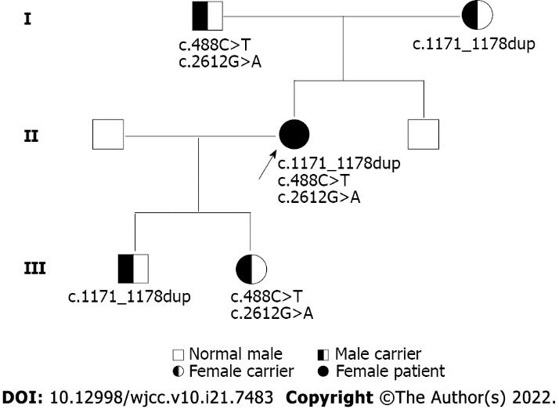
Figure 1 Pedigree diagram showing proband (arrow) and segregation of SLC12A3.

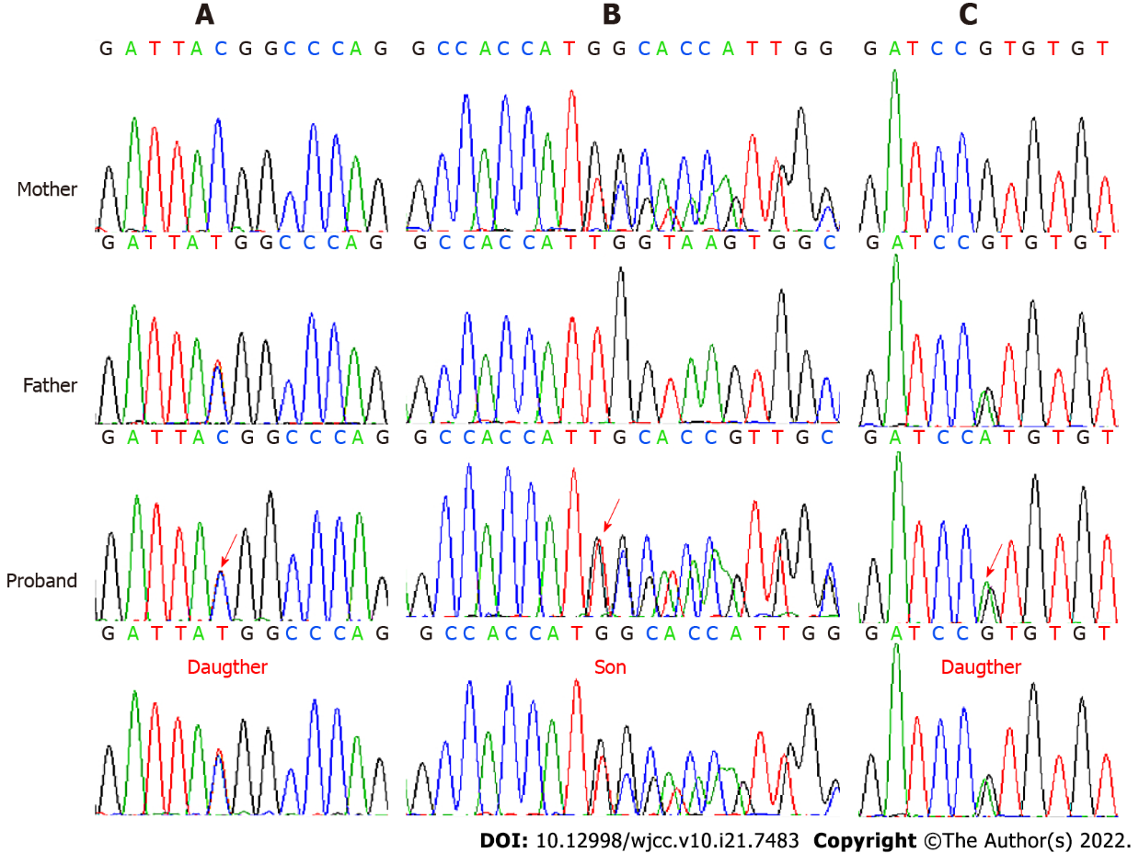
Figure 2 Sanger sequencing images of pedigree mutation type in SLC12A3. The sequence diagram from the first to the fourth row represents the mother, father, proband, and son or daughter, respectively. A: The NM_000339.2:c.488C>T(p.Thr163Met) (indicated by the red arrow) is a heterozygous missense mutation in exon 3; B: The NM_000339.2:c.1171_1178dupGCCACCAT(p.Ile393fs) (indicated by the red arrow) is a heterozygous frameshift mutation in exon 9; C: The NM_000339.2:c.2612G>A(p.Arg871His) (indicated by the red arrow) is a heterozygous missense mutation in exon 22.

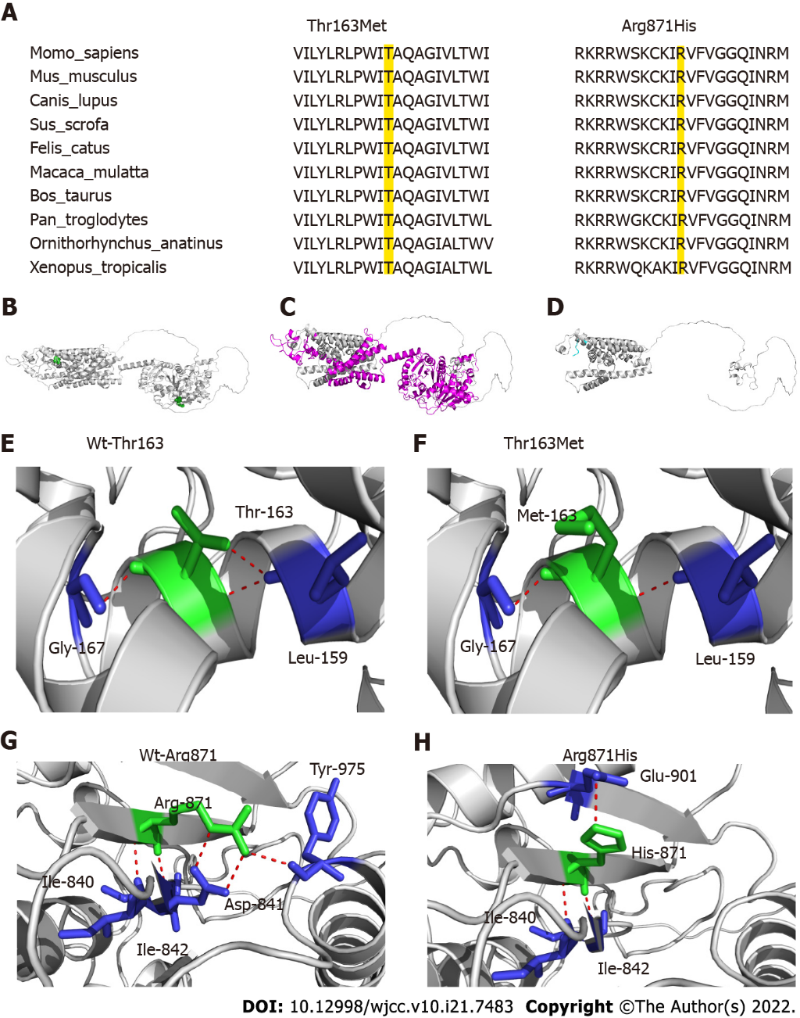
Figure 3 Schematic presentation of the structure of SLC12A3. A: Thr163 and Arg871 are highly conserved amino acids in various species (the locations colored yellow); B: Overview of the locations of Thr163 and Arg871 in the global three-dimensional structure of the protein. Thr163 and Arg871 are shown in green spheres, and the global protein structure is shown in the cartoon model; C and D: The mutation Ile393fs causes missing of some protein regions and domains (magenta), and transfer of MPPLAPAW* novel sequence (cyan); E and F: Analysis of changes in hydrogen bonds for the Thr163Met mutation. The key amino acids are shown as sticks and H-bonds are shown as red dotted line. One H-bond is destroyed when Thr163 is replaced by Met; G and H: The mutation Arg871His will cause large changes in the H-bond network, destruction of H-bond interaction with Asp841 and Tyr975, and generation of a new interaction with Glu901.

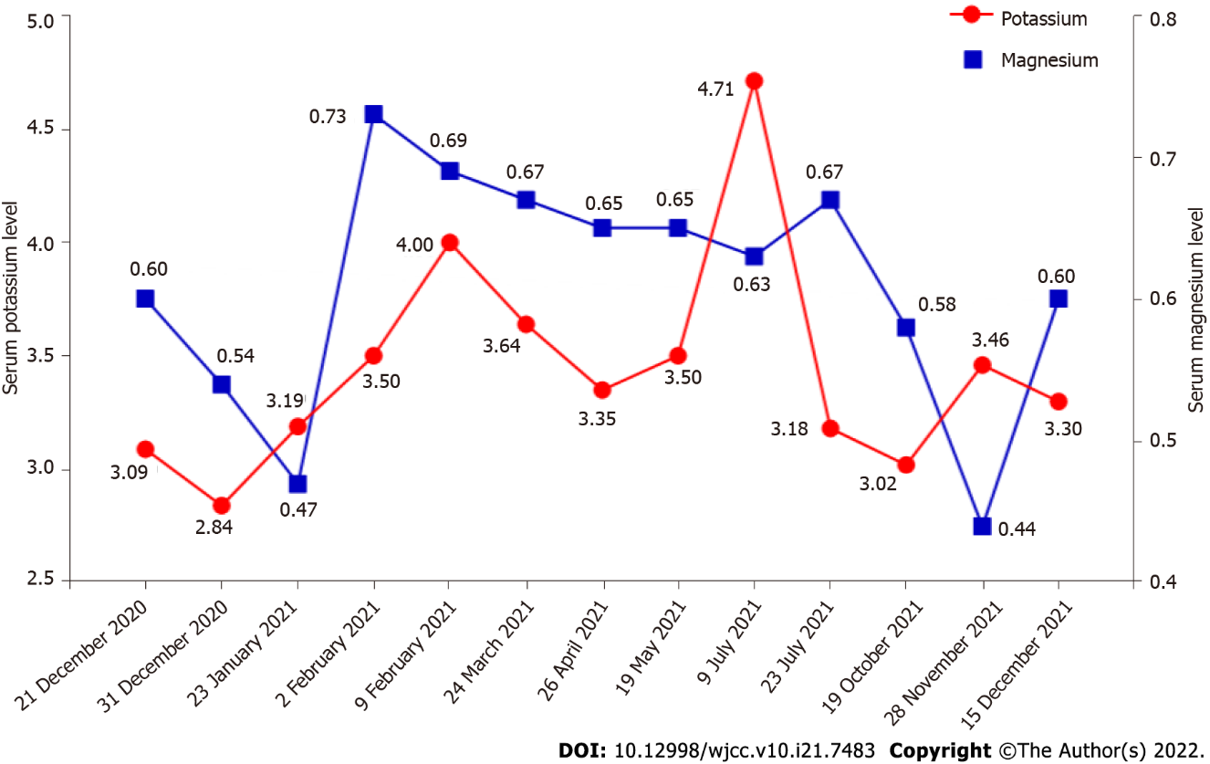
Figure 4 Hospital discharge follow-up results for serum electrolyte levels. The abscissa represents the date (format: Day/month/year). The double ordinates represent serum potassium level (the red line) and magnesium level (the blue line), respectively.
Table 1 Laboratory findings of the proband on admission
Characteristic | Detection value | Reference range | Characteristics | Detection value | Reference range
Age (yr) | 29 | - | Hormones
Height (cm) | 163.0 | - | Thyroid stimulating hormone (μU/mL) | < 0.005 | 0.27-4.2
Weight (kg) | 49.0 | - | Free triiodothyronine (pmol/L) | 13.46 | 3.1-6.8
Body mass index (kg/m²) | 18.4 | - | Free tetraiodothyronine (pmol/L) | 37.15 | 12-22
Blood pressure (mmHg) | 112/78 | - | Anti-thyroid peroxidase antibody (U/mL) | 18.2 | < 34
Biochemistry |  |  | Antithyroglobulin antibody (U/mL) | 179.6 | < 115
Total cholesterol (mmol/L) | 4.23 | < 5.20 | Thyrotrophin receptor antibody (U/L) | 2.8 | 0-1.75
Triglyceride (mmol/L) | 1.32 | < 1.70 | Aldosterone (pg/mL), upright position | 451.0 | 40-310
High-density lipoprotein (mmol/L) | 0.89 | 1.04-1.55 | Renin (pg/mL), upright position | 454.0 | 4-38
Low-density lipoprotein (mmol/L) | 2.12 | < 3.40 | Aldosterone (pg/mL), supine position | 287 | 10-160
eGFR (mL/min/1.73 m²) | 120.3 | - | Renin (pg/mL), supine position | 206 | 4-24
Serum uric acid (μmol/L) | 391.0 | 155-357 | Parathyroid hormone (pg/mL) | 34.1 | 15-65
Alanine transaminase (U/L) | 13 | 7-40 | Adrenocorticotrophic hormone (pg/mL)
Aspartate aminotransferase (U/L) | 17 | 13-35 | 8 am | 15.76 | 1.6-13.9
Total bilirubin (μmol/L) | 28.4 | < 21.0 | 4 pm | 12.35 | -
Direct bilirubin (μmol/L) | 8.6 | < 8.0 | 0 am | 5.02 | -
Sodium (mmol/L) | 137.0 | 137-147 | Serum cortisol (μg/dL)
Potassium (mmol/L) | 3.09 | 3.5-5.3 | 8 am | 12.03 | 6.02-18.4
Chloride (mmol/L) | 94.5 | 99-110 | 4 pm | 8.14 | 2.3-11.9
Calcium (mmol/L) | 2.33 | 2.11-2.52 | 0 am | 4.29 | -
Magnesium (mmol/L) | 0.60 | 0.65-1.25 | Arterial blood gas analysis
24-h urinary electrolytes |  |  | pH | 7.49 | 7.35-7.45
Sodium (mmol/24 h) | 127.60 | 137-257 | pCO₂ (mmHg) | 40 | 35-45
Potassium (mmol/24 h) | 67.98 | 36-90 | pO₂ (mmHg) | 135 | 80-100
Chloride (mmol/24 h) | 166.10 | 170-250 | HCO₃⁻ (mmol/L) | 30.5 | 22-27
Calcium (mmol/24 h) | 0.24 | 2.5-7.5 | Base excess (mmol/L) | 6.6 | -2.3-2.3
Phosphate (mmol/24 h) | 13.39 | 16.15-42 | Potassium (mmol/L) | 2.4 | 3.5-5.5
Urine volume (L/24 h) | 1.10 | -

Table 2 Results of thyroid function tests on admission and follow-up
Date | FT3 (3.1-6.8 pmol/L) | FT4 (12-22 pmol/L) | TSH (0.27-4.2 μU/mL) | TGAb (< 115 U/mL) | TPOAb (< 34 U/mL) | TRAb (0-1.75 U/L)
October 2020 | 23.28 | 48.61 | < 0.005 | NA | NA | 3.69
November 2020 | 23.46 | 37.15 | < 0.005 | 179.6 | 18.2 | 2.80
31 December 2020 | 3.97 | 12.66 | 0.28 | NA | NA | NA
09 February 2021 | 4.83 | 14.57 | 1.64 | NA | NA | NA
26 April 2021 | 5.18 | 15.50 | 1.83 | NA | NA | NA
23 July 2021 | 5.82 | 16.80 | 2.66 | NA | NA | NA
15 December 2021 | 6.03 | 16.41 | 1.68 | 24.56 | 25.48 | 1.38
FT3: Free triiodothyronine; FT4: Free tetraiodothyronine; TSH: Thyroid stimulating hormone; TPOAb: Anti-thyroid peroxidase antibody; TGAb: Antithyroglobulin antibody; TRAb: Thyrotrophin receptor antibody; NA: Not available.

Table 3 SLC12A3 pathogenic variants identified in Gitelman syndrome complicated with thyroid disease to date
Case no. | Sex | Age | Serum potassium (mmol/L) | Serum magnesium (mmol/L) | Thyroid disease | Mutation type | DNA nucleotide change | Amino acid change | Ref.
1 | F | 29 | 3.09 | 0.60 | GD | Compound heterozygote | c.488C>T | p.Thr163Met | this study
 |  |  |  |  |  |  | c.2612G>A | p.Arg871His | this study
 |  |  |  |  |  |  | c.1171_1178dupGCCACCAT | p.Ile393fs | this study
2 | F | 40 | 3.30 | 0.74 | HT | Compound heterozygote | c.2552T>A | p.Leu849His | [37]
 |  |  |  |  |  |  | c.2561G>A | p.Arg852His
3 | F | 28 | 1.70 | 0.62 | GD | Homozygote | c.2552T>A | p.Leu849His | [37]
4 | F | 18 | 3.20 | 0.86 | GD | Compound heterozygote | c.1015A>C | p.Thr339Pro | [38]
 |  |  |  |  |  |  | c.2573T>A | p.Leu858His
5 | F | 50 | 3.00 | 0.66 | GD | Compound heterozygote | c.539C>A | p.Thr180Lys | [38]
 |  |  |  |  |  |  | c.1045C>T | p.Pro349Ser
6 | F | 56 | 2.80 | 0.49 | GD | Homozygote | c.1706C>T | p.Ala569Val | [38]
7 | F | 14 | 2.20 | NA | GD | No mention | c.791G>C | p.Gly264Ala | [39]
8 | M | 16 | 2.27 | 0.40 | GD | Compound heterozygote | c.1456G>A | p.Asp486Asn | [40]
 |  |  |  |  |  |  | c.2102_2107delACAAGA | No mention
9 | F | 42 | 3.20 | 0.50 | HT | Compound heterozygote | c.248G>A | p.Arg83Gln | [41]
 |  |  |  |  |  |  | NC_000016.10:g.56872655_56872667 | No mention
 |  |  |  |  |  |  | (gcggacatttttg>accgaaaatttt)
10 | M | 2 | 1.57 | NA | GD | Compound heterozygote | c.1077C>G | p.Asn359Lys | [42]
 |  |  |  |  |  |  | c.1567G>A | p.Ala523Thr
11 | M | 45 | 2.11 | 0.54 | GD | Homozygote | 1562_1564delTCA | p.522delIle | [43]
12 | M | 21 | 2.10 | NA | GD | Compound heterozygote | c.539C>A | p.Thr180Lys | [44]
 |  |  |  |  |  |  | c.2573T>A | p.Leu858His
13 | M | 35 | 1.80 | NA | GD | Homozygote | c.1145C>T | p.Thr382Met | [45]
14 | F | 30 | 2.52 | 0.48 | HT | Compound heterozygote | c.486_490delinsA | p.Thr163fs | [46]
 |  |  |  |  |  |  | c.506-1G>A
15 | F | 34 | 2.33 | NA | HT | Compound heterozygote | c.953T>G | p.Phe318Cys | [47]
 |  |  |  |  |  |  | c.1196G>A | p.Arg399His
 |  |  |  |  |  |  | c.1664C>T | p.Ser555Leu
16 | M | 50 | 2.88 | 0.43 | GD | Compound heterozygote | c.179C>T | p.Thr60Met | [48]
 |  |  |  |  |  |  | c.1567G>A | p.Ala523Thr
17 | F | 46 | 2.30 | 0.43 | GD | Heterozygote | c.185C>T | p.Thr60Met | [49]
18 | M | 21 | 2.64 | 0.36 | GD | Homozygote | c.2744G>A | p.Arg913Gln | [49]
19 | F | 50 | 2.66 | 0.62 | GD | Compound heterozygote | c.179C>T | p.Thr60Met | [50]
 |  |  |  |  |  |  | c.863T>G | p.Leu288Arg
20 | M | 39 | 1.90 | 0.52 | GD | Compound heterozygote | c.1841C>T | p.Ser614Phe | [51]
 |  |  |  |  |  |  | c.2968G>A | p.Arg990Lys
21 | F | 41 | 2.60 | 0.40 | AP | Compound heterozygote | c.964+2T>C |  | [51]
 |  |  |  |  |  |  | c.179C>T | p.Thr60Met
22 | F | 20 | NA | NA | SAT | Compound heterozygote | c.1456G>A | p.Asp486Asn | [52]
 |  |  |  |  |  |  | c.506-1G>A
23 | F | 47 | NA | NA | GD | Compound heterozygote | c.1016C>T | p.Thr339Ile | [52]
 |  |  |  |  |  |  | c.1925G>A | p.Arg642His
GD: Graves’ disease; HT: Hashimoto’s thyroiditis; SAT: Subacute thyroiditis; AP: Antibody-positive; F: Female; M: Male; NA: Not available.

Published by Baishideng Publishing Group Inc
7041 Koll Center Parkway, Suite 160, Pleasanton, CA 94566, USA
Telephone: +1-925-3991568
E-mail: bpgoffice@wjgnet.com
Help Desk: https://www.f6publishing.com/helpdesk
https://www.wjgnet.com

© 2022 Baishideng Publishing Group Inc. All rights reserved.

