Name of Journal: World Journal of Clinical Cases
Manuscript NO: 88793
Manuscript Type: CASE REPORT

Monomorphic epitheliotropic intestinal T-cell lymphoma with bone marrow involved: A case report

Zhang FJ et al. MEITL with BM involved

Fen-Juan Zhang, Wen-Juan Fang, Cang-Jian Zhang

Fen-Juan Zhang, Wen-Juan Fang, Cang-Jian Zhang, Department of Hematology, Lishui Municipal Central Hospital, Lishui 323000, Zhejiang Province, China

Author contributions: Fang WJ designed the report and wrote the paper; Zhang FJ and Zhang CJ revised the paper; and all authors have read and approved the final version of this manuscript.

Supported by Zhejiang Province Traditional Chinese Medicine Science and Technology Project, No. 2024ZL1296.

Corresponding author: Wen-Juan Fang, MD, Nurse, Department of Hematology, Lishui Municipal Central Hospital, No. 289 Kuocang Road, Lishui 323000, Zhejiang Province, China. fang_vicky003@163.com

Received: October 9, 2023
Revised: December 8, 2023
Accepted: January 8, 2024
Published online:

Abstract
BACKGROUND
Monomorphic epithelial intestinal T-cell lymphoma (MEITL) is a rare type of peripheral T-cell lymphoma. The clinical manifestations are diarrhea, abdominal pain, perforation and an abdominal mass.

CASE SUMMARY
We present a 52-year-old female patient who was diagnosed with MEITL. Further disease progression was observed after multiline chemotherapy. Eventually, the patient died of a severe infection.

CONCLUSION
MEITL is a rare intestinal primary T-cell lymphoma with aggressive behavior, a high risk of severe life-threatening complications, and a poor prognosis.

Key Words: Monomorphic epithelial intestinal T-cell lymphoma; Autologous stem cell transplantation; Chemotherapeutics; Case report

Zhang FJ, Fang WJ, Zhang CJ. Monomorphic epitheliotropic intestinal T-cell lymphoma with bone marrow involved: A case report. World J Clin Cases 2024; In press

Core Tip: This article reports a patient diagnosed with monomorphic epithelial intestinal T-cell lymphoma (MEITL). Further disease progression was observed after multiline chemotherapy. Eventually, the patient died of a severe infection. MEITL is a rare intestinal primary T-cell lymphoma with aggressive behavior, a high risk of severe life-threatening complications, and a poor prognosis.

INTRODUCTION
Monomorphic epithelial intestinal T-cell lymphoma (MEITL) is a rare type of peripheral T-cell lymphoma^{[1]}. MEITL has a poor prognosis, and the clinical manifestations are diarrhea, abdominal pain, perforation and an abdominal mass. This article reports a patient with MEITL. To explore and analyze the clinical manifestations of MEITL, pathology and related treatment must be further characterized.

CASE PRESENTATION
Chief complaints
A 52-year-old female patient was admitted to our hospital on October 5, 2022, due to recurrent diarrhea for 1 year.

History of present illness
The patient developed diarrhea with no apparent cause, weight loss, fever, night sweats, and abdominal pain more than 1 year ago. Colonoscopy revealed a large ulcer in the blind. The pathological results showed MEITL (Figure 1). Immunohistochemistry showed the following: CD3+, CD5-, CD4-, CD8+, CD56+, TIA+, BcL-2+, Ki-67+ (approximately 40%), CD20-, PAX5-, CD10-, Bcl-6-, CD21-, CD23-, CyclinD1-, PD-1-, CD79α-, CD30-, C-Myc-, and EBER-. Pathological gene detection of JAK3 deletion mutations revealed a mutation frequency of 24.6%.

History of past illness
The patient’s past medical history included diabetes and cervical spondylosis.

Personal and family history
No personal or family history was available.

Physical examination
Physical examination showed no palpable lymph nodes, organomegaly, or cutaneous lesions.

Laboratory examinations
The peripheral blood and biochemical parameters (liver and renal function and serum lactate dehydrogenase level) were within normal limits. Bone marrow (BM) smear and biopsy did not show evidence of involvement by lymphoma cells.

Imaging examinations
Positron emission tomography/computed tomography (PET/CT) showed that the ileocecal intestinal wall was slightly thickened, the thickest part was approximately 2.6 cm, and the uptake was increased, with a maximum standardized uptake value (SUV) value of 6.3. Several enlarged lymph nodes could be seen around, the short diameter of the large one was approximately 1.5 cm, the uptake was increased, and the maximum SUV was 6.1. Rectal and colorectal wall uptake was increased, and the maximum SUV was approximately 7.0 (Figures 2A and B).

FINAL DIAGNOSIS
Based on the above findings, the final diagnosis was MEITL, stage IVB.

TREATMENT
On October 21, 2022, the patient was treated with laparoscopic right hemicolectomy. Then, three cycles of cyclophosphamide, doxorubicin, vincristine and prednisone (CHOP) were given. PET/CT re-examination indicated complete remission of the disease. On April 07, 2023, autologous stem cells were successfully collected. On May 15, 2023, the patient’s diarrhea symptoms worsened. A review PET/CT showed several enlarged abdominal lymph nodes with increased fluorodeoxyglucose metabolism. The local peritoneum was thickened in the right paracolic sulci and had increased fluorodeoxyglucose metabolism (Figures 2C and D). On May 23, 2023, two cycles of cyclophosphamide, doxorubicin, vincristine, prednisone and etoposide (CHOPE) combined with cedarbenamine were given. On July 31, 2023, the patient was admitted with fever. Routine analysis of blood results showed the following: white blood cell count 0.4 × 10⁹/L, hemoglobin 89 g/L, and blood platelet count 14 × 10⁹/L. A review abdominal CT with enhancement showed the following: Extensive thickening of the colon wall, partial edema, abdominal cavity, retroperitoneal multiple enlargement of lymph nodes, and ascites and was compared with the previous lesion. BM morphology and pathology showed that the lymphoma involved the BM.

OUTCOME AND FOLLOW-UP
On July 31, 2023, the patient was admitted with fever. Routine analysis of blood results showed the following: White blood cell count 0.4 × 10⁹/L, hemoglobin 89 g/L, and blood platelet count 14 × 10⁹/L. A review abdominal CT with enhancement showed the following: Extensive thickening of the colon wall, partial edema, abdominal cavity, retroperitoneal multiple enlargement of lymph nodes, and ascites and was compared with the previous lesion. BM morphology and pathology showed that the lymphoma involved the BM. The patient subsequently died of a severe infection.

DISCUSSION
The gastrointestinal tract is the most common site of extranodal primary lymphoma, with the stomach being the most common, followed by the intestine. In terms of pathological types, the histological types are almost all non-Hodgkin lymphoma (NHL), while primary intestinal NHL is mostly B-cell lymphoma, and T-cell lymphoma is rare. Enteropathy-associated cell lymphoma is a T-lymphocyte tumor derived from the mucosal epithelium of the gastrointestinal tract. In the 2008 edition, these tumors were divided into two types: The enteropathy-associated T cell lymphoma (EATL) type I classic type, accounting for 80%-90%; and the EATL II type, accounting for 10%-20%^{[1]}. In 2016, the new World Health Organization (WHO) classification was renamed EATL II MEITL^{[2]}.
MEITL is more common among Asians and Hispanics, especially in countries such as Korea, Japan and Singapore, but it rarely occurs in China. Cases are sporadic, and the patients usually have no history of celiac disease. MEITLs are more common in middle-aged and elderly patients and males, affecting a median age of 50 years. The lesions are mostly seen in the small intestine, mainly involving the jejunum and ileum^{[3]}, and occasionally outside the small intestine. Patients often have mesenteric lymph node enlargement or involvement of other organs, such as the stomach, liver, spleen BM, lung, and skin^{[4-8]}. MEITL has no characteristic clinical manifestations, including abdominal pain, abdominal distension, diarrhea, melena, constipation, anorexia, weight loss and other manifestations. In this case, the lesion was located in the ileocecal part, the onset was occult, and the clinical symptoms were repeated abdominal distension, diarrhea, and weight loss.
MEITL must be differentiated from a variety of intestinal diseases and tumors: (1) Crohn’s disease: The characteristic microscopic changes are full-thickness inflammation, noncaseating granulomas of the intestinal wall, and proliferation of mature small lymphocytes without atypia of lymphocytes; (2) EATL: It mainly occurs in European and American countries, and patients have a history of allergies or enteropathy, such as celiac disease. The tumor cells are medium to large pleomorphic tumor cells, which are different from small to medium large and consistent cells. CD8 and CD56 are often negative, which is opposite to MEITL; (3) Indolent T-cell lymphoproliferative diseases of the gastrointestinal tract (2016 WHO)/indolent T-lymphocystoma of the gastroentertract (2022 WHO)^{[9]}: It is similar to MEITL regarding its histological features, but its clinical course is indolent, with low invasiveness and a low cell proliferation index; (4) Extranodal NK/T cell lymphoma (nasal type): Tumor cells are pleomorphic, invading blood vessels and are commonly necrotic. Unlike MEITL, it usually lacks TCR gene rearrangements and is EBER positive by in situ hybridization; (5) Intestinal peripheral T-cell lymphoma (nonspecific type): The tumor cells are heterogeneous, with large atypia, often with an inflammatory background. The tumor cells are positive for CD5, negative for CD8, and rarely positive for CD56 and TIA-1; and (6) Intestinal B-cell lymphoma: Tumor cell B-cell markers such as CD20, CD79α and PAX-5 are positive. For some MEITLs with abnormal CD20 expression, multiple B-cell markers combined with T-cell markers can be used for differential diagnosis.
The current treatment methods for MEITL mainly include surgical resection, chemotherapy, and autologous hematopoietic stem cell transplantation. The first-line chemotherapy regimens based on anthracycline include CHOP, CHOPE, EPOCH, etc., but the efficacy of MEITL is not ideal.
It has been reported that patients with younger age, early Lugano stage, complete response to chemotherapy, and autologous stem cell transplantation have a relatively better prognosis^{[10]}. It has also been reported that the combination therapy of cedarbenzamide has certain efficacy in patients with MEITL^{[11]}. In addition, it has been shown that patients receiving autologous stem cell transplantation have significantly improved survival^{[10,12]}. In this case, the disease was relieved after three courses of CHOP chemotherapy, and autologous stem cells were collected successfully. When the patient was preparing to return to the hospital for autologous stem cell transplantation, PET/CT examination indicated disease recurrence, and two courses of CHOPE combined with chidamide chemotherapy were performed. However, the effect was poor; the disease continued to progress, with the patient developing multiple masses in the abdominal cavity and intestine and BM invasion; and the patient finally died of multiple organ failure caused by a severe infection. The survival time of this patient was approximately 1 year, which was consistent with relevant reports at home and abroad^{[10]}. However, the number of cases in this study is insufficient, and further research is needed to collect further data. There were no patients who received autologous hematopoietic stem cell transplantation in this study.

CONCLUSION
In conclusion, MEITL is a rare intestinal primary T-cell lymphoma with aggressive behavior, a high risk of severe life-threatening complications, and a poor prognosis. The diagnosis of MEITL should be based on clinical manifestations, pathological features, immunohistochemistry and genetic testing results. Early diagnosis, timely surgical intervention, chemotherapy and autologous stem cell transplantation can help to prevent complications and improve prognosis.

REFERENCES
1 Naresh KN, Medeiros LJ; WHO Fifth Edition Classification Project. Introduction to the Fifth Edition of the World Health Organization Classification of Tumors of Hematopoietic and Lymphoid Tissues. Mod Pathol 2023; 36: 100330 [PMID: 37716508 DOI: 10.1016/j.modpat.2023.100330]
2 Swerdlow SH, Campo E, Pileri SA, Harris NL, Stein H, Siebert R, Advani R, Ghielmini M, Salles GA, Zelenetz AD, Jaffe ES. The 2016 revision of the World Health Organization classification of lymphoid neoplasms. Blood 2016; 127: 2375-2390 [PMID: 26980727 DOI: 10.1182/blood-2016-01-643569]
3 Tse E, Gill H, Loong F, Kim SJ, Ng SB, Tang T, Ko YH, Chng WJ, Lim ST, Kim WS, Kwong YL. Type II enteropathy-associated T-cell lymphoma: a multicenter analysis from the Asia Lymphoma Study Group. Am J Hematol 2012; 87: 663-668 [PMID: 22641357 DOI: 10.1002/ajh.23213]
4 Kasinathan G. Monomorphic epitheliotropic intestinal T-cell lymphoma of the duodenum: an aggressive disease. Hematol Transfus Cell Ther 2021; 43: 518-520 [PMID: 32536535 DOI: 10.1016/j.htct.2020.04.005]
5 Soardo G, Castaldo V, Donnini D, Uzzau A, Pizzolitto S, Sechi LA. Monomorphic Epitheliotropic Intestinal T Cell Lymphoma of the Appendix: a Case Report and Review of Literature. J Gastrointest Cancer 2020; 51: 688-694 [PMID: 31970655 DOI: 10.1007/s12029-020-00363-6]
6 Suzuki Y, Minemura H, Tomita H, Saito M, Watanabe N, Umeda T, Kawamata T, Rikimaru M, Morimoto J, Koizumi T, Togawa R, Sato Y, Hirai K, Uematsu M, Nikaido T, Fukuhara N, Fukuhara A, Sato S, Saito J, Kanazawa K, Tanino Y, Shibata Y. Monomorphic Epitheliotropic Intestinal T-cell Lymphoma Involving the Lung and Brain: A Rare Case Study. Intern Med 2020; 59: 2559-2563 [PMID: 32641648 DOI: 10.2169/internalmedicine.4710-20]
7 Chan TSY, Lee E, Khong PL, Tse EWC, Kwong YL. Positron emission tomography computed tomography features of monomorphic epitheliotropic intestinal T-cell lymphoma. Hematology 2018; 23: 10-16 [PMID: 28581364 DOI: 10.1080/10245332.2017.1335979]
8 Olmos-Alpiste F, Vázquez I, Gallardo F, Sánchez-Gonzalez B, Colomo L, Pujol RM. Monomorphic Epitheliotropic Intestinal T-Cell Lymphoma With Secondary Cutaneous Involvement: A Diagnostic Challenge. Am J Dermatopathol 2021; 43: 300-304 [PMID: 33264131 DOI: 10.1097/DAD.0000000000001855]
9 Alaggio R, Amador C, Anagnostopoulos I, Attygalle AD, Araujo IBO, Berti E, Bhagat G, Borges AM, Boyer D, Calaminici M, Chadburn A, Chan JKC, Cheuk W, Chng WJ, Choi JK, Chuang SS, Coupland SE, Czader M, Dave SS, de Jong D, Du MQ, Elenitoba-Johnson KS, Ferry J, Geyer J, Gratzinger D, Guitart J, Gujral S, Harris M, Harrison CJ, Hartmann S, Hochhaus A, Jansen PM, Karube K, Kempf W, Khoury J, Kimura H, Klapper W, Kovach AE, Kumar S, Lazar AJ, Lazzi S, Leoncini L, Leung N, Leventaki V, Li XQ, Lim MS, Liu WP, Louissaint A Jr, Marcogliese A, Medeiros LJ, Michal M, Miranda RN, Mitteldorf C, Montes-Moreno S, Morice W, Nardi V, Naresh KN, Natkunam Y, Ng SB, Oschlies I, Ott G, Parrens M, Pulitzer M, Rajkumar SV, Rawstron AC, Rech K, Rosenwald A, Said J, Sarkozy C, Sayed S, Saygin C, Schuh A, Sewell W, Siebert R, Sohani AR, Tooze R, Traverse-Glehen A, Vega F, Vergier B, Wechalekar AD, Wood B, Xerri L, Xiao W. The 5th edition of the World Health Organization Classification of Haematolymphoid Tumours: Lymphoid Neoplasms. Leukemia 2022; 36: 1720-1748 [PMID: 35732829 DOI: 10.1038/s41375-022-01620-2]
10 Yi JH, Lee GW, Do YR, Jung HR, Hong JY, Yoon DH, Suh C, Choi YS, Yi SY, Sohn BS, Kim BS, Oh SY, Park J, Jo JC, Lee SS, Oh YH, Kim SJ, Kim WS. Multicenter retrospective analysis of the clinicopathologic features of monomorphic epitheliotropic intestinal T-cell lymphoma. Ann Hematol 2019; 98: 2541-2550 [PMID: 31493002 DOI: 10.1007/s00277-019-03791-y]
11 Liu TZ, Zheng YJ, Zhang ZW, Li SS, Chen JT, Peng AH, Huang RW. Chidamide based combination regimen for treatment of monomorphic epitheliotropic intestinal T cell lymphoma following radical operation: Two case reports. World J Clin Cases 2020; 8: 1278-1286 [PMID: 32337203 DOI: 10.12998/wjcc.v8.i7.1278]
12 Jantunen E, Boumendil A, Finel H, Luan JJ, Johnson P, Rambaldi A, Haynes A, Duchosal MA, Bethge W, Biron P, Carlson K, Craddock C, Rudin C, Finke J, Salles G, Kroschinsky F, Sureda A, Dreger P; Lymphoma Working Party of the EBMT. Autologous stem cell transplantation for enteropathy-associated T-cell lymphoma: a retrospective study by the EBMT. Blood 2013; 121: 2529-2532 [PMID: 23361910 DOI: 10.1182/blood-2012-11-466839]

Footnotes
Informed consent statement: Informed written consent was obtained from the patient for publication of this report and any accompanying images.

Conflict-of-interest statement: All the authors report no relevant conflicts of interest for this article.

CARE Checklist (2016) statement: The authors have read the CARE Checklist (2016), and the manuscript was prepared and revised according to the CARE Checklist (2016).

Open-Access: This article is an open-access article that was selected by an in-house editor and fully peer-reviewed by external reviewers. It is distributed in accordance with the Creative Commons Attribution NonCommercial (CC BY-NC 4.0) license, which permits others to distribute, remix, adapt, build upon this work non-commercially, and license their derivative works on different terms, provided the original work is properly cited and the use is non-commercial. See: https://creativecommons.org/Licenses/by-nc/4.0/

Provenance and peer review: Unsolicited article; Externally peer reviewed.
Peer-review model: Single blind

Peer-review started: October 9, 2023
First decision: November 28, 2023
Article in press:

Specialty type: Medicine, research and experimental
Country/Territory of origin: China
Peer-review report’s scientific quality classification
Grade A (Excellent): 0
Grade B (Very good): B
Grade C (Good): 0
Grade D (Fair): 0
Grade E (Poor): 0

P-Reviewer: Radenska-Lopovok SG, Russia S-Editor: Wang JJ L-Editor: A P-Editor:
Figure Legends
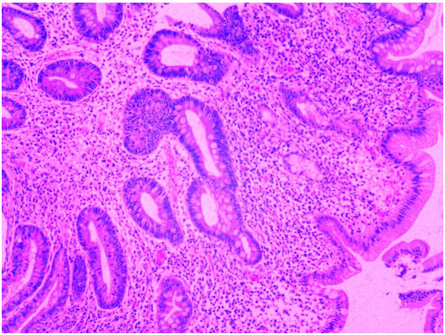
Figure 1 The pathological results showed monomorphic epithelial intestinal T-cell lymphoma.

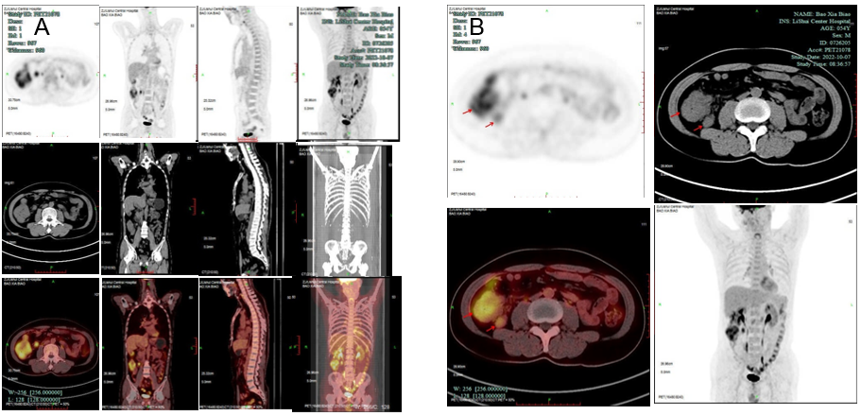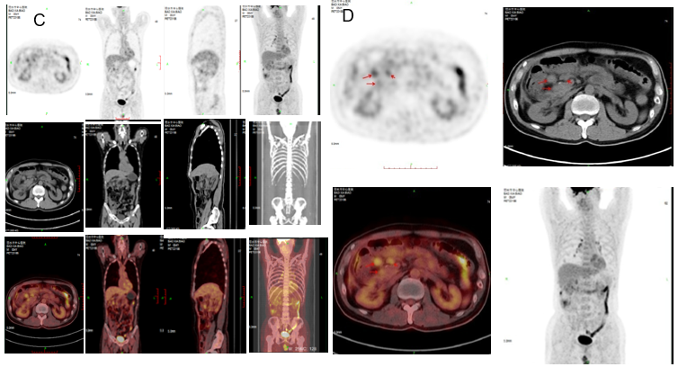
Figure 2 Positron emission tomography/computed tomography imaging. A and B: Positron emission tomography/computed tomography showed that the ileocecal intestinal wall was slightly thickened, the thickest part was approximately 2.6 cm, and the uptake was increased. Several enlarged lymph nodes could be seen around, the short diameter of the large one was approximately 1.5 cm, the uptake was increased; C and D: Positron emission tomography/computed tomography showed several enlarged abdominal lymph nodes with increased fluorodeoxyglucose metabolism. The local peritoneum was thickened in the right paracolic sulci and had increased fluorodeoxyglucose metabolism.

