Name of Journal: World Journal of Hepatology
Manuscript NO: 41335
Manuscript Type: EDITORIAL

Exosomal microRNAs as potential therapeutic strategy in hepatocellular carcinoma

Gougelet A. Exosome-based therapies

Angélique Gougelet

Angélique Gougelet, Inserm, U1016, Institut Cochin, Paris 75014, France

Angélique Gougelet, Cnrs, UMR8104, Paris 75014, France

Angélique Gougelet, Université Paris Descartes, Sorbonne Paris Cité, Paris 75006, France

ORCID number: Angélique Gougelet (0000-0001-7464-9804).

Author contributions: Gougelet A constructed and wrote the manuscript.

Conflict-of-interest statement: The authors have no conflict of interest to declare. No financial support.

Open-Access: This article is an open-access article which was selected by an in-house editor and fully peer-reviewed by external reviewers. It is distributed in accordance with the Creative Commons Attribution Non Commercial (CC BY-NC 4.0) license, which permits others to distribute, remix, adapt, build upon this work non-commercially, and license their derivative works on different terms, provided the original work is properly cited and the use is non-commercial. See: http://creativecommons.org/licenses/by-nc/4.0/

Manuscript source: Invited manuscript

Correspondence to: Angélique Gougelet, PhD, Research Scientist, Inserm, U1016, Institut Cochin, 24, rue du Faubourg Saint Jacques, Paris 75014, France. angelique.gougelet@inserm.fr
Telephone: +33-14-4412446
Fax: +33-14-4412421

Received: August 2, 2018
Peer-review started: August 3, 2018
First decision: August 24, 2018
Revised: September 5, 2018
Accepted: October 10, 2018
Article in press:
Published online:

Abstract
Hepatocellular carcinoma (HCC) is the fifth most common cancer and the second cause of cancer-related death worldwide. The incidence of HCC is constantly increasing in correlation with the rise in diabetes and obesity, arguing for an urgent need of new developments for the treatment of this lethal cancer. Exosomes are small double-membrane vesicles loaded with distinct cargos, particularly the small non-coding RNAs called microRNAs, representative of each donor cell and secreted to affect the features of neighboring cells or recipient cells located further notably in the case of metastasis. A better understanding of the role of exosomes with a microRNA signature in cancer pathogenesis gave rise to the concept of their use as a non-invasive diagnostic biomarker and in the treatment of cancer, including HCC. In this communication, we review recent works supporting that hepatic stellate cells establish an epigenetic communication with liver cancer cells, which affects their pro-malignant features. If naturally secreted exosomes derived from patients show major limitations which concerning their clinical use, bio-engineered exosome mimetics that incorporate controlled components and exhibit no protumoral properties could constitute promising carriers for the treatment of cancers of the liver, which is the organ preferentially targeted by a systemic injection of exosomes.

Key words: Exosomes; MicroRNAs; Hepatocellular carcinoma; Targeted therapy

© The Author(s) 2018. Published by Baishideng Publishing Group Inc. All rights reserved.

Core tip: Despite the intensive research efforts to identify the molecular events responsible for the emergence of liver cancer, hepatocellular carcinoma (HCC) remains a major health problem in the world. Thus, the identification of new therapeutic opportunities to counteract the challenging issues linked to HCC heterogeneity and resistance to conventional treatments is a short-term necessity. These last few decades, microRNAs appeared as interesting therapeutic strategies with their pleiotropic inhibitory action, but the use of a delivery system is a requirement for miRNA mimic administration. Exosomes, which are small vesicles naturally produced by immune cells and aberrantly by cancer cells, are recently emerging as promising vehicle.

Gougelet A. Exosomal microRNAs as potential therapeutic strategy in hepatocellular carcinoma. World J Hepatol 2018; In press

INTRODUCTION
Hepatocellular carcinoma (HCC) is the second cause of cancer-related death worldwide for which therapeutic options are very limited. Indeed, because of its heterogeneity, the development of effective therapies against this cancer remains a challenging issue. HCC is considered as the paradigm of inflammation-associated cancer, since 80% of HCC emerge following a vast liver remodeling. Briefly, HCC mainly affects men with cirrhosis due to hepatitis B and C viruses (HBV and HCV, respectively), alcohol abuse, genotoxic exposure and metabolic disorders increasingly due to diabetes and obesity^{[1]}. Efforts in the molecular and genetic profiling of HCC revealed that among the mutational landscape of HCC, the Wnt/β-catenin, p53 and Ras pathways are the most frequently mutated. Other prevalent mutations occur in epigenetic modifiers such as chromatin remodelers and imprinted clusters^{[2]}. Despite these molecular findings, the molecular pathogenesis of HCC is still not fully understood and novel strategies are urgently needed to cure this lethal disease with high incidence. The last decades, other crucial epigenetic regulators, the small non-coding RNAs named microRNAs (miRNAs), have also been largely found disturbed during hepatocarcinogenesis^{[3]}. Promisingly, due to their large spectrum of action on proliferation, inflammation and metabolism, miRNAs emerge as robust therapeutic opportunities in various cancers. Regarding liver diseases, miRNA-based therapies have been successfully tested^{[4,5]} - this type of molecules being preferentially delivered to the liver^{[6]}. Despite promising results obtained with miRNA-based therapies, a number of challenges remained to date to improve the efficiency of this type of treatments. Their limitations are similar to those which have delayed the use of therapies based on small interfering RNAs: improvement of their stability, free or encapsulated administration, problems of specificity, tissue distribution, response persistence and secondary effects. Recently, new therapeutic candidates for anticancer drug delivery have been proposed and based on a biological system transporting active cargos called exosomes. Exosomes are double membrane cell-derived microvesicles defined by a diameter from 30 to 100 nm containing a great diversity of nucleic acids, protein and lipids - 3408 mRNAs, 2838 miRNAs and 9769 proteins according to the Exocarta database based on 286 studies^{[7]}. Most cells, and particularly immune cells, are physiologically secreting exosomes originated from multivesicular bodies (MVB). MVB fusion with the plasma membrane is orchestrated by Rab, soluble N-éthylmaleimide-sensitive-factor attachment protein (SNAP) and SNAP receptor (SNARE) proteins^{[8]}. In response to different activating signals like antigenic, cytokinic or mitogenic stimuli, immune cells are able to increasingly release these small vesicles^{[9]}. Recent studies revealed that disequilibrium in exosome formation and/or delivery contributes to pathological processes leading to immunological disorders and cancers. Indeed, during tumorigenesis, tumor cells aberrantly secrete exosomes to communicate with stromal cells and also to modify secondary sites favoring metastasis^{[10]}. In consequence, the detection of exosomal miRNAs in body fluids appears as a potent non-invasive diagnosis tool for cancer, including HCC^{[11]}, but also as new therapeutic opportunities. Exosome-based therapies emerge, this decade, as an attractive strategy for tissue repair, immune vaccine and against cancer firstly because of their biocompatibility. Second, their small size facilitates their crossing through biological barriers, and notably the blood brain barrier, and limits their renal clearance. These microvesicles might prove to be suitable for liver disease and especially for liver cancer treatment since exosomes accumulate in the liver after systemic injection. In particular, exosomes preferentially target the resident macrophages, the Kupffer cells. Interestingly, the uptake of extracellular vesicles by Kupffer cells increases in case of liver damage^{[12]}. These last two years, Selaru’s laboratory published two compelling manuscripts studying exosomes carrying miRNAs as a way to dialog between stromal cells, in particular stellate cells, and cancer cells in cholangiocarcinoma (CCA)^{[13]} and in HCC^{[14]}. Both studies revealed the clinical potential of miRNAs loaded in stellate cell-derived exosomes for an in vivo delivery in mice and on a longer-term perspective for CCA or HCC treatment.

STUDY ANALYSIS
The work from Wang et al^{[14]} is focused on miR-335-5p, a microRNA already described as a tumor suppressor in HCC^{[15]}, and also gradually decreased in activated human stellate cells (HSC) during hepatic fibrosis^{[16]}. This miRNA is also reduced in the serum of HCC patients in association with progressive features and is predictive of chemo-embolization response^{[17]}. For their study, the authors used different HCC cell lines either mutated for p53 (HuH-7) or β-catenin (HepG2), or infected with HBV (MHCC97) either with low (L) or high (H) metastatic features. They confirmed a global tumor suppressive role of miR-335-5p associated with miR-335-5p loss in all cell lines as compared to the LX-2 hepatic stellate cell line^{[14]}. A miR-335-5p mimic inhibited HCC cell proliferation and invasion if it was transfected in HCC cell lines, but also, crucially, when transfected in LX-2 cells seeded in co-culture with HCC cells. This suggests that a miRNA dialog between HCC and stromal cells might be established to favor tumor progression and invasion (Figure 1). To confirm the material transfer via the exosomal route between stellate cells and HCC cell lines, the authors used an elegant system with two fluorophores coupled to a stop signal and based on the Cre lox strategy (loxp-dsRED-loxp-stop-eGFP) transfected in HCC cells. Using this tool, they could demonstrate that LX-2 cells transferred the Cre recombinase to neighboring HCC cells (green labeling). An efficient transfer is also observed when exosomes are purified from LX-2 cells and latter added to HCC cell culture. In vivo, intra-tumoral injection of LX-2 Cre-positive exosomes to subcutaneous HCC xenograft also led to GFP signal in the tumors. This means that the construct was efficiently defloxed in HCC via exosome capture. Finally, with a view to treatment, Wang et al^{[14]} showed that LX-2 isolated exosomes, extemporaneously enriched with miR-335-5p, reduce HCC growth after intra-tumoral injection every two days during 4 weeks in MHCC97H cell xenograft. The intra-tumoral administration was preferred to concentrate exosomes into the tumor mass and to mimic the historically intra-arterial administration of chemotherapeutic agents. Exosome treatment leads to overexpression of miR-335-5p by 30-fold in the tumors and modification of its target landscape, resulting in an attenuation of proliferation and an increase in apoptosis. This study confirmed the previous observations performed by Selaru’s laboratory showing that LX2 cells secrete miR-195-enriched exosomes, which could communicate with CCA cells and decrease in vivo tumor growth in a CCA rat model after intravenous injections every two days^{[13]}.

PERSPECTIVES
In conclusion, these proofs of concept studies performed in two different models of liver cancer support the existence of an epigenetic dialog between cancer cells and stromal cells driven by exosomes to favor tumor progression. In particular, hepatic stellate cells play an important part in this dialog but other non-parenchymal cells, like Kupffer cells, could also probably participate. They also highlight that stellate cell-derived exosome manipulation succeeds in restoring in vivo a more physiological expression of miRNAs found deregulated in cancer cells. The restoration of miRNA expression modifies gene expression, and subsequently limits cell proliferation and favors apoptosis. These results, and others generated in various cancer models, support extracellular vesicles as an attractive modality for personalized treatment for liver cancer. Especially since this type of particles mainly targeted the liver after systemic injection. Numbers of studies have used exosomes as a targeted delivery system for chemotherapeutic agents, leading to cancer cell killing and promoting a domino effect through the release of secondary cytotoxic vesicles^{[18]}. Additionally, exosomes produced by mesenchymal stem cells have been largely studied in liver disease, and found as modulators of immune response, favored by their engulfment by resident macrophages. They are also key modulators of oxidative stress and fibrotic process^{[19]}. Despite all these encouraging features, a number of limitations for clinical feasibility are currently a brake for using these delivery systems. Indeed, the production of patient-derived exosomes for clinical application appears expensive, time consuming and complex (preparation method, loading, characterization…). Since these biological carriers present pro-tumoral characteristics, the pro-malignant factors have to be identified preliminarily and removed before re-injection. The reproducibility also remains a major barrier since a previous study suggest that three independent preparations of exosomes from mesenchymal stem cells only shared 20% of their proteome^{[20]}. A promising alternative for extracellular vesicle-based therapeutics is the synthesis of bioengineered exosome mimetics, which could allow the production of exosome preparations suitable for clinical use (sterile, characterized, reproducible)^{[21]}. In conclusion, even if about a hundred clinical trials are currently testing the benefit of exosomes as therapeutic agents, a gold standard method for their isolation and loading has to be approved. A better deciphering of their specificity, functionality and safety is required, for which liver cancer, characterized by its pro-inflammatory microenvironment and its refractoriness to conventional treatments, undoubtedly constitutes a model of choice.

REFERENCES
1 El-Serag HB, Rudolph KL. Hepatocellular carcinoma: epidemiology and molecular carcinogenesis. Gastroenterology 2007; 132: 2557-2576 [PMID: 17570226 DOI: 10.1053/j.gastro.2007.04.061]
2 Schulze K, Imbeaud S, Letouzé E, Alexandrov LB, Calderaro J, Rebouissou S, Couchy G, Meiller C, Shinde J, Soysouvanh F, Calatayud AL, Pinyol R, Pelletier L, Balabaud C, Laurent A, Blanc JF, Mazzaferro V, Calvo F, Villanueva A, Nault JC, Bioulac-Sage P, Stratton MR, Llovet JM, Zucman-Rossi J. Exome sequencing of hepatocellular carcinomas identifies new mutational signatures and potential therapeutic targets. Nat Genet 2015; 47: 505-511 [PMID: 25822088 DOI: 10.1038/ng.3252]
3 Gougelet A, Colnot S. [microRNA: new diagnostic and therapeutic tools in liver disease?]. Med Sci (Paris) 2013; 29: 861-867 [PMID: 24148124 DOI: 10.1051/medsci/20132910013]
4 Gougelet A, Sartor C, Bachelot L, Godard C, Marchiol C, Renault G, Tores F, Nitschke P, Cavard C, Terris B, Perret C, Colnot S. Antitumour activity of an inhibitor of miR-34a in liver cancer with β-catenin-mutations. Gut 2016; 65: 1024-1034 [PMID: 25792709 DOI: 10.1136/gutjnl-2014-308969]
5 Shibata C, Otsuka M, Kishikawa T, Ohno M, Yoshikawa T, Takata A, Koike K. Diagnostic and therapeutic application of noncoding RNAs for hepatocellular carcinoma. World J Hepatol 2015; 7: 1-6 [PMID: 25624991 DOI: 10.4254/wjh.v7.i1.1]
6 Roberts J, Palma E, Sazani P, Ørum H, Cho M, Kole R. Efficient and persistent splice switching by systemically delivered LNA oligonucleotides in mice. Mol Ther 2006; 14: 471-475 [PMID: 16854630 DOI: 10.1016/j.ymthe.2006.05.017]
7 Keerthikumar S, Chisanga D, Ariyaratne D, Al Saffar H, Anand S, Zhao K, Samuel M, Pathan M, Jois M, Chilamkurti N, Gangoda L, Mathivanan S. ExoCarta: A Web-Based Compendium of Exosomal Cargo. J Mol Biol 2016; 428: 688-692 [PMID: 26434508 DOI: 10.1016/j.jmb.2015.09.019]
8 Théry C, Zitvogel L, Amigorena S. Exosomes: composition, biogenesis and function. Nat Rev Immunol 2002; 2: 569-579 [PMID: 12154376 DOI: 10.1038/nri855]
9 Blanchard N, Lankar D, Faure F, Regnault A, Dumont C, Raposo G, Hivroz C. TCR activation of human T cells induces the production of exosomes bearing the TCR/CD3/zeta complex. J Immunol 2002; 168: 3235-3241 [PMID: 11907077 DOI: 10.4049/jimmunol.168.7.3235]
10 Kalluri R. The biology and function of exosomes in cancer. J Clin Invest 2016; 126: 1208-1215 [PMID: 27035812 DOI: 10.1172/JCI81135]
11 Gougelet A, Colnot S. Hepatocellular carcinoma diagnosis: Circulating microRNAs emerge as robust biomarkers. Clin Res Hepatol Gastroenterol 2016; 40: 367-369 [PMID: 26823043 DOI: 10.1016/j.clinre.2015.12.010]
12 Haga H, Yan IK, Takahashi K, Matsuda A, Patel T. Extracellular Vesicles from Bone Marrow-Derived Mesenchymal Stem Cells Improve Survival from Lethal Hepatic Failure in Mice. Stem Cells Transl Med 2017; 6: 1262-1272 [PMID: 28213967 DOI: 10.1002/sctm.16-0226]
13 Li L, Piontek K, Ishida M, Fausther M, Dranoff JA, Fu R, Mezey E, Gould SJ, Fordjour FK, Meltzer SJ, Sirica AE, Selaru FM. Extracellular vesicles carry microRNA-195 to intrahepatic cholangiocarcinoma and improve survival in a rat model. Hepatology 2017; 65: 501-514 [PMID: 27474881 DOI: 10.1002/hep.28735]
14 Wang F, Li L, Piontek K, Sakaguchi M, Selaru FM. Exosome miR-335 as a novel therapeutic strategy in hepatocellular carcinoma. Hepatology 2018; 67: 940-954 [PMID: 29023935 DOI: 10.1002/hep.29586]
15 Liu H, Li W, Chen C, Pei Y, Long X. MiR-335 acts as a potential tumor suppressor miRNA via downregulating ROCK1 expression in hepatocellular carcinoma. Tumour Biol 2015; 36: 6313-6319 [PMID: 25804796 DOI: 10.1007/s13277-015-3317-2]
16 Chen C, Wu CQ, Zhang ZQ, Yao DK, Zhu L. Loss of expression of miR-335 is implicated in hepatic stellate cell migration and activation. Exp Cell Res 2011; 317: 1714-1725 [PMID: 21586285 DOI: 10.1016/j.yexcr.2011.05.001]
17 Cui L, Hu Y, Bai B, Zhang S. Serum miR-335 Level is Associated with the Treatment Response to Trans-Arterial Chemoembolization and Prognosis in Patients with Hepatocellular Carcinoma. Cell Physiol Biochem 2015; 37: 276-283 [PMID: 26305026 DOI: 10.1159/000430352]
18 Tang K, Zhang Y, Zhang H, Xu P, Liu J, Ma J, Lv M, Li D, Katirai F, Shen GX, Zhang G, Feng ZH, Ye D, Huang B. Delivery of chemotherapeutic drugs in tumour cell-derived microparticles. Nat Commun 2012; 3: 1282 [PMID: 23250412 DOI: 10.1038/ncomms2282]
19 Borrelli DA, Yankson K, Shukla N, Vilanilam G, Ticer T, Wolfram J. Extracellular vesicle therapeutics for liver disease. J Control Release 2018; 273: 86-98 [PMID: 29373816 DOI: 10.1016/j.jconrel.2018.01.022]
20 Lai RC, Tan SS, Teh BJ, Sze SK, Arslan F, de Kleijn DP, Choo A, Lim SK. Proteolytic Potential of the MSC Exosome Proteome: Implications for an Exosome-Mediated Delivery of Therapeutic Proteasome. Int J Proteomics 2012; 2012: 971907 [PMID: 22852084 DOI: 10.1155/2012/971907]
21 Kim OY, Lee J, Gho YS. Extracellular vesicle mimetics: Novel alternatives to extracellular vesicle-based theranostics, drug delivery, and vaccines. Semin Cell Dev Biol 2017; 67: 74-82 [PMID: 27916566 DOI: 10.1016/j.semcdb.2016.12.001]

P-Reviewer: Bogdanos DP, El Din NGB S-Editor: Ji FF L-Editor: E-Editor:

Specialty type: Gastroenterology and hepatology
Country of origin: France
Peer-review report classification
Grade A (Excellent): 0
Grade B (Very good): B, B
Grade C (Good): 0
Grade D (Fair): 0
Grade E (Poor): 0

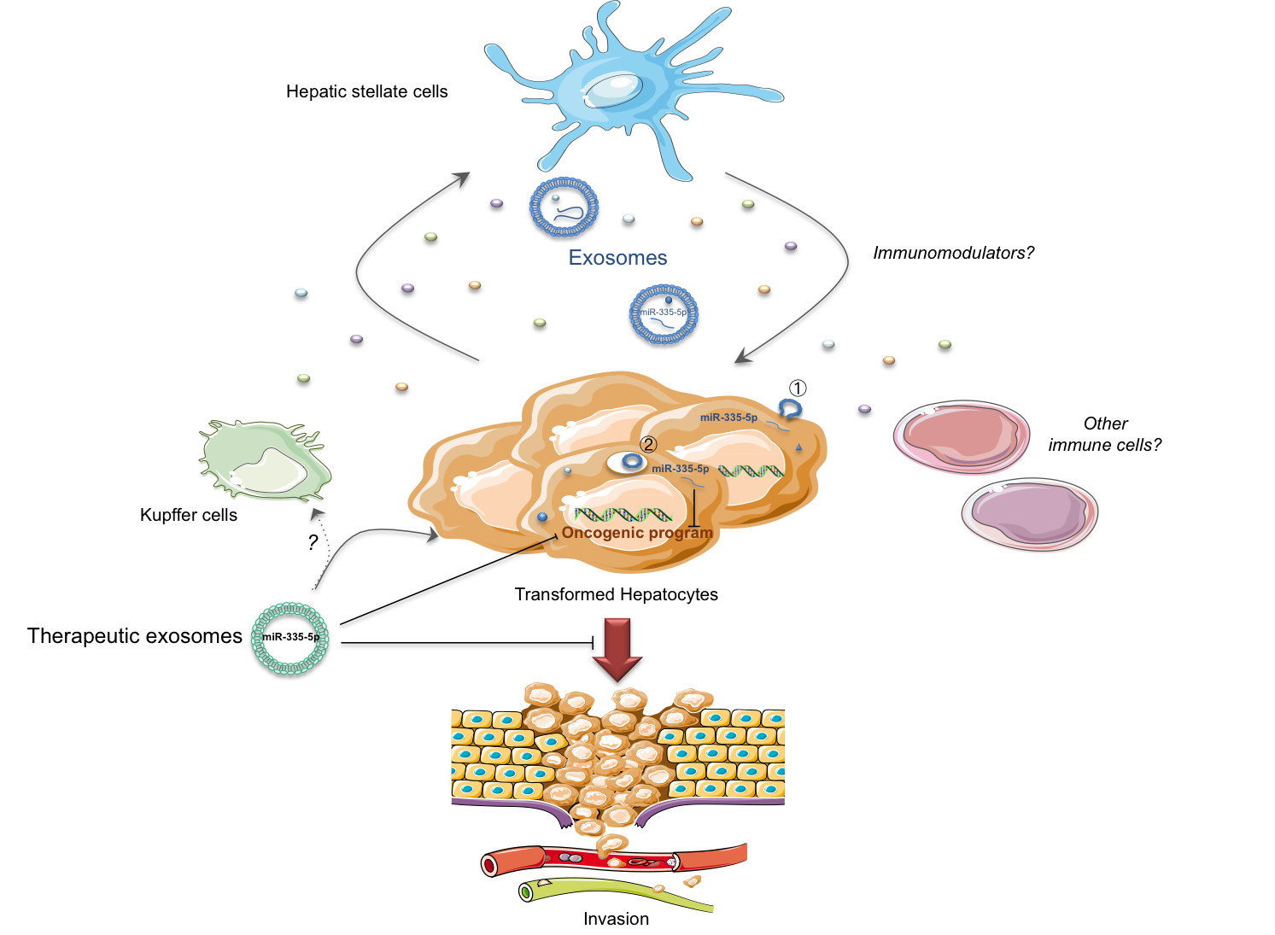

Figure 1 An exosomal miR-335-5p-based therapy for hepatocellular carcinoma. In case of hepatocellular carcinoma (HCC), miR-335-5p is lost in cancer cells favoring cell proliferation and invasion. The hepatic stellate cells could counteract these pro-malignant features by secreting exosomes containing among other nucleic acids, miRNAs including miR-335-5p, which are captured by HCC cells by a direct fusion with recipient cell membrane (1) or by endocytosis (2). Mimicking this biological process, therapeutic exosomes, either isolated from patients or bioengineered exosome mimetics, loaded with miR-335-5p might slow cell proliferation, promote apoptosis and limit cell invasion. It remains to determine if other immune cells could participate to this material transfer and which immunomodulators could regulate this exchange.

