BAISHIDENG PUBLISHING GROUP CO., LIMITED COPYRIGHT ASSIGNMENT

Name of Journal: World Journal Of Gastroenterology

ESPS Manuscript No: 3452

Title: An Ironic Case of Liver infections: Yesrsinia Enterocolitis in the Setting of Thalassemia

Authors (typed): Nathan Selsky

This manuscript is not being considered by other journals, and there is no redundant publication, plagiarism, data fabrication or falsification. There are no conflicts of interest within this paper. All material in this manuscript is original, except when appropriately referenced. I agree to transfer to Baishideng Publishing Group Co., Limited all rights of the manuscript, including: (1) all copyright ownership in both print and electronic formats; (2) the right to grant permission to republish or reprint the stated material in whole or in part, with or without a fee; (3) the right to print copies for free distribution or sale; and (4) the right to republish the stated material in a collection of articles or in any other format. Articles published by this publisher are distributed under the terms of the Creative Commons Attribution Non-commercial License, which permits use, distribution, and reproduction in any medium, provided the original work is properly cited, the use is non-commercial and is otherwise in compliance with the license.

There are no grammar, syntax, spelling, punctuation or logic errors and all figures and tables have been correctly placed and clearly indicated. The references are numbered in the order they appear in the text.

1st Author
Last Name: Nathan Selsky
First Name (all in abbreviation): Selsky N
Signature: 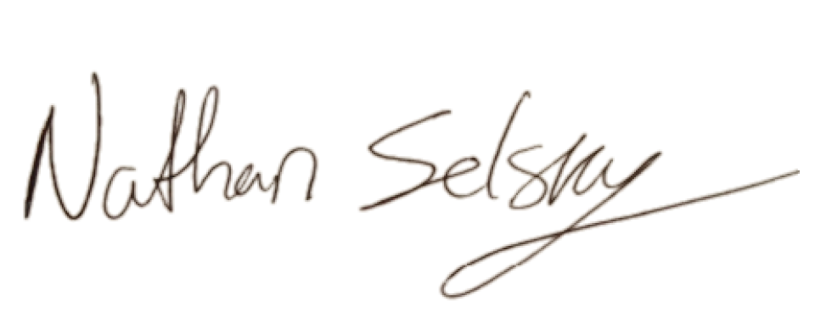
Date: 6/6/13

