Name of journal: World Journal of Gastroenterology
ESPS Manuscript NO: 11207
Columns: Retrospective study

Study of human papillomavirus prevalence in esophageal carcinoma cases from Tang Shan, China

Mehryar MM et al. HPV and esophageal carcinoma

Mohammadreza Mohammadzad Mehryar, Shu-Ying Li, Jin-Tao Li, Hong-Wei Liu, Fan Li, Fang Zhang, Yu-Bai Zhou, Yi Zeng

Mohammadreza Mohammadzad Mehryar, Jin-tao Li, Fan Li, Fang Zhang, Yu-bai Zhou, Yi Zeng, Beijing Key Laboratory of Environmental and Viral Oncology, College of Life Science and Bio-Engineering, Beijing University of Technology, Beijing 100124, China

Mohammadreza Mohammadzad Mehryar, Jin-tao Li, Yi Zeng, National Institute for Viral Disease Control and Prevention, Chinese Center for Disease Control and Prevention, and State Key Laboratory for Infectious Disease Prevention and Control, Beijing 100052, China

Shu-Ying Li, Department of Pathogenic Biology, College of Basic Medicine, Hebei United University, Tangshan 063000, Hebei province, China

Hong-wei Liu, Key Laboratory of Southwest China Wildlife Resources Conservation (Ministry of Education) College of Life Sciences, China West Normal University, Nanchong 637000, Sichuan Province, China

Author contributions: Mehryar MM contributed to this work; Li JT, Zeng Y designed research; Liu HW, Li F and Zhang F performed research; Zhou yb analyzed data; and Mehryar mm wrote the paper.

Correspondence to: Jin-tao Li, PhD, National Institute for Viral Disease Control and Prevention, Chinese Center for Disease Control and Prevention, and State Key Laboratory for Infectious Disease Prevention and Control, 100 Yingxin Street, Xuan Wu District, Beijing 100052, China. ljt2000593@163.com

Telephone: +86-10-67392780 Fax: +86-10-67392780
Received: May 8, 2014 Revised: June 27, 2014
Accepted: October 14, 2014

Published online:

Abstract
Aim: to study human papillomavirus (HPV) prevalence in paraffin embedded tissues with oesophageal carcinoma diagnosis from Tang Shan, China, as a high incidence area.

METHODS: One hundred and ninety-eight cases that were pathologically diagnosed as oesophageal squamous cell carcinoma were obtained from department of pathology files at Tang Shan, 2011-2013.DNA material for polymerase chain reaction (PCR) of HPV was extracted from formalin-fixed paraffin-embedded (FFPE) tissue of 198 cases. Beta globin PCR was done for all extracted DNA material to check the quality of DNA extraction procedure. PCR was performed to detect common HPV and type specific PCR was done for HPV16/18types. In this study negative and positive control were used for HPV 16/18.

Results: In this study DNA extracting method seems to be more effective than other methods previously reported. After DNA extraction more than 98% of FFPE had acceptable result in DNA qualification test, Beta globin PCR. Overall prevalence of HPV in tumour tissues was 79.79% in GP6+/GP5+ PCR as well as 40.40% and 47.47% for HPV 16 and 18 respectively. PCR demonstrated that HPV was present and consequently, direct sequencing confirmed genotypes. To evaluate the HPV types, all HPV-positive PCR products checked by DNA sequence analysis by DNA man and compared with the known HPV sequences according to data-base in BLAST (basic local alignment search). This analyse confirmed existence of HPV types 16 and 18. The HPV18 was the most common subtype (47.47%) whereas the HPV16 occurred at lower frequency (40.40%).

Conclusion: This study showed a presence of HPV DNA in oesophagus tumours (high risk HPV types 16 and 18), implicated HPV as one of the possible aetiology in oesophageal squamous cell carcinoma. In this study 198 oesophagus tumour tissues of Tangshan area of China as a high incidence area of oesophageal squamous cell carcinoma were tested for HPV DNA and high prevalence of high risk HPV DNA supported the hypothesis that HPV can be the possible aetiology of oesophagus squamous cell carcinoma.

© 2014 Baishideng Publishing Group Inc. All rights reserved.

Key words: oesophageal squamous cell carcinoma; Formalin fixed paraffin embedded tissue; Polymerase chain reaction; Human papilloma virus; Oesophageal carcinoma

Core tip: China considered as a high incidence country of esophageal cancer. There are a lot of causes considered as esophageal cancer etiology. In China human papilloma virus infection could be an important cause of esophageal cancer. Hebei Tangshan is one of high incidence area of esophageal cancer in China. There is no large sample analysis of human papillomavirus (HPV)existence rate in this area. We took 198 Tangshan esophageal cancer samples and analysed HPV existence rate and infection types in cancerous tissues. It has important significance to analyse the causes of local esophageal cancer, if HPV prevalence exists.

Mehryar MM, Li SY, Li JT, Liu HW, Li F, Zhang F, Zhou YB, Zeng Y. Study of human papillomavirus prevalence in esophageal carcinoma cases from Tang Shan, China. World J Gastroenterol 2014; In press

Introduction
Esophageal cancer is the 8th most common cancer and the 6th most common cause of deathin the world^{[1]}. Human papillomavirus belongs to group of non- enveloped, double- stranded DNA viruses that until now more than 100 genotype of this virus have been recognised. Many molecular and epidemiological studies have confirmed that Human papillomavirus, especially high risk HPV, has an important role in the development of cervical cancer^{[2,3]}. To start malignancy procedure of cervical epithelia, HPV DNA must be integrated into the host cell genome^{[4]}. Number of studies have done on HPV role in extra-genital cancers, but there are conflicts in involvement of HPV in these cancers^{[5,6]}. In 1982, for the first time, Syrijnen reported HPV probable involvement in oesophageal squamous cell carcinoma. After that so many researchers were interested in HPV infection as a possible cause for ESCC development (Syrjanen 1982)^{[7]}. A comprehensive review in 2002 reported that HPV was positive in 22.9% of 1485 ESCC samples evaluated by in situ Hybridization (ISH) and in 15.2% of 2020 ESCC cases checked by polymerase chain reaction (Syrjanen 2002)^{[8]}. Oesophagus cancer usually begins from epithelial layer of the oesophagus. 90% of esophageal cancers are squamous cell carcinomas. Although in some countries such as United States, their frequency is almost similar to that of adenocarcinomas^{[9]}. According to different studies in all around the world, oesophageal cancer, because of unknown factors, shows different frequency rates between countries, as well as between different regions of same countries. With regard to the WHO reports, West Africa is considered as the low-risk end, and China as the high-risk end^{[10]}. In American countries, Peru and Mexico have the lowest mortality rate for oesophageal carcinoma, and Argentina, Chile and Brazil have the highest rate^{[11]}. A lot of studies have done in different areas of China but there are conflicts in results. HPV studies in Anyang, Shandong and Gansu areas of China confirmed the presence of HPV genome, especially high-risk types^{[12]}. Butthis finding wasn’t supported by another study conducted in Linxian, China^{[13]}.
Studies on HPV involvement in oesophageal cancer have conflicting results, with 0% to 71% prevalence rates^{[14]}. Variations in the specificity and sensitivity of the evaluation techniques are probable cause of these differences. Polymerase chain reaction is the fast and sensitive method for detecting DNA in any kind of sample. But in studies use PCR using suitable pair of primers is very critical^{[15]}.
Because collecting fresh particular cancerous tissues in large scale is too hard and in the other hand by examining of fresh tissues we just can evaluate samples of short period of time, so, in this study, formalin-fixed paraffin-embedded archived tissue were used.
There are some methods to examining PETs (paraffin embedded tissues) such as Immunohistochemistry method or the other methods to examine DNA or RNA of PETs sections after extraction of DNA or RNA. Among different methods, polymerase chain reaction (PCR) has confirmed to be a rapid and particularly sensitive method for examining DNA from PETs. Adequate storage of samples and undertaking a procedure to produce high quality extracted DNA, are important factors for obtaining successful results from PCR.

MATERIALS AND METHODS
Tissue collection
Samples of esophageal squamous cell carcinoma were obtained from files in department of pathology in Tang Shan during the period between2011-2013. Samples were totally 198 formalin-fixed paraffin embedded tissue blocks of histologically confirmed esophageal squamous cell carcinoma.

DNA extraction
Formalin-fixed paraffin embedded blocks of tissues were cut in 20 μm sections and then were de-waxed by 2 h incubation in pure xylene with remixing tube continents every 45 min. This step repeated for 7 times and then de-waxed samples were washed and dehydrated with 100% ethanol for 6 times and then were dried in room temperature. Deparaffinised samples were digested with 600 μl of lysing buffer was made as follow: Tris-HCL 10 mmol/L PH 8.0, EDTA 0.1 mol/L PH 8.0, SDS 0.5% and RNA-aseA 20 μg/ml. Then added 20 μl proteinase 20 μg/ml and after mixing, tubes were incubated in 55ºC for 12 h, with remixing contents of tubes every 2 h. After complete digestion, DNA was extracted with phenol/chloroform precipitation. This process was done 2 times for every sample and then followed by 1 time phenol/chloroform precipitation. DNA was precipitated with 100% ethanol and incubated in -20 ºC for one night. After precipitating of DNA, tubes centrifuged in high speed (13000 rpm for 15 min) and then rewashed with 75% ethanol and dried in room temp. Eighty μl TE buffer added to every tube and tubes were incubated in 4 ºC for a few hours to dissolving precipitated DNA.

PCR
To test DNA extraction performance, the obtained DNA was amplified for beta-globin gene with usage of Takara PCR kit and primers of PC04/GH20 (table 1).
In this study GP5+/GP6+ set primer (table 1) with alowannealing temperature and small PCR product of 150bp were used to detect a wide range of HPV types^{[16-18]}. To specialize detection of HPV 16 and 18, two set primers (table 1) were used that annealing temperature and PCR product of these two sets are mentioned in table1. In each batch, water used as negative control and genome of HPV positive cervical cells considered as positive control. PCR products were checked on 1.0% Agar gel and visualised by staining (DMSO).

Sequencing of PCR products
To identify the HPV types and any variation in sequence, all PCR positive products were sequenced and analysed by using the T7 sequence version 2.0 DNA PCR product sequencing kit. For confirmation, nucleotide sequences were subsequently checked by basic local alignment search (BLAST).

Results
First of all we should mention that to confirm the existence of PCR product of interest, all PCR processes were done twice. The first time PCR products were used as the template of the secondary PCR. In the second time PCR, amount of all PCR mixture materials except to template of 8μl were similar to the first time PCR process. Table 2 summarized the result of every PCR process of 198 ESCC cases examined in this study. All results are shown in this table are the second time PCR results.

Beta globin(PC04/GH20) PCR
In this study DNA extracting method seems to be more effective than other methods previously reported. After DNA extraction, for testing quality of extracted DNA, all samples subjected to beta-globin PCR. Of all 198 ESCC cases, in more than 190 (more than 98%) DNA quality was good. PCR using the PC04/GH20 primer pair resulted in very clear differentiate seized DNA fragment of 150 bp (Figure 1).

General HPV PCR GP5+/GP6+
After beta-globin PCR, all 198 samples were examined by using GP5+/GP6+ primer set to visualize HPV-positive cases in agar gel. PCR using the GP5+/GP6+ primer pair resulted in a very clear differentiate seized DNA fragment of 150 bp (Figure 2). Of all 198 specimens, 158 (79.79%) were positive for HPV, with the presence of the 150 bp PCR product.

Type specific HPV16/18 PCR
All samples were amplified with the HPV16 and 18 specified primer sets of JHPV16E6F/JHPV16E6Rfor HPV 16 and X18E6F/X18E6R for HPV 18 with the sequences mentioned in table 1. These two PCR processes yielded intense band of the correct size of 350 bp for HPV 16 and 350 bp for HPV 18 (Figure 3). Of all 198 cases, 80 (40.40%) were positive for HPV16 and 94 (47.47%) were positive for HPV 18, by checking the presence of corresponding PCR product(table 2).

Sequencing PCR products
To identify the HPV types, all HPV-positive PCR products were analysed by DNA man for DNA sequence and the results compared with the known HPV sequences in the DNA database using BLAST (basic local alignment search). The specimens were shown to contain DNA of HPV types 16 and 18. The HPV18 was the most common subtype (47.47%)whereas the HPV16 occurred at lower frequency (40.40%) (Table 2). DNA analysing software results, as shown in (Figure 4), confirmed the presence of HPV DNA with a few mutations in virus DNA.

Discussion
esophageal squamous cell carcinoma is one of the high mortality cancers in the world. In some countries, with low prevalence of ESCC, using tobaccoand alcohol drinking could be the main reason of ESCC. But in regions with high incidence of ESCC, like China and in some regions such as north of Iran, only a small ratio of ESCC cases could be related to smoking or alcohol consumption. So, other risk factors should be considered for the high incidence of ESCC in some areas like Iran or China. Some of probable factors that could be responsible for this high incidence, include low intake of fruits and vegetables, drinking hot tea, consumption of opium products and tobacco, Helicobacter pylori, contaminated water source and genetic susceptibility^{[19]}.Polycyclic Aromatic Hydrocarbons and N-Nitroso compound are the most important mutagens that cause esophagus cancer^{[20]}. After the firststudy by Syrjanen in 1982, several studies have been done in different countries and in different parts of the same country to identify and confirm the HPV involvement in ESCC. Since 1982 many studies have shown the presence of HPV genome in DNA isolated from esophageal cancer tissues, but there were conflicts in results ^{[21-28]}. In the other hand, there are differences in the HPV prevalence rates from the same areas. For example in Iran, a high incidence rate in north of Iran, 36.8% HPV infection in ESCC was reported by Farhadi et al^{[29,30]} but another study in that country in other city (Shiraz) on 92 cases of ESCC showed no HPV infection. For another example we can mention China and Australia. Similar study, from Australia with usage the same evaluation method there are different reports of 50% and 23% in cases with esophageal cancer^{[31,32]}. By using molecular methods, the majority of these studies have shown the presence of high- risk HPV in a variable Proportion of cases^{[33-35]}; however, have failed to demonstrate HPV etiologic EC, even from highly prevalent regions^{[13,36]}.In this study we tested 198 cases with a pathological diagnosis of oesophageal squamous cell carcinoma. In this evaluation we found HPV DNA with high prevalence around totally 67% of total cases, include 40.40% and 47.47% for HPV16 and 18 respectively. This frequency in compare to some previous studies in other regions of this country (China) is clearly high. On the other hand another study in the other regions of China, Shandong and Gansu, indicated not so similar results. In that study, evaluation methods were almost the same, PCR, and samples were also the same type (paraffin embedded cancerous tissues) but the results weren’t as high as the evaluation was done in the other region, Shantou. HPV prevalence in this study was 19% HPV positive samples in compare to prevalence of 77.2% detection of HPV DNA in previous evaluation in the other region (Shantou)^{[10,37]}.With regard to studies previously have done in high incidence areas all around the world such as in China or the other high incidence regions in other countries, HPVDNA was detected in almost samples and these results can implicate HPV virus as a suspected causative agent beside of the other etiologies, environmentalor genetic. About the controversial results in different countries or sometime in different regions of the same country, there are several suspected reasons that we can mention the sample preparation (includes all process from cutting suspected tissue by surgeon during surgery to DNA extraction process and DNA analysing for virus genome), evaluation methods sensitivity (any item related to analysing HPV genome, for example instruments sensitivity and using high quality materials during DNA analysing in PCR procedure) and regional diet habits or other special costumes. In conclusion, a potential role of HPV in the development of esophageal squamous carcinoma has emerged as a result of the HPV-like histological changes in mucosa of patients with esophageal cancer and the presence of HPV antigens and HPV DNA in cancerous tissues. Although various types of HPV were been detected by PCR amplification or other methods, clear evidence of etiologic significance of HPV in esophageal squamous cell cancer is still lacking.
With regard to this fact that in Tangshan region of China hasn’t done any study about relation between HPV and esophagus cancer, we hope this study leads to do other efforts to confirm etiologic significance of HPV in esophagus squamous cell carcinoma.

Comments
Background
since 1982, first time human papilloma virus (HPV) was introduced as one of the possible agents in esophageal squamous cell carcinoma, until now many studies have done to prove this relation; but results were controversial.

Research frontiers
In this study we focused on Tangshan, China, as one of high incidence areas of oesophagus squamous cell carcinoma.

Innovations and breakthroughs
In this study we had a total positive result of 79.79% for HPV-16 and 18 and differentially 40.40% and 47.47% for HPV-16 and 18 respectively. In China we can also find conflicting results from different regions in the range of 0% to 71%.

Applications
One possible reason for these differences is using different evaluation methods. In this study the most sensitive and common method (PCR) was used to evaluate cancerous tissues. It is better to use another complementary methods to confirm the PCR results.

Peer review
This study introduced HPV virus as a probable cause of esophagus carcinoma but for confirmation of this involvement, other studies in different areas by using other methods are necessary. One problem in this evaluation was finding negative control, normal esophagus tissue is too difficult to obtain. This study can give others new idea to use another methods or other studies in other regions to clarify etiologic significance of HPV in esophagus squamous cell carcinoma.

References
1 Ferlay J, Shin HR, Bray F, Forman D, Mathers C, Parkin DM. Estimates of worldwide burden of cancer in 2008: GLOBOCAN 2008. Int J Cancer 2010; 127: 2893-2917 [PMID: 21351269 DOI: 10.1002/ijc.25516]
2 Muñoz N, Bosch FX, de Sanjosé S, Shah KV. The role of HPV in the etiology of cervical cancer. Mutat Res 1994; 305: 293-301 [PMID: 8121439 DOI: 10.1016/0027-5107(94)90249-6]
3 Walboomers JM, Jacobs MV, Manos MM, Bosch FX, Kummer JA, Shah KV, Snijders PJ, Peto J, Meijer CJ, Muñoz N. Human papillomavirus is a necessary cause of invasive cervical cancer worldwide. J Pathol 1999; 189: 12-19 [PMID: 10451482 DOI: 10.1002/(SICI)1096-9896(199909)189:1<12::AID-PATH431>3.0.CO;2-F]
4 zur Hausen H. Human papillomaviruses in the pathogenesis of anogenital cancer. Virology 1991; 184: 9-13 [PMID: 1651607 DOI: 10.1016/0042-6822(91)90816-T]
5 Gillison ML, Shah KV. Chapter 9: Role of mucosal human papillomavirus in nongenital cancers. J Natl Cancer Inst Monogr 2003; (31): 57-65 [PMID: 12807947 DOI: 10.1093/oxfordjournals.jncimonographs.a003484]
6 Snijders PJ, Steenbergen RD, Meijer CJ, Walboomers JM. Role of human papillomaviruses in cancer of the respiratory and upper digestive tract. Clin Dermatol 1997; 15: 415-425 [PMID: 9255447 DOI: 10.1016/S0738-081X(96)00156-3]
7 Syrjänen KJ. Histological changes identical to those of condylomatous lesions found in esophageal squamous cell carcinomas. Arch Geschwulstforsch 1982; 52: 283-292 [PMID: 7138240]
8 Syrjänen KJ. HPV infections and oesophageal cancer. J Clin Pathol 2002; 55: 721-728 [PMID: 12354793]
9 Noori S, Monabati A, Ghaderi A. The prevalence of human papilloma virus in esophageal squamous cell carcinoma. Iran J Med Sci 2012; 37: 126-133 [PMID: 23115442]
10 Stewart BW, Kleihues P, eds. World cancer report. Lyon: IARC press, 2003: 223-227
11 Bosetti C, Malvezzi M, Chatenoud L, Negri E, Levi F, La Vecchia C. Trends in cancer mortality in the Americas, 1970-2000. Ann Oncol 2005; 16: 489-511 [PMID: 15668262 DOI: 10.1093/annonc/mdi086]
12 Li T, Lu ZM, Chen KN, Guo M, Xing HP, Mei Q, Yang HH, Lechner JF, Ke Y. Human papillomavirus type 16 is an important infectious factor in the high incidence of esophageal cancer in Anyang area of China. Carcinogenesis 2001; 22: 929-934 [PMID: 11375901 DOI: 10.1093/carcin/22.6.929]
13 Gao GF, Roth MJ, Wei WQ, Abnet CC, Chen F, Lu N, Zhao FH, Li XQ, Wang GQ, Taylor PR, Pan QJ, Chen W, Dawsey SM, Qiao YL. No association between HPV infection and the neoplastic progression of esophageal squamous cell carcinoma: result from a cross-sectional study in a high-risk region of China. Int J Cancer 2006; 119: 1354-1359 [PMID: 16615110 DOI: 10.1002/ijc.21980]
14 Sur M, Cooper K.The role of the human papilloma virus in esophageal cancer. Pathology 1998; 30: 348-354 [PMID: 9839308]
15 Van den Brule AJC, Snijders PJF, Meijer CJLM, Walboomers JMM. PCR-based detection of genital HPV genotype: an update and future perspectives. Papillomavirus report 1993; 4: 95-99
16 Qu W, Jiang G, Cruz Y, Chang CJ, Ho GY, Klein RS, Burk RD. PCR detection of human papillomavirus: comparison between MY09/MY11 and GP5+/GP6+ primer systems. J Clin Microbiol 1997; 35: 1304-1310 [PMID: 9163434]
17 Baay MF, Quint WG, Koudstaal J, Hollema H, Duk JM, Burger MP, Stolz E, Herbrink P. Comprehensive study of several general and type-specific primer pairs for detection of human papillomavirus DNA by PCR in paraffin-embedded cervical carcinomas. J ClinMicrobiol 1996; 34: 745-747 [PMID: 8904451]
18 Zehbe I, Wilander E. Two consensus primer systems and nested polymerase chain reaction for human papillomavirus detection in cervical biopsies: A study of sensitivity. Hum Pathol 1996; 27: 812-815 [PMID: 8760015 DOI: 10.1016/S0046-8177(96)90454-2]
19 Farhadi M, Tahmasebi Z, Merat S, Kamangar F, Nasrollahzadeh D, Malekzadeh R. Human papillomavirus in squamous cell carcinoma of esophagus in a high-risk population. World J Gastroenterol 2005; 11: 1200-1203 [PMID: 15754405]
20 Sadjadi AR, Marjani H, SemnaniSh, Naseri-Mogaddam S. Oesophageal cancer in Iran: a review. Middle East J cancer 2010; 1: 5-14
21 Sagar PM. Aetiology of cancer of the oesophagus: geographical studies in the footsteps of Marco Polo and beyond. Gut 1989; 30: 561-564 [PMID: 2659440 DOI: 10.1136/gut.30.5.561]
22 Chalasani N, Wo JM, Waring JP. Racial differences in the histology, location, and risk factors of esophageal cancer. J Clin Gastroenterol 1998; 26: 11-13 [PMID: 9492855 DOI: 10.1097/00004836-199801000-00004]
23 Sitas F, Madhoo J, Wessie J. Incidence of histologically diagnosed cancer in south Africa. Johannesburg: south Africa Institute for medical research, 1998
24 Loke SL, Ma L, Wang M. Human papillomavirus in oesophageal squamous cell carcinoma.J Clin Pathol 1990; 27: 812-815
25 West AB, Soloway GN, Lizarraga G, Tyrrell L, Longley JB. Type 73 human papillomavirus in esophageal squamous cell carcinoma: a novel association. Cancer 1996; 77: 2440-2444 [PMID: 8640690 DOI: 10.1002/(SICI)1097-0142(19960615)77:12<2440::AID-CNCR4>3.0.CO;2-Q]
26 Poljak M, Cerar A, Seme K. Human papillomavirus infection in esophageal carcinomas: a study of 121 lesions using multiple broad-spectrum polymerase chain reactions and literature review. Hum Pathol 1998; 29: 266-271 [PMID: 9496830 DOI: 10.1016/S0046-8177(98)90046-6]
27 Miller BA, Davidson M, Myerson D, Icenogle J, Lanier AP, Tan J, Beckmann AM. Human papillomavirus type 16 DNA in esophageal carcinomas from Alaska Natives. Int J Cancer 1997; 71: 218-222 [PMID: 9139846 DOI: 10.1002/(SICI)1097-0215(19970410)71:2<218::AID-IJC16>3.0.CO;2-D]
28 Chang F, Syrjänen S, Shen Q, Wang L, Wang D, Syrjänen K. Human papillomavirus involvement in esophageal precancerous lesions and squamous cell carcinomas as evidenced by microscopy and different DNA techniques. Scand J Gastroenterol 1992; 27: 553-563 [PMID: 1322555 DOI: 10.3109/00365529209000119]
29 Chang F, Syrjänen S, Shen Q, Wang L, Syrjänen K. Screening for human papillomavirus infections in esophageal squamous cell carcinomas by in situ hybridization. Cancer 1993; 72: 2525-2530 [PMID: 8402471 DOI: 10.1002/1097-0142(19931101)72:9<2525::AID-CNCR2820720902>3.0.CO;2-L]
30 Lu S, Luo F, Li H. [Detection of human papilloma virus in esophageal squamous cell carcinoma and adjacent tissue specimens in Linxian]. Zhonghua Zhong Liu Za Zhi 1995; 17: 321-324 [PMID: 8697965]
31 Kulski J, Demeter T, Sterrett GF, Shilkin KB. Human papilloma virus DNA in oesophageal carcinoma. Lancet 1986; 2: 683-684 [PMID: 2876149 DOI: 10.1016/S0140-6736(86)90187-X]
32 Kulski JK, Demeter T, Mutavdzic S, Sterrett GF, Mitchell KM, Pixley EC. Survey of histologic specimens of human cancer for human papillomavirus types 6/11/16/18 by filter in situ hybridization. Am J Clin Pathol 1990; 94: 566-570 [PMID: 2173398]
33 Yao PF, Li GC, Li J, Xia HS, Yang XL, Huang HY, Fu YG, Wang RQ, Wang XY, Sha JW. Evidence of human papilloma virus infection and its epidemiology in esophageal squamous cell carcinoma. World J Gastroenterol 2006; 12: 1352-1355 [PMID: 16552800]
34 Matsha T, Erasmus R, Kafuko AB, Mugwanya D, Stepien A, Parker MI. Human papillomavirus associated with oesophageal cancer. J Clin Pathol 2002; 55: 587-590 [PMID: 12147651 DOI: 10.1136/jcp.55.8.587]
35 Shuyama K, Castillo A, Aguayo F, Sun Q, Khan N, Koriyama C, Akiba S. Human papillomavirus in high- and low-risk areas of oesophageal squamous cell carcinoma in China. Br J Cancer 2007; 96: 1554-1559 [PMID: 17453003]
36 Kamangar F, Qiao YL, Schiller JT, Dawsey SM, Fears T, Sun XD, Abnet CC, Zhao P, Taylor PR, Mark SD. Human papillomavirus serology and the risk of esophageal and gastric cancers: results from a cohort in a high-risk region in China. Int J Cancer 2006; 119: 579-584 [PMID: 16496409 DOI: 10.1002/ijc.21871]
37 Zhang QY, Zhang DH, Shen ZY, Xu LY, Li EM, Au WW. Infection and integration of human papillomavirus in esophageal carcinoma. Int J Hyg Environ Health 2011; 214: 156-161 [PMID: 21130683]

P-Reviewer: Tovey fi S-Editor: Ma YJ L-Editor: E-Editor:

Table 1 Primers used in polymerase chain reaction amplification of human papillomavirus DNA showing the corresponding annealing temperature and polymerase chain reaction product sizes

Primers | sequences | Annealing temperature | polymerase chain reaction product
PC04  GH20 | 5’-CAACTTCATCCACGTTCACC-3’ | 62 ºC | 150 bp
 | 5’-GAAGAGCCAAGGACAGGTAC-3’
GP5+ | 5’-TTTGTTACTGTGGTAGATACTAC-3’ | 55 ºC | 150 bp
GP6+ | 3’-CTTATACTAAATGTCAAATAAAAAG-5’
HPV16E6F  R | 5’-CAACAAGACATACATCGACC-3’ | 60 ºC | 350 bp
 | 5’-CAACAAGACATACATCGACC-3’
HPV18E6F  R | 5’-CACTTCACTGCAAGACATAGA-3’ | 55 ºC | 350 bp
 | 5’-GTTGTGAAATCGTCGTTTTTCA-3’
M, A+C; R, A+G; W, A+T; Y,C+T.
Table 2 polymerase chain reaction human papillomavirus detection frequency according to different primers

Set of used primers | Total number of tested cases | Number of positive cases | Percent of positive cases
PC04/GH20 | 198 | 196 | > 98%
GP5+/GP6+ | 198 | 158 | 79.79%
HPV 16 | 198 | 80 | 40.40%
HPV 18 | 198 | 94 | 47.47%
GP+ and HPV16/18-¹ | 198 | 13 | 6.5%
HPV 16 and 18 | 198 | 55 | 27.77%
HPV16or18 | 198 | 119 | 60.1%
GP and HPV16 and 18 | 198 | 48 | 24.24%
GP+/HPV16+/HPV18+² | 198 | 185 | 93%

¹GP5+/GP6+ positive but HPV16/18 negative; ²GP5+/GP6+ positive or HPV16 positive or HPV18 positive. HPV: human papillomavirus.

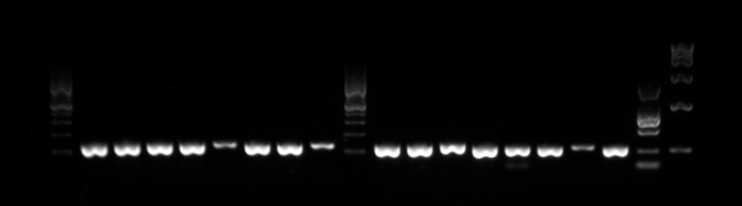
Beta globin
150 bp

1 Kb marker
5 Kb marker

Figure 1 Beta globin polymerase chain reaction result and clear differentiated seized DNA fragment of 150 bp.

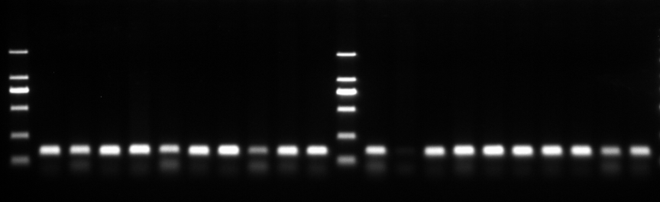
Figure 2 GP5+/GP6+ polymerase chain reaction and very clear differentiate seized DNA fragment of 150 bp.

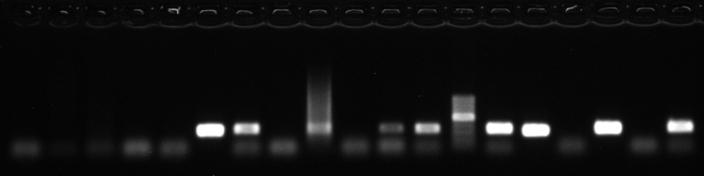
A

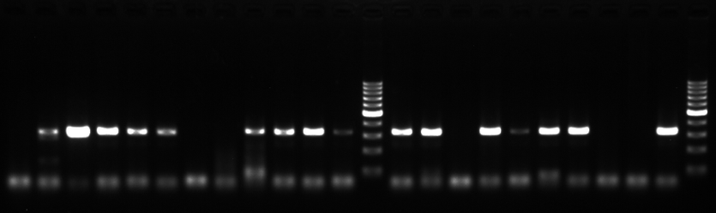
b
Figure 3 human papillomavirus 16 (A) and 18 (b) polymerase chain reaction and 350 bp DNA fragment in the result.

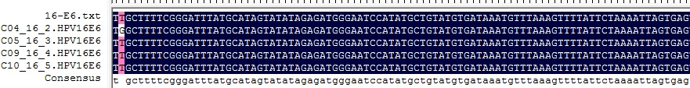
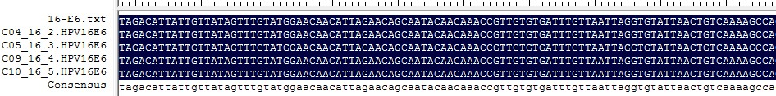
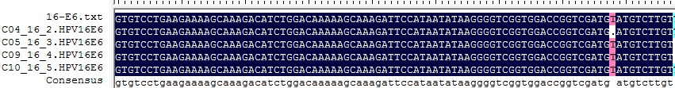

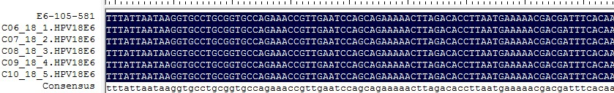
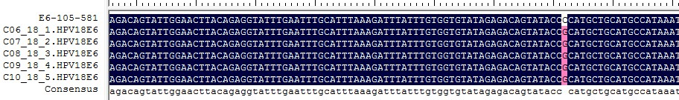
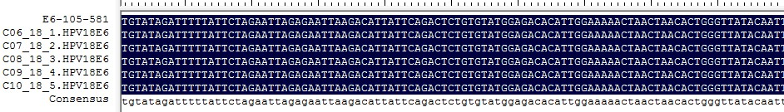
A

B
Figure 4 Sequencing result human papillomavirus 16E6in three samples with some mutation (A) and 18E6 in three samples with one mutation (b).

