Name of journal: World Journal of Gastroenterology
ESPS Manuscript NO: 1668
Columns: LETTERS TO THE EDITOR

Response letter regarding the interpretation of gene expression data

Ozmen F. Interpretation of gene expression data

Ozmen F

Fusun Ozmen, Department of Basic Oncology, Cancer Institute, Hacettepe University, 06280 Ankara, Turkey

Author contribution: Ozmen F wrote this letter.

Correspondence to: Fusun Ozmen, MD, PhD, Department of Basic Oncology, Cancer Institute, Hacettepe University, 06280 Ankara, Turkey. fusun.ozmen@hacettepe.edu.tr

Telephone: +90-312-3054322 Fax: +90-312-3242009
Received: December 26, 2012 Revised: January 10, 2013
Accepted: January 18, 2013

Published online:

Abstract
This is a response letter to E Verna's comments regarding our previous manuscript published last year in the World Journal of Gastroenterology entitled 'Relationship between LYVE-1, VEGFR-3 and CD44 gene expressions and lymphatic metastasis in gastric cancer', which evaluated the relationship between these expression levels and clinicopathological parameters (Ozmen F et al, World J Gastroenterol 2011;17:3220-3228). The mean values for LYVE1, CD44 and VEGFR3 expression (represented as 2 ^{-ΔΔCt}) were 1.13, 1.24 and 1.17, respectively, suggesting an increase in gene expression in tumour tissue compared to normal tissue. Despite the increase in gene expression in the cancer tissues (2-^{ΔΔCt} > 1), only some of the results reached statistical significance, which was thoroughly discussed in our paper. In the present letter, we report that his comments are flawed and result in confusion. Therefore, we herein provide more explanation regarding gene expression in gastric cancer. We hope that this letter will address E Verna's misunderstandings.

© 2013 Baishideng. All rights reserved.

Key words: Gastric Cancer; Lymphatic metastasis; LYVE1; VEGFR3; CD44

Ozmen F. Interpretation of gene expression data. World J Gastroenterol 2013; 19
Available from: URL:
DOI:

TO THE EDITOR
I recently noticed that a letter to the editor written by Verna E, regarding our published paper (Ozmen F et al, World J Gastroenterol 2011;17:3220-3228), had been published in the June issue of the journal this year (Verna E. World J Gastroenterol 2012; 18(24): 3181-3182 )^{[1,2]}.
Although I would like to thank Dr Verna for his interest and for providing us with this opportunity to address his concerns, I have to stress that it is very important to understand the entirety of the paper before coming to certain conclusions: (1) Our study investigated the expression levels of the LYVE-1, VEGFR-3, and CD44 genes in human tissues with or without tumour using real-time polymerase chain reaction (RT-PCR) and evaluated the relationship in gastric cancer between these expression levels and clinicopathological parameters that included tumour type, stage, differentiation, and the presence of lymph node metastasis, vascular invasion, and neural/perineural invasion ^{[1]}. (2) Relative expression levels were calculated using the PCR cycle threshold number (Ct) for each tissue and control sample using the formula 2^{-(ΔCtsample - ΔCtcontrol)}. ΔCt represents the difference in Ct values between the target and GAPDH transcripts. RT-PCR was performed in duplicate for each sample, and average Ct values were calculated according to the previous papers from Pfaffl^{[3]} and Livak et al^{[4]}, which are references he cited in his letter. (3) It is not clear why he required an explanation of the interpretation of the gene expression data because everyone involved in this type of study is familiar with the analysis. As previously explained by Livak et al^{[4]}, the choice of the calibrator for the 2^{- ΔΔCt} method depends on the type of gene expression experiment that one has planned. The simplest design is to use the untreated control (in our study, the patient’s own normal tissue) as the calibrator and GAPDH as an internal control. Using the 2-ΔΔCt method, the data are presented as the fold change in gene expression normalised to an endogenous reference gene and relative to the normal control. For the control sample, ΔΔCt equals zero, and 2⁰ equals one; as a result, the fold change in gene expression relative to the untreated control equals one, by definition. For the treated samples (tumour tissue), an evaluation of 2 ^{-ΔΔCt} indicates the fold change in gene expression relative to the untreated control. The gene expression levels in tumour tissues represent the difference from normal controls in our study, and all values were shown in figure 2^{[1]}. There were some values over 1, representing increased expression, and there were also values less than 1, representing decreased expression. (4) The mean values for LYVE1, CD44, and VEGFR3 expression (represented as 2 ^{-ΔΔCt} and shown in figure 2) were 1.13, 1.24, and 1.17, respectively, suggesting increased gene expression in tumour tissues compared to normal tissue. Therefore, we believe it is natural to conclude from these results that the expression levels were increased. Despite the increase in gene expression in the cancer tissues (2-^{ΔΔCt} > 1), only some of the results reached statistical significance, which was thoroughly discussed in our paper^{[1]}. (5) In our study, we did not only report the gene expression data, but also presented data obtained using immunohistochemistry, pathology, and other clinical features of the tumours. Although we are commenting on our results, we used all of these data to reach a logical conclusion. As shown in figures 3, 4 and 5, gene expression was increased (2-^{ΔΔCt} > 1) with increased T-stage, a PLN/TLN ratio > 0.4 and the presence of perineural invasion^{[1]}. (6) In our manuscript, we used figure 1 to show the PCR products of the genes. Dr Verna is correct to note that there are some non-specific amplicons of the VEGFR-3 gene in that figure. However, we optimised both the conventional PCR and real-time PCR reactions for the VEGFR-3 gene and also all others, as shown in the lower part of figure 1. It is easy to note that no nonspecific band is present in this reaction for VEGFR-3.
Once again, I would like to thank Dr Verna for his interest in our study and hope that this letter will resolve any misunderstandings.

REFERENCES
1 Ozmen F, Ozmen MM, Ozdemir E, Moran M, Seçkin S, Guc D, Karaagaoglu E, Kansu E. Relationship between LYVE-1, VEGFR-3 and CD44 gene expressions and lymphatic metastasis in gastric cancer. World J Gastroenterol 2011; 17: 3220-3228 [PMID: 21912471]
2 Verna E. More attention should be paid on the interpretation of gene expression data. World J Gastroenterol 2012; 18: 3181-3182 [PMID: 22791956 DOI: 10.3748 /wjg.v18.i24.3181]
3 Pfaffl MW. A new mathematical model for relative quantification in real-time RT-PCR. Nucleic Acids Res 2001; 29: e45 [PMID: 11328886 DOI: 10.1093/nar/29.9.e45]
4 Livak KJ, Schmittgen TD. Analysis of relative gene expression data using real-time quantitative PCR and the 2(-Delta Delta C(T)) Method. Methods 2001; 25: 402-408 [PMID: 11846609 DOI: 10.1006/meth.2001.1262]

P-Reviewer Morise Z S-Editor Wen LL L-Editor E-Editor

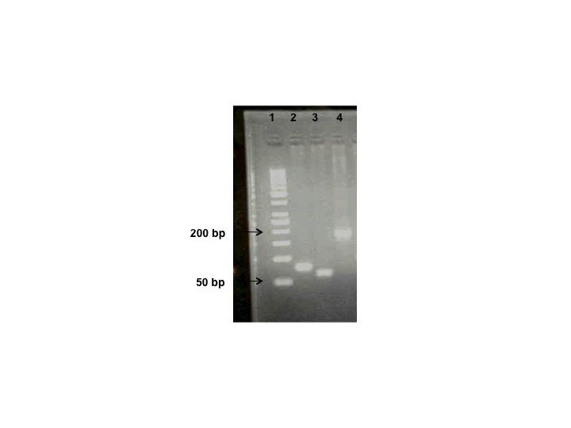
Figure 1 Polymerase chain reaction products of the CD44, VEGFR-3, and LYVE-1 genes. Lane 1: Ladder (50 bp); Lane 2: CD44 (80 bp); Lane 3: VEGFR-3 (63 bp); Lane 4: LYVE-1 (184 bp).

