Name of Journal: World Journal of Clinical Cases
Manuscript NO: 76997
Manuscript Type: ORIGINAL ARTICLE

Retrospective Study
Therapeutic effect of two methods on avulsion fracture of tibial insertion of anterior cruciate ligament

Niu HM et al. Methods on avulsion fracture of tibial insertion of ACL

Hai-Ming Niu, Qing-Chun Wang, Rui-Zhao Sun

Hai-Ming Niu, Qing-Chun Wang, Rui-Zhao Sun, Department of Orthopedics, Guanyun People's Hospital, Lianyungang 222200, Jiangsu Province, China

Author contributions: Niu HM, Wang QC and Sun RZ design the experiment; Niu HM, Wang QC and Sun RZ collected the data; Wang QC and Sun RZ analysed and interpreted data, Niu HM wrote and revised the manuscript.

Corresponding author: Hai-Ming Niu, MD, Chief Physician, Department of Orthopedics, Guanyun People's Hospital, No. 2 West Ring Road, Yishan Town, Guanyun County, Lianyungang 222200, Jiangsu Province, China. nhm1978@163.com

Received: May 6, 2022
Revised: June 11, 2022
Accepted: August 15, 2022
Published online: September 26, 2022

Abstract
BACKGROUND
The tibial stop of anterior cruciate ligament (ACL) is fan-shaped and attached to the medial groove in front of the intercondylar spine, which is located between the anterior horn of the medial and lateral meniscus. The incidence of this fracture is low previously reported, which is common in children and adolescents. With the increase of sports injury and traffic injury and the deepening of understanding, it is found that the incidence of the disease is high at present.

AIM
To explore the difference between open reduction and internal fixation with small incision and high-intensity non-absorbable suture under arthroscopy in the treatment of tibial avulsion fracture of ACL.

METHODS
Seventy-six patients with tibial avulsion fracture of anterior cruciate ligament diagnosed and treated in Guanyun County People's Hospital from April 2018 to June 2020 were retrospectively analyzed. According to the surgical methods, they were divided into group A (40 cases) and group B (36 cases). Patients in group A were treated with arthroscopic high-strength non-absorbable suture, and patients in group B were treated with small incision open reduction and internal fixation. The operation time, fracture healing time, knee joint activity and functional score before and after operation, and surgical complications of the two groups were compared.

RESULTS
The operation time of group A was higher than that of group B, and the difference was statistically significant (P < 0.05); the fracture healing time of group A was compared with that of group B, and the difference was not statistically significant (P > 0.05); The knee joint function activity was compared between two groups before operation, 3 mo and 6 mo after operation, and the difference was not statistically significant (P > 0.05); the knee joint function activity of group A and group B at 3 mo and 6 mo after operation was significantly higher than that before operation (P < 0.05); the limp, support, lock, instability, swelling, upstairs, squatting, pain and Lysholm score were compared between the two groups before and 6 mo after operation, and the difference was not statistically significant (P > 0.05); the scores of limp, support, lock, instability, swelling, upstairs, squatting, pain and Lysholm in group A and group B at 6 mo after operation were significantly higher than those before operation (P > 0.05); the surgical complication rate of group A was 2.63%, which was lower than 18.42% of group B, and the difference was statistically significant (P > 0.05).

CONCLUSION
Both small incision open reduction and internal fixation and arthroscopic high-strength non-absorbable sutures can achieve good results in the treatment of anterior cruciate ligament tibial avulsion fractures. The operation time of arthroscopic high-strength non-absorbable sutures is slightly longer, but the complication rate is lower.

Key Words: Small incision; Anterior cruciate ligament; Open reduction and internal fixation; Arthroscopy; Non-absorbable sutures; Anterior cruciate ligament tibial avulsion fracture

©The Author(s) 2022. Published by Baishideng Publishing Group Inc. All rights reserved.

Citation: Niu HM, Wang QC, Sun RZ. Therapeutic effect of two methods on avulsion fracture of tibial insertion of anterior cruciate ligament. World J Clin Cases 2022; 10(27): 9641-9649
URL: https://www.wjgnet.com/2307-8960/full/v10/i27/9641.htm
DOI: https://dx.doi.org/10.12998/wjcc.v10.i27.9641

Core Tip: Anterior cruciate ligament tibial avulsion fracture is a common type of anterior cruciate ligament injury, which has a serious impact on the quality of life and physical and mental health of patients. In this study, we compared the effect of small incision open reduction and internal fixation and arthroscopic high-strength non-absorbable suture in the treatment of tibial avulsion fracture of anterior cruciate ligament, in order to provide a basis for clinical practice.

INTRODUCTION
Anterior cruciate ligament tibial avulsion fracture is a common type of anterior cruciate ligament injury, which has a serious impact on the quality of life and physical and mental health of patients. Due to the difficulty of closed reduction in patients with tibial avulsion fracture, anterior cruciate ligament injury is often accompanied by medial meniscus rupture, and early surgical treatment is necessary^{[1]}. The traditional treatment method is to take open reduction and internal fixation for repair, which can achieve the anatomical reconstruction effect in the reconstruction of cruciate ligament and restore the stability of patients’ joints. However, it is impossible to observe the posterior horn of meniscus during the operation. Therefore, X-ray observation needs to be repeated during the operation, and some patients may damage the epiphysis during the treatment. With the popularization of arthroscopy, the intraoperative trauma to patients is smaller, but the traditional Kirschner wire fixation method has poor fixation effect, while the effect of absorbable suture on the epiphysis of patients is slight, and the fixation effect is better. However, there are different opinions on how to choose the two surgical methods in clinic^{[2]}. Therefore, this study compared the effect of small incision open reduction and internal fixation and arthroscopic high-strength non-absorbable suture in the treatment of tibial avulsion fracture of anterior cruciate ligament, in order to provide a basis for clinical practice.

MATERIALS AND METHODS
General information
A total of 76 patients with tibial avulsion fracture of anterior cruciate ligament diagnosed and treated in Yunxian People’s Hospital from April 2018 to June 2020 were selected for retrospective analysis. According to the surgical methods, they were divided into group A (n = 40) and group B (n = 36).
Inclusion criteria: (1) Patients aged 19-65 years; (2) Patients with tibial avulsion fracture of anterior cruciate ligament caused by trauma were confirmed by X-ray, computed tomography and magnetic resonance imaging after admission; (3) Patients had obvious lower limb pain on the affected side during hospitalization and limited activity. The interval between injury and operation was within 2 wk; (4) The classification standard was type II or type III (Meyers-McKeever standard)^{[3]}; (5) All operations were performed by the same group of orthopedic medical staff in our hospital; and (6) The research programme receives informed consent from patients and their families. Exclusion criteria: (1) Severe osteoporosis; (2) Patients with long-term hormone therapy; (3) Cancer patients; (4) Bone tuberculosis; (5) A history of drug use or addiction; and (6) Lower limb nerve and muscle atrophy disease.

Surgical method
Group A: Patients were treated with high-intensity non-absorbable suture under arthroscopy. Patients were placed in supine position after general anesthesia satisfaction, and the articular cartilage, meniscus and anterior cruciate ligament were explored. After placement of arthroscopic instruments, the posterior medial and posterolateral approaches were established to expose the stokes fracture block of anterior cruciate ligament. After inserting probes into the lateral approach, the fracture block was pried and reset. The blood clot was cleared by planer. A 2 cm incision was performed on the lateral side of tibial nodules. The insertion locator was used to drill the bone tunnel from the lateral side of tibial nodules along the anterior cruciate ligament, and another bone tunnel was drilled under the outside of the fracture surface. The tendon line was introduced through the tunnel to pass through the joint. The knotter was used to knot at the root of the anterior cruciate ligament, and the tunnel under the fracture block was passed to the outside of the joint. The fracture block was reset by arthroscopy, and the bone bridge between the outer mouth of the tunnel was knotted at the risk of tendon tightening.

Group B: Open reduction and internal fixation with small incision was performed, and the prone position was taken when the patient was satisfied with anesthesia. A 3-4 cm incision was made in the transverse striation of the median popliteal fossa posterior to the knee. The subcutaneous tissue and fascia were separated to expose the gap between the medial head and the lateral head of the gastrocnemius muscle. The lateral head of the gastrocnemius muscle and the vascular nerve of the popliteal fossa were pulled by the hook. The medial head of the gastrocnemius muscle was pulled inward by the hook. The posterior articular capsule was exposed, and the fracture block was reset after exposure. The Kirschner wire was used to vertical fracture line for temporary fixation. X-ray confirmed that the fracture reduction was satisfactory. The hollow nail was screwed along the Kirschner wire to perform compression fixation, and the incision was sutured to end the operation.

Observation indexes and evaluation criteria
The operation time, fracture healing time, knee joint activity and functional score before and after operation, and surgical complications of the two groups were compared.
Knee joint function evaluation using Lysholm score^{[4]}, Lysholm score scale, claudication total score of 5 points, support total score of 5 points, lock total score of 15 points, instability total score of 25 points, swelling total score of 10 points, upstairs total score of 10 points, squat total score of 5 points, pain total score of 25 points, were scored according to the scale grading standard.

Statistical analysis
In this study, the measurement indexes such as operation time and fracture healing time were tested by normal distribution, which were in line with approximate normal distribution or normal distribution, and expressed as mean ± SD. The t test was used for comparison between the two groups. Non-counting data were represented by percentage, and χ² test was used for comparison. Professional SPSS 21.0 software for data processing, test level α = 0.05.

RESULTS
Baseline data comparison of patients in the A and B groups
Age, height, weight, time from injury to operation, gender, affected side distribution, Meyers-McKeever classification and tibial instability were compared between group A and group B, and the difference was not statistically significant (P > 0.05) (Table 1).

Comparison of operative time and fracture healing time between group A and group B
The operation time of group A was higher than that of group B, and the difference was statistically significant (P < 0.05). The fracture healing time of group A was compared with that of group B, and the difference was not statistically significant (P > 0.05) (Table 2).

Comparison of knee joint functional activity between group A and group B
The knee joint functional activity was compared between the two groups before operation, 3 mo and 6 mo after operation, and the difference was not statistically significant (P > 0.05). The knee joint function activity of group A and group B at 3 mo and 6 mo after operation was significantly higher than that before operation (P < 0.05) (Table 3, Figure 1).

Comparison of knee joint function score between group A and group B
The total scores of lameness, support, strangulation, instability, swelling, upstairs, squat, pain and Lysholm were compared between the two groups before and 6 mo after operation, and the difference was not statistically significant (P > 0.05). The scores of claudication, support, lock, instability, swelling, upstairs, squatting, pain and Lysholm in group A and group B at 6 mo after operation were significantly higher than those before operation (P < 0.05) (Table 4).

Comparison of surgical complication rate between group A and group B
The complication rate of group A was 2.63% lower than that of group B 18.42%, and the difference was statistically significant (P < 0.05) (Table 5).

Typical cases
Two typical cases of tibial avulsion fracture of the left anterior cruciate ligament of the knee were reviewed (Figure 2 and Figure 3).

DISCUSSION
Avulsion fracture of tibial insertion of anterior cruciate ligament is generally caused by trauma, which causes avulsion injury of tibial attachment of anterior cruciate ligament. Children and adolescents are the most common in clinical practice. The incidence has increased in recent years, which has a serious impact on the quality of life and physical and mental health of patients^{[5]}. The incidence of avulsion fracture of tibial insertion in the anterior cruciate ligament is lower than that of the belt body. Generally, violence causes excessive extension of the knee joint or excessive internal rotation and abduction of the tibia. At the same time, the strong contraction of the quadriceps femoris exceeds the maximum tension of the anterior cruciate ligament, which leads to the rupture of the anterior cruciate ligament parenchyma or the avulsion fracture of the anterior cruciate ligament^{[6]}. The traditional treatment method is to adopt open reduction and internal fixation. However, due to the need to expose the patient’s knee joint during the operation, resulting in tissue damage around the knee joint, it is easy to cause adhesion of the knee joint. It is difficult to deal with the combined meniscus and cartilage damage, which leads to painful postoperative functional exercise and slow recovery^{[7]}.
At present, with the development of minimally invasive technology, arthroscopic treatment has become a commonly used treatment method in clinical practice. In this study, the operation time of group A was higher than that of group B, indicating that arthroscopic treatment of tibial avulsion fracture of anterior cruciate ligament with high-intensity non-absorbable suture was more complicated, so the operation time was prolonged. However, there was no difference in the fracture healing time between the two groups, indicating that the two surgical methods had similar fracture healing effects. Arthroscopic surgery without incision, clear visual field under the microscope, can avoid nerve and vascular injury and have smaller trauma for patients, but the operation is relatively complex, so the operation time is prolonged. In the process of operation, it can deal with intra-articular meniscus, other ligaments and other structural damage^{[8,9]}. In this study, the absorbable suture operation was a soft fixation material. The suture had a certain elasticity and high mechanical strength, so it was better in line with the principle of biological fixation. The fracture fixation was strong, and the patients recovered quickly after operation, which could be recovered early^{[10]}.
This study also found that two groups of patients after 3 mo, 6 mo of knee joint function activity than before surgery were significantly increased, knee function score than before surgery were markedly increased, suggesting that the two surgical methods in improving knee joint activity and recovery of knee function in patients with similar effect^{[11-13]}. Previous studies have confirmed that the two surgical methods have no effect on the medium-term efficacy of patients. The knee joint function recovery after suture fixation and screw fixation is ideal, and the difference between the both is not statistically significant, which is consistent with the results of this study^{[14,15]}. In this study, the surgical complication rate of group A was 2.63%, which was lower than that of group B (18.42%), suggesting that arthroscopic high-strength non-absorbable suture in the treatment of tibial avulsion fracture of anterior cruciate ligament can reduce the incidence of surgical complications. The suture technique can adjust the direction of the suture by controlling the direction of the bone tunnel and the outlet position of the bone tunnel joint above the epiphyseal line, which helps to enhance the accuracy and stability of the reduction, and ensures the firm fixation of the bone block. And it can adjust the tension of the ligament twice to reduce the occurrence of surgical complications^{[16,17]}. Some scholars reported that in the fixation of anterior cruciate ligament fractures, the second band-line anchor was first fixed on both sides of the central slightly deviated back of the tibial bone bed by suture technique, and the outer row of one anchor was fixed to the anterior and lateral sides of the bone bed. The position of the outer row of anchor was adjusted according to the reduction status of the fracture block. The fracture block was fixed by suture intersection ‘fan type’ compression to avoid the front and back ends of the fracture block^{[18-20]}.
In this study, the effects of two surgical methods on tibial avulsion fracture of anterior cruciate ligament were compared, and it was confirmed that arthroscopic non-absorbable suture surgery can significantly reduce the occurrence of surgical complications. High-strength sutures have certain elasticity, and the mechanical strength is large. The bone has micro-motion, which is in line with the current treatment principle of biological fixation. The fracture fixation is strong, indicating that the clinical operation can be reasonably selected according to the actual situation of patients. However, the number of cases included in this study is small, and there may be some bias in the selection of cases, forming a certain bias on the surgical results. Moreover, this study failed to take long-term follow-up for patients. Although both surgical methods have achieved satisfactory early clinical efficacy, large sample size and long-term follow-up are needed to provide more reliable conclusions.

CONCLUSION
To sum up, both small incision open reduction and internal fixation and arthroscopic high-intensity non-absorbable suture can achieve good results in the treatment of tibial avulsion fracture of anterior cruciate ligament. The operation time of arthroscopic high-intensity non-absorbable suture is slightly longer, but the complication rate is lower.

ARTICLE HIGHLIGHTS
Research background
With the increase of sports injury and traffic injury and the deepening of understanding, it is found that the incidence of the disease is high at present.

Research motivation
In this study, the therapeutic effect of two methods on avulsion fracture of tibial insertion of anterior cruciate ligament was investigated.

Research objectives
This study aimed to compare the difference between these two operations for the treatment of tibial avulsion fractures of the anterior cruciate ligament.

Research methods
Patients were treated with high-intensity non-absorbable suture under arthroscopy.

Research results
Both small incision open reduction and internal fixation and arthroscopic high-strength non-absorbable sutures can achieve good results in the treatment of anterior cruciate ligament tibial avulsion fractures.

Research conclusions
The operation time of arthroscopic high-intensity non-absorbable suture is slightly longer, but the complication rate is lower.

Research perspectives
There are different opinions on how to choose between the two surgical methods in clinical practice. More studies are required in the future.

REFERENCES
1 Niu WJ, Huang LA, Zhou X, Yang YF, Liang HR, Song WJ, Liu Y, Duan WP. [Clinical effects of arthroscopy-assisted anterior cruciate ligament tibial eminence avulsion fracture compared with traditional open surgery:a Meta-analysis]. Zhongguo Gu Shang 2022; 35: 292-299 [PMID: 35322623 DOI: 10.12200/j.issn.1003-0034.2022.03.018]
2 Lu HD, Zeng C, Dong YX, Cai DZ, Wen XY. [Treatment of tibial avulsion fracture of the posterior cruciate ligament with open reduction and steel-wire internal fixation]. Zhongguo Gu Shang 2011; 24: 195-198 [PMID: 21485563]
3 Everhart JS, Klitzman RG. Editorial Commentary: Suspensory Fixation of Displaced Tibial Posterior Cruciate Ligament Avulsions: A Novel Application of a Familiar Technique. Arthroscopy 2021; 37: 1881-1882 [PMID: 34090571 DOI: 10.1016/j.arthro.2021.03.039]
4 Mao X, Hong Q, You R, Lu Y, Zhao F. Research on Influencing Factors of Clinical Efficacy of Meniscus Resection Based on Logistic Regression Analysis. Scanning 2022; 2022: 4606139 [PMID: 35655715 DOI: 10.1155/2022/4606139]
5 Gobbi A, Herman K, Grabowski R, Szwedowski D. Primary Anterior Cruciate Ligament Repair With Hyaluronic Scaffold and Autogenous Bone Marrow Aspirate Augmentation in Adolescents With Open Physes. Arthrosc Tech 2019; 8: e1561-e1568 [PMID: 31890538 DOI: 10.1016/j.eats.2019.08.016]
6 Acebrón-Fabregat Á, Pino-Almero L, López-Lozano R, Mínguez-Rey M. [Treatment and evolution of chronic avulsion of the anterior tibial spine in the pediatric age]. Acta Ortop Mex 2019; 33: 96-101 [PMID: 31480110]
7 Mutchamee S, Ganokroj P. Arthroscopic Transosseous Suture-bridge Fixation for Anterior Cruciate Ligament Tibial Avulsion Fractures. Arthrosc Tech 2020; 9: e1607-e1611 [PMID: 33134068 DOI: 10.1016/j.eats.2020.05.005]
8 Leie M, Heath E, Shumborski S, Salmon L, Roe J, Pinczewski L. Midterm Outcomes of Arthroscopic Reduction and Internal Fixation of Anterior Cruciate Ligament Tibial Eminence Avulsion Fractures With K-Wire Fixation. Arthroscopy 2019; 35: 1533-1544 [PMID: 30979622 DOI: 10.1016/j.arthro.2018.11.066]
9 Bisping L, Lenz R, Lutter C, Schenck RC, Tischer T. Hyperflexion Knee Injury with Anterior Cruciate Ligament Rupture and Avulsion Fractures of Both Posterior Meniscal Attachments: A Case Report. JBJS Case Connect 2020; 10: e1900541 [PMID: 32910586 DOI: 10.2106/JBJS.CC.19.00541]
10 Albtoush OM, Ghafel A, Al-Mnayyis A, Farah RI, Othman A, Springer F. Segond Fracture Associated with Avulsion of both Anterior and Posterior Cruciate Ligaments. Rofo 2020; 192: 576-578 [PMID: 31918441 DOI: 10.1055/a-1067-4806]
11 Gilmer BB. Editorial Commentary: Anterior Cruciate Ligament Tibial Eminence Avulsion Fractures: Are They Trying to Tell Us Something? Arthroscopy 2019; 35: 1545-1546 [PMID: 31054729 DOI: 10.1016/j.arthro.2019.02.007]
12 Mortazavi SMJ, Hasani Satehi S, Vosoughi F, Rezaei Dogahe R, Besharaty S. Arthroscopic Fixation of Anterior Cruciate Ligament Avulsion Fracture Using FiberWire Suture With Suture Disc. Arthrosc Tech 2021; 10: e1709-e1715 [PMID: 34336568 DOI: 10.1016/j.eats.2021.03.018]
13 Bode L, Kühle J, Brenner AS, Freigang V, Eberbach H, Niemeyer P, Südkamp NP, Schmal H, Bode G. Patellofemoral cartilage defects are acceptable in patients undergoing high tibial osteotomy for medial osteoarthritis of the knee. BMC Musculoskelet Disord 2022; 23: 489 [PMID: 35610637 DOI: 10.1186/s12891-022-05398-3]
14 Xuan Q, Ruan Y, Cao C, Yin Z, Du J, Lv C, Fang F, Gu W. Effect of Ultrasonic Penetration with Volatile Oil of Olibanum and Chuanxiong Rhizoma on Acute Knee Synovitis Induced by Sports Training: An Open-Label Randomized Controlled Study. Pain Res Manag 2022; 2022: 6806565 [PMID: 35265234 DOI: 10.1155/2022/6806565]
15 Arkader A, Schur M, Refakis C, Capraro A, Woon R, Choi P. Unicortical Fixation is Sufficient for Surgical Treatment of Tibial Tubercle Avulsion Fractures in Children. J Pediatr Orthop 2019; 39: e18-e22 [PMID: 30376496 DOI: 10.1097/BPO.0000000000001269]
16 Rammelt S, Bartoníček J, Schepers T, Kroker L. Fixation of anterolateral distal tibial fractures: the anterior malleolus. Oper Orthop Traumatol 2021; 33: 125-138 [PMID: 33751133 DOI: 10.1007/s00064-021-00703-0]
17 Zhao Z, Deng Y, Chen Y, Bai XW. [Arthroscopic treatment of tibial avulsion fracture of posterior cruciate ligament with a knot-free anchor and Endobuton titanium plate]. Zhongguo Gu Shang 2021; 34: 1136-1140 [PMID: 34965631 DOI: 10.12200/j.issn.1003-0034.2021.12.009]
18 Flatman M, Harb Z. Bilateral anterior superior iliac spine apophysis avulsion fractures in a skeletally mature patient: case report and literature review. Ann R Coll Surg Engl 2021; 103: e74-e75 [PMID: 33559547 DOI: 10.1308/rcsann.2020.7015]
19 Guven MF, Karaismailoglu B, Kara E, Ahmet SH, Guler C, Tok O, Ozsahin MK, Aydıngöz Ö. Does posterior cruciate ligament sacrifice influence dynamic balance after total knee arthroplasty? Comparison of cruciate-retaining and cruciate-substituting designs in bilaterally operated patients. J Orthop Surg (Hong Kong) 2021; 29: 23094990211061610 [PMID: 34872402 DOI: 10.1177/23094990211061610]
20 Petersen W. Editorial Commentary: Medial and Lateral Meniscus Root Injuries Are Distinct, and Indications for Repair May Differ: Get Down to the Root of the Problem! Arthroscopy 2021; 37: 2217-2219 [PMID: 34226010 DOI: 10.1016/j.arthro.2021.03.068]

Footnotes
Institutional review board statement: This study was reviewed and approved by the Ethics Committee of Guanyun County People's Hospital.

Informed consent statement: All study participants, or their legal guardian, provided informed written consent prior to study enrollment.

Conflict-of-interest statement: The authors declare no conflict of interest.

Data sharing statement: The authors declare no additional data are available.

Open-Access: This article is an open-access article that was selected by an in-house editor and fully peer-reviewed by external reviewers. It is distributed in accordance with the Creative Commons Attribution NonCommercial (CC BY-NC 4.0) license, which permits others to distribute, remix, adapt, build upon this work non-commercially, and license their derivative works on different terms, provided the original work is properly cited and the use is non-commercial. See: https://creativecommons.org/Licenses/by-nc/4.0/

Provenance and peer review: Unsolicited article; Externally peer reviewed.
Peer-review model: Single blind

Peer-review started: May 6, 2022
First decision: May 30, 2022
Article in press: August 15, 2022

Specialty type: Orthopedics
Country/Territory of origin: China
Peer-review report’s scientific quality classification
Grade A (Excellent): 0
Grade B (Very good): B
Grade C (Good): C
Grade D (Fair): 0
Grade E (Poor): 0

P-Reviewer: Burden AM, Switzerland; Palacios S, Spain S-Editor: Wang JL L-Editor: A P-Editor: Wang JL
Figure Legends
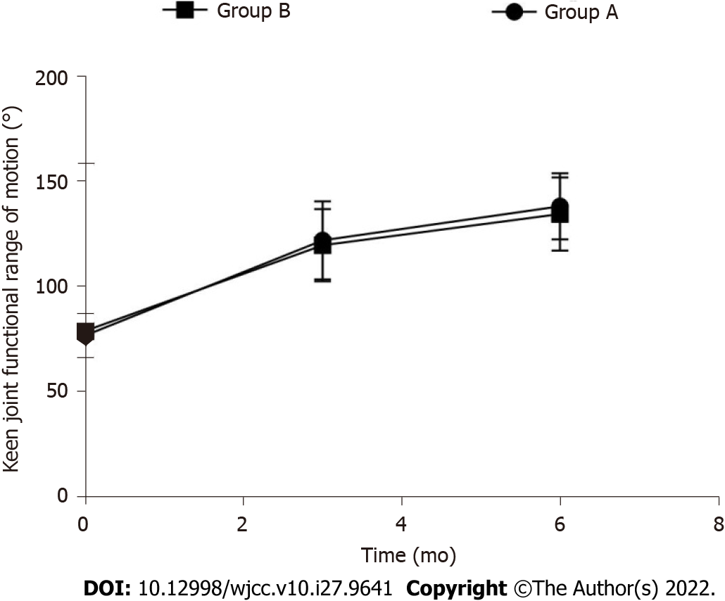
Figure 1 The change trend of knee joint functional range of patients in group A.

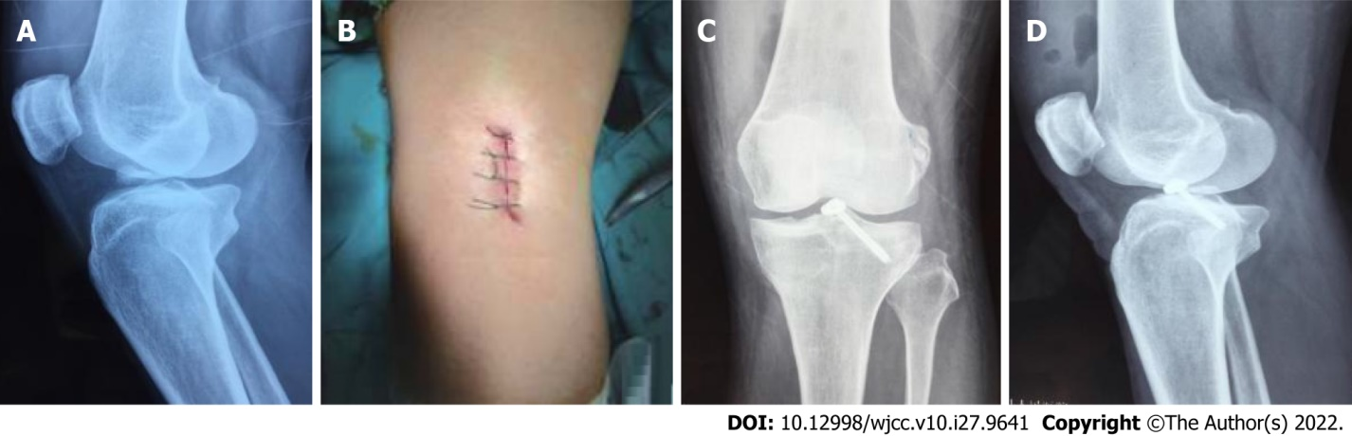
Figure 2 A 38-year-old male patient with tibial avulsion fracture of the left anterior cruciate ligament of the knee. A: The preoperative X-ray diagnosis. The patient was treated with small incision open reduction and internal fixation; B: The appearance of the postoperative incision; C: The immediate postoperative X-ray film; D: The postoperative X-ray film.

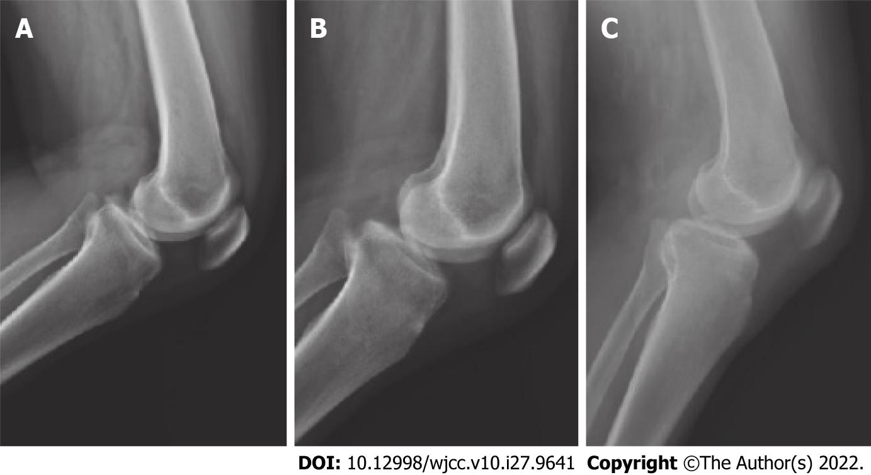
Figure 3 A 33-year-old female patient with tibial avulsion fracture of the left anterior cruciate ligament of the knee. A: The preoperative X-ray diagnosis. The patient was treated with high-intensity non-absorbable suture under arthroscopy; B: The immediate X-ray after operation; C: The X-ray one year after operation. The fracture of the patient was completely healed.
Table 1 Comparison of annual group data of consumers in groups A and B, n (%)
Basic information | Group A (n = 40) | Group B (n = 38) | t/χ² value | P value
Age (yr) | 36.4 ± 8.5 | 38.4 ± 9.0 | -1.009 | 0.316
Height (cm) | 167.8 ± 4.6 | 167.2 ± 5.0 | 0.552 | 0.583
Weight (kg) | 65.1 ± 6.8 | 67.4 ± 7.2 | -1.451 | 0.151
Time from injury to surgery (d) | 7.4 ± 2.1 | 6.9 ± 1.7 | 1.152 | 0.253
Sex |  |  | 0.601 | 0.438
Male | 24 (60.00) | 26 (68.42)
Female | 16 (40.00) | 12 (31.58)
Affected side distribution |  |  | 1.990 | 0.158
Left side | 20 (50.00) | 25 (65.79)
Right | 20 (50.00) | 13 (34.21)
Meyers-McKeever type |  |  | 0.020 | 0.887
Type II | 29 (72.50) | 27 (71.05)
Type III | 11 (27.50) | 11 (28.95)
Tibia instability |  |  | 0.690 | 0.406
Stage II | 26 (65.00) | 28 (73.68)
Stage III | 14 (35.00) | 10 (26.32)

Table 2 Comparison of operation time and fracture healing time between group A and group B (mean ± SD)
Groups | n | Operation time (min) | Fracture healing time (wk)
Group A | 40 | 108.5 ± 18.4 | 12.5 ± 1.4
Group B | 38 | 59.2 ± 11.7 | 12.8 ± 1.5
t value |  | 14.037 | -0.914
P value |  | 0.000 | 0.364

Table 3 Comparison of the functional range of motion of the knee joint in group A and group B (mean ± SD, °)
Groups | n | Preoperative | 3 mo after surgery | 6 mo after surgery
Group A | 40 | 76.9 ± 10.4 | 122.0 ± 18.5ª | 138.2 ± 15.7ª
Group B | 38 | 79.0 ± 9.8 | 119.8 ± 17.3ª | 134.6 ± 17.4ª
t value |  | -0.917 | 0.542 | 0.960
P value |  | 0.362 | 0.590 | 0.340
ªP < 0.05 vs this group before surgery.

Table 4 Comparison of knee function scores between group A and group B (mean ± SD, scores)
Project | Preoperative |  | t value | P value | 6 months after surgery |  | t value | P value
 | Group A (n = 40) | Group B (n = 38) |  |  | Group A (n = 40) | Group B (n = 38)
Limp | 1.88 ± 0.30 | 1.94 ± 0.45 | -0.696 | 0.488 | 3.92 ± 0.74ª | 4.11 ± 0.80ª | -1.090 | 0.279
Support | 1.90 ± 0.41 | 1.98 ± 0.48 | -0.793 | 0.430 | 4.13 ± 0.68ª | 4.26 ± 0.88ª | -0.732 | 0.466
Winch | 5.84 ± 1.20 | 6.12 ± 1.32 | -0.981 | 0.330 | 11.30 ± 2.57ª | 10.93 ± 2.83ª | 0.605 | 0.547
Unstable | 12.67 ± 2.48 | 11.88 ± 2.27 | 1.465 | 0.147 | 20.38 ± 3.70ª | 21.03 ± 3.58ª | -0.788 | 0.433
Swelling | 4.41 ± 0.86 | 4.67 ± 0.90 | -1.305 | 0.196 | 8.81 ± 0.89ª | 8.48 ± 1.03ª | 1.516 | 0.134
Go upstairs | 3.36 ± 0.78 | 3.62 ± 0.85 | -1.409 | 0.163 | 7.96 ± 1.14ª | 8.21 ± 1.26ª | -0.920 | 0.361
Squat | 1.67 ± 0.41 | 1.80 ± 0.48 | -1.288 | 0.202 | 3.88 ± 1.03ª | 4.02 ± 0.89ª | -0.641 | 0.524
Pain | 13.52 ± 2.96 | 12.81 ± 2.56 | 1.130 | 0.262 | 20.86 ± 3.02ª | 21.32 ± 3.31ª | -0.642 | 0.523
Total score | 45.25 ± 7.33 | 44.82 ± 6.81 | 0.268 | 0.789 | 81.24 ± 9.25ª | 82.36 ± 8.90ª | -0.544 | 0.588
ªP < 0.05 vs this group before surgery.

Table 5 Comparison of surgical complications, n (%)
Groups | n | Incision infection | Loose internal fixation | Venous thrombosis of lower extremity | Complication rate
Group A | 40 | 0 | 0 | 1 | 1 (2.63)
Group B | 38 | 2 | 2 | 3 | 7 (18.42)
χ² value |  |  |  |  | 5.367
P value |  |  |  |  | 0.021

Published by Baishideng Publishing Group Inc
7041 Koll Center Parkway, Suite 160, Pleasanton, CA 94566, USA
Telephone: +1-925-3991568
E-mail: bpgoffice@wjgnet.com
Help Desk: https://www.f6publishing.com/helpdesk
https://www.wjgnet.com

© 2022 Baishideng Publishing Group Inc. All rights reserved.

