Name of journal: World Journal of Gastroenterology
ESPS Manuscript NO: 14987
Columns: ORIGINAL ARTICLE
Retrospective Study
precore/basal core promoter mutants quantification throughout phases of hepatitis B virus infection by Simpleprobe

Tu WH et al. PC/BCP mutants quantification and HBeAg titers

Wen-Hui Tu, Ying Lv, Yong-Mei Zhang, Wei Hou, Jin-Yu Wang, Yi-Jun Zhang, Hong-Yan Liu, Hao-Xiang Zhu, Yan-Li Qin, Ri-Cheng Mao, Ji-Ming Zhang

Wen-Hui Tu, Ying Lv, Yong-Mei Zhang, Jin-Yu Wang, Yi-Jun Zhang, Hong-Yan Liu, Hao-Xiang Zhu, Yan-Li Qin, Ri-Cheng Mao, Ji-Ming Zhang, Department of Infectious Disease, Huashan Hospital, Fudan University, Shanghai 200040, China

Wen-Hui Tu, Wei Hou, Department of Infectious Disease, Taizhou Municipal Hospital, Taizhou 318000, Zhejiang Province, China

Ying Lv, Department of Infectious Disease, Public Health Clinical Center of Shanghai, Fudan University, Shanghai 201508, China

Author contributions: Tu WH and Lv Y contributed equally to this work; Zhang JM, Tu WH and Lv Y designed the study; Tu WH and Lv Y performed the majority of the study; Tu WH and Hou W collected the serum specimens and clinical data; Wang JY, Zhang YJ, Zhang YM, Liu HY, Qin YL and Mao RC also participated in the experiments; Tu WH, Lv Y and Zhang YM wrote the manuscript; and Zhang JM revised the manuscript.

supported by National Science and Technology Major Project of China, No. 2012ZX10002007-001-002 and No. 2013ZX10002001 (to Zhang JM); National Natural Science Foundation of China, No. 81271833 and No. 81471933 (to Zhang JM); Science and Technology Plan Project of Taizhou, Zhejiang province, No. 1402ky19 (to Tu WH and Hou W); and Scientific Research Project of Taizhou University, Zhejiang province, No: 2014PY054 (to Tu WH and Hou W).

Ethics approval: The study was reviewed and approved by Huashan Hospital and Taizhou Municipal Hospital Institutional Review Board.

Informed consent: All study participants, or their legal guardian, provided informed written consent prior to study enrollment.

Conflict-of-interest: All participating authors have declared no conflicts of interest.

Data sharing: Technical appendix, statistical code, and dataset available from the corresponding author at jmzhang@fudan.edu.cn. Participants gave informed consent for data sharing.

Open-Access: This article is an open-access article which was selected by an in-house editor and fully peer-reviewed by external reviewers. It is distributed in accordance with the Creative Commons Attribution Non Commercial (CC BY-NC 4.0) license, which permits others to distribute, remix, adapt, build upon this work non-commercially, and license their derivative works on different terms, provided the original work is properly cited and the use is non-commercial. See: http://creativecommons.org/licenses/by-nc/4.0/

Correspondence to: Ji-Ming Zhang, MD, Department of Infectious Disease, Huashan Hospital, Fudan University, 12 Wulumuqi Zhong Road, Shanghai 200040, China. jmzhang@fudan.edu.cn

Telephone: +86-21-52888125
Fax: +86-21-62489015
Received: November 2, 2014
Peer-review started: November 3, 2014
First decision: December 26, 2014
Revised: February 3, 2015
Accepted:February 11, 2015

Article in press:
Published online:

Abstract
AIM: To investigate precore/basal core promoter (PC/BCP) mutants throughout hepatitis B virus (HBV) infection and their relationship to hepatitis B early antigen (HBeAg) titers.

METHODS: We enrolled 191 patients in various stages of HBV infection at Huashan Hospital and Taizhou Municipal Hospital from 2010 to 2012. None of the patients received antiviral therapy. HBV DNA was isolated from 200 µl serum, eluted in 50 µl buffer EB, and quantified by real-time PCR with commercial kits; HBV genotype was determined by direct sequencing of the S gene. We used the Simpleprobe ultrasensitive quantitative method to detect PC/BCP mutants in each patient, compared the strain number, percentage, and the changes in PC/BCP mutants in different phases, and analyzed the relationship between PC/BCP mutants and HBeAg by multiple linear regression and logistic regression. Data are expressed as the median. All data analysis was performed in SPSS17.0 software, P values < 0.05 were considered statistically significant.

RESULTS: Patients with HBV infection (n = 191) were assigned to groups by phase: Immune tolerance (IT) = 55, Immune clearance (IC) = 67, Low-replicative (LR) = 49, and HBeAg-negative hepatitis (ENH) = 20. Of the patients (male patients, 112 and female patients, 79) enrolled, 122 were HBeAg-positive and 69 were HBeAg-negative. The median age was 33 years (range: 18–78 years). PC and BCP mutation detection rates were 84.82% (162/191) and 96.86% (185/191), respectively. In five HBeAg-negative cases, we detected G1896A/G1899A. The logarithm value of PC mutant quantities (log₁₀ PC) significantly differed in IT, IC, and LR phases, as well as in ENH phase (F = 49.350, P < 0.001). The logarithm value of BCP mutant quantities (log₁₀ BCP) also differed during the four phases (F = 25.530, P < 0.001). Log₁₀ PC, log₁₀ BCP values were high in the IT and IC phases, decreased in the LR phase, and increased in the ENH phase, although the absolute value at this point remained lower than in the IT and IC phases. PC mutant quantity per total viral load (PC%) and BCP mutant quantity per total viral load (BCP%) differed between phases (F = 20.040, P < 0.001; F = 10.830, P < 0.001), with PC% and BCP% gradually increasing in successive phases. HBeAg titers negatively correlated with PC% (Spearman’s rho = -0.354, P < 0.001) and BCP% (Spearman’s rho = -0.395, P < 0.001). The negative correlation between PC% and HBeAg status was significant (B = -5.281, P = 0.001), but there was no such correlation between BCP% and HBeAg status (B = -0.523, P = 0.552).

CONCLUSION: PC/BCP mutants become predominant in a dynamic and continuous process. Log₁₀ PC, log₁₀ BCP, and PC%, BCP% might be combined to evaluate disease progression. PC% determines HBeAg status.

Key words: precore mutant; basal core promoter mutant; Hepatitis B virus; Quantification; Hepatitis B early antigen titers

© The Author(s) 2015. Published by Baishideng Publishing Group Inc. All rights reserved.

Core tip: During the natural history of hepatitis B virus infection, no evidence for the correlation between the dynamic alteration of precore/basal core promoter (PC/BCP) mutated strains and hepatitis B early antigen titers has been obtained by qualitative analysis. By using Simpleprobe ultrasensitive quantification of the wild type and mutated hepatitis B virus (HBV) strains, we provided new insights into the process by which PC/BCP-mutated strains become dominant during the natural course of infection. Thus, we provide important clues for the evaluation of HBV infection status and the corresponding host immune responses.

Tu WH, Lv Y, Zhang YM, Hou W, Wang JY, Zhang YJ, Liu HY, Zhu HX, Qin YL, Mao RC, Zhang JM. precore/basal core promoter mutants quantification throughout phases of hepatitis B virus infection by Simpleprobe. World J Gastroenterol 2015; In press

Introduction
Although the hepatitis B vaccine is in widespread use, hepatitis B virus (HBV) infection remains a serious public health problem^{[1]}. In the general Chinese population, 7.18% of individuals are hepatitis B surface antigen (HBsAg) carriers, including 93 million individuals with chronic HBV infection and 20 million patients with chronic hepatitis B (CHB)^{[2]}. HBV infection is the most important factor in acute and chronic hepatitis and is associated with the occurrence of hepatocellular carcinoma (HCC)^{[3]}.
hepatitis B early antigen (HBeAg) clearance (with or without anti-HBe) is the endpoint of treatment for HBeAg-positive CHB^{[4,5]}; however, HBeAg clearance is insufficient to alleviate the disease process. Many patients treated with nucleotide analogues (NAs) achieve HBeAg clearance and experience recurrent HBeAg, or HBV DNA is detected after treatment is stopped^{[6]}. Interferon therapy produces a more sustained effect of HBeAg clearance, although long-term follow-up has revealed the presence of HBV DNA in some patients^{[7,8]}. Thus, HBeAg clearance with interferon therapy alone may produce a false impression of therapeutic efficacy. precore/basal core promoter (PC/BCP) mutants inhibit HBeAg synthesis and may account for the apparent clearance of HBeAg. The HBV Precore G1896A mutation generates a termination codon, eliminating HBeAg synthesis^{[9]}. The BCP A1762T/G1764A double mutation inhibits preC mRNA synthesis, and thus inhibits HBeAg production^{[10,11]}. Precore G1896A or G1899A mutations have been associated with increased risk of HCC^{[12,13]}, more serious hepatitis disease, and acute or chronic liver failure^{[14,15]}. The A1762T/G1764A double mutation is associated with increased virulence and disease progression to liver cirrhosis and HCC^{[16-18]}.
PC/BCP mutant detection is currently achieved by direct DNA sequencing, restriction fragment length polymorphism (RFLP) analysis, hybridization probes, and qualitative detection methods such as the line probe assay (INNO-LiPA)^{[19-23]}. In our previous study of 207 HBeAg-positive patients^{[24]}, RFLP analysis indicated that PC/BCP mutants also exist in HBeAg-positive patients and influence the expression of HBeAg. However, these methods do not provide precise quantification of mutated HBV isolates, thus limiting longitudinal observation of PC/BCP mutation during the natural course of hepatitis B virus infection and the dynamic evaluation of PC/BCP mutation. This has also limited our understanding of the correlation between PC/BCP mutation and HBeAg titers.
In this study, we used the Simpleprobe method for ultrasensitive quantitation of PC/BCP mutants, which allowed us to detect mutations as low as 0.001% in a wild-type background^{[25]}. Quantitation of PC/BCP mutants throughout the natural history of HBV infection will clarify the relationship between virus mutations and the patient’s immune status.

MATERIALS AND METHODS
Patients
We enrolled 191 patients with chronic HBV infection in Huashan Hospital and Taizhou Municipal Hospital from 2010 to 2012. Enrolled participants met the following criteria: (1) age 18–78 years; (2) HBsAg-positive for at least six months at the time of enrollment; (3) no autoimmune liver disease or concurrent hepatitis C virus (HCV), hepatitis D virus (HDV), or human immunodeficiency virus (HIV) infection; (4) no history of antiviral drug treatment; (5) no end-stage liver disease or HCC; and (6) no history of immunosuppressive therapy. The study population included 122 HBeAg-positive and 69 HBeAg-negative patients, 112 males and 79 females, with a median age of 33 years (range: 18–78 years). Patients were assigned to one of the following groups based on their HBV infection state: immune tolerance (IT = 55 cases), immune clearance (IC = 67 cases), low replication (LR = 49 cases), and HBeAg-negative hepatitis (ENH = 20 cases). The IT phase is characterized by high HBeAg titers, high HBV DNA levels, but normal ALT, and normal liver histology; The IC phase is characterized by presence of HBeAg, high HBV DNA levels (over 20000 IU/ml), elevated ALT, necroinflammation of the liver; The LR phase is characterized by HBeAg negativity and anti-HBe positivity, low or undetectable HBV DNA (below 2000 IU/ml), persistently normal ALT, no histologically active inflammation, with mild fibrosis; The ENH phase is characterized by negative HBeAg, positive anti-HBe, detectable HBV DNA levels (2000-20 million IU/ml), elevated ALT, and moderate to severe necroinflammation with variable amounts of fibrosis. Blood samples were stored at -20 °C until use. Study protocols conformed to the Declaration of Helsinki principles of ethics, and all participants were enrolled with written informed consent.

Serological assays
HBsAg, HBeAg, anti-HBe, anti-HCV, and anti-HDV were assessed using commercial AxSYM MEI kits (Abbott Laboratories, North Chicago, IL). Anti-HIV was assayed by using the Diagnostic Kit for Antibody to Human Immunodeficiency Virus Type 1 and/or 2 and HIV-1 Antigen (bioMérieux, France). HBeAg values were determined using a microparticle enzyme immunoassay; results are expressed as signal/cutoff (S/CO), with HBeAg values > 1S/CO considered positive (Abbott Architect i2000SR, United States). HBV DNA was quantified with real-time PCR with commercial kits (Shenzhen PG Biotech, Shenzhen, China). The assay detection limit is 100 IU/mL; HBV DNA standards were obtained from the National Institute for the Control of Pharmaceutical and Biological Products, China.

HBV DNA extraction, amplification, and genotyping
HBV DNA was isolated from 200 µl serum and eluted in 50 µl buffer EB from the QIAamp DNA Blood Mini kit (Qiagen, Shanghai, China), according to manufacturer protocols. Genotyping was performed by sequencing the 1.3-kb HBsAg complete gene fragment after PCR amplification (nt2816–886). Phylogenetic analysis was performed with Vector NTI 11.0 TreeView software. The neighbor-joining tree was constructed by using Jukes-Cantor corrected distances in the MEGA2 package with 1000 bootstrap replicates. All procedures were performed as described^{[24]}.

Quantitation of PC/BCP mutants
PC/BCP quantitation was performed by two-step real-time PCR as described by Nie et al^{[25]}. The first step included a wild-type blocker probe (WT-blocker probe) for selective inhibition PCR (siPCR) that blocked further amplification of wild-type DNA; subsequent cycles amplified mutant viral DNA about 10,000 times, making it easy to detect in the subsequent reaction. The second step involved amplification with a Simpleprobe followed by melt curve analysis. The first step of PC region amplification was performed in a 15-μl reaction contained 0.5 μmol/L each F1 (5'-CCAAATTCTTTATACGGGTCAATGTCCATG-3', nt1929 to 1900) and R1 (5'-CCTCCAAGCTGTGCC-3', nt1869 to 1883), 5 μl of the purified patient sample DNA as template, and 2 μmol/L WT-blocker (5'-gtccatgCcCCAAagcc-PH, nt1906 to 1890). Amplification was carried out at 95 °C for 10 s, 59 °C for 10 s and 72 °C for 5 s, for a total of 20 cycles. The first-step PCR products were diluted at 1:32 and used as templates in the second step real-time PCR which was composed of LightCycler480 Genotyping Master Mix, 0.1 μmol/L primer F1, 0.5 μmol/L primer R1, 3 mmol/L MgCl₂, and 0.1 μmol/L Simpleprobe (5'-gtcaatgtccatgTcCTAaagcc-3', nt1912 to 1890). The real time PCR was performed at 95 °C for 10 min, followed by 40 cycles of 95 °C for 10 s, 66 °C for 10 s, and 72 °C for 5 s, and then followed by a melting curve analysis from 30 °C to 80 °C.
The first step PCR amplification of BCP region was performed in a 15-μl reaction mixture containing 0.5 μmol/L each F1
（5'-AGGAGTTGGGGGAGGAGATTAGGTTAA-3', nt1735 to 1761) and R1 (5'-CTTGGAGGCTTGAACAGTAGGAC-3', nt1881 to 1854) primers, 5 μl of the purified patient sample DNA as the template, and 2 μmol/L WT-blocker (5'-aggagattaGgttAaAGGtctttGt-PH, nt1747 to 1771), PCR was carried out at 95 °C for 10 s, 57 °C for 10 s, and 65 °C for 5 s, for a total of 20 cycles, The second step PCR was composed of LightCycler480 genotyping master mix, 0.1 μmol/L primer F2 (5'-GATAAGTTGAGGAGTTGGGGG-3', nt1726 to 1746), 0.5 μmol/L primer R1, 0.1 μmol/L Simpleprobe (5'-ggagattaGgttAaTGAtct-3', nt1748 to 1767), The real-time PCR was performed at 95 °C for 10 min to activate the polymerase, followed by 40 cycles of 95 °C for 10 s, 55 °C for 10 s and 72 °C for 5 s. Capital letters in the WT-blocker and Simpleprobe sequences indicate Locked Nucleic Acids (LNAs), and the 3-end “-PH” stands for phosphorylation. The fluorescence label is indicated by an underline. The method also employs a primer-blocker-probe partial overlap design to reduce the influence of polymorphisms and improve detection accuracy, with 0.001% precision. The assay detection limit is 60 IU/mL.

Definitions
G1896A and G1896A/G1899A variants are defined as PC mutations; A1762T/G1764A variants are defined as BCP mutations. We used the log₁₀ PC and log₁₀ BCP values to represent PC and BCP mutant quantities; PC% and BCP% represent PC and BCP mutant quantities per total viral load.

Statistical analysis
Data are expressed as the median. All data analysis was performed in SPSS17.0 software; the Mann-Whitney rank sum test, one-way ANOVA, Independent-Sample T test, Spearman correlation, multiple linear regression, and logistic regression analysis were used. Statistical significance was defined as P < 0.05.

Results
Baseline characteristics of patients with chronic HBV infection
Patients with HBV infection (n = 191) were assigned to groups by phase: IT = 55, IC = 67, LR = 49, and ENH = 20. Patients with HBeAg positive 122 and HBeAg negative 69. The population included 112 male and 79 female subjects, with a median age of 33 years (range: 18–78 years). Younger patient age was associated with higher total log₁₀ HBV DNA in the IT and IC groups versus the LR and ENH groups (6.99 ± 0.97 vs 4.07 ± 1.15, P < 0.001). HBeAg titers differed significantly between the IT and IC phases (1261.27 ± 465.56 vs 825.30 ± 580.62, P < 0.001). PC% and BCP% were significantly higher in the LR and ENH phases (U = 1422.0, P < 0.001; U = 2357.0, P < 0.001; Table 1).

Prevalence of PC/BCP mutants
We identified 157 cases with G1896A mutations, 29 cases with G1899A mutations, and 5 cases with the G1896A/G1899A double mutation. Twenty-seven of the cases carrying the G1899A mutation were also HBeAg-positive, while all five cases of G1896A/G1899A double mutation were HBeAg-negative. The PC mutation detection rate was 84.82% (162/191, PC mutant quantification range: 60-60 million IU/ml). We identified 96.86% (185/191, BCP mutant quantification range: 60-60 million IU/ml) cases as carriers of the BCP (A1762T/G1764A) mutation. We identified the BCP mutation alone in 26 cases, the PC mutation alone in five cases. The PC/BCP joint mutation was identified in 159 cases, whereas the wild-type PC/BCP was found in only one case.

PC/BCP mutants distribution by phase, age, and HBeAg status
Log₁₀ PC and log₁₀ BCP distributions differed significantly between the four phases (F = 49.350, P < 0.001; F = 23.530, P < 0.001). The log₁₀ PC, log₁₀ BCP values were higher in IT and IC, decreased in LR, then higher in the ENH phase again, although the absolute value remained lower than in the IT and IC phases (Figure 1A, B). PC% and BCP% distributions gradually increased through each phase (F = 20.040, P < 0.001; F = 10.830, P < 0.001; Figure 1C, D). We compared PC%, BCP% and log₁₀ PC, log₁₀ BCP values between each group and observed significant differences (Figure 1A-D). The dynamic variation of PC%, BCP% and log₁₀ PC, log₁₀ BCP are shown in Figure 1E.
PC% increases with age (Spearman’s rho = 0.281, P < 0.001). PC% distribution did not significantly differ between the ≤ 40 and > 40 age groups (t = 1.650, P = 0.101; Figure 2A), but the log₁₀ PC distribution did differ between age groups (t = 3.340, P = 0.001; Figure2C). Similarly, BCP% also increased with age (Spearman’s rho = 0.31, P < 0.001). BCP% distribution significantly differed (≤40 vs >40; t = 2.859, P = 0.005; Figure 2B) and log₁₀ BCP distribution did not differ between age groups (t = 1.830, P = 0.069; Figure 2D).
When divided by HBeAg status, PC% distribution significantly differed between groups. PC% was higher in HBeAg-negative patients than in HBeAg-positive patients (23.95% vs 5.75%, P < 0.001; Figure 2E). The log₁₀ PC value also differed between groups; values were higher in HBeAg-positive patients (5.68 ± 1.05 vs 3.81 ± 1.32, P < 0.001; Figure 2G). BCP% was higher in HBeAg-negative patients than in HBeAg-positive patients (50.33% vs 24.80%; P < 0.001; Figure 2F). The log₁₀ BCP values were higher in the HBeAg-positive group (5.17 ± 1.77 vs 3.13 ± 1.66, P < 0.001; Figure 2H).

Correlation between HBeAg titers and total log₁₀ HBV DNA, log₁₀ PC, log₁₀ BCP value, PC% and BCP%
HBeAg titers and total log₁₀ HBV DNA were positively correlated (Spearman’s rho = 0.511, P < 0.001; Figure 3A). Total log₁₀ HBV DNA value was higher in HBeAg-positive than in HBeAg-negative patients (7.684 vs 4.769, P < 0.001). HBeAg titers and log₁₀ PC value showed no correlation (Spearman’s rho = 0.145, P = 0.111), neither did HBeAg titers and log₁₀ BCP value (Spearman’s rho = 0.135, P = 0.138) (Figure 3B). The log₁₀ PC, log₁₀ BCP value significantly differed between the HBeAg-positive and HBeAg-negative groups (5.682 vs 3.810, P < 0.001; 5.167 vs 3.129, P < 0.001).
HBeAg titers negatively correlated with PC% (Spearman’s rho = -0.354, P < 0.001) and BCP% (Spearman’s rho = -0.395, P < 0.001) (Figure 3C). The PC% and BCP% significantly differed between HBeAg < 1000 S/CO and ≥ 1000 S/CO groups (t = 3.520, P < 0.001; t = 5.289, P < 0.001): PC% and BCP% were higher in the HBeAg < 1000 S/CO group. HBeAg titers significantly differed between PC% groups < 5%, 5% to 10%, and >10% (F = 15.230, P < 0.001), as shown in Figure 4A. HBeAg titers also differed between BCP% groups <10%, 10%-40% and > 40% (F = 26.310, P < 0.001), as shown in Figure 4B.

Correlation between HBeAg, PC%, BCP% and clinical parameters
Logistic regression analysis revealed no correlation between HBeAg status and age (B = -0.050, P = 0.075). Total log₁₀ HBV DNA positively correlated with HBeAg status (B = 1.837, P < 0.001). PC% and HBeAg status showed a significant negative correlation (B = -5.281, P = 0.001), while ALT and BCP% did not correlate with HBeAg status. Multiple linear regression analysis were conducted between HBeAg titer with age, log₁₀ HBV DNA, ALT, PC% and BCP%, age and HBeAg titer showed no significant correlation (B = -3.511, P = 0.357). Total log₁₀ HBV DNA positively correlated with HBeAg titer (B = 259.233, P < 0.001). ALT did not correlate with HBeAg titer (B = 0.048, P = 0.739). PC% negatively correlated with HBeAg titer (B = -1209.594, P < 0.001). BCP% also negatively correlated with HBeAg titer (B = -446.964, P < 0.001) (Table 2).
Multiple linear regression were conducted between PC% or BCP% with age, log₁₀ HBV DNA, ALT, HBeAg titer, revealed that PC% negatively correlated with HBeAg titer (B = -0.000, P < 0.001). PC% did not correlate with age, log₁₀ HBV DNA, ALT. BCP% showed a significant negative correlation with HBeAg titer (B = -0.000, P < 0.001). BCP% positively correlated with ALT (B = 0.000, P = 0.007), while age and log₁₀ HBV DNA did not correlate with BCP% (Table 3).

Discussion
The high replication rate of HBV leads to production of 10¹² virions per day. The lack of a proofreading function in the reverse transcriptase, combined with the high replication rate yields a high mutation rate, with each replication cycle producing about 10⁻⁵ mismatches/base in actively replicating virus strains, yielding 10¹⁰ to 10¹¹ point mutations per day^{[26]}. Therefore, nucleotide polymorphisms and acquired mutations are common in the HBV virus pool and are difficult to differentiate and detect in a quantitative method. Thus, it is important do find ways to overcome the influence of nucleotide polymorphisms on detection of acquired mutations.
PC/BCP mutants are common in HBeAg-negative patients^{[27,28]}, and are observed in HBeAg-positive patients^{[24]}. Yan et al^{[28]} reported PC or BCP mutation in 65.10% of HBeAg positive patients (125/192), implying that PC/BCP mutations exists to varying degrees in different stages of HBV infection. In this article, we provide the first overview of the quantification and distribution of PC/BCP mutated isolates. BCP mutation was detected in 96.86% and PC mutation in 84.82% of a population of 191 patients; wild-type PC/BCP was found in only one patient. The mutation rate was significantly higher than in previous reports, suggesting the prevalence of PC/BCP mutations has been severely underestimated. PC% and BCP% increase with age during the natural history of HBV infection. There was a significant difference in BCP% distribution between age groups (≤ 40 vs > 40), indicating the significant correlation between BCP% and age. PC% did not differ between groups, perhaps due to the different baseline natural histories of the enrolled patients. Grouping by HBeAg status showed higher PC% and BCP% in HBeAg-negative patients^{[24,25,28]}.
During the natural history of HBV infection, there is a dynamic alteration in the log₁₀ PC, log₁₀ BCP values. Log₁₀ PC, log₁₀ BCP values are high in IT and IC, decrease in the LR phase, and rise again in the ENH phase. The PC%, BCP% was much higher than the wild-type isolates after the selection of immune responses in LR phase, demonstrating that PC/BCP mutants may evade the host immune system, consistent with the report of Nie et al^{[25]}. Interferon treatment in wild-type strains is an independent predictor of HBsAg disappearance^{[29]}. Previous studies showed that wild-type strains could be eliminated by a drug-enhanced immune reaction; however, the presence and accumulation of PC/BCP mutants may reduce the efficacy of IFN antiviral therapy.
PC% and BCP% increased during the natural course of HBV infection, which provided a clue to a dynamic variation that the PC and BCP mutants gradually become the dominant strains. Thus, disease progression can be estimated by the combination of log₁₀ PC, log₁₀ BCP and PC%, BCP% (Figure 1E). High log₁₀ PC, log₁₀ BCP and low PC%, BCP% indicate the virus infection is in the early stages (IT, IC, and HBeAg-positive). If the log₁₀ PC, log₁₀ BCP value is low, and PC%, BCP% is high, the infection is in LR phase. While the high log₁₀ PC, log₁₀ BCP and PC%, BCP% could be considered to be a marker of ENH phase, an HBeAg-negative chronic hepatitis flare may occur afterwards. Our quantitative analysis of PC/BCP mutants clarifies the relationship between the PC/BCP mutant distribution and the host immune state.
HBeAg titer correlated with PC% and BCP%. Subgroup analysis of HBeAg titers and PC%, BCP% showed a significant difference between groups, suggesting HBeAg titers are closely correlated with PC% and BCP%, which is consistent with previous reports^{[24,25]}. Logistic regression analysis analysis showed that PC% and HBeAg status have a significant negative correlation, which is also consistent with previous findings regarding the molecular mechanism of HBeAg formation^{[9,20,23,24]}. While age, serum HBV DNA, ALT, and BCP% are not relevant factors in determining HBeAg status. Interestingly, our results showed elevated ALT significantly correlated with BCP%, indicating that BCP% reflects hepatic inflammatory degradation. Nie et al^{[25]} reported that PC% (not BCP%) positively correlates with ALT elevations among HBeAg(-) patients. Several studies have shown that PC/BCP mutants cause hepatic inflammation, acute or chronic liver failure, and liver cirrhosis. Our results suggest ALT elevation might also be a result of varied host immune responses. Previous reports suggest the PC mutation is more commonly seen in genotype B patients, while the BCP mutation predominates in genotype C patients^{[30]}. Our results showed no significant difference in the prevalence of PC/BCP mutation between the two genotypes.
Our findings show that PC/BCP mutants become predominant through the natural course of HBV infection in a dynamic and continuous manner. PC/BCP mutants have a survival advantage under host immune selection pressure and accumulate in the HBV population through the course of infection. PC/BCP mutations reduce or eliminate HBeAg production, allowing the virus to avoid cellular and humoral immune attack. Only PC% determined HBeAg status. Log₁₀ PC, log₁₀ BCP and PC%, BCP% might be combined to evaluate disease progression and guide treatment of chronic hepatitis B.

COMMENTS
Background
hepatitis B early antigen (HBeAg) clearance is considered the endpoint of antiviral treatment for HBeAg-positive chronic hepatitis B. However, follow-up reveals the presence of hepatitis B virus (HBV) DNA in some patients after the loss of HBeAg, since precore and basal core promoter (PC/BCP) mutations may produce a false impression of therapeutic efficacy. So far, PC/BCP mutation detection has been achieved by indirect qualitative detection methods without precise quantification. This study provided used an accurate quantitation of PC/BCP mutants throughout the natural course of HBV infection with the Simpleprobe method, which clarifies the relationship between PC/BCP mutations and HBeAg status.

Research frontiers
The occurrence of PC/BCP mutations has been underestimated by qualitative analysis, which was affected by the presence of dominant wild isolates and nucleotide polymorphisms. To understand the practical significance of HBeAg seroconversion, precise quantitative methods can yield profiles of the dynamic process by which PC/BCP-mutated strains become dominant during the natural course of infection.

Innovations and breakthroughs
The authors applied the Simpleprobe method for ultrasensitive quantitation of PC/BCP mutants, which overcome the impact of the dominant wild-type isolates and nucleotide polymorphisms with a two-step PCR method. The accuracy of our method was 0.001%, which was the most precise quantification from our knowledge. Quantitation of PC/BCP mutants throughout the natural history of HBV infection. We also produced a model that combines log₁₀ PC, log₁₀ BCP, and PC%, BCP% to evaluate disease progression.

Applications
The study has revealed the dynamic process by which PC/BCP-mutated strains become dominant during the natural course of infection and established a practical model that combines log₁₀ PC, log₁₀ BCP, and PC%, BCP% to evaluate disease progression in routine clinical practice. The method will provide a more comprehensive and accurate evaluation of disease progression to clinicians.

Terminology
HBeAg is a soluble antigen secreted from HBV-infected cells and is a sign of HBV viral replication. HBeAg seroconversion is an indicator of treatment withdrawal. PC/BCP mutants inhibit HBeAg synthesis and may account for the apparent clearance of HBeAg. The HBV Precore G1896A mutation generates a termination codon, eliminating HBeAg synthesis. The BCP A1762T/G1764A double mutation inhibits preC mRNA synthesis, and thus inhibits HBeAg production.

Peer-review
The authors have presented an interesting retrospective study in which they aimed to show that PC/BCP mutant levels may correlate with the natural history of chronic hepatitis B. To show this, the authors enrolled 191 patients and used a Simpleprobe quantitative method to identify PC/BCP mutations in HBV isolates from these patients. The authors conclude that PC/BCP mutations became predominant in a dynamic process through the different phases of HBV infection. They conclude that the status of log₁₀ PC, log₁₀ BCP and PC%, BCP% is useful to evaluate disease progression while only PC% determines HBeAg status. Overall, the manuscript is well written and mainly concise in its content. The design of the retrospective study is well performed.

References
1 Ganem D, Prince AM. Hepatitis B virus infection--natural history and clinical consequences. N Engl J Med 2004; 350: 1118-1129 [PMID: 15014185 DOI: 10.1056/NEJMra031087]
2 Lu FM, Zhuang H. Management of hepatitis B in China. Chin Med J (Engl) 2009; 122: 3-4 [PMID: 19187608 DOI: 10.3760/cma.j.issn.0366-6999.2009.01.001]
3 Yu MW, Yeh SH, Chen PJ, Liaw YF, Lin CL, Liu CJ, Shih WL, Kao JH, Chen DS, Chen CJ. Hepatitis B virus genotype and DNA level and hepatocellular carcinoma: a prospective study in men. J Natl Cancer Inst 2005; 97: 265-272 [PMID: 15713961 DOI: 10.1093/jnci/dji043]
4 European Association for the Study of the Liver. EASL Clinical Practice Guidelines: management of chronic hepatitis B. J Hepatol 2009; 50: 227-242 [PMID: 19054588 DOI: 10.1016/j.jhep.2008.10.001]
5 Lok AS, McMahon BJ. Chronic hepatitis B: update 2009. Hepatology 2009; 50: 661-662 [PMID: 19714720 DOI: 10.1002/hep.23190]
6 Reijnders JG, Perquin MJ, Zhang N, Hansen BE, Janssen HL. Nucleos(t)ide analogues only induce temporary hepatitis B e antigen seroconversion in most patients with chronic hepatitis B. Gastroenterology 2010; 139: 491-498 [PMID: 20381492 DOI: 10.1053/j.gastro.2010.03.059]
7 Wong VW, Wong GL, Yan KK, Chim AM, Chan HY, Tse CH, Choi PC, Chan AW, Sung JJ, Chan HL. Durability of peginterferon alfa-2b treatment at 5 years in patients with hepatitis B e antigen-positive chronic hepatitis B. Hepatology 2010; 51: 1945-1953 [PMID: 20209602 DOI: 10.1002/hep.23568]
8 Senturk H, Baysal B, Tahan V, Zerdali H, Ozaras R, Tabak F, Mert A, Canbakan B, Tabak O, Ozbay G. Long-term effect of interferon therapy in patients with HBeAg positive chronic hepatitis B infection. Dig Dis Sci 2011; 56: 208-212 [PMID: 20467899 DOI: 10.1007/s10620-010-1255-9]
9 Milich D, Liang TJ. Exploring the biological basis of hepatitis B e antigen in hepatitis B virus infection. Hepatology 2003; 38: 1075-1086 [PMID: 14578844 DOI: 10.1053/jhep.2003.50453]
10 Scaglioni PP, Melegari M, Wands JR. Biologic properties of hepatitis B viral genomes with mutations in the precore promoter and precore open reading frame. Virology 1997; 233: 374-381 [PMID: 9217060 DOI: 10.1006/viro.1997.8594]
11 Laras A, Koskinas J, Hadziyannis SJ. In vivo suppression of precore mRNA synthesis is associated with mutations in the hepatitis B virus core promoter. Virology 2002; 295: 86-96 [PMID: 12033768 DOI: 10.1006/viro.2001.1352]
12 Tong MJ, Blatt LM, Kao JH, Cheng JT, Corey WG. Basal core promoter T1762/A1764 and precore A1896 gene mutations in hepatitis B surface antigen-positive hepatocellular carcinoma: a comparison with chronic carriers. Liver Int 2007; 27: 1356-1363 [PMID: 17900245 DOI: 10.1111/j.1478-3231.2007.01585.x]
13 Chen CH, Changchien CS, Lee CM, Hung CH, Hu TH, Wang JH, Wang JC, Lu SN. Combined mutations in pre-s/surface and core promoter/precore regions of hepatitis B virus increase the risk of hepatocellular carcinoma: a case-control study. J Infect Dis 2008; 198: 1634-1642 [PMID: 18939932 DOI: 10.1086/592990]
14 Zhang D, Ma S, Zhang X, Zhao H, Ding H, Zeng C. Prevalent HBV point mutations and mutation combinations at BCP/preC region and their association with liver disease progression. BMC Infect Dis 2010; 10: 271 [PMID: 20846420 DOI: 10.1186/1471-2334-10-271]
15 Xu Z, Ren X, Liu Y, Li X, Bai S, Zhong Y, Wang L, Mao P, Wang H, Xin S, Wong VW, Chan HL, Zoulim F, Xu D. Association of hepatitis B virus mutations in basal core promoter and precore regions with severity of liver disease: an investigation of 793 Chinese patients with mild and severe chronic hepatitis B and acute-on-chronic liver failure. J Gastroenterol 2011; 46: 391-400 [PMID: 20848146 DOI: 10.1007/s00535-010-0315-4]
16 Fang ZL, Sabin CA, Dong BQ, Ge LY, Wei SC, Chen QY, Fang KX, Yang JY, Wang XY, Harrison TJ. HBV A1762T, G1764A mutations are a valuable biomarker for identifying a subset of male HBsAg carriers at extremely high risk of hepatocellular carcinoma: a prospective study. Am J Gastroenterol 2008; 103: 2254-2262 [PMID: 18844615 DOI: 10.1111/j.1572-0241.2008.01974.x]
17 Liu CJ, Chen BF, Chen PJ, Lai MY, Huang WL, Kao JH, Chen DS. Role of hepatitis B viral load and basal core promoter mutation in hepatocellular carcinoma in hepatitis B carriers. J Infect Dis 2006; 193: 1258-1265 [PMID: 16586363 DOI: 10.1086/502978]
18 Liu S, Zhang H, Gu C, Yin J, He Y, Xie J, Cao G. Associations between hepatitis B virus mutations and the risk of hepatocellular carcinoma: a meta-analysis. J Natl Cancer Inst 2009; 101: 1066-1082 [PMID: 19574418 DOI: 10.1093/jnci/djp180]
19 Chu CJ, Keeffe EB, Han SH, Perrillo RP, Min AD, Soldevila-Pico C, Carey W, Brown RS, Luketic VA, Terrault N, Lok AS. Prevalence of HBV precore/core promoter variants in the United States. Hepatology 2003; 38: 619-628 [PMID: 12939588 DOI: 10.1053/jhep.2003.50352]
20 Pang A, Yuen MF, Yuan HJ, Lai CL, Kwong YL. Real-time quantification of hepatitis B virus core-promoter and pre-core mutants during hepatitis E antigen seroconversion. J Hepatol 2004; 40: 1008-1017 [PMID: 15158343 DOI: 10.1016/j.jhep.2004.02.024]
21 Waltz TL, Marras S, Rochford G, Nolan J, Lee E, Melegari M, Pollack H. Development of a molecular-beacon assay to detect the G1896A precore mutation in hepatitis B virus-infected individuals. J Clin Microbiol 2005; 43: 254-258 [PMID: 15634980 DOI: 10.1128/JCM.43.1.254-258.2005]
22 Ren XD, Lin SY, Wang X, Zhou T, Block TM, Su YH. Rapid and sensitive detection of hepatitis B virus 1762T/1764A double mutation from hepatocellular carcinomas using LNA-mediated PCR clamping and hybridization probes. J Virol Methods 2009; 158: 24-29 [PMID: 19187787 DOI: 10.1016/j.jviromet.2009.01.007]
23 Yuen MF, Sablon E, Yuan HJ, Hui CK, Wong DK, Doutreloigne J, Wong BC, Chan AO, Lai CL. Relationship between the development of precore and core promoter mutations and hepatitis B e antigen seroconversion in patients with chronic hepatitis B virus. J Infect Dis 2002; 186: 1335-1338 [PMID: 12402204 DOI: 10.1086/344327]
24 Qin Y, Zhang J, Mao R, Guo H, Yin Y, Wu X, Weng X, Wands J, Tong S. Prevalence of basal core promoter and precore mutations in Chinese chronic hepatitis B patients and correlation with serum HBeAG titers. J Med Virol 2009; 81: 807-814 [PMID: 19319958 DOI: 10.1002/jmv.21439]
25 Nie H, Evans AA, London WT, Block TM, Ren XD. Quantitative dynamics of hepatitis B basal core promoter and precore mutants before and after HBeAg seroconversion. J Hepatol 2012; 56: 795-802 [PMID: 22173170 DOI: 10.1016/j.jhep.2011.11.012]
26 Ghany M, Liang TJ. Drug targets and molecular mechanisms of drug resistance in chronic hepatitis B. Gastroenterology 2007; 132: 1574-1585 [PMID: 17408658 DOI: 10.1053/j.gastro.2007.02.039]
27 Kitab B, Essaid El Feydi A, Afifi R, Trepo C, Benazzouz M, Essamri W, Zoulim F, Chemin I, Alj HS, Ezzikouri S, Benjelloun S. Variability in the precore and core promoter regions of HBV strains in Morocco: characterization and impact on liver disease progression. PLoS One 2012; 7: e42891 [PMID: 22905181 DOI: 10.1371/journal.pone.0042891]
28 Yan CH, Zhao CY, Ding H, Peng YQ, Jin PY, Yan L, Zhuang H, Li T. Hepatitis B virus basal core promoter mutations A1762T/G1764A are associated with genotype C and a low serum HBsAg level in chronically-infected HBeAg-positive Chinese patients. Antiviral Res 2012; 96: 108-114 [PMID: 22960603 DOI: 10.1016/j.antiviral.2012.08.009]
29 Sonneveld MJ, Rijckborst V, Zeuzem S, Heathcote EJ, Simon K, Senturk H, Pas SD, Hansen BE, Janssen HL. Presence of precore and core promoter mutants limits the probability of response to peginterferon in hepatitis B e antigen-positive chronic hepatitis B. Hepatology 2012; 56: 67-75 [PMID: 22307831 DOI: 10.1002/hep.25636]
30 Chen CH, Lee CM, Hung CH, Hu TH, Wang JH, Wang JC, Lu SN, Changchien CS. Clinical significance and evolution of core promoter and precore mutations in HBeAg-positive patients with HBV genotype B and C: a longitudinal study. Liver Int 2007; 27: 806-815 [PMID: 17617124 DOI: 10.1111/j.1478-3231.2007.01505.x]

P-Reviewer: Bock CT, Liu ZW, Panduro A, Rodriguez-Frias F, Tamori A S-Editor: Ma YJ L-Editor: E-Editor:

Table 1 Baseline characteristics of patients with chronic hepatitis B virus infection
 | IC (n = 55) | IC (n = 67) | LR (n = 49) | ENH (n = 20) | ANOVA  P value
Age, yr (median, range) | 27 (18–55) | 32 (18–78) | 40 (21–65) | 41 (25–65) | < 0.001
Gender, n (M/F) | 28/27 | 40/27 | 28/21 | 16/4 | 0.160
Log₁₀HBV DNA,  Log₁₀ IU/mL (median) | 7.55 | 6.98 | 3.70 | 4.69 | < 0.001
HBV genotype, n:  B  C | 34  21 | 39  28 | 29  20 | 11  9 | 0.96
ALT, U/mL (median) | 16 | 98 | 20 | 93 | < 0.001
AST, U/mL (median) | 13 | 67 | 18 | 62 | < 0.001
HBeAg, S/CO (median) | 1376 | 899 | NA | NA | < 0.001
PC% (median) | 0.31 | 1.73 | 9.20 | 33.69 | < 0.001
BCP% (median) | 1.42 | 15.25 | 43.58 | 67.44 | < 0.001
One-way ANOVA, P < 0.05 was considered statistically significant. HBeAg: Hepatitis B early antigen; HBV: hepatitis B virus; ALT: Alanine aminotransferase; AST: Aspartate aminotransferase; PC: Precore; PC%: PC mutant quantity per total viral load; BCP: Basal core promoter; BCP%: BCP mutant quantity per total viral load; NA: Not applicable.

Table 2 Correlation between hepatitis B early antigen and clinical parameters
 | HBeAg vs HBeAg status¹ | HBeAg vs HBeAg titer²
 | P value
Age (yr) | 0.075 | 0.357
Log₁₀ HBV DNA  (log₁₀ IU/mL) | < 0.001 | < 0.001
ALT (U/L) | 0.135 | 0.739
PC% | 0.001 | < 0.001
BCP% | 0.552 | < 0.001
¹Data derived from logistic regression analysis; ²Data derived from multiple linear regression; HBeAg: Hepatitis B early antigen; HBV: Hepatitis B virus; ALT: Alanine aminotransferase; PC: Precore; PC%: PC mutant quantity per total viral load; BCP: Basal core promoter; BCP%: BCP mutant quantity per total viral load.

Table 3 Relationship between precore/basal core promoter mutants and clinical parameters

 | PC/BCP mutants vs PC% | PC/BCP mutants vs BCP%
 | P value
Age (yr) | 0.280 | 0.746
Log₁₀ HBV DNA  (log₁₀ IU/mL) | 0.440 | 0.723
ALT (U/L) | 0.655 | 0.007
HBeAg titer (S/CO) | < 0.001 | < 0.001
Data derived from multiple linear regression. PC: Precore; BCP: Basal core promoter; PC%: PC mutant quantity per total viral load; BCP%: BCP mutant quantity per total viral load; HBV: Hepatitis B virus; ALT: Alanine aminotransferase; HBeAg: Hepatitis B early antigen.

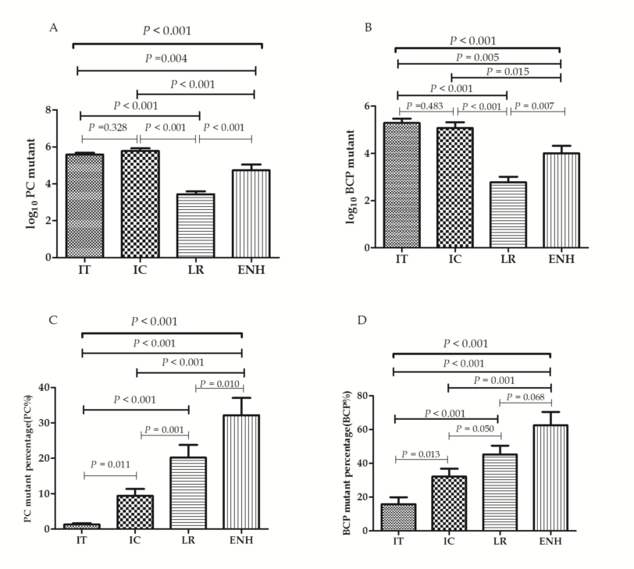
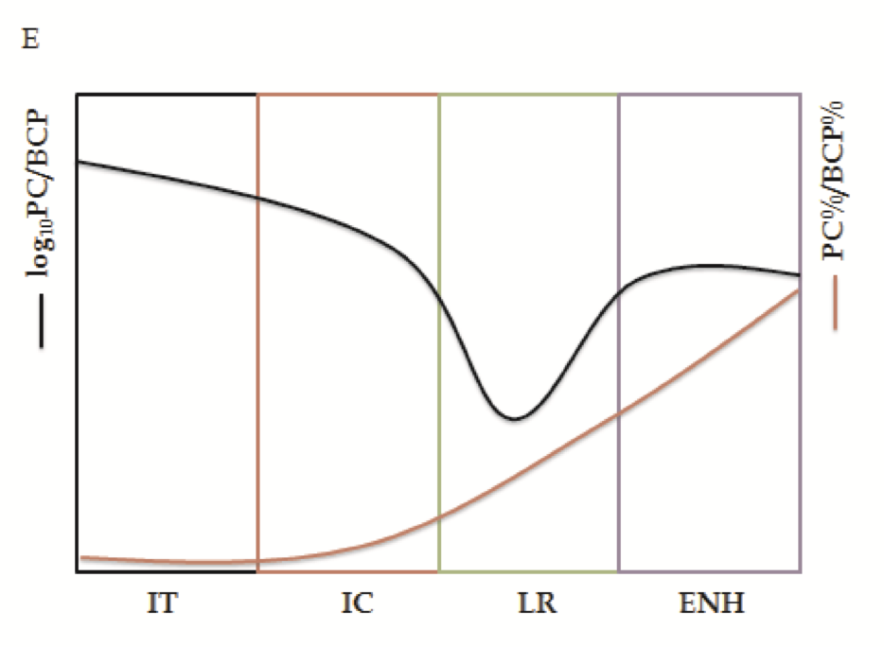
Figure 1 Log₁₀ precore, log₁₀ basal core promoter value (A, B), precore%, basal core promoter (%) (C, D) distribution through the phases of hepatitis B virus infection; disease progression can be estimated by the combination of log₁₀ precore, log₁₀ basal core promoter, and precore%, basal core promoter (%) (E). PC: Precore; BCP: Basal core promoter; IT: Immune tolerance; IC: Immune clearance; LR: Low-replicative; ENH: HBeAg-negative hepatitis; HBeAg: Hepatitis B early antigen; PC%: PC mutant quantity per total viral load; BCP%: BCP mutant quantity per total viral load.

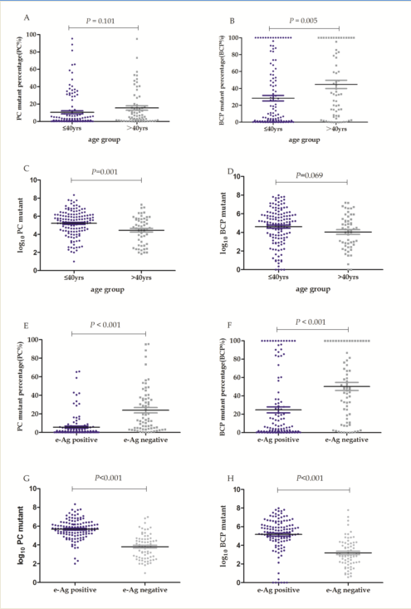
Figure 2 precore, basal core promoter mutation distribution by patient age subgroup and hepatitis B early antigen status. Age subgroup vs PC mutation percentage (PC%) (A) and BCP mutation percentage (BCP%) (B); Age subgroup vs log₁₀ PC (C) and log₁₀ BCP (D); HBeAg status vs PC% (E) and BCP% (F); HBeAg status vs log₁₀ PC (G) and log₁₀ BCP (H). Short horizontal lines flanking the means indicate SE. PC: Precore; BCP: Basal core promoter; PC%: PC mutant quantity per total viral load; BCP%: BCP mutant quantity per total viral load; HBV: Hepatitis B virus; ALT: Alanine aminotransferase; HBeAg: Hepatitis B early antigen.

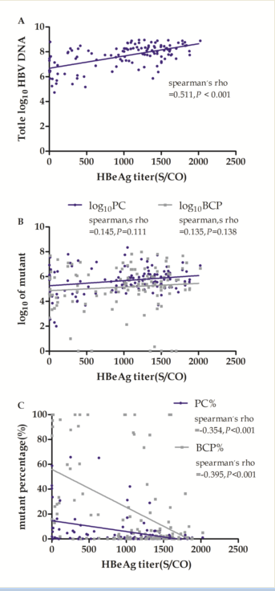
Figure 3 Correlation between hepatitis B early antigen titer and total log₁₀ hepatitis B virus DNA (A), log₁₀ precore, log₁₀ basal core promoter value (B), and precore%, basal core promoter (%) (C).

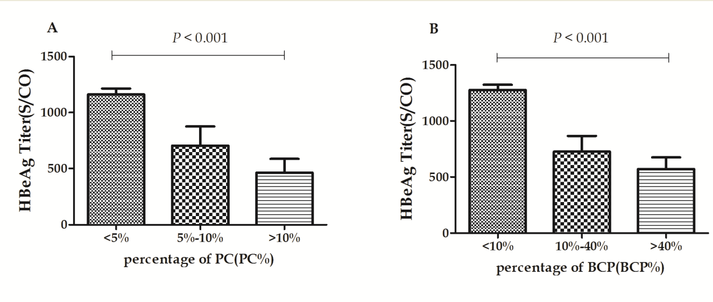
Figure 4 Differential subgroup distributions of precore%, basal core promoter (%) and hepatitis B early antigen titers. PC: Precore; BCP: Basal core promoter; PC%: PC mutant quantity per total viral load; BCP%: BCP mutant quantity per total viral load.

