Name of journal: World Journal of Gastroenterology
ESPS Manuscript NO: 27835
Manuscript type: ORIGINAL ARTICLE

Retrospective Study
Inter- and intraobserver agreement in evaluation of computed tomography enterography in inflammatory bowel disease

Horvat NSMR et al. Evaluation of CTe in ibd

Natally de Souza Maciel Rocha Horvat, Camila Carlos Tavares, Adriana Ribas Andrade, Julia Campos Simões Cabral, Hilton Muniz Leão Filho, Angela Hissae Motoyama Caiado, Serli Kiyomi Nakao Ueda, André Zonetti de Arruda Leite, Aytan Miranda Sipahi, Manoel de Souza Rocha

Natally de Souza Maciel Rocha Horvat, Camila Carlos Tavares, Hilton Muniz Leão Filho, Angela Hissae Motoyama Caiado, Serli Kiyomi Nakao Ueda, Manoel de Souza Rocha, Radiology Department, Hospital das Clínicas da Faculdade de Medicina da Universidade de São Paulo, SP 05403-010, Brazil

Adriana Ribas Andrade, Julia Campos Simões Cabral, André Zonetti de Arruda Leite, Aytan Miranda Sipahi, Gastroenterology Department, Lim 07, Hospital da Clínicas da Faculdade de Medicina da Universidade de São Paulo, São Paulo, SP 05403-000, Brazil

Author contributions: All the authors equally contributed to this paper.

Institutional review board statement: The study was reviewed and approved by the CAPPesq, the Ethics Committee for researches of the institution (CAAE number: 51651915.5.0000.0068).

Informed consent statement: Institutional review board approval was obtained and the requirement for informed written consent was waived.

Conflict-of-interest statement: We have no financial relationships to disclose.

Data sharing statement: Technical appendix, statistical code, and dataset available from the corresponding author at natally.rocha@hc.fm.usp.br Participants consent for data sharing was not obtained but the presented data are anonymized and risk of identification is low.

Open-Access: This article is an open-access article which was selected by an in-house editor and fully peer-reviewed by external reviewers. It is distributed in accordance with the Creative Commons Attribution Non Commercial (CC BY-NC 4.0) license, which permits others to distribute, remix, adapt, build upon this work non-commercially, and license their derivative works on different terms, provided the original work is properly cited and the use is non-commercial. See: http://creativecommons.org/licenses/by-nc/4.0/

Manuscript source: Unsolicited manuscript

Correspondence to: Natally de Souza Maciel Rocha Horvat, MD, Radiology Department, Hospital das Clínicas da Faculdade de Medicina da Universidade de São Paulo, Rua Dr. Ovídio Pires de Campos, 75, Cerqueira César - São Paulo, SP 05403-010, Brazil. natally.rocha@hc.fm.usp.br
Telephone: +55-11-26617068
Fax: +55-11-26617550

Received: June 18, 2016
Peer-review started: June 20, 2016
First decision: August 22, 2016
Revised: September 8, 2016
Accepted: September 28, 2016
Article in press:
Published online:

Abstract
AIM
To evaluate intra- and interobserver agreement on imaging features in inflammatory bowel disease and compare with fecal calprotectin levels.

METHODS
Our institutional computed tomography enterography (CTE) database was retrospectively queried to identify patients who underwent CTE from January 2014 to June 2015. Patient inclusion criteria were confirmed inflammatory bowel disease (IBD) and fecal calprotectin (FC) collected less than four months from the date of the CTE without any clinical or surgical treatment on this interval. The exclusion criterion was of poor image quality. Two blinded abdominal radiologists, with 12 and 3 years of experience analyzed the CTE regarding localization (small bowel, colonic, both, or no disease detected), type of IBD (inflammatory, stenosing, fistulizing, more than one pattern, or normal) and signs of active disease (present or absent). In 42 out of the 44 patients evaluated, the routine CTE reports were made by one of the readers who reevaluated the CTEs at least 6 months later, in order to determine the intraobserver agreement. FC was considered a sign of disease activity when it was higher than 250 mcg/g.

RESULTS
Forty-four patients with IBD (38 with Crohn's Disease and 6 with ulcerative colitis) were included. There was a substantial interobserver agreement regarding localization of the inflammatory bowel disease (κ = 0.540) and moderate agreement regarding the type of disease (κ = 0.410) and the presence of active signs in CT enterography (κ = 0.419). There was an almost perfect intraobserver agreement regarding localization, type and signs of active disease in IBD. The κ values were 0.902, 0.937 and 0.830, respectively. After a consensus between both radiologists regarding inflammatory activity in CTE, we found that 24 (85.7%) out of 28 patients who were classified as active disease had elevated fecal calprotectin, and 6 (37.5%) out of 16 patients without inflammatory activity in CTE had elevated FC (p = 0.003). The correlation between elevated FC and the presence of active disease in CTE was significant (κ = 0.495, p = 0.001).

DISCUSSION
We found an almost perfect intraobserver agreement and moderate interobserver agreement in the signs of active disease in CTE with concurrence of a high FC levels in those patients.

Key words: Crohn's disease; Ulcerative colitis; Computed tomography; Fecal calprotectin; Inflammatory bowel disease activity

© The Author(s) 2016. Published by Baishideng Publishing Group Inc. All rights reserved.

Core tip: The evaluation of active inflammation in inflammatory bowel disease (IBD) patients is not a simple task and demands a multidisciplinary evaluation. A few studies have evaluated the interobserver agreement in computed tomography enterography (CTE) findings of active inflammation in IBD patients. However, the intraobserver agreement was only evaluated in other imaging modalities. This manuscript showed for the first time an intraobserver agreement on CTE signs of active IBD and its correlation with fecal calprotectin levels. We found an almost perfect intraobserver agreement and moderate interobserver agreement in the characterization of signs of active disease in CTE in concurrence with a high fecal calprotectin levels in those patients with IBD.

de Souza Maciel Rocha Horvat N, Tavares CC, Andrade AR, Cabral JCS, Leão Filho HM, Caiado AHM, Ueda SKN, Leite AZA, Sipahi AM, de Souza Rocha M. Inter- and intraobserver agreement in evaluation of computed tomography enterography in inflammatory bowel disease. World J Gastroenterol 2016; In press

INTRODUCTION
Inflammatory bowel disease (IBD) is considered an important healthcare problem worldwide, with a high morbidity and poor quality of life. The treatment of IBD is directed according to the analysis of clinical, endoscopic, laboratory and imaging features. The presence of active inflammatory disease plays a central role for a tailored therapy planning. Nevertheless, the evaluation of active inflammation is not a simple task and demands a multidisciplinary evaluation.
computed tomography enterography (CTE) has become an important imaging modality for evaluation of IBD due to its accessibility and reliability. CTE provides visualization of the entire gastrointestinal tract, allowing the differentiation in inflammatory, stenosing and fistulizing disease and enables the characterization of active disease^{[1]}. Imaging features of active inflammatory disease include mucosal hyperenhancement, wall thickening, mural stratification, prominent vasa recta (comb sign), mucosal ulcerations, enlarged mesenteric lymph node and mesenteric fat stranding^{[2-5]}.
MR enterography and CTE are equally accurate to assess disease activity^{[6]}. However, CTE is more available especially in developing countries, less time consuming and more reproducible in terms of image quality^{[7]}. Despite the need of intravenous contrast media and exposure to radiation, CTE is still widely used for evaluation of patients with IBD. The use of dose modulation can reduce CTE radiation dose, increasing the use of this method^{[8]}.
Fecal calprotectin (FC) is a zinc and calcium binding protein, found in bowel-activated neutrophils, during mucosal damage and have been considered one of the most important biomarker to evaluate disease activity in IBD. Increased fecal calprotectin levels have been found in IBD with close correlation with endoscopic scores of inflammation^{[5,9]}. It is a non-invasive and low cost method, with which measures FC directly from stool samples.
The aim of this study was to evaluate inter- and intraobserver agreement on detection of inflammatory signs in CTE, in comparison with the calprotectin levels in feces.

MATERIALS AND METHODS
Study design
Institutional review board approval was obtained and the requirement for informed written consent was waived. Our institutional CTE database was retrospectively queried to identify patients who underwent CTE from January 2014 to June 2015.
Patient inclusion criteria for this study were confirmed inflammatory bowel disease and FC collected less than four months from the date of the CTE, without any clinical or surgical treatment on this interval. The exclusion criterion was of poor image quality.
The CTE of these patients were anonymised and reviewed by two abdominal radiologists (A.C.X. and C.D.Y. with 12 and 3 years of experience as an attending gastrointestinal radiologist) blinded for clinical, laboratory, endoscopic findings and previous reports of the patients. Despite the lower experience time in abdominal radiology, the reader 2 presented more experience in CTE.
In 42 out of the 44 patients evaluated, the routine CTE reports were made by the reader 2 (A.C.X.), who reevaluated the CTEs at least 6 months later, to minimize the recall bias, in order to determine the intraobserver agreement.

CTE technique
CTE examinations were performed using a standardized clinical protocol on a 64-channel CT scanner (Brilliance, Philips Medical Systems, Eindhoven, the Netherlands and Discovery HD 750, General Electric Healthcare, Waukesha, Wi, United States). Patients fasted for at least 6 h and ingested 1500 mL of a polyethylene glycol solution in 50 min to distend the small bowel. Each patient received 10 mg of intravenous N-butylhyoscine bromide, to reduce bowel peristalsis and 8 mg of intravenous ondansetron, to reduce nausea and vomiting.
CTE exams were acquired after intravenous injection of 2.0 mL/kg of contrast agent (Iopromide; Bayer, Berlin, Germany), containing 623 mg of iodine per milliliter, at a rate of 4 ml/s, followed by 25 mL of saline. Bolus-tracking software was used to trigger the arterial phase scans at 20 s after contrast enhancement of the upper abdominal aorta to an attenuation threshold of 150 HU. The enterographic phase was timed to start at 60 s after the start of the contrast injection. Contrast-enhanced CT was performed using the following scanning parameters: 250 mA, 120 kVp, 0.5-s tube rotation time and pitch 1.375. A 2.0-mm section thickness was used and images were reconstructed after every 1.5 mm.

Image evaluation
The two abdominal radiologists after a specific training analyzed the CTE in terms of localization (small bowel, colonic, both or no disease detected), type of IBD (inflammatory, stenosing, fistulizing, more than one pattern or normal) and signs of active disease (present or absent).
Active disease were defined as the presence of two or more of the following findings (1) mucosal hyperenhancement; (2) wall thickening with mural stratification; (3) hypervascularity of the involved mesentery (comb sign); (4) mucosal ulcerations; (5) enlarged mesenteric lymph node; and (6) mesenteric fat stranding (figure 1).

FC
Collected fecal samples used for FC measurements were stored and shipped on ice to Alvaro laboratory (Cascavel, PR, Brazil), where the FC levels were determined using a quantitative enzyme-linked immunosorbent assay (BÜHLMANN fCAL® ELISA), with a standard method. The detection limits of this ELISA kit for FC range from 30 to 1800 μg/g. Levels above 250 mcg/g were interpreted as disease activity.

Statistical analysis
The data were analyzed by using the statistical program softwares SPSS 22.0 and MINITAB 16.0. The Chi-square test and Mann-Whitney were used to compare variables between two groups. For all tests, a p-score < 0.05 was considered statistically significant. Interobserver agreement was assessed using weighted kappa with statistics. Kappa values were interpreted as follows: 0.00-0.20, slight agreement; 0.21-0.40, fair agreement; 0.41-0.60, moderate agreement; 0.61–0.80, substantial agreement; and 0.81-1.00, almost perfect agreement. The statistical methods of this study were reviewed by Mr. Valdecir Marvulle.

RESULTS
One hundred and fifty-one patients underwent CTE during the selected period. Fifty-seven patients had confirmed IBD. We excluded 13 patients: 12 patients collected FC more than four months from the CTE and 1 patient had a poor CTE image quality. The final study population consisted of 44 patients (Figure 2). The median interval between the CTE exam and fecal calprotectin was 58.7 (range: 0-120) d.
Among 44 patients, 25 were women (56.8%), with a mean (± SD) age of 49 ± 25.4 years old, with Crohn's disease (CD) (n = 38) and ulcerative colitis (UC) (n = 6). Thirty patients (68.2%) had elevated CF (over 250 mcg/g), and the mean CF value was 496 ± 706.31 (table 1).
The localization of the disease was defined by the reader 1 in the small bowel in 18 patients (40.9%), 4 (9.1%) in the colon, 9 (20.5%) in both, and no disease detected in 13 patients (29.5%). By the reader 2, the classification was: small bowel in 12 patients (27.3%), colon in 7 (15.9%), 17 (38.6%) in both and no disease detected in 8 patients (18.2%). There was a moderate interobserver agreement regarding localization of the disease (κ = 0.540) (table 2).
Regarding the type of IBD, the reader 1 classified 13 (29.5%) patients as inflammatory, 8 (18.3%) as stenosing, 3 (6.8%) as fistulizing, 7 (15.9%) as more than one pattern and 13 (29.5%) patients as normal. The reader 2 classified 17 (38.6%) as inflammatory, 9 (20.5%) as stenosing, 4 (9.1%) as fistulizing, 7 (15.9%) as more than one pattern and 7 (15.9%) patients as normal. The interobserver agreement regarding the type of IBD was moderate (κ = 0.410) (table 2).
The reader 1 classified 21 (48%) patients as active disease and the reader 2 classified 30 (68%) (table 2). The weighted quadratic kappa value for classifying the IBD in active or not was 0.419, indicating moderate agreement (table 2).
There was an almost perfect intraobserver agreement regarding localization, type and signs of active disease in IBD. The kappa values were 0.902, 0.937 and 0.830, respectively (table 3).
After a consensus between both radiologists regarding signs of active disease in CTE, we found that 24 (85.7%) out of the 28 patients who were classified as active disease had elevated calprotectin, and 6 (37.5%) out of 16 patients without inflammatory activity in CTE had elevated FC (p = 0.003). The correlation between elevation of FC (over 250 mcg/g) and presence of active disease in CTE was significant (κ = 0.495, p = 0.001). As such, using a Mann-Whitney test, the fecal calprotectin levels were significantly higher in patients deemed as active disease in CTE (p = 0.004) (figure 3).

DISCUSSION
Our study shows an almost perfect intraobserver and moderate interobserver agreement in classifying the IBD as active disease. We considered that the intraobserver agreement was much better than interobserver probably due to the greater experience in CTE of the reader 2. However, what has to be considered is that despite the interval of at least six months from routine evaluation to the second one and previous anonymization of the patients, a recall bias might have occurred.
A few studies evaluated that the interobserver agreement of each CTE findings of active inflammation, resulted in a moderate to substantial concordance, with kappa values ranging from 0.43 to 0.83^{[7,10]}. Their interobserver agreement was higher for mural hyperenhancement^{[10]}. However, in clinical practice, the final interpretation of the radiologists usually is more relevant than the presence of each imaging feature alone.
Siddiki et al^{[11]} evaluated the interobserver agreement regarding the final interpretation of the radiologists as active or inactive - which is similar to our study - and demonstrated a substantial interobserver agreement (κ = 0.76). One possible reason for a higher interobserver agreement is the fact that they classified the patients into 4 groups (definitely active, suspicious, inactive and absent) and then the suspicious subtype was considered as active for statistical analysis, which may have improved the concordance.
On the other hand, we found an almost perfect intraobserver agreement regarding localization, type, and inflammatory activity. To the best of our knowledge, this is the first study that evaluated intraobserver agreement on CTE, but there are few evaluations in other imaging modalities. De Franco et al^{[12]} showed a substantial intraobserver agreement (κ = 0.71) in contrast-enhanced ultrasound parameters of active disease in patients with CD in the terminal ileum. Another MR enteroclysis study showed high intraobserver agreement in the evaluation of each active criterion alone (kappa ranged from 0.61 to 1.00)^{[13]}.
The differences in interobserver agreement in our study in comparison with others may reflect the difference in CTE experience of the 2 radiologists, who, moreover, reflect the reality of most hospitals. This reinforces the need for objective and structured reports, as Magnetic Resonance Index of Activity (MaRIA) used in MRE, which can improve the reproducibility of the reports, mainly between radiologists with different levels of experience in CTE^{[14]}. Moreover, the better intraobserver agreement strengthens the need for a multidisciplinary team with experience in IBD in all specialties, including radiology. IBD is a complex condition, with a high morbidity, in which the patients benefit from being treated in a reference hospital by an engaged team with reproducible results.
After a consensus between the radiologists, we found a significant correlation between active inflammatory disease on CTE and high levels of FC (κ = 0.495, p = 0.001). Our findings are in line with those of prior studies which demonstrate a good correlation between high levels of FC with endoscopic scores and CTE^{[15,16]}. Arai et al^{[16]} evaluated the correlation between FC, CTE and balloon-assisted enteroscopy in patients with IBD. The authors created a novel CTE score in which 4 imaging variables were evaluated in 5 pre-defined ileal-colonic segments and each variable was scored from 0 to 4 per segment. The authors showed that the FC levels were well correlated with the CTE score (r = 0.4018, p = 0.0011).
We also found that 85.7% of the patients who were classified as active disease had elevated FC opposite to 37.5% of the patients without active inflammation on CTE who had elevated FC. The FC is a biomarker which reflects the intestinal mucosal damage and using a cut-off point of 250 mcg/g, as in our study, the sensitivity and specificity of detecting active inflammation in IBD are roughly 80%, when compared with endoscopy^{[15-17]}. However, some other studies have shown that FC presents a better sensitivity than specificity, which could explain the false positive results^{[4,18-20]}. Furthermore, the best area under the curve was demonstrated in studies which correlated low FC levels with inactive disease^{[21,22]}. Additionally, other authors have shown that an increase in FC levels may precede the onset of inflammation^{[23]}, but in this study we did not follow-up the patients. The combination of these factors may have influenced these discordant results.
There are several potential limitations of our study. First, the relatively small sample size and the retrospective nature of the study, not allowing the fecal calprotectin and CTE being performed on the same day. In addition, there was no correlation with the standard references, such as endoscopic or histological findings, and the inter-observer agreement was only evaluated with one reader. Finally, we did not perform a follow up of the patients with no inflammatory signs on CTE and high CF levels. Therefore, further prospective studies of larger patient populations, with multireader evaluation and with other correlations (e.g., laboratory, endoscopic and histological analysis) shall be needed to evaluate the role of each marker in the evaluation of patients with IBD.
In conclusion, we found an almost perfect intraobserver agreement and moderate interobserver agreement in the characterization of signs of active disease in CTE in concurrence with a high fecal calprotectin levels in those patients with IBD.

ACKNOWLEDGMENTS
The authors would like to thank Mr. Valdecir Marvulle, for his generous statistical advice for this manuscript, Mr. Joao Horvat and Mr. Lincoln Costa, for assistance in editing the manuscript.

COMMENTS
Background
The evaluation of active inflammation in inflammatory bowel disease (IBD) patients is not a simple task and demands a multidisciplinary evaluation, being an important tool in patient’s management. Computed tomography enterography (CTE) provides visualization of the entire gastrointestinal tract, enabling the characterization of disease activity in IBD.

Research frontiers
A few studies have evaluated the interobserver agreement in CTE findings of active inflammation in IBD patients. However, the intraobserver agreement was evaluated just in other imaging modalities. In the present study, the authors aimed to evaluate the inter- and intraobserver agreement in the characterization of signs of active disease in CTE in comparison with the calprotectin levels in feces.

Innovations and breakthroughs
This paper evaluated for the first time an intraobserver agreement in CTE signs of active IBD and its correlations with FC levels. The authors found an almost perfect intraobserver agreement in the characterization of signs of active disease in CTE and a significant correlation between active signs in CTE and high levels of FC.

Applications
This study strengthens the importance of CTE and FC in the evaluation of patients with IBD and reinforces the need of a multidisciplinary team with experience in IBD in all specialties, including radiology.

Terminology
The presence of active inflammatory disease plays a key role for a tailored therapy planning in patients with IBD and CTE and FC which are important methods to evaluate it.

Peer-review
this is an interesting study. CTE is becoming a diagnostic modality for IBD recently due to its easy accessiblity, especially for Crohn's disease. FC is confirmed correlation to the mucosal inflammation of the IBD.

REFERENCES
1 De Vos M, Louis EJ, Jahnsen J, Vandervoort JG, Noman M, Dewit O, Dʼhaens GR, Franchimont D, Baert FJ, Torp RA, Henriksen M, Potvin PM, Van Hootegem PP, Hindryckx PM, Moreels TG, Collard A, Karlsen LN, Kittang E, Lambrecht G, Grimstad T, Koch J, Lygren I, Coche JC, Mana F, Van Gossum A, Belaiche J, Cool MR, Fontaine F, Maisin JM, Muls V, Neuville B, Staessen DA, Van Assche GA, de Lange T, Solberg IC, Vander Cruyssen BJ, Vermeire SA. Consecutive fecal calprotectin measurements to predict relapse in patients with ulcerative colitis receiving infliximab maintenance therapy. Inflamm Bowel Dis 2013; 19: 2111-2117 [PMID: 23883959 DOI: 10.1097/MIB.0b013e31829b2a37]
2 Sinha R, Verma R, Verma S, Rajesh A. MR enterography of Crohn disease: part 2, imaging and pathologic findings. AJR Am J Roentgenol 2011; 197: 80-85 [PMID: 21701014 DOI: 10.2214/AJR.11.6740]
3 Schoepfer AM, Lewis JD. Serial fecal calprotectin measurements to detect endoscopic recurrence in postoperative Crohn's disease: is colonoscopic surveillance no longer needed? Gastroenterology 2015; 148: 889-892 [PMID: 25805423 DOI: 10.1053/j.gastro.2015.03.022]
4 Wright EK, Kamm MA, De Cruz P, Hamilton AL, Ritchie KJ, Krejany EO, Leach S, Gorelik A, Liew D, Prideaux L, Lawrance IC, Andrews JM, Bampton PA, Jakobovits SL, Florin TH, Gibson PR, Debinski H, Macrae FA, Samuel D, Kronborg I, Radford-Smith G, Selby W, Johnston MJ, Woods R, Elliott PR, Bell SJ, Brown SJ, Connell WR, Day AS, Desmond PV, Gearry RB. Measurement of fecal calprotectin improves monitoring and detection of recurrence of Crohn's disease after surgery. Gastroenterology 2015; 148: 938-947.e1 [PMID: 25620670 DOI: 10.1053/j.gastro.2015.01.026]
5 Sempere GA, Martinez Sanjuan V, Medina Chulia E, Benages A, Tome Toyosato A, Canelles P, Bulto A, Quiles F, Puchades I, Cuquerella J, Celma J, Orti E. MRI evaluation of inflammatory activity in Crohn's disease. AJR Am J Roentgenol 2005; 184: 1829-1835 [PMID: 15908538 DOI: 10.2214/ajr.184.6.01841829]
6 Jensen MD, Kjeldsen J, Rafaelsen SR, Nathan T. Diagnostic accuracies of MR enterography and CT enterography in symptomatic Crohn's disease. Scand J Gastroenterol 2011; 46: 1449-1457 [PMID: 21905974 DOI: 10.3109/00365521.2011.613947]
7 Jensen MD, Ormstrup T, Vagn-Hansen C, Østergaard L, Rafaelsen SR. Interobserver and intermodality agreement for detection of small bowel Crohn's disease with MR enterography and CT enterography. Inflamm Bowel Dis 2011; 17: 1081-1088 [PMID: 21484959 DOI: 10.1002/ibd.21534]
8 Lee SJ, Park SH, Kim AY, Yang SK, Yun SC, Lee SS, Jung GS, Ha HK. A prospective comparison of standard-dose CT enterography and 50% reduced-dose CT enterography with and without noise reduction for evaluating Crohn disease. AJR Am J Roentgenol 2011; 197: 50-57 [PMID: 21701010 DOI: 10.2214/AJR.11.6582]
9 Sipponen T, Savilahti E, Kolho KL, Nuutinen H, Turunen U, Färkkilä M. Crohn's disease activity assessed by fecal calprotectin and lactoferrin: correlation with Crohn's disease activity index and endoscopic findings. Inflamm Bowel Dis 2008; 14: 40-46 [PMID: 18022866 DOI: 10.1002/ibd.20312]
10 Booya F, Fletcher JG, Huprich JE, Barlow JM, Johnson CD, Fidler JL, Solem CA, Sandborn WJ, Loftus EV, Harmsen WS. Active Crohn disease: CT findings and interobserver agreement for enteric phase CT enterography. Radiology 2006; 241: 787-795 [PMID: 17032911 DOI: 10.1148/radiol.2413051444]
11 Siddiki H, Fletcher JG, Hara AK, Kofler JM, McCollough CH, Fidler JL, Guimaraes L, Huprich JE, Sandborn WJ, Loftus EV, Mandrekar J, Bruining DH. Validation of a lower radiation computed tomography enterography imaging protocol to detect Crohn's disease in the small bowel. Inflamm Bowel Dis 2011; 17: 778-786 [PMID: 20848546 DOI: 10.1002/ibd.21364]
12 De Franco A, Di Veronica A, Armuzzi A, Roberto I, Marzo M, De Pascalis B, De Vitis I, Papa A, Bock E, Danza FM, Bonomo L, Guidi L. Ileal Crohn disease: mural microvascularity quantified with contrast-enhanced US correlates with disease activity. Radiology 2012; 262: 680-688 [PMID: 22157203 DOI: 10.1148/radiol.11110440]
13 Negaard A, Sandvik L, Mulahasanovic A, Berstad AE, Klöw NE. Magnetic resonance enteroclysis in the diagnosis of small-intestinal Crohn's disease: diagnostic accuracy and inter- and intra-observer agreement. Acta Radiol 2006; 47: 1008-1016 [PMID: 17135001 DOI: 10.1080/02841850600979071]
14 Rimola J, Ordás I, Rodriguez S, García-Bosch O, Aceituno M, Llach J, Ayuso C, Ricart E, Panés J. Magnetic resonance imaging for evaluation of Crohn's disease: validation of parameters of severity and quantitative index of activity. Inflamm Bowel Dis 2011; 17: 1759-1768 [PMID: 21744431 DOI: 10.1002/ibd.21551]
15 D'Haens G, Ferrante M, Vermeire S, Baert F, Noman M, Moortgat L, Geens P, Iwens D, Aerden I, Van Assche G, Van Olmen G, Rutgeerts P. Fecal calprotectin is a surrogate marker for endoscopic lesions in inflammatory bowel disease. Inflamm Bowel Dis 2012; 18: 2218-2224 [PMID: 22344983 DOI: 10.1002/ibd.22917]
16 Arai T, Takeuchi K, Miyamura M, Ishikawa R, Yamada A, Katsumata M, Igarashi Y, Suzuki Y. Level of Fecal Calprotectin Correlates with Severity of Small-bowel Crohn's Disease, Measured by Balloon-Assisted Endoscopy and Computed Tomography Enterography. Clin Gastroenterol Hepatol 2016; Epub ahead of print [PMID: 27565523 DOI: 10.1016/j.cgh.2016.08.015]
17 Lin JF, Chen JM, Zuo JH, Yu A, Xiao ZJ, Deng FH, Nie B, Jiang B. Meta-analysis: fecal calprotectin for assessment of inflammatory bowel disease activity. Inflamm Bowel Dis 2014; 20: 1407-1415 [PMID: 24983982 DOI: 10.1097/MIB.0000000000000057]
18 Cerrillo E, Beltrán B, Pous S, Echarri A, Gallego JC, Iborra M, Pamies J, Nos P. Fecal Calprotectin in Ileal Crohn's Disease: Relationship with Magnetic Resonance Enterography and a Pathology Score. Inflamm Bowel Dis 2015; 21: 1572-1579 [PMID: 26052967 DOI: 10.1097/MIB.0000000000000404]
19 Qiu Y, Mao R, Chen BL, He Y, Zeng ZR, Xue L, Song XM, Li ZP, Chen MH. Fecal calprotectin for evaluating postoperative recurrence of Crohn's disease: a meta-analysis of prospective studies. Inflamm Bowel Dis 2015; 21: 315-322 [PMID: 25569739 DOI: 10.1097/MIB.0000000000000262]
20 Boschetti G, Laidet M, Moussata D, Stefanescu C, Roblin X, Phelip G, Cotte E, Passot G, Francois Y, Drai J, Del Tedesco E, Bouhnik Y, Flourie B, Nancey S. Levels of Fecal Calprotectin Are Associated With the Severity of Postoperative Endoscopic Recurrence in Asymptomatic Patients With Crohn's Disease. Am J Gastroenterol 2015; 110: 865-872 [PMID: 25781366 DOI: 10.1038/ajg.2015.30]
21Zittan E, Kelly OB, Kirsch R, Milgrom R, Burns J, Nguyen GC, Croitoru K, Van Assche G, Silverberg MS, Steinhart AH. Low Fecal Calprotectin Correlates with Histological Remission and Mucosal Healing in Ulcerative Colitis and Colonic Crohn's Disease. Inflamm Bowel Dis 2016; 22: 623-630 [PMID: 26829408 DOI: 10.1097/MIB.0000000000000652]
22 Mooiweer E, Severs M, Schipper ME, Fidder HH, Siersema PD, Laheij RJ, Oldenburg B. Low fecal calprotectin predicts sustained clinical remission in inflammatory bowel disease patients: a plea for deep remission. J Crohns Colitis 2015; 9: 50-55 [PMID: 25518048 DOI: 10.1093/ecco-jcc/jju003]
23 Naismith GD, Smith LA, Barry SJ, Munro JI, Laird S, Rankin K, Morris AJ, Winter JW, Gaya DR. A prospective evaluation of the predictive value of faecal calprotectin in quiescent Crohn's disease. J Crohns Colitis 2014; 8: 1022-1029 [PMID: 24566170 DOI: 10.1016/j.crohns.2014.01.029]
P-Reviewer: Day AS, Lakatos PL, Lee CL S-Editor: Gong ZM
L-Editor: E-Editor:
Specialty type: Gastroenterology and hepatology
Country of origin: Brazil
Peer-review report classification
Grade A (Excellent): 0
Grade B (Very good): 0
Grade C (Good): C, C, C
Grade D (Fair): 0
Grade E (Poor): 0

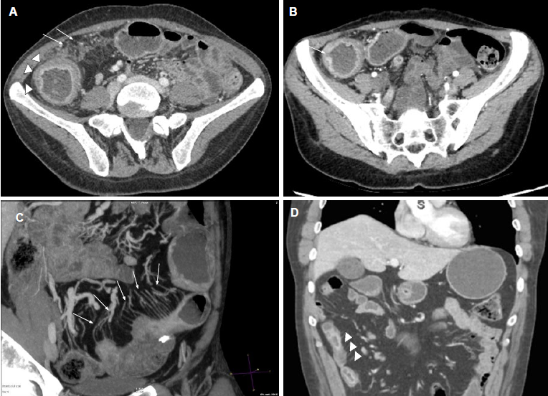
Figure 1 Computed tomography enterographys show signs of inflammatory activity in patients with inflammatory bowel disease. A: mucosal hyperenhancement, wall thickening with mural stratification (arrowheads), mesenteric fat stranding (arrows); B: mucosal ulcerations (arrow); C: hypervascularity of the involved mesentery (comb sign) (arrows); D: enlarged mesenteric lymphnodes (arrowheads).

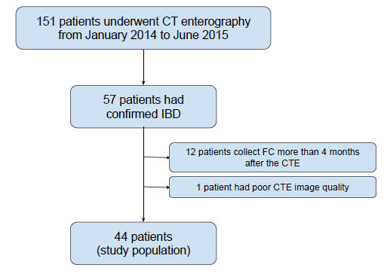
Figure 2 Selection of patients for the retrospective study with all the patients undergoing fecal calprotectin within 4 mo. CTE: Computed tomography enterography; FC: fecal calprotectin

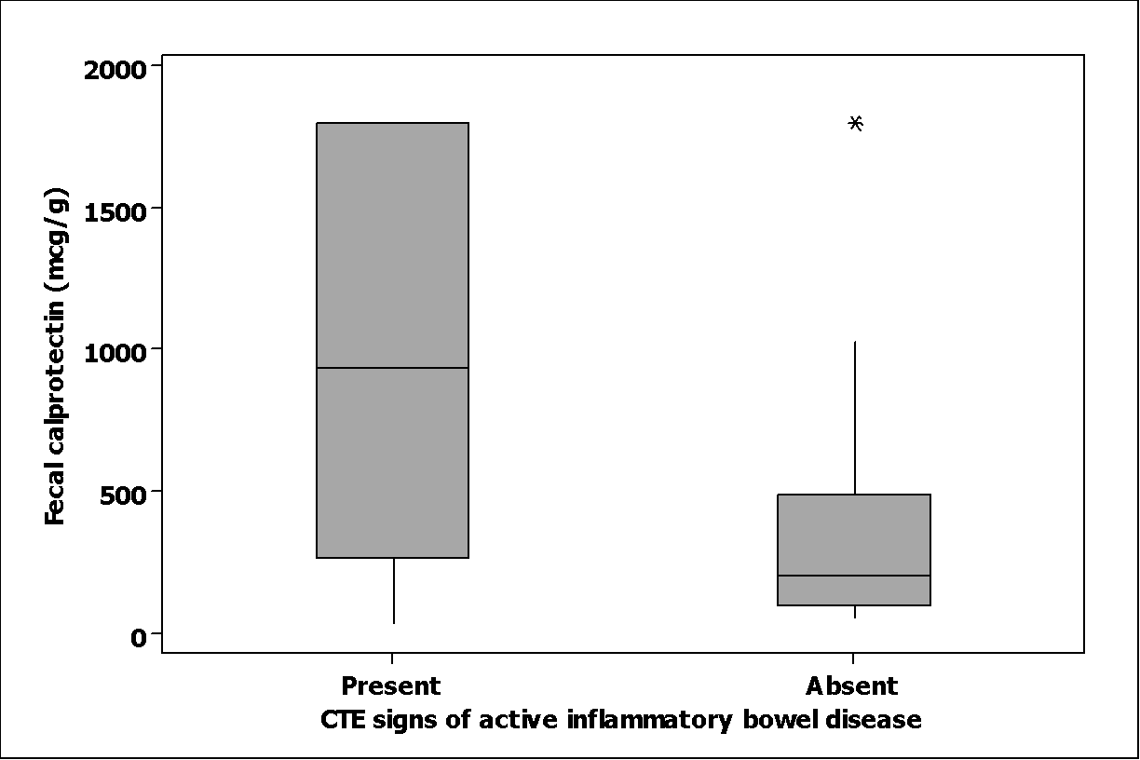
p = 0.004
Figure 3 Fecal calprotectin levels in patients with and without signs of active inflammatory disease in computed tomography enterography.

Table 1 Patient characteristics (n = 44)
Variable | Value
Sex  Male  Female | 19 (43.2%)  25 (56.8%)
Age at CTE (yr) | 49.0 ± 25.4
IBD  Crohn’s disease  Ulcerative colitis | 38 (86.3%)  6 (13.7%)
Fecal calprotectin  Minimum  Maximum  Mean (± SD)  > 250 mcg/g (%) | 30  1800  496 ± 706  30 (68.2%)
CTE: Computed tomography enterography; IBD: Inflammatory bowel disease.

Table 2 Interobserver agreement in computed tomography enterography (n = 44)
CTE variables |  |  |  |  |  |  |  |  | %¹ | Kappa value | p value
Disease localization |  |  |  |  |  |  |  |  | 65.9 | 0.540 | < 0.001
 | Reader 2
Reader 1 | SB | C |  | B | ND |  | Total
SB | 10 | 0 |  | 8 | 0 |  | 18
C | 0 | 3 |  | 0 | 1 |  | 4
B | 0 | 0 |  | 9 | 0 |  | 9
ND | 2 | 4 |  | 0 | 7 |  | 13
Total | 12 | 7 |  | 17 | 8 |  | 44
Type of IBD
 | Reader 2 |  |  |  |  |  |  |  | %¹ | Kappa value | P value
Reader 1 | I | S |  | F | M |  | N | Total | 54.5 | 0.410 | < 0.001
I | 9 | 1 |  | 0 | 2 |  | 1 | 13
S | 1 | 6 |  | 0 | 1 |  | 0 | 8
F | 0 | 0 |  | 1 | 2 |  | 0 | 3
M | 2 | 2 |  | 1 | 2 |  | 0 | 7
N | 5 | 0 |  | 2 | 0 |  | 6 | 13
Total | 17 | 9 |  | 4 | 7 |  | 7 | 44
Signs of active disease
 | Reader 2 |  |  |  |  |  |  |  | %¹ | Kappa value | P value
Reader 1 | Present |  | Absent |  |  | Total |  |  | 70.4 | 0.419 | 0,002
Present | 19 |  | 2 |  |  | 21
Absent | 11 |  | 12 |  |  | 23
Total | 30 |  | 14 |  |  | 44
¹percentage of agreement. SB: small bowel; C: colon; B: both; ND: no disease detected; I: inflammatory; S: stenosing; F: fistulizing; M: more than one pattern; N: normal; CTE: Computed tomography enterography; IBD: Inflammatory bowel disease.

Table 3 Intraobserver agreement in computed tomography enterography (n = 42)
CTE variables |  |  |  |  |  |  |  |  | %¹ | Kappa value | p value
Disease localization |  |  |  |  |  |  |  |  | 92.8 | 0.902 | < 0.001
 | Reader 2 (2nd)
Reader 2 (RE) | SB | C |  | M | ND |  | Total
SB | 12 | 0 |  | 3 | 0 |  | 15
C | 0 | 7 |  | 0 | 0 |  | 7
B | 0 | 0 |  | 12 | 0 |  | 12
ND | 0 | 0 |  | 0 | 8 |  | 8
Total | 12 | 7 |  | 15 | 8 |  | 42
Type of IBD (n = 44)
 | Reader 2 (2nd) |  |  |  |  |  |  |  | %¹ | Kappa value | p value
Reader 2 (RE) | I | S |  | F | M |  | N | Total | 95.1 | 0.937 | <0.001
I | 15 | 0 |  | 0 | 0 |  | 0 | 15
S | 0 | 8 |  | 0 | 0 |  | 0 | 8
F | 0 | 0 |  | 3 | 0 |  | 0 | 3
M | 2 | 0 |  | 0 | 6 |  | 0 | 8
N | 0 | 0 |  | 0 | 0 |  | 8 | 8
Total | 17 | 8 |  | 3 | 6 |  | 8 | 42
Signs of active disease
 | Reader 2 (2^{nd)} |  |  |  |  |  |  |  | %¹ | Kappa value | p value
Reader 2 (RE) | Present |  | Absent |  |  | Total |  |  | 92.9 | 0.830 | <0.001
Present | 28 |  | 3 |  |  | 31
Absent | 0 |  | 11 |  |  | 11
Total | 28 |  | 14 |  |  | 42
¹percentage of agreement. SB: small bowel; C: colon; B: both; ND: no disease detected; I: inflammatory; S: stenosing; F: fistulizing; M: more than one pattern; N: normal; RE: routine evaluation; 2nd: second evaluation; CTE: Computed tomography enterography; IBD: Inflammatory bowel disease.

