Name of Journal: World Journal of Meta-Analysis
ESPS Manuscript NO: 28943
Manuscript Type: meta-analysis

Preoperative colonic stents vs emergency surgery for acute left-sided malignant colonic obstruction: meta-analysis with systematic review of the literature

De Simone B et al. Emergency colonic stenting is safe?

Belinda De Simone, Fausto Catena, Federico Coccolini, Salomone Di Saverio, Massimo Sartelli, Arianna Heyer, Nicola de Angelis, Gian Luigi de Angelis, Luca Ansaloni

Belinda De Simone, Fausto Catena, Department of Emergency and Trauma Surgery, University Hospital of Parma, Via Gramsci 15, 43100 Parma, Italy

Federico Coccolini, Luca Ansaloni, Department of General and Emergency Surgery, Papa XXIII Hospital, 24121 Bergamo, Italy

Salomone Di Saverio, Department of General Surgery, Maggiore Hospital of Bologna, 42121 Bologna, Italy

Massimo Sartelli, Department of Emergency and General Surgery, Macerata’s Hospital, 62100 Macerata, Italy

Arianna Heyer, Department of Medical Sciences, University of California, Berkeley, Berkeley, CA 94720, United States

Nicola de Angelis, Liver Trasplantation and General Surgery Unit, Henry Mondor Hospital, 94000 Creteil, France

Gian Luigi de Angelis, Department of Gastroenterology, University Hospital of Parma, 43100 Parma, Italy

Author contributions: Catena F and De Simone B designed the study; De Simone B collected data and wrote the manuscript; Catena F and De Simone B statistically analyzed data for meta-analysis; Catena F reviewed the manuscript; De Simone B revised data and reviewed the final version of the manuscript; all the authors read and approved the manuscript.

Conflict-of-interest statement: The authors declare no conflict of interests in this study.

Data sharing statement: No additional data are available.

Open-Access: This article is an open-access article which was selected by an in-house editor and fully peer-reviewed by external reviewers. It is distributed in accordance with the Creative Commons Attribution Non Commercial (CC BY-NC 4.0) license, which permits others to distribute, remix, adapt, build upon this work non-commercially, and license their derivative works on different terms, provided the original work is properly cited and the use is non-commercial. See: http://creativecommons.org/licenses/by-nc/4.0/

Manuscript source: Invited manuscript

Correspondence to: Dr. Belinda De Simone, Department of Emergency and Trauma Surgery, University Hospital of Parma, Via Gramsci 15, 43100 Parma, Italy. desimone.belinda@gmail.com
Telephone: +39-3200771986
Fax: +39-05-21702134

Received: July 21, 2016
Peer-review started: July 25, 2016
First decision: September 29, 2016
Revised: October 15, 2016
Accepted: December 13, 2016
Article in press:
Published online:

Abstract
AIM
To investigate by meta analytic study and systematic review, advantages of colonic stents placement in comparison with emergency surgery.

Methods
We conducted an extensive literature search by Pubmed, Google Scholar, Embase and the Cochrane Libraries. We searched for all the papers in English published till February 2016, by applying combinations of the following terms: obstructive colon cancer, colon cancer in emergency, colorectal stenting, emergency surgery for colorectal cancer, guidelines for obstructive colorectal cancer; stenting versus emergency surgery in the treatment of obstructive colorectal cancer, self-expanding metallic stents, stenting as bridge to surgery. The study was designed following Prisma Statement. By our search, we identified 452 studies; 57 potentially relevant studies in full text were reviewed by 2 investigators: 9 randomized controlled trials were considered for meta-analysis; all the others were considered for systematic review.

Results
nine randomized controlled trials were considered for meta-analysis; By comparing colonic stenting (CS) as bridge to surgery and emergency surgery, the pooled analysis showed no significant difference between the two techniques in terms of mortality [odds ratio (or) = 0.91], morbidity (or = 2.38), permanent stoma (or = 1.67) rates; primary anastomosis was more frequent in the stent group (or = 0.45; p = 0.004) and stoma creation was more frequent in the emergency surgery group (or = 2.36; p = 0.002); no statistical difference was found in disease free survival and overall survival. The pooled analysis showed a significant difference between the colonic stent and emergency surgery groups (or = 0.37) with a significant higher one-year recurrence rate in the stent group (p = 0.007).

Conclusion
CS improves primary anastomosis rate with significant high one-year follow-up recurrence and no statistical difference in terms of disease free survival and overall survival.

Key words: Colonic stent; Self-expandable metallic stent; Obstructive left colon cancer; Emergency surgery; Endo-laparoscopic approach; Oncological outcome

© The Author(s) 2016. Published by Baishideng Publishing Group Inc. All rights reserved.

Core tip: The management of patients presenting with acute large bowel obstruction caused by left sided colorectal cancer is still debated. Recently published conflicting results regarding colonic stenting and its oncological outcome, not allowed emergency surgeon to consider this therapeutical option, with the aim to convert an urgent situation into an elective one, decreasing stoma creation rate. We decided to carry out a meta-analysis of all the available randomized controlled trials comparing colonic stenting vs surgical decompression to investigate the real advantage of self-expandable metallic stents placement and its oncological safety.

De Simone B, Catena F, Coccolini F, Di Saverio S, Sartelli M, Heyer A, De Angelis N, De Angelis GL, Ansaloni L. Preoperative colonic stents versus emergency surgery for acute left-sided malignant colonic obstruction: meta-analysis with systematic review of the literature. World J Meta-Anal 2016; In press

INTRODUCTION
Colorectal cancer (CRC) is a common malignant condition in western countries; approximately 10%-30% of patients affected present with acute large bowel obstruction (ALBO) requiring urgent decompression. CRC presenting with obstruction is associated with increasing age, lower socioeconomic status, more advanced disease and considerably increased hospital morbidity and mortality^{[1]}. Treatment options include resection of the obstructing tumor with primary anastomosis, proximal diversion, or insertion of a self-expandable metal stents (SEMS).
Emergency surgery for acute colonic obstruction is associated with a significant risk of mortality and morbidity and with a high percentage of stoma creation^{[2]}.
About 70% of all large bowel obstructions occur in left-sided lesions and there is still no consensus about the emergency management of the obstructed left colon cancer. Colonic stenting (CS) has been suggested as an alternative to surgery, as a bridge to surgery (BTS), allowing time for a preoperative evaluation, to improve the patient’s medical condition, and facilitating bowel decompression; or with palliative purpose in patients considered non operable because of advanced neoplastic disease.
Since Dohmoto et al^{[3]} described the use of SEMS in patients with non resectable or metastatic rectal cancer, and Tejero et al^{[4]} published their experience of metallic stents placement in two patients with colonic obstruction as BTS, several studies demonstrated that endoscopic stenting, followed by elective surgery in the optimal timing, within 5-7 d^{[5,6]}, increases the primary anastomosis rate in patients with obstructive left sided lesion. Lately, many studies reported conflicting results comparing SEMS as BTS and emergency surgery (ES) in terms of safety, morbidity, disease free survival (DFS), overall survival (OS), medium and long term oncological outcomes.
According to the current literature, colon perforation after SEMS placement occurs in 3.8% to 6.9% of patients treated^{[7]} resulting in seeding of neoplastic cells in the abdominal cavity; colonic perforation after stent can be classified in (1) immediate or delayed (technical problems are frequently responsible for immediate perforation; stent quality is an important factor affecting delayed perforation; patients in whom a SEMS was placed at the recto-sigmoid junction are at high risk of delayed perforation); (2) free, associated with faecal peritonitis, or silent (microperforation)^{[8]}.
Almost 70% of colon perforations occur in the first week after stenting and they could have a negative effect on long term survival, especially in patients whose disease is potentially curable. Maruthachalam first reported that endoscopic insertion of colonic stents results in increased levels of CK20 mRNA in the peripheral circulation^{[9]}. Malgras et al^{[10]} showed an increased metastatic process and shorter survival time in a mouse model of colonic cancer treated with SEMS.
We decided to comprehensively review current literature and to carry out a meta-analysis of the last randomized controlled trials (RCT) published with the aim to evaluate the efficacy and safety of CS as BTS versus ES.

MATERIALS AND METHODS
Literature search
We conducted an extensive literature search by Pubmed, Google Scholar, Embase and the Cochrane Library. We searched for all the papers in English published till February 2016 by applying combinations of the following terms: obstructive colon cancer, colon cancer in emergency, colorectal stenting, emergency surgery for colorectal cancer, guidelines for obstructive colorectal cancer; stenting versus emergency surgery in the treatment of obstructive colorectal cancer, SEMS, stenting as BTS.
We considered for our analysis all systematic reviews, RCTs, large case series, original case reports, meta-analyses, retrospective and prospective comparative studies.
The study was designed following Prisma Statement^{[11]}.

Study selection
All the collected studies as full manuscripts were reviewed and selected applying the following inclusion criteria: (1) RCTs; (2) retrospective studies; (3) prospective studies; and (4) case matched studies, comparing colonic stenting as bridge to surgery vs emergency surgery in the treatment of the left colon obstruction caused by adenocarcinoma.

Exclusion criteria
We excluded from analysis studies evaluating stenting for benign stenosis and for right colon cancer, primary and secondary stenting in patients with advanced neoplastic disease and/or for patients who received chemotherapy with palliative treatment; colon stenting for extrinsic tumor compression.

Data extraction
Two investigators, following selection criteria established before starting literature search, extracted the following data from the RCTs included in the meta-analysis: first name author and year of publication, country of origin, study design, whether it was a single or multicenter study, total number of patients included and number of subjects in each group (colonic stent and emergency surgery group), gender and age of patients. Clinical variables were: tumor site, type of stent used and modality of insertion, type of surgery after stent insertion, type of surgery in emergency, data on technical and clinical success, defined as successful stent placement across the stricture and its deployment and adequate bowel decompression (within 48-72 h) from stent insertion without need for re-intervention, stenting-related complications (bleeding, stent obstruction, stent migration, bowel perforation), elective surgery-related complications.
Primary outcomes reported for the 2 techniques were: short term morbidity, in-hospital mortality, permanent stoma creation, primary anastomosis and stoma creation rate, 1-year recurrence rate, OS, DFS.

Quality evaluation
Study quality was assessed by evaluating randomization, generation of allocation sequence and allocation concealment, blinding, description of follow-up, definition of outcome measures, adequate power for clinically significant effect size, intention to treat analysis and baseline assessment of treatment group characteristics, according to the quality criteria suggested for randomized controlled trials by Jüni et al^{[12]}.

Statistical analysis
Data analysis was performed with Revman 5.3 software (Cochrane collaboration). The outcomes of meta-analisys were morbidity and mortality rate, permanent stoma rate, primary anastomosis and temporary stoma creation rate, one year recurrence rate, disease free survival and overall survival rate. The odds ratio (OR) was used to compare the different outcomes for emergency surgery and endoscopic stenting in the groups analyzed. The p values and 95% confidence intervals (CI) were provided for all outcomes. Forest plots for all the outcomes were constructed. A p value < 0.05 was considered significant.

RESULTS
Literature search results
By our search, we identified 452 studies; 57 potentially relevant studies in full text were reviewed by 2 investigators: 9 RCTs (table 1) were considered for meta-analysis; 8 meta-analyses and systematic reviews, 4 reviews of the literature, 17 retrospective comparative studies, 11 prospective comparative studies, 1 experimental study, 5 international guidelines were included in our comprehensive review of the literature (figure 1).
Four RCTs were published between January 2012 and February 2016: (1) Cheung et al^{[13]} carried out a randomized multicenter (12 university Korean hospitals involved) prospective study on 123 patients with malignant colonic obstruction treated by stenting, 58 of them with palliative intent and 65, as bridge to surgery, to determine and compare the clinical outcome and safety of the Taewoong D-type uncovered stent and the Boston Scientific Wallflex stent; (2) Sloothaak et al^{[14]} reported oncological data of the Dutch Stent-In 2 randomized clinical trial^{[15,16]} stopped prematurely in March 2010 because of the clinical stent or procedure-related perforation rate was 13% and occult perforations were revealed in a further 10% of the resected specimens; follow up time for this study was in mean 45 months for the emergency surgery group (32 patients) and 41 months for the colonic stent as bridge to surgery (26 patients); (3) Tung et al^{[17]} reported long term follow up (32 months for the open surgery group and 65 months for the endo-laparoscopic group) data of the RCT conducted by Cheung et al^{[18]} with the aim to compare the endo-laparoscopic approach and open surgery in the treatment of obstructing left sided colon cancer^{[17]}; and (4) Ghazal et al^{[19]} conducted a RCT to compare the procedures of endoscopic stenting followed by elective colectomy versus total abdominal colectomy and ileorectal anastomosis in the management of acute obstructed carcinoma of the left colon^{[19]}.
Data from 8 RCTs^{[15-22]} were analyzed with a total of 361 patients: 182 who received colonic stenting as bridge to surgery and 179 who undergone surgery in emergency. The location of the tumor was well indicated in all the RCTs (trasverse colon; splenic flexure, discending colon, sigmoid colon, rectosigmoid).
Different colonic stents were used across the studies: Van Hooft et al used both the Boston Scientific WallFlex and Wallstent^{[15,16]}; Cheung et al^{[18]} used the Boston Scientific Wallstent; Pirlet et al^{[20]} used the Bard nitinol uncovered stent ; Ho et al^{[21]} used the Boston Scientific WallFlex, while Alcántara et al^{[22]} and Ghazal et al^{[19]} didn’t indicate the type of stent used.
The stent placement was performed by an experienced endoscopist and/or radiologist in the studies of Cheung et al^{[13]}, van Hooft et al^{[15]}, Pirlet et al^{[20]} and Alcántara et al^{[22]}; Ho et al^{[21]} reported that the stent was inserted by an endoscopist or endoscopist-surgeon; Ghazal et al^{[19]} didn’t reported this information.
The colonic stent group was surgically treated by elective colic resection with one stage technique, by laparoscopic approach^{[17,18]} or by laparotomy, or by Hartmann’s procedures.
In the ES group, the surgical technique employed was decided by the surgeon, case by case. All the patients in ES group of Ghazal’s study undergone total abdominal colectomy and ileo-rectal anastomosis^{[19]}.

Meta-analysis
A sensitivity analysis using random versus fixed-effect models for all the outcomes showed a limited difference between the OR and the corresponding 95 % CI. Statistical tests confirmed the presence of between-study heterogeneity; therefore, a random-effects model was utilized for the statistical analysis.

Morbidity and mortality
All studies provided data on mortality^{[14-22]}. There were 14/179 (7.82%) deaths in the surgery group and 15/182 (8.2%) deaths in the stent group; the pooled analysis showed no significant differences between the two strategies (OR = 0.91; 95%CI: 0.29-2.79) (Figure 2). All the studies considered reported medical and surgical complications in the two groups of patients. The morbidity rate was 37.36% (68/182) in the stent group and 53.07% (95/179) in the surgical group and, also for this parameter, the pooled analysis showed no significant differences between the two strategies (OR = 2.38; 95%CI: 0.80-7.06) (Figure 3).

Permanent stoma
Only 5 studies were considered for this parameter (16-20). The permanent stoma rate was 37/126 (29.36%) in the stent group and 52/136 (38.23%) in the surgical group; the pooled analysis showed no significant differences between the two groups (p = 0.09) (Figure 4) with an OR of 1.67 (95%CI: 0.92-3.01).

Primary anastomosis and stoma creation
By comparing emergency surgery and colonic stenting in studies that analyzed the use of stenting as a bridge to surgery procedure^{[14,16,17,19,20,22]}, the pooled analysis showed that primary anastomosis was significantly frequent in the stent group (121/171, 70.76%) as compared to the surgical group (95/169, 56.21%; Figure 5) with an OR of 0.45 (95%CI: 0.26-0.77; p = 0.004) and that the stoma creation was more frequent in the surgical group (77/169, 45.56%) as compared to the stent group (52/170, 30.58%; Figure 6) with an OR of 2.36 (95%CI: 1.37-4.07; p = 0.002).

One year recurrence rate
Only 3 studies were considered^{[16,20,22]} for this parameter. One-year recurrence rate was 18.60% (16/86) in the surgery group and 36.70% (29/79) in the stent group with an OR of 0.37 (95%CI: 0.18-076). The pooled analysis showed a significant difference between the 2 groups with a significant higher one-year recurrence rate in the stent group (p = 0.007) (Figure 7).

Disease free survival
Two studies reported data about DFS^{[20,21]}; the statistical analysis showed a higher DFS in the surgery group (46.42%-26/56) compared to the stent group (39.28%-22/56) with no significant difference in the pooled analysis (p = 0.45), and an OR of 1.34 CI ( 95%CI: 0.63-2.83) (Figure 8).

Overall survival
Cheung et al^{[18]} and van Hooft et al^{[16]} reported data about OS; the pooled analysis showed no significant difference between the 2 groups [25/56 (44.64%) vs 24/50 (48%)], respectively in the ES group and in the stent group; p = 0.65) and an OR of 0.84 (95%CI: 0.39-1.81) (Figure 9).

DISCUSSION
ALBO presents a challenge to any surgeon. Distended unprepared bowel, patient’s dehydration, advanced disease and frequent need for surgery out of hours, often at night, are all factors that predispose the patient to complications. Its surgical management is still debated and includes: (1) primary resection and anastomosis (one stage procedure): it prevents the confection of a loop colostomy but presents the risk of anastomotic leakage; (2) Hartmann’s procedure; it prevents anastomotic leakage but needs a second operation to reverse the colostomy; (3) three stage procedure (decompressive colostomy-colic resection-colostomy’s closure); (4) subtotal or total colectomy with/without primary anastomosis; it is indicated in diastatic colon perforation or synchronous right colonic cancer; and (5) temporary or definitive loop colostomy/ileostomy, in case of important bowel dilatation proximal to obstruction, advanced neoplastic disease or peritoneal carcinomatosis^{[1,2]}.
Many available studies reported the increasing number of surgical procedures involving the creation of a diverting or permanent stomas and this seems to increase with age, decreasing quality of life of patients^{[23,24]}.
The ‘ideal’ operation is the elective one. The immediate colic resection with primary anastomosis represents the gold standard in patients with low risk; a temporary de-functioning colostomy or ileostomy could be proposed to patients with an intermediate anesthetic risk; in high-risk cases, advanced obstruction, simultaneous colonic perforation, metastatic or locally advanced disease, Hartmann's operation should be preferred; colonic stents represent the best option when skills are available^{[2]}.
CS as BTS seems to provide a good alternative therapeutic to convert an emergency clinical situation into a more elective one.

sems insertion and complications
SEMS placement can be associated with complications, such as perforation, migration, tumor ingrowth, stool impaction, bleeding, and pain.
Perforation rate ranged from 0 to 83%, the overall risk of perforation was about 5%, which is a relatively low risk, but the mortality rate of patients with perforations was 16%^{[8]}.
Van Hooft et al^{[15,16]} reported 6/47 stent related perforations and Pirlet et al^{[20]} reported 2 stent perforations and 8 silent perforations in 30 patients randomized to CS as BTS.
The endoscopist’s experience, the type of colic obstruction (partial or complete), the type of stent and the insertion technique are fundamental to reach CS technical and clinical success^{[25]}.
CS is more likely to be successful in shorter, malignant strictures with less angulation, distal to the obstruction^{[26]}.
Geraghty et al^{[27]} reported that technical success and good outcome for the emergency management of malignant left colon obstruction (MLBO) by SEMS insertion is higher for experienced operators who had performed more than 10 procedures, using the through-the-scope (TTS) endoscopy technique.
Giannotti et al^{[28]} evaluating prospectively short and long term results from colonic stenting as BTS, showed a benefit for the CS group compared to ES group and concluded that this results from the experience of the endoscopist and the relatively low rate of complete colonic obstructions included in the study.
Mehmood et al^{[29]} reported that CS can be performed by an endoscopist without radiologist support if adequately trained, with good outcomes, highlighting the central role of the endoscopist.
SEMS can be divided into two types: uncovered and (fully and partially) covered. Tumor in growth occurs often with uncovered SEMS, and migration occurs often with covered SEMS^{[30]}.
The selection of the appropriate stent is very important for outcomes, considering material, design, diameter, length, radial force, flexibility, foreshortening ratio, and delivery system but there is no evidence to indicate which stent type is superior.
Cheung et al^{[13]} recently conducted a multi center, randomized, prospective, comparative study aimed to compare the efficacy and complication rates of the D-type colonic stent (Taewoong medical Co., Gimpo, South Korea) with those of the Wallflex stent (Boston Scientific Corp., Natick, MA, United States); both stents were uncovered with different radial and axial force, to reduce the excessive pressure on the ends, which could result in contact with the normal mucosa of the colon, increasing risk of perforation. Perforation occurred for 5/58 patients treated with colonic stent. 4 with the Wallflex stent and 1 with D-type stent without statistically significant difference^{[13]}.
van Halsema et al^{[7]} in his meta-analysis noted that of the 9 most frequently used stent types, the WallFlex, the Comvi, and the Niti-S D-type have a higher perforation rate (> 10%). A lower perforation rate (< 5%) was found for the Hanarostent and the Niti-S covered stent. Risk factors for perforation include benign etiology of the stricture, and chemotherapy with bevacizumab, as confirmed by others studies^{[7,31-33]}.

Colonic stenting vs emergency surgery: which are the benefits?
Many studies were proposed to investigate advantages and disadvantages of CS compared to ES in the management of acute colorectal obstruction. Data confirmed short-term safety and efficacy of SEMS placement as BTS. The conflicting data reported recently by 3 RCTs, stopped prematurely, have opened the debate on the efficacy and safety of the use of SEMS to treat potentially curable patients presenting with MLBO^{[15,20,22]}.
Van Hooft did not observe clinical advantages of colonic stenting as compared to ES. During his RCT, an interim analysis showed an increase in absolute risk of 30-d morbidity in the CS group and a high perforation rate (13%). In this trial, the ES group had an increased stoma rate after initial intervention (75% in ES vs 51% in CS), but a reduced frequency of stoma-related problems (1.9% in ES vs 10.6% in CS). The differences in the stoma rate disappeared at last follow-up (67% in ES vs 57% CS group) due to the high leakage rate of primary anastomosis in the stent group^{[15,16]}.
Pirlet et al^{[20]}, failed to demonstrate that CS significantly decreased the need for a stoma compared to ES. No significant difference was noted regarding the stoma rate, but the high number of stent-related adverse events (6.6% of perforations) and the low technical success rate for stent insertion (47%) led to premature closure of the trial^{[20]}.
In contrast, Alcántara et al^{[22]} closed their study prematurely because of the high morbidity, in particular of the high incidence of anastomotic leakage in the ES group (30.7% in the ES with intraoperative colonic lavage vs 0% in patients having CS)^{[22]}.
Since the publication of these data, several meta-analyses were designed to investigate the superiority of the use of CS as BTS compared with ES alone in the treatment of potentially curable patients presenting with MLBO.
Cennamo et al^{[34]} confirmed that in patients with ALBO, stent placement improves primary anastomosis without decreasing mortality and morbidity rates.
Zhang et al^{[35]} reported that stent placement as BTS did not adversely affect mortality and long term survival.
Cirocchi et al^{[36]} analyzed data about 197 patients, 97 of them treated with CS to assess the effectiveness of CS used as BTS, in the management of MLBO. The authors showed that when used as BTS, CS improves the primary anastomosis rate (64.9% vs 55% respectively for CS group and ES group; p = 0.003) and decreases the overall stoma rate (45.3% vs 62% respectively in the CS and ES groups; p = 0.02)^{[36]}.
De Ceglie et al^{[37]} showed that CS offers advantages over ES in terms of increase in primary anastomosis, successful primary anastomosis, reduction of stoma creation, infections and other morbidities; no significant statistical difference between CS and ES in terms of length of hospitalization, preoperative mortality and long-term survival.
Huang et al^{[25]} analyzed data from 7 RCTs comparing CS and ES and reported that compared with the ES group, the CS group achieved significantly more favorable rates of permanent stoma, primary anastomosis, wound infection, and overall complications; no significant difference between the two groups in anastomotic leakage, mortality, or intra-abdominal infection was found.
Results of our meta-analysis confirmed that in the group of patients treated with CS as BTS, primary anastomosis is significantly more frequent; as stoma creation rate is significantly higher in the ES group; no statistically significant difference was found between the two groups in permanent stoma rate (Figures 4-6).

Stent placement as bridge to surgery is oncologically safe?
The negative long-term oncological outcomes of SEMS insertion have to be proven and are still debated after the data reported by Maruthachalam and Malgras^{[9,10]}. Surely, the enforced radial dilatation by SEMS suggests the possibility of increased risk of perforation and tumor manipulation that can induce dissemination of cancer cells into the peritoneal cavity.
Matsuda et al^{[38]} conducted his meta-analysis to evaluate long-term outcomes of colonic stent insertion followed by surgery for ALBO. He included 11 studies for analysis with a total of 1136 patients, of whom 432 (38%) underwent CS as BTS and 704 (62%) underwent ES. OS, DFS and recurrence did not differ significantly between the CS as BTS and ES groups.
Kavanagh et al^{[39]} conducted an observational comparative study to evaluate medium term oncological outcomes of CS as BTS and ES with an intention to treat analysis. Data showed no difference in cancer specific and all cause mortality between both groups; there were 3 cancer related deaths in the CS group and 4 in ES group. Median follow up (months) in CS and ES group was 27.4 (range 1-81) and 26^{[39]}. Disease recurrence occurred in 4 patients in the CS group and 6 patients in the ES group; sites of recurrence in the CS were: local/peritoneal in two patients, liver in two patients; both local recurrences occurred in patients who had undergone R1 resections. In the ES group there were 1 local/liver, 2 peritoneal, and 3 liver; the local recurrence occurred in a single patient who had a R1 resection. Kavanagh reported the histological evidence of clinically silent tumor micro perforations in 3 patients in the CS group (13%) in comparison with 2 (7%) tumor micro perforations in the ES group and this suggested that it is occasionally present in the absence of stent deployment^{[39]}.
Gorissen reported that SEMS was associated with an increased local recurrence rate in patients aged ≤ 75 years. In younger patients treated with CS, a significantly higher local recurrence rate was observed at the end of the follow up (32% vs 8 %; p = 0.038). Of 20 local recurrences, 12 were diffusely peritoneal, 5 were at the large bowel anastomosis/side wall, 2 were ovarian and 1 was on the small bowel^{[40]}.
Sloothaak et al^{[14]} reported data about disease recurrence (DR), DFS, disease specific survival (DSS) and OS about patients involved in the Dutch Stent in 2 trial^{[14-16]}. Fifty eight patients were included in the analysis. Median follow up was 4 and 41 months in the ES and CS groups respectively. Loco-regional or distant disease recurrence developed in 9/32 patients in the ES group and 13/26 in the CS group. DFS was worst after a stent-related perforation.The OS rate was 50% for patients with a stent related perforation and was worse than the rate of 62% in patients without stent-related perforation^{[14]}.
Sabbagh et al^{[41]} retrospectively analyzed data from 48 patients in CS group and 39 in the ES group, using a propensity score to correct for selection bias and he reported worse OS and DFS of patients with MLBO with SEMS insertion compared with ES. In the overall population, OS (P = 0.001) and 5-year overall survival (P = 0.0003) were significantly lower in the CS group than in the ES group, and 5-year cancer-specific mortality was significantly higher in the CS group (P = 0.02). Five-year DFS, the recurrence rate, and the mean time to recurrence were better in the ES group (no statistically significant difference). For patients with no metastases or perforations at hospital admission, (P = 0.003) and 5-year overall survival (30% vs 67%, respectively, P = 0.001) were significantly lower in the CS group than in the ES group^{[41]}.The same authors wanted to explain these data by analyzing pathological specimens from the CS- and the ES groups in a case-matched analysis (with the groups matched for the T stage). A total of 84 patients were included in the study (50 in the CS group). Twenty-five patients in the CS group were matched with 25 patients of the surgery-only group. Tumor ulceration (p = 0.0001), peri-tumor ulceration (p = 0.0001), perineural invasion (p = 0.008), and lymph node invasion (p = 0.005) were significantly more frequent in the CS group. In a multivariate analysis of the CS group, T4 status and tumor size were significant risk factors for microscopic perforation, perineural invasion, and lymph node invasion^{[42]}.
Then Knight et al^{[43]} decided to carried out a retrospective cohort study to determine if preoperative stenting adversely affects long-term survival by comparing a group of patients having preoperative stenting (group A) with a group of patients having elective surgery for Dukes' B and C cancer excluding mid and low rectal tumors (group B) in a single centre. The 30-day mortality rate for groups A and B was 6.7 % (one patient) and 5.7% (five patients), respectively. The 5-year survival rate was 60 % and 58 %, respectively, with a p value of 0.96. Knight concluded that patients undergoing CS as BTS have the same long-term survival with those undergoing elective surgery^{[43]}.
Park et al^{[44]} retrospectively analyzed data from 67 patients who had undergone SEMS placement as BTS and 35 patients treated by ES to compare surgical and oncologic outcomes of the groups. The CS group had a higher laparoscopic resection rate (67.2% vs 31.4%, p = 0.001) with a lower conversion rate (4.3% vs 35.3%, p = 0.003). The rates of local recurrence and distant metastasis, recurrence-free, and OS were not significantly different between the two groups^{[44]}.
Also Kim et al^{[45]} carried out a retrospective analysis of data from 43 patients who had undergone radical resection after preoperative CS and 48 who had undergone ES with curative intent to compare short- and long-term outcomes between the two groups. The 5-year DFS and 5-year survival rates were not significantly different between the CS and ES groups^{[45]}.
Our meta-analysis showed that 16/86 (18.60%) patients in the ES group and 29/79 (36.70%) patients in the CS group presented with a recurrence at 1 year follow-up period with a statistically significant difference between the two group (p = 0.007). (Figure 7). No statistically significant difference was found in terms of DFS and OS between the groups. (Figures 8 and 9).

SEMS: International guidelines
Considering available data, the emergency surgeon is not allowed to treat with SEMS potentially curable patients presenting with obstructing left sided colon cancer.
The World Society of Emergency Surgery, after a consensus conference, stated that colonic stents represent a valuable option both for palliation and as a bridge to elective surgery, when skills are available, to treat patients presenting with obstructing left sided colon cancer and no signs of perforations. High clinical and technical expertise is mandatory to obtain good results, consequently they suggest that SEMS should be used as a bridge to elective surgery in referral centre hospitals with specific expertise, in selected patients, and that CS should be preferred to colostomy for palliation in patients not treated with bevacizumab-based therapy, since this technique is associated with similar mortality/morbidity rates and shorter hospital stay compared to surgery, avoiding high health-care cost related to stoma^{[2,32]}.
The European Society of Gastrointestinal Endoscopy does not recommend SEMS placement as a standard treatment of symptomatic MLBO; it can be considered for patients with potentially curable ALBO at high risk of postoperative mortality (American Society of Anesthesiologists Physical Status ≥ III and/or age > 70 years) as an alternative to ES; it is recommended as the preferred treatment for palliation, except in patients treated or considered for treatment with anti-angiogenic drugs such as bevacizumab^{[46]}.
The Eastern Association for the Surgery of Trauma conditionally recommend CS (if available) as initial therapy for MLBO, because of stent use was associated with decreased mortality and morbidity rates^{[47]}.
The Korean Society of Gastrointestinal Endoscopy recommends CS as BTS in order to avoid high morbidity related to ES, above all in patients with unresectable CRC, because SEMS placement can relieve symptoms, improve quality of life and allow chemotherapy and/ or radiotherapy for palliation^{[48]}.
In conclusion, CS improves primary anastomosis rate with a low stoma creation in comparison with emergency surgery. At one year follow-up, the recurrence rate is higher in patients treated with stent, with no statistical difference in terms of DFS and OS. CS is a therapeutical option to take into consideration, when skills are available, to treat patients unfit for surgery, with palliative intent, considering high health-care cost related to stoma.
Considering available data about oncological outcome of CS, surgery is the only treatment to offer to young patients presenting with a potentially curable acute colorectal obstruction.

COMMENTS
Background
Colonic stenting seems to be a good therapeutical option to convert an urgent situation into an elective one. Recently published conflicting results about oncological safety of this technique, used as a bridge to surgery, versus emergency surgery, not allow surgeons to treat with stent potentially curable patients presenting with large bowel obstruction.

Research frontiers
Emergency surgery has still high morbidity and mortality rate. The use of colonic stenting in the management of patients presenting large bowel obstruction can help to decrease morbidity and mortality, delaying surgery. The problem is that colonic stenting can potentially determinate the spreading of tumor cells but no available data can confirm that it can affect disease free survival and overall survival rates.

Innovations and breakthrough
In the present study, authors demonstrated that colonic stenting improves primary anastomosis rate with a low stoma creation. At one year follow-up, the recurrence rate is higher in patients treated with stent, with no statistical difference in terms of disease free survival and overall survival.

Applications
Colonic stenting is a therapeutical option to take into consideration, when skills are available, to treat patients unfit for surgery, with palliative intent, considering high health-care cost related to stoma. Considering available data about oncological outcome of stunting in emergency, surgery is the only treatment to offer to young patients presenting with a potentially curable acute colorectal obstruction.

Peer-review
This meta-analysis of randomized controlled trials comparing colonic stenting versus emergency surgery in the management of left large bowel obstruction and the systematic review of all the other available studies adds useful information for practice and research.

REFERENCES
1 De Simone B, Catena F. Emergency Surgery for Colorectal Cancer in Patients Aged Over 90 Years: Review of the Recent Literature. J Tumor 2015; 4: 349-353 Available from: URL: http://www.ghrnet.org/index.php/JT/article/view/1589
2 Ansaloni L, Andersson RE, Bazzoli F, Catena F, Cennamo V, Di Saverio S, Fuccio L, Jeekel H, Leppäniemi A, Moore E, Pinna AD, Pisano M, Repici A, Sugarbaker PH, Tuech JJ. Guidelenines in the management of obstructing cancer of the left colon: consensus conference of the world society of emergency surgery (WSES) and peritoneum and surgery (PnS) society. World J Emerg Surg 2010; 5: 29 [PMID: 21189148 DOI: 10.1186/1749-7922-5-29.]
3 Dohmoto M, Hünerbein M, Schlag PM. Application of rectal stents for palliation of obstructing rectosigmoid cancer. Surg Endosc 1997; 11: 758-761 [PMID: 9214327]
4 Tejero E, Fernández-Lobato R, Mainar A, Montes C, Pinto I, Fernández L, Jorge E, Lozano R. Initial results of a new procedure for treatment of malignant obstruction of the left colon. Dis Colon Rectum 1997; 40: 432-436 [PMID: 9106691]
5 Abdussamet Bozkurt M, Gonenc M, Kapan S, Kocatasş A, Temizgönül B, Alis H. Colonic stent as bridge to surgery in patients with obstructive left-sided colon cancer. JSLS 2014; 18: pii: e2014.00161 [PMID: 25408602 DOI: 10.4293/JSLS.2014.00161]
6 Sirikurnpiboon S, Awapittaya B, Jivapaisarnpong P, Rattanachu-ek T, Wannaprasert J, Panpimarnmas S. Bridging metallic stent placement in acute obstructed left sided malignant colorectal cancer: optimal time for surgery. J Med Assoc Thai 2014; 97 Suppl 11: S81-S86 [PMID: 25509700]
7 van Halsema EE, van Hooft JE, Small AJ, Baron TH, García-Cano J, Cheon JH, Lee MS, Kwon SH, Mucci-Hennekinne S, Fockens P, Dijkgraaf MG, Repici A. Perforation in colorectal stenting: a meta-analysis and a search for risk factors. Gastrointest Endosc 2014; 79: 970-982.e7; quiz 983.e2, 983.e5 [PMID: 24650852 DOI: 10.1016/j.gie.2013.11.038]
8 Kim EJ, Kim YJ. Stents for colorectal obstruction: Past, present, and future. World J Gastroenterol 2016; 22: 842-852 [PMID: 26811630 DOI: 10.3748/wjg.v22.i2.842]
9 Maruthachalam K, Lash GE, Shenton BK, Horgan AF. Tumour cell dissemination following endoscopic stent insertion. Br J Surg 2007; 94: 1151-1154 [PMID: 17541987 DOI: 10.1002/bjs.5790]
10 Malgras B, Brullé L, Lo Dico R, El Marjou F, Robine S, Therwath A, Pocard M. Insertion of a Stent in Obstructive Colon Cancer Can Induce a Metastatic Process in an Experimental Murine Model. Ann Surg Oncol 2015; 22 Suppl 3: S1475-S1480 [PMID: 25956578 DOI: 10.1245/s10434-015-4588-y]
11 Moher D, Liberati A, Tetzlaff J, Altman DG. Preferred reporting items for systematic reviews and meta-analyses: the PRISMA statement. Int J Surg 2010; 8: 336-341 [PMID: 20171303 DOI: 10.1016/J.IJSU.2010.02.007]
12 Jüni P, Altman DG, Egger M. Systematic reviews in health care: Assessing the quality of controlled clinical trials. BMJ 2001; 323: 42-46 [PMID: 11440947]
13 Cheung DY, Kim JY, Hong SP, Jung MK, Ye BD, Kim SG, Kim JH, Lee KM, Kim KH, Baik GH, Kim HG, Eun CS, Kim TI, Kim SW, Kim CD, Yang CH. Outcome and safety of self-expandable metallic stents for malignant colon obstruction: a Korean multicenter randomized prospective study. Surg Endosc 2012; 26: 3106-3113 [PMID: 22609981 DOI: 10.1007/s00464-012-2300-x]
14 Sloothaak DA, van den Berg MW, Dijkgraaf MG, Fockens P, Tanis PJ, van Hooft JE, Bemelman WA; collaborative Dutch Stent-In study group. Oncological outcome of malignant colonic obstruction in the Dutch Stent-In 2 trial. Br J Surg 2014; 101: 1751-1757 [PMID: 25298250 DOI: 10.1002/BJS.9645]
15 van Hooft JE, Fockens P, Marinelli AW, Timmer R, van Berkel AM, Bossuyt PM, Bemelman WA; Dutch Colorectal Stent Group. Early closure of a multicenter randomized clinical trial of endoscopic stenting versus surgery for stage IV left-sided colorectal cancer. Endoscopy 2008; 40: 184-191 [PMID: 18322873 DOI: 10.1055/s-2007-995426]
16 van Hooft JE, Bemelman WA, Oldenburg B, Marinelli AW, Lutke Holzik MF, Grubben MJ, Sprangers MA, Dijkgraaf MG, Fockens P; collaborative Dutch Stent-In study group. Colonic stenting versus emergency surgery for acute left-sided malignant colonic obstruction: a multicentre randomised trial. Lancet Oncol 2011; 12: 344-352 [PMID: 21398178 DOI: 10.1016/S1470-2045(11)70035-3]
17 Tung KL, Cheung HY, Ng LW, Chung CC, Li MK. Endo-laparoscopic approach versus conventional open surgery in the treatment of obstructing left-sided colon cancer: long-term follow-up of a randomized trial. Asian J Endosc Surg 2013; 6: 78-81 [PMID: 23601995 DOI: 10.1111/ASES.12030]
18 Cheung HY, Chung CC, Tsang WW, Wong JC, Yau KK, Li MK. Endolaparoscopic approach vs conventional open surgery in the treatment of obstructing left-sided colon cancer: a randomized controlled trial. Arch Surg 2009; 144: 1127-1132 [PMID: 20026830 DOI: 10.1001/archsurg.2009.216]
19 Ghazal AH, El-Shazly WG, Bessa SS, El-Riwini MT, Hussein AM. Colonic endolumenal stenting devices and elective surgery versus emergency subtotal/total colectomy in the management of malignant obstructed left colon carcinoma. J Gastrointest Surg 2013; 17: 1123-1129 [PMID: 23358847 DOI: 10.1007/s11605-013-2152-2]
20 Pirlet IA, Slim K, Kwiatkowski F, Michot F, Millat BL. Emergency preoperative stenting versus surgery for acute left-sided malignant colonic obstruction: a multicenter randomized controlled trial. Surg Endosc 2011; 25: 1814-1821 [PMID: 21170659 DOI: 10.1007/s00464-010-1471-6]
21 Ho KS, Quah HM, Lim JF, Tang CL, Eu KW. Endoscopic stenting and elective surgery versus emergency surgery for left-sided malignant colonic obstruction: a prospective randomized trial. Int J Colorectal Dis 2012; 27: 355-362 [PMID: 22033810 DOI: 10.1007/s00384-011-1331-4]
22 Alcántara M, Serra-Aracil X, Falcó J, Mora L, Bombardó J, Navarro S. Prospective, controlled, randomized study of intraoperative colonic lavage versus stent placement in obstructive left-sided colonic cancer. World J Surg 2011; 35: 1904-1910 [PMID: 21559998 DOI: 10.1007/s00268-011-1139-y]
23 Anaraki F, Vafaie M, Behboo R, Maghsoodi N, Esmaeilpour S, Safaee A. Quality of life outcomes in patients living with stoma. Indian J Palliat Care 2012; 18: 176-180 [PMID: 23439841 DOI: 10.4103/0973-1075.105687]
24 Wong SK, Young PY, Widder S, Khadaroo RG; Acute Care and Emergency Surgery (ACES) Group of the University of Alberta, Canada. A descriptive survey study on the effect of age on quality of life following stoma surgery. Ostomy Wound Manage 2013; 59: 16-23 [PMID: 24334361]
25 Huang X, Lv B, Zhang S, Meng L. Preoperative colonic stents versus emergency surgery for acute left-sided malignant colonic obstruction: a meta-analysis. J Gastrointest Surg 2014; 18: 584-591 [PMID: 24170606 DOI: 10.1007/S11605-013-2344-9]
26 Boyle DJ, Thorn C, Saini A, Elton C, Atkin GK, Mitchell IC, Lotzof K, Marcus A, Mathur P. Predictive factors for successful colonic stenting in acute large-bowel obstruction: a 15-year cohort analysis. Dis Colon Rectum 2015; 58: 358-362 [PMID: 25664716 DOI: 10.1097/DCR.0000000000000243]
27 Geraghty J, Sarkar S, Cox T, Lal S, Willert R, Ramesh J, Bodger K, Carlson GL. Management of large bowel obstruction with self-expanding metal stents. A multicentre retrospective study of factors determining outcome. Colorectal Dis 2014; 16: 476-483 [PMID: 24506142 DOI: 10.1111/CODI.12582]
28 Gianotti L, Tamini N, Nespoli L, Rota M, Bolzonaro E, Frego R, Redaelli A, Antolini L, Ardito A, Nespoli A, Dinelli M. A prospective evaluation of short-term and long-term results from colonic stenting for palliation or as a bridge to elective operation versus immediate surgery for large-bowel obstruction. Surg Endosc 2013; 27: 832-842 [PMID: 23052501 DOI: 10.1007/S00464-012-2520-0]
29 Mehmood RK, Parker J, Kirkbride P, Ahmed S, Akbar F, Qasem E, Zeeshan M, Jehangir E. Outcomes after stenting for malignant large bowel obstruction without radiologist support. World J Gastroenterol 2014; 20: 6309-6313 [PMID: 24876752 DOI: 10.3748/WJG.V20.I20.6309]
30 Kim BC, Han KS, Hong CW, Sohn DK, Park JW, Park SC, Kim SY, Baek JY, Choi HS, Chang HJ, Kim DY, Oh JH. Clinical outcomes of palliative self-expanding metallic stents in patients with malignant colorectal obstruction. J Dig Dis 2012; 13: 258-266 [PMID: 22500788 DOI: 10.1111/J.1751-2980.2012.00564.X]
31 Cetinkaya E, Dogrul AB, Tirnaksiz MB. Role of self expandable stents in management of colorectal cancers. World J Gastrointest Oncol 2016; 8: 113-120 [PMID: 26798442 DOI: 10.4251/WJGO.V8.I1.113]
32 Cennamo V, Fuccio L, Mutri V, Minardi ME, Eusebi LH, Ceroni L, Laterza L, Ansaloni L, Pinna AD, Salfi N, Martoni AA, Bazzoli F. Does stent placement for advanced colon cancer increase the risk of perforation during bevacizumab-based therapy? Clin Gastroenterol Hepatol 2009; 7: 1174-1176 [PMID: 19631290 DOI: 10.1016/J.CGH.2009.07.015]
33 Imbulgoda A, MacLean A, Heine J, Drolet S, Vickers MM. Colonic perforation with intraluminal stents and bevacizumab in advanced colorectal cancer: retrospective case series and literature review. Can J Surg 2015; 58: 167-171 [PMID: 25799132]
34 Cennamo V, Luigiano C, Coccolini F, Fabbri C, Bassi M, De Caro G, Ceroni L, Maimone A, Ravelli P, Ansaloni L. Meta-analysis of randomized trials comparing endoscopic stenting and surgical decompression for colorectal cancer obstruction. Int J Colorectal Dis 2013; 28: 855-863 [PMID: 23151813 DOI: 10.1007/S00384-012-1599-Z]
35 Zhang Y, Shi J, Shi B, Song CY, Xie WF, Chen YX. Self-expanding metallic stent as a bridge to surgery versus emergency surgery for obstructive colorectal cancer: a meta-analysis. Surg Endosc 2012; 26: 110-119 [PMID: 21789642 DOI: 10.1007/S00464-011-1835-6]
36 Cirocchi R, Farinella E, Trastulli S, Desiderio J, Listorti C, Boselli C, Parisi A, Noya G, Sagar J. Safety and efficacy of endoscopic colonic stenting as a bridge to surgery in the management of intestinal obstruction due to left colon and rectal cancer: a systematic review and meta-analysis. Surg Oncol 2013; 22: 14-21 [PMID: 23183301 DOI: 10.1016/J.SURONC.2012.10.003]
37 De Ceglie A, Filiberti R, Baron TH, Ceppi M, Conio M. A meta-analysis of endoscopic stenting as bridge to surgery versus emergency surgery for left-sided colorectal cancer obstruction. Crit Rev Oncol Hematol 2013; 88: 387-403 [PMID: 23845505 DOI: 10.1016/J.CRITREVONC.2013.06.006]
38 Matsuda A, Miyashita M, Matsumoto S, Matsutani T, Sakurazawa N, Takahashi G, Kishi T, Uchida E. Comparison of long-term outcomes of colonic stent as "bridge to surgery" and emergency surgery for malignant large-bowel obstruction: a meta-analysis. Ann Surg Oncol 2015; 22: 497-504 [PMID: 25120255 DOI: 10.1245/S10434-014-3997-7]
39 Kavanagh DO, Nolan B, Judge C, Hyland JM, Mulcahy HE, O'Connell PR, Winter DC, Doherty GA. A comparative study of short- and medium-term outcomes comparing emergent surgery and stenting as a bridge to surgery in patients with acute malignant colonic obstruction. Dis Colon Rectum 2013; 56: 433-440 [PMID: 23478610 DOI: 10.1097/DCR.0B013E3182760506]
40 Gorissen KJ, Tuynman JB, Fryer E, Wang L, Uberoi R, Jones OM, Cunningham C, Lindsey I. Local recurrence after stenting for obstructing left-sided colonic cancer. Br J Surg 2013; 100: 1805-1809 [PMID: 24227368 DOI: 10.1002/BJS.9297]
41 Sabbagh C, Browet F, Diouf M, Cosse C, Brehant O, Bartoli E, Mauvais F, Chauffert B, Dupas JL, Nguyen-Khac E, Regimbeau JM. Is stenting as "a bridge to surgery" an oncologically safe strategy for the management of acute, left-sided, malignant, colonic obstruction? A comparative study with a propensity score analysis. Ann Surg 2013; 258: 107-115 [PMID: 23324856 DOI: 10.1097/SLA.0B013E31827E30CE]
42 Sabbagh C, Chatelain D, Trouillet N, Mauvais F, Bendjaballah S, Browet F, Regimbeau JM. Does use of a metallic colon stent as a bridge to surgery modify the pathology data in patients with colonic obstruction? A case-matched study. Surg Endosc 2013; 27: 3622-3631 [PMID: 23572218 DOI: 10.1007/S00464-013-2934-3]
43 Knight AL, Trompetas V, Saunders MP, Anderson HJ. Does stenting of left-sided colorectal cancer as a "bridge to surgery" adversely affect oncological outcomes? A comparison with non-obstructing elective left-sided colonic resections. Int J Colorectal Dis 2012; 27: 1509-1514 [PMID: 22684548 DOI: 10.1007/S00384-012-1513-8]
44 Park SJ, Lee KY, Kwon SH, Lee SH. Stenting as a Bridge to Surgery for Obstructive Colon Cancer: Does It Have Surgical Merit or Oncologic Demerit? Ann Surg Oncol 2016; 23: 842-848 [PMID: 26668086 DOI: 10.1245/S10434-015-4897-1]
45 Kim HJ, Huh JW, Kang WS, Kim CH, Lim SW, Joo YE, Kim HR, Kim YJ. Oncologic safety of stent as bridge to surgery compared to emergency radical surgery for left-sided colorectal cancer obstruction. Surg Endosc 2013; 27: 3121-3128 [PMID: 23436100 DOI: 10.1007/S00464-013-2865-Z]
46 van Hooft JE, van Halsema EE, Vanbiervliet G, Beets-Tan RG, DeWitt JM, Donnellan F, Dumonceau JM, Glynne-Jones RG, Hassan C, Jiménez-Perez J, Meisner S, Muthusamy VR, Parker MC, Regimbeau JM, Sabbagh C, Sagar J, Tanis PJ, Vandervoort J, Webster GJ, Manes G, Barthet MA, Repici A. Self-expandable metal stents for obstructing colonic and extracolonic cancer: European Society of Gastrointestinal Endoscopy (ESGE) Clinical Guideline. Endoscopy 2014; 46: 990-1053 [PMID: 25325682 DOI: 10.1055/s-0034-1390700]
47 Ferrada P, Patel MB, Poylin V, Bruns BR, Leichtle SW, Wydo S, Sultan S, Haut ER, Robinson B. Surgery or stenting for colonic obstruction: A practice management guideline from the Eastern Association for the Surgery of Trauma. J Trauma Acute Care Surg 2016; 80: 659-664 [PMID: 26808035 DOI: 10.1097/TA.0000000000000966]
48 Lee KJ, Kim SW, Kim TI, Lee JH, Lee BI, Keum B, Cheung DY, Yang CH; Stent Study Group of the Korean Society of Gastrointestinal Endoscopy. Evidence-based recommendations on colorectal stenting: a report from the stent study group of the korean society of gastrointestinal endoscopy. Clin Endosc 2013; 46: 355-367 [PMID: 23964332 DOI: 10.5946/ce.2013.46.4.355]
P-Reviewer: Ayscue JM S-Editor: Gong ZM
L-Editor: E-Editor:

Records identified through database searching
(n = 452)
Records after duplicates removed
(n =157)
Records screened
(n = 157 )
Full-text articles assessed for eligibility
(n =107)
Studies included in qualitative synthesis
(n = 48)
Additional records identified through other sources
(n =2)
Records excluded
(n =50 )

Full-text articles excluded, with reasons
(n = 50 )

Studies included in quantitative synthesis (meta-analysis)
(n = 9 )

Figure 1 PRISMA 2009 flow diagram.

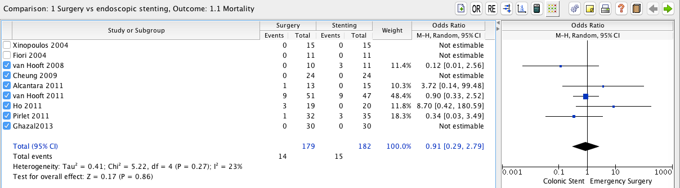
Figure 2 Mortality rate; no statistically significant difference between the colic stenting and emergency surgery groups.

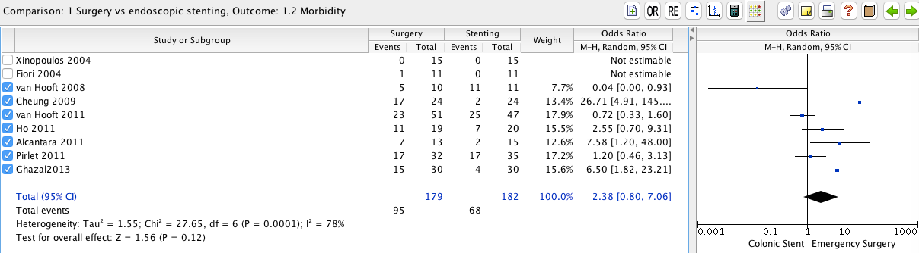
Figure 3 Morbidity rate; no statistically significant difference between colon stenting and emergency surgery groups.

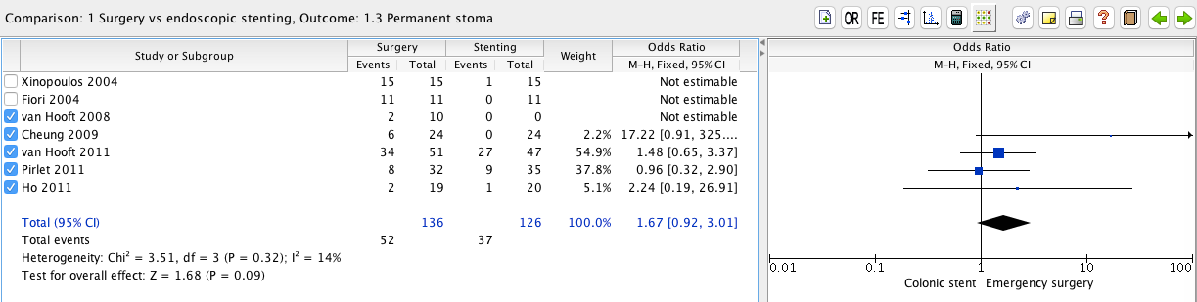
Figure 4 Permanent stoma rate; no significant difference between colon stenting and emergency surgery groups.

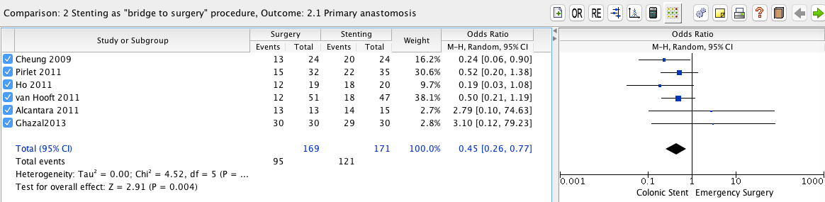
Figure 5 Primary anastomosis rate; this parameter is higher in the colonic stenting group with a significant difference in comparison with the emergency surgery group.

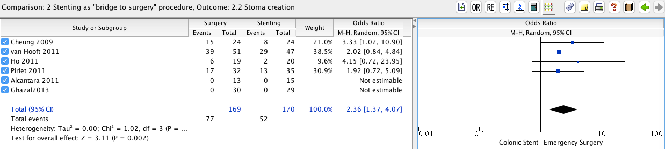 Figure 6 Stoma creation rate; this parameter is higher in the emergency surgery group with a significant difference between the two groups considered.

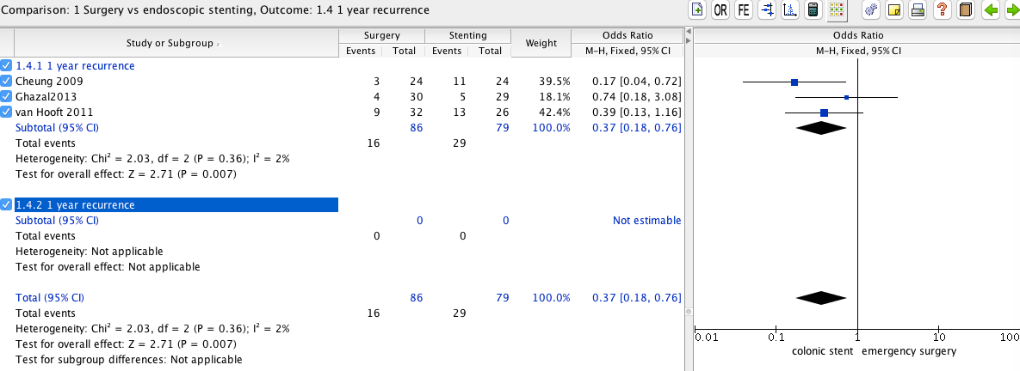
Figure 7 One-year recurrence rate; this parameter is higher in the colonic stenting in comparison with the emergency surgery group with a significant difference between the two groups.

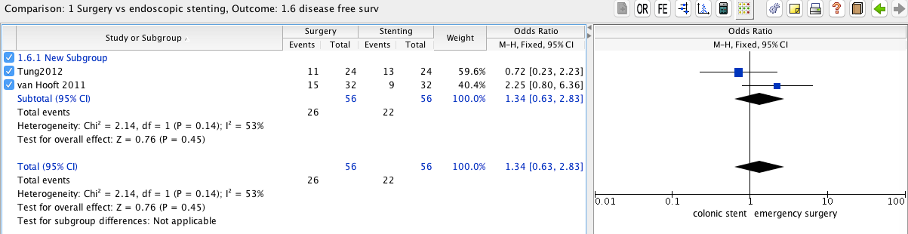
Figure 8 Disease free survival; no significant difference between colonic stenting and emergency surgery groups.

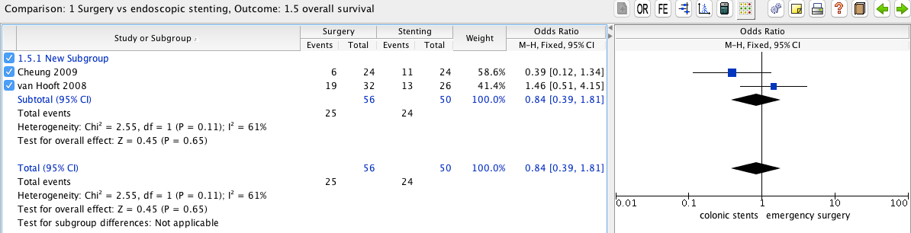
Figure 9 Overall survival; no significant difference between colonic stenting and emergency surgery groups.

Table 1 Studies characteristics
Ref. | Format | Country | Type study | CS/ES | etiology of obstruction | Site of obstruction | Colonic stent | Emergency surgery | Elective surgical  treatment
Van hooft et al^{[14]}, 2008 | FT | Netherlands | mLC | 11/10 | OLCC | RS: 16  DC: 6 | endoscopic-fluoroscopic placement of Boston Scientific Wallflex | Open or laparoscopic Palliative resection or fecal diversion | None
Cheung et al^{[18]},  2009 | FT | China | mNC | 24/24 | OLCC | between the splenic flexure and the recto-sigmoid junction | endoscopic-fluoroscopic placement of Boston Scientific Wallstent | Hartmann procedure; primary anastomosis after subtotal or total colectomy or segmental colectomy with on-table lavage according to the operators’ judgment. | elective laparoscopic-assisted colectomy
Alcántara et al^{[22]}, 2011 | FT | Spain | mNC | 15/13 | OLCC | SF: 6  DC: 3  Sigma: 15  RSJ: 3  Rectum sup: 1 | NA | Retrowash_ (Intermark Medical Interventions  Ltd, Bromley, Kent, United Kingdom) , a retrograde variation of the  traditional anterograde lavage | Colectomy with PA: 14  HP: 1
Pirlet et al^{[20]}, 2011 | FT | France | mLC | 35/32 | OLCC: 60  benign stenosis: 3  NA: 7 | RSJ: 15  Sigma: 33  DC: 8  SF: 3  NA: 1  (10 drop out) | endoscopic-fluoroscopic placement of Bard nitinol uncovered  self-expanding stents (Voisins le Bretonneux, France). | One-stage procedure: 14  Two-stage surgery: 8 three-stage surgery: 2 | colectomy with PA
van Hooft et al^{[15,16]}, 2011 | FT | Netherlands | MLC | 47/51 | NA | NA | endoscopic-fluoroscopic placement of Wallstents and WallFlex colonic stents  (Boston Scientific, Natick, MA, United States). | Treatment according to conventional standards | NA
Cheung et al^{[13]}, 2012 | FT | South Korea | mLC | 58/62 | OLCC | ascending colon: 10  trasverse: 9  dC: 14  sigma: 65  rectum: 25 | taewoong D type uncovered stent;  Boston scientific wallflex stent  fluoroscopy placement with through the scope or over the wire method |  | palliative intent: 58  BTS: 65
Ghazal et al^{[19]}, 2012 | FT | Egypt | mNC | 30/30 | OLCC | rSJ: 12-10  sigma: 14-17  dC: 4-3 | endoscopic placement under fluoroscopic guidance | total abdominal colectomy and ileorectal anastomosis by laparotomy | Left hemicolectomy or anterior resection
Tung et al^{[17]}, 2012 | FT | China | mNC | 24/24 | oLCC | NA | endoscopic-fluoroscopic placement of Boston Scientific Wallstent | NA | LR
NA: not available; FT: full text; OLCC: obstructive left sided colon cancer; LR: laparoscopic resection; MLC: multi center study; MNC: mono centric study; RSJ: rectosigmoid junction; DC: distending colon; SF: splenic flexure; PA: primary anastomosis; sigma: sigmoid colon; HP: Hartmann’s procedure; BTS: bridge to surgery.

