Name of Journal: World Journal of Clinical Cases
Manuscript NO: 80286
Manuscript Type: CASE REPORT

Complication after nipple-areolar complex tattooing performed by a non-medical person: A case report

Byeon JY et al. Complication of areolar tattooing

Je Yeon Byeon, Tae Hoon Kim, Hwan-Jun Choi

Je Yeon Byeon, Tae Hoon Kim, Hwan-Jun Choi, Plastic and Reconstructive Surgery, Soonchunhyang University Hospital, Cheonan KS002, South Korea

Author contributions: Byeon JY and Kim TH contributed to manuscript writing and editing, and data collection; Choi HJ contributed to conceptualization and supervision; all authors have read and approved the final manuscript.

Corresponding author: Hwan-Jun Choi, MD, PhD, Professor, Surgeon, Plastic and Reconstructive Surgery, Soonchunhyang University Hospital, Soonchunhyang 6 gil 31, Bongmyeong-dong, Dongnam-gu, Cheonan-si, Chungcheongnam-do, Cheonan KS002, South Korea. iprskorea@gmail.com

Received: September 25, 2022
Revised: October 14, 2022
Accepted: November 7, 2022
Published online:

Abstract
BACKGROUND
Compared to earlier, there has been an increase in the tattoo procedures for cosmetic purposes; and there has also been an increase in the tattoo procedures performed by non-medical personnel. In South Korea, only tattoos performed by a doctor are considered legal; however, there is still some debate over whether tattoo procedures performed by non-healthcare providers should be considered legal.

CASE SUMMARY
A 28-year-old woman visited our hospital with pain in both nipples and heat sensation over the last 4 d. She had a history of a nipple tattoo performed by an unlicensed person. Pinpoint bleeding was noted in both areolar areas, and the exudate mixed with pus and orange color ink was discharged. Oral medication and tulle with foam dressing were performed under the impression of cellulitis and allergic reaction. After 4 wk, nipples remained dark brown in color, resulting in a color mismatch between the nipple and orange-colored areola. The size of the areola was also found to be distinctly asymmetrical after healing. This complication may have been caused by the use of illegal ink or unsanitary procedures, or a problem may have occurred in the post-tattoo management stage.

CONCLUSION
Doctors use approved ink, aseptic procedure and appropriate postoperative care, and appropriate management can be performed in case of complications.

Key Words: Infections; Nipples; Tattooing; Licensure; Case report

Byeon JY, Kim TH, Choi HJ. Complication after nipple-areolar complex tattooing performed by a non-medical person: A case report. World J Clin Cases 2022; In press

Core Tip: Tattoos are restricted in some cultures, or they are regulated by national policies. In the case of South Korea, it is stipulated by law that only a doctor can perform tattoo procedures. Nevertheless, as the accessibility and demand for tattoos increase among the people, illegal tattoo procedures are increasing. The author presents complications that occurred after illegal tattoo procedures. The use of unapproved dyes, unsanitary procedures, and the absence of post-treatment can result in unnatural and ugly tattoos. Tattoos can be performed more beautifully and naturally by a doctor, especially by a plastic surgeon. In particular, tattoos for cosmetic purposes can produce better results than those performed by non-medical personnel. Therefore, doctors' interest and participation in tattoos are necessary, and government regulations are also necessary.

INTRODUCTION
The nipple areolar complex (NAC) is an important landmark in the breast and has a cosmetic significance^{[1]}. Therefore, it is important to preserve the NAC as much as possible during surgeries, such as mastopexy, mastectomy, and breast reconstruction. If the NAC is damaged, it is necessary to restore its shape and color^{[2]}. NAC tattooing is a procedure that can restore the color of the abnormal NAC and make it look more natural. Tattooing is usually performed by using a tattoo machine to insert ink into the dermal layer at a certain depth with a fine needle^{[3,4]}. In South Korea, a tattoo is defined as an invasive procedure in humans; thus, only doctors can legally perform a tattoo. Therefore, tattoos administered by unlicensed non-medical personnel are illegal in South Korea^{[5]}. Nonetheless, illegal tattoo procedures by non-medical personnel are increasing^{[6]}. This is because the overall demand for tattoos has increased compared to the past, and it has become more accessible to the general public^{[7]}. In addition, the purpose of tattoos has expanded in various ways; thus, tattoos are used for permanent makeup, such as eyebrows, eyeliner, and hairline. The perception of tattoos is also changing positively^{[8]}.
As mentioned earlier, tattoo procedures performed by non-medical personnel are illegal in Korea and Japan^{[5]}. Also, some countries in Islamic culture do not allow tattoos^{[9]}. Denmark does not allow tattoos on the face, neck, or hands^{[10]}. There are regulations on tattoos in many other countries^{[11]}. In common, most countries restrict unsanitary and illegal ink and tattoo procedures because of the possibility of infection or various side effects^{[12-15]}.
The author intends to report the harm and risk of non-medical tattoo procedures by presenting the case a patient who illegally received tattoo procedures from non-medical personnel without a license.

CASE PRESENTATION
Chief complaints
A 28-year-old woman visited the emergency room with pain, swelling, and exudation of both nipples after receiving a tattoo on her areolar area.

History of present illness
Pain and inflammation that occurred after receiving the tattoo three days ago worsened over time; hence, the patient visited our hospital.

History of past illness
The patient had a medical history of breast reduction and NAC reduction 10 years ago. She received a tattoo on both areolas due to dissatisfaction with the NAC color. The patient said she had been given a tattoo by an unlicensed person at an illegal tattoo clinic. The patient showed that both sides of the areolar area were stained with orange color ink.

Personal and family history
The patient denied any family history of similar symptoms.

Physical examination
The type of ink used in the tattoo could not be determined, and the method used for the procedure was not known. Pinpoint bleeding was found in both areolar areas, and the exudate mixed with pus and orange color ink were discharged. The size of both NACs appeared asymmetric. The nipples remained dark brown in color because tattoos were not performed on the nipples, and they did not match the color of the areolar area (Figures 1 and 2).

Laboratory examinations
The patient refused any laboratory examinations or clinical study.

Imaging examinations
The patient has not undergone an imaging examination.

FINAL DIAGNOSIS
The final diagnoses were cellulitis, allergic dermatitis, and foreign body reactions in the NAC.

TREATMENT
Because the patient did not have medical insurance, she refused any examination or hospitalization, and instead received outpatient treatment. Therefore, bacterial culture tests, blood tests, and biopsy were not performed. In order to control inflammation, cefroxadine antibiotic, a first-generation cephalosporin, was administered orally. Tulle dressing and foam dressing were applied to accelerate epithelialization and control exudation. Two weeks later, inflammation and exudation were controlled. Epithelialization progressed, and edema and pain decreased (Figure 3A). Four weeks later, the wound had completely healed. More than half of the orange ink in the areolar area was lost, and hyperpigmentation and hypopigmentation occurred partially. Asymmetry of both areolar sizes and color mismatch with nipples persisted (Figure 3B).

OUTCOME AND FOLLOW-UP
After the treatment was completed, NAC correction surgery and tattoo were required to correct asymmetry of the NACs, but the patient was lost to follow-up and contact.

DISCUSSION
It can be assumed that the reason for infection after the tattoo procedure was that the safety of ink used had not been assessed, the procedure itself was a septic procedure, or a problem occurred in the post-tattoo management stage. Since biopsy, blood test, or culture test was not performed, the exact cause could not be confirmed. Viruses^{[16]}, bacteria^{[17]}, and fungi^{[18,19]} can cause infections after the tattoo procedure. As the number of tattoo procedures increase^{[5-7]}, various side effects due to infection are also increasing; thus, medical experts need to pay attention.
As non-infectious complications, itching and swelling are the most common, and they occur in 30% of people who have tattoos. Local reactions may include a papulo-nodular pattern, plaque-like pattern, excessive hyperkeratosis pattern, lymphopathic pattern, neurosensory pattern, and various side effects, such as general conditions, may occur^{[20]}. Therefore, continuous and close management from a medical perspective is required even during and after tattoo procedures.
Illegal inks that have not been evaluated for human fitness are likely to contain unknown ingredients and have serious side effects. Mikkelsen et al^{[21]} reported a case of exfoliative dermatitis that occurred after using a home kit tattoo ink purchased in China. The patient had serious side effects showing edema, redness, pus formation, and dry crustation all over the body. It was confirmed that our patient had been tattooed by a Chinese person, and similarly, the procedure was unsanitary with ink that could not be identified. Therefore, it is very important for public health workers to perform the tattoo procedure hygienically using ink approved by the Food and Drug Administration or a national institution.
In a study conducted in Germany based on public search terms for tattoos, the search terms for tattoo bump, raised tattoo, swollen tattoo, itchy tattoo, tattoo fading increased sharply between 2014-2018 compared to 2004-2008, and also the search terms for infected tattoo and tattoo healing increased^{[22]}. Among these search terms were conditions that may require medical management and treatment. Therefore, appropriate counseling and treatment should be provided based on a professional background to patients complaining of side effects of tattoos.
Recently, the scope of application of tattoos has expanded to a permanent makeup procedure, and in this case, tattoos have been used for cosmetic purposes of the NAC. Tattoos are beingly increasingly used to cover up scars or complexes. Like Korea, Japan also restricts tattoo procedures to doctors and nurses with medical licenses. Tomita et al^{[5]} reported the experience of tattoo procedures by medical personnel. In 1352 patients, the rate of overall side effects was 12%, which was lower than the usual rate of side effects; and among them, itching or swelling were the most common. The proportion of infection was very small, with only three cases, and the proportion of satisfaction was high. Therefore, professional background knowledge and procedures for tattooing are essential^{[23]}.
Like a permanent makeup tattoo, the NAC can show good results if properly planned and treated by medical personnel. Sowa et al^{[24]} performed medical tattooing on the NAC. Compared to the traditional tattoo, more natural and satisfactory results were obtained through the 3D enhancing technique. Uhlmann et al^{[25]} successfully reconstructed the NAC through a 3D areolar dermopigmentation technique. If our patient had been tattooed by utilizing the above techniques, better results could have been obtained. The process of removing tattoos involves high cost and time, and pain occurs^{[26]}. Therefore, it is essential to plan adequately before getting a tattoo and to get a tattoo hygienically from an expert.

CONCLUSION
Tattoos have a positive meaning for many purposes. There are many possibilities in which tattoos can be used in the medical field. Even for getting cosmetic tattoos for non-medical purposes, a plastic surgeon with professional knowledge should be preferred compared to non-medical personnel. Careful planning, safe ink and legally approved ingredient, hygienic procedures, and systematic management should be performed so that side effects can be reduced and satisfaction can be increased in people.

REFERENCES
1 Nicholson BT, Harvey JA, Cohen MA. Nipple-areolar complex: normal anatomy and benign and malignant processes. Radiographics 2009; 29: 509-523 [PMID: 19325062 DOI: 10.1148/rg.292085128]
2 Egan KG, Cullom M, Nazir N, Butterworth JA. Patient Satisfaction Increases with Nipple Reconstruction following Autologous Breast Reconstruction. Plast Reconstr Surg 2021; 148: 177e-184e [PMID: 34133405 DOI: 10.1097/PRS.0000000000008180]
3 Ruffolo AM, Bruce WJ, Daugherty THF, Lee J, Sommer NZ. Technical Refinement in Three-Dimensional Nipple-Areola Complex Tattooing of the Reconstructed Breast. Plast Reconstr Surg 2021; 148: 737-746 [PMID: 34550927 DOI: 10.1097/PRS.0000000000008390]
4 Kuruvilla AS, Gopman JM, Cham S, Henderson PW. Nipple-areolar tattoo: Comprehensive review of history, theory, technique, and outcomes. J Plast Reconstr Aesthet Surg 2022; 75: 544-549 [PMID: 34728157 DOI: 10.1016/j.bjps.2021.09.024]
5 Tomita S, Mori K, Yamazaki H, Mori K. Complications of permanent makeup procedures for the eyebrow and eyeline. Medicine (Baltimore) 2021; 100: e25755 [PMID: 33950961 DOI: 10.1097/MD.0000000000025755]
6 Lee SH, Lee CH, Kim JS, Park MY, Jeong CW, Lee SJ, Choi EH. Perception of Tattoos in South Korea: Analysis of Citizen Survey Data. Korean J Dermatol 2021; 15-24 [DOI: 10.13029/jkaps.2003.9.1.45]
7 Kim YM, Geum KS. A Study on the Reception and Spread of Tattoo Fashion. J Korean Socie Costume 2016; 66: 18-31 [DOI: 10.7233/jksc.2016.66.3.018]
8 Park J. Signs of social change on the bodies of youth: tattoos in Korea. Visual Commu 2016; 15: 71-92 [DOI: 10.1177/1470357215608552]
9 Atik D, Yιldιrιm C. Motivations behind acquiring tattoos and feelings of regret: Highlights from an Eastern Mediterranean context. J Consumer Behaviour 2014; 13: 212-223 [DOI: 10.1002/cb.1480]
10 European Council. Resolution ResAP(2008)1 on requirements an criteria for the safety of tattoos and permanent make-up. In: Products CoEoC, ed; 2008
11 Laumann AE, Derick AJ. Tattoos and body piercings in the United States: a national data set. J Am Acad Dermatol 2006; 55: 413-421 [PMID: 16908345 DOI: 10.1016/j.jaad.2006.03.026]
12 Sagoe D, Pallesen S, Andreassen CS. Prevalence and correlates of tattooing in Norway: A large-scale cross-sectional study. Scand J Psychol 2017; 58: 562-570 [PMID: 29105125 DOI: 10.1111/sjop.12399]
13 Das Eidgenössische Departement des Innern (EDI). Verordnung über Gegenstände für den Schleimhaut-, Haut- und Haarkontakt sowie über Kerzen, Streichhölzer, Feuerzeuge und Scherzartikel (Verordnung über Gegenstände für den Humankontakt), Swiss Government. Bern, 2005: 1-26
14 European Council. Council directive 76/768/EEC on the approximation of the law as of the member states relating to cosmetic produtcs. OJEU, 1976: 1-169
15 Worp J, Boonstra A, Coutinho RA, van den Hoek JA. Tattooing, permanent makeup and piercing in Amsterdam; guidelines, legislation and monitoring. Euro Surveill 2006; 11: 34-36 [PMID: 16484732 DOI: 10.2807/esm.11.01.00591-en]
16 Cohen PR. Tattoo-Associated Viral Infections: A Review. Clin Cosmet Investig Dermatol 2021; 14: 1529-1540 [PMID: 34720594 DOI: 10.2147/CCID.S284796]
17 Dieckmann R, Boone I, Brockmann SO, Hammerl JA, Kolb-Mäurer A, Goebeler M, Luch A, Al Dahouk S. The Risk of Bacterial Infection After Tattooing. Dtsch Arztebl Int 2016; 113: 665-671 [PMID: 27788747 DOI: 10.3238/arztebl.2016.0665]
18 Park AM, Hathaway NE, Wright KT. Mycobacterium mageritense tattoo infection: a known complication with a novel species. Dermatol Online J 2020; 26 [PMID: 32621684]
19 Lobo Y, Lun K. Tattoo-Associated Cutaneous Mycobacterium mageritense Infection: A Case Report and Brief Review of the Literature. Case Rep Dermatol 2021; 13: 513-520 [PMID: 35082611 DOI: 10.1159/000520255]
20 Serup J, Carlsen KH, Sepehri M. Tattoo complaints and complications: diagnosis and clinical spectrum. Curr Probl Dermatol 2015; 48: 48-60 [PMID: 25833625 DOI: 10.1159/000369645]
21 Mikkelsen CS, Holmgren HR, Arvesen KB, Jarjis RD, Gunnarsson GL. Severe scratcher-reaction: an unknown health hazard? Dermatol Reports 2015; 7: 5816 [PMID: 25918618 DOI: 10.4081/dr.2015.5816]
22 Kluger N. Tattoo side effects worldwide: a Google Trends-based time series analysis. Acta Dermatovenerol Alp Pannonica Adriat 2019; 28: 125-127 [PMID: 31545390]
23 Rubio L, Costa M, Barrulas P, Lores M, Garcia-Jares C, Barrocas-Dias C. Understanding the chemical and mineralogical composition of commercial henna and jagua tattoos and dyes-a multi-analytical approach. Anal Bioanal Chem 2022; 414: 6233-6246 [PMID: 35829771 DOI: 10.1007/s00216-022-04194-1]
24 Sowa Y, Kodama T, Hori T, Numajiri T. A Medical Tattooing Technique for Enhancing the Three-Dimensional Appearance of the Nipple-Areola Complex After Flap-Based Nipple Reconstruction. Aesthetic Plast Surg 2021; 45: 2631-2636 [PMID: 34350501 DOI: 10.1007/s00266-021-02471-5]
25 Uhlmann NR, Martins MM, Piato S. 3D areola dermopigmentation (nipple-areola complex). Breast J 2019; 25: 1214-1221 [PMID: 31321852 DOI: 10.1111/tbj.13427]
26 Khunger N, Molpariya A, Khunger A. Complications of Tattoos and Tattoo Removal: Stop and Think Before you ink. J Cutan Aesthet Surg 2015; 8: 30-36 [PMID: 25949020 DOI: 10.4103/0974-2077.155072]

Footnotes
Informed consent statement: Written informed consent was obtained from the patient for publication of this report and any accompanying images.

Conflict-of-interest statement: All the authors report no relevant conflicts of interest for this article.

CARE Checklist (2016) statement: The authors have read the CARE Checklist (2016), and the manuscript was prepared and revised according to the CARE Checklist (2016).

Open-Access: This article is an open-access article that was selected by an in-house editor and fully peer-reviewed by external reviewers. It is distributed in accordance with the Creative Commons Attribution NonCommercial (CC BY-NC 4.0) license, which permits others to distribute, remix, adapt, build upon this work non-commercially, and license their derivative works on different terms, provided the original work is properly cited and the use is non-commercial. See: https://creativecommons.org/Licenses/by-nc/4.0/

Provenance and peer review: Unsolicited article; Externally peer reviewed.

Peer-review model: Single blind

Peer-review started: September 25, 2022
First decision: October 12, 2022
Article in press:

Specialty type: Medicine, research and experimental
Country/Territory of origin: South Korea
Peer-review report’s scientific quality classification
Grade A (Excellent): 0
Grade B (Very good): B
Grade C (Good): 0
Grade D (Fair): D
Grade E (Poor): 0

P-Reviewer: Agrawal P, United States; Touihmi S, Morocco S-Editor: Fan JR L-Editor: A P-Editor: Fan JR

Figure Legends
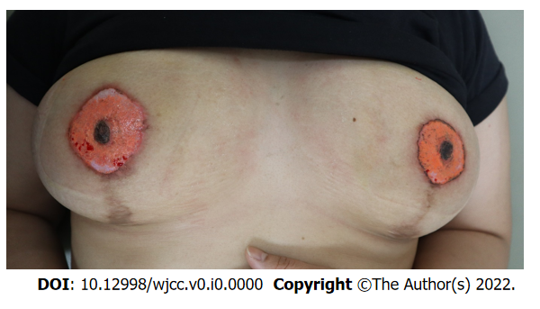
Figure 1 Initial Photograph of both nipple areolar complex. Scars were seen on both peri-areolar areas and lower pole of the breast after the breast reduction operation. Pinpoint bleeding was found in both areolar areas. The size of the nipple areolar complex (NAC) on the right side appeared larger than that of the NAC on the left side. The nipples remained dark brown in color because tattoos were not performed on that area and they did not match the color of the areolar area. Hypopigmentation was seen in both areolar areas.
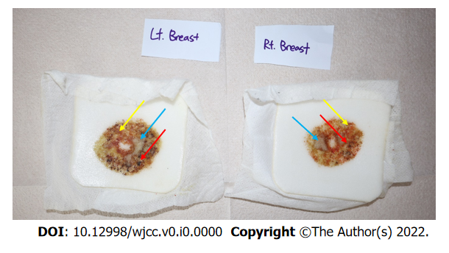
Figure 2 An exudate from the areolar area. Red arrow indicated blood clot and bleeding. Yellow arrow indicated orange color ink ejected from the areolar area. Blue arrow indicated an exudate mixed with pus.
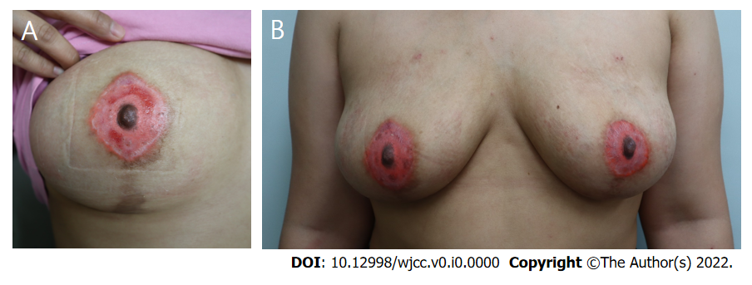
Figure 3 A photograph taken after treatment. A: A photograph taken after two weeks of treatment. Swelling, discharge, and pain improved, and bleeding stopped. Epithelialization was in progress, but there was still a raw surface on the areolar area. Hyperpigmentation and hypopigmentation were seen. Also, color mismatch and size mismatch of both nipple areolar complex (NACs) were noted, and there was a color mismatch between the nipple and areolar area, which looked unnatural; B: A photograph taken after four weeks of treatment. After treatment, more than half of the ink was lost, leaving only a part. Hyperpigmentation and hypopigmentation had worsened. It was necessary to correct the size and color of both NACs. The areolar tissue had turned into scar tissue and looked even more unnatural.

