Dr Wai Kin Mak,
Department of Upper GI Surgery
Royal Devon and Exeter NHS Foundation Trust
Barrack Road, Exeter EX25DW, United Kingdom
w.mak@nhs.net
+44 01392 406296

To the editors of World Journal of Clinical Cases and World Journal of Gasteroenterology,

We would like to thank you for the opportunity to resubmit a revised copy of our manuscript now entitled “Hospital admissions from alcohol-related acute pancreatitis during the COVID-19 pandemic: a single-centre study”.
We would also like to take this opportunity to express our thanks and gratitude to the reviewers’ positive feedback and constructive criticism. The comments have provided us with valuable insight and we have tried to address the issues as best as possible.

Below we have included each individual comment with reference to changes made and where this can be found in the manuscript. These changes are highlighted within the revised manuscript.

- There is missing information about data sources and methods to compare temporal trends. ANOVA does not seem appropriate for time-series analysis.

We have added details regarding data sources and methods as seen in line 86-102 and figure1.

Whilst we appreciate the reviewers’ comment regarding time series analysis, we do not believe it would be appropriate in this instance. As we are interested in the total number of admissions within discrete periods (March-September). We do not have the data for October-February and therefore do not have a complete 12 monthly timeseries to carry out the suggested analysis. We could use simple linear regression to predict the total admissions for the March-September period in 2020 and compare this with the observed value. As we only have 4 years of data, this means the linear prediction would be subject to large error. We therefore do not think this analysis is appropriate with the data we have. Please see below for linear regression demonstrating error.

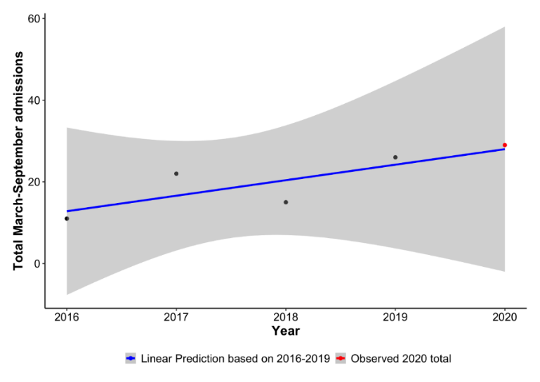

- Biases are not appropriately addressed in the text; due to the type of study and data collection, there is a clear possibility of an ecological fallacy. This should be discussed openly.

The authors agree with this comment and this should now be addressed as seen on line 179-184.

- Why in 2019 is there an overall increase in alcohol consumption?

We cannot comment on the reason behind an overall increase in alcohol consumption in 2019. This is an observation of the admission pattern only. Although the overall admission of AP was higher in 2019 compared to 2020, this is likely due to the recurrent AP group. When examining the first onset patient group, 2020 is 11.5% higher. Other observations of note include when taking March-May (lockdown) as the period of interest, 2020 admissions were higher in both overall admission and first onset groups.
There are of course other factors to consider such as ecological fallacy and world sporting events (i.e. Rugby world cup 2019).

- Why the reduction in admission in 2020 just after the lockdown? Did the alcohol consumption habit change in that short period of time? Why or how this change happened?

This is a very good question. The reduction in alcohol consumption is only a hypothesis. The reduction in admission following the lockdown period was only observed. Data such as alcohol intake was outside the scope of this study.

- Reconsider the title because data do not justify the implicit correlation between habit changes and alcohol admission.

The authors agree with this comment and have addressed this. Title “Changes in social behaviour during the COVID-19 pandemic and consequences on hospital admissions from acute alcohol-related pancreatitis” has now been changed to “Hospital admissions from alcohol-related acute pancreatitis during the COVID-19 pandemic: a single-centre study”.

- Is there information about the severity of the diagnosis in different years?

This is another good question that the reviewers posed. We have now addressed this as shown in Figure 1 and line138. We did not observe a significant difference in severity of AP between the 5-year group.

- The Introduction is too short and it could be developed more. Some sentences from the abstract are repeated in the Introduction.

This has now been addressed as seen in the Introduction section.

- The inclusion and exclusion criteria should be properly highlighted and discussed more/ Patients’ group could be described in more detail, especially how they were selected for the study. The authors could use a flowchart.

This has now been addressed and discussed in Figure 1, eligibility criteria and data collection section

- By “normal distribution” do the authors mean “Gaussian distribution”? In this case, mean values are usually expressed as mean values and standard deviation not standard error.

Thank you for highlighting this error. When using the term “normal distribution”, we did mean Gaussian distribution and agree mean should be expressed with standard deviation. This has now been addressed.

- A linear regression model could be used to determine the factors that influenced the hospitalization rates.

The authors welcomed the suggestion of a linear regression model. However, would disagree on the basis that we would require risk factors for this model. We studied the general population in a specific time frame only. Risk factors were outside of the scope of this observational study, thus making this unsuitable.

- In Figure 1, violin plots could be used.

This is a good suggestion from the reviewers. However, Figure 1 shows the number of admissions over the observed period of 2016-2020. Box plot/ violin would be used to depict distribution of numerical data with range, number of admissions (absolute numbers) cannot be displayed in this fashion. The appendix for Figure 1 does however say “admissions in year groups’’, would it be possible that the reviewers misinterpreted our meaning of year group?
- The phrasing of the figure 1 legend has now been changed to “Distribution of new alcohol-related acute pancreatitis and readmission cases between March and September 2016-2020”

If reviewers prefer age to be displayed, then a violin/ box plot would be appropriate and have been demonstrated below.
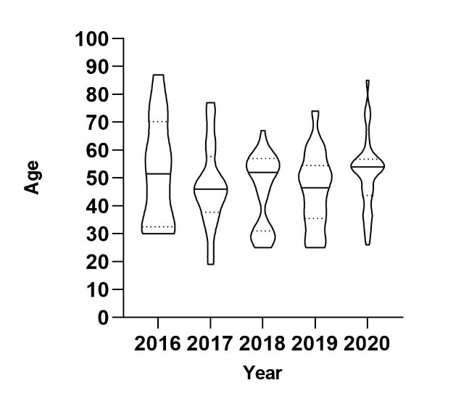

- In Results, the authors should specify the exact number of male and female patients.

Thank you for highlighting this error. We have now addressed this on line 119.

- If the authors have data regarding how many patients had AP after the infection with SARS-CoV-2, they could compare this subgroup with the subgroup of patients with AP but without history of COVID-19 infection.

The authors welcomed this suggestion and agreed it would add value to the manuscript. However, we have reviewed the case notes of the 136 patients and found no positive SARS-CoV-2 PCR test on admission. This has now been highlighted in the results section of the manuscript.

- How was the diagnosis of acute/ recurrent pancreatitis established?

At our institution, AP is diagnosed in the presence of at least 2 out of the 3 following criteria [ref]: abdominal pain, serum amylase >450 IU/L and findings of AP on imaging. This has now been highlighted in the data collection section.

- Include a table with laboratory results, for each of the 5 groups. There could even be a difference between these values.

Thank you for the above suggestion. We have addressed this by adding a table of relevant serum biochemistry results in Table 2 and on line 120-124.

- Was there a relation between the alcohol consumption (in units) and the severity of pancreatitis?

We were unable to retrieve any specific data on alcohol consumption due to a several reasons. There was a change from paper notes to an electronic system which made retrieval of specific data such as consumption difficult. As such, we can only rely on documentation from discharge summaries which rarely documented consumption (in units). The level of alcohol consumption was also outside the scope of this study.

- In Discussion, how was “high risk’ levels of drinking” determined? Did the authors use the AUDIT scale ore another scale?

On review of references, no scoring system was identified when quantifying levels of drinking. Phrasing has now been edited in the manuscript.

- The manuscript would benefit if the authors would describe the mechanisms responsible for acute pancreatitis. Because of the pandemic, it is difficult to determine if none of the patients had COVID-19 previous to the hospitalization. The SARS-CoV-2 virus exerts a direct inflammatory effect on multiple organs (pancreas, liver, heart, etc.) and secondary, to the release of cytokine storm. These aspects could be highlighted in the discussions (References provided by reviewer 2).

The authors are unsure of the above question. The manuscript focuses on alcohol related pancreatitis and not COVID-19 related pancreatitis, therefore this aspect was not investigated. Perhaps the reviewer is asking whether patients admitted in 2020 were COVID-19 positive? If so, this has now been addressed in the manuscript as stated in point 13.

- The authors report an increase in admissions for first-time disease onset during the lockdown months in 2020 compared to the same time period in the years 2016-2019, thus suggesting increased alcohol use. However, this in and of itself, given the fact that the overall numbers were higher in 2019 and the fact that admissions for recurrent AP follow a different pattern is not enough to prove the relationship, although it can strongly suggest it.

Thank you for the above comment. The authors would agree with this.

- Is there documentation/data that the patients that came in with acute pancreatitis during the 2020 lockdown period had changed their drinking habits during the lockdown?

This is a valid point and a good suggestion. As mentioned in point 16- the specific data on alcohol consumption could not be retrieved due to the limitation of data source. When reviewing the 27 patients in 2020, we were unable to obtain this information.

- What was the severity of the acute pancreatitis in these patients?

The authors agree that it is important to review the severity of the disease in these patients. We have classified the severity using the revised Atlanta classification of acute pancreatitis. We have now addressed this in Figure 1, data collection and results section.

Once again, we would like to express our thanks and gratitude for the time you have put into reviewing our work. I hope that you find this suitable for publication. However, if the reviewers are not satisfied, we would be happy to make further edits.

Thank you for your consideration of this manuscript.

Yours sincerely,

Dr Wai Kin Mak

