Name of journal: World Journal of Neurology
ESPS Manuscript NO: 4079
Columns: EDITORIAL

A common genetic mechanism underlying susceptibility to posttraumatic stress disorder

He Z et al. Aberrant neuronal gene expression and PTSD

He Zhen, Cui Li, He Bei, Sherry A Ferguson, Merle G Paule

He Zhen, Sherry A Ferguson, Merle G Paule, Division of Neurotoxicology, National Center for Toxicological Research, Food and Drug Administration, Jefferson, AR 72079-9502, United States

He Zhen, Cui Li, He Bei, Department of Neurology, University of Arkansas for Medical Sciences, Little Rock, AR 72205, United States

Author contributions: Zhen H reviewed literature and designed the project, conducted laser-assisted microdissection (LAM) and microarray experiments, and wrote the manuscript; Li C optimized the experimental protocols and performed single cell collection with LAM and microarray data analysis; Bei H settled down the RAN quality-assurance method in the lab, determined sample RNA amount and quality, and revised the manuscript; Ferguson SA re-reviewed literature and significantly edited the manuscript.; Paule MG contributed to the conceptual design and significantly edited the manuscript.

Supported by In part by the Mayo Foundation, Mayo Clinic Jacksonville, Florida; National Center for Toxicological Research/FDA (Protocol P00710) to Zhen H; in part supported by a UAMS Hornick Award to Li C

Correspondence to: He Zhen, MD, PhD, Division of Neurotoxicology, National Center for Toxicological Research, Food and Drug Administration, 3900 NCTR Road, Jefferson, Arkansas 72079-9502, United States. zhen.he@fda.hhs.gov

Telephone: +1-870-5437053 Fax: +1-870-5437745
Received: June 13, 2013 Revised: July 27, 2013
Accepted: August 20, 2013

Published online:

Abstract
We hypothesize that susceptibility to post-traumatic stress disorder (PTSD) may be determined in part by aberrant microtubule-associated protein tau expression in neurons of critical brain structures. The following lines of evidence support this hypothesis. First, epidemiologic data suggest the involvement of genetic factors in the susceptibility to PTSD. Second, the common features of both abnormal tau expression and PTSD include amygdalar and hippocampal atrophy, upregulation of norepinephrine biosynthetic capacity in the surviving locus coeruleus neurons and dysfunction of N-methyl-D-aspartate-receptors. Finally, our experiments using rTg4510 mice, a model that over-expresses human mutant tau and develops age-dependent tauopathy, demonstrate that these animals display circling behavior thought to be related to states of anxiety. To detect the potential molecular mechanisms underlying PTSD episodes, laser-assisted/capture microdissection can be used with microarray analysis as an alternative approach to identify changes in gene expression in excitatory and/or inhibitory neurons in critical brain structures (i.e., hippocampus and amygdala) in response to the onset of PTSD.

© 2013 Baishideng. All rights reserved.

Key words: Amygdalar damage; Anxiety behavior; Microarrays; Microdissection; Microtubule-associated protein tau; Post-traumatic stress disorder; RNA quality

Core tip: We propose that susceptibility to post-traumatic stress disorder (PTSD) may be determined, in part, by aberrant microtubule-associated protein tau expression in neurons of critical brain structures. We review several lines of evidence to support this novel hypothesis. In addition, we review types of PTSD, namely non-classical PTSD, induced by various medical conditions and address this issue of why non-classical PTSD can be reliably elicited. To verify our hypothesis, we propose to use animal models of PTSD combined with laser-assisted/capture microdissection and microarray analysis to examine gene expression changes in selected cellular elements in response to the occurrence of PTSD.

Zhen H, Li C, Bei H, Ferguson SA, Paule MG. A common genetic mechanism underlying susceptibility to posttraumatic stress disorder. World J Neurol 2013;
Available from: URL: http://www.wjgnet.com/esps/
DOI: http://dx.doi.org/10.5316/wjn.v0.i0.0000
INTRODUCTION
Defining posttraumatic stress disorder
Posttraumatic stress disorder (PTSD) is an anxiety disorder which can develop following exposure to a traumatic event such as combat, natural disasters, domestic violence, or other catastrophes. Epidemiological studies demonstrate that 4%-23% of those experiencing a traumatic event develop PTSD^{[1-4]}. The lifetime prevalence of PTSD among US citizens is approximately 8%^{[5,6]}. Functionally, abnormalities in amygdala, prefrontal cortex, and hippocampus as well as abnormalities in neuroendocrinologicol characteristics may be associated with PTSD^{[7]}.
The development of PTSD requires exposure to a traumatic event which is then followed by the altered regulation of the neural circuits that govern what is often termed the “fight-or-flight” response. As reviewed by Sherin and Nemeroff^{[8]}, this dysregulation likely involves norepinephrine, γ-aminobutyric acid (GABA), serotonin, and neuropeptide Y and includes the hippocampus, amygdala and the prefrontal cortex. Still, the majority of those exposed to a traumatic event do not develop PTSD and thus, risk factors have been identified which indicate increased vulnerability. These risk factors include smaller hippocampal volume, below normal executive function abilities, poorer attention, older age at time of traumatic event, female gender, and co-morbid disease^{[3,4,9]}. Further, gene-environment interactions as well as epigenetic influences are likely to be important factors in the consideration of PTSD risk^{[10,11]}. Still, the molecular and pathogenic bases underlying vulnerability to PTSD are largely unknown.

Non-classical PTSD
PTSD-like symptoms can arise after serious health events that may be associated with brain damage/neural loss. We call this medically induced condition “non-classical PTSD” to discriminate it from the classical PTSD qualified for standards of the fifth edition of the American Psychiatric Association's Diagnostic and Statistical Manual of Mental Disorders (DSM-5). Such medical events include stroke^{[12,13]}, brain trauma^{[14]}, acute coronary syndromes (ACS) , ^{[7]} a brief treatment in an intensive care unit^{[15]} and even hematopoietic stem-cell transplantation therapy for cancer^{[16,17]}. The diagnostic criteria for non-classical PTSD are similar to those for classical PTSD and include symptoms such as re-experiencing, cognitive or behavioral avoidance of reminders of the event, and physiological hyperarousal following occurrence of the above mentioned critical medical events. Per the DSM-5, non-classical PTSD should not be included in the PTSD category since one of its exclusive criteria is that the medical condition(s) and not a traumatic/catastrophic event(s) is the eliciting cause. Interestingly, the prevalence of non-classical PTSD is similar to that of classical PTSD. For example, the overall prevalence of ACS-induced PTSD is 12% and individual study prevalence estimates range 0%-32%^{[7]}; and incidence of stroke-elicited non-classical PTSD is 10%-31%^{[13,18]}. Further, non-classical PTSD appears to be unrelated to neurologic impairment^{[18]}. In addition, the biological basis underlying the occurrence of non-classical PTSD remains unclear, even when substantial brain damage is involved. One approach is to examine whether non-classical PTSD shares, at least partially, a common biological basis/pathogenic pathway with that described for classical PTSD. Modeling non-classical PTSD should be feasible and/or reproducible in experimental animals because the key PTSD brain structures, such as the amygdala and/or the hippocampus, could be directly targeted.

HYPOTHESIS
Here, we hypothesize that susceptibility to PTSD may be determined in part, by aberrant tau expression in the amygdala and hippocampus. This abnormal expression is thought to then interfere with the normal cognitive processes in response to traumatic events, thus conferring vulnerability to PTSD development.

GENETIC FACTORS AND PTSD
As defined by the DSM-5, PTSD symptoms include four main types: re-experiencing the traumatic event, avoiding reminders of the trauma, negative cognitions and mood, and increased anxiety/emotional arousal. Clinical reports clearly support a role for genetic factors in the development of PTSD^{[19]}. Quantitative genetic analyses of monozygotic and dizygotic male twin pairs reveal that genetic factors account for 13%-30% of the variance in liability for symptoms in the ”re-experiencing“ cluster, 30%-34% for symptoms in the ”avoidance cluster“ and 28%-32% for symptoms in the ”arousal cluster” ^{[20]}. Hyperresponsivity in the dorsal anterior cingulate is proposed as a familial risk factor for the development of PTSD following psychological trauma^{[21]}. A report on 200 members of 12 multigenerational families that experienced an earthquake demonstrated the likelihood of inherited vulnerability to symptoms of PTSD^{[22]}. The specific genes that may cause increased PTSD susceptibility have not been identified. However, in the first genome-wide association study of PTSD, several single-nucleotide polymorphisms (SNPs) were associated with PTSD^{[23]}. It has been hypothesized that strong memory of a traumatic event could contribute to PTSD development and symptoms, and a genetic inclination for strong memories might confer an increased risk. In support of this, a specific SNP within the gene that encodes protein kinase C alpha, a memory-relevant gene, may be linked to increased PTSD risk^{[24]}. Nevertheless, clinical association studies have not established a causative relationship between any specific gene and PTSD.

PTSD AND ALZHEIMER’S DISEASE
At least four million Americans suffer from Alzheimer’s disease (AD) and associated disorders in which tau pathology is one of the hallmarks. While there are no reports directly linking PTSD and AD (or mild cognitive impairment), common features of the disorders include amygdalar and hippocampal atrophy^{[25-29]}, upregulation of norepinephrine biosynthetic capacity in surviving locus coeruleus neurons^{[30]}, and NMDA-receptor activation dysfunction^{[31]}. A review of imaging studies (single photon emission tomography; positron emission tomography; magnetic resonance imaging; and functional magnetic resonance imaging) described morphological similarities between AD and PTSD in the medial temporal lobe, hippocampus, and cingulate cortex^{[32]}. In addition, there is increasing evidence to suggest that amygdalar degeneration is associated with emotional disorders, including AD and PTSD, and that unilateral amygdalar atrophy can manifest in tauopathies^{[33]}.
Anatomical connections may provide an explanation of the aforementioned similarities between PTSD and AD: noradrenergic projections to the amygdalar complex and hippocampus originate in the locus coeruleus^{[34]}. In response to stressful stimuli, the hypothalamic-pituitary-adrenocortical (HPA) axis acts with a surge in adrenocorticotropic hormone and glucocorticoid release which initiates a response in central nervous system circuitry^{[35]}. Locus coeruleus norepinephrine projections are some of the pivotal structures bridging the central stress response pathways to HPA activity^{[36,37]}. The locus ceruleus, via release of norepinephrine, can modulate cellular excitability and synaptic efficacy and, thus, influence behavioral performance^{[38]}. Nevertheless, there is little information concerning how this anatomical link may contribute to vulnerability to PTSD in AD or AD-susceptible populations.

ANIMAL MODELS OF PTSD
Several paradigms for inducing PTSD in animal models have been accepted. Generally, they include the use of brief stressors which result in biological and behavioral outcomes that simulate PTSD symptoms. As reviewed by Pitman et al^{[39]}, models with both face and construct validity include predator exposure, serial exposure to multiple stressors, and footshock with additional stressors. Nevertheless, the complexity and variability of human PTSD symptoms make it difficult to establish animal models that precisely mimic human PTSD.

RTG4510 TRANSGENIC MOUSE MODEL AND PTSD
The rTg4510 transgenic mouse was created as a model of inducible tauopathy^{[40]}. With age, rTg4510 mice develop neurofibrillary tangles (NFTs) and neuronal and memory loss. The tau transgene is driven by a tetracycline-operon-responsive element. Tet transactivator binds the tetracycline operator sequences within the cytomegalovirus promoter and drives the expression of the human tau transgene (human 4-repeat tau containing the P301L mutation). A 15-fold over-expression of tau in the forebrain (hippocampus and cortex) can occur and can be repressed with doxycycline in this model. This model has been widely investigated with reports of decreased amygdala and hippocampal activity^{[41]}, loss of synapses^{[42]}, and poor spatial learning and memory, particularly in females^{[43]}. Importantly, the cognitive dysfunction in older rTg4510 mice can be reversed by repressing tau expression, despite the pre-existence of brain atrophy, neuronal loss, and the continued accumulation of the 64 kDa insoluble tau species and NFTs^{[40]}.
Our hypothesis that tau expression may be linked to PTSD risk is based on our recent report describing injection of 2 μL of 1% fluorogold, a “harmless” fluorescent tracer, into the right amygdala elicited circling behavior thought to be related to an anxiety-like state^{[44]}. This circling behavior was transient in control mice, but persisted for 14 days in rTg4510 mice. The post-injection clinical signs observed in the rTg4510 mice were of the type thought to be relevant to those appropriate for an animal model of PTSD^{[45]}. Specifically, the fluorogold injections elicited: seizure-like attacks which were characterized by high-amplitude motor spasms of the extremities and trunk while the animal was lying on its back; rolling along the longitudinal body axis and/or turning over spontaneously; persistent circling behavior, in the presence or absence of stimuli, that occurred primarily during the light period when mice would normally be sleeping; and hyperexcitablity (the circling behavior often occurred following minimal stimulation, such as a gentle push)^{[44]}.

MECHANISMS UNDERLYING THE VULNERABILITY OF THE RTG4510 MOUSE MODEL TO PTSD
Reduced volume in key brain structures
Reduced hippocampal and anterior cingulate volumes appear to be a characteristic of PTSD^{[46-50]} as well as dysfunction in the medial prefrontal cortex, amygdala, and hippocampus^{[51]}. rTg4510 mice develop NFTs and neuronal and memory loss in an age-dependent fashion^{[40]}. Very little tau pathology exists at 1 month of age, but hippocampal and cortical pre-tangle structures are detectable by 2.5 mo and argyrophilic tangles develop by 4-5.5 mo. By 5.5 mo of age, brain weight is significantly less and the total number of CA1 hippocampal neurons is decreased by about 60%^{[40]}. Reduced hippocampal volume suggests a reduced capacity to handle stress. Neuronal loss may involve those cells that are critical to maintain the balance of corticosteroid receptors/responses in these regions, which together with other modulators control the final output of the stress response^{[52]}. In rTg4510 mice treated with fluorogold, the abnormal behavior was observed at 2.5 mo of age, when no significant brain weight or neuron loss would be detectable^{[44]}. Animals at this age, however, begin to show pre-tangles, an early sign of neuronal tau pathology, implying a reduced functional neuron capacity^{[40,53]}.
Interestingly, mortality occurred exclusively in the rTg4510 mice following the fluorogold injection and this did not correlate with either age or severity of tauopathy^{[44]}: seventeen to twenty-five percent of the fluorogold injected rTg4510 mice died while all fluorogold injected wild type mice survived. Fourteen days after the fluorogold injection, in both rTG4510 and control mice, the fluorogold was well distributed and easily detected on the side of injection throughout the hippocampus and parietal cortex^{[44]}, both pivotal structures involved in the development of PTSD. Fluorogold deposition in the amygdala, hippocampus and primary and secondary motor cortices (which occurred via axonal transport whereas in the amygdala it occurred via direct injection) may have served as an enduring “traumatic event” which resulted in the abnormal behavior in the rTg4510 mice. Describing fluorogold injection as a “traumatic event” may be valid even though the amygdala did not exhibit significant caspase-3 immunoreactivity or terminal deoxynucleotidyl transferase-mediated dUTP nick end labeling assay-measured neuronal death^{[44]}. Because the distribution of fluorogold via axonal transport appeared similar in control and rTg4510 mice^{[44]} (our unpublished data), the behavioral abnormalities expressed by the rTg4510 mice are, at least partially, attributable to a vulnerability associated with overexpression of human mutant tau.

Over-activation of excitatory pathways
Increased excitatory activity: The only FDA-approved treatments for AD involve pharmacological manipulation of the glutamatergic NMDA receptor pathway. One of those treatments is memantine, an adamantane derivative and NMDA receptor antagonist. NMDA receptors in the amygdala are thought to participate in the modulatory effect of glucocorticoids on the extinction of fear memories. ^{[54]} NMDA receptors are also involved in stress-induced anxiety: administration of the NMDA receptor antagonist, MK-801, before exposure to a predator prevented the increase in anxiety-like behaviors typically exhibited after that stress^{[55]}. That same administration (i.e., MK-801) increased the number of approaches to the predator^{[55]}. Hippocampal-associated memory impairments after stress are likely influenced by stress-induced elevations in corticosteroid levels which modulate fast excitatory amino acid-mediated synaptic transmission and synaptic plasticity^{[56]}. Relevant to our hypothesis here, the excitotoxin quinolinic acid can induce tau phosphorylation via NMDA receptor activation^{[57]}. Tau-tubulin kinase-1 (TTBK1) levels were reported to be up-regulated in human AD brains compared with age-matched controls. Additionally, in TTBK1 transgenic mice, up-regulation of TTBK1 was associated with the aggregation of phosphorylated neurofilaments in brain and reduced expression of NMDA receptor types 2B and D^{[58]}, suggesting aberrant activities of NMDA receptors in these animals. Nevertheless, mechanisms underlying how over-expression of human mutant tau protein elicits over-activity of NMDA receptors or NMDA pathways remain unclear.

Reduced “inhibitory” activity associated with NMDA receptor activation: Neuronal activity often involves the NMDA receptor in the transfer of electrical signals and it is thought that the NMDA receptor ion channel must be open for it to be functional. Inhibition of NMDA receptors via NMDA antagonist treatment can induce an anesthetic state characterized by catalepsy, amnesia, and analgesia^{[59]}. On the other hand, NMDA receptors can be modulated by various endogenous and exogenous molecules. Local ions, such as Mg²⁺ and Zn²⁺, can block the NMDA receptor ion channel^{[60,61]} and external and/or internal cellular Ca²⁺, Na⁺ and K⁺ concentrations can modulate NMDA receptor activity^{[62-64]}. Perhaps importantly, extracellular proton concentrations regulate NMDA channels^{[65]}: the responses of NMDA receptors to glutamate can be down-regulated by increasing extracellular H⁺ ions^{[60]}, whereas under alkaline conditions, NMDA-evoked cytosolic calcium influxes can be increased^{[66]}. Synaptically-evoked H⁺ shifts modulate NMDA receptor activity^{[67]}. In addition, polyamines can modulate NMDA-induced depolarization^{[68]}. Mechanistically, this modulation may depend upon on polyamine interactions with a proton-sensitive location on the extracellular N-terminal of the NR1 subunit^{[69]}. In addition, polyamines can function as allosteric modulators of NMDA receptors via N-terminal interactions on NR2 subunits^{[70,71]}.
The vulnerability of rTg4510 mice to fluorogold treatment may be attributable to aberrant NMDA receptor function. Fluorogold may act on NMDA receptors in the transgenic mice differently than those in the normal/wild type controls. The active constituent of fluorogold is the weak base hydroxystilbamidine. Accordingly, fluorogold may affect NMDA receptor function by increasing the extracellular pH at the injection site. It has also been suggested that fluorogold crosses cell membranes in its uncharged form and then is trapped intracellularly in acidic cellular compartments due to a favorable pH gradient^{[72]}. This action may then regulate NMDA receptor activity by changing intracellular pH. Second, because hydroxystilbamidine, as an aromatic diamidine, can inhibit the cellular uptake of polyamines^{[73,74]}, fluorogold may alter polyamine metabolism, thereby indirectly affecting NMDA receptor activity. Finally, fluorogold may cause imbalances in neurotransmitter concentrations at the injection site: micromolar concentrations of fluorogold inhibit dopamine release and fluorogold abolishes the dopamine release evoked by glutamate or Ca^{2+[75]}.

FUTURE STUDIES
Two specific questions will be addressed in future studies. One aim of investigation will involve an examination of the hypothesis that expression of human mutant tau in amygdalar and hippocampal neurons enhances susceptibility to development of PTSD and that inhibition of mutant tau expression will decrease this vulnerability. Young female rTg4510 and wild-type mice with/without doxycycline treatment could be subjected to PTSD modeling (such as electric foot-shock), followed by the measurement of anxiety-relevant behaviors, such as elevated plus maze behavior. If pathophysiological changes occur in the amygdala and hippocampus as a result of specific traumatic events (e.g., foot shock), this may trigger the cascade needed to model PTSD. rTg4510 mice would be expected to exhibit increased vulnerability to foot shock which would be reflected in increased anxiety-like behavior as a result. It is highly likely that rTg4510 mice are also susceptible to other types of traumatic events due to their tau pathology burden and/or aberrant gene expression in neurons in the amygdala and hippocampus. Accordingly, lifelong suppression of tau gene expression by treatment with doxycycline may reverse this vulnerability in rTg4510 mice.
Another aim of investigation will test the hypothesis that intra-amygdala injection of fluorogold as a traumatic stimulus can produce animals with reliable and reproducible behavioral profiles reminiscent of PTSD. In addition, the fluorogold model could be used to optimize manipulations to decipher the molecular mechanisms underlying the susceptibility of the rTg4510 mouse to stress-induced abnormalities. Here, rTg4510 and wildtype mice would be unilaterally injected with fluorogold or vehicle into the amygdala and then subjected to footshock or sham-treatment. Subsequently, all mice would be assessed for anxiety-relevant behaviors. Mice would be sacrificed at various times following anxiety measures and brains harvested for evaluation. Neurons in the contralateral (i.e., intact side) amygdala and hippocampus would be collected via laser-capture microdissection (LCM) or laser-assisted microdissection (LAM). A T7 method (the Eberwine T7 protocol) that linearly increases mRNA copies could be used for mRNA signal amplification and RNA quantity and quality could be determined using microfluidic technology (e.g., Bioanalyzer, Agilent Technologies, Palo Alto, CA, United States). Gene expression could then be profiled using genome-wide/pathway microarrays. Validation of microarray outcomes would be performed at the transcriptional and translational levels.
The molecular mechanisms underlying the pathology of PTSD are poorly understood. A traumatic event directly targeting the amygdala unilaterally may result in an animal model characterized by reliable and reproducible behavioral characteristics that are relevant to the study of PTSD. The contralateral (untreated) amygdala would remain “intact” and thus serve as a within-subject control, facilitating analyses of potential molecular mechanisms. Utilization of LCM/LAM to collect the targeted tissue for subsequent microarray analyses will allow for the evaluation of cell-specific gene expression. Validation of the information using independent molecular biological techniques will be important and may lead to the identification of new research and therapeutic and preventive strategies with direct relevance for PTSD.
Interestingly, there have been multiple studies using LCM/LAM and microarray analyses to define the genetics associated with the functional responses in the decisive components (neurons) within the amygdalar complex^{[76-78]}. In addition, integrating LCM/LAM techniques with RNA amplification (PCR/quantitative PCR) has also been described in efforts to define changes in the targeted amygdalar gene(s) that may be responsible for the control of emotion or memory^{[79-83]}. However, it appears that monitoring RNA quality before microarray/RNA amplification of microdissected neurons has not been properly addressed: the RNA quality in the cited references was either indirectly examined or was not verified at all; it is arguable, though, that the reproducibility of microarray data and/or the detectability of targeted genes provide evidence for a certain degree of reliability.
In our laboratory, neurons in the mouse spinal cord (NeuN-positive profiles) or the rat hippocampus (methyl green stained cells in the CA1 layer and dentate gyrus granule cell layer) were harvested either singly in the case of NeuN-stained motor neurons, or in groups in the case of methyl green-stained hippocampal cells (Figure 1) using a laser microdissection system (Version 4.0, Leica, Bannockburn, IL, United States) under a × 40 objective (final magnification × 400) for single cells or a × 10 objective (final magnification × 100) for groups of cells. A total of 37 tubes of microdissected cells from the hippocampus and dentate gyrus were collected. Each of these tubes contained variable numbers of cells, up to several thousand cells per tube. RNA extracts were then analyzed with a Pico Chip (Agilent Technologies, Palo Alto, CA, United States). A few of these samples exhibited noticeable degradation (e.g., Figure 2 lane 7) although multiple, constrained, standard operating procedures were followed to ensure RNA quality used in profiling the 18S and 28S rRNAs with the Model 2001 Bioanalyzer (Agilent Technologies, Palo Alto, CA, United States). The amount of RNA in these tubes ranged from 193 pg/μL to 9475 pg/μL, RNA samples provided reasonable microarray data (Figure 3), while the RNA samples that did not qualify with the 18S and/or 28S rRNAs profiles were not analyzed. On the other hand, from approximately 1000 motor neurons that were individually harvested via microdissection from the anterior horn of the mouse spinal cord, the yield of RNA was 116 ± 68 pg/μL^{[84]}, which is beyond the recommended capability of the Bioanalyzer (limit of 200 pg/μL: below this value, the Bioanalyzer may not display the electrophoretic profiles including the 18S and/or 28S rRNAs). Thus, the RNA quality cannot be determined using the criteria used previously for the 18S and 28S rRNAs. Forty-nine out of 50 sets of the 1000-neuron RNA samples were amplifiable using a T7 amplification method and the electropherograms (Figure 4) indicated that the aRNA sizes extended to well beyond 6000 nucleotides, providing an alternative measure: the number of nucleotides might be used as a type of criteria for addressing the quality of the aRNA. Actually, the aRNAs yielded reproducible microarrays with correlation coefficients of > 0.9 (Figure 5) between 2 microarrays that were randomly chosen. Practically, a subset of neurons that express the targeted proteins - such as excitatory glutamatergic neurons with CamKIIα as a marker or inhibitory GABAergic neurons with GAD67 as a marker^{[85]} - can be selectively collected using an optimized immunohistochemical labeling technique followed by the LAM/LCM procedures. Presumably, the altered gene expressions in the excitatory and/or inhibitory neurons may indicate the signaling pathways accountable for the vulnerability to and onset of PTSD.

CONCLUSION
Susceptibility to PTSD may be related, in part, to aberrant tau expression in neurons of critical brain structures. This abnormal expression is postulated to interfere with the function of those central nervous system circuits that normally respond to traumatic stress, thus conferring vulnerability to PTSD development. Verification of the vulnerability of the brain to develop PTSD due to an overabundance of tau expression may require a model that does not employ direct intra-brain/amygdalar damage. On the other hand, modeling PTSD might be more feasible using this approach because the key PTSD brain structures, the amygdala and the hippocampus, could be directly targeted. Defining the molecular mechanism(s) underlying the expression of PTSD will be challenging. The integration of the LAM/LCM technique with gene expression analyses in neurons of brain structures critical to the development of PTSD seems a useful approach, provided that the quality of the RNA obtained using LAM/LCM can be demonstrated.

ACKNOWLEDGEMENTS
The authors wish to thank Dr. Xuan Zhang, Amy L Inselman, Luisa Camacho, and Jyotshnabala Kanungo for their careful review of this manuscript.

REFERENCES
1 Arnberg FK, Bergh Johannesson K, Michel PO. Prevalence and duration of PTSD in survivors 6 years after a natural disaster. J Anxiety Disord 2013; 27: 347-352 [PMID: 23660149 DOI: 10.1016/j.janxdis.2013.03.011.]
2 Chou FH, Wu HC, Chou P, Su CY, Tsai KY, Chao SS, Chen MC, Su TT, Sun WJ, Ou-Yang WC. Epidemiologic psychiatric studies on post-disaster impact among Chi-Chi earthquake survivors in Yu-Chi, Taiwan. Psychiatry Clin Neurosci 2007; 61: 370-378 [PMID: 17610661]
3 Haagsma JA, Ringburg AN, van Lieshout EM, van Beeck EF, Patka P, Schipper IB, Polinder S. Prevalence rate, predictors and long-term course of probable posttraumatic stress disorder after major trauma: a prospective cohort study. BMC Psychiatry 2012; 12: 236 [PMID: 23270522 DOI: 10.1186/1471-244X-12-236.]
4 Zhou X, Kang L, Sun X, Song H, Mao W, Huang X, Zhang Y, Li J. Prevalence and risk factors of post-traumatic stress disorder among adult survivors six months after the Wenchuan earthquake. Compr Psychiatry 2013; 54: 493-499 [PMID: 23337407 DOI: pii: ]
5 Kessler RC, Sonnega A, Bromet E, Hughes M, Nelson CB. Posttraumatic stress disorder in the National Comorbidity Survey. Arch Gen Psychiatry 1995; 52: 1048-1060 [PMID: 7492257]
6 Vieweg WV, Julius DA, Fernandez A, Beatty-Brooks M, Hettema JM, Pandurangi AK. Posttraumatic stress disorder: clinical features, pathophysiology, and treatment. Am J Med 2006; 119: 383-390 [PMID: 16651048]
7 Edmondson D, Richardson S, Falzon L, Davidson KW, Mills MA, Neria Y. Posttraumatic stress disorder prevalence and risk of recurrence in acute coronary syndrome patients: a meta-analytic review. PLoS One 2012; 7: e38915 [PMID: 22745687 DOI: 10.1371/journal.pone.0038915.]
8 Sherin JE, Nemeroff CB. Post-traumatic stress disorder: the neurobiological impact of psychological trauma. Dialogues Clin Neurosci 2011; 13: 263-278 [PMID: 22034143]
9 Kremen WS, Koenen KC, Afari N, Lyons MJ. Twin studies of posttraumatic stress disorder: differentiating vulnerability factors from sequelae. Neuropharmacology 2012; 62: 647-653 [PMID: 21443892]
10 Mehta D, Binder EB. Gene × environment vulnerability factors for PTSD: the HPA-axis. Neuropharmacology 2012; 62: 654-662 [PMID: 21439305 DOI: 10.1016/j.neuropharm.2011.03.009.]
11 Skelton K, Ressler KJ, Norrholm SD, Jovanovic T, Bradley-Davino B. PTSD and gene variants: new pathways and new thinking. Neuropharmacology 2012; 62: 628-637 [PMID: 21356219 DOI: 10.1016/j.neuropharm.2011.02.013.]
12 Aström M. Generalized anxiety disorder in stroke patients. A 3-year longitudinal study. Stroke 1996; 27: 270-275 [PMID: 8571422]
13 Sembi S, Tarrier N, O'Neill P, Burns A, Faragher B. Does post-traumatic stress disorder occur after stroke: a preliminary study. Int J Geriatr Psychiatry 1998; 13: 315-322 [PMID: 9658264]
14 Pardini M, Krueger F, Koenigs M, Raymont V, Hodgkinson C, Zoubak S, Goldman D, Grafman J. Fatty-acid amide hydrolase polymorphisms and post-traumatic stress disorder after penetrating brain injury. Transl Psychiatry 2012; 2: e75 [PMID: 22832737 DOI: 10.1038/tp.2012.1.]
15 Griffiths J, Fortune G, Barber V, Young JD. The prevalence of post traumatic stress disorder in survivors of ICU treatment: a systematic review. Intensive Care Med 2007; 33: 1506-1518 [PMID: 17558490]
16 DuHamel KN, Mosher CE, Winkel G, Labay LE, Rini C, Meschian YM, Austin J, Greene PB, Lawsin CR, Rusiewicz A, Grosskreutz CL, Isola L, Moskowitz CH, Papadopoulos EB, Rowley S, Scigliano E, Burkhalter JE, Hurley KE, Bollinger AR, Redd WH. Randomized clinical trial of telephone-administered cognitive-behavioral therapy to reduce post-traumatic stress disorder and distress symptoms after hematopoietic stem-cell transplantation. J Clin Oncol 2010; 28: 3754-3761 [PMID: 20625129 DOI: 10.1200/JCO.2009.26.8722.]
17 Wettergren L, Langius A, Björkholm M, Björvell H. Post-traumatic stress symptoms in patients undergoing autologous stem cell transplantation. Acta Oncol 1999; 38: 475-480 [PMID: 10418715]
18 Bruggimann L, Annoni JM, Staub F, von Steinbüchel N, Van der Linden M, Bogousslavsky J. Chronic posttraumatic stress symptoms after nonsevere stroke. Neurology 2006; 66: 513-516 [PMID: 16505303]
19 McLeod DS, Koenen KC, Meyer JM, Lyons MJ, Eisen S, True W, Goldberg J. Genetic and environmental influences on the relationship among combat exposure, posttraumatic stress disorder symptoms, and alcohol use. J Trauma Stress 2001; 14: 259-275 [PMID: 11469155]
20 True WR, Rice J, Eisen SA, Heath AC, Goldberg J, Lyons MJ, Nowak J. A twin study of genetic and environmental contributions to liability for posttraumatic stress symptoms. Arch Gen Psychiatry 1993; 50: 257-264 [PMID: 8466386]
21 Shin LM, Bush G, Milad MR, Lasko NB, Brohawn KH, Hughes KC, Macklin ML, Gold AL, Karpf RD, Orr SP, Rauch SL, Pitman RK. Exaggerated activation of dorsal anterior cingulate cortex during cognitive interference: a monozygotic twin study of posttraumatic stress disorder. Am J Psychiatry 2011; 168: 979-985 [PMID: 21724666 DOI: 10.1176/appi.ajp.2011.09121812.]
22 Goenjian AK, Noble EP, Walling DP, Goenjian HA, Karayan IS, Ritchie T, Bailey JN. Heritabilities of symptoms of posttraumatic stress disorder, anxiety, and depression in earthquake exposed Armenian families. Psychiatr Genet 2008; 18: 261-266 [PMID: 19018230 DOI: 10.1097/YPG.0b013e3283060f48.]
23 Logue MW, Baldwin C, Guffanti G, Melista E, Wolf EJ, Reardon AF, Uddin M, Wildman D, Galea S, Koenen KC, Miller MW. A genome-wide association study of post-traumatic stress disorder identifies the retinoid-related orphan receptor alpha (RORA) gene as a significant risk locus. Mol Psychiatry 2013; 18: 937-942 [PMID: 22869035 DOI: 10.1038/mp.2012.113.]
24 de Quervain DJ, Kolassa IT, Ackermann S, Aerni A, Boesiger P, Demougin P, Elbert T, Ertl V, Gschwind L, Hadziselimovic N, Hanser E, Heck A, Hieber P, Huynh KD, Klarhöfer M, Luechinger R, Rasch B, Scheffler K, Spalek K, Stippich C, Vogler C, Vukojevic V, Stetak A, Papassotiropoulos A. PKCα is genetically linked to memory capacity in healthy subjects and to risk for posttraumatic stress disorder in genocide survivors. Proc Natl Acad Sci U S A 2012; 109: 8746-8751 [PMID: 22586106 DOI: 10.1073/pnas.1200857109.]
25 Kovacevic S, Rafii MS, Brewer JB. High-throughput, fully automated volumetry for prediction of MMSE and CDR decline in mild cognitive impairment. Alzheimer Dis Assoc Disord 2009; 23: 139-145 [PMID: 19474571 DOI: 10.1097/WAD.0b013e318192e745.]
26 Niklowitz WJ, Mandybur TI. Neurofibrillary changes following childhood lead encephalopathy. J Neuropathol Exp Neurol 1975; 34: 445-455 [PMID: 1176997]
27 Shin LM, Shin PS, Heckers S, Krangel TS, Macklin ML, Orr SP, Lasko N, Segal E, Makris N, Richert K, Levering J, Schacter DL, Alpert NM, Fischman AJ, Pitman RK, Rauch SL. Hippocampal function in posttraumatic stress disorder. Hippocampus 2004; 14: 292-300 [PMID: 15132428]
28 Shin LM, Rauch SL, Pitman RK. Amygdala, medial prefrontal cortex, and hippocampal function in PTSD. Ann N Y Acad Sci 2006; 1071: 67-79 [PMID: 16891563]
29 Villarreal G, King CY. Brain imaging in posttraumatic stress disorder. Semin Clin Neuropsychiatry 2001; 6: 131-145 [PMID: 11296313]
30 Szot P. Common factors among Alzheimer's disease, Parkinson's disease, and epilepsy: possible role of the noradrenergic nervous system. Epilepsia 2012; 53 Suppl 1: 61-66 [PMID: 22612810 DOI: 10.1111/j.1528-1167.2012.03476.x.]
31 Heresco-Levy U, Javitt DC. The role of N-methyl-D-aspartate (NMDA) receptor-mediated neurotransmission in the pathophysiology and therapeutics of psychiatric syndromes. Eur Neuropsychopharmacol 1998; 8: 141-152 [PMID: 9619693]
32 Tsolaki M, Eleftheriou M, Karavida N. Alzheimer's dementia and post-traumatic stress disorder differences and similarities in neuroimaging. Hell J Nucl Med 2009; 12: 41-46 [PMID: 19330182]
33 Barnes J, Whitwell JL, Frost C, Josephs KA, Rossor M, Fox NC. Measurements of the amygdala and hippocampus in pathologically confirmed Alzheimer disease and frontotemporal lobar degeneration. Arch Neurol 2006; 63: 1434-1439 [PMID: 17030660]
34 Mason ST, Fibiger HC. Regional topography within noradrenergic locus coeruleus as revealed by retrograde transport of horseradish peroxidase. J Comp Neurol 1979; 187: 703-724 [PMID: 90684]
35 Herman JP, Figueiredo H, Mueller NK, Ulrich-Lai Y, Ostrander MM, Choi DC, Cullinan WE. Central mechanisms of stress integration: hierarchical circuitry controlling hypothalamo-pituitary-adrenocortical responsiveness. Front Neuroendocrinol 2003; 24: 151-180 [PMID: 14596810]
36 Dunn AJ, Swiergiel AH, Palamarchouk V. Brain circuits involved in corticotropin-releasing factor-norepinephrine interactions during stress. Ann N Y Acad Sci 2004; 1018: 25-34 [PMID: 15240349]
37 Ziegler DR, Cass WA, Herman JP. Excitatory influence of the locus coeruleus in hypothalamic-pituitary-adrenocortical axis responses to stress. J Neuroendocrinol 1999; 11: 361-369 [PMID: 10320563]
38 Eckhoff P, Wong-Lin KF, Holmes P. Optimality and robustness of a biophysical decision-making model under norepinephrine modulation. J Neurosci 2009; 29: 4301-4311 [PMID: 19339624 DOI: 10.1523/JNEUROSCI.5024-08.2009.]
39 Pitman RK, Rasmusson AM, Koenen KC, Shin LM, Orr SP, Gilbertson MW, Milad MR, Liberzon I. Biological studies of post-traumatic stress disorder. Nat Rev Neurosci 2012; 13: 769-787 [PMID: 23047775 DOI: 10.1038/nrn3339.]
40 Santacruz K, Lewis J, Spires T, Paulson J, Kotilinek L, Ingelsson M, Guimaraes A, DeTure M, Ramsden M, McGowan E, Forster C, Yue M, Orne J, Janus C, Mariash A, Kuskowski M, Hyman B, Hutton M, Ashe KH. Tau suppression in a neurodegenerative mouse model improves memory function. Science 2005; 309: 476-481 [PMID: 16020737]
41 Perez PD, Hall G, Kimura T, Ren Y, Bailey RM, Lewis J, Febo M, Sahara N. In vivo functional brain mapping in a conditional mouse model of human tauopathy (tau(P301L)) reveals reduced neural activity in memory formation structures. Mol Neurodegener 2013; 8: 9 [PMID: 23379588 DOI: 10.1186/1750-1326-8-9.]
42 Kopeikina KJ, Polydoro M, Tai HC, Yaeger E, Carlson GA, Pitstick R, Hyman BT, Spires-Jones TL. Synaptic alterations in the rTg4510 mouse model of tauopathy. J Comp Neurol 2013; 521: 1334-1353 [PMID: 23047530 DOI: 10.1002/cne.23234.]
43 Yue M, Hanna A, Wilson J, Roder H, Janus C. Sex difference in pathology and memory decline in rTg4510 mouse model of tauopathy. Neurobiol Aging 2011; 32: 590-603 [PMID: 19427061 DOI: 10.1016/j.neurobiolaging.2009.04.006.]
44 He Z. Fluorogold induces persistent neurological deficits and circling behavior in mice over-expressing human mutant tau. Curr Neurovasc Res 2009; 6: 54-61 [PMID: 19355926]
45 Yehuda R, Antelman SM. Criteria for rationally evaluating animal models of posttraumatic stress disorder. Biol Psychiatry 1993; 33: 479-486 [PMID: 8513032]
46 Narayan M, Bremner JD, Kumar A. Neuroanatomic substrates of late-life mental disorders. J Geriatr Psychiatry Neurol 1999; 12: 95-106 [PMID: 10593698]
47 Rauch SL, Shin LM, Segal E, Pitman RK, Carson MA, McMullin K, Whalen PJ, Makris N. Selectively reduced regional cortical volumes in post-traumatic stress disorder. Neuroreport 2003; 14: 913-916 [PMID: 12802174]
48 Yamasue H, Kasai K, Iwanami A, Ohtani T, Yamada H, Abe O, Kuroki N, Fukuda R, Tochigi M, Furukawa S, Sadamatsu M, Sasaki T, Aoki S, Ohtomo K, Asukai N, Kato N. Voxel-based analysis of MRI reveals anterior cingulate gray-matter volume reduction in posttraumatic stress disorder due to terrorism. Proc Natl Acad Sci U S A 2003; 100: 9039-9043 [PMID: 12853571]
49 Woodward SH, Kaloupek DG, Streeter CC, Martinez C, Schaer M, Eliez S. Decreased anterior cingulate volume in combat-related PTSD. Biol Psychiatry 2006; 59: 582-587 [PMID: 16165099]
50 Rogers MA, Yamasue H, Abe O, Yamada H, Ohtani T, Iwanami A, Aoki S, Kato N, Kasai K. Smaller amygdala volume and reduced anterior cingulate gray matter density associated with history of post-traumatic stress disorder. Psychiatry Res 2009; 174: 210-216 [PMID: 19914045 DOI: 10.1016/j.pscychresns.2009.06.001.]
51 Bremner JD. Neuroimaging in posttraumatic stress disorder and other stress-related disorders. Neuroimaging Clin N Am 2007; 17: 523-38, ix [PMID: 17983968]
52 Sousa N, Cerqueira JJ, Almeida OF. Corticosteroid receptors and neuroplasticity. Brain Res Rev 2008; 57: 561-570 [PMID: 17692926]
53 Ramsden M, Kotilinek L, Forster C, Paulson J, McGowan E, SantaCruz K, Guimaraes A, Yue M, Lewis J, Carlson G, Hutton M, Ashe KH. Age-dependent neurofibrillary tangle formation, neuron loss, and memory impairment in a mouse model of human tauopathy (P301L). J Neurosci 2005; 25: 10637-10647 [PMID: 16291936]
54 Yang YL, Chao PK, Ro LS, Wo YY, Lu KT. Glutamate NMDA receptors within the amygdala participate in the modulatory effect of glucocorticoids on extinction of conditioned fear in rats. Neuropsychopharmacology 2007; 32: 1042-1051 [PMID: 17047672]
55 Adamec RE, Burton P, Shallow T, Budgell J. NMDA receptors mediate lasting increases in anxiety-like behavior produced by the stress of predator exposure--implications for anxiety associated with posttraumatic stress disorder. Physiol Behav 1999; 65: 723-737 [PMID: 10073474]
56 Alfarez DN, Wiegert O, Krugers HJ. Stress, corticosteroid hormones and hippocampal synaptic function. CNS Neurol Disord Drug Targets 2006; 5: 521-529 [PMID: 17073655]
57 Rahman A, Ting K, Cullen KM, Braidy N, Brew BJ, Guillemin GJ. The excitotoxin quinolinic acid induces tau phosphorylation in human neurons. PLoS One 2009; 4: e6344 [PMID: 19623258 DOI: 10.1371/journal.pone.0006344.]
58 Sato S, Xu J, Okuyama S, Martinez LB, Walsh SM, Jacobsen MT, Swan RJ, Schlautman JD, Ciborowski P, Ikezu T. Spatial learning impairment, enhanced CDK5/p35 activity, and downregulation of NMDA receptor expression in transgenic mice expressing tau-tubulin kinase 1. J Neurosci 2008; 28: 14511-14521 [PMID: 19118186 DOI: 10.1523/JNEUROSCI.3417-08.2008.]
59 Pender JW. Dissociative anesthesia. JAMA 1971; 215: 1126-1130 [PMID: 5107596]
60 Kreitzer MA, Birnbaum AD, Qian H, Malchow RP. Pharmacological characterization, localization, and regulation of ionotropic glutamate receptors in skate horizontal cells. Vis Neurosci 2009; 26: 375-387 [PMID: 19678977 DOI: 10.1017/S0952523809990149.]
61 Zhu ZT, Munhall A, Shen KZ, Johnson SW. Calcium-dependent subthreshold oscillations determine bursting activity induced by N-methyl-D-aspartate in rat subthalamic neurons in vitro. Eur J Neurosci 2004; 19: 1296-1304 [PMID: 15016087]
62 Kager H, Wadman WJ, Somjen GG. Simulated seizures and spreading depression in a neuron model incorporating interstitial space and ion concentrations. J Neurophysiol 2000; 84: 495-512 [PMID: 10899222]
63 Vander Jagt TA, Connor JA, Shuttleworth CW. Localized loss of Ca2+ homeostasis in neuronal dendrites is a downstream consequence of metabolic compromise during extended NMDA exposures. J Neurosci 2008; 28: 5029-5039 [PMID: 18463256 DOI: 10.1523/JNEUROSCI.5069-07.2008.]
64 Xin WK, Kwan CL, Zhao XH, Xu J, Ellen RP, McCulloch CA, Yu XM. A functional interaction of sodium and calcium in the regulation of NMDA receptor activity by remote NMDA receptors. J Neurosci 2005; 25: 139-148 [PMID: 15634775]
65 Chang HR, Kuo CC. Extracellular proton-modulated pore-blocking effect of the anticonvulsant felbamate on NMDA channels. Biophys J 2007; 93: 1981-1992 [PMID: 17513365]
66 Gray AT, Buck LT, Feiner JR, Bickler PE. Interactive effects of pH and temperature on N-methyl-D-aspartate receptor activity in rat cortical brain slices. J Neurosurg Anesthesiol 1997; 9: 180-187 [PMID: 9100191]
67 Taira T, Smirnov S, Voipio J, Kaila K. Intrinsic proton modulation of excitatory transmission in rat hippocampal slices. Neuroreport 1993; 4: 93-96 [PMID: 8095823]
68 Hackman JC, Holohean AM. The effects of polyamine agonists and antagonists on N-methyl-D-aspartate-induced depolarizations of amphibian motoneurons in situ. Brain Res 2010; 1325: 10-18 [PMID: 20156426 DOI: 10.1016/j.brainres.2010.02.025.]
69 Traynelis SF, Hartley M, Heinemann SF. Control of proton sensitivity of the NMDA receptor by RNA splicing and polyamines. Science 1995; 268: 873-876 [PMID: 7754371]
70 Williams K, Hanna JL, Molinoff PB. Developmental changes in the sensitivity of the N-methyl-D-aspartate receptor to polyamines. Mol Pharmacol 1991; 40: 774-782 [PMID: 1682796]
71 Williams K, Zappia AM, Pritchett DB, Shen YM, Molinoff PB. Sensitivity of the N-methyl-D-aspartate receptor to polyamines is controlled by NR2 subunits. Mol Pharmacol 1994; 45: 803-809 [PMID: 8190097]
72 Wessendorf MW. Fluoro-Gold: composition, and mechanism of uptake. Brain Res 1991; 553: 135-148 [PMID: 1933270]
73 Jones HE, Blundell GK, Wyatt I, John RA, Farr SJ, Richards RJ. The accumulation of pentamidine into rat lung slices and its interaction with putrescine. Biochem Pharmacol 1992; 43: 431-437 [PMID: 1540201]
74 Navas IM, García-Fernández AJ, Johnson RA, Reguera RM, Balaña-Fouce R, Ordóñez D. Structural determinants of putrescine uptake inhibition produced by cationic diamidines in the model of trypanosomatid Crithidia fasciculata. Biol Chem 1996; 377: 833-836 [PMID: 8997494]
75 Bowyer JF, Gough B, Broening HW, Newport GD, Schmued L. Fluoro-gold and pentamidine inhibit the in vitro and in vivo release of dopamine in the striatum of rat. J Pharmacol Exp Ther 1993; 266: 1066-1074 [PMID: 8355181]
76 . Zirlinger M, Anderson D. Molecular dissection of the amygdala and its relevance to autism. Genes Brain Behav 2003; 2: 282-294.
77 Kai N, Iwase K, Imai K, Nakahira E, Soma M, Ohtsuka S, Yagi T, Kobayashi K, Koga H, Takiguchi M, Yuasa S. Altered gene expression in the subdivisions of the amygdala of Fyn-deficient mice as revealed by laser capture microdissection and mKIAA cDNA array analysis. Brain Res 2006; 1073-1074: 60-70 [PMID: 16427614]
78 Monje FJ, Kim EJ, Cabatic M, Lubec G, Herkner KR, Pollak DD. A role for glucocorticoid-signaling in depression-like behavior of gastrin-releasing peptide receptor knock-out mice. Ann Med 2011; 43: 389-402 [PMID: 21254899 DOI: 10.3109/07853890.2010.538716.]
79 Albrecht A, Bergado-Acosta JR, Pape HC, Stork O. Role of the neural cell adhesion molecule (NCAM) in amygdalo-hippocampal interactions and salience determination of contextual fear memory. Int J Neuropsychopharmacol 2010; 13: 661-674 [PMID: 20003620 DOI: 10.1017/S1461145709991106.]
80 Kwon B, Goltz M, Houpt TA. Expression of AP-1 family transcription factors in the amygdala during conditioned taste aversion learning: role for Fra-2. Brain Res 2008; 1207: 128-141 [PMID: 18374904 DOI: 10.1016/j.brainres.2008.01.072.]
81 Kwon B, Houpt TA. A combined method of laser capture microdissection and X-Gal histology to analyze gene expression in c-Fos-specific neurons. J Neurosci Methods 2010; 186: 155-164 [PMID: 19925827 DOI: 10.1016/j.jneumeth.2009.11.011.]
82 Ordway GA, Szebeni A, Chandley MJ, Stockmeier CA, Xiang L, Newton SS, Turecki G, Duffourc MM, Zhu MY, Zhu H, Szebeni K. Low gene expression of bone morphogenetic protein 7 in brainstem astrocytes in major depression. Int J Neuropsychopharmacol 2012; 15: 855-868 [PMID: 21896235 DOI: 10.1017/S1461145711001350.]
83 Sangha S, Ilenseer J, Sosulina L, Lesting J, Pape HC. Differential regulation of glutamic acid decarboxylase gene expression after extinction of a recent memory vs. intermediate memory. Learn Mem 2012; 19: 194-200 [PMID: 22511241 DOI: 10.1101/lm.025874.112.]
84 . Cui L, Yen SH. Differentail expression of non-tau genes in neurons expressing P301L mutant tau. The 9th International Conference on Alzheimer’s Disease and Related Disorders July 17 – 22, 2004. Philadelphia, Pennsylvania, USA.
85 Basu K, Gravel C, Tomioka R, Kaneko T, Tamamaki N, Sík A. Novel strategy to selectively label excitatory and inhibitory neurons in the cerebral cortex of mice. J Neurosci Methods 2008; 170: 212-219 [PMID: 18321591 DOI: 10.1016/j.jneumeth.2008.01.016.]

P-Reviewers Li CJ, Petmitr S, Tanabe S, Wang TH S-Editor Gou SX
L-Editor E-Editor

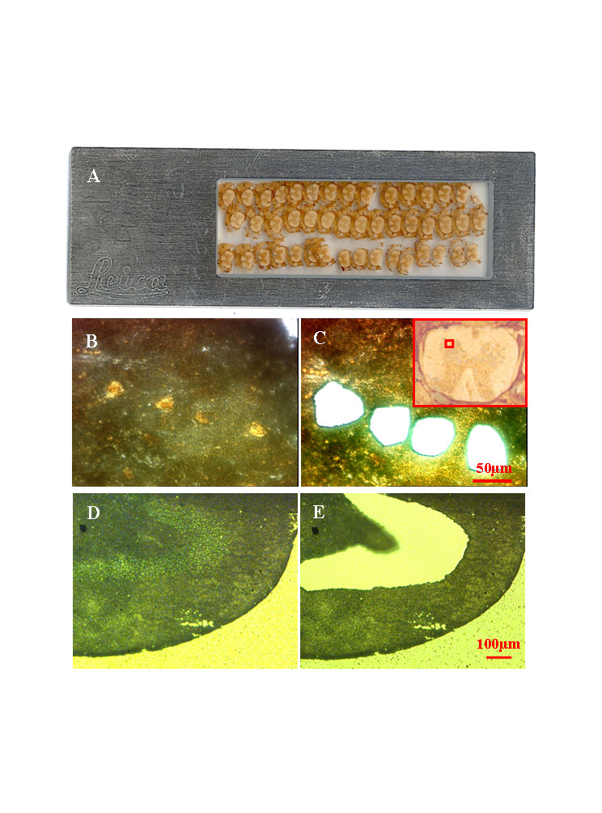
Figure 1 Examples of tissues following microdissection using a Leica DMLA laser-assisted microdissection system. A: A scanned image of a foil slide with multiple coronal sections of mouse spinal cord mounted. These sections are 16 μm thick; B: A high-power (× 40 objective, × 400 final magnification) image of the ventral gray region of mouse spinal cord that was immuno-stained for the NeuN neuronal marker. The yellow-brown profiles are motor neurons; C: The same view as in panel B, but after laser microdissection and collection of four motor neurons; C: A low-power (× 5 objective, × 50 final magnification) image of the spinal cord section (shown upside down), with the red square marking the region shown in panels B and C; D: A low-power view (× 10 objective, × 100 final magnification) of methyl green-stained rat dentate gyrus. The section is 10 μm thick; E: An image of the same section shown in panel D, but after microdissection and collection of the neurons in the granule cell layer.
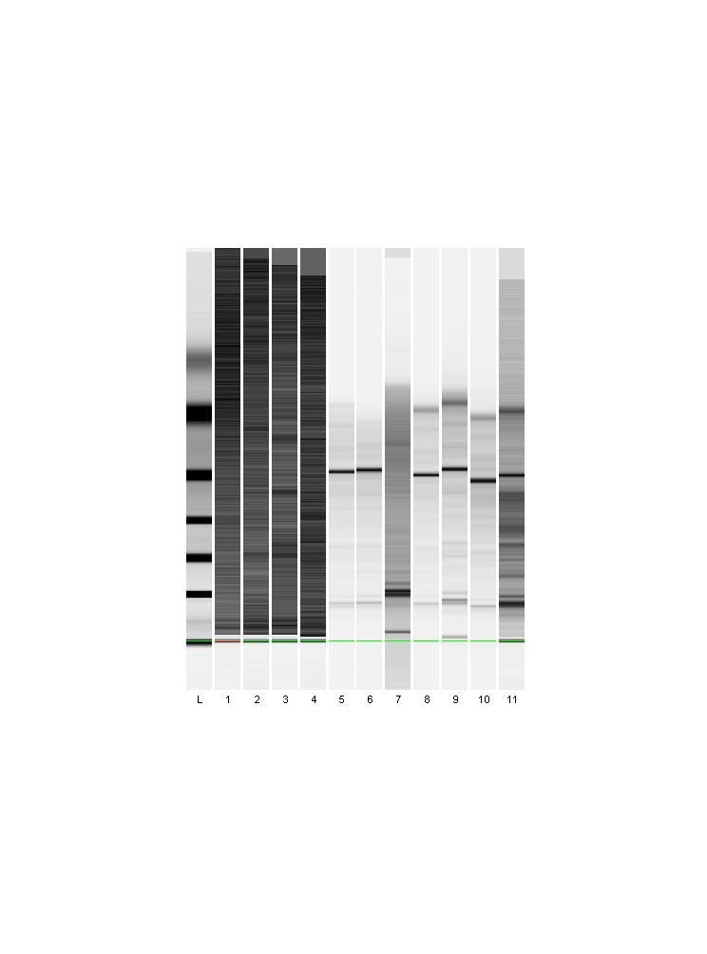
Figure 2 Ensuring quality of the microdissected neural RNA samples. For the 28S and 18S rRNA species/bands, a Bioanalyzer Model 2001 was used to examine the quality of the RNA sample derived from the neurons collectively harvested from the hippocampus (Figure 1D and E). Lane L: The RNA ladder; lanes 1-4: Non-sample controls; lanes 5-11: Electrophoretic profiles of RNA from multiple tubes of cells collected via laser-assisted microdissection; lane 7: The sample to be degraded and was excluded from further evaluation.
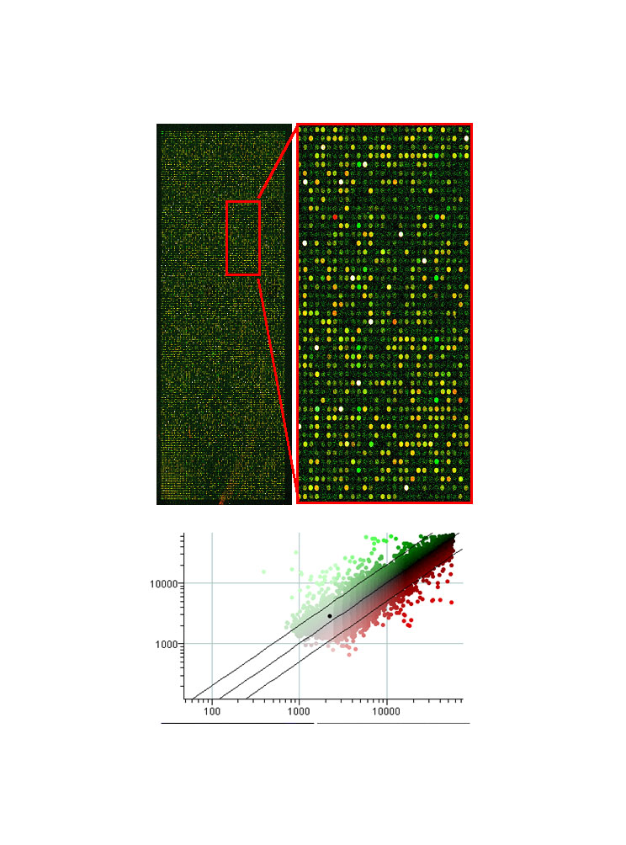
Figure 3 Example of an Agilent Rat Oligo microarray hybridized with probes from microdissected neurons. The upper, right-hand panel is an enlarged view of a portion of the microarray. The two probes used were made from RNA amplified through one stage of the T7 method, the Cy3-labeled probe was synthesized from total RNA extracted from several thousand CA1 pyramidal neurons and the Cy5-labeled probe was synthesized from several thousand dentate gyrus granule cells, after laser-assisted microdissection. The two probes are shown overlaid; the predominance of yellow spots indicates that most of the genes in the two samples were at or near equivalent levels. Only a few spots are saturated (white). Shown in the lower panel, the genes of interest can be identified on the scatterplot (CA1 neurons vs dentate granular neurons). An example of one gene of interest is the highlighted black spot, which represents caspase-3, a key apoptotic mediator.
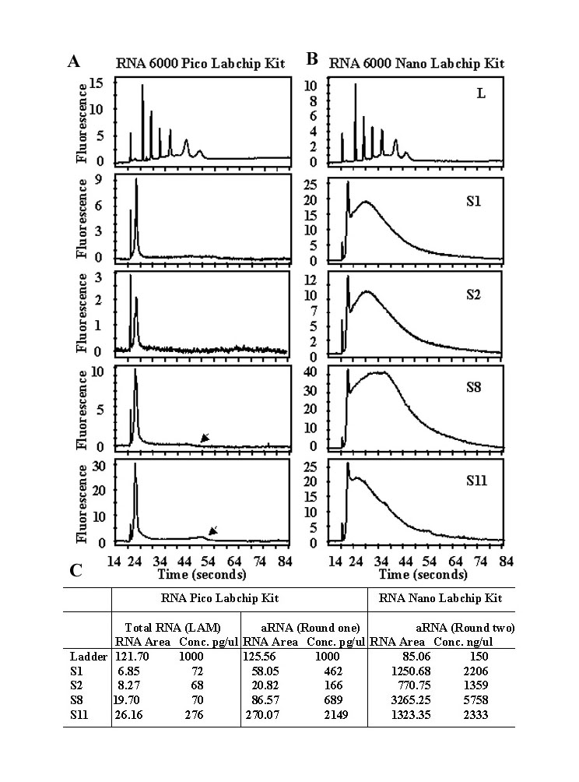
Figure 4 Bioanalyzer profiles of aRNA products from microdissected mouse spinal cord motor neurons using the Arcturus PicoAmp kit. A and B: These are the standard views obtained from the Bioanalyzer of the Pico Chip and Nano Chip data, providing electrophoretic profiles in time (s). The ladder is shown in the uppermost profiles. Note that the quantity of ladder used in the Pico Chip (A, upper panel) was 1000 pg, but the quantity of ladder used in the Nano Chip (B, upper panel) was 150 ng (150000 pg). Thus, the scales for the Pico Chip (A) and Nano Chip (B) profiles are approximately 150-fold different. The samples shown (S1, S2, S8, and S11) are aRNA products obtained after the first round of PicoAmp amplification (A) and the second round of amplification (B). The black arrowheads in the Pico Chip data for S8 and S11 show visible points of maximal migration for RNA in these two samples; C: RNA concentrations before and after one- and two-rounds of amplifications in 4 representative samples of S1, 2, 8, and 11.
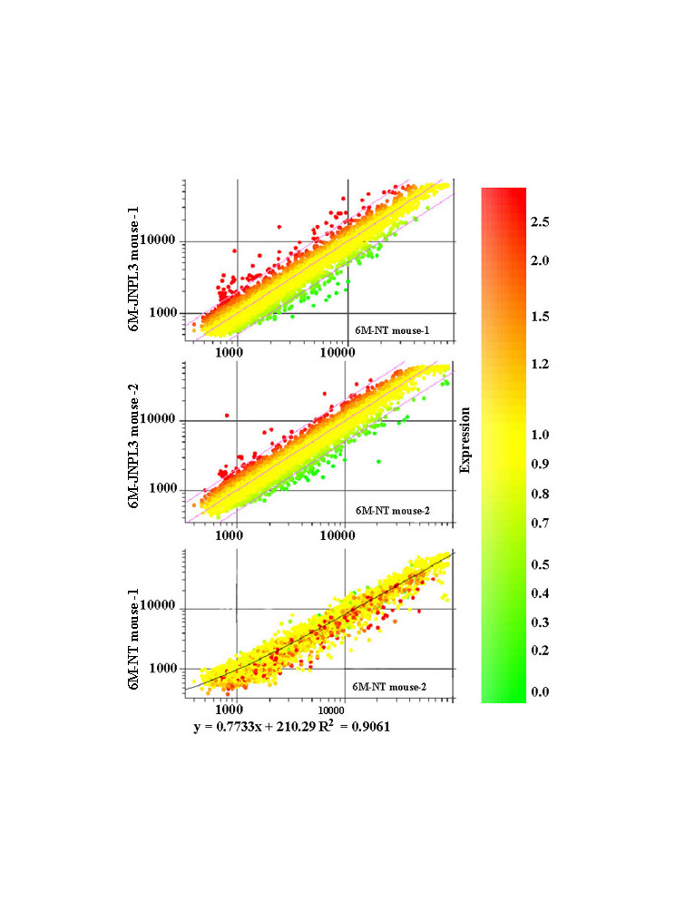
Figure 5 Examples of microarray data obtained from microdissected neurons. Two microarray experiments using spinal cord motor neurons from four mice were performed. Scatterplots of processed data generated using the program GeneSpring are shown. In each microarray experiment, a Cy3-labeled probe made from approximately 1000 motor neurons from a P301L transgenic mouse was co-hybridized with a Cy5-labeled probe made from approximately 1000 motor neurons from a non-transgenic littermate. The results are shown in the top two scatterplots. The colors of the plotted data are derived from the scale shown at right, indicating the expression fold change. To further examine the quality of the data, a derivative plot was made (bottom). The data from two non-transgenic littermates from the two microarray experiments were plotted against each other. The correlation coefficient of these two biological replicates was r = 0.9 (bottom panel).

