Name of journal: World Journal of Gastroenterology
ESPS Manuscript NO: 34101
Manuscript Type: CASE REPORT

Study on the mechanism of portal vein thrombosis after irreversible electroporation for locally advanced pancreatic cancer

Su JJ et al. Study on the mechanism of portal vein thrombosis

Jun-Jun Su, Ming Su, Kai Xu, Peng-Fei Wang, Li Yan, Shi-Chun Lu, Wan-Qing Gu, Yong-Liang Chen

Jun-Jun Su, Division of Gastroenterological Surgery, Department of Surgery, Shanxi Provincial People's Hospital, Taiyuan 030012, Shanxi Province, China

Jun-Jun Su, Ming Su, Kai Xu, Peng-Fei Wang, Li Yan, Shi-Chun Lu, Wan-Qing Gu, Yong-Liang Chen, Department of Hepatobiliary Surgery, Chinese People's Liberation Army General Hospital, Beijing 100853, China

Author contributions: Su Jun Jun collected case data and prepared the photos; all authors proofread the pathologic materials; Su Jun Jun wrote the manuscript; Su Ming, Xu Kai, Wang Peng Fei, Yan Li proofread and revised the manuscript; all authors approved the final version to be published.

Institutional review board statement: The study was reviewed and approved by the Department of Hepatobiliary Surgery, Chinese People's Liberation Army General Hospital, China.

Informed consent statement: Informed consent was obtained from the patient.

Conflict-of-interest statement: The authors declare that there is no conflict of interest related to this report.

Open-Access: This article is an open-access article which was selected by an in-house editor and fully peer-reviewed by external reviewers. It is distributed in accordance with the Creative Commons Attribution Non Commercial (CC BY-NC 4.0) license, which permits others to distribute, remix, adapt, build upon this work non-commercially, and license their derivative works on different terms, provided the original work is properly cited and the use is non-commercial. See: http://creativecommons.org/licenses/by-nc/4.0/

Manuscript source: Unsolicited manuscript

Correspondence to: Dr. Yong-Liang Chen, Department of Hepatobiliary Surgery, Chinese People's Liberation Army General Hospital, 28 Fuxing Road, Beijing 100853, China. chenyongl301@163.com
Telephone: +86-13601021099

Received: March 27, 2017
Peer-review started: March 28, 2017
First decision: April 10, 2017
Revised: July 2, 2017
Accepted: July 22, 2017
Article in press:
Published online:

Abstract
Portal vein thrombosis (PVT) is a rare but serious postoperative complication associated with irreversible electroporation (IRE). We report a case of postoperative PVT in a 54-year-old woman who underwent IRE for locally advanced pancreatic cancer. Drain removal and discharge of the patient from the hospital were scheduled on postoperative day (POD) 7; however, a magnetic resonance imaging scan revealed the presence of PVT. We suspected postoperative inflammation in the pancreas as the main cause of PVT. However, the patient did not undergo any medical treatment because she did not have any clinical symptoms, and she was discharged on POD 8.

Key words: Irreversible electroporation; Portal vein thrombosis; Locally advanced pancreatic cancer; Safety

© The Author(s) 2017. Published by Baishideng Publishing Group Inc. All rights reserved.

Core tip: Irreversible electroporation is a medical technology that utilizes high voltage pulses to create permanent nanopores in the cell membrane, which in turn induces apoptosis in the targeted cells. Portal vein thrombosis is a rare but serious postoperative complication associated with irreversible electroporation. This review focuses on the mechanism of portal vein thrombosis after irreversible electroporation in Locally Advanced Pancreatic Cancer.

Su JJ, Su M, Xu K, Wang PF, Yan L, Lu SC, Gu WQ, Chen YL. Study on the mechanism of portal vein thrombosis after irreversible electroporation for locally advanced pancreatic cancer. World J Gastroenterol 2017; In press

INTRODUCTION
Irreversible electroporation (IRE) is a medical technology that utilizes high voltage pulses to create permanent nanopores in the cell membrane, which in turn induces apoptosis in the targeted cells^{[1-4]}. The main advantage of IRE over other approaches is the avoidance of thermal injury to the surrounding structures, thereby sparing essential structures such as the nerves, vessels, and bile ducts^{[5-8]}. Although there are benefits of IRE, the many adverse events should be taken into consideration before its use, including mild hypertension and hemodynamically relevant arrhythmia. Initial long-term survival data in animals have confirmed the safety of IRE as it does not show vascular thrombosis as a related complication^{[9,10]}. We report a case of successful IRE in a patient with locally advanced pancreatic cancer who developed PVT shortly after IRE.

CASE REPORT
We report the case of a 54-year-old woman who was diagnosed with tumor in the body of the pancreas, using computed tomography (CT). Magnetic resonance imaging (MRI) of the abdomen also revealed a tumor mass located at the pancreatic body; hence, pancreatic cancer was suspected. Artery invasions were seen near the celiac axis (Figure 1).
The patient underwent abdominal vascular ultrasonographic scanning of the hepatic vein, inferior vena cava, superior mesenteric vein, splenic vein, and portal vein, which showed that the blood flow was unobstructed prior to the surgery. The blood flow volume of the splenic vein was 14.5 cm/s and that of the superior mesenteric vein was 18.8 cm/s. The diameter of the portal vein was 1.1 cm and its blood flow volume was 28.8 cm/s. The patient underwent IRE ablation under balanced general anesthesia for pancreatic cancer because the tumor mass was considered unresectable because of tumor infiltration of the celiac axis root and major abdominal blood vessels. Furthermore, multiple metastases were established in the lymph nodes of different regions. Before the IRE ablation, we performed tumor mass biopsies. The patient was admitted to the hospital after routine blood tests, which showed normal levels of leukocytes, neutrophils, erythrocytes, leukocytes, platelets, and amylase. These levels increased on POD 2. The levels of C- reactive protein (CRP), interleukin 6 (IL-6), interleukin 8 (IL-8), and tumor necrosis factor (TNF) were also increased on POD 2. The amylase level of the drain from the IRE was 922.8 U/L on POD 3, which was 6 times higher than the upper limit of the normal serum amylase level, indicating the presence of postoperative pancreatic fistula according to the International Study Group on Pancreatic Fistula classification^{[11]}. The drain amylase level reached the normal serum range on POD 5 and after the drain removal. The levels of cancer antigen 199 in the serum were decreased after the surgery. The re-evaluation MRI scan following the IRE ablation demonstrated thrombosis of the portal vein trunk on POD 7 and revealed that the tumor size had decreased (Figure 2).
Non-occlusive PVT did not affect the patient's general condition, and the patient was discharged from the hospital on POD 8 because she showed no other complications. The patient currently has a good quality of life.

DISCUSSION
There is no effective treatment available for patients with pancreatic cancer. Therefore, we put forward a novel method of minimally invasive IRE for the treatment of pancreatic tumors, which was reported recently in 2008. Although IRE is now regarded as an attractive treatment option for locally advanced pancreatic cancer, there are some complications associated with the use of this method. PVT is a rare but serious postoperative complication of IRE^{[12]}. Although the mechanism is still unclear^{[13]}, medical literature on the occurrence of PVT reports that it is associated with 3 factors: endothelial cell injury, slow blood flow, and hypercoagulable state of the blood. In pancreatitis， various inflammatory mediators are released with concomitant thrombosis, resulting in high levels of IL-6, IL-8, and TNF. These factors stimulate the hepatic cells, which in turn produce large quantities of CRP. CRP is a sensitive indicator of the severity of inflammation. The initial clinical signs of PVT are often subtle and similar to those observed in postoperative pancreatitis. PVT can be detected using CT, MRI, and Doppler ultrasonography. Doppler ultrasonography is a non-invasive, easily available bedside examination with 89% sensitivity and 92% specificity in detecting PVT^{[14]}. Early diagnosis of PVT might provide clinicians an opportunity for intervention before severe damage occurs. Once the thrombus is formed, thrombolysis and anticoagulation must be performed as soon as possible, including surgical treatment if necessary. In this case, the patient developed PVT, which did not completely block the portal vein. No clinical symptoms such as abdominal pain and portal hypertension were observed; hence, anticoagulant was not administered. However, the case was closely followed up. The patient was administered no special medical treatment during the follow-up period because she recovered from acute pancreatitis and showed no signs of thrombus. In this case, the levels of Prothrombin time, activated partial thromboplastin time, fibrinogen, and thrombin time were normal before the operation. But after surgery, patients with abnormal blood coagulation and white blood cells, CRP, IL-6, IL-8 and TNF increased significantly, which explain PTV occurred due to abdominal surgery.

COMMENTS
Case characteristics
A 54-year-old woman was referred to our hospital because of an tumor in the body of the pancreas found by physical examination.

Clinical diagnosis
The abdomen was soft, lax and nondistended without evidence of a palpable mass.

Differential diagnosis
Abdominal sarcoma, abdominal neurogenic tumor and cholangiocarcinoma.

Laboratory diagnosis
Before surgery, laboratory results were normal.

Imaging diagnosis
Computed tomography scan showed locally advanced pancreatic malignant mass of 34 mm in diameter surrounded and narrowed coeliac trunk. MRI demonstrating the mass located in the pancreatic body.

Pathological diagnosis
The tumor was diagnosed as a low differentiated adenocarcinoma in the pancreas.

Treatment
The patient underwent Irreversible electroporation for locally advanced pancreatic cancer.

Related reports
Portal vein thrombosis is a rare but serious postoperative complication associated with irreversible electroporation. To date, only a few cases have been reported in the English literature, including our case presented in this report.

Experiences and lessons
Portal vein thrombosis is a rare but serious postoperative complication associated with irreversible electroporation. Patient with locally advanced pancreatic cancer who developed portal vein thrombosis (PVT) shortly after IRE make us suspected postoperative inflammation in the pancreas as the main cause of PVT.

Peer-review
This study highlights the mechanism of portal vein thrombosis after irreversible electroporation in locally advanced pancreatic cancer and the authors also conducted a literature review so as to deepen the understanding of the subject. The information of this paper is valuable to the readers.

REFERENCES
1 Al-Sakere B, André F, Bernat C, Connault E, Opolon P, Davalos RV, Rubinsky B, Mir LM. Tumor ablation with irreversible electroporation. PLoS One 2007; 2: e1135 [PMID: 17989772 DOI: 10.1371/journal.pone.0001135]
2 Edd JF, Horowitz L, Davalos RV, Mir LM, Rubinsky B. In vivo results of a new focal tissue ablation technique: irreversible electroporation. IEEE Trans Biomed Eng 2006; 53: 1409-1415 [PMID: 16830945 DOI: 10.1109/tbme.2006.873745]
3 Davalos RV, Mir IL, Rubinsky B. Tissue ablation with irreversible electroporation. Ann Biomed Eng 2005; 33: 223-231 [PMID: 15771276]
4 Davalos RV, Otten DM, Mir LM, Rubinsky B. Electrical impedance tomography for imaging tissue electroporation. IEEE Trans Biomed Eng 2004; 51: 761-767 [PMID: 15132502 DOI: 10.1109/tbme.2004.824148]
5 Jiang C, Davalos RV, Bischof JC. A review of basic to clinical studies of irreversible electroporation therapy. IEEE Trans Biomed Eng 2015; 62: 4-20 [PMID: 25389236 DOI: 10.1109/tbme.2014.2367543]
6 Dollinger M, Zeman F, Niessen C, Lang SA, Beyer LP, Müller M, Stroszczynski C, Wiggermann P. Bile Duct Injury after Irreversible Electroporation of Hepatic Malignancies: Evaluation of MR Imaging Findings and Laboratory Values. J Vasc Interv Radiol 2016; 27: 96-103 [PMID: 26777402 DOI: 10.1016/j.jvir.2015.10.002]
7 Choi JW, Lu DS, Osuagwu F, Raman S, Lassman C. Assessment of chronological effects of irreversible electroporation on hilar bile ducts in a porcine model. Cardiovasc Intervent Radiol 2014; 37: 224-230 [PMID: 24196262 DOI: 10.1007/s00270-013-0731-y]
8 Cannon R, Ellis S, Hayes D, Narayanan G, Martin RC 2nd. Safety and early efficacy of irreversible electroporation for hepatic tumors in proximity to vital structures. J Surg Oncol 2013; 107: 544-549 [PMID: 23090720 DOI: 10.1002/jso.23280]
9 Bower M, Sherwood L, Li Y, Martin R. Irreversible electroporation of the pancreas: definitive local therapy without systemic effects. J Surg Oncol 2011; 104: 22-28 [PMID: 21360714 DOI: 10.1002/jso.21899]
10 Charpentier KP, Wolf F, Noble L, Winn B, Resnick M, Dupuy DE. Irreversible electroporation of the pancreas in swine: a pilot study. HPB (Oxford) 2010; 12: 348-351 [PMID: 20590911 DOI: 10.1111/j.1477-2574.2010.00174.x]
11 Bassi C, Dervenis C, Butturini G, Fingerhut A, Yeo C, Izbicki J, Neoptolemos J, Sarr M, Traverso W, Buchler M; International Study Group on Pancreatic Fistula Definition. Postoperative pancreatic fistula: an international study group (ISGPF) definition. Surgery 2005; 138: 8-13 [PMID: 16003309 DOI: 10.1016/j.surg.2005.05.001]
12 Yan L, Chen YL, Su M, Liu T, Xu K, Liang F, Gu WQ, Lu SC. A Single-institution Experience with Open Irreversible Electroporation for Locally Advanced Pancreatic Carcinoma. Chin Med J (Engl) 2016; 129: 2920-2925 [PMID: 27958223 DOI: 10.4103/0366-6999.195476]
13 Paiella S, Butturini G, Frigerio I, Salvia R, Armatura G, Bacchion M, Fontana M, D'Onofrio M, Martone E, Bassi C. Safety and feasibility of Irreversible Electroporation (IRE) in patients with locally advanced pancreatic cancer: results of a prospective study. Dig Surg 2015; 32: 90-97 [PMID: 25765775 DOI: 10.1159/000375323]
14 Tessler FN, Gehring BJ, Gomes AS, Perrella RR, Ragavendra N, Busuttil RW, Grant EG. Diagnosis of portal vein thrombosis: value of color Doppler imaging. AJR Am J Roentgenol 1991; 157: 293-296 [PMID: 1853809 DOI: 10.2214/ajr.157.2.1853809]

P-Reviewer: Thiele M, Dokus MK S-Editor: Qi Y L-Editor: E-Editor:
Specialty type: Gastroenterology and hepatology
Country of origin: China
Peer-review report classification
Grade A (Excellent): 0
Grade B (Very good): B, B
Grade C (Good): 0
Grade D (Fair): 0
Grade E (Poor): 0

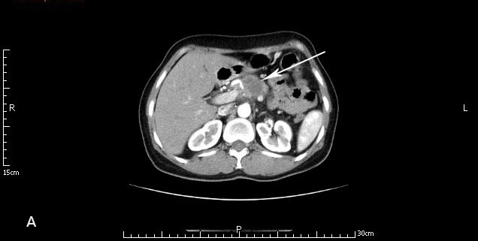
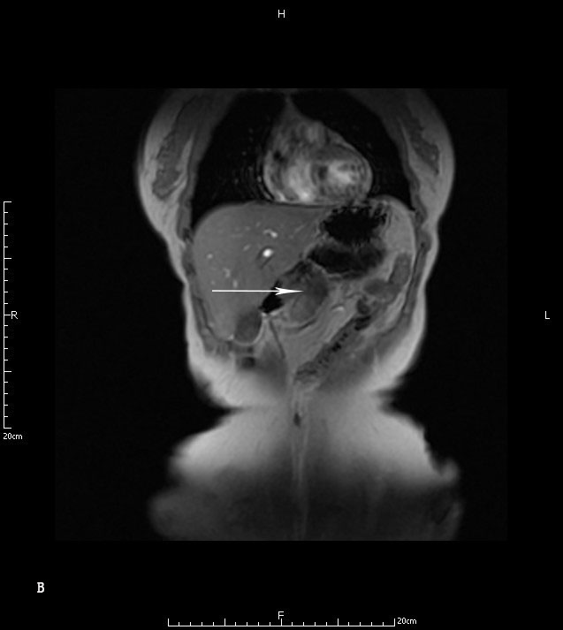
Figure 1 Computed tomography and magnetic resonance imaging. A: Computed tomography scan showed locally advanced pancreatic malignant mass of 34 mm in diameter surrounded and narrowed coeliac trunk (arrow); B: Magnetic resonance imaging demonstrating the mass located in the pancreatic body (arrow).

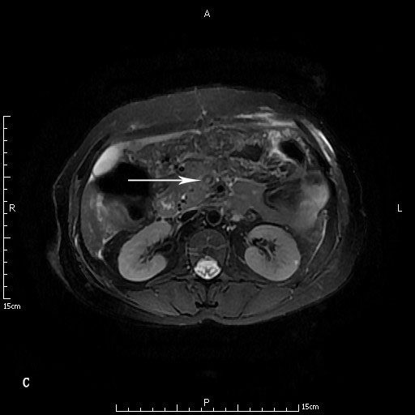
Figure 2 Magnetic resonance imaging findings. Magnetic resonance imaging showed thrombosis of the portal vein trunk.

