Name of Journal: World Journal of Gastrointestinal Surgery
Manuscript NO: 39424
Manuscript Type: CASE REPORT

Inverted Meckel’s diverticulum: Two case reports and review of the literature

Chong EH et al. Inverted Meckel’s diverticulum with intussusception

Eui Hyuk Chong, Dae Jung Kim, Sewha Kim, Gwangil Kim, Woo Ram Kim

Eui Hyuk Chong, Woo Ram Kim, Department of Surgery, CHA Bundang Medical Center, CHA University, Gyeonggi 463-712, South Korea

Dae Jung Kim, Department of Radiology, CHA Bundang Medical Center, CHA University, Gyeonggi 463-712, South Korea

Sewha Kim, Gwangil Kim, Department of Pathology, CHA Bundang Medical Center, CHA University, Gyeonggi 463-712, South Korea

ORCID number: Eui Hyuk Chong (0000-0002-8998-7811); Dae Jung Kim (0000-0001-9852-7860); Sewha Kim (0000-0002-1561-8968); Gwangil Kim (0000-0002-4867-9003); Woo Ram Kim (0000-0003-1651-3778).

Author contributions: Chong EH, Kim DJ, Kim S, Kim G and Kim WR contributed equally to this work; Chong EH and Kim WR designed research; Chong EH, Kim DJ, Kim S, Kim G and Kim WR performed research; Kim DJ, Kim S and Kim G provided Figure legend.

Informed consent statement: All study participants provided informed written consent prior to study enrollment.

Conflict-of-interest statement: The authors have no conflict of interest to declare.

CARE Checklist (2013) statement: We have adopted the guidelines of the CARE checklist (2013).

Open-Access: This article is an open-access article which was selected by an in-house editor and fully peer-reviewed by external reviewers. It is distributed in accordance with the Creative Commons Attribution Non Commercial (CC BY-NC 4.0) license, which permits others to distribute, remix, adapt, build upon this work non-commercially, and license their derivative works on different terms, provided the original work is properly cited and the use is non-commercial. See: http://creativecommons.org/licenses/by-nc/4.0/

Manuscript source: Unsolicited manuscript

Correspondence to: Woo Ram Kim, MD, Assistant Professor, Department of Surgery, CHA Bundang Medical Center, CHA University, Yatap-ro No. 59, Gyeonggi 463-712, South Korea. christtome81@chamc.co.kr
Telephone: +82-31-7801874
Fax: +82-31-7805660

Received: April 27, 2018
Peer-review started: April 27, 2018
First decision: May 22, 2018
Revised: July 2, 2018
Accepted: August 3, 2018
Article in press:

Abstract
Gastrointestinal surgeons seldom encounter inverted Meckel's diverticulum in their clinical practice. We describe two cases of inverted Meckel’s diverticulum. If the patient has a disease-related complication such as intussusception, it can be easily detected, as with our first case. However, if the patient has subacute or chronic symptoms, as with our second case, the diagnosis might be delayed. Regardless of the disease-related complication, intussusception of inverted Meckel's diverticulum can be easily managed with laparoscopic single-port surgery.

Key words: Inverted Meckel’s diverticulum; Intussusception; Laparoscopic surgery; Intermittent hematochezia; Abdominal pain

© The Author(s) 2018. Published by Baishideng Publishing Group Inc. All rights reserved.

Core tip: When clinicians encounter an adult patient complaining of intermittent hematochezia and/or abdominal pain without any evidence of gastrointestinal bleeding after esophagogastroduodenoscopy and colonoscopy, inverted Meckel’s diverticulum and other small bowel pathologies must be considered to avoid un-wanted complications related to these rare disease entities. Computed tomography scan is a beneficial diagnostic tool to identify small bowel pathology and to differentiate among diverse diseases, including lipomas, inflammatory fibroid polyps, vascular malformations, lymphomas, inverted diverticula and malignant tumors.

Chong EH, Kim DJ, Kim S, Kim G, Kim WR. Inverted Meckel’s diverticulum: Two case reports and review of the literature. World J Gastrointest Surg 2018; In press

INTRODUCTION
Meckel’s diverticulum is a congenital anomaly that results from persistence of the omphalomesenteric duct at its attachment to the distal ileum. This condition is found in 2% of general population, according to autopsy studies^{[1,2]}. On average, the diverticulum is located two feet proximal to the ileocecal valve and often contains gastric or pancreatic tissue, causing mucosal bleeding. Patients with Meckel’s diverticulum are usually asymptomatic; however, when left untreated, the lifetime risk of developing complications requiring surgical treatment can be as high as 6.4%, according to a population-based study^{[3]}. The most common presentation of complicated Meckel’s diverticulum is gastrointestinal (GI) bleeding; less frequent symptoms include diverticulitis, volvulus and intestinal obstruction with or without intussusception, a condition in which a proximal segment of bowel rolls into a distal part^{[4]}. To the best of our knowledge, inversion of a Meckel’s diverticulum is rare and has been reported in only a few case series worldwide^{[5-8]}.

CASE REPORT
Case 1
A 34-year-old man without any underlying disease visited our gastroenterology clinic on October 29, 2014, for melena beginning 5 d earlier. The initial laboratory findings were all in normal ranges, and subsequent esophagogastroduodenoscopy (EGD) showed no remarkable findings except for several areas of erosive gastritis. The patient was diagnosed with irritable bowel disease, but the symptoms remained intractable during one-year of follow-up. On March 16, 2016, the patient complained of hematochezia with left lower quadrant abdominal pain. Emergent sigmoidoscopy was performed but failed to reveal any focus of bleeding. Thereafter, computed tomography (CT) scans revealed small bowel intussusception with segmental thickening of mucosa (Figure 1A). The patient was referred to the Department of General Surgery, and laparoscopic single-port exploration was performed. During the operation, bowel edema at the distal ileum (50-60 cm upstream of the ileocecal valve) was observed, and an intraluminal mass was palpable. Securing the margin, segmental resection of the small bowel with side-to-side stapled anastomosis was performed. The delivered specimen was inspected, and the intraluminal polyp-like mass was exposed (Figure 1B). The patient had an uneventful postoperative course and was discharged 6 d after surgery. Final pathology revealed an inverted intussusception of Meckel’s diverticulum with focal heterotopic gastric mucosa (Figure 1C).

Case 2
A 27-year-old man with a history of heavy alcohol consumption visited the emergency room on December 31, 2017, for hematochezia beginning 4 d earlier. The initial laboratory findings showed low hemoglobin levels (8.5 g/dL). Serial physical examinations revealed old clots on irrigation through a Levin tube and melena on digital rectal examination. On admission, two pints of packed RBC was transfused, and emergent EGD with sigmoidoscopy failed to reveal intestinal pathology. Therefore, the gastroenterologist decided to perform capsule endoscopy. This procedure revealed small bowel bleeding but failed to detect intestinal pathology due to low video quality (Figure 2A). A CT scan revealed small bowel intussusception at the distal ileum with a possible 2-cm lipoma (Figure 2B). After diagnosis of intussusception, the patient was referred to the Department of General Surgery, and on January 4, 2018, laparoscopic single-port exploration was performed. During surgery, the intussusception at the distal ileum with a palpable club-like intraluminal mass (Figure 2C) was detected, and segmental small bowel resection with end-to-end anastomosis was performed. Exploring the specimen, a large polyp-like mass with mucosal ulceration at the tip was demonstrated in the small bowel (length 6 cm, width 1.5 cm). The patient had an uneventful postoperative course and was discharged 6 d after surgery. The final pathology revealed that the mucosa showed a finger-like projection with normal mucosa and surface ulceration measuring 5 cm × 2 cm × 2 cm (Figure 2D). On section of the finger projection, the cut surface showed serosal in folding with mesenteric tissue, consistent with an inverted diverticulum causing intussusception without heterotopic tissue (Figure 2E).

DISCUSSION
The mechanism of inversion in Meckel’s diverticulum is not yet clearly understood. One possible explanation is that abnormal peristaltic movement around an ulceration or ectopic tissue at Meckel’s diverticulum may cause inversion^{[9]}. Inverted Meckel’s diverticulum can cause two clinical manifestations: GI bleeding and intussusception, as in our two cases. Most complaints are of hematochezia and/or melena due to ulceration of the inverted Meckel’s diverticulum. Ulceration may be caused by ectopic gastric or pancreatic tissues in the inverted Meckel’s diverticulum itself, but it also occurs without accompanying abnormal ectopic tissues. The latter can be explained by repetitive mechanical trauma to the mucosa from the reversible intussusception.
CT is a common tool for diagnosing intussusception in the small intestine. A characteristic coiled spring appearance or target sign are well-known findings on CT scan. However, if the patient visits the clinic complaining of melena or hematochezia without abdominal pain, as in Case 2, the diagnosis may be delayed. Linda et al. reported that approximately 80% of patients with inverted Meckel’s diverticulum complained of subacute or chronic symptoms including GI bleeding, intermittent abdominal pain or other signs of low-grade small bowel obstruction^{[8]}. Even though capsule endoscopy can help confirm small bowel bleeding, as in Case 2, routine use of this device for diagnosing small bowel bleeding must be done with caution, not only because of low video quality and its limitations regarding exact location of the intestinal pathology^{[10]} but also because of the increased risk of intestinal obstruction. On the other hand, CT scan is much more beneficial for the identification of small bowel pathology and differentiation of diverse diseases, including lipomas, inflammatory fibroid polyps, vascular malformations, lymphomas, inverted diverticula and malignant tumors. Inverted Meckel’s diverticulum is sometimes confused with lipoma on CT scan, but findings of an intraluminal polypoid lesion in the small intestine covered with a thick collar of enhancing soft tissue may be a decisive indicator of inverted Meckel’s diverticulum as opposed to lipoma, which appears on CT scan only as a thin covering over the low-density fatty mass^{[5]}.
Intermittent and/or small amounts of GI bleeding can be easily detected by Tc^{99m} RBC scintigraphy, where the minimum detectable bleeding rate was reported as 0.05-0.2 mL/min; relatively stable persistence in the circulation made it possible to monitor of patients with intermittent bleeding^{[11]}. Scintigraphy could have been used to locate the bleeding focus in the first case. However, according to the gastroenterologist, they initially thought that the chronic intermittent hematochezia in this patient was due to a hemorrhoid. That was why the patient was followed by a local gastroenterology clinic for 1 year. Subsequently, the patient was admitted to the emergency room complaining of hematochezia with abdominal pain. CT scan was used to evaluate the cause of left lower quadrant pain but not the hematochezia in this case. In the second case, scintigraphy could have been used to evaluate the cause of melena. However, the gastroenterologist decided on capsule endoscopy, revealing GI bleeding in the small intestine. According to the gastroenterologist, scintigraphy was not considered at that moment because the bleeding from the small intestine was already confirmed by capsule endoscopy and because CT scan is performed to reveal underlying pathologies causing GI bleeding in adults. CT angiography can be considered if the GI bleeding is active. The detection limit of CT angiography for active bleeding was 0.3 mL/min in porcine models.^{[11]} Our cases were regarded as having chronic and intermittent GI bleeding, not active bleeding.
Even though our gastroenterologist had 30 years’ experience, they performed capsule endoscopy in the second case. They expected to find small bowel pathology but failed to do so. Apart from low video quality, if the capsule was obliterated by small bowel pathologies, the patient might experience intestinal obstruction, leading to increased morbidity related to surgery. Following this report, we hope clinicians worldwide will be cautious regarding use of capsule endoscopy to evaluate the cause of GI bleeding in adults.
Currently, small bowel intussusception in adults, regardless of cause, requires prompt surgical management such as segmental resection of the small bowel. A thorough appreciation of the characteristic CT scan findings of inverted diverticulum (as opposed to those of malignant tumors such as lymphoma) may help create an appropriate surgical approach.

ARTICLE HIGHLIGHTS
Case characteristics
The chief complaint of inverted Meckel’s diverticulum in adults wound most likely is intermittent hematochezia, melena and/or abdominal colicky pain.

Clinical diagnosis
If adult patient with chronic intermittent abdominal pain and/or melena, hematochezia complains of intestinal obstruction, inverted Meckel’s diverticulum with intussusception should be considered.

Differential diagnosis
Computed tomography (CT) scan would be beneficial in differentiating among other diseases such as lipoma, inflammatory fibroid polyps, vascular malformations, lymphoma, and malignant tumors.

Laboratory diagnosis
In case of intermittent hematochezia and/or melena, hemoglobin level wound reveal anemia.

Imaging diagnosis
A characteristic coiled spring appearance or target sign are well known findings on CT scan.

Pathological diagnosis
Full-thickness inversion of diverticulum with or without heterotopic tissues such as stomach, pancreas etc. in HE stain would be the main finding of inverted Meckel’s diverticulum.

Treatment
Small bowel intussusception in adults, regardless of cause, requires prompt surgical management such as segmental resection of the small bowel.

Related reports
Meckel’s diverticulum is a congenital anomaly of the omphalomesenteric duct remnant attached to the distal ileum and, when untreated, the lifetime risk of developing complications requiring surgical treatment can be as high as 6.4%

Term explanation
Intussusception means a condition in which a proximal segment of bowel rolls into a distal part causing intestinal obstruction.

Experiences and lessons
Following this report, we hope clinicians worldwide will be cautious regarding use of capsule endoscopy to evaluate the cause of gastrointestinal bleeding in adults.

REFERENCES
1 Weinstein EC, Cain JC, Remine WH. Meckel's diverticulum: 55 years of clinical and surgical experience. JAMA 1962; 182: 251-253 [PMID: 13999637 DOI: 10.1001/jama.1962.03050420027007]
2 Brown CK, Olshaker JS. Meckel's diverticulum. Am J Emerg Med 1988; 6: 157-164 [PMID: 3281686 DOI: 10.1016/0735-6757(88)90055-1]
3 Cullen JJ, Kelly KA, Moir CR, Hodge DO, Zinsmeister AR, Melton LJ 3rd. Surgical management of Meckel's diverticulum. An epidemiologic, population-based study. Ann Surg 1994; 220: 564-8; discussion 568-9 [PMID: 7944666 DOI: 10.1016/0022-3468(95)90190-6]
4 Turkington JR, Devlin PB, Dace S, Madden M. An unusual cause of intermittent abdominal pain (2006: 5b). Inverted Meckel's diverticulum. Eur Radiol 2006; 16: 1862-1864 [PMID: 16752152 DOI: 10.1007/s00330-006-0151-3]
5 Gaisie G, Kent C, Klein RL, Schreiber H. Radiographic characteristics of isolated invaginated Meckel's diverticulum. Pediatr Radiol 1993; 23: 355-356 [PMID: 8233685 DOI: 10.1007/BF02011956]
6 Mani VR, Kalabin A, Dinesh A, Rajabalan A, Landa M, Adu A. Inverted Meckel's Diverticulum: Rare Etiology of an Intestinal Obstruction. Cureus 2017; 9: e1806 [PMID: 29308334 DOI: 10.7759/cureus.1806]
7 Steinwald PM, Trachiotis GD, Tannebaum IR. Intussusception in an adult secondary to an inverted Meckel's diverticulum. Am Surg 1996; 62: 889-894 [PMID: 8895708]
8 Pantongrag-Brown L, Levine MS, Elsayed AM, Buetow PC, Agrons GA, Buck JL. Inverted Meckel diverticulum: clinical, radiologic, and pathologic findings. Radiology 1996; 199: 693-696 [PMID: 8637989 DOI: 10.1148/radiology.199.3.8637989]
9 Blakeborough A, McWilliams RG, Raja U, Robinson PJ, Reynolds JV, Chapman AH. Pseudolipoma of inverted Meckel's diverticulum: clinical, radiological and pathological correlation. Eur Radiol 1997; 7: 900-904 [PMID: 9228106 DOI: 10.1007/s003300050224]
10 Payeras Capó MA, Ambrona Zafra D, Garrido Durán C. Inverted Meckel's diverticulum in an adult patient diagnosed via capsule endoscopy. Rev Esp Enferm Dig 2018; 110: 210-211 [PMID: 29368940 DOI: 10.17235/reed.2018.5347/2017]
11 Grady E. Gastrointestinal Bleeding Scintigraphy in the Early 21st Century. J Nucl Med 2016; 57: 252-259 [PMID: 26678616 DOI: 10.2967/jnumed.115.157289]

P-Reviewer: Nuno-Guzman CM, Ricci G, Yamamoto T S-Editor: Cui LJ
L-Editor: E-Editor:

Specialty type: Gastroenterology and Hepatology
Country of origin: South Korea
Peer-review report classification
Grade A (Excellent): 0
Grade B (Very good): B
Grade C (Good): C, C
Grade D (Fair): 0
Grade E (Poor): 0

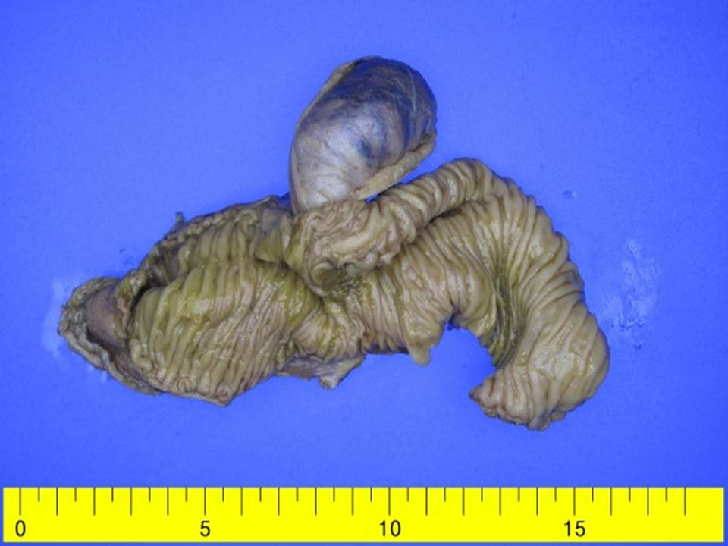
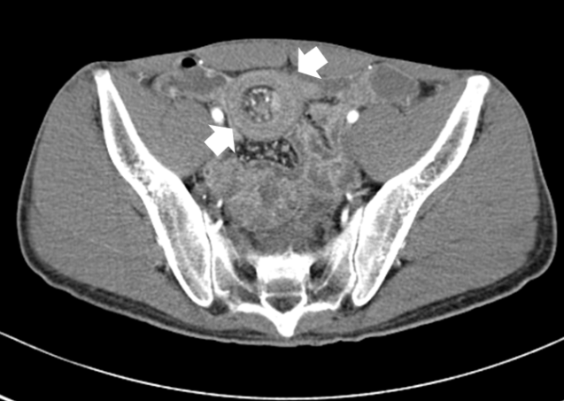
A B

C
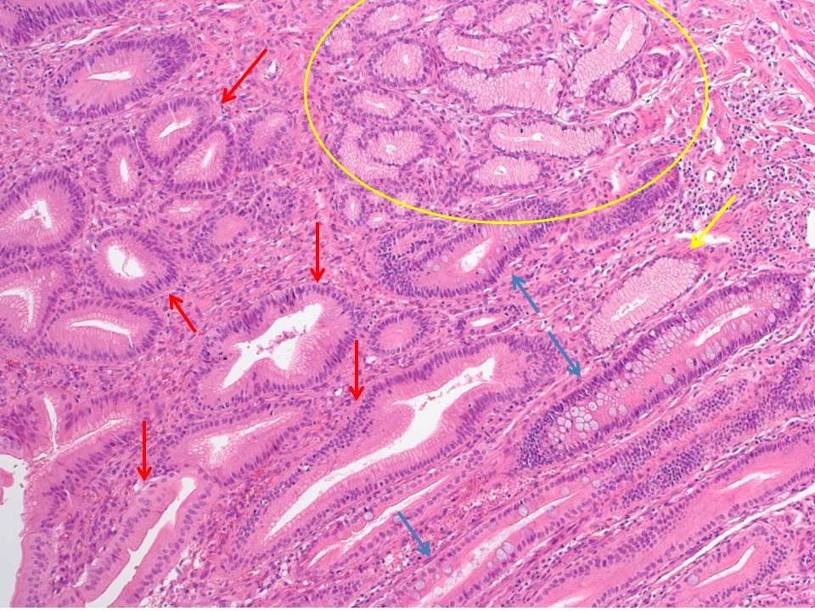

x 100

Figure 1 Inverted Meckel’s diverticulum causing intussusception with focal heterotopic gastric mucosa. A: Computed tomography scan: Small bowel intussusception with segmental thickening of mucosa at the distal ileum; B: Bowel edema at the distal ileum (50-60 cm upstream from ileocecal valve) with a polyp-like mass; C: Inverted intussusception of Meckel’s diverticulum with focal heterotopic gastric mucosa. White arrow: Typical target sign; Yellow circle: Goblet cells; Yellow arrow: Pyloric glands; Red arrow: Foveolar epithelium; Blue arrow: Small intestinal epithelium.

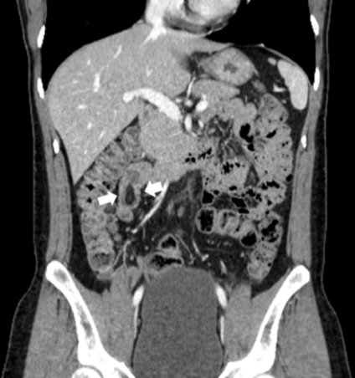
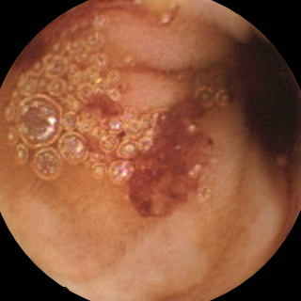
A B C

D E
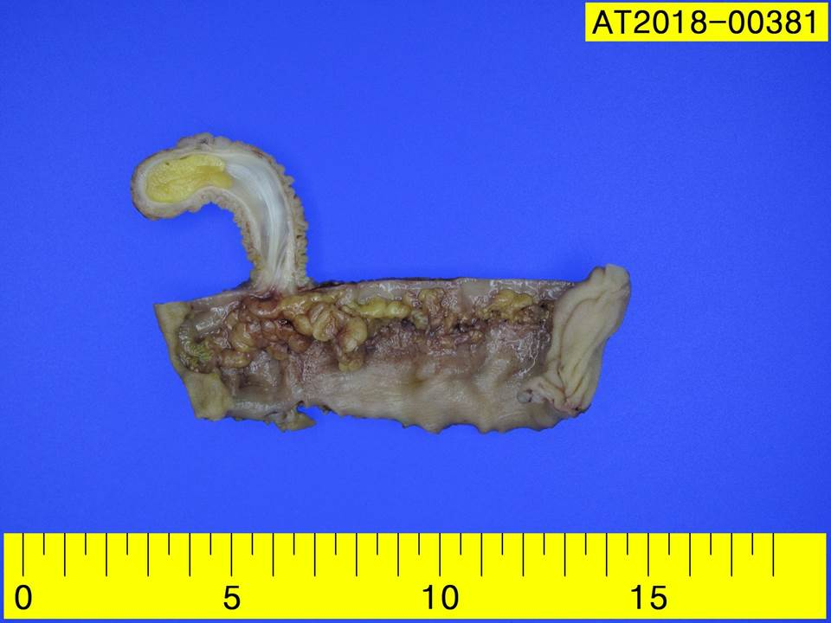
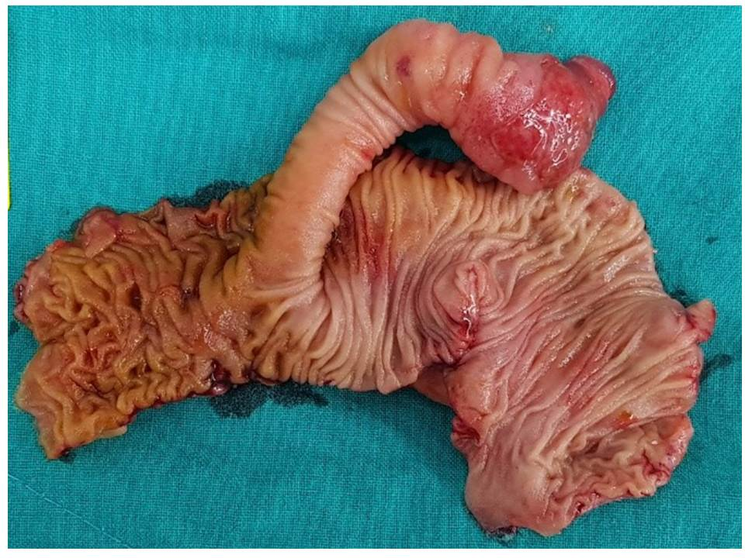
Figure 2 Inverted Meckel’s diverticulum causing intussusception without heterotopic tissue. A: Capsule endoscopy: small bowel bleeding but failed to detect intestinal pathology; B: Computed tomography scan: Small bowel intussusception at the distal ileum with possible 2 cm sized low-density mass (white arrow); C: Laparoscopic finding: the intussusception at the distal ileum with palpable club-like intraluminal mass; D: A finger-like projection with normal mucosa and surface ulceration; E: Section of finger-like projection: Serosal in folding with mesenteric tissue, consistent with inverted diverticulum causing intussusception without heterotopic tissue.

