Name of Journal: World Journal of Clinical Cases
Manuscript NO: 51210
Manuscript Type: Case Report

Successful treatment of warfarin-induced skin necrosis using oral rivaroxaban: a case report

Kamada M et al. Successful treatment of warfarin-induced skin necrosis using oral rivaroxaban

Momoka Kamada, Tsuneaki Kenzaka

Momoka Kamada, Department of Internal Medicine, Hyogo Prefectural Tamba Medical Center, Tamba 669-3395, Japan

Tsuneaki Kenzaka, Division of Community Medicine and Career Development, Kobe University Graduate School of Medicine, Kobe 652-0032, Japan

ORCID number: Momoka Kamada (0000-0001-6396-9271); Tsuneaki Kenzaka (0000-0002-3120-6605).

Author contributions: Kamada M managed the case and redaction and correction of the manuscript; Kenzaka T assisted with redaction, correction, and reconstruction of the manuscript; all authors read and approved the final manuscript.

Informed consent statement: Written informed consent was obtained from the patient for publication of this case report and accompanying images. A copy of the written consent is available for review by the Editor of this journal.

Conflict-of-interest statement: The authors declare that they have no competing interests.

CARE Checklist (2016) statement: The authors have read the CARE Checklist statement, and the manuscript was prepared and revised according to the CARE Checklist statement.

Open-Access: This article is an open-access article which was selected by an in-house editor and fully peer-reviewed by external reviewers. It is distributed in accordance with the Creative Commons Attribution Non Commercial (CC BY-NC 4.0) license, which permits others to distribute, remix, adapt, build upon this work non-commercially, and license their derivative works on different terms, provided the original work is properly cited and the use is non-commercial. See: http://creativecommons.org/licenses/by-nc/4.0/

Manuscript source: Unsolicited manuscript

Corresponding author: Tsuneaki Kenzaka, MD, PhD, Professor, Division of Community Medicine and Career Development, Kobe University Graduate School of Medicine, 2-1-5, Arata-cho, Hyogo-ku, Kobe 652-0032, Japan. smile.kenzaka@jichi.ac.jp
Telephone: +81-78-3826732
Fax: +81-78-3826283

Received: September 2, 2019
Peer-review started: September 2, 2019
First decision: November 13, 2019
Revised: November 17, 2019
Accepted: November 30, 2019
Article in press: November 30, 2019
Published online: December 26, 2019

Abstract
Background
Heparin is commonly recommended for warfarin-induced skin necrosis; however, there is currently no established therapy for this disease. We present a serious case of warfarin-induced skin necrosis that was successfully treated with oral rivaroxaban, a factor Xa inhibitor.

Case Summary
A 48-year-old woman was admitted to the hospital for cellulitis of the right lower extremity. After antibiotic treatment, she developed pain and swelling of the left lower extremity, and deep vein thrombosis of both lower extremities was diagnosed. She was treated with a continuous heparin injection; subsequently, oral warfarin was concomitantly administered. Heparin was terminated after the therapeutic range was reached. On the following day, the patient had swelling and pain in the left lower extremity. In addition to decrease in protein S activity due to systemic lupus erythematosus, warfarin also reduced protein C activity, resulting in further hypercoagulation and skin necrosis. Warfarin was discontinued, and continuous heparin injection was resumed. Although the patient had to undergo amputation of the distal end of her left foot, continuous heparin injection was switched to oral rivaroxaban, and she was eventually discharged from the hospital in remission.

Conclusion
Administration of direct oral anticoagulants instead of warfarin is important in patients with decreased protein S and C activity.

Key words: Skin necrosis; Warfarin; Heparin; Rivaroxaban; Systemic lupus erythematosus; Case report

© The Author(s) 2019 Published by Baishideng Publishing Group Inc. All rights reserved.

Core tip: We present a serious case of warfarin-induced skin necrosis that was successfully treated with oral rivaroxaban, a factor Xa inhibitor. Administration of direct oral anticoagulants instead of warfarin is important in patients with decreased protein S and C activity.

Citation: Kamada M, Kenzaka T. Successful treatment of warfarin-induced skin necrosis using oral rivaroxaban: a case report. World J Clin Cases 2019; 7(24): 4285-4291
URL: https://www.wjgnet.com/2307-8960/full/v7/i24/4285.htm
DOI: https://dx.doi.org/10.12998/wjcc.v7.i24.4285

Introduction
In warfarin-induced skin necrosis, the production of protein C and S is inhibited in an early stage after warfarin administration, which increases coagulability and thrombosis formation in the capillaries and venules of the dermis or subcutaneous tissue, leading to skin ischemia or necrosis^{[1]}. Although there is currently no established treatment for warfarin-induced skin necrosis, heparin is commonly recommended^{[1]}. However, the use of non-vitamin K antagonist anticoagulants is recommended in some case reports^{[2-6]}.
We report the case of a patient who developed serious warfarin-induced skin necrosis as well as protein S deficiency caused by systemic lupus erythematosus (SLE), who was then successfully treated with oral rivaroxaban.

Case Presentation
Chief complaints
A 48-year-old woman presented to the emergency room with chief complaints of swelling of the right lower extremity and pyrexia.

History of present illness
Regarding her present illness, pyrexia and redness, and swelling of the right lower extremity developed 10 and 5 d before hospitalization, respectively. She visited our hospital because the pyrexia was unresolved, and the symptoms of the lower extremity worsened.

History of past illness
Her medical history included paronychia of the right big toe. She was gravida 3 and para 3, with no history of abortion.

Personal and family history
Her father had a history of cerebral infarction.

Physical examination upon admission
The patient’s physical examination findings during examination were as follows: body temperature, 39.4 °C; blood pressure, 107/65 mmHg; pulse rate, 81 beats/min and regular; respiratory rate, 13 breaths/min; and oxygen saturation, 97% (room air). Physical findings included swelling, warmth, redness, and pain in the right lower extremity as well as tinea unguium in the right foot.

Laboratory examinations
Blood test findings on admission were as follows: white blood cell count, 4800 cells/μL; C-reactive protein, 9.51 mg/dL; prothrombin time (PT), 13.5 seconds; activated partial thromboplastin time, 34.5 s; and D-dimer, 6.9 μg/mL (Table 1).
The patient was admitted to the hospital for cellulitis of the right lower extremity. Cefazolin (1 g) was administered every 8 h; subsequently, pyrexia declined. However, she redeveloped pyrexia (temperature, 39 °C). Considering the possibility of drug fever, we switched the antibiotic to clindamycin (600 mg) and administered it every 8 h from day 4 of hospitalization. As skin findings improved, the treatment of cellulitis was completed after 8 d.

Imaging examinations
On day 8 of hospitalization, the patient developed swelling of the left lower extremity. Deep vein thrombosis was suspected because she was on bed rest for the treatment of cellulitis. Contrast-enhanced computed tomography revealed deep vein thrombi in both femoral veins (Figure 1); she was diagnosed with bilateral deep vein thrombosis of the lower extremities. Blood tests for the evaluation of thrombophilia as a risk factor for the development of deep vein thrombosis revealed decreased protein S activity (Table 2); therefore, the patient was diagnosed with deep vein thrombosis caused by protein S deficiency.
Continuous intravenous infusion of heparin was initiated for deep vein thrombosis on day 8 of hospitalization, and oral warfarin was concomitantly administered from day 14 of hospitalization. Continuous heparin injection was completed on day 19 of hospitalization when the PT-international normalized ratio (INR) reached the therapeutic target range (1.6-2.5). Immediately after heparin cessation, the patient developed pain, swelling, redness, and blisters in her left lower extremity, as well as cold peripheries and skin necrosis (Figure 2). The activities of protein S and C at this time were both < 10%. Warfarin administration during the period of low protein S activity subsequently led to decreased protein C activity, and discontinuation of the heparin injection caused hypercoagulation, leading to the onset of skin necrosis. The patient had a score of 7 points on the Naranjo adverse drug reaction probability scale^{[7]}. Accordingly, we diagnosed her with warfarin-induced skin necrosis.
When evaluating the cause of decrease in protein S activity in this patient, we observed that she developed pleurisy approximately at the same time as the onset of bilateral deep vein thrombosis of the lower extremities. Along with lymphopenia, the patient fulfilled 2 clinical and 3 immunologic criteria of the Systemic Lupus International Collaborating Clinics classification^{[7]}: antinuclear antibody-positive (640-fold, homogeneous); low complement C4 (10 mg/dL; reference value, 17-45 mg/dL), C3 (56 mg/dL; reference value, 86-160 mg/dL) and CH50 (25 U/mL; reference value, 30-45 U/mL) levels; and direct Coombs test-positive. Therefore, the patient was diagnosed with SLE.
The activities of protein S and C over time are shown in Figure 3. Protein S activity was normalized with 30 mg of prednisolone (PSL). Based on these results, the decrease in protein S activity in this patient was attributed to SLE. Warfarin was discontinued on the day 22 of hospitalization, and continuous heparin injection was resumed for warfarin-induced skin necrosis, and protein C activity was normalized. Necrotic tissue debridement was performed on day 35 of hospitalization (Figure 4), and left side toe amputation and free flap surgery were performed on day 67 of hospitalization (Figure 5). Subsequently, heparin was discontinued, and the patient was switched to oral rivaroxaban (15 mg/d) on day 68 of hospitalization. She was admitted to another hospital for rehabilitation on day 86 of hospitalization. At the 2-year follow-up, no aggravations of skin necrosis were observed, and the activities of both proteins S and C remained normal.

FINAL DIAGNOSIS
Decreased protein S activity caused by systemic lupus erythematosus, and warfarin-induced skin necrosis decreased with protein C activity.

TREATMENT
Prednisolone and rivaroxaban.

OUTCOME AND FOLLOW-UP
At the 2-year follow-up, no aggravations of skin necrosis were observed, and the activities of both proteins S and C remained normal. Activity of systemic lupus erythematosus was stable.

Discussion
In this report, the patient developed warfarin-induced skin necrosis as well as decreased protein S activity secondary to SLE. Warfarin-induced skin necrosis occurred after discontinuation of heparin; however, the skin necrosis was not aggravated by the SLE treatment or oral administration of rivaroxaban, a direct factor Xa inhibitor. Only three other cases showing response to rivaroxaban for warfarin-induced skin necrosis have been previously reported^{[4-6]}.
Our patient developed bilateral deep vein thrombosis of the lower extremities during the treatment for cellulitis. A detailed examination for thrombophilia revealed markedly decreased protein S activity. Protein S deficiency can occur due to the following: congenital factors, pregnancy, oral hormonal contraceptive use, disseminated intravascular coagulation, acute thromboembolism, human immunodeficiency virus infection, nephrotic syndrome, liver disease, L-asparaginase chemotherapy, varicella recovery, antiphospholipid antibody syndrome, oral steroid use, and vitamin K deficiency (i.e., decreased food intake, biliary obstruction, and oral warfarin administration)^{[8]}. Protein S deficiency has been rarely reported in patients with SLE^{[9,10]}. Our patient developed pleurisy during the clinical course. She was diagnosed with SLE after she fulfilled the Systemic Lupus International Collaborating Clinics classification criteria (i.e., clinical criteria of pleurisy and lymphopenia as well as the immunologic criteria of positive antinuclear antibody, low complement, and positive direct Coombs-test)^{[7]}. She had no family history, history of abortion, hepatic dysfunction, or renal dysfunction suggestive of congenital diseases. After initiating PSL treatment, protein S activity returned to normal as SLE improved, indicating that decreased protein S activity was caused by SLE.
Warfarin induced skin necrosis develops when proteins C and S production is inhibited in the early stage after the administration of warfarin, a vitamin K antagonist, resulting in increased coagulability and hypercoagulation^{[11]}. Our case demonstrated that serious skin necrosis can occur in the early stage of treatment despite achieving a PT-INR within the therapeutic range. Onset of skin necrosis can occur within a few hours or several weeks after warfarin administration^{[11]}. There are no currently established anticoagulant therapies for patients with decreased proteins S and C activities. Heparin, which is not a vitamin K antagonist, is commonly used for the treatment of warfarin-induced necrosis^{[11]}. However, direct oral anticoagulants, such as dabigatran and rivaroxaban, have been found to be more effective for our patient based on previous findings^{[2-6]}. We could find only three studies reporting that oral rivaroxaban was effective^{[7-9]}. Heparin requires continuous intravenous injection, and its administration is not suitable for patients with deep vein thrombosis who require long-term anticoagulant therapy, such as our patient, because of the route of administration and necessity of hospitalization.

Conclusion
We report the case of a patient with warfarin-induced skin necrosis who was successfully treated with oral rivaroxaban, a factor Xa inhibitor. It is important to administer DOACs instead of warfarin in patients with decreased activities of protein S and C, which are vitamin K-dependent coagulation inhibitors. During treatment of bilateral deep vein thrombosis of the lower extremities, it is necessary to closely examine the patient for the presence of thrombophilia and avoid warfarin administration until confirmation of the examination results. Furthermore, continuous heparin injections should be carefully discontinued when warfarin is administered.

References
1 Kakagia DD, Papanas N, Karadimas E, Polychronidis A. Warfarin-induced skin necrosis. Ann Dermatol 2014; 26: 96-98 [PMID: 24648693 DOI: 10.1016/j.jaad.2008.12.039]
2 Tripodi A, Martinelli I, Chantarangkul V, Clerici M, Artoni A, Passamonti S, Peyvandi F. Thrombin generation and other coagulation parameters in a patient with homozygous congenital protein S deficiency on treatment with rivaroxaban. Int J Hematol 2016; 103: 165-172 [PMID: 26586461 DOI: 10.1007/s12185-015-1898-6]
3 Bakoyiannis C, Karaolanis G, Patelis N, Maskanakis A, Tsaples G, Klonaris C, Georgopoulos S, Liakakos T. Dabigatran in the Treatment of Warfarin-Induced Skin Necrosis: A New Hope. Case Rep Dermatol Med 2016; 2016: 3121469 [PMID: 27110410 DOI: 10.1155/2016/3121469]
4 Martinelli I, Bucciarelli P, Artoni A, Fossali EF, Passamonti SM, Tripodi A, Peyvandi F. Anticoagulant treatment with rivaroxaban in severe protein S deficiency. Pediatrics 2013; 132: e1435-e1439 [PMID: 24144709 DOI: 10.1542/peds.2013-1156]
5 Lai J, Ramai D, Alchi R, Bloomfield D. Anticoagulation therapy for thromboembolism prevention: a case of warfarin-induced skin necrosis in the setting of protein C deficiency. BMJ Case Rep 2017; 2017 [PMID: 28500260 DOI: 10.1136/bcr-2016-218015]
6 Menon N, Sarode R, Zia A. Rivaroxaban dose adjustment using thrombin generation in severe congenital protein C deficiency and warfarin-induced skin necrosis. Blood Adv 2018; 2: 142-145 [PMID: 29365322 DOI: 10.1182/bloodadvances.2017012047]
7 Petri M, Orbai AM, Alarcón GS, Gordon C, Merrill JT, Fortin PR, Bruce IN, Isenberg D, Wallace DJ, Nived O, Sturfelt G, Ramsey-Goldman R, Bae SC, Hanly JG, Sánchez-Guerrero J, Clarke A, Aranow C, Manzi S, Urowitz M, Gladman D, Kalunian K, Costner M, Werth VP, Zoma A, Bernatsky S, Ruiz-Irastorza G, Khamashta MA, Jacobsen S, Buyon JP, Maddison P, Dooley MA, van Vollenhoven RF, Ginzler E, Stoll T, Peschken C, Jorizzo JL, Callen JP, Lim SS, Fessler BJ, Inanc M, Kamen DL, Rahman A, Steinsson K, Franks AG Jr, Sigler L, Hameed S, Fang H, Pham N, Brey R, Weisman MH, McGwin G Jr, Magder LS. Derivation and validation of the Systemic Lupus International Collaborating Clinics classification criteria for systemic lupus erythematosus. Arthritis Rheum 2012; 64: 2677-2686 [PMID: 22553077 DOI: 10.1002/art.34473]
8 Bauer KA. Protein S deficiency. 2017. Available from: https://www.uptodate.com/contents/protein-s-deficiency?search=Protein%20S%20deficiencysource=search_resultselectedTitle=1~76usage_type=defaultdisplay_rank=1
9 Lertnawapan R, Sakonlaya D. Lupus protein-losing enteropathy patient with protein C and protein S deficiency-induced thrombosis: A case report with review of the literature. Acta Reumatol Port 2017; 42: 265-268 [PMID: 28375198]
10 Ginsberg JS, Demers C, Brill-Edwards P, Bona R, Johnston M, Wong A, Denburg JA. Acquired free protein S deficiency is associated with antiphospholipid antibodies and increased thrombin generation in patients with systemic lupus erythematosus. Am J Med 1995; 98: 379-383 [PMID: 7709951 DOI: 10.1016/S0002-9343(99)80317-9]
11 Naranjo CA, Busto U, Sellers EM, Sandor P, Ruiz I, Roberts EA, Janecek E, Domecq C, Greenblatt DJ. A method for estimating the probability of adverse drug reactions. Clin Pharmacol Ther 1981; 30: 239-245 [PMID: 7249508 DOI: 10.1038/clpt.1981.154]

P-Reviewer: Ciccone MM, De Ponti F S-Editor: Ma YJ L-Editor: A E-Editor: Liu JH

Specialty type: Medicine, research and experimental
Country of origin: Japan
Peer-review report classification
Grade A (Excellent): 0
Grade B (Very good): B, B
Grade C (Good): 0
Grade D (Fair): 0
Grade E (Poor): 0

Figure 1 Contrast-enhanced computed tomography on hospitalization day 8. Deep vein thrombi in both femoral veins were observed.

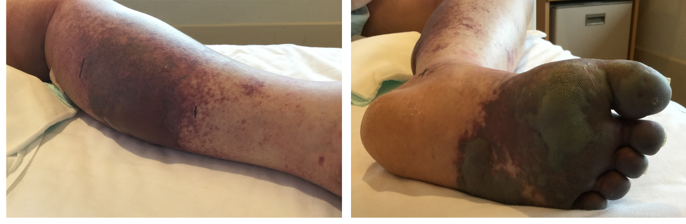
a b
Figure 2 Skin necrosis observed in the left lower extremity on hospitalization day 19. A: Left calf; B: Left foot.

Days | 12 | 22 | 29 | 35 | 42 | 56 | 67 | 105
PT-INR | 1.25 | 5.19 | 1.33 | 1.15 | 1.17 | 1.17 | 1.07 | 0.99
APTT (s) | 41.7 | 76.6 | 96.8 | 73.0 | 111.3 | 73.5  PS(%) | 35.8  PC(%) | 29.6
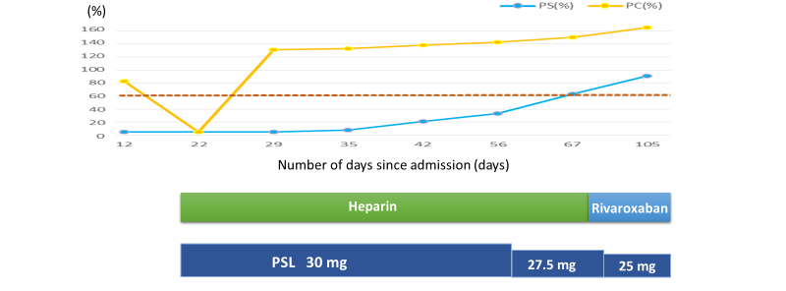
25 mg
27.5 mg
PSL 30 mg
Rivaroxaban
Heparin
Number of days since admission (d)
105
67
56
42
35
29
22
12
0
20
40
60
80
100
120
140
160
Figure 3 Clinical course of the patient. The course of treatment with prednisolone and anticoagulants as well as the activities of proteins C and S are shown. PSL: prednisolone.

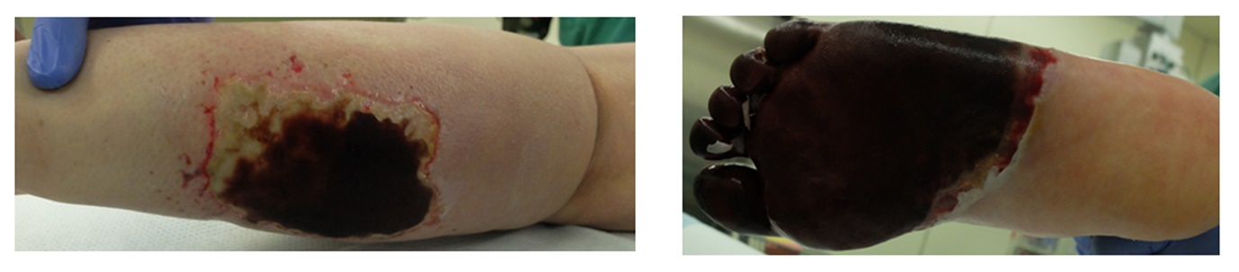
A B
Figure 4 Debridement of necrotic tissue in the left lower extremity (hospitalization day 35). A: Left calf; B: Left foot.

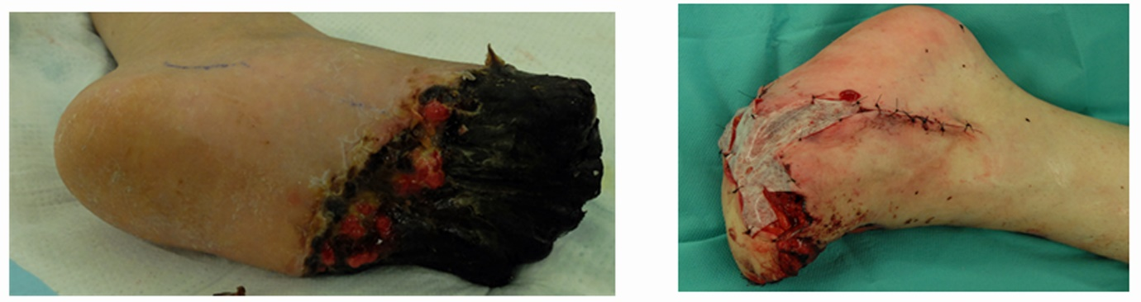
A B
Figure 5 Left toe amputation and free flap surgery were performed on hospitalization day 67. A: Pre-surgery of left foot; B: Post-surgery of left foot.

Table 1 Laboratory data upon admission
Parameter | Recorded value | Standard value
White blood cell count | 4800/µL | 4500-7500/µL
Lymphocyte count | 1300/µL
Red blood cell count | 327 × 10³/µL | 380-480 × 10³/µL
Hemoglobin | 9.4 g/dL | 11.3-15.2 g/dL
Hematocrit | 31.3% | 36%-45%
Platelet count | 10.6 × 10³/µL | 13-35 × 10³/µL
International normalized ratio | 1.05 | 0.80-1.20
Activated partial thromboplastin time | 34.5 s | 26.9-38.1 s
Fibrinogen | 374 mg/L | 150-400 mg/dL
D-dimer | 6.9 µg/mL | ≤ 1.0 µg/mL
C-reactive protein | 9.51 mg/L | ≤ 1.0 mg/L
Total protein | 7.5 g/dL | 6.9-8.4 g/dL
Albumin | 3.6 g/dL | 3.9-5.1 g/dL
Total bilirubin | 0.6 mg/dL | 0.2-1.2 mg/dL
Aspartate aminotransferase | 22 U/L | 11-30 U/L
Alanine aminotransferase | 24 U/L | 4-30 U/L
Lactate dehydrogenase | 262 U/L | 109-216 U/L
Creatine phosphokinase | 75 U/L | 40-150 U/L
Blood urea nitrogen | 7.6 mg/dL | 8-20 mg/dL
Creatinine | 0.43 mg/dL | 0.63-1.03 mg/dL
Sodium | 137 mEq/L | 136-148 mEq/L
Potassium | 3.6 mEq/L | 3.6-5.0 mEq/L
Chloride | 103 mEq/L | 98-108 mEq/L
Glucose | 146 mg/dL | 70-109 mg/dL
Hemoglobin A1c | 5.7% | ≤ 5.8%

Table 2 Tests of thrombophilia
Parameter | Recorded value | Standard value
Anti-cardiolipin β2-glycoprotein I complex antibody | 2.0 U/mL | < 3.5 U/mL
Lupus anticoagulant | 1.3 | < 1.3
Protein S activity | < 10% | 56%-126%
Protein C activity | 83% | 64%-146%
Antithrombin III | 79% | 79%-121%

