Name of Journal: World Journal of Gastroenterology
Manuscript NO: 82919
Manuscript Type: META-ANALYSIS

Association of non-alcoholic fatty liver and metabolic-associated fatty liver with COVID-19 outcomes: A systematic review and meta-analysis

Jagirdhar GSK et al. NAFLD and COVID-19

Gowthami Sai Kogilathota Jagirdhar, Rakhtan K Qasba, Harsha Pattnaik, Kaanthi Rama, Akshat Banga, Shiva Teja Reddy, Anna Carolina Flumignan Bucharles, Rahul Kashyap, Praveen Reddy Elmati, Vikas Bansal, Yatinder Bains, Theodore DaCosta, Salim Surani

Gowthami Sai Kogilathota Jagirdhar, Department of Medicine, Saint Michaels Medical Center, Newark, NJ 07102, United States

Rakhtan K Qasba, Department of Medicine, Green Life Medical College and Hospital, Dhaka 1205, Bangladesh

Harsha Pattnaik, Department of Medicine, Lady Hardinge Medical College, New Delhi 110001, India

Kaanthi Rama, Shiva Teja Reddy, Department of Medicine, Gandhi Medical College, Telangana 500003, India

Akshat Banga, Department of Medicine, Sawai Man Singh Medical College, Jaipur 302004, Rajistan, India

Anna Carolina Flumignan Bucharles, Department of Medicine, Universidade Positivo, Curitiba 81290-000, PR, Brazil

Rahul Kashyap, Research, WellSpan Health, York, PA 17403, United States

Praveen Reddy Elmati, Department of Interventional Pain Medicine, University of Louisville, Louisville, KY 40292, United States

Vikas Bansal, Department of Internal Medicine, Mayo Clinic, Rochester, MN 55902, United States

Yatinder Bains, Theodore DaCosta, Department of Gastroenterology, Saint Michaels Medical Center, Newark, NJ 07102, United States

Salim Surani, Department of Medicine, Texas A&M University, College Station, TX 77843, United States

Author contributions: Jagirdhar GSK conceived and designed the study; Jagirdhar GSK, Qasba RK, Rama K, Banga A, Reddy ST, and Flumignan Bucharles AC included studies and data extraction; Jagirdhar GSK, Qasba RK, Pattnaik H, Rama K, Banga A, Elmati PR, and Bansal V contributed to the data processing; Jagirdhar GSK, Qasba RK, Pattnaik H, Rama K, Banga A, Reddy ST, Flumignan Bucharles AC, Kashyap R, Elmati PR, Bansal V, Bains Y, and DaCosta T wrote the original manuscript; Jagirdhar GSK, Kashyap R, Bains Y, DaCosta T, and Surani S revised the paper and approved the final version.

Corresponding author: Salim Surani, FCCP, MD, MHSc, Professor, Department of Medicine, Texas A&M University, Administration Building, 400 Bizzell St, College Station, TX 77843, United States. srsurani@hotmail.com

Received: December 29, 2022
Revised: February 25, 2023
Accepted: April 28, 2023
Published online: June 7, 2023

Abstract
BACKGROUND
Non-alcoholic fatty liver disease (NAFLD) and metabolic-associated fatty liver disease (MAFLD) are on the rise like any other liver disease, and tend to affect 25% of the United States population. The impact of NAFLD and MAFLD on patients with coronavirus disease 2019 (COVID-19) remains unclear.

AIM
To identify the association of NAFLD and MAFLD with mortality, hospitalization, hospital length of stay, and supplemental oxygen utilization in COVID-19 patients.

METHODS
A systematic review of literature on Cochrane, Embase, PubMed, ScienceDirect, and Web of Science databases was conducted from January 2019 to July 2022. Studies that evaluated NAFLD/MAFLD using laboratory methods, noninvasive imaging, or liver biopsy were included. The study protocol was registered in PROSPERO (ID CRD42022313259) and PRISMA guidelines were followed. The National Institutes of Health quality assessment tool was used to assess the quality of the studies. Pooled analysis was conducted using software Rev Man version 5.3. The stability of the results was assessed using sensitivity analysis.

RESULTS
Thirty-two studies with 43388 patients were included in the meta-analysis of whom 8538 (20%) patients were observed to have NAFLD. There were 42254 patients from 28 studies included in the mortality analysis. A total of 2008 patients died from COVID-19; 837 (10.52%) in the NAFLD group and 1171 (3.41%) in the non-NAFLD group. The odds ratio (OR) was 1.38 for mortality with a 95% confidence interval (95%CI) of 0.97-1.95 and P = 0.07. A total of 5043 patients from eight studies were included in the hospital length of stay analysis. There were 1318 patients in the NAFLD group and 3725 patients in the non-NAFLD group. A qualitative synthesis showed that the mean difference in hospital length of stay was about 2 d between the NAFLD and non-NAFLD groups with a 95%CI of 0.71-3.27 and P = 0.002. For hospitalization rates, the OR was 3.25 with a 95%CI of 1.73-6.10 and P = 0.0002. For supplemental oxygen utilization, the OR was 2.04 with a 95%CI of 1.17-3.53 and P = 0.01.

CONCLUSION
Our meta-analysis suggests that there are increased odds of hospitalization, longer hospital length of stay, and increased use of supplemental oxygen in NAFLD/MAFLD patients.

Key Words: Non-alcoholic fatty liver; Fatty liver; Coronavirus; COVID-19; Metabolic-associated fatty liver

©The Author(s) 2023. Published by Baishideng Publishing Group Inc. All rights reserved.

Citation: Jagirdhar GSK, Qasba RK, Pattnaik H, Rama K, Banga A, Reddy ST, Flumignan Bucharles AC, Kashyap R, Elmati PR, Bansal V, Bains Y, DaCosta T, Surani S. Association of non-alcoholic fatty liver and metabolic-associated fatty liver with COVID-19 outcomes: A systematic review and meta-analysis. World J Gastroenterol 2023; 29(21): 3362-3378
URL: https://www.wjgnet.com/1007-9327/full/v29/i21/3362.htm
DOI: https://dx.doi.org/10.3748/wjg.v29.i21.3362

Core Tip: Metabolic-associated fatty liver disease (MAFLD) is like non-alcoholic fatty liver disease (NAFLD) and is a hepatic presentation of metabolic syndrome. They are widely prevalent. It is estimated that 25% of the United States population have this condition. The association and effect size between fatty liver disease and coronavirus disease 2019 (COVID-19) infection is still unconfirmed. The discrepancies in the available literature may be due to study design, confounding, small study population, and heterogeneity. We performed a systematic review and meta-analysis to study the impact of NAFLD/MAFLD on mortality, hospitalization, hospital length of stay, and supplemental oxygen utilization in COVID-19 patients.

INTRODUCTION
Severe acute respiratory syndrome coronavirus 2 (SARS-CoV-2) is one of the subspecies of coronavirus that is responsible for causing coronavirus disease 2019 (COVID-19), the respiratory illness responsible for the ongoing COVID-19 pandemic. The first detected case was reported back in December of 2019 from Wuhan, China^{[1]}. Since then, it has spread worldwide leading to a global pandemic. As of 12 December 2022, over 650 million confirmed cases have been reported with more than 6 million deaths^{[2]}. Most COVID-19 cases are mild to moderate with usual signs and symptoms varying from general fatigue, fever, and dry cough to some very unusual ones like loss of smell and taste. In the severe form, it is associated with several comorbidities such as diabetes, hypertension, obesity, chronic obstructive pulmonary disease, and other cardiovascular diseases^{[3,4]}. Patients with metabolic syndrome (MS) having obesity, hyperglycemia, dyslipidemia, and hypertension had worse outcomes in COVID-19^{[5,6]}. A retrospective study from Cleveland Clinic, United States concluded that patients with MS were 77% more likely to be hospitalized, 56% more likely to be admitted to the intensive care unit, and 81% more likely to die from COVID-19^{[6]}. A recent consensus of experts proposed redefining non-alcoholic fatty liver disease (NAFLD) as metabolic-associated fatty liver disease (MAFLD)^{[7-9]}. It is now considered the hepatic form of MS^{[10]} and is one of the most common etiologies of chronic liver diseases (CLDs). It has an estimated global prevalence rate of about 24%^{[11]}. These patients may have a higher risk of hospitalization and severity of COVID-19 according to recently published reports. A cohort of Chinese patients indicated a higher risk of respiratory disease progression in MAFLD patients^{[12]}. In another subsequent study, there was an increased risk for COVID-19 progression in younger patients with MAFLD^{[13]}. However, there is still conflicting evidence addressing the severity of COVID-19 in MAFLD and NAFLD patients. Prior meta-analysis of a small number of studies did not detect worse outcomes in NAFLD/MAFLD patients with COVID-19^{[14-16]}.
Therefore, we conducted this systematic review and meta-analysis to assess the effects of NAFLD or MAFLD on mortality, hospitalization, length of hospital stay, and supplemental oxygen utilization among patients with COVID-19.

MATERIALS AND METHODS
This review is reported following the Preferred Reporting Items for Systematic Reviews and Meta-Analysis (PRISMA) statement^{[17]} as indicated in the PRISMA checklist and was registered with PROSPERO (ID CRD42022313259; www.crd.york.ac.uk/prospero).

Search and selection
A literature search was performed in six bibliographic databases PubMed, Cochrane, Embase, Science Direct, and Web of Science from January 2020 to July 2022. Using a combination of keywords and medical subject headings, we used vocabulary related to “COVID-19” OR “SARS-CoV-2” AND “NASH” OR “NAFLD” OR “non-alcoholic fatty liver disease” OR “fatty liver” OR “metabolic syndrome” (Supplementary Table 1 shows the search strategy for the study).
Six authors (Jagirdhar GSK, Qasba RK, Kashyap R, Flumignan Bucharles AC, Banga A, and Reddy ST) were involved in the study selection. After removing duplicates using Endnote reference manager software, two authors did the title and abstract screening independently using the Rayyan software (https://rayyan.ai/). Studies satisfying the inclusion criteria were retrieved and screened for full-text eligibility. Conflicts between two authors on study selection were resolved among the authors or were solved by an additional third arbiter in case a consensus could not be reached. We included observational studies that studied mortality, hospitalization, hospital length of stay, and supplemental oxygen utilization outcomes in COVID-19 patients. We included studies that assessed NAFLD/MAFLD using lab assessment (fibrosis-4 [FIB-4], aminotransferase/platelet ratio index, fibrosis score, hepatic steatosis index [HIS]), non-invasive imaging (elastography, liver ultrasound or computed tomography [CT] scan, magnetic resonance elastography, liver stiffness measurement), or liver biopsy. For studies that diagnosed NAFLD using biomarkers/lab diagnosis, we only included studies that measured NAFLD prior to index admission since acute COVID infection can increase biomarker/lab values leading to misdiagnosis as NAFLD. We excluded studies that were: (1) systematic reviews; (2) meta-analyses; (3) literature reviews; (4) survey studies; (5) case reports; (6) animal studies; (7) single-arm studies; (8) studies that do not measure NAFLD/MAFLD/fatty liver; (9) not a retrospective or prospective study; (10) randomized controlled trials; (11) studies not related to COVID-19 patients; (12) not in English language; and (13) Abstract only studies. We studied NAFLD/MAFLD patients together since recent studies are emerging that NAFLD is related to MS both mutually and bi-directionally. We included studies that compared no or mild NAFLD/MAFLD patient outcomes to moderate or severe NAFLD/MAFLD patient outcomes. We also searched systematic reviews and meta-analyses obtained from our search for eligible articles and added studies meeting our inclusion criteria. When multiple publications used overlapping study populations, we included the study with greater sample size. We grouped studies for the meta-analysis based on mortality, hospitalization, hospital length of stay, and supplemental oxygen utilization outcomes.

Data extraction
Three independent authors (Qasba RK, Banga A, Flumignan Bucharles AC) performed data extraction from all of the included studies into a prepiloted data extraction form in Microsoft Excel. A fourth author (Jagirdhar GSK) independently assessed the extracted data for validation. The following was extracted from each study: (1) general information: first author, title, digital object identifier, and year of publication; (2) study characteristics: study site/country, study period, number of centers, journal, study design; (3) participant characteristics: number of NAFLD/MAFLD and non-NAFLD/MAFLD patients and their demographic characteristics, method of assessment of NAFLD; and (4) outcomes: number of patients with the events (mortality, hospital length of stay, hospitalization, and supplemental oxygen utilization) in NAFLD/MAFLD and non-NAFLD/MAFLD populations.

Statistical analyses
The Review Manager (RevMan) [Computer application] Version 5.4.1, the Cochrane Collaboration, 2020 was used to assess all results^{[18]}. Using a random-effects model, crude odds ratios (ORs) for each study with corresponding 95% confidence intervals (CIs) were calculated from raw data for events and non-events from each research^{[19]}. P < 0.05 was considered statistically significant for the analysis. Forest plots were generated to present the results of the meta-analyses. A previously proven technique was used to transform the median to mean to examine continuous outcomes^{[20]}. The estimates for mean differences were then produced using the random effects model^{[19]}. To measure study heterogeneity, the Cochrane Q and the I² statistics were used^{[19]}. Low-level heterogeneity was defined as I² 20%^{[19]}. The stability of the results was assessed using sensitivity analysis. Egger’s test and funnel plots were used to determine the likelihood of publication bias^{[21]}.

Quality assessment
The National Institutes of Health scale was used to assess case control, cohort, and randomized controlled trials for appraisal of study quality. As per the scale, studies were classified into three categories: good, fair, or poor. Five authors (Jagirdhar GSK, Qasba RK, Banga A, Rama K, Pattnaik H) independently performed the quality assessment of the included studies, and any discrepancies were resolved through discussion.

RESULTS
Search and selection
A total of 1084 records were identified from the initial search, of which 242 were excluded as duplicates and 842 articles were selected for the screening of title and abstract. Eighty-seven were chosen for full-text screening and a total of thirty-two studies met the inclusion criteria. These papers were eligible for qualitative and quantitative.
Figure 1 shows the PRISMA diagram for the study selection process. Since we included studies that compared mortality, hospitalization, hospital length of stay, and supplemental oxygen utilization in mild or no NAFLD/MAFLD to moderate to severe NAFLD/MAFLD. We excluded studies that did not present these outcomes or those that did not mention the method of NAFLD assessment^{[22-28]}.

Characteristics of included studies
We analyzed data for a total of 43388 patients from 32 studies in the meta-analysis of which 8538 (20%) patients were observed to have NAFLD and 34850 did not have NAFLD. The studies observed the outcomes of patients infected with COVID-19 with and without NAFLD/MAFLD. The outcomes recorded were the rate of hospitalization, length of stay in the hospital, supplemental oxygen requirement, and mortality of patients in both groups.
All 29 of 32 studies reported mortality data for COVID-19 infection. Ten studies reported hospital length of stay, four studies reported need for hospitalization, and four reported supplemental oxygen utilization. The main characteristics of the included studies are summarized in Table 1.

NAFLD/MAFLD and mortality outcomes in COVID-19: A total of 42254 patients from 28 studies were included in the qualitative analysis. A total of 2008 patients died from COVID-19: 837 (10.52%) in the NAFLD group and 1171 (3.41%) in the non-NAFLD group. The OR was 1.38 for mortality with a 95%CI of 0.97-1.95, I² = 84%, and P = 0.07. Figure 2A shows the forest plot and meta-analysis of mortality outcomes in COVID-19 patients. Figure 2B shows the sensitivity analysis of the studies. We failed to observe an association between NAFLD/MAFLD and in-hospital mortality in COVID-19 patients. Visual inspection of the standard error plots for the mortality meta-analysis (Supplementary Figure 1) suggests symmetry without an underrepresentation of studies of any precision. No publication bias was found on Egger’s test, P = 0.466.

NAFLD/MAFLD and hospitalization in COVID-19: Four studies were taken for the quantitative analysis with 28199 patients to assess the need for hospitalization in NAFLD and non-NAFLD groups with COVID-19. A total of 4302 patients were hospitalized for COVID-19: 765 (50.83%) patients from the NAFLD group and 3537 (13.25%) patients from the non-NAFLD group. The OR was 3.25 with a 95%CI of 1.73-6.10, I² = 92%, and a P = 0.0002. Figure 3A shows the forest plot for hospitalization in COVID-19 patients with and without NAFLD/MAFLD. Figure 3B shows the sensitivity analysis of the studies. Visual inspection of the standard error plots for the need for hospital admission meta-analysis showed (Supplementary Figure 2) symmetry without an underrepresentation of studies of any precision. No publication bias was found (Egger’s test, P = 0.254). However, as there were < 10 studies included in the analysis, publication bias cannot be completely excluded.

NAFLD/ MAFLD and hospital length of stay in COVID-19: A total of 5043 patients from 10 studies were included in the qualitative analysis. A total of 1318 patients were in the NAFLD group and 3725 patients were in the non-NAFLD group. A qualitative synthesis showed that the mean difference in hospital length of stay was 1.99 d between the NAFLD and non-NAFLD groups with a 95%CI of 0.71-3.27, I² = 70%, and P = 0.002. This denotes an average of about 2 d of additional hospital stays among NAFLD/MAFLD patients with COVID-19. Figure 4A shows a forest plot and meta-analysis of hospital length of stay in COVID-19 patients with and without NAFLD/MAFLD. Figure 4B shows the sensitivity analysis of the studies. Visual inspection of the standard error plots for the hospital length of stay meta-analysis (Supplementary Figure 3) suggests symmetry without an underrepresentation of studies of any precision. Publication bias was found on Egger’s test, P = 0.013.

NAFLD/MAFLD and supplemental oxygen utilization in COVID-19: A total of 3609 patients from four studies were included in the qualitative analysis to assess the requirement for supplemental oxygen in COVID-19 patients during their in-hospital stay. A total of 170 (7.30%) patients in the NAFLD group and 96 (7.48 %) in the non-NAFLD group required supplemental oxygen. The OR was 2.04 with a 95%CI of 1.17-3.53, I² = 56%, and P = 0.01. Figure 5A shows a forest plot and meta-analysis of supplemental oxygen utilization in COVID-19 patients with and without NAFLD/MAFLD. Figure 5B shows the sensitivity analysis of the studies. Visual inspection of the standard error plots for the need for supplemental oxygen requirement meta-analysis (Supplementary Figure 4) suggests symmetry without an underrepresentation of studies of any precision. No publication bias was found on Egger’s test, P = 0.500. However, as there were < 10 studies included in the analysis, publication bias cannot be completely excluded.

Quality assessment
Figures for quality assessment of case-control, cross-sectional, and cohort studies included in our study are attached with Supplementary material. For case-control studies, the quality assessment of included studies identified three as good quality, one as fair, and no poor rated studies. None of the studies were able to recruit a concurrent control or blind the outcome assessors. Only Madan et al^{[41]} discussed reasons for selecting included participants, providing a sample size justification additionally, Trivedi et al^{[48]} were the only ones to include a random selection of participants. For included cohorts, 19 were identified as good and 10 as fair with no poor rated studies. Only Kim et al^{[40]}, Yoo et al^{[54]}, and Zhou et al^{[56]} could provide a sample size justification additionally studies scored poorly on blinding of outcome assessors with only Marjot et al^{[42]} and Zhou et al^{[56]} being able to do so, Furthermore Ji et al^{[34]} and Huang et al^{[38]} were the only ones to measure exposure more than once for each person during the study period (Supplementary Tables 2 and 3 show the Quality assessment of the studies included based on the National Institutes of Health quality appraisal tool for case control, cohort, and cross-sectional studies).

DISCUSSION
Our systematic review and meta-analysis of 32 studies and 43388 COVID-19 patients, of which 8538 (20%) patients were observed to have NAFLD/MAFLD, provided a comprehensive assessment of mortality, need for hospitalization, hospital length of stay, and need for supplemental oxygen in COVID-19-afflicted patients with fatty liver disease. In the current meta-analysis, there was no relation between pre-existing NAFLD/MAFLD and COVID-19-related mortality. The results for the unadjusted analysis showed an increased risk of mortality, but the results were not statistically significant. Similar results were seen in a prior meta-analysis^{[57]}. Meta-analysis of seven studies by Hayat et al^{[58]} on MAFLD and COVID-19 mortality found an OR of 1.45 and a non-significant 95%CI of 0.74-2.84 (P < 0.01).
As per our meta-analysis, patients with NAFLD/MAFLD had higher hospitalization rates compared to non-NAFLD/MAFLD patients (OR = 2.71, 95%CI: 1.10-6.70; P = 0.03). COVID-19 is associated with increased inflammation and thrombosis, while NAFLD/MAFLD are states of chronic inflammation. When occurring together, these may worsen disease status causing increased hospitalization rates. Contrarily, some studies have reported no increase in disease severity or need for hospitalization in NAFLD patients with COVID compared to controls. This could be due to the small study population and the retrospective nature of the study results^{[39,54]}. Since our meta-analysis may be one of the largest to date, the results provided are expected to be closer to the true value. Our meta-analysis found that patients with NAFLD/MAFLD had a statistically significant longer hospital length of stay compared to those without. An unadjusted assessment of eight studies found that patients with pre-existing NAFLD, on average, spent an additional 2 d in the hospital compared to COVID-19 patients without NAFLD. Patients with NAFLD have ongoing inflammation processes which compound the disease process of COVID-19, thus leading to a more severe course of illness. This could explain the higher hospitalization rates and longer duration of hospital stay. Previous studies have reported similar results with longer hospital stays for NAFLD patients afflicted with COVID-19^{[32,58,59]}. On the contrary, some studies reported no difference in the duration of hospital stay in those with or without NAFLD^{[52,60]}.
Our meta-analysis of four studies revealed that NAFLD patients had a greater need for supplemental oxygen as compared to controls. NAFLD patients may have a more severe disease course and therefore, require supplemental oxygen during their hospital stay. One previous study reported that NAFLD patients had a more frequent need for oxygen support^{[51]}.
CLD due to NAFLD has seen a rising trend over the years. Over 83 million Americans suffered from NAFLD with a prevalence rate of 26% according to data from 2015. This value is said to rise by 21% to over 100 million patients by the year 2030. The growing epidemics of obesity and diabetes mellitus II have played a major role in increasing the prevalence of NAFLD worldwide, including the progression of NAFLD to non-alcoholic steatohepatitis (NASH), cirrhosis, and even hepatocellular malignancy^{[61,62]}. NAFLD is found in more than 50% of individuals suffering from obesity or type 2 diabetes mellitus. In their study, Estes et al^{[61]} reported the median age of NAFLD patients to be about 50 years. They also found that more males suffered from NAFLD as compared to females. These results are similar to our study. The absence of an established screening method and global health policies focusing on NAFLD, and primary care interventions lead to a substantial increase in patients with NAFLD going undetected^{[55]}. It also means that it is up to the clinician’s preference and choice of the screening tool to measure NAFLD, thus creating a selection bias amongst various studies. This discrepancy could be observed in the studies included in our meta-analysis as multiple screening modalities were used in different clinical settings, including HSI, FIB-4 scoring, CT scan of the liver, liver function tests, and liver biopsy among others.
The presence of NAFLD confers additional susceptibility to COVID-19 infection in individuals exposed to SARS-CoV-2^{[63]}. Pre-existing NAFLD at the time of COVID-19 diagnosis can be an indicator of increased severity of infection and utilization of health care services. As mentioned earlier, more than half of the individuals with type 2 diabetes mellitus (2nd most common comorbidity in COVID-19) have comorbid NAFLD to a certain degree^{[60]}. Similarly, NAFLD is associated with multiple risk factors like cardiovascular diseases, obesity, and coexisting chronic lung disease which independently influences COVID-19 susceptibility and severity^{[61,64-68]}. The impact of NAFLD on disease severity is seen through a blunted immune response to SARS-CoV-2 infection in COVID-19, leading to an increased risk of severe disease^{[30,13,47,55]}. A retrospective observational study observed that ongoing inflammation in NAFLD puts patients with active COVID-19 infection at an increased risk of thromboembolism and associated mortality^{[51]}. Various SARS-CoV-2 entry factors like angiotensin-converting enzyme (ACE), a disintegrin and metalloprotease 17, dipeptidyl peptidase 4, and transmembrane protease, serine 2 and NAFLD-related genes such as ACE, dipeptidyl peptidase 4, interleukin 10 (IL-10), tumor necrosis factor (TNF), and AKT1 as well as cytokine-mediated signaling, phosphoinositide 3 kinase-Akt, AMP-activated protein kinase, and mechanistic target of rapamycin signaling pathways have been identified which sheds light on the propensity for increased severity of illness in SARS-CoV-2 infected NAFLD patients. The spike protein of coronavirus has a high affinity for the receptor of ACE, which is found in the lung and the hepatobiliary cells. Furthermore, COVID-19 infection upregulates the expression of ACE receptors^{[69]}. This leads to the hyperactivation of an immune cascade that damages the hepatocytes^{[70,71]}. Chronic low-grade inflammatory state in individuals with NAFLD/MS creates a hypoxic environment for adipocytes leading to their dysfunction. This promotes the increased release of pro-inflammatory cytokines IL-6, IL-8, C-reactive protein, and TNF-α, and the recruitment of macrophages, B cells, and T cells. This effect is compounded by the systemic hyperactivation of the inflammatory cascade in active COVID-19 infection, which aggravates the ongoing inflammation of the hepatocytes, leading to decompensation of NAFLD and extensive hepatocyte damage^{[72]}. Additionally, patients with NAFLD have insulin resistance, which further serves as a conducive ground for widespread inflammation^{[73,74]}.
Bramante et al^{[75]} conducted a retrospective study that showed that with each additional year of having NAFLD/NASH the risk of hospitalization for COVID-19 increased. An assessment of the association between liver fibrosis scores and the clinical outcomes in patients with COVID-19 reported that a one-point score increase in FIB-4 was significantly associated with increased death, but not hospitalization. The authors also found that for every unit elevation in aspartate aminotransferase/alanine aminotransferase ratio, the risk of death increased by 178%^{[76]}. Patients with higher FIB-4 > 2.67 scores had a higher risk of developing COVID-19^{[77]}. Therefore, primary prevention is essential to control NAFLD during its development. Bramante et al^{[75]} also showed that patients on prior treatments for NAFLD such as metformin and glucagon-like-peptide 1 receptor agonists had a reduced risk of hospitalization with the most significantly decreased risk from recent bariatric surgery. This highlights the importance of obesity as a cofactor to worse outcomes in COVID-19 patients and weight loss as the most significant contributing factor to improved outcomes in NAFLD^{[60]}. Several studies found a higher incidence of obesity and NAFLD in patients hospitalized for COVID, which can also worsen disease severity^{[53,59,75]}. This association may be confounded by the presence of obesity, which is an independent risk factor for COVID-19 severity. Previous studies reported odds ratios after adjusting for obesity and found statistically significant results in the association between NAFLD and COVID-19^{[77,78]}. However, in a regression analysis, Li et al^{[79]} observed that NAFLD independently does not affect the prognosis of severe COVID-19. Any association between NAFLD and COVID-19 is likely attributed to the confounding effect of obesity, measured in terms of body mass index, waist circumference, and hip circumference. Further studies with a larger sample size are needed to explain the varied results observed in these studies. Roca-Fernández et al^{[63]} reported that higher liver fat percentages or evidence of liver fibro-inflammation, and features of NAFLD, increased the likelihood of symptomatic COVID-19. Interestingly, they found that obese patients with higher liver fat had a higher probability of having symptomatic COVID-19 compared to obese patients with normal liver fat. This is in favor of NAFLD being an independent risk factor for COVID-19 irrespective of obesity.

Strengths and limitations
We followed rigorous methodology, adhered to PRISMA guidelines, and registered our study in PROSPERO. Most of the studies were retrospective case-control and cohort studies which can be associated with the risk of bias, particularly in the absence of adjusting for confounders. NAFLD/MAFLD patients underlying medical conditions and co-morbidities that are components of MS can interfere with the outcomes studied. We excluded studies on NAFLD/MAFLD patients with other underlying causes for liver diseases including alcoholic liver disease. We understand there may be additional etiology for liver disease in patients that are underdiagnosed and may impact our study findings. The retrospective nature of most of the studies in our analysis does not imply a causal relationship between NAFLD/MAFLD and measured outcomes. We included studies that measured NAFLD/MAFLD using non-invasive procedures such as imaging and biomarker/lab diagnosis. Since they are not the gold standard for diagnosis, there may be misclassification of patients with and without NAFLD/MAFLD. The method of diagnosis of NAFLD/MAFLD varied across studies so, there may be some misdiagnoses that can influence the results of the study. However, we included studies that compared absent or mild NAFLD/MAFLD to moderate or severe NAFLD/MAFLD to maintain homogeneity. We considered NAFLD/MAFLD patients in the same group, however, there may be important differences between these two groups that may alter the outcomes. We observed the per-study protocol in our meta-analysis. We detected significant differences in our study population for the various outcomes measured. However, there was statistical heterogeneity in our results that should be taken into consideration. We also excluded studies in a language other than English due to difficulty with translation and interpretation of results. This can introduce bias in our study results. The studies included in our meta-analysis were from 12 different countries with more studies from China and the United States, but we consider the results to be generalizable globally. However, since the studies were from different countries the level of care at each health institution may be different, which can lead to different levels of disease severity, disease progression, and death. Our study aims for hypothesis generation and further research in NAFLD/MAFLD patients to better understand the disease pathophysiology and patient risk profiles.

CONCLUSION
Our meta-analysis suggests that NAFLD/MAFLD patients appear to have higher rates of hospital admissions and longer in-hospital stays without any increase in mortality compared to non-NAFLD/MAFLD patients. Further research is needed to explore if fatty liver disease may be a risk factor that can lead to severe COVID-19 infection.

Implications for clinical practice
NAFLD/MAFLD are chronic pandemics rapidly on the rise. There is a lack of awareness and education among healthcare professionals and patients about its health impact, morbidity, and economic impact as they progress. There is a lack of systems/protocols in place to enforce the diagnosis of NAFLD globally and as a part of regular screening in primary care clinics, diabetic clinics, and routine health care visits. Propagation of information on NAFLD and involvement of international organizations, scientific societies, and the pharmaceutical industry to improve public health policies related to NAFLD. Patient education on NAFLD/MAFLD as a co-morbid risk factor for infectious diseases such as COVID-19 like other known risk factors such as hypertension, obesity, and diabetes, and measures to diagnose and treat NAFLD actively are needed.
Implication for research
Futures research on longitudinal prospective studies with larger numbers on NAFLD/MAFLD as a risk factor for COVID-19. Future studies should focus on genetics, immunology, and molecular epidemiology to better understand the mechanisms for poor outcomes in the NAFLD population.

ARTICLE HIGHLIGHTS
Research background
Non-alcoholic fatty liver disease (NAFLD) and its hepatic manifestation metabolic-associated fatty liver disease (MAFLD) have a rising prevalence worldwide. It is a co-morbidity like obesity, hypertension, and chronic kidney disease. NAFLD/MAFLD like obesity is considered chronic inflammatory states according to recent literature. Therefore, patients with NAFLD/MAFLD are hypothesized to have worse outcomes with coronavirus disease 2019 (COVID-19).

Research motivation
Existing literature shows conflicting information on the association of NAFLD/MAFLD in COVID-19 patients. Some studies show worse outcomes with NAFLD/MAFLD and COVID-19 infection. Some studies state it is not a risk factor for severe COVID-19. Understanding the pathophysiology and pathogenesis between fatty liver disease and COVID-19 is necessary for prevention, and management of NAFLD/MAFLD patients. Insight into this relationship will help further research and better preventative and nutritional management of these patients. It is imperative to explore the relationship of NAFLD/MAFLD with COVID-19 to improve patient care and treatment protocols for better outcomes.

Research objectives
In this meta-analysis, we investigated the association between NAFLD/MAFLD with the mortality and severity of COVID-19 infection.

Research methods
A systematic review of literature across five databases was done from January 2019 to June 2022. Observational studies were included. Studies that evaluated NAFLD/MAFLD using lab assessment/biomarker assessment, non-invasive imaging, or liver biopsy were included. We registered our study protocol in Prospero and followed the “PRISMA” guidelines (Figure 1). Meta-analysis was conducted on studies with outcomes for hospitalization, hospital length of stay, supplemental oxygen utilization, and mortality of COVID-19 infection outcomes using Rev Man version 5.3. To evaluate the validity of our studies the National Institutes of Health quality assessment tool was used. The stability of the results was assessed using sensitivity analysis.

Research results
A total of 43388 patients from thirty-two studies were included in the final analysis. There were 8538 (20%) with NAFLD/MAFLD. A total of 42475 patients from twenty-nine studies were included in the mortality analysis. There was an odds ratio of 1.36, a P-value of 0.07 for mortality with COVID-19. A total of 5043 patients from eight studies were included in the hospital length of stay analysis. NAFLD patients spent a mean hospital stay of an additional about 2 d when compared to non-NAFLD. For hospitalization rates, the odds ratio is 3.25 and a P-value of 0.0002. For supplemental oxygen utilization, the odds ratio was 2.04 with a P-value of 0.01. Our meta-analysis was able to show that there is an association between NAFLD/MAFLD and COVID-19. Our study aims to increase awareness that NAFLD/MAFLD may be a potential risk factor for severe outcomes in infections. More research is needed to better explain the relationship and the pathophysiology behind it.

Research conclusions
This systematic review and meta-analysis of observational studies suggests that NAFLD/MAFLD patients had higher odds of developing severe forms of COVID-19 in comparison to non-NAFLD patients. Further research to understand the causality and strength of this relationship is needed.

Research perspectives
This review was not able to clarify why the association between NAFLD/MAFLD and COVID-19 was seen. Large size prospective studies with balanced confounding factors are necessary. Since the global burden of NAFLD/MAFLD is rapidly rising, understanding genetics and immunological mechanisms will help advance treatment and prevention strategies.

REFERENCES
1 Zhou Y, Yang Q, Chi J, Dong B, Lv W, Shen L, Wang Y. Comorbidities and the risk of severe or fatal outcomes associated with coronavirus disease 2019: A systematic review and meta-analysis. Int J Infect Dis 2020; 99: 47-56 [PMID: 32721533 DOI: 10.1016/j.ijid.2020.07.029]
2 Zádori N, Váncsa S, Farkas N, Hegyi P, Erőss B; KETLAK Study Group. The negative impact of comorbidities on the disease course of COVID-19. Intensive Care Med 2020; 46: 1784-1786 [PMID: 32601834 DOI: 10.1007/s00134-020-06161-9]
3 Földi M, Farkas N, Kiss S, Zádori N, Váncsa S, Szakó L, Dembrovszky F, Solymár M, Bartalis E, Szakács Z, Hartmann P, Pár G, Erőss B, Molnár Z, Hegyi P, Szentesi A; KETLAK Study Group. Obesity is a risk factor for developing critical condition in COVID-19 patients: A systematic review and meta-analysis. Obes Rev 2020; 21: e13095 [PMID: 32686331 DOI: 10.1111/obr.13095]
4 Wu S, Zhou K, Misra-Hebert A, Bena J, Kashyap SR. Impact of Metabolic Syndrome on Severity of COVID-19 Illness. Metab Syndr Relat Disord 2022; 20: 191-198 [PMID: 34995147 DOI: 10.1089/met.2021.0102]
5 Eslam M, Sanyal AJ, George J; International Consensus Panel. MAFLD: A Consensus-Driven Proposed Nomenclature for Metabolic Associated Fatty Liver Disease. Gastroenterology 2020; 158: 1999-2014.e1 [PMID: 32044314 DOI: 10.1053/j.gastro.2019.11.312]
6 Eslam M, Newsome PN, Sarin SK, Anstee QM, Targher G, Romero-Gomez M, Zelber-Sagi S, Wai-Sun Wong V, Dufour JF, Schattenberg JM, Kawaguchi T, Arrese M, Valenti L, Shiha G, Tiribelli C, Yki-Järvinen H, Fan JG, Grønbæk H, Yilmaz Y, Cortez-Pinto H, Oliveira CP, Bedossa P, Adams LA, Zheng MH, Fouad Y, Chan WK, Mendez-Sanchez N, Ahn SH, Castera L, Bugianesi E, Ratziu V, George J. A new definition for metabolic dysfunction-associated fatty liver disease: An international expert consensus statement. J Hepatol 2020; 73: 202-209 [PMID: 32278004 DOI: 10.1016/j.jhep.2020.03.039]
7 Tilg H, Effenberger M. From NAFLD to MAFLD: when pathophysiology succeeds. Nat Rev Gastroenterol Hepatol 2020; 17: 387-388 [PMID: 32461575 DOI: 10.1038/s41575-020-0316-6]
8 Kim CH, Younossi ZM. Nonalcoholic fatty liver disease: a manifestation of the metabolic syndrome. Cleve Clin J Med 2008; 75: 721-728 [PMID: 18939388 DOI: 10.3949/ccjm.75.10.721]
9 Cheemerla S, Balakrishnan M. Global Epidemiology of Chronic Liver Disease. Clin Liver Dis (Hoboken) 2021; 17: 365-370 [PMID: 34136143 DOI: 10.1002/cld.1061]
10 Ji D, Qin E, Xu J, Zhang D, Cheng G, Wang Y, Lau G. Non-alcoholic fatty liver diseases in patients with COVID-19: A retrospective study. J Hepatol 2020; 73: 451-453 [PMID: 32278005 DOI: 10.1016/j.jhep.2020.03.044]
11 Zhou YJ, Zheng KI, Wang XB, Yan HD, Sun QF, Pan KH, Wang TY, Ma HL, Chen YP, George J, Zheng MH. Younger patients with MAFLD are at increased risk of severe COVID-19 illness: A multicenter preliminary analysis. J Hepatol 2020; 73: 719-721 [PMID: 32348790 DOI: 10.1016/j.jhep.2020.04.027]
12 Lopez-Mendez I, Aquino-Matus J, Gall SM, Prieto-Nava JD, Juarez-Hernandez E, Uribe M, Castro-Narro G. Association of liver steatosis and fibrosis with clinical outcomes in patients with SARS-CoV-2 infection (COVID-19). Ann Hepatol 2021; 20: 100271 [PMID: 33099028 DOI: 10.1016/j.aohep.2020.09.015]
13 Mushtaq K, Khan MU, Iqbal F, Alsoub DH, Chaudhry HS, Ata F, Iqbal P, Elfert K, Balaraju G, Almaslamani M, Al-Ejji K, AlKaabi S, Kamel YM. NAFLD is a predictor of liver injury in COVID-19 hospitalized patients but not of mortality, disease severity on the presentation or progression - The debate continues. J Hepatol 2021; 74: 482-484 [PMID: 33223215 DOI: 10.1016/j.jhep.2020.09.006]
14 Forlano R, Mullish BH, Mukherjee SK, Nathwani R, Harlow C, Crook P, Judge R, Soubieres A, Middleton P, Daunt A, Perez-Guzman P, Selvapatt N, Lemoine M, Dhar A, Thursz MR, Nayagam S, Manousou P. In-hospital mortality is associated with inflammatory response in NAFLD patients admitted for COVID-19. PLoS One 2020; 15: e0240400 [PMID: 33031439 DOI: 10.1371/journal.pone.0240400]
15 Liberati A, Altman DG, Tetzlaff J, Mulrow C, Gøtzsche PC, Ioannidis JP, Clarke M, Devereaux PJ, Kleijnen J, Moher D. The PRISMA statement for reporting systematic reviews and meta-analyses of studies that evaluate healthcare interventions: explanation and elaboration. BMJ 2009; 339: b2700 [PMID: 19622552 DOI: 10.1136/bmj.b2700]
16 Cochrane Training. Cochrane RevMan. [cited 15 November 2022]. Available from: https://training.cochrane.org/online-learning/core-software/revman
17 Deeks JJ, Higgins JP, Altman DG, group on behalf of the Cochrane Statistical Methods Group. Analysing data and undertaking meta-analyses. In: Cochrane Handbook for Systematic Reviews of Interventions. United States: John Wiley & Sons, Ltd, 2019
18 Wan X, Wang W, Liu J, Tong T. Estimating the sample mean and standard deviation from the sample size, median, range and/or interquartile range. BMC Med Res Methodol 2014; 14: 135 [PMID: 25524443 DOI: 10.1186/1471-2288-14-135]
19 Boutron I, Page MJ, Higgins JP, Altman DG, Lundh A, Hróbjartsson A, group on behalf of the Cochrane Statistical Methods Group. Considering bias and conflicts of interest among the included studies. In: Cochrane Handbook for Systematic Reviews of Interventions. United States: John Wiley & Sons, Ltd, 2019
20 Demirtas CO, Keklikkiran C, Ergenc I, Erturk Sengel B, Eskidemir G, Cinel I, Odabasi Z, Korten V, Yilmaz Y. Liver stiffness is associated with disease severity and worse clinical scenarios in coronavirus disease 2019: A prospective transient elastography study. Int J Clin Pract 2021; 75: e14363 [PMID: 33993597 DOI: 10.1111/ijcp.14363]
21 Ma Y, Zhu DS, Chen RB, Shi NN, Liu SH, Fan YP, Wu GH, Yang PY, Bai JF, Chen H, Chen LY, Feng Q, Guo TM, Hou Y, Hu GF, Hu XM, Hu YH, Huang J, Huang QH, Huang SZ, Ji L, Jin HH, Lei X, Li CY, Li MQ, Li QT, Li XY, Liu H, Liu JP, Liu Z, Ma YT, Mao Y, Mo LF, Na H, Wang JW, Song FL, Sun S, Wang DT, Wang MX, Wang XY, Wang YZ, Wang YD, Wu W, Wu LP, Xiao YH, Xie HJ, Xu HM, Xu SF, Xue RX, Yang C, Yang KJ, Yuan SL, Zhang GQ, Zhang JB, Zhang LS, Zhao SS, Zhao WY, Zheng K, Zhou YC, Zhu JT, Zhu TQ, Zhang HM, Wang YP, Wang YY; 'lung cleansing & detoxifying decoction' emergency project expert group for covid-19. Association of Overlapped and Un-overlapped Comorbidities with COVID-19 Severity and Treatment Outcomes: A Retrospective Cohort Study from Nine Provinces in China. Biomed Environ Sci 2020; 33: 893-905 [PMID: 33472729 DOI: 10.3967/bes2020.123]
22 Campos-Murguía A, Román-Calleja BM, Toledo-Coronado IV, González-Regueiro JA, Solís-Ortega AA, Kúsulas-Delint D, Cruz-Contreras M, Cruz-Yedra N, Cubero FJ, Nevzorova YA, Martínez-Cabrera CF, Moreno-Guillén P, Lozano-Cruz OA, Chapa-Ibargüengoitia M, Gulías-Herrero A, Aguilar-Salinas CA, Ruiz-Margáin A, Macías-Rodríguez RU. Liver fibrosis in patients with MAFLD is a risk factor for adverse outcomes in COVID-19. Dig Liver Dis 2021; 53: 525-533 [PMID: 33551355 DOI: 10.1016/j.dld.2021.01.019]
23 Ge J, Pletcher MJ, Lai JC; N3C Consortium. Outcomes of SARS-CoV-2 Infection in Patients With Chronic Liver Disease and Cirrhosis: A National COVID Cohort Collaborative Study. Gastroenterology 2021; 161: 1487-1501.e5 [PMID: 34284037 DOI: 10.1053/j.gastro.2021.07.010]
24 Kim SW, Jeon JH, Moon JS, Kim MK. High Fibrosis-4 Index Is Related with Worse Clinical Outcome in Patients with Coronavirus Disease 2019 and Diabetes Mellitus: A Multicenter Observational Study. Endocrinol Metab (Seoul) 2021; 36: 800-809 [PMID: 34418914 DOI: 10.3803/EnM.2021.1040]
25 Park JG, Kang MK, Lee YR, Song JE, Kim NY, Kweon YO, Tak WY, Jang SY, Lee C, Kim BS, Hwang JS, Jang BK, Bae J, Lee JY, Suh JI, Park SY, Chung WJ; Daegu-Gyeongbuk Liver Study Group (DGLSG). Fibrosis-4 index as a predictor for mortality in hospitalised patients with COVID-19: a retrospective multicentre cohort study. BMJ Open 2020; 10: e041989 [PMID: 33184086 DOI: 10.1136/bmjopen-2020-041989]
26 Gao F, Zheng KI, Wang XB, Yan HD, Sun QF, Pan KH, Wang TY, Chen YP, George J, Zheng MH. Metabolic associated fatty liver disease increases coronavirus disease 2019 disease severity in nondiabetic patients. J Gastroenterol Hepatol 2021; 36: 204-207 [PMID: 32436622 DOI: 10.1111/jgh.15112]
27 Calapod OP, Marin AM, Onisai M, Tribus LC, Pop CS, Fierbinteanu-Braticevici C. The Impact of Increased Fib-4 Score in Patients with Type II Diabetes Mellitus on Covid-19 Disease Prognosis. Medicina (Kaunas) 2021; 57 [PMID: 33946377 DOI: 10.3390/medicina57050434]
28 Campos-Varela I, Villagrasa A, Simon-Talero M, Riveiro-Barciela M, Ventura-Cots M, Aguilera-Castro L, Alvarez-Lopez P, Nordahl EA, Anton A, Bañares J, Barber C, Barreira-Diaz A, Biagetti B, Camps-Relats L, Ciudin A, Cocera R, Dopazo C, Fernandez A, Jimenez C, Jimenez MM, Jofra M, Gil C, Gomez-Gavara C, Guanozzi D, Guevara JA, Lobo B, Malagelada C, Martinez-Camprecios J, Mayorga L, Miret E, Pando E, Pérez-Lopez A, Pigrau M, Prio A, Rivera-Esteban JM, Romero A, Tasayco S, Vidal-Gonzalez J, Vidal L, Minguez B, Augustin S, Genesca J. The role of liver steatosis as measured with transient elastography and transaminases on hard clinical outcomes in patients with COVID-19. Therap Adv Gastroenterol 2021; 14: 17562848211016567 [PMID: 34104210 DOI: 10.1177/17562848211016567]
29 Chang Y, Jeon J, Song TJ, Kim J. Association between the fatty liver index and the risk of severe complications in COVID-19 patients: a nationwide retrospective cohort study. BMC Infect Dis 2022; 22: 384 [PMID: 35430797 DOI: 10.1186/s12879-022-07370-x]
30 Chen VL, Hawa F, Berinstein JA, Reddy CA, Kassab I, Platt KD, Hsu CY, Steiner CA, Louissaint J, Gunaratnam NT, Sharma P. Hepatic Steatosis Is Associated with Increased Disease Severity and Liver Injury in Coronavirus Disease-19. Dig Dis Sci 2021; 66: 3192-3198 [PMID: 32980956 DOI: 10.1007/s10620-020-06618-3]
31 Çoraplı M, Çil E, Oktay C, Kaçmaz H, Çoraplı G, Bulut HT. Role of hepatosteatosis in the prognosis of COVID 19 disease. Clin Imaging 2021; 80: 1-5 [PMID: 34214871 DOI: 10.1016/j.clinimag.2021.06.034]
32 Davidov-Derevynko Y, Ben Yakov G, Wieder A, Segal G, Naveh L, Orlova N, Gringauz I, Amit S, Mor O, Klempfner R, Rahav G, Ben Ari Z. The liver in severe acute respiratory syndrome coronavirus 2 (SARS-CoV-2) infection. Eur J Gastroenterol Hepatol 2021; 33: e313-e319 [PMID: 33653988 DOI: 10.1097/MEG.0000000000002048]
33 Demir N, Yüzbasıoglu B, Calhan T, Ozturk S. Prevalence and Prognostic Importance of High Fibrosis-4 Index in COVID-19 Patients. Int J Clin Pract 2022; 2022: 1734896 [PMID: 35685537 DOI: 10.1155/2022/1734896]
34 Ji D, Zhang D, Yang T, Mu J, Zhao P, Xu J, Li C, Cheng G, Wang Y, Chen Z, Qin E, Lau G. Effect of COVID-19 on patients with compensated chronic liver diseases. Hepatol Int 2020; 14: 701-710 [PMID: 32734407 DOI: 10.1007/s12072-020-10058-6]
35 Effenberger M, Grander C, Fritsche G, Bellmann-Weiler R, Hartig F, Wildner S, Seiwald S, Adolph TE, Zoller H, Weiss G, Tilg H. Liver stiffness by transient elastography accompanies illness severity in COVID-19. BMJ Open Gastroenterol 2020; 7 [PMID: 32665398 DOI: 10.1136/bmjgast-2020-000445]
36 Elfeki MA, Robles J, Akhtar Z, Ullah F, Ganapathiraju I, Tran C, Inman C, Collin SM, Rosa R. Impact of Fibrosis-4 Index Prior to COVID-19 on Outcomes in Patients at Risk of Non-alcoholic Fatty Liver Disease. Dig Dis Sci 2022; 67: 3333-3339 [PMID: 34173917 DOI: 10.1007/s10620-021-07120-0]
37 Hashemi N, Viveiros K, Redd WD, Zhou JC, McCarty TR, Bazarbashi AN, Hathorn KE, Wong D, Njie C, Shen L, Chan WW. Impact of chronic liver disease on outcomes of hospitalized patients with COVID-19: A multicentre United States experience. Liver Int 2020; 40: 2515-2521 [PMID: 32585065 DOI: 10.1111/liv.14583]
38 Huang R, Zhu L, Wang J, Xue L, Liu L, Yan X, Huang S, Li Y, Yan X, Zhang B, Xu T, Li C, Ji F, Ming F, Zhao Y, Cheng J, Wang Y, Zhao H, Hong S, Chen K, Zhao XA, Zou L, Sang D, Shao H, Guan X, Chen X, Chen Y, Wei J, Zhu C, Wu C. Clinical Features of Patients With COVID-19 With Nonalcoholic Fatty Liver Disease. Hepatol Commun 2020; 4: 1758-1768 [PMID: 32838108 DOI: 10.1002/hep4.1592]
39 Hussain A, Iftikhar M, Rizvi A, Latif M, Javed Ahmed M, Zartash S, Laique T. Outcomes of Nonalcoholic Fatty Liver Disease In Covid Positive Diabetic Patients: Cross Sectional Study. Pakistan J Med Health Sci 2021; 15: 3241-3243 [DOI: 10.53350/pjmhs2115123241]
40 Kim D, Adeniji N, Latt N, Kumar S, Bloom PP, Aby ES, Perumalswami P, Roytman M, Li M, Vogel AS, Catana AM, Wegermann K, Carr RM, Aloman C, Chen VL, Rabiee A, Sadowski B, Nguyen V, Dunn W, Chavin KD, Zhou K, Lizaola-Mayo B, Moghe A, Debes J, Lee TH, Branch AD, Viveiros K, Chan W, Chascsa DM, Kwo P, Dhanasekaran R. Predictors of Outcomes of COVID-19 in Patients With Chronic Liver Disease: US Multi-center Study. Clin Gastroenterol Hepatol 2021; 19: 1469-1479.e19 [PMID: 32950749 DOI: 10.1016/j.cgh.2020.09.027]
41 Madan K, Rastogi R, Bhargava R, Dagar V, Singla V, Sahu A, Singh P, Garg P, Aggarwal B, Singh RK. Is Fatty Liver Associated with Increased Mortality and Morbidity in Coronavirus Disease 2019 (COVID-19) Pneumonia? J Clin Exp Hepatol 2022; 12: 1320-1327 [PMID: 35469129 DOI: 10.1016/j.jceh.2022.04.013]
42 Marjot T, Moon AM, Cook JA, Abd-Elsalam S, Aloman C, Armstrong MJ, Pose E, Brenner EJ, Cargill T, Catana MA, Dhanasekaran R, Eshraghian A, García-Juárez I, Gill US, Jones PD, Kennedy J, Marshall A, Matthews C, Mells G, Mercer C, Perumalswami PV, Avitabile E, Qi X, Su F, Ufere NN, Wong YJ, Zheng MH, Barnes E, Barritt AS 4th, Webb GJ. Outcomes following SARS-CoV-2 infection in patients with chronic liver disease: An international registry study. J Hepatol 2021; 74: 567-577 [PMID: 33035628 DOI: 10.1016/j.jhep.2020.09.024]
43 Romero-Cristóbal M, Clemente-Sánchez A, Piñeiro P, Cedeño J, Rayón L, Del Río J, Ramos C, Hernández DA, Cova M, Caballero A, Garutti I, García-Olivares P, Hortal J, Guerrero JE, García R, Bañares R, Rincón D. Possible unrecognised liver injury is associated with mortality in critically ill COVID-19 patients. Therap Adv Gastroenterol 2021; 14: 17562848211023410 [PMID: 34178116 DOI: 10.1177/17562848211023410]
44 Rentsch CT, Kidwai-Khan F, Tate JP, Park LS, King JT Jr, Skanderson M, Hauser RG, Schultze A, Jarvis CI, Holodniy M, Re VL 3rd, Akgün KM, Crothers K, Taddei TH, Freiberg MS, Justice AC. Covid-19 Testing, Hospital Admission, and Intensive Care Among 2,026,227 United States Veterans Aged 54-75 Years. medRxiv 2020 [PMID: 32511595 DOI: 10.1101/2020.04.09.20059964]
45 Shao J, Liang Y, Li Y, Ding R, Zhu M, You W, Wang Z, Huang B, Wu M, Zhang T, Li K, Wu W, Wu L, Wang Q, Xia X, Wang S, Lu L. Implications of liver injury in risk-stratification and management of patients with COVID-19. Hepatol Int 2021; 15: 202-212 [PMID: 33548030 DOI: 10.1007/s12072-020-10123-0]
46 Targher G, Mantovani A, Byrne CD, Wang XB, Yan HD, Sun QF, Pan KH, Zheng KI, Chen YP, Eslam M, George J, Zheng MH. Risk of severe illness from COVID-19 in patients with metabolic dysfunction-associated fatty liver disease and increased fibrosis scores. Gut 2020; 69: 1545-1547 [PMID: 32414813 DOI: 10.1136/gutjnl-2020-321611]
47 Tignanelli CJ, Bramante CT, Dutta N, Tamariz L, Usher MG, Ikramuddin S. Metabolic surgery may protect against admission for COVID-19 in persons with nonalcoholic fatty liver disease. Surg Obes Relat Dis 2021; 17: 1780-1786 [PMID: 34326020 DOI: 10.1016/j.soard.2021.05.029]
48 Trivedi HD, Wilechansky R, Goyes D, Vieira Barbosa J, Canakis A, Lai M, Long MT, Fricker Z. Radiographic Hepatic Steatosis Is Not Associated With Key Clinical Outcomes Among Patients Hospitalized With COVID-19. Gastroenterology Res 2021; 14: 179-183 [PMID: 34267833 DOI: 10.14740/gr1389]
49 Vázquez-Medina MU, Cerda-Reyes E, Galeana-Pavón A, López-Luna CE, Ramírez-Portillo PM, Ibañez-Cervantes G, Torres-Vázquez J, Vargas-De-León C. Interaction of metabolic dysfunction-associated fatty liver disease and nonalcoholic fatty liver disease with advanced fibrosis in the death and intubation of patients hospitalized with coronavirus disease 2019. Hepatol Commun 2022; 6: 2000-2010 [PMID: 35438253 DOI: 10.1002/hep4.1957]
50 Moctezuma-Velázquez P, Miranda-Zazueta G, Ortiz-Brizuela E, Garay-Mora JA, González-Lara MF, Tamez-Torres KM, Román-Montes CM, Díaz-Mejía BA, Pérez-García E, Villanueva-Reza M, Chapa-Ibargüengoitia M, Uscanga-Domínguez L, Sifuentes-Osornio J, Ponce-de-León A, Kershenobich-Stalnikowitz D, Mota-Ayala B, Moctezuma-Velázquez C. NAFLD determined by Dallas Steatosis Index is associated with poor outcomes in COVID-19 pneumonia: a cohort study. Intern Emerg Med 2022; 17: 1355-1362 [PMID: 35138548 DOI: 10.1007/s11739-022-02933-x]
51 Vrsaljko N, Samadan L, Viskovic K, Mehmedović A, Budimir J, Vince A, Papic N. Association of Nonalcoholic Fatty Liver Disease With COVID-19 Severity and Pulmonary Thrombosis: CovidFAT, a Prospective, Observational Cohort Study. Open Forum Infect Dis 2022; 9: ofac073 [PMID: 35287335 DOI: 10.1093/ofid/ofac073]
52 Wang G, Wu S, Wu C, Zhang Q, Wu F, Yu B, Zhang S, Wu C, Wu G, Zhong Y. Association between non-alcoholic fatty liver disease with the susceptibility and outcome of COVID-19: A retrospective study. J Cell Mol Med 2021; 25: 11212-11220 [PMID: 34761514 DOI: 10.1111/jcmm.17042]
53 Yao R, Zhu L, Wang J, Liu J, Xue R, Xue L, Liu L, Li C, Zhao H, Cheng J, Huang S, Li Y, Zhao XA, Zhu C, Li M, Huang R, Wu C. Risk of severe illness of COVID-19 patients with NAFLD and increased NAFLD fibrosis scores. J Clin Lab Anal 2021; 35: e23880 [PMID: 34213039 DOI: 10.1002/jcla.23880]
54 Yoo HW, Jin HY, Yon DK, Effenberger M, Shin YH, Kim SY, Yang JM, Kim MS, Koyanagi A, Jacob L, Smith L, Yoo IK, Shin JI, Lee SW. Non-alcoholic Fatty Liver Disease and COVID-19 Susceptibility and Outcomes: a Korean Nationwide Cohort. J Korean Med Sci 2021; 36: e291 [PMID: 34697932 DOI: 10.3346/jkms.2021.36.e291]
55 Younossi ZM, Stepanova M, Lam B, Cable R, Felix S, Jeffers T, Younossi E, Pham H, Srishord M, Austin P, Estep M, Terra K, Escheik C, de Avila L, Golabi P, Kolacevski A, Racila A, Henry L, Gerber L. Independent Predictors of Mortality Among Patients With NAFLD Hospitalized With COVID-19 Infection. Hepatol Commun 2022; 6: 3062-3072 [PMID: 34558853 DOI: 10.1002/hep4.1802]
56 Zhou YJ, Zheng KI, Wang XB, Sun QF, Pan KH, Wang TY, Ma HL, Chen YP, George J, Zheng MH. Metabolic-associated fatty liver disease is associated with severity of COVID-19. Liver Int 2020; 40: 2160-2163 [PMID: 32573883 DOI: 10.1111/liv.14575]
57 Singh A, Hussain S, Antony B. Non-alcoholic fatty liver disease and clinical outcomes in patients with COVID-19: A comprehensive systematic review and meta-analysis. Diabetes Metab Syndr 2021; 15: 813-822 [PMID: 33862417 DOI: 10.1016/j.dsx.2021.03.019]
58 Hayat U, Ashfaq MZ, Johnson L, Ford R, Wuthnow C, Kadado K, El Jurdi K, Okut H, Kilgore WR, Assi M, Siddiqui AA. The Association of Metabolic-Associated Fatty Liver Disease with Clinical Outcomes of COVID-19: A Systematic Review and Meta-Analysis. Kans J Med 2022; 15: 241-246 [PMID: 35899064 DOI: 10.17161/kjm.vol15.16522]
59 Ziaee A, Azarkar G, Ziaee M. Role of fatty liver in coronavirus disease 2019 patients' disease severity and hospitalization length: a case-control study. Eur J Med Res 2021; 26: 115 [PMID: 34565475 DOI: 10.1186/s40001-021-00590-y]
60 Nath P, Kumar R, Mallick B, Das S, Anand A, Panigrahi SC, Duseja A, Acharya SK, Chawla YK, Praharaj DL. Effect of Nonalcoholic Fatty Liver Disease (NAFLD) on COVID-19: A Single-Center Study of 3983 Patients With Review of Literature. Cureus 2022; 14: e26683 [PMID: 35949776 DOI: 10.7759/cureus.26683]
61 Estes C, Razavi H, Loomba R, Younossi Z, Sanyal AJ. Modeling the epidemic of nonalcoholic fatty liver disease demonstrates an exponential increase in burden of disease. Hepatology 2018; 67: 123-133 [PMID: 28802062 DOI: 10.1002/hep.29466]
62 Mitra S, De A, Chowdhury A. Epidemiology of non-alcoholic and alcoholic fatty liver diseases. Transl Gastroenterol Hepatol 2020; 5: 16 [PMID: 32258520 DOI: 10.21037/tgh.2019.09.08]
63 Roca-Fernández A, Dennis A, Nicolls R, McGonigle J, Kelly M, Banerjee R. High Liver Fat Associates with Higher Risk of Developing Symptomatic COVID-19 Infection - Initial UK Biobank Observations. 2020 Preprint. Available from: medRxiv:2020.06.04.20122457 [DOI: 10.1101/2020.06.04.20122457]
64 Singh R, Rathore SS, Khan H, Karale S, Chawla Y, Iqbal K, Bhurwal A, Tekin A, Jain N, Mehra I, Anand S, Reddy S, Sharma N, Sidhu GS, Panagopoulos A, Pattan V, Kashyap R, Bansal V. Association of Obesity With COVID-19 Severity and Mortality: An Updated Systemic Review, Meta-Analysis, and Meta-Regression. Front Endocrinol (Lausanne) 2022; 13: 780872 [PMID: 35721716 DOI: 10.3389/fendo.2022.780872]
65 Bae S, Kim SR, Kim MN, Shim WJ, Park SM. Impact of cardiovascular disease and risk factors on fatal outcomes in patients with COVID-19 according to age: a systematic review and meta-analysis. Heart 2021; 107: 373-380 [PMID: 33334865 DOI: 10.1136/heartjnl-2020-317901]
66 He ZF, Zhong NS, Guan WJ. Impact of Chronic Respiratory Diseases on the Outcomes of COVID-19. Arch Bronconeumol 2022; 58: 5-7 [PMID: 34075267 DOI: 10.1016/j.arbres.2021.05.009]
67 Apicella M, Campopiano MC, Mantuano M, Mazoni L, Coppelli A, Del Prato S. COVID-19 in people with diabetes: understanding the reasons for worse outcomes. Lancet Diabetes Endocrinol 2020; 8: 782-792 [PMID: 32687793 DOI: 10.1016/S2213-8587(20)30238-2]
68 Lighter J, Phillips M, Hochman S, Sterling S, Johnson D, Francois F, Stachel A. Obesity in Patients Younger Than 60 Years Is a Risk Factor for COVID-19 Hospital Admission. Clin Infect Dis 2020; 71: 896-897 [PMID: 32271368 DOI: 10.1093/cid/ciaa415]
69 Zou X, Chen K, Zou J, Han P, Hao J, Han Z. Single-cell RNA-seq data analysis on the receptor ACE2 expression reveals the potential risk of different human organs vulnerable to 2019-nCoV infection. Front Med 2020; 14: 185-192 [PMID: 32170560 DOI: 10.1007/s11684-020-0754-0]
70 Xu Z, Shi L, Wang Y, Zhang J, Huang L, Zhang C, Liu S, Zhao P, Liu H, Zhu L, Tai Y, Bai C, Gao T, Song J, Xia P, Dong J, Zhao J, Wang FS. Pathological findings of COVID-19 associated with acute respiratory distress syndrome. Lancet Respir Med 2020; 8: 420-422 [PMID: 32085846 DOI: 10.1016/S2213-2600(20)30076-X]
71 Polakos NK, Cornejo JC, Murray DA, Wright KO, Treanor JJ, Crispe IN, Topham DJ, Pierce RH. Kupffer cell-dependent hepatitis occurs during influenza infection. Am J Pathol 2006; 168: 1169-78; quiz 1404-5 [PMID: 16565492 DOI: 10.2353/ajpath.2006.050875]
72 Muscogiuri G, Pugliese G, Barrea L, Savastano S, Colao A. Commentary: Obesity: The "Achilles heel" for COVID-19? Metabolism 2020; 108: 154251 [PMID: 32353356 DOI: 10.1016/j.metabol.2020.154251]
73 Chen Z, Yu R, Xiong Y, Du F, Zhu S. A vicious circle between insulin resistance and inflammation in nonalcoholic fatty liver disease. Lipids Health Dis 2017; 16: 203 [PMID: 29037210 DOI: 10.1186/s12944-017-0572-9]
74 de Luca C, Olefsky JM. Inflammation and insulin resistance. FEBS Lett 2008; 582: 97-105 [PMID: 18053812 DOI: 10.1016/j.febslet.2007.11.057]
75 Bramante C, Tignanelli CJ, Dutta N, Jones E, Tamariz L, Clark JM, Usher M, Metlon-Meaux G, Ikramuddin S. Non-alcoholic fatty liver disease (NAFLD) and risk of hospitalization for Covid-19. medRxiv 2020 [PMID: 32909011 DOI: 10.1101/2020.09.01.20185850]
76 Liu M, Mei K, Tan Z, Huang S, Liu F, Deng C, Ma J, Yu P, Liu X. Liver Fibrosis Scores and Hospitalization, Mechanical Ventilation, Severity, and Death in Patients with COVID-19: A Systematic Review and Dose-Response Meta-Analysis. Can J Gastroenterol Hepatol 2022; 2022: 7235860 [PMID: 35369116 DOI: 10.1155/2022/7235860]
77 Targher G, Mantovani A, Byrne CD, Wang XB, Yan HD, Sun QF, Pan KH, Zheng KI, Chen YP, Eslam M, George J, Zheng MH. Detrimental effects of metabolic dysfunction-associated fatty liver disease and increased neutrophil-to-lymphocyte ratio on severity of COVID-19. Diabetes Metab 2020; 46: 505-507 [PMID: 32505652 DOI: 10.1016/j.diabet.2020.06.001]
78 Sachdeva S, Khandait H, Kopel J, Aloysius MM, Desai R, Goyal H. NAFLD and COVID-19: a Pooled Analysis. SN Compr Clin Med 2020; 2: 2726-2729 [PMID: 33173850 DOI: 10.1007/s42399-020-00631-3]
79 Li J, Tian A, Zhu H, Chen L, Wen J, Liu W, Chen P. Mendelian Randomization Analysis Reveals No Causal Relationship Between Nonalcoholic Fatty Liver Disease and Severe COVID-19. Clin Gastroenterol Hepatol 2022; 20: 1553-1560.e78 [PMID: 35124268 DOI: 10.1016/j.cgh.2022.01.045]

Footnotes
Conflict-of-interest statement: The authors have no conflicts of interest to declare.

PRISMA 2009 Checklist statement: The authors have read the PRISMA 2009 Checklist, and the manuscript was prepared and revised according to the PRISMA 2009 Checklist.

Open-Access: This article is an open-access article that was selected by an in-house editor and fully peer-reviewed by external reviewers. It is distributed in accordance with the Creative Commons Attribution NonCommercial (CC BY-NC 4.0) license, which permits others to distribute, remix, adapt, build upon this work non-commercially, and license their derivative works on different terms, provided the original work is properly cited and the use is non-commercial. See: https://creativecommons.org/Licenses/by-nc/4.0/

Provenance and peer review: Invited article; Externally peer reviewed.
Peer-review model: Single blind
Corresponding Author’s Membership in Professional Societies: American College of CHEST Physician; American College of Physician.

Peer-review started: December 29, 2022
First decision: February 15, 2023
Article in press: April 28, 2023

Specialty type: Gastroenterology and hepatology
Country/Territory of origin: United States
Peer-review report’s scientific quality classification
Grade A (Excellent): 0
Grade B (Very good): B
Grade C (Good): C, C
Grade D (Fair): 0
Grade E (Poor): 0

P-Reviewer: Pham TTT, Viet Nam; Protopapas AA, Greece; Silva LD, Brazil S-Editor: Wang JJ L-Editor: Filipodia P-Editor: Yu HG

Figure Legends
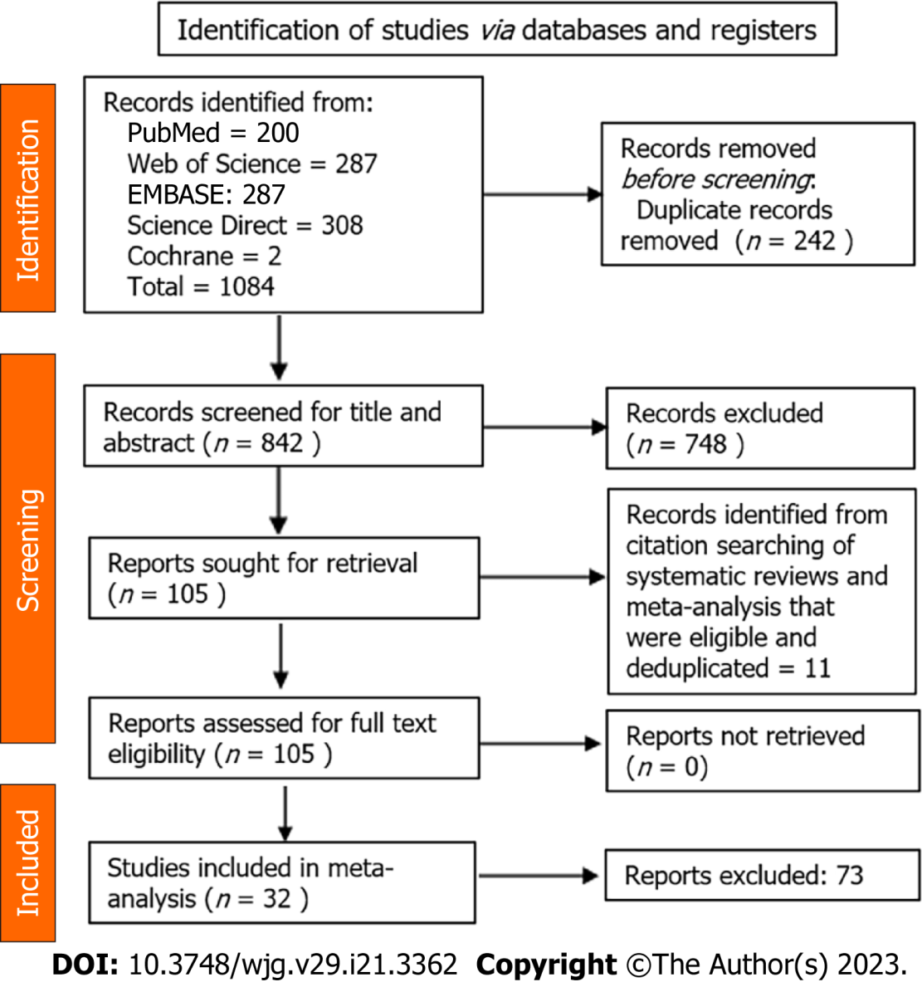
Figure 1 PRISMA flowchart outlining the study search.

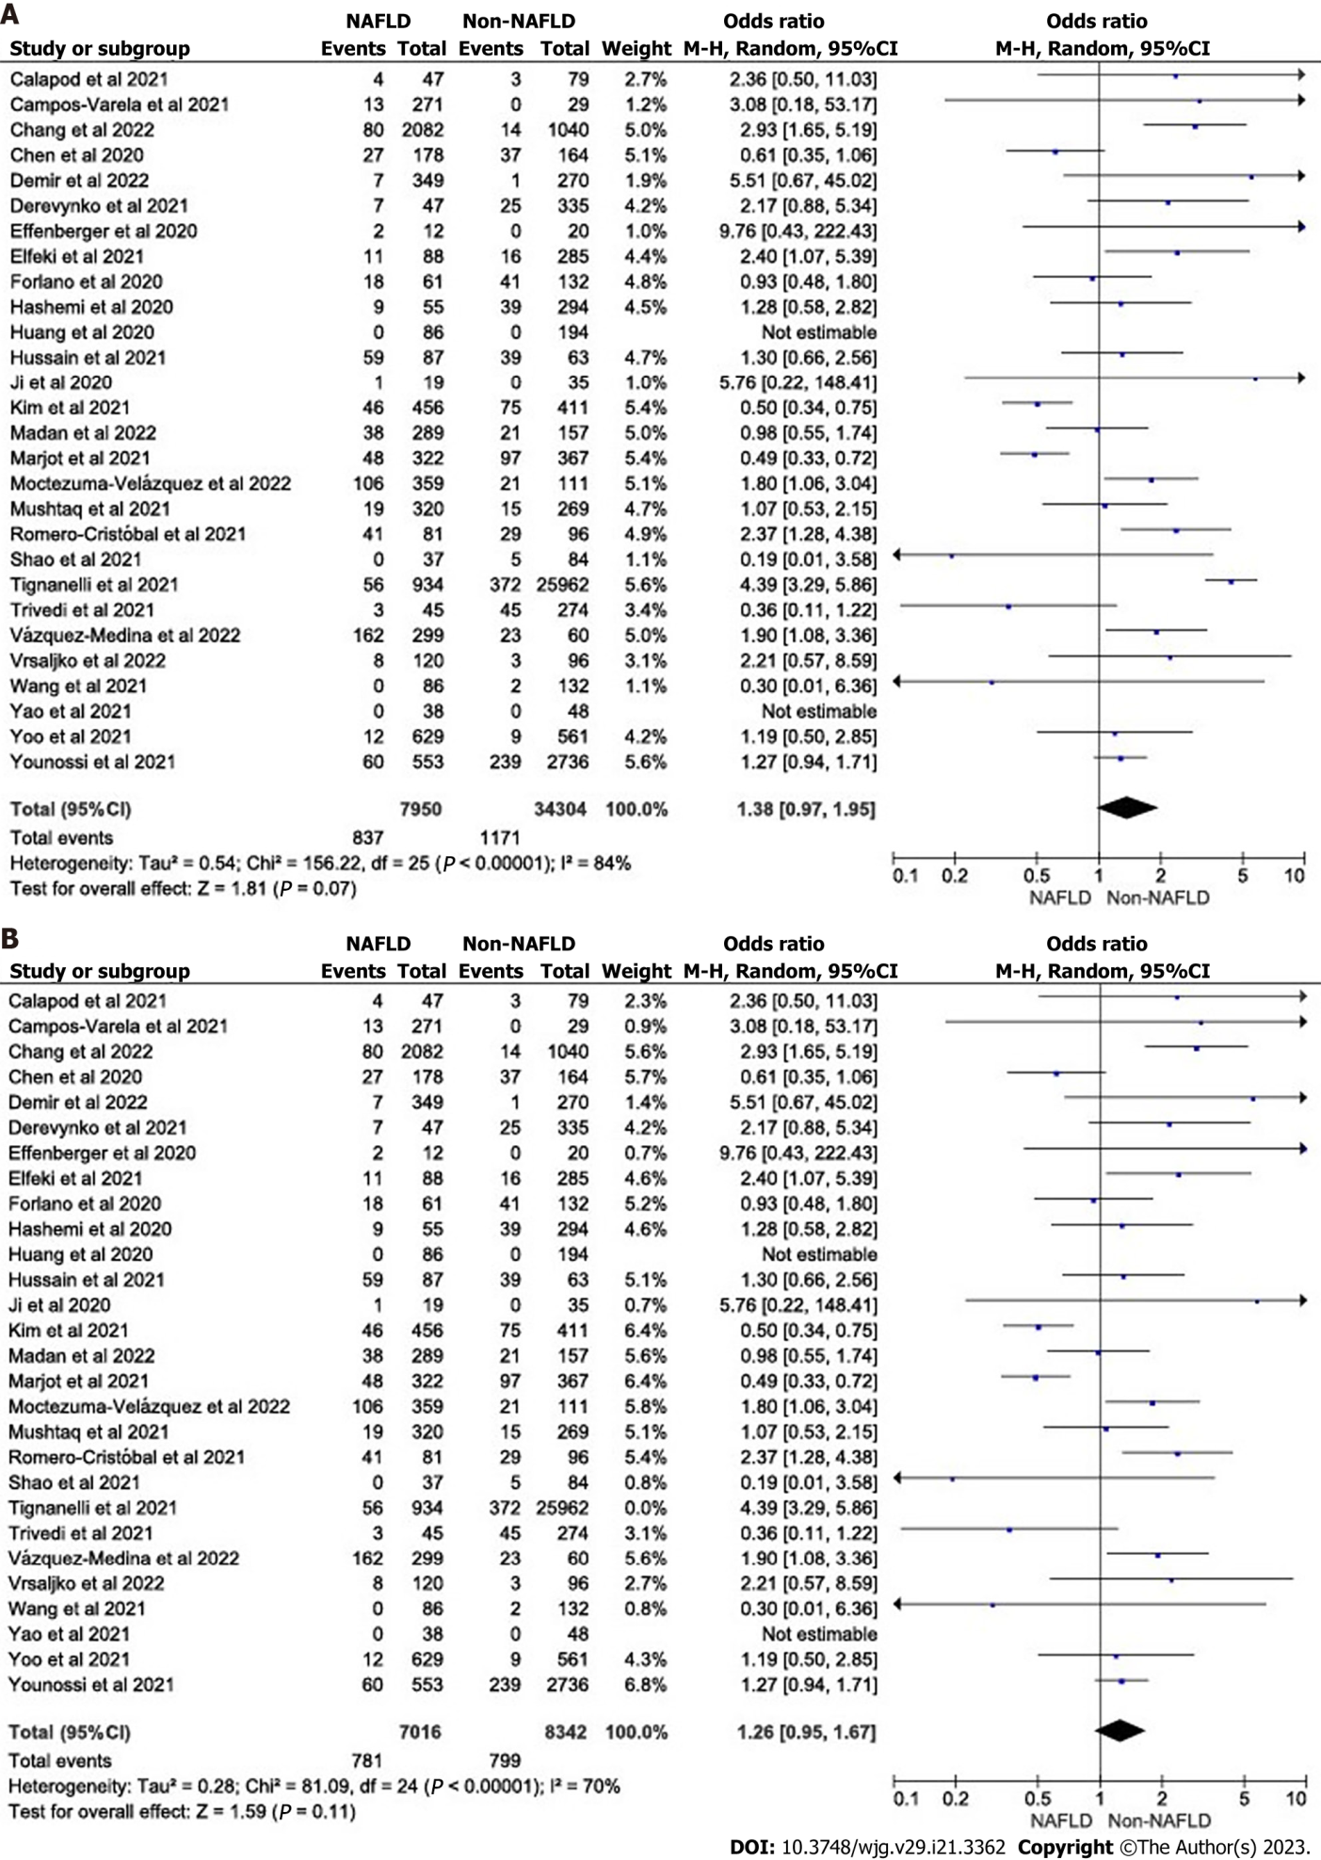
Figure 2 Forest plot for mortality outcomes in coronavirus disease 2019 patients. A: In coronavirus disease 2019 (COVID-19) patients with and without non-alcoholic fatty liver disease/metabolic-associated fatty liver disease (NAFLD/MAFLD); B: In COVID-19 patients with and without NAFLD/MAFLD sensitivity analysis after excluding Tignanelli et al^{[47]}. CI: Confidence interval.

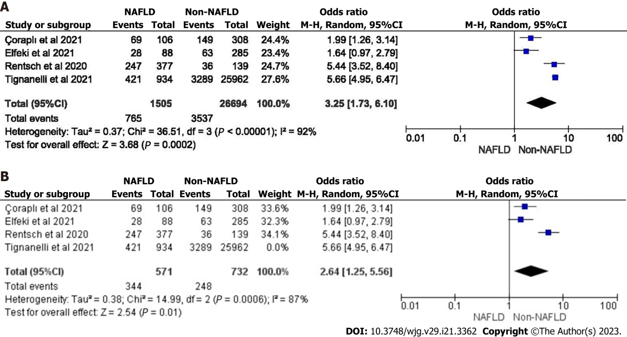
Figure 3 Forest plot for hospitalization and need for hospitalization in coronavirus disease 2019 patients. A: Forest plot for hospitalization in coronavirus disease 2019 (COVID-19) patients with and without non-alcoholic fatty liver disease/metabolic-associated fatty liver disease (NAFLD/MAFLD); B: Forest plot for need for hospitalization in COVID-19 patients with and without NAFLD/MAFLD sensitivity analysis after excluding Tignanelli et al^{[47]}. CI: Confidence interval.

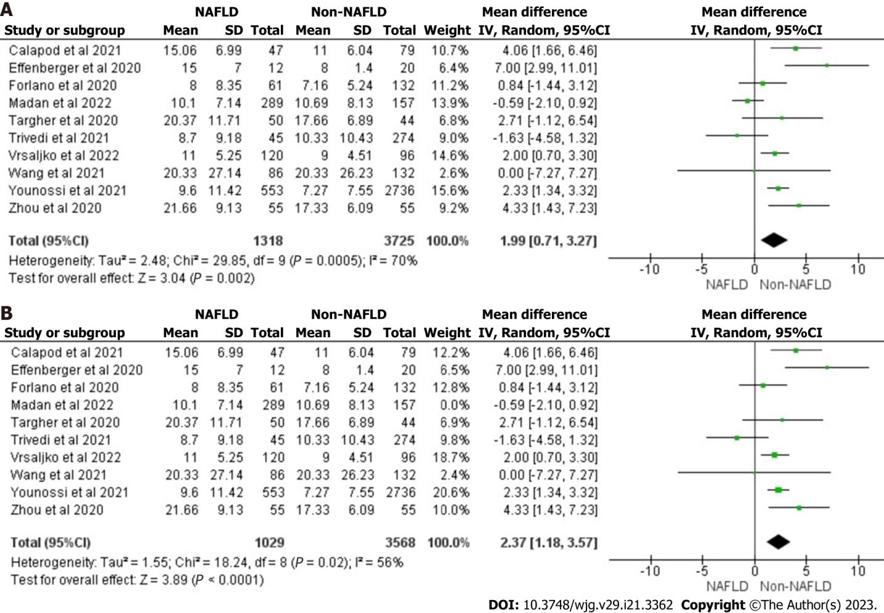
Figure 4 Forest plot for hospital length of stay in coronavirus disease 2019 patients. A: In coronavirus disease 2019 (COVID-19) patients with and without non-alcoholic fatty liver disease/metabolic-associated fatty liver disease (NAFLD/MAFLD); B: In COVID-19 patients with and without NAFLD/MAFLD sensitivity analysis after excluding Madan et al^{[41]}. CI: Confidence interval.

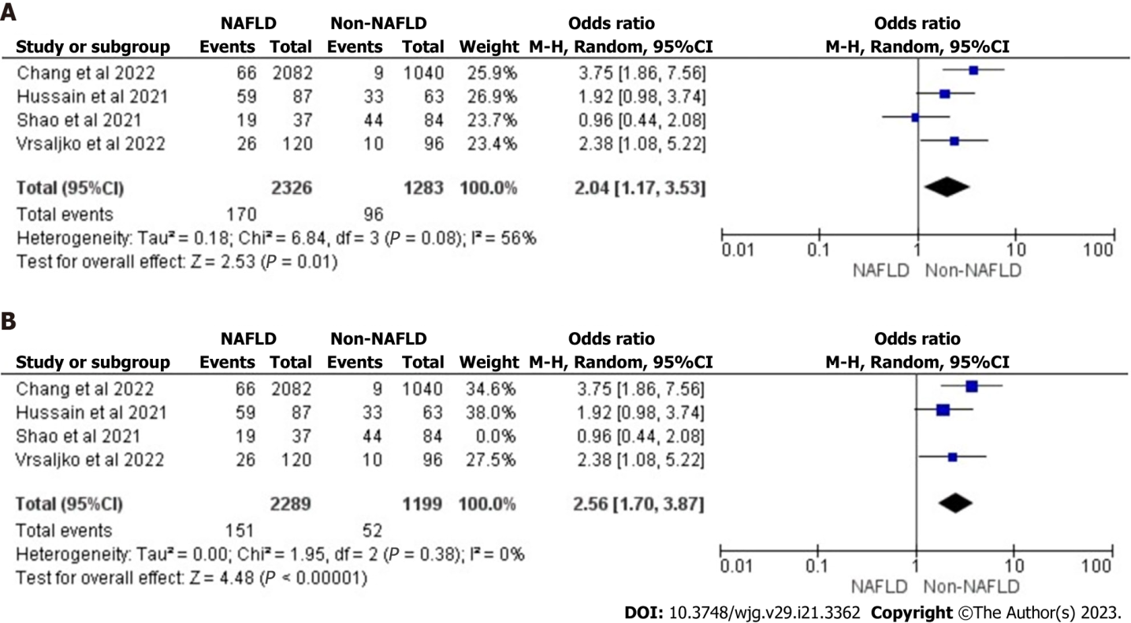
Figure 5 Forest plot for need for supplemental oxygen utilization in coronavirus disease 2019 patients. A: In coronavirus disease 2019 (COVID-19) patients with and without non-alcoholic fatty liver disease/metabolic-associated fatty liver disease (NAFLD/MAFLD); B: In COVID-19 patients with and without NAFLD/MAFLD sensitivity analysis after excluding Shao et al^{[45]}. CI: Confidence interval.

Table 1 Main characteristics of the included studies in the systematic review and meta-analysis
Serial No. | Ref. | Country | Study design | NAFLD, n | No NAFLD, n | Mean ± SD | Male, n | Measure of NAFLD | Measure of NAFLD
1 | Calapod et al^{[27]} | Romania | Prospective descriptive study | 47 | 79 | 66.32 ± 13.72 | 57.20% | Imaging evidence (ultrasound or computer tomography) | Biochemical enzymes (liver function test) within the past 12 mo.
2 | Campos-Varela et al^{[28]} | Spain | Prospective observational (cohort) study | 271 | 29 | 55.25 ± 11.69 | 49% | Liver steatosis by hepatic steatosis index | Transient elastography by controlled attenuation parameter
3 | Chang et al^{[29]} | South Korea | Retrospective cohort study | 2082 | 1040 | - | 30.72% | FLI index
4 | Chen et al^{[30]} | United States | Retrospective single-center cohort study | 178 | 164 | 62.6 ± 15.6 | 53.50% | Liver steatosis | Imaging evidence of steatosis > 30 d before COVID-19 diagnosis, or hepatic steatosis index
5 | Çoraplı et al^{[31]} | Turkey | Retrospective cohort study | 106 | 308 | - | 56.04% | Hepatic-to-splenic attenuation ratio
6 | Davidov-Derevynko et al^{[32]} | Israel | Single center retrospective cohort study | 47 | 335 | 58.6 ± 18.6 | 61% | Imaging, previous medical records, admission fibrosis-4 | Prior liver enzymes
7 | Demir et al^{[33]} | Turkey | Retrospective cohort study | 349 | 270 | 51.6 ± 9.65 | 58.60% | Fibrosis-4 index
8 | Ji et al^{[34]} | China | Cohort | 19 | 35 | 43.6 ± 14.1 | 58.6 | Fibrosis-4 index, APRI, ultrasound
9 | Effenberger et al^{[35]} | Austria | Prospective study | 12 | 20 | - | 40.62% | Liver stiffness measurements and controlled attenuation parameter with a fibro scan | Liver and spleen sonography and elastography
10 | Elfeki et al^{[36]} | United States | Retrospective cohort study | 88 | 285 | 63.3 ± 14.8 | 52% | Prior data lab values
11 | Forlano et al^{[14]} | United Kingdom | Retrospective cohort study | 61 | 132 | - | 60% | Fibrosis-4 index | Imaging (either ultrasound or computerized tomography) or past medical history
12 | Hashemi et al^{[37]} | United States | Retrospective cohort | 55 | 294 | 63.4 ± 16.5 | 55.4% | Hepatic steatosis on any prior imaging studies or liver histology
13 | Huang et al^{[38]} | China | Retrospective cohort study | 86 | 194 | 43.6 ± 17.8 | 52.10% | Hepatic steatosis index
14 | Hussain et al^{[39]} | Pakistan | Cross sectional study | 87 | 63 | 59.73 ± 11.35 | 56% | Clinical parameters like hepatomegaly and lab parameters like AST, ALT
15 | Kim et al^{[40]} | United States | Observational cohort study | 456 | 411 | 56.9 ± 14.5 | 54.70% | Fibrosis by magnetic resonance elastography | Fibro scan, fibrosis-4, or biopsy
16 | Madan et al^{[41]} | India | Case control study | 289 | 157 | - | 64.5% | Liver attenuation index
17 | Marjot et al^{[42]} | United States | Cohort study | 322 | 367 | 58 ± 15.6 | 62.40% | Reported by clinician
18 | Mushtaq et al^{[13]} | Qatar | Prospective study | 320 | 269 | - | 84.71% | Hepatic steatosis index
19 | Romero-Cristóbal et al^{[43]} | Spain | Prospective observational (cohort) study | 81 | 96 | 59.58 ± 13.79 | 71.96 | Fibrosis-4 index
20 | Rentsch et al^{[44]} | United States | Retrospective cohort study | 377 | 139 | 65.8 ± 7.8 | 95.4 | Fibrosis-4 index
21 | Shao et al^{[45]} | China | Observational cohort study | 37 | 84 | 60.6 ± 13.5 | 64.46% | Liver enzyme/GGT twice upper limit of normal
22 | Targher et al^{[46]} | China | Cohort study | 50 | 43 | - | 48% | Fibrosis-4 | NAFLD fibrosis score
23 | Tignanelli et al^{[47]} | United States | Retrospective cohort study | 934 | 25962 | 51 ± 23.7 | 56% | Elevated ALT level on 3 separate dates
24 | Trivedi et al^{[48]} | United States | Case control study | 45 | 274 | 65 (median) | 50% | Abdominal imaging (computed tomography, magnetic resonance imaging, or ultrasound)
25 | Vázquez-Medina et al^{[49]} | Mexico | Retrospective case control study | 299 | 60 | 54.3 ± 14.69 | 22.01% | Fibrosis-4 index
26 | Moctezuma-Velázquez et al^{[50]} | Mexico | Retrospective cohort study | 359 | 111 | 51.6 ± 14.8 | 63% | Computed tomography scans
27 | Vrsaljko et al^{[51]} | Republic of Croatia | Prospective observational (cohort) study | 120 | 96 | 59.3 ± 12.6 | 63.43% | Ultrasound | Difference between liver and spleen computed tomography attenuation
28 | Wang et al^{[52]} | China | Retrospective cohort study | 86 | 132 | - | 50.40% | Ultrasound parameters
29 | Yao et al^{[53]} | China | Retrospective cohort study | 38 | 48 | 43.2 ± 15.45 | 58.10% | Hepatic steatosis index | NAFLD fibrosis score
30 | Yoo et al^{[54]} | South Korea | Retrospective cohort study | 629 | 561 | - | - | Hepatic steatosis index, FLI, claims based NAFLD
31 | Younossi et al^{[55]} | United States | Observational cohort study | 553 | 2736 | - | 49.55% | Abdominal imaging, magnetic resonance imaging, computer tomography, ultra-sound
32 | Zhou et al^{[56]} | China | Cohort study | 55 | 55 | 42.1 ± 11.4 | 74.50% | Computed tomography
Non-alcoholic fatty liver disease is used synonymously with metabolic-associated fatty liver disease in this table.
ALT: Alanine aminotransferase; APRI: Aminotransferase/platelet ratio index; AST: Aspartate aminotransferase; COVID-19: Coronavirus disease 2019; FLI: Fatty liver index; GGT: Gamma-glutamyl transferase; NAFLD: Non-alcoholic fatty liver disease.

Published by Baishideng Publishing Group Inc
7041 Koll Center Parkway, Suite 160, Pleasanton, CA 94566, USA
Telephone: +1-925-3991568
E-mail: bpgoffice@wjgnet.com
Help Desk: https://www.f6publishing.com/helpdesk
https://www.wjgnet.com

© 2023 Baishideng Publishing Group Inc. All rights reserved.

