Name of journal: World Journal of Gastrointestinal Endoscopy
Manuscript NO: 40212
Manuscript type: Minireviews

Linear endoscopic ultrasound evaluation of hepatic veins

Sharma M et al. EUS of hepatic veins

Malay Sharma, Piyush Somani, Chittapuram Srinivasan Rameshbabu

Malay Sharma, Piyush Somani, Department of Gastroenterology, Jaswant Rai Speciality Hospital, Meerut 25001, Uttar Pradesh, India

Piyush Somani, Department of Gastroenterology, Thumbay Hospital, Dubai 415555, United Arab Emirates

Chittapuram Srinivasan Rameshbabu, Department of Anatomy, Muzaffarnagar Medical College, Muzaffarnagar 251001, Uttar Pradesh, India

ORCID number: Malay Sharma (0000-0003-2478-9117); Piyush Somani (0000-0002-5473-7265); Chittapuram Srinivasan Rameshbabu (0000-0002-6505-2296).

Author contributions: Sharma M wrote the manuscript; Somani P, Rameshbabu CS edited the manuscript; Sharma M, Somani P, Rameshbabu CS designed the study.

Conflict-of-interest statement: Authors declare no conflict of interests for this article

Open-Access: This article is an open-access article which was selected by an in-house editor and fully peer-reviewed by external reviewers. It is distributed in accordance with the Creative Commons Attribution Non Commercial (CC BY-NC 4.0) license, which permits others to distribute, remix, adapt, build upon this work non-commercially, and license their derivative works on different terms, provided the original work is properly cited and the use is non-commercial. See: http://creativecommons.org/licenses/by-nc/4.0/

Manuscript source: Invited manuscript

Correspondence to: Malay Sharma, MD, DM, Department of Gastroenterology, Jaswant Rai Speciality Hospital, Meerut 25001, Uttar Pradesh, India. sharmamalay@hotmail.com
Telephone: +91-98-37031148
Fax: +91-121-2657154

Received: June 7, 2018
Peer-review started: June 7, 2018
First decision: June 15, 2018
Revised: July 30, 2018
Accepted: August 12, 2018
Article in press:
Published online:

Abstract
Liver resection surgery can be associated with significant perioperative mortality and morbidity. Extensive knowledge of the vascular anatomy is essential for successful, uncomplicated liver surgeries. Various imaging techniques like multidetector computed tomographic and magnetic resonance angiography are used to provide information about hepatic vasculature. Linear endoscopic ultrasound (EUS) can offer a detailed evaluation of hepatic veins, help in assessment of liver segments and can offer a possible route for EUS guided vascular endotherapy involving hepatic veins. A standard technique for visualization of hepatic veins by linear EUS has not been described. This review paper describes the normal EUS anatomy of hepatic veins and a standard technique for visualization of hepatic veins from four stations. With practice an imaging of all the hepatic veins is possible from four stations. The imaging from fundus of stomach is the easiest and most convenient method of imaging of hepatic veins. EUS of hepatic vein and the tributaries is an operator dependent technique and in expert hands may give a mapping comparable to computed tomographic and magnetic resonance imaging. EUS of hepatic veins can help in identification of individual sectors and segments of liver. EUS guided interventions involving hepatic veins may require approach from different stations.

Key words: Endoscopic ultrasound; Hepatic vein; Portal vein; Liver segments; Caudate lobe; Inferior vena cava; Liver; Cantlie line; Falciform ligament; Gall bladder

© The Author(s) 2018. Published by Baishideng Publishing Group Inc. All rights
reserved

Core tip: A standard technique for hepatic veins imaging by linear endoscopic ultrasound (EUS) has not been described. EUS of hepatic veins can help in identification of individual sectors and segments of liver. This review paper describes the normal EUS anatomy of hepatic veins and a standard technique for visualization of hepatic veins from four stations.

Sharma M, Somani P, Rameshbabu CS. Linear endoscopic ultrasound evaluation of hepatic veins. World J gastrointest endosc 2018; in press

INTRODUCTION

Liver resection surgery is associated with significant perioperative mortality and morbidity^{[1]}. Despite refinements in hepatic surgical techniques, vascular complications still occur. A detailed knowledge of the vascular anatomy and pre-surgical planning of vascular anastomosis on a vessel-to-vessel basis is essential for successful, uncomplicated liver surgeries^{[2-5]}. A wide variety of imaging strategies are used to provide comprehensive preprocedural information about hepatic angioarchitecture^{[6]}. Currently multidetector computed tomographic (CT) and magnetic resonance angiography are complementary modalities of hepatic angioarchitecture evaluation^{[7]}. Ultrasound offers the advantage of Doppler assessment^{[8,9]}. Despite comprehensive evaluation many smaller vessels may not be picked up, however from a surgical point of view these smaller vessels are insignificant and are tied up during surgery. The identification of these smaller vessels and specifically accessory veins of liver is sometimes important as they may drain a complete segment of liver. Separate segmental venous anastomosis is required for such cases to maintain sufficient hepatic venous drainage and to prevent postoperative complications resulting from the venous obstruction. An adequate maintenance of segmental hepatic venous drainage is also important as there is no adequate venovenous shunt between hepatic venous systems^{[10,11]}. Linear endoscopic ultrasound (EUS) can offer a detailed evaluation of hepatic veins, help in assessment of liver segments and can offer a possible route for EUS guided vascular endotherapy involving hepatic veins. A standard technique for visualization of hepatic veins by linear EUS has not been described. This article describes the normal EUS anatomy of hepatic veins.

APPLIED ANATOMY: LIVER LOBES, SECTORS AND HEPATIC VEINS
The anatomical classification of the liver, which divides the right and left lobe by the attachment of the falciform ligament is no longer accepted in routine terminology. The true physiological classification divides right and left hemi-liver by an imaginary line of Cantlie. Typically, the Cantlie’s line is 1 cm to the right of the middle hepatic vein (MHV), and corresponds to an important surgical plane in the sagittal axis that extends craniocaudally from the medial aspect of the gallbladder fossa to the left margin of inferior vena cava (IVC) (Figure 1a). Posteroinferiorly this line passes from gallbladder fossa to the main bifurcation of hepatic pedicle (portal triad) and then to retrohepatic IVC.
The hepatic veins are thin-walled anechoic vessels which do not have any valves, originate from the core (central) vein of the liver lobule and drain blood toward the IVC. The hepatic veins can be segregated into three major veins (right, middle and left) and many accessory veins or short hepatic veins. The three major hepatic veins are 6 to 15 mm in diameter, have no course outside liver and open directly into the supra hepatic part of IVC in the bare area of the liver (Figure 1b). The major veins are intersegmental in their course and divide the liver into four sectors; right anterior, right posterior, left medial and left lateral. The divisions separating the sectors are called portal fissures, which do not correspond to any superficially visible clefts but within each of which runs a hepatic vein. The right hepatic vein lies in the right portal fissure and separates the right hemi liver into anterior and posterior sectors. The right hepatic vein is the longest vein, passes through the segment I and lies parallel to the gallbladder fossa. The left hepatic vein (LHV) lies in the left portal fissure which is very close to the course of ligamentum venosum and separates the left hemi liver into medial and lateral sectors. The MHV lies in the middle portal fissure and separates the anterior division of right liver from medial division of left liver (Figure 1a). The accessory veins join the retro or intrahepatic part of IVC and are usually smaller in diameter (Figure 1b). The basic organisation of the segments and sectors of liver in relationship with hepatic vein tributaries is shown in figure 2.

TECHNIQUES OF EVALUATION
The images given in this pictorial essay are taken by Pentax UTK 3870 UT from cases undergoing EUS examination. The imaging of hepatic veins is usually aided by proper identification of the IVC and the gallbladder both of which are discussed as important home bases for imaging of hepatic veins.

Imaging of IVC
IVC can be visualized from different positions during EUS. The appearance of IVC may vary from rounded to an elongated axis depending on the axis of imaging and the angulation of the probe in these positions (Figures 3-7). It is usually possible to image the entire length (approximately 6 to 8 cm) of intrahepatic/retrohepatic part of IVC in a single frame at 1 to 3 cm distance from the probe in an axis parallel to the probe near the esophagogastric junction. In this position the surface closer to the probe corresponds to the posterior surface of IVC and the surface away from the probe corresponds to the anterior surface of IVC (Figure 8). The position and course of each of the hepatic vein is usually best assessed from the abdominal part of esophagus. Slight clockwise or anticlockwise rotation can trace the lateral surfaces of the IVC. The supra hepatic, or retro hepatic course of IVC can be followed for assessment of hepatic veins which join the anterior or lateral surface of IVC. No vein joins the posterior surface of IVC. During imaging from abdominal part of esophagus and stomach the spiral course of IVC in the liver is easily traced from above downwards from an anteriorly placed position of the IVC near the right atrium to a posteriorly placed position of the IVC in abdomen (Figures 4, 5, 8 and 9). The imaging of IVC and the hepatic veins is also possible from duodenal bulb and descending duodenum but the longer distance of hepatic veins and IVC from the bulb and descending duodenum may make it technically difficult to acquire similar amount of information (Figures 6 and 7).

Imaging of gallbladder
The gallbladder lies in a shallow fossa on the down sloping visceral surface of liver and can be visualized from the stomach, the duodenal bulb and from the descending part of duodenum. It is located near the right end of porta hepatis, its neck is highest, its fundus lowest. The location of gallbladder helps in following the course of hepatic vein; the right hepatic vein runs parallel to the upper surface of gallbladder (Figure 10), the MHV runs towards the neck of gallbladder (Figure 10) and the LHV runs away from the neck of the gallbladder (Figures 11 and 12).

EVALUATION OF HEPATIC VEINS
The course of hepatic veins and the hepatic vein branches is described from four stations: the abdominal part of esophagus, the fundus of stomach, the duodenal bulb and the descending duodenum (Figure 13). The imaging from each station may be done in following steps: (1) Demarcation of right and left lobe is done by following the course of MHV. The course of left and right hepatic vein helps in identification of the four sectors (Figure 14); (2) Further subdivision of the sectors into independent liver segments is possible by following the tributary free part of each hepatic vein and tracing the direction and path of travel of the tributaries (Figure 15); and (3) The location and side of appearance of 1st major tributary of each hepatic vein is helpful for segmental identification (Figures 15-18).

Evaluation from abdominal part of esophagus
The abdominal part of esophagus lies very close to the entry point of left and MHV into the suprahepatic part of IVC. Initially the LHV is identified in an open position to the left (Figures 12 and 14a). The course of LHV divides the left lateral and left medial sector (Figure 14a). Slight clockwise rotation traces the joining of MHV at an angle of about 60° with the IVC (Figures 14b and 16). The presence of MHV divides the left medial (IVa) from right anterior sector (Figures 14b and 16). On further rotation, the right hepatic vein is seen, which divides the right anterior from right posterior sector (Figures 14c and 17). Usually in this position the merger of right hepatic vein is seen when the IVC is seen in an axis parallel to the probe (Figure 17). With a single movement of clockwise rotation from abdominal part of esophagus, the three hepatic veins can be identified within the portal fissures and the four sectors can be separated according to the order of appearance of hepatic veins (Figure 13).

Evaluation from the stomach
A EUS examination of most of the liver lobe, sectors and hepatic veins is possible from the visceral surface of liver which is in contact with stomach and forms the gastric impression on the under surface of liver (Figure 19a and b). An open position to left places the tip of the transducer close to left lateral sector of liver in stomach. A clockwise rotation from an open position to the left brings into view the umbilical part of left branch of portal vein within the umbilical fissure which lies close to left edge of transverse fissure. Further clockwise rotation traces the transverse fissure from the left edge of the fissure to the right edge and moves the beam of probe from the left lateral sector to left medial sector (Figure 20). On continued rotation the beam moves towards the right anteior sector where the gallbladder is seen (Figure 21).

Evaluation from the duodenal bulb
Imaging from duodenal bulb requires positioning of the scope in the duodenal bulb where clockwise and anticlockwise rotation results in appearance of left and right lobe (Figure 22). The presence of MHV is seen moving towards the neck of gall bladder and this divides the liver into right and left lobe (Figure 23). Further division into sectors is possible by clockwise rotation to visualize the left lobe (Figure 24) and anticlockwise rotation to visualize the right lobe (Figure 25). Imaging from the duodenal bulb usually visualizes the gallbladder neck near the liver hilum at 12 O’ clock position, fundus at 3 O’ clock position (Figures 23 and 25) and in this position the IVC is seen moving from 6 to 9 O’ clock positions (Figure 24). A clockwise rotation moves the beam towards the duodenum and towards the retrorenal part of IVC whereas as an anticlockwise rotation traces the IVC towards the right lobe of liver.

Evaluation from the descending duodenum
The evaluation of the hepatic veins from descending duodenum is possible by extreme anti-clockwise rotation coupled with upwards angulation to prevent the slipping of the scope back into the stomach. During this rotation, the beam moves traces the IVC from behind the kidney towards the heart and sequentially rotates towards the axis of imaging across the right lobe of the liver, the gallbladder fossa and the left lobe of liver. In this position the IVC gradually moves from 9 O’ clock position towards 4 O’ clock position (Figure 26). During this rotation, the MHV (Figure 27), the RHV (Figure 28) and the LHV (Figure 29) appear one by one and help in identification of all the sectors of liver.

Evaluation of short hepatic/accessory veins
The accessory veins have significant variations in their number and size and the size may be larger, smaller or of the same size as the main hepatic veins. Larger size accessory veins usually provide independent and complete drainage of blood from a complete liver segment^{[11]}. A universal classification of accessory veins is not given in literature and a simple description of accessory veins may mention all veins joining the IVC caudal to the main veins as right, middle or left inferior hepatic veins. Sometimes the accessory veins are classified into two groups according to the side that enter into IVC. The left side veins are called caudal hepatic veins, while the right sided veins are referred to as inferior right hepatic veins. On EUS the evaluation of the anterior and lateral wall of IVC below the joining of main hepatic vein is done in a craniocaudal axis (no vein joins the posterior aspect of IVC) for assessment of accessory veins (Figures 30-32). The number and diameter of hepatic veins joining IVC can be counted. The caudate lobe venous drainage is independent and occurs directly by two small fairly constant veins that enter the left side of IVC (Figure 5). In cases of liver donor, the caudate lobe usually remains in the donor because it directly drains into the IVC. The vena caval openings are considered as large openings with the diameter of 1.5-2 cm and medium when the diameter is 0.5-1.0 cm^{[11,12]}. The distance of accessory vein from the main hepatic vein is important as it may be difficult to apply a single clamp if distance between accessory vein and the confluence of the hepatic vein 5 cm in the coronal plane.

DISCUSSION
EUS of hepatic vein and the tributaries is an operator dependent technique and in expert hands may give a mapping comparable to CT and magnetic resonance imaging. EUS of hepatic veins can help in identification of individual sectors and segments of liver. EUS offers additional superiority in assessing the flow dynamics of individual hepatic veins and can provide an opportunity for assessment of the anatomical features of hepatic vein length, diameter, pattern of joining, and evaluation of segmental venous drainage. Knowledge of the presence of supernumerary right hepatic veins or an inferior hepatic vein may facilitate extrahepatic or intrahepatic venous ligation during resection of the right hemi liver^{[13-16]}. Studies done in animal models have shown a possible route for EUS guided intrahepatic portosystemic shunt from IVC and hepatic vein to portal vein^{[17]}. The EUS anatomy of portal venous system has been well defined^{[18-20]}. The assessment of hepatic veins can be also useful for assessing the path and possible techniques of specific hepatic vein puncture in planning a EUS guided procedures involving hepatic veins and portal vein (Figure 33).

CONCLUSION
This article describes a standard technique for visualization of hepatic veins. With practice an imaging of all the hepatic veins is possible from four stations. The imaging from fundus of stomach is the easiest and most convenient method of imaging of hepatic veins. EUS guided interventions may require approach from different stations. Knowledge of the hepatic venous territories and “venous drainage map” may provide useful information for complex liver surgeries and therapeutic procedure involving hepatic veins.

ACKNOWLEDGMENTS
Pran Prakash (Graphic designer) for his contribution.

References
1 Koea J. Getting started as a hepatobiliary surgeon: lessons learned from the first 100 hepatectomies as a consultant. N Z Med J 2005; 118: U1322 [PMID: 15776098]
2 Van Thiel DH, Wright HI, Fagiuoli S, Caraceni P, Rodriguez-Rilo H. Preoperative evaluation of a patient for hepatic surgery. J Surg Oncol Suppl 1993; 3: 49-51 [PMID: 8503983 DOI: 10.1002/jso.2930530514]
3 Ozeki Y, Uchiyama T, Katayama M, Sugiyama A, Kokubo M, Matsubara N. Extended left hepatic trisegmentectomy with resection of main right hepatic vein and preservation of middle and inferior right hepatic veins. Surgery 1995; 117: 715-717 [PMID: 7778036 DOI: 10.1016/S0039-6060(95)80018-2]
4 Fan ST, Lo CM, Liu CL, Yong BH, Chan JK, Ng IO. Safety of donors in live donor liver transplantation using right lobe grafts. Arch Surg 2000; 135: 336-340 [PMID: 10722038 DOI: 10.1001/archsurg.135.3.336]
5 Chen WT, Liang JL, Chen MH, Liao CC, Huang TL, Chen TY, Tsang LL, Ou HY, Hsu HW, Lazo MZ, Chen CL, Cheng YF. Noncontrast Magnetic Resonance Angiography Using Inflow Sensitive Inversion Recovery Technique for Vascular Evaluation in Pre-liver Transplantation Recipients. Transplant Proc 2016; 48: 1032-1035 [PMID: 27320549 DOI: 10.1016/j.transproceed.2015.12.083]
6 Soyer P, Bluemke DA, Choti MA, Fishman EK. Variations in the intrahepatic portions of the hepatic and portal veins: findings on helical CT scans during arterial portography. AJR Am J Roentgenol 1995; 164: 103-108 [PMID: 7998521 DOI: 10.2214/ajr.164.1.7998521]
7 Sahani D, Mehta A, Blake M, Prasad S, Harris G, Saini S. Preoperative hepatic vascular evaluation with CT and MR angiography: implications for surgery. Radiographics 2004; 24: 1367-1380 [PMID: 15371614 DOI: 10.1148/rg.245035224]
8 Appleton CP, Hatle LK, Popp RL. Superior vena cava and hepatic vein Doppler echocardiography in healthy adults. J Am Coll Cardiol 1987; 10: 1032-1039 [PMID: 3668102 DOI: 10.1016/S0735-1097(87)80343-1]
9 Honda H, Yanaga K, Onitsuka H, Kaneko K, Murakami J, Masuda K. Ultrasonographic anatomy of veins draining the left lobe of the liver. Feasibility of live related transplantation. Acta Radiol 1991; 32: 479-484 [PMID: 1742129 DOI: 10.1177/028418519103200608]
10 Nayak SB, Surendran S, Nelluri VM, Kumar N, Aithal AP. A South Indian Cadaveric Study About the Relationship of Hepatic Segment of Inferior Vena Cava with the Liver. J Clin Diagn Res 2016; 10: AC04-AC07 [PMID: 27656424 DOI: 10.7860/JCDR/2016/19892.8295]
11 Nayak SB, Deepthinath R, Kumar N, Shetty P, Kumar V, Aithal A, Shetty SD. Evaluation of Numerical and Positional Variations of the Hepatic Veins: A Cadaveric Study. J Cardiovasc Echogr 2016; 26: 5-10 [PMID: 28465952 DOI: 10.4103/2211-4122.178468]
12 Camargo AM, Teixeira GG, Ortale JR. Anatomy of the ostia venae hepaticae and the retrohepatic segment of the inferior vena cava. J Anat 1996; 188 (Pt 1): 59-64 [PMID: 8655416]
13 Makuuchi M, Hasegawa H, Yamazaki S, Bandai Y, Watanabe G, Ito T. The inferior right hepatic vein: ultrasonic demonstration. Radiology 1983; 148: 213-217 [PMID: 6304809 DOI: 10.1148/radiology.148.1.6304809]
14 Makuuchi M, Sugawara Y. Technical progress in living donor liver transplantation for adults. HPB (Oxford) 2004; 6: 95-98 [PMID: 18333057 DOI: 10.1080/13651820410032914]
15 Kamel IR, Lawler LP, Fishman EK. Variations in anatomy of the middle hepatic vein and their impact on formal right hepatectomy. Abdom Imaging 2003; 28: 668-674 [PMID: 14628873 DOI: 10.1007/s00261-002-0088-1]
16 Erbay N, Raptopoulos V, Pomfret EA, Kamel IR, Kruskal JB. Living donor liver transplantation in adults: vascular variants important in surgical planning for donors and recipients. AJR Am J Roentgenol 2003; 181: 109-114 [PMID: 12818839 DOI: 10.2214/ajr.181.1.1810109]
17 Schulman AR, Ryou M, Aihara H, Abidi W, Chiang A, Jirapinyo P, Sakr A, Ajeje E, Ryan MB, Thompson CC. EUS-guided intrahepatic portosystemic shunt with direct portal pressure measurements: a novel alternative to transjugular intrahepatic portosystemic shunting. Gastrointest Endosc 2017; 85: 243-247 [PMID: 27468858 DOI: 10.1016/j.gie.2016.07.041]
18 Rameshbabu CS, Wani ZA, Rai P, Abdulqader A, Garg S, Sharma M. Standard imaging techniques for assessment of portal venous system and its tributaries by linear endoscopic ultrasound: a pictorial essay. Endosc Ultrasound 2013; 2: 16-34 [PMID: 24949362 DOI: 10.7178/eus.04.005]
19 Sharma M, Babu CS, Garg S, Rai P. Portal venous system and its tributaries: a radial endosonographic assessment. Endosc Ultrasound 2012; 1: 96-107 [PMID: 24949345 DOI: 10.7178/eus.02.008]
20 Sharma M, Rameshbabu CS. Collateral pathways in portal hypertension. J Clin Exp Hepatol 2012; 2: 338-352 [PMID: 25755456 DOI: 10.1016/j.jceh.2012.08.001]
P-Reviewer: Goral V, Hosoe N, Skok P S-Editor: Gong ZM
L-Editor: E-Editor:
Specialty type: Gastroenterology and hepatology
Country of origin: India
Peer-review report classification
Grade A (Excellent): 0
Grade B (Very good): B, B, B
Grade C (Good): 0
Grade D (Fair): 0
Grade E (Poor): 0

a

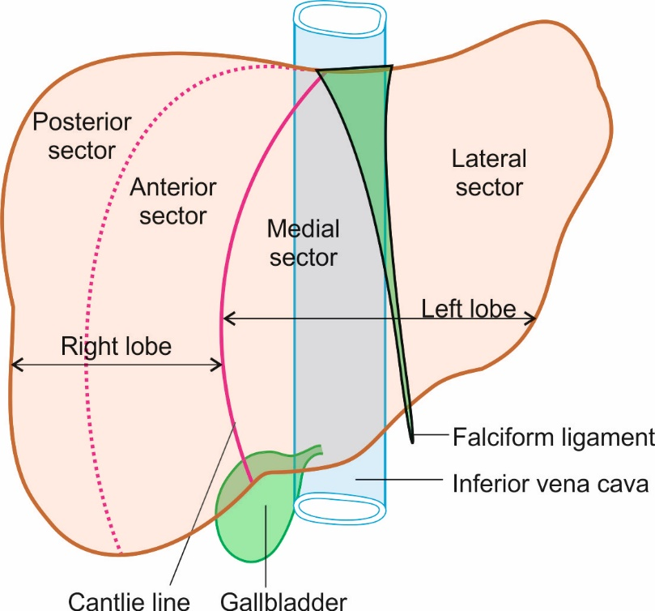

b

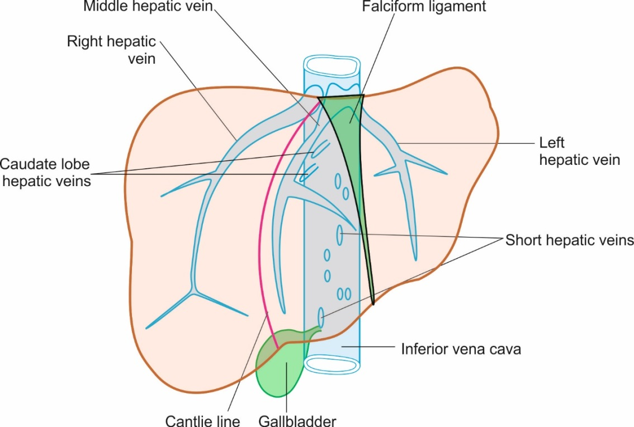
Figure 1 Anatomy of liver. A: The four sectors of liver, i.e., right anterior, right posterior, left medial and left lateral; B: The three major veins, emerge from the posterior surface of the liver and open immediately into the supra hepatic part of inferior vena cava (IVC) just before it pierces the diaphragm. Short hepatic/accessory veins drain into lower part of IVC. The accessory veins and the caudate lobe veins join the anterior and lateral aspect of IVC.

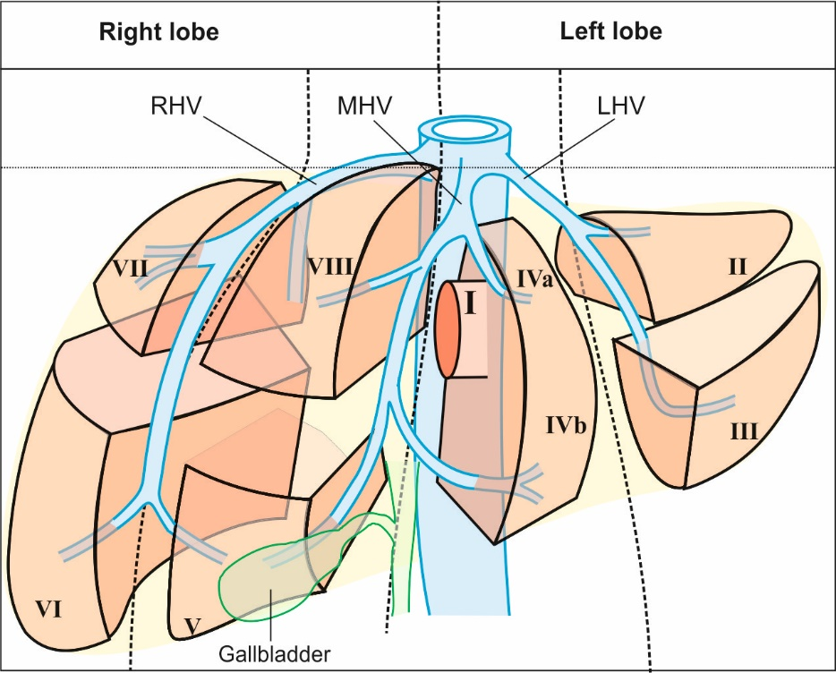
Figure 2 The segments and sectors of liver and their relationship with hepatic vein tributaries. MHV: middle hepatic vein; RHV: right hepatic vein; LHV: Left hepatic vein.

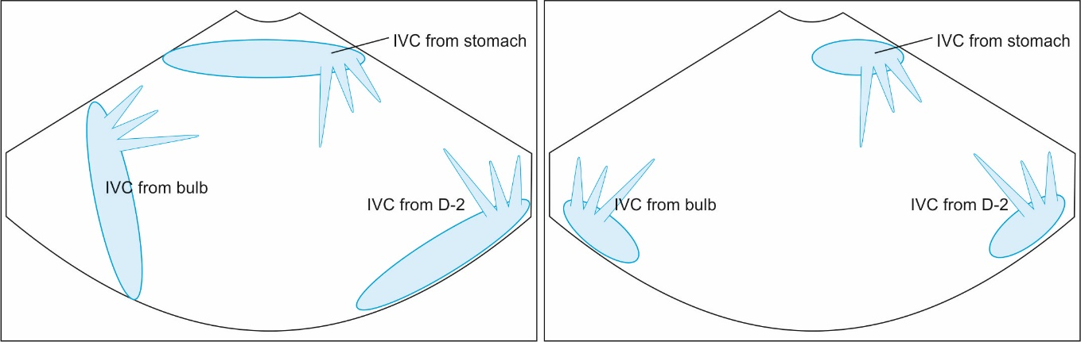
Figure 3 The appearance of inferior vena cava from three stations in a rounded or elongated axis.

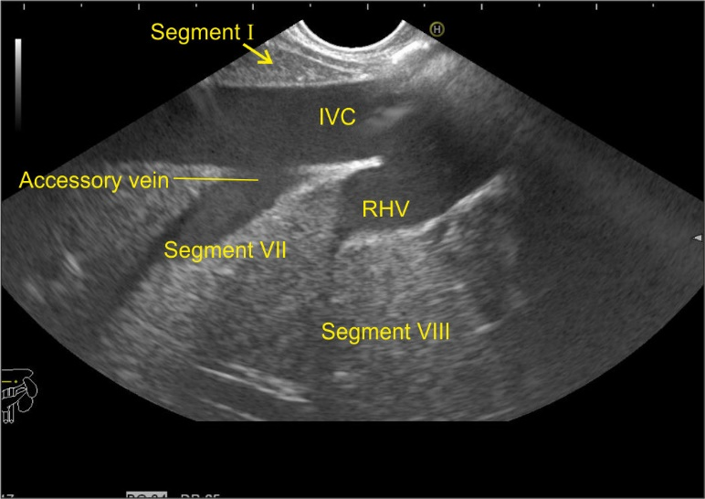
Figure 4 Inferior vena cava running parallel to the probe in a long axis from abdominal part of esophagus. RHV: right hepatic vein; IVC: inferior vena cava.

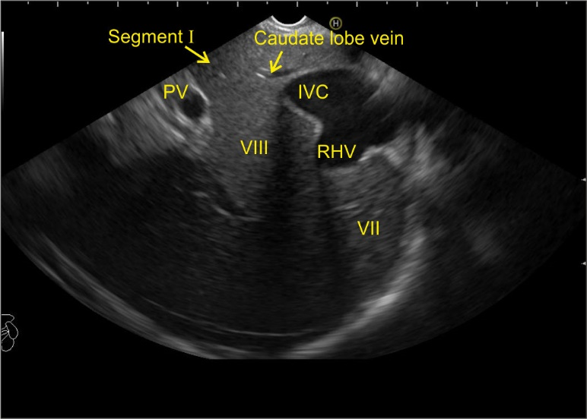
Figure 5 This figure shows inferior vena cava running parallel to the probe in a long axis. In this image slight up angulation of the probe shows inferior vena cava in a more oval axis. PV: portal vein; RHV: right hepatic vein; IVC: inferior vena cava.

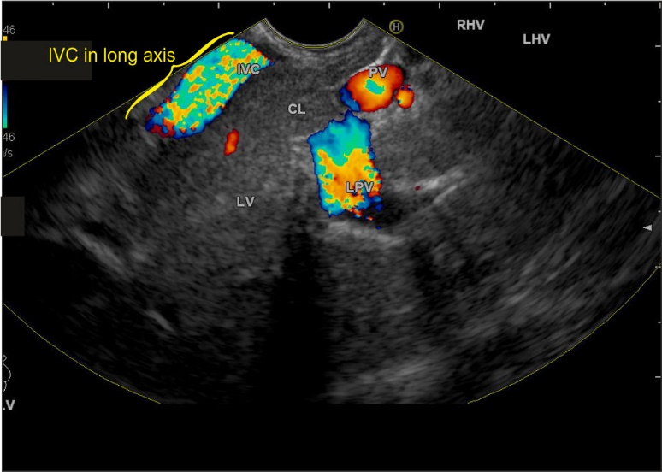
Figure 6 This figure shows inferior vena cava running from 7 O’clock position to 11 O’ clock position on the far side of the screen in a long axis from the duodenal bulb. PV: portal vein; RHV: right hepatic vein; LHV: Left hepatic vein; IVC: inferior vena cava; CL: Caudate lobe; LPV: Left portal vein.

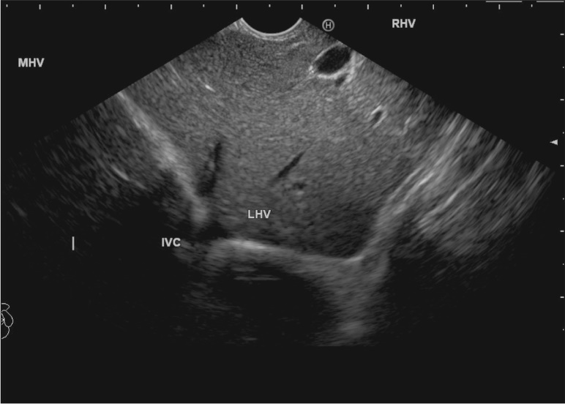
Figure 7 This figure shows inferior vena cava in a rounded axis from duodenal bulb. MHV: middle hepatic vein; RHV: right hepatic vein; LHV: Left hepatic vein; IVC: inferior vena cava.

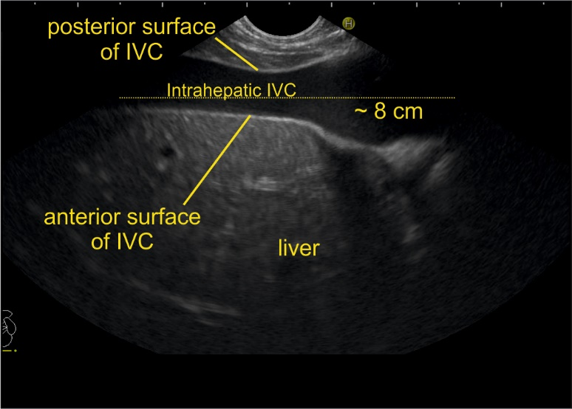
Figure 8 During imaging from the abdominal part of esophagus, the anterior surface of inferior vena cava is always found in close contact with the liver parenchyma whereas the posterior or lateral surface of the inferior vena cava is variably covered. IVC: inferior vena cava.

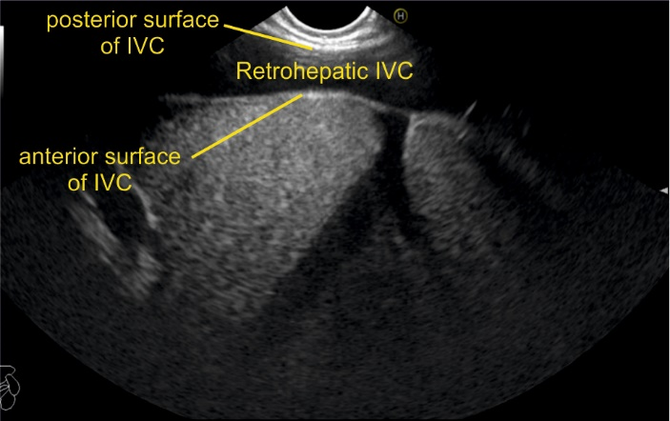
Figure 9 If the inferior vena cava is surrounded on all sides by liver parenchyma it is called as intrahepatic, if it is surrounded only anteriorly or anterolaterally it is called as retrohepatic. In this case, right hepatic vein is seen joining the retrohepatic part of inferior vena cava. IVC: inferior vena cava.

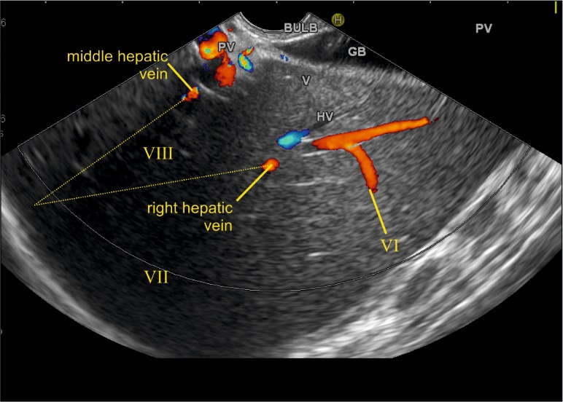
Figure 10 This image from duodenal bulb shows the right and middle hepatic vein. The right hepatic vein goes parallel to the surface of gallbladder and the middle hepatic vein goes towards the neck of gallbladder. GB: Gall bladder.

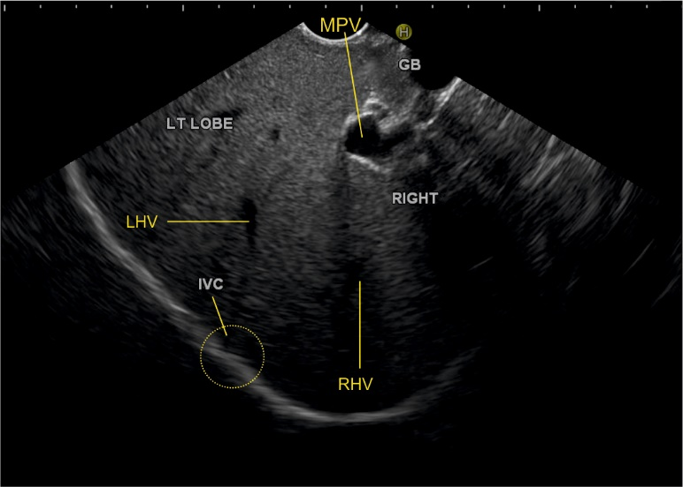
Figure 11 The inferior vena cava is not seen in this image but rotation of the scope shows the approximate area of inferior vena cava (yellow circle) where the left and right hepatic veins merge into inferior vena cava. MHV: middle hepatic vein; RHV: right hepatic vein; LHV: Left hepatic vein; IVC: inferior vena cava.

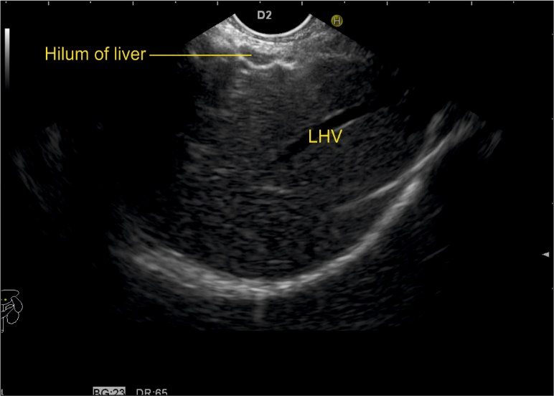
Figure 12 While imaging through the left lobe, the left hepatic vein is seen as a long vascular channel coursing towards the right side of the image into inferior vena cava which is usually seen in a rounded shape in a transverse axis. LHV: Left hepatic vein.

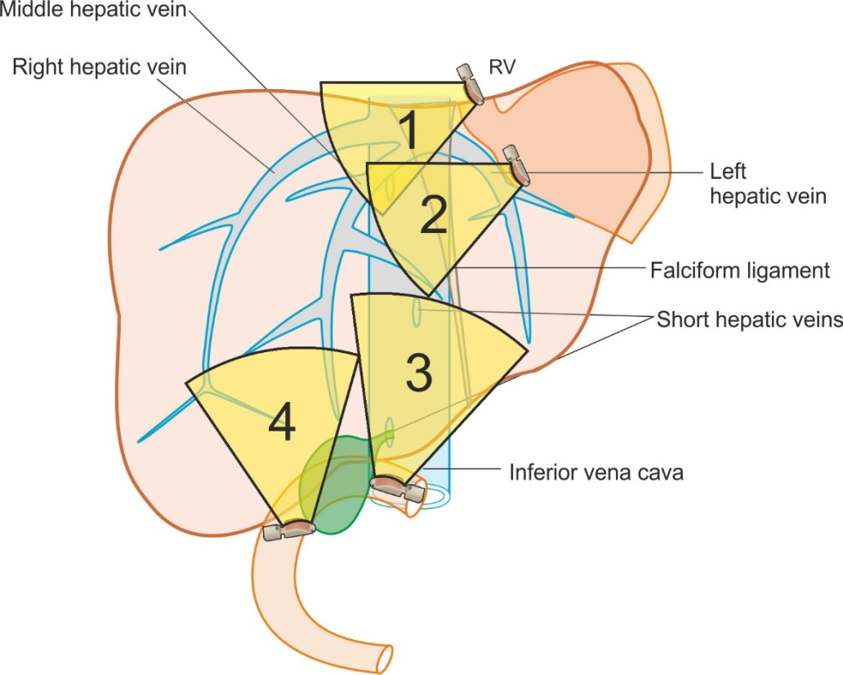
Figure 13 The imaging of hepatic veins can be done from four stations: the abdominal part of esophagus, the stomach, the duodenal bulb and the 2nd part of duodenum.

a

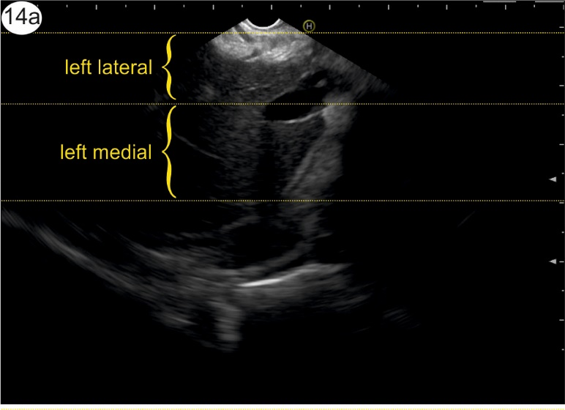

B

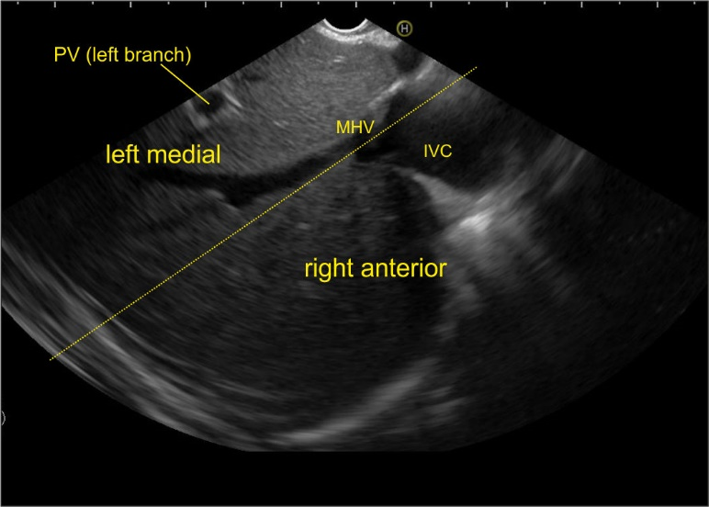

C

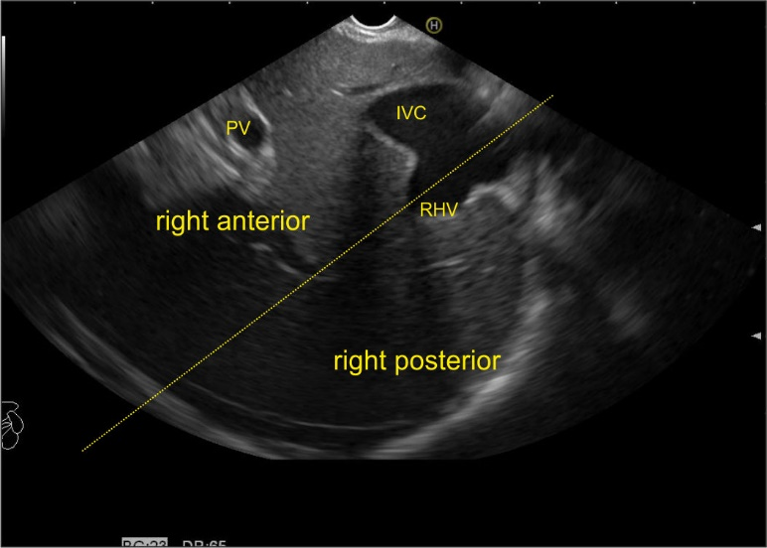
Figure 14 The images from abdominal part of esophagus shows presence of left (a), middle (b), and right hepatic vein (c) dividing the liver into four sectors. MHV: Middle hepatic vein; RHV: Right hepatic vein; LHV: Left hepatic vein; IVC: Inferior vena cava; PV: Portal vein.

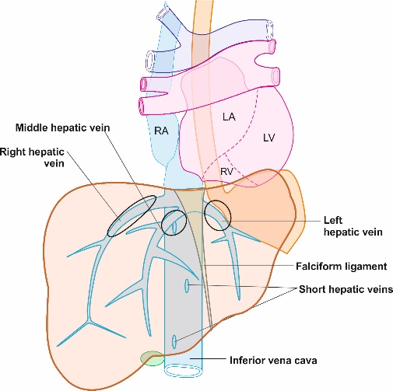
Figure 15 The tributary free part of each hepatic vein is shown.

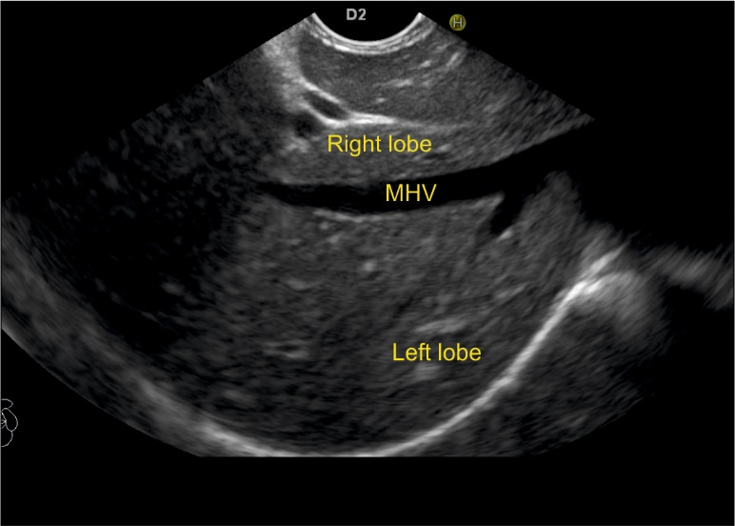
Figure 16 The middle hepatic vein has got tributaries on the right and the left side. The right side tributaries drain segment VIII and segment V. The left side tributaries drain segment IV. MHV: middle hepatic vein.

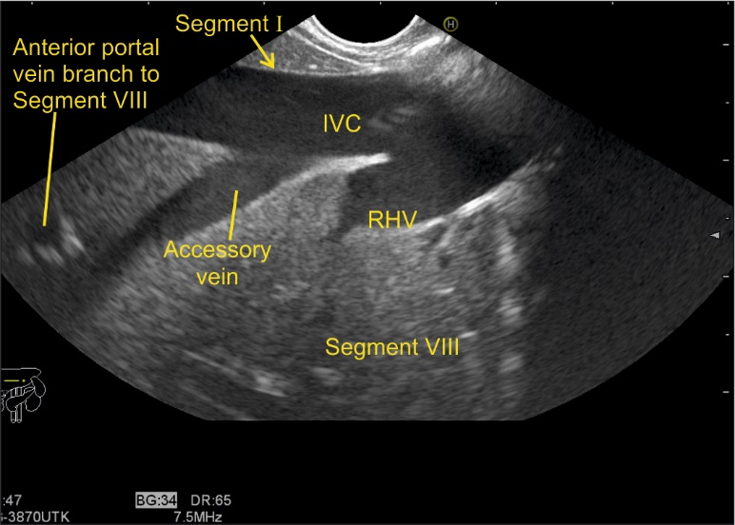
Figure 17 The right hepatic vein is seen joining at an angle of around 60°. The segment VIII is seen between hepatic vein and IVC. RHV: right hepatic vein; IVC: inferior vena cava.

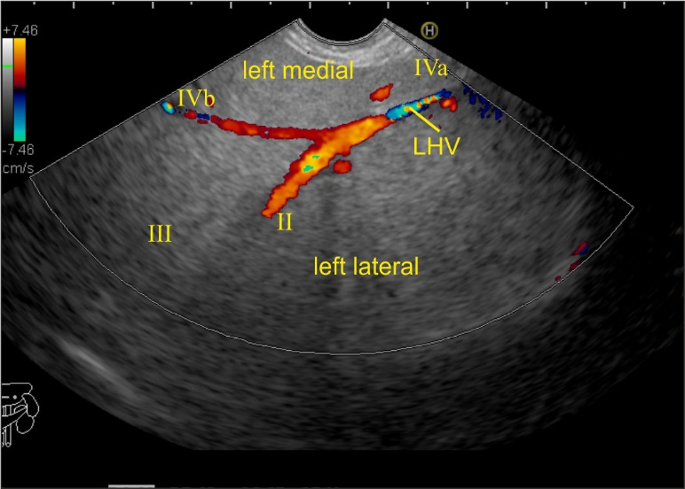
Figure 18 The left hepatic vein is seen running parallel to the probe. The segment II, III, IVa and IVb veins are seen. In this case the imaging is done from the visceral surface of the liver and from an area close to the antrum and body. Hence, the segment IVb appears closer than segment III. LHV: Left hepatic vein.

A

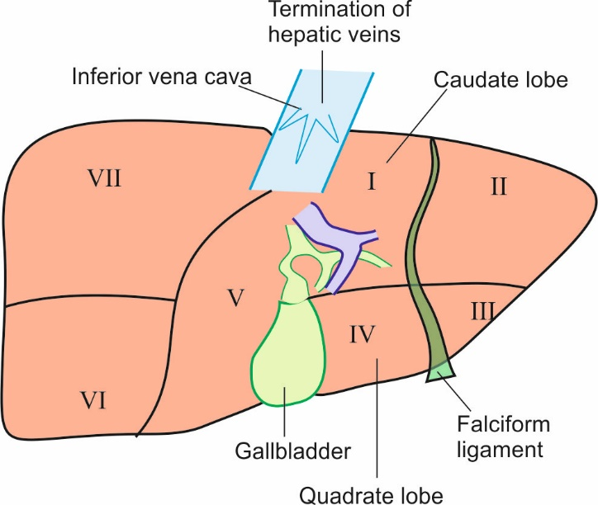

B

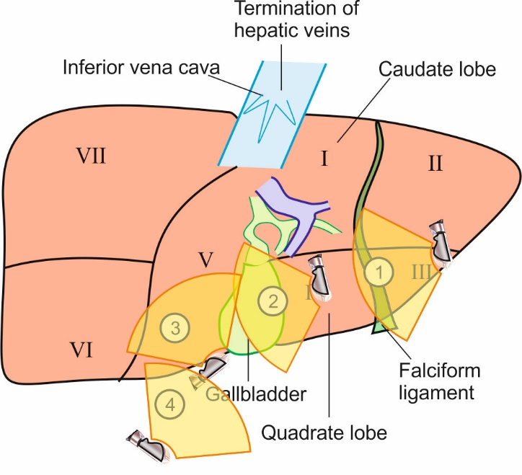
Figure 19 visceral surface of liver. A: The visceral surface of the liver is shown. All the segments of liver except segment VIII are related to the visceral surface of the liver; B: The imaging from visceral surface of liver can be done from four positions.

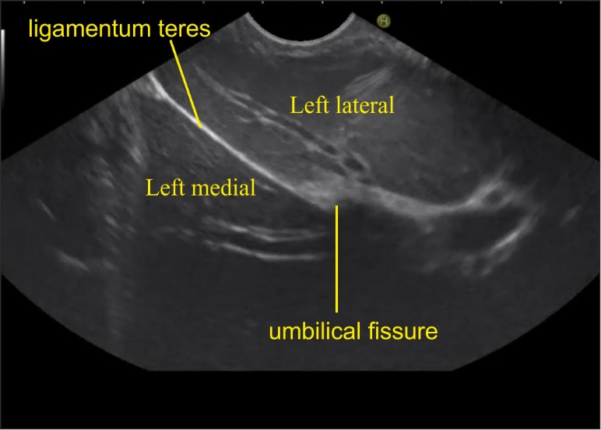

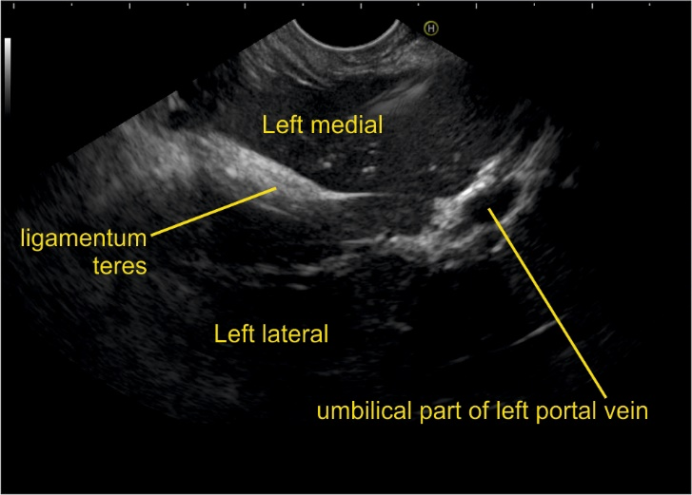
Figure 20 Imaging from visceral surface of liver shows the left lateral and left medial segment below the level of umbilical fissure separated by ligamentum teres.

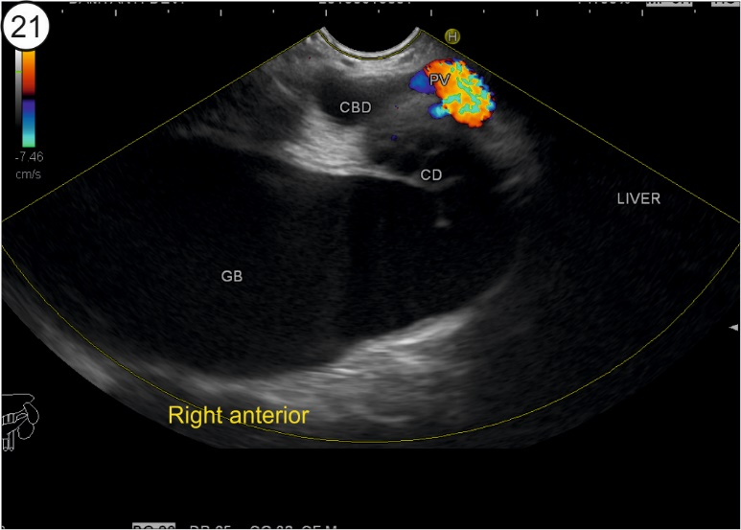
Figure 21 This image shows right anterior sector from stomach. CBD: common bile duct; CD: cystic duct; GB: gallbladder.

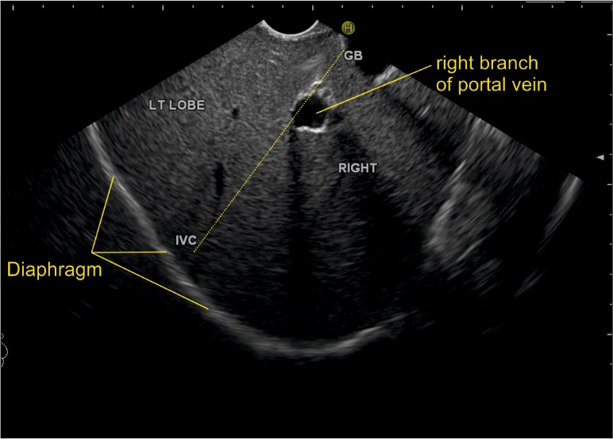
Figure 22 This image from duodenal bulb shows an imaginary line (dotted yellow line) going from inferior vena cava towards the gallbladder. This line divides the right and left lobe of liver. The right branch of portal vein is seen as a rounded structure within the liver parenchyma in the path of this line. GB: gallbladder; IVC: inferior vena cava.

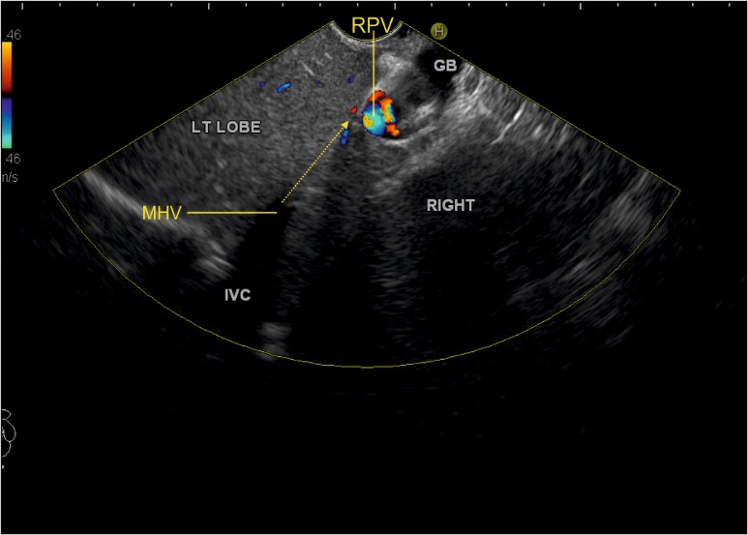
Figure 23 This image shows that the middle hepatic vein going towards the neck of gallbladder (yellow arrow). MHV: middle hepatic vein; GB: gallbladder; IVC: inferior vena cava; RPV: Right portal vein.

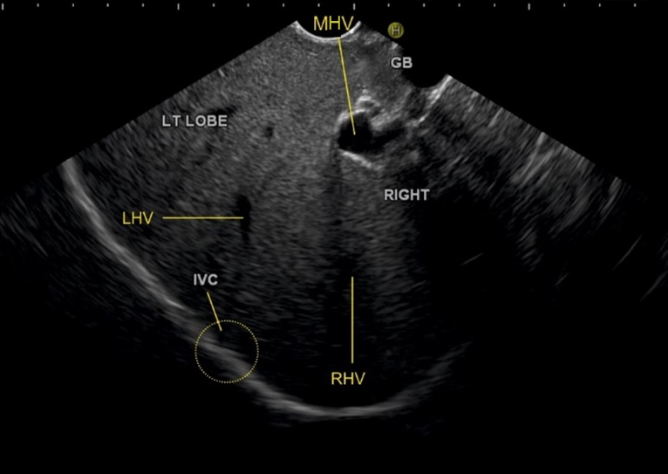
Figure 24 This image shows the course of left hepatic vein on clockwise rotation in duodenal bulb. MHV: middle hepatic vein; GB: gallbladder; RHV: right hepatic vein; LHV: Left hepatic vein; IVC: inferior vena cava.

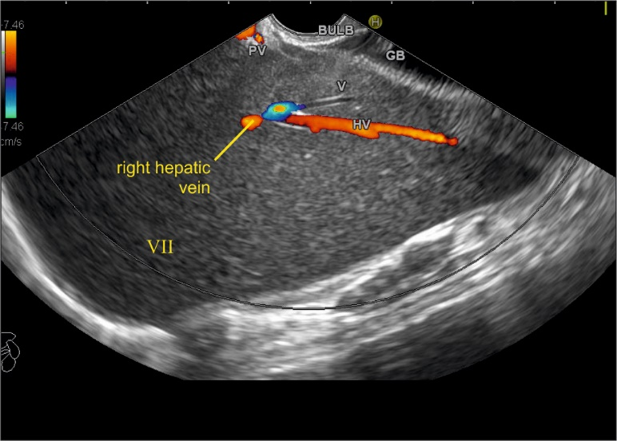
Figure 25 Imaging from duodenal bulb with anticlockwise rotation to visualize the right lobe. The middle hepatic vein is seen coursing from the neck of the gallbladder and the right hepatic vein is seen coursing parallel to the upper surface of gallbladder. An imaginary line can be drawn back to the approximate position of merger into inferior vena cava which is not seen in this frame.

a

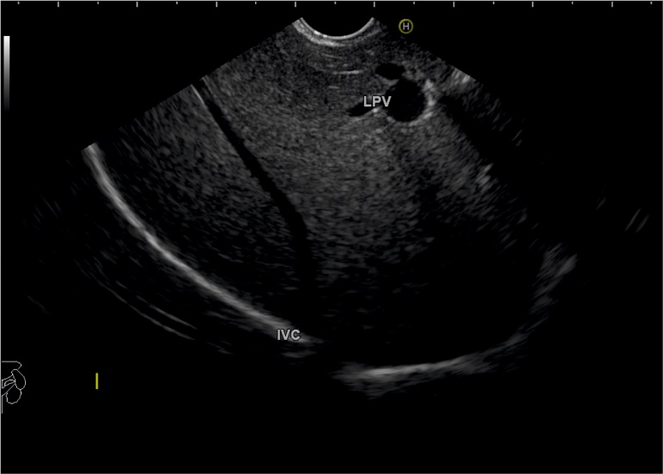

b

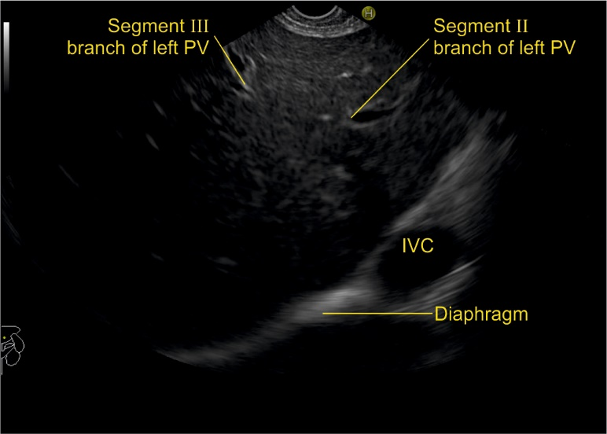
Figure 26 Endoscopic ultrasound from descending duodenum. A: Figure showing right hepatic vein; B: on anticlockwise rotation from 2nd part of duodenum, the inferior vena cava gradually moves from 9 O’clock position towards 4 O’clock position. LPV: left portal vein; PV: portal vein; IVC: inferior vena cava.

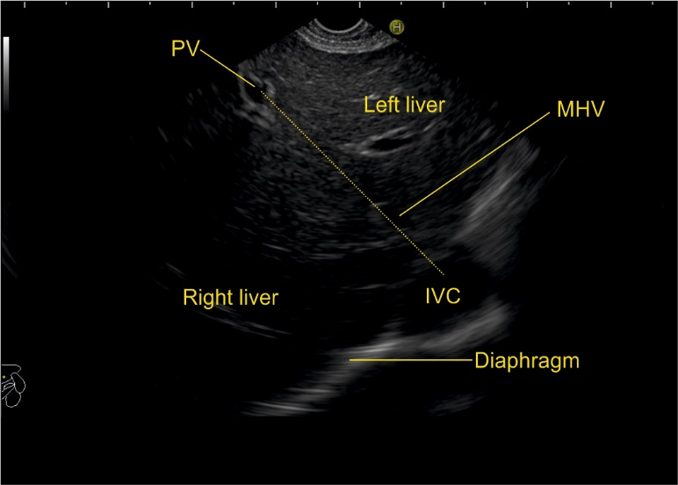
Figure 27 This figure shows the course of middle hepatic vein proceeding towards the portal vein by the dotted line and dividing the right anterior sector from the left medial sector. MHV: middle hepatic vein; PV: portal vein; IVC: inferior vena cava.

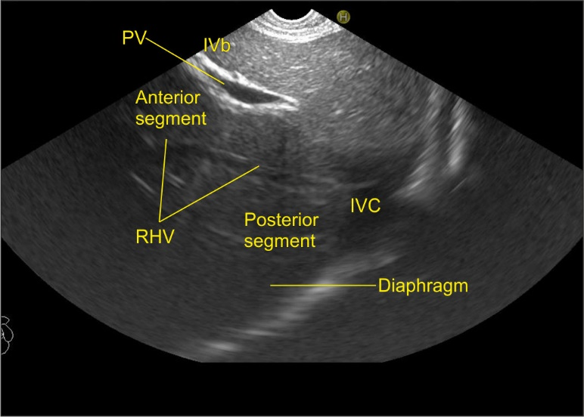
Figure 28 This figure shows the course of right hepatic vein dividing the anterior and posterior sector of right lobe of liver. PV: portal vein; RHV: right hepatic vein; IVC: inferior vena cava.

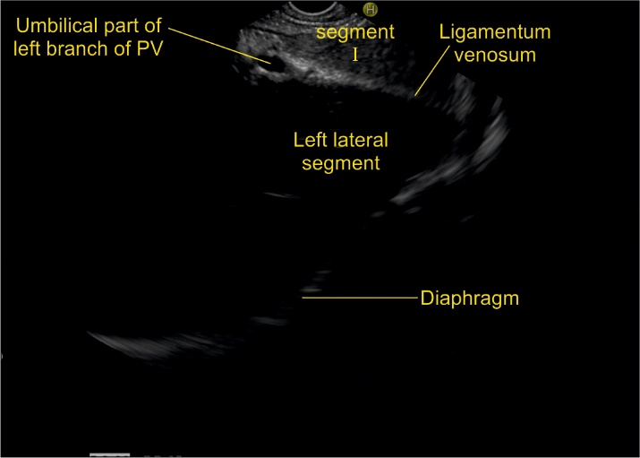
Figure 29 This figure shows the course of ligamentum venosum proceeding towards the umbilical part of portal vein and dividing the left lateral segment from the caudate lobe. The separation of left lateral and left medial segment is done by the course of left hepatic vein but more posteriorly near the liver hilum the ligamentum venosum separates left lateral segment from the caudate lobe. PV: portal vein.

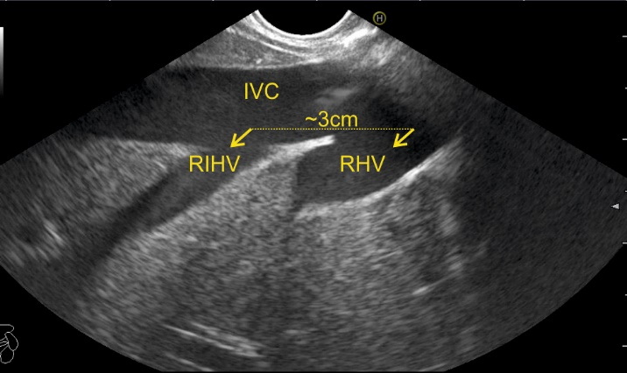
Figure 30 This image shows the presence of prominent right inferior hepatic vein below the right main hepatic vein. This vein has a size almost similar to main right hepatic vein and provides segmental drainage of a complete segment. The distance between right hepatic vein from the right inferior hepatic vein in this image is 3 cm. IVC: Inferior vena cava; RHV: right hepatic vein; RIHV: Right inferior hepatic vein.

Figure 31 This image shows the right inferior accessory hepatic vein draining the right posterior sector. The presence of liver parenchyma above the joining of the vein points to retro rather than suprahepatic course of the vein. In this case the main right hepatic vein was absent and all the venous drainage was provided by the accessory vein. IVC: inferior vena cava.

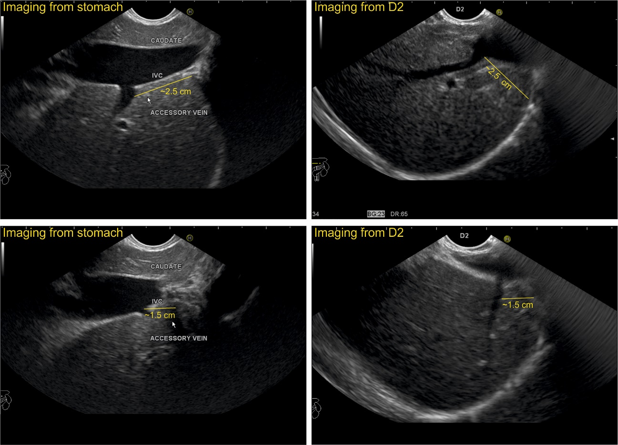
Figure 32 In this case, two accessory veins are seen about 1.5 cm and 2.5 cm below the diaphragm. A comparative imaging of the same accessory vein is shown from stomach and second part of duodenum.

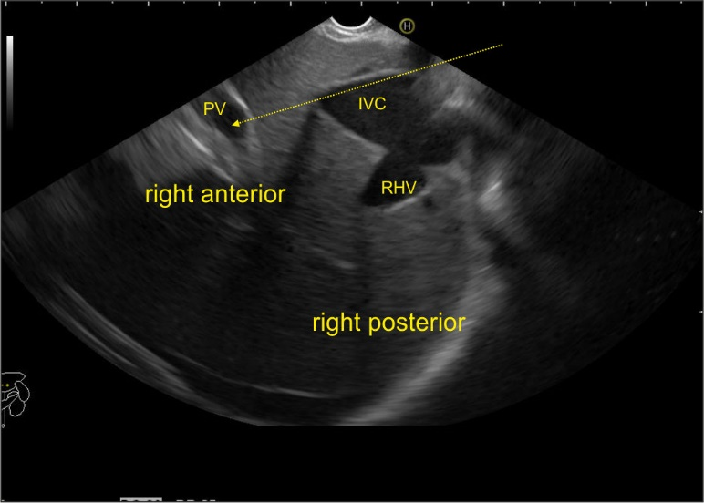
Figure 33 The imaging is done from abdominal part of esophagus and the main portal vein is seen on the far side of the screen. A possible communication is shown between the inferior vena cava and the main portal vein by the arrow. PV: portal vein; RHV: right hepatic vein; IVC: inferior vena cava.

