Name of Journal: World Journal of Clinical Cases
Manuscript NO: 53137
Manuscript Type: META-ANALYSIS

Efficacy of totally laparoscopic compared with laparoscopic-assisted total gastrectomy for gastric cancer: A meta-analysis

Wang S et al. Safety and feasibility of intracorporeal esophagojejunostomy

Song Wang, Mei-Lan Su, Yang Liu, Zhi-Ping Huang, Ning Guo, Tian-Jin Chen, Zhong-Hui Zou

Song Wang, Yang Liu, Zhi-Ping Huang, Ning Guo, Tian-jin Chen, Zhong-Hui Zou, Department of Stomach/Thyroid/Vascular Surgery, Chongqing Three Gorges Central Hospital, Chongqing 404000, China

Mei-Lan Su, Department of Psychosomatic Medicine, Chongqing Three Gorges Central Hospital, Chongqing 404000, China

Author contributions: Wang S and Su ML contributed to the study design, data collection, and paper writing; Zou ZH contributed to the study design, and critical revision of the paper; Liu Y, Huang ZP, Guo N, and Chen TJ contributed to the data collection. All authors have approved the final version to be published.

Supported by the Ethics Committee of Chongqing Three Gorges Central Hospital, and the Guiding Project of Science and Technology Plan for Social Development in Wanzhou District Chongqing, No. wzstc-z 201707.

Corresponding author: Zhong-Hui Zou, MA, Professor, Surgeon, Department of Stomach/Thyroid/Vascular Surgery, Chongqing Three Gorges Central Hospital, No. 165 Xincheng Road, Wanzhou District, Chongqing 404000, China. zouzhonghui97@163.com

Received: December 6, 2019
Revised: February 18, 2020
Accepted: February 21, 2020
Published online: March 6, 2020
Abstract
BACKGROUND
Laparoscopic radical gastrectomy is currently the most common surgical approach for gastric cancer. The main difference between totally laparoscopic total gastrectomy (TLTG) and laparoscopic-assisted total gastrectomy (LATG) is the route of digestive tract reconstruction. However, TLTG is currently not widespread as the safety and feasibility of intracorporeal esophagojejunostomy is uncertain.

AIM
To compare the short-term efficacy of TLTG and LATG for radical gastrectomy of gastric cancer, and to determine the safety and feasibility of intracorporeal esophagojejunostomy.

METHODS
PubMed, EMBASE, and Web of Science databases were searched for all relevant articles regarding TLTG vs LATG for gastric cancer published up to October 1, 2019. Inclusion and exclusion criteria were established. All the basic conditions of patients and important clinical data related to surgery were extracted, and a meta-analysis was performed with RevMan 5.3 software.

RESULTS
Eight studies involving a total of 1883 cases (869 cases in the TLTG group and 1014 cases in the LATG group) were included. Compared with the LATG group, reduced intraoperative blood loss (weighted mean difference = −35.37, 95%CI: −61.69 - −9.06, P = 0.008) and a larger number of retrieved lymph nodes (weighted mean difference = 3.11, 95%CI: -2.60 - 12.00, P = 0.01) were found in the TLTG group. There were no significant differences in operating time, anastomotic time, tumor size, proximal resection margin length, postoperative pain score, time to first flatus, time to first oral intake, postoperative hospital stay, postoperative anastomosis-related complication rate and overall complication rate between the two groups (P > 0.05).

CONCLUSION
Intracorporeal esophagojejunostomy is safe and feasible. TLTG has the advantages of being minimally invasive, reduced intraoperative blood loss and easier access to lymph nodes compared with LATG. Totally laparoscopic gastrectomy is likely to be the surgical trend for gastric cancer in the future.

Key words: Gastric cancer; Total gastrectomy; Esophagojejunostomy; Totally laparoscopic; Laparoscopic-assisted; Meta-analysis

Wang S, Su ML, Liu Y, Huang ZP, Guo N, Chen TJ, Zou ZH. Efficacy of totally laparoscopic compared with laparoscopic-assisted total gastrectomy for gastric cancer: A meta-analysis. World J Clin Cases 2020; 8(5): 900-911 URL: https://www.wjgnet.com/2307-8960/full/v8/i5/900.htm DOI: https://dx.doi.org/10.12998/wjcc.v8.i5.900

Core tip: The safety and feasibility of intracorporeal esophagojejunostomy totally laparoscopic total gastrectomy (TLTG) are uncertain. We hypothesized that TLTG was safe and feasible, and the efficacy of TLTG was superior to that of laparoscopic-assisted total gastrectomy. A meta-analysis was performed to demonstrate this. The results showed that intracorporeal esophagojejunostomy is safe and feasible. TLTG has the advantages of being minimally invasive, reduced intraoperative blood loss and easier access to lymph nodes compared with laparoscopic-assisted total gastrectomy. Totally laparoscopic gastrectomy is likely to be the surgical trend for gastric cancer in the future.
INTRODUCTION
According to the 2018 cancer statistics, the incidence of gastric cancer ranks second and fifth of the various malignant tumors in China and worldwide, respectively; and its mortality rate ranks third both in China and globally^{[1]}. Surgical resection is still the main treatment for gastric cancer. With the rapid development of laparoscopic techniques, laparoscopic radical gastrectomy has been widely recognized and performed. The indications for laparoscopic surgery have gradually extended from early gastric cancer to advanced gastric cancer, and the surgical approach has also evolved from laparoscopic-assisted radical gastrectomy to totally laparoscopic radical gastrectomy. It is reported^{[2-4]} that totally laparoscopic distal gastrectomy has many advantages, such as smaller scars, better visualization, fewer postoperative adhesions, and faster postoperative recovery, when compared with traditional surgery. However, it is difficult to complete totally laparoscopic total gastrectomy (TLTG)^{[5]}, as the safety and feasibility of intracorporeal esophagojejunostomy are uncertain, and TLTG is currently not widespread. In view of this, we hypothesize that TLTG is safe and feasible, and that the efficacy of TLTG is superior to that of laparoscopic-assisted total gastrectomy (LATG). The present meta-analysis was performed to compare their short-term efficacy and investigate the safety and feasibility of totally laparoscopic esophagojejunostomy for gastric cancer in order to obtain the best evidence to guide clinical practice.

MATERIALS AND METHODS
Literature search strategy
An analysis of clinical controlled studies on gastric cancer treated by TLTG and LATG published before October 2019 was conducted. PubMed, EMBASE, and Web of Science databases were searched for relevant studies written in English. The search keywords included: gastric cancer/gastric carcinoma/stomach cancer, total gastrectomy, intracorporeal/total laparoscopic/totally laparoscopic/completely laparoscopic, laparoscopic-assisted/laparoscopy-assisted/laparoscopically assisted, esophagojejunal anastomosis/esophagojejunostomy, and a manual review of the references in the selected studies was performed to identify further publications.

Inclusion and exclusion criteria
Inclusion criteria: (1) Patients were diagnosed with gastric cancer by histopathological examination; (2) All published comparative studies on the efficacy of TLTG and LATG for gastric cancer; (3) Important intraoperative and postoperative clinical data were provided; (4) Primary statistics, continuous variables such as mean and standard deviation (SD) or median and range, and binary variables such as odds ratio (OR) were presented; and (5) For studies from the same department, high quality or recently published studies with a larger sample were selected. Exclusion criteria: (1) Studies involving proximal gastrectomy, distal gastrectomy, palliative total gastrectomy, or robot-assisted total gastrectomy in totally laparoscopic gastrectomy; (2) Studies involving non-stomach cancer; (3) Studies without a comparison of LATG and TLTG; and (4) Studies including patients with preoperative neoadjuvant chemotherapy.

Data extraction and quality evaluation
A unified data collection form was used, and information on the first author, nationality, publication time, sample size, age, body mass index (BMI), and important clinical data related to surgery were extracted independently by two systematic reviewers. If there was any disagreement, a decision was made after discussion with a third reviewer.
In this study, the quality of the included studies was evaluated by two independent reviewers using the Newcastle–Ottawa Scale (NOS)^{[6]}. The evaluation was made in terms of study selection, study comparison, and study outcome of interest. A study was awarded a maximum of one star for each numbered item within the Selection and Outcome categories. A maximum of two stars was given for Comparability. The full score was 9 points, and a score greater than 6 points was considered a high quality study.

Statistical analysis
Statistical analysis was performed using Review Manager software version 5.3 (Cochrane Collaboration, Oxford, United Kingdom). The OR was applied to assess the dichotomous variables, and the weighted mean difference (WMD) was used to evaluate the continuous variables. If the mean values and SD values were not provided, they were determined based on the available median and range data as described by Hozo et al^{[7]}. Publication bias was evaluated by Egger’s test. Egger’s test was not suitable for subgroup analysis if less than ten studies were included. A heterogeneity test was performed on the included studies, and I² ≤ 50% indicated no significant heterogeneity and a fixed-effect model (F model) was used, if I² > 50%, a random-effect model (R model) was chosen. An R model was chosen for all clinical data related to surgery, even if there was no statistical heterogeneity. A value of P < 0.05 was considered statistically significant.

RESULTS
Study selection
During the initial search, 147 publications were selected. By screening the title and abstract, irrelevant studies were excluded, the the full-text of 14 studies were further assessed. Of these, five papers were excluded for the following reasons: three papers^{[8-10]} were not written in English, one paper^{[11]} included both total gastrectomy and distal gastrectomy, and another paper^{[12]} involved laparoscopy-assisted proximal gastrectomy with double tract anastomosis. In total, eight studies^{[13-20]} were considered for the meta-analysis (Figure 1).

Study characteristics and quality assessment
Eight controlled studies^{[13-20]} of gastric cancer treated with TLTG and LATG were finally screened out. In total, 1883 clinical cases were included, 869 cases in the TLTG group and 1014 cases in the LATG group. No deaths were reported in any of the included studies. The main TNM stages of gastric cancer were I-III. Of these eight studies, four were from Korea, one from Japan, and three from China, and all were published between 2013 and 2017. Seven^{[13-19]} studies reported the average age, and six^{[13-18]} reported the BMI for each group. The meta-analysis showed that both age and BMI were not significantly different between the two groups (P > 0.05). Seven^{[13-19]} studies had a NOS score ≥ 7 and were considered high quality studies. The basic information related to the included studies is shown in Table 1.

Intraoperative outcomes
Seven studies^{[13-19]} reported the operating time. The meta-analysis showed that there was no significant difference in operating time between the TLTG group and the LATG group (WMD = −4.84, 95%CI: −11.62-1.95, P = 0.16; Figure 2A). Two studies^{[14,16]} described the anastomosis time, and no significant difference was found between the two groups (WMD = 9.36, 95%CI: −1.32-20.04, P = 0.09; Figure 2B). Six studies^{[14-18,20]} reported intraoperative blood loss. The meta-analysis showed that intraoperative blood loss in group TLTG was significantly less than that in group LATG (WMD = −35.37, 95%CI: −61.69- −9.06, P = 0.008; Figure 2C). Six studies^{[13-17,19]} described the number of retrieved lymph nodes. The meta-analysis showed that a larger number of retrieved lymph nodes was found in the TLTG group compared to the LATG group (WMD = 3.11, 95%CI: 0.63-5.60, P = 0.01; Figure 2D). Seven studies^{[14-19]} described the size of resected tumors. No significant difference in tumor size was found between the two groups according to the meta-analysis (WMD = −0.43, 95%CI: −0.89-0.04, P = 0.07; Figure 2E). Five studies^{[14-16,18,19]} reported the length of the proximal margin. The meta-analysis showed that there was no significant difference in the length of the proximal margin between the two groups (WMD = −0.28, 95%CI: −1.12-0.56, P = 0.52; Figure 2F).

Postsurgical outcomes
Three studies^{[13,15,19]} reported the postoperative pain score (visual analog scale). The meta-analysis showed that there were no significant differences in the pain score between the TLTG group and the LATG group on Day 1, 3, and 5 after surgery (P = 0.89, 0.45, and 0.07, respectively). In addition, no significant difference in the peak pain score during the recovery period was found between the two groups (P = 0.70). Five studies^{[13,14,16-18]} reported the time to first flatus. The meta-analysis showed that there was no significant difference in time to first flatus between the two groups (WMD = 0.07, 95%CI: −0.09-0.22, P = 0.40; Figure 2G). Six studies^{[13-18]} reported the time to first oral intake. There was no significant difference in time to first oral intake between the two groups according to the meta-analysis (WMD = −0.31, 95%CI: −0.67-0.06, P = 0.10; Figure 2H). Six studies^{[13-18]} reported the length of postoperative hospital stay. The meta-analysis showed that there was no significant difference in the length of postoperative hospital stay between the two groups (WMD = −0.78, 95%CI: −1.74-0.19, P = 0.11; Figure 2I). All eight studies included^{[13-20]} reported the incidence of anastomosis-related complications (anastomotic leakage, anastomotic stenosis, and anastomotic bleeding) 30 days postoperatively. The meta-analysis showed that the postoperative anastomosis-related complication rate was not significantly different between the two groups (OR = 0.73, 95%CI: 0.38-1.40, P = 0.34; Figure 2J). Six studies^{[13-16,18,19]} reported the overall rate of postoperative complications. There was no significant difference in postoperative complications between the two groups according to the meta-analysis (WMD = 1.00, 95%CI: 0.75-1.32, P = 0.97; Figure 2K). Intraoperative and postoperative information on the eight studies are summarized in Table 2.

Sensitivity analysis
In the present study, we focused on the safety and feasibility of totally laparoscopic (intracorporeal) esophagojejunostomy, and a sensitivity analysis of all included studies was performed. Different anastomosis patterns may have an impact on the final results, and low-quality research may also affect the final findings. Among the eight studies included, seven^{[13-16,18-20]} reported reconstruction using Roux-en-Y anastomosis, while Huang et al^{[17]} reported an isoperistaltic jejunum-later-cut overlap method. Six^{[13-15,17-19]} of the eight studies used a linear stapler for anastomosis and the NOS score was high, while Ito et al^{[20]} used a circular stapler, with a lower NOS score, and Chen et al^{[16]} used multiple anastomoses. Therefore, three studies^{[16,17,20]} were removed in the sensitivity analysis. The results of our sensitivity analysis showed that there was no significant change in all results after removing the three studies.

DISCUSSION
Laparoscopy-assisted gastrectomy is currently the most common surgical approach for gastric cancer. With the development of laparoscopic techniques, totally laparoscopic gastrectomy has gradually been carried out. The main difference between totally laparoscopic gastrectomy and laparoscopic-assisted gastrectomy is the route of digestive tract reconstruction, e.g., the digestive tract reconstruction of the former is implemented totally under laparoscopy. However, this is difficult to put into effect for intracorporeal gastrointestinal reconstruction. At present, totally laparoscopic gastrectomy is not performed as the first choice for gastric cancer surgery in most medical departments^{[16]}.
The ideal surgical method for digestive tract reconstruction should minimize the incidence of postoperative anastomosis-related complications and maximize the quality of life^{[21]}. During TLTG for gastric cancer, esophagojejunostomy is a formidable procedure because of the “anatomical specificity” (high anastomotic site, and narrow operating space), which determines the success or failure of surgery. Therefore, the safety and feasibility of totally laparoscopic esophagojejunostomy have attracted considerable attention. The approach used for digestive tract reconstruction after laparoscopic total gastrectomy is diverse. Roux-en-Y anastomosis can effectively reduce reflux esophagitis and maintain good nutritional status, and is currently the main method of reconstruction^{[22]}. In previous studies^{[23,24]}, two patterns of intracorporeal esophagojejunostomy were introduced, including hand-sewn purse-string suture techniques as well as mechanical staplers (linear stapler and circular stapler). It was reported^{[13]} that intracorporeal reconstruction using endoscopic linear staplers enables a tension-free anastomosis and thus avoids damage to the surrounding structures. Gong et al^{[19]} suggested that TLTG using a linear stapler may be a more appropriate procedure than LATG using a circular stapler, and may be recommended for the treatment of gastric cancer of the upper third of the stomach. In fact, linear staplers can be inserted into the abdominal cavity via a trocar, and can complete digestive tract reconstruction without the need for an auxiliary incision, which is different to circular staplers.
In the eight studies included in this analysis, in seven^{[13-16,18-20]} reconstruction was performed using Roux-en-Y anastomosis, while Huang et al^{[17]} reported an isoperistaltic jejunum-later-cut overlap method. In six^{[13-15,17-19]} of the eight studies, anastomoses were performed using a linear stapler, while Ito et al^{[20]} used a circular stapler, and Chen et al^{[16]} used multiple anastomoses. The present meta-analysis showed that the incidence of postoperative anastomosis-related complications was quite low in both the TLTG group (3.91%) and the LATG group (5.03%), and there was no significant difference between the two groups. Three studies^{[12,13,16]} were removed in our sensitivity analysis, which resulted in no significant change to the final results. Therefore, these different anastomosis patterns did not affect the outcomes of our study, and our results are quite reliable.
It is generally believed that TLTG is time-consuming, as totally laparoscopic reconstruction of the digestive tract may prolong the operating time, and may even increase intraoperative blood loss. The results of this meta-analysis demonstrated that TLTG led to significantly reduced intraoperative blood loss compared to LATG, while there were no significant differences in the overall operating time and anastomosis time between the two groups. Less intraoperative blood loss in the TLTG group may be attributed to the following reasons: First, TLTG does not involve an abdominal auxiliary incision and results in smaller intra-abdominal wounds. Second, TLTG can reduce excessive tissue traction and decrease the risk of bleeding. In addition, laparoscopic operating skills may affect intraoperative blood loss, and the TLTG and LATG operators might be different. It was reported^{[25]} that after learning the technique for totally laparoscopic distal gastrectomy (residual stomach and duodenal anastomosis), the operating time for TLTG will be significantly shortened. Thus, the operating time may be related to the operator's proficiency in totally laparoscopic surgery. It is recommended that operators should master skillful laparoscopic techniques before performing TLTG, especially simple totally laparoscopic surgery, such as totally laparoscopic distal gastrectomy and other simulation operations.
It is very difficult to carry out total gastrectomy and esophagojejunostomy in obese patients by means of an abdominal auxiliary incision, and the surgical incision must be longer; therefore, the patient’s postoperative incision pain may be increased. Previous studies^{[5,13]} have suggested that TLTG is still safe and favorable in overweight patients. Huang et al^{[17]} found that TLTG is associated with less pain and thus improves quality of life after surgery. However, the present meta-analysis showed that no significant differences in BMI and pain scores were found between the TLTG group and LATG group. Thus, large-scale randomized controlled trials (RCTs) in patients with different BMIs are needed to prove whether TLTG is safe and favorable in obese patients and can reduce postoperative incision pain.
In general, radical surgery for malignant tumors involves obtaining adequate margins, thorough lymph node dissection, and standardized surgical procedures, and so forth^{[26]}. In totally laparoscopic gastrectomy, larger tumors may be difficult to remove from the abdomen due to the absence of an abdominal auxiliary incision. If the location of the tumor is near the esophagus, the length of the proximal margin resection is often insufficient, and it is difficult to achieve an ideal surgical outcome. Our meta-analysis showed that there was no significant difference in the length of the proximal margin and tumor size between the TLTG group and the LATG group, while a larger number of lymph nodes were retrieved in the TLTG group compared to the LATG group. Thus, it can be seen that TLTG is more conducive to radical surgery for gastric cancer, compared to LATG.
For patients with gastric cancer, no matter how successful the surgery is, postoperative recovery and efficacy are important factors. In the clinic, the short-term effects mainly rely on indicators such as the time to first flatus, time to first oral intake, postoperative hospital stay, and overall postoperative complication rate. The results of this meta-analysis showed that there was no significant difference in these clinical indicators between the TLTG group and the LATG group.
To date, we have found two similar meta-analyses (articles on TLTG vs LATG for gastric cancer). Of these, one article^{[16]} was published in 2016 had only four related studies, and the sample size was small. Another article^{[27]} was published in 2019 had 10 related studies, but it included studies reported in all languages (including English and other languages). In addition, we believe that the tumor size and postoperative pain scores are also worthy of attention in the comparative study of TLTG vs LATG for gastric cancer. However, neither of the two articles compared and explained these two points. In the present analysis, all the included studies were written in English and clinical information was sufficient, and we compared the short-term efficacy of TLTG vs LATG on gastric cancer in more detail and comprehensively.
This analysis had certain limitations. Firstly, all the included studies did not report and evaluate the long-term outcomes of totally laparoscopic radical gastrectomy, thus long-term efficacy differences between TLTG and LATG for gastric cancer need to be determined in future studies. In addition, all the included studies were retrospective, no blinded studies or RCTs were included, and the sample size may have been insufficient in this meta-analysis; thus, additional large-scale studies and RCTs are required. Furthermore, we focused on the safety and feasibility of intracorporeal esophagojejunostomy; however, laparoscopic operating skills may affect surgical outcomes, and the skills of TLTG and LATG operators may be different.

CONCLUSION
According to this meta-analysis, TLTG is technically safe and feasible, and has the advantages of being minimally invasive, reduced intraoperative blood loss and easier access to lymph nodes compared to LATG. However, large-scale RCTs are required to confirm these findings. TLTG should be encouraged in surgeons with sufficient laparoscopic experience. Totally laparoscopic gastrectomy is likely to be the surgical trend for gastric cancer in the future.

ARTICLE HIGHLIGHTS
Research background
Laparoscopic total gastrectomy for gastric cancer includes laparoscopic-assisted total gastrectomy (LATG) and totally laparoscopic total gastrectomy (TLTG). The main difference between LATG and TLTG is the route of digestive tract reconstruction. Needless to say, TLTG has the advantage of being more minimally invasive when compared with LATG. However, TLTG has not yet been promoted, mainly because the safety and feasibility of intracorporeal esophagojejunostomy of TLTG have not been determined.

Research motivation
If the safety and feasibility of intracorporeal esophagojejunostomy of TLTG for gastric cancer can be confirmed, TLTG may be more widely used in clinical practice due to its unique advantages.

Research objectives
The present meta-analysis was performed to compare the short-term efficacy of TLTG and LATG for gastric cancer, and investigate the safety and feasibility of totally laparoscopic esophagojejunostomy in order to obtain the best evidence to guide clinical practice.

Research methods
We collected high-quality published articles on TLTG vs LATG for gastric cancer via English language databases (such as PubMed, EMBASE, and Web of Science). All the basic conditions of patients (e.g. the first author, nationality, publication time, sample size, age, body mass index) and important clinical data related to surgery (e.g. the operating time, anastomotic time, intraoperative blood loss, tumor size, proximal resection margin length, number of retrieved lymph nodes, postoperative pain score, time to first flatus, time to first oral intake, postoperative hospital stay, postoperative anastomosis-related complication rate and overall complication rate) were extracted. A comprehensive and detailed comparison of two surgical approaches (TLTG vs LATG) for gastric cancer was performed by meta-analysis to explore the efficacy differences.

Research results
Compared with the LATG group, reduced intraoperative blood loss and a larger number of retrieved lymph nodes were found in the TLTG group. There were no significant differences in operating time, anastomotic time, tumor size, proximal resection margin length, postoperative pain score, time to first flatus, time to first oral intake, postoperative hospital stay, postoperative anastomosis-related complication rate and overall complication rate between the two groups.
Research conclusions
We confirmed the clinical safety and feasibility of TLTG for gastric cancer, and TLTG has the advantages of being minimally invasive, reduced intraoperative blood loss and easier access to lymph nodes compared to LATG.

Research perspectives
We speculate that totally laparoscopic radical gastrectomy for gastric cancer is likely to be the surgical trend for gastric cancer in the future.

REFERENCES
1 Bray F, Ferlay J, Soerjomataram I, Siegel RL, Torre LA, Jemal A. Global cancer statistics 2018: GLOBOCAN estimates of incidence and mortality worldwide for 36 cancers in 185 countries. CA Cancer J Clin 2018; 68: 394-424 [PMID: 30207593 DOI: 10.3322/caac.21492]
2 Kim JH, Jun KH, Chin HM. Short-term surgical outcomes of laparoscopy-assisted versus totally laparoscopic Billroth-II gastrectomy for gastric cancer: a matched-cohort study. BMC Surg 2017; 17: 45 [PMID: 28431531 DOI: 10.1186/s12893-017-0245-7]
3 Han WH, Yehuda AB, Kim DH, Yang SG, Eom BW, Yoon HM, Kim YW, Ryu KW. A comparative study of totally laparoscopic distal gastrectomy versus laparoscopic-assisted distal gastrectomy in gastric cancer patients: Short-term operative outcomes at a high-volume center. Chin J Cancer Res 2018; 30: 537-545 [PMID: 30510365 DOI: 10.21147/j.issn.1000-9604.2018.05.07]
4 Shinohara T, Kawano S, Tanaka Y, Fujisaki M, Watanabe A, Yamamoto K, Hanyu N. Comparison of the cost and outcomes following totally laparoscopic and laparoscopy-assisted distal gastrectomies for gastric cancer: a single-institution comparison. Surg Endosc 2016; 30: 3573-3581 [PMID: 26541736 DOI: 10.1007/s00464-015-4656-1]
5 Chen K, Wu D, Pan Y, Cai JQ, Yan JF, Chen DW, Maher H, Mou YP. Totally laparoscopic gastrectomy using intracorporeally stapler or hand-sewn anastomosis for gastric cancer: a single-center experience of 478 consecutive cases and outcomes. World J Surg Oncol 2016; 14: 115 [PMID: 27094509 DOI: 10.1186/s12957-016-0868-7]
6 Stang A. Critical evaluation of the Newcastle-Ottawa scale for the assessment of the quality of nonrandomized studies in meta-analyses. Eur J Epidemiol 2010; 25: 603-605 [PMID: 20652370 DOI: 10.1007/s10654-010-9491-z]
7 Hozo SP, Djulbegovic B, Hozo I. Estimating the mean and variance from the median, range, and the size of a sample. BMC Med Res Methodol 2005; 5: 13 [PMID: 15840177 DOI: 10.1186/1471-2288-5-13]
8 Cui CL, Liang W, Zhu ZQ, Yao HH, Wu Y, Liu L, Guan JJ. Feasibility, safety and short‑term efficacy of totally laparoscopic total gastrectomy for upper stomach cancer (In Chinese). Chin J Gen Surg 2015; 24(10): 1377-1382 [DOI: 10.3978/j.issn.1005-6947.2015.10.007]
9 Hong QQ, Wang W, Zhang J, Fan L, Zhu JM, Ji G, Yan S, You J. Clinical efficacies of totally laparoscopic and laparoscopy-assisted radical total gastrectomies in 373 patients: a multicentre retrospective study, Chin J Dig Surg 2017; 16 (8): 822–827 [DOI: 10.3760/cma.j.issn.1673-9752.2017.08.013]
10 Miao R, Li Z, Wang Y. Usage of mechanical stapler in digestive tract reconstruction of laparoscopic total gastrectomy, Chin J Pract Surg 2016; 36 (9): 968–972 [DOI: 10.7504/CJPS. ISSN1005-2208.2016.09.13]
11 Chen K, Pan Y, Zhai ST, Cai JQ, Chen QL, Chen DW, Zhu YP, Zhang Y, Zhang YP, Maher H, Wang XF. Laparoscopic gastrectomy in obese gastric cancer patients: a comparative study with non-obese patients and evaluation of difference in laparoscopic methods. BMC Gastroenterol 2017; 17: 78 [PMID: 28629379 DOI: 10.1186/s12876-017-0638-1]
12 Jung YJ, Kim DJ, Lee JH, Kim W. Safety of intracorporeal circular stapling esophagojejunostomy using trans-orally inserted anvil (OrVil) following laparoscopic total or proximal gastrectomy - comparison with extracorporeal anastomosis. World J Surg Oncol 2013; 11: 209 [PMID: 23972079 DOI: 10.1186/1477-7819-11-209]
13 Kim HS, Kim MG, Kim BS, Lee IS, Lee S, Yook JH, Kim BS. Comparison of totally laparoscopic total gastrectomy and laparoscopic-assisted total gastrectomy methods for the surgical treatment of early gastric cancer near the gastroesophageal junction. J Laparoendosc Adv Surg Tech A 2013; 23: 204-210 [PMID: 23256584 DOI: 10.1089/lap.2012.0393]
14 Kim EY, Choi HJ, Cho JB, Lee J. Totally Laparoscopic Total Gastrectomy Versus Laparoscopically Assisted Total Gastrectomy for Gastric Cancer. Anticancer Res 2016; 36: 1999-2003 [PMID: 27069193]
15 Kim HB, Kim SM, Ha MH, Seo JE, Choi MG, Sohn TS, Bae JM, Kim S, Lee JH. Comparison of Reduced Port Totally Laparoscopic-assisted Total Gastrectomy (Duet TLTG) and Conventional Laparoscopic-assisted Total Gastrectomy. Surg Laparosc Endosc Percutan Tech 2016; 26: e132-e136 [PMID: 27846181 DOI: 10.1097/SLE.0000000000000329]
16 Chen K, Pan Y, Cai JQ, Wu D, Yan JF, Chen DW, Yu HM, Wang XF. Totally laparoscopic versus laparoscopic-assisted total gastrectomy for upper and middle gastric cancer: a single-unit experience of 253 cases with meta-analysis. World J Surg Oncol 2016; 14: 96 [PMID: 27036540 DOI: 10.1186/s12957-016-0860-2]
17 Huang ZN, Huang CM, Zheng CH, Li P, Xie JW, Wang JB, Lin JX, Lu J, Chen QY, Cao LL, Lin M, Tu RH, Lin JL. Digestive tract reconstruction using isoperistaltic jejunum-later-cut overlap method after totally laparoscopic total gastrectomy for gastric cancer: Short-term outcomes and impact on quality of life. World J Gastroenterol 2017; 23: 7129-7138 [PMID: 29093621 DOI: 10.3748/wjg.v23.i39.7129]
18 Lu X, Hu Y, Liu H, Mou T, Deng Z, Wang D, Yu J, Li G. Short-term outcomes of intracorporeal esophagojejunostomy using the transorally inserted anvil versus extracorporeal circular anastomosis during laparoscopic total gastrectomy for gastric cancer: a propensity score matching analysis. J Surg Res 2016; 200: 435-443 [PMID: 26421708 DOI: 10.1016/j.jss.2015.08.013]
19 Gong CS, Kim BS, Kim HS. Comparison of totally laparoscopic total gastrectomy using an endoscopic linear stapler with laparoscopic-assisted total gastrectomy using a circular stapler in patients with gastric cancer: A single-center experience. World J Gastroenterol 2017; 23: 8553-8561 [PMID: 29358863 DOI: 10.3748/wjg.v23.i48.8553]
20 Ito H, Inoue H, Odaka N, Satodate H, Onimaru M, Ikeda H, Takayanagi D, Nakahara K, Kudo SE. Evaluation of the safety and efficacy of esophagojejunostomy after totally laparoscopic total gastrectomy using a trans-orally inserted anvil: a single-center comparative study. Surg Endosc 2014; 28: 1929-1935 [PMID: 24488351 DOI: 10.1007/s00464-014-3417-x]
21 Piessen G, Triboulet JP, Mariette C. Reconstruction after gastrectomy: which technique is best? J Visc Surg 2010; 147: e273-e283 [PMID: 20934934 DOI: 10.1016/j.jviscsurg.2010.09.004]
22 Matsuda T, Iwasaki T, Mitsutsuji M, Hirata K, Maekawa Y, Tsugawa D, Sugita Y, Shimada E, Kakeji Y. Surgical outcomes of intracorporeal circular-stapled esophagojejunostomy using modified over-and-over suture technique in laparoscopic total gastrectomy. Surg Endosc 2015; 29: 3386-3391 [PMID: 25631108 DOI: 10.1007/s00464-015-4073-5]
23 Chen K, Pan Y, Cai JQ, Xu XW, Wu D, Yan JF, Chen RG, He Y, Mou YP. Intracorporeal esophagojejunostomy after totally laparoscopic total gastrectomy: A single-center 7-year experience. World J Gastroenterol 2016; 22: 3432-3440 [PMID: 27022225 DOI: 10.3748/wjg.v22.i12.3432]
24 Morimoto M, Kitagami H, Hayakawa T, Tanaka M, Matsuo Y, Takeyama H. The overlap method is a safe and feasible for esophagojejunostomy after laparoscopic-assisted total gastrectomy. World J Surg Oncol 2014; 12: 392 [PMID: 25527860 DOI: 10.1186/1477-7819-12-392]
25 Kim HG, Park JH, Jeong SH, Lee YJ, Ha WS, Choi SK, Hong SC, Jung EJ, Ju YT, Jeong CY, Park T. Totally laparoscopic distal gastrectomy after learning curve completion: comparison with laparoscopy-assisted distal gastrectomy. J Gastric Cancer 2013; 13: 26-33 [PMID: 23610716 DOI: 10.5230/jgc.2013.13.1.26]
26 McCulloch P, Nita ME, Kazi H, Gama-Rodrigues JJ. WITHDRAWN: Extended versus limited lymph nodes dissection technique for adenocarcinoma of the stomach. Cochrane Database Syst Rev 2012; 1: CD001964 [PMID: 22258947 DOI: 10.1002/14651858.CD001964.pub3]
27 Zhao S, Zheng K, Zheng JC, Hou TT, Wang ZN, Xu HM, Jiang CG. Comparison of totally laparoscopic total gastrectomy and laparoscopic-assisted total gastrectomy: A systematic review and meta-analysis. Int J Surg 2019; 68: 1-10 [PMID: 31189084 DOI: 10.1016/j.ijsu.2019.05.020]

Footnotes
Conflict-of-interest statement: The authors deny any conflict of interest.

PRISMA 2009 Checklist statement: The authors have read the PRISMA 2009 Checklist, and the manuscript was prepared and revised according to the PRISMA 2009 Checklist.

Open-Access: This article is an open-access article that was selected by an in-house editor and fully peer-reviewed by external reviewers. It is distributed in accordance with the Creative Commons Attribution Non Commercial (CC BY-NC 4.0) license, which permits others to distribute, remix, adapt, build upon this work non-commercially, and license their derivative works on different terms, provided the original work is properly cited and the use is non-commercial. See: http://creativecommons.org/licenses/by-nc/4.0/

Manuscript source: Unsolicited manuscript

Corresponding Author's Membership in Professional Societies:

Peer-review started: December 6, 2019
First decision: December 30, 2019
Article in press:

Specialty type: Medicine, research and experimental
Country of origin: China
Peer-review report classification
Grade A (Excellent): 0
Grade B (Very good): 0
Grade C (Good): C, C
Grade D (Fair): 0
Grade E (Poor): 0

P-Reviewer: de Mattos Â, Yong D S-Editor: Wang J L-Editor: Webster JR E-Editor:
Figure Legends
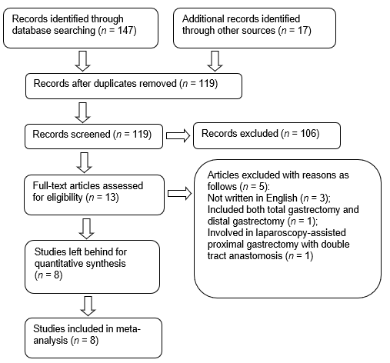
Figure 1 Flowchart of the search strategy.

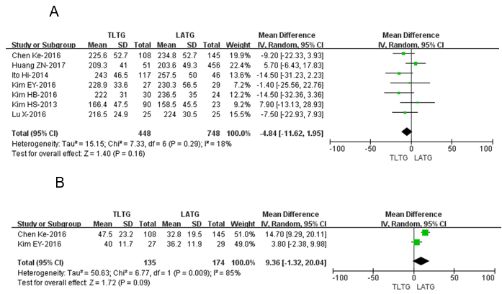

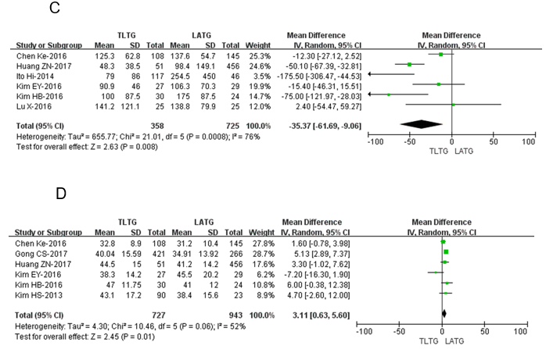
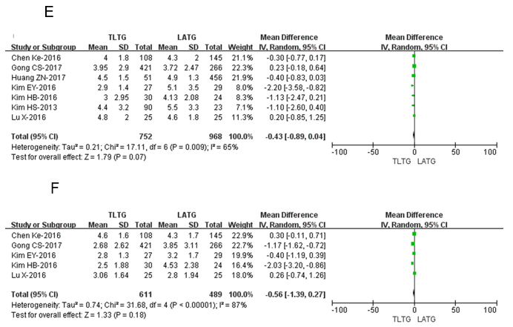

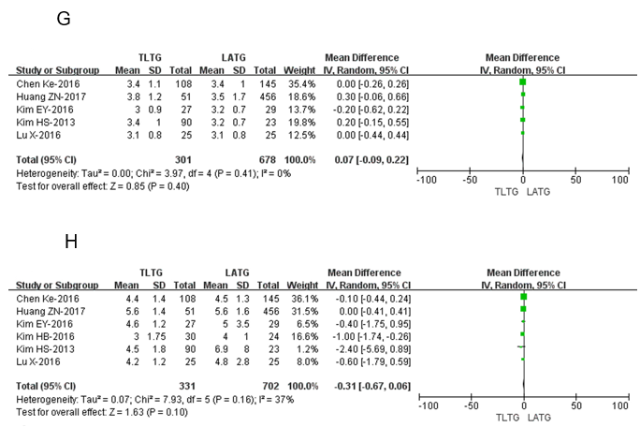
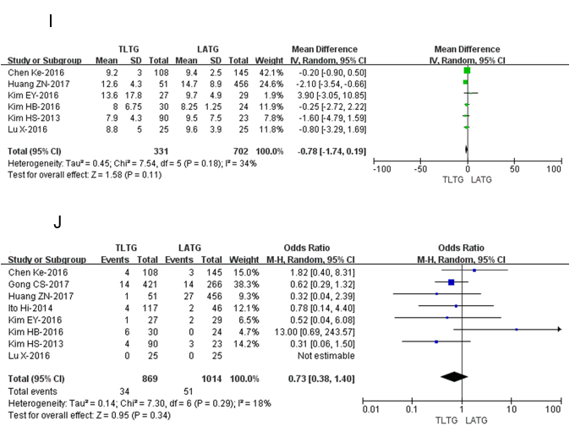
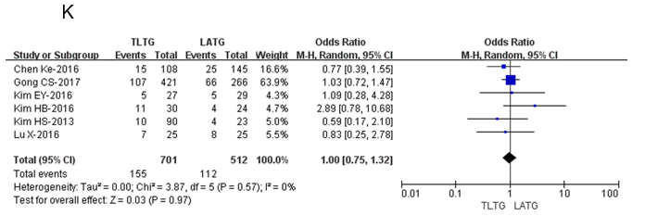
Figure 2 Forest plot based on intraoperative and postoperative clinical data. A: Operating time; B: Anastomotic time; C: Volume of intraoperative bleeding; D: Number of lymph nodes removed; E: Tumor size; F: Proximal resection margin length; G: Time to first flatus; H: Time to first oral intake; I: Postoperative hospital stay; J: Postoperative anastomosis-related complication rate; K: Overall postoperative complication rate. TLTG: Totally laparoscopic total gastrectomy; LATG: Laparoscopic-assisted total gastrectomy; SD: Standard deviation.

Table 1 Baseline characteristics of the included studies
Ref. | Nation | Publication  year | Sample size |  |  | Age (years, mean ± SD) |  |  | BMI (kg/m², mean ± SD) |  | NOS  scores
 |  |  | TLTG | LATG |  | TLTG | LATG |  | TLTG | LATG
Kim et al^{[13]} | Korea | 2013 | 90 | 23 |  | 58 ± 10.8 | 56.8 ± 14.2 |  | 23.2 ± 2.9 | 22.2 ± 1.8 | 7
Ito et al^{[20]} | Japan | 2014 | 117 | 46 |  | / | / |  | / | / | 6
Kim et al^{[14]} | Korea | 2016 | 27 | 29 |  | 60.8± 9.1 | 59.3 ± 13.1 |  | 24 ± 2.9 | 23.3 ± 3.2 | 7
Kim et al^{[15]} | Korea | 2016 | 30 | 24 |  | 51 ± 12.25 | 54.75 ± 11.25 |  | 22.2 ± 2.7 | 23.6 ± 2.95 | 8
Chen et al^{[16]} | China | 2016 | 108 | 145 |  | 59.4± 11.1 | 57.3 ± 12.5 |  | 23.5 ± 3.5 | 23.1 ± 4.2 | 8
Gong et al^{[19]} | Korea | 2017 | 421 | 266 |  | 57.78± 11.2 | 55.69 ± 11.96 |  | / | / | 7
Huang et al^{[17]} | China | 2017 | 51 | 456 |  | 55.5± 12.1 | 61.6 ± 11.2 |  | 22.5 ± 13.1 | 22.3 ± 13.5 | 7
Lu et al^{[18]} | China | 2017 | 25 | 25 |  | 59 ± 8.9 | 58.4 ± 7.7 |  | 22.5 ± 2.5 | 22.9 ± 3.7 | 8
TLTG: Totally laparoscopic total gastrectomy; LATG: Laparoscopic-assisted total gastrectomy; SD: Standard deviation; BMI: Body mass index; NOS: The Newcastle–Ottawa Scale.

Table 2 Intraoperative and postoperative information in all included studies
Outcomes | Number of  studies | Sample size |  | Heterogeneity  (P, I²) | Effect  model | Overall effect size | 95%CI of overall  effect | P value
 |  | TLTG | LATG
Operation time (min) | 7 | 448 | 748 | 0.29, 18% | R | WMD = −4.84 | −11.62-1.95 | 0.16
Anastomotic time (min) | 2 | 135 | 174 | 0.009, 85% | R | WMD = 9.36 | −1.32-20.04 | 0.09
Tumor size (cm) | 7 | 752 | 968 | 0.009, 65% | R | WMD = −0.43 | −0.89-0.04 | 0.07
Proximal margin (cm) | 5 | 611 | 489 | < 0.001, 87% | R | WMD = −0.56 | −1.39-0.27 | 0.18
Intraoperative blood loss (mL) | 6 | 358 | 725 | < 0.001, 76% | R | WMD = −35.37 | −61.69--9.06 | 0.008
Number of lymph nodes removed | 6 | 727 | 943 | 0.06, 52% | R | WMD = 3.11 | 0.63-5.60 | 0.01
Postoperative VAS pain scores
Peak pain score | 2 | 511 | 289 | 0.09, 66% | R | WMD = 0.17 | −0.71-1.05 | 0.70
POD #1 (8 am) | 3 | 541 | 313 | 0.73, 0% | R | WMD = −0.01 | −0.22-0.19 | 0.89
POD #3 (8 am) | 3 | 541 | 313 | 0.02, 73% | R | WMD = −0.17 | −0.61-0.27 | 0.45
POD #5 (8 am) | 2 | 451 | 290 | 0.40, 0% | R | WMD = −0.19 | −0.39-0.01 | 0.07
Time to first flatus (d) | 5 | 301 | 678 | 0.41, 0% | R | WMD = 0.07 | −0.09-0.22 | 0.40
Time to first oral intake (d) | 6 | 331 | 702 | 0.16, 37% | R | WMD = −0.31 | −0.67-0.06 | 0.10
Postoperative hospital stay (d) | 6 | 331 | 702 | 0.18, 34% | R | WMD = −0.78 | −1.74-0.19 | 0.11
Anastomosis-related complications | 8 | 869 | 1014 | 0.29, 18% | R | OR = 0.73 | 0.38-1.40 | 0.34
Overall postoperative complications | 6 | 701 | 512 | 0.57, 0% | R | OR = 1.00 | 0.75-1.32 | 0.97
TLTG: Totally laparoscopic total gastrectomy; LATG: Laparoscopic-assisted total gastrectomy; F: Fixed; R: Random; WMD: Weighted mean difference; OR: Odds ratio; CI: Confidence interval; VAS: Visual analog scale; POD: Postoperative day.

