Name of journal: World Journal of Gastrointestinal Endoscopy
ESPS Manuscript NO: 14589
Columns: Review

Serrated polyps of the colon and rectum: Endoscopic features including image enhanced endoscopy

Saito S et al. Serrated polyps of the colon and rectum

Shoichi Saito, Hisao Tajiri, Masahiro Ikegami

Shoichi Saito, Hisao Tajiri, Department of Endoscopy, the Jikei University School of Medicine, Tokyo 105-8461, Japan
Hisao Tajiri, Department of Internal Medicine, Division of Gastroenterology and Hepatology, the Jikei University School of Medicine, Tokyo 105-8461, Japan
Masahiro Ikegami, Department of Pathology, the Jikei University School of Medicine, Tokyo 105-8461, Japan

Author contributions: All authors contributed to this work.

Conflict-of-interest: All authors declare that we have received no financial supports.

Open-Access: This article is an open-access article which was selected by an in-house editor and fully peer-reviewed by external reviewers. It is distributed in accordance with the Creative Commons Attribution Non Commercial (CC BY-NC 4.0) license, which permits others to distribute, remix, adapt, build upon this work non-commercially, and license their derivative works on different terms, provided the original work is properly cited and the use is non-commercial. See: http://creativecommons.org/licenses/by-nc/4.0/

Correspondence to: Shoichi Saito, MD, PhD, Department of Endoscopy, the Jikei University School of Medicine, 3-25-8, Nishi-Shinbashi Minato-Ward, Tokyo 105-8461, Japan. ssaito@jikei.ac.jp
Telephone: +81-33-4331111-3181
Fax: +81-33-4594524

Received: October 14, 2014
Peer-review started: October 14, 2014
First decision: December 17, 2014
Revised: June 1, 2015
Accepted: June 15, 2015
Article in press:
Published online:

Abstract
In this review, I outline the characteristic endoscopic findings of serrated lesions of the colorectum based on image enhanced endoscopy (IEE). Histopathologically, lesions with serrated structures are typically classified into the following three types based: hyperplastic polyps (HPs), traditional serrated adenomas (TSAs), and sessile serrated adenoma/polyps (SSA/Ps). Both HP and SSA/P often present as dark-green colors on auto fluorescence imaging (AFI) colonoscopy that are similar to the normal surrounding mucosa. In contrast, TSAs often have elevated shapes and present as magenta colors that are similar to the tubular adenomas. The superficial type of TSA also includes many lesions that present as magenta colors. When SSA/Ps are associated with cytological dysplasia, many lesions present with magenta colors, whereas lesions that are not associated with cytological dysplasia present with dark-green colors. When observed via narrow band imaging (NBI), many SSA/P include lesions with strong mucus adhesions. Because these lesions are observed with reddish mucus adhesions, we refer to them as “red cap sign” and place such signs among the typical findings of SSA/P. Because the dilatation of the pit in SSA/P is observed as a round/oval black dot on magnified observations, we refer to this finding as “II-dilatation pit (II-D pit) and also positioned it as a characteristic finding of SSA/P. In contrast, dilatations of the capillary vessels surrounding the glands, such as those that occur in tubular adenoma, are not considered to be useful for differentiating HPs from SSA/Ps. However, in cases in which SSA/P is associated with cytological dysplasia, the dilatation of capillary vessels is observed in the same area. When submucosal layer (SM) invasion occurs in the same area, the blood flow presents with irregularities that are similar to those of common colorectal cancer at an early stage and disappears as the invasion proceeds deeply. The surface pattern of invasive cancer that is observed at the tumor surface is also likely to disappear. Based on the above results, we considered that the differentiations between HP and TSA, between TSA and SSA/P, and between HP and SSA/P might become easier due to the concomitant use of white light observation and IEE. We also concluded that AFI and NBI can be useful modalities for SSA/P lesions associated with cytological dysplasia.

Key words: Hyperplastic polyp; Traditional serrated adenoma; Sessile serrated adenoma/polyp; Image enhanced endoscopy; Early colon cancer

© The Author(s) 2015. Published by Baishideng Publishing Group Inc. All rights reserved.

Core tip: Histopathologically, “serrated lesions” are categorized by the WHO into three groups: (1) hyperplastic polyp; (2) traditional serrated adenoma; and (3) sessile serrated adenoma/polyp (SSA/P). I have discussed the findings associated with each lesion type as observed on image enhanced endoscopy. Regarding HPs and SSA/Ps, it is easy to differentiate both lesions. Especially, dilatations of the gland orifices are frequently observed in SSA/P and appear as blackish dotted orifices. And a thick mucus adhesion referred to as a “mucosal cap” can be confirmed as red mucus on narrow band imaging observation and can be recognized when it adheres to the surface of a “red cap” polyp in SSA/P.

Saito S, Tajiri H, Ikegami M. Serrated polyps of the colon and rectum: Endoscopic features including image enhanced endoscopy. World J Gastrointest Endosc 2015; In press

INTRODUCTION
Among colon polyps, hyperplastic polyps (HPs) have previously been defined as non-neoplastic lesions and are not considered to be lesions that are indicated for endoscopic treatment^{[1]}. However, since the mid-1980’s, reports on HP lesions associated with neoplastic changes have become more common^{[2,3]} and it has been suggested in 1990 that the serrated lesions that are associated with neoplastic changes be referred to as serrated adenomas^{[4]} to differentiate them from HPs. Later, in 2003, there was a report of a lesion with a gland structure that was an extremely similar to that of HP, and this lesion invaded into the submucosal layer (SM) primarily in the right colon^{[5]}.
Therefore, several guidelines for colon polyps have been published regarding the indications for the endoscopic treatment of sessile serrated lesion in the past several years^{[6-9]}. However, the details of the endoscopic characteristics of sessile serrated lesions have obviously never been described in terms of guidelines. Particularly, the macroscopic appearances of sessile serrated lesions present as flat elevations in the proximal colon, and it has been suggested that proximal serrated lesions, which can be more difficult to find than lesions in the distal portion due to the fold, might have an important role in this limitation^{[10-13]}. Thus, Butterly et al^{[14]} recommended that more time should be taken to withdraw to enable the detection of sessile serrated lesions in the proximal colon.
Here, we would like to illustrate the characteristic endoscopic findings from these serrated lesions of the colorectum, particularly as observed with image enhanced endoscopy (IEE). These endoscopic images are observed with a Lucera Elite system® (Olympus Medical Science, Tokyo Japan).

ENDOSCOPIC FEATURES WITH PATHOLOGICAL FINDINGS
Histopathologically, “serrated polyps” can be categorized into the following three types according to the WHO classification^{[15]} (Table 1): (1) HPs; (2) traditional serrated adenomas (TSAs); and (3) sessile serrated adenoma/polyps (SSA/Ps). All of these lesions have serrated structures within the crypts from the histological perspective: however, the extent to which these tissue diagnostic standards have become widespread and commonly understood among gastroenterological pathologists across the world remain unclear^{[16]}. Especially, the definition of all sessile serrated adenomas (SSAs) and SSPs are not as neoplastic changed lesions despite of the usage of “adenoma”. Therefore there is a strong possibility to confuse whether neoplastic or non-neoplastic lesions for SSA/Ps.
Here, the conventional endoscopic features, including those from magnified examinations, related to sessile serrated lesions (SSLs) are reviewed based on previous reports^{[9,17-19]}.

HP (Figure 1)
HPs can be categorized into the following three subtypes based on histological findings: (1) microvesicular HPs: MVHPs (Figure 1A); (2) goblet-cell rich HPs: GCHPs (Figure 1B); and (3) mucin-poor HPs: MPHPs (Figure 1C). Of these, MVHPs are thought to often be found often in the right side of the colon, and GCHPs are often found in the left side of the colon. The incidence of MPHPs is low^{[20-23]}. All of these lesions are small in diameter and treated as non-neoplastic lesions^{[24]}.
The characteristic endoscopic findings of these HPs are that they generally present with pale colors and the boundaries with the normal surrounding mucosa are occasionally obscure. Adhesions of the mucosa are also commonly observed on the surface. Large tumors are often found in the right side of the colon and differentiation between the above-mentioned MVHPs and SSA/Ps can be necessary. HPs characteristically presents with primarily asteroid shaped pits (type II pits) on magnifying endoscopy.

SSA/P (Figures 2, 3 and 4)
Prior to the proposal of a definition of SSA/Ps based on pathological criteria, SSA/Ps were termed “large HPs^{[25]}”, “giant HPs^{[26]}”, etc. Therefore, these sessile serrated lesions thought to be defined as a single entity.
SSA/Ps are primarily located in the right side of the colon and account for 3%-9% of all of the colorectal polyps^{[10,15,21,23,27]}. The most important histological findings of SSA/Ps are characterized by the shapes of the growth pattern within the serrated glands as follows: (1) crypt dilatation; (2) irregularly branching crypts;and (3) horizontally arranged crypts in the basal portion that have boot-like shapes, (i.e., inverted T- and/or L-shaped crypts) (Figure 2H and I, 3H, 4J)^{[5,15,28-30]}.
The histological characteristics of SSA/Ps can be differentiated from those of HPs based on the histological criteria advocated by the WHO. SSA/Ps are also subcategorized into the following two types based on cellular dysplasia (Table 1); i.e., those without and with cytological dysplasia (Figures 2, 3 and 4). As shown in the Figure, SSA/Ps with cytological dysplasia comprise two types of lesion; the first is confined within the mucosa (Figure 3), and the second invades further into the SM layer (Figure 4).
Conventional SSA/P endoscopic findings have revealed superficial types of lesions with a pale color that is similar to that of HPs. Notably, the characteristic tumor sizes of such lesions are greater than 10 mm and these lesions adhered with a yellowish thick mucus. Some studies have termed this mucus a “mucus cap”^{[19,31,32]}. When observed with crystal violet staining under magnification, the orifices can be seen to be widely opened and are referred to as II-open pit^{[19,32,33]}. However, these findings are often also found in associated with HPs and thus not suitable for differentiation at present.

Traditional serrated adenoma (Figure 5)
Traditional serrated adenoma (TSA) is an additional name for “serrated adenoma” that was previously advocated and is currently user to differentiate TSAs from SSA/Ps as further discussed below. Although this type of lesions is primarily observed on left side of the colon^{[17,18]} and these lesions are primarily of the protruded type (Figure 5), there are also some superficial types of lesion. The characteristic pathological findings as a serrated adenoma are the following: (1) the presence of goblet cell; (2) upper zone mitoses; (3) prominent of nucleoli; and (4) the absence of a thickened collagen table^{[4]}．Based on the above observations, the characteristic pathological findings of SSA/Ps are not observed among the above-mentioned four findings.
The characteristic endoscopic findings of TSAs reveal that the protruded type is composed of enhanced-reddish villous lesions that are often associated with a type II pit pattern at the base^{[17]}. The macroscopic gross type is characterized as “pine cone-shaped” or “coral-shaped” via conventional observation^{[34]}. Magnifying endoscopic findings also reveal that the type IV pit pattern is often present and that differentiation from traditional adenomas is easy. In contrast, differentiation of superficial type lesions from SSA/Ps based on endoscopy is considered difficult due to the similar pit patterns. Some endoscopists have used the terms types IIIH and IVH pits or type IV-serrated pit pattern to differentiate conventional villous adenomas (Figure 4E and F)^{[18,19,33,34]}.

ENDOSCOPIC FEATURES ON IEE
According to the endoscopic imaging-object-oriented classification^{[35,36]}, IEE can be classified into three major categories: auto fluorescence imaging (AFI); narrow band imaging (NBI); and infra-red imaging (IRI). In this review, I will describe the characteristic endoscopic findings of AFI and NBI observations in details.

HP
Most of HPs are visualized as dark-green colors on AFI that are similar to the normal surrounding mucosa. We have previously reported that HPs can also be observed to exhibit dark-green colors^{[36,37]}. Unlike neoplastic lesions, dilatation of the capillary vessels surrounding the glands cannot be observed via NBI magnifying endoscopy (NBI-ME)^{[38-42]}, and the type II pit pattern can be indirectly observed. Basically, as visualized by IEE, HPs appear to be similar to the normal colon mucosa.

SSA/P (Figures 6)
Currently, satisfactory analysis based on AFI has not been achieved^{[43,44]}. However, in a single study from our group, we identified substantial difference between SSA/Ps with and without cytological dysplasia based on further prospective study prior to resection.
Specifically, the frequency with which the color changed to magenta color in SSA/Ps with dysplasia was higher than that of the SSA/Ps without dysplasia (Figures 2A and 3A). Moreover, the frequency of color changes among SSA/Ps is also higher than that among HPs^{[43]}. Specifically, highly dysplastic lesions were strongly visualized. In contrast, 26 out of 46 SSA/P lesions (56.5%) presented with dark-green colors. Additionally, 17 out of 25 HP lesions (68.0%) presented with dark-green colors. Based on the above results, AFI observations can be considered useful for diagnoses in terms of whether SSA/Ps are associated with neoplastic changes.
When the above-mentioned “mucosal cap” is observed on NBI, the bile is visualized in a red color tone; therefore, we reported this observation as the “red cap sign” (Figure 6A) and considered it to be useful in the differentiation of SSA/Ps. Additionally, because the orifices of the glands are frequently found to be wide open on magnified NBI observation, such orifices are referred to as type II dilatation pits (II-D pits) to differentiate them from II-open pits^{[19,33]} (Figure 6B).
Also in this study, II-D pits were observed in 37 of 46 SSA/Ps without dysplasia lesions (80.4%), and HPs were found in approximately half of the lesions (7/25, 28.0%). Regarding SSA/Ps with dysplasia, only 4 of the 15 lesions presented type II pits or II-D pits, and 11 of these lesions presented with type III to V pits (Figure 4D). Based on the above results, differentiation can be considered to the possible based on observation of magenta color on AFI and the neoplastic pit pattern (with the exception of type II pits) on magnified NBI observations when SSA/Ps are mixed with neoplastic changes.
Additionally, one, study has also reported that the presence of varicose microvascular vessels (VMV) is useful for the differentiation of HPs based on magnified NBI observations of SSA/P lesions^{[45]}. Unlike the blood vessels around the glands of the superficial mucosal layer, this finding is characterized by the observation of blood vessels running throughout the deep mucosal layer.
Dilatations and irregularities of the capillary vessels that are similar to those that develop from conventional adenomas are observed in polyp sites of SSA/Ps with dysplasia, but the disappearance of blood vessels and the superficial structures have been confirmed in invasive lesions that are deep into the SM layer (Figure 4D).

TSA (Figure 5)
Unlike HPs, TSAs can be visualized as magenta colors when observed on AFI, and this change is indicative of a neoplastic lesion. Protruded type TSAs primarily present with villous structures^{[17,18]} and can be visualized as a color that is a mix of magenta and dark-green (Figure 5A). In contrast, superficial type TSAs can be identified although the intensity of the visualization of the magenta color varies depending on the degree of histological dysplasia.
In contrast, lesions that present with red color under white light observation can be observed to exhibit brownish color on NBI. Regarding the protruded type, the orifices of the glands and the interstitial capillaries can be observed in whitish and in blackish -brown color, respectively, on NBI magnifying observations; thus, their appearances are similar to those of normal villous tumors (Figure 5D). The superficial type of TSA can also be indirectly observed to exhibit a relatively villous structure that is characteristic of a lack of associated with vasodilatation in contrast to the protruded type. However, within the lesion, a blackish dotted orifice of the crypt that is similar to that of SSA/Ps is often observed as discussed later (Figure 2B); this similarity makes, differentiation difficult.

INDICATIONS FOR ENDOSCOPIC TREATMENT
Currently, there is no established indication for endoscopic treatment about serrated polyps. However, according to the guidelines of management published by the ASGE^{[6,11,31]} or ESGE^{[46]}, a five year follow-up period is recommended for SSA/Ps without dysplasia that are 10 mm or less in size, and a follow-up with a three year intervals is recommended for SSA/Ps with dysplasia of that are 10 mm or more in size. Notably, a biennial follow-up is recommended for serrated polyposis.
However, we summarized about the indication for endoscopic treatment of serrated polyps as a flow chart in Figure 7. Especially, the indication of endoscopic treatment for SSA/Ps is complicated. As we mentioned above, it is recommended to use the magnifying endoscopy with NBI method and chromoendoscopy for diagnosis of characterized findings. At first, it is recommended to do the endoscopic treatment for greater than 6mm sized polyps with II-D pit and neoplastic changes (type III-V pit pattern) on right side colon. In contrast, small sized polyps smaller than 10mm are should be follow up, even if shown to the mucus cap and II-D pit. And also most of small sized HPs at sigmoid colon and/or rectum are not indication for endoscopic treatment. However TSAs, which are shown to type III-IV pit pattern in left side colon are indication for endoscopic treatment.
In terms of numbers of lesions, once every-five-year follow-ups are recommended when SSA/Ps and TSAs greater than 10 mm are found at three or more sites, and once every-three-year follow-ups are similarly recommended for SSA/Ps and TSAs greater than 10 mm according to guideline. In contrast, once every-three-year follow-ups are recommended when SSA/Ps and TSAs of 10 mm or less are found at three or fewer sites, and one to three year follow-ups are recommended when lesions of 10 mm or more are found at two or more sites. The same follow-up schedule is recommended when associated cytological dysplasia is found.
Although the above mentioned guidelines recommend a once every-three-year follow-ups for lesions that are associated with dysplasia and are 10 mm or more in size (regardless whether they are SSA/Ps or TSAs), we recommend endoscopic resection such conditions in our department. We made this recommendation because some lesions will develop SM invasion even if they are less than 10 mm sized polyp. Lesions with tumors that are 20 mm or greater are particularly recommended for endoscopic resection even when endoscopic findings of obvious dysplasia are absent.

CONCLUSION
Histopathologically, “serrated lesions” are categorized by the WHO into three groups^{[15]}: (1) HPs; (2) TSAs; and (3) SSA/Ps. I have discussed the findings associated with each lesion type as observed on IEE and provided a particular focus on such associated findings on magnified, AFI and NBI^{[43]}. The differentiation between HP and TSA or SSA/P based on AFI is possible to some extent based on changes in color tone. However, similarly to HPs, more than half of SSA/Ps exhibit no change in color. In contrast, 90% lesions of SSA/P with cytological dysplasia changed in magenta color tone; therefore, AFI might be a useful method for determining the presence of neoplastic characteristic of SSA/Ps.
Regarding HPs and SSA/Ps, differentiation is impossible based only on the presence or absence of dilated microcapillary vessels because such dilatation is not observed around the glands on magnified NBI observation. However, dilatations of the gland orifices are frequently observed in SSA/P and appear as blackish dotted orifices (Figure 6B). Additionally, a thick mucus adhesion referred to as a “mucosal cap” can be confirmed as red mucus on NBI observation and can be recognized when it adheres to the surface of a “red cap” polyp (Figure 6A). According to our data, it is concluded to possible to differentiate between SSA/Ps and another serrated polyps. When AFI color changes were used to differentiate from HPs and SSA/Ps, the sensitivity, specificity, PPV, NPV, and diagnostic accuracy of SSA/P diagnosis were 43%, 68%, 71%, 40%, and 52%, respectively. In contrast, NBI method with using magnifying observation is also usefulness. When the red cap sign was used to differentiate between HPs and SSA/Ps, the sensitivity, specificity, PPV, NPV, and diagnostic accuracy of SSA/P diagnosis were 94%, 40%, 74%, 77%, and 75%, respectively. And the existence of II-D pit in magnifying observation is also important. When the II-D pit was used to differentiate between HPs and SSA/Ps, the sensitivity, specificity, PPV, NPV, and diagnostic accuracy of SSA/P diagnosis were 80%, 72%, 84%, 67%, and 78%, respectively.
Based on the above findings, the differentiation of HPs and SSA/Ps is likely possible. In contrast, the superficial type of TSA is considered to be difficult to differentiate from SSA/Ps. However, further studies should be conducted because the histopathological diagnoses of both HPs and SSA/Ps have ambiguities that have yet to be resolved.
Additionally, SSA/Ps with dysplasia are observed to be associated with dilatation of the microcapillary vessels at the tumor site, and the same finding as been observed to be associated with traditional neoplastic change (Figure 4D).

REFERENCES
1 Lane N. The precursor tissue of ordinary large bowel cancer. Cancer Res 1976; 36: 2669-2672 [PMID: 1277173]
2 Urbanski SJ, Kossakowska AE, Marcon N, Bruce WR. Mixed hyperplastic adenomatous polyps--an underdiagnosed entity. Report of a case of adenocarcinoma arising within a mixed hyperplastic adenomatous polyp. Am J Surg Pathol 1984; 8: 551-556 [PMID: 6742315]
3 Jaramillo E, Watanabe M, Rubio C, Slezak P. Small colorectal serrated adenomas: endoscopic findings. Endoscopy 1997; 29: 1-3 [PMID: 9083728 DOI: 10.1055/s-002-7830]
4 Longacre TA, Fenoglio-Preiser CM. Mixed hyperplastic adenomatous polyps/serrated adenomas. A distinct form of colorectal neoplasia. Am J Surg Pathol 1990; 14: 524-537 [PMID: 2186644]
5 Torlakovic E, Skovlund E, Snover DC, Torlakovic G, Nesland JM. Morphologic reappraisal of serrated colorectal polyps. Am J Surg Pathol 2003; 27: 65-81 [PMID: 12502929]
6 Rex DK, Ahnen DJ, Baron JA, Batts KP, Burke CA, Burt RW, Goldblum JR, Guillem JG, Kahi CJ, Kalady MF, O'Brien MJ, Odze RD, Ogino S, Parry S, Snover DC, Torlakovic EE, Wise PE, Young J, Church J. Serrated lesions of the colorectum: review and recommendations from an expert panel. Am J Gastroenterol 2012; 107: 1315-1329; quiz 1314, 1330 [PMID: 22710576 DOI: 10.1038/aig.2012161]
7 Huang CS, Farraye FA, Yang S, O'Brien MJ. The clinical significance of serrated polyps. Am J Gastroenterol 2011; 106: 229-240; quiz 241 [PMID: 21045813 DOI: 10.1038/aig.2010429]
8 Lieberman DA, Rex DK, Winawer SJ, Giardiello FM, Johnson DA, Levin TR. Guidelines for colonoscopy surveillance after screening and polypectomy: a consensus update by the US Multi-Society Task Force on Colorectal Cancer. Gastroenterology 2012; 143: 844-857 [PMID: 22763141 DOI: 10.1053/j.gastro201206.001]
9 Quirke P, Risio M, Lambert R, von Karsa L, Vieth M. Quality assurance in pathology in colorectal cancer screening and diagnosis—European recommendations. Virchows Arch 2011; 458: 1-19 [PMID: 21061133 DOI: 10.1007/s00428-010-0977-6]
10 Hetzel JT, Huang CS, Coukos JA, Omstead K, Cerda SR, Yang S, O'Brien MJ, Farraye FA. Variation in the detection of serrated polyps in an average risk colorectal cancer screening cohort. Am J Gastroenterol 2010; 105: 2656-2664 [PMID: 20717107]
11 Rex DK, Hewett DG, Snover DC. Editorial: Detection targets for colonoscopy: from variable detection to validation. Am J Gastroenterol 2010; 105: 2665-2669 [PMID: 21131934]
12 Kahi CJ, Hewett DG, Norton DL, Eckert GJ, Rex DK. Prevalence and variable detection of proximal colon serrated polyps during screening colonoscopy. Clin Gastroenterol Hepatol 2011; 9: 42-46 [PMID: 20888435 DOI: 10.1016/j.cgh.2010.09.013]
13 Burnett-Hartman AN, Newcomb PA, Phipps AI, Passarelli MN, Grady WM, Upton MP, Zhu LC, Potter JD. Colorectal endoscopy, advanced adenomas, and sessile serrated polyps: implications for proximal colon cancer. Am J Gastroenterol 2012; 107: 1213-1219 [PMID: 22688851 DOI: 10.1038/aig.2012167]
14 Butterly L, Robinson CM, Anderson JC, Weiss JE, Goodrich M, Onega TL, Amos CI, Beach ML. Serrated and adenomatous polyp detection increases with longer withdrawal time: results from the New Hampshire Colonoscopy Registry. Am J Gastroenterol 2014; 109: 417-426 [PMID: 24394752 DOI: 10.1038/aig.2013.442]
15 Snover D, Ahnen DI, Burt RW, Odze RD. Serrated polyps of the colon and rectum and serrated polyposis, In: Bosman FT, Carnerio F, Hurban RH. (editors) WHO Classification of Tumours of the digestive system, Lyon, France: IARC, 2010: 160-165
16 Jass JR. Classification of colorectal cancer based on correlation of clinical, morphological and molecular features. Histopathology 2007; 50: 113-130 [PMID: 17204026 DOI: 10.1111/j.1365-2559.2006.02549]
17 Saito S, Ikegami M, Ono M, sato Y, Ichinose M, Sasaki T, Yamasaki T, Tomimatsu H, Ikenobe H, Ichikawa H. Clinicopathological study of serrated adenoma and mixed hyperplastic adenomatous polyp (MHAP). Gastroenterological Endosc 1998; 40: 12-21 (In English Japanese abstract)
18 Oka S, Tanaka S, Hiyama T, Ito M, Kitadai Y, Yoshihara M, Haruma K, Chayama K. Clinicopathologic and endoscopic features of colorectal serrated adenoma: differences between polypoid and superficial types. Gastrointest Endosc 2004; 59: 213-219 [PMID: 14745394]
19 Ishigooka S, Nomoto M, Obinata N, Oishi Y, Sato Y, Nakatsu S, Suzuki M, Ikeda Y, Maehata T, Kimura T, Watanabe Y, Nakajima T, Yamano HO, Yasuda H, Itoh F. Evaluation of magnifying colonoscopy in the diagnosis of serrated polyps. World J Gastroenterol 2012; 18: 4308-4316 [PMID: 22969193 DOI: 10.3748/wig.v18i32.4308]
20 Mäkinen MJ. Colorectal serrated adenocarcinoma. Histopathology 2007; 50: 131-150 [PMID: 17204027]
21 Carr NJ, Mahajan H, Tan KL, Hawkins NJ, Ward RL. Serrated and non-serrated polyps of the colorectum: their prevalence in an unselected case series and correlation of BRAF mutation analysis with the diagnosis of sessile serrated adenoma. J Clin Pathol 2009; 62: 516-518 [PMID: 19126563 DOI: 10.1136/jcp.2008.061960]
22 Kim KM, Lee EJ, Ha S, Kang SY, Jang KT, Park CK, Kim JY, Kim YH, Chang DK, Odze RD. Molecular features of colorectal hyperplastic polyps and sessile serrated adenoma/polyps from Korea. Am J Surg Pathol 2011; 35: 1274-1286 [PMID: 21836485 DOI: 10.1097/PAS.0b013e318224cd2e]
23 Spring KJ, Zhao ZZ, Karamatic R, Walsh MD, Whitehall VL, Pike T, Simms LA, Young J, James M, Montgomery GW, Appleyard M, Hewett D, Togashi K, Jass JR, Leggett BA. High prevalence of sessile serrated adenomas with BRAF mutations: a prospective study of patients undergoing colonoscopy. Gastroenterology 2006; 131: 1400-1407 [PMID: 17101316]
24 Yamane L, Scapulatempo-Neto C, Reis RM, Guimarães DP. Serrated pathway in colorectal carcinogenesis. World J Gastroenterol 2014; 20: 2634-2640 [PMID: 24627599 DOI: 10.3748/wjg.v20.i10.2634]
25 Warner AS, Glick ME, Fogt F. Multiple large hyperplastic polyps of the colon coincident with adenocarcinoma. Am J Gastroenterol 1994; 89: 123-125 [PMID: 8273780]
26 Whittle TS, Varner W, Brown FM. Giant hyperplastic polyp of the colon simulating adenocarcinoma. Am J Gastroenterol 1978; 69: 105-107 [PMID: 645684]
27 Bariol C, Hawkins NJ, Turner JJ, Meagher AP, Williams DB, Ward RL. Histopathological and clinical evaluation of serrated adenomas of the colon and rectum. Mod Pathol 2003; 16: 417-423 [PMID: 12748247]
28 Watanabe T, Itabashi M, Shimada Y, Tanaka S, Ito Y, Ajioka Y, Hamaguchi T, Hyodo I, Igarashi M, Ishida H, Ishiguro M, Kanemitsu Y, Kokudo N, Muro K, Ochiai A, Oguchi M, Ohkura Y, Saito Y, Sakai Y, Ueno H, Yoshino T, Fujimori T, Koinuma N, Morita T, Nishimura G, Sakata Y, Takahashi K, Takiuchi H, Tsuruta O, Yamaguchi T, Yoshida M, Yamaguchi N, Kotake K, Sugihara K. Japanese Society for Cancer of the Colon and Rectum (JSCCR) guidelines 2010 for the treatment of colorectal cancer. Int J Clin Oncol 2012; 17: 1-29 [PMID: 22002491 DOI: 10.1007/s10147-011-0315-2]
29 Higuchi T, Jass JR. My approach to serrated polyps of the colorectum. J Clin Pathol 2004; 57: 682-686 [PMID: 15220357]
30 Higuchi T, Sugihara K, Jass JR. Demographic and pathological characteristics of serrated polyps of colorectum. Histopathology 2005; 47: 32-40 [PMID: 15982321]
31 Tadepalli US, Feihel D, Miller KM, Itzkowitz SH, Freedman JS, Kornacki S, Cohen LB, Bamji ND, Bodian CA, Aisenberg J. A morphologic analysis of sessile serrated polyps observed during routine colonoscopy (with video). Gastrointest Endosc 2011; 74: 1360-1368 [PMID: 22018553 DOI: 10.1016/j.gie.2011.08.008]
32 Limketkai BN, Lam-Himlin D, Arnold MA, Arnold CA. The cutting edge of serrated polyps: a practical guide to approaching and managing serrated colon polyps. Gastrointest Endosc 2013; 77: 360-375 [PMID: 23410696 DOI: 10.1016/j.gie.2012.11.013]
33 Kimura T, Yamamoto E, Yamano HO, Suzuki H, Kamimae S, Nojima M, Sawada T, Ashida M, Yoshikawa K, Takagi R, Kato R, Harada T, Suzuki R, Maruyama R, Kai M, Imai K, Shinomura Y, Sugai T, Toyota M. A novel pit pattern identifies the precursor of colorectal cancer derived from sessile serrated adenoma. Am J Gastroenterol 2012; 107: 460-469 [PMID: 22233696 DOI: 10.1038/ajg.2011.457]
34 Arao J, Sano Y, Fujii T, Kato S, Fu KI, Yoshino T, Ochiai A, Fujimori T, Yoshida S. Cyclooxygenase-2 is overexpressed in serrated adenoma of the colorectum. Dis Colon Rectum 2001; 44: 1319-1323 [PMID: 11584208]
35 Tajiri H, Niwa H. Proposal for a consensus terminology in endoscopy: how should different endoscopic imaging techniques be grouped and defined? Endoscopy 2008; 40: 775-778 [PMID: 18698532 DOI: 10.1055/s-2008-1077507]
36 Saito S, Aihara H, Tajri H, Ikegami M. Autofluorescence imaging makes it easy to differentiate neoplastic lesions from non-neoplastic lesions in the colon. New Challenges in Gastrointestinal Endoscopy. Springer Inc. Tokyo, Japan, 2008: 330-337
37 Aihara H, Sumiyama K, Saito S, Tajiri H, Ikegami M. Numerical analysis of the autofluorescence intensity of neoplastic and non-neoplastic colorectal lesions by using a novel videoendoscopy system. Gastrointest Endosc 2009; 69: 726-733 [PMID: 19251018 DOI: 10.1016/j.gie.2008.10.044]
38 Hirata M, Tanaka S, Oka S, Kaneko I, Yoshida S, Yoshihara M, Chayama K. Magnifying endoscopy with narrow band imaging for diagnosis of colorectal tumors. Gastrointest Endosc 2007; 65: 988-995 [PMID: 17324407]
39 Sano Y, Ikematsu H, Fu KI, Emura F, Katagiri A, Horimatsu T, Kaneko K, Soetikno R, Yoshida S. Meshed capillary vessels by use of narrow-band imaging for differential diagnosis of small colorectal polyps. Gastrointest Endosc 2009; 69: 278-283 [PMID: 18951131 DOI: 10.1016/j.gie.2008.04.066]
40 Wada Y, Kudo SE, Kashida H, Ikehara N, Inoue H, Yamamura F, Ohtsuka K, Hamatani S. Diagnosis of colorectal lesions with the magnifying narrow-band imaging system. Gastrointest Endosc 2009; 70: 522-531 [PMID: 19576581 DOI: 10.1016/j.gie.2009.01.040]
41 Saito S, Tajiri H, Ohya T, Nikami T, Aihara H, Ikegami M. Imaging by Magnifying Endoscopy with NBI Implicates the Remnant Capillary Network As an Indication for Endoscopic Resection in Early Colon Cancer. Int J Surg Oncol 2011; 2011: 242608 [PMID: 22312499 DOI: 10.1155/2011/242608]
42 Hewett DG, Kaltenbach T, Sano Y, Tanaka S, Saunders BP, Ponchon T, Soetikno R, Rex DK. Validation of a simple classification system for endoscopic diagnosis of small colorectal polyps using narrow-band imaging. Gastroenterology 2012; 143: 599-607.e1 [PMID: 22609383 DOI: 10.1053/j.gastro.2012.05.006]
43 Nakao Y, Saito S, Ohya T, Aihara H, Arihiro S, Kato T, Ikegami M, Tajiri H. Endoscopic features of colorectal serrated lesions using image-enhanced endoscopy with pathological analysis. Eur J Gastroenterol Hepatol 2013; 25: 981-988 [PMID: 23820237 DOI: 10.1097/MEG.0b013e3283614b2b]
44 Boparai KS, van den Broek FJ, van Eeden S, Fockens P, Dekker E. Hyperplastic polyposis syndrome: a pilot study for the differentiation of polyps by using high-resolution endoscopy, autofluorescence imaging, and narrow-band imaging. Gastrointest Endosc 2009; 70: 947-955 [PMID: 19595313]
45 Uraoka T, Higashi R, Horii J, Harada K, Hori K, Okada H, Mizuno M, Tomoda J, Ohara N, Tanaka T, Chiu HM, Yahagi N, Yamamoto K. Prospective evaluation of endoscopic criteria characteristic of sessile serrated adenomas/polyps. J Gastroenterol 2015; 50: 555-563 [PMID: 25270966 DOI: 10.1007/s00535-014-0999-y]
46 Hassan C, Quintero E, Dumonceau JM, Regula J, Brandão C, Chaussade S, Dekker E, Dinis-Ribeiro M, Ferlitsch M, Gimeno-García A, Hazewinkel Y, Jover R, Kalager M, Loberg M, Pox C, Rembacken B, Lieberman D. Post-polypectomy colonoscopy surveillance: European Society of Gastrointestinal Endoscopy (ESGE) Guideline. Endoscopy 2013; 45: 842-851 [PMID: 24030244 DOI: 10.1055/s-0033-1344548]

P-Reviewer: Patai AV, Rosty C, Vieth M S-Editor: Ji FF L-Editor: E-Editor:

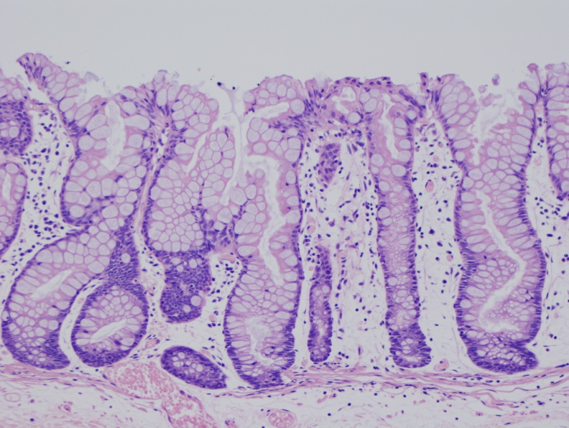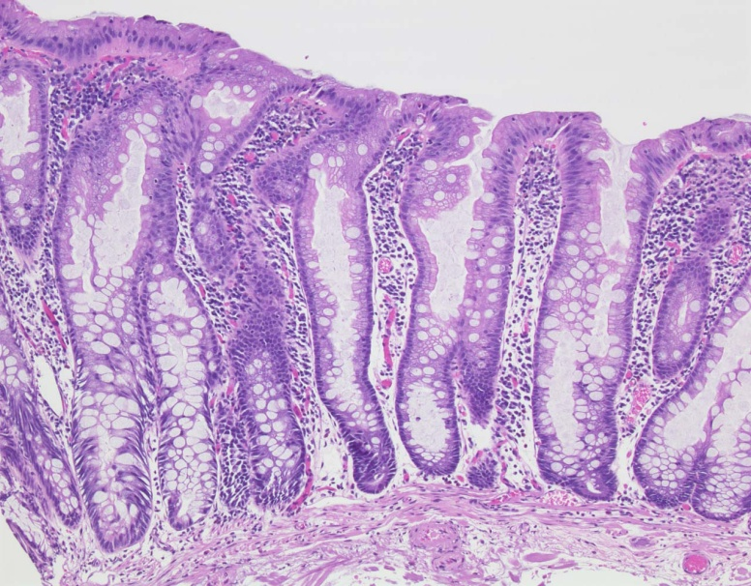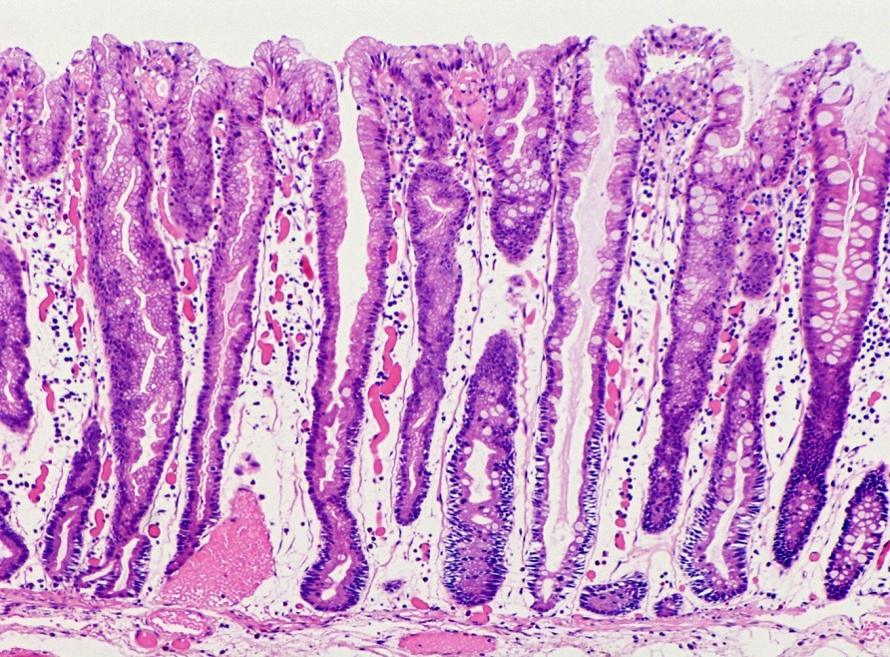
Figure. １
1-a
1-b
1-c
Figure 1 Histological findings of hyperplastic polyps. A: Microvesicular HP (MVHP): The crypts and surface epithelium showing a serrated appearance with micro-goblet cells increased. High power view is shown at left side bottom. Many small droplet (microvesicular) mucin within the cytoplasm at the epithelial layer is specific findings as shown the picture; B: Goblet-cell rich HP (GCHP): In contrast to MVHP, this type polyp is showing a much less serrated appearance inside the surface epithelium of crypts. And showing a preponderance of goblet cells without microvesicular mucin; C: Mucin-poor HP (MPHP): MPHP is rare, and little is known about their molecular features and natural history. The histological features are showing no cytoplasmic mucin with a luminal serration pattern. And also showing increased nuclear atypia without pseudostratification.

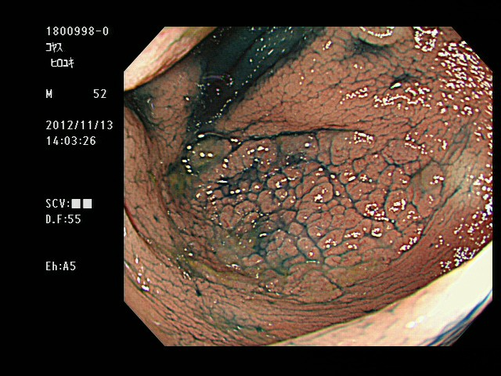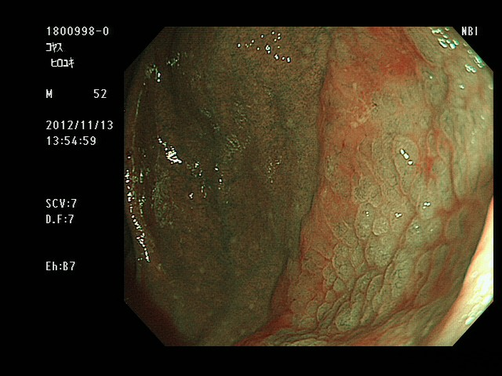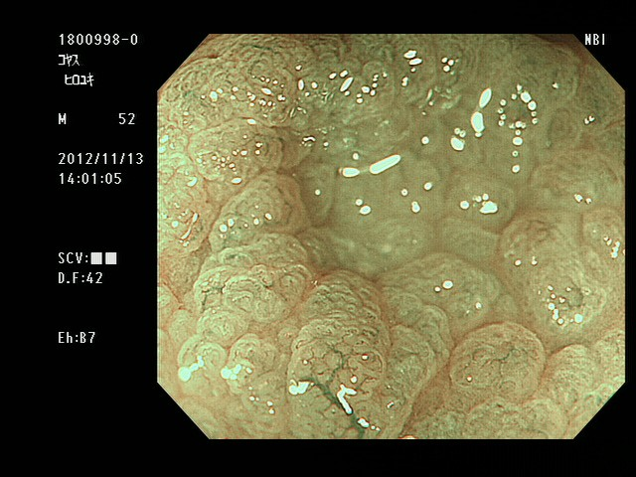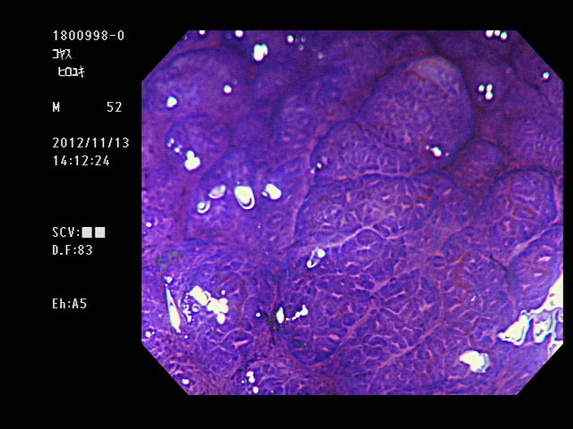
2-a
2-b
2-c
2-d
2-e
Figure. 3
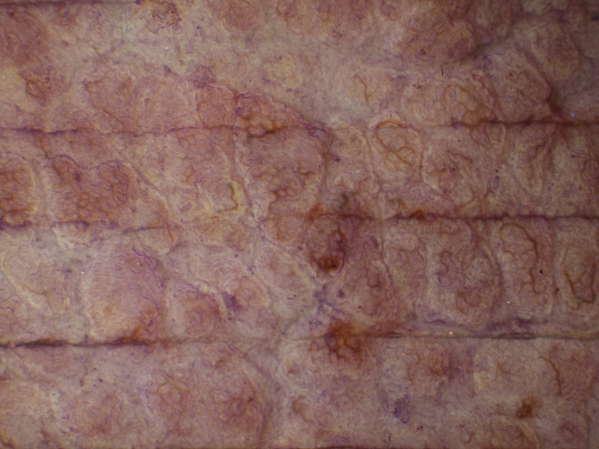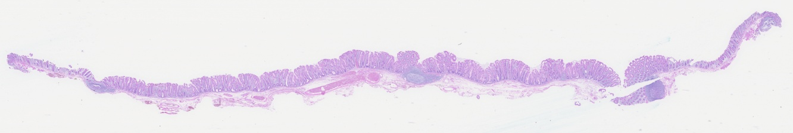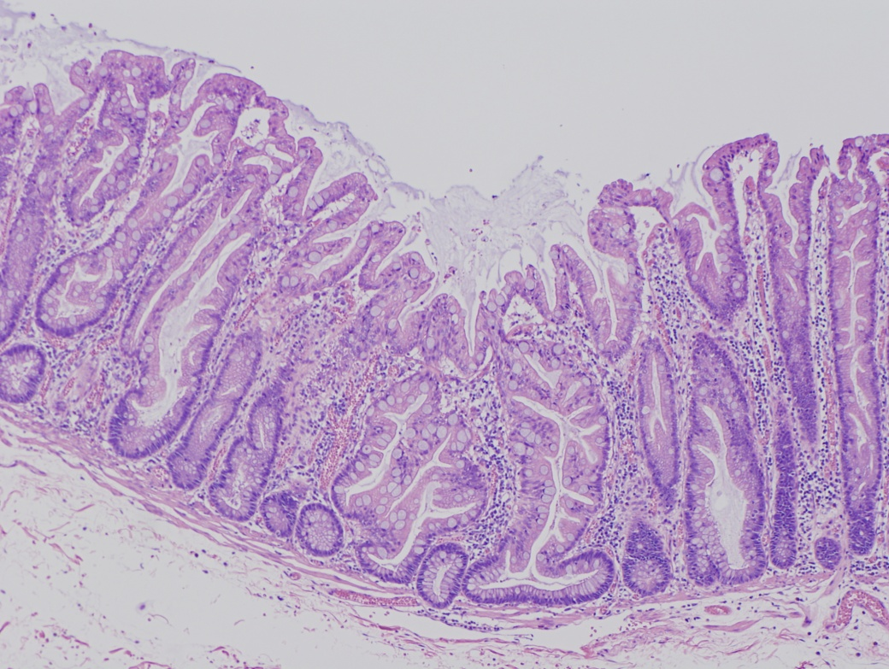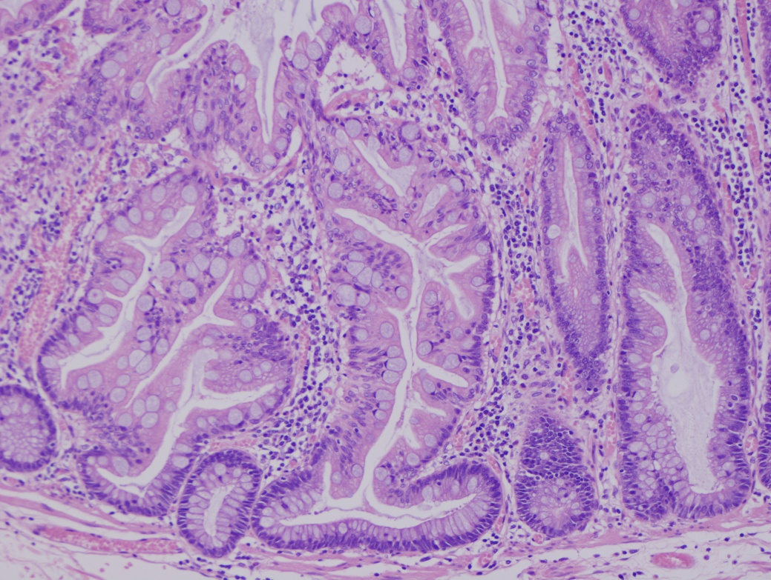
2-f
2-g
2-h
2-i
Figure. 2
Figure 2 A case of sessile serrated adenoma/polyp without cytological dysplasia (scope: CF: FH260AZI). A: AFI imaging. The flat elevated polyp is approximately 37 mm in diameter as is located in cecum. No change to magenta of the tumor relative to the surrounding normal mucosa can be observed (inside white arrows); B: Indigocarmine spraying endoscopic finding. The structure of the granular surface is clearly revealed by chromoendoscopy; C: NBI observation, non-magnified. A red cap is covering the surface of the tumor; D: NBI observation, magnified. Small black dots can be observed in the tumor. This finding indicates that this tumor possesses the characteristic of SSA/P; E: Crystal violet staining under magnified observation. Type II open pits (II-O pits) containing T normal type II pits are shown in the tumor; F: Stereoscopic finding. The tumor was excised by the ESD method. The tumor was cut into12 pieces; G: HE staining, whole specimen findings from section #4; H: Low power view of the HE staining findings. The tumor contains serrated glands in the mucosal layer; I: High power view of the HE staining findings. Typical histological findings for SSA/P. The crypt exhibits an “inverted T” type. NBI: Narrow band imaging; SSA/P: Sessile serrated adenoma/polyp; AFI: Auto fluorescence imaging.

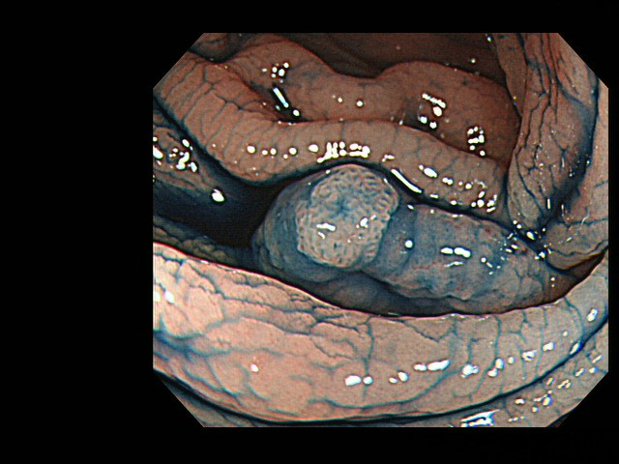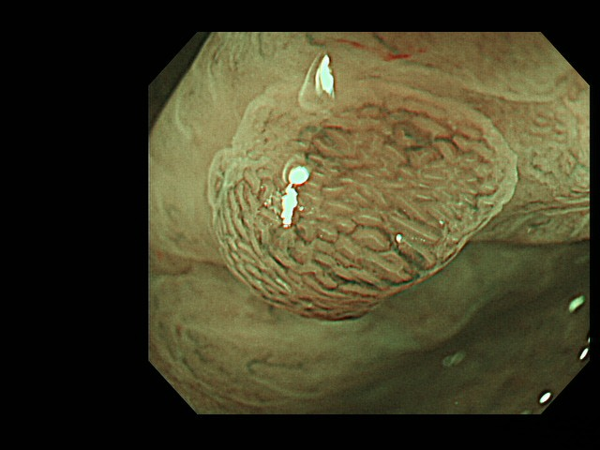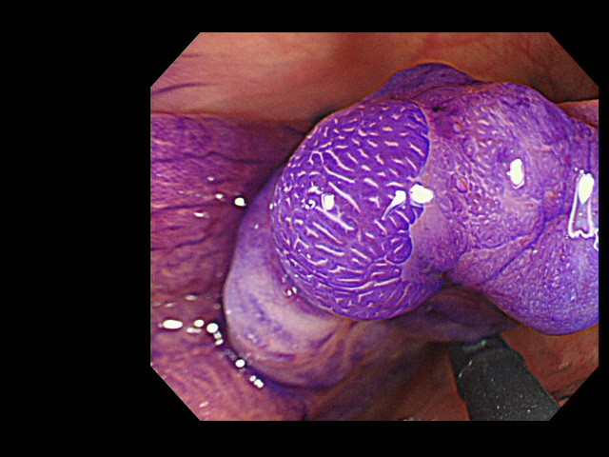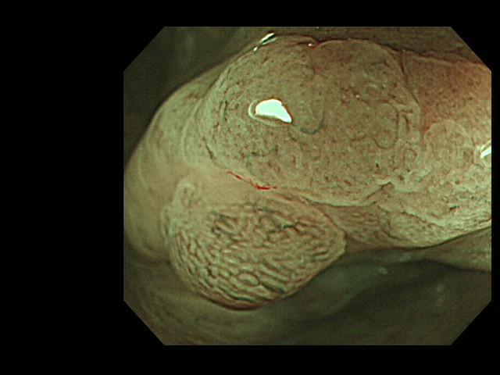
3-a
3-b
3-c
3-d
3-e
Figure. 3

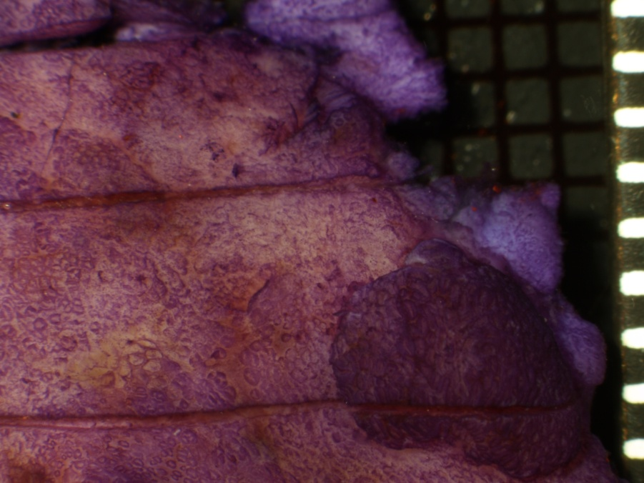
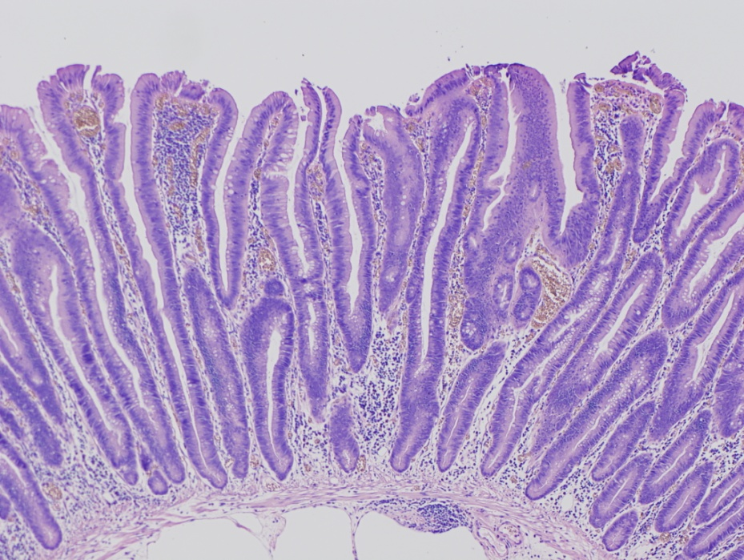
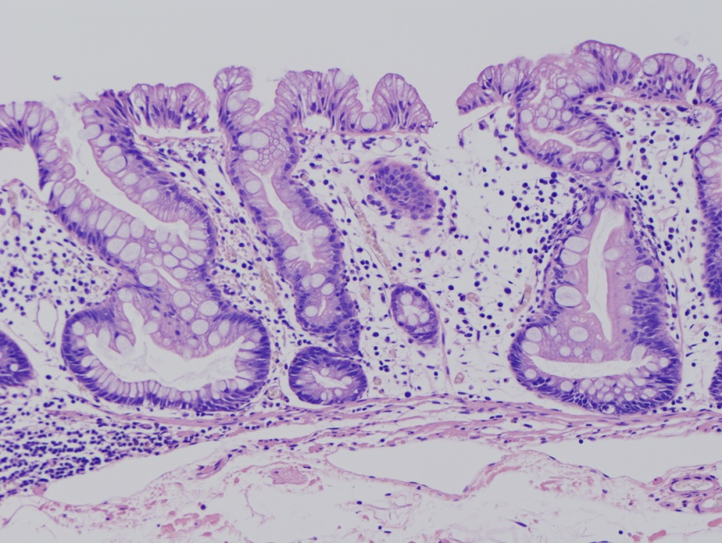
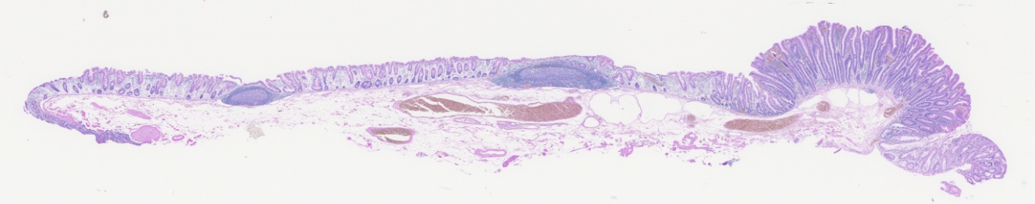
3-f
3-g
3-h
3-i
Figure. 3

Figure 3 A case of sessile serrated adenoma/polyp with cytological dysplasia (scope: CF: FH260AZI). A: AFI imaging. The polyp is shown as a flat elevated lesion with a small nodule and is located in the ascending colon. A slightly change to a magenta color can be seen localized to a small elevated lesion in the tumor; B: Indigocarmine spraying endoscopic finding. The small elevated nodule in the tumor can be seen observed following dye spraying; C: Magnified NBI observation. In the tumor lesion, whitish mucosa with II-D pits can be observed. The microcapillary vessels are not dilated in the tumor; D: Magnified NBI observation. In contrast, the microcapillary vessels are dilated surrounding the tumor pits at the small elevated nodule. Moreover, a IIIL pit (white line) can be indirectly observed; E: Magnified crystal violet staining observation. Type II open pits (II-O pits) containing normal type II pits are shown in the tumor; F: Stereoscopic finding. The tumor was excised by the ESD method. The tumor was cut eight pieces; G: HE staining, whole specimen findings from section #4 including a small nodule; H: High power view of the HE staining finding. A part of an SSA/P is shown in the picture; I: High power view of the HE staining finding. The small elevated lesion is shown as a neoplastic change. Low grade cytologic dysplasia is present with nuclear hyperchromasia and pseudostratification. NBI: Narrow band imaging; SSA/P: Sessile serrated adenoma/polyp; AFI: Auto fluorescence imaging.

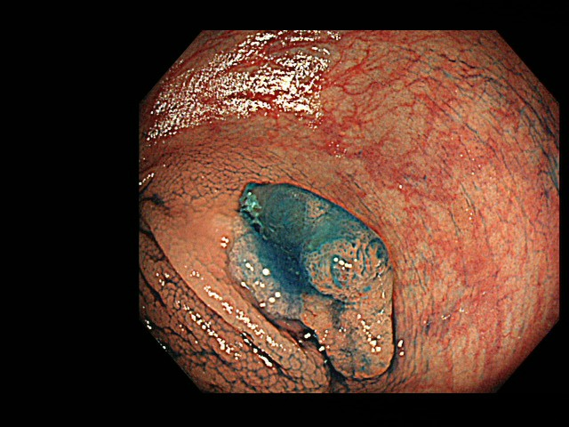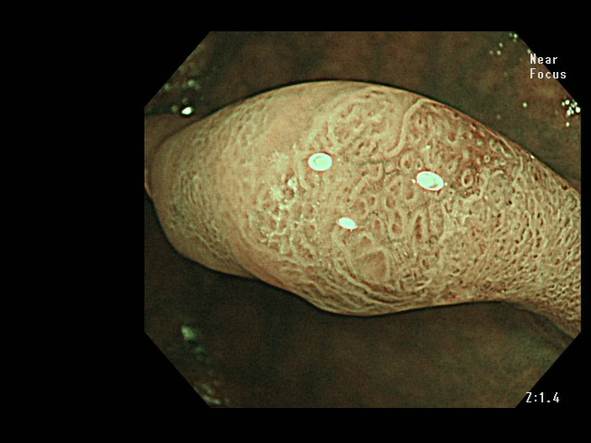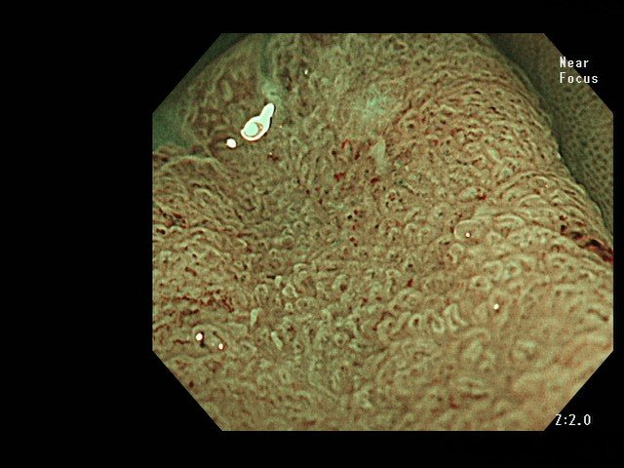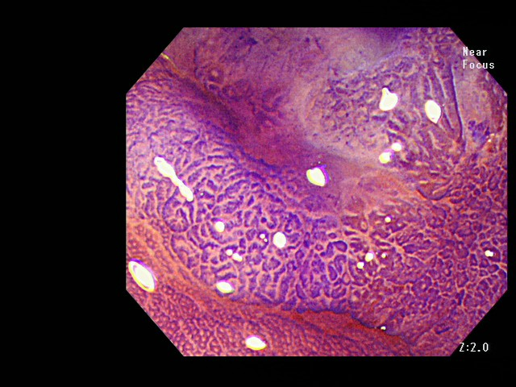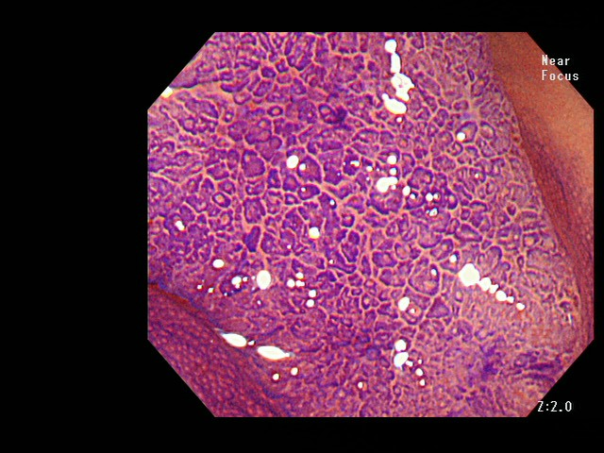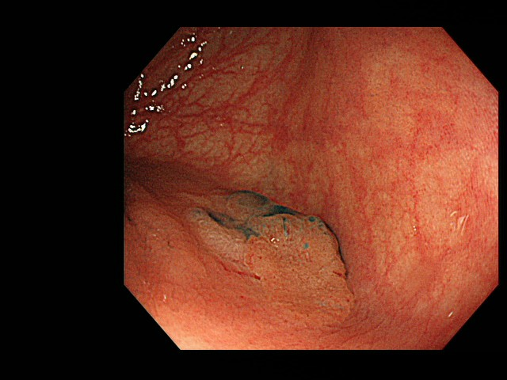
Figure. 4
4-a
4-b
4-c
4-d
4-e
4-ｆ
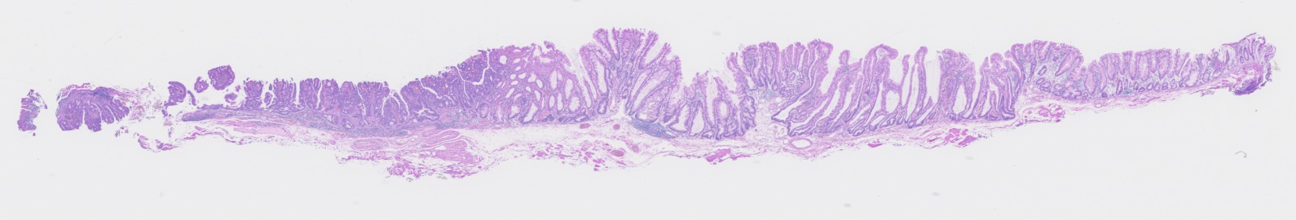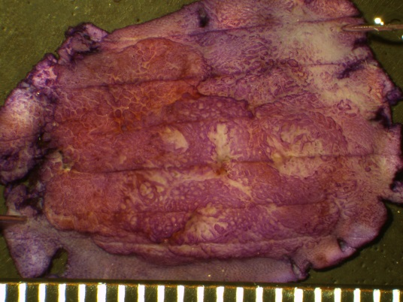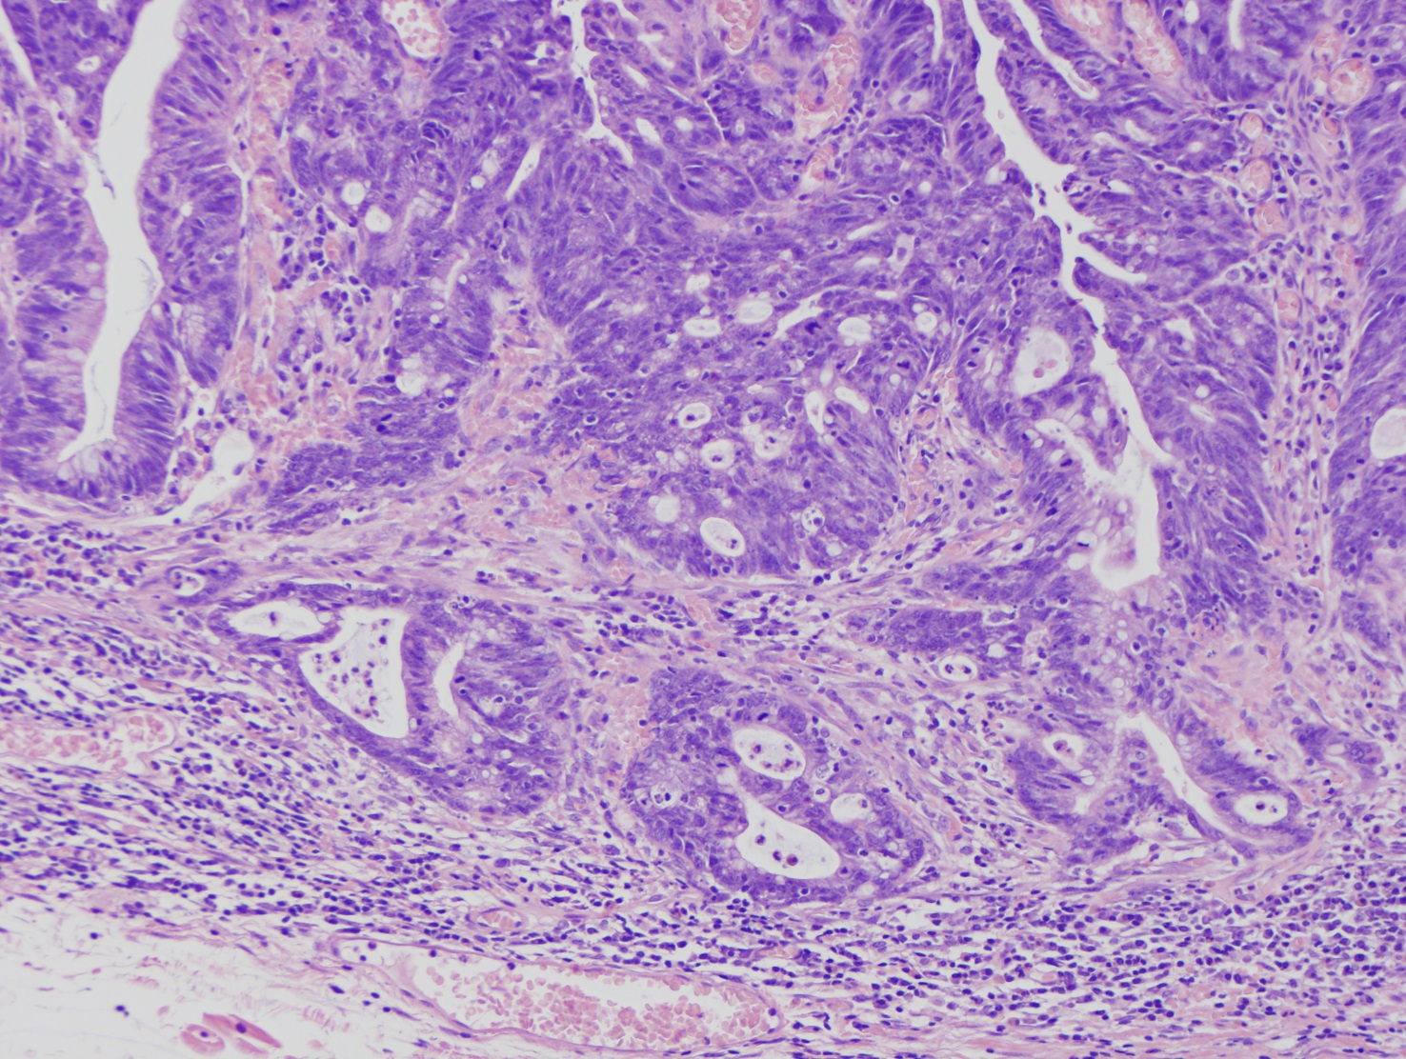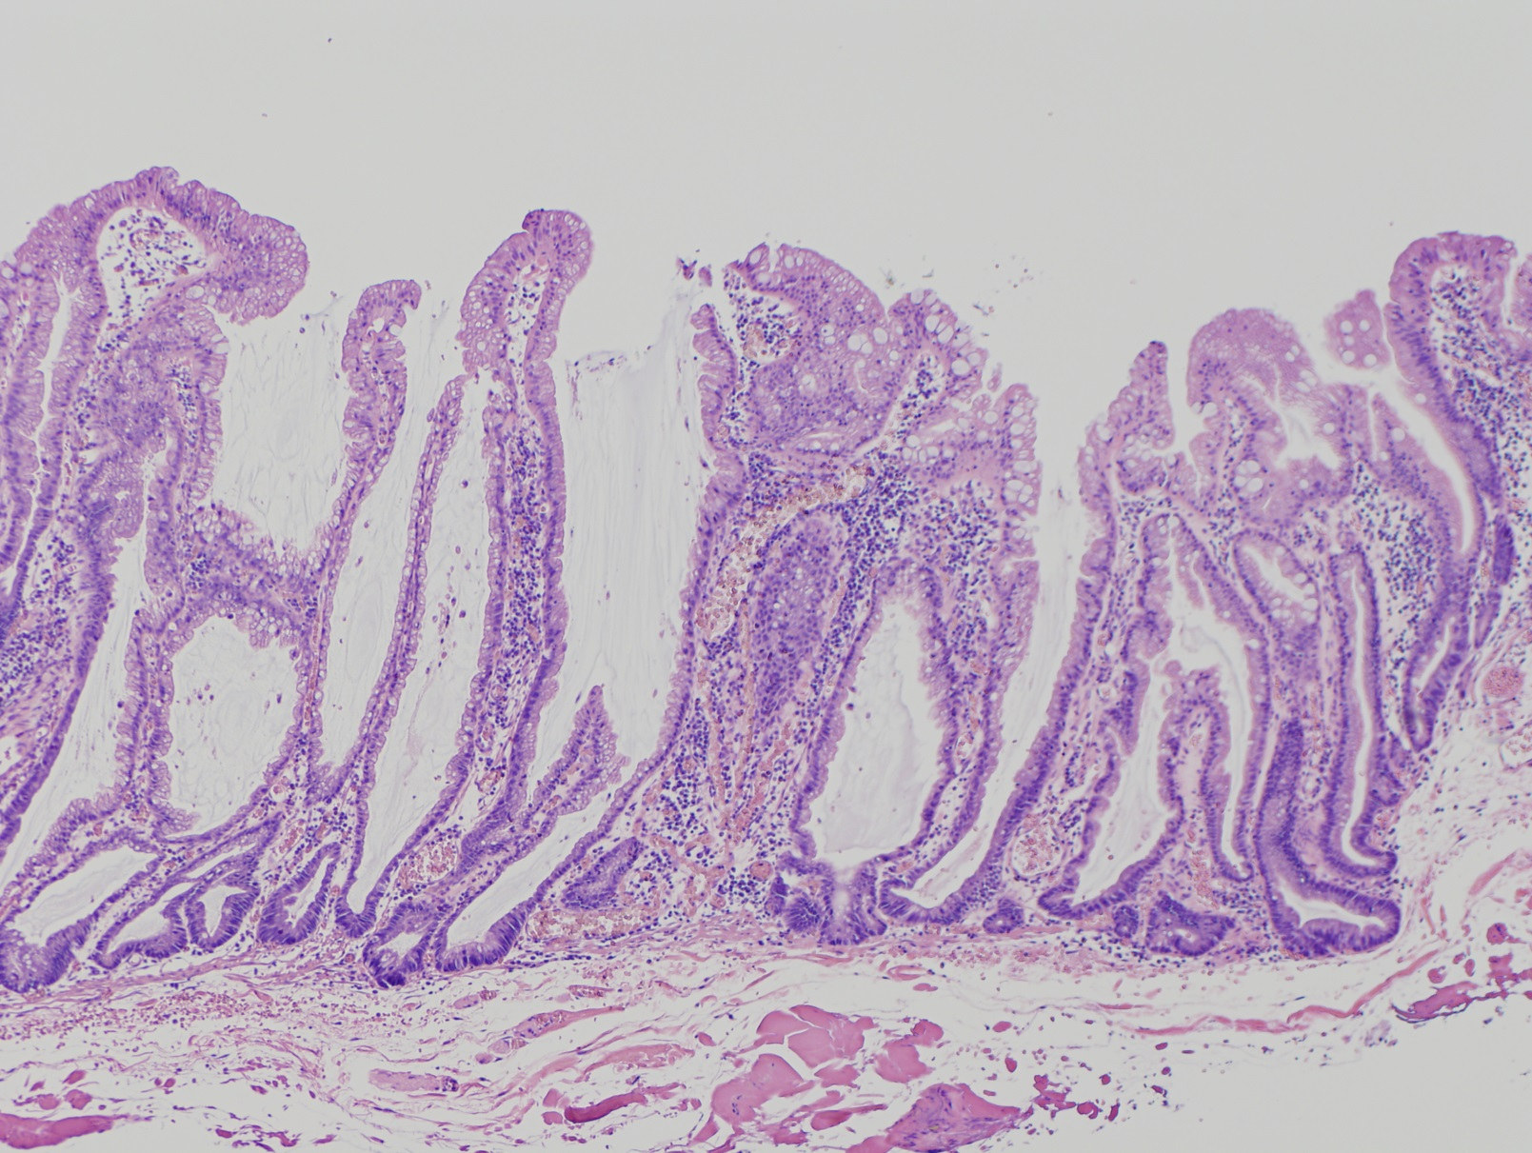
4-g
4-h
4-i
4-j
4-i
4-j
Figure 4 A case of an sessile serrated adenoma/polyp that has invaded the submucosal layer (scope: CF: HQ290I). A: Conventional white light observation. A flat elevated polyp of approximately 20 mm with a reddish depressed area can be observed in the ascending colon; B: Indigocarmine spraying endoscopic finding. Chromoendoscopy revealed this lesion, which is clearly composed of lesions. One edge area is covered with thick mucus; C: Magnified NBI observation. Firmly attached mucus can be observed on the tumor. A II-D pit that is indicative are markedly dilated crypts can be seen in this area; D: Magnified NBI observation. A granular surface pattern with dilated microcapillary vessels can be observed on this tumor in the absence of a thick mucus adhesion; E and F: Magnified crystal violet staining observation; G: Stereoscopic finding. The tumor was excised by the EMR method. The tumor was cut into seven pieces; H: HE staining, whole specimen finding from #4; I: High power view of the HE staining. The neoplastic glands have invaded into the SM layer to a depth of approximately 400m. The glands exhibit high grade dysplastic change; J: Low power view of the HE staining. This polyp is composed of SSA/P glands with markedly dilated crypts. NBI: Narrow band imaging; SSA/P: Sessile serrated adenoma/polyp.

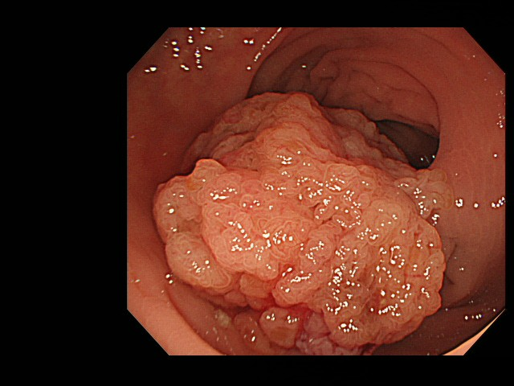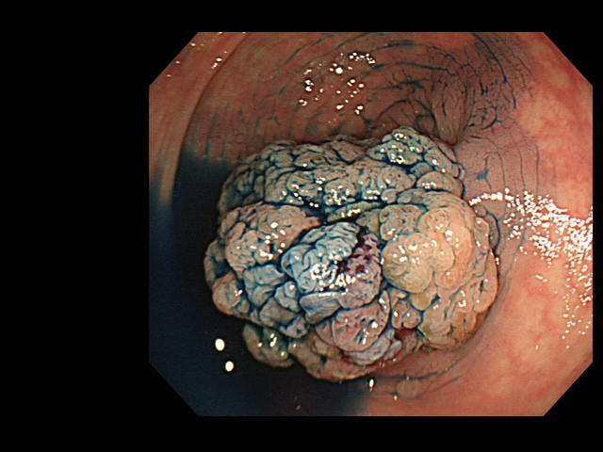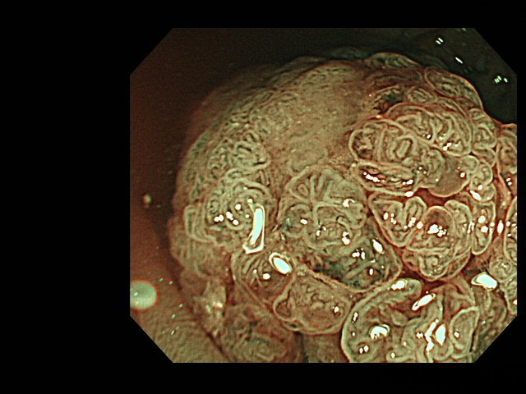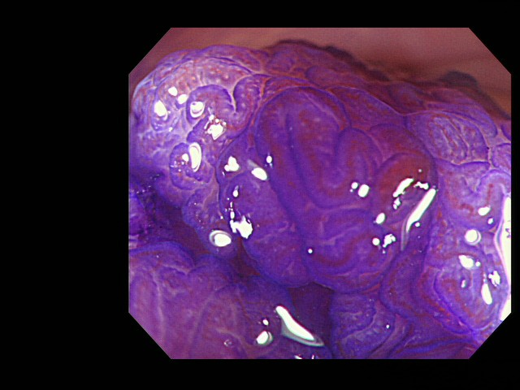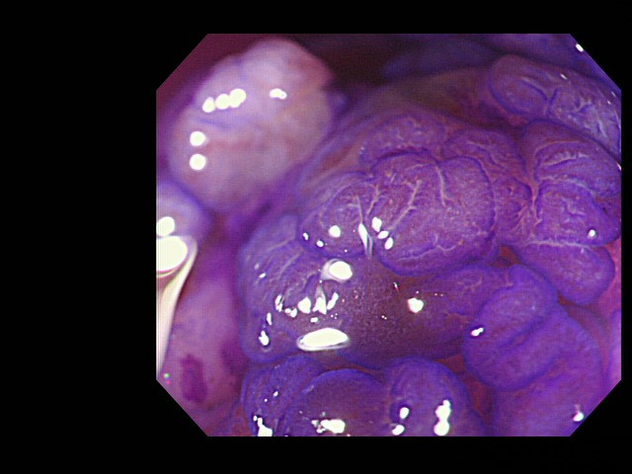
Figure. 5
5-a
5-b
5-c
5-d
5-e
5-f

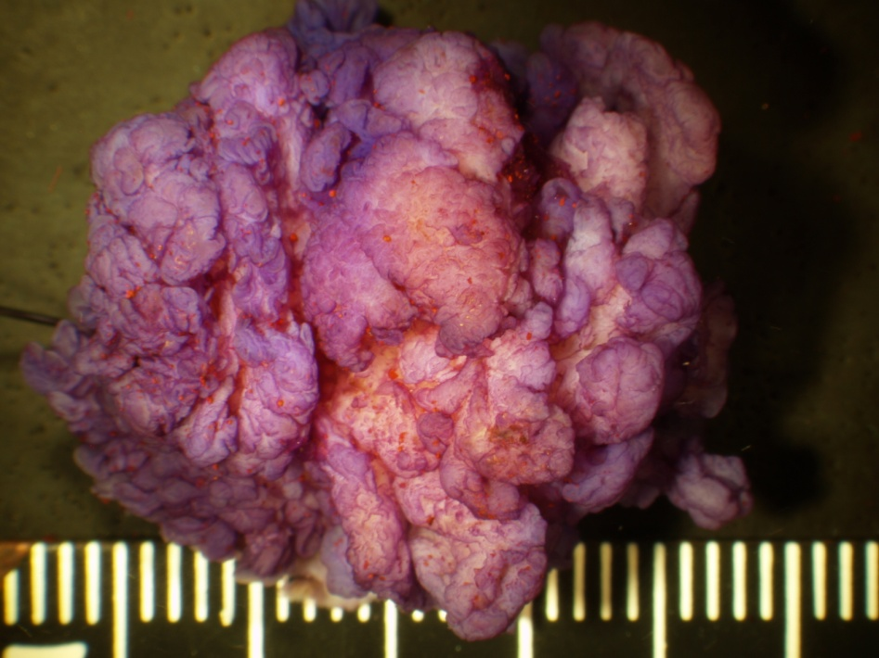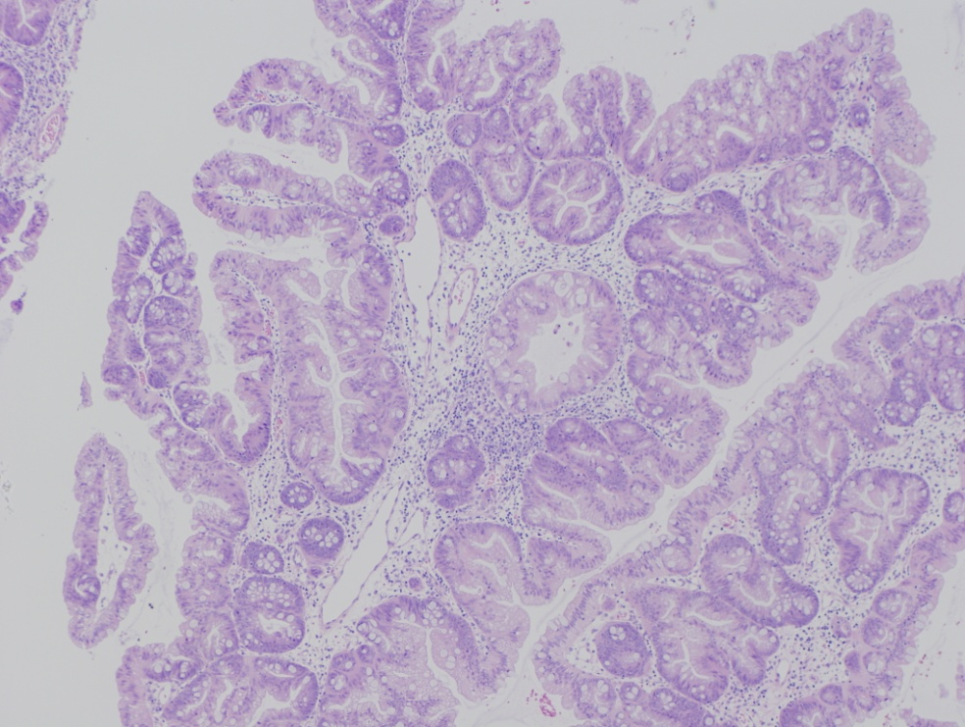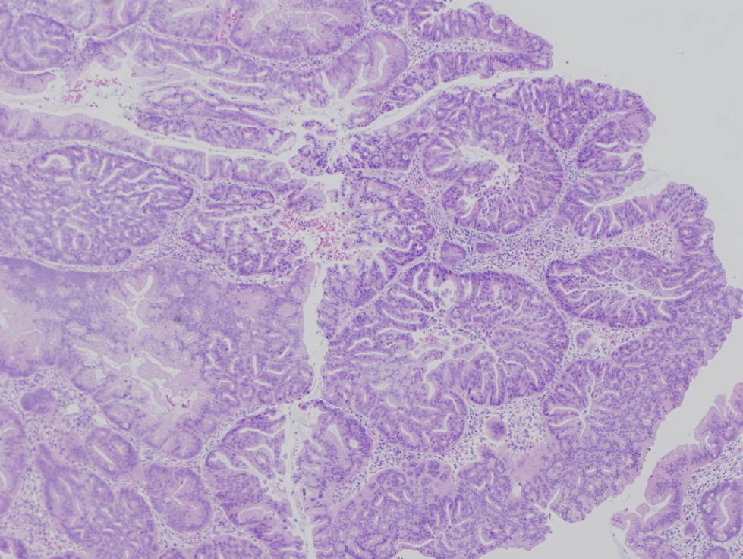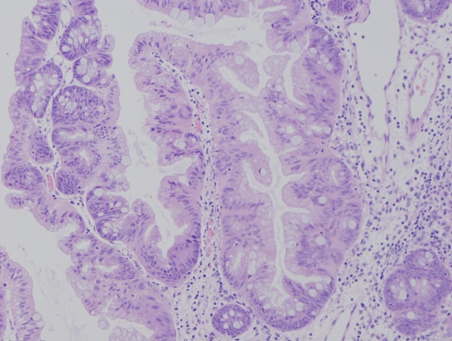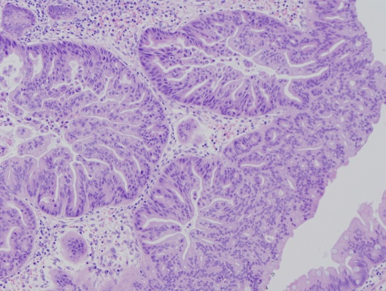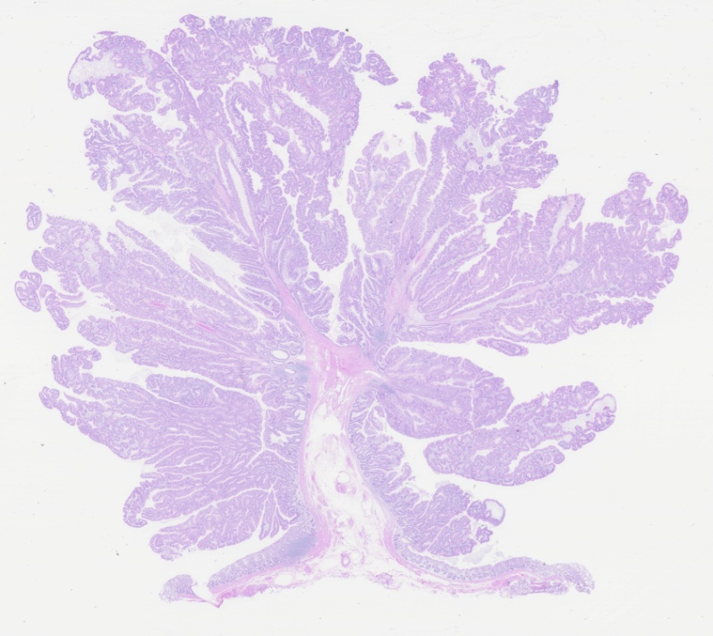
5-g
5-h
5-i
5-j
Figure. 5
5-i
5-j
Figure 5 A case of a traditional serrated adenoma with conventional dysplasia (scope: CF: FH260AZI). A: AFI imaging. A dark green tone that is nearly the same as the surrounding normal colon mucosa can be observed in the tumor; B: Conventional white light observation. A large (approximately 30mm) semipedunculated polyp exhibiting a slightly reddish change can be observed at the rect-sigmoid junction. There are no findings suggestive of submucosal invasion of the cancer; C: Indigocarmine spraying endoscopic findings. The structure of the nodular surface pattern is clearly revealed; D: NBI observation, magnified. A granular surface pattern with dilated microcapillary vessels can be observed in the tumor; E and F: Magnified crystal violet staining with observation. A type IIIH or IVH pit pattern is shown in the tumor; G: Stereoscopic finding. The tumor was excised by the EMR method. The tumor was cut into 4 pieces; H: HE staining, whole specimen finding from section #2; I: Histological findings from the HE staining. The tumor contains serrated glands in the mucosal layer. Dysplastic change is not observed; J: Histological findings of the HE staining. At several points, TSAs with conventional epithelial dysplasia exhibiting enlarged crowding and pseudostratification of the nuclei with crypt structure dysplastic changes can be observed. TSA: Traditional serrated adenoma; NBI: Narrow band imaging; AFI: Auto fluorescence imaging.

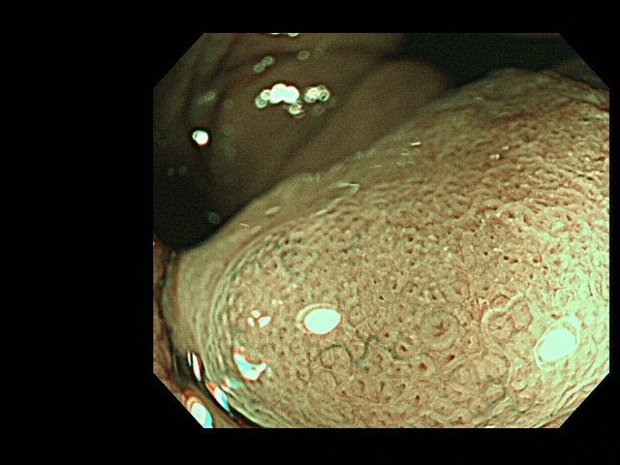
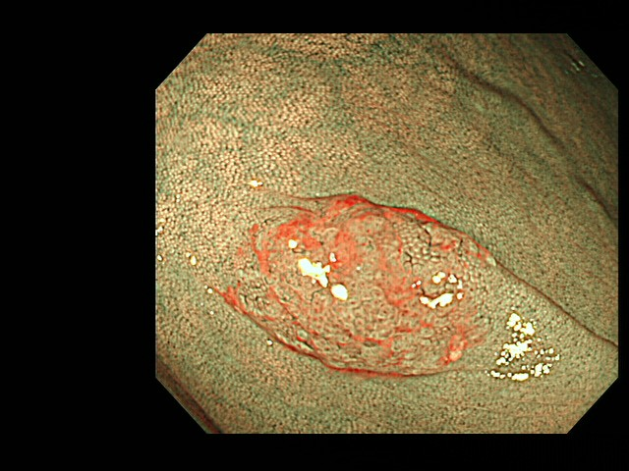
Figure. 6
6-a
6-b

Figure 6 Endoscopic characteristics on narrow band imaging observation. A: Red cap sign – positive case; B: A finding of showing II-D pit.

Location
Endoscopic Imaging
White light imaging
NBI
Method
Right side colon
Mucosal Cap
Magnifying imaging
Size (mm)
II-D pit, Red cap sign
Type II pit
(+)
(-)
(+)
Type II-open pit + III-V pit
Follow up (once a year)
Endoscopic treatment
(+)
X<10mm
11mm<X
X<10mm
Type II-open pit
(+)
11mm<X
X<5mm
6mm<X

Figure 7 Floe chart for endoscopic treatment about sessile serrated adenoma/polyp.

Table 1 Classification of serrated lesion World Health Organization (2010)
Hyperplastic polyp
Microvesicular hyperplastic polyp
Goblet cell rich hyperplastic polyp
Mucin poor
Sessile serrated adenoma/ polyp
Without cytological dysplasia
With cytological dysplasia
Traditional serrated adenoma

