Name of journal: World Journal of Clinical Cases
ESPS Manuscript NO: 8765
Columns: Case Report

Cabazitaxel in castration resistant prostate cancer with brain metastases: 3 case reports

Rescigno P et al. Cabazitaxel and brain metastases

Pasquale Rescigno, Piera Federico, Carlo Buonerba, Davide Bosso, Livio Puglia, Michela Izzo, Tania Policastro, Sabino De Placido, Giuseppe Di Lorenzo

Pasquale Rescigno, Piera Federico, Carlo Buonerba, Davide Bosso, Livio Puglia, Michela Izzo, Tania Policastro, Sabino De Placido, Giuseppe Di Lorenzo, Genitourinary Cancer Section, Medical Oncology, Department of Clinical Medicine, Federico II University, Napoli 80140, Italy

Author contributions: Rescigno P contributed to drafting of the manuscript; Federico P, Buonerba C, Bosso D, Puglia L, Izzo M and Policastro T contributed to acquisition of the data; De Placido S and Di Lorenzo G contributed to critical revision of the manuscript.

Correspondence to: Di Lorenzo Giuseppe, MD, PhD, Genitourinary Cancer Section, Medical Oncology, Department of Clinical Medicine, Federico II University, Corso Umberto I, Napoli 80140, Italy. giuseppedilorenzoncol@hotmail.com

Telephone: +39-081-7463660 Fax: +39-081-2203147

Received: January 5, 2014 Revised: March 31, 2014
Accepted: May 8, 2014

Published online:

Abstract
Prostate cancer represents the most common non-cutaneous malignancy for men. Skeleton is the most common metastatic site but, following an improvement of survival, metastases in uncommon sites are found more frequently in clinical practice, especially brain metastases. Despite new drugs, now available for metastatic castration resistant prostate cancer, no clinical evidence exists about their effectiveness on the brain metastases. We describe clinical history of 3 patients treated with cabazitaxel plus whole brain radiotherapy. These case reports demonstrate that cabazitaxel is highly active and well tolerated in brain metastases.

© 2014 Baishideng Publishing Group Inc. All rights reserved.

Key words: Cabazitaxel; Brain metastases; Prostate cancer

Core tip: Due to the improvement in term of survival, the incidence of brain metastases (BMs) has increased in patient with metastatic castration resistant prostatic cancer (mCRPC). Despite a large number of treatments now available, the prognosis of patients with BMs is still poor. First we demonstrate the efficacy of cabazitaxel on brain mestastases in three CRPC patients and show its profile of tolerability in combination with whole brain radiotherapy.

Rescigno P, Federico P, Buonerba C, Bosso D, Puglia L, Izzo M, Policastro T, De Placido S, Di Lorenzo G. Cabazitaxel in castration resistant prostate cancer with brain metastases: 3 case reports. World J Clin Cases 2014; In press

Available from: URL:
DOI:

INTRODUCTION
Prostate cancer (PC) represents the most common non-cutaneous malignancy for men, with an estimated number of new cases of 241740 in 2013 in the United States ^{[1]}. Nevertheless PC is not the first cause of death in male population due to its ability to metastasize rarely to organs that are not the bones ^{[2]}.
Although the skeleton remains the most common metastatic site, the availability of new active drugs for metastatic castration resistant prostatic cancer (mCRPC) has changed the natural history of this disease leading to a considerable improvement in survival so that metastases in previously considered uncommon sites are now found more frequently ^{[3]}.
Brain is involved as site of metastases in almost 12% of cases and the prognosis of the patients is poor at their appearance^{[4]}.
Despite of an increased incidence of BMs the impact of new drugs for mCRPC on this metastatic site remains poorly understood. First of all patients with BMs are not routinely enrolled in phase III clinical trials, then there are no prospective and ad-hoc studies in this particular setting. Actually we have only preclinical data showing that cabazitaxel is able to pass brain-blood barrier (BBB) ^{[5]} but we have no evidence about his efficacy in humans.
Otherwise we have also few data concerning the role of radiation therapy on the treatment of BMs from PC and it seems to have only a palliative intent ^{[6]}. Here we describe three case reports of brain metastases in CRPC patients who were treated with cabazitaxel plus whole brain radiotherapy.

CASE REPORT
The patients were 70, 70 and 72 years old. All patients presented at diagnosis a high risk disease (Table 1). Patients 1 and 2 didn’t receive primary treatment because bone metastases and lymph node metastases were detected with bone and computed tomography scan. These 2 patients began hormonal therapy with luteinizing-hormone-releasing hormone analogue (aLHRH) first and then with complete androgen blockage (CAB) adding bicalutamide 50 mg.
Patient 3 underwent prostatectomy and radiotherapy for locally advanced disease. Then he experienced a disease progression after 5 mo due to bone metastases appearance and started aLHRH. All patients had a long androgen deprivation therapy (ADT) history (36-50 mo). Docetaxel was first line chemotherapy with a progression free survival (PFS) of 7, 7, and 11 months respectively (Table 1). Patient 3 was treated with abiraterone as second line treatment and progressed after 6 mo.
The patients presented multiple BMs (in number of 2, 3 and 3 respectively) confirmed with a magnetic resonance imagining (MRI) before starting cabazitaxel, liver and lung represented other metastatic sites (Table 1). A total of 30 cycles of cabazitaxel were administered at standard dose without reductions (Table 1). Contemporaneous whole brain radiotherapy was performed at the dose of 30 Gy.
Patient 3 obtained a complete response on brain and liver metastases with a PSA reduction of 90% after 6 cycles (Figure 1), while two partial responses in brain (the lesions were halved) and lung were observed with a PSA decrease of 40% after 6 cycles for patient 1 and 2.
No grade 3-4 toxicities were experienced; all patients received pegylated-granulocyte-colony stimulating factor (PEG-G-CSF) to prevent febrile neutropenia. The most important non-haematological toxicities were grade 2 nausea and asthenia.
The PFS of patient 1 and 2 were 7 and 13 mo while patient 3 is still progression-free. Patient 1 and 2 received further therapies after cabazitaxel (abiraterone and platinum regimen) and died after 3 mo.

DISCUSSION
BMs appearance is a rare and terminal event in the natural history of PC, due to greater aggressiveness and poor response to common therapies. BMs are often essentially single, supratentorial and occur with nonfocal neurologic symptoms related to intracranial hypertension. A retrospective study about 103 patients with BMs showed that radiotherapy alone is an effective treatment with a median survival of 3.5 mo^{[7]}.
Further improvement in survival was noted in five patients who underwent stereotactic radiosurgery (SRS). No complete responses were obtained, however best improvement regarded symptoms^{[8]}.
BMs are more frequent in CRPC setting than in the past, due to the availability of new drugs and longer survival of metastatic patients. In docetaxel era the prognosis of patient with BMs was still poor and median survival was only 8 wk after BMs diagnosis, demonstrating clinical ineffectiveness of docetaxel^{[3]}.
Among new approved drugs for mCRPC such as cabazitaxel, abiraterone, enzalutamide, sipuleucel-T, only cabazitaxel has shown to be able to pass BBB. Cisternino and colleagues observed a non-linear accumulation of cabazitaxel in brains of rats occurring by saturation of the P-glycoprotein in BBB^{[5]}.
These 3 case reports describe for the first time the role of cabazitaxel in patients with BMs and the results are encouraging for 3 aspects.
Firstly it shows doubtless the efficacy of cabazitaxel in BMs with an amazing PFS if compared with Tropic trial PFS^{[9]}. Secondly the association of whole brain radiotherapy and chemotherapy with cabazitaxel gives better results in term of radiological response and survival than data presented above.
Thirdly the combination seems not be particularly toxic, especially in terms of hematological toxicities. We have administered preventive PEG-G-CSF and, as previously shown in an Italian study, it reduces the grade 3 and 4 neutropenia reported with cabazitaxel^{[10]}.
Our case reports demonstrate that cabazitaxel has improved PFS and overall survival in our patients with BMs and it is well tolerated in combination with radiotherapy. The lack of ad-hoc studies and the exclusion of men with brain metastases from phase III trials make our data the first evidence in this field. Prospective trials are needed to confirm our preliminary results.

COMMENTS
Case characteristics
All patients presented at diagnosis a high risk disease.

Treatment
The authors demonstrate the efficacy of cabazitaxel on brain mestastases in three CRPC patients and show its profile of tolerability in combination with whole brain radiotherapy.

Experiences and lessons
These case reports demonstrate that cabazitaxel is highly active and well tolerated in brain metastases.

Peer review
Nice, well written paper with interest data potentially useful in clinical setting.

REFERENCES
1 Siegel R, Naishadham D, Jemal A. Cancer statistics, 2013. CA Cancer J Clin 2013; 63: 11-30 [PMID: 23335087 DOI: 10.3322/caac.21166]
2 Scosyrev E, Messing EM, Mohile S, Golijanin D, Wu G. Prostate cancer in the elderly: frequency of advanced disease at presentation and disease-specific mortality. Cancer 2012; 118: 3062-3070 [PMID: 22006014 DOI: 10.1002/cncr.26392]
3 Caffo O, Veccia A, Fellin G, Mussari S, Russo L, Tomio L, Galligioni E. Frequency of brain metastases from prostate cancer: an 18-year single-institution experience. J Neurooncol 2013; 111: 163-167 [PMID: 23096134 DOI: 10.1007/s11060-012-0994-1]
4 Gandaglia G, Abdollah F, Schiffmann J, Trudeau V, Shariat SF, Kim SP, Perrotte P, Montorsi F, Briganti A, Trinh QD, Karakiewicz PI, Sun M. Distribution of metastatic sites in patients with prostate cancer: A population-based analysis. Prostate 2014; 74: 210-216 [PMID: 24132735 DOI: 10.1002/pros.22742]
5 Cisternino S, Bourasset F, Archimbaud Y, Sémiond D, Sanderink G, Scherrmann JM. Nonlinear accumulation in the brain of the new taxoid TXD258 following saturation of P-glycoprotein at the blood-brain barrier in mice and rats. Br J Pharmacol 2003; 138: 1367-1375 [PMID: 12711638 DOI: 10.1038/sj.bjp.0705150]
6 Expósito J, Jaén J, Alonso E, Tovar I. Use of palliative radiotherapy in brain and bone metastases (VARA II study). Radiat Oncol 2012; 7: 131 [PMID: 22863023 DOI: 10.1186/1748-717X-7-131]
7 Tremont-Lukats IW, Bobustuc G, Lagos GK, Lolas K, Kyritsis AP, Puduvalli VK. Brain metastasis from prostate carcinoma: The M. D. Anderson Cancer Center experience. Cancer 2003; 98: 363-368 [PMID: 12872358 DOI: 10.1002/cncr.11522]
8 Kim SH, Chao ST, Toms SA, Vogelbaum MA, Barnett GH, Suh JH, Weil RJ. Stereotactic radiosurgical treatment of parenchymal brain metastases from prostate adenocarcinoma. Surg Neurol 2008; 69: 641-66; discussion 646 [PMID: 18262258 DOI: 10.1016/j.surneu.2007.05.035]
9 de Bono JS, Oudard S, Ozguroglu M, Hansen S, Machiels JP, Kocak I, Gravis G, Bodrogi I, Mackenzie MJ, Shen L, Roessner M, Gupta S, Sartor AO; TROPIC Investigators. Prednisone plus cabazitaxel or mitoxantrone for metastatic castration-resistant prostate cancer progressing after docetaxel treatment: a randomised open-label trial. Lancet 2010; 376: 1147-1154 [PMID: 20888992 DOI: 10.1016/S0140-6736(10)61389-X]
10 Di Lorenzo G, DʼAniello C, Buonerba C, Federico P, Rescigno P, Puglia L, Ferro M, Bosso D, Cavaliere C, Palmieri G, Sonpavde G, De Placido S. Peg-filgrastim and cabazitaxel in prostate cancer patients. Anticancer Drugs 2013; 24: 84-89 [PMID: 23044721 DOI: 10.1097/CAD.0b013e32835a56bc]
P-Reviewers: Creta M, Figg WD, Georgoulias V, Rubello D
S-Editor: Song XX L-Editor: E-Editor:

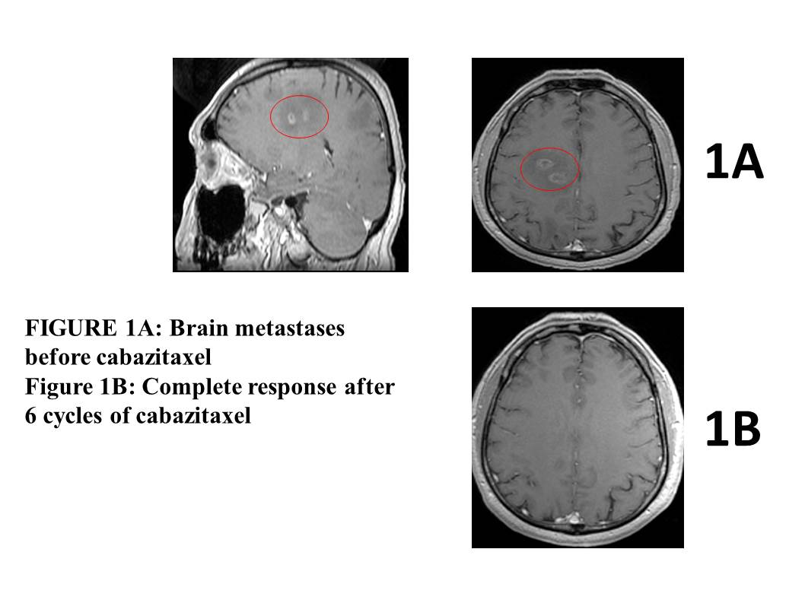
Figure 1 A and B show a complete response in the brain lesions before and after 6 cycles of cabazitaxel.

Table 1 Patient’s characteristics
 | Patient 1 | Patient 2 | Patient 3
Age | 70 | 70 | 72
Comorbidities | Hypertension | Hypertension | Diabetes
Primary treatment | Hormonal therapy | Hormonal therapy | Surgery and radiation therapy
Gleason score | 8 (4+4) | 8 (4+4) | 8 (5+3)
PSA at baseline¹ (ng/mL) | 158 | 82 | 17
ADT time (mo) | 38 | 36 | 50
Docetaxel cycles | 12 | 8 | 8
PSA pre-cabazitaxel (ng/mL) | 95 | 292 | 140
Sites of metastases | Bone, lung, brain | Bone, lung, brain | Bone, liver, brain
Cabazitaxel cycles | 12 | 8 | 10
Best response | PR on brain and lung | PR on brain and lung | CR on liver and brain
Toxicities | Anemia grade 1, asthenia grade 2 | Nausea grade 2; neutropenia grade 2 | Asthenia grade 2
¹Before primary treatment. ADT: androgen deprivation therapy; PR: Partial response; CR: Complete response.

