Name of Journal: World Journal of Clinical Cases
Manuscript NO: 80174
Manuscript Type: CASE REPORT

Giant myxofibrosarcoma of the esophagus treated by endoscopic submucosal dissection: A case report

Wang XS et al. ESD for giant MFS of esophagus

Xiao-Song Wang, Cheng-Guang Zhao, Hui-Ming Wang, Xiao-Yan Wang

Xiao-Song Wang, Department of Digestive Diseases, Suqian First People’s Hospital Affiliated to Nanjing Medical University, Suqian 223800, Jiangsu Province, China

Cheng-Guang Zhao, Hui-Ming Wang, Xiao-Yan Wang, Department of Gastroenterology, Suqian First People’s Hospital Affiliated to Nanjing Medical University, Suqian 223800, Jiangsu Province, China

Author contributions: Wang XS and Wang HM wrote and revised the case report; Zhao CG and Wang XY were responsible for all the clinical aspects of the paper; and all authors issued final approval for the version to be submitted.

Supported by the Key Project of Jiangsu Province, China, No. ZD2022052.

Corresponding author: Xiao-Yan Wang, MM, Chief Physician, Professor, Department of Gastroenterology, Suqian First People’s Hospital Affiliated to Nanjing Medical University, No. 120 Suzhi Road, Suqian 223800, Jiangsu Province, China. 726343819@qq.com

Received: November 1, 2022
Revised: November 17, 2022
Accepted: January 16, 2023
Published online:

Abstract
BACKGROUND
Myxofibrosarcoma (MFS) is a fibroblast-derived sarcoma that mainly occurs in subcutaneous tissue. MFS rarely occurs in the gastrointestinal tract, especially in the esophagus.

CASE SUMMARY
A 79-year-old male patient was admitted to our hospital for dysphagia for a week. Computed tomography and electronic gastroscopy showed that a giant mass was located 30 cm from the incisor and extended to the cardia. There was incomplete esophageal stenosis. Endoscopic pathology showed spindle cell lesions, which were considered inflammatory myofibroblast like hyperplasia. Considering the strong demands of the patient and his family, and the fact that most inflammatory myofibroblast tumors are benign, we decided to perform endoscopic submucosal dissection (ESD) even if the tumor size was giant (9.0 cm × 3.0 cm). Postoperative pathological examination resulted in a final diagnosis of MFS. MFS rarely occurs in the gastrointestinal tract, especially in the esophagus. Surgical resection and local adjuvant radiotherapy are the first choices to improve the prognosis. This case report firstly described the ESD for esophageal giant MFS. It suggests that ESD may be an alternative treatment for primary esophageal MFS.

CONCLUSION
This case report for the first time describe the successful treatment of a giant esophageal MFS by ESD, suggesting that ESD may be an alternative treatment for primary esophageal MFS, especially in elderly high-risk patients with obvious dysphagia symptoms.

Key Words: Endoscopic submucosal dissection; Giant myxofibrosarcoma; Esophagus; Case report

Wang XS, Zhao CG, Wang HM, Wang XY. Giant myxofibrosarcoma of the esophagus treated by endoscopic submucosal dissection: A case report. World J Clin Cases 2023; In press

Core Tip: For the first time, we report a giant esophageal myxofibrosarcoma (MFS) measuring about 9.0 cm × 3.0 cm. We managed to remove the MFS completely through endoscopic submucosal dissection (ESD) without severe complications. This case suggests that ESD may be an alternative treatment for esophageal MFS, especially in aged high-risk patients with obvious dysphagia symptoms.

INTRODUCTION
Myxofibrosarcoma (MFS) is a fibroblast-derived sarcoma that mainly occurs in the subcutaneous tissue^{[1,2]}. Most cases of MFS occur in the extremities, and only about 20% of cases occur in the trunk, retroperitoneum, heart, etc^{[3-5]}. MFS rarely occurs in the gastrointestinal tract, especially in the esophagus. Surgical resection and local adjuvant radiotherapy are the first choice to improve the prognosis. In this paper, we report a patient with a giant MFS whose family chose endoscopic submucosal dissection (ESD) as a treatment strategy since they considered it was relatively safe and could maintain the anatomical integrity of the esophagus. The challenges for endoscopists were that the MFS with a size of about 9.0 cm × 3.0 cm was too large to be completely removed, and that there would be a high risk of gastrointestinal perforation and bleeding. Fortunately we managed to remove the MFS completely through ESD without severe complications. And the patient recovered well. This case suggests that ESD may be an alternative treatment for primary MFS in the esophagus.

CASE PRESENTATION
Chief complaints
A 79-year-old male patient was admitted to our hospital for dysphagia for a week.

History of present illness
The patient had dysphagia in the last week and had, which was more obvious when eating solid food. He did not have nausea, vomiting, or hoarseness.

History of past illness
The patient had no remarkable medical history.

Personal and family history
The patient had no remarkable personal and family history.

Physical examination
No abnormality was found in the physical examination.

Laboratory examinations
Laboratory examinations showed no abnormalities.

Imaging examinations
Computed tomography (CT) showed thickening of the lower esophageal wall and stenosis of the lumen. Gastroscopy revealed a giant mass located 30 cm from the incisor and extended to the cardia. There was incomplete esophageal stenosis. Macroscopically, the tumor looked like a serpentine, with a size of about 9.0 cm × 3.0 cm (Figure 1A). Endoscopic ultrasound revealed that the tumor originated from the submucosa, had mixed echo changes, and exhibited some inner cystoid structures (Figure 1B). Endoscopic pathology showed spindle cell lesions, which were considered inflammatory myofibroblast like hyperplasia.

Further diagnostic work-up
Immunohistochemical staining showed KI67 (55%+), P53 (3+, Mutant), Vimentin (3+), P40 (-), CK5/6 (-), SMA (-), Desmin (-), HMB45 (-), CD34 (-), CD117 (-), DOG-1 (-), CKpan (-), and EBER (-) (Figure 2).

FINAL DIAGNOSIS
The final diagnosis was MFS.

TREATMENT
The operation was performed under general anesthesia with transparent cap assisted endoscopic therapy. After injecting the cerium mixture (composed of indigo, adrenaline, sodium hyaluronate, and normal saline) under the mucosa on the oral side, we made an incision using a fixed insulated tip (IT) knife (Olympus, Japan). Then we used the IT knife and double knife (Olympus, Japan) to gradually resect the tumor en bloc without serious complications (Figure 3).

OUTCOME AND FOLLOW-UP
The patient recovered well and was discharged from the hospital a week later without dysphagia.

DISCUSSION
MFS is a fibroblast-derived sarcoma that mainly occurs in the subcutaneous tissue^{[1,2]}. MFS often occurs in elderly patients, with the extremities and girdles being the most frequently affected sites^{[6]}. Although some studies report a higher incidence in men, the current evidence suggest no obvious gender preference^{[4,7]}. MFS is a malignant fibroblastic neoplasm characterized by a high risk of local recurrence^{[8]}. Surgical resection and local adjuvant radiotherapy are the first choice to improve the prognosis. As a soft tissue tumor mainly occurring in subcutaneous tissue, MFS rarely occurs in the gastrointestinal tract, especially in the esophagus. The diagnosis of this entity is challenging due to its rare and nonspecific clinical manifestations. MFS presents as a heterogeneous soft tissue mass on CT. Magnetic resonance imaging (MRI) is another choice for diagnosis. Typically, T1-weighted MRI shows a low to intermediate signal, and T2-weighted MRI shows that the solid and myxoid components have high signal intensity, and the signal intensity of the myxoid component is higher than that of the fluid^{[9]}. Surgical excision and histologic tests are considered the gold standard for MFS diagnosis, particularly if the tumor is present in a rare location. Thoracoscopic surgery may be the first choice to remove this unusual tumor. However, compared with endoscopic surgery, open surgery is invasive and expensive, and often leads to additional complications, especially in elderly patients. ESD is relatively safe and can keep the integrity of esophageal anatomy. And some scholars have used ESD to treat giant esophageal masses^{[10,11]}. However, ESD may not be able to completely remove the huge tumor. In addition, the risk of esophageal perforation and bleeding is high. If the above situations occur, surgery is still required to remove the tumor. In the present case, considering the obvious symptoms of dysphagia, the advanced age of the patient, and the strong demand of the patient and his family, we decided to perform ESD even if the tumor size was big (9.0 cm × 3.0 cm). Fortunately, the tumor was en bloc removed by ESD without severe complications. Combined with immunohistochemistry results, the tumor was diagnosed as MFS. This is the first case of MFS occurring in the esophagus and being resected by ESD. With the increasing incidence of gastrointestinal tumors, we believe that this case report will help promote the ESD as an alternative treatment for esophageal MFS.

CONCLUSION
Resection of esophageal MFS by ESD has not been reported before. This case report suggests that ESD may be an alternative treatment for esophageal MFS, especially in elderly high-risk patients with obvious dysphagia symptoms.

REFERENCES
1 Hambleton C, Noureldine S, Gill F, Moroz K, Kandil E. Myxofibrosarcoma with metastasis to the lungs, pleura, and mediastinum: a case report and review of literature. Int J Clin Exp Med 2012; 5: 92-95 [PMID: 22328954]
2 Nakahara S, Uemura H, Kurita T, Suzuki M, Fujii T, Tomita Y, Yoshino K. A case of myxofibrosarcoma of the maxilla with difficulty in preoperative diagnosis. Int J Clin Oncol 2012; 17: 390-394 [PMID: 21830085 DOI: 10.1007/s10147-011-0302-7]
3 Antbring R, Parker SG, Lordan JT, Windsor AC. High-grade myxofibrosarcoma of the abdominal wall. BMJ Case Rep 2017; 2017 [PMID: 28576911 DOI: 10.1136/bcr-2017-219643]
4 Gopalratnam K, Rodriguez JA, Woodson KA, Folman R. A Case of Myxofibrosarcoma in an Unusual Thoracic Location. Case Rep Oncol 2016; 9: 39-44 [PMID: 26933417 DOI: 10.1159/000442875]
5 Lazaros GA, Matsakas EP, Madas JS, Toli DI, Nikas DJ, Kershaw MA, Alpert MA. Primary myxofibrosarcoma of the left atrium: case report and review of the literature. Angiology 2008; 59: 632-635 [PMID: 18388050 DOI: 10.1177/0003319707306079]
6 Willems SM, Debiec-Rychter M, Szuhai K, Hogendoorn PC, Sciot R. Local recurrence of myxofibrosarcoma is associated with increase in tumour grade and cytogenetic aberrations, suggesting a multistep tumour progression model. Mod Pathol 2006; 19: 407-416 [PMID: 16415793 DOI: 10.1038/modpathol.3800550]
7 Rongioletti F. Myxofibrosarcoma: rare malignant skin tumors. New York: Springer, 2014
8 Gambarotti M. Myxofibrosarcoma: atlas of musculoskeletal tumors and Tumorlike lesions. New York: Springer International Publishing, 2014
9 Inoue M, Yamaguchi M, Kohada Y, Jeongho M, Hatanaka N, Seo S, Misumi T, Shimizu W, Irei T, Suzuki T, Onoe T, Sudo T, Shimizu Y, Hinoi T, Tashiro H. [A Case of Myxofibrosarcoma of the Retroperitoneum]. Gan To Kagaku Ryoho 2016; 43: 2109-2111 [PMID: 28133238 DOI: 10.1016/j.ijscr.2022.107253]
10 Zhu XS, Dai YC, Chen ZX. Giant Solitary Fibrous Tumor of Esophagus Resected by Endoscopic Submucosal Dissection. Ann Thorac Surg 2015; 100: 2340-2343 [PMID: 26652528 DOI: 10.1016/j.athoracsur.2015.02.128]
11 Zhang SL, Du X, Tang XY, Liu D. Submucosal tunneling endoscopic resection for an unusually sized esophageal submucosal tumor protruding into the mediastinum. Rev Esp Enferm Dig 2019; 111: 710-711 [PMID: 31368327 DOI: 10.17235/reed.2019.5750/2018]

Footnotes
Informed consent statement: Informed consent was obtained from the patient for the publication of this case report and any accompanying images.

Conflict-of-interest statement: All the authors report no relevant conflicts of interest for this article.

CARE Checklist (2016) statement: The authors have read the CARE Checklist (2016), and the manuscript was prepared and revised according to the CARE Checklist (2016).

Open-Access: This article is an open-access article that was selected by an in-house editor and fully peer-reviewed by external reviewers. It is distributed in accordance with the Creative Commons Attribution NonCommercial (CC BY-NC 4.0) license, which permits others to distribute, remix, adapt, build upon this work non-commercially, and license their derivative works on different terms, provided the original work is properly cited and the use is non-commercial. See: https://creativecommons.org/Licenses/by-nc/4.0/

Provenance and peer review: Unsolicited article; Externally peer reviewed
Peer-review model: Single blind

Peer-review started: November 1, 2022
First decision: November 11, 2022
Article in press:

Specialty type: Medicine, research and experimental
Country/Territory of origin: China
Peer-review report’s scientific quality classification
Grade A (Excellent): 0
Grade B (Very good): B
Grade C (Good): C
Grade D (Fair): D
Grade E (Poor): 0

P-Reviewer: Atanasova EG, Bulgaria; Beji H, Tunisia; Vyshka G, Albania S-Editor: Wang JJ L-Editor: Wang TQ P-Editor: Wang JJ

Figure Legends
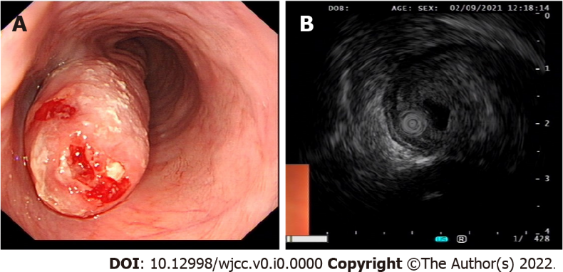
Figure 1 Imaging examinations. A: Gastroscopy showed that a giant mass was located 30 cm from the incisor and extended to the cardia; B: Endoscopic ultrasonography showed that the mass was located in the submucosa, had mixed echo change, and exhibited some inner cystoid structures.

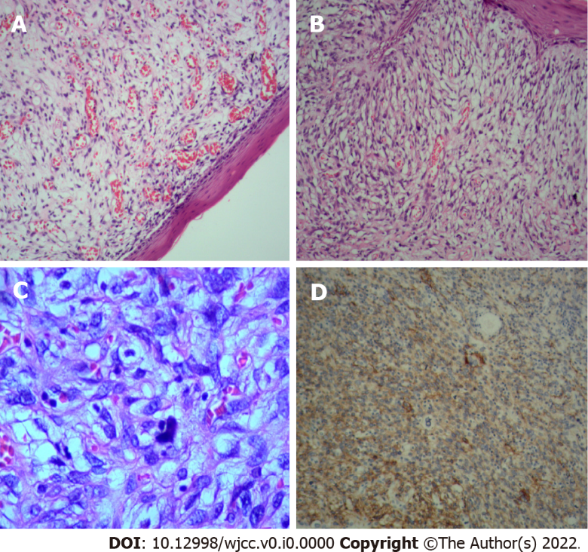
Figure 2 Histologic images of the myxofibrosarcoma. A: Spindle tumor cells; B: Myxoid stroma; C: Karyokinesis; D: Positive vimentin.

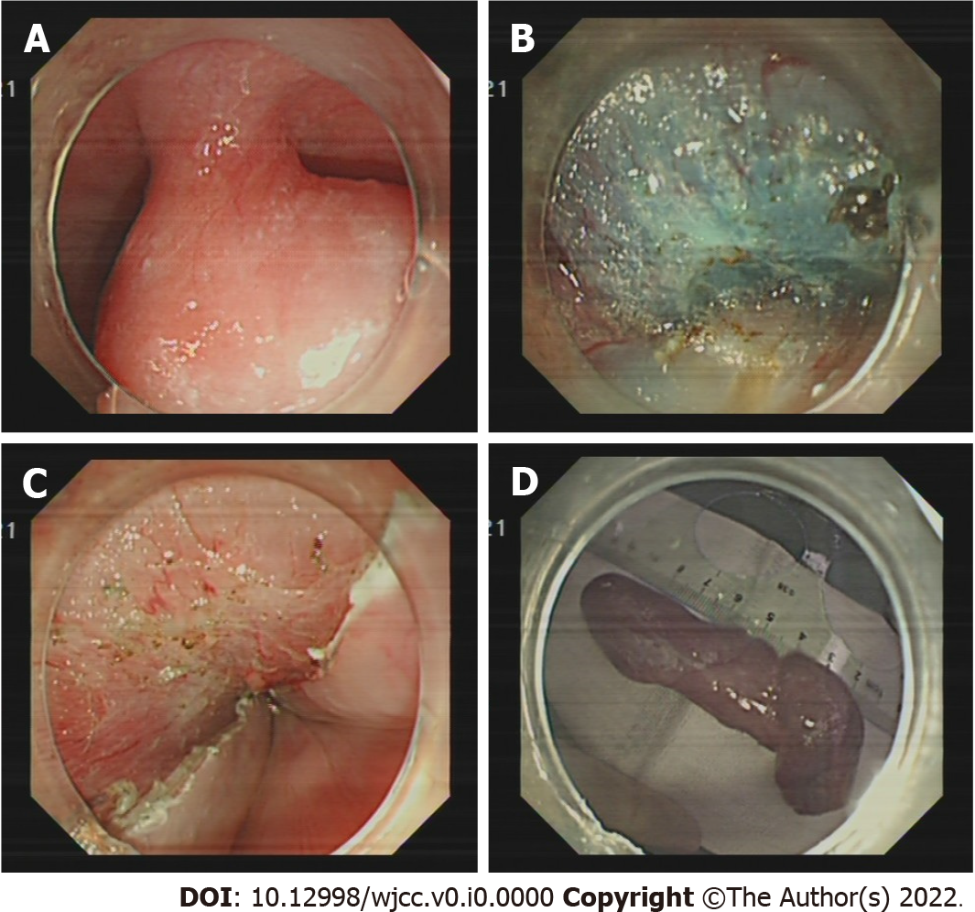
Figure 3 The endoscopic submucosal dissection procedure. A: A submucosal tumor in the esophagus was found and marked; B: Mucosal injection and submucosal precut created using an insulated tip-2 knife; C: The wound surface after removal of the tumor; D: The specimen of the tumor measuring 9.0 cm × 3.0 cm.

