Name of Journal: World Journal of Clinical Cases
Manuscript NO: 43178
Manuscript Type: CASE REPORT

Papillary cystadenoma of the parotid gland: A case report

Wang L et al. Parotid gland papillary cystadenoma

Li Wang, Shi-Kun Zhang, Ying Ma, Patrick K Ha, Zhi-Ming Wang

Li Wang, Shi-Kun Zhang, Zhi-Ming Wang, Department of Oral and Maxillofacial Surgery, Shengjing Hospital of China Medical University, Shenyang 110004, Liaoning Province, China

Ying Ma, Department of Pathology, Shengjing Hospital of China Medical University, Shenyang 110004, Liaoning Province, China

Patrick K Ha, Division of Head and Neck Oncologic and Endocrine Surgery, Department of Otolaryngology-Head and Neck Surgery, University of California-San Francisco, San Francisco, CA 94115, United States

ORCID number: Li Wang (0000-0002-1083-0505); Shi-Kun Zhang (0000-0001-6655-3490); Ying Ma (0000-0001-9821-8857); Patrick K Ha (0000-0003-0306-6147); Zhi-Ming Wang (0000-0002-2381-2461).

Author contributions: Wang L and Wang ZM contributed to the design of the article; Wang L and Zhang SK contributed to the literature review and manuscript drafting and editing; Ha PK, as an English native speaker, contributed to critical revision of the manuscript; all authors approved the final draft submitted.

Supported by Natural Science Foundation of Liaoning Province, No. 20170541042.

Informed consent statement: Informed written consent was obtained from the patient for publication of this report and any accompanying images. The study was reviewed and approved by the Shengjing Hospital of China Medical University Institutional Review Board.

Conflict-of-interest statement: The authors state that they have no conflicts of interest.

CARE Checklist (2016) statement: The authors have read the CARE Checklist (2016), and the manuscript was prepared and revised according to the CARE Checklist (2016).

Open-Access: This article is an open-access article which was selected by an in-house editor and fully peer-reviewed by external reviewers. It is distributed in accordance with the Creative Commons Attribution Non Commercial (CC BY-NC 4.0) license, which permits others to distribute, remix, adapt, build upon this work non-commercially, and license their derivative works on different terms, provided the original work is properly cited and the use is non-commercial. See: http://creativecommons.org/licenses/by-nc/4.0/

Manuscript source: Unsolicited manuscript

Corresponding author: Zhi-Ming Wang, DDS, MD, PhD, Doctor, Professor, Surgeon, Department of Oral and Maxillofacial Surgery, Shengjing Hospital of China Medical University, No. 36, Sanhao Street, Heping District, Shenyang 110004, Liaoning Province, China. wangzm@sj-hospital.org
Telephone: +86-24-9661561515

Received: November 1, 2018
Peer-review started: November 1, 2018
First decision: November 27, 2018
Revised: December 20, 2018
Accepted: December 29, 2018
Article in press: December 30, 2018
Published online: February 6, 2019
Abstract
BACKGROUND
Papillary cystadenoma is a rare benign epithelial tumor of the salivary gland, which is characterized by papillary structures and oncocytic cells with rich eosinophilic cytoplasm. We found only one case of papillary cystadenoma in nearly 700 cases of salivary gland tumors. Our case was initially mistaken for a tumor of the right temporomandibular joint (TMJ) capsule rather than of parotid gland origin. Preoperative magnetic resonance imaging (MRI) and computed tomography (CT) should be carefully studied, which allows for appropriate preoperative counseling and operative planning.

CASE SUMMARY
Here, we report an unusual case of a 54-year-old woman with a parotid gland papillary cystadenoma (PGPC) that was misdiagnosed as a tumor of the right TMJ capsule. She was initially admitted to our hospital due to a mass anterior to her right ear inadvertently found 5 d ago. Preoperative CT and MRI revealed a well circumscribed tumor that was attached to the right TMJ capsule. The patient underwent a resection through an incision for TMJ, but evaluation of an intraoperative frozen section revealed a benign tumor of the parotid gland. Then we removed part of the parotid gland above the temporal facial trunk. The facial nerve was preserved. Postoperative histopathological findings revealed that the tumor was PGPC. No additional treatment was performed. There was no recurrence during a 20-mo follow-up period.

CONCLUSION
The integrity of the interstitial space around the condyle in MRI or CT should be carefully evaluated for parotid gland or TMJ tumors.

Key words: Papillary cystadenoma; Parotid gland; Temporomandibular joint; Case report

© The Author(s) 2019. Published by Baishideng Publishing Group Inc. All rights reserved.

Core tip: We present an unusual parotid gland papillary cystadenoma that was mistaken for a temporomandibular joint (TMJ) tumor. Surgeons should pay particular attention to the integrity of the interstitial space around the condyle in preoperative magnetic resonance imaging and computed tomography. If the space is intact, the mass may come from the parotid gland, otherwise, it is of TMJ origin. The tumor‘s origin determines operative planning and process.

Citation: Wang L, Zhang SK, Ma Y, Ha PK, Wang ZM. Papillary cystadenoma of the parotid gland: A case report. World J Clin Cases 2019; 7(3): 366-372
URL: https://www.wjgnet.com/2307-8960/full/v7/i3/366.htm
DOI: https://dx.doi.org/10.12998/wjcc.v7.i3.366

INTRODUCTION
Cystadenoma is a rare benign epithelial tumor of the salivary gland. It can be divided into mucinous and papillary subtypes^{[1]}. It is mainly characterized by polycystic growth, with the epithelial component showing adenomatous hyperplasia^{[2]}. It can occur in all the salivary glands, and is most commonly seen in the parotid and palatal glands^{[3]}. For many years, the classification of cystadenoma and knowledge about its properties were unclear. Cystadenoma was once known as a cystic duct adenoma or oncocytic cystadenoma. This tumor was described in 1990 by the World Health Organization as a separate entity, which was classified as a subtype of salivary gland tumor^{[4]}. However, in 2005, it was defined as a specific type of salivary gland epithelial tumor^{[5]}. Papillary cystadenoma is easily confused with papillary cystadenoma lymphomatosum (Warthin tumor), due to their histologic similarity: papillary structures and oncocytic cells with rich eosinophilic cytoplasm. However, Warthin tumors are rich in lymphoid stroma. Here, we report a case of papillary cystadenoma of the right parotid gland, which was preoperatively misdiagnosed as a tumor of the temporomandibular joint (TMJ). The main treatment in this case included removal of the entire tumor and locally extended excision of the parotid gland. The histopathological diagnosis was papillary cystadenoma of the parotid gland.

CASE PRESENTATION
Chief complaints
A 54-year-old female patient was initially admitted to our department due to a mass anterior to her right ear inadvertently found for 5 d.

History of present illness
There were no significant changes in size since she found the mass. The patient complained of dull pain when she opened her mouth, but did not take any medicine for it.

History of past illness
At admission, her medical history was otherwise unremarkable.

Personal and family history
The patient was a nonsmoker, without personal or family history of other diseases.

Physical examination upon admission
On physical examination a palpable mass, about 2.5 × 2.0 cm, was found to be located near the right parotid region immediately anterior to the tragus. The mass had unclear boundaries, was fairly immobile, and was not tender.

Laboratory examinations
Laboratory results including complete blood count, electrolytes, and coagulation panels were within normal limits, with a white blood count of 4.21 K/μL, red blood cell count of 4.5 × 10¹²/L, and hemoglobin of 138 G/L.

Imaging examinations
Computed tomography (CT) revealed an occupying lesion just outside the right TMJ capsule. A clear capsule surrounded the mass, which contained cystic structures. The right mandibular condyle showed no evidence of bone destruction (Figure 1). Closed-position magnetic resonance imaging (MRI) revealed symmetrical bilateral TMJs without evidence of bone destruction. T2-weighted scanning showed a mixed polycystic lesion in the lateral right condyle. The mass measured approximately 2.0 × 1.6 cm. Open-position MRI showed stripe-like high-signal images in the right TMJ (Figure 2).

FINAL DIAGNOSIS
The preoperative diagnosis was a tumor in the right TMJ capsule. Although we strongly recommended a fine needle aspiration biopsy before surgery, the patient refused our suggestion due to her deep worry about the tumor spread.

TREATMENT
At surgery, we designed and performed an incision for TMJ, that was a 3 cm preauricular vertical incision and a 3 cm temporal incision in the hair line with an angle of 135° to the preauricular incision as described in the literature^{[6]}. After further dissecting procedures, a cystic mass was found, which was loosely attached to the TMJ capsule. The mass was resected completely without opening the TMJ capsule. It measured approximately 2.0 × 1.5 cm (Figure 3). Evaluation of an intraoperative frozen section revealed a benign tumor of the parotid gland. Because the tumor was located within the upper part of the parotid gland, we decided to remove the part of the parotid gland above the temporal facial trunk. Thus, we extended the vertical incision down to the earlobe and then around it as an S-shaped incision for the parotid gland. After dissection anterior to the surface of the sternocleidomastoid muscle, the main trunk of the facial nerve was exposed. Dissection was performed along the temporal facial trunk, and the upper part of the parotid gland was resected. The facial nerve was preserved. This operation took 105 min and estimated blood loss was 60 mL. The patient’s postoperative course was uneventful. Postoperative histopathological examination found cystic regions that were lined by one to three layers of cuboidal or columnar cells. Multiple papillary projections extended into cyst lumens. The lumens contained eosinophilic material with inflammatory, scattered epithelial and foamy cells. Based on these findings, the patient was diagnosed with parotid gland papillary cystadenoma (PGPC) (Figure 4).

OUTCOME AND FOLLOW-UP
There was no recurrence during a 20-mo follow-up period according to postoperative CT.

DISCUSSION
Cystadenoma has also been reported to occur in intrahepatic bile ducts, the pancreas, ovary, epididymis, and kidney^{[7-11]}. The prevalence of salivary gland papillary cystadenoma is low. In a study of 360 cases of salivary gland tumors, three patients (all female) were found to have cystadenoma of the parotid gland, which accounted for about 0.83% of all study tumors and about 1.0% of the benign study tumors^{[12]}. A review of 30 cases of papillary cystadenoma of the minor salivary glands reported 17 male and 13 female patients^{[13]}. Our study of 700 patients with salivary gland tumors during 2010 to 2016 found only one patient (female) with PGPC, which accounted for about 0.14% of all study tumors and about 0.15% of benign study tumors. We listed the reported cases of PGPC with comparatively complete data between 2009 and 2018 in Table 1^{[3,14-17]}, while solely retrospective studies without detailed data were excluded. Because of the rarity of cystadenoma of the salivary glands, the gender ratio of patients remains unclear and the etiopathogenesis of this disease has not been well discussed in textbooks and other published articles.
The preoperative imaging examinations of our case showed a well circumscribed mass. MRI of the parotid gland revealed a polycystic mass tightly surrounding the lateral and upper sides of the right TMJ capsule, which was misdiagnosed as a tumor of the TMJ capsule. However, during surgery the mass appeared to be a vascular malformation. The frozen section examination showed a benign tumor of the parotid gland that was diagnosed by postoperative histopathology as a papillary cystadenoma of the parotid gland. Therefore, the clinical manifestations and imaging examinations were not adequate for the correct definitive diagnosis. More notably, if the interstitial space around the condyle does not change and margin of the space is smooth in MRI, this indicates that the condyle is not damaged, and the mass is probably free of TMJ origin. Our case reminds surgeons of the utility of preoperative imaging, and surgeons should pay particular attention to the integrity of the interstitial space around the condyle in MRI, which stands for the condyle cortical plate. If the space is intact, the mass may come from the parotid gland, otherwise, it is of TMJ origin. Consequently, preoperative evaluation would potentially lead to a different incision design and an operative plan.
Surgical excision remains the main treatment of choice, despite the benign characteristics of this tumor; and the prognosis is good. Recurrence is seldom seen, with more tumors recurring in major salivary glands than in minor ones. Inadequate removal due to an incomplete capsule or tumor cell infiltration of the parotid gland is probably responsible for recurrence^{[13,18]}. Although cystadenoma of the salivary gland is a benign tumor, postoperative malignant transformation has been reported^{[19]}. A long-standing mass in the parotid gland may compress the facial nerve, causing hemifacial spasms^{[20]}.
The definitive diagnosis is made mainly on the basis of histopathological findings. Histologically, papillary cystadenoma is composed of well-defined unilocular or multilocular cysts, with intraluminal papillary projections^{[21]}. The epithelial cells lining the cystic spaces are cuboidal or columnar, and the cystic structures are separated by a limited amount of interstitial tissue^{[13]}. The differential diagnosis of papillary cystadenoma includes a variety of malignant and benign lesions, including Warthin tumor, intraductal papilloma, cystadenocarcinoma, and oncocytoma^{[13]}. Warthin tumors are rich in lymphoid stroma. Sections of the lesion reveal multiple small cystic regions or a single large cyst surrounded by salivary gland lobules or connective tissue^{[22]}. Intraductal papilloma is composed of dilated cystic ducts with papillary epithelial projections^{[23]}. Oncocytoma is characterized by polyhedral oncocytic cells and absence of papillary projections^{[15]}. Cystadenocarcinomas have structures similar to those of papillary cystadenomas, but cystadenocarcinomas have more cells invading the surrounding connective tissue^{[21,24]}.

CONCLUSION
We present an unusual case of PGPC that was mistaken for a TMJ tumor. Preoperative MRI and CT should be carefully studied for all tumors near this area in order to evaluate the integrity of the interstitial space around the condyle. This allows for appropriate preoperative counseling and operative planning. If possible, preoperative fine needle aspiration should be strongly recommended so as to distinguish the tumor’s nature and origin. In the future, more cases are helpful to learn about this disease.
REFERENCES
1 Mahler V, Schell H. Papillary cystadenoma: a rare tumor of the minor salivary glands. Eur J Dermatol 1999; 9: 387-389 [PMID: 10417444]
2 Lim CS, Ngu I, Collins AP, McKellar GM. Papillary cystadenoma of a minor salivary gland: report of a case involving cytological analysis and review of the literature. Oral Surg Oral Med Oral Pathol Oral Radiol Endod 2008; 105: e28-e33 [PMID: 18155598 DOI: 10.1016/j.tripleo.2007.07.019]
3 Zhang S, Bao R, Abreo F. Papillary oncocytic cystadenoma of the parotid glands: a report of 2 cases with varied cytologic features. Acta Cytol 2009; 53: 445-448 [PMID: 19697734 DOI: 10.1159/000325350]
4 Seifert G, Brocheriou C, Cardesa A, Eveson JW. WHO International Histological Classification of Tumours. Tentative Histological Classification of Salivary Gland Tumours. Pathol Res Pract 1990; 186: 555-581 [PMID: 1962854 DOI: 10.1016/S0344-0338(11)80220-7]
5 Barnes L, Eveson JW, Reichart P, Sidransky D. World Health Organization classification of tumours. Pathology and genetics of head and neck tumours. Lyon: IARC Press 2005; 232–233
6 Qiu YT, Yang C, Chen MJ, Qiu WL. Can a Novel Surgical Approach to the Temporomandibular Joint Improve Access and Reduce Complications? J Oral Maxillofac Surg 2016; 74: 1336-1342 [PMID: 26907557 DOI: 10.1016/j.joms.2016.01.039]
7 Li H, Peng B. Laparoscopic Anatomical Left Hepatectomy for Intrahepatic Bile Duct Papillary Mucinous Cystadenoma With Intraoperative Vascular Repair: A Case Report. Medicine (Baltimore) 2016; 95: e2802 [PMID: 26871845 DOI: 10.1097/MD.0000000000002802]
8 Pravisani R, Intini SG, Girometti R, Avellini C, Leo CA, Bugiantella W, Risaliti A. Macrocystic serous cystadenoma of the pancreas: Report of 4 cases. Int J Surg 2015; 21 Suppl 1: S98-S101 [PMID: 26118606 DOI: 10.1016/j.ijsu.2015.04.097]
9 Singh AK, Singh M. Collision tumours of ovary: a very rare case series. J Clin Diagn Res 2014; 8: FD14-FD16 [PMID: 25584236 DOI: 10.7860/JCDR/2014/11138.5222]
10 Kano H, Adachi Y, Nagahama K, Maeda M, Ishida T. A case of papillary cystadenoma of the epididymis mimicking a testicular tumor. Hinyokika Kiyo 2012; 58: 39-43 [PMID: 22343743]
11 Davidov MI, Ponomareva TB, Liadov AA. [Multiple bilateral papillary cystadenoma of the kidney]. Urologiia 2003; 60-61 [PMID: 12846103]
12 Mejía-Velázquez CP, Durán-Padilla MA, Gómez-Apo E, Quezada-Rivera D, Gaitán-Cepeda LA. Tumors of the salivary gland in Mexicans. A retrospective study of 360 cases. Med Oral Patol Oral Cir Bucal 2012; 17: e183-e189 [PMID: 22143697 DOI: 10.4317/medoral.17434]
13 Tjioe KC, de Lima HG, Thompson LD, Lara VS, Damante JH, de Oliveira-Santos C. Papillary Cystadenoma of Minor Salivary Glands: Report of 11 Cases and Review of the English Literature. Head Neck Pathol 2015; 9: 354-359 [PMID: 25547059 DOI: 10.1007/s12105-014-0602-0]
14 Gupta S, Sodhani P, Jain S, Khurana N, Agarwal PN. Oncocytic papillary cystadenoma of parotid gland: a diagnostic challenge on fine-needle aspiration cytology. Diagn Cytopathol 2011; 39: 627-630 [PMID: 21761584 DOI: 10.1002/dc.21501]
15 Chin S, Kim HK, Kwak JJ. Oncocytic papillary cystadenoma of major salivary glands: Three rare cases with diverse cytologic features. J Cytol 2014; 31: 221-223 [PMID: 25745293 DOI: 10.4103/0970-9371.151140]
16 Alexiev BA, Jennings LJ, Samant S, Rao S. Oncocytic papillary cystadenoma with prominent mucinous differentiation of parotid gland: A case report. Pathol Res Pract 2017; 213: 1310-1314 [PMID: 28756976 DOI: 10.1016/j.prp.2017.06.018]
17 Bajpai M, Pardhe N, Kumar M. Oncocytic Papillary Cystadenoma of Parotid Gland. J Coll Physicians Surg Pak 2018; 28: 814 [PMID: 30266135]
18 Girotra C, Padhye MN, Mahajan P, Nair A. A rare case report of mucinous cystadenoma with immunohistochemical analysis and review of literature. J Maxillofac Oral Surg 2015; 14: 426-434 [PMID: 25861198 DOI: 10.1007/s12663-014-0656-2]
19 Telugu RB, Job AJ, Manipadam MT. Papillary Cystadenocarcinoma of the Parotid Gland: A Rare Case Report. J Clin Diagn Res 2016; 10: ED01-ED03 [PMID: 27504297 DOI: 10.7860/JCDR/2016/17750.7907]
20 Erol O, Aydın E. A Rare Cause of Hemifacial Spasm: Papillary Oncocytic Cystadenoma. Balkan Med J 2016; 33: 569-572 [PMID: 27761290 DOI: 10.5152/balkanmedj.2016.150849]
21 Gallego L, Junquera L, Fresno MF, de Vicente JC. Papillary cystadenoma and cystadenocarcinoma of salivary glands: two unusual entities. Med Oral Patol Oral Cir Bucal 2008; 13: E460-E463 [PMID: 18587312]
22 Goto M, Ohnishi Y, Shoju Y, Wato M, Kakudo K. Papillary oncocytic cystadenoma of a palatal minor salivary gland: A case report. Oncol Lett 2016; 11: 1220-1222 [PMID: 26893722 DOI: 10.3892/ol.2015.3978]
23 Brannon RB, Sciubba JJ, Giulani M. Ductal papillomas of salivary gland origin: A report of 19 cases and a review of the literature. Oral Surg Oral Med Oral Pathol Oral Radiol Endod 2001; 92: 68-77 [PMID: 11458248 DOI: 10.1067/moe.2001.115978]
24 Foss RD, Ellis GL, Auclair PL. Salivary gland cystadenocarcinomas. A clinicopathologic study of 57 cases. Am J Surg Pathol 1996; 20: 1440-1447 [PMID: 8944036 DOI: 10.1097/00000478-199612000-00002]

P-Reviewer: Sridharan G S-Editor: Dou Y L-Editor: Wang TQ E-Editor: Song H

Specialty type: Medicine, Research and Experimental
Country of origin: China
Peer-review report classification
Grade A (Excellent): 0
Grade B (Very good): 0
Grade C (Good): C
Grade D (Fair): 0
Grade E (Poor): 0

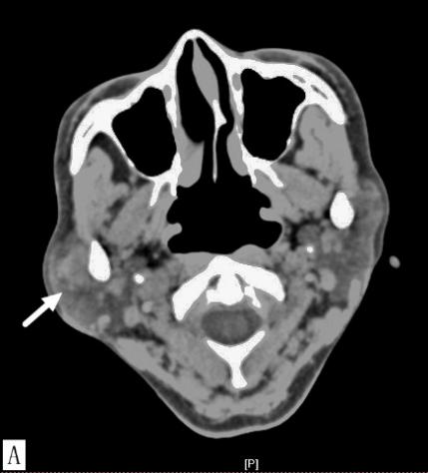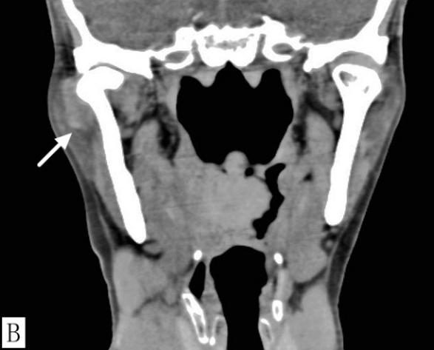
Figure 1 Computed tomography of the right temporomandibular joint. A: Axial computed tomography (CT) scan; B: Coronal CT scan. Axial and corona CT scans showed a clear semilunar mass (white arrow) surrounding the lateral aspect of the right temporomandibular joint (TMJ). The TMJ was free of bony involvement.

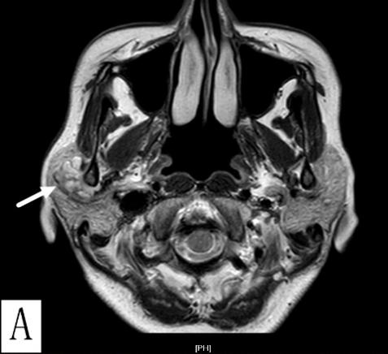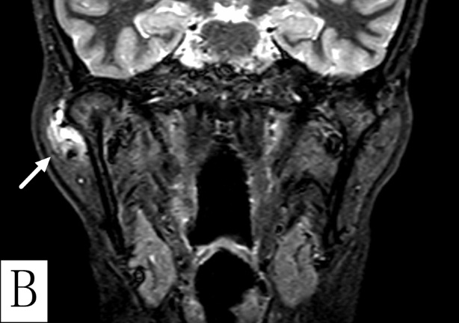
Figure 2 Magnetic resonance imaging of the right temporomandibular joint capsule. A: Axial T2-weighted scan; B: Coronal T2-weighted scan. Axial and coronal T2-weighted scans revealed a hypodense, multicystic, well circumscribed lesion, measuring 2.0 × 1.6 cm (white arrow), attached to the lateral side of the right temporomandibular joint capsule.
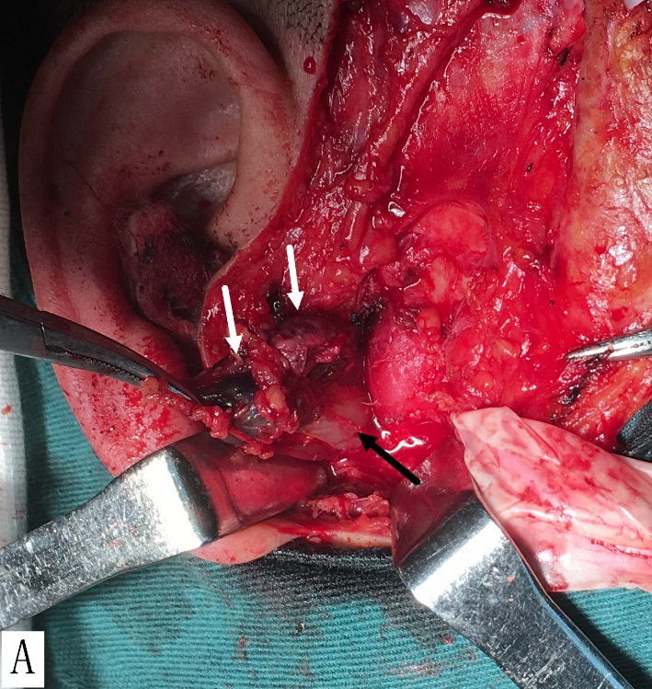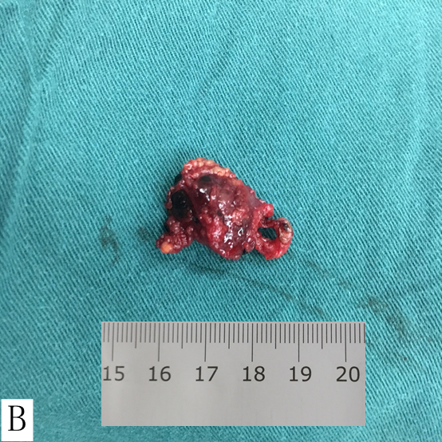
Figure 3 The cystic mass. A: The 2.0 × 1.5 cm mass was located lateral to the temporomandibular joint capsule, deep in the right parotid gland. The mass was soft and dark red in color, similar to a vascular lesion (Mass, white arrow; condyle, black arrow); B: The resected mass.

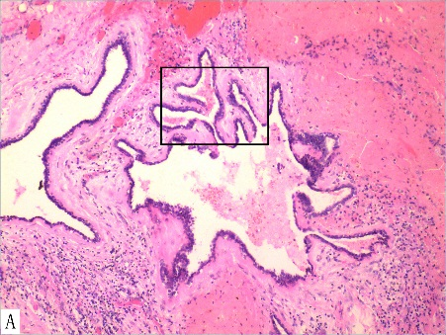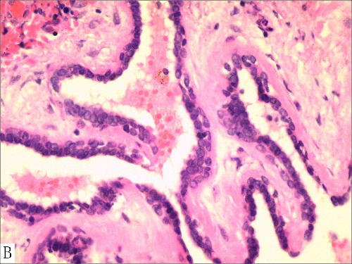
Figure 4 Postoperative histopathology. A: Cystic spaces with papillary projections supported by fibrous connective tissue and underlying capsular connective tissue; (H&E staining: ×100) B: The cystic papillary projections and the major cyst cavity were lined by one to three layers of oncocytic cuboidal or columnar epithelial cells. (H&E staining: ×400).

Table 1 Reported cases of major salivary gland papillary cystadenoma (2009–2018)
Case | Authors | Year | Age | Sex | Location | Symptom duration | Size (cm) | Treatment | Recurrence | Follow-up
1  2  3  4  5  6  7  8  9 | Zhang et al^{[3]}  Zhang et al^{[3]}  Gupta et al^{[14]}  Chin et al^{[15]}  Chin et al^{[15]}  Chin et al^{[15]}  Alexiev et al^{[16]}  Bajpai et al^{[17]}  Wang ZM* | 2009  2009  2011  2014  2014  2014  2017  2018  2018 | 26  52  75  38  84  57  64  54  54 | F  M  M  M  M  M  M  M  F | Right parotid gland  Left parotid gland  Right parotid gland  Right parotid gland  Left parotid gland  Right submandibular Gland  Left parotid gland  Right parotid gland  Right parotid gland | 4 mo  Few  12 mo  1 mo  12 mo  12 mo  3 mo  3 mo  5 d | 2.4  1.5  2.5  2.5  3.1 × 2.7  2.4  3.0 × 2.5  3.5  2.0 × 1.6 | Excision  Excision  Excision  Excision  Excision  Excision  Excision  Excision  Excision | n/r  n/r  n/r  n/r  n/r  n/r  No  n/r  No | n/r  n/r  n/r  n/r  n/r  n/r  2 months  n/r  20 months
*Our case. F: Female; M: male; n/r: Not reported.

