Name of journal: World Journal of Gastroenterology
ESPS Manuscript NO: 4010
Columns: CASE REPORT

DOG1 is useful for diagnosis of KIT-negative gastrointestinal stromal tumor of stomach

Wada T et al. DOG1 is useful for KIT-negative GIST

Takuya Wada, Satoshi Tanabe, Kenji Ishido, Katsuhiko Higuchi, Tohru Sasaki, Chikatoshi Katada, Mizutomo Azuma, Akira Naruke, Myunguchul Kim, Wasaburo Koizumi, Tetsuo Mikami

Takuya Wada, Satoshi Tanabe, Kenji Ishido, Katsuhiko Higuchi, Tohru Sasaki, Chikatoshi Katada, Mizutomo Azuma, Akira Naruke, Myunguchul Kim, Wasaburo Koizumi, Department of Gastroenterology, Kitasato University East Hospital, Kanagawa 252-0380, Japan

Tetsuo Mikami, Department of Pathology, Kitasato University East Hospital, Kanagawa 252-0380 Japan

Author contributions: Wada T, Tanabe S and Ishido K designed and wrote the paper; Higuchi K, Sasaki T, Katada C, Azuma M, Naruke A, Kim M and Koizumi W performed the image diagnosis; Mikami T performed the pathological examinations.

Correspondence to: Kenji Ishido, MD, Department of Gastroenterology, Kitasato University East Hospital, 2-1-1 Asamizodai, Minami-ku, Sagamihara, Kanagawa 252-0380, Japan. k.ishido@kitasato-u.ac.jp

Telephone: +81-42-7489111 Fax: +81-42-7498690

Received: June 7, 2013 Revised: September 24, 2013
Accepted: October 19, 2013

Published online:

Abstract
Approximately 80%-95% of gastrointestinal stromal tumors (GISTs) show positive staining for KIT, while the other 5%-20% show negative staining. If the tumor is negative for KIT, but is positive for CD34, a histological diagnosis is possible. However, if the tumor is negative for KIT, CD34, S-100, and SMA, a definitive diagnosis is often challenging. Recently, Discovered on GIST-1 (DOG1) has received considerable attention as a useful molecule for the diagnosis of GIST. DOG1, a membrane channel protein, is known to be overexpressed in GIST. Because the sensitivity and specificity of DOG1 are higher than those of KIT, positive staining for DOG1 has been reported, even in KIT-negative GISTs. KIT-negative GISTs most commonly arise in the stomach and are mainly characterized by epithelioid features histologically. We described our experience with a rare case of a KIT-negative GIST of the stomach that was diagnosed by positive immunohistochemical staining for DOG1 in a patient who presented with severe anemia. Our findings suggest that immunohistochemical staining for DOG1, in addition to gene analysis, is useful for the diagnosis of KIT-negative tumors that are suspected to be GISTs.
© 2013 Baishideng. All rights reserved.

Key words: KIT negative; Gastrointestinal stromal tumors; DOG1; Platelet-derived growth factor receptor alpha

Core tip: We described our experience with a rare case of a KIT-negative gastrointestinal stromal tumors (GISTs) of the stomach that was diagnosed by positive immunohistochemical staining for discovered on GIST-1 (DOG1) in a patient who presented with severe anemia. Our findings suggest that immunohistochemical staining for DOG1, in addition to gene analysis, is useful for the diagnosis of KIT-negative tumors that are suspected to be GISTs.

Wada T, Tanabe S, Ishido K, Higuchi K, Sasaki T, Katada C, Azuma M, Naruke A, Kim M, Koizumi W, Mikami T. DOG1 is useful for diagnosis of KIT-negative gastrointestinal stromal tumors of the stomach.

Available from:
DOI:

INTRODUCTION
A gastrointestinal stromal tumor (GIST) is a mesenchymal tumor derived from the mesoderm that arises in the gastrointestinal tract. The estimated incidence is 2 cases per 100,000 people per year. The most common age at diagnosis is 50 to 60 years. KIT protein is characteristically expressed by immunohistochemical staining. Gain-of-function mutations of the c-kit gene (approximately 90%) or the platelet-derived growth factor receptor alpha (PDGFRA) gene (approximately 5%) are the major causes of GISTs^{[1]}. Immunohistochemical staining and gene analysis are considered useful for diagnosis, but if the tumor is negative for KIT, CD34, S-100, and SMA, a definitive diagnosis is often challenging. We describe our experience with a patient in whom immunohistochemical staining for discovered on GIST-1 (DOG1) enabled the diagnosis of a KIT-negative GIST^{[2]}.

CASE REPORT
A 60-year-old man was referred to the Department of Gastroenterology of our hospital because of wooziness, shortness of breath on effort, and tarry stools. A blood test showed that the hemoglobin level was 3.6 g/dL, indicating severe anemia. Upper gastrointestinal endoscopy disclosed a submucosal tumor accompanied by an ulcer with an adherent clot, arising in the superior portion of the anterior wall of the gastric antrum (Figure 1). Endoscopic ultrasonography (EUS) revealed a well-demarcated, homogeneous, hypoechoic mass with a flat border. The mass was approximately 4 cm in diameter and arose from the fourth layer of the gastric wall (Figure 2). Endoscopic ultrasound-guided fine needle aspiration biopsy (EUS-FNAB) ^{[3,4]} was performed to obtain a definitive diagnosis and showed aggregations of cells with spindle-like or polygonal nuclei. However, immunohistochemical staining was negative for KIT, CD34, S-100, and smooth muscle actin (SMA). A gastrointestinal stromal tumor (GIST) was strongly suspected, but a definite diagnosis was not reached. Gene analysis could not be performed because the tissue sample was too small. However, the patient had a symptomatic, submucosal tumor with no distinct evidence of distant metastasis or direct invasion on enhanced computed tomography of the chest and abdomen. Surgery was, therefore, indicated according to the clinical practice guidelines for GIST in Japan^{[5]}, and a distal gastrectomy was performed. On macroscopic examination, the surgically resected specimen showed no evidence of bleeding or necrosis. The tumor measured 45 mm in diameter, and the resection margins were tumor negative. Histopathological examination showed that the tumor consisted of mixed components, including diffuse proliferations of spindle cells with eosinophilic cytoplasm, as well as epithelioid cells in some regions. One mitosis was found per 50 high-power fields, and the MIB-1 index was 3%. Immunohistochemical staining was negative for KIT, CD34, S-100, and SMA, but it was positive for vimentin and DOG1, a membrane channel protein (Figure 3). The tissue specimen obtained by EUS-FNA also stained positively for DOG1 (Figure 4). Genetic analysis showed a mutation in exon 18 (D842V) of the platelet-derived growth factor receptor alpha (PDGFRA) gene, with no mutation in the c-kit gene. On the basis of these results, a KIT-negative GIST with low risk according to Fletcher’s classification ^{[6]}, and very low risk according to Miettinen’s classification, was diagnosed ^{[7]}. The patient recovered uneventfully after surgery. As of 3 years after surgery, the patient has followed up on an outpatient basis and remains free of metastasis and recurrence.

DISCUSSION
GIST is a mesenchymal tumor of the mesoderm arising from the interstitial cells of Cajal in the gastrointestinal tract. The most common site is the stomach (60%), followed by the small intestine (30%), duodenum (5%), and large intestine (4%)^{[8]}. GIST can be associated with diverse clinical symptoms, such as gastrointestinal bleeding, abdominal pain, and tumor obstruction. Histopathologically, GIST can be classified into 3 categories: spindle-cell type, epithelioid-cell type, and mixed type. Epithelioid-cell type accounts for approximately 70% of all GISTs, epithelioid-cell type accounts for approximately 20%, and mixed type, as was found in our patient, accounts for approximately 10%^{[8]}.
At present, specific tumor markers for the diagnosis of GIST are unavailable. A definite diagnosis is established by immunostaining tissue specimens obtained by EUS-FNAB or at surgery for KIT, CD34, SMA, desmin, S-100, and Ki-67 ^{[4,6]}. Approximately 80% to 95% of GISTs show positive staining for KIT, while the other 5% to 20% show negative staining. If the tumor is negative for KIT but positive for CD34, a histological diagnosis is possible; however, if the tumor is negative for KIT, CD34, S-100, and SMA, similar to our patient, a definitive diagnosis is often challenging.
Recently, DOG1 has received considerable attention as a useful molecule for the diagnosis of GIST ^{[2]}. DOG1, a membrane channel protein, is known to be overexpressed in GIST. Because the sensitivity and specificity of DOG1 are higher than those of KIT, positive staining for DOG1 has been reported even in KIT-negative GIST^{[9-11]}. KIT-negative GISTs most commonly arise in the stomach and are mainly characterized by epithelioid features histologically. KIT-negative GISTs are often associated with PDGFRA gene mutations ^{[8]}. Rizzardi et al. genetically analyzed a DOG1-positive, KIT-negative GIST of the stomach and reported the presence of a deletion in exon 14 of the PDGFRA gene, with no mutation in the c-kit gene^{[12]}.
In our patient, pathological examination of the surgically resected specimen showed a mixed-type GIST, including epithelioid cells. Immunostaining was negative for both KIT and CD34 but was positive for DOG1. Consistent with these findings, a mutation was found in exon 18 (D842V) of the PDGFRA gene, with no mutation in the c-kit gene. Because the exon18 (D842V) mutation of the PDGFRA gene is resistant to imatinib, sunitinib is prescribed when recurrence is found^{[1,13]}.
In histological specimens obtained by EUS-FNAB before surgery, immunostaining was negative for KIT. A definite diagnosis could not be made. Immunohistochemical staining for DOG1 was additionally performed and showed that the cytoplasm of the tumor cells was positively stained. Hwang et al. reported that DOG1 was a useful marker for the cytologic diagnosis of GIST in tissue specimens obtained by EUS-FNAB^{[14]}. However, one study reported that approximately 30% of KIT-negative GISTs are negative for DOG1, suggesting that tumors suspected to be GIST should be comprehensively evaluated, including analysis of other genes^{[10]}.
We described our experience with a rare case of KIT-negative GIST of the stomach that was diagnosed by positive immunostaining for DOG1 in a patient who presented with severe anemia. Our findings suggest that immunostaining for DOG1, in addition to gene analysis, is useful for the diagnosis of KIT-negative tumors suspected to be GISTs.

REFERENCES
1 Heinrich MC, Corless CL, Demetri GD, Blanke CD, von Mehren M, Joensuu H, McGreevey LS, Chen CJ, Van den Abbeele AD, Druker BJ, Kiese B, Eisenberg B, Roberts PJ, Singer S, Fletcher CD, Silberman S, Dimitrijevic S, Fletcher JA. Kinase mutations and imatinib response in patients with metastatic gastrointestinal stromal tumor. J Clin Oncol 2003; 21: 4342-4349 [PMID: 14645423]
2 Sepe PS, Moparty B, Pitman MB, Saltzman JR, Brugge WR. EUS-guided FNA for the diagnosis of GI stromal cell tumors: sensitivity and cytologic yield. Gastrointest Endosc 2009; 70: 254-261 [PMID: 19482280 DOI: 10.1016/j.gie.2008.11.038]
3 Hoda KM, Rodriguez SA, Faigel DO. EUS-guided sampling of suspected GI stromal tumors. Gastrointest Endosc 2009; 69: 1218-1223 [PMID: 19394006 DOI: 10.1016/j.gie.2008.09.045]
4 Liegl B, Hornick JL, Corless CL, Fletcher CD. Monoclonal antibody DOG1.1 shows higher sensitivity than KIT in the diagnosis of gastrointestinal stromal tumors, including unusual subtypes. Am J Surg Pathol 2009; 33: 437-446 [PMID: 19011564 DOI: 10.1097/PAS.0b013e318186b158]
5 Nishida T, Hirota S, Yanagisawa A, Sugino Y, Minami M, Yamamura Y, Otani Y, Shimada Y, Takahashi F, Kubota T. Clinical practice guidelines for gastrointestinal stromal tumor (GIST) in Japan: English version. Int J Clin Oncol 2008; 13: 416-430 [PMID: 18946752 DOI: 10.1007/s10147-008-0798-7]
6 Fletcher CD, Berman JJ, Corless C, Gorstein F, Lasota J, Longley BJ, Miettinen M, O'Leary TJ, Remotti H, Rubin BP, Shmookler B, Sobin LH, Weiss SW. Diagnosis of gastrointestinal stromal tumors: A consensus approach. Hum Pathol 2002; 33: 459-465 [PMID: 12094370]
7 Miettinen M, Lasota J. Gastrointestinal stromal tumors: pathology and prognosis at different sites. Semin Diagn Pathol 2006; 23: 70-83 [PMID: 17193820]
8 Liegl-Atzwanger B, Fletcher JA, Fletcher CD. Gastrointestinal stromal tumors. Virchows Arch 2010; 456: 111-127 [PMID: 20165865 DOI: 10.1007/s00428-010-0891-y]
9 West RB, Corless CL, Chen X, Rubin BP, Subramanian S, Montgomery K, Zhu S, Ball CA, Nielsen TO, Patel R, Goldblum JR, Brown PO, Heinrich MC, van de Rijn M. The novel marker, DOG1, is expressed ubiquitously in gastrointestinal stromal tumors irrespective of KIT or PDGFRA mutation status. Am J Pathol 2004; 165: 107-113 [PMID: 15215166]
10 Espinosa I, Lee CH, Kim MK, Rouse BT, Subramanian S, Montgomery K, Varma S, Corless CL, Heinrich MC, Smith KS, Wang Z, Rubin B, Nielsen TO, Seitz RS, Ross DT, West RB, Cleary ML, van de Rijn M. A novel monoclonal antibody against DOG1 is a sensitive and specific marker for gastrointestinal stromal tumors. Am J Surg Pathol 2008; 32: 210-218 [PMID: 18223323 DOI: 10.1097/PAS.0b013e3181238cec.]
12 Lee CH, Liang CW, Espinosa I. The utility of discovered on gastrointestinal stromal tumor 1 (DOG1) antibody in surgical pathology-the GIST of it. Adv Anat Pathol 2010; 17: 222-232 [PMID: 20418677 DOI: 10.1097/PAP.0b013e3181d973c2]
11 Rizzardi C, Marzinotto S, Avellini C, Melato M, Mariuzzi L. A KIT-negative, DOG1-positive epithelioid GIST of the stomach harboring a novel PDGFRA exon 14 single nucleotide deletion. Anticancer Res 2012; 32: 1775-1778 [PMID: 22593460]
13 Demetri GD, van Oosterom AT, Garrett CR, Blackstein ME, Shah MH, Verweij J, McArthur G, Judson IR, Heinrich MC, Morgan JA, Desai J, Fletcher CD, George S, Bello CL, Huang X, Baum CM, Casali PG. Efficacy and safety of sunitinib in patients with advanced gastrointestinal stromal tumour after failure of imatinib: a randomised controlled trial. Lancet 2006; 368: 1329-1338 [PMID: 17046465]
14 Hwang DG, Qian X, Hornick JL. DOG1 antibody is a highly sensitive and specific marker for gastrointestinal stromal tumors in cytology cell blocks. Am J Clin Pathol 2011; 135: 448-453 [PMID: 21350101 DOI: 10.1309/AJCP0PPKOBNDT9LB]
P-Reviewers Borges BD, Guo J, Tetsu O S-Editor Zhai HH L-Editor E-Editor

Figure 1 Findings on upper gastrointestinal endoscopy. A submucosal tumor accompanied by an ulcer with an adherent clot was found in the superior portion of the anterior wall of the gastric antrum.

Figure 2 Findings on upper endoscopic ultrasonography. A homogeneous, hypoechoic, well-demarcated mass, approximately 4 cm in diameter with a flat border, arising from the fourth layer of the gastric wall.
A B
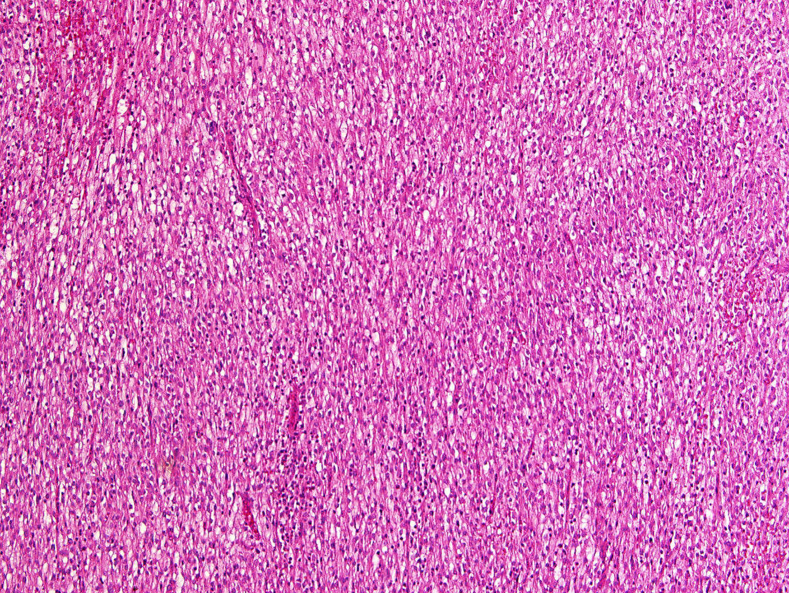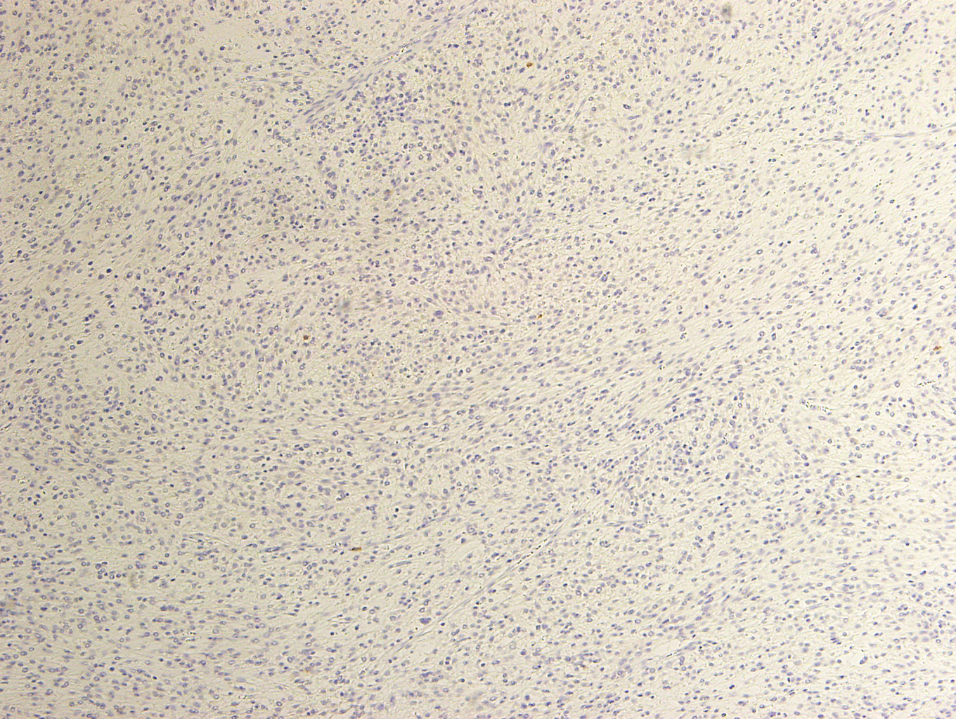
C D
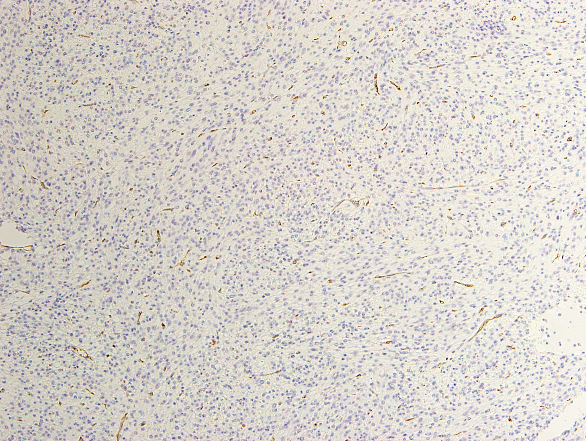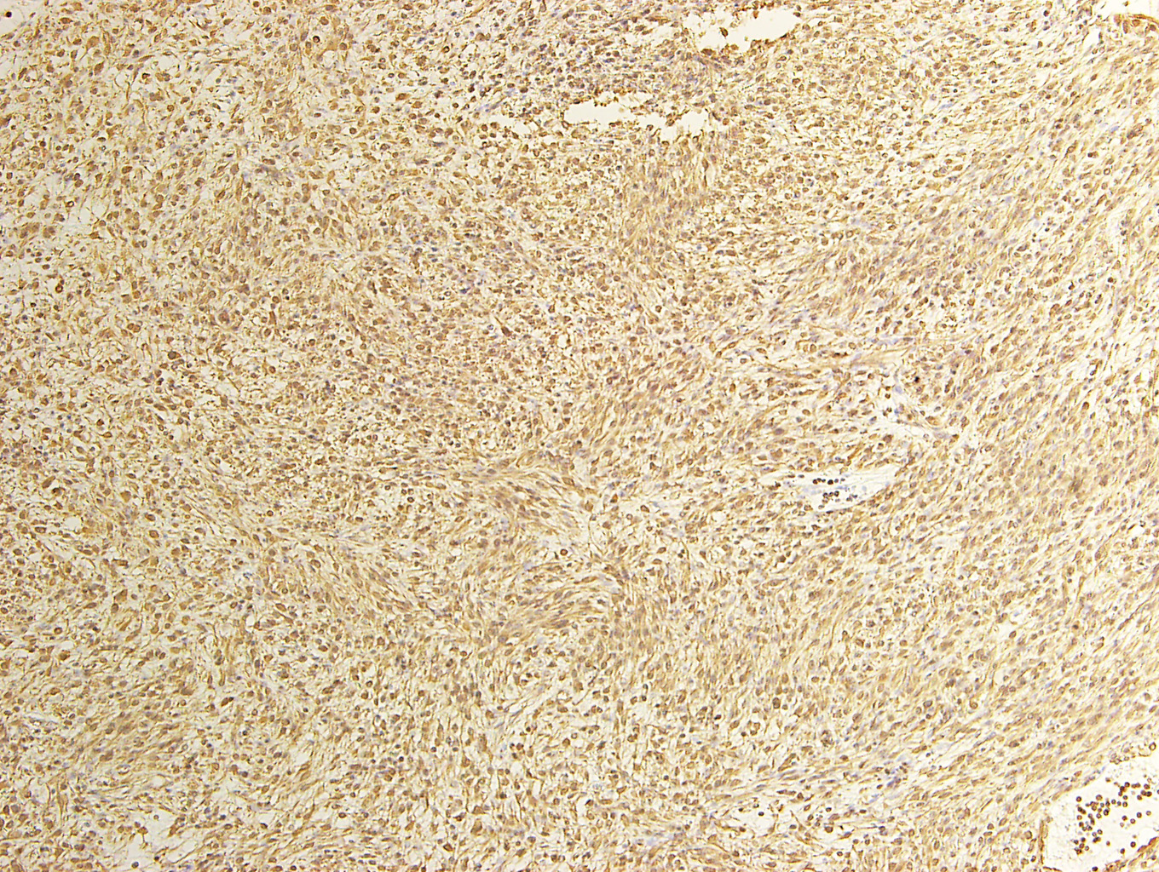
E F
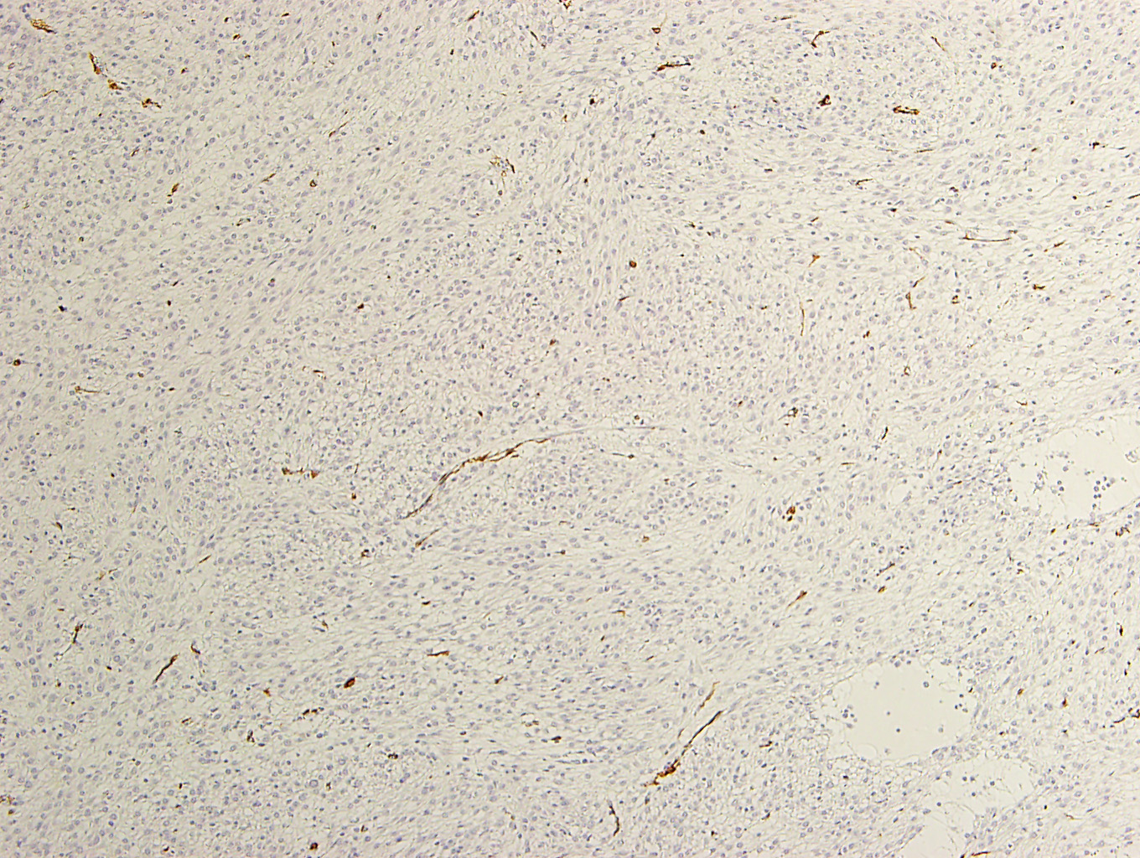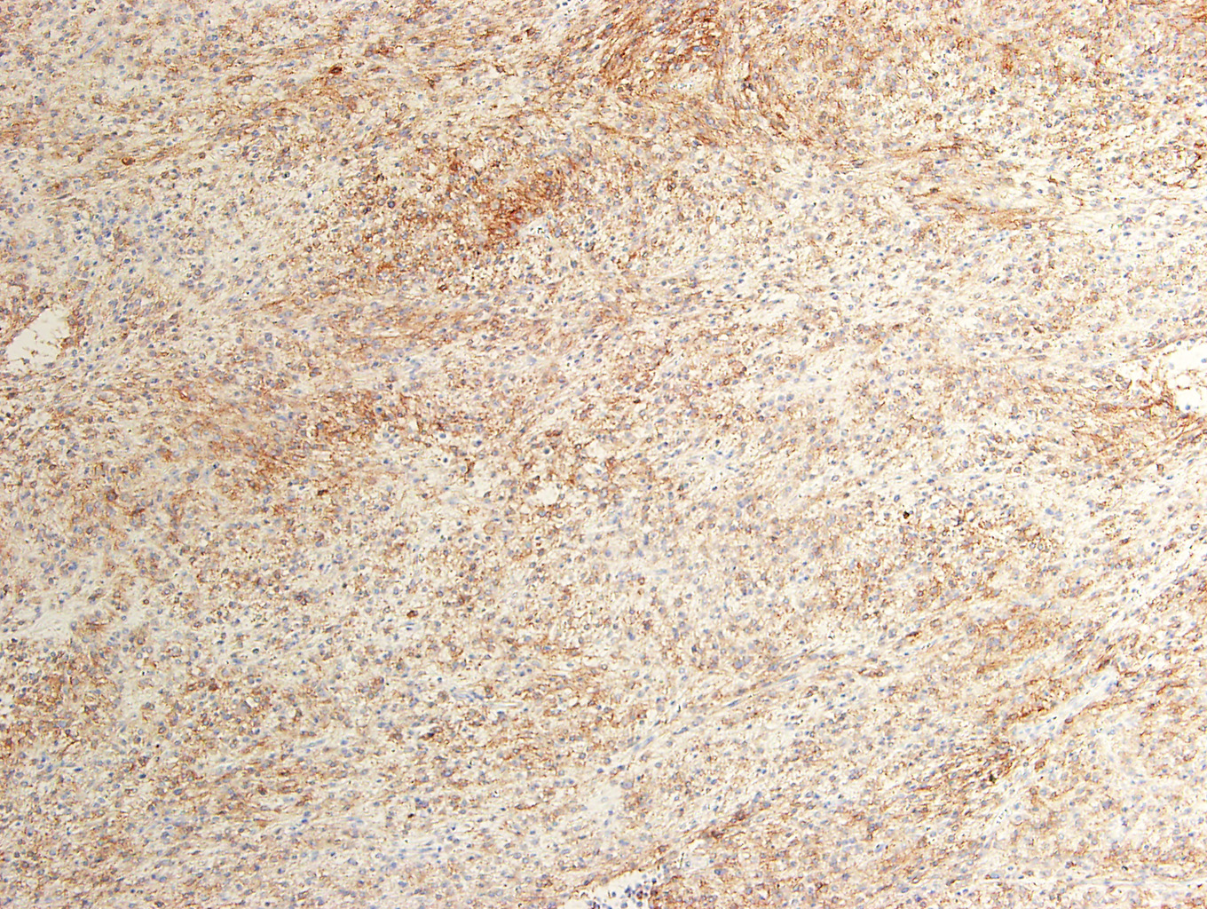
Figure 3 Histopathological findings of the surgically resected specimen.
A: Hematoxylin and eosin staining (×100). The tumor consisted of mixed components, including spindle cells with eosinophilic cytoplasm, as well as epithelioid cells in some regions; B: KIT staining (×100), KIT staining was negative; C: CD34 staining (×100),CD34 staining was negative; D: Vimentin staining (×100); vimentin staining was positive. E: Smooth muscle actin (SMA) staining (×100), SMA staining was negative; F: DOG1 staining (×100); Immunostaining for DOG1 was positive mainly in the cell membrane and cytoplasm.

A B
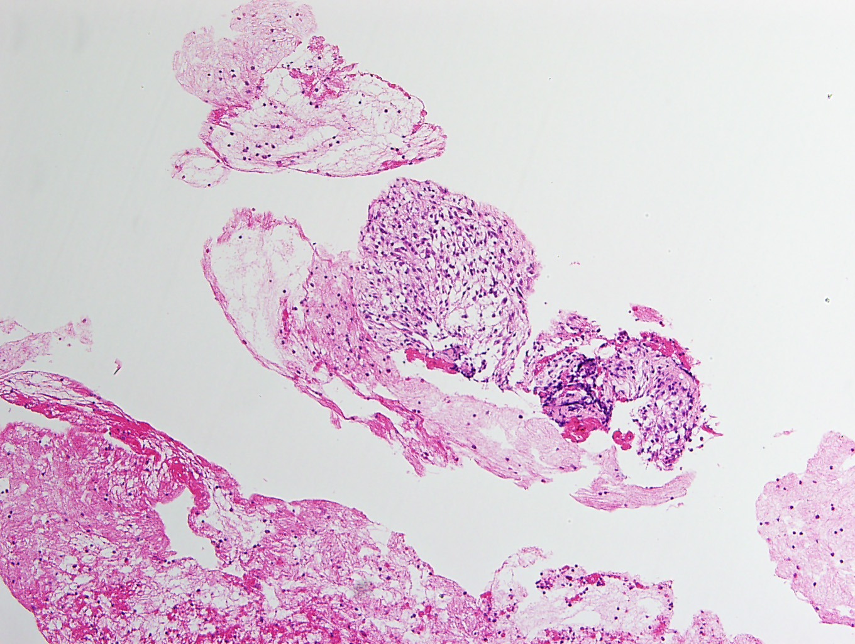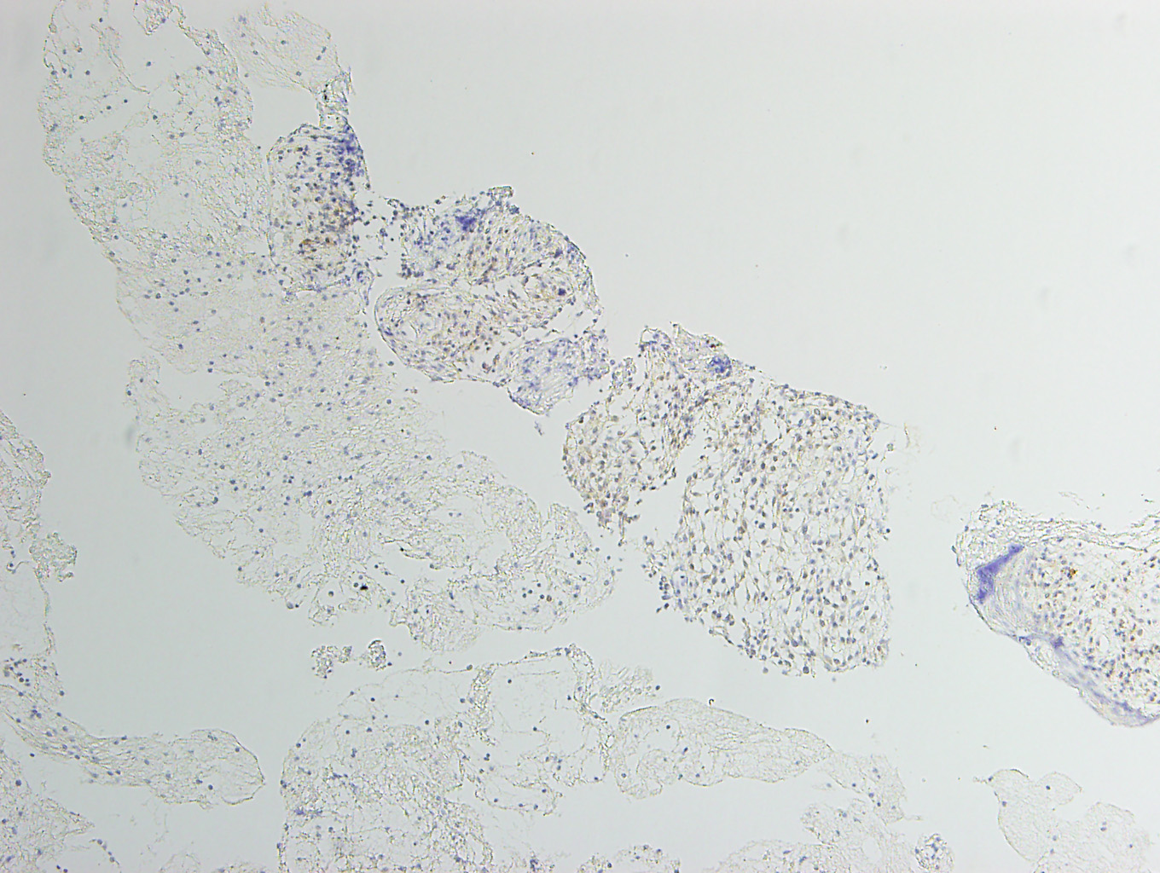
C
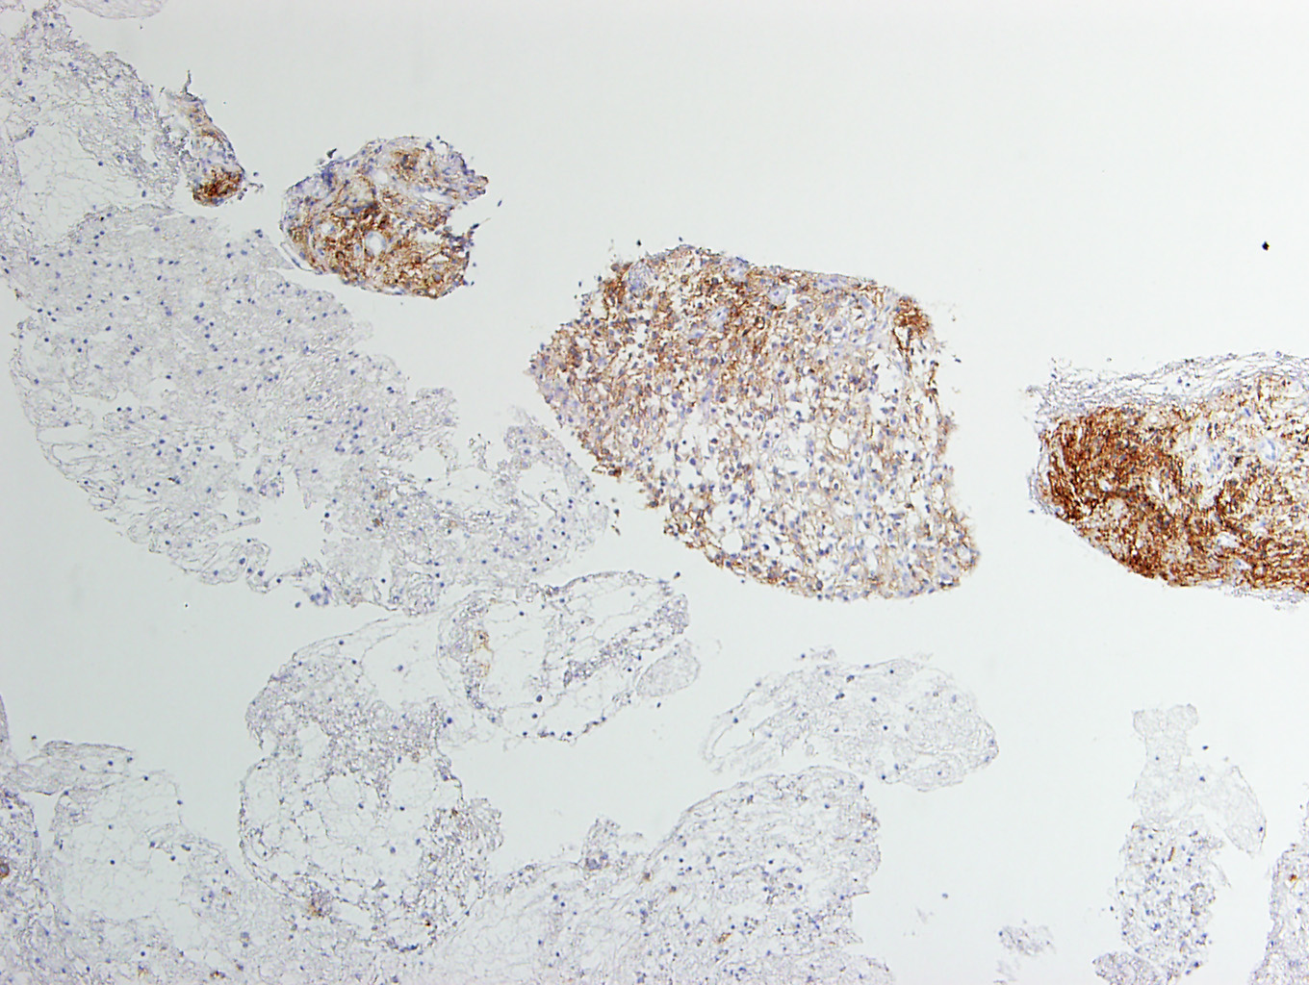

Figure 4 Histopathological findings (specimen obtained by endoscopic ultrasound-guided fine needle aspiration biopsy). A: Hematoxylin and eosin staining (×100).The tumor consisted of mixed components, consisting of spindle cells with eosinophilic cytoplasm, as well as cells with epithelioid features in some regions; B: KIT staining (×100), KIT staining was negative; C: DOG1 staining (×100). Immunostaining for DOG1 was positive mainly in the cell membrane and cytoplasm.

