Name of Journal: World Journal of Clinical Cases
Manuscript NO: 63319
Manuscript Type: CASE REPORT

Clinical observation of pediatric-type follicular lymphomas in adult: Two case reports

Yao L et al. Clinical observation of PTFL in adult

Yao Liu, Hui Xing, Yue-Ping Liu

Yao Liu, Hui Xing, Yue-Ping Liu, Department of Pathology, The Fourth Hospital of Hebei Medical University, Shijiazhuang 050000, Hebei Province, China

Author contributions: Liu Y analyzed and interpreted the patient data and drafted the article; Xing H collected the data and contributed to manuscript writing; Liu YP performed the histological examination; Liu YP was in charge of the imaging data analysis; Liu YP reviewed the paper and put forward constructive suggestions; All authors read and approved the final version of the manuscript.

Supported by the Special Fund of Hebei Provincial Finance Department, No. 2016034942.

Corresponding author: Yue-Ping Liu, MD, PhD, Director, Doctor, Professor, Senior Scientist, Department of Pathology, The Fourth Hospital of Hebei Medical University, No. 12 Jiankang Road, Shijiazhuang 050000, Hebei Province, China. annama@163.com

Received: January 27, 2021
Revised: July 22, 2021
Accepted: September 22, 2021
Published online:

Abstract
BACKGROUND
Pediatric-type follicular lymphoma (PTFL) is a unique pathological type in the 4th edition of hematopoiesis and lymphoid tissue tumor classification revised by World Health Organization. It is unique in clinical practice and seldom seen in adult. PTFL mainly occurs in the head and neck lymph nodes. Most of the cases are short of fever, night sweat, weight loss, and other B symptoms which substitute for lymphadenopathy as the main symptom. PTFL can be disposed of surgical resection and it can achieve long-term tumor-free survival, and it has an excellent outcome.

CASE SUMMARY
Two cases of PTFL were reported and their clinicopathological features, differential diagnosis, therapy and prognosis were discussed. PTFL showed gray-brown tough texture in general performance. The histological manifestations of PTFL were similar to that of adult-follicular lymphoma (FL). Under low power microscope, the structure of lymph nodes was destroyed in different degree, the follicles were closely arranged, expanded and irregular, and the mantle zone became thin or disappeared. In addition, the “starry sky phenomenon” could be seen. At high magnification, the follicles were mainly composed of single medium-sized central cells, and some of them mainly consisted of centroblastic cells to characterize scattered chromatin and inconspicuous nucleoli. Immunohistochemical showed the tumor cells expressed CD20, PAX5, CD79a and CD10, BCL6, FOXP-1, which were limited in germinal center; Ki-67 was highly expressed in germinal center. CD21 and CD23 showed nodular and expanded follicular dendritic cells. Immunoglobulin gene rearrangement was positive for IGH and IGK. The two patients underwent surgical resection with no complications. After discharge, the two patients with a close review for 18 mo and 5 mo respectively and showed no evidence of recurrence.

CONCLUSION
PTFL in adult is generally supposed to be extremely rare. PTFL displayed characteristic morphological, immunophenotypic, and molecular biological changes which are a kind of neoplasm with satisfactory prognosis after surgical excision.

Key Words: Pediatric-type follicular lymphoma; Adult; Clinical pathology; Diagnosis; Immunophenotype; Case report

Liu Y, Xing H, Liu YP. Clinical observation of pediatric-type follicular lymphomas in adult: Two case reports. World J Clin Cases 2021; In press

Core Tip: Pediatric-type follicular lymphoma (PTFL) is a unique type of follicular lymphoma, which occurs in childhood and adolescents frequently. PTFL is unique in clinical practice and seldom seen in adult. It has unique clinical and pathological characteristics, which is different from the pathological type of FL in adult. Through the discussion of the cases, we can deepen our understanding of the disease.
INTRODUCTION
Pediatric-type follicular lymphoma (PTFL) is a unique type of follicular lymphoma (FL), which occurs in childhood and adolescents frequently. PTFL is unique in clinical practice and seldom seen in adult. It accounts for 1%-2% of all non-Hodgkin's lymphoma (NHL) cases in childhood approximately^{[1]}. PTFL was classified as a subtype of FL, that is FL occurs in childhood over the past few years. In 2017, the novel classification of hematopoiesis and lymphoid tissue tumor of World Health Organization (WHO) distinguished it from FL. It is suggested that PTFL revealed unique clinical and pathological characteristic that are a distinctive pathological type from adult-FL^{[2]}.

CASE PRESENTATION
Chief complaints
Case 1: A 43-year-old male patient presented with posterior occipital scalp mass.

Case 2: A 37-year-old male patient presented with left cervical lymphadenectasis.

History of present illness
Case 1: The male had no apparent inducement to appear posterior occipital scalp mass half a year ago, with the size of 1 cm × 1 cm × 1 cm. The male had no apparent discomfort, local skin fever, local skin variation, and exceptional treatment.

Case 2: The male had no apparent cause of left cervical lymph node enlargement half a year ago and with the size of 3 cm × 2 cm × 2 cm approximately. The male had no apparent indisposition, local skin fever and local skin variation.

History of past illness
Case 1: The patient had an insignificant medical history.

Case 2: The patient had an insignificant medical history.

Personal and family history
These two patients had insignificant personal and family history.

Physical examination
No obvious abnormality.

Laboratory examinations
Pathological findings: (1) Visual inspection: As seen by naked eyes, nodule like substance in size of 2 cm × 1.5 cm × 1.5 cm and with a smooth surface, gray-brown tough texture, no bleeding or necrosis region; (2) Microscope observation: PTFL was similar to that of FL, the lymph node structure was destroyed partially or completely, the follicles were arranged closely, expanded and irregular. The mantle zone was thin or disappeared and the follicles were lack of polarity. The bright and dark area was inconspicuous, and the “starry sky phenomenon” could be seen under the low power microscope (Figure 1A). Under the high power microscope, the follicle mainly consists of single medium-sized central cells, some of which are centroblastic cells to characterize scattered chromatin and inconspicuous nucleoli. The histological grade was by following per under the grade 3 standard of FL (Figure 1B); (3) Immunohistochemical staining demonstrated that tumor cells expressed CD20, PAX5, CD79a (B cell markers) and CD10 (Figure 1C), BCL6 (Figure 1D), FOXP-1 (germinal center markers) which were limited to germinal center; IRF4, BCL2 (Figure 1E) and MUM1 were negative; Ki-67 was highly expressed in germinal center (Figure 1F); CD21 and CD23 revealed nodular and expanded follicular dendritic cells (FDC); and (4) Immunoglobulin gene rearrangement was positive for IGH (Figure 2A) and IGK (Figure 2B). BCL2, BCL6 and MYC genes were negative (Figure 3A-C).

Imaging examinations
Case 1: Ultrasound inspection displayed a hypoechoic nodule in the rear of the neck. It had no apparent enlarged lymph nodes were found in the bilateral perivascular neck, supraclavicular fossa and thoracoabdominal region.

Case 2: Ultrasonography of thyroid and cervical lymph nodes revealed hypoechoic left supraclavicular fossa. There was no else superficial lymph node enlargement.

FINAL DIAGNOSIS
Based on the above imaging examinations and pathological findings, two patients were diagnosed with PTFL and confirmed by immunoglobulin (IG) gene rearrangement.

TREATMENT
The two patients underwent surgical resection, the strategy of observation was adopted in the follow-up.

OUTCOME AND FOLLOW-UP
Case 1 was followed up for 25 mo and case 2 was followed up for 10 mo without recurrence. Two patients come to the hospital regularly for reexamination.

DISCUSSION
PTFL was a unique clinicopathological type in the fourth edition of hematopoiesis and lymphoid tissue tumor classification revised by WHO^{[2]}. Although PTFL was found in childhood initially and accounting for 1%-2% of all childhood with NHL approximately, but it was discovered that it can be seen in adolescent afterwards, even less in the adult^{[1]}. The median age showed between 7.5 to 14 years old, and most of which were males (male to female ratio > 10:1)^{[3,4]}. Currently, PTFL is considered a lymph node disease that most often arises in the head and neck lymph nodes. It usually isolated peripheral lymph nodes and less involved in the groin and axillary lymph nodes^{[1,5]}. Most of the cases are short of fever, night sweat, weight loss, and other B symptoms which substitute for lymphadenopathy as the main symptom. On account of the differences in histopathological features, molecular structure and clinical behavior, the revised WHO hematopoiesis and lymphoid tissue tumors of the fourth edition excluded the cases of extranodal FL, that including testis, epididymis, gastrointestinal tract, and kidney, which were reported as PTFL previously^{[1]}. Another tumor that should be excluded is a novel tumor namely large B-cell lymphoma with IRF4 gene rearrangement^{[1,6]} which usually occurs in the pharyngeal lymph ring and/or cervical lymph nodes, but it may also occur in the gastrointestinal tract. The tumor growth pattern can be diffuse or follicular hyperplasia or both. Histologically, PTFL was replaced by an enlarged follicular structure partially or completely. Under the low power microscope, there were irregular lymphoid follicles characterize of different sizes and shapes. The germinal center displayed a “starry sky phenomenon” and without a clear distinction between bright and dark areas. In some cases, marginal zone differentiation could be seen around the tumor follicles. The mantle area was thinned or disappeared, the follicles were short of polarity, and some areas were diffuse hyperplasia of lymphoid tissue. In terms of cell morphology, PTFL had a large number of high-grade cells more often than not (so in the old days, the histological grade of this kind cases were mostly 3a or 3b, but in the fourth edition classification, PTFL was isolated, and the grading standard of adult follicular lymphoma was no longer used)^{[1]}. The cell-rich tumor area had a single cell composition, it mainly consisted of medium-sized blastoid cells which characterize the irregular nucleus and unclear nucleolus. The mitosis was easy to found, and some cases contain more typical immature centroblastic cells^{[7]}. In terms of immunophenotype, tumor cells expressed mature B cell markers, namely CD20, PAX5, and CD79a. CD10, BCL6, FOXP-1 were frequently strongly positive^{[8]}. BCL2 was not expressed in most cases, but in a few cases, it could reveal weakly positive^{[9]}. Ki-67 demonstrated a medium to high proliferative activity. CD21 and CD23 revealed nodular and dilated FDC in the follicle. Negative IGD can reveal the disappearance or thinness of the mantle zone. IRF4/MUM1 was usually negative, for which in the event of strongly positive, it might be large B-cell lymphoma with IRF4 rearrangement^{[10]}. In terms of molecular genetics, the IG gene was positive in respect of clonal rearrangement, which was a benefit to differentiate it from most reactive follicular hyperplasia. BCL2, BCL6 and IRF4 genes were normal and short of KMT2D (MLL2), CREBBP, EZH2 genes mutation in FL^{[11]}. The most common gene abnormalities were 1p36 deletion and TNFRSF14/MAP2K1 mutation^{[1,12]}. Although the hot spot mutation (K66R, p.L66A) of IRF8 was rarely reported, it seems to be only one in PTFL^{[8]}.
PTFL should be differentiated from FL, large B-cell lymphoma with IRF4 rearrangement, lymphoid node marginal zone lymphoma in children (NMZL), lymph nodes involvement by B-lymphoblastic leukemia/Lymphoblastic lymphoma, and reactive follicular hyperplasia. FL was usually found in middle-aged and elderly people, and the enlarged germinal center had no "starry sky phenomenon" frequently. In respect of immunohistochemistry displayed that tumor cells usually expressed BCL2 and BCL2 gene amplification. Large B-cell lymphoma with IRF4 rearrangement may also reveal nodular hyperplasia under a microscope. In terms of immunohistochemical, the tumor cells expressed B-cell markers, namely CD20, CD79a and PAX5. Furthermore, it can also express MUM1 (IRF4), and it had an abnormal IRF4 gene. The BCL2 of the tumor usually negative^{[13]}. The clinical manifestations of pediatric NMZL in children were similar to that of PTFL, but the mantle cells of NMZL extend into the follicles, it similar to that of the germinal center of progressive transformation. Large and irregular margin follicles can be found in the lymph nodes of NMZL, and the marginal and interfollicular areas were enlarged, some cases were accompanied by plasma cell differentiation^{[14]}. B lymphoblastic leukemia/Lymphoblastic lymphoma was mainly characterized by immature, single, and diffuse proliferation of medium-sized lymphocytes under a microscope. It usually without apparent nodular hyperplasia and often involving multiple system lymph nodes of the whole body. In terms of immunohistochemical, the tumor cells expressed CD79a, while CD20 was usually weakly positive or negative. TDT and CD43 were strongly positive. BCL2 was not expressed in the follicular germinal center of reactive hyperplasia, Ki-67 proliferation was high and the germinal center was completely outlined. The proliferative small lymphocytes in the interfollicular did not express CD10 and it had not the clonal rearrangement of IG by genetic discovery.
PTFL can be treated by surgical excision and it can combine with low-dose chemotherapy/radiotherapy, or adopting the strategy of "observation and waiting". PTFL usually be in early clinical stage, the long-term tumor-free survival can be obtained after surgical resection, and PTFL is a kind of neoplasm with a satisfactory prognosis.

CONCLUSION
PTFL in adult is generally supposed to be extremely rare. PTFL displayed characteristic morphological, immunophenotypic, and molecular biological changes which are a kind of neoplasm with satisfactory prognosis after surgical excision. To avoid misdiagnosis, differential diagnosis plays a crucial role in clinical practice.

ACKNOWLEDGEMENTS
The authors thank all the clinicians and nurses involved in the treatment of this case and thank other members of the Department of Pathology, Fourth Hospital of Hebei Medical University.

REFERENCES
1 Attarbaschi A, Beishuizen A, Mann G, Rosolen A, Mori T, Uyttebroeck A, Niggli F, Csoka M, Krenova Z, Mellgren K, Kabickova E, Chiang AK, Reiter A, Williams D, Burkhardt B; European Intergroup for Childhood Non-Hodgkin Lymphoma (EICNHL) and the international Berlin-Frankfurt-Münster (i-BFM) Study Group. Children and adolescents with follicular lymphoma have an excellent prognosis with either limited chemotherapy or with a "Watch and wait" strategy after complete resection. Ann Hematol 2013; 92: 1537-1541 [PMID: 23665980 DOI: 10.1007/s00277-013-1785-2]
2 Jaffe ES, Harris NL, Siebert R. Paediatric-typefollicular lymphoma. In: Swerdlow SH, Campo E, Harris NL, Jaffe ES, Pileri SA, Stein H, Thiele J. WHO Classification of Tumours of Haematopoietic and Lymphoid Tissues. Lyon: IARC Press, 2017: 278-279.
3 Quintanilla-Martinez L, Sander B, Chan JK, Xerri L, Ott G, Campo E, Swerdlow SH. Indolent lymphomas in the pediatric population: follicular lymphoma, IRF4/MUM1+ lymphoma, nodal marginal zone lymphoma and chronic lymphocytic leukemia. Virchows Arch 2016; 468: 141-157 [PMID: 26416032 DOI: 10.1007/s00428-015-1855-z]
4 Schmidt J, Gong S, Marafioti T, Mankel B, Gonzalez-Farre B, Balagué O, Mozos A, Cabeçadas J, van der Walt J, Hoehn D, Rosenwald A, Ott G, Dojcinov S, Egan C, Nadeu F, Ramis-Zaldívar JE, Clot G, Bárcena C, Pérez-Alonso V, Endris V, Penzel R, Lome-Maldonado C, Bonzheim I, Fend F, Campo E, Jaffe ES, Salaverria I, Quintanilla-Martinez L. Genome-wide analysis of pediatric-type follicular lymphoma reveals low genetic complexity and recurrent alterations of TNFRSF14 gene. Blood 2016; 128: 1101-1111 [PMID: 27257180 DOI: 10.1182/blood-2016-03-703819]
5 Louissaint A Jr, Schafernak KT, Geyer JT, Kovach AE, Ghandi M, Gratzinger D, Roth CG, Paxton CN, Kim S, Namgyal C, Morin R, Morgan EA, Neuberg DS, South ST, Harris MH, Hasserjian RP, Hochberg EP, Garraway LA, Harris NL, Weinstock DM. Pediatric-type nodal follicular lymphoma: a biologically distinct lymphoma with frequent MAPK pathway mutations. Blood 2016; 128: 1093-1100 [PMID: 27325104 DOI: 10.1182/blood-2015-12-682591]
6 Pittaluga S, Harris NL, Siebert R, Salaverria I. IRF4 B-cell lymphoma with IRF4 rearrangment. In: Swerdlow SH, Campo E, Harris NL, Jaffe ES, Pileri SA, Stein H, Thiele J (Eds): WHO Classification of Tumours of Haematopoietic and Lymphoid Tissues. Lyon: IARC Press, 2017: 280-281
7 Attarbaschi A, Abla O, Arias Padilla L, Beishuizen A, Burke GAA, Brugières L, Bruneau J, Burkhardt B, d'Amore ESG, Klapper W, Kontny U, Pillon M, Taj M, Turner SD, Uyttebroeck A, Woessmann W, Mellgren K. Rare non-Hodgkin lymphoma of childhood and adolescence: A consensus diagnostic and therapeutic approach to pediatric-type follicular lymphoma, marginal zone lymphoma, and nonanaplastic peripheral T-cell lymphoma. Pediatr Blood Cancer 2020; 67: e28416 [PMID: 32452165 DOI: 10.1002/pbc.28416]
8 Agostinelli C, Akarca AU, Ramsay A, Rizvi H, Rodriguez-Justo M, Pomplun S, Proctor I, Sabattini E, Linch D, Daw S, Pittaluga S, Pileri SA, Jaffe ES, Quintanilla-Martinez L, Marafioti T. Novel markers in pediatric-type follicular lymphoma. Virchows Arch 2019; 475: 771-779 [PMID: 31686194 DOI: 10.1007/s00428-019-02681-y]
9 Zhang H, Sun S, Zhang B, Yang H. An unusual case of pediatric-type follicular lymphoma: A case report. Medicine (Baltimore) 2019; 98: e17567 [PMID: 31593142 DOI: 10.1097/MD.0000000000017567]
10 Sukswai N, Lyapichev K, Khoury JD, Medeiros LJ. Diffuse large B-cell lymphoma variants: an update. Pathology 2020; 52: 53-67 [PMID: 31735345 DOI: 10.1016/j.pathol.2019.08.013]
11 Zhou Y, Shi YK. [Progress in the research of gene mutations in follicular lymphoma]. Zhonghua Xue Ye Xue Za Zhi 2020; 41: 172-176 [PMID: 32135639 DOI: 10.3760/cma.j.issn.0253-2727.2020.02.018]
12 Schmidt J, Ramis-Zaldivar JE, Nadeu F, Gonzalez-Farre B, Navarro A, Egan C, Montes-Mojarro IA, Marafioti T, Cabeçadas J, van der Walt J, Dojcinov S, Rosenwald A, Ott G, Bonzheim I, Fend F, Campo E, Jaffe ES, Salaverria I, Quintanilla-Martinez L. Mutations of MAP2K1 are frequent in pediatric-type follicular lymphoma and result in ERK pathway activation. Blood 2017; 130: 323-327 [PMID: 28533310 DOI: 10.1182/blood-2017-03-776278]
13 Chapman JR, Alvarez JP, White K, Sanchez S, Khanlari M, Algashaamy K, Cassidy D, Peng JH, Fan YS, Alencar A, Alderuccio JP, Lossos IS, Vega F. Unusual Variants of Follicular Lymphoma: Case-based Review. Am J Surg Pathol 2020; 44: 329-339 [PMID: 31688142 DOI: 10.1097/PAS.0000000000001399]
14 Bai DY, Xie JL, Zheng YY, Zhang YL, Ma DY, Zhou XG. [Paediatric nodal marginal zone lymphoma: a clinicopathological study of seven cases]. Zhonghua Bing Li Xue Za Zhi 2019; 48: 369-372 [PMID: 31104676 DOI: 10.3760/cma.j.issn.0529-5807.2019.05.007]

Footnotes
Informed consent statement: The patient provided informed written consent prior to study enrollment.

Conflict-of-interest statement: The authors declare that they have no competing interests to report.

CARE Checklist (2016) statement: The authors have read the CARE Checklist (2016), and the manuscript was prepared and revised according to the CARE Checklist (2016).

Open-Access: This article is an open-access article that was selected by an in-house editor and fully peer-reviewed by external reviewers. It is distributed in accordance with the Creative Commons Attribution NonCommercial (CC BY-NC 4.0) license, which permits others to distribute, remix, adapt, build upon this work non-commercially, and license their derivative works on different terms, provided the original work is properly cited and the use is non-commercial. See: http://creativecommons.org/Licenses/by-nc/4.0/

Manuscript source: Unsolicited manuscript

Peer-review started: January 27, 2021
First decision: July 16, 2021
Article in press:

Specialty type: Hematology
Country/Territory of origin: China
Peer-review report’s scientific quality classification
Grade A (Excellent): 0
Grade B (Very good): 0
Grade C (Good): C
Grade D (Fair): 0
Grade E (Poor): 0

P-Reviewer: Popa-Fotea NM S-Editor: Zhang H L-Editor: P-Editor:
Figure Legends
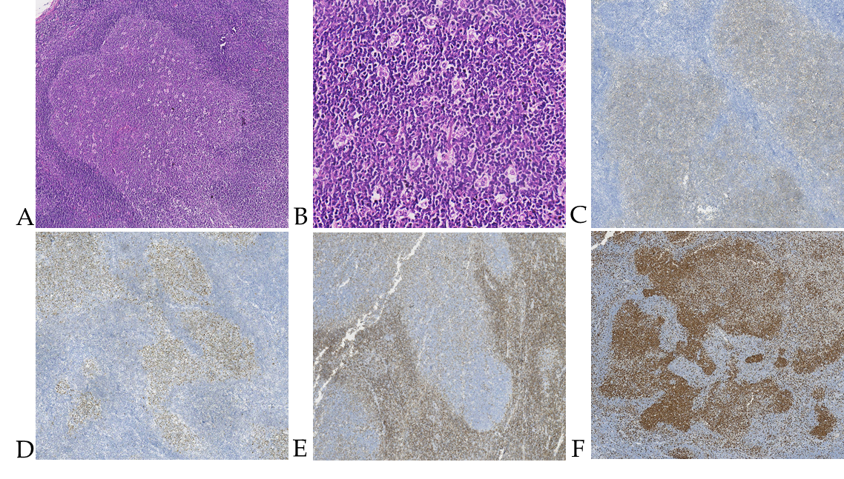
Figure 1 Pathological characteristics. A: This pediatric-type follicular lymphoma displayed the "starry sky phenomenon” in case 1, seen on hematoxylin and eosin stain at 100× magnification; B: At 400× magnification in case 2, the follicle is mainly composed of a single medium-sized central cell, with scattered chromatin and inconspicuous nucleoli. The histological grade was by following per under the grade 3 standard of follicular lymphoma; C and D: tumor cells in case 1 expressed CD10 and BCL6 at 100× magnification; E: BCL2 was negative in case 2 at 100× magnification; F: Ki-67 was highly expressed in germinal center (positive index showed 90%) in case 2 at 100× magnification.

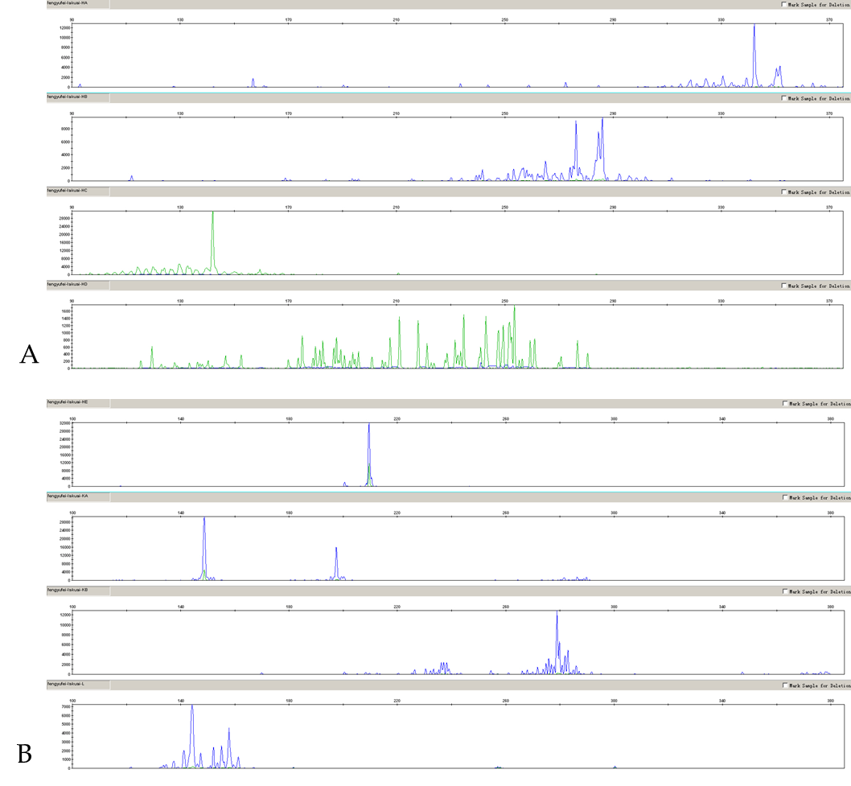
Figure 2 Detection of IGH immunoglobulin gene rearrangement. A: This pediatric-type follicular lymphoma displayed IGH immunoglobulin gene rearrangement was positive in case 1; B: IGK immunoglobulin gene rearrangement was positive in case 1.

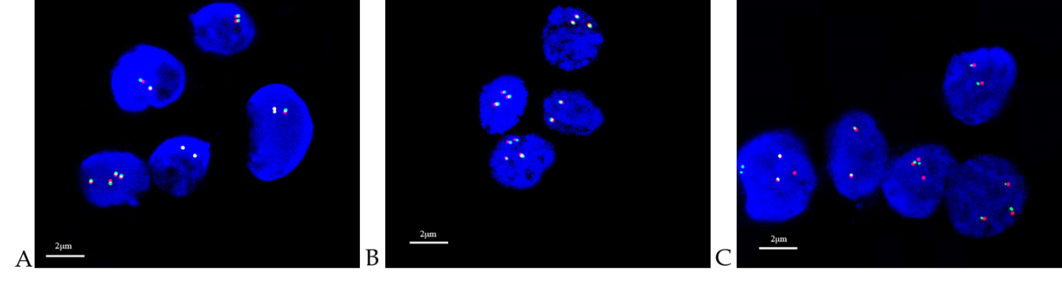
Figure 3 Detection of gene isolation of BCL2, BCL6 and MYC. A: This pediatric-type follicular lymphoma (PTFL) displayed BCL2 gene isolation were negative in case 1 by fluorescence in situ hybridization (FISH). There were two green signals and two red signals in the cells. Red signals and green signals were close to each other, and some signals overlapped and yellow signals appeared; B: BCL6 gene isolation was negative in case 1 by FISH, there were two green signals and two red signals in the cells. Red signals and green signals were closed to each other; C: This PTFL displayed MYC gene isolation were negative in case 1 by FISH. There were two green signals and two red signals in the cells. Red signals and green signals were close to each other, and some signals overlapped and yellow signals appeared.

