Name of journal: World Journal of Gastroenterology
ESPS Manuscript NO: 27643
Manuscript Type: ORIGINAL ARTICLE

Basic Study
Hepatoprotective and antioxidant effects of lycopene on non-alcoholic fatty liver disease in rat

Jiang W et al. Hepatoprotective effects of lycopene

Wei Jiang, Xin Hai, Mei-Hua Guo

Wei Jiang, Xin Hai, Mei-Hua Guo, Medicine Division, First Affiliated Hospital of Harbin Medical University, Harbin 150001, Heilongjiang Province, China

Author contributions: Hai X guaranteed the entire study; Jiang W carried out the whole experiment; Guo Mh participated in the design of the study, performed the statistical analysis, and drafted the manuscript; Guo Mh and Hai X edited and reviewed the manuscript; all authors read and approved the final manuscript.

Institutional review board statement: The study was reviewed and approved by Harbin Medical University Institutional Review Board, Harbin, China.

Institutional animal care and use committee statement: All procedures involving rat in this manuscript were reviewed and approved by the Institutional Animal Care and Use Committee on the Ethics of Animal Experiments of Harbin Medical University (HMU, Protocol Number: 20150301).

Conflict-of-interest statement: We have no financial relationships to disclose.

Data sharing statement: No additional data are available.

Open-Access: This article is an open-access article which was selected by an in-house editor and fully peer-reviewed by external reviewers. It is distributed in accordance with the Creative Commons Attribution Non Commercial (CC BY-NC 4.0) license, which permits others to distribute, remix, adapt, build upon this work non-commercially, and license their derivative works on different terms, provided the original work is properly cited and the use is non-commercial. See: http://creativecommons.org/licenses/by-nc/4.0/

Manuscript source: Unsolicited manuscript

Correspondence to: Xin Hai, MD, Medicine Division, First Affiliated Hospital of Harbin Medical University, Harbin 150001, Heilongjiang Province, China. xiangl2016@163.com
Telephone: +86-451-53643849
Fax: +86-451-53641824

Received: June 8, 2016
Peer-review started: June 13, 2016
First decision: July 29, 2016
Revised: August 15, 2016
Accepted: October 10, 2016
Article in press:
Published online:
Abstract
AIM
To evaluate the hepatoprotective effect of lycopene (Ly) on non-alcoholic fatty liver disease (NAFLD) in rat.

METHODS
A rat model of NAFLD were first established using a high-fat diet for 14 weeks. Sixty-five rats were randomly divided into normal group, model group and Ly treatment groups. Alanine transferase (ALT), aspartate transaminase (AST), triglycerides (TG), total cholesterol (TC) in serum and low density lipoprotein-cholesterol (LDL-C), high density lipoprotein-cholesterol (HDL-C), free fatty acid (FFA), malondialdehyde (MDA), superoxide dismutase (SOD), glutathione (GSH) in liver tissue were evaluated, respectively. While the hepatoprotective effect were also confirmed by histopathological analysis, and the expression of TNF-α and cytochrome P₄₅₀ (CYP) 2E1 in rats liver were determined by immunohistochemistry (IHC) analysis.

RESULTS
A significantly decrease was observed in the levels of serum AST (2.07-fold), ALT (2.95-fold), and the blood lipid TG (2.34-fold), TC (1.66-fold) in the dose of 20 mg/kg Ly-treated rats (p < 0.01), compared to the model group. Pretreatment with 5, 10 and 20 mg/kg of Ly significantly raised the levels of antioxidant enzyme SOD with a dose-dependent manner to 90.95 ± 9.56, 109.52 ± 11.34 and 121.25 ± 10.68 (p < 0.05, p < 0.01) as compared with the model group. Similarly, the levels of GSH were significantly increased (p < 0.05, p < 0.01) in after the Ly-treated. While, pretreatment with 5, 10 and 20 mg/kg of Ly significantly reduced MDA amount by 30.87, 45.51 and 54.49% in the liver homogenate, respectively (p < 0.01). Ly-treatment group was signiﬁcantly decreased the levels of lipid products LDL-C (p < 0.05, p < 0.01), improved HDL-C level and significantly decreased the content of FFA, compared to the model group (p < 0.05, p < 0.01). Furthermore, Ly-treated group also exhibited a down-regulated TNF-α and CYP2E1 expression, decreased the infiltration of liver fats and reversed the histopathological changes in a dose-dependent manner (p < 0.05, p < 0.01).

CONCLUSION
This study suggests that Ly has a protective effect on NAFLD, down-regulated expression of TNF-α and CYP2E1 may be one of the action mechanism for Ly.

Key words: Lycopene; Non-alcoholic fatty liver; Hepatoprotective; Antioxidant; Cytochrome P450 2E1

© The Author(s) 2016. Published by Baishideng Publishing Group Inc. All rights reserved.

Core tip: Lycopene (Ly), a phytochemical belonging to carotenoid family, is a red colored pigment, apolar and acyclic carotenoid. The present study was designed to evaluate the possible hepatoprotective effect of Ly on non-alcoholic fatty liver disease (NAFLD) in rat. It is the first time to examine the effects of Ly on the therapy of NAFLD, and the down-regulated expression of TNF-α and CYP2E1 may be one of the action mechanism for Ly.

Jiang W, Hai X, Guo Mh. Hepatoprotective and antioxidant effects of lycopene on non-alcoholic fatty liver disease in rat. World J Gastroenterol 2016; In press

INTRODUCTION
Non-alcoholic fatty liver disease (NAFLD) is one of the causes of fatty liver, occurring when fat is deposited (steatosis) in the liver due to causes other than excessive alcohol use. NAFLD is considered to covers a spectrum of liver diseases including simple steatosis, non-alcoholic steatohepatitis (NASH), liver ﬁbrosis, liver cirrhosis and hepatocellular carcinoma (HCC)^{[1,2]}. Ninety percent of patients with NAFLD have closely related with one or more of the following risk factors: hypertension, dyslipidemia, elevated triglyceride levels, obesity, insulin resistance, metabolic syndrome, type 2 diabetes mellitus and cardiovascular disease^{[3]}. Currently, the percentage of people with NAFLD is approximately 20% worldwide and 25% in Western countries, making it one of the most dominant causes of chronic liver disease affecting both adults and children^{[4]}. NAFLD is more common in patients with severe diabetes and obesity, mortality and disease evolution to liver ﬁbrosis or liver cirrhosis is increased in old people with NAFLD^{[5]}. Recently, the “two-hit” theory has been accepted as a popular mechanism, although the cause of NAFLD was not clearly elucidated^{[6]}. Furthermore, there is no any speciﬁc drug can be available, and no drug has currently been tested in clinical phase III trials. Therefore, there is no speciﬁc therapy can be ﬁrmly recommended to the patients with NAFLD^{[7]}.
Lycopene (Ly), a phytochemical belonging to carotenoid family, is a red colored pigment, acyclic and apolar carotenoid^{[8]}. It is abundantly found in red colored vegetables and fruits such as tomatoes, papaya, gac fruit, pink grape-fruit, pink guava, carrots and watermelon, with the concentrations ranging from 9 to 42 mg/kg depending on the variety^{[9]}. Ly displays a range of unique and distinct biological properties owing to its acyclic structure, hydrophobicity and large array of conjugated double bonds. Recently, diverse studies have been reported that lycopene has a powerful antioxidant both in vitro and in vivo against the oxidation of proteins, lipids, and DNA, and also has the potential of quenching singlet oxygen 100 times more efﬁciently than vitamin E and 125 times more than glutathione^{[10]}. Furthermore, even at low oxygen tension, it can also scavenge peroxyl radicals, inhibiting the process of lipid peroxidation^{[11]}. It is the most efﬁcient quencher of singlet oxygen among all naturally occurring carotenoids ^{[11]}, and recently it has been in great demand as a food additive and a natural antioxidant. Additionally, lycopene also exhibited a potent neuroprotective, anti-inﬂammatory, anti-proliferative, maintaining normal cell metabolism, cognition enhancing properties, regulating blood lipid metabolism and so on^{[12-16]}. Therefore, with this background, we would like to investigate the possible beneﬁcial effects and the possible action mechanism of Ly on NAFLD in rats.

MATERIALS AND METHODS
Materials and reagents
Alanine aminotransferase (ALT), aspartate aminotransferase (AST), triglycerides (TG), total cholesterol (TC), low density lipoprotein-cholesterol (LDL-C), high density lipoprotein-cholesterol (HDL-C), free fatty acid (FFA), malondialdehyde (MDA), superoxide dismutase (SOD) and glutathione (GSH) kits were obtained from Nanjing Jiancheng Bioengineering Institute (China). Protein assay kit was from Zhongshan Institute of Biotechnology (Beijing, China).
Mouse anti-TNF-α, rabbit anti-cytochrome P₄₅₀2E1 (CYP2E1), horseradish peroxidase (HRP)-conjugated goat anti-mouse IgG, HRP-conjugated goat anti-rabbit IgG antibodies were provided by Proteintech Group, Inc. (Chicago, USA).
Lycopene (> 95%) was purchased from North China Pharmaceutical Co., Ltd., China.
The high fat diet (HFD: 88% basic feed + 10% lard + 2% cholesterol) was prepared in our lab.

Animals
Male Wistar rats body weight 150 ± 10 g were obtained from Experimental Animal Center of Harbin Medical University, China. Six rats were kept in one polyacrylic cages on a 12 h day/night cycle and quarantined for one week before the experiments. All animals were housed under standard controlled conditions (temperature: 24 ± 1℃, humidity: 50% ± 5% and 12 h light/dark cycle), free access to food and water, and received human care according to National Institutes of Health Guidelines of United States (National Research Council of United States, 1996) and related ethical regulations of Harbin Medical University. Animals were fasted for 12 h before sampling of material.

Experimental design
After acclimatization for one week, 65 Wistar male rats were randomized into 2 groups. Group 1 (normal group) were raised with normal feed (n = 12), Group 2 (model group) were raised on high fat feed (HFD: 88% basic feed + 10% lard + 2% cholesterol) (n = 53) for consecutive 8 weeks. From the 9th week, all the survival rats in the model group were further randomly divided into a model group and three doses of Ly treatment groups, which were given Ly with a dose of 5, 10 and 20 mg/kg/d (n = 12), respectively. Model group was continued to be fed with the HFD for 6 weeks as before, and Ly groups were administered orally and continued to be fed with the HFD for 6 weeks as before.
Rats were sacrificed by cervical dislocation at the end of the experiment, blood samples of all rats were harvested for serum biochemical markers assay. The fresh liver obtained was weighed to calculate liver coefficient (Liver coefficient % = liver weight/body weight × 100). The right liver lobe was fixed in 10% formalin to prepare paraffin sections and the rest was stored at -80℃ for the other assays.

Serum biochemical markers assay
Serum was collected from blood after the centrifugation at 3000 rpm for 10 min, 4°C. Serum ALT, AST, TG and TC were detected using commercial kits according to the manufacturer’s instructions by a multifunctional biochemistry analyzer Olympus AU600 (Olympus, Tokyo, Japan). The observation absorbance of ALT and AST were read at 505 nm and the enzyme activity was calculated as U/L. The observation absorbance of TG and TC was read at 510 nm and the content was calculated as mmol/L.

Measurement of MDA formation in lipid peroxidation
Liver homogenate (10%, w/v) was prepared by homogenizing the liver tissue in 150 mmol/L Tris-HCl buffered saline (pH 7.2) with a polytron homogenizer. The level of MDA in liver tissues was measured at 532 nm with a spectrophotometer (Hitachi U-2001) following the kit protocol from Jiancheng Biological Engineering Institute (Nanjing, China). The data are expressed as nmol/mg protein of liver tissue.

Measurement of antioxidant and antioxidant enzyme activity
SOD and GSH activity were determined by commercial kit from Jiancheng Biological Engineering Institute (Nanjing, China) following the protocol provided by manufacture. The observation absorbance of SOD reaction was read at 550 nm and the data are expressed as U/mg protein, while GSH reaction was read at 420 nm and the enzyme activity was calculated as mg/g protein.

Measurement of liver LDL-C, HDL-C and FFA activity
LDL-C, HDL-C and FFA in liver tissue were measured by commercial kit from Jiancheng Biological Engineering Institute (Nanjing, China) following the protocol provided by manufacture. The observation absorbance of LDL-C, HDL-C and FFA reaction was read at 546 nm and the data are expressed as mmol/L.

Histopathological observation
Liver specimens were fixed overnight in 10% formaldehyde buffer, then embedded in paraffin and cut into 5 µm thickness according to the routine procedure. The sections stained with hematoxylin and eosin (H&E) for routine histopathological examination, and examined under a light microscope (Olympus BX-50 Microscope, Leica Microsystems, Germany) at 200 × magnification for the degree of hepatic steatosis and photographed.

Immunohistochemistry analysis of hepatic TNF-α and CYP2E1
Paraffin-embedded sections (5 μm) were mounted on glass slides, then deparaffinized, incubated in 3% H₂O₂, 10 min to quench endogenous peroxidase activity. The sections were stained with mouse anti-TNF-α antibody and rabbit anti-CYP2E1 antibody at 4°C overnight respectively, after blocking with normal goat serum for 20 min. Then incubation with HRP-conjugated goat anti-mouse and HRP-conjugated goat anti-rabbit antibody at 37 °C, 30 min, respectively. The biding sites of the antibody were visualized by incubation with DAB-H₂O₂ at room temperature, 10 min. Images were taken at original magniﬁcation of 200 × (Olympus BX-50 Microscope, Japan and Leica DMIL, Leica Microsystems, Germany).

Statistical analysis
Data were expressed as mean ± SD and all statistical comparisons were made by means of a one-way ANOVA test followed by Dunett’s t-test. p < 0.05 and < 0.01 were considered statistically significant.

RESULTS
Effects of Ly on body weight and liver coefficient
After 8 weeks HFD feeding, the body weights of rats in model group had a significant increase compared rats that of in control groups (p < 0.01, Figure 1A). While, after Ly-treated for 6 weeks, the gain of the rats body weight in 10 and 20 mg/kg Ly-treated groups was lower than that of model group (p < 0.01, Figure 1A), which indicated that Ly treatment could inhibit the occurrence of obesity in HFD administrated rats. Furthermore, consistent with these modifications, the live coefficient was also reduced markedly in Ly-treated rats (p < 0.05, p < 0.01, Figure 1B), compared to control group.

Effect of Ly on serum ALT and AST levels
Serum levels of AST and ALT indirectly reflects the failure of liver function. In Table 1, serum AST (2.67-fold) and ALT (3.66-fold) activities were significantly increased after the administration of HFD as compared with the normal group (p < 0.01). Compared with model group, the levels of AST and ALT were significantly decreased in a dose-dependent manner after Ly treatment (5, 10 and 20 mg/kg) (p < 0.05, p < 0.01, Table 1).

Effects of Ly on blood lipid levels
High fat and cholesterol diet induced NAFLD provoked a markedly increment of TC and TG levels compared with normal group (p < 0.01, Table 1), which indicates the successful establishment of the NAFLD model in rats. However, after Ly exposure, the concentrations of both TC and TG in blood were remarkably decreased in dose-dependent manners versus NAFLD model group (p < 0.05, p < 0.01, Table 1). All of these indicated that Ly had obvious lipid-lowering effects against NAFLD.

Effects of Ly on liver tissue SOD, GSH and MDA levels
The levels of liver antioxidant activities of SOD and GSH were measured due to the oxidative stress exhibited in the development of NAFLD^{[17]}. SOD and GSH could scavenge the lipid hydroperoxides, lipid peroxide radicals and other products which is a toxic metabolite of NAFLD. Therefore, our study measured the contents of SOD, GSH and MDA in liver tissue of rats. From Table 2, we can clearly see the significant difference between HFD-treated model group and the normal group, the levels of SOD and GSH were largely decreased (p < 0.01, Table 2) in HFD-treated group compared with that of normal group. However, pretreatment with 5, 10 and 20 mg/kg of Ly significantly raised the levels of antioxidant enzyme SOD with a dose-dependent manner to 90.95 ± 9.56, 109.52 ± 11.34 and 121.25 ± 10.68 (p < 0.05, p < 0.01, Table 2) as compared with the model group. Similarly, the levels of GSH were significantly increased by treatment with 10 and 20 mg/kg of Ly (p < 0.05, p < 0.01, Table 2).
MDA, an end-product of the breakdown of polyunsaturated fatty acids and related esters, is an important index of lipid peroxidation in many organ homogenate^{[17]}. Administration with HFD caused a significant increase in MDA concentration (2.19-fold) when compared with the normal group (p < 0.01, Table 2). However, pretreatment with 5, 10 and 20 mg/kg of Ly significantly reduced MDA amount by 30.87, 45.51 and 54.49% in the liver homogenate, respectively (p < 0.01, Table 2).

Effects of Ly on LDL-C, HDL-C and FFA levels in liver tissue
Levels of lipid products were significantly increased after 8 weeks HFD feeding in model group compared to control group (p < 0.01, Table 3). Results showed that LDL-C was signiﬁcantly increased in model group compared with normal group (p < 0.01, Table 3) and dramaticly decreased in Ly-treatment group compared that of model group (p < 0.05, p < 0.01, Table 3). In contrast, HDL-C level was significantly decreased at the end of experiment, and Ly-treatment could signiﬁcantly improved HDL-C level compared with that in model group (p < 0.05, p < 0.01, Table 3). Similarly, the concentration of FFA was remarkably increased after HFD administration, and while pretreatment with Ly significantly decreased the content of FFA in a dose-dependent manners (p < 0.05, p < 0.01, Table 3).

Histopathological changes in the liver tissue
Observed under naked eyes, livers were deep red, moist, glossy and resilient in control group (Figure 2A Ⅰ), while yellow necrosis foci, grey-red, lost luster and tumescent were often found on the surface of livers in model group (Figure 2A Ⅱ). However, in Ly-treated rat, liver injury was attenuated dramatically in a dose-dependent manners (Figure 2A Ⅲ-V).
H&E stained sections are shown in Figure 2B. Under the photomicroscope, liver sections showed normal lobular architecture, liver cells with a well-preserved cytoplasm and well-deﬁned nucleus in the normal control group (Figure 2BⅠ). While in the model group, full fat vacuoles in lobule cells, infiltration of inflammatory cells, cell swelling and lipid degeneration could be seen in the central region of the lobules (Figure 2B Ⅱ). Furthermore, in Ly-treated group, inflammatory response and lipid degeneration were remarkably alleviated as compared with the model group, and the liver cell volume became smaller, the fat droplet number was reduced and the hepatic lobules were clearly delineated (Figure 2B Ⅲ-V).

Effect of Ly on immunohistochemistry analysis of hepatic TNF-α and CYP2E1
In the immunohistochemical analysis, liver tissue shows no TNF-α expression in normal group (Figure 3AⅠ), while HFD-model group increased the expression of TNF-α in liver (Figure 3AⅡ). After pretreatment with Ly (5, 10 and 20 mg/kg), TNF-α expression shows decrease in a dose-dependent manners, but it is still higher than normal group (Figure 3A Ⅲ-V). Quantiﬁcation of the positive expression of TNF-α showed in Figure 3A Ⅵ. Result is showed as the mean ± SD of (n = 12). ^{b}p < 0.01 signiﬁcantly different from normal group; ^{c}p < 0.05 and ^{d}p < 0.01 signiﬁcantly different from model group, respectively.
In Figure 3B, the normal liver expressed the lowest amount of CYP2E1 (Figure 3B Ⅰ). HFD-model group significantly highly expressed CYP2E1 when compared with the controls (p < 0.01, Figure 3B Ⅱ). While Ly-treated group (5, 10 and 20 mg/kg) shows markedly decreased of CYP2E1 expression (Figure 3B Ⅲ-V). Quantiﬁcation of the positive expression of CYP2E1 showed in Figure 3B Ⅵ. Result is showed as the mean ± SD (n = 12). ^{b}p < 0.01 signiﬁcantly different from control group; ^{c}p < 0.05 and ^{d}p < 0.01 signiﬁcantly different from model group, respectively.

DISCUSSION
NAFLD is defined by hepatic fat deposition in the absence of excessive alcohol intake, which associated with the insulin resistance (IR) and metabolic syndrome^{[18-20]}. Generally, NAFLD is defined as a concentration of hepatic TG exceeding 5% liver weight, and often exhibited a histological spectrum ranging from simple steatosis to NASH. NASH is characterized by hepatocellular damage, fibrogenesis and lobular necro-inflammation^{[21,22]}, which may evolve to hepatic cirrhosis and HCC^{[23,24]}. Although HFD induced NAFLD animal models need a lengthy feeding period, these models are more close to human NAFLD in the pathophysiology, including induced obesity, IR and hepatic steatosis in mice or rats^{[25]}. Emotional disorders or poor diet with the key points of blood stasis and phlegm is regarded as the etiology of NAFLD, and these etiologies are related to the organs of liver, spleen and kidney, according to the traditional medicine theory^{[26]}. Thus, promoting blood circulation to remove meridian obstruction, reducing phlegm, removing dampness and liver-kidney-tonifying are an effective way for the treatment of NAFLD. However, at present, although tremendous effort has made in prevention of NAFLD from clinicians and researchers, there are no approved treatment drugs for NAFLD. Hence, develop and explore a novel agent to delay or reverse the pathogenesis progression in NAFLD is very important.
Ly is a natural pigment, synthesized by plants and microorganisms. Red fruits and vegetables are the most common sources of Ly, which exhibits the highest antioxidant activity among all dietary carotenoids. Furthermore, the Mediterranean dietary pattern, which include proportionally high consumption of vegetables and fruits with Ly, has shown notable benefits for NAFLD patients^{[27,28]}. Therefore, nowadays, the potential role of Ly in human health is beginning to be recognized, and the most important health benefits are hypothesized to occur through their ability to protect against oxidative damage^{[29,30]}. In vitro studies, Ly is reported as an effective antioxidant and radical scavenger^{[31,32]}. Ly is the most potent singlet oxygen quencher among natural carotenoids, since its high number of conjugated dienes^{[33]}, and recent studies show that Ly at least two times as active as β-carotene in protecting lymphocytes for NO₂· radical induced membrane damage^{[34,35]}, and which indications that Ly is the most potent scavenger of ROS among other major dietary carotenoids^{[36,37]}. In addition, Ly protected human LDL against photosensitized oxidative damage^{[32]}. Thus, based on the benefits of Ly, the aim of the present study was to explore the effect of Ly in prevention of HFD induced NAFLD rat model. To our best knowledge, this is the first time to explore the potent effects of Ly on HFD-induced NAFLD rats.
In the present study, compared to normal control group, it is demonstrated that the liver coefficient and the levels of serum ALT, AST, TG and TC were signiﬁcantly increased, the levels of LDL-C and FFA in liver were markedly increased, and HDL-C were markedly reduced in HFD-induced NAFLD model group. While pretreatment with Ly, we found that Ly is able to inhibition the increment of ALT and AST, to decreased TG, TC, LDL-C and FFA levels, and to increased HDL-C levels. In addition, the histopathological changes from microscopy observation correlated with the examination of liver function. The centrilobular hepatic necrosis, ballooning degeneration, fatty change and infiltrating lymphocytes were observed in NAFLD model group. Treatment with Ly prevented these histopathological changes in rat induced with HFD. Thus, these results suggested that the inhibition of the elevation of liver function markers, obvious lipid-lowering and liver damage may related in the protective effect of Ly against HFD-induced NAFLD. Moreover, Ly enhanced the activities of SOD, increased the GSH and diminished MDA against the HFD-induced NAFLD in these animals, suggesting that the activity of antioxidant may plays a role in the mechanism of its hepatoprotective effects.
TNF-α is a central proinflammatory cytokine, which associated with a variety of physiological and pathological conditions including cytotoxicity, growth stimulation, immune-modulation and pro-inﬂammatory activity. In addition, since TNF-α is produced predominantly by the monocyte macrophage lineage in liver and the mainly population of this lineage is Kupffer cells. Thus, increased TNF-α production by activated Kupffer cells may be responsible for NAFLD. Furthermore, currently studies have displayed that inhibition of TNF-α could decrease the content of hepatic fatty storage in HFD-induced NAFLD model^{[38]}. In our study, the effects of TNF-α in damaged liver was evaluated by IHC. Compared to the normal group, treated with HFD up-regulated the expression of TNF-α, while pretreatment with Ly down-regulated the expression of TNF-α compared to the HFD-model group.
The isoform 2E1 of CYP is one of the most potent microsome cytochromes to generate ROS, and it is involved in the metabolism of isoniazid and the mediation of its hepatotoxicity^{[39]}, which has been exhibited to be invariably increased in the livers of NAFLD patients^{[40]}. In this study, the expression of CYP2E1 in HFD-model group was observed increased, while Ly treatment group showed a significant down-regulate its expression, especially in the high dose of Ly-treated group.
In conclusion, oral administration of Ly improves lipid profiles and remarkably decreased the levels of serum AST, ALT, TG and TC, alleviate the levels of liver LDL-C and FFA, increased the activities of antioxidant enzymes (GSH, SOD) and reduced the lipid peroxides in liver (MDA) in NAFLD model rats. Further, Ly-treated group also down-regulated the expression of TNF-α and CYP2E1, decreased the liver fats infiltration and improved the histopathological changes in a dose-dependent manners. The increased antioxidant enzyme levels and the decreased lipid peroxides contents are suggested to be the important mechanisms of Ly in preventing the development of liver damage induced by HFD.

COMMENTS
Background
Non-alcoholic fatty liver disease (NAFLD) is one of the causes of fatty liver, which encompasses a spectrum of liver diseases including simple steatosis, non-alcoholic steatohepatitis (NASH), liver ﬁbrosis, liver cirrhosis and hepatocellular carcinoma (HCC). Until now, there is no any speciﬁc drug can be available, and no drug has currently been tested in clinical phase III trials. Lycopene (Ly), a phytochemical belonging to carotenoid family, is a red colored pigment, apolar and acyclic carotenoid. Ly exhibits a range of distinct and unique biological properties owing to its acyclic structure, hydrophobicity and large array of conjugated double bonds. Recent report showed that the Mediterranean dietary pattern, which include proportionally high consumption of vegetables and fruits with Ly, has shown notable benefits for NAFLD patients. Thus, with this background, we would like to investigate the possible beneﬁcial effects and the possible action mechanism of Ly on NAFLD in rats.

Research frontiers
No any speciﬁc drug has currently been tested in clinical phase III trials for NAFLD, and there is few research on the study of hepatoprotective effects of Ly.

Innovations and breakthrough
It is the first time to examine the effects of Ly on the therapy of NAFLD, and the down-regulated expression of TNF-α and CYP2E1 may be one of the action mechanism for Ly.

Applications
This study suggests that Ly has a protective effect on NAFLD, which is very important for the development of the potent NAFLD drug.

Terminology
NAFLD is one of the causes of fatty liver, deﬁned as biopsy proven hepatic steatosis. It covers a spectrum of liver diseases including simple steatosis, NASH, liver ﬁbrosis, liver cirrhosis and HCC. Recently, many NAFLD drug researches are focus on the traditional Chinese medicines.

Peer-review
This is an meanful study in which related to effects of “lycopene” on NAFLD rat model. This results are very important and suggest that lycopene has a protective effect on NAFLD through down-regulated TNF-α and CYP2E1 expression.

REFERENCES
1 Masarone M, Federico A, Abenavoli L, Loguercio C, Persico M. Non alcoholic fatty liver: epidemiology and natural history. Rev Recent Clin Trials 2014; 9: 126-133 [PMID: 25514916 DOI: 10.2174/1574887109666141216111143]
2 Wilkins T, Tadkod A, Hepburn I, Schade RR. Nonalcoholic fatty liver disease: diagnosis and management. Am Fam Physician 2013; 88: 35-42 [PMID: 23939604]
3 Schuppan D, Schattenberg JM. Non-alcoholic steatohepatitis: pathogenesis and novel therapeutic approaches. J Gastroenterol Hepatol 2013; 28 Suppl 1: 68-76 [PMID: 23855299 DOI: 10.1111/jgh.12212]
4 Keating SE, Hackett DA, George J, Johnson NA. Exercise and non-alcoholic fatty liver disease: a systematic review and meta-analysis. J Hepatol 2012; 57: 157-166 [PMID: 22414768 DOI: 10.1016/j.jhep.2012.02.023]
5 Satapathy SK, Sanyal AJ. Epidemiology and Natural History of Nonalcoholic Fatty Liver Disease. Semin Liver Dis 2015; 35: 221-235 [PMID: 26378640 DOI: 10.1055/s-0035-1562943]
6 Day CP, James OF. Steatohepatitis: a tale of two "hits"? Gastroenterology 1998; 114: 842-845 [PMID: 9547102 DOI: 10.1016/S0016-5085(98)70599-2]
7 European Association for the Study of the Liver (EASL), European Association for the Study of Diabetes (EASD), European Association for the Study of Obesity (EASO). EASL-EASD-EASO Clinical Practice Guidelines for the management of non-alcoholic fatty liver disease. J Hepatol 2016; 64: 1388-1402 [PMID: 27062661 DOI: 10.1016/j.jhep.2015.11.004]
8 Engelmann NJ, Clinton SK, Erdman JW. Nutritional aspects of phytoene and phytofluene, carotenoid precursors to lycopene. Adv Nutr 2011; 2: 51-61 [PMID: 22211189 DOI: 10.3945/an.110.000075]
9 Visioli F, Riso P, Grande S, Galli C, Porrini M. Protective activity of tomato products on in vivo markers of lipid oxidation. Eur J Nutr 2003; 42: 201-206 [PMID: 12923651 DOI: 10.1007/s00394-003-0415-5]
10 Mein JR, Lian F, Wang XD. Biological activity of lycopene metabolites: implications for cancer prevention. Nutr Rev 2008; 66: 667-683 [PMID: 19019036 DOI: 10.1111/j.1753-4887.2008.00120.x]
11 Stahl W, Sies H. Carotenoids and flavonoids contribute to nutritional protection against skin damage from sunlight. Mol Biotechnol 2007; 37: 26-30 [PMID: 17914160 DOI: 10.1007/s12033-007-0051-z]
12 Kumar P, Kalonia H, Kumar A. Lycopene modulates nitric oxide pathways against 3-nitropropionic acid-induced neurotoxicity. Life Sci 2009; 85: 711-718 [PMID: 19822156 DOI: 10.1016/j.lfs.2009.10.001]
13 Datta S, Jamwal S, Deshmukh R, Kumar P. Beneficial effects of lycopene against haloperidol induced orofacial dyskinesia in rats: Possible neurotransmitters and neuroinflammation modulation. Eur J Pharmacol 2016; 771: 229-235 [PMID: 26712377 DOI: 10.1016/j.ejphar.2015.12.032]
14 Sachdeva AK, Chopra K. Lycopene abrogates Aβ(1-42)-mediated neuroinflammatory cascade in an experimental model of Alzheimer's disease. J Nutr Biochem 2015; 26: 736-744 [PMID: 25869595 DOI: 10.1016/j.jnutbio.2015.01.012]
15 Maiani G, Castón MJ, Catasta G, Toti E, Cambrodón IG, Bysted A, Granado-Lorencio F, Olmedilla-Alonso B, Knuthsen P, Valoti M, Böhm V, Mayer-Miebach E, Behsnilian D, Schlemmer U. Carotenoids: actual knowledge on food sources, intakes, stability and bioavailability and their protective role in humans. Mol Nutr Food Res 2009; 53 Suppl 2: S194-S218 [PMID: 19035552 DOI: 10.1002/mnfr.200800053]
16 Ried K, Fakler P. Protective effect of lycopene on serum cholesterol and blood pressure: Meta-analyses of intervention trials. Maturitas 2011; 68: 299-310 [PMID: 21163596 DOI: 10.1016/j.maturitas.2010.11.018]
17 Yen FL, Wu TH, Lin LT, Lin CC. Hepatoprotective and antioxidant effects of Cuscuta chinensis against acetaminophen-induced hepatotoxicity in rats. J Ethnopharmacol 2007; 111: 123-128 [PMID: 17145147 DOI: 10.1016/j.jep.2006.11.003]
18 Marchesini G, Brizi M, Morselli-Labate AM, Bianchi G, Bugianesi E, McCullough AJ, Forlani G, Melchionda N. Association of nonalcoholic fatty liver disease with insulin resistance. Am J Med 1999; 107: 450-455 [PMID: 10569299 DOI: 10.1016/S0002-9343(99)00271-5]
19 Fabbrini E, Mohammed BS, Magkos F, Korenblat KM, Patterson BW, Klein S. Alterations in adipose tissue and hepatic lipid kinetics in obese men and women with nonalcoholic fatty liver disease. Gastroenterology 2008; 134: 424-431 [PMID: 18242210 DOI: 10.1053/j.gastro.2007.11.038]
20 Cohen JC, Horton JD, Hobbs HH. Human fatty liver disease: old questions and new insights. Science 2011; 332: 1519-1523 [PMID: 21700865 DOI: 10.1126/science.1204265]
21 Kleiner DE, Brunt EM, Van Natta M, Behling C, Contos MJ, Cummings OW, Ferrell LD, Liu YC, Torbenson MS, Unalp-Arida A, Yeh M, McCullough AJ, Sanyal AJ. Design and validation of a histological scoring system for nonalcoholic fatty liver disease. Hepatology 2005; 41: 1313-1321 [PMID: 15915461 DOI: 10.1002/hep.20701]
22 Day CP. From fat to inflammation. Gastroenterology 2006; 130: 207-210 [PMID: 16401483 DOI: 10.1053/j.gastro.2005.11.017]
23 Bugianesi E, Leone N, Vanni E, Marchesini G, Brunello F, Carucci P, Musso A, De Paolis P, Capussotti L, Salizzoni M, Rizzetto M. Expanding the natural history of nonalcoholic steatohepatitis: from cryptogenic cirrhosis to hepatocellular carcinoma. Gastroenterology 2002; 123: 134-140 [PMID: 12105842 DOI: 10.1053/gast.2002.34168]
24 Liu YL, Patman GL, Leathart JB, Piguet AC, Burt AD, Dufour JF, Day CP, Daly AK, Reeves HL, Anstee QM. Carriage of the PNPLA3 rs738409 C & gt; G polymorphism confers an increased risk of non-alcoholic fatty liver disease associated hepatocellular carcinoma. J Hepatol 2014; 61: 75-81 [PMID: 24607626 DOI: 10.1016/j.jhep.2014.02.030]
25 Carabelli J, Burgueño AL, Rosselli MS, Gianotti TF, Lago NR, Pirola CJ, Sookoian S. High fat diet-induced liver steatosis promotes an increase in liver mitochondrial biogenesis in response to hypoxia. J Cell Mol Med 2011; 15: 1329-1338 [PMID: 20629985 DOI: 10.1111/j.1582-4934.2010.01128.x]
26 Dong H, Lu FE, Zhao L. Chinese herbal medicine in the treatment of nonalcoholic fatty liver disease. Chin J Integr Med 2012; 18: 152-160 [PMID: 22311412 DOI: 10.1007/s11655-012-0993-2]
27 Federico A, Zulli C, de Sio I, Del Prete A, Dallio M, Masarone M, Loguercio C. Focus on emerging drugs for the treatment of patients with non-alcoholic fatty liver disease. World J Gastroenterol 2014; 20: 16841-16857 [PMID: 25492998 DOI: 10.3748/wjg.v20.i45.16841]
28 Godos J, Federico A, Dallio M, Scazzina F. Mediterranean diet and nonalcoholic fatty liver disease: molecular mechanisms of protection. Int J Food Sci Nutr 2016; 2: 1-10 [PMID: 27484357 DOI: 10.1080/09637486.2016.1214239]
29 Stahl W, Sies H. Lycopene: a biologically important carotenoid for humans? Arch Biochem Biophys 1996; 336: 1-9 [PMID: 8951028 DOI: 10.1006/abbi.1996.0525]
30 Gerster H. The potential role of lycopene for human health. J Am Coll Nutr 1997; 16: 109-126 [PMID: 9100211 DOI: 10.1080/07315724.1997.10718661]
31 Clinton SK. Lycopene: chemistry, biology, and implications for human health and disease. Nutr Rev 1998; 56: 35-51 [PMID: 9529899 DOI: 10.1111/j.1753-4887.1998.tb01691.x]
32 Rao AV, Fleshner N, Agarwal S. Serum and tissue lycopene and biomarkers of oxidation in prostate cancer patients: a case-control study. Nutr Cancer 1999; 33: 159-164 [PMID: 10368811 DOI: 10.1207/S15327914NC330207]
33 Miller NJ, Sampson J, Candeias LP, Bramley PM, Rice-Evans CA. Antioxidant activities of carotenes and xanthophylls. FEBS Lett 1996; 384: 240-242 [PMID: 8617362 DOI: 10.1016/0014-5793(96)00323-7]
34 Böhm F, Tinkler JH, Truscott TG. Carotenoids protect against cell membrane damage by the nitrogen dioxide radical. Nat Med 1995; 1: 98-99 [PMID: 7585018 DOI: 10.1038/nm0295-98]
35 Tinkler JH, Böhm F, Schalch W, Truscott TG. Dietary carotenoids protect human cells from damage. J Photochem Photobiol B 1994; 26: 283-285 [PMID: 7853120 DOI: 10.1016/1011-1344(94)07049-0]
36 Mortensen A, Skibsted LH. Relative stability of carotenoid radical cations and homologue tocopheroxyl radicals. A real time kinetic study of antioxidant hierarchy. FEBS Lett 1997; 417: 261-266 [PMID: 9409729 DOI: 10.1016/S0014-5793(97)01297-0]
37 Mortensen A, Skibsted LH, Sampson J, Rice-Evans C, Everett SA. Comparative mechanisms and rates of free radical scavenging by carotenoid antioxidants. FEBS Lett 1997; 418: 91-97 [PMID: 9414102 DOI: 10.1016/S0014-5793(97)01355-0]
38 Gao HY, Huang J, Wang HY, Du XW, Cheng SM, Han Y, Wang LF, Li GY, Wang JH. Protective effect of Zhuyeqing liquor, a Chinese traditional health liquor, on acute alcohol-induced liver injury in mice. J Inflamm (Lond) 2013; 10: 30 [PMID: 24090365 DOI: 10.1186/1476-9255-10-30]
39 Yang P, Zeng Q, Cao WC, Wang YX, Huang Z, Li J, Liu C, Lu WQ. Interactions between CYP2E1, GSTZ1 and GSTT1 polymorphisms and exposure to drinking water trihalomethanes and their association with semen quality. Environ Res 2016; 147: 445-452 [PMID: 26970898 DOI: 10.1016/j.envres.2016.03.009]
40 Weltman MD, Farrell GC, Hall P, Ingelman-Sundberg M, Liddle C. Hepatic cytochrome P450 2E1 is increased in patients with nonalcoholic steatohepatitis. Hepatology 1998; 27: 128-133 [PMID: 9425928 DOI: 10.1002/hep.510270121]
P-Reviewer: Abenavol L, Lee HC S-Editor: Gong ZM
L-Editor: E-Editor:
Specialty type: Gastroenterology and hepatology
Country of origin: China
Peer-review report classification
Grade A (Excellent): A
Grade B (Very good): b
Grade C (Good): 0
Grade D (Fair): 0
Grade E (Poor): 0

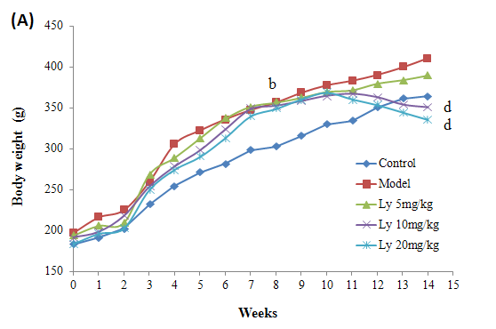
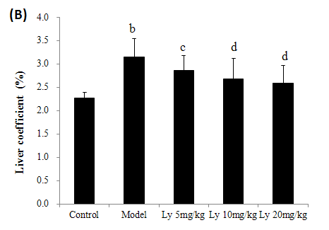
Figure 1 Effects of the lycopene on body weight (A) and liver coefficient (b). ^{b}p < 0.01 vs control group; ^{c}p < 0.05, ^{d}p < 0.01 vs model group. Ly: lycopene.

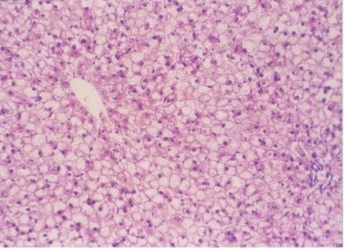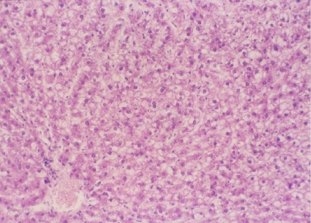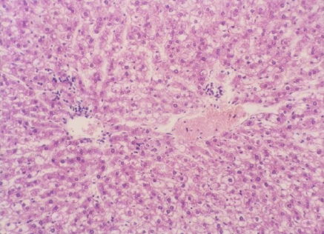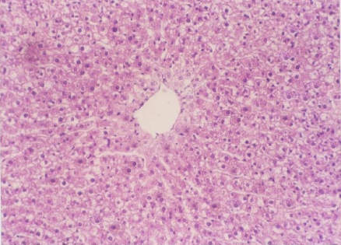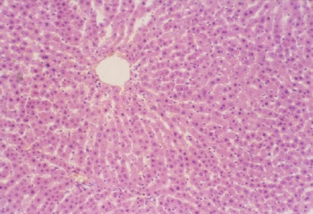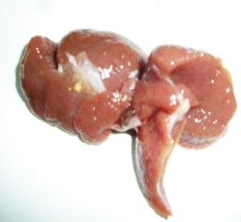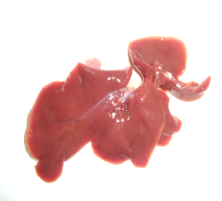
Ⅰ
Ⅱ
Ⅲ
IV
V
Ⅰ
Ⅱ
Ⅲ
IV
V
(A)
(B)
Figure 2 The appearance of rat liver tissue (A) and histopathological examination by H&E (B, 200 ×). I: Control group, II: Model group, III: Ly 5 mg/kg group, IV: Ly 10 mg/kg group, V: Ly 20 mg/kg group. Ly: lycopene.

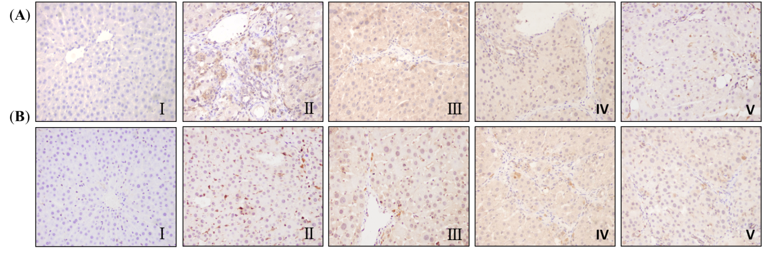
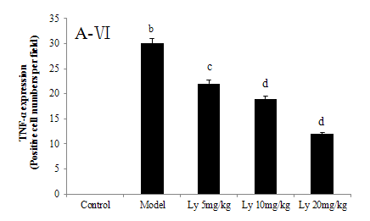
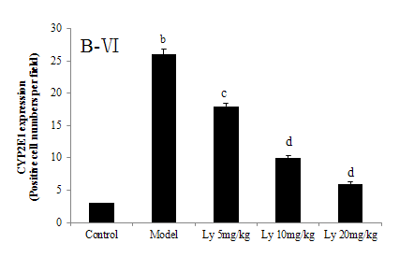
Figure 3 Representative photographs of immunological histological chemistry examination (200 ×). A: TNF-α, B: CYP2E1. Ⅰ: Control group, Ⅱ: Model group,Ⅲ: Ly 5 mg/kg group, IV: Ly 10 mg/kg group, V: Ly 20 mg/kg group; Ⅵ: Quantiﬁcation of TNF-α (A-VI) and CYP2E1 (B-VI) stained cells. Result is expressed as the mean ± SD of 12 rats. ^{b}p < 0.01 vs control group; ^{c}p < 0.05, ^{d}p < 0.01 vs model group. Ly: lycopene.

Table 1 Effect of lycopene on serum liver function markers and blood lipid levels
Group | ALT ( IU/L) | AST ( IU/L) | TG ( mmol/L) | TC (mmol/L)
Control | 16.72 ± 2.62 | 60.65 ± 6.28 | 0.52 ± 0.04 | 0.81 ± 0.06
Model | 61.25 ± 13.55^{b} | 162.17 ± 35.53^{b} | 1.38 ± 0.21^{b} | 3.04 ± 0.72^{b}
Ly 5mg/kg | 30.90 ± 3.84^{c} | 95.91 ± 13.65^{c} | 1.02 ± 0.10 | 2.31 ± 0.24
Ly 10mg/kg | 26.33 ± 2.06^{d} | 88.53 ± 9.18^{d} | 0.75 ± 0.06^{c} | 2.00 ± 0.12^{c}
Ly 20mg/kg | 20.77 ± 3.52^{d} | 78.44 ± 9.79^{d} | 0.59 ± 0.03^{d} | 1.83 ± 0.15^{d}
Data are expressed as the mean ± SD (n = 12) in each group. ^{b}p < 0.01 vs control group; ^{c}p < 0.05, ^{d}p < 0.01 vs model group. Ly: Lycopene; ALT: Alanine transferase; AST: aspartate transaminase; TG: triglycerides; TC: total cholesterol.

Table 2 Effect of lycopene on liver antioxidant enzymes-specific activities, antioxidant and lipid peroxidation levels
Group | SOD (U/mgprot) | GSH (mg/g prot) | MDA (nmol/mgprot)
Control | 131.42 ± 16.24 | 6.76 ± 1.54 | 3.46 ± 1.11
Model | 77.70 ± 7.63^{b} | 2.55 ± 0.78^{b} | 7.58 ± 3.10^{b}
Ly 5mg/kg | 90.95 ± 9.56^{c} | 2.68 ± 1.26 | 5.24 ± 1.46^{d}
Ly 10mg/kg | 109.52 ± 11.34^{d} | 3.76 ± 0.91^{c} | 4.13 ± 1.13^{d}
Ly 20mg/kg | 121.25 ± 10.68^{d} | 4.79 ± 1.51^{d} | 3.45 ± 1.39^{d}
Data are expressed as the mean ± SD (n = 12) in each group. ^{b}p < 0.01 vs control group; ^{c}p < 0.05, ^{d}p < 0.01 vs model group. Ly: Lycopene; SOD: superoxide dismutase; GSH: glutathione; MDA: malondialdehyde.

Table 3 Effect of lycopene on low density lipoprotein-cholesterol, high density lipoprotein-cholesterol and free fatty acid levels in liver tissue
Group | LDL-C (mmol/L) | HDL-C (mmol/L) | FFA (mmol/L)
Control | 0.34 ± 0.08 | 0.98 ± 0.10 | 0.82 ± 0.13
Model | 2.48 ± 0.13^{b} | 0.55 ± 0.02^{b} | 2.03 ± 0.15^{b}
Ly 5mg/kg | 1.32 ± 0.10^{c} | 0.70 ± 0.04^{c} | 1.73 ± 0.12
Ly 10mg/kg | 0.95 ± 0.05^{d} | 0.80 ± 0.05^{d} | 1.56 ± 0.10^{c}
Ly 20mg/kg | 0.62 ± 0.08^{d} | 0.87 ± 0.05^{d} | 1.34 ± 0.08^{d}
Data are expressed as the mean ± SD (n = 12) in each group. ^{b}p < 0.01 vs control group; ^{c}p < 0.05, ^{d}p < 0.01 vs model group. Ly: Lycopene; LDL-C: low density lipoprotein-cholesterol; HDL-C: high density lipoprotein-cholesterol; FFA: free fatty acid.

