Name of Journal: World Journal of Clinical Cases
Manuscript NO: 51478
Manuscript Type: CASE REPORT

Ulcerated intussuscepted jejunal lipoma-uncommon cause of obscure gastrointestinal bleeding: A case report

Cuciureanu T et al. Jejunal lipoma-uncommon cause of gastrointestinal bleeding

Tudor Cuciureanu, Laura Huiban, Stefan Chiriac, Ana-Maria Singeap, Mihai Danciu, Florin Mihai, Carol Stanciu, Anca Trifan, Nutu Vlad

Tudor Cuciureanu, Laura Huiban, Stefan Chiriac, Ana-Maria Singeap, Carol Stanciu, Anca Trifan, Department of Gastroenterology, “Grigore T. Popa” University of Medicine and Pharmacy, “St. Spiridon” Emergency Hospital, Iasi 700115, Romania

Mihai Danciu, Department of Pathology, “Grigore T. Popa” University of Medicine and Pharmacy, “St. Spiridon” Emergency Hospital, Iasi 700115, Romania

Florin Mihai, Department of Radiology, “Grigore T. Popa” University of Medicine and Pharmacy, “St. Spiridon” Emergency Hospital, Iasi 700115, Romania

Nutu Vlad, Department of General Surgery, “Grigore T. Popa” University of Medicine and Pharmacy, “St. Spiridon” Emergency Hospital, Iasi 700115, Romania

ORCID number: Tudor Cuciureanu (0000-0003-11550-8870); Laura Huiban (0000-0002-3044-0715); Stefan Chiriac (0000-0003-2497-9236); Ana-Maria Singeap (0000-0001-5621-548X); Mihai Danciu (0000-0002-0194-7832); Florin Mihai (0000-0003-2523-1633); Nutu Vlad (0000-0003-4087-9470); Carol Stanciu (0000-0002-6427-4049); Anca Trifan (0000-0001-9144-5520).

Author contributions: Trifan A and Singeap AM had the idea to publish the case and provided images of some investigation used in diagnosis. Cuciureanu T, Huiban L and Stanciu C contributed to the manuscript preparation. Danciu M, Vlad N and Mihai F provided images and contributed to the figure design, Chiriac S contributed to the literature review.

Informed consent statement: Informed written consent was obtained from the patient for publication of this report and any accompanying images.

Conflict-of-interest statement: The authors declare that they have no conflict of interest.

CARE Checklist (2016) statement: The manuscript was prepared and revised according to the CARE Checklist (2016).

Open-Access: This article is an open-access article which was selected by an in-house editor and fully peer-reviewed by external reviewers. It is distributed in accordance with the Creative Commons Attribution Non Commercial (CC BY-NC 4.0) license, which permits others to distribute, remix, adapt, build upon this work non-commercially, and license their derivative works on different terms, provided the original work is properly cited and the use is non-commercial. See: http://creativecommons.org/licenses/by-nc/4.0/

Manuscript source: Unsolicited manuscript

Corresponding author: Anca Trifan, MD, PhD, FRCP, Professor, Doctor, Department of Gastroenterology, “Grigore T. Popa” University of Medicine and Pharmacy, “St. Spiridon” Emergency Hospital, Iasi 700115, Romania. ancatrifan@yahoo.com
Telephone: +40-72-6108428

Received: September 18, 2019
Peer-review started: September 18, 2019
First decision: October 24, 2019
Revised: October 29, 2019
Accepted: November 15, 2019
Article in press: November 15, 2019
Published online: November 26, 2019

Abstract
BACKGROUND
Intestinal lipomas are rare benign gastrointestinal (GI) tumors, usually asymptomatic, but may become symptomatic as the result of some complications such as intussusception, intestinal obstruction, volvulus or bleeding. They can occur at any site along the entire GI tract, more frequent in colon and rarely in small intestine. The patient reported here is a very rare case of jejunal lipoma, ulcerated and intussuscepted, diagnosed in an adult investigated for a chronic iron deficiency anemia (IDA), and successfully managed by segmental jejunal resection.

CASE SUMMARY
A 63-year-old male was referred to “St. Spiridon” Hospital, Institute of Gastroenterology and Hepatology, Iasi, to investigate an obscure GI bleeding with an IDA. After upper GI endoscopy and colonoscopy were performed, excluding potentially bleeding lesions, videocapsule endoscopy was then performed, revealing fresh blood and a protruding lesion in proximal jejunum, findings confirmed by a single-balloon enteroscopy. Multiple biopsies were taken from the lesion, but histological results were inconclusive. Then, contrast - enhanced computed tomography was performed showing jejunal polypoid mass with homogenous fat density, suggestive for lipoma. A week later a laparotomy was performed revealing the intussuscepted jejunal segment which was resected en bloc, and sent for further histopathologic analysis. The patient made an uneventful recovery and was discharged seven days later, and at six months follow-up he had no complains and his hemoglobin returned to normal value.

CONCLUSION
Lipomas are very rarely located in the jejunum, usually asymptomatic, but they may lead to complications such as intussusception and bleeding. Surgical resection remains the treatment of choice.

Key words: Lipoma; Intussusception; Computed tomography; Video capsule endoscopy; Gastrointestinal bleeding; Case report

© The Author(s) 2019. Published by Baishideng Publishing Group Inc. All rights reserved.

Core tip: Jejunal lipomas are very rare benign tumors in adults, usually asymptomatic, and found incidentally during investigation for other abdominal pathologies or when cases present a complication such as intussusception, intestinal obstruction or bleeding. Here we present a case of jejunal lipoma complicated by ulceration, intussusception, and gastrointestinal bleeding, successfully managed by segmental resection. Location of lipoma in jejunum is exceptional with only 10 cases reported in the literature with similar location and complications as our case.

Citation: Cuciureanu T, Huiban L, Chiriac S, Singeap AM, Danciu M, Mihai F, Stanciu C, Trifan A, Vlad N. Ulcerated intussuscepted jejunal lipoma-uncommon cause of obscure gastrointestinal bleeding: A case report. World J Clin Cases 2019; 7(22): 3765-3771
URL: https://www.wjgnet.com/2307-8960/full/v7/i22/3765.htm
DOI: https://dx.doi.org/10.12998/wjcc.v7.i22.3765

INTRODUCTION
Lipomas are benign, fatty gastrointestinal (GI) tumors, more commonly located in the colon (64%)^{[1]}, the small intestine being the second site, and very rarely in the jejunum (< 2%)^{[2]}. Usually, small bowel lipomas are asymptomatic, uncomplicated and discovered incidentally during investigation for other abdominal diseases such as an obstructive bowel syndrome or GI bleeding^{[2,3]}. However, they may become symptomatic as the result of a number of complications such as bleeding, intussusception, and obstruction. The intussusception is defined as the telescoping of a proximal segment of bowel into the lumen of an adjacent segment of bowel (usually resulting in obstruction), and it is more common in children, where is generally idiopathic; it seldom occurs in adults (with 5% of all cases of intussusception)^{[3]} and it is often due to a malignancy (70% of the colonic and 30% of small bowel intussusceptions are attributable to malignancy)^{[4]}. In a retrospective study including all adult patients diagnosed with intussusception at Mayo Clinic, Rochester from 1983 to 2008, among all 196 patients, only 10 presented with small bowel lipomas^{[5]}. We report a very rare case of an ulcerated intussuscepted jejunal lipoma in an adult, discovered after investigating an obscure GI bleeding and managed by surgical resection. We also made a short review of the literature regarding the small bowel (jejunal) intussuscepted lipoma.

CASE PRESENTATION
Chief complaints
A 63-year-old man with personal history of hypertension was admitted to our department of Gastroenterology and Hepatology to investigate an obscure GI bleeding with iron deficiency anemia (IDA).

History of present illness
He complained of intermittent abdominal pain accompanied by nausea.

History of past illness
He had a prior history of hypertension well controlled by treatment with angiotensin-converting enzyme inhibitors. He had no abdominal surgery.

Personal and family history
He was a construct engineer and a current smoker (15 cigarettes/d for the past 20 years). He had no serious family history.

Physical examination
Physical examination showed pale teguments, and the abdomen was soft and tender in the umbilical and right flank area, without any palpable abdominal mases.

Laboratory examinations
Laboratory data showed IDA (hemoglobin 9.5 g/dL, serum iron 45 µg/dL, ferritin 10 µg/L).

Imaging examinations
An upper GI endoscopy and colonoscopy were performed, excluding lesions with potential for bleeding. Then, videocapsule endoscopy was performed, revealing fresh blood in the proximal jejunum, and a protruding lesion, with discolored covering mucosa (Figure 1A and B). Next, a single–balloon enteroscopy was carried out, which showed a polypoid mass with ulceration, situated in the proximal segment of jejunum (Figure 2A and B). Multiple biopsies were taken from the lesion, but the histological result was inconclusive, as it frequently occurs in submucosal GI benign tumors including lipomas, due to depth factor–the amount of subcutaneous tissue required in biopsies of the lesion. Then, contrast-enhanced abdominal computed tomography was performed which showed a 6 centimeters elongated structure inside the intestinal lumen with homogenous fat density and smooth well-defined contour, suggestive for an intestinal lipoma (Figure 3). Within the next week the patient complained of abdominal pain, nausea and several episodes of vomiting. A laparotomy was performed revealing jejuno-jejunal intussusception.

FINAL DIAGNOSIS
Intra-operative macroscopic observation identified six centimeters intussuscepted yellowish mass suggestive for lipoma (Figure 4). The histological examination revealed in the submucosa a nodular mesenchymal tumor consisting in mature adipocytes, with no pleomorphism and no mitotic activity. These findings were compatible with a diagnosis of lipoma (Figure 5A and B).

TREATMENT
The intussuscepted jejunal segment was resected en bloc and the inspection of this segment showed a submucosal firm mass with ulceration of the mucosa. End-to-end anastomosis was performed.

OUTCOME AND FOLLOW-UP
The patient made an uneventful recovery and was discharged seven days later, and at six months follow-up he had no complains and his hemoglobin returned to normal value.

DISCUSSION
Jejunal lipomas are rare, but they may, nonetheless, represent a diagnostic challenge when complicated by lower gastrointestinal tract hemorrhage or intussusception. Large benign tumors of the small bowel rarely include intussusception in their spectrum, which may become an important risk factor for ischemia and necrosis of the intestinal wall.
The most common sites of GI lipomas reported in the literature are the colon (64%), followed by the small bowel (31%), stomach (3%) and the esophagus (12%)^{[6]}. While most of small bowel lipomas are small in size and asymptomatic, those surpassing 2 cm in size usually manifest through clinical symptoms such as abdominal pain, hemorrhage or bowel obstruction^{[7]}.
In adult patients, intussusception is more likely to present progressive misleading symptomatology with diffuse abdominal pain and rarely with classical triad-symptoms such as intense abdominal pain, vomiting and lower gastrointestinal hemorrhage, making the diagnosis complex and requiring further radiological documentation. Intussusception is documented frequently on computed tomography, a method of choice due to its accuracy of virtually staging the lesion^{[8]}. Over 90% of intussusception cases found in adults have an organic cause^{[9]}.
In order to find similar cases, we have reviewed the literature using Pub Med and found ten cases in the published accounts^{[4,10-18]}. The keywords used were “lipoma”, “intussusception”, “jejunum”, “bleeding”. All ten cases presented jejunal lipoma with intussusception and bleeding (Table 1).
Over the past decade, there has been a constant debate about the appropriate and safe treatment of small bowel benign tumors. Clinical presentation differed probably on account of the different sizes in tumoral mass. Yu et al^{[19]} reported fifteen cases of gastrointestinal lipomas with different sizes that benefited from endoscopic therapy without important complications. However, it should be noted that endoscopic resection may be associated with a risk of bleeding and perforation. Thus, Raju et al^{[20]} reported that endoscopic removal of lipomas > 2 cm in diameter was associated with a greater risk of perforation. In our case, the patient presented a tumor over 5 cm in length with a wide base of implantation. Due to its size and vascularization, surgical resection was considered to be the optimal treatment.

CONCLUSION
Jejunal lipomas, very rare benign tumors of the GI tract, are mostly asymptomatic and found incidentally during investigations for other abdominal diseases. However, in some cases, they may lead to complications such as intussusception and hemorrhage. Surgical resection remains the treatment of choice for large and complicated lipomas.
References
1 Zirpe D, Wani M, Tiwari P, Ramaswamy PK, Kumar RP. Duodenal Lipomatosis as a Curious Cause of Upper Gastrointestinal Bleed: A Report with Review of Literature. J Clin Diagn Res 2016; 10: PE01-PE04 [PMID: 27437304 DOI: 10.7860/JCDR/2016/19851.7881]
2 Kordzadeh A, Lorenzi B, Elias S, Khan MJK, Charalabopoulos A. Subtle presentation of jejunal lipomata with intussusception in a young adult. J Surg Case Rep 2017; 2017: rjx199 [PMID: 29423142 DOI: 10.1093/jscr/rjx199]
3 Uyulmaz S, Zünd M, Caspar U, Diebold J, Slankamenac K. Ileoileal intussusception in unspecific recurrent abdominal pain in adult: A case report. SAGE Open Med Case Rep 2018; 6: 2050313X18792814 [PMID: 30116530 DOI: 10.1177/2050313X18792814]
4 Manouras A, Lagoudianakis EE, Dardamanis D, Tsekouras DK, Markogiannakis H, Genetzakis M, Pararas N, Papadima A, Triantafillou C, Katergiannakis V. Lipoma induced jejunojejunal intussusception. World J Gastroenterol 2007; 13: 3641-3644 [PMID: 17659719 DOI: 10.3748/wjg.v13.i26.3641]
5 Onkendi EO, Grotz TE, Murray JA, Donohue JH. Adult intussusception in the last 25 years of modern imaging: is surgery still indicated? J Gastrointest Surg 2011; 15: 1699-1705 [PMID: 21830152 DOI: 10.1007/s11605-011-1609-4]
6 Toya Y, Endo M, Orikasa S, Sugai T, Matsumoto T. Lipoma of the small intestine treated with endoscopic resection. Clin J Gastroenterol 2014; 7: 502-505 [PMID: 25414085 DOI: 10.1007/s12328-014-0538-7]
7 Wilson JM, Melvin DB, Gray G, Thorbjarnarson B. Benign small bowel tumor. Ann Surg 1975; 181: 247-250 [PMID: 1078626]
8 Heiken JP, Forde KA, Gold RP. Computed tomography as a definitive method for diagnosing gastrointestinal lipomas. Radiology 1982; 142: 409-414 [PMID: 7054830 DOI: 10.1148/radiology.142.2.7054830]
9 Martínez-Ubieto F, Jiménez-Bernadó T, Bueno-Delgado A, Martínez-Ubieto J, Pascual-Bellosta A. Recurrent intestinal intussusception in an adult due to intestinal pseudopolyps not associated with inflammatory bowel disease: a case report. J Med Case Rep 2015; 9: 260 [PMID: 26593269 DOI: 10.1186/s13256-015-0754-x]
10 Ferrara F, Duburque C, Quinchon JF, Gaudissart Q. Laparoscopic resection of small bowel lipoma causing obscure gastrointestinal bleeding. Updates Surg 2012; 64: 153-156 [PMID: 21691916 DOI: 10.1007/s13304-011-0087-2]
11 Mouaqit O, Hasnai H, Chbani L, Benjelloun B, El Bouhaddouti H, Ibn El Majdoub K, Toughrai I, Laalim SA, Oussaden A, Maazaz K, Amarti A, Taleb KA. Adult intussusceptions caused by a lipoma in the jejunum: report of a case and review of the literature. World J Emerg Surg 2012; 7: 28 [PMID: 22913731 DOI: 10.1186/1749-7922-7-28]
12 Pinto J, Castela J, Mão de Ferro S. Jejunal Lipoma, an Uncommon Cause of Gastrointestinal Bleeding. GE Port J Gastroenterol 2018; 25: 337-339 [PMID: 30480055 DOI: 10.1159/000486560]
13 Sarabjit S, Dabar S, Suman S, Vineet K. Intussusception due to Jejunal Lipoma: A Case Report. JIMSA 2013; 26: 112-113
14 Yiğitler C, Ataç K, Yiğit T, Güleç B, Balkan M, Oner K. [A rare cause of bleeding intestinal intussusception in adult: jejunal lipoma]. Ulus Travma Acil Cerrahi Derg 2007; 13: 237-240 [PMID: 17978901]
15 Charalambous G, Katergiannakis V, Manouras A. Jejunojejunal lipoma causing intussusception. Case Rep Gastroenterol 2012; 6: 684-688 [PMID: 23185150 DOI: 10.1159/000345379]
16 Kida A, Matsuda K, Matsuda M, Sakai A, Noda Y. A unique case of massive gastrointestinal bleeding. SAGE Open Med Case Rep 2017; 5: 2050313X17700345 [PMID: 28540052 DOI: 10.1177/2050313X17700345]
17 Akyüz U, Erzin Y, Gürses B, Yalniz F, Pata C. Jejunal lipoma causing intussusception and gastrointestinal bleeding. Turk J Gastroenterol 2008; 19: 291-292 [PMID: 19119492]
18 Baron Y, Priesack W, Sötje G, Brix F, Scheunemann C. Hemorrhagic jejunal lipoma with intermittent intussusception. Eur J Radiol 1996; 22: 123-125 [PMID: 8793430 DOI: 10.1016/0720-048x(96)00753-x]
19 Yu HG, Ding YM, Tan S, Luo HS, Yu JP. A safe and efficient strategy for endoscopic resection of large, gastrointestinal lipoma. Surg Endosc 2007; 21: 265-269 [PMID: 17122972 DOI: 10.1007/s00464-006-0059-7]
20 Raju GS, Gomez G. Endoloop ligation of a large colonic lipoma: a novel technique. Gastrointest Endosc 2005; 62: 988-990 [PMID: 16301055 DOI: 10.1016/j.gie.2005.08.018]

P-Reviewer: Kwon KA S-Editor: Zhang L L-Editor: A E-Editor: Liu JH

Specialty type: Medicine, Research and Experimental
Country of origin: Romania
Peer-review report classification
Grade A (Excellent): 0
Grade B (Very good): 0
Grade C (Good): C
Grade D (Fair): 0
Grade E (Poor): 0

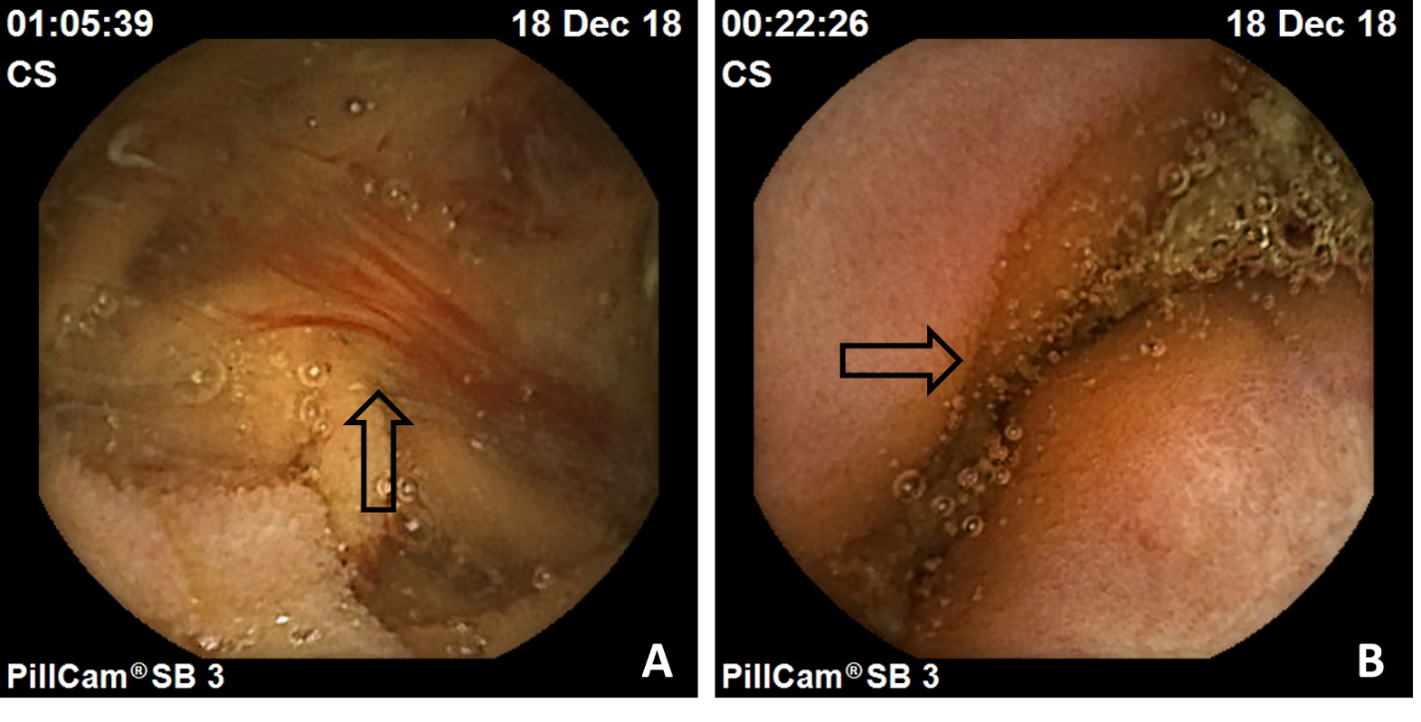
Figure 1 Videocapsule endoscopy findings obtained from our patient. A: Fresh blood in the jejunum; B: Protruding jejunal lesion.

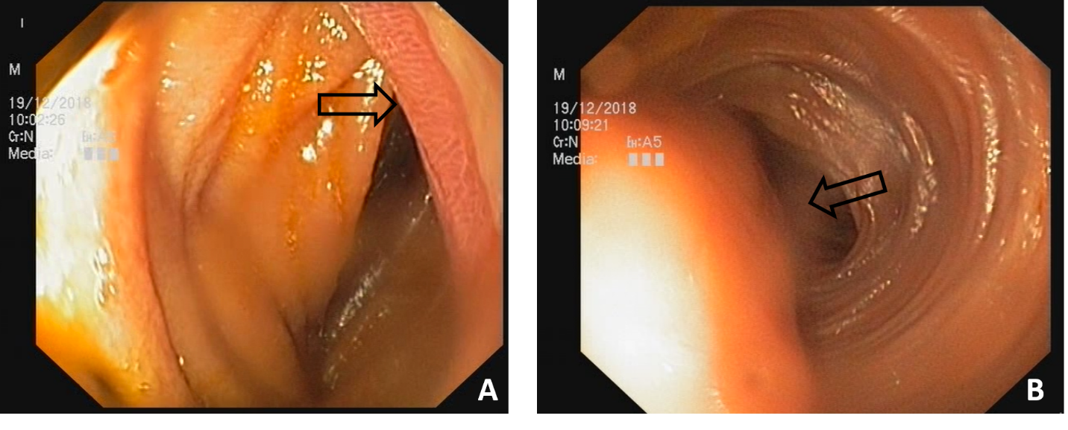
Figure 2 Images acquired through enteroscopy performed in our patient. A: Ulcerated tumoral mass; B: Tumoral mass with partial bowel obstruction.

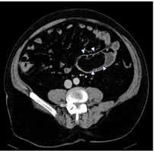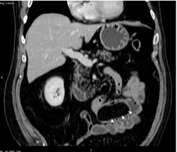
Figure 3 Contrast–enhanced abdominal computed tomography scan. Both axial (left) and coronal (right) reformatted images show a large elongated structure inside of intestinal lumen (arrowheads) with homogeneous fat density and smooth, well defined contour.

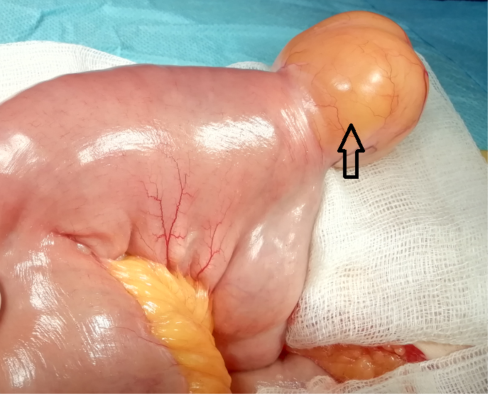

Figure 4 Macroscopic appearance of the jejunal lipoma (arrow).

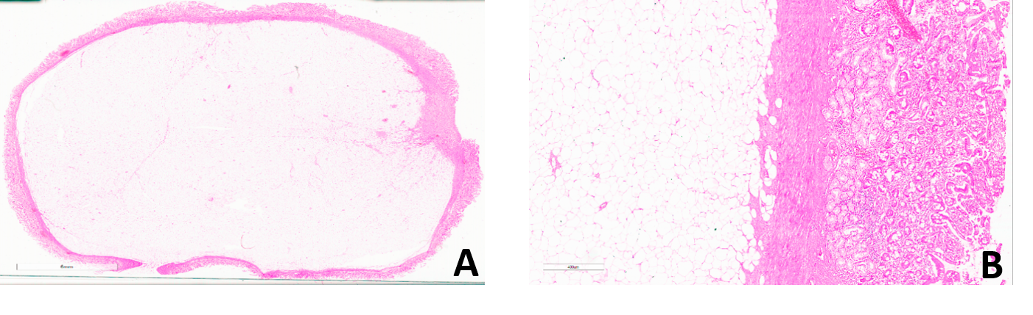
Figure 5 Jejunal submucosal lipoma with ulcerated area of the mucosa. A: Full section (Hematoxylin-eosin staining, × 40); B: Detail (Hematoxylin-eosin staining, × 200).

Table 1 Cases of adult patients with jejunal lipoma complicated with intussusception and bleeding
Ref. | Gender/Age | Diagnostic modality | Size (cm) | Treatment
Ferrara et al^{[10]}, 2011 | F/78 | CT, VCE, Laparoscopy | 3 × 3 × 2.5 | Surgical resection
Mouaqit et al^{[11]}, 2012 | M/35 | CT, Laparotomy | 4 | Surgical resection
Pinto et al^{[12]}, 2018 | M/46 | CT, VCE, Enteroscopy | 7.5 | Surgical resection
Sarabjit et al^{[13]}, 2013 | M/22 | CT, Exploratory laparotomy | 4 | Surgical resection
Manouras et al^{[4]}, 2007 | M/55 | CT, Laparoscopy | 4 × 4 | Surgical resection
Yiğitler et al^{[14]}, 2007 | M/76 | US, CT | 4 × 5 | Surgical resection
Charalambous et al^{[15]}, 2012 | M/46 | CT, Laparotomy | 4 × 4 | Surgical resection
Kida et al^{[16]}, 2017 | M/67 | CT, Enteroscopy | 4 | Surgical resection
Akyüz et al^{[17]}, 2018 | F/61 | CT | 1.5 × 1.5 | Surgical resection
Baron et al^{[18]}, 1996 | F/60 | CT | 5 | Surgical resection
CT: Computed tomography; US: Ultrasonography; VCE: Video capsule endoscopy.

