Name of Journal: World Journal of Clinical Cases
Manuscript NO: 71271
Manuscript Type: CASE REPORT

Implant site development using titanium plate and platelet-rich fibrin for congenitally missed maxillary lateral incisors: A case report

Zhang TS et al. Implant with platelet concentrates

Tian-Shou Zhang, Mahmoud Mudalal, Si-Cong Ren, Yan-Min Zhou

Tian-Shou Zhang, Department of Prosthodontics, School and Hospital of Stomatology, Jilin University, Changchun 130021, Jilin Province, China

Mahmoud Mudalal, Si-Cong Ren, Yan-Min Zhou, Department of Dental Implantology, School and Hospital of Stomatology, Jilin University, Changchun 130021, Jilin Province, China

Mahmoud Mudalal, Department of Oral and Maxillofacial Surgery and Periodontology, Faculty of Dentistry, The Arab American University, Jenin 240, Palestine

Author contributions: Zhou YM contributed to conceptualization and supervision; Mudalal M contributed to investigation and editing; Zhang TS contributed to investigation and data curation; and Ren SC contributed to manuscript reviewing and formal analysis.

Supported by Developmental Plan Project of Science and Technology at Jilin Province, No. 20200201302JC.

Corresponding author: Yan-Min Zhou, PhD, Chief Doctor, Professor, Department of Dental Implantology, School and Hospital of Stomatology, Jilin University, No. 1500 Qinghua Road, Chaoyang District, Changchun 130021, Jilin Province, China. zhouym@jlu.edu.cn

Received: September 2, 2021
Revised: November 29, 2021
Accepted: January 19, 2022
Published online:

Abstract
BACKGROUND
Bone deficiency and soft tissue atrophy in the absence of maxillary lateral incisors are among the most challenging problems for implant clinicians. Autologous bone grafting is the gold standard for bone augmentation, but not without limitations. Platelet-rich fibrin (PRF), a biodegradable autologous biomaterial, has been widely used for bone and soft tissue management. Moreover, titanium plate is an advantageous barrier due to its good space-maintaining ability. However, there is a lack of literature on implant site development using titanium plate and PRF for congenitally missing maxillary lateral incisors.

CASE SUMMARY
The patient was a 19-year-old girl with a congenitally missing tooth (#12). She underwent implant placement and simultaneous autologous bone grafting with titanium plate and PRF. At the follow-up visit 15 d post-procedure, the vascularization of soft tissue was visible. There was no swelling or pain after the surgery. Six months postoperatively, bone regeneration was evident. Subsequently, the definitive restoration was placed, and the patient was satisfied with the esthetic outcomes.

CONCLUSION
Implant site development using titanium plate and PRF for congenitally missing maxillary lateral incisors is a feasible procedure. In this case, the labial bone plate was displaced but remained connected to the base bone, ensuring blood supply. The titanium plate fixed the labial bone plate and maintained the osteogenic space, while the PRF provided growth factors and leukocytes for bone and soft tissue regeneration. Furthermore, the procedure reduced the surgical complexity and adverse reactions, displaying outstanding esthetic outcomes.

Key Words: Implant placement; Platelet-rich fibrin; Missing incisor; Bone augmentation; Soft tissue regeneration; Case report

Zhang TS, Mudalal M, Ren SC, Zhou YM. Implant site development using titanium plate and platelet-rich fibrin for congenitally missed maxillary lateral incisors: A case report. World J Clin Cases 2021; In press

Core Tip: The procedure reported in this paper reduced the surgical complexity and adverse reactions, besides displaying outstanding esthetic outcomes by: (1) Displacement of the labial bone plate that remained connected to the base bone, ensuring blood supply; (2) fixing the labial bone plate and maintaining the osteogenic space with a titanium plate; and (3) providing growth factors and leukocytes for bone and soft tissue regeneration by leukocyte-platelet rich fibrin.

INTRODUCTION
Missing maxillary lateral incisors is a common congenital and developmental anomaly that affects the esthetics due to their position on the denture. Patients are offered several treatment options in such cases, including dental implant treatment, orthodontic space closure, or prosthetic rehabilitation. Dental implant treatment is a popular choice because it offers maximum restoration of tooth function and esthetics. Sufficient quality and quantity of alveolar bone and soft tissue are essential at the implant recipient sites, especially in the esthetic zone for this treatment. Most studies indicated that labial bone and soft tissue thickness should exceed 2 mm to ensure the best outcome and esthetics for implants^{[1]}. Conversely, an extensive bone and soft tissue deficiency with congenitally absent maxillary lateral incisors poses a challenge for dental implant treatment.
Autologous bone grafting is the gold standard for bone augmentation but not without its limitations, such as low blood supply, unpredictable resorption, and donor site morbidity, contributing to research intensification for suitable alternatives^{[2]}. Some studies have reported reconstruction in severe bone deficiency using autologous bone with bone substitute materials in the first procedure to expand the available bone volume and reduce the resorption of autologous bone^{[3,4]}. An adequate blood supply is essential in this procedure, and space creation/maintenance is necessary for bone ingrowth. In addition, primary closure is crucial to ensure uneventful healing^{[5]}. Nevertheless, perfect primary closure may not always occur, especially with the incidence of soft tissue atrophies due to the congenitally missing maxillary lateral incisors. Platelet-rich fibrin (PRF), a biodegradable autologous biomaterial, promotes angiogenesis and bone and soft tissue regeneration and prevents infection since it contains platelets, growth factors, and leukocytes^{[6,7]}. Meanwhile, titanium plate is an advantageous barrier due to its good space-maintaining ability.
In this case report, a procedure was designed to restore a congenitally missing maxilla lateral incisor. First, the labial bone plate was displaced but remained connected to the base bone for bone augmentation using a titanium plate to create/maintain the space. Then, PRF was applied for angiogenesis, bone and soft tissue regeneration, and infection prevention.

CASE PRESENTATION
Chief complaints
A 19-year-old girl visited the Department of Oral Implantology with congenitally absent tooth #12.

History of present illness
The clinical examination found that the spacing was in the maxillary anterior region, and tooth #12 was missing. In addition, keratinized gingiva atrophy and alveolar crest absorption were observed in the edentulous space. After consultation with orthodontists, an interdisciplinary treatment plan was drawn up (Figure 1).

History of past illness
The patient denied any systemic diseases, and her family history was unremarkable.

Personal and family history
Family history was unremarkable.

Physical examination
Physical examination revealed no remarkable findings.

Laboratory examinations
Complete blood count and common urine analysis were performed, which showed no abnormalities.

Imaging examinations
Cone-beam computed tomography (CBCT) showed no residual root and other abnormal conditions, although substantial alveolar bone was lost at the edentulous space (buccal bone thickness = 3.0 mm; alveolar crest height = 12.8 mm) (Figure 2).

FINAL DIAGNOSIS
Tooth #12 congenital absence.

TREATMENT
Pre-operatively, the patient rinsed her mouth with 0.12% chlorhexidine solution every 3 min, thrice. Then, two PRF clots were established using the standard protocol (two whole blood samples were collected in two glass-coated 10 mL plastic tubes without anticoagulant and immediately centrifuged at 3000 rpm for 10 min). Subsequently, one PRF clot was mixed with the xenograft bone substitutes, while the other was pressed into the membranes with a sterile dry gauze to cover the bone granulates. Following local anaesthesia, the #12 alveolar ridge crest mucoperiosteum was excised angularly, followed by flap surgery. First, the bone was expanded to form a receptor site for implant using the ridge splitting set (Helmut, Zepf, Germany) without any bone removal. Then, the labial bone plate was displaced carefully, ensuring that its base remained attached. Next, an implant (Nobel replace 3.5 mm × 13 mm) was inserted at the prepared site (Figure 3A), and the bone block was then fixed with a titanium plate to maintain the bone block (Figure 3B), which was grafted with the PRF and xenograft bone substitute mixture (Bio-oss, 2.5 g, Geistlich) (Figure 3C). Finally, resorbable and PRF membranes were used to double cover the defect site (Figure 3D and E), and the recipient site was loosely sutured (Figure 3F).
For antibiotic therapy, 500 mg azithromycin was prescribed twice daily for 5 d. Additionally, the patient was instructed to avoid chewing in the surgical area and continue using mouthwash with chlorhexidine 0.12% for 10 d. The sutures were removed after 15 d.

OUTCOME AND FOLLOW-UP
The patient denied any swelling and pain after the surgery. Furthermore, the vascularization of soft tissue at the surgery site was visible at the follow-up visit on day 15 (Figure 4). Later, implant osseointegration was evident after a healing period of 6 mo. During the second surgery, the area was explored using the same flap design. Upon reopening the surgical site for titanium plate and healing abutment replacement, it was found that the shoulder of the implant was surrounded by bone, and the titanium plate was covered by the new bone (Figure 5A), indicating that the bone defect had completely regenerated. Then, the recipient site was sutured (Figure 5B). After 14 d of gingiva stabilization, the sutures were removed, and a final impression was taken to construct a conventional permanent super-structure for restoration. Subsequently, the definitive restoration was placed (Figure 6). Later, a 1-year follow-up revealed the integration of soft tissue and tooth with the adjacent tooth (Figure 7A-C). Apart from that, CBCT showed that the bone around the implant was stable (Figure 7D). Thus, the patient was satisfied with the esthetic and functional outcomes.

DISCUSSION
Dental implant treatment is often selected based on their functional and esthetic outcomes in congenitally missing maxillary lateral incisors with available space. However, insufficient bone and soft tissue become obstacles to successful implant treatment. An adequate supporting bone around the implant is essential for the long-term stability and esthetic results of the implant. Some studies proposed combining autologous bone with bone substitute materials for the reconstruction of severe alveolar ridge defects to reduce autologous bone resorption. Titanium plate effectively prevents connective tissue colonization and has good mechanical strength to maintain the osteogenic space during the alveolar ridge reconstruction^{[8,9]}. Meanwhile, Strauss et al^{[10]} reported that PRF with Bio-Oss had an outstanding ability in promoting osteogenesis due to its abundant growth factors.
In this report, the labial bone plate was first displaced, ensuring that the base of the labial bone plate was attached to the basal bone for blood supply. Afterwards, a titanium plate was placed to fix the labial bone plate and maintain the bone formation space. Then, the bone substitute materials and PRF were mixed to cover the bone defect. Upon reopening of the surgical site for titanium plate removal and replacement of healing abutment, it was found that the implant shoulder was surrounded by bone, and the titanium plate was covered by the new bone, indicating that the bone defect had completely regenerated. In addition, CBCT displayed adequate supporting bone around the implant during the 1-year follow-up, and the labial bone plate exceeded 2 mm.
In the esthetic zone, sufficient soft tissue is mandatory for successful implant outcomes. Primary closure is vital to ensure uneventful healing and the soft tissue abundance ensures the esthetic results and long-term health of the implant. Some studies suggested that obtaining primary closure through the relaxation of incision or connective tissue free flap may disrupt the blood supply, accompanied by higher surgical complexity^{[11]}. Recently, concentrated platelets have been recommended as an efficient strategy for wound healing^{[12,13]}. PRF, a second-generation platelet concentrate, contains various growth factors, platelets, and leukocytes^{[14]}. The three-dimensional fibrin scaffold of PRF continuously releases growth factors^{[15]} that promote local tissue vascularization and regeneration during wound healing^{[16]}. Moreover, PRF plays a crucial role in wound healing as an excellent anti-inflammatory and antibacterial agent^{[17,18]}.
In addition, Miron et al^{[19]} reviewed the effects of PRF on wound healing and highlighted its positive effects on the management of soft tissue. Meanwhile, Cui et al^{[20]} reported that the PRF membrane without a tight flap closure could achieve excellent soft tissue regeneration. In the present case, bio-guide membrane and PRF membrane were utilized to double cover the bone substitute materials without a tight flap closure for mechanical barrier and soft tissue regeneration. The patient denied any swelling and pain after the surgery, which might be attributed to the anti-inflammatory and antibacterial activity of PRF. Furthermore, at the follow-up on day 15, the vascularization of soft tissue was visible, and excellent gingival contour was obtained when the definitive restoration was placed. On top of that, the 1-year follow-up revealed harmony and stability of the gingival contour.

CONCLUSION
Bone regeneration and soft tissue management pose challenges for dental implant treatment in congenitally missing maxillary lateral incisors. In the present case, the labial bone plate was displaced but remained connected to the base bone, ensuring blood supply. A titanium plate was used to fix the labial bone plate and maintain the osteogenic space. Meanwhile, the PRF supplied growth factors and leukocytes for bone and soft tissue regeneration. This procedure reduced the surgical complexity besides demonstrating fewer adverse reactions and outstanding esthetic outcomes.

REFERENCES
1 Grunder U, Gracis S, Capelli M. Influence of the 3-D bone-to-implant relationship on esthetics. Int J Periodontics Restorative Dent 2005; 25: 113-119 [PMID: 15839587]
2 Kolk A, Handschel J, Drescher W, Rothamel D, Kloss F, Blessmann M, Heiland M, Wolff KD, Smeets R. Current trends and future perspectives of bone substitute materials - from space holders to innovative biomaterials. J Craniomaxillofac Surg 2012; 40: 706-718 [PMID: 22297272 DOI: 10.1016/j.jcms.2012.01.002]
3 Schwartz-Arad D, Levin L. Multitier technique for bone augmentation using intraoral autogenous bone blocks. Implant Dent 2007; 16: 5-12 [PMID: 17356367 DOI: 10.1097/ID.0b013e3180327595]
4 Schwartz-Arad D, Levin L. Symphysis revisited: clinical and histologic evaluation of newly formed bone and reharvesting potential of previously used symphysial donor sites for onlay bone grafting. J Periodontol 2009; 80: 865-869 [PMID: 19405841 DOI: 10.1902/jop.2009.080602]
5 Wang HL, Boyapati L. "PASS" principles for predictable bone regeneration. Implant Dent 2006; 15: 8-17 [PMID: 16569956 DOI: 10.1097/01.id.0000204762.39826.0f]
6 Dohle E, El Bagdadi K, Sader R, Choukroun J, James Kirkpatrick C, Ghanaati S. Platelet-rich fibrin-based matrices to improve angiogenesis in an in vitro co-culture model for bone tissue engineering. J Tissue Eng Regen Med 2018; 12: 598-610 [PMID: 28509340 DOI: 10.1002/term.2475]
7 Pitzurra L, Jansen IDC, de Vries TJ, Hoogenkamp MA, Loos BG. Effects of L-PRF and A-PRF+ on periodontal fibroblasts in in vitro wound healing experiments. J Periodontal Res 2020; 55: 287-295 [PMID: 31782171 DOI: 10.1111/jre.12714]
8 Zita Gomes R, Paraud Freixas A, Han CH, Bechara S, Tawil I. Alveolar Ridge Reconstruction with Titanium Meshes and Simultaneous Implant Placement: A Retrospective, Multicenter Clinical Study. Biomed Res Int 2016; 2016: 5126838 [PMID: 27999799 DOI: 10.1155/2016/5126838]
9 Rasia-dal Polo M, Poli PP, Rancitelli D, Beretta M, Maiorana C. Alveolar ridge reconstruction with titanium meshes: a systematic review of the literature. Med Oral Patol Oral Cir Bucal 2014; 19: e639-e646 [PMID: 25350597 DOI: 10.4317/medoral.19998]
10 Miron RJ, Zucchelli G, Pikos MA, Salama M, Lee S, Guillemette V, Fujioka-Kobayashi M, Bishara M, Zhang Y, Wang HL, Chandad F, Nacopoulos C, Simonpieri A, Aalam AA, Felice P, Sammartino G, Ghanaati S, Hernandez MA, Choukroun J. Use of platelet-rich fibrin in regenerative dentistry: a systematic review. Clin Oral Investig 2017; 21: 1913-1927 [PMID: 28551729 DOI: 10.1007/s00784-017-2133-z]
11 Waasdorp J, Feldman S. Bone regeneration around immediate implants utilizing a dense polytetrafluoroethylene membrane without primary closure: a report of 3 cases. J Oral Implantol 2013; 39: 355-361 [PMID: 21905904 DOI: 10.1563/AAID-JOI-D-10-00128]
12 Durmuşlar MC, Balli U, Dede FÖ, Misir AF, Bariş E, Kürkçü M, Kahraman SA. Histological Evaluation of the Effect of Concentrated Growth Factor on Bone Healing. J Craniofac Surg 2016; 27: 1494-1497 [PMID: 27428921 DOI: 10.1097/SCS.0000000000002873]
13 Strauss FJ, Stähli A, Gruber R. The use of platelet-rich fibrin to enhance the outcomes of implant therapy: A systematic review. Clin Oral Implants Res 2018; 29 Suppl 18: 6-19 [PMID: 30306698 DOI: 10.1111/clr.13275]
14 Cortese A, Pantaleo G, Amato M, Howard CM, Pedicini L, Claudio PP. Platelet-Rich Fibrin (PRF) in Implants Dentistry in Combination with New Bone Regenerative Flapless Technique: Evolution of the Technique and Final Results. Open Med (Wars) 2017; 12: 24-32 [PMID: 28401197 DOI: 10.1515/med-2017-0005]
15 Kobayashi E, Flückiger L, Fujioka-Kobayashi M, Sawada K, Sculean A, Schaller B, Miron RJ. Comparative release of growth factors from PRP, PRF, and advanced-PRF. Clin Oral Investig 2016; 20: 2353-2360 [PMID: 26809431 DOI: 10.1007/s00784-016-1719-1]
16 Bielecki T, Dohan Ehrenfest DM, Everts PA, Wiczkowski A. The role of leukocytes from L-PRP/L-PRF in wound healing and immune defense: new perspectives. Curr Pharm Biotechnol 2012; 13: 1153-1162 [PMID: 21740376 DOI: 10.2174/138920112800624373]
17 Feng M, Wang Y, Zhang P, Zhao Q, Yu S, Shen K, Miron RJ, Zhang Y. Antibacterial effects of platelet-rich fibrin produced by horizontal centrifugation. Int J Oral Sci 2020; 12: 32 [PMID: 33243983 DOI: 10.1038/s41368-020-00099-w]
18 Zhang J, Yin C, Zhao Q, Zhao Z, Wang J, Miron RJ, Zhang Y. Anti-inflammation effects of injectable platelet-rich fibrin via macrophages and dendritic cells. J Biomed Mater Res A 2020; 108: 61-68 [PMID: 31449340 DOI: 10.1002/jbm.a.36792]
19 Miron RJ, Fujioka-Kobayashi M, Bishara M, Zhang Y, Hernandez M, Choukroun J. Platelet-Rich Fibrin and Soft Tissue Wound Healing: A Systematic Review. Tissue Eng Part B Rev 2017; 23: 83-99 [PMID: 27672729 DOI: 10.1089/ten.TEB.2016.0233]
20 Cui A, Zhou J, Mudalal M, Wang Y, Wang J, Gong M, Zhou Y. Soft tissue regeneration around immediate implant placement utilizing a platelet-rich fibrin membrane and without tightly flap closure: Two case reports. Medicine (Baltimore) 2020; 99: e22507 [PMID: 33019451 DOI: 10.1097/MD.0000000000022507]

Footnotes
Informed consent statement: Informed written consent was obtained from the patient for publication of this report and any accompanying images.

Conflict-of-interest statement: The authors declare that they have no conflict of interest to disclose.

CARE Checklist (2016) statement: The authors have read the CARE Checklist (2016), and the manuscript was prepared and revised according to the CARE Checklist (2016).

Open-Access: This article is an open-access article that was selected by an in-house editor and fully peer-reviewed by external reviewers. It is distributed in accordance with the Creative Commons Attribution NonCommercial (CC BY-NC 4.0) license, which permits others to distribute, remix, adapt, build upon this work non-commercially, and license their derivative works on different terms, provided the original work is properly cited and the use is non-commercial. See: http://creativecommons.org/Licenses/by-nc/4.0/

Provenance and peer review: Unsolicited article; Externally peer reviewed.
Peer-review model: Single blind

Peer-review started: September 2, 2021
First decision: November 19, 2021
Article in press:

Specialty type: Dentistry, oral surgery and medicine
Country/Territory of origin: China
Peer-review report’s scientific quality classification
Grade A (Excellent): 0
Grade B (Very good): B, B
Grade C (Good): C
Grade D (Fair): D
Grade E (Poor): 0

P-Reviewer: Grawish ME, Madi M, Nappe C, Şentürk MF S-Editor: Li X L-Editor: Wang TQ P-Editor: Li X

Figure Legends
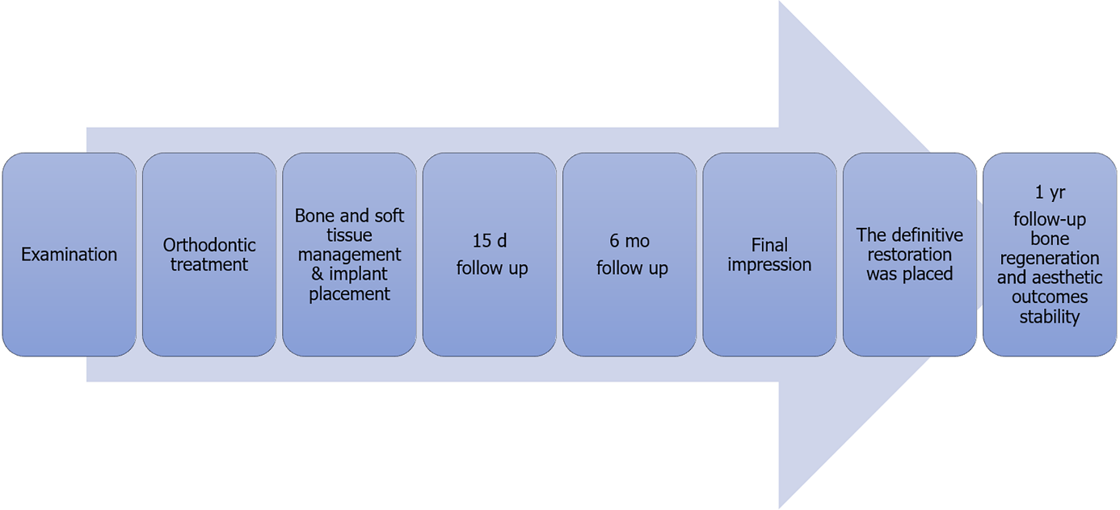
Figure 1 Flow chart timeline of the treatment plan.

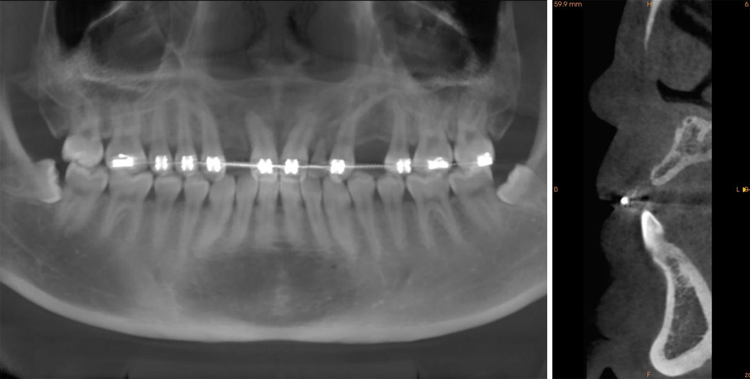
Figure 2 Cone-beam computed tomography revealed considerable alveolar bone loss.

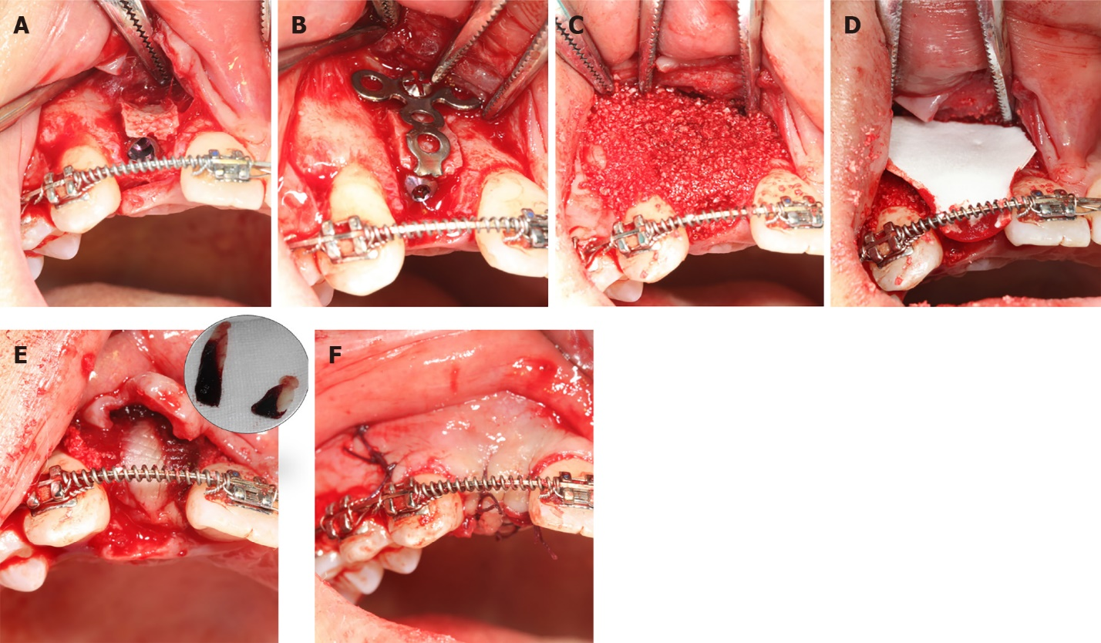
Figure 3 The surgical procedure. A: The implant was placed at the recipient cite #12 after the labial bone plate displacement; B: A T-type titanium plate was used to fix the bone block; C: The mixture of bone grafts and platelet-rich fibrin (PRF) clot covered the T-type titanium plate and the socket walls; D: Resorbable membrane covered the bone grafts; E: PRF membrane covered the resorbable membrane and alveolar crest; F: The wound was non-tightly sutured.

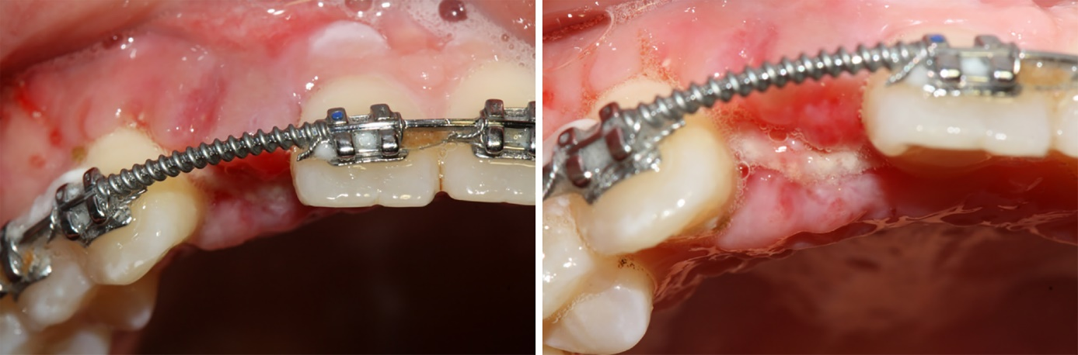
Figure 4 Intraoral condition at the 15 d follow-up visit: The vascularization of soft tissue was visible.

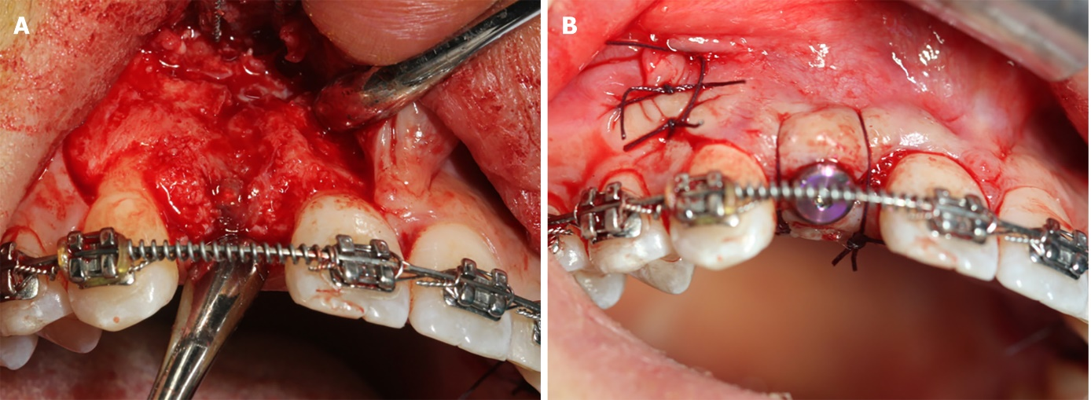
Figure 5 Second stage surgery. A: The implant was surrounded by bone and the titanium plate was covered by the new bone; B: The incision was non-tightly sutured.

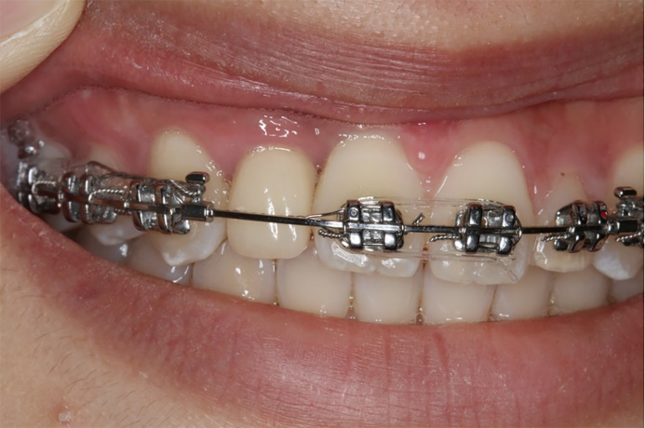
Figure 6 The definitive restoration.

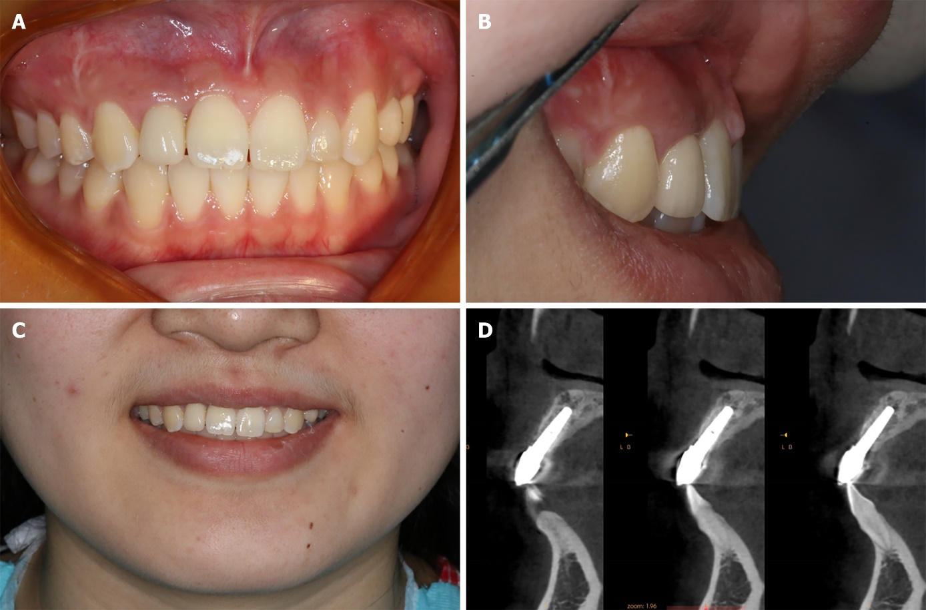
Figure 7 Assessments at 1 year after surgery. A-C: Intraoral condition; D: Cone-beam computed tomography image showing the stable bone around implant.

