Name of Journal: World Journal of Psychiatry
Manuscript NO: 71969
Manuscript Type: ORIGINAL ARTICLE

Case Control Study
Altered thalamic subregion functional networks in patients with treatment-resistant schizophrenia

Kim WS et al. Thalamic subregion functional networks in TRS

Woo-Sung Kim, Jie Shen, Uyanga Tsogt, Soyolsaikhan Odkhuu, Young-Chul Chung

Woo-Sung Kim, Jie Shen, Uyanga Tsogt, Soyolsaikhan Odkhuu, Young-Chul Chung, Department of Psychiatry, Jeonbuk National University, Jeon-ju 54907, South Korea

Author contributions: Chung YC conceptualized the study; Tsogt U, Shen J, Kim WS, Odkhuu S, and Chung YC performed the study and acquired data; Kim WS conducted experiment and statistical analysis; Kim WS drafted the manuscript; Tsogt U, Shen J, Kim WS, and Odkhuu critically reviewed the manuscript; Chung YC finalized the manuscript; all authors approved the final manuscript.

Supported by the Korean Mental Health Technology R&D Project, Ministry of Health & Welfare, Republic of Korea, No. HL19C0015; and the Korea Health Technology R&D Project through the Korea Health Industry Development Institute, funded by the Ministry of Health & Welfare, Republic of Korea, No. HR18C0016.

Corresponding author: Young-Chul Chung, MD, PhD, Professor, Department of Psychiatry, Jeonbuk National University, 20, Geonji-ro, Deokjin-gu, Jeonju-si, Jeollabuk-do, Republic of Korea, Jeon-ju 54907, South Korea. chungyc@jbnu.ac.kr

Received: September 28, 2021
Revised: November 25, 2022
Accepted: April 2, 2022
Published online:

Abstract
BACKGROUND
The thalamus plays a key role in filtering information and has extensive interconnectivity with other brain regions. A large body of evidence points to impaired functional connectivity (FC) of the thalamocortical pathway in schizophrenia. However, the functional network of the thalamic subregions has not been investigated in patients with treatment-resistant schizophrenia (TRS).

AIM
To identify the neural mechanisms underlying TRS, we investigated FC of thalamic sub-regions with cortical networks and voxels, and the associations of this FC with clinical symptoms. We hypothesized that the FC of thalamic sub-regions with cortical networks and voxels would differ between TRS patients and HCs.

METHODS
In total, 50 patients with TRS and 61 healthy controls (HCs) matched for age, sex, and education underwent resting-state functional magnetic resonance imaging (rs-fMRI) and clinical evaluation. Based on the rs-fMRI data, we conducted a FC analysis between thalamic subregions and cortical functional networks and voxels, and within thalamic subregions and cortical functional networks, in the patients with TRS. A functional parcellation atlas was used to segment the thalamus into nine subregions. Correlations between altered FC and TRS symptoms were explored.

RESULTS
We found differences in FC within thalamic subregions and cortical functional networks between patients with TRS and HCs. In addition, increased FC was observed between thalamic subregions and the sensorimotor cortex, frontal medial cortex, and lingual gyrus. These abnormalities were associated with the pathophysiology of TRS.

CONCLUSION
Our findings suggest that disrupted FC within thalamic subregions and cortical functional networks, and within the thalamocortical pathway, has potential as a marker for TRS. Our findings also improve our understanding of the relationship between the thalamocortical pathway and TRS symptoms.

Key Words: Treatment-resistant schizophrenia; Thalamus; Rs-fMRI; Functional connectivity; Thalamocortical pathway

Kim WS, Shen J, Tsogt U, Odkhuu S, Chung YC. Altered thalamic subregion functional networks in patients with treatment-resistant schizophrenia. World J Psychiatr 2022; In press

Core Tip: The thalamus represents the interface between the sensory and motor systems, and is a major hub for cognitive processes. A large body of evidence has demonstrated involvement of the thalamus in the pathophysiology of schizophrenia. Most previous studies employing resting state functional magnetic resonance imaging used the whole thalamus as a seed region to identify abnormalities in thalamic connectivity. To identify more specific disturbances, we conducted functional connectivity analysis of thalamic subregions with cortical networks and voxels in patients with treatment resistant schizophrenia. Important novel findings regarding the pathophysiology of treatment resistant schizophrenia were obtained.

INTRODUCTION
The thalamus is an important deep gray matter structure that transmits sensory information from the peripheral sensory nervous system to the cortex, and serves as a major hub for cognitive processes^{[1]}. Given its 'central roles' in perception and cognition, disturbances of which are major symptoms of schizophrenia (SZ), the thalamus has been focused on in brain imaging studies of SZ. Structural magnetic resonance imaging (sMRI) studies revealed thalamic surface deformation in patients with first-episode and chronic SZ, as well as reduced thalamus volume in a cohort of early onset psychosis patients^{[2-5]}. Moreover, resting state functional magnetic resonance imaging (rs-fMRI) studies have consistently revealed decreased thalamic connectivity with the prefrontal cortex (PFC) in SZ, as well as increased connectivity with motor and somatosensory cortical areas^{[6]}. Furthermore, these aberrant connectivities were also observed in clinical high-risk (CHR) individuals, suggesting that thalamic dysconnectivity onsets prior to the disease itself^{[7,8]}.
Previous studies treated the thalamus as a homogeneous structure, averaging blood oxygen level-dependent (BOLD) signals across the entire thalamus. However, this approach may fail to capture disturbances in specific networks, so it is necessary to investigate functional connectivity (FC) between sub-regions of the thalamus and cortex to better understand altered neural circuits in SZ. Several atlases segment the thalamus, including histological-^{[9,10]}, structural-^{[11,12]} and functional-based atlases^{[13]}. In this study, we used a functional parcellation atlas to identify nine thalamic sub-regions having strong FC with various cortical functional networks^{[13]}. The atlas allows the topological roles of thalamic nuclei in functional brain networks to be elucidated through graph-theoretic network analysis of rs-fMRI data. Few studies have examined altered FC in thalamic sub-regions in SZ. Three studies reported findings similar to those of investigations using average BOLD signals for the thalamus, i.e., weaker PFC-thalamic network connectivity and stronger motor-thalamic and somatosensory-thalamic network connectivity compared to healthy controls (HCs)^{[14,15,16]}. On the other hand, Gong et al^{[17]} observed loss of connectivity between several thalamic sub-regions and the sensorimotor system, anterior cingulate cortex, and cerebellum in patients with SZ. To the best of our knowledge, no study has examined the FC of thalamic sub-regions in patients with treatment-resistant schizophrenia (TRS).
We hypothesized that the FC of thalamic sub-regions with cortical networks and voxels would differ between TRS patients and HCs. To identify the neural mechanisms underlying TRS, we investigated FC of thalamic sub-regions with cortical networks and voxels, and the associations of this FC with clinical symptoms.

MATERIALS AND METHODS
Participants
This study included 111 subjects (50 patients with TRS and 61 HCs). SZ was diagnosed based on the DSM-IV^{[18]} criteria by a board-certified psychiatrist and psychiatric residents. The exclusion criteria were as follows: alcohol or substance use disorder; intellectual disability (IQ ≤ 70); current or past neurological disease, serious medical illness, or pregnancy; and claustrophobia. Treatment resistance was defined as follows: failure to respond to at least two different antipsychotic medications administered in adequate doses (equivalent to ≥ 600 mg/day of chlorpromazine [CPZ]) for at least 6 wk; and persistence of clinically relevant positive or negative symptoms (at least one positive or negative symptom and a Positive and Negative Syndrome Scale (PANSS) score of ≥ 4)^{[19]}. The second criterion was not applied to patients on clozapine. The severity of symptoms was evaluated within a week of fMRI using the PANSS^{[20,21]}. HCs were recruited via advertisements and interviewed using the Structured Clinical Interview for DSM, Non-Patient Edition (SCID-NP)^{[22]}. A requirement for study inclusion was no previous or current psychiatric disorders, neurological disorders, or significant medical conditions. Controls having a first-degree relative with a psychiatric disorder were also excluded. All participants were aged between 19 and 60 years, and all were confirmed as right-handed by the Edinburgh Handedness Inventory^{[23]}. They all participated voluntarily and provided written informed consent. The study was approved by the Ethics Committee of Jeonbuk National University Hospital (approval number: CUH 2012-08-001).

Image acquisition and preprocessing
The rs-fMRI and sMRI data were obtained at the Jeonbuk National University Hospital using a 3T Verio scanner (Magnetom Verio; Siemens, Erlangen, Germany) with a 12-channel standard quadrature head coil. Three-dimensional T1-weighted images were acquired using a magnetization-prepared rapid gradient echo sequence (repetition time [TR]: 1,900 ms; echo time [TE]: 2.5 ms; flip angle: 9°; field of view [FOV]: 250 mm; image matrix: 256 × 246 mm; voxel size: 1.0 × 1.0 × 1.0 mm³; 176 slices). A 5-minute resting-state scan consisting of 150 contiguous echo-planar imaging functional images (TR: 2,000 ms; TE: 30 ms; flip angle: 90°; FOV: 220 mm; image matrix: 64 × 64 mm; voxel size: 3.4 × 3.4 × 5.0 mm³; 26 slices) was also obtained. During resting-state image acquisition, participants were asked to relax with their eyes closed, but not to sleep. MRI data processing was conducted using the Statistical Parametric Mapping software package, version 12 (SPM12; Wellcome Department of Cognitive Neurology, London, UK) implemented in MATLAB (MathWorks, Natick, MA, United States). The first three volumes were discarded to adjust for magnetization equilibrium. Functional images were slice-time corrected, realigned to the first image of each series, and co-registered with each participant's structural image. Then, the co-registered functional data were transformed into standard anatomical space through spatial normalization of each T1 image to the Montreal Neurological Institute (MNI) template. Normalized images were smoothed using an 8 mm full-width at half-maximum isotropic Gaussian kernel. The voxels were resampled (2.0 mm × 2.0 mm × 2.0 mm). Head motion was considered excessive when framewise displacement (FD) was > 0.5 mm. FD values were computed using the CONN toolbox (version 14f; http://www.nitrc.org/projects/conn). Participants for whom more than 10% of the volumes showed excessive head motion were excluded from the analysis^{[24]}. The component correction (CompCor)^{[25]} function of the CONN toolbox was used to increase the accuracy of grey matter (GM) signals by removing physiological noise, such as heart rate and breathing signals, followed by removal of the components of interest from the global, white matter (WM), and cerebrospinal fluid (CSF) signals. The linear trend was then removed and a band-pass filter (0.008 < f < 0.09 Hz) was applied.

Functional connectivity analysis
The functional parcellation atlas¹³ was used to segment the thalamus into nine subregions (Figure S1). Nine thalamic subregions showing strong FC with nine cortical functional networks were identified, i.e., the default mode (DM), cingulo-opercular occipital (CO), somatomotor (SM), frontal parietal (FP), lateral occipital (LO), medial occipital (MO), medial temporal (MT), temporal, and superior FP networks. The components of each cortical functional network are described in Supplementary Table 1. For each region of interest (ROI) of the thalamus and cortical functional networks, the BOLD signal was averaged to generate the BOLD time series. FC analysis was performed between thalamic ROIs and cortical functional network ROIs, within the nine thalamic and nine cortical functional network ROIs, and between the thalamic ROIs and all cortical voxels (using the CONN toolbox). The patient and HC groups were compared using one-way analysis of variance (ANOVA). We used a voxel-level height threshold of P < 0.01 (uncorrected) and a cluster-level extent threshold of P < 0.05, corrected for multiple comparisons using the family wise error (FWE). We performed 10,000 permutation tests using the CONN toolbox (www.nitrc.org/projects/conn, RRID:SCR_009550).

Statistical analysis
Demographic and clinical data were compared between the two groups using a two-sample t-test or Chi-square test. For partial correlation analysis, a ROI extraction tool (http://software.incf.org/software/rex) in the CONN toolbox was used to extract Fisher's Z-transformed signal intensity values for brain regions with significant group differences at an uncorrected p-value of < 0.01. Relationships between the extracted Z-scores and PANSS scores were analyzed using age, sex, and FD as covariates. The analyses were performed using SPSS software (ver. 20.0; SPSS Inc., Chicago, IL, United States).

RESULTS
Functional connectivity between and within thalamic subregions and cortical functional networks in TRS
There were no significant differences in age, sex, or education level between the two groups (Table 1). The TRS group showed significantly increased FC between thalamic subregion 2 and the MO network (t = 2.78, P < 0.05) compared to the HC group. The TRS group also exhibited significantly increased FC of the CO network with the MO (t = 3.29, P < 0.05) and superior MT networks, and between the MT network and superior FP network (t = 2.63, P < 0.05) (t = 4.31, P < 0.05) compared to the HC group. On the other hand, the TRS group exhibited decreased FC of thalamic subregion 1 with thalamic subregions 2 and 9 (t = -2.95, P < 0.05) and of thalamic subregion 2 with thalamic subregions 3 and 4 (t = -4.58, P < 0.05), compared to the HC group. Also, in the TRS group, decreased FC of the FP network was observed with the MT (t = -2.69, P < 0.05) and superior FP networks (t = -2.73, P < 0.05), between the DM and CO networks (t = -2.90, P < 0.05), and between the MO and MT networks (t = -2.90, P < 0.05), compared to the HC group (Table 2, Figure 1).

Functional connectivity between thalamic subregions and cortical voxels in TRS
Compared to the HC group, the TRS group exhibited significantly increased FC between thalamic subregion 1 and the left lingual gyrus (t = 5.22, P < 0.05), thalamic subregion 2 and the left precentral gyrus (t = 5.22, P < 0.05), thalamic subregion 3 and the right supplementary motor cortex (t = 5.26, P < 0.05), thalamic subregion 6 and the frontal medial cortex (t = 7.05, P < 0.05), the left postcentral gyrus (t = 5.26, P < 0.05) and right precentral gyrus (t = 4.79, P < 0.05), and thalamic subregion 9 and the left precentral gyrus (t = 5.26, P < 0.05). On the other hand, the TRS group exhibited significantly decreased FC between thalamic subregion 3 and the left intracalcarine cortex (t = -4.18, P < 0.05) compared to the HC group (Table 3, Figure 2).

Correlations between altered ROI-to-ROI functional connectivity and PANSS scores
The Z-values of FP and MT network connectivity were negatively correlated with positive symptoms, negative symptoms, general pathophysiology, and PANSS total scores (r = -0.411, P = 0.005; r = -0.414, P = 0.004; r = -0.427, P = 0.003; and r = -0.472, P = 0.001, respectively) in the TRS group. Also, negative correlations were observed between the Z-value of the DM and MT networks and negative symptoms, general pathophysiology, and the PANSS total score (r = -0.316, P = 0.032; r = -0.322, P = 0.029; and r = -0.298, P = 0.044, respectively) (Table 4, Figure 3).

Correlations between altered seed-to-voxel functional connectivity and PANSS scores
No significant relationship was found between altered FC and PANSS scores at an uncorrected p-value of < 0.01 (Supplementary Table 2). Therefore, the analysis was performed against an uncorrected p-value of < 0.05 (Supplementary Table 3). In the TRS group, the Z-value of thalamic subregion 3 and the right lingual gyrus FC was negatively correlated with positive symptoms, negative symptoms, general pathophysiology, and the PANSS total score (r = -0.342, P = 0.020; r = -0.355, P = 0.015; r = -0.350, P = 0.017; and r = -0.396, P = 0.007, respectively). However, there was a positive correlation between the Z-value of thalamic subregion 2 and the left precentral gyrus and the score for general pathophysiology (r = 0.292, P = 0.049) (Table 5, Figure 4).

DISCUSSION
The thalamus represents the interface between the sensory and motor systems, and is a major hub for cognitive processes. A large body of evidence has demonstrated involvement of the thalamus in the pathophysiology of SZ. Most previous studies employing rs-fMRI used the whole thalamus as a seed region to identify abnormalities in thalamic connectivity. To identify more specific disturbances, we conducted FC analysis of thalamic subregions with cortical networks and voxels in patients with TRS. Important novel findings regarding the pathophysiology of TRS were obtained, and are discussed below.
The network analysis revealed significant FC only between thalamic subregion 2 and the MO network. By mapping the coordinates of 333 cortical ROIs, identified using the Gordon atlas^{[26]}, to the masks of cortical functional networks^{[13]}, we were able to identify subcomponents of the MO network, including the superior frontal gyrus, superior parietal gyrus, inferior parietal gyrus, precentral gyrus, postcentral gyrus, supplementary motor area, insula, precuneus, Rolandic operculum, and paracentral lobule. As the MO network consists of many different regions, it is difficult to determine which of them have the most clinical importance. However, thalamic subregion 2 has a high participation coefficient (PC), indicating that it serves as a connector hub^{[13]}; as such, altered functioning of thalamic subregion 2 may mediate cortical-to-cortical communication in patients with TRS. The other significant FC results were related to connectivity between thalamic subregions and cortical functional networks. Among these, decreased FC between several thalamic subregions in TRS patients was of particular interest, because previous studies mainly focused on the thalamocortical or corticothalamic pathway. In line with our results, Gong et al (2019)^{[17]} reported deceased within-thalamic FC in an SZ group compared to controls. Furthermore, a decreased thalamic volume in chronic SZ patients was seen^{[27,28,29]} as well as reduced regional glucose metabolism in the medial dorsal nucleus and posterior thalamus of antipsychotic-naïve patients with SZ^{[30]}. It may be that reduced intrathalamic connectivity mediates the key role of the thalamus in perception, motor function, and cognitive integration^{[1]}, in turn contributing to the development of pathophysiology in TRS. More commonly described abnormalities in TRS include hyperconnectivity and hypoconnectivity between cortical functional networks. In this study, each cortical functional network consisted of many heterogeneous areas, and the results were significant even when using the BOLD time series for large cortical areas. Therefore, these findings may be considered as functional biomarkers for TRS. However, our expectation that the role of the thalamus as a connector hub would be disrupted in TRS was not confirmed.
With respect to thalamic connectivity with cortical voxels, we identified significant hyperconnectivity of five thalamic subregions with various cortical regions in patients with TRS compared to HCs. Interestingly, most of these involved increased connectivity to the precentral and postcentral gyri and supplementary motor cortex. Considering the role of these areas in integrating sensorimotor information and coordinating physical movements^{[31,32]}, these findings may be relevant to the sensory and motor abnormalities found in TRS, such as hallucinations and neurological soft signs. Many studies have reported increased functional coupling between the thalamus and sensorimotor cortices in SZ^{[33,34,35,36,37]}. However, this is the first study to report hyperconnectivity between thalamic subregions and the sensorimotor cortex in TRS. We also found increased connectivity to the frontal medial cortex and lingual gyrus. This is in contrast to previous research showing a reduction in FC of the thalamus with the prefrontal and cingulate cortices in SZ, based on signals averaged across the entire thalamus^{[33,34,36,38,39,40,41]} as well as separate signals for individual thalamic subregions^{[15,16,17]}. However, the subjects in previous studies were not patients with TRS. The medial PFC has been shown to play a fundamental role in a wide range of social cognitive abilities, such as self-reflection, person perception, and theory of mind/mentalizing^{[42]}. Also, the lingual gyrus has been implicated in visual memory^{[43]} and divergent thinking^{[44]}. Therefore, increased thalamo-frontal or thalamo-lingual connectivity might serve as a marker for TRS. The potential associations of FC with social cognition and divergent thinking warrant further investigation. Finally, decreased connectivity of thalamic subregion 3 with the intracalcarine cortex was observed in our TRS patients. A similar result was reported in chronic SZ^{[17]}. Given that the calcarine cortex is known to be involved in the processing of visual mental imagery^{[45]}, an fMRI study using a visual mental imagery task could be useful for exploring the pathophysiological mechanisms of TRS.
With regard to our analyses of altered ROI-to-ROI FCs, FC between the FP and MT networks, and between the DM and MT networks, showed negative relationships with positive symptoms, negative symptoms, general pathophysiology, and PANSS total scores. These findings suggest that altered connectivity between intracortical functional networks is associated with overall pathophysiology rather than specific symptom domains. This is intuitive considering that each cortical functional network consists of many heterogenous cortical regions. Regarding our analyses of cortical voxels, FC between thalamic subregion 3 and the right lingual gyrus showed negative relationships with positive symptoms, negative symptoms, general pathophysiology, and PANSS total scores. Even after considering the role of the lingual gyrus in visual memory and divergent thinking, it is difficult to determine how this altered FC is associated with overall pathophysiology. However, it may be that impairment of thalamic subregion 3, in terms of its role as a connector hub, has significant effects on the integration of cortical information. Finally, the positive association of FC between thalamic subregion 2 and the precentral gyrus with general pathophysiology accords with the findings of prior studies^{[17,33]}. Even though patients with SZ often show abnormal involuntary movements or neurological soft signs related to the function of the precentral gyrus, it is difficult to identify relationships between motor functions and general pathophysiology^{[46]}.

CONCLUSION
Several limitations of this study need to be considered. First, although the use of a functional parcellation atlas to segment the thalamus into subregions was a strength of this study, the roles and precise locations of thalamic subregions are still largely unknown, making it difficult to determine which specific regions had the largest effect on the results. Second, we did not recruit all subtypes of TRS patients, as recommended by the Treatment Response and Resistance in Psychosis Working Group^{[19]}. The proportions of positive, negative, and positive and negative subtypes were 22%, 14%, and 32%, respectively. The remaining 32% of patients did not meet the criteria for the positive or negative subtype, because we applied a rating of moderate severity to just one symptom item. This should be addressed in future studies. Third, the TRS patients were all heavily medicated, so it is unclear whether the significant changes in FC reported above were a consequence of the disease process or medication. In this context, it will be important to determine the relative importance of illness duration, the number of psychotic episodes, and medication. Despite these weaknesses, this is the first report on altered FC of the thalamocortical pathway in TRS using thalamic subregions as seeds. In summary, in our TRS patients, we found altered FC between various thalamic subregions, between various cortical functional networks, and between thalamic subregions and various cortical regions. These abnormalities were associated with overall pathophysiology. Collectively, these results suggest that disrupted FC within thalamic and cortical functional networks, and within the thalamocortical pathway, could serve as markers for TRS. This study improves our understanding of the relationships between the thalamocortical pathway and symptoms of TRS.

ARTICLE HIGHLIGHTS
Research background
The thalamus is an important deep gray matter structure that transmits sensory information from the peripheral sensory nervous system to the cortex, and serves as a major hub for cognitive processes. Previous studies treated the thalamus as a homogeneous structure, averaging blood oxygen level-dependent signals across the entire thalamus. However, this approach may fail to capture disturbances in specific networks, so it is necessary to investigate functional connectivity (FC) between sub-regions of the thalamus and cortex to better understand altered neural circuits in Schizophrenia (SZ).

Research motivation
To the best of our knowledge, no study has examined the FC of thalamic sub-regions in patients with treatment-resistant schizophrenia (TRS).

Research objectives
To identify the neural mechanisms underlying TRS. We hypothesized that the FC of thalamic sub-regions with cortical networks and voxels would differ between TRS patients and HCs (Healthy Controls).

Research methods
This study included 111 subjects (50 patients with TRS and 61 HCs). The rs-fMRI and sMRI data were obtained at the Jeonbuk National University Hospital using a 3T Verio scanner (Magnetom Verio; Siemens, Erlangen, Germany) with a 12-channel standard quadrature head coil. The functional parcellation atlas was used to segment the thalamus into nine subregions. FC analysis was performed between thalamic ROIs and cortical functional network ROIs, within the nine thalamic and nine cortical functional network ROIs, and between the thalamic ROIs and all cortical voxels. Demographic and clinical data were compared between the two groups using a two-sample t-test or Chi-square test. For partial correlation analysis. Relationships between the extracted Z-scores and PANSS scores were analyzed using age, sex, and FD as covariates.

Research results
There were no significant differences in age, sex, or education level between the two groups. We found differences in FC within thalamic subregions and cortical functional networks between patients with TRS and HCs. In addition, increased FC was observed between thalamic subregions and the sensorimotor cortex, frontal medial cortex, and lingual gyrus. These abnormalities were associated with the pathophysiology of TRS.

Research conclusions
The thalamus represents the interface between the sensory and motor systems, and is a major hub for cognitive processes. A large body of evidence has demonstrated the involvement of the thalamus in the pathophysiology of SZ. we found altered FC between various thalamic subregions, between various cortical functional networks, and between thalamic subregions and various cortical regions. These abnormalities were associated with overall pathophysiology. Collectively, these results suggest that disrupted FC within thalamic and cortical functional networks, and within the thalamocortical pathway, could serve as markers for TRS.

Research perspectives
This study improves our understanding of the relationships between the thalamocortical pathway and symptoms of TRS.

ACKNOWLEDGEMENTS
The corresponding author would like to thank all participants in the study and father for guidance and support.

REFERENCES
1 Wolff M, Vann SD. The Cognitive Thalamus as a Gateway to Mental Representations. J Neurosci 2019; 39: 3-14 [PMID: 30389839 DOI: 10.1523/JNEUROSCI.0479-18.2018]
2 Coscia DM, Narr KL, Robinson DG, Hamilton LS, Sevy S, Burdick KE, Gunduz-Bruce H, McCormack J, Bilder RM, Szeszko PR. Volumetric and shape analysis of the thalamus in first-episode schizophrenia. Hum Brain Mapp 2009; 30: 1236-1245 [PMID: 18570200 DOI: 10.1002/hbm.20595]
3 Danivas V, Kalmady SV, Venkatasubramanian G, Gangadhar BN. Thalamic shape abnormalities in antipsychotic naïve schizophrenia. Indian J Psychol Med 2013; 35: 34-38 [PMID: 23833340 DOI: 10.4103/0253-7176.112198]
4 Faria AV, Zhao Y, Ye C, Hsu J, Yang K, Cifuentes E, Wang L, Mori S, Miller M, Caffo B, Sawa A. Multimodal MRI assessment for first episode psychosis: A major change in the thalamus and an efficient stratification of a subgroup. Hum Brain Mapp 2021; 42: 1034-1053 [DOI: 10.1002/hbm.25276]
5 Janssen J, Alemán-Gómez Y, Reig S, Schnack HG, Parellada M, Graell M, Moreno C, Moreno D, Mateos-Pérez JM, Udias JM, Arango C, Desco M. Regional specificity of thalamic volume deficits in male adolescents with early-onset psychosis. Br J Psychiatry 2012; 200: 30-36 [PMID: 22116979 DOI: 10.1192/bjp.bp.111.093732]
6 Steullet P. Thalamus-related anomalies as candidate mechanism-based biomarkers for psychosis. Schizophr Res 2020; 226: 147-157 [PMID: 31147286 DOI: 10.1016/j.schres.2019.05.027]
7 Anticevic A, Haut K, Murray JD. Association of Thalamic Dysconnectivity and Conversion to Psychosis in Youth and Young Adults at Elevated Clinical Risk. JAMA Psychiatry 2015; 72: 882-891 [DOI: 10.1001/jamapsychiatry.2015.0566]
8 Cao H, Chén OY, Chung Y, Forsyth JK, McEwen SC, Gee DG, Bearden CE, Addington J, Goodyear B, Cadenhead KS, Mirzakhanian H, Cornblatt BA, Carrión RE, Mathalon DH, McGlashan TH, Perkins DO, Belger A, Seidman LJ, Thermenos H, Tsuang MT, van Erp TGM, Walker EF, Hamann S, Anticevic A, Woods SW, Cannon TD. Cerebello-thalamo-cortical hyperconnectivity as a state-independent functional neural signature for psychosis prediction and characterization. Nat Commun 2018; 9: 3836 [PMID: 30242220 DOI: 10.1038/s41467-018-06350-7]
9 Iglesias JE, Insausti R, Lerma-Usabiaga G, Bocchetta M, Van Leemput K, Greve DN, van der Kouwe A; Alzheimer's Disease Neuroimaging Initiative, Fischl B, Caballero-Gaudes C, Paz-Alonso PM. A probabilistic atlas of the human thalamic nuclei combining ex vivo MRI and histology. Neuroimage 2018; 183: 314-326 [PMID: 30121337 DOI: 10.1016/j.neuroimage.2018.08.012]
10 Morel A, Magnin M, Jeanmonod D. Multiarchitectonic and stereotactic atlas of the human thalamus. J Comp Neurol 1997; 387: 588-630 [PMID: 9373015 DOI: 10.1002/(sici)1096-9861(19971103)387:4< 588::aid-cne8>3.0.co;2-z]
11 Battistella G, Najdenovska E, Maeder P, Ghazaleh N, Daducci A, Thiran JP, Jacquemont S, Tuleasca C, Levivier M, Bach Cuadra M, Fornari E. Robust thalamic nuclei segmentation method based on local diffusion magnetic resonance properties. Brain Struct Funct 2017; 222: 2203-2216 [PMID: 27888345 DOI: 10.1007/s00429-016-1336-4]
12 Su JH, Thomas FT, Kasoff WS, Tourdias T, Choi EY, Rutt BK, Saranathan M. Thalamus Optimized Multi Atlas Segmentation (THOMAS): fast, fully automated segmentation of thalamic nuclei from structural MRI. Neuroimage 2019; 194: 272-282 [PMID: 30894331 DOI: 10.1016/j.neuroimage.2019.03.021]
13 Hwang K, Bertolero MA, Liu WB, D'Esposito M. The Human Thalamus Is an Integrative Hub for Functional Brain Networks. J Neurosci 2017; 37: 5594-5607 [PMID: 28450543 DOI: 10.1523/JNEUROSCI.0067-17.2017]
14 Chen P, Ye E, Jin X, Zhu Y, Wang L. Association between Thalamocortical Functional Connectivity Abnormalities and Cognitive Deficits in Schizophrenia. Sci Rep 2019; 9: 2952 [PMID: 30814558 DOI: 10.1038/s41598-019-39367-z]
15 Hua J, Blair NIS, Paez A, Choe A, Barber AD, Brandt A, Lim IAL, Xu F, Kamath V, Pekar JJ, van Zijl PCM, Ross CA, Margolis RL. Altered functional connectivity between sub-regions in the thalamus and cortex in schizophrenia patients measured by resting state BOLD fMRI at 7T. Schizophr Res 2019; 206: 370-377 [PMID: 30409697 DOI: 10.1016/j.schres.2018.10.016]
16 Woodward ND, Heckers S. Mapping Thalamocortical Functional Connectivity in Chronic and Early Stages of Psychotic Disorders. Biol Psychiatry 2016; 79: 1016-1025 [PMID: 26248537 DOI: 10.1016/j.biopsych.2015.06.026]
17 Gong J, Luo C, Li X, Jiang S, Khundrakpam BS, Duan M, Chen X, Yao D. Evaluation of functional connectivity in subdivisions of the thalamus in schizophrenia. Br J Psychiatry 2019; 214: 288-296 [PMID: 30791964 DOI: 10.1192/bjp.2018.299]
18 American PA. Diagnostic and Statistical Manual of Mental Disorders: Diagnostic and Statistical Manual of Mental Disorders, 5th Edition. Arlington, VA: American Psychiatric Association, 2013
19 Howes OD, McCutcheon R, Agid O. Treatment-resistant schizophrenia: treatment response and resistance in psychosis (TRRIP) working group consensus guidelines on diagnosis and terminology. American Journal of Psychiatry 2017; 174: 216-229 [DOI: 10.1093/schbul/sbaa060]
20 Kay SR, Fiszbein A, Opler LA. The positive and negative syndrome scale (PANSS) for schizophrenia. Schizophr Bull 1987; 13: 261-276 [PMID: 3616518 DOI: 10.1093/schbul/13.2.261]
21 Yi JS, Ahn YM, Shin HK, et al Reliability and validity of the Korean version of the Positive and Negative Syndrome Scale. J Korean Neuropsychiatr Assoc 2001; 40: 1090-1105 [DOI: 10.4306/jknpa.2019.58.1.55]
22 Han OS, Ahn JH, Song SH. Development of Korean version of structured clinical interview schedule for DSM-IV axis I disorder: interrater reliability. J Korean Neuropsychiatr Assoc 2000; 39: 362-372 [DOI: 10.4306/jknpa.2015.54.2.228]
23 Oldfield RC. The assessment and analysis of handedness: the Edinburgh inventory. Neuropsychologia 1971; 9: 97-113 [PMID: 5146491 DOI: 10.1016/0028-3932(71)90067-4]
24 Heleven E, Van Overwalle F. The person within: memory codes for persons and traits using fMRI repetition suppression. Soc Cogn Affect Neurosci 2016; 11: 159-171 [PMID: 26371337 DOI: 10.1093/scan/nsv100]
25 Behzadi Y, Restom K, Liau J, Liu TT. A component based noise correction method (CompCor) for BOLD and perfusion based fMRI. Neuroimage 2007; 37: 90-101 [PMID: 17560126 DOI: 10.1016/j.neuroimage.2007.04.042]
26 Gordon EM, Laumann TO, Adeyemo B, Huckins JF, Kelley WM, Petersen SE. Generation and Evaluation of a Cortical Area Parcellation from Resting-State Correlations. Cereb Cortex 2016; 26: 288-303 [PMID: 25316338 DOI: 10.1093/cercor/bhu239]
27 Adriano F, Spoletini I, Caltagirone C, Spalletta G. Updated meta-analyses reveal thalamus volume reduction in patients with first-episode and chronic schizophrenia. Schizophr Res 2010; 123: 1-14 [PMID: 20682456 DOI: 10.1016/j.schres.2010.07.007]
28 Konick LC, Friedman L. Meta-analysis of thalamic size in schizophrenia. Biol Psychiatry 2001; 49: 28-38 [PMID: 11163777 DOI: 10.1016/s0006-3223(00)00974-4]
29 van Erp TG, Hibar DP, Rasmussen JM. Subcortical brain volume abnormalities in 2028 individuals with schizophrenia and 2540 healthy controls via the ENIGMA consortium. Mol Psychiatry 2016; 21: 547-553
30 Lehrer DS, Christian BT, Mantil J, Murray AC, Buchsbaum BR, Oakes TR, Byne W, Kemether EM, Buchsbaum MS. Thalamic and prefrontal FDG uptake in never medicated patients with schizophrenia. Am J Psychiatry 2005; 162: 931-938 [PMID: 15863795 DOI: 10.1176/appi.ajp.162.5.931]
31 Desmurget M, Richard N, Harquel S. Neural representations of ethologically relevant hand/mouth synergies in the human precentral gyrus. Proceedings of the National Academy of Sciences 2014; 111: 5718-5722
32 Graziano MS, Taylor CS, Moore T. Complex movements evoked by microstimulation of precentral cortex. Neuron 2002; 34: 841-851 [PMID: 12062029 DOI: 10.1016/s0896-6273(02)00698-0]
33 Anticevic A, Cole MW, Repovs G, Murray JD, Brumbaugh MS, Winkler AM, Savic A, Krystal JH, Pearlson GD, Glahn DC. Characterizing thalamo-cortical disturbances in schizophrenia and bipolar illness. Cereb Cortex 2014; 24: 3116-3130 [PMID: 23825317 DOI: 10.1093/cercor/bht165]
34 Giraldo-Chica M, Woodward ND. Review of thalamocortical resting-state fMRI studies in schizophrenia. Schizophr Res 2017; 180: 58-63 [PMID: 27531067 DOI: 10.1016/j.schres.2016.08.005]
35 Klingner CM, Langbein K, Dietzek M. Thalamocortical connectivity during resting state in schizophrenia. Eur Arch Psychiatry Clin Neurosci 2014; 264: 111-119 [DOI: 10.1007/s00406-013-0417-0]
36 Skåtun KC, Kaufmann T, Brandt CL, Doan NT, Alnæs D, Tønnesen S, Biele G, Vaskinn A, Melle I, Agartz I, Andreassen OA, Westlye LT. Thalamo-cortical functional connectivity in schizophrenia and bipolar disorder. Brain Imaging Behav 2018; 12: 640-652 [PMID: 28444556 DOI: 10.1007/s11682-017-9714-y]
37 Dong D, Duan M, Wang Y, Zhang X, Jia X, Li Y, Xin F, Yao D, Luo C. Reconfiguration of Dynamic Functional Connectivity in Sensory and Perceptual System in Schizophrenia. Cereb Cortex 2019; 29: 3577-3589 [PMID: 30272139 DOI: 10.1093/cercor/bhy232]
38 Avram M, Brandl F, Bäuml J, Sorg C. Cortico-thalamic hypo- and hyperconnectivity extend consistently to basal ganglia in schizophrenia. Neuropsychopharmacology 2018; 43: 2239-2248 [PMID: 29899404 DOI: 10.1038/s41386-018-0059-z]
39 Penner J, Osuch EA, Schaefer B, Théberge J, Neufeld RWJ, Menon RS, Rajakumar N, Bourne JA, Williamson PC. Higher order thalamic nuclei resting network connectivity in early schizophrenia and major depressive disorder. Psychiatry Res Neuroimaging 2018; 272: 7-16 [PMID: 29247717 DOI: 10.1016/j.pscychresns.2017.12.002]
40 Tu PC, Lee YC, Chen YS, Li CT, Su TP. Schizophrenia and the brain's control network: aberrant within- and between-network connectivity of the frontoparietal network in schizophrenia. Schizophr Res 2013; 147: 339-347 [PMID: 23706416 DOI: 10.1016/j.schres.2013.04.011]
41 Zhu J, Zhuo C, Xu L, Liu F, Qin W, Yu C. Altered Coupling Between Resting-State Cerebral Blood Flow and Functional Connectivity in Schizophrenia. Schizophr Bull 2017; 43: 1363-1374 [PMID: 28521048 DOI: 10.1093/schbul/sbx051]
42 Amodio DM, Frith CD. Meeting of minds: the medial frontal cortex and social cognition. Nat Rev Neurosci 2006; 7: 268-277 [PMID: 16552413 DOI: 10.1038/nrn1884]
43 Bogousslavsky J, Miklossy J, Deruaz JP, Assal G, Regli F. Lingual and fusiform gyri in visual processing: a clinico-pathologic study of superior altitudinal hemianopia. J Neurol Neurosurg Psychiatry 1987; 50: 607-614 [PMID: 3585386 DOI: 10.1136/jnnp.50.5.607]
44 Zhang L, Qiao L, Chen Q, Yang W, Xu M, Yao X, Qiu J, Yang D. Gray Matter Volume of the Lingual Gyrus Mediates the Relationship between Inhibition Function and Divergent Thinking. Front Psychol 2016; 7: 1532 [PMID: 27752250 DOI: 10.3389/fpsyg.2016.01532]
45 Klein I, Paradis AL, Poline JB, Kosslyn SM, Le Bihan D. Transient activity in the human calcarine cortex during visual-mental imagery: an event-related fMRI study. J Cogn Neurosci 2000; 12 Suppl 2: 15-23 [PMID: 11506644 DOI: 10.1162/089892900564037]
46 Whitty PF, Owoeye O, Waddington JL. Neurological signs and involuntary movements in schizophrenia: intrinsic to and informative on systems pathobiology. Schizophr Bull 2009; 35: 415-424 [PMID: 18791074 DOI: 10.1093/schbul/sbn126]

Footnotes
Institutional review board statement: The study was approved by the Ethics Committee of Jeonbuk National University Hospital (approval number: CUH 2012-08-001).

Informed consent statement: All patients gave informed consent.

Conflict-of-interest statement: No benefits in any form have been received or will be received from a commercial party related directly or indirectly to the subject of this article.

Data sharing statement: No additional data are available.

STROBE Statement: The authors have read the STROBE Statement—checklist of items, and the manuscript was prepared and revised according to the STROBE Statement—checklist of items.

Open-Access: This article is an open-access article that was selected by an in-house editor and fully peer-reviewed by external reviewers. It is distributed in accordance with the Creative Commons Attribution NonCommercial (CC BY-NC 4.0) license, which permits others to distribute, remix, adapt, build upon this work non-commercially, and license their derivative works on different terms, provided the original work is properly cited and the use is non-commercial. See: https://creativecommons.org/Licenses/by-nc/4.0/

Provenance and peer review: Unsolicited article; Externally peer reviewed.
Peer-review model: Single blind

Peer-review started: September 28, 2021
First decision: November 17, 2021
Article in press:

Specialty type: Psychiatry
Country/Territory of origin: South Korea
Peer-review report’s scientific quality classification
Grade A (Excellent): 0
Grade B (Very good): B, B, B
Grade C (Good): 0
Grade D (Fair): 0
Grade E (Poor): 0

P-Reviewer: Khan MM, India; Li X, China; Yu R, China S-Editor: Wang LL L-Editor: A P-Editor:
Figure Legends
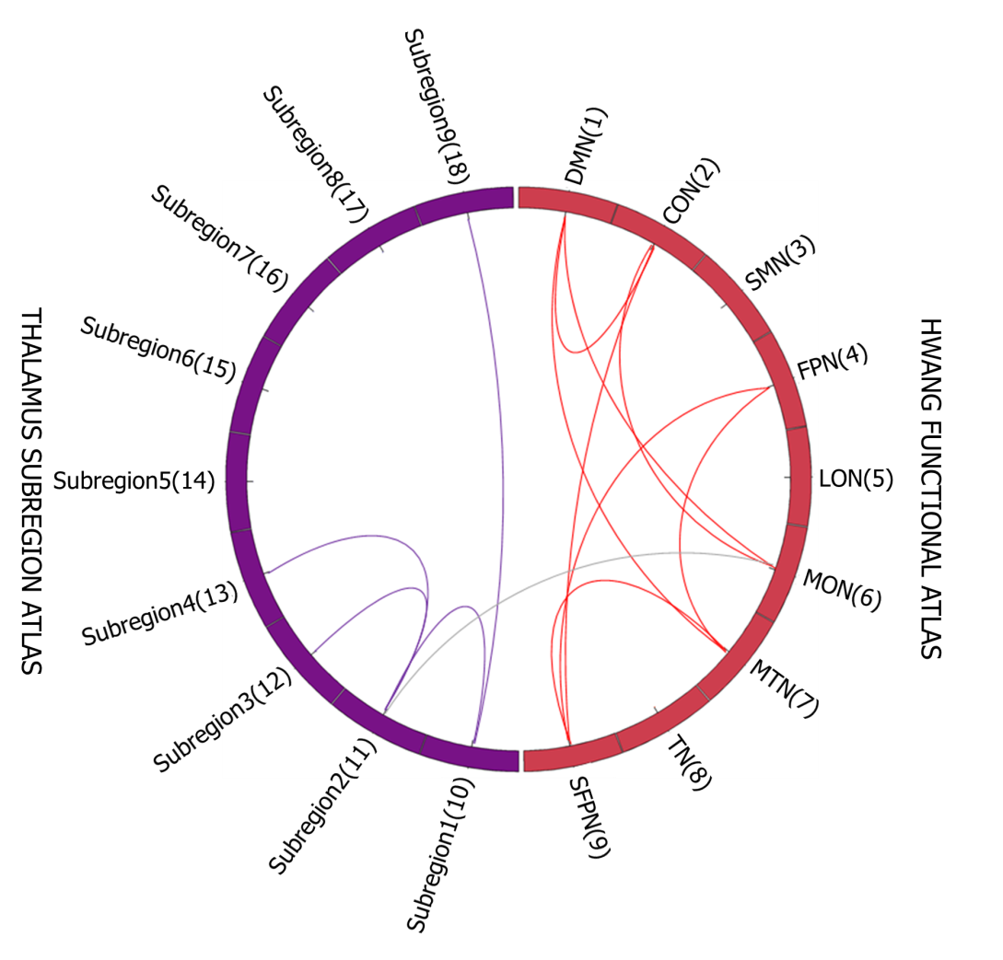
Figure 1 Altered functional connectivity of thalamus subregions and cortical functional networks between treatment resistant schizophrenia and healthy control groups. Between- and within-connectivity were presented in grey color and in each network’s color respectively. CON: Cingulo-Opercular Network; DMN: Default Mode Network; FPN: Fronto-Parietal Network; LON: Lateral Occipital Network; MON: Medial Occipital Network; MTN: Medial Temporal Network; SFPN: Superior Fronto-Parietal Network; SMN: Somato-Motor Network; TN: Temporal Network.

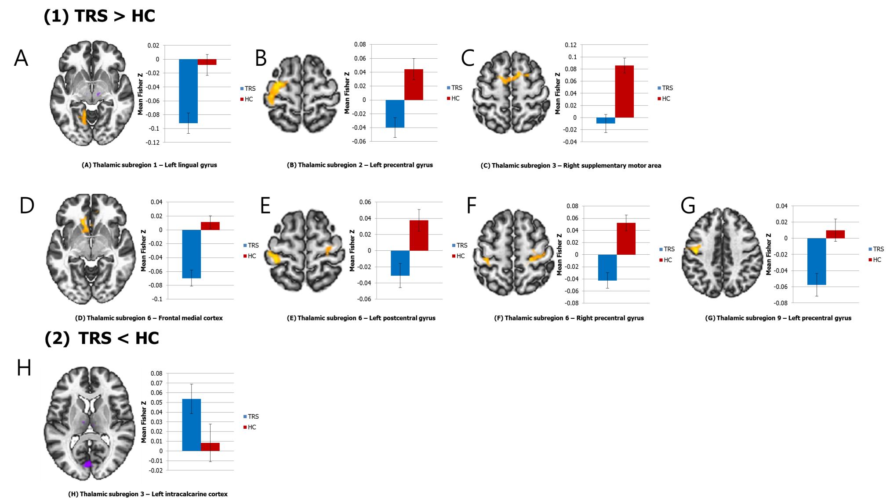
Figure 2 Altered thalamus subregion-based functional connectivity between treatment resistant schizophrenia and healthy control groups. Significant differences were revealed between the (A) Thalamic subregion 1 and Left lingual gyrus; (B) Thalamic subregion 2 and Left precentral gyrus; (C) Thalamic subregion 3 and right supplementary motor area; (D) Thalamic subregion 6 and Frontal medial cortex; (E) Thalamic subregion 6 and Left postcentral gyrus; (F) Thalamic subregion 6 and Right precentral gyrus; (G) Thalamic subregion 9 and Left precentral gyrus; and (H) Thalamic subregion 3 and Left intracalcarine cortex. The functional connectivity Z values of regions showing significant differences are presented in bar graph.
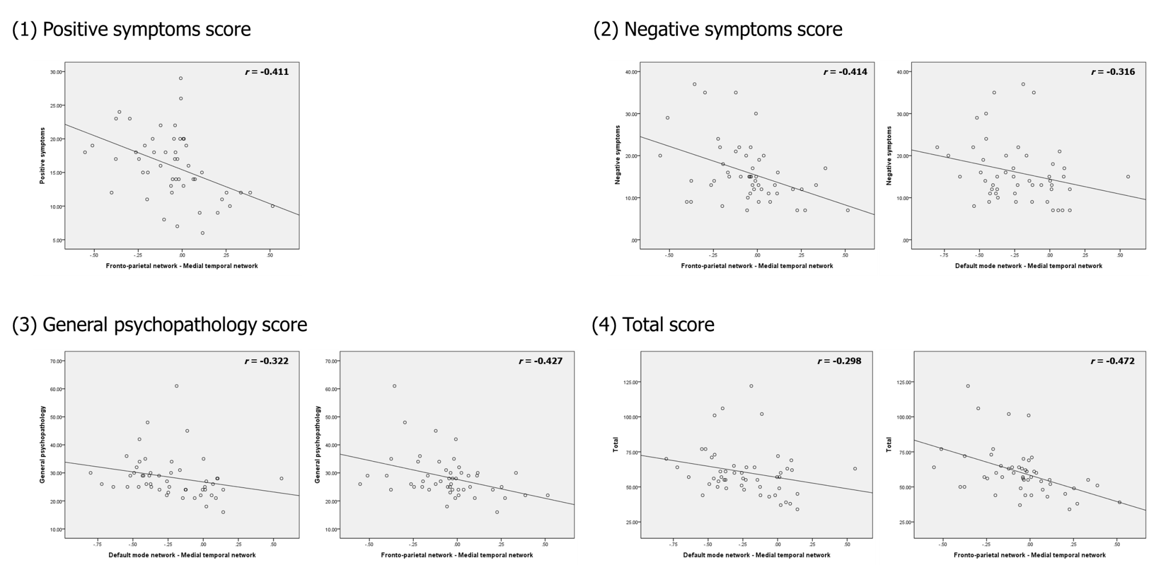
Figure 3 Associations between the significantly altered region of interest to region of interest functional connectivity and Positive and Negative Syndrome Scale scores in the treatment resistant schizophrenia group.
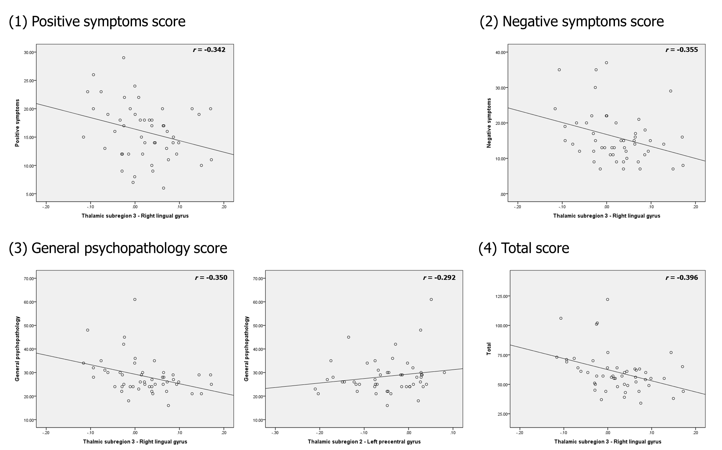
Figure 4 Associations between the significantly altered seed to voxel functional connectivity and Positive and Negative Syndrome Scale scores in the treatment resistant schizophrenia group.

Table 1 Demographic and clinical characteristics of patients with treatment-resistant schizophrenia and healthy controls
Characteristics | TRS (n = 50) | HCs (n = 61) | P value
Age (yr) | 42.64 (9.79) | 39.89 (9.52) | 0.137
Sex
Male (%) | 32 (64%) | 29 (48%) | 0.083
Female (%) | 18 (36%) | 32 (52%)
Education (years) | 13.53 (2.27) | 13.33 (1.92) | 0.613
Duration of illness (mo) | 215.22 (110.09) | - | -
PANSS
Positive symptoms | 15.96 (4.99) | - | -
Negative symptoms | 16.00 (7.30) | - | -
General psychopathology | 28.40 (7.74) | - | -
Total | 60.36 (17.52) | - | -
SOFAS | 49.00 (8.81) | - | -
Medication
Chlorpromazine equivalent (mg/d) | 915.33 (411.41) | - | -
Data given as mean (SD). HCs: Healthy controls; PANSS: Positive and Negative Syndrome Scale; SOFAS: Social and Occupational Functioning Assessment Scale; TRS: Treatment Resistant Schizophrenia.
Table 2 Comparison of between- and within-functional connectivity of thalamic subregions and cortical functional networks between patients with treatment-resistant schizophrenia (n = 50) and HCs (n = 61)
Seed region | t value | P FWE | P-unc | Brain region
TRS > HCs
Thalamic subregion 2 | 2.78 | < 0.001 | 0.006 | Medial occipital network
Cingulo-opercular network | 3.29 | 0.008 | 0.001 | Medial occipital network
 | 2.63 | 0.008 | 0.010 | Superior fronto-parietal network
Medial temporal network | 4.31 | < 0.001 | < 0.001 | Superior fronto-parietal network
TRS < HCs
Thalamic subregion 1 | -4.58 | < 0.001 | < 0.001 | Thalamic subregion 2
 | -2.95 | 0.019 | 0.004 | Thalamic subregion 9
Thalamic subregion 2 | -3.16 | < 0.001 | 0.002 | Thalamic subregion 3
 | -3.38 | < 0.001 | 0.001 | Thalamic subregion 4
Fronto-parietal network | -2.69 | < 0.001 | 0.008 | Medial temporal network
 | -2.73 | 0.008 | 0.007 | Superior fronto-parietal network
Default mode network | -2.90 | < 0.001 | 0.004 | Cingulo-opercular network
 | -3.37 | < 0.001 | 0.001 | Medial occipital network
 | -5.40 | < 0.001 | < 0.001 | Medial temporal network
Thresholded at P < 0.01, uncorrected; P < 0.05, Family Wise Error rate corrected. TRS: Treatment-resistant schizophrenia; HCs: Healthy controls.
Table 3 Comparison of functional connectivity of thalamic subregions with cortical voxels between patients with treatment-resistant schizophrenia (n = 50) and healthy controls (n = 61)
Seed Region | MNI  coordinate | Cluster Size | t value | P FWE | P-unc | Name (voxel size - region)
TRS > HCs
Thalamic subregion 1 | -14 -44 -12 | 612 | 5.22 | 0.009 | < 0.001 | 339 - Left lingual gyrus  142 - Left cerebellum 4_5
Thalamic subregion 2 | -28 -10 66 | 1309 | 5.30 | < 0.001 | < 0.001 | 604 - Left precentral gyrus  483 - Left postcentral gyrus
Thalamic subregion 3 | 10 6 54 | 523 | 5.26 | 0.003 | < 0.001 | 173 - Right supplementary motor cortex
Thalamic subregion 6 | -8 38 -22 | 1229 | 7.05 | < 0.001 | < 0.001 | 186 - Frontal medial cortex
 | -36 -34 62 | 358 | 5.26 | 0.030 | < 0.001 | 342 - Left postcentral gyrus
 | 26 -28 60 | 467 | 4.79 | 0.006 | < 0.001 | 305 - Right precentral gyrus  132 - Right postcentral gyrus
Thalamic subregion 9 | -44 -14 42 | 380 | 5.26 | 0.020 | < 0.001 | 281 - Left precentral gyrus
TRS < HCs
Thalamic subregion 3 | 6 -90 -2 | 458 | -4.18 | 0.008 | < 0.001 | 163 - Left intracalcarine cortex
Thresholded at P < 0.01, uncorrected; P < 0.05, Family Wise Error rate corrected. TRS: Treatment-resistant schizophrenia; HCs: Healthy controls.
Table 4 Correlation between Z score of significantly altered between-and within-connectivity of thalamic subregions and cortical functional networks between groups and Positive and Negative Syndrome Scale¹
Connectivity | r value | P value
Positive symptoms
Thalamic subregion 1 - Thalamic subregion 9 | -0.267 | 0.073
Fronto-parietal network - Medial temporal network | -0.411 | 0.005
Negative symptoms
Default mode network - Medial temporal network | -0.316 | 0.032
Fronto-parietal network - Medial temporal network | -0.414 | 0.004
General psychopathology
Default mode network - Medial occipital network | -0.257 | 0.085
Default mode network - Medial temporal network | -0.322 | 0.029
Fronto-parietal network - Medial temporal network | -0.427 | 0.003
Total
Default mode network - Medial temporal network | -0.298 | 0.044
Fronto-parietal network - Medial temporal network | -0.472 | 0.001
¹Partial correlation analysis with age, sex, and head motion (framewise displacement) as covariates; P < 0.01, uncorrected; P < 0.05, Family Wise Error rate corrected.
Table 5 Correlation between Z score of significantly altered connectivity between thalamic subregions and cortical voxels between groups and Positive and Negative Syndrome Scale¹
Connectivity | r value | P value
Positive symptoms
Thalamic subregion 3 - Right lingual gyrus | -0.342 | 0.020
Thalamic subregion 2 - Right precentral gyrus | 0.270 | 0.069
Thalamic subregion 7 - Precuneus cortex | -0.285 | 0.055
Negative symptoms
Thalamic subregion 3 - Right lingual gyrus | -0.355 | 0.015
Thalamic subregion 6 - Right precentral gyrus | -0.247 | 0.098
General psychopathology
Thalamic subregion 2 - Left precentral gyrus | 0.292 | 0.049
Thalamic subregion 3 - Right lingual gyrus | -0.350 | 0.017
Thalamic subregion 9 - Left precentral gyrus | 0.262 | 0.079
Total
Thalamic subregion 3 - Right lingual gyrus | -0.396 | 0.007
¹Partial correlation analysis with age, sex, and head motion (framewise displacement) as covariates; P < 0.05, uncorrected; P < 0.05, Family Wise Error rate corrected.

