Name of Journal: World Journal of Clinical Cases
Manuscript NO: 71020
Manuscript Type: CASE REPORT

Surgical treatment for a combined anterior cruciate ligament and posterior cruciate ligament avulsion fracture: a case report

Yoshida K et al. Surgery for combined knee injury

Katsuhiro Yoshida, Michiyuki Hakozaki, Hideo Kobayashi, Masashi Kimura, Shinichi Konno

Katsuhiro Yoshida, Michiyuki Hakozaki, Hideo Kobayashi, Shinichi Konno, Department of Orthopaedic Surgery, Fukushima Medical University School of Medicine, Fukushima 960-1295, Japan

Katsuhiro Yoshida, Michiyuki Hakozaki, Higashi-Shirakawa Orthopaedic Academy, Fukushima Medical University School of Medicine, Fukushima 960-1295, Japan

Hideo Kobayashi, Department of Orthopaedic Surgery, Sukagawa Hospital, Fukushima 962-0022, Japan

Masashi Kimura, Gunma Sports Medicine Research Center, Zenshukai Hospital, Gunma 379-2115, Japan

Author contributions: Yoshida K performed the patient's surgery and wrote the manuscript; Kimura M was involved in the patient care, manuscript preparation, and review; Hakozaki M, Kobayashi H, and Konno S were involved in the manuscript preparation and review; and All authors read and approved the final manuscript.

Corresponding author: Michiyuki Hakozaki, MD, PhD, Professor, Department of Orthopaedic Surgery, Fukushima Medical University School of Medicine, 1 Hikarigaoka, Fukushima-shi, Fukushima 960-1295, Japan. paco@fmu.ac.jp

Received: September 8, 2021
Revised: February 9, 2022
Accepted: March 6, 2022
Published online:

Abstract
BACKGROUND
Independent avulsion fractures with anterior cruciate ligament (ACL) or posterior cruciate ligament (PCL) attachment are relatively common among tibial intercondylar eminence fractures, and their postoperative outcomes are generally favorable. Conversely, huge avulsion fractures of the intercondylar eminence containing the attachment site of both the ACL and the PCL are extremely rare, and the reported clinical outcomes are poor.

CASE SUMMARY
We describe a 30-year-old Japanese male's huge avulsion fracture of the intercondylar eminence of a tibia containing the attachment site of both the ACL and PCL, together with a complete tear of the medial collateral ligament and a partial tear of both the medial and lateral menisci caused by a fall from a high place. All of these injuries were treated surgically, with anatomical reduction and stable fixation. The limb function at 1 year post-surgery was excellent (Lysholm score: 100 points).

CONCLUSION
Although this patient's complete surgical repair was complex, it should be performed in similar cases for an excellent final clinical outcome.

Key Words: Avulsion fracture; Intercondylar eminence; Tibia; anterior cruciate ligament; posterior cruciate ligament; Meniscal tear

Yoshida K, Hakozaki M, Kobayashi H, Kimura M, Konno S. Surgical treatment for a combined anterior cruciate ligament and posterior cruciate ligament avulsion fracture: A case report. World J Clin Cases 2022; In press

Core Tip: Avulsion fractures of the tibial intercondylar eminence containing the attachment site of both the anterior cruciate ligament (ACL) and posterior cruciate ligament (PCL) are extremely rare, and the reported clinical outcomes are poor. We report a case of combined knee injury of ACL and PCL avulsion fracture together with a tear of the medial collateral ligament and both the medial and lateral menisci. All of these injuries were treated surgically, with anatomical reduction and rigid fixation. The limb function at 1 year post-surgery was excellent.
INTRODUCTION
Among the tibial intercondylar eminence fractures, independent avulsion fractures with anterior cruciate ligament (ACL) or posterior cruciate ligament (PCL) attachment are relatively common, and there are many reports about their favorable postoperative outcomes^{[1–3]}. Conversely, huge avulsion fractures of the intercondylar eminence coincidently containing the attachment site of both the ACL and the PCL are extremely rare, and their reported clinical outcomes are poor^{[4–8]}. We describe herein the rare case of a huge avulsion fracture of the intercondylar eminence of a tibia containing the attachment site of both the ACL and PCL, together with a complete tear of the medial collateral ligament and a partial tear of both the medial and lateral menisci. All of these injuries were treated surgically, and the patient's postsurgical functional outcome was excellent.

CASE PRESENTATION
Chief complaints
A 30-year-old Japanese man was injured by a fall from a 6-m height during his work day. During the fall, he hit his right leg on stairs, and the right knee was sprained to overextension and the valgus position.

History of present illness
He was transported to the emergency room of the primary hospital and diagnosed with a right knee injury without other injuries. One week after the injury, he was referred to our hospital for surgical treatment.

History of past illness
At his admission, he was in good health with no history of other diseases or injuries.

Personal and family history
None in particular.

Physical examination
Although the patient's lower right leg showed marked swelling, there was no palsy or ischemia. The range of motion (ROM) of the right knee was 10° of overextension and 80° of limited flexion. The knee showed both anterior and posterior instability. Valgus instability in the 0° extension position was also observed, but varus instability was not observed.

Laboratory examinations
None in particular.

Imaging examinations
Plain radiographs of the right knee revealed a huge avulsion fracture of the intercondylar eminence of the tibia containing the attachment site of both the ACL and the PCL (Figure 1A and B). Computed tomography (CT) revealed that the fracture line reached the medial tibial plateau (Figure 1C and D). Magnetic resonance imaging also revealed a complete tear of the medial collateral ligament (MCL) and a partial tear of both medial meniscus (MM) and lateral meniscus (LM) (Figure 1E–G).

FINAL DIAGNOSIS
The final diagnosis was a combined knee injury of the ACL and PCL avulsion fracture with MCL, MM and LM tears.

TREATMENT
Surgical procedure
The surgical treatment was performed in a single session under general anesthesia. An air tourniquet was not used. First, bone fixation was performed with the patient in a prone position (72 min). Open reduction followed by fixation with a 4.5-mm cannulated cancellous screw was performed for the PCL-attached bone fragment via Burks' approach (posterior approach)^{[9]}. The bone fragment of the medial tibial plateau was fixed with a bioabsorbable screw and pin.
Arthroscopic surgery was then performed with the patient in a supine position (83 min). Since the ACL-attached bone fragment was avulsed, it was anatomically reduced and sutured with #2 FiberWire® (Arthrex, Naples, FL, United States) and then pulled out and fixed with an end-button. The oblique tear of the LM observed in the middle body to the posterior horn was sutured with the inside-out technique (Figure 2A). In the medial compartment of the femorotibial joint, the MCL was sunk into the intra-articular space through the peripheral part of the vertical MM tear. The MCL was pulled out via a vertical incision and fixed slightly proximal to the femoral insertion of the MCL with a suture anchor. At that timepoint, the vertical MM tear was sutured under direct viewing (Figure 2B). Postoperative plain radiographs revealed satisfactory reduction and fixation (Figure 3).

Postoperative course
The knee was immobilized with a splint for 1 wk, followed by postoperative ROM exercise with a rigid knee orthosis. The patient's lower extremity was kept non-weight-bearing for 4 wk, and thereafter partial-weight bearing was started. Full weight-bearing was permitted 8 wk after the operation.

OUTCOME AND FOLLOW-UP
The physical examination at 1 year post-surgery showed that the active ROM of the knee was from 0° to 150°. The results of both the Lachman test and the posterior drawer test were negative, and the valgus stress test results at both 0° and 30° were negative. The International Knee Documentation Committee (IKDC) objective-form grade was A^{[10]}, the IKDC subjective-form score was 100 points^{[10]}, and the Lysholm score for limb function was 100 points^{[11]}. Plain CT showed complete bone union with excellent alignment (Figure 4A and B). A valgus stress radiograph denied valgus instability (Figure 4C and D). Arthroscopic observation was also performed at 1 year post-surgery together with the screw-removal surgery; the tension of the ACL was good and the sutured MM and LM were healed (Figure 5). The patient was asked whether the data and images of his case could be submitted for publication, and he provided consent.

DISCUSSION
Huge avulsion fractures of the intercondylar eminence coincidently containing the attachment sites of both the ACL and PCL are exceedingly rare, and the most frequent cause of this rare injury is high-energy trauma from events such as traffic accidents and falls from a height (Table 1)^{[4–8]}. Our patient suffered high-energy trauma by falling from a 6-m height.
Cases of an open fracture of a lower leg^{[4]} and a fracture of the ipsilateral femoral shaft^{[5]} complicated with an avulsion fracture of the attached sites of the ACL and PCL due to high-energy trauma have been reported, but to the best of our knowledge, there is no published report in English describing an avulsion fracture with both ACL and PCL attachment combined with the LM, MM, LCL, or MCL. As mentioned above, most of the cases of such an avulsion fracture are thought to be due to high-energy trauma, and thus such avulsion fractures are suspected to be complicated with an undetected meniscus and/or collateral ligament injury, with high probability. In the reported cases without a description of a complicated meniscus and/or collateral ligament, it is possible that the assessment and treatment of the complicated meniscus and collateral ligament were insufficient and thus led to an insufficient clinical outcome of such avulsion fractures. We speculate that in the present case, the careful preoperative evaluation followed by a complete surgical repair of the LM, MM, and MCL led to the excellent clinical outcome.
Concerning the surgical procedure, anatomical reduction and rigid fixation of the bone fragment together with the ACL and PCL are essential. Arthroscopic surgery is generally performed for an ACL-attached avulsion fracture^{[12,13]}, whereas both arthroscopic^{[14]} and open^{[15]} surgeries are performed for a PCL-attached avulsion fracture. In the present case, we performed a combined arthroscopic and open procedure; the avulsion fracture of the PCL was open-reduced and fixed with the patient in the prone position, and thereafter the avulsion fracture of the ACL was arthroscopically reduced and sutured, the LM tear was arthroscopically sutured, and the MCL and MM were open-sutured with the patient in the supine position. Compared to the earlier reports, the present procedure was extremely complex; however, the final clinical outcome was excellent with the Lysholm score of 100 and 0°–150° as the active ROM of the knee; in addition, the patient was able to sit straight. In light of these results, it is apparent that the absolute anatomical reduction and meticulous repair of the intra-articular structures led to the excellent joint function.

CONCLUSION
We encountered an extremely rare case of a huge avulsion fracture of the intercondylar eminence of a tibia containing the attachment site of both the ACL and the PCL combined with an LM, MM, and MCL tear. All of these injuries were reduced and repaired surgically in a single session, and the final clinical outcome was excellent.

REFERENCES
1 Gans I, Baldwin KD, Ganley TJ. Treatment and Management Outcomes of Tibial Eminence Fractures in Pediatric Patients: A Systematic Review. Am J Sports Med 2014; 42: 1743-1750 [PMID: 24256714 DOI: 10.1177/0363546513508538]
2 Yoon JR, Park CD, Lee DH. Arthroscopic suture bridge fixation technique with multiple crossover ties for posterior cruciate ligament tibial avulsion fracture. Knee Surg Sports Traumatol Arthrosc 2018; 26: 912-918 [PMID: 27681893 DOI: 10.1007/s00167-016-4339-z]
3 Pailhé R, Bauer T, Flecher X, Bonnevialle N, Roussignol X, Saragaglia D, Ehlinger M; SOFCOT. Better functional outcomes for ORIF in tibial eminence fracture treatment: a national comparative multicentric study of ORIF vs ARIF. Knee Surg Sports Traumatol Arthrosc 2020; 28: 653-657 [PMID: 31797020 DOI: 10.1007/s00167-019-05785-9]
4 Kim SJ, Shin SJ, Choi NH, Cho SK. Arthroscopically assisted treatment of avulsion fractures of the posterior cruciate ligament from the tibia. J Bone Joint Surg Am 2001; 83: 698-708 [PMID: 11379739 DOI: 10.2106/00004623-200105000-00008]
5 Calpur OU, Copuroglu C, Ozcan M. Avulsion fractures of both anterior and posterior cruciate ligament tibial insertions. Knee Surg Sports Traumatol Arthrosc 2002; 10: 223-225 [PMID: 12172715 DOI: 10.1007/s00167-002-0282-2]
6 Lombardo-Torre M, Espejo-Reina A, García-Gutiérrez G, Espejo-Baena A, Espejo-Reina MJ. Arthroscopic Treatment of Concurrent Avulsion Fracture of Anterior and Posterior Cruciate Ligament with Suspension Device. J Orthop Case Rep 2018; 8: 81-85 [PMID: 30167421 DOI: 10.13107/jocr.2250-0685.1062]
7 de Souza Leão MG, Santoro ES, Avelino RL, Granjeiro RC, Orlando Junior N. Combined anterior and posterior cruciate ligaments avulsion from the tibial side in adult patient: case report. Rev Bras Ortop 2013; 48: 581-585 [PMID: 31304173 DOI: 10.1016/j.rboe.2013.12.007]
8 Liu Q, Wang W, Fan W, Zhu W. Hoffa fracture associated with tibial shaft fracture and multiple ligament avulsion fractures: A case report. Trauma Case Rep 2020; 26: 100277 [PMID: 31989015 DOI: 10.1016/j.tcr.2020.100277]
9 Burks RT, Schaffer JJ. A simplified approach to the tibial attachment of the posterior cruciate ligament. Clin Orthop Relat Res 1990: 216-219 [PMID: 2323134 DOI: 10.1097/00003086-199005000-00031]
10 Hefti F, Müller W, Jakob RP, Stäubli HU. Evaluation of knee ligament injuries with the IKDC form. Knee Surg Sports Traumatol Arthrosc 1993; 1: 226-234 [PMID: 8536037 DOI: 10.1007/BF01560215]
11 Tegner Y, Lysholm J. Rating systems in the evaluation of knee ligament injuries. Clin Orthop Relat Res 1985: 43-49 [PMID: 4028566 DOI: 10.1097/00003086-198509000-00007]
12 Lubowitz JH, Grauer JD. Arthroscopic treatment of anterior cruciate ligament avulsion. Clin Orthop Relat Res 1993: 242-246 [PMID: 8358923 DOI: 10.1097/00003086-199309000-00034]
13 Huang TW, Hsu KY, Cheng CY, Chen LH, Wang CJ, Chan YS, Chen WJ. Arthroscopic suture fixation of tibial eminence avulsion fractures. Arthroscopy 2008; 24: 1232-1238 [PMID: 18971052 DOI: 10.1016/j.arthro.2008.07.008]
14 Zhao J, He Y, Wang J. Arthroscopic treatment of acute tibial avulsion fracture of the posterior cruciate ligament with suture fixation technique through Y-shaped bone tunnels. Arthroscopy 2006; 22: 172-181 [PMID: 16458803 DOI: 10.1016/j.arthro.2005.10.020]
15 Abdallah AA, Arafa MS. Treatment of posterior cruciate ligament tibial avulsion by a minimally-invasive open posterior approach. Injury 2017; 48: 1644-1649 [PMID: 28577891 DOI: 10.1016/j.injury.2017.05.032]

Footnotes
Informed consent statement: Written informed consent for the publication of his case was obtained from the patient.

Conflict-of-interest statement: The authors declare that they have no conflicts of interest.

CARE Checklist (2016) statement: The authors have read the CARE Checklist (2016), and the manuscript was prepared and revised according to the CARE Checklist (2016).

Open-Access: This article is an open-access article that was selected by an in-house editor and fully peer-reviewed by external reviewers. It is distributed in accordance with the Creative Commons Attribution NonCommercial (CC BY-NC 4.0) license, which permits others to distribute, remix, adapt, build upon this work non-commercially, and license their derivative works on different terms, provided the original work is properly cited and the use is non-commercial. See: https://creativecommons.org/Licenses/by-nc/4.0/

Provenance and peer review: Unsolicited article; Externally peer reviewed.
Peer-review model: Single blind

Peer-review started: September 8, 2021
First decision: December 27, 2021
Article in press:

Specialty type: Orthopedics
Country/Territory of origin: Japan
Peer-review report’s scientific quality classification
Grade A (Excellent): A
Grade B (Very good): B
Grade C (Good): 0
Grade D (Fair): 0
Grade E (Poor): 0

P-Reviewer: Abulsoud MI, Egypt; Widmer KH, Switzerland S-Editor: Ma YJ L-Editor: A P-Editor: Ma YJ
Figure Legends
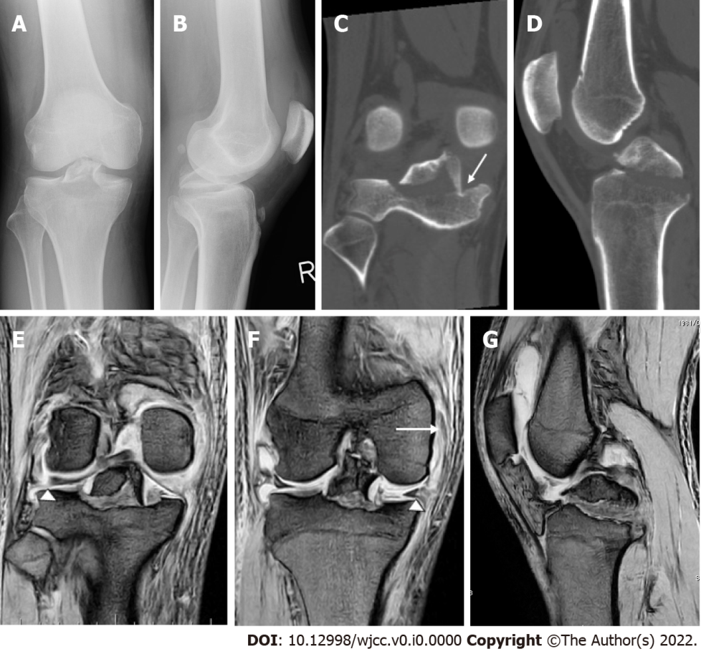
Figure 1 Preoperative radiological findings of the right knee. A, B: Plain anteroposterior and lateral radiographs revealing a huge avulsion fracture of the intercondylar eminence of the tibia containing the attachment of site of both the anterior and posterior cruciate ligaments; C, D: Coronal and sagittal computed tomography scans showing the fracture line that reached the medial tibial plateau (arrow); E–G: Coronal and sagittal T2-weighted magnetic resonance imaging of the right knee indicating the medial collateral ligament tear (arrow), and tear of both the medial and lateral menisci (arrowheads).
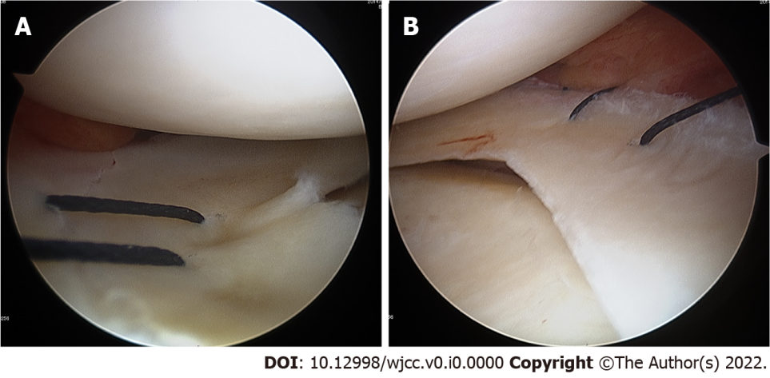
Figure 2 Intraoperative arthroscopic findings of the lateral and medial menisci. A: The lateral meniscus tear was sutured with the inside-out technique; B: The medial meniscus tear was sutured under direct view.
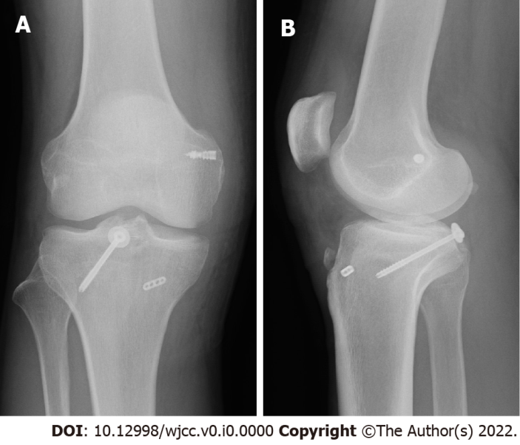
Figure 3 Postoperative plain radiographs of the right knee. A, B: Plain anteroposterior and lateral radiographs revealing satisfactory reduction and fixation.
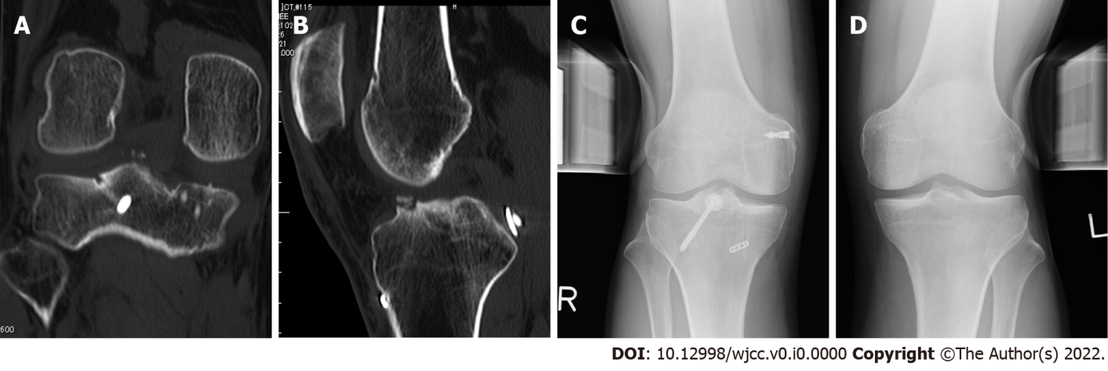
Figure 4 Follow-up imaging at 1 yr post-surgery. A, B: Coronal and sagittal computed tomography scans of the right knee show bone union with excellent alignment; C, D: Valgus stress radiographs of the bilateral knee joints showed no lateral instability of the right knee.
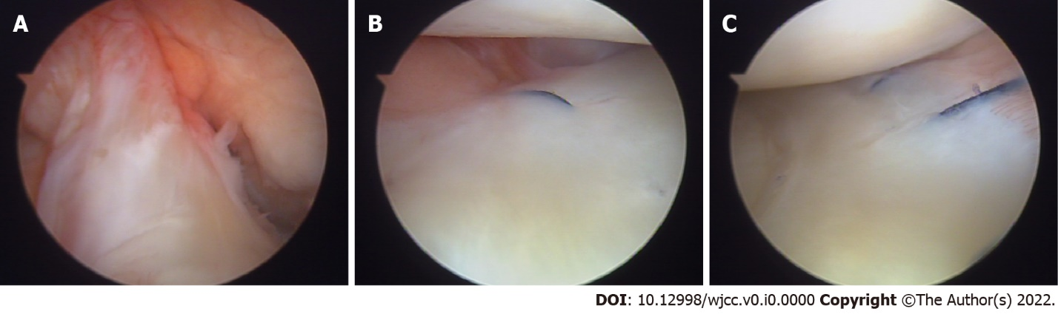
Figure 5 Intraoperative arthroscopic findings at 1 yr post-surgery. A: The tension of the anterior cruciate ligament is moderate; B, C: Both the lateral and medial menisci show complete healing.

Table 1 Cases of avulsion fractures of the intercondylar eminence containing the attachment site of both the anterior and posterior cruciate ligaments
Ref. | Age (yr/sex) | Cause of injury | Complications | Surgical procedure | Clinical outcome
Kim et al^{[4]} | 39/M | Car accident | Open fracture of lower leg | ACL: NA; PCL: Arthroscopic fixation | IKDC objective form grade^{[10]}: C
Kim et al^{[4]} | 52/M | Car accident | NA | ACL: NA; PCL: Arthroscopic fixation | IKDC objective form grade: B
Calpur et al^{[5]} | 17/M | Car accident | Femoral fracture  Patella fracture | ACL: Arthroscopic fixation; PCL: Arthroscopic fixation | Flexion angle: 135°
Lombardo-Torre et al^{[6]} | 25/M | Motorcycle accident | NA | ACL: Arthroscopic fixation; PCL: Arthroscopic fixation | ROM: 5°–130°; Lysholm score^{[11]}: 85 pts
de Souza Leão et al^{[7]} | 28/M | Motorcycle accident | NA | ACL: Open fixation; PCL: Open fixation | ROM: 0°–115°; Lysholm score: 85 pts
Liu et al^{[8]} | 17/M | Motorcycle accident | Hoffa fracture  Lower leg fractures  Patella fracture | ACL: Open fixation; PCL: Arthroscopic fixation | Lysholm score: 92 pts
Present case | 30/M | Fall from high place | MCL, MM, and LM tear | ACL: Arthroscopic fixation; PCL: Open fixation | ROM: 0°–150°; IKDC objective form grade: A; IKDC subjective form score: 100 pts; Lysholm score: 100 pts
ACL: Anterior cruciate ligament; IKDC: International knee documentation committee; LM: Lateral meniscus; MCL: Medial collateral ligament; MM: Medial meniscus; NA: Not available; PCL: Posterior cruciate ligament; ROM: Range of motion; pts: Points.

