Name of Journal: World Journal of Clinical Cases
Manuscript NO: 86181
Manuscript Type: CASE REPORT

Managing spindle cell sarcoma with surgery and high-intensity focused ultrasound: A case report

Zhu YQ et al. Treatment of spindle cell sarcoma with surgery and HIFU

Ying-Qiong Zhu, Gan-Chao Zhao, Chen-Xi Zheng, Lei Yuan, Geng-Biao Yuan

Ying-Qiong Zhu, Department of Endocrinology, People’s Hospital of Fengjie, Fengjie 404600, Chongqing, China

Gan-Chao Zhao, Department of Oncology, People’s Hospital of Fengjie, Fengjie 404600, Chongqing, China

Chen-Xi Zheng, Geng-Biao Yuan, Department of Nuclear Medicine, The Second Affiliated Hospital of Chongqing Medical University, Chongqing 400010, China

Lei Yuan, Department of Endocrinology, The Second Affiliated Hospital of Chongqing Medical University, Chongqing 400010, China

Author contributions: Zhu YQ prepared the manuscript; Yuan GB served as the corresponding author and provided manuscript review; Zhao GC and Zheng CX were responsible for the clinical management and patient follow-up; Yuan L contributed to the manuscript revision and engaged in helpful discussions; All authors contributed to the manuscript and approved the submitted version.

Corresponding author: Geng-Biao Yuan, MD, PhD, Chief Physician, Department of Nuclear Medicin, The Second Affiliated Hospital of Chongqing Medical University, No. 288 Chayuan Astronomical Avenue, Nanan District, Chongqing 400010, China. 300784@hospital.cqmu.edu.cn

Received: June 6, 2023
Revised: August 18, 2023
Accepted: August 31, 2023
Published online: September 26, 2023

Abstract
BACKGROUND
Undifferentiated pleomorphic sarcomas, also known as spindle cell sarcomas, are a relatively uncommon subtype of soft tissue sarcomas in clinical practice.

CASE SUMMARY
We present a case report of a 69-year-old female patient who was diagnosed with undifferentiated spindle cell soft tissue sarcoma on her left thigh. Surgical excision was initially performed, but the patient experienced a local recurrence following multiple surgeries and radioactive particle implantations. High-intensity focused ultrasound (HIFU) was subsequently administered, resulting in complete ablation of the sarcoma without any significant complications other than bone damage at the treated site. However, approximately four months later, the patient experienced a broken lesion at the original location. After further diagnostic workup, the patient underwent additional surgery and is currently stable with a good quality of life.

CONCLUSION
HIFU has shown positive outcomes in achieving local control of limb spindle cell sarcoma, making it an effective non-invasive treatment option.

Key Words: Spindle cell sarcoma; High-intensity focused ultrasound; Cancer therapy; Case report

©The Author(s) 2023. Published by Baishideng Publishing Group Inc. All rights reserved.

Citation: Zhu YQ, Zhao GC, Zheng CX, Yuan L, Yuan GB. Managing spindle cell sarcoma with surgery and high-intensity focused ultrasound: A case report. World J Clin Cases 2023; 11(27): 6551-6557
URL: https://www.wjgnet.com/2307-8960/full/v11/i27/6551.htm
DOI: https://dx.doi.org/10.12998/wjcc.v11.i27.6551

Core Tip: High-intensity focused ultrasound (HIFU) has the potential to be a reliable, minimally invasive technique that could revolutionize cancer treatment. Although relatively rare, limb spindle cell sarcomas can be effectively controlled by non-invasive treatment, as demonstrated in this case report. Continued advancements in HIFU technology will improve its effectiveness and benefit patients.
INTRODUCTION
Limb spindle cell sarcomas are undifferentiated pleomorphic sarcomas, and they account for 12.18% of soft tissue sarcomas (STS) of the extremities^{[1]}. STS in adults are a heterogeneous group of tumors of mesenchymal origin that share similar biological patterns of local tumor growth and metastasis. They can be carcinogenic or tumorigenic in their morphology^{[2]}. This rare malignancy accounts for only up to 1% of all cancers^{[3]}. Due to its rarity and complexity, there are few effective studies on its clinicopathological features and diagnosis. Here, we present a case involving a lower-extremity spindle cell sarcoma, detailing its treatment [including high-intensity focused ultrasound (HIFU)] and the evaluation of the treatment efficacy, in order to raise awareness about treatment options for this rarely detected tumor.

CASE PRESENTATION
Chief complaints
A 69-year-old female patient presented with a 3-cm-diameter firm mass that had gradually increased over the prior 6 years on the left thigh, with local pain.

History of present illness
Lumpectomy was performed at The Second Affiliated Hospital of Chongqing Medical University. Postoperative pathology results confirmed the mass to be a spindle cell soft tissue sarcoma. Postoperative immunohistochemistry results indicated CK(-), EMA(-), Vim(+), S100(-), SMA(±), Act(-), CD34(+), BCL-2(-), CD9(±), Ki-67(+), 50% AB(+), MBP(-), NF(-), and CD68(+), confirming the diagnosis of spindle cell soft tissue sarcoma (Figure 1A and B). The patient was treated with an expanded resection.

History of past illness
However, after 2 years, a firmer mass with some tenderness was found at the surgical site. Therefore, the patient underwent another expanded resection, followed by radioactive particle implantation. Postoperative immunohistochemistry results indicated CK(-), EMA(±), DES(-), S100(-), SMA(-), CD34(+), SDX-10(-), CDK4(-), MDM2(-), CD68(-), CD99(±), BCL-2(+), Vim(+), and Ki-67(+) > 50%.

Personal and family history
Nevertheless, after 16 mo, magnetic resonance imaging (MRI) revealed that the patient had relapsed. Subsequently, the patient underwent three lumpectomies and radioactive particle implantation.

Physical examination
Despite this, after 5 mo, the follow-up pathology results revealed another relapse. A new treatment plan was designed: five sessions of HIFU (which occurred on March 5, June 11, August 20, October 13, and November 24, 2021), using an integrated circuit -type HIFU tumor treatment system (Chongqing Haifu Medical Technology Co., Ltd., China), which mainly consists of an ultrasonic generator, a focused ultrasonic transducer, a motion system, a control system, and a B-ultra real-time guidance system. The vertical scanning mode with a slice thickness of 2 mm was used. The ultrasonic transmitter worked at frequencies of 0.85 and 1.5 MHz. The ultrasonic power was 150–238W. The duration of each treatment was 275–1325s. The focal length was 135 mm and the lesion had a diameter > 5 cm.

Laboratory examinations
The ablation effect was assessed by MRI. After the first HIFU session, MRI indicated grayscale changes for the whole mass at the lesion site, mild skin edema, and orange peel-like changes, without induration. MRI indicated coagulative necrosis in the treated region, with homogeneous enhancement at the edge of the tumor (Figure 2A). Residual tumor cells were not found in repeated biopsies at 2 and 4 wk after 5 HIFU (Figure 2B and C).

Imaging examinations
During the course of the disease (April 26, 2017 to April 2, 2022), the patient underwent seven chest computed tomography (CT) scans, all of which were free of lung metastases, four whole-body bone scans (whole-body scans before and after HIFU are shown in Figure 3A and B), all of which were free of bone metastases but showed localized bone damage, and ten MRI scans (MRI scans before and after HIFU are shown in Figure 4A and B). HIFU completely ablated the tumor without complications except for localized bone damage. No further chemotherapy, radiotherapy, or biological therapy was required for tumor control.

FINAL DIAGNOSIS
Unfortunately, the patient returned 4 mo later with a 2 cm × 4 cm tissue breakdown at the site of the original lesion.

TREATMENT
The patient underwent a comprehensive evaluation followed by a successful surgery on March 3, 2022 (Figure 5).

OUTCOME AND FOLLOW-UP
The patient is now in a stable condition and her limb has been preserved. Further collection and analysis of follow-up data is underway.

DISCUSSION
Diagnosing spindle cell cancers can be challenging due to their rarity and complexity. Differentiating this condition from clear spindle cell tumor, spindle cell/sclerosing rhabdomyosarcoma, and pleomorphic rhabdomyosarcoma is crucial. Factors such as age of onset, gender, clinical manifestations, and imaging findings should be carefully considered to make an accurate diagnosis. Immunohistochemical tests, including β-catenin nuclear staining, Ki-67 staining, and anti-CD34 antibody tests, are critical in achieving a definitive diagnosis^{[4-6]}. De Vita et al. suggested that immunohistochemistry for MyoD1, Myogenin, and base depletion can be used in the diagnosis^{[7]}. By combining clinical imaging and postoperative pathology, our medical team was able to reach a definitive diagnosis of spindle cell sarcomas for this patient.
The management of limb spindle cell sarcomas requires a comprehensive approach that considers the tumor’s behavior^{[8]}, individual patient factors, and the potential risks and benefits of various treatment options. Surgery is typically the primary treatment option^{[9]}. Aggressive management is necessary for regional and distant metastases. However, despite the diligent efforts made, it is worth mentioning that limb spindle cell sarcomas still exhibit a notable recurrence rate^{[10-12]}, which, in certain instances, may necessitate the consideration of amputation as a treatment option. Additionally, there is a risk of radiation toxicity associated with radiotherapy^{[13]}. Consequently, physicians have been actively seeking alternative treatments that are both safe and effective.
Recently, HIFU has gained popularity as a treatment options for solid tumors^{[14]}. It utilizes a piezoelectric transducer with a fixed aperture and focal length to produce ultrasound waves (1-7 MHz). These waves have thermal and mechanical impacts on tissue. Thermal effects involve heating the targeted tissue, resulting in coagulative necrosis and cell death at higher energy doses (> 55 °C). CT or MRI guidance helps convert the ultrasound waves into heat energy, which fuses at the focal point, causing coagulation and necrosis^{[15]}. HIFU accurately ablates lesions without affecting surrounding normal tissues^{[16]}. It has been widely used for treating uterine fibroids^{[17]}, pancreatic cancer^{[18]}, prostate cancer^{[19]}, thyroid nodules^{[20]}, hepatocellular carcinoma^{[21]}, and even bone metastases^{[22,23]}. HIFU is also utilized in the treatment of soft tissue sarcomas. The application of MRI-guided focused ultrasound (MR-HIFU) in myxofibrosarcoma (MFS) has shown promise. Studies by Vanni et al^{[24]} and Zhao et al^{[25]} have reported positive results in using MR-HIFU for recurrent MFS cases, both as a palliative treatment to alleviate pain and as a curative treatment for effective local disease control. While HIFU demonstrated effectiveness in our patient, it is important to note that there was bone damage observed at the treatment site. To assess tumor progression and bone damage during HIFU treatment, a combination of MRI and whole body bone imaging can be utilized^{[26,27]}.
Based on research findings, HIFU has been proven to be a safe, effective, reproducible, and minimally invasive treatment option. It offers the advantage of avoiding the potential side effects associated with radiotherapy and chemotherapy^{[28]}. It achieves a delicate balance by effectively preventing bleeding, minimizing tissue damage, and enhancing the overall quality of life for patients^{[25]}. In this case, the utilization of HIFU treatment proved to be a safe, effective, reliable, and noninvasive approach for addressing a soft tissue lesion in the left lower extremity of the patient. Nevertheless, it is important to note that the follow-up period in this study was relatively brief, and therefore, additional extensive clinical studies are required to validate and substantiate these findings.

CONCLUSION
In conclusion, limb spindle cell sarcomas are rare, but this case report highlights the effectiveness of non-invasive HIFU for local control of such tumors. Further studies on HIFU for treating spindle cell sarcomas are necessary to improve the management of this condition.

REFERENCES
1 Nakayama R, Mori T, Okita Y, Shiraishi Y, Endo M. A multidisciplinary approach to soft-tissue sarcoma of the extremities. Expert Rev Anticancer Ther 2020; 20: 893-900 [PMID: 32820961 DOI: 10.1080/14737140.2020.1814150]
2 Bickels J, Malawer MM. Adult Soft-Tissue Sarcomas of the Extremities. J Bone Joint Surg Am 2022; 104: 379-389 [PMID: 34780385 DOI: 10.2106/JBJS.21.00196]
3 Naghavi AO, Fernandez DC, Mesko N, Juloori A, Martinez A, Scott JG, Shah C, Harrison LB. American Brachytherapy Society consensus statement for soft tissue sarcoma brachytherapy. Brachytherapy 2017; 16: 466-489 [PMID: 28342738 DOI: 10.1016/j.brachy.2017.02.004]
4 Hames-Fathi S, Nottley SWG, Pillay N. Unravelling undifferentiated soft tissue sarcomas: insights from genomics. Histopathology 2022; 80: 109-121 [PMID: 34958500 DOI: 10.1111/his.14446]
5 Abs D, Landman S, Osio A, Lepesant P, Schneider P, Obadia D, Moguelet P, Farges C, Poirot B, Lehmann-Che J, Lebbé C, Battistella M. Spindle cell tumor with CD34 and S100 co-expression and distinctive stromal and perivascular hyalinization showing EML4-ALK fusion. J Cutan Pathol 2021; 48: 896-901 [PMID: 33241586 DOI: 10.1111/cup.13926]
6 Garcia del Muro X, de Alava E, Artigas V, Bague S, Braña A, Cubedo R, Cruz J, Mulet-Margalef N, Narvaez JA, Martinez Tirado O, Valverde C, Verges R, Viñals J, Martin-Broto J; Spanish Group for Research on Sarcoma. Clinical practice guidelines for the diagnosis and treatment of patients with soft tissue sarcoma by the Spanish group for research in sarcomas (GEIS). Cancer Chemother Pharmacol 2016; 77: 133-146 [PMID: 26563256 DOI: 10.1007/s00280-015-2809-5]
7 De Vita A, Vanni S, Fausti V, Cocchi C, Recine F, Miserocchi G, Liverani C, Spadazzi C, Bassi M, Gessaroli M, Campobassi A, De Luca G, Pieri F, Farnedi A, Franchini E, Ferrari A, Domizio C, Cavagna E, Gurrieri L, Bongiovanni A, Riva N, Calpona S, Di Menna G, Debonis SA, Ibrahim T, Mercatali L. Deciphering the Genomic Landscape and Pharmacological Profile of Uncommon Entities of Adult Rhabdomyosarcomas. Int J Mol Sci 2021; 22 [PMID: 34768995 DOI: 10.3390/ijms222111564]
8 Bleckman RF, Acem I, van Praag VM, Dorleijn DMJ, Verhoef C, Schrage YM, Haas RML, van de Sande MAJ, The Collaborative Persarc Research Group; collaborative PERSARC research group. Multimodality treatment of undifferentiated pleomorphic soft tissue sarcoma of the extremity (eUPS) in the elderly. Eur J Surg Oncol 2022; 48: 985-993 [PMID: 34930647 DOI: 10.1016/j.ejso.2021.12.008]
9 Hua H, He Z, Lei L, Xie H, Deng Z, Cheng Z, Zuo S, Sun C, Yu C. Retroperitoneal Spindle Cell Tumor: A Case Report. Front Surg 2021; 8: 764901 [PMID: 34977142 DOI: 10.3389/fsurg.2021.764901]
10 Meyer M, Seetharam M. First-Line Therapy for Metastatic Soft Tissue Sarcoma. Curr Treat Options Oncol 2019; 20: 6 [PMID: 30675651 DOI: 10.1007/s11864-019-0606-9]
11 Salerno KE, Alektiar KM, Baldini EH, Bedi M, Bishop AJ, Bradfield L, Chung P, DeLaney TF, Folpe A, Kane JM, Li XA, Petersen I, Powell J, Stolten M, Thorpe S, Trent JC, Voermans M, Guadagnolo BA. Radiation Therapy for Treatment of Soft Tissue Sarcoma in Adults: Executive Summary of an ASTRO Clinical Practice Guideline. Pract Radiat Oncol 2021; 11: 339-351 [PMID: 34326023 DOI: 10.1016/j.prro.2021.04.005]
12 Gamboa AC, Gronchi A, Cardona K. Soft-tissue sarcoma in adults: An update on the current state of histiotype-specific management in an era of personalized medicine. CA Cancer J Clin 2020; 70: 200-229 [PMID: 32275330 DOI: 10.3322/caac.21605]
13 Hoefkens F, Dehandschutter C, Somville J, Meijnders P, Van Gestel D. Soft tissue sarcoma of the extremities: pending questions on surgery and radiotherapy. Radiat Oncol 2016; 11: 136 [PMID: 27733179 DOI: 10.1186/s13014-016-0668-9]
14 Kennedy JE. High-intensity focused ultrasound in the treatment of solid tumours. Nat Rev Cancer 2005; 5: 321-327 [PMID: 15776004 DOI: 10.1038/nrc1591]
15 Bachu VS, Kedda J, Suk I, Green JJ, Tyler B. High-Intensity Focused Ultrasound: A Review of Mechanisms and Clinical Applications. Ann Biomed Eng 2021; 49: 1975-1991 [PMID: 34374945 DOI: 10.1007/s10439-021-02833-9]
16 Tempany CM, McDannold NJ, Hynynen K, Jolesz FA. Focused ultrasound surgery in oncology: overview and principles. Radiology 2011; 259: 39-56 [PMID: 21436096 DOI: 10.1148/radiol.11100155]
17 Liu L, Wang T, Lei B. High-intensity focused ultrasound (HIFU) ablation versus surgical interventions for the treatment of symptomatic uterine fibroids: a meta-analysis. Eur Radiol 2022; 32: 1195-1204 [PMID: 34333684 DOI: 10.1007/s00330-021-08156-6]
18 Sofuni A, Asai Y, Tsuchiya T, Ishii K, Tanaka R, Tonozuka R, Honjo M, Mukai S, Nagai K, Yamamoto K, Matsunami Y, Kurosawa T, Kojima H, Homma T, Minami H, Nakatsubo R, Hirakawa N, Miyazawa H, Nagakawa Y, Tsuchida A, Itoi T. Novel Therapeutic Method for Unresectable Pancreatic Cancer-The Impact of the Long-Term Research in Therapeutic Effect of High-Intensity Focused Ultrasound (HIFU) Therapy. Curr Oncol 2021; 28: 4845-4861 [PMID: 34898585 DOI: 10.3390/curroncol28060409]
19 Napoli A, Alfieri G, Scipione R, Leonardi A, Fierro D, Panebianco V, De Nunzio C, Leonardo C, Catalano C. High-intensity focused ultrasound for prostate cancer. Expert Rev Med Devices 2020; 17: 427-433 [PMID: 32275187 DOI: 10.1080/17434440.2020.1755258]
20 Lang BHH, Woo YC, Chiu KW. Combining high-intensity focused ultrasound (HIFU) ablation with percutaneous ethanol injection (PEI) in the treatment of benign thyroid nodules. Eur Radiol 2021; 31: 2384-2391 [PMID: 32974689 DOI: 10.1007/s00330-020-07317-3]
21 Sehmbi AS, Froghi S, Oliveira de Andrade M, Saffari N, Fuller B, Quaglia A, Davidson B. Systematic review of the role of high intensity focused ultrasound (HIFU) in treating malignant lesions of the hepatobiliary system. HPB (Oxford) 2021; 23: 187-196 [PMID: 32830069 DOI: 10.1016/j.hpb.2020.06.013]
22 Lin X, Chen W, Wei F. Technique Success, Technique Efficacy and Complications of HIFU Ablation for Palliation of Pain in Patients With Bone Lesions: A Meta-Analysis of 28 Feasibility Studies. Ultrasound Med Biol 2021; 47: 1182-1191 [PMID: 33583637 DOI: 10.1016/j.ultrasmedbio.2021.01.018]
23 Bongiovanni A, Foca F, Oboldi D, Diano D, Bazzocchi A, Fabbri L, Mercatali L, Vanni S, Maltoni M, Bianchini D, Casadei C, Matteucci F, Nanni O, Rossi B, Sintuzzi E, Martoni ME, Zavoiu V, Barone D, Altini M, Ibrahim T. 3-T magnetic resonance-guided high-intensity focused ultrasound (3 T-MR-HIFU) for the treatment of pain from bone metastases of solid tumors. Support Care Cancer 2022; 30: 5737-5745 [PMID: 35332373 DOI: 10.1007/s00520-022-06990-y]
24 Vanni S, De Vita A, Gurrieri L, Fausti V, Miserocchi G, Spadazzi C, Liverani C, Cocchi C, Calabrese C, Bongiovanni A, Riva N, Mercatali L, Pieri F, Casadei R, Lucarelli E, Ibrahim T. Myxofibrosarcoma landscape: diagnostic pitfalls, clinical management and future perspectives. Ther Adv Med Oncol 2022; 14: 17588359221093973 [PMID: 35782752 DOI: 10.1177/17588359221093973]
25 Zhao Y, Hu X, Zhong X, Shen H, Yuan Y. High-intensity focused ultrasound treatment as an alternative regimen for myxofibrosarcoma. Dermatologic Therapy 2021; 34 [DOI: 10.1111/dth.14816]
26 Siedek F, Yeo SY, Heijman E, Grinstein O, Bratke G, Heneweer C, Puesken M, Persigehl T, Maintz D, Grüll H. Magnetic Resonance-Guided High-Intensity Focused Ultrasound (MR-HIFU): Overview of Emerging Applications (Part 2). Rofo 2019; 191: 531-539 [PMID: 30630199 DOI: 10.1055/a-0817-5686]
27 Siedek F, Yeo SY, Heijman E, Grinstein O, Bratke G, Heneweer C, Puesken M, Persigehl T, Maintz D, Grüll H. Magnetic Resonance-Guided High-Intensity Focused Ultrasound (MR-HIFU): Technical Background and Overview of Current Clinical Applications (Part 1). Rofo 2019; 191: 522-530 [PMID: 30630200 DOI: 10.1055/a-0817-5645]
28 Elhelf IAS, Albahar H, Shah U, Oto A, Cressman E, Almekkawy M. High intensity focused ultrasound: The fundamentals, clinical applications and research trends. Diagn Interv Imaging 2018; 99: 349-359 [PMID: 29778401 DOI: 10.1016/j.diii.2018.03.001]

Footnotes
Informed consent statement: This study participant provided informed written consent prior to study enrollment.

Conflict-of-interest statement: The authors declare that the research was conducted in the absence of any commercial or financial relationships that could be construed as a potential conflict of interest.

CARE Checklist (2016) statement: The authors have read the CARE Checklist (2016), and the manuscript was prepared and revised according to the CARE Checklist (2016).

Open-Access: This article is an open-access article that was selected by an in-house editor and fully peer-reviewed by external reviewers. It is distributed in accordance with the Creative Commons Attribution NonCommercial (CC BY-NC 4.0) license, which permits others to distribute, remix, adapt, build upon this work non-commercially, and license their derivative works on different terms, provided the original work is properly cited and the use is non-commercial. See: https://creativecommons.org/Licenses/by-nc/4.0/

Provenance and peer review: Unsolicited article; Externally peer reviewed.
Peer-review model: Single blind

Peer-review started: June 6, 2023
First decision: August 8, 2023
Article in press: August 31, 2023

Specialty type: Oncology
Country/Territory of origin: China
Peer-review report’s scientific quality classification
Grade A (Excellent): 0
Grade B (Very good): B
Grade C (Good): C
Grade D (Fair): 0
Grade E (Poor): 0

P-Reviewer: Aydin S, Turkey S-Editor: Liu JH L-Editor: A P-Editor: Liu JH

Figure Legends
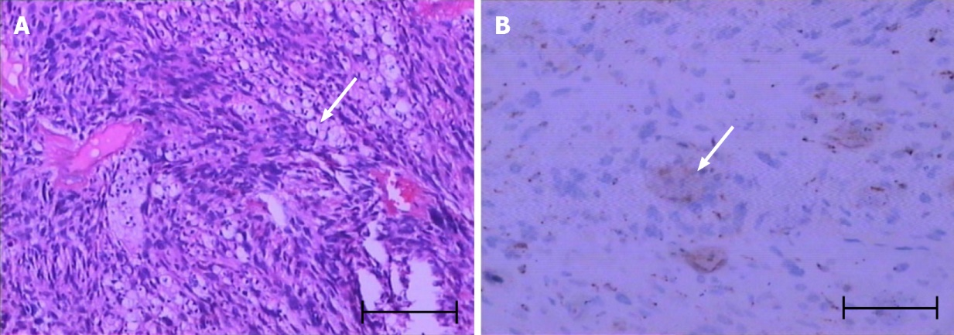
Figure 1 Pathological examination and immunohistochemical detection. A: H&E staining showing obviously heterogeneous and fat spindle-shaped cells, arranged in intertwined and bundle-like patterns (arrow); B: Immunohistochemical staining establishing the spindle cell origin of the abnormal cell population: CD68+ (arrow). Scale bar: 100 μm.
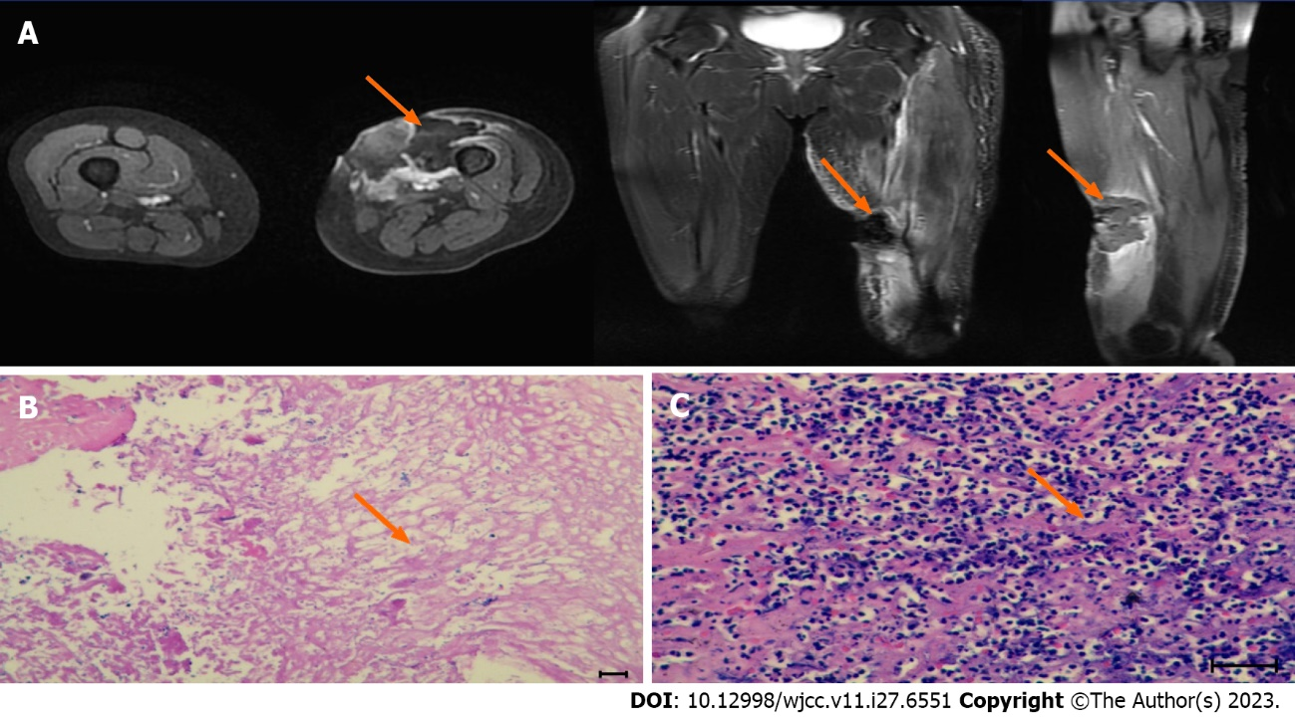
Figure 2 Magnetic resonance imaging imaging and pathological biopsy after the first high-intensity focused ultrasound treatment. A: An ovoid mass (about 26 mm × 36 mm × 36 mm) with an equal/slightly low signal on T1WI and a slightly low/high mixed signal on T2WI was seen under the skin of the anterior medial part of the left mid-thigh, with a clear border. The lesion was mildly enhanced at the edge after enhancement. A patchy slightly high signal on T2WI with poorly defined borders was seen adjacent to the left middle femur (about 11 mm × 14 mm × 55 mm), with heterogeneous enhancement after enhancement; B and C: H&E staining showing acute and chronic inflammation with necrotic granulomatous tissue proliferation. Scale bar: 100 μm.

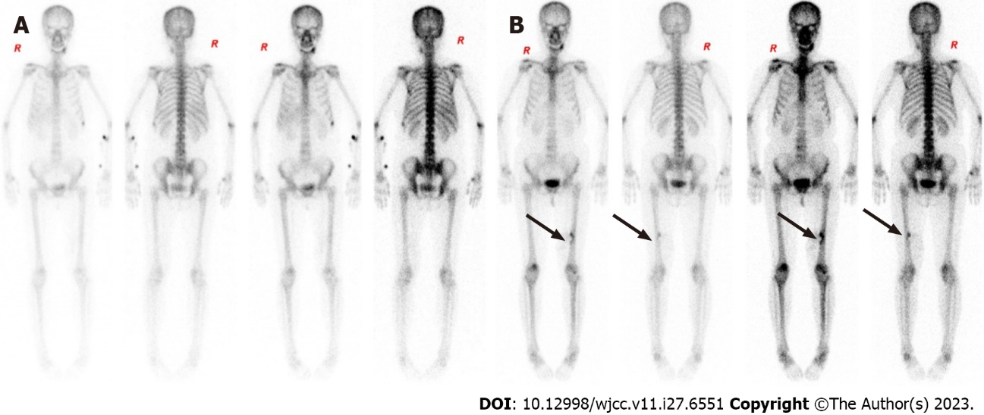
Figure 3 Comparison whole-body scintigraphy before and after high-intensity focused ultrasound treatment. A: Before high-intensity focused ultrasound (HIFU) (October 19, 2020): No abnormalities; B: After HIFU (June 7, 2021): Localized radiolucent defect at the inner edge of the left lower and middle femoral segments involving a marginal increase in radiolucent shadow, suggesting post-HIFU changes (arrows).
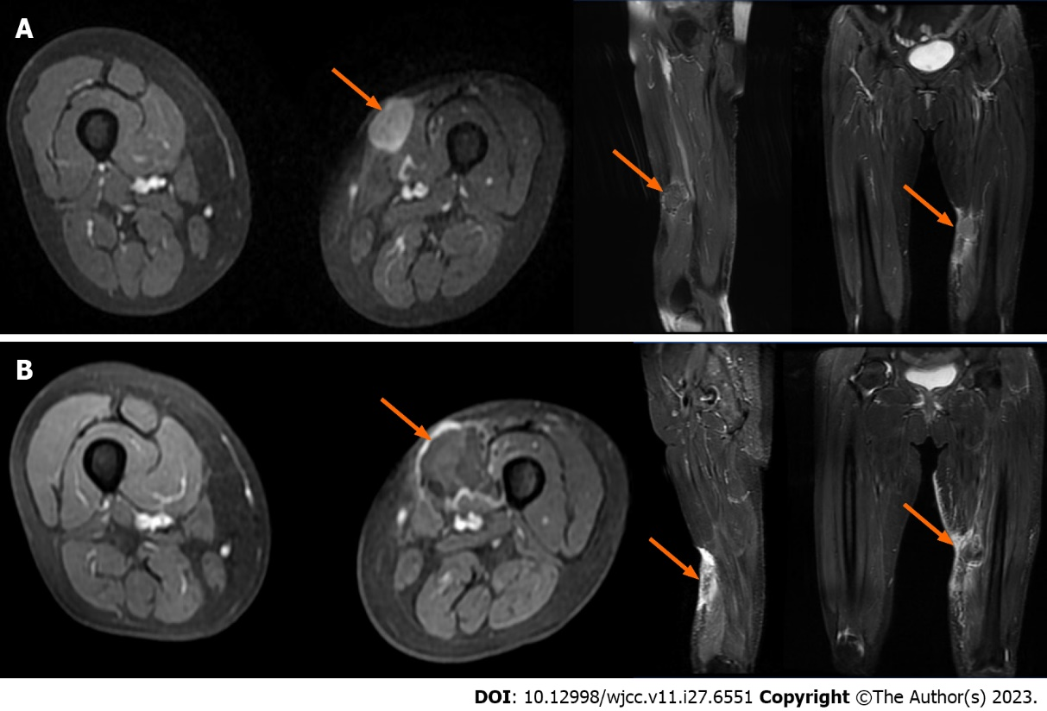
Figure 4 Comparison of magnetic resonance imaging of lower limbs before and after high-intensity focused ultrasound treatment. A and B: Enhanced magnetic resonance imaging (MRI) of the left thigh. A: Before high-intensity focused ultrasound (HIFU) (March 1, 2021): On the coronal, sagittal and cross-sectional MRI of the left thigh, an oval signal nodule with slightly longer T1 and slightly longer T2 (about 31 mm × 26 mm × 30 mm) was found under the skin of the anterior medial side of the middle part of the left thigh (arrows). After enhancement, it was obviously slightly uneven, and the surrounding soft tissues were edema; B: After HIFU (March 12, 2021): On the coronal, sagittal and cross-sectional MRI of the left thigh, the oval signal nodule with slightly longer T1 and slightly longer T2 (about 28 mm × 30 mm × 25 mm) is located under the skin of the anterior medial side of the middle part of the left thigh, and its boundary with subcutaneous fat and adjacent muscle tissue is unclear (arrows).
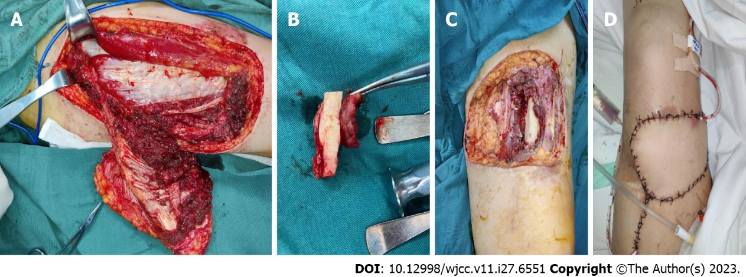
Figure 5 Illustration of patient undergoing surgery on March 3, 2022. A–D: Surgical images. A: A tissue breaks down (about 8 cm × 10 cm × 5 cm) was seen above the knee joint on the left thigh, deep to the medial, lateral, and rectus femoris muscles; B: Trauma after excision of the mass; C: Left thigh swelling: Gray/yellow/brown soft tissue with skin (10 cm × 6 cm × 3.5 cm) and a gray/white/brown mass (4 cm × 3.5 cm × 2.5 cm) on the skin surface; D: The wound was closed with an 8 cm × 6 cm flap and a drainage tube was left in place.

Published by Baishideng Publishing Group Inc
7041 Koll Center Parkway, Suite 160, Pleasanton, CA 94566, USA
Telephone: +1-925-3991568
E-mail: bpgoffice@wjgnet.com
Help Desk: https://www.f6publishing.com/helpdesk
https://www.wjgnet.com

© 2023 Baishideng Publishing Group Inc. All rights reserved.

