Name of Journal: World Journal of Gastroenterology
ESPS Manuscript NO: 25530
Manuscript Type: ORIGINAL ARTICLE

Randomized Controlled Trial

Hemostatic effect of topical hemocoagulase spray in digestive endoscopy

Wang T et al. Hemocoagulase spray in digestive endoscopy

Tao Wang, Dan-Na Wang, Wen-Tian Liu, Zhong-Qing Zheng, Xin Chen, Wei-Li Fang, Shu Li, Li Liang, Bang-Mao Wang

Tao Wang, Dan-Na Wang, Wen-Tian Liu, Zhong-Qing Zheng, Xin Chen, Wei-Li Fang, Shu Li, Li Liang, Bang-Mao Wang, Department of Gastroenterology, Tianjin Medical University General Hospital, Tianjin 300052, China

Author contributions: Wang T, Wang DN, Liu WT and Wang BM designed research; Wang T, Liu WT, Zheng ZQ, Chen X, Fang WL, Li S, Liang L and Wang BM took part in this study as endoscopic operators or assistants; Wang T, Wang DN, Liu WT and Wang BM analyzed the data; Wang T, Wang DN and Wang BM wrote the paper and gave final approval of the version to be published.

Institutional review board statement: The study was reviewed and approved by the Medical Ethics Committee of Tianjin Medical University General Hospital.

Clinical trial registration statement: This study has not been registered temporarily.

Informed consent statement: All study participants, or their legal guardian, provided informed written consent prior to study enrollment.

Conflict-of-interest statement: There are no conflicts of interest in relation to this manuscript.

Data sharing statement: No additional data are available.

Open-Access: This article is an open-access article which was selected by an in-house editor and fully peer-reviewed by external reviewers. It is distributed in accordance with the Creative Commons Attribution Non Commercial (CC BY-NC 4.0) license, which permits others to distribute, remix, adapt, build upon this work non-commercially, and license their derivative works on different terms, provided the original work is properly cited and the use is non-commercial. See: http://creativecommons.org/licenses/by-nc/4.0/

Correspondence to: Bang-Mao Wang, Professor, Department of Gastroenterology, Tianjin Medical University General Hospital, Anshan Road 154, Heping District, Tianjin 300052, China. wangt1976@126.com
Telephone: +86-22-60363800

Received: March 13, 2016
Peer-review started: March 13, 2016
First decision: March 31, 2016
Revised: April 21, 2016
Accepted: May 4, 2016
Article in press:
Published online:

Abstract
AIM: To evaluate the hemostatic effect of topical hemocoagulase spray in digestive endoscopy.

Methods: Eighty-nine patients who developed oozing bleeding during endoscopic treatment from September 2014 to October 2014 at Center for Digestive Endoscopy, Tianjin Medical University General Hospital were randomly divided into either a study group (n = 39) or a control group (n = 50). The study group was given topical hemocoagulase spray intraoperatively, while the control group was given traditional 8% norepinephrine spray. Hemostatic efficacy was compared between the two groups. Bleeding site, wound cleanliness and perforation were recorded, and the rates of perforation andlate bleeding were compared.

Results: Successful hemostasis was achieved in 39 (100%) patients of the study group and in 47 (94.0%) patients of the control group, and there was no significant difference in the rate of successful hemostasis between the two groups. Compared with the control group, after topical hemocoagulase spray in the study group, the surgical field was clearer, the bleeding site was more easily identified, and the wound was cleaner. There was no significant difference in the rate of perforation between the study and control groups (16.7% vs 35.0%, P = 0.477), but the rates of late bleeding (0% vs 15.8%, P = 0.048) and overall complications (P = 0.032) were significantly lower in the study group.

Conclusion: Topical hemocoagulase spray has a definite hemostatic effect for oozing bleeding in digestive endoscopy, and this method isconvenient, safe, and reliable. It is expected to become a new method for endoscopic hemostasis.

Key words: Hemocoagulase; Digestive endoscopy; Oozing bleeding; Spray; Hemostatic effect

© The Author(s) 2016. Published by Baishideng Publishing Group Inc. All rights reserved.

Core tip: In this study, we evaluated the hemostatic effect of topical hemocoagulase spray in digestive endoscopy. There was no significant difference in the rate of perforation between the study and control groups, but the rates of late bleeding and overall complications were significantly lower in the study group. There was no significant difference in the rate of successful hemostasis between the two group, but the rates of late bleeding and overall complications of the hemocoagulase group were significantly lower than the 8% norepinephrine group, and the surgical field was clearer, the bleeding site was more easily identified, and the wound was cleaner.

Wang T, Wang DN, Liu WT, Zheng ZQ, Chen X, Fang WL, Li S, Liang L, Wang BM. Hemostatic effect of topical hemocoagulase spray in digestive endoscopy. World J Gastroenterol 2016; In press

INTRODUCTION
With the development of endoscopic techniques, more and more gastrointestinal diseases can be treated endoscopically, such as endoscopic resection of gastrointestinal polyps and endoscopic submucosal dissection (ESD) of tumors. Compared with traditional open surgery, endoscopic surgery can greatly reduce the trauma to patients. However, bleeding and perforation are the main complications of endoscopic treatment^{[1-3]}. Effectively reducing the development of intraoperative bleeding and maintaining adequate visualization of the surgical field are the keys to reducing the incidence of complications with endoscopic treatment and ensuring successful endoscopic treatment.
Hemocoagulase for injection (Baquting), a hemostatic agent extracted and purified from the venom of Bothrops jararacussu, has thrombin- and thrombokinase-like effects^{[4,5]}. It can cause platelet aggregation at the bleeding site, accelerate the hydrolysis of fibrin to formfibrin I monomer and polymer, and promote the formation of white thrombi, thereby achieving hemostatic effects^{[6]}. Currently, hemocoagulase has been widely used to manage bleedingin various clinical settings, such as obstetrics, orthopaedics^{[7,8]}, and general surgery^{[9]}. Hemocoagulase combined with proton pump inhibitors has been used to manage peptic ulcer bleeding. These studies indicated that hemocoagulase has a definite hemostatic effect. However, hemocoagulase was delivered via an intravenous route in most of previous studies. A study^{[10]} showed that topical application of hemocoagulase at the bleeding site had dose-related effects in promoting fibrinogen polymerization, which was not inhibited by any plasma thrombin inhibitor or anticoagulant. Thus, hemocoagulase can be used as a topical hemostatic. A recent study^{[11]} showed that local injection of hemocoagulase can achieve rates of successful hemostasis of 100% and 88.9%, respectively, for portal veins with inner diameters of < 1 mm and 1-2 mm, and the maximum time to achieve hemostasis was 24.0 ± 7.2 s, suggesting that hemocoagulase has a more obvious hemostatic effect in tiny blood vessels (diameter < 1 mm).
The purpose of the present study was to evaluate the hemostatic effect of hemocoagulase spraying on oozing bleeding in digestive endoscopy.

MATERIALS AND METHODS

Patients
Eighty-nine patients who developed oozing bleeding (non-small artery or vein bleeding) during endoscopic treatment from September 2014 to October 2014 at Center for Digestive Endoscopy, Tianjin Medical University General Hospital were included in this study, including 32 patients who underwent ESD for gastric muscularis propria tumors, 22 patients who underwentesophageal tunneling techniques (including STER and POEM), and 35 patients who underwent ESD for gastric mucosal or submucosaltumors. Patients with coagulation disordersor drug allergies were excluded. The patients were randomly divided into a study group (n = 39) and a control group (n = 50). The study group was given topical hemocoagulase spray intraoperatively, while the control groupwasgiven traditional 8% norepinephrine (in normal saline) spray. There were no significant differences in demographic data between the two groups (Table 1).

Methods
All patients were preoperatively given an intravenous drip of esomeprazole (40 mg + 0.9% normal saline100 mL) once every 24 h. Patients who developed oozing bleeding (non-small artery or vein bleeding) during endoscopic treatment were randomly divided into a study group and a control group. The study group was treated with hemocoagulase for injection (Baquting).The hemocoagulase solution was prepared by dissolving 4U hemocoagulasein 60 mL normal saline. The solution (20 mL) was sprayed to the wound site at 30 s intervals until the bleeding stopped. The control group was treated with 8% norepinephrine spray at 30 s intervals. If active bleeding persisted 5 min after spraying, failed hemostasis was considered. For patients who had failed hemostasis and were found to have small artery or vein bleeding, electrocoagulation or clipping was performed to achieve hemostasis. Hemostatic efficacy was compared between the two groups. Bleeding site, wound cleanliness and perforation were observed. After wound processing was performed, the endoscope was withdrawn. Postoperatively, gastrointestinal decompression was carried out, and the patients were fasted and given parenteral nutrition support and an intravenous drip of esomeprazole (40 mg + 0.9% normal saline 100 mL) once every 12 h. Patients with perforation were treated with antibiotics to prevent wound infection. Late bleeding was observed and recorded. Statistical methods were then used to compare the rates of successful hemostasis, perforation and late bleeding between the two groups.

RESULTS
There were no significant differences in demographic data such as gender or age between the two groups.
Successful hemostasis was achieved in 39 (100%) patients of the study group and in 47 (94.0%) patients of the control group, and there was no significant difference in the rate of successful hemostasis between the two groups (X² = 3.541, P = 0.060) (Table 2). Three patients in the control group had failed hemostasis, and all of them underwent ESD for gastric mucosal or submucosa tumors. After endoscopic electrocoagulation or clipping was performed, successful hemostasis was achieved in all the three cases.
There were a total of 9 cases of perforation, all of which occurred in the gastric muscularis propria, including 2 (16.7%) cases in the study group and 7 (35.0%) cases in the control group. Patients with perforation after clipping hemostasis did not show any sign of peritonitis such as obvious abdominal pain. There was no significant difference in the rate of perforation between the two groups (X² = 0.505, P = 0.477) (Table 3). No late bleeding occurred in the study group, but there were 3 (15.8%) cases in the control group, all of which occurred in patients who underwent ESD for gastric mucosal or submucosa tumors. The rate of late bleeding was significantly lower in the study group than in the control group (X² = 3.901, P = 0.048) (Table 3). The rate of overall complications was also significantly lower in the study group than in the control group (X² = 4.576, P = 0.032) (Table 3).
Compared with the control group, after hemocoagulase spray in the study group, bleeding stopped more rapidly, the surgical field was clearer, the bleeding site was more easily identified, and the world was cleaner (Figures 1 and 2).

DISCUSSION
With the wide application of digestive endoscopy in clinical practice, minimally invasive endoscopic techniques have gradually advocated by more and more patients. Bleeding and perforation are common complications of endoscopic treatment^{[1-3]}. Therefore, effective, fast endoscopic hemostasisis is very important for endoscopic treatment. Currently commonly used endoscopic hemostatic methods include mechanical hemostasis methods (such aselectrocoagulation and clipping), topical spray of drugs, and local injection of drugs^{[12-14]}.
Clipping hemostasis is achieved by using titanium clips to mechanically clamp the bleeding blood vessels and surrounding tissues^{[15]}, with a definite and reliable hemostatic effect. However, clipping hemostasis is mainly suitable for exposed large or deep blood vessels^{[16]}, and its application in endoscopic tunneling techniques (such as STER and POEM) is limited. Electrocoagulation hemostasis is achieved by using local high-frequency heat energy to make local tissue necroticor coagulated^{[17]}, and this method is particularly effective for small blood vessel hemorrhage^{[18]}. However, the above hemostatic methods have a high requirement for operation skill, are expensive and more suitable for local hemostasis, and are often associated with unclean wound, which makes it difficult to identify the bleeding site. Thus, their application value in diffuse oozing bleeding is limited.
Many studies^{[11,14,19-21]} showed that endoscopic injection or spray of hemostatic drugs can be used for topical hemostasis, with a definite hemostatic effect. Common topical hemostatic drugs include hypertonic saline, Yunnan Baiyao, thrombin, adrenaline and so on. Hypertonic saline can induce tissue edema at the injection site, local compression, fibrosis of the vessel wall, and vascular lumen thrombosis, thus achieving hemostasis. However, the application of hypertonic saline affects the observation of the wound and bleeding site, and for this reason, hypertonic saline was less applied clinically. Adrenaline does not damage the tissue, and after injection it can induce local vasoconstriction, swelling of the surrounding tissue to compress blood vessels, and platelet aggregation, thus achieving temporary hemostasis, with a rate of successful hemostasis of approximately 80%^{[20]}. However, studies have shown that with the increase of the dose of adrenaline, it can lead to high blood pressure and increased heart rate. Therefore, its use in patients with cardiovascular disease is restricted^{[22]}. In addition, the hemostatic effect of adrenaline is short-acting, and it is associated with high rates of pseudo hemostasis and late bleeding.
Hemocoagulase is a hemostatic agent extracted and purified from the venom of Bothrops jararacussu, and it has advantages of high efficiency, rapid action, definite topical hemostatic effect, reduced local tissue inflammation and accelerated wound healing. It can not only promote the fibrin formation and result in rapid blood solidification to form blood clots, but also promote irreversible platelet aggregation and platelet release reaction, accelerate blood clotting, promote vascular epithelial cell growth, and accelerate wound healing, thus achieving a good hemostatic effect^{[11, 23]}. In this study, we used local hemocoagulase spray to manage oozing bleeding in digestive endoscopic treatment. The results showed that hemocoagulase had a comparable hemostatic effect to norepinephrine and was associated with a lower incidence of complications. In addition, no systemic adverse reactions such as elevated blood pressure and heart rate were observed. Compared with norepinephrine, hemocoagulase had a longer hemostatic effect. After endoscopic hemocoagulase spray, the wound was cleaner and the broken ends of small blood vessels were clearly shown, which makes the identification of bleeding sites easier. Therefore, topical hemocoagulase spray can not only achieve hemostasis, but also help provide good wound conditions for other hemostatic methods such as electrocoagulation and clipping to improve the efficiency of hemostasis, increase the success rate of hemostasis, reduce the damage of electrocoagulationto the wound, and decrease the rates of perforation and late bleeding associated with electrocoagulation.
In conclusion, topical hemocoagulase spray has a definite hemostatic effect for oozing bleeding in digestive endoscopy, and this method is simple and has low cost. Since the wound after topical hemocoagulase spray is clean, the bleeding site is easily identified, which is conductive to postoperative recovery. Topical hemocoagulase spray is associated with a low rate of late bleeding, it is expected to be widely used in endoscopic therapy. A study has shown that topical hemocoagulase spray can be used for the treatment of upper gastrointestinal mucosa bleeding in hepatitis B patients ^{[24]}, but its curative effect needs further validation. However, topical hemocoagulase spray is more suitable for oozing non-small artery or vein bleeding, and its hemostatic effect in large vessel bleeding is poorer than clipping, which is the main limitation of topical hemocoagulase spray. In addition, the sample size of this study is small, and multicenter studies with larger sample sizes are warranted to confirm the hemostatic efficacy of topical hemocoagulase spray.

comments
Background
The bleeding and perforation are the main complications of endoscopic treatment, how to reduce the incidence of complications are still haunt the authors. Many studies indicated that hemocoagulase has a definite hemostatic effect and can be used as a topical hemostatic. The purpose of the present study was to evaluate the hemostatic effect of hemocoagulase spraying on oozing bleeding in digestive endoscopy.

Research frontiers
Hemocoagulase has thrombin- and thrombokinase-like effects, it has been widely used to manage bleeding in various clinical settings. A study showed that topical application of hemocoagulase at the bleeding site had dose-related effects in promoting fibrinogen polymerization. However, there are no one used it for endoscopic hemostasis, and did not explore the effectiveness.

Innovations and breakthroughs
The authors compared the rate of successful hemostasis between hemocoagulase spray and 8% norepinephrine spray, and showed that there was no significant difference, but the rates of late bleeding and overall complications of the hemocoagulase group were significantly lower than the 8% norepinephrine group, and the surgical field was clearer, the bleeding site was more easily identified, and the wound was cleaner.

Applications
Topical hemocoagulase spray has a definite hemostatic effect for oozing bleeding in digestive endoscopy, and this method is convenient, safe, and reliable. It is expected to become a new method for endoscopic hemostasis.

Terminology
Endoscopic hemocoagulase spray is a method of the hemocoagulase solution was sprayed to the wound site at 30s intervals until the bleeding stopped.

Peer-review
This study is an interesting about the hemostatic effect of topical hemocoagulase spray in digestive endoscopy. Compared with the control group, after topical hemocoagulase spray in the study group, the surgical field was clearer, the bleeding site was more easily identified, and the wound was cleaner. There was no significant difference in the rate of perforation between the study and control groups, but the rates of late bleeding and overall complications were significantly lower in the study group. Over all, the study is well designed and the manuscript can be accepted. Large-sample studies should be performed in the future.

REFERENCES
1 Takeda S, Mitoro A, Namisaki T, Yoshida M, Sawai M, Yamao J, Yoshiji H, Uejima M, Moriya K, Douhara A, Seki K, Ishida K, Morita K, Noguchi R, Kitade M, Kawaratani H, Okura Y, Takaya H, Fukui H. Gastric adenocarcinoma of fundic gland type (chief cell predominant type) with unique endoscopic appearance curatively treated by endoscopic submucosal resection. Acta Gastroenterol Belg 2015; 78: 340-343 [PMID: 26448418]
2 Zhang Y, Chen Y, Qu CY, Zhou M, Ni QW, Xu LM. Effects of medical adhesives in prevention of complications after endoscopic submucosal dissection. World J Gastroenterol 2013; 19: 2704-2708 [PMID: 23674879 DOI: 10.3748/wjg.v19.i17.2704]
3 Salah W, Faigel DO. When to puncture, when not to puncture: Submucosal tumors. Endosc Ultrasound 2014; 3: 98-108 [PMID: 24955339 DOI: 10.4103/2303-9027.131038]
4 Marsh N, Williams V. Practical applications of snake venom toxins in haemostasis. Toxicon 2005; 45: 1171-1181 [PMID: 15922782]
5 Braud S, Bon C, Wisner A. Snake venom proteins acting on hemostasis. Biochimie 2000; 82: 851-859 [PMID: 11086215]
6 Stocker KF. Snake venom proteins affecting hemostasis and fibrinolysis. In: Stocker KF. Medical Use of Snake Venom Proteins. Boca Raton: CRC Press Inc, 1990: 97-160
7 Hu HM, Chen L, Frary CE, Chang CC, Hui H, Zhang HP, Huang DG, Liu ZK, Zhao YT, He SM, Zhang XF, He BR, Hao DJ. The beneficial effect of Batroxobin on blood loss reduction in spinal fusion surgery: a prospective, randomized, double-blind, placebo-controlled study. Arch Orthop Trauma Surg 2015; 135: 491-497 [PMID: 25720848 DOI: 10.1007/s00402-015-2183-0]
8 Xu C, Wu A, Yue Y. Which is more effective in adolescent idiopathic scoliosis surgery: batroxobin, tranexamic acid or a combination? Arch Orthop Trauma Surg 2012; 132: 25-31 [PMID: 21909815 DOI: 10.1007/s00402-011-1390-6]
9 Zeng Z, Xiao P, Chen J, Wei Y. Are batroxobin agents effective for perioperative hemorrhage in thoracic surgery? A systematic review of randomized controlled trials. Blood Coagul Fibrinolysis 2009; 20: 101-107 [PMID: 19786937 DOI: 10.1097/MBC.0b013e3283254532]
10 Meier J, Stocker K. Effects of snake venoms on hemostasis. Crit Rev Toxicol 1991; 21: 171-182 [PMID: 2039593]
11 Luo Y, Liu Q, Jiao Z, Wu R, Tang J, Lv F. A comparison study of local injection and radiofrequency ablation therapy for traumatic portal vein injure guided by contrast-enhanced ultrasonography. Ann Hepatol 2012; 11: 249-256 [PMID: 22345343]
12 Barkun AN, Bardou M, Kuipers EJ, Sung J, Hunt RH, Martel M, Sinclair P. International consensus recommendations on the management of patients with nonvariceal upper gastrointestinal bleeding. Ann Intern Med 2010; 152: 101-113 [PMID: 20083829 DOI: 10.7326/0003-4819-152-2-201001190-00009]
13 Sung JJ, Chan FK, Chen M, Ching JY, Ho KY, Kachintorn U, Kim N, Lau JY, Menon J, Rani AA, Reddy N, Sollano J, Sugano K, Tsoi KK, Wu CY, Yeomans N, Vakil N, Goh KL. Asia-Pacific Working Group consensus on non-variceal upper gastrointestinal bleeding. Gut 2011; 60: 1170-1177 [PMID: 21471571 DOI: 10.1136/gut.2010.230292]
14 Holster IL, Kuipers EJ. Update on the endoscopic management of peptic ulcer bleeding. Curr Gastroenterol Rep 2011; 13: 525-531 [PMID: 21918857 DOI: 10.1007/s11894-011-0223-7]
15 Raju GS, Gajula L. Endoclips for GI endoscopy. Gastrointest Endosc 2004; 59: 267-279 [PMID: 14745407]
16 Ljubicic N. Efficacy of endoscopic clipping and long-term follow-up of bleeding Dieulafoy's lesions in the upper gastrointestinal tract. Hepatogastroenterology 2006; 53: 224-227 [PMID: 16608029]
17 Lei KF, Chen KH, Tsui PH, Tsang NM. Real-time electrical impedimetric monitoring of blood coagulation process under temperature and hematocrit variations conducted in a microfluidic chip. PLoS One 2013; 8: e76243 [PMID: 24116099 DOI: 10.1371/journal.pone.0076243]
18 Hui AJ, Sung JJ. Endoscopic Treatment of Upper Gastrointestinal Bleeding. Curr Treat Options Gastroenterol 2005; 8: 153-162 [PMID: 15769437]
19 Changela K, Papafragkakis H, Ofori E, Ona MA, Krishnaiah M, Duddempudi S, Anand S. Hemostatic powder spray: a new method for managing gastrointestinal bleeding. Therap Adv Gastroenterol 2015; 8: 125-135 [PMID: 26082803 DOI: 10.1177/1756283X1557258]
20 Calvet X, Vergara M, Brullet E, Gisbert JP, Campo R. Addition of a second endoscopic treatment following epinephrine injection improves outcome in high-risk bleeding ulcers. Gastroenterology 2004; 126: 441-450 [PMID: 14762781]
21 Chung SC, Leong HT, Chan AC, Lau JY, Yung MY, Leung JW, Li AK. Epinephrine or epinephrine plus alcohol for injection of bleeding ulcers: a prospective randomized trial. Gastrointest Endosc 1996; 43: 591-595 [PMID: 8781939]
22 Liou TC, Lin SC, Wang HY, Chang WH. Optimal injection volume of epinephrine for endoscopic treatment of peptic ulcer bleeding. World J Gastroenterol 2006; 12: 3108-3113 [PMID: 16718798]
23 Jin Y. Hemostasis mechanism of Hemocoagulase atrox for injection. Zhongguo Yiyuan Yongyao Pingjia Yu Fenxi 2012; 12: 488-490
24 Wang X, Wang Z, Jin B, Xiang L, Li H, Han J. Efficacy of endoscopic spray blood coagulation in the treatment of patients with hepatitis B. Zhongguo Yiyao 2010; 11: 1092 [DOI: 10.3760/cma.j.issn.1673-4777.2010.11.058]

P-Reviewer: Sogabe I, Toth E S-Editor: Ma YJ L-Editor: E-Editor:

Table 1 General data of patients in both groups
 | Study group | Control group
Drug spray | hemocoagulase | 8% norepinephrine
Patients | 39 | 50
Gender
Male | 18 | 20
Female | 21 | 30
Age | 52.90 ± 1.73 | 53.10 ± 1.76
Category of endoscopic treatments
ESD | 28 | 39
Submucosal Tunneling  (POEM and STER) | 11 | 11
Hemostatic effect
Successful | 39 | 47
Failed | 0 | 3
Complication | 2 | 10
Perforation | 2 | 7
Late bleeding | 0 | 3
ESD: Endoscopic submucosal dissection; POEM: Peroral endoscopic myotomy; STER: Submucosal tunneling endoscopic resection.

Table 2 Hemostatic efficacy between the two groups
Group | Study | Control | Total
Successful hemostasis | 39 (100) | 47 (94) | 86 (97)
Failed hemostasis | 0 (0) | 3 (6) | 3 (3)
Total | 39 | 50 | 89
X² = 3.541, P = 0.060.
Table 3 Complications between the two groups
Group | Study | Control | Total
Perforation | 2 (5) | 7 (14) | 9 (10)
Late bleeding | 0ª | 3 (6) | 3 (3)
Total | 2 (5)^{b} | 10 (20) | 12 (13)
X²=3.901, ªP = 0.048 vs control; X² = 4.576, ^{b}P = 0.032 vs control.

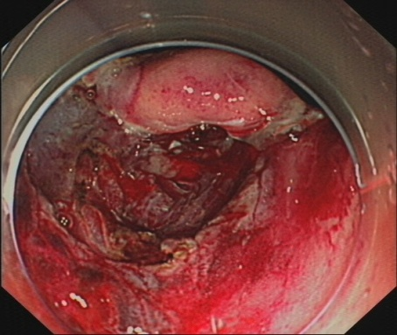 | 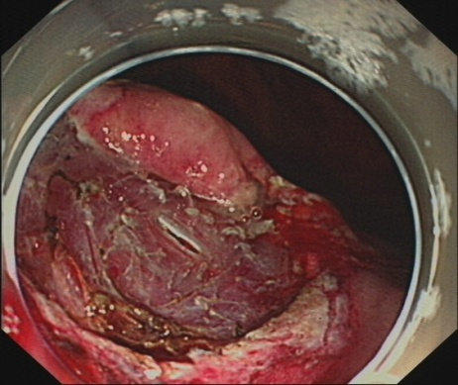
A | B
Figure 1 Gastric muscularis propria manifestations in endoscopic treatment. A: Before hemocoagulase spray; B: After hemocoagulase spray.

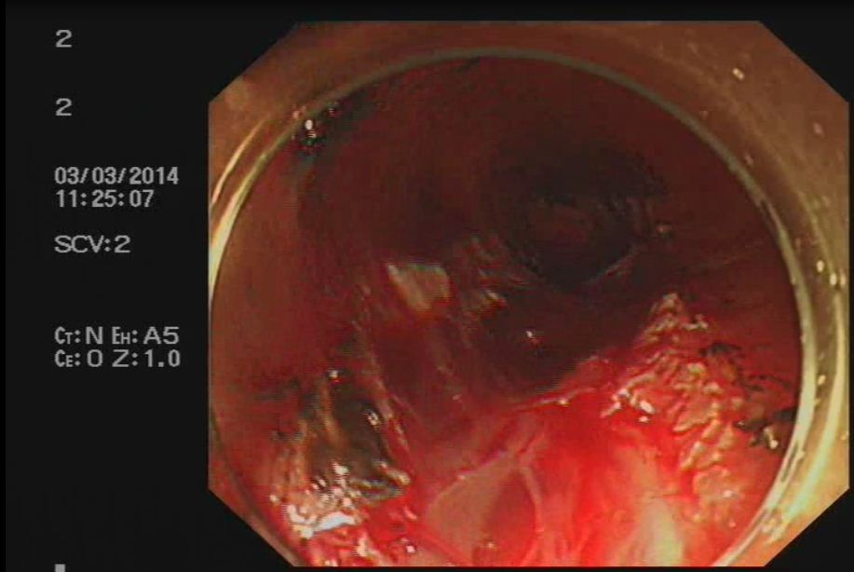 | 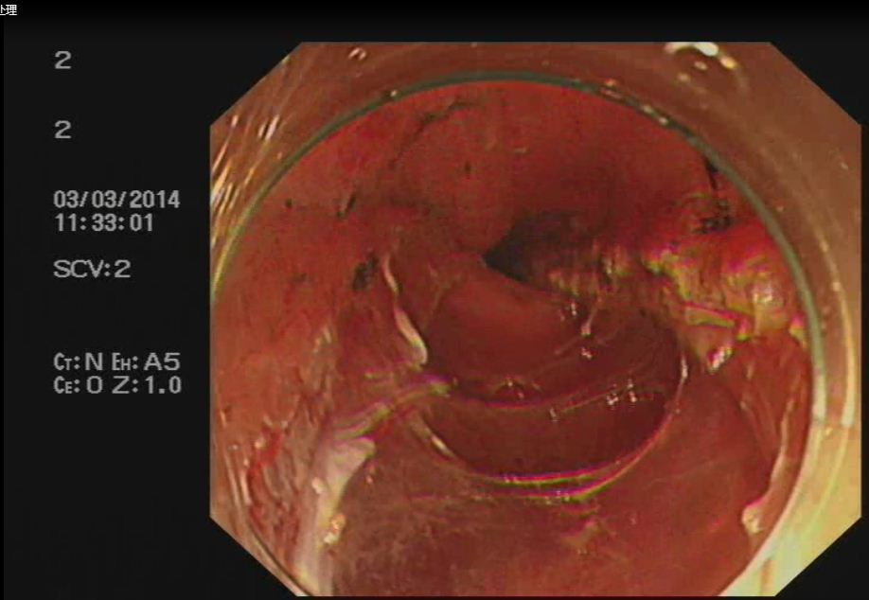
A | B

Figure 2 Esophageal muscularis propria manifestations in endoscopic treatment. A: Before hemocoagulase spray; B: After hemocoagulase spray.

