Name of Journal: World Journal of Clinical Cases
Manuscript NO: 76360
Manuscript Type: CASE REPORT

Effects of intravascular photobiomodulation on motor deficits and brain perfusion images in intractable myasthenia gravis: A case report

Lan CH et al. Intravascular photobiomodulation in intractable MG

Chiao-Hsin Lan, Yu-Che Wu, Cheng-Chun Chiang, Shin-Tsu Chang

Chiao-Hsin Lan, Cheng-Chun Chiang, Shin-Tsu Chang, School of Medicine, National Defense Medical Center, Taipei 114201, Taiwan

Yu-Che Wu, Department of Medical Education and Research, Kaohsiung Veterans General Hospital, Kaohsiung 813414, Taiwan

Shin-Tsu Chang, Department of Physical Medicine and Rehabilitation, Kaohsiung Veterans General Hospital, Kaohsiung 813414, Taiwan

Shin-Tsu Chang, Department of Physical Medicine and Rehabilitation, Tri-Service General Hospital, Taipei 114202, Taiwan

Author contributions: Lan CH reviewed the literature and contributed to manuscript drafting; Lan CH, Wu YC, and Chiang CC analyzed and interpreted the imaging findings; Chang ST were responsible for the revision of the manuscript for important intellectual content and supervised the study and managed the project; and All authors issued final approval for the version to be submitted.

Corresponding author: Shin-Tsu Chang, MD, MS, PhD, Director, Department of Physical Medicine and Rehabilitation, Kaohsiung Veterans General Hospital, No. 386 Dazhong 1st Road, Zuoying District, Kaohsiung 813414, Taiwan. ccdivlaser1959@gmail.com

Received: March 14, 2022
Revised: May 24, 2022
Accepted: July 16, 2022
Published online: August 26, 2022

Abstract
BACKGROUND
Myasthenia gravis (MG) is an autoimmune disorder caused by neuromuscular junction failure characterized by muscle weakness and fatigability. We herein report a case of MG that received intravascular laser irradiation of blood (ILIB) interventions and regained muscle power and better quality of life. To our knowledge, no previous study has investigated the benefits of ILIB treatment on patients with MG. We also evaluated the changes in brain perfusion scan and the MG activities of daily living (MG-ADL) and quantitative MG (QMG) scales.

CASE SUMMARY
A 59-year-old man presented to our outpatient hospital experiencing ptosis, diplopia, fibromyalgia, muscle fatigue, and fluctuating weakness in his limbs for 1 year. Based on his history, physical examination, and laboratory investigations, the final diagnosis was a flare-up of MG with poor endurance and muscle fatigue. The patient agreed to receive ILIB. Brain single-photon emission computed tomography (SPECT) was performed both before and after ILIB therapy. After receiving three courses of ILIB, the brain SPECT images showed greatly increased perfusion of the frontal lobe and anterior cingulate gyri. The patient’s MG-ADL scale score decreased markedly from 17/24 to 3/24. The QMG scale score also decreased remarkably from 32/39 to 9/39. The symptoms of MG became barely detectable and the patient was able to perform his activities of daily living and regain muscle power.

CONCLUSION
ILIB might have beneficial effects on MG, and brain SPECT images provided direct evidence of a positive correlation between ILIB and clinical performance.

Key Words: Myasthenia gravis; Intravascular laser irradiation of blood; Myasthenia gravisactivities of daily living scale; Quantitative myasthenia gravis scale; Single-photon emission computed tomography; Case report

©The Author(s) 2022. Published by Baishideng Publishing Group Inc. All rights reserved.

Citation: Lan CH, Wu YC, Chiang CC, Chang ST. Effects of intravascular photobiomodulation on motor deficits and brain perfusion images in intractable myasthenia gravis: A case report. World J Clin Cases 2022; 10(24): 8718-8727
URL: https://www.wjgnet.com/2307-8960/full/v10/i24/8718.htm
DOI: https://dx.doi.org/10.12998/wjcc.v10.i24.8718

Core Tip: Myasthenia gravis (MG) is an autoimmune disease without effective treatments. We herein report a case of intractable MG administered a novel therapy, intravascular laser irradiation of blood interventions (ILIB), which regained muscle power and improved quality of life. To our knowledge, this is the first study investigating the benefits of ILIB treatment in patients with MG. We also evaluated the changes in brain perfusion scan and MG activities of daily living scale, and quantitative MG scale scores. We report this case to trigger further research and facilitate the recovery of patients with MG.
INTRODUCTION
Myasthenia gravis (MG) is an autoimmune disease that occurs due to the failure of neuromuscular transmission resulting from antibodies against the acetylcholine receptor, muscle-specific kinase, lipoprotein-related protein 4, or agrin in the postsynaptic membrane at the neuromuscular junction^{[1-4]}. During the initial lifetime course of MG, patients often present with ocular symptoms of ptosis and diplopia^{[5,6]}. About half of these patients progress to generalized disease within 2 years^{[7]}. The clinical manifestation of this disorder is fluctuation and variable weakness in the ocular, bulbar, limb, and respiratory muscles, which lead to major symptoms such as dysarthria, dysphagia, fatigable chewing, fatigable limb, or axial weakness. Skeletal muscle fatigue manifests as weakened muscle contractile force^{[8-10]}.
The conventional treatment of MG usually includes a combination of symptomatic therapy with acetylcholinesterase inhibitors (e.g., pyridostigmine), immunosuppressive drugs, and immunotherapy using either intravenous immunoglobulin (IVIG) or plasma exchange in selected patients thymectomy^{[10-14]}. The common therapeutic goal of these treatments is to help patients return to normal function as soon as possible while minimizing the side effects. However, patients receiving these treatments often experience adverse side effects and have difficulties in recovering^{[15]}.
A novel alternative therapy is intravascular photobiomodulation, also known as intravascular laser irradiation of blood (ILIB). ILIB treatment utilizes a helium-neon laser with a wavelength of 632.8 nm (red light). An optic fiber is inserted into a superficial vein to deliver the laser light^{[16]}. ILIB is considered an alternative treatment for diseases such as chronic spinal cord injury, cerebral stroke, traumatic brain injury, rheumatoid arthritis, chronic Sjögren’s syndrome, fibromyalgia, and chronic pain conditions, due to its effects in increasing microcirculation and improving oxygen supply^{[17-21]}. Before this case, the usefulness of ILIB in patients with MG had not been reported. This study presents a case diagnosed with MG that was treated with ILIB therapy, which resulted in regained muscle power and improved quality of life.

CASE PRESENTATION
Chief complaints
A 59-year-old man experienced ptosis, diplopia, fibromyalgia, muscle fatigue, and fluctuating limb weakness for 1 year. Worsening weakness in bilateral lower limbs caused walking disability. The patient then came to our outpatient hospital in hopes of regaining muscle power and better walking ability.

History of present illness
The patient’s symptoms had started 1 year ago with recurrent episodes of weakness in four limbs. His eyelid dropped soon after he woke up and double vision appeared spontaneously. He also required a ventilator to maintain his daily sleeping.

History of past illness
The patient was initially diagnosed with MG on August 5, 2018, accompanied by severe ptosis, diplopia, and fibromyalgia. He visited a neurologist in a local medical center, who prescribed acetylcholinesterase inhibitor, pyridostigmine (oral: 60 mg/tab, 2 tabs three times daily), for 1 year. Later, the patient was treated with immunosuppressive drugs; namely, rituximab (intravenously: 375 mg/m², once weekly for 4 wk), and received six courses of IVIG to improve his conditions. However, the severe ptosis, diplopia, and fibromyalgia persisted without any sign of recovery. The patient reported no improvements in the weaknesses of his bilateral lower limbs, which caused walking disability and muscle fatigue, which severely affected his daily life.

Personal and family history
The patient had no significant personal or family history.

Physical examination
During his visit, the MG activities of daily living scale (MG-ADL scale)^{[22]} total score was 20/24 (Figure 1, Table 1), while that for the quantitative MG scale (QMG scale)^{[23]} was 32/39 (Figure 2, Table 2). The patient’s vital signs were within the normal ranges. Repetitive stimulation test at 3 Hz revealed decremental responses (11.8%) in both orbicularis oculi muscles but not in the right abductor pollicis brevis muscle, which suggested the need to consider post-synaptic neuromuscular junctional disorder.

Laboratory examinations
Laboratory evaluation revealed positivity for acetylcholine receptor antibody (5.97 nmol/L). The blood biochemistry examinations revealed mildly decreased complement C3 (74.8 mg/dL) levels compared to normal values (79–152 mg/dL). The urine analysis showed normal values.

Imaging examinations
No abnormalities were noted on electrocardiograms and chest X-rays. Regional cerebral perfusion (rCBF) scans by brain single-photon emission computed tomography (SPECT) were performed 30 min after the intravenous injection of 30.8 mCi Tc-99m ECD. Easy Z-score Imaging System was used for statistical analysis. The first brain SPECT showed decreased rCBF in the frontal regions and anterior cingulate gyri (Figures 3 and 4). Magnetic resonance imaging of the chest showed no evidence of a thymic mass.

Further diagnostic work-up
The results of the antinuclear autoantibodies (ANA) test were negative. The levels of RA factor (serum) were within normal limits (< 20 IU/mL). The levels in anti-cyclic citrullinated peptide (anti-CCP) screening were also normal (0.6 U/mL). The patient was negative for HLA-B27. Finally, the result of the myositis 16-specific Ag panel was unremarkable.

FINAL DIAGNOSIS
Based on the patient’s history, physical examinations, and laboratory investigations, the final diagnosis of the presented case was a flare-up of MG with poor endurance and muscle fatigue (Figure 5).

TREATMENT
The patient was advised to undergo ILIB and agreed. He received three courses of ILIB (60 min each session for 10 consecutive days per course, with a rest interval of 1–2 wk). A helium-neon (He-Ne) laser illuminator (TAIEX He-Ne Laser, YJ-ILIB-5, Bio-ILIB Human Energy Corporation, Taiwan) was applied with a wavelength of 632.8 nm, energy of 12.6 to 14.4 J, energy density of 6428.57 J/cm², power output of 2.5–3.5 w/cm², power intensity of 1.79–2.04 w/cm², and irradiation time of 3600 s/session^{[20]}. The laser power was adjusted depending on the patient’s responses.

OUTCOME AND FOLLOW-UP
After completing three courses of ILIB, the patient’s double vision and eyelid-dropping were remarkably improved, with his MG-ADL scale total score decreasing from 17/24 to 3/24. The weaknesses in both upper and lower limbs changed as anticipated. In the QMG scale, the time for both arms outstretched (90° standing) increased from 0–10 s to 90–240 s, while that for both legs’ outstretched (45° supine) increased from 0–10 s to 90–240 s. The patient’s breathing also improved. The algesia of both arms caused by fibromyalgia was also alleviated. Notably, the second total score of the QMG Scale decreased from 32/39 to 9/39. The second brain SPECT showed increased activities in the frontal regions and anterior cingulate gyri (Figures 3 and 4). The patient is content with the efficacy of ILIB treatment.

DISCUSSION
After several years of conventional treatments, including acetylcholinesterase inhibitors and immunosuppressive drugs without subjective improvement, the relatively rapid improvement in motor and respiratory function during ILIB treatment in our case suggests that the patient benefited significantly from ILIB therapy. This patient also made great clinical progress, according to his MG ADL and QMG scale scores. This is the first case report on the novel treatment of MG with ILIB. This is also the first study to describe the benefit of ILIB as a treatment for impaired motor function and analgesia by SPECT imaging of a patient with MG.
We used regional perfusion brain SPECT images to assess brain function before and after the ILIB intervention. We observed two intriguing findings in this study of a patient with MG.
First, we observed remarkably increased perfusion in the motor areas of the frontal lobe (Figure 3), which indicated a strong relationship between motor function and frontal lobe activity. Recent studies showed that ILIB therapy improved regional cerebral blood flow and provided faster repair of the affected nervous system through increased ATP production^{[24,25]}. The motor cortex comprises three different areas of the frontal lobe, immediately anterior to the central sulcus. These areas are the primary motor cortex (Brodmann’s area 4), the premotor cortex (PMC), and the supplementary motor area (SMA)^{[26]}. Our SPECT images showed significantly increased perfusion in both the SMA and PMC after ILIB therapy, suggesting that blood flow might re-perfuse, contributing to the improvement in muscle weakness and fatigue.
Second, the SPECT images also showed higher activity in the anterior cingulate cortex (ACC) after ILIB therapy (Figure 4), which indicated a correlation between pain relief and the ACC. Davis et al^{[27]} reported that the signal intensity changes within the ACC were correlated with pain intensity, sensory, cognitive processes, and motor function including voluntary movement^{[28]}. Hence, higher activities in the ACC, considered a complicated integrative center, showed a re-distribution of blood flow in the brain, which resulted in pain relief in both arms and regained power in the skeletal muscles.
Furthermore, ILIB is considered a treatment that facilitates circulation in the frontal area of the cortex, especially in this case. ILIB may enhance muscular strength and relieve fluctuating and variable fatigue^{[29,30]}. ILIB also plays a role as an immunomodulator through direct or indirect effects on the immune system^{[21]}, which was unbalanced in our case with MG. The post-treatment imaging study revealed that ILIB effectively facilitated circulation around the frontal area of the cortex, which improved the clinical symptoms of this patient with MG.
However, the role of the peripheral mechanism in contributing to the recovery of muscle power cannot be ignored. To sustain muscle contraction, ATP needs to be regenerated at a rate complementary to ATP demand. Three major ways are used to replenish ATP in muscle. These systems-phosphagen, glycolytic, and mitochondrial respiration-differ in the substrates used, products, maximal rate of ATP regeneration, capacity of ATP regeneration, and associated contributions to fatigue^{[31,32]}. In addition, ILIB therapy has been reported to promote total cellular ATP synthesis, and antioxidant activity, which contributes to the alleviation of chronic conditions, such as chronic spinal cord injury and fibromyalgia^{[17,20]}. Therefore, we believe that ILIB therapy might enhance muscle power by increasing ATP synthesis in the peripheral mechanism.

CONCLUSION
MG is an autoimmune disease that previously lacked effective treatments and detailed brain perfusion images. Our case showed the feasible management of this condition with ILIB treatment. The brain perfusion scan demonstrated increased activity in the prior deficit of the brain lesion. ILIB might have beneficial effects on MG and SPECT images could be a good monitor for any deficits in the brain.

REFERENCES
1 Vincent A, Palace J, Hilton-Jones D. Myasthenia gravis. Lancet 2001; 357: 2122-2128 [PMID: 11445126 DOI: 10.1016/S0140-6736(00)05186-2]
2 Conti-Fine BM, Milani M, Kaminski HJ. Myasthenia gravis: past, present, and future. J Clin Invest 2006; 116: 2843-2854 [PMID: 17080188 DOI: 10.1172/JCI29894]
3 Koneczny I, Herbst R. Myasthenia Gravis: Pathogenic Effects of Autoantibodies on Neuromuscular Architecture. Cells 2019; 8 [PMID: 31269763 DOI: 10.3390/cells8070671]
4 Zhang B, Tzartos JS, Belimezi M, Ragheb S, Bealmear B, Lewis RA, Xiong WC, Lisak RP, Tzartos SJ, Mei L. Autoantibodies to lipoprotein-related protein 4 in patients with double-seronegative myasthenia gravis. Arch Neurol 2012; 69: 445-451 [PMID: 22158716 DOI: 10.1001/archneurol.2011.2393]
5 Dresser L, Wlodarski R, Rezania K, Soliven B. Myasthenia Gravis: Epidemiology, Pathophysiology and Clinical Manifestations. J Clin Med 2021; 10 [PMID: 34064035 DOI: 10.3390/jcm10112235]
6 Grob D, Brunner N, Namba T, Pagala M. Lifetime course of myasthenia gravis. Muscle Nerve 2008; 37: 141-149 [PMID: 18059039 DOI: 10.1002/mus.20950]
7 Kupersmith MJ, Latkany R, Homel P. Development of generalized disease at 2 years in patients with ocular myasthenia gravis. Arch Neurol 2003; 60: 243-248 [PMID: 12580710 DOI: 10.1001/archneur.60.2.243]
8 Hehir MK, Silvestri NJ. Generalized Myasthenia Gravis: Classification, Clinical Presentation, Natural History, and Epidemiology. Neurol Clin 2018; 36: 253-260 [PMID: 29655448 DOI: 10.1016/j.ncl.2018.01.002]
9 Gilhus NE, Tzartos S, Evoli A, Palace J, Burns TM, Verschuuren JJGM. Myasthenia gravis. Nat Rev Dis Primers 2019; 5: 30 [PMID: 31048702 DOI: 10.1038/s41572-019-0079-y]
10 Meriggioli MN, Sanders DB. Autoimmune myasthenia gravis: emerging clinical and biological heterogeneity. Lancet Neurol 2009; 8: 475-490 [PMID: 19375665 DOI: 10.1016/S1474-4422(09)70063-8]
11 Gold R, Schneider-Gold C. Current and future standards in treatment of myasthenia gravis. Neurotherapeutics 2008; 5: 535-541 [PMID: 19019304 DOI: 10.1016/j.nurt.2008.08.011]
12 Kumar V, Kaminski HJ. Treatment of myasthenia gravis. Curr Neurol Neurosci Rep 2011; 11: 89-96 [PMID: 20927659 DOI: 10.1007/s11910-010-0151-1]
13 Gilhus NE, Verschuuren JJ. Myasthenia gravis: subgroup classification and therapeutic strategies. Lancet Neurol 2015; 14: 1023-1036 [PMID: 26376969 DOI: 10.1016/S1474-4422(15)00145-3]
14 Gajdos P, Chevret S, Toyka KV. Intravenous immunoglobulin for myasthenia gravis. Cochrane Database Syst Rev 2012; 12: CD002277 [PMID: 23235588 DOI: 10.1002/14651858.CD002277.pub4]
15 Schneider-Gold C, Gilhus NE. Advances and challenges in the treatment of myasthenia gravis. Ther Adv Neurol Disord 2021; 14: 17562864211065406 [PMID: 34987614 DOI: 10.1177/17562864211065406]
16 Moskvin SV. Low-Level Laser Therapy for Herpesvirus Infections: A Narrative Literature Review. J Lasers Med Sci 2021; 12: e38 [PMID: 34733761 DOI: 10.34172/jlms.2021.38]
17 Huang SF, Tsai YA, Wu SB, Wei YH, Tsai PY, Chuang TY. Effects of intravascular laser irradiation of blood in mitochondria dysfunction and oxidative stress in adults with chronic spinal cord injury. Photomed Laser Surg 2012; 30: 579-586 [PMID: 22891782 DOI: 10.1089/pho.2012.3228]
18 Chiran DA, Weber M, Ailioaie LM, Moraru E, Ailioaie C, Litscher D, Litscher G. Intravenous laser blood irradiation and tocilizumab in a patient with juvenile arthritis. Case Rep Med 2014; 2014: 923496 [PMID: 24715926 DOI: 10.1155/2014/923496]
19 Yang WH, Lin SP, Chang ST. Case report: Rapid improvement of crossed cerebellar diaschisis after intravascular laser irradiation of blood in a case of stroke. Medicine (Baltimore) 2017; 96: e5646 [PMID: 28079797 DOI: 10.1097/MD.0000000000005646]
20 Momenzadeh S, Abbasi M, Ebadifar A, Aryani M, Bayrami J, Nematollahi F. The intravenous laser blood irradiation in chronic pain and fibromyalgia. J Lasers Med Sci 2015; 6: 6-9 [PMID: 25699161]
21 Liu EY, Chang ST. Benefits of intravascular laser irradiation of blood on motor and sensory recovery viewing from brain function images: Portrait of a case with chronic Sjögren’s syndrome, transverse myelitis, and Guillain-Barré syndrome. Biomed J Sci Tech Res 2019; 14 [DOI: 10.26717/bjstr.2019.14.002572]
22 Muppidi S. The myasthenia gravis--specific activities of daily living profile. Ann N Y Acad Sci 2012; 1274: 114-119 [PMID: 23252905 DOI: 10.1111/j.1749-6632.2012.06817.x]
23 Wolfe GI, Herbelin L, Nations SP, Foster B, Bryan WW, Barohn RJ. Myasthenia gravis activities of daily living profile. Neurology 1999; 52: 1487-1489 [PMID: 10227640 DOI: 10.1212/wnl.52.7.1487]
24 Dompe C, Moncrieff L, Matys J, Grzech-Leśniak K, Kocherova I, Bryja A, Bruska M, Dominiak M, Mozdziak P, Skiba THI, Shibli JA, Angelova Volponi A, Kempisty B, Dyszkiewicz-Konwińska M. Photobiomodulation-Underlying Mechanism and Clinical Applications. J Clin Med 2020; 9 [PMID: 32503238 DOI: 10.3390/jcm9061724]
25 Tafur J, Mills PJ. Low-intensity light therapy: exploring the role of redox mechanisms. Photomed Laser Surg 2008; 26: 323-328 [PMID: 18665762 DOI: 10.1089/pho.2007.2184]
26 Schlaug G, Renga V. Transcranial direct current stimulation: a noninvasive tool to facilitate stroke recovery. Expert Rev Med Devices 2008; 5: 759-768 [PMID: 19025351 DOI: 10.1586/17434440.5.6.759]
27 Davis KD, Taylor SJ, Crawley AP, Wood ML, Mikulis DJ. Functional MRI of pain- and attention-related activations in the human cingulate cortex. J Neurophysiol 1997; 77: 3370-3380 [PMID: 9212281 DOI: 10.1152/jn.1997.77.6.3370]
28 Kwan CL, Crawley AP, Mikulis DJ, Davis KD. An fMRI study of the anterior cingulate cortex and surrounding medial wall activations evoked by noxious cutaneous heat and cold stimuli. Pain 2000; 85: 359-374 [PMID: 10781909 DOI: 10.1016/S0304-3959(99)00287-0]
29 Tomé RFF, Silva DFB, Dos Santos CAO, de Vasconcelos Neves G, Rolim AKA, de Castro Gomes DQ. ILIB (intravascular laser irradiation of blood) as an adjuvant therapy in the treatment of patients with chronic systemic diseases-an integrative literature review. Lasers Med Sci 2020; 35: 1899-1907 [PMID: 32656732 DOI: 10.1007/s10103-020-03100-4]
30 Wang X, Tian F, Soni SS, Gonzalez-Lima F, Liu H. Interplay between up-regulation of cytochrome-c-oxidase and hemoglobin oxygenation induced by near-infrared laser. Sci Rep 2016; 6: 30540 [PMID: 27484673 DOI: 10.1038/srep30540]
31 Baker JS, McCormick MC, Robergs RA. Interaction among Skeletal Muscle Metabolic Energy Systems during Intense Exercise. J Nutr Metab 2010; 2010: 905612 [PMID: 21188163 DOI: 10.1155/2010/905612]
32 Hargreaves M, Spriet LL. Skeletal muscle energy metabolism during exercise. Nat Metab 2020; 2: 817-828 [PMID: 32747792 DOI: 10.1038/s42255-020-0251-4]

Footnotes
Informed consent statement: Informed written consent was obtained from the patient for publication of this report and any accompanying images.

Conflict-of-interest statement: The authors declare that they have no conflicts of interest.

CARE Checklist (2016) statement: The authors have read the CARE Checklist (2016), and the manuscript was prepared and revised according to the CARE Checklist (2016).

Open-Access: This article is an open-access article that was selected by an in-house editor and fully peer-reviewed by external reviewers. It is distributed in accordance with the Creative Commons Attribution NonCommercial (CC BY-NC 4.0) license, which permits others to distribute, remix, adapt, build upon this work non-commercially, and license their derivative works on different terms, provided the original work is properly cited and the use is non-commercial. See: https://creativecommons.org/Licenses/by-nc/4.0/

Provenance and peer review: Unsolicited article; Externally peer reviewed.
Peer-review model: Single blind

Peer-review started: March 14, 2022
First decision: May 11, 2022
Article in press: July 16, 2022

Specialty type: Medicine, research and experimental
Country/Territory of origin: Taiwan
Peer-review report’s scientific quality classification
Grade A (Excellent): A
Grade B (Very good): 0
Grade C (Good): C
Grade D (Fair): 0
Grade E (Poor): 0

P-Reviewer: Han J, China; Liu YC, China S-Editor: Ma YJ L-Editor: A P-Editor: Ma YJ
Figure Legends
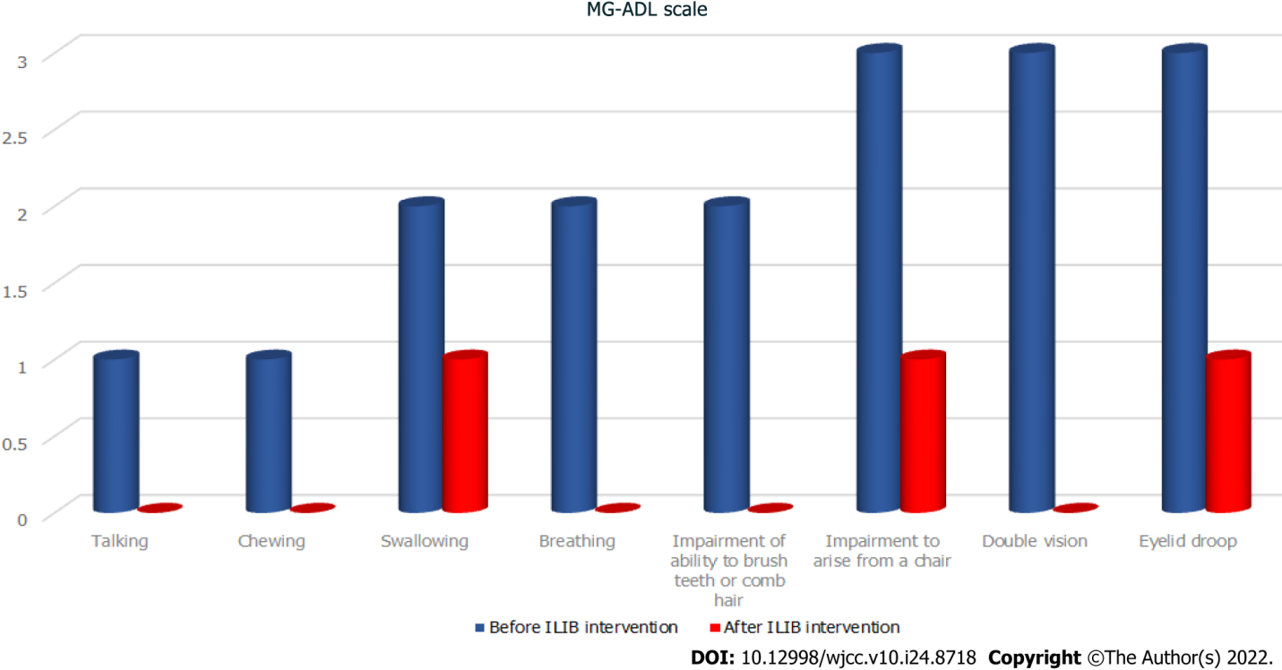
Figure 1 Myasthenia gravis activities of daily living scale. The symptoms of the patient with myasthenia gravis, including difficulties in talking, chewing, breathing, brushing teeth, and combing hair, as well as double vision were greatly ameliorated after intravascular laser irradiation of blood intervention, with grades dropping to zero. Swallowing, rising from a chair, and eyelid droop also showed good progress. MG-ADL: Myasthenia gravis activities of daily living; ILIB: Intravascular laser irradiation of blood.
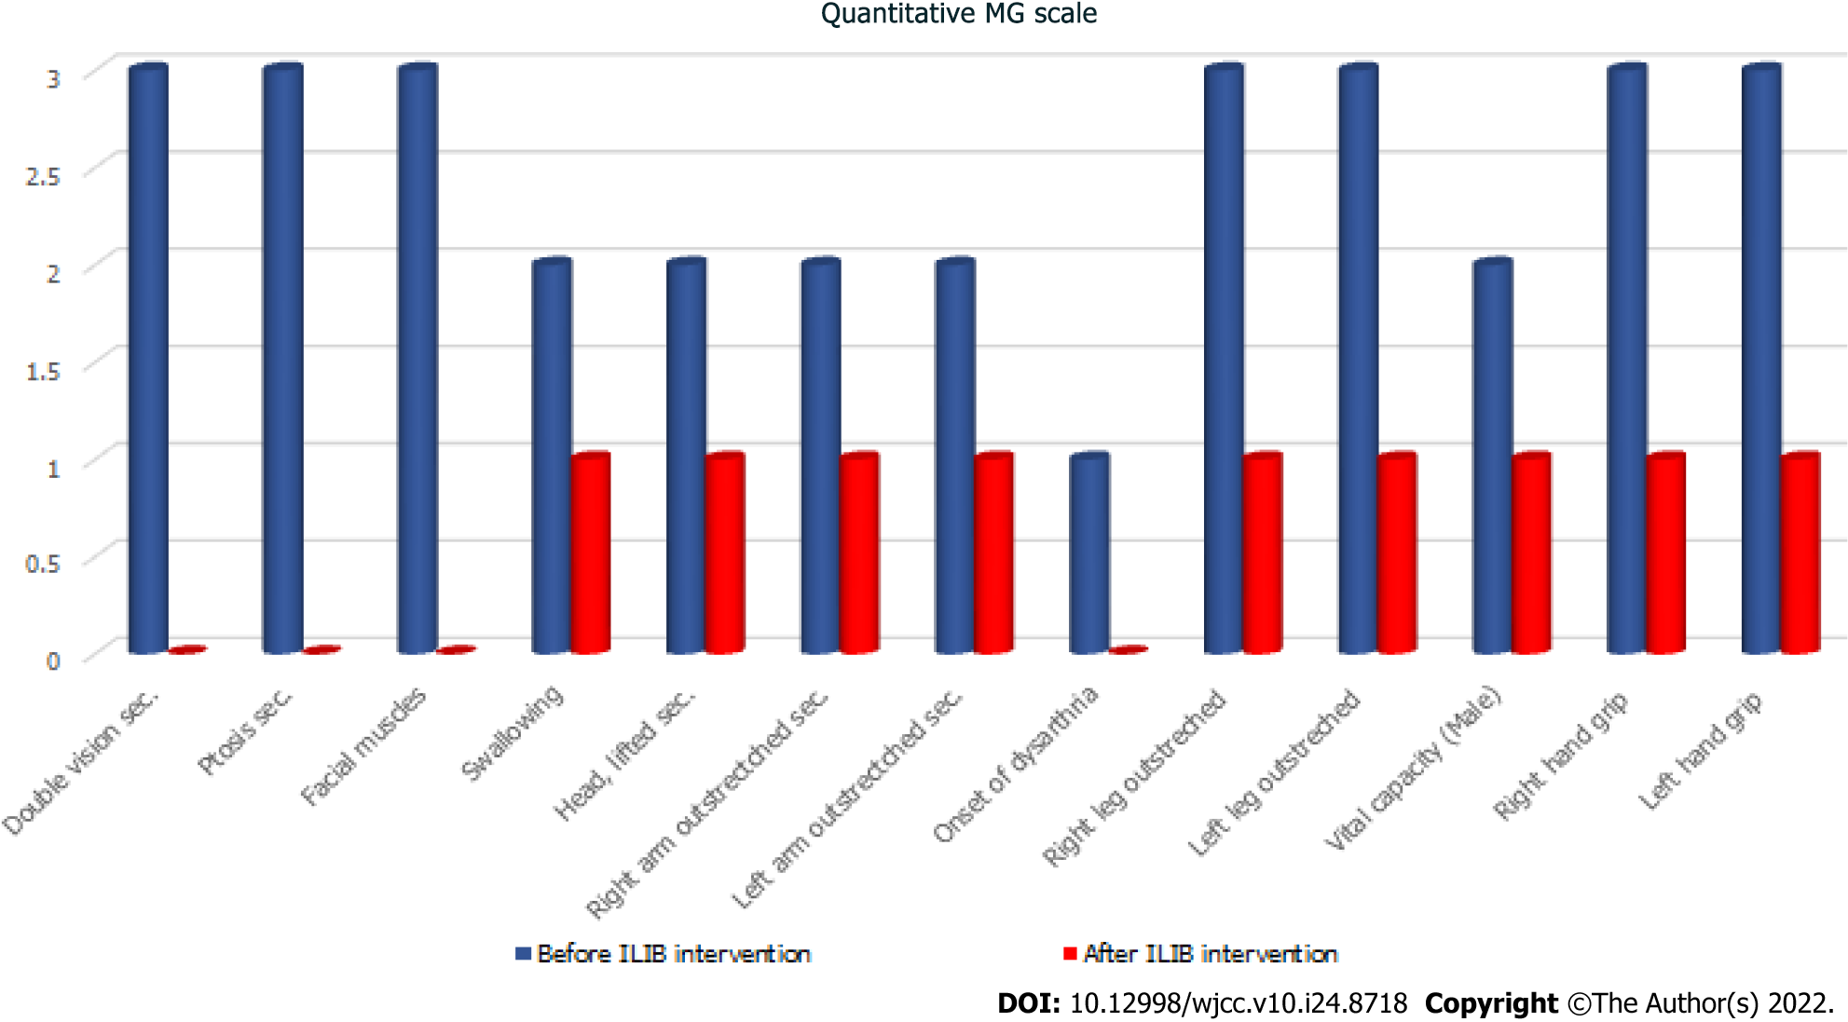
Figure 2 Quantitative myasthenia gravis scale. The effect of intravascular laser irradiation of blood was measured using 13 criteria of the quantitative myasthenia gravis scale. MG: Myasthenia gravis; ILIB: Intravascular laser irradiation of blood.
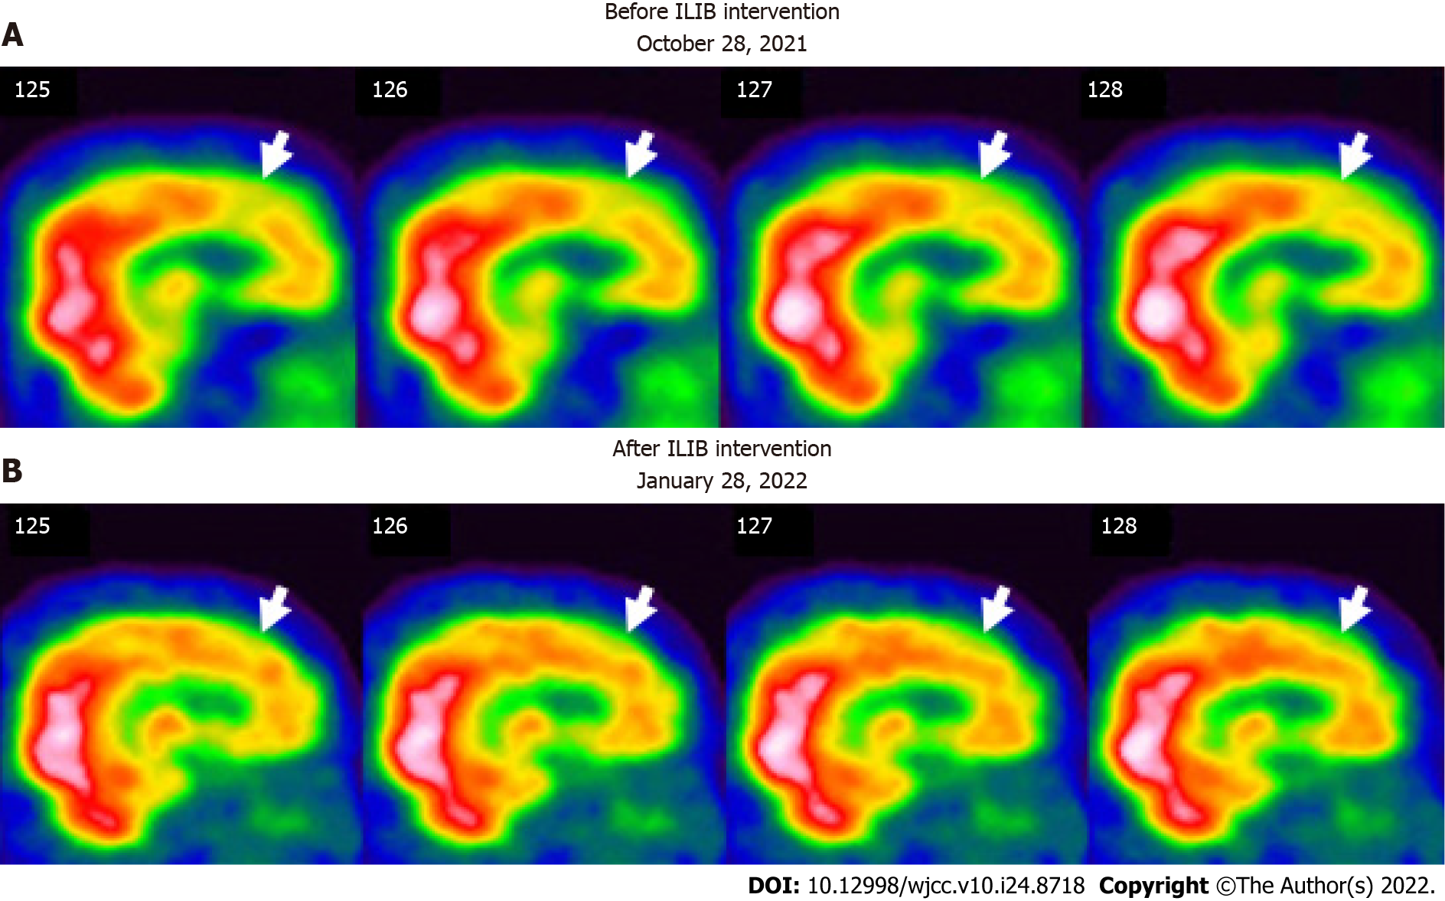
Figure 3 Regional perfusion brain single-photon emission computed tomography before and after therapeutic intravascular laser irradiation of blood intervention (sagittal view). The white to red and green to blue areas indicate high and low perfusion, respectively. A:The first single-photon emission computed tomography (SPECT) (before ILIB intervention) shows perfusion deficits in the frontal lobe (white arrows); B: The second SPECT [after the third course of intravascular laser irradiation of blood (ILIB) intervention] shows more blood flow in the frontal lobe (white arrows). ILIB: Intravascular laser irradiation of blood.
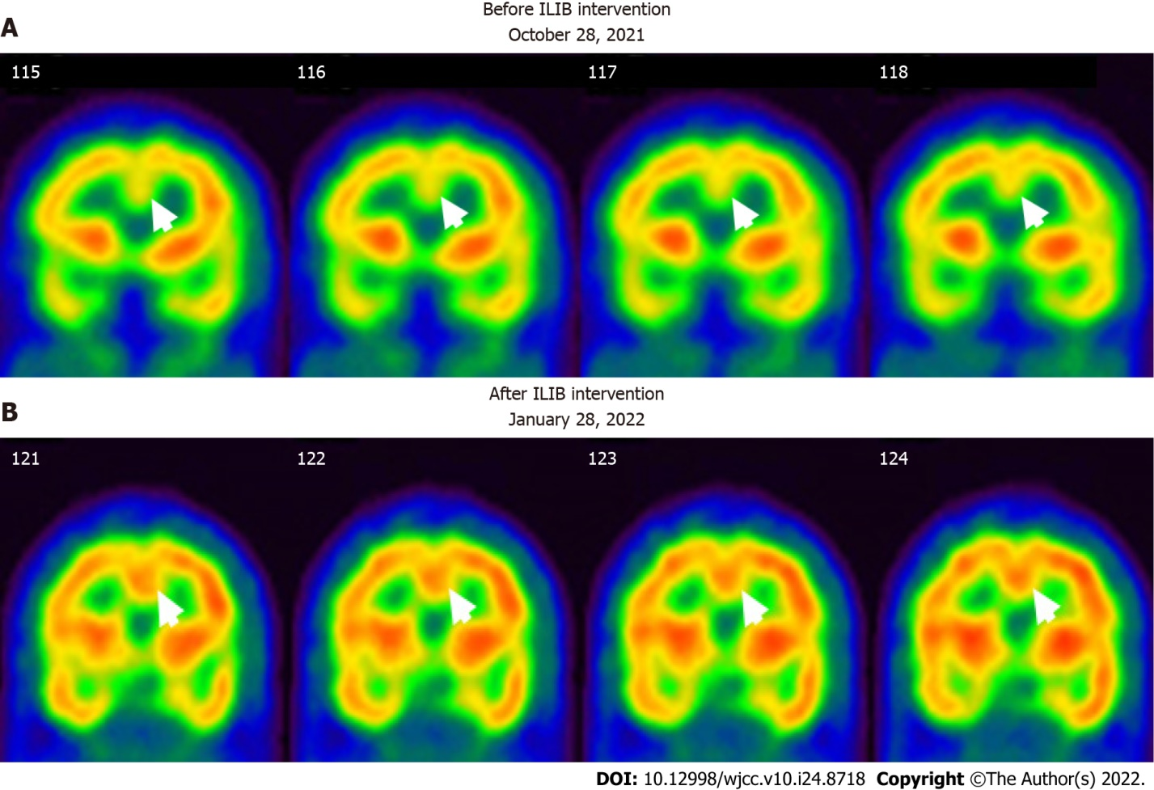
Figure 4 Regional perfusion brain single-photon emission computed tomography before and after therapeutic intravascular laser irradiation of blood intervention (coronal view). The white to red and green to blue areas indicate high and low perfusion, respectively. A: The first SPECT (before ILIB intervention) shows perfusion deficits at the anterior cingulate gyri (white arrows); B: The second SPECT (after the third course of ILIB intervention) shows high activity in the anterior cingulate gyri (black arrows). ILIB: Intravascular laser irradiation of blood; SPECT: Single-photon emission computed tomography.
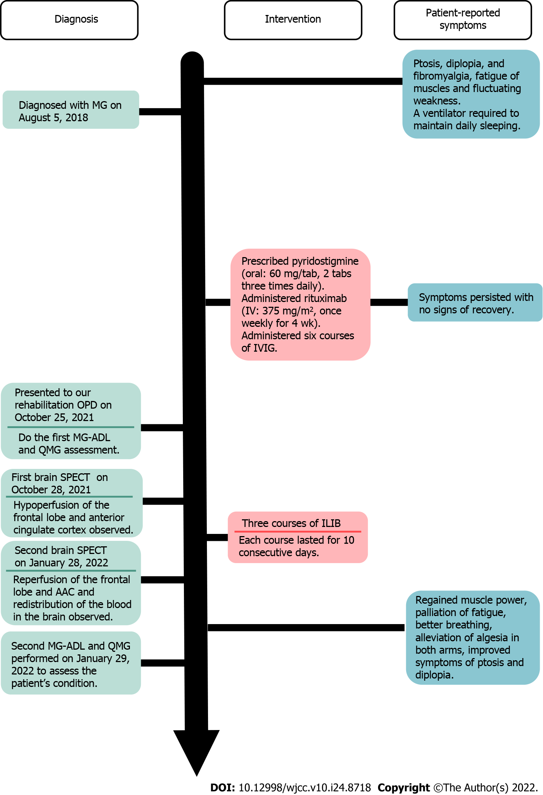
Figure 5 Time course of the case and the patient’s reported symptoms. IVIG: Intravenous immunoglobulin; OPD: Outpatient department; SPECT: Single-photon emission computed tomography; ILIB: Intravascular laser irradiation of blood; MG-ADL: Myasthenia gravis activities of daily living; QMG: Quantitative myasthenia gravis.
Table 1 Myasthenia gravis activities of daily living scale
MG-ADL scale | Before ILIB intervention | After ILIB intervention
Talking | 1 | 0
Chewing | 1 | 0
Swallowing | 2 | 1
Breathing | 2 | 0
Impairment of ability to brush teeth or comb hair | 2 | 0
Impairment to arise from a chair | 3 | 1
Double vision | 3 | 0
Eyelid droop | 3 | 1
Total | 17 | 3
The effect of intravascular laser irradiation of blood was assessed using the myasthenia gravis activities of daily living scale for the following eight criteria: talking, chewing, swallowing, breathing, brushing teeth or combing hair, rising from a chair, double vision, and eyelid droop. The numbers in the table represent grades from the maximum of 3 to the minimum of 0. MG-ADL: Myasthenia gravis activities of daily living; ILIB: Intravascular laser irradiation of blood.
Table 2 Quantitative myasthenia gravis scale
Quantitative MG scale | Before ILIB intervention | After ILIB intervention
Double vision sec. | 3 | 0
Ptosis sec. | 3 | 0
Facial muscles | 3 | 0
Swallowing | 2 | 1
Head, lifted sec. | 2 | 1
Right arm outstrectched sec. | 2 | 1
Left arm outstrectched sec. | 2 | 1
Onset of dysarthria | 1 | 0
Right leg outstreched | 3 | 1
Left leg outstreched | 3 | 1
Vital capacity (male) | 2 | 1
Right hand grip | 3 | 1
Left hand grip | 3 | 1
Total | 32 | 9
The effect of intravascular laser irradiation of blood was measured based on 13 criteria from the quantitative myasthenia gravis scale. The numbers in the table represent grades from the maximum of 3 to the minimum of 0. MG: Myasthenia gravis; ILIB: Intravascular laser irradiation of blood.

Published by Baishideng Publishing Group Inc
7041 Koll Center Parkway, Suite 160, Pleasanton, CA 94566, USA
Telephone: +1-925-3991568
E-mail: bpgoffice@wjgnet.com
Help Desk: https://www.f6publishing.com/helpdesk
https://www.wjgnet.com

© 2022 Baishideng Publishing Group Inc. All rights reserved.

