Name of Journal: World Journal of Meta-Analysis
Manuscript NO: 45768
Manuscript Type: META-ANALYSIS

Evaluation of tumor response to antiangiogenic therapy in patients with recurrent gliomas using contrast-enhanced perfusion-weighted magnetic resonance imaging techniques: A meta-analysis

Kasenene A et al. PW-MRI evaluation of antiangiogenic therapy for recurrent gliomas

Akanganyira Kasenene, Aju Baidya, Salman Shams, Hai-Bo Xu

Akanganyira Kasenene, Aju Baidya, Salman Shams, Hai-Bo Xu, Department of Radiology and Nuclear Medicine, Zhongnan Hospital of Wuhan University, Wuhan University, Wuhan 430071, Hubei Province, China

ORCID number: Akanganyira Kasenene (0000-0003-1844-3494); Aju Baidya (0000-0002-6815-049X); Salman Shams (0000-0001-6319-0233); Hai-Bo Xu (0000-0002-8451-8979).

Author contributions: Kasenene A and Baidya A contributed equally to this work; Kasenene A and Xu HB designed this study; Kasenene A and Baidya A analyzed the data; Kasenene A, Baidya A, Shams S, and Xu HB drafted the paper.

Conflict-of-interest statement: There is no conflict of interest.

PRISMA 2009 Checklist statement: The current manuscript was prepared and revised according to the PRISMA 2009 Checklist.

Open-Access: This article is an open-access article which was selected by an in-house editor and fully peer-reviewed by external reviewers. It is distributed in accordance with the Creative Commons Attribution Non Commercial (CC BY-NC 4.0) license, which permits others to distribute, remix, adapt, build upon this work non-commercially, and license their derivative works on different terms, provided the original work is properly cited and the use is non-commercial. See: http://creativecommons.org/licenses/by-nc/4.0/

Manuscript source: Unsolicited manuscript

Corresponding author: Hai-Bo Xu, MD, PhD, Director, Doctor, Professor, Teacher, Department of Radiology and Nuclear Medicine, Zhongnan Hospital of Wuhan University, Wuhan University, No. 169, Donghu Road, Wuchang District, Wuhan 430071, Hubei Province, China. xuhaibo1120@hotmail.com
Telephone: +86-27-67812533
Fax: +86-27-67812533

Received: January 16, 2019
Peer-review started: January 16, 2019
First decision: January 30, 2019
Revised: February 7, 2019
Accepted: February 13, 2019
Article in press: February 14, 2019
Published online: February 22, 2019

Abstract
BACKGROUND
It is of vital importance to find radiologic biomarkers that can accurately predict treatment response. Usually, the initiation of antiangiogenic therapy causes a rapid decrease in the contrast enhancing tumor. However, the treatment response is observed only in a fraction of patients due to the partial radiological response secondary to stabilization of abnormal vessels which does not essentially indicate a true antitumor effect. Perfusion-weighted magnetic resonance imaging (PW-MRI) techniques have shown implicitness as a strong imaging biomarker for gliomas since they give hemodynamic information of blood vessels. Hence, there is a rapid expansion of PW-MRI related studies and clinical applications.

AIM
To determine the diagnostic performance of PW-MRI techniques including: (A) dynamic contrast-enhanced magnetic resonance imaging (DCE-MRI); and (B) dynamic susceptibility contrast magnetic resonance imaging (DSC-MRI) for evaluating response to antiangiogenic therapy in patients with recurrent gliomas.

METHODS
Databases such as PubMed (MEDLINE included), EMBASE, and Google Scholar were searched for relevant original articles. The included studies were assessed for methodological quality with the Quality Assessment of Diagnostic Accuracy Studies 2 tool. Medical imaging follow-up or histopathological analysis was used as the reference standard. The data were extracted by two reviewers independently, and then the sensitivity, specificity, summary receiver operating characteristic curve, area under the curve (AUC), and heterogeneity were calculated using Meta-Disc 1.4 software.

RESULTS
This study analyzed a total of six articles. The overall sensitivity for DCE-MRI and DSC-MRI was 0.69 [95% confidence interval (CI): 0.53-0.82], and the specificity was 0.99 (95%CI: 0.93-1) by a random effects model (DerSimonianee-Laird model). The likelihood ratio (LR) +, LR-, and diagnostic odds ratio (DOR) were 12.84 (4.54-36.28), 0.35 (0.22-0.53), and 24.44 (7.19-83.06), respectively. The AUC (± SE) was 0.9921 (± 0.0120), and the Q* index (± SE) was 0.9640 (± 0.0323). For DSC-MRI, the sensitivity was 0.73, the specificity was 0.98, the LR+ was 7.82, the LR- was 0.32, the DOR was 31.65, the AUC (± SE) was 0.9925 (± 0.0132), and the Q* index was 0.9649 (± 0.0363). For DCE-MRI, the sensitivity was 0.41, the specificity was 0.97, the LR+ was 5.34, the LR- was 0.71, the DOR was 8.76, the AUC (± SE) was 0.9922 (± 0.2218), and the Q* index was 0.8935 (± 0.3037).

CONCLUSION
This meta-analysis demonstrated a beneficial value of PW-MRI (DSC-MRI and DCE-MRI) in monitoring the response of recurrent gliomas to antiangiogenic therapy, with reasonable sensitivity, specificity, +LR, and -LR.

Key words: Glioma; Perfusion-weighted magnetic resonance imaging; Dynamic contrast-enhanced magnetic resonance imaging; Dynamic susceptibility contrast magnetic resonance imaging; Anti-vascular endothelial growth factor; Antiangiogenic; Meta-analysis

© The Author(s) 2019. Published by Baishideng Publishing Group Inc. All rights reserved.

Core tip: Perfusion-weighted magnetic resonance imaging is one of the advanced magnetic resonance (MR) techniques which offer non-invasive and effective ways of grading, differentiating, and assessing therapeutic response and prognosis of brain tumors. This meta-analysis evaluates the clinical applicability of this MR technique in the assessment of the response of recurrent gliomas to antiangiogenic therapy.

Citation: Kasenene A, Baidya A, Shams S, Xu HB. Evaluation of tumor response to antiangiogenic therapy in patients with recurrent gliomas using contrast-enhanced perfusion-weighted magnetic resonance imaging techniques: A meta-analysis. World J Meta-Anal 2019; 7(2): 51-65
URL: https://www.wjgnet.com/2308-3840/full/v7/i2/51.htm
DOI: https://dx.doi.org/10.13105/wjma.v7.i2.51

INTRODUCTION
Gliomas are the most common primary brain neoplasms in adults^{[1]}. They overgrow and are very invasive and angiogenic with a high rate of recurrence and dismal median 15-mo survival regardless of multi-modality management including surgical resection, radiotherapy, and chemotherapy^{[2]}. Glioma-associated neovascularization peculiar assembly is an essential factor which contributes to several biological patterns like tumor development, invasiveness, and treatment response^{[3]}.
Thanks to the recognition of different signaling pathways and growth factors imperative in tumor angiogenesis, a couple of new anti-angiogenic drugs have so far been manufactured^{[4]}. Vascular endothelial growth factor (VEGF) is an arch controller of angiogenesis, vessel development, and vessel permeability^{[5]}. The angiogenic action of VEGF is promoted by VEGF receptor-2 (VEGFR-2) which is also the central target for anti-angiogenic therapies, even though added studies have highlighted the significance of signaling via VEGFR-1^{[6]}.
Bevacizumab (BEV), a humanized monoclonal antibody to the VEGF-A, was the first VEGF inhibitor accredited for cancer treatment by the food and drug authority^{[7]}. Also, other multiple approaches for inhibiting VEGF were researched over the past decade. These approaches include neutralizing antibodies to VEGF^{[8]}, low-molecular-weight VEGFR tyrosine kinase inhibitors (TKIs)^{[9,10]}, and soluble VEGFR constructs (VEGF-Trap)^{[11]}. Although antiangiogenic drugs result in a rapid decrease in the contrast enhancing tumor, the treatment response is observed in just a fraction of patients, because the radiological response may partially result from stabilization of abnormal vessels and does not inherently indicate a true antitumor effect^{[12,13]}. Therefore, it is of vital importance to find radiologic biomarkers that can accurately predict treatment response or measure response after the initiation of anti-VEGF therapy^{[14]}.
The current imaging modality of choice for clinical use in brain tumors is magnetic resonance imaging (MRI)^{[15]}. Although the conventional MRI techniques show excellent anatomical information of tumors, they cannot evaluate quantitatively the blood vessel physiology and exhibit biological characteristics within the tumor molecules and cells, which play a part in tumor grading^{[16]}, treatment evaluation^{[17]}, and prognosis prediction^{[18]}. Moreover, non-enhancing regions representative of edema surrounding the tumor cannot be seen on conventional MRI, hampering the total safe tumor excision and treatment response evaluation^{[19,20]}. Perfusion-weighted MRI (PW-MRI) techniques, including dynamic contrast-enhanced MRI (DCE-MRI) and dynamic susceptibility contrast MRI (DSC-MRI), have shown implicitness as a reliable imaging biomarker for gliomas since they give hemodynamic information of blood vessels^{[21-23]}. Hence, there is a rapid expansion of PW-MRI application range which explores the association of imaging parameters and the distinctive features of gliomas non-invasively^{[24]}.
Recently, a meta-analysis containing 35 studies assessed the diagnostic accuracy of MRI techniques in the evaluation of treatment responses in patients with high-grade gliomas^{[25]}. In 23 studies, DSC-MRI and DCE-MRI scans were carried out. The sensitivity and specificity of DSC-MRI (18 reviews, 708 patients) were 87% (82–91%) and 86%, respectively. The pooled analysis showed that the sensitivity and specificity of DCE- MRI (five studies, 207 patients) were 92% (73–98%) and 85%, respectively. However, there is no meta-analysis on the use of PW-MRI in the assessment of the response of recurrent gliomas to antiangiogenic therapy. Therefore, we believe that a meta-analysis of the relevant studies is required to better clarify the role of PW-MRI in predicting and assessing the response of recurrent gliomas to antiangiogenic drugs.

MATERIALS AND METHODS
The present Meta-analysis was done as per the Preferred Reporting Items for Systematic Reviews and Meta-Analyses statement^{[26]}.

Inclusion criteria
Studies included in this analysis fulfilled these requirements: (A) the study researched the performance of DSC-MRI or DCE-MRI for evaluating antiangiogenic therapy response in recurrent glioma patients; (B) the patients underwent tumor resection and chemotherapy treatment before recurrence and were treated with antiangiogenic therapy after recurrence; (C) The reference standard was either pathology reports or clinical observation or by imaging follow-up; and (D) the primary data were enough to compute the true positive (TP), true negative (TN), false positive (FP), and false negative (FN).

Exclusion criteria
The studies were excluded for the following reasons: (A) reviews, pre-clinical studies, titles, abstracts, and expert opinions; (B) studies assessing PW-MRI in glioma grading; and (C) inadequate data to generate a 2 × 2 table.

Study selection
We conducted a comprehensive search in EMBASE, Google Scholar, and Medline (PubMed) for studies up to December 31, 2017 that evaluated the use of PW-MRI in the detection of antiangiogenic response for recurrent gliomas. For PubMed which was the primary database we used to search for studies, MeSH headings used were “MRI”, “DCE-MRI”, “DSC-MRI”, “PW-MRI”, “Glioma”, “Glioblastoma”, “GBM”, “Anti-VEGF”, “Antiangiogenic”, and their combinations.

Data extraction and quality assessment
Data extraction was carried out by two reviewers (Kasenene A and Baidya A) from each of the selected studies using an Excel spreadsheet.
The extracted data included general characteristics (i.e., first author and year of publication for each study, country, number of patients, median age, study design, imaging modality, imaging biomarkers, MR scanner tesla intensity, type of anti-angiogenic therapy given, and the treatment response gold standard used), TP, TN, FP, and FN. Disagreements between investigators concerning outcomes of interest were reviewed later, and the consensus was reached by discussion.
The Quality Assessment of Diagnostic Accuracy Studies 2 (QUADAS-2) tool^{[27]} was used to assess the quality of the included studies, where we scored all 14 QUDAS items used to determine the risk of bias as “low risk”, “high risk”, or “uncertain risk”.

Statistical analysis
We constructed 2 × 2 tables for each study independently. Data from the original publications were used to calculate the sensitivity, specificity, positive likelihood ratio (LR+), negative likelihood ratio (LR-), diagnostic odds ratio (DOR), 95% confidence intervals (CI), summary receiver operating characteristic (SROC) curves, and Q* index. Wherever any of TP, FP, FN, and TN values was zero, we added 0.5 to every cell of each study.
We adopted a random effects model (DerSimonianee-Laird model) in this study because of the difference in sample size, anti-angiogenic therapy, and reference standards among the included studies.
The analysis was done using Meta-Disc (version 1.4) software and Microsoft Excel 2016 (Microsoft, Seattle, WA, USA)^{[28]}.

RESULTS
Search strategy and study selection
This meta-analysis included studies which met the selection criteria successfully and were published before December 31, 2017. The search strategy generated a total of 133 clinical studies, of which 44 were investigated further. Out of the 44 studies, we excluded 38 studies, and finally, in this meta-analysis, we included only six studies. The flowchart outlining the process of study selection and exclusion reasons is showed in Figure 1.

Quality assessment
The quality assessment was performed as per the QUADAS-2 tool and the findings are shown in Table 1. Among the six included studies, four were conducted prospectively, and two were conducted retrospectively. None of the included studies checked all 14 QUDAS risk assessment items.

Characteristics of the studies
The characteristics and the clinical responses of the six studies encompassed in this meta-analysis are delineated in Tables 2 and 3. The studies were all in English, containing 120 patients all together with their age ranging from 25-78 years. The sample size of the studies was 10 to 36 patients.
There were two studies on DCE-MRI, two studies on DSC-MRI, and two combined both. All studies performed a sequential DCE-MRI, DSC-MRI, or both before and after the antiangiogenic treatment. Four different types of antiangiogenic therapies were used as the treatment of choice whereby BEV, which is a recombinant humanized monoclonal antibody targeting the VEGF, was used in three studies. VEGF Trap, which acts as a trap by inhibiting the activity of the VEGF subtypes VEGF-A and VEGF-B, was used in one study. Pazopanib, a potent and selective multi-targeted receptor TKI which stops the growth of the tumor and halts angiogenesis, was used in one study. Tivozanib, which is also a TKI, was used in the remaining one study. In four studies, a decrease in volume transfer constant (K^{trans}) value was used as the cutoff criterion for response to antiangiogenic therapy. The other studies relied on a reduction of relative cerebral blood volume (rCBV), extracellular volume fraction (EES V_{e}) value, vessel leakage reduction, decrease in tumor volume, tissue oxygenation, or vasogenic edema criteria for therapy response.

Data analysis
DSC-MRI and DCE-MRI: Due to the heterogeneity across all six included studies which evaluated DCE-MRI or DSC-MRI or both, a random effects model (DerSimonianee-Laird model) was used to compute the sensitivity, specificity, LR+, LR–, and DOR (Figures 2, 3, and 4). The overall sensitivity of DCE-MRI and DSC-MRI was 69%. The specificity was 99%. The detailed sensitivity, specificity, LR+, LR–, and DOR with 95%CI for individual studies are presented in Table 4.
The SROC curves with the Q* index are shown in Figure 5. Of all six studies, the area under the curve (AUC) (± SE) was 0.9921 (± 0.0120), and the Q* index was 0.9640 (± 0.0323).

DSC-MRI: Four included studies evaluated DSC-MRI. Also, the random effects model (DerSimonianee-Laird model) was used to calculate sensitivity, specificity, LR+, LR–, and DOR (Figures 6, 7, and 8). The sensitivity of DSC-MRI to assess antiangiogenic treatment response in gliomas was 73%. The specificity was 98%. The pooled LR+ was 7.82; LR- was 0.32. The pooled DOR was 31.65.
The SROC curves with the Q* index are shown in Figure 9. Of all four studies, the AUC (± SE) was 0.9925 (± 0.0132), and the Q* index was 0.9649 (± 0.0363).

DCE-MRI: Four included studies evaluated DCE-MRI, again the random effects model (DerSimonianee-Laird model) was used to calculate sensitivity, specificity, LR+, LR–, and DOR (Figures 10, 11, and 12). The sensitivity of DCE-MRI to assess antiangiogenic treatment response in gliomas ranged from 21% to 64%. The specificity was 97%. The pooled LR+ was 5.34; LR- was 0.71. The pooled DOR was 8.76.
The SROC curves with the Q* index are shown in Figure 13. Of all four studies, the AUC (± SE) was 0.9922 (± 0.2218), and the Q* index was 0.8935 (± 0.3037).

DISCUSSION
PW-MRI is a non-invasive imaging technique which is increasingly used in clinical evaluation and treatment response assessment of brain tumors. The current meta-analysis was conducted to assess the diagnostic performance of PW-MRI techniques (DCE-MRI and DSC-MRI) in the evaluation of glioma response to antiangiogenic therapy.
The overall sensitivity and specificity for DSC-MRI and DCE-MRI were 0.69 and 0.99, respectively. Although the pooled sensitivity for the present study was relatively low, the statistical results still showed that PW-MRI (DSC-MRI and DCE-MRI) techniques are effective ways to assess the response of gliomas to antiangiogenic therapy. On the SROC, the summary points were closer to the left hand, and the AUC was 0.9921, which indicates an excellent diagnostic accuracy. Likelihood ratios are other measures of the diagnostic accuracy, with LR greater than 1 meaning that the test result is associated with the disease presence, and the LR ratio less than 1 meaning that the test result is related to the disease absence. The higher the LR are from 1, the stronger the evidence for the presence or absence of disease; LR > 10 and < 0.1 are thought to provide strong evidence to declare the presence or absence of the disease in most cases^{[34]}. The LR+ for the DSC-MRI and DCE-MRI group was 12.84, indicating that there were an approximately 13 times chance of PWI-MRI showing clinically meaningful changes as the result of antiangiogenic therapy. On the other hand, the LR- was 0.35, meaning it was below the cut-off value, indicating a chance of not showing any changes was approximately 0.4 times.
Moreover, for the DSC-MRI group, the sensitivity and specificity were 0.73 and 0.98, respectively, where the sensitivity was slightly higher than in the DSC-MRI and DCE-MRI group. The pooled LR+ was 7.82, which means the chance of DSC-MRI indicating the changes associated with antiangiogenic therapy was approximately 8 times; LR- was 0.32 and below the cut-off point, which suggests that the chance of DSC-MRI not showing treatment-associated changes was 0.3 times, and AUC was 0.9925, indicating an excellent diagnostic accuracy. While for the DCE-MRI group, the sensitivity and specificity were 0.41 and 0.97, respectively; the sensitivity of the DCE-group was lower as compared to the previous two groups, and this might be due to the patient sample size variation among the studies in this group. The LR+ was 5.34, indicating a 5 times chance of showing treatment-associated changes; LR- was 0.71 and below the cut-off value, indicating a 0.7 times chance of not showing anything, and the AUC was 0.9922, indicating a higher diagnostic accuracy. All of these values suggest that both DSC-MRI and DCE-MRI have diagnostic value in treatment evaluation of recurrent gliomas.

Limitations
First, some included studies were too small, which may have led to imprecise and inconclusive results. Second, only articles published in English were included, which may have led to publication bias. Third, there was verification bias or workup bias, because patients were subjected to different reference tests and antiangiogenic medications.

Conclusion
Regardless of some limitations, this meta-analysis demonstrated a beneficial value of PW-MRI (DSC-MRI and DCE-MRI) in monitoring the response to antiangiogenic therapy in recurrent gliomas, with reasonable sensitivity, specificity, +LR, and -LR.

ARTICLE HIGHLIGHTS
Research background
The perfusion-weighted imaging is an advanced magnetic resonance (MR) technique capable of giving a detailed hemodynamic status of the tumors; this has prompted a surge of studies both in vitro and in vivo with some of these studies done on humans. The current meta-analysis is exploring the clinical application of this method in recurrent glioma patients after antiangiogenic therapy.

Research motivation
So far, biopsy, which is too invasive, is the gold standard for diagnosing brain tumors; perfusion-weighted magnetic resonance imaging (PW-MRI) offers a non-invasive way for diagnosing, grading, and assessing progression of brain tumors. Therefore, scientifically proving that this method works is of paramount importance in the spirit of encouraging its incorporation to the daily clinical practices.

Research objectives
The primary objective of this study was to assess the use of PW-MRI in evaluating the response of recurrent gliomas to antiangiogenic treatment based on the already available literature, and the finding of this study showed that both dynamic contrast-enhanced MRI and dynamic susceptibility contrast MRI could be used for this purpose. These findings would warrant further human-based studies on this MR technique to achieve its universal acceptability for clinical use.

Research methods
Studies related to this topic were searched in PubMed, Google Scholar, and other scientific search engines. The selected studies were sorted according to the Preferred Reporting Items for Systematic Reviews guidelines, and only six studies meeting the inclusion criteria were included in the current meta-analysis. Meta-Disc 1.4 software and Microsoft Excel were used to analyze the data.

Research results
The sensitivity and specificity of this study proved that PW-MR techniques are capable of evaluating treatment response in patients with brain tumors, i.e., recurrent gliomas, and these findings, together with other related studies, mean that we are getting a step closer to its complete adaption for clinical use. The only concern is what should be done to improve and perfect this technique.

Research conclusions
This meta-analysis showed that PW-MRI could be used to assess brain tumor therapeutic response. However, more studies must be conducted because that is the only way we will be sure of its clinical efficacy in diagnosing, follow-up, and treatment of brain tumors.

Research perspectives
While searching for studies, we realized that very few studies had been carried out on human subjects; this tells us that there is more to be done until it is adopted universally for clinical use. There are many studies carried on animals, which mean the technique is being perfected and improved with each passing day. We need more studies assessing its application on human subjects.

REFERENCES
1 Louis DN, Perry A, Reifenberger G, von Deimling A, Figarella-Branger D, Cavenee WK, Ohgaki H, Wiestler OD, Kleihues P, Ellison DW. The 2016 World Health Organization Classification of Tumors of the Central Nervous System: a summary. Acta Neuropathol 2016; 131: 803-820 [PMID: 27157931 DOI: 10.1007/s00401-016-1545-1]
2 Stupp R, Mason WP, van den Bent MJ, Weller M, Fisher B, Taphoorn MJ, Belanger K, Brandes AA, Marosi C, Bogdahn U, Curschmann J, Janzer RC, Ludwin SK, Gorlia T, Allgeier A, Lacombe D, Cairncross JG, Eisenhauer E, Mirimanoff RO; European Organisation for Research and Treatment of Cancer Brain Tumor and Radiotherapy Groups; National Cancer Institute of Canada Clinical Trials Group. Radiotherapy plus concomitant and adjuvant temozolomide for glioblastoma. N Engl J Med 2005; 352: 987-996 [PMID: 15758009 DOI: 10.1056/NEJMoa043330]
3 Hardee ME, Zagzag D. Mechanisms of glioma-associated neovascularization. Am J Pathol 2012; 181: 1126-1141 [PMID: 22858156 DOI: 10.1016/j.ajpath.2012.06.030]
4 Schmainda KM, Prah M, Connelly J, Rand SD, Hoffman RG, Mueller W, Malkin MG. Dynamic-susceptibility contrast agent MRI measures of relative cerebral blood volume predict response to bevacizumab in recurrent high-grade glioma. Neuro Oncol 2014; 16: 880-888 [PMID: 24431219 DOI: 10.1093/neuonc/not216]
5 Soker S, Takashima S, Miao HQ, Neufeld G, Klagsbrun M. Neuropilin-1 is expressed by endothelial and tumor cells as an isoform-specific receptor for vascular endothelial growth factor. Cell 1998; 92: 735-745 [PMID: 9529250]
6 Carmeliet P, Moons L, Luttun A, Vincenti V, Compernolle V, De Mol M, Wu Y, Bono F, Devy L, Beck H, Scholz D, Acker T, DiPalma T, Dewerchin M, Noel A, Stalmans I, Barra A, Blacher S, VandenDriessche T, Ponten A, Eriksson U, Plate KH, Foidart JM, Schaper W, Charnock-Jones DS, Hicklin DJ, Herbert JM, Collen D, Persico MG. Synergism between vascular endothelial growth factor and placental growth factor contributes to angiogenesis and plasma extravasation in pathological conditions. Nat Med 2001; 7: 575-583 [PMID: 11329059 DOI: 10.1038/87904]
7 Food and Drug Administration. Drug Safety and Availability - Avastin (bevacizumab) Information. Available from: https://www.fda.gov/Drugs/DrugSafety/ucm193900.htm
8 Hurwitz H, Fehrenbacher L, Novotny W, Cartwright T, Hainsworth J, Heim W, Berlin J, Baron A, Griffing S, Holmgren E, Ferrara N, Fyfe G, Rogers B, Ross R, Kabbinavar F. Bevacizumab plus irinotecan, fluorouracil, and leucovorin for metastatic colorectal cancer. N Engl J Med 2004; 350: 2335-2342 [PMID: 15175435 DOI: 10.1056/NEJMoa032691]
9 Motzer RJ, Michaelson MD, Redman BG, Hudes GR, Wilding G, Figlin RA, Ginsberg MS, Kim ST, Baum CM, DePrimo SE, Li JZ, Bello CL, Theuer CP, George DJ, Rini BI. Activity of SU11248, a multitargeted inhibitor of vascular endothelial growth factor receptor and platelet-derived growth factor receptor, in patients with metastatic renal cell carcinoma. J Clin Oncol 2006; 24: 16-24 [PMID: 16330672 DOI: 10.1200/JCO.2005.02.2574]
10 Llovet JM, Ricci S, Mazzaferro V, Hilgard P, Gane E, Blanc JF, de Oliveira AC, Santoro A, Raoul JL, Forner A, Schwartz M, Porta C, Zeuzem S, Bolondi L, Greten TF, Galle PR, Seitz JF, Borbath I, Häussinger D, Giannaris T, Shan M, Moscovici M, Voliotis D, Bruix J; SHARP Investigators Study Group. Sorafenib in advanced hepatocellular carcinoma. N Engl J Med 2008; 359: 378-390 [PMID: 18650514 DOI: 10.1056/NEJMoa0708857]
11 Gomez-Manzano C, Holash J, Fueyo J, Xu J, Conrad CA, Aldape KD, de Groot JF, Bekele BN, Yung WK. VEGF Trap induces antiglioma effect at different stages of disease. Neuro Oncol 2008; 10: 940-945 [PMID: 18708344 DOI: 10.1215/15228517-2008-061]
12 Wen PY, Macdonald DR, Reardon DA, Cloughesy TF, Sorensen AG, Galanis E, Degroot J, Wick W, Gilbert MR, Lassman AB, Tsien C, Mikkelsen T, Wong ET, Chamberlain MC, Stupp R, Lamborn KR, Vogelbaum MA, van den Bent MJ, Chang SM. Updated response assessment criteria for high-grade gliomas: response assessment in neuro-oncology working group. J Clin Oncol 2010; 28: 1963-1972 [PMID: 20231676 DOI: 10.1200/JCO.2009.26.3541]
13 Leu K, Pope WB, Cloughesy TF, Lai A, Nghiemphu PL, Chen W, Liau LM, Ellingson BM. Imaging biomarkers for antiangiogenic therapy in malignant gliomas. CNS Oncol 2013; 2: 33-47 [PMID: 24570837 DOI: 10.2217/cns.12.29]
14 Kickingereder P, Wiestler B, Graf M, Heiland S, Schlemmer HP, Wick W, Wick A, Bendszus M, Radbruch A. Evaluation of dynamic contrast-enhanced MRI derived microvascular permeability in recurrent glioblastoma treated with bevacizumab. J Neurooncol 2015; 121: 373-380 [PMID: 25359396 DOI: 10.1007/s11060-014-1644-6]
15 Kimura M, da Cruz LCH Jr. Multiparametric MR Imaging in the Assessment of Brain Tumors. Magn Reson Imaging Clin N Am 2016; 24: 87-122 [PMID: 26613877 DOI: 10.1016/j.mric.2015.09.001]
16 Jain R, Gutierrez J, Narang J, Scarpace L, Schultz LR, Lemke N, Patel SC, Mikkelsen T, Rock JP. In vivo correlation of tumor blood volume and permeability with histologic and molecular angiogenic markers in gliomas. AJNR Am J Neuroradiol 2011; 32: 388-394 [PMID: 21071537 DOI: 10.3174/ajnr.A2280]
17 Jiang W, Huang Y, An Y, Kim BY. Remodeling Tumor Vasculature to Enhance Delivery of Intermediate-Sized Nanoparticles. ACS Nano 2015; 9: 8689-8696 [PMID: 26212564 DOI: 10.1021/acsnano.5b02028]
18 Sorensen AG, Emblem KE, Polaskova P, Jennings D, Kim H, Ancukiewicz M, Wang M, Wen PY, Ivy P, Batchelor TT, Jain RK. Increased survival of glioblastoma patients who respond to antiangiogenic therapy with elevated blood perfusion. Cancer Res 2012; 72: 402-407 [PMID: 22127927 DOI: 10.1158/0008-5472.CAN-11-2464]
19 Lemée JM, Clavreul A, Menei P. Intratumoral heterogeneity in glioblastoma: don't forget the peritumoral brain zone. Neuro Oncol 2015; 17: 1322-1332 [PMID: 26203067 DOI: 10.1093/neuonc/nov119]
20 Ellingson BM, Wen PY, van den Bent MJ, Cloughesy TF. Pros and cons of current brain tumor imaging. Neuro Oncol 2014; 16 Suppl 7: vii2-vi11 [PMID: 25313235 DOI: 10.1093/neuonc/nou224]
21 Jain R. Measurements of tumor vascular leakiness using DCE in brain tumors: clinical applications. NMR Biomed 2013; 26: 1042-1049 [PMID: 23832526 DOI: 10.1002/nbm.2994]
22 O'Connor JP, Jackson A, Parker GJ, Roberts C, Jayson GC. Dynamic contrast-enhanced MRI in clinical trials of antivascular therapies. Nat Rev Clin Oncol 2012; 9: 167-177 [PMID: 22330689 DOI: 10.1038/nrclinonc.2012.2]
23 Barajas RF Jr, Cha S. Benefits of dynamic susceptibility-weighted contrast-enhanced perfusion MRI for glioma diagnosis and therapy. CNS Oncol 2014; 3: 407-419 [PMID: 25438812 DOI: 10.2217/cns.14.44]
24 Chung C, Metser U, Ménard C. Advances in Magnetic Resonance Imaging and Positron Emission Tomography Imaging for Grading and Molecular Characterization of Glioma. Semin Radiat Oncol 2015; 25: 164-171 [PMID: 26050586 DOI: 10.1016/j.semradonc.2015.02.002]
25 van Dijken BRJ, van Laar PJ, Holtman GA, van der Hoorn A. Diagnostic accuracy of magnetic resonance imaging techniques for treatment response evaluation in patients with high-grade glioma, a systematic review and meta-analysis. Eur Radiol 2017; 27: 4129-4144 [PMID: 28332014 DOI: 10.1007/s00330-017-4789-9]
26 Moher D, Liberati A, Tetzlaff J, Altman DG; PRISMA Group. Preferred reporting items for systematic reviews and meta-analyses: the PRISMA statement. BMJ 2009; 339: b2535 [PMID: 19622551 DOI: 10.1136/bmj.b2535]
27 Zeng X, Zhang Y, Kwong JS, Zhang C, Li S, Sun F, Niu Y, Du L. The methodological quality assessment tools for preclinical and clinical studies, systematic review and meta-analysis, and clinical practice guideline: a systematic review. J Evid Based Med 2015; 8: 2-10 [PMID: 25594108 DOI: 10.1111/jebm.12141]
28 Zamora J, Abraira V, Muriel A, Khan K, Coomarasamy A. Meta-DiSc: a software for meta-analysis of test accuracy data. BMC Med Res Methodol 2006; 6: 31 [PMID: 16836745 DOI: 10.1186/1471-2288-6-31]
29 Iwamoto FM, Lamborn KR, Robins HI, Mehta MP, Chang SM, Butowski NA, Deangelis LM, Abrey LE, Zhang WT, Prados MD, Fine HA. Phase II trial of pazopanib (GW786034), an oral multi-targeted angiogenesis inhibitor, for adults with recurrent glioblastoma (North American Brain Tumor Consortium Study 06-02). Neuro Oncol 2010; 12: 855-861 [PMID: 20200024 DOI: 10.1093/neuonc/noq025]
30 Piludu F, Marzi S, Pace A, Villani V, Fabi A, Carapella CM, Terrenato I, Antenucci A, Vidiri A. Early biomarkers from dynamic contrast-enhanced magnetic resonance imaging to predict the response to antiangiogenic therapy in high-grade gliomas. Neuroradiology 2015; 57: 1269-1280 [PMID: 26364181 DOI: 10.1007/s00234-015-1582-9]
31 Kalpathy-Cramer J, Chandra V, Da X, Ou Y, Emblem KE, Muzikansky A, Cai X, Douw L, Evans JG, Dietrich J, Chi AS, Wen PY, Stufflebeam S, Rosen B, Duda DG, Jain RK, Batchelor TT, Gerstner ER. Phase II study of tivozanib, an oral VEGFR inhibitor, in patients with recurrent glioblastoma. J Neurooncol 2017; 131: 603-610 [PMID: 27853960 DOI: 10.1007/s11060-016-2332-5]
32 O'Neill AF, Qin L, Wen PY, de Groot JF, Van den Abbeele AD, Yap JT. Demonstration of DCE-MRI as an early pharmacodynamic biomarker of response to VEGF Trap in glioblastoma. J Neurooncol 2016; 130: 495-503 [PMID: 27576699 DOI: 10.1007/s11060-016-2243-5]
33 Hilario A, Sepulveda JM, Hernandez-Lain A, Salvador E, Koren L, Manneh R, Ruano Y, Perez-Nuñez A, Lagares A, Ramos A. Leakage decrease detected by dynamic susceptibility-weighted contrast-enhanced perfusion MRI predicts survival in recurrent glioblastoma treated with bevacizumab. Clin Transl Oncol 2017; 19: 51-57 [PMID: 27026567 DOI: 10.1007/s12094-016-1502-4]
34 Um O, Cn O. Evaluating Measures of Indicators of Diagnostic Test Performance: Fundamental Meanings and Formulars. J Biom Biostat 2012: 3 [DOI: 10.4172/2155-6180.1000132]

P- Reviewer: Petretta M S- Editor: Dou Y L- Editor: Wang TQ E- Editor: Bian YN
Specialty type: Medicine, research and experimental
Country of origin: China
Peer-review report classification
Grade A (Excellent): 0
Grade B (Very good): 0
Grade C (Good): 0
Grade D (Fair): D
Grade E (Poor): 0

Studies identified
(Medline/PUBMED)
(n = 119)
Additional studies identified through other sources
(n = 14)
Studies excluded on the basis of title and abstract (n = 89)
Studies for potential inclusion (n = 44)
Final studies included in this meta-analysis
(n = 6; DCE-MRI = 2; DSC-MRI = 2 and DCE-MRI + DSC-MRI = 2)
Studies excluded on the basis of full text based on the following reasons:
- Duplicate studies = 4;
- Studies that did not meet the gold standard = 33;
- Study with data that could not construct a 2 × 2 table = 1.

Figure 1 Flowchart outlining the study selection process according to the Preferred Reporting Items for Systematic Reviews guidelines. DCE-MRI: Dynamic contrast-enhanced magnetic resonance imaging; DSC-MRI: Dynamic susceptibility contrast magnetic resonance imaging.
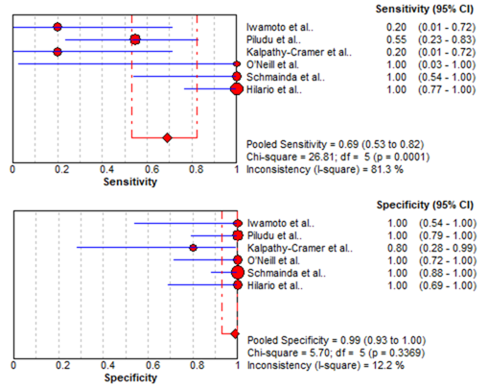
Figure 2 Sensitivity and specificity of dynamic contrast-enhanced magnetic resonance imaging and dynamic susceptibility contrast magnetic resonance imaging in the evaluation of response to antiangiogenic therapy in recurrent gliomas.

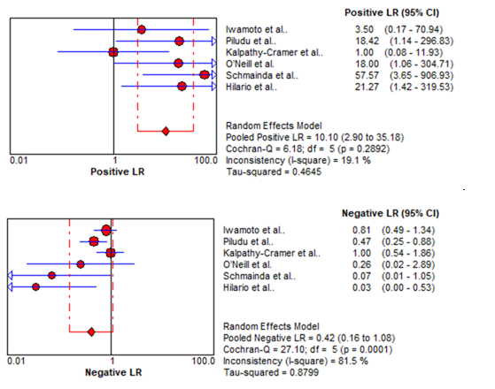
Figure 3 Likelihood ratio + and likelihood ratio - of dynamic contrast-enhanced magnetic resonance imaging and dynamic susceptibility contrast magnetic resonance imaging in the evaluation of response to antiangiogenic therapy in recurrent gliomas.

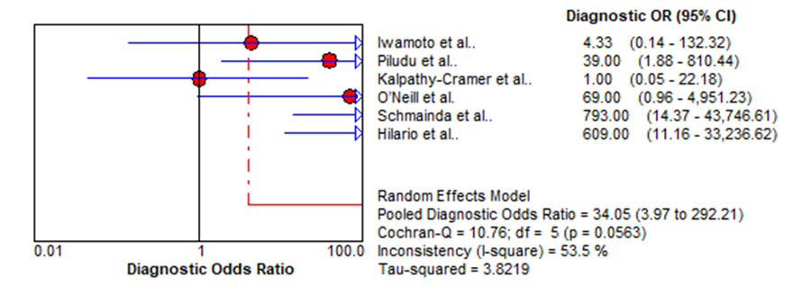
Figure 4 Diagnostic odds ratio of dynamic contrast-enhanced magnetic resonance imaging and dynamic susceptibility contrast magnetic resonance imaging in the evaluation of response to antiangiogenic therapy in recurrent gliomas.

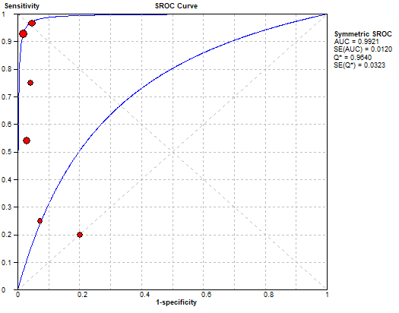
Figure 5 Summary receiver operating characteristic curve for dynamic contrast-enhanced magnetic resonance imaging and dynamic susceptibility contrast magnetic resonance imaging. Solid circle represents each study in the meta-analysis, and the circle size indicates the study size. SROC: Summary receiver operating characteristic.

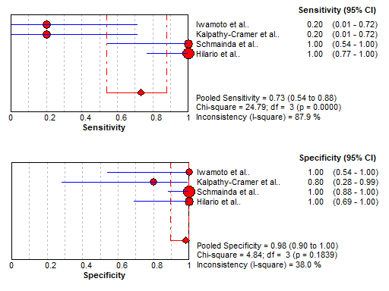
Figure 6 Sensitivity and specificity of dynamic susceptibility contrast magnetic resonance imaging in the evaluation of response to antiangiogenic therapy in recurrent gliomas.

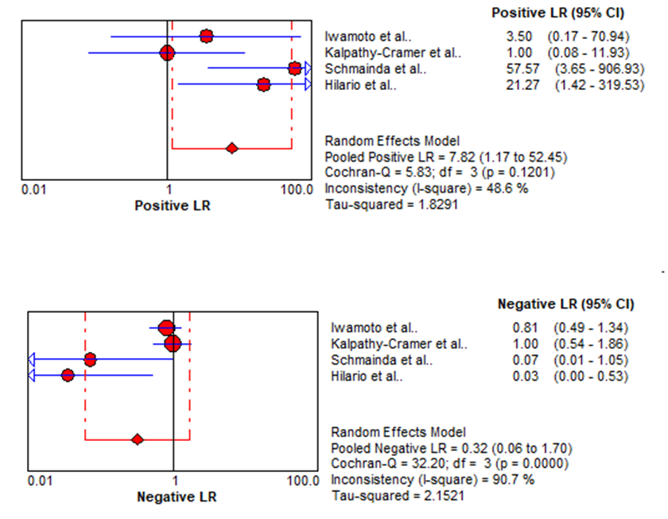
Figure 7 Likelihood ratio + and likelihood ratio - of dynamic susceptibility contrast magnetic resonance imaging in the evaluation of response to antiangiogenic therapy in recurrent gliomas.

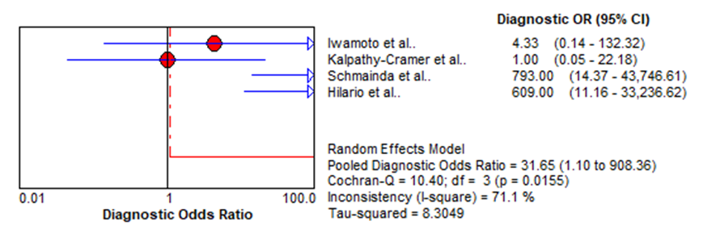
Figure 8 Diagnostic odds ratio of dynamic susceptibility contrast magnetic resonance imaging in the evaluation of response to antiangiogenic therapy in recurrent gliomas.

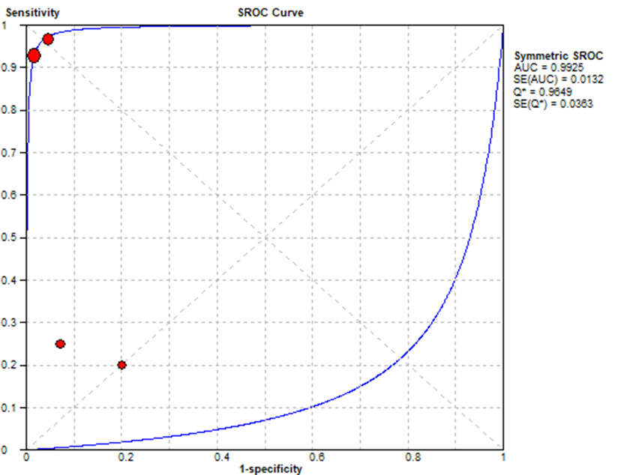
Figure 9 Summary receiver operating characteristic curve for dynamic susceptibility contrast magnetic resonance imaging. SROC: Summary receiver operating characteristic.

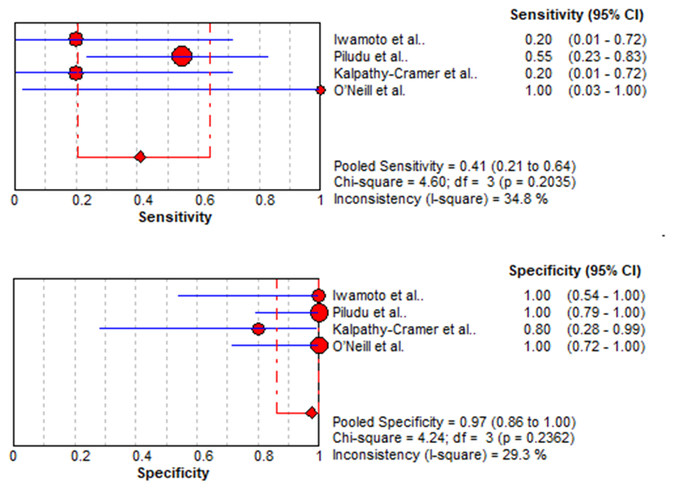
Figure 10 Sensitivity and specificity of dynamic contrast-enhanced magnetic resonance imaging in the evaluation of response to antiangiogenic therapy in gliomas.

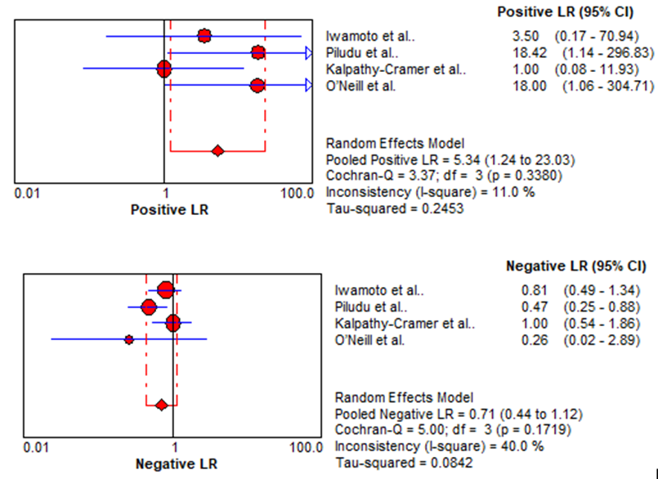
Figure 11 Likelihood ratio + and likelihood ratio - of dynamic contrast-enhanced magnetic resonance imaging in the evaluation of response to antiangiogenic therapy in recurrent gliomas.

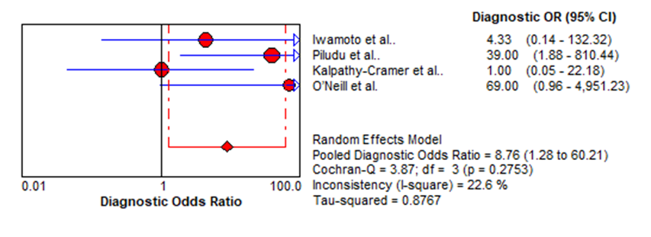
Figure 12 Diagnostic odds ratio of dynamic contrast-enhanced magnetic resonance imaging in the evaluation of response to antiangiogenic therapy in recurrent gliomas.

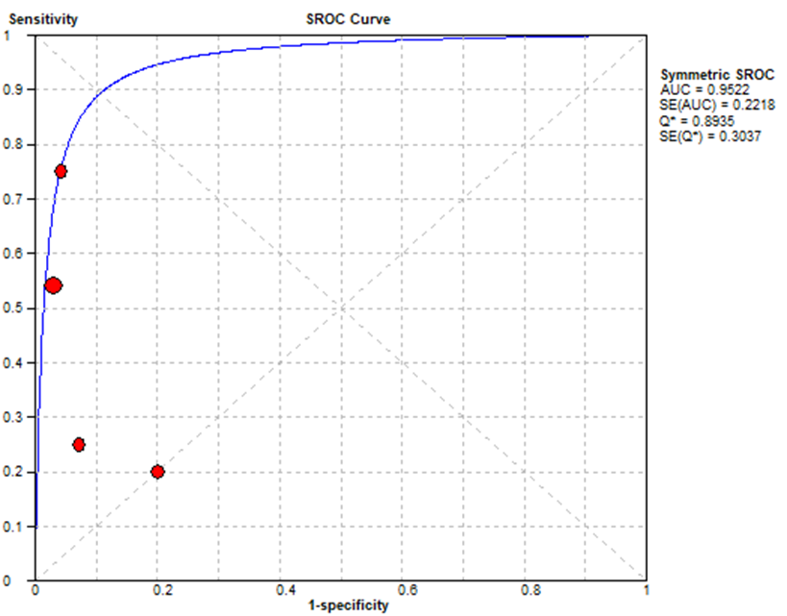
Figure 13 Summary receiver operating characteristic curve for dynamic contrast-enhanced magnetic resonance imaging. SROC: Summary receiver operating characteristic.

Table 1 Quality assessment of the included studies
Study | Risk of bias |  |  |  | Applicability concerns
 | Patient  selection | Index  test | Reference  standard | Flow and timing | Patient  selection |  | Index  test | Reference  standard
Iwamoto et al^{[29]}, 2010 | L | U | H | L | L | L |  | L
Piludu et al^{[30]}, 2015 | L | U | U | L | L | L |  | L
Kalpathy-Cramer et al^{[31]}, 2017 | L | U | U | L | L | L |  | L
O’Neill et al^{[32]}, 2016 | L | U | H | L | L | L |  | L
Schmainda et al^{[4]}, 2014 | L | U | U | L | L | L |  | L
Hilario et al^{[33]}, 2016 | L | U | U | L | L | L |  | L
L: Low risk; U: Unclear risk; H: High risk.

Table 2 The basic characteristics of the included studies | _{TN} | ₄ | ₁₆ | ₄ | ₁₁ | ₃₀ | ₁₀
 | _{FN} | ₆ | ₅ | ₄ | ₀ | ₀ | ₀
 | _{FP} | ₀ | ₀ | ₁ | ₀ | ₀ | ₀
 | _{TP} | ₁ | ₆ | ₁ | ₁ | ₆ | ₁₄
 | _{Standard reference} | Macdonald criteria RANO criteria | _{RANO criteria} | _{RANO criteria} | _{Macdonald criteria} | Macdonald criteria RANO criteria | _{RANO criteria}
 | _{Clinical question} | _{DSC and DCE vs response} | _{DCE vs response} | _{DSC and DCE vs response} | _{DCE vs response} | _{DSC vs response} | _{DSC vs response}
 | _{Anti-angiogenic treatment} | _{Pazopanib} | _{Bevacizumab} | _{Tivozanib} | _{VEGF Trap} | _{Bevacizumab} | _{Bevacizumab}
 | _{MR}  _{scanner}  _{tesla} | _{NR} | _{3.0T} | _{3.0T} | _{1.5T} | _{1.5T or 3.0T} | _{1.5T}
 | _{Imaging biomarkers} | _{Ktrans, rCBV} | _{nIAUGC, Ktrans} | _{Ktrans, rCBV, rCBF} | _{Ktrans, Ve} | _{rCBV, stdrCBV} | _{Leakage volume (CBV-LCCBV)}
 | _{Imaging modality} | _{DSC, DCE} | _{DCE} | _{DSC, DCE} | _{DCE} | _{DSC} | _{DSC}
 | _{Study design} | _{Prospective} | _{Prospective} | _{Prospective} | _{Prospective} | _{Retro-spective} | _{Retro-spective}
 | _{Median age} | ₅₃ ₍₂₉₋₇₃₎ | ₅₄ ₍₃₃₋₇₇₎ | ₆₂ ₍₅₁₋₇₄₎ | _{NR} | ₃₄ ₍₃₀₋₆₈₎ | _{52.5 (31-74)}
 | _{patientsnumber} | ₁₁ | ₂₇ | ₁₀ | ₁₂ | ₃₆ | ₂₄
 | _{Country} | _{USA} | _{Germany} | _{USA} | _{USA} | _{USA} | _{Spain}
 | _{Studies} | _{Iwamoto et al}^{[29]}_{, 2010} | _{Piludu et al}^{[30]}_{, 2015} | _{Kalpathy-Cramer et al}^{[31]}, ₂₀₁₇ | _{O’Neill et al}^{[32]}_{, 2016} | _{Schmainda et al}^{[4]}_{, 2014} | _{Hilario et al}^{[33]}_{, 2016}
TP: True positive; FP: False positive; TN: True negative; FN: False negative; DCE: dynamic contrast-enhanced; DSC: Dynamic susceptibility.

Table 3 Clinical responses of gliomas to antiangiogenic treatments
Study | Patient number | RANO criteria |  |  |  | Macdonald criteria
 |  | Responders |  | Non-responders |  | Responders |  | Non-responders
 |  | CR | PR | SD | PD | CR | PR | SD | PD
O’Neill et al^{[32]}, 2016 | 12 | - | - | - | - | 0 | 1 | 0 | 11
Piludu et al^{[30]}, 2015 | 27 | 0 | 6 | 5 | 16 | - | - | - | -
Schmainda et al^{[4]}, 2014 | 36 | 0 | 6 | 0 | 30 | - | - | - | -
Iwamoto et al^{[29]}, 2010 | 11 | - | - | - | - | 0 | 1 | 6 | 4
Hilario et al^{[33]}, 2016 | 24 | 0 | 14 | 0 | 10 | - | - | - | -
Kalpathy-Cramer et al^{[31]}, 2017 | 10 | 1 | 1 | 4 | 4 | - | - | - | -
CR: Complete response; PR: Partial response; SD: Stable disease; PD: Progressive disease.
*Response as defined using the Macdonald criteria and Response Assessment in Neuro-Oncology (RANO) working group guidelines

Table 4 True positive, false positive, true negative, and false negative as well as the sensitivity, specificity, likelihood ratio, and diagnostic odds ratio for the meta-analysis of antiangiogenic treatment evaluation
Study | TP | FP | FN | TN | Sensitivity  (95%CI) | Specificity  (95%CI) | LR+  (95%CI) | LR-  (95%CI) | DOR  (95%CI)
Iwamoto et al^{[29]}, 2010 | 1 | 0 | 4 | 6 | 0.2 (0.01-0.72) | 1 (0.54-1) | 3.5 (0.17-70.94) | 0.81 (0.49-1.340) | 4.33 (0.14-132.32)
Piludu et al^{[30]}, 2015 | 6 | 0 | 5 | 16 | 0.55 (0.23-0.83) | 1 (0.79-1) | 18.42 (1.14-296.83) | 0.47 (0.25-0.880 | 39 (1.88-810.44)
Kalpathy-Cramer et al^{[31]}, 2017 | 1 | 1 | 4 | 4 | 0.2 (0.01-0.72) | 0.8 (0.28-0.99) | 1 (0.08-11.93) | 1 (0.54-1.86) | 1 (0.05-22.18)
O’Neill et al^{[32]}, 2016 | 1 | 0 | 0 | 11 | 1 (0.03-1) | 1 (0.72-1) | 18 (1.06-304.71) | 0.26 (0.02-2.89) | 69 (0.96-4951.23)
Schmainda et al^{[4]}, 2014 | 6 | 0 | 0 | 30 | 1 (0.54-1) | 1 (0.88-1) | 57.57 (3.65-906.93) | 0.07 (0.01-1.05) | 793 (14.37-43,746.61)
Hilario et al^{[33]}, 2016 | 14 | 0 | 0 | 10 | 1 (0.77-1) | 1 (0.69-1) | 21.27 (1.42-319.53) | 0.03 (0-0.53) | 609 (911.16-33,236.62)
Pooled results | 29 | 1 | 13 | 77 | 0.69 (0.53-0.82) | 0.99 (0.93-1) | 12.84 (4.54-36.28) | 0.35 (0.22-0.53) | 24.44 (7.19-83.06)
Heterogeneity  Test |  |  |  |  | I² = 81.30%  P = 0.0001 | I² = 12.2%)  P = 0.3369 | I² = 19.1%  P = 0.2892 | I² = 81.5%  P = 0.0001 | I² = 53.5%  P = 0.0563
TP: True positive; FP: False positive; TN: True negative; FN: False negative; LR+: Positive likelihood ratio; LR–: Negative likelihood ratio; DOR: Diagnostic odds ratio; CI: Confidence interval.

