Name of Journal: World Journal of Clinical Cases
Manuscript NO: 63725
Manuscript Type: CASE REPORT

Diffuse xanthoma in early esophageal cancer: A case report

Yang XY et al. Diffuse xanthoma concurrent with esophageal cancer

Xiao-Yun Yang, Kuang-I Fu, Yan-Ping Chen, Zhen-Wei Chen, Jing Ding

Xiao-Yun Yang, Yan-Ping Chen, Jing Ding, Department of Gastroenterology and Hepatology, The Affiliated Jinhua Hospital, Zhejiang University School of Medicine, Jinhua 321000, Zhejiang Province, China

Kuang-I Fu, Department of Endoscopy, Kanma Memorial Hospital, Tokyo 325-0046, Japan

Zhen-Wei Chen, Department of Pathology, The Affiliated Jinhua Hospital, Zhejiang University School of Medicine, Jinhua 321000, Zhejiang Province, China

Author contributions: Yang XY was the patient’s attending physician and was responsible for collecting the medical history, performing magnifying endoscopy, reviewing the literature, and drafting the manuscript; Fu KI analyzed and interpreted the endoscopic findings and contributed to manuscript drafting; Chen YP performed the endoscopic submucosal dissection for the patient; Chen ZW was the pathologist who gave the pathological results; Ding J reviewed the literature and contributed to revising the manuscript; all authors issued the final approval for the version to be submitted.

Supported by the Basic Public Welfare Research Program of Zhejiang Province, China, No. LGF19H160022.

Corresponding author: Jing Ding, MD, Associate Professor, Chief Physician, Department of Gastroenterology and Hepatology, The Affiliated Jinhua Hospital, Zhejiang University School of Medicine, No. 365 Renmin Road, Jinhua 321000, Zhejiang Province, China. watbrooker@163.com

Received: February 8, 2021
Revised: April 9, 2021
Accepted: May 8, 2021
Published online: July 6, 2021

Abstract
BACKGROUND
Gastrointestinal xanthomas are asymptomatic and infrequent non-neoplastic lesions that commonly occur in the stomach with Helicobacter pylori-associated gastritis and rarely in the esophagus. To date, there have been no reports of esophageal xanthoma combined with esophageal cancer. Herein, we present the first case in the literature of a diffuse xanthoma complicated with early esophageal cancer. Moreover, this combination makes the endoscopic diagnosis difficult if it is not in mind.

CASE SUMMARY
A 68-year-old man visited our department with a 2-mo history of epigastric discomfort. He underwent surgery for gastric cancer 6 years ago. Esophagogastroduodenoscopy showed a semi-circumferential irregular yellowish-colored and granular lesion in the esophagus (30-35 cm from the incisors). Using magnifying endoscopy with narrow band imaging, aggregated minute and yellowish-colored spots with tortuous microvessels on the surface were observed, and background coloration was clearly seen in the lesion. As endoscopic biopsy suggested a histologically high-grade dysplasia; the lesion was completely resected en bloc by endoscopic submucosal dissection (ESD). The resected specimen was confirmed to be a squamous cell carcinoma in situ with extensive foamy cells in the superficial mucosal layer. Immunohistochemically, the observed foamy cells were strongly positive for CD68, which is characteristic of xanthoma. The clinical course was favorable, and no recurrence was observed 2 years and 7 mo after ESD.

CONCLUSION
Diffuse xanthoma concurrent with early esophageal cancer is extremely rare. The characteristic endoscopic features may assist endoscopists in diagnosing similar lesions.

Key Words: Esophageal xanthoma; Early esophageal cancer; Magnifying endoscopy; Endoscopic submucosal dissection; Case report

©The Author(s) 2021. Published by Baishideng Publishing Group Inc. All rights reserved.

Yang XY, Fu KI, Chen YP, Chen ZW, Ding J. Diffuse xanthoma in early esophageal cancer: A case report. World J Clin Cases 2021; 9(19): 5259-5265 URL: https://www.wjgnet.com/2307-8960/full/v9/i19/5259.htm DOI: https://dx.doi.org/10.12998/wjcc.v9.i19.5259

Core Tip: Esophageal xanthomas are uncommon, non-neoplastic lesions characterized by the accumulation of foamy histiocytes. Herein, we present the first case of early esophageal cancer covered by xanthomas, diffusely and superficially treated by endoscopic submucosal dissection. Knowing these characteristic endoscopic features can help endoscopists reach a correct diagnosis for appropriate treatment.

INTRODUCTION
Xanthomas are considered to be asymptomatic, non-neoplastic lesions that can be found anywhere along the gastrointestinal tract, commonly in the stomach and colon, and rarely in the esophagus. Endoscopically, they are small (1-2 mm in size), single or multiple, yellow, orange, or white well-demarcated sessile macules with irregular outlines that rarely exceed 5 mm^{[1,2]}. Diffuse xanthoma complicated by early esophageal cancer has never been reported in the literature. We herein present the first case treated by endoscopic submucosal dissection (ESD).

CASE PRESENTATION
Chief complaints
A 68-year-old man was admitted with a 2-mo history of epigastric discomfort.

History of present illness
The patient presented with a complaint of intermittent, dull, and non-radiating epigastric pain. No associated nausea, vomiting, melena, or loss of body mass was observed.

History of past illness
The patient underwent distal gastrectomy for gastric cancer 6 years ago. Histological analysis revealed a moderately poorly differentiated adenocarcinoma, staged at pT4aN2M0 IIIB. The patient recovered well after adjuvant chemotherapy, and he was followed regularly. No evidence of local recurrence or distant metastasis was identified 6 years after surgery. His history included hypertension and type 2 diabetes mellitus controlled with medications for more than 10 years.

Personal and family history
The patient reported consuming alcohol daily and smoking one pack of cigarettes per day for 42 years until he was 60 years old. His family history was negative for cancers.

Physical examination
The patient’s temperature was 36.5 °C, heart rate was 63 bpm, respiratory rate was 18 breaths per minute, and blood pressure was 141/93 mmHg. The physical examination was unremarkable.

Laboratory examinations
The laboratory work-up showed that the levels of the tumor markers CA19-9, CA-125, carcinoembryonic antigen, squamous cell carcinoma antigen, and alpha-fetoprotein were in the normal range. Other biochemistry test results were also within normal limits.

Imaging examinations
Abdominal computed tomography revealed postoperative changes. Chest computed tomography and cardiac ultrasound were normal. No nodal involvement or distant metastasis was identified.

Further diagnostic work-up
Esophagogastroduodenoscopy showed a semi-circumferential, irregular, yellowish-colored and granular lesion in the esophagus (30-35 cm from the incisors) (Figure 1A). Magnifying endoscopy with narrow band imaging (NBI) revealed aggregated minute yellowish spots with tortuous microvessels inside (Figure 1B). Moreover, type B1 intrapapillary capillary loops (IPCLs) and intervascular background coloration were observed around the yellow spots (Figure 1C). Lugo's iodine staining (1%) demonstrated a well-demarcated, irregular, unstained lesion (Figure 1D). As endoscopic biopsy suggested a high-grade dysplasia with the accumulation of foamy macrophages histologically, the lesion was diagnosed as an early esophageal cancer with esophageal xanthomas.

FINAL DIAGNOSIS
The final preoperative diagnosis was diffuse esophageal xanthoma complicated with early esophageal cancer.

TREATMENT
The lesion was completely resected en bloc by ESD (Figure 2). Oral prednisolone was administered at a dose of 30 mg/d on the third day after ESD. The dose was then gradually tapered in decrements of 5 mg/d every 2 wk for 1 mo followed by decrements of 5 mg/d every week for the next 4 wk. Steroids were discontinued after 8 wk.

OUTCOME AND FOLLOW-UP
Histologically, the resected specimen was confirmed to be a squamous cell carcinoma in situ in which extensive foam cells were seen in the superficial mucosal layer (Figure 3). Immunohistochemical staining showed that the lesion was positive for P53 and negative for P16 (Figure 4A and B). The Ki-67 index was 90% (Figure 4C). The observed foamy cells were strongly positive for CD68, identical to a histiocytic cell origin, which is characteristic of xanthoma (Figure 4D). Postoperatively, the patient recovered well and was discharged from the hospital on day 5. There were no complaints of dysphagia following ESD. On follow-up endoscopy, which was scheduled at 3, 6, 12 and 24 mo after ESD, there was no postprocedural esophageal stricture, and neither recurrent nor metachronous lesions were found (Figure 5).

DISCUSSION
Gastrointestinal xanthomas are asymptomatic and infrequent non-neoplastic lesions characterized by the accumulation of foamy cells in the lamina propria^{[3]}. They occur more frequently in the stomach with Helicobacter pylori-associated gastritis, and are rarely seen in the intestine or esophagus. The endoscopic findings of esophageal xanthomas have been reported as yellowish granular spots, yellowish elevated lesions, yellow-white colored plaques, or yellow verruciform lesions, measuring from 2 to 20 mm (usually ≤ 5 mm)^{[4-8]}. Diffuse and extensive esophageal xanthoma in a patient is extremely rare. Gastrointestinal xanthoma is considered benign without clinical significance. However, it can be missed unless proven by a negative biopsy^{[2]}. Therefore, endoscopic biopsy is recommended for such yellowish elevated lesions to distinguish ectopic sebaceous glands, carcinoid tumors, granular cell tumors, malignant lymphomas, or papillomas^{[1,3,9,10]}. Histologically, the accumulation of foamy histiocytes of xanthoma could be a clue for differential diagnosis. Positive immunohistochemical staining for CD68, which indicates a histiocytic origin, is another characteristic finding of xanthoma^{[1]}.
Although the etiology of esophageal xanthoma remains unknown, it was reported to be derived from focal mucosal damage, in which lipids from damaged cell membranes are captured by interstitial histiocytes^{[11]}. This may explain why they occur less frequently in the esophagus than in the stomach because the esophageal mucosa can better tolerate mucosal injury^{[12]}. Xanthoma may also be associated with conditions such as history of radiotherapy or chemotherapy, infection, and biliary reflux^{[3,4,10]}. To date, no apparent relationship between esophageal xanthoma and hyperlipidemia has been reported^{[13]}. To the best of our knowledge, there have been no reports of esophageal xanthoma combined with esophageal malignancy. A history of subtotal gastrectomy and adjuvant chemotherapy may be related to the occurrence of diffuse xanthoma of the esophagus in our patient. Furthermore, the patient's long-term history of smoking together with heavy alcohol consumption could be a risk factor for concurrent esophageal cancer.
Changes in IPCLs, seen in magnifying NBI with the endoscopic classification of the Japan Esophageal Society, have been demonstrated to be simple and useful for differentiating whether identified lesions are neoplastic, and the prediction of the depth of invasion of superficial esophageal squamous cell carcinoma (SESCC) was also available^{[14]}. Type A, lacking severe irregularity, corresponds to non-cancerous lesions; type B exhibits severe irregularity, identical to neoplastic lesions. Type B IPCLs were sub-classified into B1, B2, and B3 for T1a-EP or T1a-LPM, T1a-MM or T1b-SM1, and T1b-SM2 tumors, respectively^{[14]}. In previous reports, magnifying endoscopy revealed esophageal xanthoma lesions as areas with aggregated minute yellowish spots with tortuous micro-vessels inside^{[15,16]}. In addition to these reported characteristics, type B1 IPCLs and intervascular background coloration were also observed in our case. Intervascular background coloration has been reported to be useful for predicting the histology of high-grade intraepithelial neoplasia and invasive SESCC^{[17,18]}. Type B1 tumors consist of abnormal IPCLs with a conserved loop-like formation, which is considered to correspond to T1a-EP or T1a-LPM^{[14]}. These endoscopic findings correspond well with the histological findings in this case. As mentioned above, despite the fact that esophageal xanthomas are usually considered to be uncommon non-neoplastic lesions, determination of these lesions is imperative since they might be concurrent with malignancy. In addition, the characteristic endoscopic findings of our case may assist endoscopists in diagnosing similar lesions.

CONCLUSION
We report the first case of diffuse xanthoma complicated with early esophageal cancer. The characteristic endoscopic findings of xanthomas and esophageal cancer seen in image-enhanced endoscopy can help endoscopists to reach the correct diagnosis for appropriate treatment if this rare combination of disease is kept in mind.

ACKNOWLEDGEMENTS
The authors thank Dr. Qian LJ at Department of Pathology, The Affiliated Jinhua Hospital, Zhejiang University School of Medicine for providing some of the immunohistochemical findings from the resected specimen.

REFERENCES
1 Hirokawa M, Takenaka R, Takahashi A, Sugihara K, Wada H, Tashiro T, Horiguchi H, Wakatsuki S, Sano T. Esophageal xanthoma: report of two cases and a review of the literature. J Gastroenterol Hepatol 2003; 18: 1105-1108 [PMID: 12911673 DOI: 10.1046/j.1440-1746.2003.02844.x]
2 Dirweesh A, Khan M, Bukhari S, Rimmer C, Shmuts R. Nodular Esophageal Xanthoma: A Case Report and Review of the Literature. Case Rep Gastrointest Med 2017; 2017: 1503967 [PMID: 28487782 DOI: 10.1155/2017/1503967]
3 Vimala R, Ananthalakshmi V, Murthy M, Shankar TR, Jayanthi V. Xanthelasma of esophagus and stomach. Indian J Gastroenterol 2000; 19: 135 [PMID: 10918723]
4 Salamanca J, Alemany I, Sosa G, Pinedo F, Hernando S, Martín-Acosta P. Esophageal verruciform xanthoma following radiotherapy. Gastroenterol Hepatol 2012; 35: 317-320 [PMID: 22285788 DOI: 10.1016/j.gastrohep.2011.12.009]
5 Hamada K, Yamasaki Y, Kubota JI, Okada H. Yellowish lesions in the oesophagus. Gut 2019; 68: 39-158 [PMID: 29259070 DOI: 10.1136/gutjnl-2017-315700]
6 Licci S, Campo SM, Ventura P. Verruciform xanthoma of the esophagus: an uncommon entity in an unusual site. Endoscopy 2010; 42 Suppl 2: E330 [PMID: 21170833 DOI: 10.1055/s-0030-1255944]
7 Becheanu G, Dumbrava M, Arbanas T, Diculescu M, Hoyeau-Idrissi N, Fléjou JF. Esophageal xanthoma--report of two new cases and review of the literature. J Gastrointestin Liver Dis 2011; 20: 431-433 [PMID: 22187711]
8 Bang CS, Kim YS, Baik GH, Han SH. Xanthoma of the esophagus. Clin Endosc 2014; 47: 358-361 [PMID: 25133126 DOI: 10.5946/ce.2014.47.4.358]
9 Tsai SJ, Lin CC, Chang CW, Hung CY, Shieh TY, Wang HY, Shih SC, Chen MJ. Benign esophageal lesions: endoscopic and pathologic features. World J Gastroenterol 2015; 21: 1091-1098 [PMID: 25632181 DOI: 10.3748/wjg.v21.i4.1091]
10 Herrera-Goepfert R, Lizano-Soberón M, García-Perales M. Verruciform xanthoma of the esophagus. Hum Pathol 2003; 34: 814-815 [PMID: 14506645 DOI: 10.1016/s0046-8177(03)00236-3]
11 Odze R, Antonioli D, Shocket D, Noble-Topham S, Goldman H, Upton M. Esophageal squamous papillomas. A clinicopathologic study of 38 lesions and analysis for human papillomavirus by the polymerase chain reaction. Am J Surg Pathol 1993; 17: 803-812 [PMID: 8393303 DOI: 10.1097/00000478-199308000-00005]
12 Gencosmanoglu R, Sen-Oran E, Kurtkaya-Yapicier O, Tozun N. Xanthelasmas of the upper gastrointestinal tract. J Gastroenterol 2004; 39: 215-219 [PMID: 15064997 DOI: 10.1007/s00535-003-1288-3]
13 Díaz Del Arco C, Álvarez Sánchez Á, Fernández Aceñero MJ. Non-gastric Gastrointestinal Xanthomas: Case Series and Literature Review. J Gastrointestin Liver Dis 2016; 25: 389-394 [PMID: 27689205]
14 Oyama T, Inoue H, Arima M, Momma K, Omori T, Ishihara R, Hirasawa D, Takeuchi M, Tomori A, Goda K. Prediction of the invasion depth of superficial squamous cell carcinoma based on microvessel morphology: magnifying endoscopic classification of the Japan Esophageal Society. Esophagus 2017; 14: 105-112 [PMID: 28386209 DOI: 10.1007/s10388-016-0527-7]
15 Hamada K, Uedo N, Kubo C, Tomita Y, Ishihara R, Yamasaki Y, Omori M, Arao M, Suzuki S, Iwatsubo T, Kato M, Tonai Y, Shichijo S, Matsuura N, Nakahira H, Kanesaka T, Yamamoto S, Akasaka T, Hanaoka N, Takeuchi Y, Higashino K, Okada H, Iishi H. Endoscopic appearance of esophageal xanthoma. Endosc Int Open 2019; 7: E1214-E1220 [PMID: 31579702 DOI: 10.1055/a-0966-8544]
16 Mori H, Kato M, Uraoka T. A Case of Esophageal Xanthoma with Epithelial Reactive Inflammation with a Characteristic Finding of Narrow-Band Imaging Magnifying Endoscopy. Dig Dis 2020; 38: 85-88 [PMID: 31280259 DOI: 10.1159/000501448]
17 Minami H, Inoue H, Ikeda H, Satodate H, Hamatani S, Nakao K, Kudo SE. Usefulness of Background Coloration in Detection of Esophago-Pharyngeal Lesions Using NBI Magnification. Gastroenterol Res Pract 2012; 2012: 529782 [PMID: 22927837 DOI: 10.1155/2012/529782]
18 Kanzaki H, Ishihara R, Ishiguro S, Nagai K, Matsui F, Yamashina T, Ohta T, Yamamoto S, Hanaoka N, Hanafusa M, Takeuchi Y, Higashino K, Uedo N, Iishi H, Tomita Y. Histological features responsible for brownish epithelium in squamous neoplasia of the esophagus by narrow band imaging. J Gastroenterol Hepatol 2013; 28: 274-278 [PMID: 23190157 DOI: 10.1111/jgh.12059]

Footnotes
Informed consent statement: Informed written consent was obtained from the patient for publication of this report and any accompanying images.

Conflict-of-interest statement: The authors declare that they have no conflict of interest to report.

CARE Checklist (2016) statement: The authors have read the CARE Checklist (2016), and the manuscript was prepared according to the CARE Checklist (2016).

Open-Access: This article is an open-access article that was selected by an in-house editor and fully peer-reviewed by external reviewers. It is distributed in accordance with the Creative Commons Attribution NonCommercial (CC BY-NC 4.0) license, which permits others to distribute, remix, adapt, build upon this work non-commercially, and license their derivative works on different terms, provided the original work is properly cited and the use is non-commercial. See: http://creativecommons.org/Licenses/by-nc/4.0/

Manuscript source: Unsolicited manuscript

Peer-review started: February 8, 2021
First decision: March 28, 2021
Article in press: May 8, 2021

Specialty type: Gastroenterology and hepatology
Country/Territory of origin: China
Peer-review report’s scientific quality classification
Grade A (Excellent): 0
Grade B (Very good): 0
Grade C (Good): C
Grade D (Fair): D, D
Grade E (Poor): 0

P-Reviewer: Endo S, Kinami S S-Editor: Zhang H L-Editor: Wang TQ P-Editor: Xing YX
Figure Legends
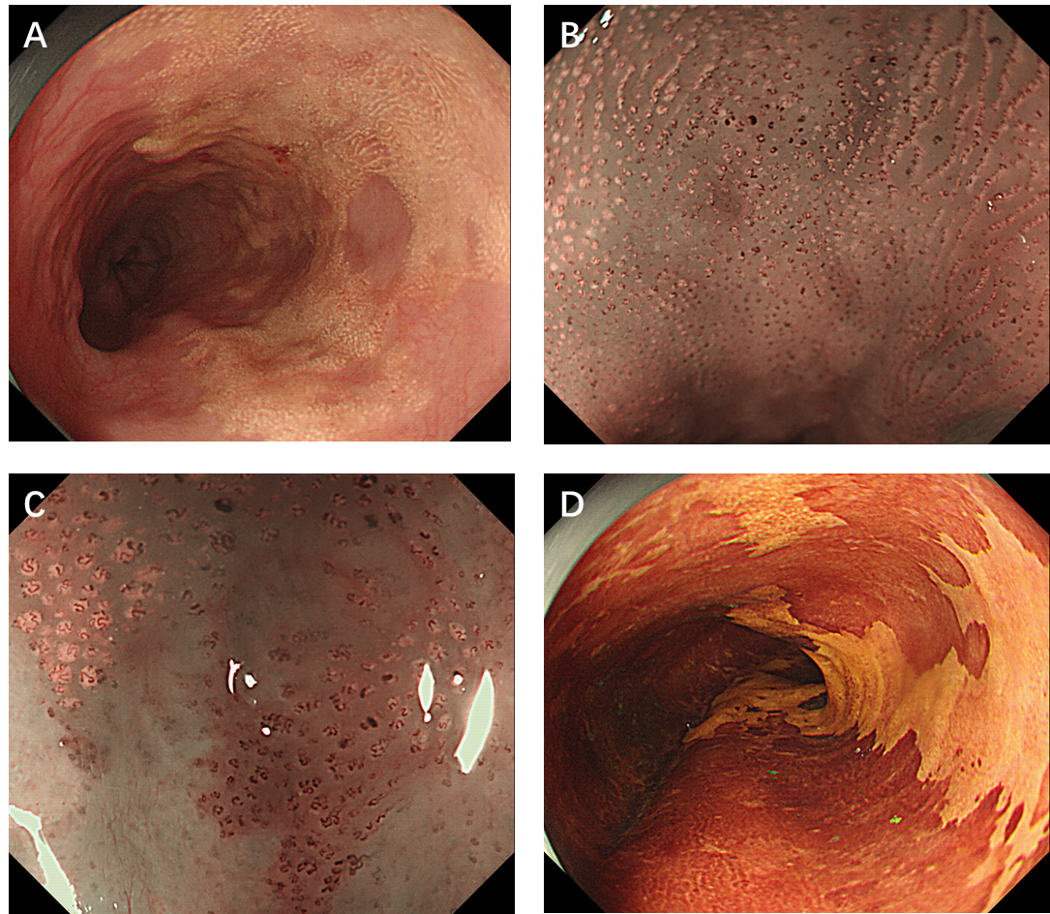
Figure 1 Endoscopic illustrations (GIF-H260Z, Olympus). A: White light endoscopy showed a semi-circumferential, irregular, yellowish-colored, and granular lesion localized in the middle and lower esophagus (white arrow); B: Narrow band imaging endoscopy revealed aggregation of minute yellowish spots with tortuous microvessels inside; C: Type B1 intrapapillary capillary loops were identified by magnifying endoscopy in the region around the yellow spots, and the lesion was positive for background coloration (white arrow); D: Lugol's iodine staining revealed a well-demarcated unstained lesion (white arrow).

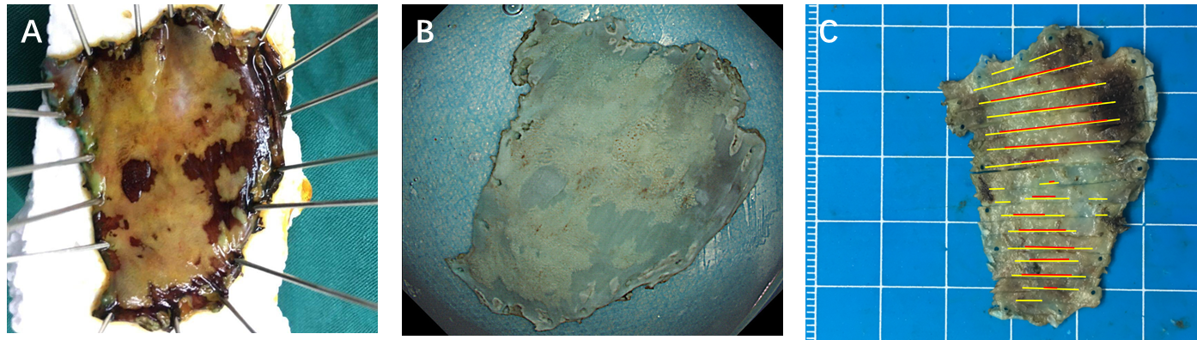
Figure 2 Macroscopic findings. A: Lugol's iodine staining of the specimen revealed that the tumor was removed en bloc by endoscopic submucosal dissection; B: Diffuse yellowish-colored lesion was recognized in this fixed specimen (white arrow); C: The size of the specimen is 45 × 33 mm. The yellow line indicates the esophageal xanthoma. The red line demonstrates squamous cell carcinoma in the superficial mucosal layer.
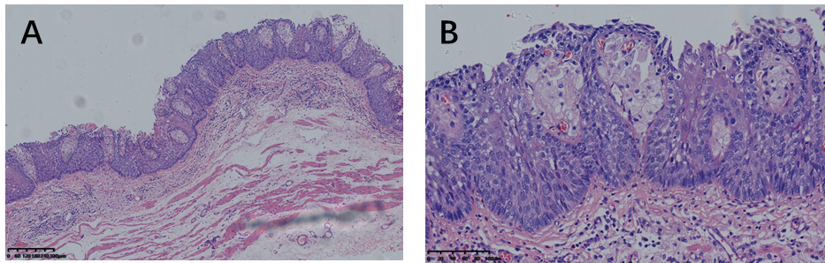
Figure 3 Histopathological findings. Hematoxylin and eosin staining of the lesion showed squamous cell carcinoma in situ in which extensive foam cells were seen in the superficial mucosal layer. A: Magnification × 5; B: Magnification × 20.
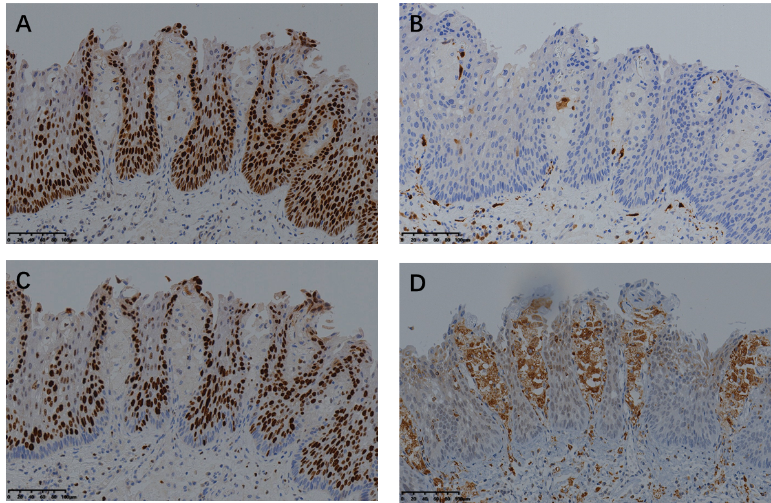
Figure 4 Immunohistochemical findings. A and B: Immunohistochemical staining showed that the regions of squamous cell carcinoma were positive for P53 and negative for P16 (× 20); C: The Ki-67 index was 90% (× 20); D: The observed foam cells were strongly positive for CD68 (× 20).
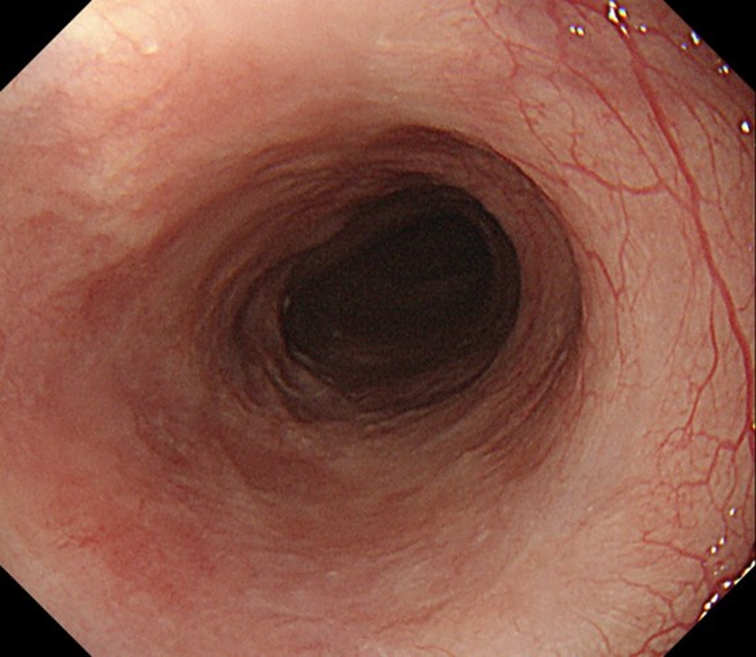
Figure 5 White light endoscopy showed no stricture and local recurrence 24 mo after endoscopic submucosal dissection.

Published by Baishideng Publishing Group Inc
7041 Koll Center Parkway, Suite 160, Pleasanton, CA 94566, USA
Telephone: +1-925-3991568
E-mail: bpgoffice@wjgnet.com
Help Desk: https://www.f6publishing.com/helpdesk
https://www.wjgnet.com

© 2021 Baishideng Publishing Group Inc. All rights reserved.

