Name of journal: World Journal of Gastroenterology
ESPS Manuscript NO: 16940
Manuscript Type: ORIGINAL ARTICLE

Observational Study
EUS-guided drainage of the pancreatic duct after unsuccessful EUS-ERP in patients with symptomatic obstruction and enlargement of the pancreatic duct

Will U et al. EUS-guided translumenal drainage of pancreatic duct – long-term results

Uwe Will, Andreas Reichel, Frank Fueldner, Frank Meyer

Uwe Will, Andreas Reichel, Frank Fueldner, Department of Internal Medicine III (Gastroenterology and Hepatology), Municipal Hospital (SRH Waldklinikum GmbH), 07548 Gera, Germany

Frank Meyer, Department of General, Abdominal and Vascular Surgery, University Hospital, 39104 Magdeburg, Germany

Author contributions: Will U, Reichel A, and Fueldner F designed and performed the research; Will U, Reichel A, Fueldner F and Meyer F analyzed and evaluated data; Will U, Meyer F wrote the paper; Meyer F proof-read the final version.

Open-Access: This article is an open-access article which was selected by an in-house editor and fully peer-reviewed by external reviewers. It is distributed in accordance with the Creative Commons Attribution Non Commercial (CC BY-NC 4.0) license, which permits others to distribute, remix, adapt, build upon this work non-commercially, and license their derivative works on different terms, provided the original work is properly cited and the use is non-commercial. See: http://creativecommons.org/licenses/by-nc/4.0/

Correspondence to: Uwe Will, MD, Head, Professor, Department of Internal Medicine III (Gastroenterology and Hepatology), Municipal Hospital (SRH Waldklinikum GmbH), Strasse des Friedens 122, 07548 Gera, Germany. uwe.will@wkg.srh.de
Telephone: +49-365-8282401
Fax: +49-365-8282402

Received: February 3, 2015
Peer-review started: February 6, 2015
First decision: April 13, 2015
Revised: June 17, 2015
Accepted: August 28, 2015
Article in press:
Published online:

Abstract
AIM: To investigate, in a representative number of patients, the feasibility, safety, and long-term clinical outcome of the novel technique of translumenal pancreatography with placement of a drain [endoscopic ultrasonography (EUS)-guided drainage of the pancreatic duct (EUPD)].

METHODS: From June 2002 to April 2014, all consecutive patients who underwent EUS-guided pancreatography and subsequent placement of a drain with symptomatic retention of fluid in the pancreatic duct after one or more previous unsuccessful attempts at endoscopic retrograde cannulation of the pancreatic were enrolled in this study to reflect daily practice and distinguishing three different approaches: (1) the EUS-endoscopic retrograde pancreatography (ERP) rendezvous technique; (2) EUS-guided drainage of the pancreatic duct; and (3) EUS-guided, internal antegrade drainage of the pancreatic duct.

RESULTS: Over the time period of the study, 111 interventions were performed in 94 patients (ERP failed in all of them) with the intention of carrying out EUS-guided transgastric pancreatography with subsequent drainage. The mean duration of the intervention was 21 (range, 15–69) min. Median patient age was 54 (range, 28–87) years; the sex ratio M:F was 60:34. In all 94 patients, puncture of the pancreatic duct including pancreatography was achieved (technical success rate, 100%). However, in 10 patients with altered anatomy after previous surgery drainage was not required because there was sufficient flow of the contrast agent through the anastomosis (in one patient, Histoacryl was injected into the pancreatic duct as a primary procedure because of DPTS). Successful placement of a drain at first attempt was achieved in 47 of 83 patients (56.6%). Of these, 26 patients underwent transgastric/transbulbar positioning of a stent, whereas in 21 drainage was performed through the papilla using the rendezvous technique. Of the 26 patients undergoing transgastric (retrograde) drainage, plastic prostheses were used in 11 and metal stents in 12. Three of the 26 patients received placement of a ring drain (antegrade internal drainage) because of anastomotic stenosis after a previous surgical intervention. Of the 21 patients with transpapillary drains, the majority (n = 19) received plastic prostheses; only 2 received metal stents (covered self-expanding metal stents). The median follow-up time in the 21 patients with transpapillary drainage was 28 (range, 1–79) mo, while that of the 26 patients with successful transgastric/transduodenal drainage was 9.5 (range, 1–82) mo. Clinical success, as indicated by reduced pain or absence of further pain after the EUS-guided intervention was achieved in 68/83 patients (81.9%); this number includes several patients who improved without drainage, but in whom manipulation of the access route obviously sufficed.

CONCLUSION: EUPD is a safe and feasible alternative approach to ERP, but it can only be performed by experienced interventional endoscopists/-sonographers in centers with great expertise in therapeutic EUS. EUPD deserves further systematic investigation and analysis in studies, possibly with a multicenter design, which needs to include an assessment of the subgroup of patients in whom this treatment is indicated before this novel therapeutic technique can be finally validated and recommended. For example, patients who have previously undergone GI surgery or those in whom the papilla cannot be reached endoscopically or catheterized due to severe changes caused by chronic pancreatitis may be, in particular, suited to EUPD.

Key words: Endoscopic ultrasonography; Endoscopic ultrasonography-guided transmural pancreatography; Endoscopic ultrasonography-guided drainage of the pancreatic duct; Prospective long-term single-center study; Technical success; Clinical success; Plastic prosthesis; Metal stent

© The Author(s) 2015. Published by Baishideng Publishing Group Inc. All rights reserved.

Core tip: Endoscopic ultrasonography (EUS)-guided drainage of the pancreatic duct (EUPD) can be considered a safe and feasible procedure for a selected group of patients (with regard to age, comorbidities, difficult anatomy after former surgical intervention, DPTS, persisting fistula postoperatively, patient denies further surgical intervention), and an alternative treatment of surgical intervention. Currently, EUPD is still an experimental clinical procedure and it should be performed only in experienced hands with great expertise in interventional endoscopy/EUS. Further studies are recommendable perhaps in a multi-center design to finally assess clinical value of EUPD and to determine general selection criteria of patients for the procedure as well as criteria for the technical/clinical success.

Will U, Reichel A, Fueldner F, Meyer F. EUS-guided drainage of the pancreatic duct after unsuccessful EUS-ERP in patients with symptomatic obstruction and enlargement of the pancreatic duct. World J Gastroenterol 2015; In press

INTRODUCTION
Pain is the most frequent symptom in patients with obstructed and enlarged pancreatic duct, and is associated with considerably reduced subjective well-being. Increased intraductal pressure is regarded as causing the signs, symptoms, and complaints, so the therapeutic response is based on attempting endoscopic transpapillary drainage or surgical intervention^{[1,2]}.
For patients with symptomatic obstruction and enlargement of the pancreatic duct, in whom pancreatic carcinoma can be excluded, or those with leakage from a postoperative pancreatic fistula, transpapillary endoscopic retrograde pancreatography (ERP) including placement of a drain has been established as the gold standard of treatment^{[3-9]}. In a certain proportion of these patients, the papilla of Vater (papilla) can be neither catheterized nor reached endoscopically. To be specific, the catheter cannot be introduced into the pancreatic duct via the major or minor papilla in patients with either chronic pancreatitis or pancreas divisum. Postoperatively, where the anatomy in the upper abdomen/gastrointestinal (GI) tract has been altered – e.g., after gastrectomy with Roux-en-Y reconstruction or a Kausch-Whipple procedure – the papilla or the anastomotic segment of a hepaticojejunostomy can no longer be reached, or cannot be easily reached via the conventional endoscopic route. Other considerations include patients with considerable perioperative risk factors, such as comorbidities, advanced age, and others, in whom recurrent invasive surgical interventions are necessarily associated with considerable morbidity and mortality. For these selected groups of patients, or for patients who refuse to undergo surgical intervention, endoscopic ultrasonography (EUS)-guided internal drainage of the pancreatic duct (EUPD) can be considered a novel alternative therapeutic approach^{[10-22]}.
The aim of this systematic single-center observational clinical study was to reflect on our own daily practice and analyze the indications, technical feasibility, safety and long-term clinical success of this novel interventional endoscopic technique in a representative number of patients. The primary endpoints of the study were the technical and clinical success rate. Secondary endpoint was the safety of the approach as characterized by the range and frequency of adverse events and by intervention-related mortality. In particular, we describe our own procedural experiences in comparison with published data from the literature. In addition, we discuss the advantages and disadvantages of the procedure and their relevance for routine clinical practice.

MATERIALS AND METHODS
Over a period of almost 12 years (June 2002 to April 2014), all consecutive patients with symptomatic retained pancreatic duct after previous unsuccessful ERP who underwent EUS-guided transgastric pancreatography were enrolled in this systematic clinical, single-center observational study with prospective data collection and retrospective evaluation. The indications for which EUS-guided transgastric pancreatography was carried out are listed in Table 1.
All interventions were performed by the same endoscopist/endosonographer (Will U).
For the procedure, the patient was positioned lying on the left side on a fluoroscopy table undergoing EUS with therapeutic longitudinal scanner (EG 3270 UK, Hitachi Ultraschall Berlin, Germany; GF-UCT 180, Olympus, Hamburg, Germany). Peri-interventionally, ceftriaxone 2 g was given iv The pancreatic duct was identified by EUS imaging and was punctured using a 19-G needle (Boston Scientific, Ratingen, Germany) via a transgastric or transbulbar route, using the shortest possible distance to minimize the potential for complications. Whenever possible, given the usually low amount of pancreatic fluid in the duct, a sample of pancreatic juice was obtained for routine cytological analysis (double check for pancreatic cancer) and microbiological study (for preparation of any antibiotic therapy required according to the resistogram in the presence of microbial colonization). After this, the pancreatic duct was imaged by the administration of contrast medium under fluoroscopy control (Figure 1). In addition, a 0.035-inch guide wire (Boston Scientific, Ratingen, Germany) was introduced into the pancreatic duct and advanced toward and through the papilla or anastomosis.
For EUS-guided drainage of the pancreatic duct, three options were tried:
EUS-ERP rendezvous technique: If the papilla could be reached endoscopically and the guide wire could be advanced toward and through the papilla from inside the ductal lumen, the echoendoscope was replaced by a duodenoscope. The guide wire was gripped and pulled out further, and then conventional ERP including EPT and placement of a stent was performed (Figure 1 A-D).

EUS-guided drainage of the pancreatic duct: If it was not possible to advance the guide wire toward or through the papilla, or if the papilla could not be reached using a duodenoscope (e.g., after a previous surgical intervention including Roux-en-Y reconstruction, Kausch-Whipple procedure, or a pylorus-preserving cephalic pancreatoduodenectomy), the guide wire was advanced into the pancreatic duct as far as possible. Via the guide wire, access to the pancreatic duct was created using Will’s high-frequency ring knife (MTW-Endoskopie, Wesel, Germany) (Figure 2) and the duct was dilated with a 6-mm dilatation balloon specific for the biliary tree (Boston Scientific, Ratingen, Germany). The puncture site and the direction and diameter of the pancreatic duct were the relevant criteria for deciding on the type of prosthesis that was finally placed. Correct positioning of the drain was checked endoscopically by observing the intragastric end of the stent, and regular outflow of contrast medium via the “pancreatointestinostomy” (pancreatointestinostomy or pancreatoduodenostomy) was checked fluoroscopically (Figure 3 A-D).

EUS-guided internal antegrade drainage of the pancreatic duct: If advancement of the guide wire through the stenosis succeeds but the papilla (or anastomosis) cannot be reached endoscopically, access is created using Will’s high-frequency ring knife (MTW-Endoskopie, Wesel, Germany). Using the ring knife, the stenotic segment can be reached and dilated with a balloon (6–12 mm). To keep the dilatation effect and further “conditioning” of the channel that has been created, pigtail drainage can be placed (Figure 4 A-D).
Implants available were double pigtail prostheses and straight plastic prostheses (diameter, 5 Fr to 10 Fr.; Amsterdam prosthesis, Medi-Globe, Achenmühle, Germany), covered self-expanding metal stents (cSEM, Boston Scientific, Ratingen, Germany), and AXIOSTM stents (Xlumena, Mountain View, California, USA) (diameter, 10–15 mm) available. On the 1st postinterventional day, transabdominal ultrasonography was performed to document correct stent location. Air within the pancreatic duct, reduction of the ductal diameter, and/or reduced secretion from the pancreatic fistula (in patients with a fistula) were interpreted as indicating technically successful drainage of the pancreatic duct.
All patients were followed up within 3 to 6 mo after the intervention – in particular, any new onset of clinical symptoms was assessed. The imaging criteria for adequate drainage were a smaller-diameter pancreatic duct and air within the duct.
Each patient gave written informed consent prior to the intervention. The study was performed according the recommendations of the 1964 Declaration of Helsinki for Biomedical Research and its later amendments, and according to the standards of the GCP and the guidelines of our hospital’s institutional review board.

RESULTS
From June 2002 to April 2014, 111 interventions were performed in 94 patients with the intention of carrying out EUS-guided transgastric pancreatography and drainage. Median patient age was 54 (range, 28–87) years. Almost twice as many men as women were enrolled (M:F = 60:34). The mean duration of the procedure was 21 (range, 15–69) min.
In all 94 patients, puncture of the pancreatic duct including pancreatography was achieved (technical success rate, 100%). However, in 10 patients with altered anatomy after previous surgical intervention, no drainage was required because there was sufficient flow of contrast medium through the anastomosis. In one further patient, Histoacryl was injected into the tail segment of the pancreatic duct as a primary procedure because of DPTS and a recurrent symptomatic retention cyst, which was drained transmurally during the same endoscopic session. Postinterventionally, there were no complications and the patient was discharged with no further complaints. Unfortunately, this patient did not attend as requested for clinical and imaging follow-up (Figure 5).
In the remaining 83 patients in whom obstruction of the pancreatic duct or anastomotic stenosis was found, drainage of the duct was indicated. In all patients a minimum of two ERP attempts had been made (range, 2–8), all of which failed. Successful placement of drainage at first attempt was achieved in 47 out of 83 patients (56.6%). Overall, 26 of the 47 underwent transgastric/transbulbar positioning of a stent whereas in the other 21 patients drainage was through the papilla using the rendezvous technique. Of the 26 patients undergoing transgastric (retrograde) drainage, plastic prostheses were used in 11 and metal stents in 12. The remaining 3/26 patients underwent placement of a ring drain (antegrade internal drainage) because of the presence of an anastomotic stenosis after former surgical intervention. Of the 21 patients with transpapillary drainage, the majority (n = 19) received plastic prostheses; only 2 received metal stents [covered self-expanding metal stents (cSEM)].
Of the 47 patients in whom primary placement of drainage was possible, 3 underwent a total of 6 reinterventions because of: (1) Stent dislocations (n = 2); (2) Stent occlusions (n = 2); or (3) Unsuccessful positioning of the drainage in a further intervention (n = 2).
The median follow–up time in patients who had undergone placement of transpapillary drainage (n = 21) was 28 mo (range, 1–79 mo). Among these patients,
in 8/21 patients, the stent was minimally changed once later during the clinical course; In 17/21 patients, drains were removed during the postinterventional time period; In 2/21 patients, prostheses were still in situ postinterventionally; In one of the 21 patients, there was a spontaneous dislocation of the prosthesis, but reintervention was not immediately carried out since the patient reported no complaints; One other patient of the 21 could not be included in the postinterventional follow-up investigation protocol since he did not attend as requested. The median postinterventional time for which patients had no complaints after successful transpapillary drainage was 12 mo. Interestingly, in 5 patients surgical intervention was required because of their underlying disease (chronic pancreatitis); In 6 cases, further endoscopic interventions became necessary because of recurrent complaints and symptoms after removal of the prosthesis, and it was possible to perform these via the conventional route; In 1 patient, recurrent acute pancreatitis was successfully managed with analgesics alone; In 8 individuals, no postinterventional complaints, signs, or symptoms occurred.
The 26 patients with successful transgastric/transduodenal drainage did not undergo elective stent change, since if there were no complaints and recurrent obstruction and enlargement of the pancreatic duct was not detected, a change of stent was not offered. The median follow-up time of these patients was 9.5 (range, 1–82) mo. In 15/26 patients, drainage was left in situ because they had no complaints; In 4 subjects, spontaneous dislocation of the prosthesis occurred; out of these, 3 did not need any further re-intervention since they had not reported any further problems; In 1 patient, re-intervention for placement of ring drainage through the anastomotic stenosis after former surgical intervention became necessary; In 7 patients, drainage was removed later on – of these 7, 2 underwent surgical interventions because of recurrent complaints, 2 were successfully managed with analgesics, and 3 were stable (no complaints) after formation of a persistent fistula.
In total, 36 of 83 patients were not successfully drained by the primary intervention (primary failure rate, 43.4%) (Figure 5). In 5 out of 36 patients, drainage was achieved after re-intervention. These were: 1 patient with a transpapillary plastic prosthesis, 3 patients with transgastric retrograde drainage (2 with a plastic prosthesis and one with SEM), and 1 patient with a ring drain as antegrade internal drainage; Three out of 36 patients showed distinct clinical improvement after guide wire manipulation at the pancreatic duct only, despite the failure to achieve placement of a drain (one patient had no problems for 19 mo, one patient with chronic pancreatitis underwent resection of the pancreatic head, and one patient underwent a further intervention with successful transpapillary drainage because of recurrent complaints); One out of 36 patients reported reduction of signs and symptoms after balloon dilatation only, following a previous unsuccessful attempt to place a drain using the rendezvous technique; One-third of the patients (n = 12/36) in whom placement of a drainage had failed showed clinical improvement after additional manipulation at the transgastric access site using a ring knife, combined – if required – with additional balloon dilatation (5/12 patients); in 2/12 patients, 3 re-interventions were necessary for recurrent abdominal pain (in one patient, placement of a ring drainage; in a second patient, freedom from any complaints, signs, or symptoms was achieved after repeat manipulation using a ring knife following the failed attempt at drainage placement). Three of the 12 patients were lost to follow-up. The remaining 9 patients developed no further problems in 52 mo.
A total of 15/36 patients had persistent complaints after the failed intervention. One patient needed to undergo urgent surgical intervention (suturing) because of a perforation; this patient underwent resection of the pancreatic head after 6 mo later. Four patients underwent the same surgical procedure during further clinical observation period. In 4 patients the procedure was converted to conventional ERP, and this led to reduced complaints during a 60-mo follow-up. The remaining 6 patients were treated either conservatively (analgesics for symptom control) or using interventional endoscopy (plexus blockade).
Clinical success, as indicated by the reduction or elimination of pain after the EUS-guided intervention, was achieved in 68/83 patients (success rate, 81.9%). For a better clinical success rate, the following technical point may play a substantial role. The most frequent cause for unsuccessful drainage placement is failure to advance the guide wire, or else dislocation of the guide wire, because of the difficulty of the access route. By optimizing (“conditioning”) the access route using a ring knife and – if required – additional balloon dilatation, a more stable access route can be created, facilitating interventions in the pancreatic duct. In addition, fistulotomy alone as the only result of manipulation, even without subsequent placement of a drainage, can lead to clinical improvement. Thus, our clinical success rate improved by 20% after the ring knife was introduced to optimize the access route, and a marked reduction in the number of re-interventions and the adverse event rate was also seen (Table 2). This needs further thoughtful investigation.
The median follow-up observation time was 15 (range, 1–94) months; in drainage patients alone it was 9.5 (range, 1–82) mo. In total, 17 re-interventions were required for the following reasons: pain, n = 3/17; stent dislocation, n = 3/17; stent occlusion, n = 2/17; technical problems, n = 9/17. In addition, one patient needed urgent surgical intervention because of perforation, 2 patients died of malignant disease (tonsillar carcinoma, n = 1; cancer of unknown primary, n = 1), and 2 patients had metastasized bronchial carcinoma.
Overall, 12 patients underwent surgical intervention for their underlying disease (chronic pancreatitis).
No pancreatic cancer was found after EUPD postinterventionally – one of the predictions that can be ruled out as a cause of obstruction and enlargement of the pancreatic duct and thus an indication for performing EUPD.
Adverse events occurred in 24 out of 111 interventions (21.6%) (Table 3). Bleeding occurred in 6/24 patients. In 1 patient it stopped spontaneously; in 4 further cases, it was controlled by epinephrine injection and/or clip application. In 1 patient, bleeding that led to a large hematoma needed to be externally drained.
Moderate pancreatitis occurred in 6/24 patients all of whom improved (no further symptoms) with conservative treatment (e.g., infusion therapy, analgesics). Four out of 24 patients developed an abscess. Internal drainage was placed in 2 of them, and external drainage in one; one abscess was drained laparoscopically.
Perigastric fluid collections were found in 3/24 patients. Conservative antibiotic treatment was successful as indicated by the fact that the fluid collections then reabsorbed spontaneously. One further patient (out of 24) needed to undergo urgent surgical intervention because of a perforation. In one patient (out of 24), a retention cyst occurred after the intervention. No further treatment was necessary because no symptoms were caused. In one patient (out of 24), aspiration occurred during the intervention, but no need operation was necessary as suction and antibiotic therapy prevented any further problems.
Two patients (out of 24) with pain had pressure-associated ulcers. After endoscopic shortening of the stents (cSEM) with argon plasma coagulation, the patients had no further complaints.
Taken all together, there were 2 severe, 20 intermediate, and 2 minor adverse events. There was no intervention-related death (mortality, 0).

DISCUSSION
The main cause of pain in patients with benign retention of fluid in the pancreatic duct is intraductal hypertension^{[1,2]}. Most frequently, chronic pancreatitis with inflammatory stenosis of the duct (ductal system), obstructions due to pancreatolithiasis, and pseudocysts or rupture of the pancreatic duct is the main cause. In addition, inflammatory stenosis of the papilla, anatomic variants (e.g., pancreas divisum) and anastomotic stenosis after previous surgical intervention can lead to obstruction and enlargement of the pancreatic duct. The aim of all types of treatment is, therefore, to lower the intraductal pressure, whether by endoscopic techniques or surgical intervention, to create a draining effect in the pancreatic duct. However, pain has a multifactorial background. While increased intraductal pressure is probably an important factor, it is important to avoid attributing all pain to intraductal pressure alone.
Endoscopic and surgical measures allow success rates from 70% to 90% to be achieved^{[23-26]}. In this context, ERP as a minimally invasive procedure is considered the gold standard vs surgical intervention. However, conventional ERP has limitations in cases where the papilla cannot be reached (due to previous surgical interventions) or a guide wire/catheter cannot be introduced. Until now, this has led to surgical intervention as the only remaining therapeutic option. Now, however, a novel alternative to avoid surgical intervention as the last option is EUS-guided drainage of the pancreatic duct (EUPD).
Before EUPD is attempted, malignant tumor growth must be definitely ruled out as a cause of the obstruction and enlargement of the pancreatic duct. If there is any doubt, explorative laparotomy and – if required – surgical resection are recommended to resolve symptomatic obstruction and enlargement of the pancreatic duct. In three studies, 3/20 (15%) ^{[12]}, 4/36 (11%)^{[19]}, and 2/45 (4%)^{[13]} patients, respectively, were diagnosed with malignant tumor growth. In our own group of patients, no pancreatic cancer was found after EUPD. However, in patients in whom symptoms persist after EUPD, early surgical intervention should be carried out.
In performing EUPD, there are basically three options (Figure 6): (1) If the papilla can be reached endoscopically but the catheter cannot be introduced, a rendezvous procedure should be used; (2) If the papilla cannot be reached endoscopically, transgastric or transbulbar drainage with ante- or retrograde outflow should be created; and (3) Alternatively, if the papilla cannot be reached but the stenotic ductal segment can be passed, internal antegrade drainage can be placed in the form of “ring drainage”.
In the available studies, pancreatography was achieved in almost 100% of cases, as also in the present study; however, the technical success rate varied – sometimes due in part to low case numbers – ranging between 25% and 92%^{[10-22]} (Table 4). The most frequent cause of failed transgastric drainage is the difficulty of the puncture route; for example, often the guide wire cannot be advanced because of fibrotic changes in the pancreatic parenchyma, or because the guide wire dislocates. Using a high-frequency diathermy knife, balloons, bougies, or retrievers, it is usually possible to “stabilize” the access route, giving easier access and making intervention in the pancreatic duct possible. In the present authors’ own experience, the introduction of Will’s ring knife (MTW-Endoskopie, Wesel, Germany) into clinical endoscopic practice has led to a marked rise in the clinical success rate (up to 90%) and, simultaneously, to a fall in the number of re-interventions (from 31% down to 12%) and the adverse event rate (40% down to 22%). In addition to the technical elements, the experience of the investigator is one of the most important factors^{[13]}. For this reason, EUPD should only be carried out in centers with great expertise in ERCP and interventional EUS.
Clinical long-term success rates ranging from 50% to 100% have been reported in the available literature^{[10-22]} (Table 4). The enormous difference in rates can be explained by the variability of case numbers, which in some studies were low. Because of the heterogeneity of the patient groups, it is not really possible to compare the treatment results. However, the success rate of EUPD is comparable to those of ERP or surgical intervention^{[23-26]} as achieved in this study. In our own group of patients, stents were routinely changed only in patients with transpapillary drainage in order to avoid stent-induced strictures of the pancreatic duct as reported in the literature^{[27,28]}. Elective stent change was not regularly scheduled in patients with transgastric drainage: if the patient was free of complaints, signs, and symptoms, and if postinterventional imaging showed characteristics of adequate drainage (e.g., the pancreatic duct no longer showed obstruction/enlargement as previously, the duct’s caliber was small, and air bubbles were seen within it), the stent was left in situ.
Stent-associated changes of the pancreatic duct have not been observed yet. Whether a regular change of the stent in case of no complaints is necessary at all is still a matter of debate. Greater case numbers and a long-term follow-up time period for postinterventional observation are required to clarify this point. In a certain proportion of patients (14%; n = 12/83), sole manipulation at the transgastric access route using a ring knife – in part combined with balloon dilatation – can result in clinical improvement. This can be explained by formation of a chronic fistula or of a neo-ostium, through which overshooting intraductal pressure can be drained. Even after a longer time period of transgastric drainage in situ, a persisting pancreatogastric fistula could still be found after removal of the prosthesis. Whether sole fistulotomy or a temporary stenting can be sufficient and which factor(s) are the most important one(s) cannot be clarified at presence.
Adverse event rates reported in the literature have ranged from 14% to 25%^{[10-22]} (Table 4). So far, no intervention-related death has been reported. Reported adverse events have included bleedings, perforations, pancreatitis episodes, and the formation of pseudocysts, all of which were successfully managed conservatively (pancreatic enzyme replacement therapy, analgesics) or by interventional endoscopy.
The strengths of the present study are that it includes the largest number of patients in any published study on EUPD so far; excludes inter-endoscopist variability (depending on perspective, this can be also regarded as a limitation – see below), and reports no intervention-related deaths, indicating appropriate patient selection.
The limitations of the study relate to the incomplete follow-up, the single-center study design and, associated with this, the fact that the experience is that of one single endoscopist.
This study supplies further strong support for EUPD as a safe and practicable procedure that is steadily becoming more established in the daily clinical endoscopic practice of therapeutic EUS. However, it should still be carried out in multidisciplinary centers that provide the back-up possibility of abdominal surgery.
In conclusion, the place of EUPD in the spectrum of therapeutic options for approaching symptomatic obstruction and enlargement of the pancreatic duct cannot be satisfactorily and finally answered at the present time. In the light of current experience, EUPD can be regarded as: (1) a safe and feasible procedure for a selected group of patients (in terms of age, comorbidities, altered anatomy after previous surgical intervention, DPTS, persistent postoperative fistula, or refusal to undergo further surgical intervention); and (2) an alternative to surgical intervention. Given the limited number of cases in the majority of studies, adequate comparison of EUPD with established procedures and approaches (such as ERCP and surgical intervention) in respect of adverse events or technical or long-term clinical success does not appear to be satisfyingly possible at present^{[3-9]}.
Currently, EUPD is still an experimental clinical procedure and should be performed only by experienced endoscopists with great expertise in interventional endoscopy and EUS. Further prospective studies and, in addition, greater numbers of cases and studies (possibly of multicenter design) are needed to validate and assess technical and clinical success as well as to allow general recommendations as to which patients are likely to benefit most from EUPD.

COMMENTS
Background
For patients with symptomatic obstruction and enlargement of the pancreatic duct, in whom pancreatic carcinoma can be excluded, or those with leakage from a postoperative pancreatic fistula, transpapillary endoscopic retrograde pancreatography (ERP) including placement of a drain has been established as the gold standard of treatment. In particular, increased intraductal pressure is regarded as causing the signs, symptoms, and complaints, so the therapeutic response is based on attempting endoscopic transpapillary drainage or even surgical intervention.

Research frontiers
In a certain proportion of patients: (1) the papilla of Vater (papilla) can be neither catheterized (due to chronic pancreatitis or pancreas divisum) nor reached endoscopically (if the anatomy in the upper abdomen/gastrointestinal (GI) tract has been altered postoperatively – e.g., after gastrectomy with Roux-en-Y reconstruction, Kausch-Whipple procedure or hepaticojejunostomy); (2) there are considerable perioperative risk factors (comorbidities, advanced age); or (3) patient refuses to undergo surgical intervention. Then, endoscopic ultrasonography (EUS)-guided transluminal pancreatography with following internal drainage of the pancreatic duct (EUPD) can be considered a novel alternative therapeutic approach.

Innovations and breakthroughs
The aim of this systematic single-center observational clinical study was to reflect on our own daily practice and analyze the indications, technical feasibility, safety and long-term clinical success of this novel interventional endoscopic technique in a consecutive patient cohort. The primary endpoints of the study were the technical and clinical success rate. Secondary endpoint was the safety of the approach as characterized by the range and frequency of adverse events and by intervention-related mortality.
From the authors’ point of view, EUPD can provide excellent technical and acceptable clinical success rate even in the mid-term time period based on the own initial procedural experiences in comparison with published data from the literature. Derived from this, the advantages and disadvantages of the procedure and their relevance for routine clinical practice can be first more extensively discussed based on a rather representative number of patients.

Applications
EUPD is a safe and feasible alternative approach to ERP for a selected group of patients (in terms of age, comorbidities, altered anatomy after previous surgical intervention, DPTS, persistent postoperative fistula, or refusal to undergo further surgical intervention), and an alternative to surgical intervention, but it can only be performed by experienced interventional endoscopists/-sonographers in centers with great expertise in therapeutic EUS since it has to be considered still an experimental clinical procedure.

Terminology
ERP/ERCP is regarded as the gold standard for symptomatic therapy in patients with chronic pancreatitis. EUS-guided transluminal pancreatography with following internal drainage of the pancreatic duct (EUPD) can be considered a novel minimally invasive technique of interventional endoscopy/EUS and therapeutic alternative for ERCP or even surgical intervention where the (1) anatomy of the upper GI tract has been altered by previous surgery; (2) patient’s surgical risk is high, or iii) patient has withheld consent.

Peer-review
The place of EUPD in the spectrum of therapeutic options for approaching symptomatic obstruction and enlargement of the pancreatic duct cannot be satisfactorily and finally answered at the present time. In the light of current experience, EUPD can be regarded as a safe and feasible procedure (study-specific results: total, n = 94 patients; procedures, n = 111; technical success rate for pancreatography and drainage, 100% and 56.6%, respectively; adverse event rate, 21.6%; no intervention-related death) for a selected group of patients. EUPD deserves further systematic investigation and analysis in studies, possibly with a multicenter design, which needs to include an assessment of the subgroup of patients in whom this treatment is indicated before this novel therapeutic technique can be finally validated and recommended. For example, patients who have previously undergone GI surgery or those in whom the papilla cannot be reached endoscopically or catheterized due to severe changes caused by chronic pancreatitis may be, in particular, suited to EUPD. Given the limited number of cases in the majority of studies, adequate comparison of EUPD with established procedures and approaches (such as ERCP and surgical intervention) in respect of adverse events or technical or long-term clinical success does not appear to be satisfyingly possible at present. Further prospective studies and, in addition, greater numbers of cases and studies are needed to validate and assess technical and clinical success as well as to allow general recommendations as to which patients are likely to benefit most from EUPD.

REFERENCES
1 Ebbehøj N, Borly L, Bülow J, Rasmussen SG, Madsen P, Matzen P, Owre A. Pancreatic tissue fluid pressure in chronic pancreatitis. Relation to pain, morphology, and function. Scand J Gastroenterol 1990; 25: 1046-1051 [PMID: 2263877]
2 Widdison AL, Alvarez C, Karanjia ND, Reber HA. Experimental evidence of beneficial effects of ductal decompression in chronic pancreatitis. Endoscopy 1991; 23: 151-154 [PMID: 1860444]
3 Chauhan S, Forsmark CE. Pain management in chronic pancreatitis: A treatment algorithm. Best Pract Res Clin Gastroenterol 2010; 24: 323-335 [PMID: 20510832 DOI: 10.1016/j.bpg.2010.03.007]
4 Cotton PB. Endoscopic retrograde cholangiopancreatography: maximizing benefits and minimizing risks. Gastrointest Endosc Clin N Am 2012; 22: 587-599 [PMID: 22748250 DOI: 10.1016/j.giec.2012.05.002)]
5 Díte P, Ruzicka M, Zboril V, Novotný I. A prospective, randomized trial comparing endoscopic and surgical therapy for chronic pancreatitis. Endoscopy 2003; 35: 553-558 [PMID: 12822088]
6 Dumonceau JM, Delhaye M, Tringali A, Dominguez-Munoz JE, Poley JW, Arvanitaki M, Costamagna G, Costea F, Devière J, Eisendrath P, Lakhtakia S, Reddy N, Fockens P, Ponchon T, Bruno M. Endoscopic treatment of chronic pancreatitis: European Society of Gastrointestinal Endoscopy (ESGE) Clinical Guideline. Endoscopy 2012; 44: 784-800 [PMID: 22752888 DOI: 10.1055/s-0032-1309840)]
7 Freeman ML. Complications of endoscopic retrograde cholangiopancreatography: avoidance and management. Gastrointest Endosc Clin N Am 2012; 22: 567-586 [PMID: 22748249 DOI: 10.1016/j.giec.2012.05.001]
8 Hoffmeister A, Mayerle J, Beglinger C, Büchler MW, Bufler P, Dathe K, Fölsch UR, Friess H, Izbicki J, Kahl S, Klar E, Keller J, Knoefel WT, Layer P, Loehr M, Meier R, Riemann JF, Rünzi M, Schmid RM, Schreyer A, Tribl B, Werner J, Witt H, Mössner J, Lerch MM. [S3-Consensus guidelines on definition, etiology, diagnosis and medical, endoscopic and surgical management of chronic pancreatitis German Society of Digestive and Metabolic Diseases (DGVS)]. Z Gastroenterol 2012; 50: 1176-1224 [PMID: 23150111 DOI: 10.1055/s-0032-1325479]
9 Nguyen-Tang T, Dumonceau JM. Endoscopic treatment in chronic pancreatitis, timing, duration and type of intervention. Best Pract Res Clin Gastroenterol 2010; 24: 281-298 [PMID: 20510829 DOI: 10.1016/j.bpg.2010.03.002]
10 Barkay O, Sherman S, McHenry L, Yoo BM, Fogel EL, Watkins JL, DeWitt J, Al-Haddad MA, Lehman GA. Therapeutic EUS-assisted endoscopic retrograde pancreatography after failed pancreatic duct cannulation at ERCP. Gastrointest Endosc 2010; 71: 1166-1173 [PMID: 20303489 DOI: 10.1016/j.gie.2009.10.048]
11 Brauer BC, Chen YK, Fukami N, Shah RJ. Single-operator EUS-guided cholangiopancreatography for difficult pancreaticobiliary access (with video). Gastrointest Endosc 2009; 70: 471-479 [PMID: 19560768 DOI: 10.1016/j.gie.2008.12.233]
12 Ergun M, Aouattah T, Gillain C, Gigot JF, Hubert C, Deprez PH. Endoscopic ultrasound-guided transluminal drainage of pancreatic duct obstruction: long-term outcome. Endoscopy 2011; 43: 518-525 [PMID: 21437853 DOI: 10.1055/s-0030-1256333]
13 Fujii LL, Topazian MD, Abu Dayyeh BK, Baron TH, Chari ST, Farnell MB, Gleeson FC, Gostout CJ, Kendrick ML, Pearson RK, Petersen BT, Truty MJ, Vege SS, Levy MJ. EUS-guided pancreatic duct intervention: outcomes of a single tertiary-care referral center experience. Gastrointest Endosc 2013; 78: 854-864.e1 [PMID: 23891418 DOI: 10.1016/j.gie.2013.05.016]
14 Giovannini M. EUS-guided pancreatic duct drainage: ready for prime time? Gastrointest Endosc 2013; 78: 865-867 [PMID: 24237945 DOI: 10.1016/j.gie.2013.10.019]
15 Kahaleh M, Hernandez AJ, Tokar J, Adams RB, Shami VM, Yeaton P. EUS-guided pancreaticogastrostomy: analysis of its efficacy to drain inaccessible pancreatic ducts. Gastrointest Endosc 2007; 65: 224-230 [PMID: 17141775]
16 Kurihara T, Itoi T, Sofuni A, Itokawa F, Moriyasu F. Endoscopic ultrasonography-guided pancreatic duct drainage after failed endoscopic retrograde cholangiopancreatography in patients with malignant and benign pancreatic duct obstructions. Dig Endosc 2013; 25 Suppl 2: 109-116 [PMID: 23617660]
17 Mallery S, Matlock J, Freeman ML. EUS-guided rendezvous drainage of obstructed biliary and pancreatic ducts: Report of 6 cases. Gastrointest Endosc 2004; 59: 100-107 [PMID: 14722561]
18 Shah JN, Marson F, Weilert F, Bhat YM, Nguyen-Tang T, Shaw RE, Binmoeller KF. Single-operator, single-session EUS-guided anterograde cholangiopancreatography in failed ERCP or inaccessible papilla. Gastrointest Endosc 2012; 75: 56-64 [PMID: 22018554 DOI: 10.1016/j.gie.2011.08.032]
19 Tessier G, Bories E, Arvanitakis M, Hittelet A, Pesenti C, Le Moine O, Giovannini M, Devière J. EUS-guided pancreatogastrostomy and pancreatobulbostomy for the treatment of pain in patients with pancreatic ductal dilatation inaccessible for transpapillary endoscopic therapy. Gastrointest Endosc 2007; 65: 233-241 [PMID: 17258981]
20 Will U, Fueldner F, Thieme AK, Goldmann B, Gerlach R, Wanzar I, Meyer F. Transgastric pancreatography and EUS-guided drainage of the pancreatic duct. J Hepatobiliary Pancreat Surg 2007; 14: 377-382 [PMID: 17653636]
21 Will U, Fueldner F, Goldmann B, Mueller AK, Wanzar I, Meyer F. Successful transgastric pancreaticography and endoscopic ultrasound-guided drainage of a disconnected pancreatic tail syndrome. Therap Adv Gastroenterol 2011; 4: 213-218 [PMID: 21765865 DOI: 10.1177/1756283X10394232]
22 Will U, Füldner F, Reichel A, Meyer F. [EUS-guided drainage of the pancreatic duct (EUPD)--promising therapeutic alternative to surgical intervention in case of symptomatic retention of the pancreatic duct and unsuccessful ERP]. Zentralbl Chir 2014; 139: 318-325 [PMID: 24293122 DOI: 10.1055/s-0033-1350868]
23 Cahen DL, Gouma DJ, Nio Y, Rauws EA, Boermeester MA, Busch OR, Stoker J, Laméris JS, Dijkgraaf MG, Huibregtse K, Bruno MJ. Endoscopic versus surgical drainage of the pancreatic duct in chronic pancreatitis. N Engl J Med 2007; 356: 676-684 [PMID: 17301298]
24 Delhaye M, Arvanitakis M, Verset G, Cremer M, Devière J. Long-term clinical outcome after endoscopic pancreatic ductal drainage for patients with painful chronic pancreatitis. Clin Gastroenterol Hepatol 2004; 2: 1096-1106 [PMID: 15625655]
25 Eleftherladis N, Dinu F, Delhaye M, Le Moine O, Baize M, Vandermeeren A, Hookey L, Devière J. Long-term outcome after pancreatic stenting in severe chronic pancreatitis. Endoscopy 2005; 37: 223-230 [PMID: 18556820]
26 Rösch T, Daniel S, Scholz M, Huibregtse K, Smits M, Schneider T, Ell C, Haber G, Riemann JF, Jakobs R, Hintze R, Adler A, Neuhaus H, Zavoral M, Zavada F, Schusdziarra V, Soehendra N. Endoscopic treatment of chronic pancreatitis: a multicenter study of 1000 patients with long-term follow-up. Endoscopy 2002; 34: 765-771 [PMID: 12244496]
27 Smith MT, Sherman S, Ikenberry SO, Hawes RH, Lehman GA. Alterations in pancreatic ductal morphology following polyethylene pancreatic stent therapy. Gastrointest Endosc 1996; 44: 268-275 [PMID: 8885345]
28 Kozarek RA. Pancreatic stents can induce ductal changes consistent with chronic pancreatitis. Gastrointest Endosc 1990; 36: 93-95 [PMID: 2335298]

P-Reviewer: Ammendola M, Cucu D S-Editor: Yu J L-Editor: E-Editor:

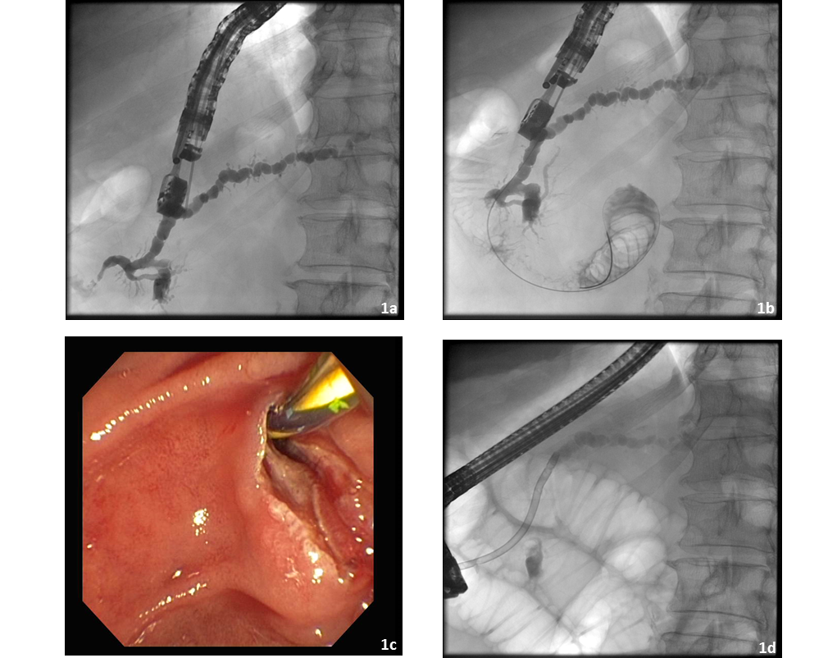
Figure 1 Patient with dilated pancreatic duct and recurrent pancreatitis. The patient has pancreas divisum and endoscopic retrograde cholangio pancreatography has already failed. A: After endoscopic ultrasonography (EUS)-guided puncture and administration of contrast medium, imaging of the pancreatic duct under fluoroscopic control shows there is almost no outflow of contrast out of the minor papilla; B: The guide wire is advanced into the pancreatic duct and on through and out of the minor papilla; C: After changing to a duodenoscope, the guide wire was identified and an extending papillotomy performed using conventional technique; D: An 11.5-Fr. prosthesis is placed into the minor papilla, with subsequent adequate outflow of contrast medium.

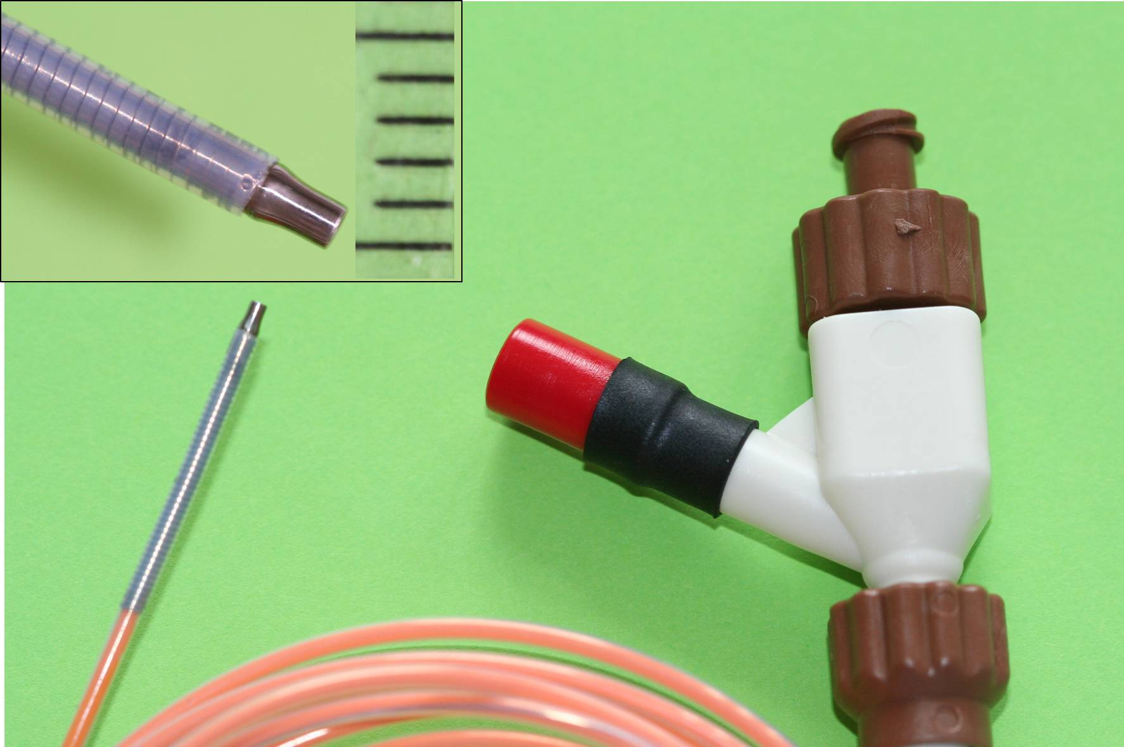
Figure 2 Will’s high-frequency ring knife (MTW-Endoskopie, Wesel, Germany). The inset top left shows the tip of the device, enlarged.

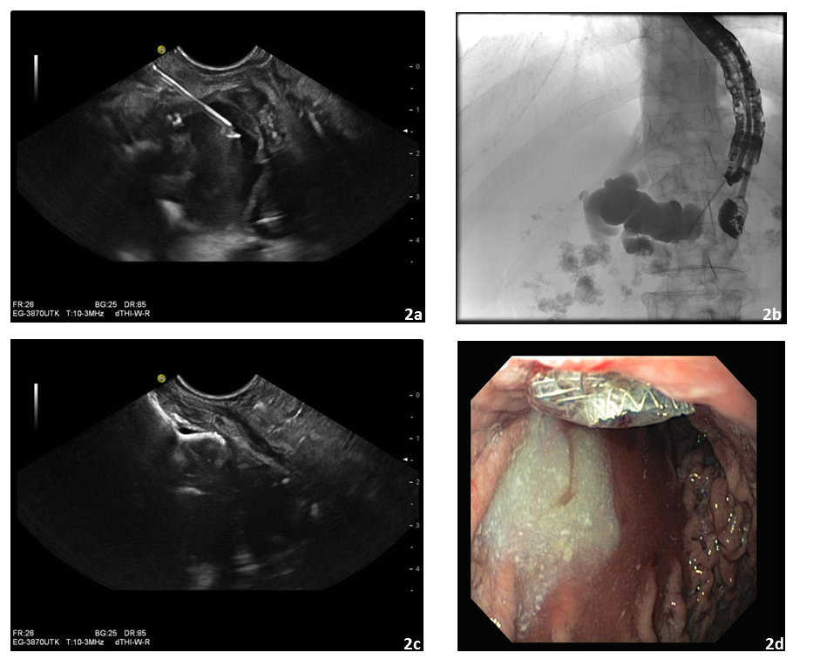
Figure 3 Patient with recurrent episodes of severe chronic pancreatitis and manifest retention of fluid in the pancreatic duct against a background of pancreatolithiasis. Endoscopic retrograde cholangio pancreatography has failed to bring relief: A: Endoscopic ultrasonography (EUS)-guided puncture of the clearly dilated pancreatic duct; B: Pancreatography showed complete obturation of the pancreatic duct; C: After failure to advance the guide wire through and out of the papilla, a 10 × 10 mm AXIOSTM stent was released and the position of the intraductal part of the stent checked using EUS; D: The intragastric part of the AXIOSTM stent with secreted opaque pancreatic juice flowing into the gastric lumen.

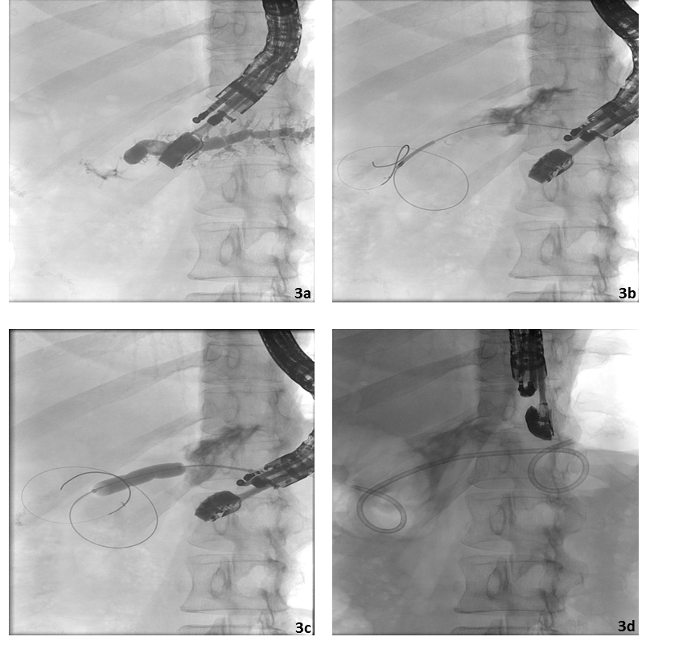
Figure 4 Patient with anastomotic stenosis and painful retention in the pancreatic duct after
previous resection of the pancreatic head for metastasized bronchial
carcinoma. A: After endoscopic ultrasonography (EUS)-guided puncture and pancreatography, retention of fluid in the
pancreatic duct is revealed – there is no flow of contrast through the stenotic
anastomosis; B: The guide wire is advanced through the anastomotic stenosis; C: Balloon dilatation of the anastomotic stenosis up to 8 mm; D: Transgastric implantation of a 7-Fr. Double pigtail prosthesis as a so-called “ring drainage” (gastropancreatojejunostomy).

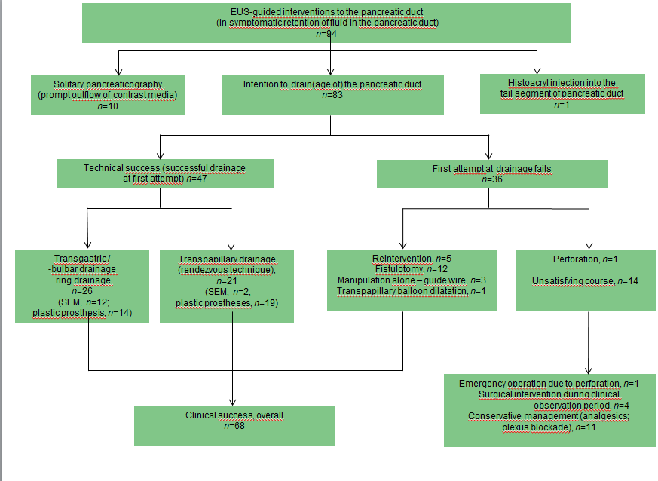
Figure 5 Overview of the endoscopic ultrasonography-guided interventions of the pancreatic duct performed at the Gera Municipal Hospital from June 2002 to April 2014.

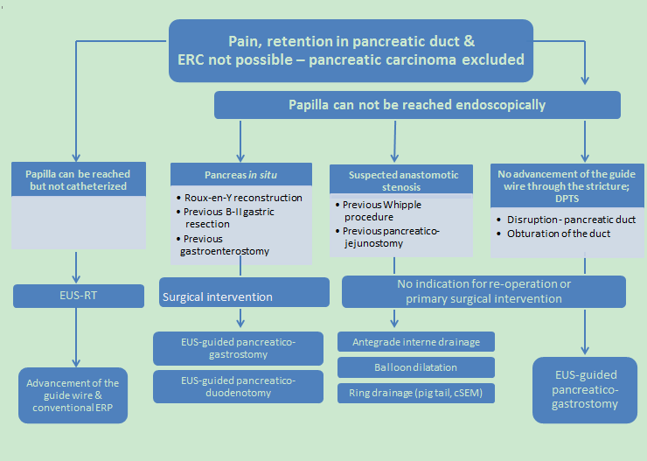
Figure 6 Treatment algorithm for patients with symptomatic retention in the pancreatic duct. EUS: Endoscopic ultrasonography; EUS-RT: EUS-guided rendezvous technique; DPTS: disconnected pancreatic tail syndrome.

Table 1 Clinical and pathological characteristics of 94 patients who underwent endoscopic ultrasonography-guided drainage of the pancreatic duct between June 2002 and April 2014
Category | Data
Clinical/pathological characteristics
Patients, n (%) (total enrolled) | n = 94 | 100%
Age (yr) | Mean, 54 | Range, 28-87
Sex ratio, n | M:F | 60:34
Interventions, n (%) | n = 111 | 100%
Duration of the procedure (min) | Mean, 21 | Range, 15-69
EUS-guided pancreatography: Indication | n = 94 | 100%
Success rate | n = 94
EUS-guided drainage: Indication | n = 83 | 100%  (88.3 % out of n = 94)
Success rate | n = 47 | 56.6 %
Indication for EUPD (total, n = 94) | n | %
Chronic pancreatitis | 35 | 37
Previous surgical intervention with retention of fluid in the pancreatic duct | 30 | 32
Pancreas divisum | 15 | 16
Disconnected pancreatic tail syndrome | 9 | 10
Persistent postoperative fistula | 5 | 5
EUS-guided drainage of the pancreatic duct | n | %
Total No. | 83 | 100
Success rate | 47 | 56.6
Route of access (n = 47): Transpapillary Transgastric | 21  26 | 44.7  55.3

Table 2 Comparison of clinical success, re-intervention, and adverse event rate in endoscopic ultrasonography-guided drainage of the pancreatic duct performed before and after introduction of Will’s HF ring knife into clinical endoscopic practice n (%)
 | Clinical success | Re-interventions | Adverse events
Interventions before introduction of ring knife (n = 35) | n = 25 (71.4) | n = 11 (31.4) | n = 14 (40.0)
Interventions after introduction of ring knife (n = 48) | n = 43 (89.6) | n = 6 (12.5) | n = 11 (22.9)

Table 3 Adverse events related to endoscopic ultrasonography-guided drainage of the pancreatic duct in 111 interventions performed between June 2002 and April 2014

Adverse event (severity/ type) | Number (total, n = 24)
Major (n = 2)  Perforation  Abscess | 1  1
Intermediate (n = 20):  Bleeding | 6
oderate pancreatitis | 6
Abscess | 3
Perigastric fluid | 2
Ulcer caused by pressure | 2
Aspiration | 1
Minor (n = 2)  Perigastric fluid | 1
Retention cyst | 1

Table 4 Results of endoscopic ultrasonography-guided drainage of the pancreatic duct as assessed by endoscopic ultrasonography-guided transgastric pancreatography
Authors | n | Technical success (%) | Clinical success (%) | Adverse events (%)
Mallery et al^{[17]}, 2004 | 4 | 25 | ND | 25
Will et al^{[20]}, 2007 | 14 | 69 | 78 | 15
Kahaleh et al^{[15]}, 2007 | 13 | 76 | 69 | 15
Tessier et al^{[19]} 2007 | 36 | 92 | 69 | 14
Brauer et al^{[11]}, 2009 | 8 | 88 | 50 | 0
Barkay et al^{[10]}, 2010 | 21 | 48 | 100 | 10
Ergun et al^{[12]}, 2011 | 20 | 90 | 72 | 19
Will et al^{[21]}, 2011 | 65 | 60 | 74 | 15
Shah et al^{[18]}, 2012 | 25 | 88 | ND | 16
Kurihara et al^{[16]}, 2013 | 14 | 88 | ND. | 6
Fuji et al^{[13]}, 2013 | 45 | 74 | 83 | 6
Will et al^{[22]}, 2013 | 84 | 59 | 78 | 18
ND: No data.

