Name of Journal: World Journal of Clinical Cases
Manuscript NO: 87672
Manuscript Type: CASE REPORT

Asymptomatic low-grade appendiceal mucinous neoplasm: A case report

Yao MQ et al. A case of asymptomatic LAMN

Min-Quan Yao, Yu-Peng Jiang, Yuan-Yu Wang, Yi-Ping Mou, Jin-Xing Fan

Min-Quan Yao, Yu-Peng Jiang, Department of Gastrointestinal Surgery, Tongxiang First People’s Hospital, Jiaxing 314500, Zhejiang Province, China

Yuan-Yu Wang, Yi-Ping Mou, Department of General Surgery, Zhejiang Provincial People’s Hospital, Hangzhou 310014, Zhejiang Province, China

Jin-Xing Fan, Endoscopy Center, Tongxiang First People’s Hospital, Jiaxing 314500, Zhejiang Province, China

Author contributions: Yao MQ and Jiang YP wrote the manuscript; Wang YY collected the information and images; Mou YP and Fan JX reviewed the manuscript; All authors were involved in drafting the manuscript and critically revising it for important intellectual content, read and approved the final manuscript, and take public responsibility for appropriate portions of the content and have agreed to be accountable for all aspects of the work.

Supported by Scientific Research Fund of National Health Commission of China, Key Health Science and Technology Program of Zhejiang Province, No. WKJ-ZJ-2201; Key Project of Social Welfare Program of Zhejiang Science and Technology Department, “Lingyan” Program, No. 2022C03099; and Clinical Research Fund Project of Zhejiang Medical Association, No. 2021ZYC-A173.

Corresponding author: Jin-Xing Fan, BSc, Nurse, Endoscopy Center, Tongxiang First People’s Hospital, No. 1918 Jiaochang East Road, Jiaxing 314500, Zhejiang Province, China. 116304728@qq.com

Received: August 21, 2023
Revised: December 5, 2023
Accepted: December 26, 2023
Published online:

Abstract
BACKGROUND
Low-grade appendiceal neoplasms (LAMN) are characterized by low incidence and atypical clinical presentations, often leading to misdiagnosis as acute or chronic appendicitis before surgery. The primary diagnostic tool for LAMN is abdominal computed tomography (CT) imaging. Surgical resection remains the cornerstone of LAMN management, necessitating en bloc tumor excision to minimize the risk of iatrogenic rupture. Laparoscopy, known for its minimal invasiveness, reduced postoperative discomfort, and expedited recovery, is a safe and reliable approach for LAMN treatment. Despite the possibility of pseudomyxoma peritonei development, appendectomy and partial appendectomy generally result in negative tumor margins and favorable outcomes, which can be attributed to the disease’s slow growth and lower malignancy.

CASE SUMMARY
A 71-year-old male patient was admitted to our hospital with a pelvic space-occupying lesion detected 1 mo prior. Physical examination showed a soft abdomen without tenderness or rebound and no palpable masses. No shifting dullness was noted, and digital rectal examination revealed no palpable mass. Enteroscopy revealed a raised, smooth-surfaced mass measuring 3.0 cm in the cecum. Abdominal contrast-enhanced CT showed a markedly thickened and dilated appendix with visible cystic shadows. Laparoscopic surgery was performed and revealed a significantly dilated appendix, leading to laparoscopic resection of the appendix and part of the cecum. Post-surgical pathologic analysis confirmed LAMN. The patient received symptomatic and supportive post-operative care and was discharged on postoperative day 4 without complications such as abdominal bleeding, intestinal obstruction, or incision infection. No tumor recurrence was observed during a 7-mo follow-up period.

CONCLUSION
LAMN is a rare disease that lacks specific clinical manifestations. Abdominal CT plays a crucial role in diagnosing LAMN, and laparoscopic surgery is a safe and effective diagnostic and therapeutic approach.

Key Words: Low-grade appendiceal mucinous neoplasm; Pseudomyxoma peritonei; Computed tomography; Laparoscopy; appendectomy; Case report

Yao MQ, Jiang YP, Wang YY, Mou YP, Fan JX. Asymptomatic low-grade appendiceal mucinous neoplasm: A case report. World J Clin Cases 2023; In press

Core Tip: This study presents a case of asymptomatic low-grade appendiceal neoplasm (LAMN), highlighting the crucial role of abdominal computed tomography in its diagnosis. The early identification and treatment of LAMN are essential for mitigating the risk of pseudomyxoma peritonei and enhancing patient outcomes. Laparoscopic surgery is demonstrated to be a safe and effective diagnostic and therapeutic approach.

INTRODUCTION
Appendiceal mucinous neoplasm (AMN) is a rare disease detected in less than 0.3% of appendectomy specimens and accounts for approximately 1% of gastrointestinal tumors^{[1]}. In 2016, the Peritoneal Surface Oncology Group International classified AMNs into low-grade appendiceal neoplasms (LAMN), high-grade appendiceal neoplasms, mucinous adenocarcinoma, and goblet cell carcinoid^{[2]}. LAMN is the most common pathological AMN subtype. LAMN is defined as mucinous neoplasms with low-grade cytology and any of the following: loss of muscularis mucosae, submucosal fibrosis, “pushing” infiltration (bulging or diverticular-like growth), undulating or flattened epithelial growth, rupture of the appendix, and/or mucinous cells and/or mucinous tissue outside the appendix^{[2]}. LAMN has a low incidence and is more prevalent in adults and females. It is often incidentally detected during appendectomy^{[3]}.
On April 15, 2023, a patient was admitted to our hospital because of a pelvic space-occupying lesion. The lesion was surgically resected on April 18, 2023, and postoperatively confirmed as LAMN. Here, we describe this case, along with a literature review.

CASE PRESENTATION
Chief complaints
A 71-year-old male patient was admitted to the hospital because of a pelvic space-occupying lesion detected 1 mo previously.

History of present illness
Examination revealed a cystic space-occupying lesion in the lower right abdomen. The patient had no fever, nausea/vomiting, abdominal pain, abdominal distension, hematemesis, or black stools.

History of past illness
The patient had a 10-year history of hypertension that was controlled with 80 mg/12.5 mg valsartan and hydrochlorothiazide tablets once daily.

Personal and family history
He had a smoking history of approximately 20 cigarettes daily for 30 years and reported no alcohol consumption. There was no significant family medical history.

Physical examination
The patient was alert and oriented, and his mental status was unremarkable. There were no signs of enlarged or swollen superficial lymph nodes. Cardiac and pulmonary physical examination showed no apparent signs of abnormality. The patient’s abdomen was soft, without any tenderness or rebound, and there were no palpable masses. Physical examination revealed no shifting dullness, and the patient’s bowel sounds were approximately four times per minute. There was no palpable mass on digital rectal examination.

Laboratory examinations
Laboratory tests following admission showed a white blood cell count of 6.0 × 10⁹/L, red blood cell count of 4.78 × 10¹²/L, hemoglobin of 14.8 g/dL, platelet count of 234.0 × 10⁹/L, and C-reactive protein concentration of 11.5 mg/L. The result of the fecal occult blood test was negative. Detection of tumor markers showed the following results: carcinoembryonic antigen, 10.83 ng/mL; CA72-4, 1.1 U/mL; and CA199, 5.1 kU/L.

Imaging examinations
A raised mass with a smooth surface measuring 3.0 cm was observed in the cecum during enteroscopy (Figure 1). Abdominal contrast-enhanced computed tomography (CT) showed a markedly thickened and dilated appendix with visible cystic shadows. The appendix wall showed a slight enhancement following contrast enhancement (Figure 2).

FINAL DIAGNOSIS
The final diagnosis of LAMN was pathologically confirmed.

TREATMENT
On the 3rd d of admission, laparoscopic surgery was performed and revealed a significantly dilated appendix (Figure 3A). A linear cutter/stapler was used to laparoscopically resect the appendix and portions of the cecum (Figure 3B). The appendix was 12 cm in length and 4 cm in width (Figure 4). Postoperative pathology confirmed that the tumor had invaded the entire appendix with mucus accumulation in the apical part of the appendix and the sub-plasma layer of the appendiceal body. The resection margins were negative (Figure 5). After surgery, the patient received symptomatic and supportive care, including treatment with cefuroxime 1.5 g twice daily for 2 d for preventing bacterial infections and nutrition therapy.

OUTCOME AND FOLLOW-UP
The patient was discharged from our hospital on postoperative day 4 without experiencing any complications such as abdominal bleeding, intestinal obstruction, or incision infection. Routine blood tests, biochemical analyses, tumor marker assessments, and chest and abdominal CT scans were performed in an outpatient setting on November 20, 2023, revealing no evidence of recurrence.

DISCUSSION
Diagnosing LAMN is challenging because of its low incidence rate, atypical clinical features, lack of specific clinical symptoms, and absence of a specific tumor marker. The primary symptom of LAMN is pain in the lower right abdomen due to dilatation of the appendiceal lumen resulting from early-stage tumor growth. This may be mistaken for acute or chronic appendicitis before surgery^{[4]}. Additional symptoms of LAMN include weight loss, nausea/vomiting, decreased appetite, and changes in bowel habits, which can lead to intestinal obstruction, intussusception, gastrointestinal hemorrhage, ureteral compression, and secondary infections and necrosis/hemorrhage from the tumor in severe cases^{[5]}. Approximately 25% of LAMN patients are asymptomatic, and the disease is often detected during health check-ups or surgical procedures^{[6]}.
Tumor rupture is the most serious and frequent complication of LAMN. It can cause the spread of tumor cells and mucinous ascites into the intraperitoneal cavity, which can result in pseudomyxoma peritonei (PMP)^{[7]}, a severe clinical syndrome with high morbidity and mortality. Therefore, early identification and treatment of LAMN is crucial in mitigating the risk of PMP and enhancing patient outcomes.
Imaging is crucial for both LAMN diagnosis and treatment. AMNs are characterized by mucus accumulation and the "onion skin" sign on ultrasound^{[8]}. LAMN is most commonly diagnosed through CT imaging, as it reveals two common features of LAMN: cystic dilation of the appendiceal lumen and irregular thickening of the appendiceal wall. Wall calcification may accompany the latter. Mucinous tissue typically does not reach the cecal lumen because of blockage in the appendiceal lumen. Colonoscopy may reveal a smooth elevated mass originating from the opening of the appendix, without any visible mucinous tumor tissue.
LAMN has the potential to become malignant, and rupture of the appendiceal wall can lead to PMP. Surgical resection is the primary treatment for LAMN, during which the tumor must be excised en bloc to minimize the risk of iatrogenic rupture. Ideally, LAMN lesions at different sites should be completely resected, ensuring negative surgical margins. Regional lymphadenectomy is not typically required^{[9]}. For LAMNs found in the distal appendix, removal of the appendix may be sufficient. If the tumor involves the appendiceal root or adheres to the cecum, removal of part of the cecum may be required. Finally, for large and malignant tumors, ileocolic resection or right hemicolectomy will be required^{[10]}. Intraoperative frozen section pathology can be useful in identifying the nature of the tumor and resection margins. During open surgery, the tumor can be placed outside the body and surrounded by gauze to prevent tumor cell dissemination, thus reducing surgical risks. Laparoscopy offers advantages over open surgery as it can reduce stress responses, relieve postoperative pain, and reduce length of postoperative stay^{[11,12]}. According to Singh et al^{[13]}, laparoscopic appendectomy using a specimen retrieval bag was a safe treatment option for LAMN when surgery was performed with low pneumoperitoneum pressure. Despite the possibility of PMP development in patients with LAMN, appendectomy and partial appendectomy often produce negative tumor margins and yield good outcomes because of the slow and less malignant nature of the disease process.

CONCLUSION
LAMN is a rare disease that lacks specific clinical manifestations and is usually identified incidentally following appendectomy. Before undergoing an appendectomy, a thorough medical history and physical examination are necessary. Medical imaging plays a crucial role in diagnosing LAMN. Prompt abdominal CT and enteroscopy are crucial for LAMN diagnosis, and laparoscopic examination is a safe and effective diagnostic and therapeutic approach. Appendectomy and partial appendectomy usually result in favorable outcomes, including a possible cure.

REFERENCES
1 Ramaswamy V. Pathology of Mucinous Appendiceal Tumors and Pseudomyxoma Peritonei. Indian J Surg Oncol 2016; 7: 258-267 [PMID: 27065718 DOI: 10.1007/s13193-016-0516-2]
2 Carr NJ, Cecil TD, Mohamed F, Sobin LH, Sugarbaker PH, González-Moreno S, Taflampas P, Chapman S, Moran BJ; Peritoneal Surface Oncology Group International. A Consensus for Classification and Pathologic Reporting of Pseudomyxoma Peritonei and Associated Appendiceal Neoplasia: The Results of the Peritoneal Surface Oncology Group International (PSOGI) Modified Delphi Process. Am J Surg Pathol 2016; 40: 14-26 [PMID: 26492181 DOI: 10.1097/PAS.0000000000000535]
3 Al-Tarakji M, Ali SM, Shah AA, Petkar MA, Mirza S, Singh R, Zarour A. A Unique Case of Low-Grade Mucinous Neoplasm in Stump Appendectomy. Case Rep Surg 2020; 2020: 8850403 [PMID: 33014506 DOI: 10.1155/2020/8850403]
4 Boshnaq M, Toeima M, Hamade A, Bagla N. Local Protocol for Management of Low-Grade Appendiceal Mucinous Neoplasm (LAMN). Indian J Surg Oncol 2020; 11: 355-359 [PMID: 33013110 DOI: 10.1007/s13193-020-01147-x]
5 Gonzalez HH, Herard K, Mijares MC. A Rare Case of Low-grade Appendiceal Mucinous Neoplasm: A Case Report. Cureus 2019; 11: e3980 [PMID: 30967980 DOI: 10.7759/cureus.3980]
6 Kwak HD, Ju JK. A prospective study of discrepancy between clinical and pathological diagnosis of appendiceal mucinous neoplasm. Ann Surg Treat Res 2020; 98: 124-129 [PMID: 32158732 DOI: 10.4174/astr.2020.98.3.124]
7 Yamaguchi T, Murata K, Shiota T, Takeyama H, Noura S, Sakamoto K, Suto T, Takii Y, Nagasaki T, Takeda T, Fujii M, Kagawa Y, Mizushima T, Ohno Y, Yao T, Kishimoto M, Sugihara K; Study Group of Appendiceal Neoplasms in the JSCCR. Clinicopathological Characteristics of Low-Grade Appendiceal Mucinous Neoplasm. Dig Surg 2021; 38: 222-229 [PMID: 33691316 DOI: 10.1159/000513973]
8 Xiao J, Li P, Liu W. Analysis of Clinical Characteristics of Low-Grade Appendiceal Mucinous Neoplasm (LAMN): A Retrospective Cohort Study of 51 LAMN Patients. J Invest Surg 2021; 34: 721-727 [PMID: 31906733 DOI: 10.1080/08941939.2019.1695986]
9 Wu YC, Wen L, Dou WD, Zhang JL, Wu T, Wang X. [Clinicopathological analysis and surgical strategy of primary appendiceal neoplasms]. Zhonghua Wei Chang Wai Ke Za Zhi 2021; 24: 1065-1072 [PMID: 34923789 DOI: 10.3760/cma.j.cn441530-20201122-00621]
10 Qi XM, Sun P, Wan JY. Clinicopathologic analysis of low appendiceal mucinous neoplasm. Zhonghua Quanke Yishi Zazhi 2016; 15: 871-874
11 Han S, Li XW, Zhao PX, Guan TW, LiSY, Zhang DJ. Research progress on the diagnosis and treatment of low-grade appendiceal mucinous neoplasm. Zhonghua Jiepouyulinchuang Zazhi 2019; 24:512-515
12 Chicago Consensus Working Group. The Chicago Consensus on Peritoneal Surface Malignancies: Management of Appendiceal Neoplasms. Ann Surg Oncol 2020; 27: 1753-1760 [PMID: 32285275 DOI: 10.1245/s10434-020-08316-w]
13 Singh MK, Kumar MK, Singh R. Laparoscopic appendectomy for mucocele of the appendix. J Nat Sci Biol Med 2014; 5: 204-206 [PMID: 24678230 DOI: 10.4103/0976-9668.127332]

Footnotes
Informed consent statement: Informed written consent was obtained from the patient for publication of this report and any accompanying images.

Conflict-of-interest statement: The authors declare that they do not have any relevant conflicts of interest for this article.

CARE Checklist (2016) statement: The authors have read the CARE Checklist (2016), and the manuscript was prepared and revised according to the CARE Checklist (2016).

Open-Access: This article is an open-access article that was selected by an in-house editor and fully peer-reviewed by external reviewers. It is distributed in accordance with the Creative Commons Attribution NonCommercial (CC BY-NC 4.0) license, which permits others to distribute, remix, adapt, build upon this work non-commercially, and license their derivative works on different terms, provided the original work is properly cited and the use is non-commercial. See: https://creativecommons.org/Licenses/by-nc/4.0/

Provenance and peer review: Unsolicited article; Externally peer reviewed.

Peer-review model: Single blind

Peer-review started: August 21, 2023
First decision: November 20, 2023
Article in press:

Specialty type: Medicine, research and experimental
Country/Territory of origin: China
Peer-review report’s scientific quality classification
Grade A (Excellent): 0
Grade B (Very good): 0
Grade C (Good): C
Grade D (Fair): 0
Grade E (Poor): 0

P-Reviewer: Wong Y, Taiwan S-Editor: Lin C L-Editor: Filipodia P-Editor:
Figure Legends
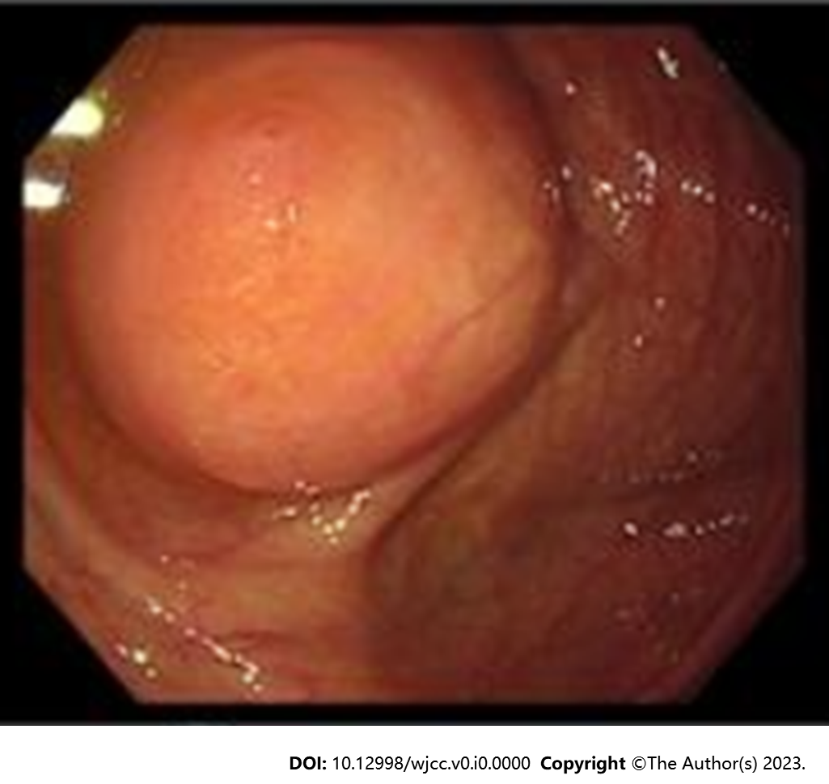
Figure 1 Enteroscopy. A raised mass with a smooth surface measuring 3.0 cm was observed in the cecum.

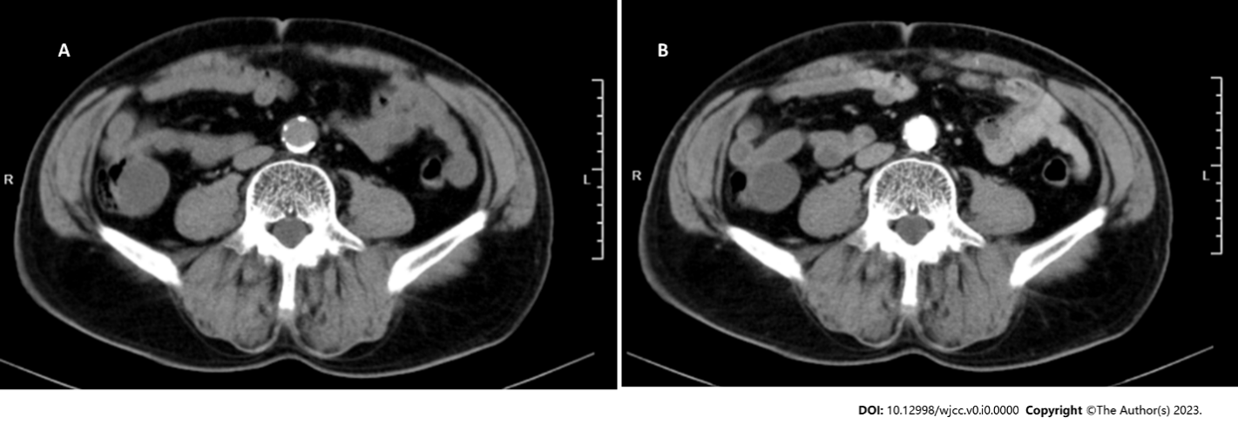
Figure 2 Abdominal computed tomography. A: Markedly thickened and dilated appendix with visible cystic shadows; B: Appendix wall showed a slight enhancement following the contrast enhancement procedure.

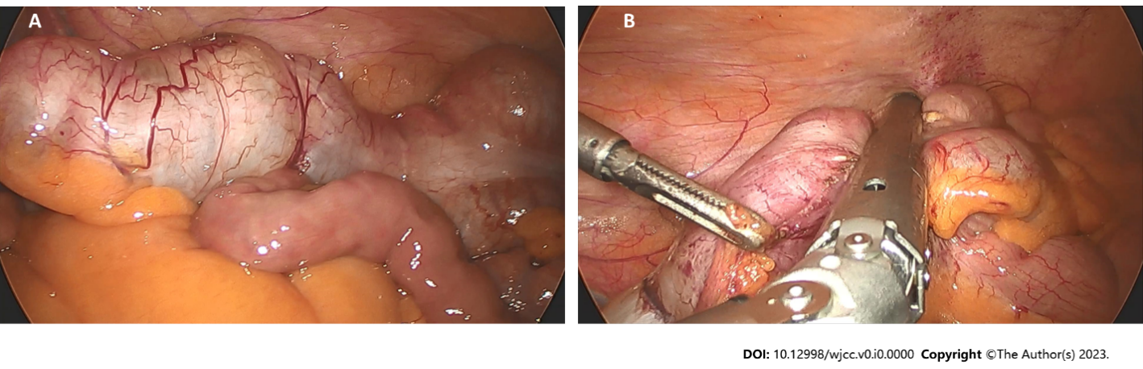
Figure 3 Intraoperative view. A: Significantly dilated appendix; B: Linear cutter/stapler was used to laparoscopically resect the appendix and portions of the cecum.

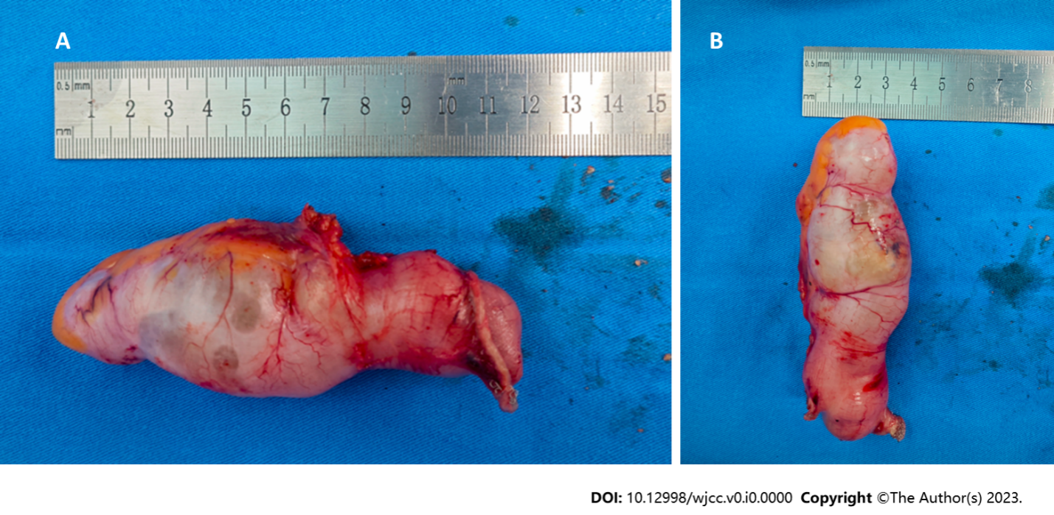
Figure 4 Appendix. A: 12 cm in length; B: 4 cm in width.

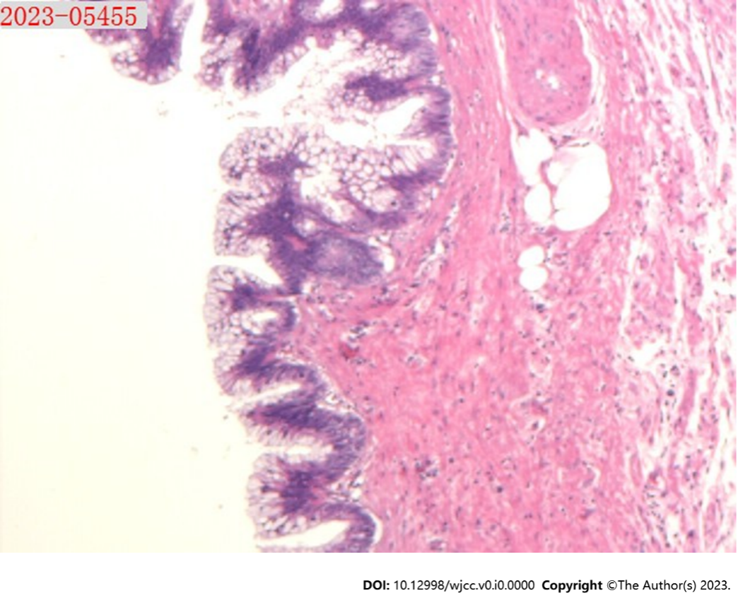
Figure 5 Postoperative pathology. The tumor had invaded the entire appendix with mucus accumulation in the apical part of the appendix and the sub-plasma layer of the appendiceal body. The resection margins were negative (hematoxylin–eosin, × 200).

