Name of Journal: World Journal of Clinical Cases
Manuscript NO: 61364
Manuscript Type: CASE REPORT

Detection of EGFA-SEPT14 fusion in cell-free DNA of a patient with advanced gastric cancer: A case report

Kim B et al. EGFR-SEPT14 fusion in advanced gastric cancer

Boyeon Kim, Yoonjung Kim, Inho Park, Jae Yong Cho, Kyung-A Lee

Boyeon Kim, Department of Laboratory Medicine, Yonsei University College of Medicine, Seoul 03722, South Korea

Boyeon Kim, Yoonjung Kim, Kyung-A Lee, Department of Laboratory Medicine, Gangnam Severance Hospital, Yonsei University College of Medicine, Seoul 06273, South Korea

Inho Park, Center for Precision Medicine, Gangnam Severance Hospital, Yonsei University College of Medicine, Seoul 06273, South Korea

Jae Yong Cho, Division of Medical Oncology, Department of Internal Medicine, Gangnam Severance Hospital, Yonsei University College of Medicine, Seoul 06273, South Korea

Author contributions: Kim B reviewed the literature and contributed to manuscript drafting; Cho JY provided clinical information regarding the patient; Kim Y and Park I contributed to panel assay design and gene curation; Kim B, Kim Y, and Lee KA performed analysis of genetic data; Lee KA and Cho JY were responsible for revision of the manuscript for important intellectual content; All authors issued final approval for the version to be submitted.

Corresponding author: Kyung-A Lee, MD, PhD, Full Professor, Department of Laboratory Medicine, Gangnam Severance Hospital, Yonsei University College of Medicine, 211 Eonju-Ro, Gangnam-Gu, Seoul 06273, South Korea. kal1119@yuhs.ac

Received: December 4, 2020
Revised: February 2, 2021
Accepted: March 3, 2021
Published online: April 26, 2021

Abstract
BACKGROUND
Gastric cancer is the fifth most diagnosed cancer worldwide and the third most common cause of cancer-related death. In recent decades, increasing application of next-generation sequencing has enabled detection of molecular aberrations, including fusions. In cases where tissue is difficult to obtain, cell-free DNA (cfDNA) is used for detecting mutations to identify the molecular profile of cancer. Here, we report a rare case of EGFR-SEPT14 fusion detected from cfDNA analysis in a patient with gastric cancer.

CASE SUMMARY
A 49-year-old female diagnosed with advanced gastric cancer in July 2019 received capecitabine and then combination chemotherapy of ramucirumab and paclitaxel, but ascites was detected. The therapy was switched to nivolumab, but disease progression was observed on a positron emission tomography/computed tomography scan in May 2020. Therapy was discontinued, and cfDNA next-generation sequencing was immediately evaluated. All genomic variants, including fusions, were analyzed from cfDNA. The following somatic alterations were detected from the patient’s cfDNA: an APC frameshift mutation (NM_000038.5:c.6579del, p.V2194fs) with variant allele frequency of 0.5%, an EGFR amplification with a copy number of 17.3, and an EGFR-SEPT14 fusion with variant allele frequency of 45.3%. The site of the fusion was exon 24 of EGFR fused to exon 10 of SEPT14. The fusion was in-frame and considered to be protooncogenic. Although the patient refused to continue therapy, we suggest that EGFR-targeted therapies be tried in such future cases.

CONCLUSION
The expanded applications of the cfDNA assay may open a new horizon in treatment of patients with advanced gastric cancer.

Key Words: Gene fusion; Cell-free DNA; Liquid biopsy; Gastric cancer; EGFR tyrosine kinase inhibitor; Case report

©The Author(s) 2021. Published by Baishideng Publishing Group Inc. All rights reserved.

Citation: Kim B, Kim Y, Park I, Cho JY, Lee KA. Detection of EGFR-SEPT14 fusion in cell-free DNA of a patient with advanced gastric cancer: A case report. World J Clin Cases 2021; 9(12): 2884-2889
URL: https://www.wjgnet.com/2307-8960/full/v9/i12/2884.htm
DOI: https://dx.doi.org/10.12998/wjcc.v9.i12.2884

Core Tip: In recent decades, increasing application of next-generation sequencing has enabled detection of molecular aberrations, including fusions. In cases where tissue is not easily obtainable, cell-free DNA is used for detecting mutations to determine the molecular profile of cancer. In this study, we report the first case of EGFR-SEPT14 fusion detected from next-generation sequencing analysis of cell-free DNA from a patient with advanced gastric cancer. We suggest expanded applications of the cell-free DNA assay regardless of cancer type, which may open a new horizon in treatment of patients with advanced gastric cancer.

INTRODUCTION
Gastric cancer is the fifth most diagnosed cancer worldwide with a particularly high incidence in East Asia and the third most common cause of cancer-related death^{[1]}. Curative surgery is the primary treatment of choice, but systemic chemotherapies are used for patients with metastatic or unresectable advanced or recurrent gastric cancer. Because systemic chemotherapies are nonspecific and can cause serious adverse effects, development of molecular targeted drugs has been attempted to improve outcomes in patients with gastric cancer.
In recent decades, increasing application of next-generation sequencing (NGS) has enabled detection of molecular aberrations such as copy number gains or losses, somatic mutations, and gene fusions. For cases where tissue is not easily obtainable, cell-free DNA (cfDNA) is used for detecting mutations to determine the molecular profile of cancer^{[2]}. Successful identification of oncogenic gene fusions can aid in diagnosis and molecular treatment of patients^{[3]}. Here, we report a rare case of EGFR-SEPT14 fusion detected from cfDNA analysis in a patient with gastric cancer.

CASE PRESENTATION
Chief complaints
A 49-year-old female patient had been treated for advanced gastric cancer (AGC) with chemotherapy. After therapy, she expressed whole body pain, especially on the left side of the pelvis.

History of present illness
This patient had been diagnosed with AGC in July 2019. The pathological diagnosis indicated signet ring cell carcinoma. While receiving her first round of chemotherapy with capecitabine, the patient developed acute pyelonephritis and hydronephrosis in both kidneys, leading to a suspicion of periureteral metastases. Therefore, the patient started a new regimen of combination chemotherapy with ramucirumab and paclitaxel. However, ascites was observed after two cycles of chemotherapy. The treatment was switched to nivolumab. After five cycles, an abdominopelvic computed tomography scan was performed in April 2020 that showed improvement in peritoneal carcinomatosis compared to an image from February 2020. She received seven cycles of nivolumab, but progressive disease was observed by the positron emission tomography/computed tomography scan, and other therapeutic options were needed to be discussed.

History of past illness
The patient did not have any other medical history beyond AGC.

Personal and family history
The patient reported a family history of gastric cancer in her grandfather.

Physical examination
Physical examination revealed pain on the left side of the pelvis.

Laboratory examinations
Blood analysis revealed mild leukocytosis (14 × 10⁹/L) with low hemoglobin (10.3 g/dL). Platelet count was in the normal range. Serum C-reactive protein was increased at 181 mg/L (normal range, 0.1-6.0 mg/L).

Imaging examinations
A positron emission tomography/computed tomography scan obtained in May 2020 revealed bone, multiple nodal, and right lateral abdominal wall soft tissue metastases after the patient had received seven cycles of nivolumab. The therapy was discontinued, and cfDNA NGS was performed immediately.

Further genetic diagnostic work-up
For genetic testing, the patient provided informed written consent for specimen collection and genetic analysis. This study was approved with a waiver of informed consent by the Institutional Review Board of Gangnam Severance Hospital, Seoul, Korea (IRB No. 3-2020-0268).
cfDNA was extracted using the MagMAX Cell-Free Total Nucleic Acid Kit (Thermo Fisher Scientific, Waltham, MA, United States). A DNA library was constructed with the AlphaLiquid®100 kit (IMBDx Inc., Seoul, Korea), which was designed to include intronic regions of target genes. Hybrid-capture-selected libraries were sequenced to a mean coverage of 14237x (cfDNA) and 735x (DNA) on an Illumina NextSeq-550 (Illumina, San Diego, CA, United States). GeneFuse was used to detect fusions^{[4]}, and a Genome Reference Consortium Human Build 38 was used for variant interpretation. All genomic variants, including fusions, were analyzed from cfDNA. Because of the patient’s family history, the presence of germline mutation was tested in parallel for the following genes: APC, ATM, BRCA1, BRCA2, CDH1, CDK4, CDKN2A, and MLH1. No germline mutations were detected from the genomic DNA. Somatic alterations detected from the cfDNA were an APC frameshift mutation (NM_000038.5:c.6579del, p.V2194fs) with variant allele frequency of 0.5%, an EGFR amplification with a copy number of 17.3, and an EGFR-SEPT14 fusion with variant allele frequency of 45.3% (Figure 1A). Because the EGFR and SEPT14 genes are closely located on chromosome 7, we tested 50 normal healthy controls with the same panel and confirmed that the fusion detected in the patient was a true positive. We also confirmed EGFR-SEPT14 fusion by complementary DNA sequencing, which was processed using the patient’s cell-free RNA extracted by MagMAX Cell-Free Total Nucleic Acid Kit. The site of fusion was exon 24 of EGFR fused to exon 10 of SEPT14 (Figure 1B). The fusion was in-frame and considered to be proto-oncogenic.

FINAL DIAGNOSIS
The final diagnosis of the present case was EGFR-SEPT14 fusion in AGC.

TREATMENT
The patient refused further treatment.

OUTCOME AND FOLLOW-UP
The patient could have tried EGFR targeted therapy such as erlotinib, which has been used in other types of carcinomas with EGFR-SEPT14 fusion^{[5]}, but she refused further treatment and passed away about 1 month after discontinuation of nivolumab.

DISCUSSION
EGFR1 (EGFR; ErbB1; HER1) is one of four transmembrane growth factor receptor proteins that constitute the EGFR family of receptor tyrosine kinases^{[6]}. Activation of EGFR leads to cell proliferation, differentiation, motility, and metastasis^{[7]}. SEPT14 is a member of a highly conserved septin family of guanosine 5’-triphosphate-binding cytoskeletal proteins with multiple cellular functions, such as membrane transport, apoptosis, cell polarity, cell cycle regulation, cytokinesis, and oncogenesis^{[8]}. Among all septins, SEPT14 shows the highest mutation frequency in skin cancer followed by SEPT9 exhibiting high mutation frequency in stomach cancer^{[9]}.
The EGFR-SEPT14 fusion was first reported in glioblastoma in which the site of fusion was the tyrosine kinase domain of EGFR and the coiled-coil domain of SEPT14. The EGFR-SEPT14 fusion is the most frequent functional gene fusion in human glioblastoma^{[10]}. The EGFR-SEPT14 fusion was also identified in tissue from salivary gland secretory carcinoma using fluorescence in situ hybridization. That previous case indicated that a tumor harboring this fusion would be sensitive to EGFR inhibitors^{[11]}. Recently, the EGFR-SEPT14 fusion was reported in colorectal adenocarcinoma by using a comprehensive NGS assay on tumor samples^{[5]}.
In the present study, the tissue biopsy of the patient was difficult. Therefore, we used a comprehensive NGS assay with a sample of cfDNA from the patient. We identified an EGFR-SEPT14 fusion in AGC. To our knowledge, this is the first case of EGFR-SEPT14 fusion identified in a cfDNA sample from an AGC patient. The patient went through unusually rapid disease progression, and this progression might have been caused by the fusion mutation. Unfortunately, because the patient refused to continue therapy, we could not determine whether the EGFR-SEPT14 fusion responded to EGFR targeted therapies, such as tyrosine kinase inhibitors. However, the use of such therapies might have been effective in AGC with an EGFR-SEPT14 fusion because there was a report of a patient with colorectal cancer with an EGFR-SEPT14 fusion treated with erlotinib therapy. The fusion site reported in that study is the same as that in the present study, and the patient was administered erlotinib therapy to which the EGFR-SEPT14 fusion is known to be sensitive^{[10]}. However, soon after treatment, an EGFR variant III was detected and can result in resistance to erlotinib^{[5]}. To confirm the treatment effect and disease progression in AGC, further studies are needed.
Nevertheless, detection of genomic fusion by the well-established cfDNA NGS assay confirmed that cfDNA can serve as an alternate source for detecting gene aberrations, including fusions. Furthermore, EGFR-SEPT14 fusion has been reported in various types of cancer. Therefore, expanded applications of cfDNA assays should be considered regardless of cancer type. We also suggest that genomic variants including fusions can be therapeutic targets in AGC, which may open a new horizon in treatment.

CONCLUSION
To the best of our knowledge, this is the first case of an EGFR-SEPT14 fusion identified in a cfDNA sample from a patient with AGC. Detection of genomic fusion by the well-established cfDNA NGS assay confirmed that cfDNA can serve as an alternate source for detecting gene aberrations, including fusions. Successful identification of genomic variants, including fusions, from cfDNA can aid in diagnosis and molecular treatment of patients with AGC.

REFERENCES
1 Bray F, Ferlay J, Soerjomataram I, Siegel RL, Torre LA, Jemal A. Global cancer statistics 2018: GLOBOCAN estimates of incidence and mortality worldwide for 36 cancers in 185 countries. CA Cancer J Clin 2018; 68: 394-424 [PMID: 30207593 DOI: 10.3322/caac.21492]
2 Volckmar AL, Sültmann H, Riediger A, Fioretos T, Schirmacher P, Endris V, Stenzinger A, Dietz S. A field guide for cancer diagnostics using cell-free DNA: From principles to practice and clinical applications. Genes Chromosomes Cancer 2018; 57: 123-139 [PMID: 29205637 DOI: 10.1002/gcc.22517]
3 Schram AM, Chang MT, Jonsson P, Drilon A. Fusions in solid tumours: diagnostic strategies, targeted therapy, and acquired resistance. Nat Rev Clin Oncol 2017; 14: 735-748 [PMID: 28857077 DOI: 10.1038/nrclinonc.2017.127]
4 Chen S, Liu M, Huang T, Liao W, Xu M, Gu J. GeneFuse: detection and visualization of target gene fusions from DNA sequencing data. Int J Biol Sci 2018; 14: 843-848 [PMID: 29989075 DOI: 10.7150/ijbs.24626]
5 Li Y, Zhang HB, Chen X, Yang X, Ye Y, Bekaii-Saab T, Zheng Y, Zhang Y. A Rare EGFR-SEPT14 Fusion in a Patient with Colorectal Adenocarcinoma Responding to Erlotinib. Oncologist 2020; 25: 203-207 [PMID: 32162810 DOI: 10.1634/theoncologist.2019-0405]
6 Herbst RS. Review of epidermal growth factor receptor biology. Int J Radiat Oncol Biol Phys 2004; 59: 21-26 [PMID: 15142631 DOI: 10.1016/j.ijrobp.2003.11.041]
7 Sigismund S, Avanzato D, Lanzetti L. Emerging functions of the EGFR in cancer. Mol Oncol 2018; 12: 3-20 [PMID: 29124875 DOI: 10.1002/1878-0261.12155]
8 Peterson EA, Kalikin LM, Steels JD, Estey MP, Trimble WS, Petty EM. Characterization of a SEPT9 interacting protein, SEPT14, a novel testis-specific septin. Mamm Genome 2007; 18: 796-807 [PMID: 17922164 DOI: 10.1007/s00335-007-9065-x]
9 Angelis D, Spiliotis ET. Septin Mutations in Human Cancers. Front Cell Dev Biol 2016; 4: 122 [PMID: 27882315 DOI: 10.3389/fcell.2016.00122]
10 Frattini V, Trifonov V, Chan JM, Castano A, Lia M, Abate F, Keir ST, Ji AX, Zoppoli P, Niola F, Danussi C, Dolgalev I, Porrati P, Pellegatta S, Heguy A, Gupta G, Pisapia DJ, Canoll P, Bruce JN, McLendon RE, Yan H, Aldape K, Finocchiaro G, Mikkelsen T, Privé GG, Bigner DD, Lasorella A, Rabadan R, Iavarone A. The integrated landscape of driver genomic alterations in glioblastoma. Nat Genet 2013; 45: 1141-1149 [PMID: 23917401 DOI: 10.1038/ng.2734]
11 Black M, Liu CZ, Onozato M, Iafrate AJ, Darvishian F, Jour G, Cotzia P. Concurrent Identification of Novel EGFR-SEPT14 Fusion and ETV6-RET Fusion in Secretory Carcinoma of the Salivary Gland. Head Neck Pathol 2020; 14: 817-821 [PMID: 31502214 DOI: 10.1007/s12105-019-01074-6]

Footnotes
Informed consent statement: Informed written consent was obtained for specimen collection and genetic analysis.

Conflict-of-interest statement: The authors declare that they have no conflict of interest.

CARE Checklist (2016) statement: The authors have read the CARE Checklist (2016), and the manuscript was prepared and revised according to the CARE Checklist (2016).

Open-Access: This article is an open-access article that was selected by an in-house editor and fully peer-reviewed by external reviewers. It is distributed in accordance with the Creative Commons Attribution NonCommercial (CC BY-NC 4.0) license, which permits others to distribute, remix, adapt, build upon this work non-commercially, and license their derivative works on different terms, provided the original work is properly cited and the use is non-commercial. See: http://creativecommons.org/Licenses/by-nc/4.0/

Manuscript source: Unsolicited manuscript

Peer-review started: December 4, 2020
First decision: January 24, 2021
Article in press: March 3, 2021

Specialty type: Medicine, research and experimental
Country/Territory of origin: South Korea
Peer-review report’s scientific quality classification
Grade A (Excellent): 0
Grade B (Very good): B
Grade C (Good): 0
Grade D (Fair): 0
Grade E (Poor): 0

P-Reviewer: Jin X S-Editor: Fan JR L-Editor: Filipodia P-Editor: Yuan YY
Figure Legends

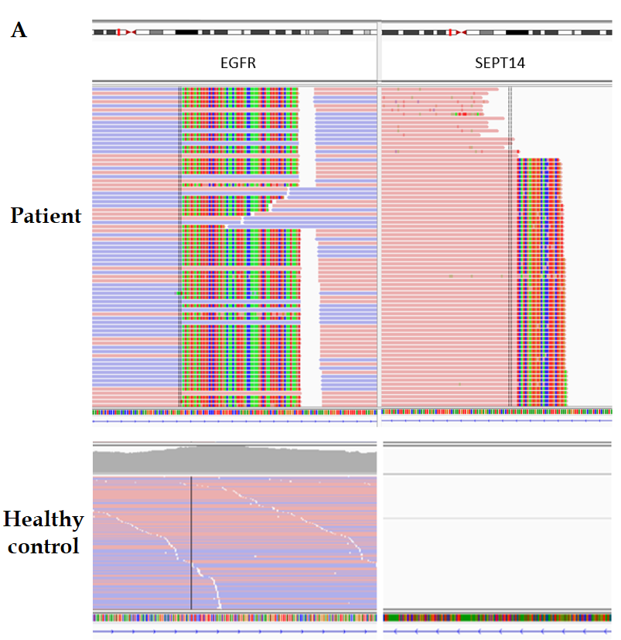
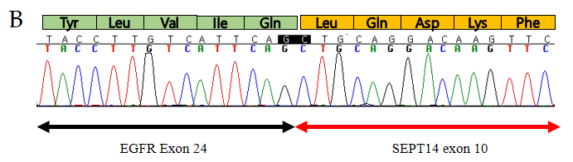
Figure 1 EGFR-SEPT14 fusion. A: Genomic fusion of EGFR exon 24 with exon 10 of SEPT14; B: RNA sequencing analysis of the EGFR-SEPT14 fusion.

Published by Baishideng Publishing Group Inc
7041 Koll Center Parkway, Suite 160, Pleasanton, CA 94566, USA
Telephone: +1-925-3991568
E-mail: bpgoffice@wjgnet.com
Help Desk: https://www.f6publishing.com/helpdesk
https://www.wjgnet.com

© 2021 Baishideng Publishing Group Inc. All rights reserved.

