Name of journal: World Journal of Gastroenterology
ESPS Manuscript No: 8982
Columns: PROSPECTIVE STUDY

Complications after ileal pouch-anal anastomosis in Korean patients with ulcerative colitis

Ryoo SB et al. Outcomes of IPAA for UC

Seung-Bum Ryoo, Heung-Kwon Oh, Eon Chul Han, Heon-Kyun Ha, Sang Hui Moon, Eun Kyung Choe, Kyu Joo Park

Seung-Bum Ryoo, Heung-Kwon Oh, Eon Chul Han, Heon-Kyun Ha, Sang Hui Moon, Eun Kyung Choe, Kyu Joo Park, Division of Colorectal Surgery, Department of Surgery, Seoul National University College of Medicine, Seoul 110-744, South Korea

Eun Kyung Choe, Healthcare Research Institute, Seoul National University Hospital Healthcare System Gangnam Center, Seoul 135-984, South Korea

Author contributions: Park KJ and Ryoo SB conceived and designed the study; Park KJ, Ryoo SB, Oh HK, Ha HK, Moon SH and Choe EK conducted the research; Ryoo SB, Han EC and Ha HK collected and analyzed the data; Ryoo SB and Park KJ drafted the manuscript; Park KJ, Ryoo SB, Oh HK, Moon SH, Han EC and Choe EK reviewed and modified the manuscript.

Correspondence to: Kyu Joo Park, MD, PhD, Professor, Division of Colorectal Surgery, Department of Surgery, Seoul National University College of Medicine, 101 Daehak-ro, Jongro‐gu, Seoul 110-744, South Korea. kjparkmd@plaza.snu.ac.kr

Telephone: +82-2-20722901 Fax: +82-2-7663975
Received: January 14, 2014 Revised: March 17, 2014
Accepted: May 23, 2014

Published online:

Abstract
AIM: To investigate the outcomes of treatments for complications after ileal pouch-anal anastomosis (IPAA) in Korean patients with ulcerative colitis.

METHODS: Between March 1998 and February 2013, 72 patients (28 male and 44 female, median age 43.0 ± 14.0 years) underwent total proctocolectomy with IPAA. The study cohort was registered prospectively and analyzed retrospectively. Patient characteristics, medical management histories, operative findings, pathology reports and postoperative clinical courses, including early postoperative and late complications and their treatments, were reviewed from a medical record system. All of the ileal pouches were J-pouch and were performed with either the double-stapling technique (n = 69) or a hand-sewn (n = 3) technique.

RESULTS: Thirty-one (43.1%) patients had early complications, with 12 (16.7%) patients with complications related to the pouch. Pouch bleeding, pelvic abscesses and anastomosis ruptures were managed conservatively. Patients with pelvic abscesses were treated with surgical drainage. Twenty-seven (38.0%) patients had late complications during the follow-up period (82.5 ± 50.8 mo), with 21 (29.6%) patients with complications related to the pouch. Treatment for pouchitis included antibiotics or anti-inflammatory drugs. Pouch-vaginal fistulas, perianal abscesses or fistulas and anastomosis strictures were treated surgically. Pouch failure developed in two patients (2.8%). Analyses showed that an emergency operation was a significant risk factor for early pouch-related complications compared to elective procedures (55.6% vs 11.1%; P < 0.05). Pouchitis was related to early (35.3%) and the other late pouch-related complications (41.2%) (P < 0.05). The complications did not have an effect on pouch failure nor pouch function.

CONCLUSION: The complications following IPAA can be treated successfully. Favorable long-term outcomes were achieved with a lower pouch failure rate than reported in Western patients.

© 2014 Baishideng Publishing Group Inc. All rights reserved.

Key words: Ulcerative colitis; Ileal pouch-anal anastomosis; Complications; Pouch failure; Pouch function

Core tip: There has been a recent increase in the number of ileal pouch-anal anastomosis (IPAA) procedures conducted to treat ulcerative colitis in Asian countries, including Korea. However, the reports on the outcomes of IPAA have been lacking. This study investigated the treatment outcomes for complications associated with ileal pouch formation, including pouch failure. The early postoperative complications included pouch bleeding, pelvic abscess, and anastomosis rupture. The late complications included pouchitis, pouch-vaginal fistula, perianal abscess or fistula, and anastomosis stricture. The post IPAA complications were treatable either medically or surgically with a lower pouch failure rate than previously reported from Western countries.

Ryoo SB, Oh HK, Han EC, Ha HK, Moon SH, Choe EK, Park KJ. Complications after ileal pouch-anal anastomosis in Korean patients with ulcerative colitis. World J Gastroenterol 2014; In press

INTRODUCTION
Ulcerative colitis (UC) is characterized by a chronic course of recurrent relapse and remission and the need for long-term medical management. However, 20%-30% of patients undergo surgical treatment and are successfully treated by total colectomy^{[1]}. Since the first introduction of ileal pouch-anal anastomosis (IPAA) in 1978, the procedure has become a standard surgical method for treatment of UC while avoiding a permanent ileostomy^{[2]}. The J-pouch is a popular method, and many surgeons have accepted IPAA as a safe procedure with favorable functional results and improvements in quality of life^{[3-6]}.
Many complications may be encountered after IPAA and several reports presented significant morbidity and mortality rates^{[7,8]}. Early postoperative complications, such as small bowel obstruction, pouch bleeding, leakage and pelvic sepsis, may be detrimental to the patient’s health. Late complications can often cause troublesome results, reducing the satisfaction of surgical treatments. Pouchitis is one of the late complications and readministration of anti-inflammatory treatment is required. Pouch stricture or fistulas can develop, resulting in functional problems such as frequency, incontinence or sexual dysfunction, leading to further distress. These complications are difficult to manage and require complex treatments including various medications and surgical procedures. In 5%-10% of the patients, complications cannot be resolved resulting in a pouch failure^{[9,10]}.
In Asian countries, including Korea, there has been an increase in the number of UC cases, consequently increasing the number of surgical treatments^{[11]}. However, there has been a lack of reports regarding the long-term treatment outcomes for complications of IPAA. This study describes the early and late complications associated with IPAA for UC, as well as the outcomes of the corresponding treatments, including the rate of pouch failure.

MATERIALS AND METHODS
Patient population and surgical procedure
Between March 1998 and February 2013, 72 consecutive patients underwent IPAA for UC by a single surgeon (KJ Park) at our institution with extensive experience in the colorectal division. The prospective registered patient cohort was analyzed retrospectively. This study was approved by our Institutional Review Board (IRB approval number: H-1107-044-368). Patient characteristics, medical management histories, operative findings, pathology reports, postoperative clinical courses, including complications and their treatments, and stool frequency presented as bowel movements/day were reviewed from an electronic medical record system. The criteria for elective operations were medical intractability, dysplasia or malignancy. The criteria for emergency operations were massive bleeding, fulminant colitis or toxic megacolon. Medical intractability was defined as an inability to remain in remission despite long periods of medical anti-inflammatory treatment. Dysplasia or malignancy was confirmed by routine colonoscopy. Massive bleeding was defined by a continuous necessity for more than four units of packed red blood cells in 24 h or bleeding that put the patient at risk of developing shock. Fulminant colitis was suspected when sepsis resulted from an aggravation of the colitis and peritonitis despite the initial attempts of medical management. Toxic megacolon was diagnosed by radiologic examinations. The surgical procedure was composed of a proctocolectomy and IPAA with or without a loop ileostomy. All of the ileal pouches were generated by the J-pouch procedure, and most of the anastomoses were performed by the double-stapling technique. A few patients required hand-sewn anastomoses, and all of these procedures were performed from the anal side. Only after confirming the security of IPAA, through radiological imaging of the loopogram using a water-soluble dye, was the loop ileostomy taken down.

Classification of complications
Postoperative complications were classified into three categories based upon the post-surgery period in which they occurred. The first category included early complications, which occurred during the postoperative recovery period after IPAA, usually within 30 d of surgery. The second category included complications related to the ileostomy takedown, and the third category included late complications that occurred during the follow-up period. Pouch failure was defined as excision of a total pouch or a nonfunctioning pouch requiring permanent diversion with ileostomy as a result of failure to manage the pouch-related complications.

Statistical analysis
The treatments and outcomes of the postoperative complications were investigated, and the risk factors for complications were analyzed using SPSS for Windows, version 18.0 (SPSS Inc., Chicago, IL, United States). Univariate analysis was performed using Pearson’s χ² test and Fisher’s exact test. Multivariate analysis was performed using logistic regression for the factors with P values of < 0.25 by univariate analysis. A Mann-Whitney test was performed for comparison of the values of stool frequency. Data are presented as median ± the standard deviation. Statistical significance was accepted for P values of < 0.05.

RESULTS
Clinical characteristics
The median age at surgery was 43.0 ± 14.0-year-old (range: 11–67 years; interquartile range (IQR): 33.5-55.5). The median age at diagnosis of UC was 39.0 ± 14.0-year-old (range: 5–67 years; IQR: 26.0-49.0), and the median duration from the diagnosis to surgery was 52.0 ± 65.0 months (range, 1.0–260.0 mo; IQR: 23.3-118.8). All of the patients had taken at least one anti-inflammatory drug, such as 5-aminosalicylic acid, azathioprine or steroids. The median body mass index (BMI) was 21.7 ± 3.6 (range: 12.9-31.1; IQR: 19.4-24.2). The clinical characteristics of the patients are described in Table 1.

Operations
Total proctocolectomy was performed on 71 (98.6%) patients. Remnant proctectomy was performed on one (1.4%) patient who underwent total colectomy and ileorectal anastomosis due to the uncertainty in a preoperative diagnosis of colitis. This patient was eventually diagnosed with UC and underwent remnant proctectomy and IPAA. Most of the patients underwent IPAA using a double stapling technique, but hand-sewn anastomosis was also performed in three (4.2%) patients. Of these three, two patients had serious tearing on the distal stump subsequent to stapling, and the other patient had a negative margin of low rectal cancer. Diverting loop ileostomy was performed in 71 (98.6%) patients. One patient underwent surgery for dysplasia and inflammation of the colon followed by a loop ileostomy a month later due to the development of a pouch-vaginal fistula. The characteristics of operations are described in Table 1.

Treatments for early postoperative complications after IPAA
Thirty-one (43.1%) patients experienced early postoperative complications (Table 2). One patient (1.4%), who underwent emergency surgery, died due to pneumonia. Pouch-related complications occurred in 12 (16.7%) patients. Most of the early complications were treated conservatively, for example, with transfusion for pouch bleeding, antibiotics or percutaneous drainage for pelvic abscess or anastomosis rupture. One patient was treated surgically with irrigation and drainage through the anal side to treat a pelvic abscess and an anastomosis rupture.

Treatments for complications related to ileostomy takedown
Diverting loop ileostomies were closed in 71 (98.6%) patients after a median period of 4.4 ± 3.4 mo (range: 2.0–23.0 mo; IQR: 3.6-6.7). Only one patient died of an early postoperative complication after IPAA. The 12 (16.9%) patients with pouch-related early complications underwent an ileostomy takedown after 7.1 ± 5.4 mo (range: 4.0 – 23.0 mo; IQR: 4.8-7.7), whereas the remaining patients underwent takedown after 4.3 ± 2.5 mo (range: 2.0–13.0 mo; IQR: 3.4-6.0) (P < 0.05). Seventeen (23.9%) patients had complications related to ileostomy takedown (Table 3) that were managed conservatively. No patients were lost following the ileostomy takedown.

Treatment for late complications during the follow-up periods
Seventy-one patients were followed-up and the median follow-up period was 82.5 ± 50.8 months (range: 2.0–179.0 mo; IQR: 35.5-136.). Twenty-seven (38.0%) patients had late complications, and the complications related to IPAA were found in 21 (29.6%) patients (Table 4). Pouchitis was the most common late complication, and occurred at a median of 15.0 ± 29.4 mo (range: 2.0–90.0 mo; IQR: 5.9-46.8) after IPAA. Pouchitis was managed by antibiotics or anti-inflammatory drugs. Pouch-vaginal fistulas developed at 17.0 ± 22.7 mo (range: 1.0–58.0 mo; IQR: 3.0-42.0), and were treated by a transanal advancement flap in three patients or diverting loop ileostomy in two patients. One patient, who had undergone a transanal advancement flap experienced recurrent fistulas, and an ileostomy was consequently performed. However, a fistula recurred again after the ileostomy was taken down, and a transanal rectal advancement flap was repeated. The patient eventually underwent pouch removal and re-formation of the IPAA, but suffered from a recurrent pouch-vaginal fistula and severe incontinence. As a result, a pouch excision with permanent end ileostomy was performed. One of the patients, who had a rectovaginal fistula treated with an ileostomy, underwent an ileostomy takedown after closure of the fistula, while another patient requested a permanent ileostomy. Perianal abscesses or fistulas were treated by conventional procedures of incision and drainage, fistulotomy or seton placement. Anastomosis stricture was managed by anal strictureplasty or manual dilatation. As a result, pouch failure developed in two (2.8%) patients due to pouch excision following a re-pouch formation for recurrent pouch-vaginal fistula and a refusal of ileostomy takedown, respectively. The outcomes of treatments for the pouch-related complications are described in Figure 1.

Risk factors for pouch-related complications and pouch failure
In a univariate analysis, emergency operation was a statistically significant risk factor for pouch-related early complications (P < 0.05), which were related to the development of pouchitis (P < 0.05). In a multivariate analysis, emergency operation and pouchitis were significantly related to pouch-related early complications (HR = 19.1, 95%CI: 3.1 - 119.7; P < 0.05, and HR = 6.4, 95%CI: 1.4-30.5; P < 0.05, respectively) (Table 5). Pouchitis was a significant risk factor for other late pouch-related complications in univariate (P < 0.05) and multivariate analyses (HR = 10.0, 95%CI: 2.1-47.0; P < 0.05). There was no significant risk factor for pouch failure.

Pouch function at the last follow-up
The median stool frequency, an indication of pouch function, was 6.0 ± 2.2 bowel movements/day (range: 3–10 movements/d; IQR: 5.0-8.0) at the last follow-up visit. Patients with early pouch-related complications (n = 12) had 7.0 ± 2.3 bowel movements/day (range: 3–10 times/d; IQR: 4.3 - 8.5), and early pouch-related complication-free patients (n = 59) had 5.0 ± 2.2 bowel movements/day (range: 3–10 movements/d; IQR: 5.0-8.0) (Figure 2A). Patients with late pouch-related complications (n = 21) had 7.0 ± 2.4 bowel movements/day (range: 3–10 movements/d; IQR: 5.0-10.0), whereas late pouch-related complication-free patients (n = 50) had 5.0 ± 2.1 bowel movements/day (range: 3–10 movements/d; IQR: 4.8-8.0) (Figure 2B).

DISCUSSION
IPAA is considered a safe procedure due to low mortality (< 1.0%) with most patients having a long-term satisfactory functional pouch and a pouch failure rate of 5%–10%^{[12]}. However, the morbidity rate varies greatly (30%–60%) with pouch-related complications distressing both the patient and surgeon. In some cases, a permanent ileostomy is needed for severe refractory pouchitis, fistula, incontinence or stenosis^{[13]}. Recently, laparoscopy has been reported as a safe procedure with a significantly lower rate of early complications. However, laparoscopy is a challenging procedure, and long-term results should be further evaluated^{[14]}.
In this study, early postoperative complications occurred in 43.1% of patients, and late complications occurred in 38.0% of patients. Pouch failure developed in 2.8% of patients with complete pouch failure developing in one patient who developed recurrent pouch-vaginal fistulas. The pouch failure rate was relatively lower than in some Western reports despite a similar incidence of complications. Although the pouch failure rate can increase during the duration of the follow-up period, our long-term results were still comparable to those of Western counterparts. A meta-analysis study published by a Dutch team, which pooled data from more than 40 Western studies, reported a pouch failure rate of 6.8% in a 36.7-mo follow-up period. The pouch failure rate increased to 8.5% in a follow-up period of > 5 years^{[8]}. The differences in pouch failure rates between the present and Western studies may be due to ethnic and dietary differences between Asian and Western patients. Earlier Japanese studies also reported a lower rate of pouch failure, suggesting that Asian countries might achieve better outcomes with IPAA treatment of UC. However, further studies are necessary to confirm this statement. Another explanation for the lower pouch failure rates in this study is a lack of patients with indeterminate colitis. The IPAA treatment outcomes for indeterminate colitis or Crohn’s disease are poorer than for preoperatively confirmed UC^{[15]}. The rate of success in this study may be due to the aggressive and methodical treatments for the complications. Most of the complications were treated successfully, though some of the patients with pouch failure still had unresolved late pouch-related complications. Thus, prompt and targeted treatment for pouch-related complications is important to prevent future pouch failure.
Early pouch-related postoperative complications were significantly related to pouchitis, which was also a significant risk factor for the other late pouch-related complications in this study. One explanation is that extensive delays of diverting loop ileostomy takedown for treatment of pouch-related complications could lead to inflammation of the mucosa. The inflammation may be a result of changes in pH, bacterial flora or oxygen content, and consequently increase the rate of chronic pouchitis^{[16]}. Patients with early pouch-related complications delayed ileostomy longer than others in this study. Pouch bleeding may also be an early sign of acute pouchitis^{[17,18]}, but in this study, the acute pouch bleedings during the immediate postoperative periods most likely originated from the ileal mucosa of the anastomosed staple lines. Based on the correlation with subsequent pouch-related complications, previous reports have recommended early and long-standing maintenance and treatment for pouchitis^{[19]}. Although both antibiotics and topical steroid enemas have been shown to effectively treat pouchitis, anti-inflammatory or immunosuppressive drugs might still be required in severe cases. Recently, infliximab was shown to be effective in some patients^{[20]}, and probiotics may also be beneficial in acquiring a prophylactic effect^{[21]}.
Cuffitis is a complication comparable to pouchitis that can arise from the remnant columnar cuff 2-3 cm above the anal margin after double-stapling IPAA^{[22]}. The cuffitis, which can cause pouch-related symptoms, can be treated with topical anti-inflammatory suppositories^{[23]}. We performed most of the IPAAs using the double-stapling technique because of its simplicity and feasibility compared to hand-sewn anastomosis. Furthermore, the double-stapling technique is known to have lower postoperative complications with better functional outcomes against anal incontinence^{[24]}. As minimal cuff length is the critical factor for the prevention of cuffitis and development of dysplasia or cancer, a surgeon should make every effort to avoid insufficient resection of the distal rectum.
Pouch-vaginal fistula is one of the most devastating complications and has a high recurrence rate following local repair^{[25]}. In certain cases, either a long-standing diverting ileostomy might be necessary, or more a complex procedure, such as a gracilis muscle flap, should be performed^{[26]}. Pouch-vaginal fistulas are more frequent and more complex in Crohn’s colitis than in UC, resulting in a 48% IPAA failure rate^{[27-29]}. However, there are reports of pouch-vaginal fistulas developing in UC patients with pelvic sepsis or when a surgeon encountered technical problems^{[4,30]}. Thorough histologic reviews, performed on the five patients who had pouch-vaginal fistulas, confirmed UC. The conclusion was based on the presence of diffuse chronic inflammation without ileal inflammation and diffuse crypt changes with atrophy, distortion or villiform surface, all favoring a diagnosis of UC over Crohn’s disease^{[31]}. Most of our patients presented with relatively simple fistulas and were treated with either a transanal advancement flap or ileostomy. Only one patient had a pouch failure from recurrent fistulas despite re-formation of the IPAA resulting in a complete pouch excision. We hypothesize that the fistula may have been due to severe pouchitis. Although favorable results have been reported in some cases, a re-pouching procedure may be difficult due to intra-abdominal adhesions from previous laparotomies, severe inflammation around the pouch and difficulty in finding the deep lower fistula opening^{[32,33]}.
The performance of an emergency operation was found to be a risk factor for early pouch-related complications, and was conducted in patients with a more severe status. Massive bleeding, fulminant colitis or toxic megacolon could deteriorate the general physical conditions of the patients, and many reports have asserted that pouch surgery should be avoided under these circumstances^{[34]}. However, we performed pouch procedures in emergency surgeries with low mortality despite the significant morbidity of early pouch-related complications. Emergency operations were not related to late pouch-related complications, and there were no pouch failures in these patients. Although there are few reports stating that IPAA is a safe procedure in severe emergency cases^{[35,36]}, we considered IPAA to be a reasonable procedure if performed by an experienced colorectal surgeon. Nonetheless, further studies are necessary to verify its safety.
Long-term pouch function and quality of life have been reported to be satisfactory in many patients, and we previously reported good functional outcomes of IPAA^{[37,38]}. In this study, stool frequency in the patients with early and late pouch-related complications was slightly higher, but there was no significant difference when compared to pouch-related complication-free patients. The conclusion is that successfully treated complications can lead to good pouch function and, therefore, better quality of life. The two major limitations of this study are retrospective data analysis and a small sample pool. Nevertheless, due to an increase in number of UC cases in Korea, it is important to investigate the outcomes of IPAA and identify treatments for long-term follow-up periods.
In conclusion, conducting IPAA for UC is a safe and successful procedure despite the potential for complications. Early detection and aggressive medical and surgical treatment for pouch-related complications are critical in achieving lower rate of pouch failure and better functional outcomes. Furthermore, meticulous effort by the surgeon is required to prevent recurrent complications, especially during technically demanding procedures.

COMMENTS
Background
Ileal pouch-anal anastomosis (IPAA) is a safe procedure for treatment of ulcerative colitis (UC). However, the reported rate of complications from this procedure is 30%-60%, with pouch failure developing at a rate of 5%–10% in Western patients.

Research frontiers
There has been a recent increase in the number of UC cases diagnosed in Asian countries. However, studies on the long-term outcomes of IPPA have been lagging. In this study, the authors evaluated the outcomes of treatments for complications after ileal-pouch formation in Korean UC patients, including pouch failure, and compared the findings to previous Western studies.

Innovations and breakthroughs
Although similar incidences of complications were reported, the rate of pouch failure during the long-term follow-up periods was relatively lower in the present study as compared to Western reports. Both aggressive surgical and medical treatment of the complications are necessary to lower the rate of pouch failure and obtain better functional outcomes.

Applications
Differences between the Korean and Western patient outcomes may be due to differences in ethnic or dietary factors. Furthermore, Japanese studies also had lower incidences of pouch failure suggesting that if ethnic and dietary factors are the key players, similar outcomes may be achieved in other Asian countries. Nevertheless, further research is necessary to elucidate the role of these factors in pouch failure.

Terminology
Early complications occur during the IPAA postoperative recovery periods, usually within 30 d after surgery. Late complications occur during the follow-up periods. Pouch failure was defined as an excision of the total pouch or a non-functioning pouch, which required permanent diversion with ileostomy.

Peer review
This is an intriguing study as authors were able to achieve a very low rate of pouch failure with aggressive treatment for the complications following IPAA of UC. The results are interesting and encouraging in that patients undergoing IPAA can expect good results with surgeons being able to successfully treat complications, which may arise following IPAA of UC.

REFERENCES
1 Cottone M, Scimeca D, Mocciaro F, Civitavecchia G, Perricone G, Orlando A. Clinical course of ulcerative colitis. Dig Liver Dis 2008; 40 Suppl 2: S247-S252 [PMID: 18598996 DOI: 10.1016/S1590-8658(08)60533-2]
2 Parks AG, Nicholls RJ. Proctocolectomy without ileostomy for ulcerative colitis. Br Med J 1978; 2: 85-88 [PMID: 667572]
3 Utsunomiya J, Iwama T, Imajo M, Matsuo S, Sawai S, Yaegashi K, Hirayama R. Total colectomy, mucosal proctectomy, and ileoanal anastomosis. Dis Colon Rectum 1980; 23: 459-466 [PMID: 6777128]
4 Meagher AP, Farouk R, Dozois RR, Kelly KA, Pemberton JH. J ileal pouch-anal anastomosis for chronic ulcerative colitis: complications and long-term outcome in 1310 patients. Br J Surg 1998; 85: 800-803 [PMID: 9667712 DOI: 10.1046/j.1365-2168.1998.00689.x]
5 Fazio VW, Ziv Y, Church JM, Oakley JR, Lavery IC, Milsom JW, Schroeder TK. Ileal pouch-anal anastomoses complications and function in 1005 patients. Ann Surg 1995; 222: 120-127 [PMID: 7639579]
6 Park KJ, Park G. Analysis of the Results of Surgical Treatment Options for Ulcerative Colitis. J Korean Soc Coloproctol 1997; 13: 77-96
7 El-Raouf AA, Hak NG, Fathy O, El-Ebidy G, Salah T, El-Hemaly M. Outcome of pouch surgery for ulcerative colitis: single center experience. Hepatogastroenterology 2008; 55: 2130-2134 [PMID: 19260491]
8 Hueting WE, Buskens E, van der Tweel I, Gooszen HG, van Laarhoven CJ. Results and complications after ileal pouch anal anastomosis: a meta-analysis of 43 observational studies comprising 9,317 patients. Dig Surg 2005; 22: 69-79 [PMID: 15838175 DOI: 10.1159/000085356]
9 Bach SP, Mortensen NJ. Revolution and evolution: 30 years of ileoanal pouch surgery. Inflamm Bowel Dis 2006; 12: 131-145 [PMID: 16432378 DOI: 10.1097/01.MIB.0000197547.80558.59]
10 Tekkis PP, Lovegrove RE, Tilney HS, Smith JJ, Sagar PM, Shorthouse AJ, Mortensen NJ, Nicholls RJ. Long-term failure and function after restorative proctocolectomy - a multi-centre study of patients from the UK National Ileal Pouch Registry. Colorectal Dis 2010; 12: 433-441 [PMID: 19226364 DOI: 10.1111/j.1463-1318.2009.01816.x]
11 Yang SK, Hong WS, Min YI, Kim HY, Yoo JY, Rhee PL, Rhee JC, Chang DK, Song IS, Jung SA, Park EB, Yoo HM, Lee DK, Kim YK. Incidence and prevalence of ulcerative colitis in the Songpa-Kangdong District, Seoul, Korea, 1986-1997. J Gastroenterol Hepatol 2000; 15: 1037-1042 [PMID: 11059934]
12 Vella M, Masood MR, Hendry WS. Surgery for ulcerative colitis. Surgeon 2007; 5: 356-362 [PMID: 18080610]
13 Wibmer AG, Kroesen AJ, Gröne J, Slavova N, Weinhold A, Buhr HJ, Ritz JP. Predictors of permanent ileostomy after restorative proctocolectomy. Br J Surg 2010; 97: 1561-1566 [PMID: 20632324 DOI: 10.1002/bjs.7135]
14 Fleming FJ, Francone TD, Kim MJ, Gunzler D, Messing S, Monson JR. A laparoscopic approach does reduce short-term complications in patients undergoing ileal pouch-anal anastomosis. Dis Colon Rectum 2011; 54: 176-182 [PMID: 21228665 DOI: 10.1007/DCR.0b013e3181fb4232]
15 Ikeuchi H, Uchino M, Matsuoka H, Bando T, Matsumoto T, Tomita N, Syoji Y, Kusunoki M, Yamamura T, Utsunomiya J. Surgery for ulcerative colitis in 1,000 patients. Int J Colorectal Dis 2010; 25: 959-965 [PMID: 20217422 DOI: 10.1007/s00384-010-0915-8]
16 Hoda KM, Collins JF, Knigge KL, Deveney KE. Predictors of pouchitis after ileal pouch-anal anastomosis: a retrospective review. Dis Colon Rectum 2008; 51: 554-560 [PMID: 18266037 DOI: 10.1007/s10350-008-9194-7]
17 Pastrana RJ, Torres EA, Arroyo JM, Rivera CE, Sánchez CJ, Morales L. Iron-deficiency anemia as presentation of pouchitis. J Clin Gastroenterol 2007; 41: 41-44 [PMID: 17198064 DOI: 10.1097/01.mcg.0000212641.90477.d0]
18 M'Koma AE, Wise PE, Schwartz DA, Muldoon RL, Herline AJ. Prevalence and outcome of anemia after restorative proctocolectomy: a clinical literature review. Dis Colon Rectum 2009; 52: 726-739 [PMID: 19404082 DOI: 10.1007/DCR.0b013e31819ed571]
19 Pardi DS, D'Haens G, Shen B, Campbell S, Gionchetti P. Clinical guidelines for the management of pouchitis. Inflamm Bowel Dis 2009; 15: 1424-1431 [PMID: 19685489 DOI: 10.1002/ibd.21039]
20 Viscido A, Habib FI, Kohn A, Papi C, Marcheggiano A, Pimpo MT, Vernia P, Cadau G, Caprilli R. Infliximab in refractory pouchitis complicated by fistulae following ileo-anal pouch for ulcerative colitis. Aliment Pharmacol Ther 2003; 17: 1263-1271 [PMID: 12755839]
21 Gionchetti P, Rizzello F, Helwig U, Venturi A, Lammers KM, Brigidi P, Vitali B, Poggioli G, Miglioli M, Campieri M. Prophylaxis of pouchitis onset with probiotic therapy: a double-blind, placebo-controlled trial. Gastroenterology 2003; 124: 1202-1209 [PMID: 12730861 DOI: 10.1016/S0016-5085(03)00171-9]
22 Thompson-Fawcett MW, Warren BF, Mortensen NJ. A new look at the anal transitional zone with reference to restorative proctocolectomy and the columnar cuff. Br J Surg 1998; 85: 1517-1521 [PMID: 9823914 DOI: 10.1046/j.1365-2168.1998.00875.x]
23 Shen B, Lashner BA, Bennett AE, Remzi FH, Brzezinski A, Achkar JP, Bast J, Bambrick ML, Fazio VW. Treatment of rectal cuff inflammation (cuffitis) in patients with ulcerative colitis following restorative proctocolectomy and ileal pouch-anal anastomosis. Am J Gastroenterol 2004; 99: 1527-1531 [PMID: 15307872 DOI: 10.1111/j.1572-0241.2004.30518.x]
24 Ziv Y, Fazio VW, Church JM, Lavery IC, King TM, Ambrosetti P. Stapled ileal pouch anal anastomoses are safer than handsewn anastomoses in patients with ulcerative colitis. Am J Surg 1996; 171: 320-323 [PMID: 8615465 DOI: 10.1016/S0002-9610(97)89634-1]
25 Tsujinaka S, Ruiz D, Wexner SD, Baig MK, Sands DR, Weiss EG, Nogueras JJ, Efron JE, Vernava AM. Surgical management of pouch-vaginal fistula after restorative proctocolectomy. J Am Coll Surg 2006; 202: 912-918 [PMID: 16735205 DOI: 10.1016/j.jamcollsurg.2006.02.014]
26 Aydin F, Eisenberger CF, Raffel A, Rehders A, Hosch SB, Knoefel WT. Recurrent Fistula between Ileal Pouch and Vagina-Successful Treatment with a Gracilis Muscle Flap. Case Rep Med 2009; 2009: 676392 [PMID: 19718250 DOI: 10.1155/2009/676392]
27 Keighley MR. The final diagnosis in pouch patients for presumed ulcerative colitis may change to Crohn's disease: patients should be warned of the consequences. Acta Chir Iugosl 2000; 47: 27-31 [PMID: 11432239]
28 Wagner-Bartak NA, Levine MS, Rubesin SE, Laufer I, Rombeau JL, Lichtenstein GR. Crohn's disease in the ileal pouch after total colectomy for ulcerative colitis: findings on pouch enemas in six patients. AJR Am J Roentgenol 2005; 184: 1843-1847 [PMID: 15908540 DOI: 10.2214/ajr.184.6.01841843]
29 Shen B, Remzi FH, Brzezinski A, Lopez R, Bennett AE, Lavery IC, Queener E, Fazio VW. Risk factors for pouch failure in patients with different phenotypes of Crohn's disease of the pouch. Inflamm Bowel Dis 2008; 14: 942-948 [PMID: 18300279 DOI: 10.1002/ibd.20409]
30 Ikeuchi H, Nakano H, Uchino M, Nakamura M, Yanagi H, Noda M, Yamamura T. Incidence and therapeutic outcome of pouchitis for ulcerative colitis in Japanese patients. Dig Surg 2004; 21: 197-201 [PMID: 15218235 DOI: 10.1159/000079372]
31 Feakins RM. Ulcerative colitis or Crohn's disease? Pitfalls and problems. Histopathology 2014; 64: 317-335 [PMID: 24266813 DOI: 10.1111/his.12263]
32 MacLean AR, O'Connor B, Parkes R, Cohen Z, McLeod RS. Reconstructive surgery for failed ileal pouch-anal anastomosis: a viable surgical option with acceptable results. Dis Colon Rectum 2002; 45: 880-886 [PMID: 12130874]
33 Baixauli J, Delaney CP, Wu JS, Remzi FH, Lavery IC, Fazio VW. Functional outcome and quality of life after repeat ileal pouch-anal anastomosis for complications of ileoanal surgery. Dis Colon Rectum 2004; 47: 2-11 [PMID: 14719144 DOI: 10.1007/s10350-003-0003-z]
34 Grucela A, Steinhagen RM. Current surgical management of ulcerative colitis. Mt Sinai J Med 2009; 76: 606-612 [PMID: 20014421 DOI: 10.1002/msj.20152]
35 Harms BA, Myers GA, Rosenfeld DJ, Starling JR. Management of fulminant ulcerative colitis by primary restorative proctocolectomy. Dis Colon Rectum 1994; 37: 971-978 [PMID: 7924717]
36 Ziv Y, Fazio VW, Church JM, Milsom JW, Schroeder TK. Safety of urgent restorative proctocolectomy with ileal pouch-anal anastomosis for fulminant colitis. Dis Colon Rectum 1995; 38: 345-349 [PMID: 7720438]
37 Berndtsson I, Lindholm E, Oresland T, Börjesson L. Long-term outcome after ileal pouch-anal anastomosis: function and health-related quality of life. Dis Colon Rectum 2007; 50: 1545-1552 [PMID: 17762968 DOI: 10.1007/s10350-007-0278-6]
38 Yoon SN, Hong CW, Lee MR, Park KJ. Functional Outcome after Ileal J-pouch Anal Anastomosis in Patients with Ulcerative Colitis. J Korean Soc Coloproctol 2004; 20: 263-270

P-Reviewers: Lopez-Sanroman A, M'Koma AE, Fujimori S S-Editor: Ma YJ
L-Editor: E-Editor:

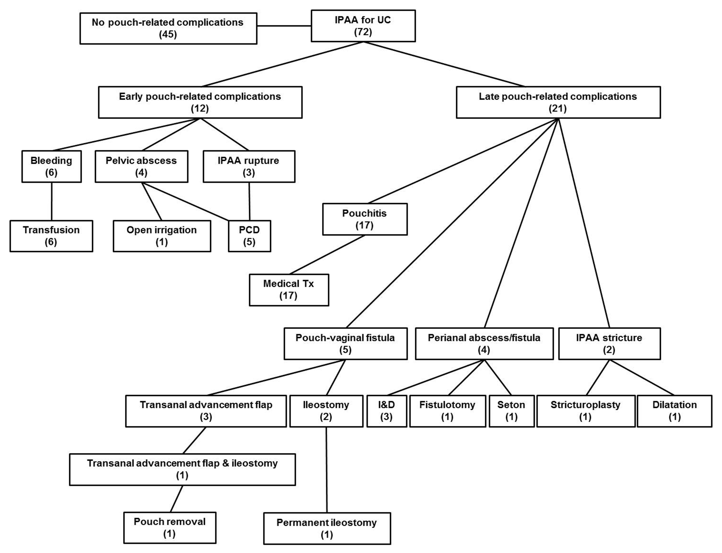
Figure 1 Treatment outcomes for pouch-related complications following ileal pouch-anal anastomosis in Korean patients with ulcerative colitis. Most of the pouch-related complications were treated successfully and pouch failure developed in two patients. IPAA: Ileal pouch-anal anastomosis; UC: Ulcerative colitis; PCD: Per-cutaneous drainage; Tx: Treatment; I and D: Incision and drainage.

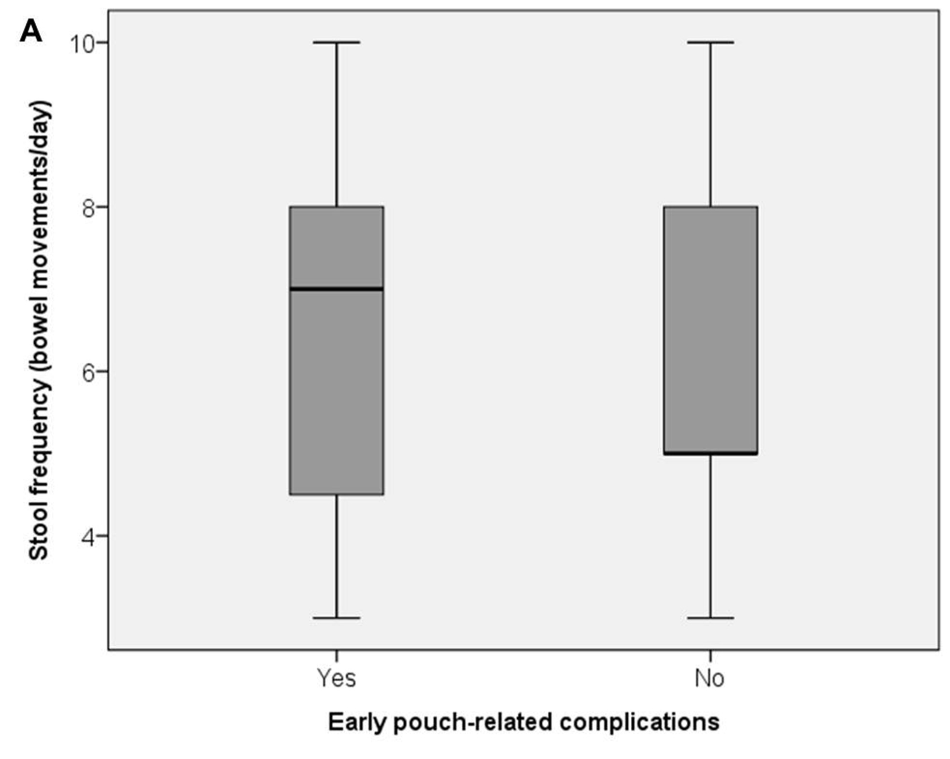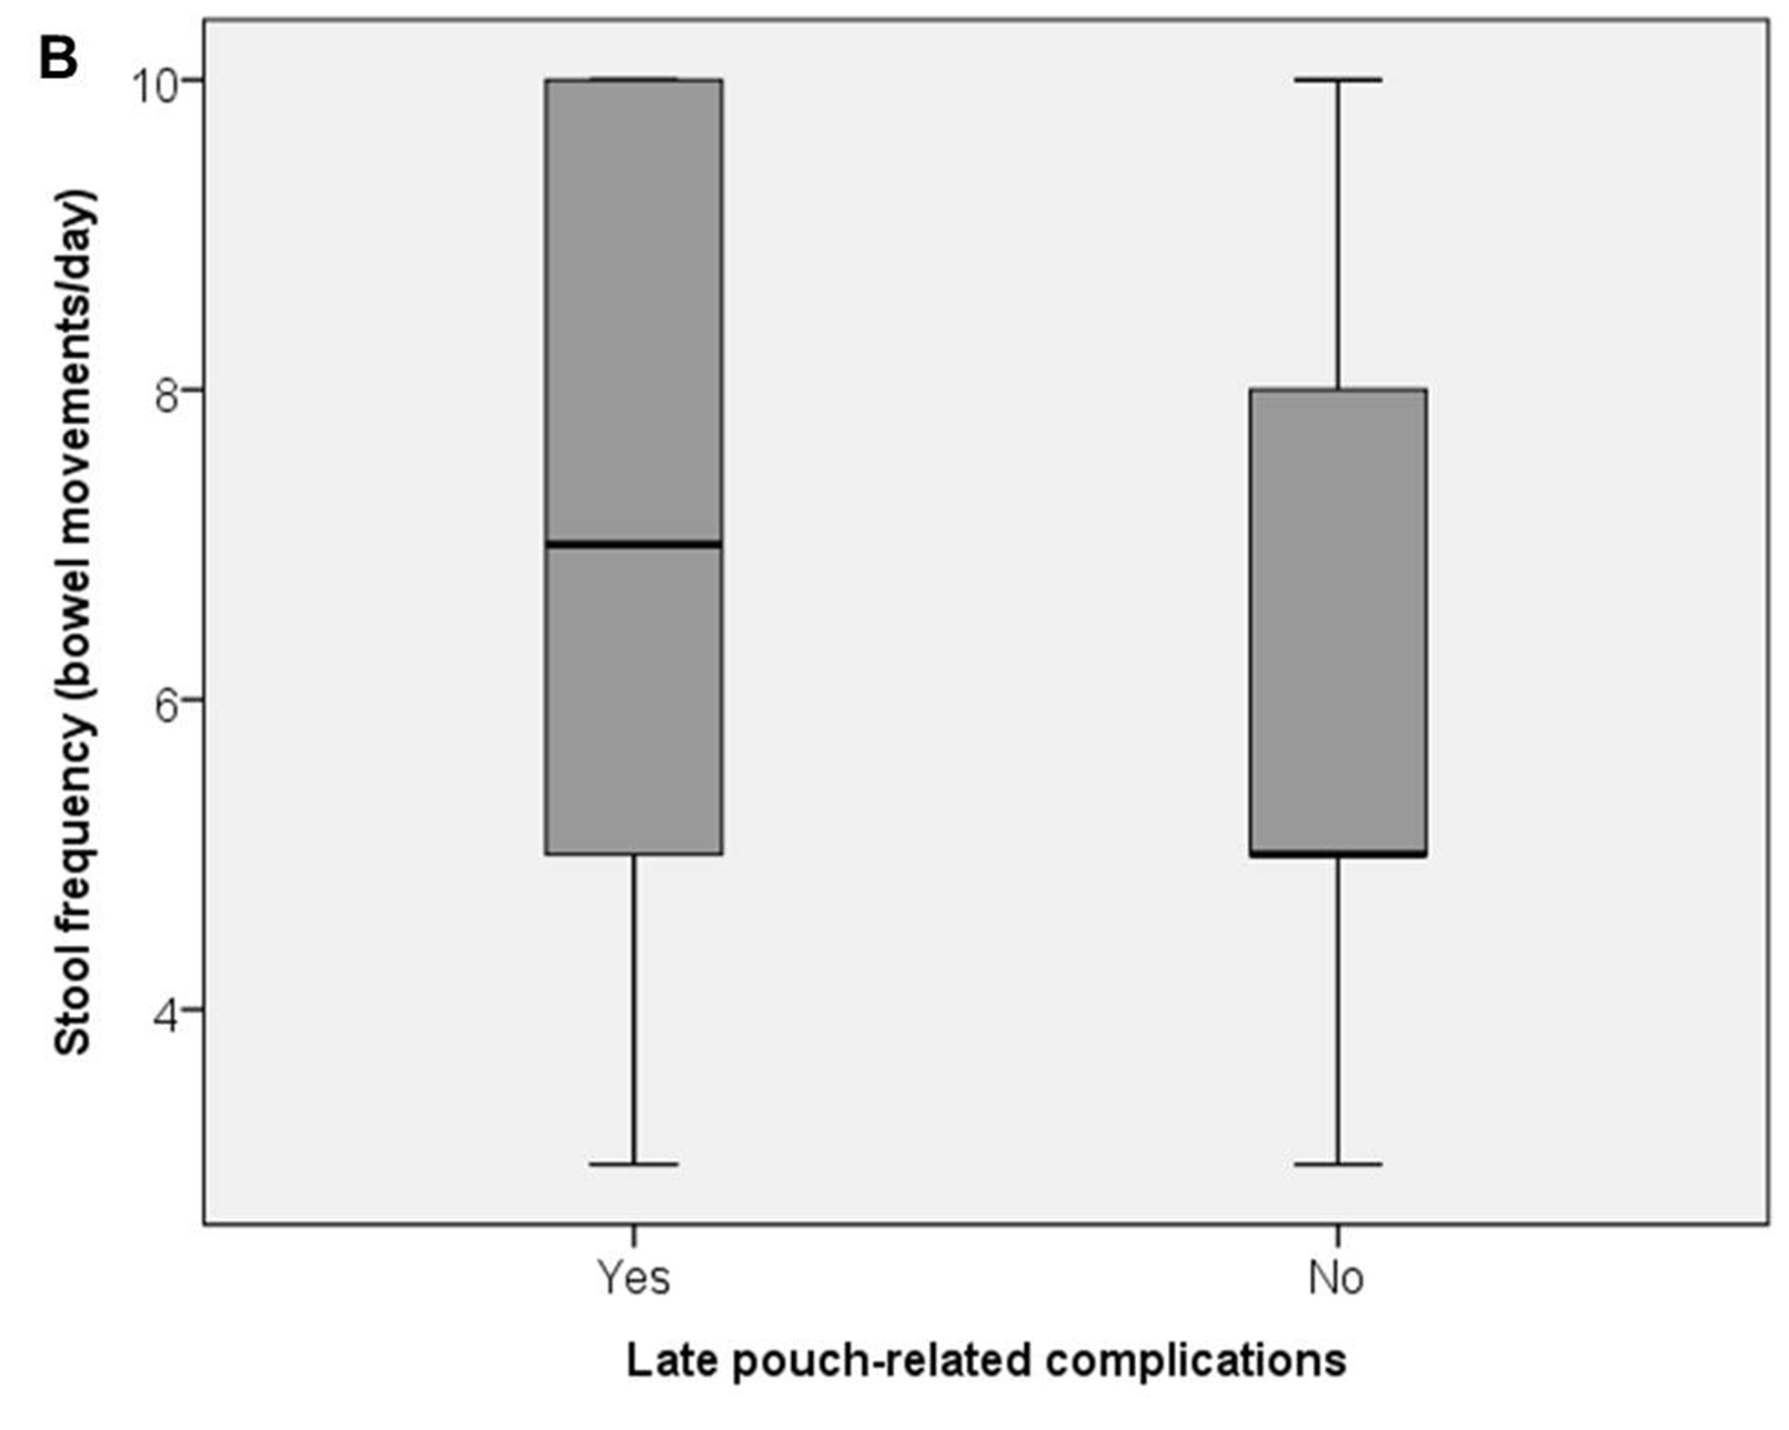
A B
Figure 2 Stool frequencies after ileal pouch-anal anastomosis. A: Bowel movements/day was compared between patients with early pouch-related complications (n = 12) and early pouch-related complication-free patients (n = 59) (7.0 ± 2.3 vs 5.0 ± 2.2 movements/d); B: Bowel movements/day was compared between patients with late pouch-related complications (n = 21) and late pouch-related complication-free patients (n = 50) (7.0 ± 2.4 vs 5.0 ± 2.1 movements/d).

