Name of Journal: World Journal of Gastrointestinal Surgery
Manuscript NO: 80396
Manuscript Type: META-ANALYSIS

Network meta-analysis of the prognosis of curative treatment strategies for recurrent hepatocellular carcinoma after hepatectomy

Chen JL et al. Network meta-analysis of recurrent HCC

Jen-Lung Chen, Yaw-Sen Chen, Chen-Guo Ker

Jen-Lung Chen, Chen-Guo Ker, Department of General Surgery, E-Da Hospital, I-Shou University, Kaohsiung 824, Taiwan

Yaw-Sen Chen, Department of Surgery, School of Medicine, I-Shou University, Kaohsiung 824, Taiwan

Author contributions: Chen JL contributed to the research design, analysis, and manuscript revision; Chen YS contributed to the interpretation and conception; Ker CG contributed to the search and evaluation, analysis, and manuscript preparation.

Supported by the Research Fund from E-Da Hospital, No. EDAHS110012.

Corresponding author: Chen-Guo Ker, FACS, MD, PhD, Professor, Department of General Surgery, E-Da Hospital, I-Shou University, Yi-Da Road, Jian-Su Village, Yan-Chio District, Kaohsiung 824, Taiwan. ed112739@edah.org.tw

Received: September 26, 2022
Revised: November 28, 2022
Accepted: January 16, 2023
Published online:

Abstract
BACKGROUND
Recurrent hepatocellular carcinoma (rHCC) is a common outcome after curative treatment. Retreatment for rHCC is recommended, but no guidelines exist.

AIM
To compare curative treatments such as repeated hepatectomy (RH), radiofrequency ablation (RFA), transarterial chemoembolization (TACE) and liver transplantation (LT) for patients with rHCC after primary hepatectomy by conducting a network meta-analysis (NMA).

METHODS
From 2011 to 2021, 30 articles involving patients with rHCC after primary liver resection were retrieved for this NMA. The Q test was used to assess heterogeneity among studies, and Egger’s test was used to assess publication bias. The efficacy of rHCC treatment was assessed using disease-free survival (DFS) and overall survival (OS).

RESULTS
From 30 articles, a total of 17, 11, 8, and 12 arms of RH, RFA, TACE, and LT subgroups were collected for analysis. Forest plot analysis revealed that the LT subgroup had a better cumulative DFS and 1-year OS than the RH subgroup, with an odds ratio (OR) of 0.96 (95%CI: 0.31-2.96). However, the RH subgroup had a better 3-year and 5-year OS compared to the LT, RFA, and TACE subgroups. Hierarchic step diagram of different subgroups measured by the Wald test yielded the same results as the forest plot analysis. LT had a better 1-year OS (OR: 1.04, 95%CI: 0.34-03.20), and LT was inferior to RH in 3-year OS (OR: 10.61, 95%CI: 0.21-1.73) and 5-year OS (OR: 0.95, 95%CI: 0.39-2.34). According to the predictive P score evaluation, the LT subgroup had a better DFS, and RH had the best OS. However, meta-regression analysis revealed that LT had a better DFS (P < 0.001) as well as 3-year OS (P = 0.881) and 5-year OS (P = 0.188). The differences in superiority between DFS and OS were due to the different testing methods used.

CONCLUSION
According to this NMA, RH and LT had better DFS and OS for rHCC than RFA and TACE. However, treatment strategies should be determined by the recurrent tumor characteristics, the patient’s general health status, and the care program at each institution.

Key Words: Hepatocellular carcinoma; Recurrence; Network meta-analysis; Curative treatment; Outcome; Survival rate

Chen JL, Chen YS, Ker CG. Network meta-analysis of the prognosis of curative treatment strategies for recurrent hepatocelluar carcinoma after hepatectomy. World J Gastrointest Surg 2023; In press

Core Tip: Network meta-analysis was used to compare treatments for recurrent hepatocellular carcinoma including repeated hepatectomy, radiofrequency ablation, transarterial chemoembolization, and liver transplantation. Thirty articles published from 2012-2021 were included in the analysis. Disease-free survival and overall survival were compared using forest plot analysis and hierarchic step diagram of subgroups by the Wald test, forest plot analysis, and predictive P score for subgroup analysis. Repeated hepatectomy or liver transplantation had better disease-free survival and overall survival compared to the others based on the testing methods from this network meta-analysis.

INTRODUCTION
In Taiwan, hepatocellular carcinoma (HCC) was one of the most common causes of cancer-related deaths in 2019, ranking second in men and fourth in women^{[1]}. Despite improvements in hepatitis control and care programs in Taiwan through antiviral therapy and vaccination projects, HCC remains a critical public health issue with a poor prognosis. Recurrent HCC (rHCC) after primary treatment is common in most patients, often resulting in a life-threatening situation and a major global health problem. According to Eastern and Western studies, the recurrence rates after primary hepatectomy are 70% or higher within 5 years^{[2-6]}. Retreatment methods are crucial for improved survival, but the option of a retreatment method should be established where possible^{[7]}.
Currently, a precise treatment strategy for rHCC, including surgical or non-surgical methods, is controversial^{[8-10]}. However, once an rHCC lesion is diagnosed during an imaging study, an effective treatment method should be implemented without delay. The therapeutic options for primary HCC are clearly dependent on the specified staging and international guidelines. Curative techniques such as liver transplantation (LT), hepatectomy, and radiofrequency ablation (RFA), among others, have been established^{[11-13]}. Consequently, rHCC management necessitates specific guidance based on risk factors such as recurrence time, tumor nature, and the patient profile^{[13]}. Therefore, a better treatment option for rHCC would be advantageous, but a guideline for clinical decision-making is still lacking.
In evidence-based medicine, network meta-analysis (NMA) of clinical studies is used to reach a conclusion based on multiple treatment comparisons^{[14]}. It quickly garners insight for clinical decision-making by synthesizing both direct evidence from head-to-head trials and indirect evidence from indirect comparisons with treatment comparators^{[15-17]}. The majority of studies are traditional two-arm meta-analyses, but NMA integrates multiple arms, including surgical and non-surgical arms, and provides a useful ranking of intervention methods for patients with rHCC^{[18]}. Many institutions have adopted the consensus guidelines for primary HCC^{[11,12,19,20]}. However, these guidelines are not useful for rHCC.
Treatment options for rHCC include repeated hepatectomy (RH), RFA, transarterial chemoembolization (TACE), LT, radiation therapy, and systemic target or immunotherapy^{[21-24]}. When compared with other treatments, LT resulted in better overall survival (OS) in rHCC, whereas TACE was significantly worse than LT, RH, and RFA^{[8]}. Accordingly, treatment strategies should be chosen based on the tumor characteristics and the patient profile at the time of recurrence.
In the recent decade, many studies comparing different treatment options for rHCC have been published. Four curative retreatment methods, including RH, RFA, TACE, and LT, are now routinely adopted in current practice and are coded globally^{[8,9,25-27]}. Therefore, we aimed to conduct an NMA to compare four curative retreatment methods for patients with rHCC after primary hepatectomy.

MATERIALS AND METHODS
Search strategy and data extraction
A systematic search for rHCC treatment on PubMed, EMBASE, and the Cochrane Library Databases from 2012 to 2021 was conducted, and all relevant clinical cohorts or observational studies were identified. The keywords of article searching were HCC, recurrent hepatocellular carcinoma, liver cancer, recurrence, liver resection, hepatectomy, repeated hepatectomy, repeated liver resection, radio-frequency ablation, RFA, trans-arterial chemo-embolization, TACE, chemotherapy, chemoembolization, or liver transplantation. In this NMA, articles included should meet the following criteria: (1) Patients had an intrahepatic rHCC after initial liver resection; (2) Randomized controlled or observational clinical studies; (3) Must compare one of the four curative rHCC treatments, including RH, RFA, TACE, and LT; and (4) Have prognosis or outcome results. The exclusion criteria were as follows: (1) Conference abstracts, commentaries, case reports, reviews, or meta-analyses; and (2) Insufficient main outcome data for data extraction. If there were more than two studies from the same institution, the data were extracted from the most recent one. After reviewing the retrieved full articles, a final decision on eligibility for analysis was made.
The topics of each article were appropriately categorized in order to select the articles concerned with the retreatment methods of RH, RFA, TACE, or LT. For each study arm’s outcome, the title, first author, publication year, intervention methods, outcomes, and associated risk factors, if available, were extracted. The study’s endpoints were the disease-free survival (DFS) and OS rates for each subgroup. In addition, data for DFS were collected from 49 arms pooled for comparison in all studies, including recurrence-free survival in one arm of RH and RFA and two arms of LT, progression-free survival in one arm of TACE, and tumor-free survival in one arm of LT.
In addition, we conducted a relevant search by Reference Citation Analysis (https://www.referencecitationanalysis.com/) to supplement the latest cutting-edge research results.

Quality assessment
For quality assessment in the meta-analysis, two statistical models based on heterogeneity could be used: the fixed effects and random effects models. In the fixed effects model, all studies in the meta-analysis shared the same true effect size, whereas in the random effects model the true effect size varies from study to study. The heterogeneity among trials was assessed using the Q test with I² values, which represents the proportion of total variation in studies based on estimated heterogeneity^{[28]}. An I² statistic of more than 50% or a P value of less than 0.05 indicated significant heterogeneity among trials, and the random effects model was used. The overall heterogeneity and publication bias of the effects model were used to assess the size deviation of the inconsistency in the variance parameter. After comparing each subgroup, ranking diagrams of presumed therapeutic effects were created based on the probability of superiority.

Statistical analysis
In this NMA, the data were analyzed using R software (version 3.0.2; R Foundation, Vienna, Austria) and comprehensive meta-analysis (Biostat Inc., 4 North Dean Street, Englewood, NJ, United States). The Q test is the sum of a heterogeneity measurement, which represents the variability of treatment effect between direct and indirect comparisons in a meta-analysis based on an I² statistic of more than 50% or P value^{[28]}. A frequent analog to the surface under the cumulative ranking curve could be replaced by a P score, which measured whether a treatment was better than the comparative treatments^{[14,16]}. Another predictive P score was 100% when a treatment was certain to be the best and 0% when it was certain to be the worst^{[16,29]}. The forest plot displayed a summary of the overall estimation and was compared by treatment method subgroup. A hierarchic step diagram of the cumulative comparative efficacy of treatment methods based on effect size was displayed with odds ratios (OR) and 95%CI, which were used to measure superiority in decision-making with the Wald test^{[30]}. For each arm, publication bias was assessed using Egger’s test and illustrated with a funnel plot analysis^{[31,32]}. The statistically significant level was set at 0.05 for all treatment comparisons.

RESULTS
Profiles of eligible articles of treatment methods in all studies
After the initial search, a total of 2671 published articles relating to rHCC treatment from 2012 to 2021 were retrieved. After duplicate removal and initial screening, 157 relevant articles were selected based on the selection criteria. Finally, 30 articles involving patients with intrahepatic rHCC after primary liver resection were included. Data were extracted from these studies and pooled for analysis. There were 4, 10, and 16 studies, with three, two, and one arm, respectively. These 30 articles were assembled and divided into 17, 11, 8, and 12 subgroups with the interventions RH, RFA, TACE, and LT, respectively, as shown in Figure 1. The basic characteristics of all studies are listed in Supplementary Table 1^{[3,6,9,21-22,24,26-27,33-54]}. There were 14, 4, 4, 5, 2, and 1 articles from China, Taiwan, Korea, Japan, France, and Germany, respectively. The patients’ characteristics and the cumulative mean value of the subgroups are summarized in Table 1. The total numbers of patients were 1405, 1013, 1123, and 1484 in the RH, RFA, TACE, and LT subgroups, respectively. Males were dominant in all groups, with prevalence ranging from 79.9% to 89.1%. The mean recurrence times after primary liver resection were 26.0 ± 8.3, 18.1 ± 6.5, 14.7 ± 6.6, and 19.4 ± 10.4 mo in the RH, RFA, TACE, and LT subgroups, respectively. The other relative factors of patients in each subgroup are listed in Table 1.

DFS and OS of rHCC after retreatment
The cumulative means of DFS and OS rates were assessed using the Wilcoxon rank sum test, as illustrated in Figure 2. The pooled 1-year, 3-year, and 5-year DFS in patients with rHCC were found to be the best in the LT subgroup, with 76.3 ± 8.8%, 57.1 ± 13.3%, and 51.2 ± 16.0%, respectively (Figure 2A). The pooled OS rates were found to be better in the RFA subgroup, with a 1-year OS of 91.1 ± 7.4%, and in the RH subgroup, with a 3-year OS of 71.9 ± 13.7% and a 5-year OS of 53.2 ± 17.6% (Figure 2B), with a significant difference in the 5-year OS between the RH and LT subgroups (P = 0.019). However, TACE was found to be inferior in both DFS and OS rates.

Comparison favorability of pooled outcome displayed with forest plot
The forest plot analysis revealed that LT had a higher DFS than other treatment methods (Figure 3A-C). In addition, the RH subgroup had a better 1-year OS than the LT (OR: 0.96, 95%CI: 0.31-2.96), RFA (OR: 1.19, 95%CI: 2.71-2.00), and TACE (OR: 2.56, 95%CI: 1.26-5.20) subgroups (Figure 3D). RH subgroup had a more favorable 3-year and 5-year OS than the LT (OR: 1.64, 95%CI: 0.56-4.66 and OR: 1.05, 95%CI: 0.43-2.56), RFA, and TACE subgroups (Figure 3E and F).

Hierarchic step diagram for comparison with the Wald test
The Wald test was used to compare the OS between the four interventional arms: RH, RFA, TACE, and LT. The results of cumulative comparisons between each treatment were displayed using a hierarchical step diagram in Figure 4. Compared to other treatments, RH had an expressed ranking probability with OR and 95%CI. LT had the better in 1-year OS (OR: 1.04, 95%CI: 0.34-03.20), and RH had a higher ranking probability based on 3-year OS (OR: 0.61, 95%CI: 0.21-1.73) or 5-year OS (OR: 0.95, 95%CI: 0.39-2.34), while TACE had the lowest probability of the better OS.

Predictive P score
Based on the predictive P score evaluation, the LT group had the best 1-year, 3-year, and 5-year DFS (Table 2). TACE data were insufficient for DFS analysis. In terms of OS, RH had the highest P scores of 0.739, 0.932, and 0.8331 for 1-year, 3-year, and 5-year OS, respectively. TACE had the lowest P scores for OS.

Meta-regression analysis
Meta-regression analysis provided a sensitivity analysis for model specification^{[29]}. Compared to other treatments, LT had better results than RH in 1-year, 3-year, and 5-year DFS with β = 0.93 (P = 0.001), β = 1.181 (P < 0.001), and β = 1.258 (P < 0.001) respectively. LT compared with RH was inferior for 1-year OS with β = -0.036 (P = 0.913) but superior for 3-year OS with β = 0.04 (P = 0.881) and 5-year OS with β = 0.392 (P = 0.188), respectively. From this study, LT had better results for DFS (P < 0.001) and 3-year and 5-year overall survival (P > 0.05). RH had a better result for 1-year OS (P > 0.05) than other treatment options (Table 3).

Heterogeneity and publication bias
The heterogeneity among studies was estimated based on I² values using the Q test. The I² values for 1-year, 3-year, and 5-year DFS were 86.65%, 94.86%, and 95.81%, respectively, and for 1-year, 3-year, and 5-year OS, they were 79.07%, 89.72%, and 93.43%, respectively (Table 4). Therefore, the random effects models were used for analysis based on a P value of less than 0.05 obtained from the I² value among retreatment methods. The Z value indicated the pooled effect size of all subgroups, and further details are listed in Supplementary Table 2. A detailed analysis of heterogeneity using a forest plot for DFS and OS is available in Supplementary Figures 1-6. The publication bias was assessed by Egger’s regression test and resulted in 1-year, 3-year, and 5-year OS P values of 0.8459, 0.0562, and 0.3574, respectively. Funnel plot graphs were used for displaying publication bias among all studies. The number of potential missing studies for the association between analysis of treatment methods of 1-year, 3-year, and 5-year OS were depicted in the Figure 5A-C.

DFS and OS summary of subgroups among all testing methods
The best-pooled outcomes of the four retreatment methods analyzed by multiple testing methods are summarized in Table 5. In general, the LT subgroup had superior DFS (P < 0.001), whereas the RH subgroup had superior OS without a significant difference compared to other treatments.

DISCUSSION
NMA models are simple to implement in clinical decision-making as a treatment strategy for patients with rHCC after primary liver resection^{[8,55]}. The high recurrence rate has consistently undermined patient survival, making rHCC a major global healthcare problem. In terms of the optimal strategy for rHCC, LT had the best OS, followed by RH and RFA, while TACE had the worst^{[8]}. Compared to RH and RFA, the LT subgroup had a superior DFS but not OS^{[42,45,47,56]}. However, patients with rHCC treated with RH had a better OS, with no significant difference between the testing methods in our study, which is consistent with other studies^{[9]}. The salvage LT group had a significantly higher 3-year and 5-year DFS than the RH subgroup with significant difference^{[57]}. Although LT appears to have better survival, operative mortality still existed and ranged from 1.9% to 11.0%, which is higher than that in the RH group (ranging from 0% to 6.0%), with a significant difference^{[22,42,45,47]}.
Currently, LT is considered the best treatment for rHCC, but it is challenging due to organ shortages. Therefore, the number of patients who meet the transplantation criteria at the time of recurrence is low, particularly in Asian countries^{[40,42,45,58]}. There was no significant difference in DFS or OS between the patients who underwent primary LT and those who underwent primary resection and LT performed after recurrence from primary resection^{[27]}. Surgical resection has been shown to be a viable procedure in the treatment of primary HCC or rHCC, with better survival than non-surgical methods in general^{[9,52,53]}.
The patients with rHCC who were treated again with a curative RH or LT approach had evident survival advantages. When the Japan Society of Hepatology guideline for primary HCC is applied to rHCC, either RFA or TACE are generally indicated in Child-Pugh Class A or B patients with 2-3 tumors of 3 cm or less in diameter or 4 tumors or more, and TACE may be indicated in some patients even with minor vascular invasion^{[12]}. According to the European Association for the Study of the Liver guideline for primary HCC, most patients with rHCC had a similar recurrent tumor burden, favoring non-surgical treatment^{[59]}. In this study, the cumulative means of recurrent tumor size and the percentage of single nodules were 21.5-32.2 mm and 62.2%-78.6%, respectively. Recurrent tumor size is one of the most significant prognostic factors associated with survival^{[6,9,60]}. Currently, surgical resection is the first option in both primary and rHCC. An NMA revealed that RH is the most feasible intervention for recurrence after primary resection and is widely used to compare other treatments^{[8]}. Nevertheless, RFA or TACE are less invasive and have fewer complications but have a lower survival rate.
Tumor recurrence after HCC resection has been proven to be unpreventable^{[13]}. Based on the retreatment methods, the recurrence time after primary resection had a strong impact on survival. There is no universal definition of early and late recurrence after resection, and recurrence time ranges from 8 to 24 mo^{[13,61-64]}. According to an international study, curative procedures mostly benefited patients who relapsed after 8 mo^{[61]}. However, Yamashita et al^{[42]} reported that the recurrence time may effectively identify patients with a poor prognosis who relapse before 17 mo. Because intrahepatic recurrence is often associated with aggressive cancer cell biological behavior and a poor prognosis^{[62,64]}, the potential effect of curative procedures such as RH, LT, or RFA may be considered, especially when the recurrence is within 1 year^{[35,65]}.
On the basis of ongoing hepatocarcinogenesis, late rHCC occurring more than 1 year after primary resection in the context of cirrhosis is regarded as a de novo tumor occurrence of different clonal origin^{[64,66,67]}. In addition, before deciding on retreatment methods, it is possible to overlook de novo minute nodules. In this situation, TACE will have unexpected benefits for the simultaneous treatment of ignored minute nodules alongside the main recurrent tumor. Therefore, the 5-year OS is significantly lower in patients with early recurrence and ranges from 4.5%-15.4% to 27.1%-36.3% compared to late recurrence, according to previous studies^{[64,68,69]}.
For patients with intrahepatic rHCC, a multicentric occurrence pattern is associated with better long-term outcomes than the intrahepatic metastasis pattern. LT is the preferred option for intrahepatic rHCC, especially for multicentric occurrence patients^{[70]}. Appropriate rHCC management strategies are important for improving long-term survival if available data can be used to aid clinical decision-making^{[7]}. Nevertheless, in most institutions, treatment strategy with RH and RFA could be the first-line treatment for rHCC. There is no difference between the LT and curative locoregional therapy (RFA or TACE) groups regarding 1-year and 3-year OS. However, the 5-year OS and 1-year, 3-year, and 5-year DFS were significantly higher after salvage LT than after locoregional therapy^{[57]}. The feasibility of a retreatment method is determined by the number and location of the recurrent tumor, liver function, remnant liver volume, and the patient’s general health status at the time of recurrence.
In this study, about one-third of the patients at the time of recurrence had multiple or moderate-to-large nodular tumors, impaired liver function, or were unable to receive surgical curative treatment. rHCC patients treated by a palliative approach (TACE or target therapy) or having a median size of the recurrent nodule > 5 cm have a significantly decreased OS compared with curative treatment methods^{[58]}. Non-surgical methods such as RFA or TACE were effective as non-radical treatments for these patients. TACE, while not as effective as other curative treatments, significantly improves survival in patients with unresectable rHCC^{[41,49,54]}. TACE was also recommended in rHCC as a treatment for downstaging before curative LT, according to the treatment flowchart based on the Barcelona Clinic Liver Cancer staging and treatment strategy published in 2022^{[59]}.
rHCC can be caused by multicentric carcinogenesis or inadequate initial treatment. Prevention of rHCC necessitates early diagnosis and complete anatomic resection of primary HCC lesions with a safety margin^{[71]}. Currently, there are no solid and effective chemotherapeutic agents available to prevent rHCC. However, molecularly targeted drugs and anti-hepatitis B/C virus oral nucleoside/nucleotide analogs agents are recommended, but they are expensive and not promising. Therefore, the only option is to detect tumors as early as possible, and tumors can be treated based on the facilities at each institution.
The most common limitation of NMA is unexplained heterogeneity for available pairwise comparisons, which random effects meta-analysis models can accommodate^{[72]}. In NMA studies, we should place more emphasis on treatment effects and consider the possibility of uncertainty with less emphasis on the probabilities of an NMA output. Clinical decision-making highlights the complexities of recommending a treatment method at the individual level based on tumor burden and patient condition.

CONCLUSION
In conclusion, patients with rHCC treated with RH or LT had comparably favorable DFS and OS. Currently, no solid algorithm can be expected to provide a guideline for patients with rHCC. Treatment strategies with RH, LT, RFA, or TACE are determined by factors such as liver function, tumor burden, metastasis, vascular invasion, and others. A multiparametric evaluation should be in place for personalized treatment of patients with rHCC, and it should be integrated into multidisciplinary tumor boards and partners in care programs at each institution.

ARTICLE HIGHLIGHTS
Research background
Recurrent hepatocellular carcinoma (rHCC) is a common outcome after curative treatment. Retreatment for rHCC is controversial, and no guidelines are currently available.

Research motivation
Acceptable decision making for treatment of rHCC patients is a priority.

Research objectives
Our objectives were to conduct a network meta-analysis (NMA) to compare curative treatments including repeated hepatectomy (RH), radiofrequency ablation, transarterial chemoembolization (TACE), and liver transplantation (LT) for patients with rHCC after primary hepatectomy.

Research methods
There were 30 articles involving patients with rHCC after primary liver resection from 2011 to 2021 that were retrieved for this NMA.

Research results
The best-pooled outcomes of four retreatment methods were analyzed by multiple testing methods. In general, the LT subgroup had superior disease-free survival (DFS) (P < 0.001), whereas the RH subgroup had superior overall survival (OS) without significant differences compared to other treatments.

Research conclusions
RH and LT had better DFS and OS for rHCC than radiofrequency ablation and TACE. However, treatment strategies should be determined by the recurrent tumor characteristics, the patient’s general health status, and the care program of each institution.

Research perspectives
Retreatment with RH, LT, radiofrequency ablation, or TACE are determined by factors such as liver function, tumor burden, metastasis, vascular invasion, and others. A multiparametric evaluation should be in place for personalized treatment of patients with rHCC and re-evaluated in the future.

ACKNOWLEDGEMENTS
The authors would like to express our sincere appreciation to Chien-Hao Chen, PhD and I-Pur Chen, MS for their valuable assistance with this analysis. In addition, the authors express sincere appreciation to the research fund from E-Da Hospital (EDAHS110012).

REFERENCES
1 Health Promotion Administration Ministry of Health and Welfare Taiwan Cancer Registry Annual Report, 2019, Taiwan. 2021: 2-5 [cited 21 Jun 2022]. Available from: https://wwwhpagovtw/Pages/Detailaspx?nodeid=269&pid=14913
2 Roayaie S, Blume IN, Thung SN, Guido M, Fiel MI, Hiotis S, Labow DM, Llovet JM, Schwartz ME. A system of classifying microvascular invasion to predict outcome after resection in patients with hepatocellular carcinoma. Gastroenterology 2009; 137: 850-855 [PMID: 19524573 DOI: 10.1053/j.gastro.2009.06.003]
3 Zhang X, Li C, Wen T, Yan L, Li B, Yang J, Wang W, Xu M, Lu W, Jiang L. Appropriate treatment strategies for intrahepatic recurrence after curative resection of hepatocellular carcinoma initially within the Milan criteria: according to the recurrence pattern. Eur J Gastroenterol Hepatol 2015; 27: 933-940 [PMID: 25933127 DOI: 10.1097/MEG.0000000000000383]
4 Kaibori M, Kon M, Kitawaki T, Kawaura T, Hasegawa K, Kokudo N, Ariizumi S, Beppu T, Ishizu H, Kubo S, Kamiyama T, Takamura H, Kobayashi T, Kim DS, Wang HJ, Kim JM, Han DH, Park SJ, Kang KJ, Hwang S, Roh Y, You YK, Joh JW, Yamamoto M. Comparison of anatomic and non-anatomic hepatic resection for hepatocellular carcinoma. J Hepatobiliary Pancreat Sci 2017; 24: 616-626 [PMID: 28887834 DOI: 10.1002/jhbp.502]
5 Minagawa M, Makuuchi M, Takayama T, Kokudo N. Selection criteria for repeat hepatectomy in patients with recurrent hepatocellular carcinoma. Ann Surg 2003; 238: 703-710 [PMID: 14578733 DOI: 10.1097/01.sla.0000094549.11754.e6]
6 Ho CM, Lee PH, Shau WY, Ho MC, Wu YM, Hu RH. Survival in patients with recurrent hepatocellular carcinoma after primary hepatectomy: comparative effectiveness of treatment modalities. Surgery 2012; 151: 700-709 [PMID: 22284764 DOI: 10.1016/j.surg.2011.12.015]
7 Tranchart H, Chirica M, Sepulveda A, Massault PP, Conti F, Scatton O, Soubrane O. Long-term outcomes following aggressive management of recurrent hepatocellular carcinoma after upfront liver resection. World J Surg 2012; 36: 2684-2691 [PMID: 22851144 DOI: 10.1007/s00268-012-1723-9]
8 Zheng J, Cai J, Tao L, Kirih MA, Shen Z, Xu J, Liang X. Comparison on the efficacy and prognosis of different strategies for intrahepatic recurrent hepatocellular carcinoma: A systematic review and Bayesian network meta-analysis. Int J Surg 2020; 83: 196-204 [PMID: 32980518 DOI: 10.1016/j.ijsu.2020.09.031]
9 Matsumoto M, Yanaga K, Shiba H, Wakiyama S, Sakamoto T, Futagawa Y, Gocho T, Ishida Y, Ikegami T. Treatment of intrahepatic recurrence after hepatectomy for hepatocellular carcinoma. Ann Gastroenterol Surg 2021; 5: 538-552 [PMID: 34337303 DOI: 10.1002/ags3.12449]
10 Philips CA, Rajesh S, Nair DC, Ahamed R, Abduljaleel JK, Augustine P. Hepatocellular carcinoma in 2021: An exhaustive update. Cureus 2021; 13: e19274 [PMID: 34754704 DOI: 10.7759/cureus.19274]
11 Shao YY, Wang SY, Lin SM; Diagnosis Group,; Systemic Therapy Group. Management consensus guideline for hepatocellular carcinoma: 2020 update on surveillance, diagnosis, and systemic treatment by the Taiwan Liver Cancer Association and the Gastroenterological Society of Taiwan. J Formos Med Assoc 2021; 120: 1051-1060 [PMID: 33199101 DOI: 10.1016/j.jfma.2020.10.031]
12 Kudo M, Kawamura Y, Hasegawa K, Tateishi R, Kariyama K, Shiina S, Toyoda H, Imai Y, Hiraoka A, Ikeda M, Izumi N, Moriguchi M, Ogasawara S, Minami Y, Ueshima K, Murakami T, Miyayama S, Nakashima O, Yano H, Sakamoto M, Hatano E, Shimada M, Kokudo N, Mochida S, Takehara T. Management of hepatocellular carcinoma in Japan: JSH consensus statements and recommendations 2021 update. Liver Cancer 2021; 10: 181-223 [PMID: 34239808 DOI: 10.1159/000514174]
13 Tampaki M, Papatheodoridis GV, Cholongitas E. Intrahepatic recurrence of hepatocellular carcinoma after resection: an update. Clin J Gastroenterol 2021; 14: 699-713 [PMID: 33774785 DOI: 10.1007/s12328-021-01394-7]
14 Rücker G, Schwarzer G. Ranking treatments in frequentist network meta-analysis works without resampling methods. BMC Med Res Methodol 2015; 15: 58 [PMID: 26227148 DOI: 10.1186/s12874-015-0060-8]
15 Seide SE, Jensen K, Kieser M. A comparison of Bayesian and frequentist methods in random-effects network meta-analysis of binary data. Res Synth Methods2020; 11: 363-378 [PMID: 31955519 DOI: 10.1002/jrsm.1397]
16 Rosenberger KJ, Duan R, Chen Y, Lin L. Predictive P-score for treatment ranking in Bayesian network meta-analysis. BMC Med Res Methodol 2021; 21: 213 [PMID: 34657593 DOI: 10.1186/s12874-021-01397-5]
17 Jansen JP, Crawford B, Bergman G, Stam W. Bayesian meta-analysis of multiple treatment comparisons: an introduction to mixed treatment comparisons. Value Health 2008; 11: 956-964 [PMID: 18489499 DOI: 10.1111/j.1524-4733.2008.00347.x]
18 Katsanos K, Kitrou P, Spiliopoulos S, Maroulis I, Petsas T, Karnabatidis D. Comparative effectiveness of different transarterial embolization therapies alone or in combination with local ablative or adjuvant systemic treatments for unresectable hepatocellular carcinoma: A network meta-analysis of randomized controlled trials. PloS One 2017; 12: e0184597 [PMID: 28934265 DOI: 10.1371/journal.pone.0184597]
19 European Association for the Study of the Liver. Electronic address: easloffice@easloffice.eu; European Association for the Study of the Liver. EASL Clinical practice guidelines: Management of hepatocellular carcinoma. J Hepatol 2018; 69: 182-236 [PMID: 29628281 DOI: 10.1016/j.jhep.2018.03.019]
20 Xie DY, Ren ZG, Zhou J, Fan J, Gao Q. 2019 Chinese clinical guidelines for the management of hepatocellular carcinoma: updates and insights. Hepatobiliary Surg Nutr 2020; 9: 452-463 [PMID: 32832496 DOI: 10.21037/hbsn-20-480]
21 Eisele RM, Chopra SS, Lock JF, Glanemann M. Treatment of recurrent hepatocellular carcinoma confined to the liver with repeated resection and radiofrequency ablation: a single center experience. Technol Health Care 2013; 21: 9-18 [PMID: 23358055 DOI: 10.3233/THC-120705]
22 Ma KW, Chok KSH, She WH, Chan ACY, Cheung TT, Dai WC, Fung JYY, Lo CM. Defining optimal surgical treatment for recurrent hepatocellular carcinoma: A propensity score matched analysis. Liver Transpl 2018; 24: 1062-1069 [PMID: 29451360 DOI: 10.1002/lt.25033]
23 Shen PC, Chang WC, Lo CH, Yang JF, Lee MS, Dai YH, Lin CS, Fan CY, Huang WY. Comparison of stereotactic body radiation therapy and transarterial chemoembolization for unresectable medium-sized hepatocellular carcinoma. Int J Radiat Oncol Biol Phys 2019; 105: 307-318 [PMID: 31175903 DOI: 10.1016/j.ijrobp.2019.05.066]
24 Ryu T, Takami Y, Wada Y, Hara T, Sasaki S, Saitsu H. Efficacy of surgical microwave ablation for recurrent hepatocellular carcinoma after curative hepatectomy. HPB (Oxford) 2020; 22: 461-469 [PMID: 31473076 DOI: 10.1016/j.hpb.2019.08.001]
25 Solimando AG, Susca N, Argentiero A, Brunetti O, Leone P, De Re V, Fasano R, Krebs M, Petracci E, Azzali I, Nanni O, Silvestris N, Vacca A, Racanelli V. Second-line treatments for advanced hepatocellular carcinoma: A systematic review and Bayesian network meta-analysis. Clin Exp Med 2022; 22: 65-74 [PMID: 34146196 DOI: 10.1007/s10238-021-00727-7]
26 Kim HS, Yi NJ, Kim JM, Joh JW, Lee KW, Suh KS. Clinical impact of the treatment modality on small, solitary, recurrent intrahepatic hepatocellular carcinomas after primary liver resection. Ann Surg Treat Res 2021; 101: 85-92 [PMID: 34386457 DOI: 10.4174/astr.2021.101.2.85]
27 Hwang S, Song GW, Ahn CS, Kim KH, Moon DB, Ha TY, Jung DH, Park GC, Yoon YI, Lee SG. Salvage living donor liver transplantation for hepatocellular carcinoma recurrence after hepatectomy: Quantitative prediction using ADV score. J Hepatobiliary Pancreat Sci 2021; 28: 1000-1013 [PMID: 33175453 DOI: 10.1002/jhbp.863]
28 Bowden J, Tierney JF, Copas AJ, Burdett S. Quantifying, displaying and accounting for heterogeneity in the meta-analysis of RCTs using standard and generalised Q statistics. BMC Med Res Methodol 2011; 11: 41 [PMID: 21473747 DOI: 10.1186/1471-2288-11-41]
29 Stanley TD, Doucouliagos H, Giles M, Heckemeyer JH, Johnston RJ, Laroche P, Nelson JP, Paldam M, Poot J, Pugh G, Rosenberger RS, Rost K. Meta-Analysis of economics research reporting guidelines. J Econ Surv 2013; 27: 390-394 [DOI: 10.1111/joes.12008]
30 Shoukri MM, Colak D, Kaya N, Donner A. Comparison of two dependent within subject coefficients of variation to evaluate the reproducibility of measurement devices. BMC Med Res Methodol 2008; 8: 24 [PMID: 18430244 DOI: 10.1186/1471-2288-8-24]
31 Begg CB, Mazumdar M. Operating characteristics of a rank correlation test for publication bias. Biometrics 1994; 50: 1088-1101 [PMID: 7786990]
32 Duval S, Tweedie R. A nonparametric “trim and fill” method of accounting for publication bias in meta-analysis. J Am Stat Assoc 2000; 95: 89-98 [DOI: 10.1080/01621459.2000.10473905]
33 Lu G, Ades AE. Combination of direct and indirect evidence in mixed treatment comparisons. Stat Med 2004; 23: 3105-3124 [PMID: 15449338 DOI: 10.1002/sim.1875]
34 Tsujita E, Yamashita Y, Takeishi K, Matsuyama A, Tsutsui S, Matsuda H, Toshima T, Taketomi A, Shirabe K, Ishida T, Maehara Y. Poor prognostic factors after repeat hepatectomy for recurrent hepatocellular carcinoma in the modern era. Am Surg 2012; 78: 419-425 [PMID: 22472398]
35 Huang ZY, Liang BY, Xiong M, Zhan DQ, Wei S, Wang GP, Chen YF, Chen XP. Long-term outcomes of repeat hepatic resection in patients with recurrent hepatocellular carcinoma and analysis of recurrent types and their prognosis: a single-center experience in China. Ann Surg Oncol 2012; 19: 2515-2525 [PMID: 22395985 DOI: 10.1245/s10434-012-2269-7]
36 Chan AC, Poon RT, Cheung TT, Chok KS, Chan SC, Fan ST, Lo CM. Survival analysis of re-resection versus radiofrequency ablation for intrahepatic recurrence after hepatectomy for hepatocellular carcinoma. World J Surg 2012; 36: 151-156 [PMID: 22030561 DOI: 10.1007/s00268-011-1323-0]
37 Hu Z, Zhou J, Xu X, Li Z, Zhou L, Wu J, Zhang M, Zheng S. Salvage liver transplantation is a reasonable option for selected patients who have recurrent hepatocellular carcinoma after liver resection. PloS One 2012; 7: e36587 [PMID: 22574187 DOI: 10.1371/journal.pone.0036587]
38 Lee HS, Choi GH, Joo DJ, Kim MS, Choi JS, Kim SI. The clinical behavior of transplantable recurrent hepatocellular carcinoma after curative resection: implications for salvage liver transplantation. Ann Surg Oncol 2014; 21: 2717-2724 [PMID: 24916744 DOI: 10.1245/s10434-014-3597-6]
39 Wang K, Liu G, Li J, Yan Z, Xia Y, Wan X, Ji Y, Lau WY, Wu M, Shen F. Early intrahepatic recurrence of hepatocellular carcinoma after hepatectomy treated with re-hepatectomy, ablation or chemoembolization: a prospective cohort study. Eur J Surg Oncol 2015; 41: 236-242 [PMID: 25434327 DOI: 10.1016/j.ejso.2014.11.002]
40 Abe T, Tashiro H, Teraoka Y, Hattori M, Tanimine N, Kuroda S, Tahara H, Ohira M, Tanaka Y, Kobayashi T, Ide K, Ishiyama K, Ohdan H. Efficacy and feasibility of salvage living donor liver transplantation after initial liver resection in patients with hepatocellular carcinoma. Dig Surg 2016; 33: 8-14 [PMID: 26551258 DOI: 10.1159/000441397]
41 Koh PS, Chan AC, Cheung TT, Chok KS, Dai WC, Poon RT, Lo CM. Efficacy of radiofrequency ablation compared with transarterial chemoembolization for the treatment of recurrent hepatocellular carcinoma: a comparative survival analysis. HPB (Oxford) 2016; 18: 72-78 [PMID: 26776854 DOI: 10.1016/j.hpb.2015.07.005]
42 Yamashita Y, Yoshida Y, Kurihara T, Itoh S, Harimoto N, Ikegami T, Yoshizumi T, Uchiyama H, Shirabe K, Maehara Y. Surgical results for recurrent hepatocellular carcinoma after curative hepatectomy: Repeat hepatectomy versus salvage living donor liver transplantation. Liver Transpl 2015; 21: 961-968 [PMID: 25772591 DOI: 10.1002/lt.24111]
43 Song KD, Lim HK, Rhim H, Lee MW, Kim YS, Lee WJ, Paik YH, Gwak GY, Kim JM, Kwon CH, Joh JW. Repeated hepatic resection versus radiofrequency ablation for recurrent hepatocellular carcinoma after hepatic resection: A propensity score matching study. Radiology 2015; 275: 599-608 [PMID: 25559235 DOI: 10.1148/radiol.14141568]
44 Bhangui P, Allard MA, Vibert E, Cherqui D, Pelletier G, Cunha AS, Guettier C, Vallee JC, Saliba F, Bismuth H, Samuel D, Castaing D, Adam R. Salvage versus primary liver transplantation for early hepatocellular carcinoma: Do both strategies yield similar outcomes? Ann Surg 2016; 264: 155-163 [PMID: 26649581 DOI: 10.1097/SLA.0000000000001442]
45 Ali MA, Li WF, Wang JH, Lin CC, Chen YJ, Lin TL, Lin TS, Lu SN, Wang CC, Chen CL. Impact of pathological features of primary hepatocellular carcinoma on the outcomes of intrahepatic recurrence management: single center experience from Southern Taiwan. HPB (Oxford) 2016; 18: 851-860 [PMID: 27567971 DOI: 10.1016/j.hpb.2016.07.004]
46 Sun WC, Chen IS, Liang HL, Tsai CC, Chen YC, Wang BW, Lin HS, Chan HH, Hsu PI, Tsai WL, Cheng JS. Comparison of repeated surgical resection and radiofrequency ablation for small recurrent hepatocellular carcinoma after primary resection. Oncotarget 2017; 8: 104571-104581 [PMID: 29262662 DOI: 10.18632/oncotarget.21604]
47 Lim C, Shinkawa H, Hasegawa K, Bhangui P, Salloum C, Gomez Gavara C, Lahat E, Omichi K, Arita J, Sakamoto Y, Compagnon P, Feray C, Kokudo N, Azoulay D. Salvage liver transplantation or repeat hepatectomy for recurrent hepatocellular carcinoma: An intent-to-treat analysis. Liver Transpl 2017; 23: 1553-1563 [PMID: 28945955 DOI: 10.1002/lt.24952]
48 Zhang X, Li C, Wen T, Peng W, Yan L, Yang J. Treatment for intrahepatic recurrence after curative resection of hepatocellular carcinoma: Salvage liver transplantation or re-resection/radiofrequency ablation? A retrospective cohort study. Int J Surg 2017; 46: 178-185 [PMID: 28890407 DOI: 10.1016/j.ijsu.2017.09.001]
49 Peng Z, Wei M, Chen S, Lin M, Jiang C, Mei J, Li B, Wang Y, Li J, Xie X, Kuang M. Combined transcatheter arterial chemoembolization and radiofrequency ablation versus hepatectomy for recurrent hepatocellular carcinoma after initial surgery: a propensity score matching study. Eur Radiol 2018; 28: 3522-3531 [PMID: 29536241 DOI: 10.1007/s00330-017-5166-4]
50 Yin X, Hua T, Liang C, Chen Z. Efficacy of re-resection versus radiofrequency ablation for recurrent Barcelona Clinic Liver Cancer stage 0/A hepatocellular carcinoma (HCC) after resection for primary HCC. Transl Cancer Res 2019; 8: 1035-1045 [PMID: 35116847 DOI: 10.21037/tcr.2019.06.11]
51 Chan KM, Cheng CH, Wu TH, Lee CF, Wu TJ, Chou HS, Lee WC. Salvage living donor liver transplantation for post-hepatectomy recurrence: a higher incidence of recurrence but promising strategy for long-term survival. Cancer Manag Res 2019; 11: 7295-7305 [PMID: 31447587 DOI: 10.2147/CMAR.S215732]
52 Xia Y, Li J, Liu G, Wang K, Qian G, Lu Z, Yang T, Yan Z, Lei Z, Si A, Wan X, Zhang H, Gao C, Cheng Z, Pawlik TM, Wang H, Lau WY, Wu M, Shen F. Long-term effects of repeat hepatectomy vs percutaneous radiofrequency ablation among patients with recurrent hepatocellular carcinoma: A randomized clinical trial. JAMA Oncol 2020; 6: 255-263 [PMID: 31774468 DOI: 10.1001/jamaoncol.2019.4477]
53 Lu LH, Mei J, Kan A, Ling YH, Li SH, Wei W, Chen MS, Zhang YF, Guo RP. Treatment optimization for recurrent hepatocellular carcinoma: Repeat hepatic resection versus radiofrequency ablation. Cancer Med 2020; 9: 2997-3005 [PMID: 32108433 DOI: 10.1002/cam4.2951]
54 Wang C, Liao Y, Qiu J, Yuan Y, Zhang Y, Li K, Zou R, Wang Y, Zuo D, He W, Zheng Y, Li B, Yuan Y. Transcatheter arterial chemoembolization alone or combined with ablation for recurrent intermediate-stage hepatocellular carcinoma: a propensity score matching study. J Cancer Res Clin Oncol 2020; 146: 2669-2680 [PMID: 32449005 DOI: 10.1007/s00432-020-03254-2]
55 Pechlivanoglou P, Abegaz F, Postma MJ, Wit E. An alternative parameterization of Bayesian logistic hierarchical models for mixed treatment comparisons. Pharm Stat 2015; 14: 322-331 [PMID: 25958984 DOI: 10.1002/pst.1688]
56 Kostakis ID, Machairas N, Prodromidou A, Stamopoulos P, Garoufalia Z, Fouzas I, Sotiropoulos GC. Comparison between salvage liver transplantation and repeat liver resection for recurrent hepatocellular carcinoma: A systematic review and meta-analysis. Transplant Proc 2019; 51: 433-436 [PMID: 30879559 DOI: 10.1016/j.transproceed.2019.01.072]
57 Wang HL, Mo DC, Zhong JH, Ma L, Wu FX, Xiang BD, Li LQ. Systematic review of treatment strategy for recurrent hepatocellular carcinoma: Salvage liver transplantation or curative locoregional therapy. Medicine (Baltimore) 2019; 98: e14498 [PMID: 30813151 DOI: 10.1097/MD.0000000000014498]
58 Famularo S, Donadon M, Cipriani F, Bernasconi DP, LaBarba G, Dominioni T, Iaria M, Molfino S, Conci S, Ferrari C, Garatti M, Delvecchio A, Troci A, Patauner S, Frassani S, Cosimelli M, Zanus G, Giuliante F, Jovine E, Valsecchi MG, Grazi G, Antonucci A, Frena A, Crespi M, Memeo R, Zimmitti G, Griseri G, Ruzzenente A, Baiocchi G, DallaValle R, Maestri M, Ercolani G, Aldrighetti L, Torzilli G, Romano F; HE.RC.O.LE.S. Group. Curative versus palliative treatments for recurrent hepatocellular carcinoma: a multicentric weighted comparison. HPB (Oxford) 2021; 23: 889-898 [PMID: 33144053 DOI: 10.1016/j.hpb.2020.10.007]
59 Reig M, Forner A, Rimola J, Ferrer-Fàbrega J, Burrel M, Garcia-Criado Á, Kelley RK, Galle PR, Mazzaferro V, Salem R, Sangro B, Singal AG, Vogel A, Fuster J, Ayuso C, Bruix J. BCLC strategy for prognosis prediction and treatment recommendation: The 2022 update. J Hepatol 2022; 76: 681-693 [PMID: 34801630 DOI: 10.1016/j.jhep.2021.11.018]
60 Umeda Y, Matsuda H, Sadamori H, Matsukawa H, Yagi T, Fujiwara T. A prognostic model and treatment strategy for intrahepatic recurrence of hepatocellular carcinoma after curative resection. World J Surg 2011; 35: 170-177 [PMID: 20922387 DOI: 10.1007/s00268-010-0794-8]
61 Wei T, Zhang XF, Bagante F, Ratti F, Marques HP, Silva S, Soubrane O, Lam V, Poultsides GA, Popescu I, Grigorie R, Alexandrescu S, Martel G, Workneh A, Guglielmi A, Hugh T, Lv Y, Aldrighetti L, Pawlik TM. Early Versus Late Recurrence of Hepatocellular Carcinoma After Surgical Resection Based on Post-recurrence Survival: an International Multi-institutional Analysis. J Gastrointest Surg 2021; 25: 125-133 [PMID: 32128681 DOI: 10.1007/s11605-020-04553-2]
62 Portolani N, Coniglio A, Ghidoni S, Giovanelli M, Benetti A, Tiberio GA, Giulini SM. Early and late recurrence after liver resection for hepatocellular carcinoma: prognostic and therapeutic implications. Ann Surg 2006; 243: 229-235 [PMID: 16432356 DOI: 10.1097/01.sla.0000197706.21803.a1]
63 Li T, Fan J, Qin LX, Zhou J, Sun HC, Qiu SJ, Ye QH, Wang L, Tang ZY. Risk factors, prognosis, and management of early and late intrahepatic recurrence after resection of primary clear cell carcinoma of the liver. Ann Surg Oncol 2011; 18: 1955-1963 [PMID: 21240562 DOI: 10.1245/s10434-010-1540-z]
64 Poon RT. Differentiating early and late recurrences after resection of HCC in cirrhotic patients: implications on surveillance, prevention, and treatment strategies. Ann Surg Oncol 2009; 16: 792-794 [PMID: 19190964 DOI: 10.1245/s10434-009-0330-y]
65 Lacaze L, Scotté M. Surgical treatment of intra hepatic recurrence of hepatocellular carcinoma. World J Hepatol 2015; 7: 1755-1760 [PMID: 26167248 DOI: 10.4254/wjh.v7.i13.1755]
66 Xu XF, Xing H, Han J, Li ZL, Lau WY, Zhou YH, Gu WM, Wang H, Chen TH, Zeng YY, Li C, Wu MC, Shen F, Yang T. Risk Factors, Patterns, and Outcomes of Late Recurrence After Liver Resection for Hepatocellular Carcinoma: A Multicenter Study From China. JAMA Surg 2019; 154: 209-217 [PMID: 30422241 DOI: 10.1001/jamasurg.2018.4334]
67 Kumada T, Nakano S, Takeda I, Sugiyama K, Osada T, Kiriyama S, Sone Y, Toyoda H, Shimada S, Takahashi M, Sassa T. Patterns of recurrence after initial treatment in patients with small hepatocellular carcinoma. Hepatology 1997; 25: 87-92 [PMID: 8985270 DOI: 10.1053/jhep.1997.v25.pm0008985270]
68 Kobayashi T, Aikata H, Kobayashi T, Ohdan H, Arihiro K, Chayama K. Patients with early recurrence of hepatocellular carcinoma have poor prognosis. Hepatobiliary Pancreat Dis Int 2017; 16: 279-288 [PMID: 28603096 DOI: 10.1016/s1499-3872(16)60181-9]
69 Xing H, Sun LY, Yan WT, Quan B, Liang L, Li C, Zhou YH, Wang H, Zhong JH, Gu WM, Chen TH, Wang MD, Wu H, Pawlik TM, Lau WY, Wu MC, Shen F, Yang T. Repeat hepatectomy for patients with early and late recurrence of hepatocellular carcinoma: A multicenter propensity score matching analysis. Surgery 2021; 169: 911-920 [PMID: 31879090 DOI: 10.1016/j.surg.2019.11.005]
70 Zhang X, Li C, Wen T, Peng W, Yan L, Yang J. Outcomes of salvage liver transplantation and re-resection/radiofrequency ablation for intrahepatic recurrent hepatocellular carcinoma: A new surgical strategy based on recurrence pattern. Dig Dis Sci 2018; 63: 502-514 [PMID: 29238896 DOI: 10.1007/s10620-017-4861-y]
71 Samant H, Amiri HS, Zibari GB. Addressing the worldwide hepatocellular carcinoma: epidemiology, prevention and management. J Gastrointest Oncol 2021; 12: S361-S373 [PMID: 34422400 DOI: 10.21037/jgo.2020.02.08]
72 Mills EJ, Thorlund K, Ioannidis JP. Demystifying trial networks and network meta-analysis. BMJ 2013; 346: f2914 [PMID: 23674332 DOI: 10.1136/bmj.f2914]

Footnotes
Conflict-of-interest statement: The authors declare that they have no conflicts of interest.

PRISMA 2009 Checklist statement: The authors have read the PRISMA 2009 Checklist statement, and the manuscript was prepared and revised according to the PRISMA 2009 Checklist statement.

Open-Access: This article is an open-access article that was selected by an in-house editor and fully peer-reviewed by external reviewers. It is distributed in accordance with the Creative Commons Attribution NonCommercial (CC BY-NC 4.0) license, which permits others to distribute, remix, adapt, build upon this work non-commercially, and license their derivative works on different terms, provided the original work is properly cited and the use is non-commercial. See: https://creativecommons.org/Licenses/by-nc/4.0/

Provenance and peer review: Invited article; Externally peer reviewed.
Peer-review model: Single blind

Corresponding Author’s Membership in Professional Societies: Taiwan Surgical Society of Gastroenterology, 014; Formosan Society of Surgery, 2-776; American College of Surgeons.

Peer-review started: September 26, 2022
First decision: November 15, 2022
Article in press:

Specialty type: Surgery
Country/Territory of origin: Taiwan
Peer-review report’s scientific quality classification
Grade A (Excellent): 0
Grade B (Very good): B
Grade C (Good): C, C
Grade D (Fair): 0
Grade E (Poor): 0

P-Reviewer: Manrai M, India; Zhao G, China; Zimmitti G, Italy S-Editor: Zhang H L-Editor: Filipodia P-Editor: Zhang H

Figure Legends
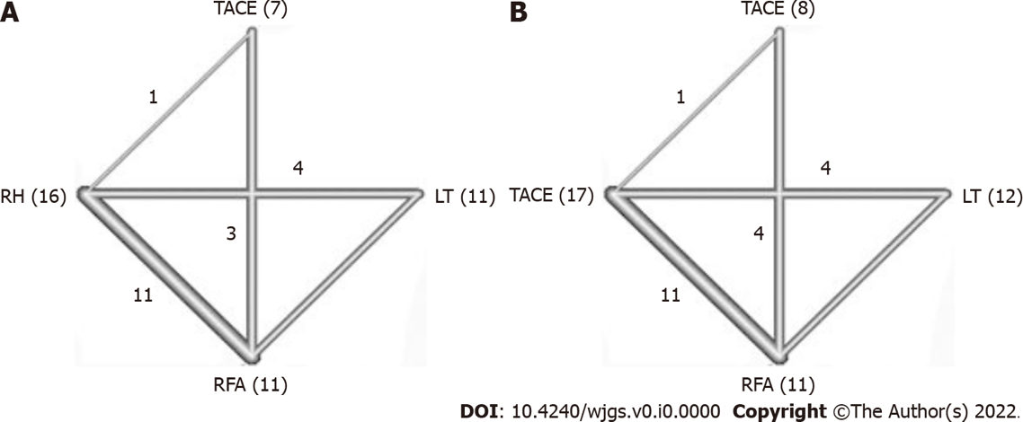
Figure 1 Network graph of study number. Numbers appeared on the line of paired studies, and numbers with parenthesis at the angles of connected line were the cumulative number of subgroup of treatment methods in all studies. A: One-year and three-year overall survival (OS); B: Five-year OS. LT: Liver transplantation; RFA: Radiofrequency ablation; RH: Repeat hepatectomy; TACE: Transarterial chemoembolization.

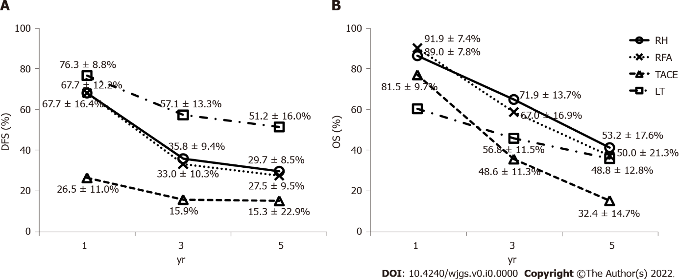
Figure 2 Pooled mean survival rates of disease-free and overall survival of the patients treated by repeated hepatectomy, radiofrequency ablation, transarterial chemoembolization, or liver transplantation in recurrent hepatocellular carcinoma from all studies. A and B: The results of transarterial chemoembolization (TACE) disclosed the inferiority to other treatment options in disease-free survival (DFS) (A) or overall survival (B). The data of DFS were recorded and pooled together from recurrent-free survival in one arm of repeated hepatectomy and radiofrequency ablation and two arms of liver transplantation (LT), progression-free survival in one arm of TACE, and tumor-free rate in one arm of LT. DFS: Disease-free survival; LT: Liver transplantation; OS: Overall survival; RH: Repeated hepatectomy; RFA: Radiofrequency ablation; TACE: Transarterial chemoembolization.

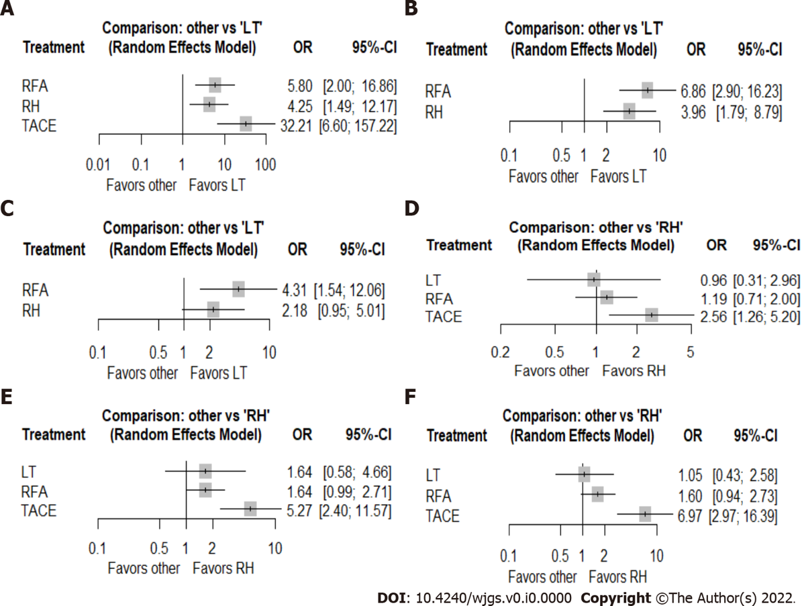
Figure 3 Forest plot analysis demonstrated the odds ratio (95%CI) of 1-year, 3-year, and 5-year disease-free survival in the liver transplantation subgroup compared with repeated hepatectomy, radiofrequency ablation, and transarterial chemoembolization and 1-year, 3-year, and 5-year overall survivalin the repeated hepatectomy subgroup compared with liver transplantation, radiofrequency ablation, and transarterial chemoembolization with the random effects model. A: One-year disease-free survival (DFS); B: Three-year DFS; C: Five-year DFS; D: One-year overall survival (OS); E: Three-year OS; F: Five-year OS. RFA: Radiofrequency ablation; RH: Repeated hepatectomy; LT: Liver transplantation; OR: Odds ratio; TACE: Transarterial chemoembolization.

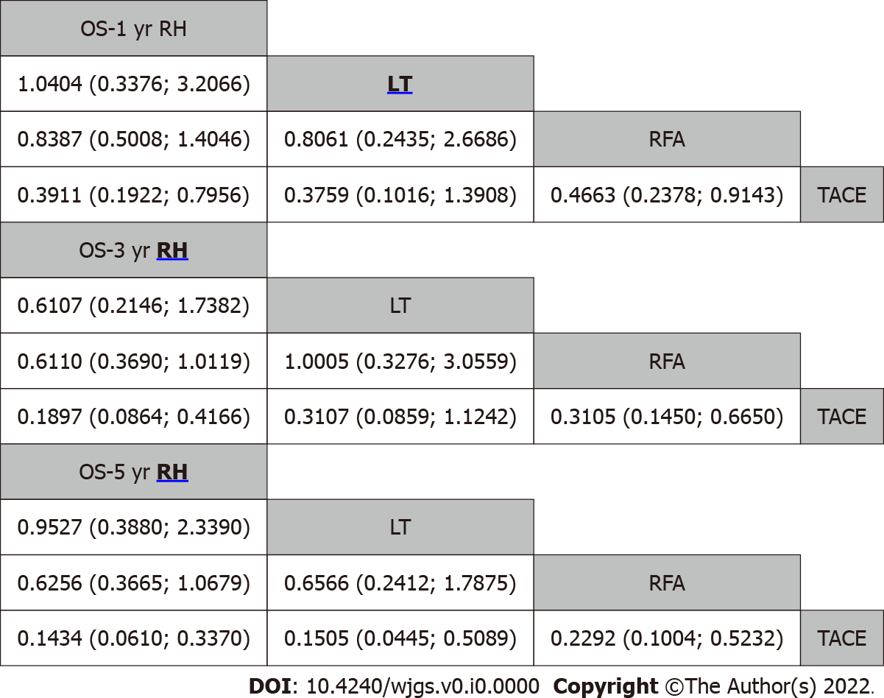
Figure 4 Hierarchic step diagram of cumulative comparative efficacy of treatment methods based on the effect size displayed with the odds ratio and corresponding 95% confidence interval of the 1-year, 3-year, and 5-year overall survival. All results were presented as the ratio of the x-axis over the y-axis with the Wald test. The better option had an underline and bold letter. LT: Liver transplantation; OS: Overall survival; RFA: Radiofrequency ablation; RH: Repeated hepatectomy; TACE: Transarterial chemoembolization.

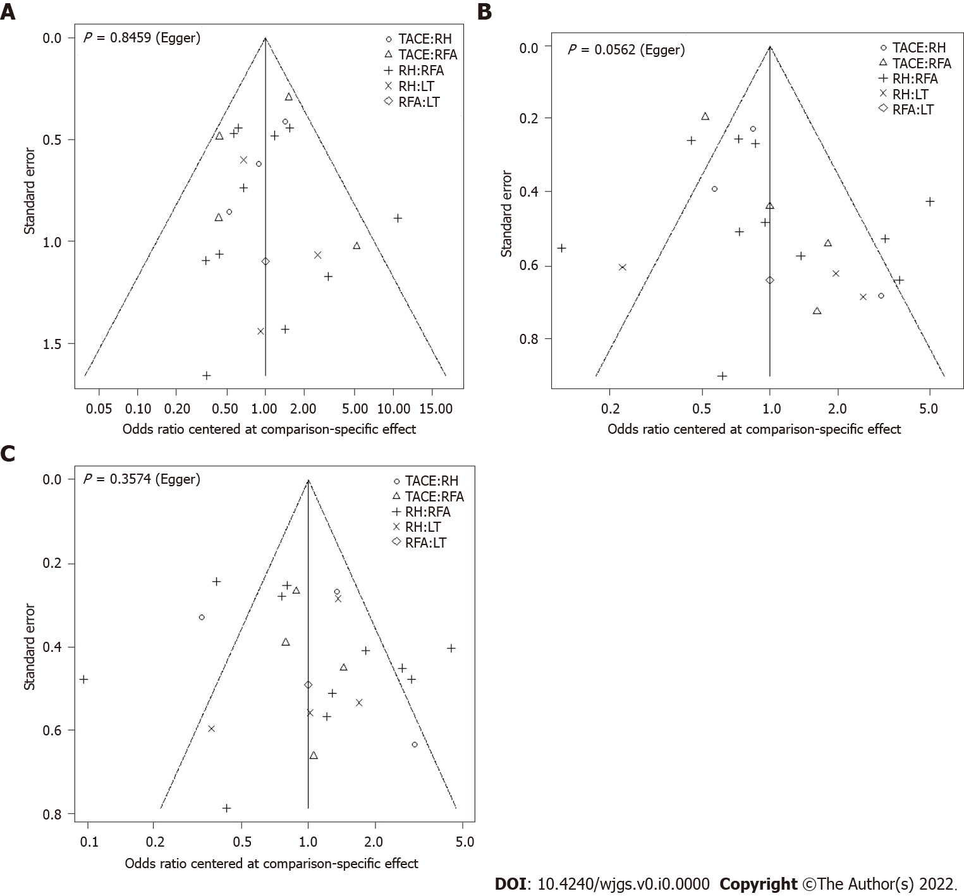
Figure 5 Publication bias measured by the comparison of the specific effect for 1-year, 3-year, and 5-year overall survival. P > 0.05 were obtained among all studies after Egger’s regression test. A: One-year overall survival (OS); B: Three-year OS; C: Five-year OS. LT: Liver transplantation; RFA: Radiofrequency ablation; RH: Repeated hepatectomy; TACE: Transarterial chemoembolization.

Table 1 Cumulative mean value of 49 arms of studies and patient profiles from 30 articles of curative treatment of recurrent hepatocellular carcinoma after primary liver resection
Arm in study, n | Patient, n¹ | Male % | Age in yr | HBV (+) % | HCV (+) % | Cirrhosis % | MVI (+) % | rChild A % | Time to recurrence in mo | rTumor size in mm | rTumor (n = 1) %
RH = 17 | 1405 | 79.9 | 56.5 ± 6.8 | 68.6 | 33.3 | 55.8 | 29.8 | 78.7 | 26.0 ± 8.3 | 25.3 ± 6.8 | 76.2
RFA = 11 | 1013 | 83.2 | 56.4 ± 5.5 | 78.5 | 12.4 | 59.0 | 26.6 | 94.9 | 18.1 ± 6.5 | 21.5 ± 4.0 | 78.6
TACE = 8 | 1123 | 86.5 | 54.6 ± 8.7 | 73.4 | 21.7 | 49.3 | 30.7 | 91.7 | 14.7 ± 6.6 | 32.2 ± 16.1 | 62.3
LT = 12 | 1484 | 89.1 | 53.6 ± 5.3 | 81.7 | 9.3 | 68.4 | 31.6 | 76.9 | 19.4 ± 10.4 | 27.1 ± 8.0 | 62.2
¹Patients n, cumulated number of patients in subgroup from all studies.
Details of each study are listed in Supplementary Table 1. RH: Repeated hepatectomy; RFA: Radiofrequency ablation; TACE: Transarterial chemoembolization; LT: Liver transplantation; r: Recurrent; HBV: Hepatitis B virus; HCV: Hepatitis C virus; MVI: Microvascular invasion.

Table 2 Predictive P score for each treatment method for recurrent hepatocellular carcinoma
P score/subgroup | 1-yr DFS | 3-yr DFS | 5-yr DFS | 1-yr OS | 3-yr OS | 5-yr OS
RH | 0.6470 | 0.4999 | 0.5100 | 0.7390¹ | 0.9320¹ | 0.8331¹
LT | 0.9986¹ | 0.9998¹ | 0.9820¹ | 0.6980 | 0.5470 | 0.7505
RFA | 0.3531 | 0.0003 | 0.0080 | 0.5340 | 0.5090 | 0.4159
TACE | 0.0012 | NA | NA | 0.0300 | 0.0130 | 0.0500
¹Best treatment option.
DFS: Disease-free survival; NA: Not available; LT: Liver transplantation; OS: Overall survival; RFA: Radio-frequency ablation; RH: Repeated hepatectomy; TACE: Transarterial chemoembolization.

Table 3 Meta-regression analysis for comparison of subgroups
Subgroup | β | SE | 95%CI |  | Z value | P value
 |  |  | Lower limit | Upper limit
1-yr DFS
Intercept | 0.658 | 0.177 | 0.311 | 1.005 | 3.720 | < 0.001
LT vs RH | 0.930¹ | 0.283 | 0.376 | 1.485 | 3.290 | 0.001
RFA vs RH | -0.315 | 0.272 | -0.848 | 0.217 | -1.160 | 0.246
TACE vs RH | -1.823 | 0.447 | -2.699 | -0.946 | -4.080 | < 0.001
3-yr DFS
Intercept | -0.353 | 0.212 | -0.769 | 0.063 | -1.660 | 0.096
RFA vs RH | -0.609 | 0.335 | -1.266 | 0.049 | -1.810 | 0.070
TACE vs RH | -2.235 | 0.751 | -3.707 | -0.763 | -2.980 | 0.003
LT vs RH | 1.181¹ | 0.322 | 0.550 | 1.812 | 3.670 | < 0.001
5-yr DFS
Intercept | -0.748 | 0.216 | -1.171 | -0.325 | -3.460 | 0.001
RFA vs RH | -0.834 | 0.366 | -1.552 | -0.116 | -2.280 | 0.023
TACE vs RH | -0.762 | 0.577 | -1.893 | 0.369 | -1.320 | 0.186
LT vs RH | 1.258¹ | 0.324 | 0.623 | 1.893 | 3.880 | < 0.001
1-yr OS
Intercept | 2.185 | 0.208 | 1.777 | 2.594 | 10.480 | < 0.001
LT vs RH | -0.036¹ | 0.332 | -0.687 | 0.614 | -0.110 | 0.913
RFA vs RH | -0.041 | 0.325 | -0.677 | 0.596 | -0.130 | 0.900
TACE vs RH | -0.614 | 0.332 | -1.264 | 0.036 | -1.850 | 0.064
3-yr OS
Intercept | 0.996 | 0.162 | 0.679 | 1.313 | 6.150 | < 0.001
RFA vs RH | -0.394 | 0.251 | -0.885 | 0.098 | -1.570 | 0.116
TACE vs RH | -1.114 | 0.287 | -1.676 | -0.551 | -3.880 | < 0.001
LT vs RH | 0.040¹ | 0.265 | -0.479 | 0.558 | 0.150 | 0.881
5-yr OS
Intercept | 0.204 | 0.185 | -0.158 | 0.565 | 1.100 | 0.270
RFA vs RH | -0.317 | 0.293 | -0.890 | 0.257 | -1.080 | 0.279
TACE vs RH | -0.917 | 0.328 | -1.559 | -0.275 | -2.800 | 0.005
LT vs RH | 0.392¹ | 0.298 | -0.192 | 0.975 | 1.320 | 0.188
¹Best treatment option.
DFS: Disease-free survival; LT: Liver transplantation; OS: Overall survival; RFA: Radiofrequency ablation; RH: Repeated hepatectomy; SE: Standard error; TACE: Transarterial chemoembolization.

Table 4 Overall heterogeneity of outcome measured by Q test with random effects model and pooled effect size of each subgroup
Outcome | Heterogeneity |  |  |  | Pooled effect (overall)
 | Q value | df (Q) | P value | I² | Z value | 95%CI | P value
1-yr DFS | 224.670 | 30 | < 0.001 | 86.65 | 0.672 | 0.625-0.716 | P < 0.001
3-yr DFS | 583.665 | 30 | < 0.001 | 94.86 | 0.414 | 0.370-0.46 | P < 0.001
5-yr DFS | 764.476 | 32 | < 0.001 | 95.81 | 0.315 | 0.276-0.357 | P < 0.001
1-yr OS | 219.820 | 46 | < 0.001 | 79.07 | 0.874 | 0.850-0.895 | P < 0.001
3-yr OS | 437.662 | 45 | 0.002 | 89.72 | 0.642 | 0.642-0.714 | P < 0.001
5-yr OS | 730.285 | 48 | < 0.001 | 93.43 | 0.546 | 0.497-0.594 | P = 0.068
DFS: Disease-free survival; OS: Overall survival.

Table 5 Summary of the better pooled outcome of treatments depended on the analysis method
Test method | 1-yr DFS | 3-yr DFS | 5-yr DFS | 1-yr OS | 3-yr OS | 5-yr OS
Wilcoxon rank sum test | LT | LT | LT | RFA | RH | RH
Forest plot analysis | LT | LT | LT | LT | RH | RH
Wald test | LT | LT | LT | LT | RH | RH
P score | LT | LT | LT | RH | RH | RH
Meta-regression analysis | LT | LT | LT | RH | LT | LT
DFS: Disease-free survival; LT: Liver transplantation; RFA: Radio-frequency ablation; RH: Repeated hepatectomy; OS: Overall survival.

