Name of Journal: WORL JOURNAL OF GASTROENTEROLOGY ENDOSCOPY
Manuscript NO: 37285
Manuscript Type: OBSERVATIONAL STUDY

Title: Endoscopic ultrasound-guided drainage of pancreatic walled-off necrosis using self-expanding metal stents without fluoroscopy
Braden B et al. EUS-guided metal stent placement without X-ray
Barbara Braden, Professor, Andreas Koutsoumpas, MD, Michael A Silva¹, MD, Zahir Soonawalla¹, MD, Christoph F Dietrich², Professor

Biostatistics statement

The statistical methods of this study were reviewed by Prof. Dr. Barbara Braden, Department of Gastroenterology, John Radcliffe Hospital, Oxford, UK

Barbara Braden, Oxford, UK 18/02/2018

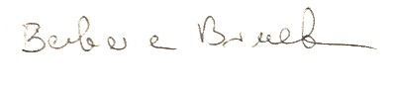
Professor Barbara Braden MD PhD FEBG
Translational Gastroenterology Unit
Oxford University Hospitals NHS Foundation Trust
Headley Way
Oxford, UK
OX3 9 DU

