Name of Journal: World Journal of Clinical Cases
Manuscript NO: 67802
Manuscript Type: ORIGINAL ARTICLE

Retrospective Study
Jumbo cup in hip joint renovation may cause the center of rotation to increase

Peng YW et al. Jumbo cup in hip joint renovation

Ya-Wen Peng, Jun-Min Shen, Yan-Chao Zhang, Jing-Yang Sun, Yin-Qiao Du, Yong-Gang Zhou

Ya-Wen Peng, Jun-Min Shen, Yan-Chao Zhang, Jing-Yang Sun, Yin-Qiao Du, Yong-Gang Zhou, Department of Orthopedics, The First Medical Centre, Chinese People’s Liberation Army General Hospital, Beijing 100853, China

Author contributions: Peng YW and Shen JM design the experiment; Zhang YC drafted the work, Sun JY, Du YQ and Zhou YG collected the data; Peng YW and Shen JM analyzed and interpreted data, Peng YW, Shen JM and Zhang YC wrote the article.

Corresponding author: Yong-Gang Zhou, MD, PhD, Doctor, Department of Orthopedics, The First Medical Centre, Chinese People’s Liberation Army General Hospital, No. 28 Fuxing Road, Haidian District, Beijing 100853, China. ygzhou301@163.com

Received: May 15, 2021
Revised: May 24, 2021
Accepted: May 27, 2021
Published online: Augst 6, 2021

Abstract
BACKGROUND
Utilizing the large jumbo cup in revision total hip arthroplasty is an effective approach to cure many lacunar and segmental peripheral bone defects. However, with the use of the jumbo cup, the center of the hip joint may become elevated relative to the primary acetabulum, and the diameter of the large cup is greater.

AIM
To study the height and the significance of the elevation of the hip joint center.

METHODS
Eighty-eight patients matched the criteria for this condition and were included in the study. The center height of the hip joint was measured relative to the opposite normal hip joint. The diameter of the jumbo cup was measured and checked according to operation notes, and the diameter of the jumbo cup was measured with a prosthesis label. Then, the horizontal and vertical centers of rotation were measured on the surgical side and opposite side. The average center height of the hip joint on the renovated side and the opposite side and the position of the hip cup relative to the teardrop were compared using a paired t-test.

RESULTS
Radiometric analysis showed that the average hip joint center was elevated by 7.6 mm. The rotational center height delta of the renovated hip was 7.6 ± 5.6 mm, and there was an obvious difference between the two groups (P = 0.00). The difference in horizontal distance was 0.5 ± 5.1 mm (-11.5 -14.0 mm), and there was no obvious difference between the two groups (P = 0.38). According to the foreign standard, the rotational center height delta of the renovated hip was 7.5 ± 6.2 mm, and there was a significant difference between the two groups (P = 0.00). There was no obvious difference between the domestic and foreign standards (P > 0.05) between the two groups.

CONCLUSION
The application of the jumbo cup elevates the rotational center of the hip joint, but it is feasible and effective to use the jumbo cup.

Key Words: Hip revision surgery; Jumbo cup; Center of rotation; Hip joint renovation; Hip joint

©The Author(s) 2021. Published by Baishideng Publishing Group Inc. All rights reserved.

Citation: Peng YW, Shen JM, Zhang YC, Sun JY, Du YQ, Zhou YG. Jumbo cup in hip joint renovation may cause the center of rotation to increase. World J Clin Cases 2021; 9(22): 6300-6307 URL: https://www.wjgnet.com/2307-8960/full/v9/i22/6300.htm DOI: https://dx.doi.org/10.12998/wjcc.v9.i22.6300

Core Tip: In this study, we discuss the application of the jumbo cup via observing how high the elevation of the center of the hip joint is and its significance in imaging X-rays, and came to the conclusion: The application of the jumbo cup elevates the rotational center of the hip joint, but it is feasible and effective to use the jumbo cup.

INTRODUCTION
Boneless, cement-coated, giant cups (jumbo cups) and bolt-fixed revision total hip arthroplasty (THA) are valid technologies for curing most failed acetabular components with cavities or subtle segmental bone defects^{[1-3]}. In revision THA, giant, hemispheric, boneless concrete acetabular cups (jumbo cups) generally have excellent outcomes in durability and versatility in dealing with cavities or subtle segmental bone defects^{[1-3]}. Compared with other acetabulum renovations, there are several advantages to the use of jumbo cups. First, they offer a large contact area between the principal bone and the surface of porous implants, which is good for reliable biological fixation^{[4]}. Moreover, this method can utilize hemispheric surgical techniques.
Reamer and screw fixation are similar applications in initial THA. However, many bone defects we often confront can be filled by transplanting large acetabular cups and spongy bone, and we sometimes do not need large amounts of allogeneic bone transplantation and reinforcer. A giant cup (jumbo cup) provides a substitute method for filling bone defects and acetabular cavities, which involves the placing of a cup to fill defects in the acetabulum (high hip center) or using a hunch in the anatomical acetabulum^{[5]}.
However, to suit implants that are usually larger than the primary acetabulum, the jumbo cup technique requires reaming and preparation of the surface of the acetabulum. Compared with the primary acetabulum, the diameter of the jumbo cup is greater, which may cause elevation of the center of the hip joint. This issue is related to changes in hip biomechanics and hip instability^{[6-8]}.
Leg length discrepancy is not uncommon after revision THA. However, unlike primary THA, limb shortening is more common than lengthening during revision THA, which can be related to cup positioning^{[9]}.
In the present study, there is clinical verification of the computer simulation research. We discuss the application of the jumbo cup through observations based on the height of the elevation of the center of the hip joint and its significance (about limb shortening or not) in imaging X-rays.

MATERIALS AND METHODS
General information
Inclusion criteria: One hip joint was normal, another underwent revision hip arthroplasty, and the diameter of the jumbo cup was no less than 64 mm in males and 60 mm in females and had no heel or reinforcer.

Exclusion criteria: (1) The diameter of the jumbo cup was less than 64 mm in males and 60 mm in females; (2) The other hip joint had abnormalities, such as avascular necrosis, or integration; (3) Revision of total hip arthroplasty; (4) The use of a heel or reinforcer; and (5) A jumbo cup was placed with a high center of rotation on the renovated side.

Eighty-eight patients met the study criteria: 44 were males and 44 were females. The average age was 61 ± 11 years (range from 32-85 years), the average height was 165.1 ± 7.8 cm (range from 146-182 cm), and the average weight was 70.8 ± 13.5 kg (range from 43 -100 kg). We analyzed the images with Medcare software to measure the height and horizontal distance of the bilateral hip joint rotational center, including the abduction angle by utilizing this software.

Materials used
Prostheses were mainly from Pinnacle, with Gription Acetabular Cups from DePuy Orthopedics, Inc., acetabular cups from Zimmer Inc., America, and Cementless Hip Prostheses (CombiCups PF and TOPII) from Waldemar Link.

Measurement methods
All imaging measurements were performed by one experimenter. All imaging was conducted 1 wk after the operation (Figure 1), and measurements were taken with orthotopic X-ray of the pelvis using MedCare software. The main results were compared with those of the opposite side hip joint to assess vertical and horizontal differences between the hip joint centers. To identify the location of the rotational center, we drew a circle in the jumbo and opposite side hip joints, and these circles were aligned with the edge of the acetabulum. The center of this circle was assumed to be the hip joint center (Figure 2). The center height of the hip joint was estimated by measuring the height of the vertical line from the lower edge of the acetabular tear to the center of the hip joint. We could carry out measurements in the hip joint of the jumbo cup side and opposite side, and the difference in the vertical position of the center of the two hips was seen as the measurement of the upward movement of the center of the hip at the jumbo cup side. The lower edge of the acetabular teardrop was used as a reference point for measurement in that teardrop as an independent anatomical structure whose vertical position is not substantially affected by the rotation of the pelvis.

Data reconciliation
To determine how much of the vertical change in the center of the revision hip was due to the placement of the prosthesis above the teardrop line, the straight-line distance from the jumbo cup to the teardrop line was measured (Figure 3). This was deemed the elevation of the center of the hip join for the placement of the cup above the site originally planned. If the lower lip of the giant cup was under the teardrop line, then the cup was given a negative number. Since the position of the lower edge of the cup body is also affected by the abduction angle, the normal position of the cup should be at a 45° abduction angle.
The diameter of the jumbo cup was measured and checked according to the operation notes and using a prosthesis label. Then, the horizontal and vertical centers of rotation (H-COR and V-COR) were measured on the surgical side and opposite side. The average center height of the hip joint on the renovated side and the opposite side and the position of the hip cup relative to the teardrop were compared using a paired t-test.

RESULTS
The X-ray imaging analysis showed that our jumbo cup technique elevated the center of the hip joint. The average hip joint rotational center height of the jumbo cup was 23.0 ± 6.1 mm (males = 22.1 mm, females = 24.0 mm). The average hip joint opposite side rotational center height was 15.4 ± 3.4 mm (males = 15.3 mm, females = 15.5 mm). This approach produced an average hip joint rotational center height difference of 7.6 mm. The horizontal distance of the jumbo cup was 36.4 ± 4.6 mm (25.3-48.6 mm). The horizontal distance on the opposite side was 35.9 ± 4.4 mm (28.0-47.6 mm). The difference in horizontal distance in the renovated hip joint was 0.5 ± 5.1 mm (-11.5-14.0 mm). The average abduction angle of the horizontal distance in the renovated hip joint was 40.6° ± 6.9° (28.1°-63.0°, Table 1).
The results of the paired t test showed that the height difference of the rotational center of renovated hip joints was 7.6 ± 5.6 mm, and that there was an obvious difference between the two groups (P = 0.00); however, the difference in horizontal distance was 0.5 ± 5.1 mm (-11.5-14.0 mm), and there was no obvious difference between the two groups (P = 0.38, Table 2).
According to European and American definitions of the jumbo cup criteria, we performed the statistical analysis again for patients who met the criteria, which resulted in a total of 88 patients (88 hips) in this study; a total of 54 patients (54 cases; 25 males and 29 females) met the criteria for reanalysis. The average hip joint rotational center height of the jumbo cup was 23.2 ± 6.6 mm (males = 21.0 mm, females = 25.0 mm). The average hip joint rotational center height of the opposite side was 15.7 ± 3.4 mm (males = 15.7 mm, females = 15.7 mm). The results of this analysis showed an average hip joint rotational center height difference, and we found that the difference between the two groups was 7.5 ± 6.2 mm (-6.6-19.5 mm). The horizontal distance of the jumbo cup was 36.8 ± 4.5 mm (26.4-48.6 mm), and the horizontal distance on the opposite side was 36.0 ± 4.0 mm (28.1-46.3 mm). The difference in horizontal distance in the renovated hip joint was 0.8 ± 5.0 mm (-11.5-13.7 mm). The average abduction angle of the horizontal distance in the renovated hip joint was 41.2° ± 7.0° (28.1°-61.5°). The height difference in the rotational center of the renovated hip joint was 7.5 ± 6.2 mm, and there was an obvious difference between the two groups (paired t test P = 0.00); however, the difference in horizontal distance was 0.8 ± 5.0 mm (-11.5-13.7 mm), and there was no obvious difference between the two groups (P = 0.26, Table 3).
There were no significant differences between the domestic and foreign standards (Table 4).

DISCUSSION
Compared with other methods of acetabulum renovation, there are many advantages in applying the jumbo cup such as a large contact area between the principal bone and the surface of porous implants, which is good for reliable biological fixation. The jumbo cup also permits relatively direct and repeatable hemispheric surgical techniques with reaming and screw fixation at the same time. However, to suit hemispheric implants that are usually larger than the primary acetabulum, the jumbo cup technique requires preparation of the surface of the acetabulum, which may cause elevation of the center of the hip joint. The secondary cause is reaming in a dominant direction and placing the cup body above its intended position and/or causing the cup radius to increase geometrically. The diameter of jumbo cup is larger than that of the primary acetabulum. Reaming in an upward direction may lead to the cup body being over the anatomical acetabulum, which causes elevation of the center of the hip joint. Moreover, using a large acetabular cup may cause elevation of the center of the hip joint due to the larger radius of the jumbo cup.
A vertical hip center shift during revision THA may result in leg length discrepancies, altered hip biomechanics, and soft tissue laxity. A retrospective study involving 79 THA revisions by Dou et al^{[9]} showed that acetabular cup placement contributes to hip center elevation and leg length discrepancies after revision THA. In addition to its role in leg length changes, an elevated hip center can result in suboptimum biomechanics of the hip. Delp et al^{[8]} showed that superolateral placement of the hip center (2 cm superior and 2 cm lateral) decreases the moment arms of the hip abductors by an average of 28%, thus reducing force-generating capacity. Lachiewicz et al^{[10]} reported a dislocation rate of 10% after jumbo cup revision THA, which was the most common complication observed in their series. Hip center elevation in jumbo cup revision THA, as we observed, may be one of several factors that contribute to soft tissue laxity and hip instability. To compensate for an elevated hip center, appropriate adjustments on the femoral side can be made to increase leg length and/or offset.
Despite the elevation of the rotational center of the hip joint, it was not sufficient to match the definition of a high rotational center, the elevation was a minimal. Although Nwankwo et al^{[11]} and others found that the average rotational center rose 11 mm in their study, the rise in the average rotational center was only 7.5 mm in our study. These values represent excellent outcomes in numerous research reports regarding the placement of jumbo cups with high rotational centers in treating lateral acetabular defects^{[12-15]}. Kelley^{[16]}’s study of 23 jumbo cups placed with a high rotational center did not show loosening at an average of 35 mo of follow-up. In the longer series reported by Dearborn et al^{[17]}, there was only a 6% rate of mechanical loosening with a mean follow-up of 10.4 years. Utilizing a high center of the hip joint has a negative influence on the function of the abductor muscles, and differences in mean limb length were reduced after femoral reconstruction. This finding suggests that increasing the length of the femoral head may help to avoid limb shortening when using jumbo cup technology in revision THA. Some authors have reported encouraging clinical results with jumbo cups^{[10,18-21]}.
There are some limitations in our research design. There were deviations in the measurements from radiographic plain films. Measurements were made from specific anatomical marks used by an observer in every patient to reduce measurement errors. However, we were unable to identify accurately the reliability of the measurement techniques because there were no repeatability tests of intra-observer and inter-observer variability included in the study. We also did not utilize an established taxonomy to quantify acetabular lesions in this series of patients.

CONCLUSION
Based on our findings, we suggest that applying a jumbo cup in revision THA increases the height of the rotational center of the hip joint, but it is feasible and effective to utilize jumbo cups in revision THA with a limited height.

ARTICLE HIGHLIGHTS
Research background
Utilizing the large jumbo cup in revision total hip arthroplasty (THA) is an effective approach to cure many lacunar and segmental peripheral bone defects. However, with the use of the jumbo cup, the center of the hip joint may become elevated relative to the primary acetabulum, and the diameter of the large cup is greater.

Research motivation
In order to explore the height and significance of X-rays used to study the height of the hip joint center, as a guide for clinical work.

Research objectives
X-rays were applied to study the height and the significance of the elevation of the hip joint center.

Research methods
Eighty-eight patients were included in the study. The center height of the hip joint was measured relative to the opposite normal hip joint. The diameter of the jumbo cup was measured and checked according to operation notes, and the diameter of the jumbo cup was measured with a prosthesis label.

Research results
Radiometric analysis showed that the average hip joint center was elevated by 7.6 mm. The rotational center height delta of the renovated hip was 7.6 ± 5.6 mm, and there was an obvious difference between the two groups. For the difference in horizontal distance, there was no obvious difference between the two groups. The rotational center height delta of the renovated hip was 7.5 ± 6.2 mm, and there was a significant difference between the two groups.

Research conclusions
The application of the jumbo cup elevates the rotational center of the hip joint, but it is feasible and effective to use the jumbo cup.

Research perspectives
Applying a jumbo cup in revision THA increases the height of the rotational center of the hip joint, but it is feasible and effective to utilize jumbo cups in revision THA with a limited height.

REFERENCES
1 Dearborn JT, Harris WH. Acetabular revision arthroplasty using so-called jumbo cementless components: an average 7-year follow-up study. J Arthroplasty 2000; 15: 8-15 [PMID: 10654456 DOI: 10.1016/s0883-5403(00)90999-9]
2 Patel JV, Masonis JL, Bourne RB, Rorabeck CH. The fate of cementless jumbo cups in revision hip arthroplasty. J Arthroplasty 2003; 18: 129-133 [PMID: 12629600 DOI: 10.1054/arth.2003.50038]
3 Whaley AL, Berry DJ, Harmsen WS. Extra-large uncemented hemispherical acetabular components for revision total hip arthroplasty. J Bone Joint Surg Am 2001; 83: 1352-1357 [PMID: 11568198 DOI: 10.2106/00004623-200109000-00010]
4 Jasty M. Jumbo cups and morsalized graft. Orthop Clin North Am 1998; 29: 249-254 [PMID: 9553570 DOI: 10.1016/s0030-5898(05)70323-0]
5 Brooks PJ. The jumbo cup: the 95% solution. Orthopedics 2008; 31: 913, 915 [PMID: 18814612 DOI: 10.3928/01477447-20080901-04]
6 Vasavada AN, Delp SL, Maloney WJ, Schurman DJ, Zajac FE. Compensating for changes in muscle length in total hip arthroplasty. Effects on the moment generating capacity of the muscles. Clin Orthop Relat Res 1994: 121-133 [PMID: 8168289 DOI: 10.1097/00003086-199405000-00020]
7 Tanzer M. Role and results of the high hip center. Orthop Clin North Am 1998; 29: 241-247 [PMID: 9553569 DOI: 10.1016/s0030-5898(05)70322-9]
8 Delp SL, Wixson RL, Komattu AV, Kocmond JH. How superior placement of the joint center in hip arthroplasty affects the abductor muscles. Clin Orthop Relat Res 1996: 137-146 [PMID: 8653946 DOI: 10.1097/00003086-199607000-00022]
9 Dou Y, Zhou Y, Tang Q, Yang D, Liu J. Leg-length discrepancy after revision hip arthroplasty: are modular stems superior? J Arthroplasty 2013; 28: 676-679 [PMID: 23142440 DOI: 10.1016/j.arth.2012.08.009]
10 Lachiewicz PF, Soileau ES. Fixation, survival, and dislocation of jumbo acetabular components in revision hip arthroplasty. J Bone Joint Surg Am 2013; 95: 543-548 [PMID: 23515989 DOI: 10.2106/JBJS.L.00758]
11 Nwankwo CD, Ries MD. Do jumbo cups cause hip center elevation in revision THA? A radiographic evaluation. Clin Orthop Relat Res 2014; 472: 2793-2798 [PMID: 24744132 DOI: 10.1007/s11999-014-3632-8]
12 Shen J, Sun J, Ma H, Du Y, Li T, Zhou Y. High Hip Center Technique in Total Hip Arthroplasty for Crowe Type II-III Developmental Dysplasia: Results of Midterm Follow-up. Orthop Surg 2020; 12: 1245-1252 [PMID: 32776482 DOI: 10.1111/os.12756]
13 Montalti M, Castagnini F, Giardina F, Tassinari E, Biondi F, Toni A. Cementless Total Hip Arthroplasty in Crowe III and IV Dysplasia: High Hip Center and Modular Necks. J Arthroplasty 2018; 33: 1813-1819 [PMID: 29500091 DOI: 10.1016/j.arth.2018.01.041]
14 Galea VP, Laaksonen I, Donahue GS, Fukui K, Kaneuji A, Malchau H, Bragdon C. Developmental Dysplasia Treated With Cementless Total Hip Arthroplasty Utilizing High Hip Center Reconstruction: A Minimum 13-Year Follow-up Study. J Arthroplasty 2018; 33: 2899-2905 [PMID: 29803578 DOI: 10.1016/j.arth.2018.04.037]
15 Chen M, Luo ZL, Wu KR, Zhang XQ, Ling XD, Shang XF. Cementless Total Hip Arthroplasty With a High Hip Center for Hartofilakidis Type B Developmental Dysplasia of the Hip: Results of Midterm Follow-Up. J Arthroplasty 2016; 31: 1027-1034 [PMID: 26712347 DOI: 10.1016/j.arth.2015.11.009]
16 Kelley SS. High hip center in revision arthroplasty. J Arthroplasty 1994; 9: 503-510 [PMID: 7807108 DOI: 10.1016/0883-5403(94)90097-3]
17 Dearborn JT, Harris WH. High placement of an acetabular component inserted without cement in a revision total hip arthroplasty. Results after a mean of ten years. J Bone Joint Surg Am 1999; 81: 469-480 [PMID: 10225792 DOI: 10.2106/00004623-199904000-00004]
18 Zhang J, Huang Y, Zhou B, Zhou Y. Mid-Term Follow-Up of Acetabular Revision Arthroplasty Using Jumbo Cups. Orthop Surg 2019; 11: 811-818 [PMID: 31549788 DOI: 10.1111/os.12522]
19 von Roth P, Abdel MP, Harmsen WS, Berry DJ. Uncemented jumbo cups for revision total hip arthroplasty: a concise follow-up, at a mean of twenty years, of a previous report. J Bone Joint Surg Am 2015; 97: 284-287 [PMID: 25695978 DOI: 10.2106/JBJS.N.00798]
20 Moon JK, Ryu J, Kim Y, Yang JH, Hwang KT, Kim YH. Acetabular revision arthroplasty using press-fitted jumbo cups: an average 10-year follow-up study. Arch Orthop Trauma Surg 2019; 139: 1149-1160 [PMID: 31187257 DOI: 10.1007/s00402-019-03214-7]
21 Gustke KA, Levering MF, Miranda MA. Use of jumbo cups for revision of acetabulae with large bony defects. J Arthroplasty 2014; 29: 199-203 [PMID: 23993345 DOI: 10.1016/j.arth.2012.11.010]

Footnotes
Institutional review board statement: The study was reviewed and approved by the Chinese People’s Liberation Army General Hospital Institutional Review Board.

Informed consent statement: All study participants, or their legal guardian, provided informed written consent prior to study enrollment.

Conflict-of-interest statement: The authors declare that there is no conflict of interest.

Data sharing statement: No additional data are available.

Open-Access: This article is an open-access article that was selected by an in-house editor and fully peer-reviewed by external reviewers. It is distributed in accordance with the Creative Commons Attribution NonCommercial (CC BY-NC 4.0) license, which permits others to distribute, remix, adapt, build upon this work non-commercially, and license their derivative works on different terms, provided the original work is properly cited and the use is non-commercial. See: http://creativecommons.org/Licenses/by-nc/4.0/

Manuscript source: Unsolicited manuscript

Peer-review started: May 15, 2021
First decision: May 23, 2021
Article in press: May 27, 2021

Specialty type: Orthopedics
Country/Territory of origin: China
Peer-review report’s scientific quality classification
Grade A (Excellent): 0
Grade B (Very good): 0
Grade C (Good): C
Grade D (Fair): 0
Grade E (Poor): 0

P-Reviewer: Goudeau YR S-Editor: Wang JL L-Editor: Filipodia P-Editor: Yuan YY

Figure Legends
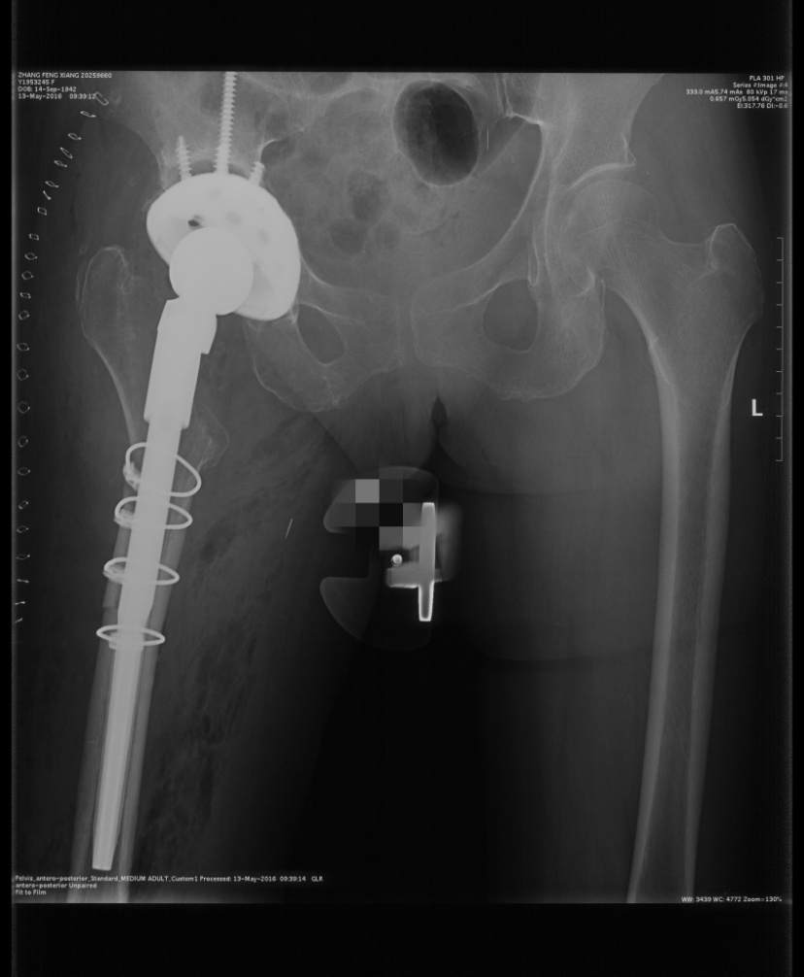
Figure 1 Postoperative reexamination of jumbo cup.

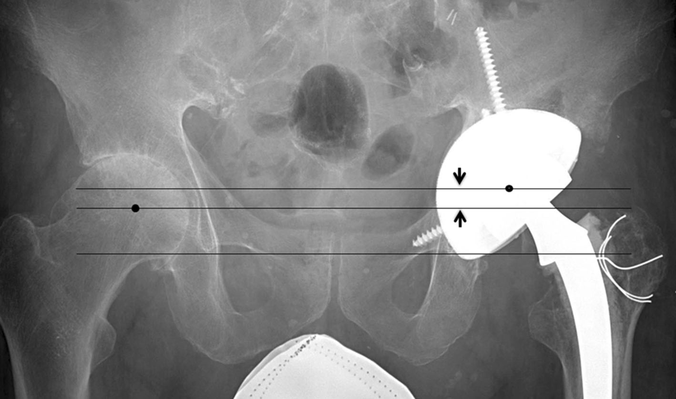
Figure 2 The center of this circle was assumed to be the hip joint center^{[11]}. After the left revision total hip arthroplasty obtained anteroposterior pelvic radiographs with a giant cup showed that the revision cup was larger than the contralateral acetabulum. The teardrop line intersects the lower edge of the cup, indicating that jumbo cup is placed in planned position that the lower edge of cup at the lower edge of acetabulum. The medium line is parallel to the lower edge of teardrop line and intersects center of right hip. The upper end line parallel to the tear drop line intersects center of the left giant cup. The distance (arrows) between two lines is labeled as elevated height of rotating center occurred in applying jumbo cup.

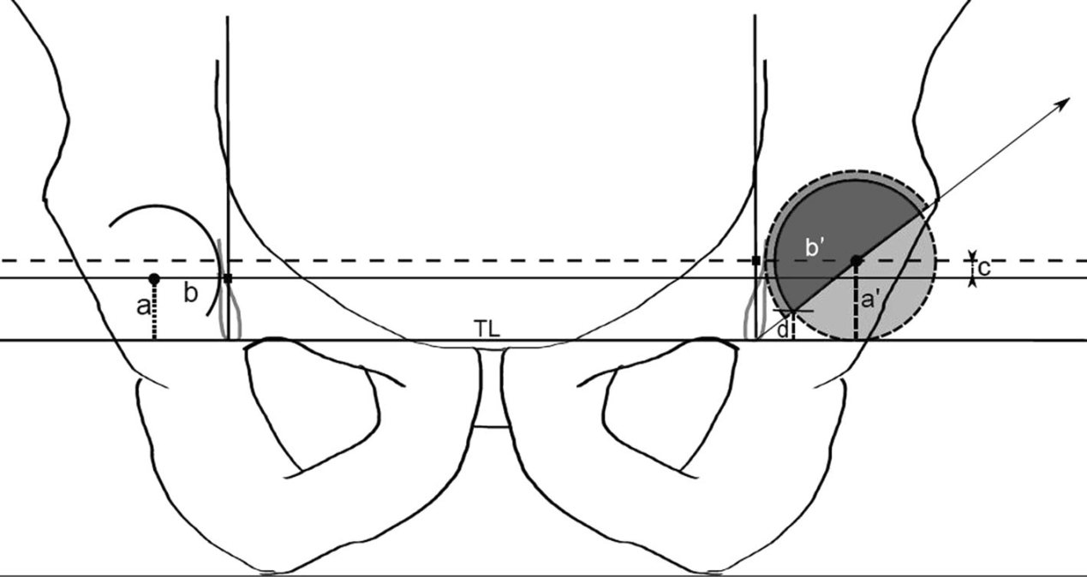
Figure 3 The X-ray photogrammetry used to determine relative center elevation and upper cup position of the hip joint is shown^{[11]}. TL: Teardrop line; a’: Center height of hip joint of jumbo cup; a: Center height of hip joint offside; b’: Horizontal distance between teardrop and teardrop line and center line of jumbo cup hip; b: Horizontal distance between vertical line crossed teardrop and center of contralateral hip joint; c: The amount of elevation of center of hip joint (a’-a); d: The amount of elevation of center of hip joint due to the upper acetabular cup.
Table 1 Measured values and mean values
 | Maximum values | Minimum values | Mean values
Diameter of acetabular cup (mm) | 60.00 | 72.00 | 65.0000
Height of rotating center (mm) | 5.60 | 39.80 | 23.0273
Height of contralateral rotating center (mm) | 5.60 | 24.70 | 15.4011
Differences (mm) | -6.60 | 19.50 | 7.6261
Horizontal distance of jumbo cup (mm) | 25.30 | 48.60 | 36.4398
Contralateral horizontal distance (mm) | 28.00 | 47.60 | 35.9398
Differences (mm) | -11.50 | 14.00 | 0.5000
Abduction angle (°) | 28.10 | 63.00 | 40.6011

Table 2 Significant difference of rotating center in revision hip
 | Mean values | SD | t | Degree of freedom | Significance (two tail)
Differences of vertical height | 7.62614 | 5.58741 | 12.804 | 87 | 0.000
Differences of horizontal height | 0.50000 | 5.07586 | 0.924 | 87 | 0.358

Table 3 Significant analysis of foreign standard groups
 | Mean values | SD | t | Degree of freedom | Significance (two tail)
Differences of vertical height | 7.50926 | 6.24353 | 8.838 | 53 | 0.000
Differences of horizontal height | 0.76667 | 4.96030 | 1.136 | 53 | 0.261

Table 4 Comparison of domestic and foreign standards
 | The test of variance equivalence |  | Mean isotropic t-test
 | F | Significance | t | Degree of freedom | Significance (two tail)
Differences of height
Assumed equivariance | 988 | 0.322 | 0.116 | 140 | 0.908
No assumed equivariance |  |  | 0.113 | 102.772 | 0.911
Differences of horizon
Assumed equivariance | 0 | 0.997 | -0.307 | 140 | 0.76
No assumed equivariance |  |  | -0.308 | 114.256 | 0.758

Published by Baishideng Publishing Group Inc
7041 Koll Center Parkway, Suite 160, Pleasanton, CA 94566, USA
Telephone: +1-925-3991568
E-mail: bpgoffice@wjgnet.com
Help Desk: https://www.f6publishing.com/helpdesk
https://www.wjgnet.com

© 2021 Baishideng Publishing Group Inc. All rights reserved.

