Name of Journal: World Journal of Gastroenterology
ESPS Manuscript NO: 31046
Manuscript Type: ORIGINAL ARTICLE

Observational Study
Upper gastrointestinal cancer burden in Hebei Province, China: A population-based study

Li DJ et al. Estimate of upper gastrointestinal cancer burden

Dao-Juan Li, Di Liang, Guo-Hui Song, Yong-Wei Li, Deng-Gui Wen, Jing Jin, Yu-Tong He

Dao-Juan Li, Di Liang, Deng-Gui Wen, Jing Jin, Yu-Tong He, Cancer Institute, The Fourth Hospital of Hebei Medical University/The Tumor Hospital of Hebei Province, Shijiazhuang 050011, Hebei Province, China

Guo-Hui Song, Cixian Cancer Institute, Cixian 056500, Hebei Province, China

Yong-Wei Li, Shexian Cancer Institute, Shexian 056400, Hebei Province, China

Author contributions: He YT contributes to study conception and design; Li DJ, Liang D, Song GH, Li YW and Wen DG contribute to acquisition of data; He YT, Li DJ, Liang D and Jin J contribute to analysis and interpretation of data; Li DJ contributes to drafting of manuscript; He YT, Li DJ and Jin J contribute to critical revision.

Institutional review board statement: All procedures performed in studies involving human participants were in accordance with the ethical standards of the institutional and/or national research committee and with the 2013 Helsinki declaration and its later amendments or comparable ethical standards. This article does not contain any studies with animals performed by any of the authors. The study was reviewed and approved by Cancer Institute, the Fourth Hospital of Hebei Medical University (Shijiazhuang).

Informed consent statement: All study participants, or their legal guardian, provided informed written consent prior to study enrollment.

Conflict of interest: There are no conflicts of interest to declare.

Data sharing statement: No additional data are available.

Open-Access: This article is an open-access article which was selected by an in-house editor and fully peer-reviewed by external reviewers. It is distributed in accordance with the Creative Commons Attribution Non Commercial (CC BY-NC 4.0) license, which permits others to distribute, remix, adapt, build upon this work non-commercially, and license their derivative works on different terms, provided the original work is properly cited and the use is non-commercial. See: http://creativecommons.org/licenses/by-nc/4.0/

Manuscript source: Unsolicited manuscript

Correspondence to: Dr. Yu-Tong He, The Fourth Hospital of Hebei Medical University/The Tumor Hospital of Hebei Province, No. 12, Jiankang Road, Shijiazhuang 050011, Hebei Province, China. hytong69@yahoo.com
Telephone: +86-311-86095613
Fax: +86-311-86095613

Received: November 2, 2016
Peer-review started: November 2, 2016
First decision: January 19, 2017
Revised: January 22, 2017
Accepted: February 16, 2017
Article in press:
Published online:

Abstract
AIM
To investigate incidence and mortality rates of upper gastrointestinal cancer (including oesophageal cancer and stomach cancer) in Hebei Province, aiming to identify high-risk populations for improving cancer prevention and control.

METHODS
Hebei Provincial cancer registry collected data of upper gastrointestinal cancer from 21 population-based cancer registries, covering 15.25% of population in Hebei Province. The mortality data were extracted from the three times of national retrospective death surveys (1973-1975, 1990-1992 and 2004-2005). Data stratified by 5-year age groups, gender and area (high-risk/non-high-risk areas) were analyzed. The age-period-cohort and grey system model were used.

RESULTS
The crude incidence rate of upper gastrointestinal cancer was 55.47/100000 and the adjusted rate (Segi’s population) was 44.90/100000. Males in rural areas had the highest incidence rate (ASR World 87.89/100000). The crude mortality rate of upper gastrointestinal cancer displayed a decrease trend in Hebei Province from the 1970s to 2013 and the adjusted rate decreased by 43.81% from 1970s (58.07/100000) to 2013 (32.63/100000). The mortality rate declined more in high-risk areas (57.26%) than in non-high-risk areas (55.02%) from 1970s to 2013. The median age at diagnosis of upper gastrointestinal cancer was 65.06 years old in 2013. There was a notable delay for the median age at death from the 1970s (66.15 years old) to 2013 (70.39 years old), especially in high-risk areas. In Cixian, the total trend of the cohort effect was a decline and people who were aged 65-69 years old were a population at a relatively high-risk of upper gastrointestinal cancer. It was predicted that the crude mortality rates of upper gastrointestinal cancer for Cixian and Shexian would decrease to 98.80 and 133.99 per 100000 in 2018, respectively.

CONCLUSION
Upper gastrointestinal cancer was the major cause of cancer death in Hebei Province, and males in rural areas were a population at a high-risk. We should still strengthen early detection and treatment.

Key words: Upper gastrointestinal cancer; Incidence; Mortality; Age-period-cohort; Grey system model

© The Author(s) 2017. Published by Baishideng Publishing Group Inc. All rights reserved.

Core tip: This is the first time that the trends of upper gastrointestinal cancer have been reported out in Hebei Province. The study collected data from 21 population-based cancer registries, covering 15.25% of the whole population in 2013, which had not maximally covered Hebei Province until now. We applied the age-period-cohort model to analyze the incidence rate of upper gastrointestinal cancer in high-risk area of Hebei Province, Cixian. And we selected the grey system model to predict the mortality rate of upper gastrointestinal cancer in high-risk areas of Hebei Province, Cixian and Shexian. The aim was to provide epidemiological evidence for strategies to control upper gastrointestinal cancer.

Li DJ, LiangD, Song GH, LiY W, Wen DG, Jin J, He YT. Upper gastrointestinal cancer burden in Hebei Province, China: A population-based study. World J Gastroenterol 2017; In press

INTRODUCTION
According to GLOBOCAN 2012, upper gastrointestinal cancer (including oesophageal cancer and stomach cancer) was the third most common cancer in the world and the second leading cause of death among all types of cancers. Approximately 45% of all cases occurred in China^{[1]}. Its incidence and mortality proportions were approximately 19.8% and 23.3% of the total malignancies in China, respectively^{[2]}. Thus, monitoring and studying the incidence and mortality can provide important information, thereby enabling an effective assessment and potentially generating a strategy for upper gastrointestinal cancer prevention and control based on the different distribution patterns.
Hebei Province is located in northern China along the Taihang Mountain chain and has a relatively developing economy. It was recognized as a high-risk area for upper gastrointestinal cancer in the 1970s. In 2015, it had 21 population-based cancer registries that covered 11,185,626 registered populations (approximately 15.25% of the total population in Hebei Province). Additionally, Hebei Province participated in three national death surveys that were conducted during the periods from 1973-1975^{[3]}, 1990-1992^{[4]} and 2004-2005^{[5]}. Cixian and Shexian in Hebei Province exhibit a high frequency of upper gastrointestinal cancer, and their cancer registries were established in 1974 and 2000, respectively. A series of investigations^{[6-8]} regarding the potential risk factors and corresponding aetiological intervention methods and screening measures were conducted.
This study combined data of oesophageal cancer and stomach cancer, aiming to investigate the real burden of upper gastrointestinal cancer in Hebei Province and to provide information on prevention and treatment.

MATERIALS AND METHODS
Cancer registry data
Hebei Provincial Cancer Registry was established in 2009 and it is responsible for cancer data collection, evaluation and publication. This study collected data from 21 local population-based registries in 2013 which included 16 counties (Cixian, Shexian, Qianxi county, Wuan county, Zanhuang county, Fengning county, Xinji county, Xingtai county, Zhangbei county, Anguo county, Haixing county, Yanshan county, Neiqiu county, Renxian, Xuanhua county and Shenze county) and 5 cities (Baoding city, Qinhuangdao city, Cangzhou city, Shijiazhuang city and Shuangqiao district of Chengde city). 16 counties and 5 cities were urban areas and rural areas, respectively. The reported cases were from multiple sources, including local hospitals and community health centres, as well as the Urban Resident Basic Medical Insurance Program and the New Rural Cooperative Medical Scheme. All the data on cancer in Hebei Province were obtained from the Hebei Provincial Cancer Registry Database. Population information was collected from local statistical bureau or household register department in local public security bureau. We also extracted data on upper gastrointestinal cancer from 1989 to 2013 in Cixian and from 2004 to 2013 in Shexian. According to the International Classification of Diseases, 10th revision (ICD-10), C15 and C16 which are upper gastrointestinal cancer were extracted to analysis.

Quality control
The inclusion criteria of data were based on Guidelines of Chinese Cancer Registration^{[9]} and International Agency for Research on Cancer/International Association of Cancer Registries (IARC/IACR) . The analyzed data should meet that the morphological verification (MV%) was higher than 66%, the percentage of cancer cases identified with death certification only (DCO%) was less than 15% and the mortality to incidence ratio (M/I) was between 0.6 and 0.8. All the data were checked and evaluated based on the criteria of data quality.

National retrospective survey of mortality
In the mid-1970s, a nationwide retrospective survey of causes of mortality was conducted in 29 provinces, including all 153 cities and counties covering 47.725 million people in Hebei Province^{[3]}. It provided a profile of cancer mortality in Hebei Province.
The second national retrospective sampling survey of cancer mortality was held from 1990 to 1992. This survey used a stratified sampling method and covered approximately 10% of the population in China^{[4]}. A total of 21 cities and counties, covering 6.375 million people from Hebei Province, were enrolled as sampling areas.
The third national retrospective stratified sampling survey of all causes of death in the period from 2004-2005 was performed in 31 provinces/municipalities/autonomous regions, which included Hebei Province. A total of 18 cities and counties were selected as sampling areas, covering 13.79 million people with 20.15% of the total population of Hebei Province^{[5]}.
The pooled data of the three national retrospective sampling surveys of upper gastrointestinal cancer mortality were stratified by area (high-risk /non-high-risk area) and gender. Cixian, Shexian and Zanhuang County were selected as the high-risk areas; the rest were non-high-risk regions.

Statistical analysis
All of the data analysis used SPSS version 19.0 (SPSS Inc., Chicago, IL, USA), SAS version 9.4 (SAS Institute Inc., Cary, NC, USA) and MS-Excel. The world age-standardized rate (ASR World) and Chinese age-standardized rate (ASR China) were calculated by Segi’s population and the Chinese population in 2000, respectively. Long-term trends of upper gastrointestinal cancer in Cixian and Shexian were analyzed using an age-period-cohort model and grey system GM (1, 1) model. We used an age-period-cohort model to estimate the relative risks by age, period, and birth cohort from Cixian data from 1989 to 2013. Additionally, we extracted 13 5-year age groups from 25-29 to 85+ year-old and 5 5-year periods ranging from 1989-1993 to 2009-2013, producing birth cohorts from 1904-1908 to 1984-1988. The 3 components (i.e., cohort, period, age) in the age-period-cohort model are linearly dependent. Thus, we adopted the common method of including an additional arbitrary reference constraint for the period effect^{[10,11]}. Additionally, the 85+-year-old group, the periods from 2004-2008 and 2009-2013 and the birth cohort from 1934-1938 were chosen as reference groups.
On the basis of crude mortality rates of upper gastrointestinal cancer in Cixian and Shexian during the period from 2004-2013, an Excel table was used to establish the GM (1, 1)^{[12]}, posterior error ratio (C) and small error probability (P) to determine the prediction accuracy, the relative error between the predicted value and actual value, and the extrapolated prediction of mortality of upper gastrointestinal cancer in Cixian and Shexian from 2014-2018.

RESULTS
The incidence rate of upper gastrointestinal cancer in 2013
In 2013, there were 6205 new upper gastrointestinal cancer cases (4328 in male and 1877 in female), accounting for 24.62% of all types of cancer in Hebei Provincial cancer registry areas. The crude incidence rate of the total areas was 55.47 per 100000 people. The ASR World standard population and the ASR China population 2000 were 44.90 and 44.16/100000 people, respectively (Table 1). The incidence rate of upper gastrointestinal cancer in males was higher than that in females. The incidence rate was 2.62 times higher in rural areas (75.17/100000) than that in urban areas (28.69/100000). Almost 78% of new cases were from rural cancer registries, and more than 50% of cases were males from rural areas. The male incidence rate in rural areas (101.35/100000) was the highest. The median age at diagnosis of upper gastrointestinal cancer was 65.06 (64.73 in male, 66.03 in female) years old in Hebei Province. The median age was 4.36 years younger in rural areas (64.37) than in urban areas (68.74).
The age-specific incidence rate was relatively low for those younger than 40 years old, and then it increased dramatically. The incidence rate reached a peak in the 85+-year-old group (504.44/100000), although the incidence rate reached a peak at 80- years old (598.17/100000) in males. In urban and rural areas, the trend was similar to the total area (Figure 1).

Age, period and cohort effects in Cixian
Generally speaking, the trend of incidence rates of upper gastrointestinal cancer decreased with the year of birth. The incidence rate increased after a decrease and then decreased again for those older than the 55- to 59-year-old age group, whereas it remained steady for the 25- to 54-year-old age groups (Figure 2).
Age, period and cohort effects contributed to the observed changes in upper gastrointestinal cancer incidence. The model including all three components had the best goodness of fit; i.e., it had the lowest Akaike’s information criterion values (691.267).
The incidence rate increased with age but decreased with cohort. The figure of age effect showed an increasing trend for those aged 25-65 years, and the 65- to 69-year-old age group had the highest relative risk (RR = 2.38) compared with the reference group (85+ age group). The birth cohort effect had a consistent decline in incidence rate in all cohorts after those who born in the early of 1900s. The relative risk of period effects in 1989-1993 was lower than that of the reference group (Figure 3).

The mortality rates of upper gastrointestinal cancer in Hebei Province, 1970’s-2013
A decreasing trend in the mortality rates of upper gastrointestinal cancer was observed between the period 1973-1975 (50.53/100000) and 2013 (40.21/100000). In the period from the 1970s to 1990s, the mortality rates increased slightly. Subsequently, the mortality rates dropped sharply. In Hebei Province, the data from the four periods of the death survey indicated that the mortality rate in 2013 had decreased by 20.42%, 25.15% and 21.53% when its rate was compared with three periods from the National Causes of Death Sampling Survey (1973-1975, 1990-1992, and 2004-2005, respectively). After age-standardization, it decreased by 43.81%, 50.27% and 29.08%, respectively. For males, the ASRW in 1973-1975 (80.04/100 000) was 1.79 times higher than that in 2013 (44.77/100 000). In females, the rate decreased from 36.30/100 000 in 1973-1975 to 21.03/100 000 in 2013 (Table 2, Figure 4). The proportions of upper gastrointestinal cancer among all types of cancers were 51.29%, 47.00%, 38.55% and 27.64% during 1973-1975, 1990-1992, 2004-2005, and 2013; it showed a stepwise decrease, especially for males. The mortality rates of upper gastrointestinal cancer dropped both in the high-risk areas and non-high-risk areas from the 1970s to 2013. In high-risk areas, the mortality rate in 2013 decreased by 57.26%, 54.17% and 29.44% compared with the three periods from the National Causes of Death Sampling Survey (1973-1975, 1990-1992, and 2004-2005), while they dropped 55.02%, 39.67% and 21.65% in non-high-risk areas, respectively. The mortality rate in high-risk areas was 3.76 times higher than that in non-high-risk areas in 2013. Additionally, the ratio of ASRW between high-risk areas and non-high-risk areas was lower than the ratios from the three death survey periods (3.95, 4.94 and 4.17, respectively) (Table 3).
According to the figure with age-specific rates in different periods, the periods from 1973-1975, 2004-2005 and 2013 had a similar trend. Beginning with the 45- to 49-year-old age group, the mortality rate of upper gastrointestinal cancer increased. At the 80-year-old age group, mortality rates reached a peak. In contrast, in 1990-1992, the mortality rate of the 70- to 74-year-old age group was the highest. The age-specific mortality rates were lower in 2013 than in 1973-1975, 1990-1992 and 2004-2005 for those younger than 75 years old but dramatically increased afterward, reporting a mortality rate higher than that in the three National Causes of Death Sampling Surveys (Figure 5).

The median age at death of upper gastrointestinal cancer in Hebei Province, 1970’s-2013
The median age at death caused by upper gastrointestinal cancer gradually became older; it was 66.15 years in 1973-1975 and was 66.22 years in 1990-1992.The median age at death increased from 68.09 years in 2004-2005 to 70.39 years in 2013. The median age at death increased to 72.95 years for females in 2013.
Meanwhile, there was a notable delay in the median age at death caused by upper gastrointestinal cancer from the 1970s to 2013 in high-risk areas. It was deferred 6.84 years old in high-risk areas, but it was only 4.08 years old in non-high-risk regions. The median age at death of upper gastrointestinal cancer for female delayed 8.34 and 5.69 years in high-risk areas and non-high-risk areas, respectively. In 2013, the median age at death in high-risk areas (70.37) was similar to non-high-risk areas (70.40).

Mortality rates prediction of upper gastrointestinal cancer for Cixian
The mortality rate of upper gastrointestinal cancer in Cixian was 113.41 per 100000 in 2004. It decreased to 106.87 per 100000 in 2013. The GM (1, 1) equation was Y_{t} = -6992.90e^{-0.01802(t-1)} +7106.31, and it was used to predict that the mortality rate of upper gastrointestinal cancer for Cixian will decrease to 98.80 per 100 000 in 2018, with a maximum relative error of 9.10%. The C was 0.58, and the P was 0.78, which indicated that the model was qualified (Table 4, Figure 6).

Mortality rates prediction of upper gastrointestinal cancer for Shexian
The mortality rate of upper gastrointestinal cancer in Shexian decreased 10.38% from 2004 to 2013. The GM (1, 1) equation was Y_{t} = -11725.81e^{-0.01376(t-1)} +11881.89, which predicted that the mortality rate of upper gastrointestinal cancer for Shexian will decrease to 133.99 per 100 000 in 2018 with a maximum relative error of 12.84%. The C and P were 0.94 and 0.44, respectively, making the model up to standard (Table 4, Figure 6).

DISCUSSION
This is the first time that the incidence and mortality trends of upper gastrointestinal cancer have been examined in Hebei Province. The study collected data from 21 population-based cancer registries, covering 15.25% of the whole population in 2013, which had not maximally covered Hebei Province until now. The aim was to provide epidemiological evidence for strategies to control upper gastrointestinal cancer. The crude incidence rate of upper gastrointestinal cancer was 55.47/100000 in Hebei Province, and it was approximately 1.06 times higher than that for the Chinese population (52.45/100000) and far higher than that for the world (19.95/100000)^{[1,2]}. In Hebei Province, the newly diagnosed upper gastrointestinal cancer cases comprised 24.62% of all types of cancers, whereas it was only 10.0% in the world. The mortality rate of upper gastrointestinal cancer for males in the rural areas of Hebei Province was approximately 5.08 times higher than that of the world. Males in rural areas of Hebei Province were a population at a high risk of new upper gastrointestinal cancer cases.
From the data, we showed that the burden of upper gastrointestinal cancer in Hebei Province was heavy. Upper gastrointestinal cancer resulted from life habits, such as unreasonable dietary structure, tobacco smoking, alcohol drinking, smoked food consumption and poor oral health^{[13-17]}. A significant inverse association has been reported between fruit consumption and upper gastrointestinal cancer (oesophageal cancer, RR = 0.60; gastric cancer, OR = 0.43)^{[18,19]}. For cancers of the gastrointestinal tract, an intake of cereal fibre was significantly, inversely associated with risk^{[18]}. One recent study showed that in Hebei Province, the deficiency of fresh fruit was serious, and the intake of dietary fibre was only 37.3% of the reference intake from 2010-2013^{[20]}. Heavy smoking and chronic alcohol consumption were reported to be the major risk factors for upper gastrointestinal cancer^{[21]}. People who were current cigarette smokers were associated with an increased risk of oesophageal cancer (RR = 1.67) and gastric cancer (RR = 1.60) compared with never smokers^{[22]}. In China, the smoking rate was 52.9% for males, and the secondary-hand smoking rate was approximately 72.4%, which was significantly higher than the world level^{[23]}. In Hebei province, the cigarette smoking rate of both sexes was 26.08%, while it was 48.09% for males^{[24]}. Additionally, the smoking prevalence was still increasing. According to an investigation on the alcohol consumption of adult residents in Hebei Province^{[25]}, the total drinking rate was 41.1%, and it was higher for males (71.8%) than for females (19.7%). Males were the primary population that drank alcohol. It is necessary for one’s health to keep good life habits. We suggest that people, especially males in rural areas, should quit smoking and limit alcohol consumption.
The economic, environment and genetic risk factors also led to the high incidence and mortality rates of upper gastrointestinal cancer^{[26-28]}. It has been known that upper gastrointestinal cancer is a disease of the poor and the socially disadvantaged. A large number of epidemiologic studies have confirmed that upper gastrointestinal cancer risk is higher in populations with a lower socioeconomic status because of limited medical care, limited education and poor living conditions^{[29-33]}. There were almost 78% new cases that occurred in rural areas of Hebei Province in 2013.The per capita annual net income in urban households (¥17278) was approximately 2.64 times higher than that in rural households (¥6539) of Hebei Province in the 2010s^{[34]}. The low income set constraints on their involvement with health care for prevention or treatment of illness and injuries; the level of good education they could earn, which would improve their health awareness and lifestyle; their ability to live in a favourable environment where they could avoid exposure to bacteria, viruses and other infection-causing agents; and their health diet. One study that identified the influential risk factors for oesophageal cancer residents in Hebei Province showed that living in rural areas (OR = 3.14) and eating mildewed food (OR = 7.44) were risk factors of oesophageal cancer^{[35]}.
A family history of cancer is an important risk factor for upper gastrointestinal cancers. A first-degree family history of oesophageal and gastric cancer was significantly associated with upper gastrointestinal cancer development with an adjusted OR of 4.7 (95%CI: 2.6-8.4)^{[36]}. The study on residents of Hebei Province found that having a family history of oesophageal cancer was a risk factor for oesophageal cancer, with an OR of 3.23^{[35]}. In Cixian, a family history of gastric cancer was a risk factor for gastric cancer (OR = 1.84) ^{[7]}. Therefore, appropriate screening strategies, especially for relatives of patients, should be considered to prevent and control cancer in Hebei Province.
Moreover, upper gastrointestinal cancer was associated with geographical factors. Liang et al^{[8]} showed that the levels of nitrate, nitrite, nitrogen and ammonia in high-risk areas of Hebei Province, which were 7 times higher than that in low risk regions, exceeded the national standards for drinking water. Cao et al^{[6]} also found that the level of nitrate in the high-risk area of Shexian in Hebei Province was 5 times higher than that in the low-risk area of Chicheng County and that the levels of nitrogen and ammonia in Shexian were also higher. This illustrated that nitrate and ammonia were important risk factors for upper gastrointestinal cancer. We should improve drinking water and provide safe water to high-risk areas of Hebei Province.
The mortality rate of upper gastrointestinal cancer in Hebei Province had dropped from the 1970s to 2013. In Hebei Province, the data from the four periods of the death survey indicated that the mortality rate in 2013 had decreased by 20.42% compared with that in 1973-1975 from the National Causes of Death Sampling Survey. Regardless of whether it was a high-risk area or a non-high-risk area, the mortality rates of upper gastrointestinal cancer dropped from the 1970s to 2013, and the rates declined more in high-risk areas than in non-high-risk areas.
The age-specific mortality rate was lower in 2013 than that in 1973-1975, 1990-1992 and 2004-2005 for ages younger than 75 years old but it dramatically increased after 75-year-old group and the age-specific mortality rate in 2013 was higher than that in 1973-1975, 1990-1992 and 2004-2005, which showed the ageing population trend. To date, as economic growth drives the standards of living higher, the median age at death caused by upper gastrointestinal cancer increased. The median age at death caused by upper gastrointestinal cancer increased approximately 4 years from the 1970s to 2013. We can see that it is increasing faster in high-risk areas than in non-high-risk areas and that the median age at death in high-risk areas (70.37) was basically the same as in non-high-risk areas (70.40) in 2013. This indicated that we have achieved great success in screening, early detection and treatment of upper gastrointestinal cancer in Hebei Province, especially in high-risk areas, and the diagnosis and treatment have improved, which can extend people’s lifespan. However, we need to continue efforts to reduce the mortality rate.
The prognosis of upper gastrointestinal cancer is poor. The main reason for this is that most cases are asymptomatic during the early stages and are detected at an advanced stage, when they are no longer amenable to surgical resection. Therefore, it is necessary to screen and treat patients for upper gastrointestinal precancerous lesions to prevent the development of malignancy in high-risk individuals. Cixian and Shexian have been chosen as demonstration bases for the early detection and treatment of upper gastrointestinal cancer. An endoscopy with mucosal iodine staining is a sensitive technique to identify clinically relevant upper gastrointestinal cancer. Since 2000, a national screening programme that used an endoscopy with mucosal iodine staining and an index biopsy combined with a pathological examination for confirming and staging the disease has become available at 17 sites in Hebei Province, including Cixian and Shexian. To date, there are 25000 high-risk individuals in Hebei Province who are screened every year. The screening programme reduced total cancer mortality rates in Cixian and Shexian populations. It may be one reason for the decreasing trend.
We described the age, period and birth cohort effects of the condition in Cixian from 1989 to 2013 via an age-period-cohort model. The age effect and cohort effect played an important role. People who were aged between 65 and 69 years old were a population at a relatively high-risk of upper gastrointestinal cancer. The total trend of the cohort effect was a decline, and the early birth cohort had a higher risk of developing upper gastrointestinal cancer. The reason may be that in rural areas, long-term unhealthy lifestyle behaviours, such as heavy smoking, chronic alcohol consumption, and a weakened immune system, increase the birth cohort effect of incidence risk during these time periods. The period effect did not show a large variation. Using the grey system model, we found that the mortality rates of upper gastrointestinal cancer for Cixian and Shexian had a downward trend that should be attributed to the early diagnosis and treatment in the high-risk areas of Cixian and Shexian in Hebei Province, and it was predicted that the mortality rates of upper gastrointestinal cancer would decrease to 98.80 and 133.99 per 100000 in 2018, respectively. However, we should still enhance upper gastrointestinal cancer measures for control and prevention.
In summary, the mortality rate of upper gastrointestinal cancer has been decreasing during the past 40 years. However, upper gastrointestinal cancer was the major cause of cancer death in Hebei Province. Intensifying the primary prevention of healthy lifestyle and the secondary prevention with endoscopic iodine staining are priorities for the reduction in morbidity and mortality of the upper gastrointestinal cancer in Hebei Province.

COMMENTS
Background
Among the world, approximately 45% upper gastrointestinal cancer (including oesophageal cancer and stomach cancer) occurred in China. Its incidence and mortality proportions were approximately 19.8% and 23.3% of the total malignancies in China, respectively. Hebei Province is recognized as a high-risk area for upper gastrointestinal cancer.

Research frontiers
In China, the burden of upper gastrointestinal cancer was heavy. However, there are few studies about epidemiological trends of upper gastrointestinal cancer. The research hotspot is to introduce the real burden of upper gastrointestinal cancer in Hebei province and the trend in high-risk regions of Hebei province even of China to provide epidemiological evidence for strategies to control upper gastrointestinal cancer.

Innovations and breakthroughs
The study collected data from 21 population-based cancer registries, covering 11185626 populations in Hebei Province in 2013. The authors applied the age-period-cohort model to analyze the incidence rate of upper gastrointestinal cancer in high-risk area of Hebei Province, Cixian. And we predict the mortality rate of upper gastrointestinal cancer in high-risk areas of Hebei Province, Cixian and Shexian by grey system model.

Application
This study investigated the real burden of upper gastrointestinal cancer in Hebei Province. This study analyzed why the incidence and mortality rates of upper gastrointestinal cancer were higher in high-risk areas than that in non-high-risk areas and how they decreased. It can provide reference value for upper gastrointestinal cancer control.

Peer-review
The aim of this study was to provide epidemiological evidence for strategies to control upper gastrointestinal cancer (UGIC) which is defined as the principle cause of death in a large area of China, Hebei Province with a risk of 5.08 times higher than that estimated in the world. All these epidemiological data are of enormous importance since they represent the basis for a smart health policy that should be oriented and balanced on actual risk data for different regions and populations. The paper is well written and organized. I have no major criticism for the methodology and I recognize the effort by the Authors to collect as many records in different oncological registries in different regions for 47.000 million of inhabitants. The reviewers hope that further studies will be done by the authors on the subject to provide some information about the percentage of people who might have benefited for a surgical treatment with survival data on this cohort of patients.

REFERENCES
1 GLOBOCAN 2012: Estimated Cancer Incidence, Mortality and Prevalence Worldwide in 2012. Available from: URL: http: //globocan.iarc.fr/Pages/fact_sheets_cancer.aspx.2012
2 Chen W, Zheng R, Zhang S, Zeng H, Zuo T, Jia M, Xia C, Zou X, He J. Report of Cancer Incidence and Mortality in China, 2012. China Cancer 2016; 25: 8
3 Office for Cancer Prevention C, Ministry of Health, P.R.China. Malignant tumor mortality survey report. 1st ed. 1980
4 Control NOfCPa. Survey of cancer mortality in China 1990–1992. People Health Publishing House, 1993
5 Office for Cancer Prevention C, Ministry of Health, P.R.China. Malignant tumor mortality survey report (2004–2005), 1st edition. Beijing: People’s Medical Publishing House, 2007
6 Cao Y, Liang S, Akazawa K, Zhang F, Huang S, Wang S. Correlation between esophageal cancer and nitrogen compounds in drinking water. Linchuang Huicui 2011; 26: 2036-2038
7 Hou J, Zhang G, He Y, Chen Z, Qiao C, Liu J, Meng F, Song G, Li S, Hao S, Ji H. A case-control study on risk factor of gastric carcinoma in Cixian of Hebei Province. Zhongliu Fangzhi Yangjiu 2000; 27: 415-417
8 Liang S, CY. Research of the "three nitrogen" content in drinking water in rural of high incidence of esophageal, Cixian. Zhonghu Zhongliu Yufang Zazhi 2012; 19: 649-651
9 National Cancer Center DPaCB MoH. Chinese Cancer Registry Annual Report 2012. Beijing: China Ministry of Health, 2012
10 Wong IO, Cowling BJ, Law SC, Mang OW, Schooling CM, Leung GM. Understanding sociohistorical imprint on cancer risk by age-period-cohort decomposition in Hong Kong. J Epidemiol Community Health 2010; 64: 596-603 [PMID: 19710042 DOI: 10.1136/jech.2008.080788]
11 Piontek D, Kraus L, Pabst A, Legleye S. An age-period-cohort analysis of cannabis use prevalence and frequency in Germany, 1990-2009. J Epidemiol Community Health 2012; 66: 908-913 [PMID: 22016398 DOI: 10.1136/jech-2011-200180]
12 Zhang Y. Medical statistical forecast. Beijing: China Science and Technology Publishing House, 1995
13 Chen ZM, Peto R, Iona A, Guo Y, Chen YP, Bian Z, Yang L, Zhang WY, Lu F, Chen JS, Collins R, Li LM. Emerging tobacco-related cancer risks in China: A nationwide, prospective study of 0.5 million adults. Cancer 2015; 121 Suppl 17: 3097-3106 [PMID: 26331816 DOI: 10.1002/cncr.29560]
14 Zhang Y. Epidemiology of esophageal cancer. World J Gastroenterol 2013; 19: 5598-5606 [PMID: 24039351 DOI: 10.3748/wjg.v19.i34.5598]
15 Mao WM, Zheng WH, Ling ZQ. Epidemiologic risk factors for esophageal cancer development. Asian Pac J Cancer Prev 2011; 12: 2461-2466 [PMID: 22320939]
16 Murata A, Fujino Y, Pham TM, Kubo T, Mizoue T, Tokui N, Matsuda S, Yoshimura T. Prospective cohort study evaluating the relationship between salted food intake and gastrointestinal tract cancer mortality in Japan. Asia Pac J Clin Nutr 2010; 19: 564-571 [PMID: 21147719]
17 Wang Q, Chen Y, Wang X, Gong G, Li G, Li C. Consumption of fruit, but not vegetables, may reduce risk of gastric cancer: results from a meta-analysis of cohort studies. Eur J Cancer 2014; 50: 1498-1509 [PMID: 24613128 DOI: 10.1016/j.ejca.2014.02.009]
18 Bradbury KE, Appleby PN, Key TJ. Fruit, vegetable, and fiber intake in relation to cancer risk: findings from the European Prospective Investigation into Cancer and Nutrition (EPIC). Am J Clin Nutr 2014; 100 Suppl 1: 394S-398S [PMID: 24920034 DOI: 10.3945/ajcn.113.071357]
19 Denova-Gutiérrez E, Hernández-Ramírez RU, López-Carrillo L. Dietary patterns and gastric cancer risk in Mexico. Nutr Cancer 2014; 66: 369-376 [PMID: 24628363 DOI: 10.1080/01635581.2014.884237]
20 Tian M, Chen L, Song L, Liu C, Shi Y, Miao R, Zhu X. Analysis of dietary pattern of residents at 7 monitoring sites in Hebei Province. Xiandai Yufang Yixue 2015; 42: 3679-3681
21 Pöschl G, Seitz HK. Alcohol and cancer. Alcohol Alcohol 2004; 39: 155-165 [PMID: 15082451]
22 Steevens J, Schouten LJ, Goldbohm RA, van den Brandt PA. Alcohol consumption, cigarette smoking and risk of subtypes of oesophageal and gastric cancer: a prospective cohort study. Gut 2010; 59: 39-48 [PMID: 19828467 DOI: 10.1136/gut.2009.191080]
23 China HPCo. 2015 report on Chinese nutrition and chronic disease. Available from: URL: http: //www.nhfpc.gov.cn/jkj/s5879/201506/4505528e65f3460fb88685081ff158a2.shtml
24 Lu A, Wang X, Gao G, Ma Y, Sun J, Xue Y. Comparative study on cigarette smoking between urban and rural residents in Hebei province. Zhongguo Gonggong Weisheng 2005; 21: 908-909
25 Wang L, Li H, Zhang J, Sun J. The investigation of alcohol consumption status in adult residents living in Hebei Province. Xiandai Yufang Yixue 2007; 34: 279-283
26 Bhat GA, Shah IA, Rafiq R, Nabi S, Iqbal B, Lone MM, Islami F, Boffetta P, Dar NA. Family history of cancer and the risk of squamous cell carcinoma of oesophagus: a case-control study in Kashmir, India. Br J Cancer 2015; 113: 524-532 [PMID: 26125444 DOI: 10.1038/bjc.2015.218]
27 Shin CM, Kim N, Yang HJ, Cho SI, Lee HS, Kim JS, Jung HC, Song IS. Stomach cancer risk in gastric cancer relatives: interaction between Helicobacter pylori infection and family history of gastric cancer for the risk of stomach cancer. J Clin Gastroenterol 2010; 44: e34-e39 [PMID: 19561529 DOI: 10.1097/MCG.0b013e3181a159c4]
28 Bryere J, Dejardin O, Bouvier V, Colonna M, Guizard AV, Troussard X, Pornet C, Galateau-Salle F, Bara S, Launay L, Guittet L, Launoy G. Socioeconomic environment and cancer incidence: a French population-based study in Normandy. BMC Cancer 2014; 14: 87 [PMID: 24524213 DOI: 10.1186/1471-2407-14-87]
29 Kamangar F, Chow WH, Abnet CC, Dawsey SM. Environmental causes of esophageal cancer. Gastroenterol Clin North Am 2009; 38: 27-57, vii [PMID: 19327566 DOI: 10.1016/j.gtc.2009.01.004]
30 Khatami F, Karbakhsh M. Socioeconomic position and incidence of gastric cancer: a systematic review and meta-analysis. J Epidemiol Community Health 2015; 69: 818-819 [PMID: 25096810 DOI: 10.1136/jech-2013-203784]
31 Lagergren J, Andersson G, Talbäck M, Drefahl S, Bihagen E, Härkönen J, Feychting M, Ljung R. Marital status, education, and income in relation to the risk of esophageal and gastric cancer by histological type and site. Cancer 2016; 122: 207-212 [PMID: 26447737 DOI: 10.1002/cncr.29731]
32 Mendoza D, Herrera P, Gilman RH, Lanfranco J, Tapia M, Bussalleu A, Tenorio JH, Guillén-Rodríguez CE, Arróspide MT, Piscoya A, Rosas-Aguirre A, Watanabe-Yamamoto J, Ferrufino JC, Scavino Y, Ramírez-Ramos A. Variation in the prevalence of gastric cancer in Perú. Int J Cancer 2008; 123: 414-420 [PMID: 18449884 DOI: 10.1002/ijc.23420]
33 Uthman OA, Jadidi E, Moradi T. Socioeconomic position and incidence of gastric cancer: a systematic review and meta-analysis. J Epidemiol Community Health 2013; 67: 854-860 [PMID: 23929615 DOI: 10.1136/jech-2012-201108]
34 Statistics HPBo. 2010. Available from: URL: http: //www.hetj.gov.cn/hetj/tjsj/
35 Shi J, Peng Y, Ding S, Wang L, Wang R, Gao Y. Influential factors of esophageal cancer in residents of Hebei Province: a case-control study. Zhongguo Gonggong Weisheng 2012; 28: 454-457
36 Safaee A, Moghimi Dehkordi B, Fatemi SR, Maserat E, Ghafarnejad F, Zali MR. Family History as a Risk for Upper Gastrointestinal Tract Cancer: A Case Control Study. Iran J Cancer Prev 2011; 4: 114-118 [PMID: 26328049]
P-Reviewer: Aseni P S-Editor: Yu J L-Editor: E-Editor:

Specialty type: Gastroenterology and hepatology
Country of origin: China
Peer-review report classification
Grade A (Excellent): 0
Grade B (Very good): B
Grade C (Good): 0
Grade D (Fair): 0
Grade E (Poor): 0

Table 1 Upper gastrointestinal cancer in Hebei Provincial cancer registry areas, 2013
Area | Gender | Upper gastrointestinal cancer |  |  |  | Esophageal cancer |  |  |  | Stomach cancer
 |  | No. | Crude Rate (1/10⁵) | ASR China (1/10⁵) | ASRWorld (1/10⁵) | No. | Crude Rate (1/10⁵) | ASRChina (1/10⁵) | ASRWorld (1/10⁵) | No. | Crude Rate (1/10⁵) | ASRChina (1/10⁵) | ASRW orld (1/10⁵)
Total | Both sexes | 6205 | 55.47 | 44.16 | 44.90 | 2349 | 21.00 | 16.63 | 16.91 | 3856 | 34.47 | 27.54 | 27.99
 | Male | 4328 | 75.80 | 62.43 | 63.50 | 1517 | 26.57 | 21.83 | 22.16 | 2811 | 49.23 | 40.60 | 41.34
 | Female | 1877 | 34.28 | 26.43 | 26.75 | 832 | 15.19 | 11.59 | 11.81 | 1045 | 19.08 | 14.84 | 14.94
Urban | Both sexes | 1360 | 28.69 | 21.73 | 21.65 | 449 | 9.47 | 7.12 | 7.16 | 911 | 19.22 | 14.61 | 14.49
 | Male | 969 | 40.46 | 32.51 | 32.50 | 315 | 13.15 | 10.51 | 10.48 | 654 | 27.31 | 22.00 | 22.02
 | Female | 391 | 16.67 | 12.03 | 11.74 | 134 | 5.71 | 4.00 | 4.05 | 257 | 10.96 | 8.03 | 7.69
Rural | Both sexes | 4845 | 75.17 | 62.30 | 63.75 | 1900 | 29.48 | 24.45 | 24.97 | 2945 | 45.69 | 37.85 | 38.79
 | Male | 3359 | 101.35 | 85.84 | 87.89 | 1202 | 36.27 | 30.92 | 31.67 | 2157 | 65.08 | 54.91 | 56.22
 | Female | 1486 | 47.46 | 38.79 | 39.69 | 698 | 22.29 | 18.05 | 18.37 | 788 | 25.17 | 20.73 | 21.31

Table 2 The mortality rate of upper gastrointestinal cancer in Hebei Province from 1970's to 2013
 | 1973-1975 |  |  | 1990-1992 |  |  | 2004-2005 |  |  | 2013
 | Both | Male | Female | Both | Male | Female | Both | Male | Female | Both | Male | Female
Deaths | 72347 | 49516 | 22831 | 10429 | 7049 | 3380 | 7103 | 4927 | 2176 | 4498 | 3000 | 1498
Crude rate (1/10⁵) | 50.53 | 67.68 | 32.61 | 53.72 | 70.82 | 35.72 | 51.24 | 69.16 | 32.29 | 40.21 | 52.54 | 27.35
ASRChina (1/10⁵) | 57.61 | 79.19 | 36.29 | 65.24 | 90.35 | 41.46 | 45.84 | 64.49 | 27.71 | 32.76 | 44.86 | 21.28
ASRWorld (1/10⁵) | 58.07 | 80.04 | 36.30 | 65.62 | 91.02 | 41.45 | 46.01 | 64.75 | 27.70 | 32.63 | 44.77 | 21.03
Ratio (%) | 51.29 | 58.14 | 40.86 | 47.00 | 49.75 | 42.13 | 38.55 | 41.94 | 32.59 | 27.64 | 29.55 | 24.49
Median age (yr) | 66.15 | 65.78 | 67.04 | 66.22 | 65.81 | 67.11 | 68.09 | 67.64 | 69.23 | 70.39 | 69.21 | 72.95
ASRChina: Age-standardized rates by China standard population (2000); ASRWorld: Age-standardized rates by World standard population.

Table 3 The mortality rate of upper gastrointestinal cancer in high risk areas and non-high risk areas of Hebei Province from 1970's to 2013
 | 1973-1975 |  |  |  |  | 1990-1992 |  |  |  | 2004-2005 |  |  |  | 2013
 | Deaths | Crude rate (1/10⁵) | ASRWorld (1/10⁵) | Median age (years) |  | Deaths | Crude rate (1/10⁵) | ASRW orld(1/10⁵) | Median age (years) | Deaths | Crude rate (1/10⁵) | ASRW orld(1/10⁵) | Median age (years) | Deaths | Crude rate (1/10⁵) | ASRW orld(1/10⁵) | Median age (yr)
High risk areas
Male | 2975 | 214.94 | 286.44 | 62.99 |  | 3182 | 189.69 | 300.62 | 62.91 | 2005 | 158.63 | 188.08 | 65.46 | 969 | 143.19 | 131.41 | 69.22
Female | 1536 | 118.93 | 150.76 | 64.70 |  | 1645 | 98.63 | 133.82 | 64.55 | 910 | 76.25 | 80.50 | 67.21 | 489 | 75.68 | 59.43 | 73.04
Both sexes | 4511 | 168.60 | 218.69 | 63.54 |  | 4827 | 140.79 | 203.94 | 63.48 | 2915 | 118.62 | 132.47 | 66.01 | 1458 | 110.22 | 93.46 | 70.37
Non-high risk areas
Male | 46541 | 64.85 | 76.49 | 65.95 | 3867 |  | 46.73 | 58.14 | 66.10 | 2922 | 49.87 | 45.00 | 67.12 | 2031 | 40.36 | 34.22 | 69.21
Female | 21295 | 30.99 | 34.39 | 67.22 | 1735 |  | 22.26 | 24.85 | 66.36 | 1266 | 22.83 | 18.91 | 68.11 | 1009 | 20.89 | 15.91 | 72.91
Both sexes | 67836 | 48.28 | 55.34 | 66.32 | 5602 |  | 35.04 | 41.26 | 66.18 | 4188 | 36.72 | 31.77 | 67.41 | 3040 | 30.82 | 24.89 | 70.40
ASRWorld: Age-standardized rates by World standard population.

Table 4 The mortality data analysis of upper gastrointestinal cancer via grey system model in Cixian and Shexian
Year | t | Cixian |  |  |  | Shexian
 |  | Mortality rate |  | Predicted rate | Error | Mortality rate | Predicted rate | Error
2004 | 1 | 113.41 |  |  |  | 156.08
2005 | 2 | 117.74 | 124.88 |  | -7.13 | 158.66 | 160.24 | -1.57
2006 | 3 | 126.51 | 129.78 |  | -3.27 | 150.89 | 159.62 | -8.73
2007 | 4 | 123.38 | 123.73 |  | -0.35 | 145.89 | 164.62 | -18.73
2008 | 5 | 122.51 | 118.66 |  | 3.85 | 167.40 | 172.49 | -5.09
2009 | 6 | 123.59 | 112.34 |  | 11.25 | 168.63 | 156.75 | 11.88
2010 | 7 | 99.45 | 102.87 |  | -3.42 | 148.73 | 137.70 | 11.02
2011 | 8 | 114.65 | 115.50 |  | -0.85 | 147.39 | 136.52 | 10.88
2012 | 9 | 112.17 | 110.93 |  | 1.24 | 138.28 | 134.65 | 3.63
2013 | 10 | 106.87 | 106.87 |  | 0.00 | 139.88 | 139.90 | -0.02
2014 | 11 |  | 106.18 |  |  |  | 141.57
2015 | 12 |  | 104.29 |  |  |  | 139.64
2016 | 13 |  | 102.42 |  |  |  | 137.73
2017 | 14 |  | 100.59 |  |  |  | 135.85
2018 | 15 |  | 98.80 |  |  |  | 133.99

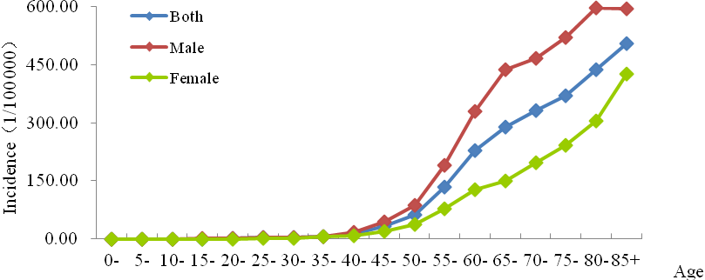

Figure 1 Age-specific incidence rate of upper gastrointestinal cancer in Hebei Province, 2013.

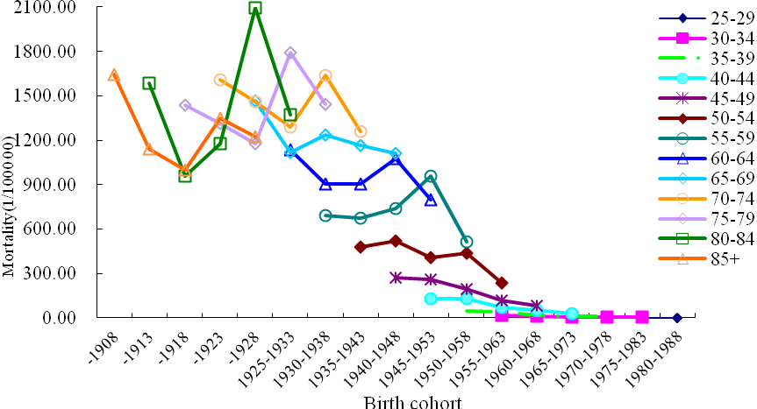

Figure 2 Trend in age-specific incidence rate of upper gastrointestinal cancer plotted against birth cohort.

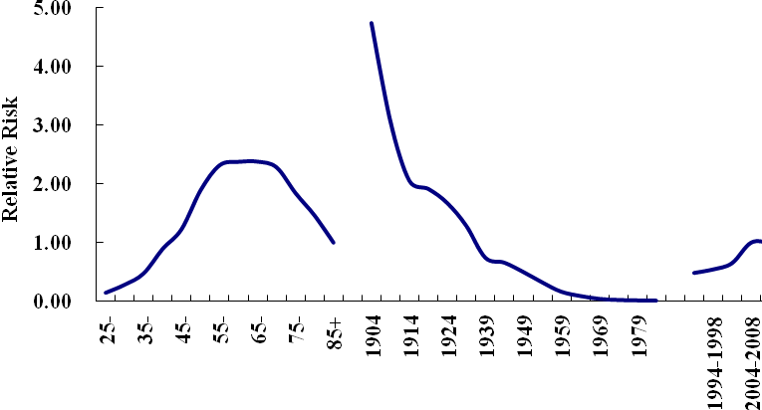

Figure 3 The estimation of age, period and birth cohort effects of upper gastrointestinal cancer incidence in Cixian, 1989-2013.

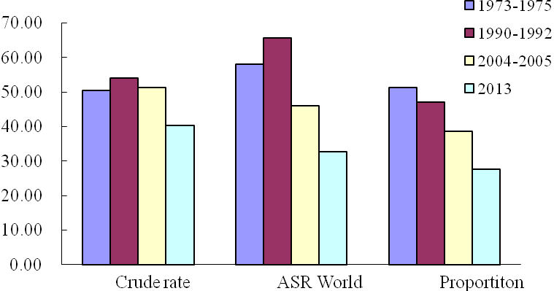

Figure 4 The mortality of upper gastrointestinal cancer in Hebei province from 1970's to 2013.

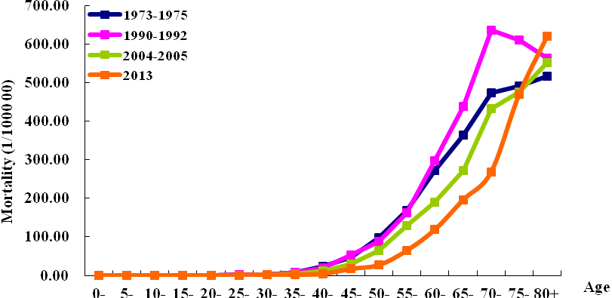

Figure 5 Age-specific mortality rate of upper gastrointestinal cancer in Hebei Province from 1970s to 2013.

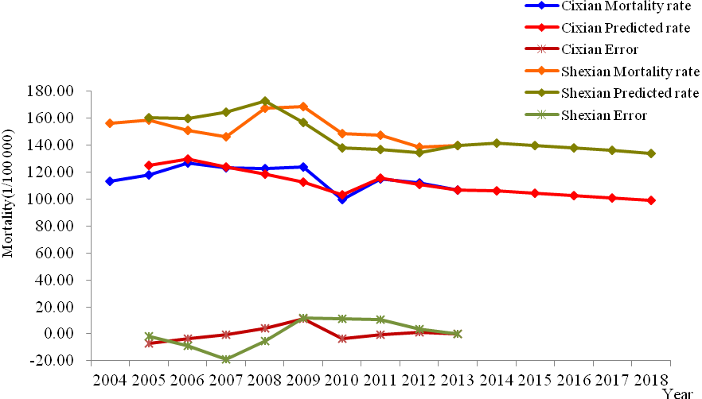

Figure 6 The mortality rates prediction of upper gastrointestinal cancer via grey system model in Cixian and Shexian.

