Name of Journal: World Journal of Gastroenterology
Manuscript NO: 38381
Manuscript Type: ORIGINAL ARTICLE

Randomized Clinical Trial
Papillary fistulotomy vs conventional cannulation for endoscopic biliary access: A prospective randomized trial

Furuya CK et al. Papillary fistulotomy for biliary access

Carlos Kiyoshi Furuya, Paulo Sakai, Fabio Ramalho Tavares Marinho, Jose Pinhata Otoch, Spencer Cheng, Lívia Lemes Prudencio, Eduardo Guimarães Hourneaux de Moura, Everson Luiz de Almeida Artifon

Carlos Kiyoshi Furuya, Paulo Sakai, Fabio Ramalho Tavares Marinho, Spencer Cheng, Eduardo Guimarães Hourneaux de Moura, Department of Gastrointestinal Endoscopy Unit, University of Sao Paulo, Sao Paulo 05409001, Brazil

Jose Pinhata Otoch, Lívia Lemes Prudencio, Department of Surgery, University of Sao Paulo, Sao Paulo 05403000, Brazil

Everson Luiz de Almeida Artifon, Department of Gastroenterology and Radiology, University of Sao Paulo, Sao Paulo 04107-030, Brazil

ORCID number: Carlos Kiyoshi Furuya (0000-0002-6512-5029); Paulo Sakai (0000-0003-3088-9210); Fabio Ramalho Tavares Marinho (0000-0002-7509-7113); Jose Pinhata Otoch (0000-0002-8293-1508); Spencer Cheng (0000-0001-9584-203X); Lívia Lemes Prudencio (0000-0002-8256-9035); Eduardo Guimarães Hourneaux de Moura (0000-0003-1215-5731); Everson Luiz de Almeida Artifon (0000-0003-1900-8777).

Author contributions: Furuya CK designed research and performed research; Sakai P wrote the paper; Marinho FRT wrote the paper; Otoch JP analyzed data; Prudencio LL wrote the paper; de Moura EGH analyzed data; de Almeida Artifon EL performed research and analyzed data.

Institutional review board statement: The study was reviewed and approved by Ethics Committee for Research Project Analysis of Clinics Hospital, University of Sao Paulo and UNILUS Ethics Subcommittee.

Informed consent statement: All study participants, or their legal guardian, provided informed written consent prior to study enrollment.

Conflict-of-interest statement: All authors declare no potential conflicting interests related to this paper.

Data sharing statement: No additional data are available.

Open-Access: This article is an open-access article which was selected by an in-house editor and fully peer-reviewed by external reviewers. It is distributed in accordance with the Creative Commons Attribution Non Commercial (CC BY-NC 4.0) license, which permits others to distribute, remix, adapt, build upon this work non-commercially, and license their derivative works on different terms, provided the original work is properly cited and the use is non-commercial. See: http://creativecommons.org/licenses/by-nc/4.0/

Manuscript source: Unsolicited manuscript

Correspondence to: Carlos Kiyoshi Furuya, MD, PhD, Medical Assistant, Departament of Gastrointestinal Endoscopy Unit, University Of Sao Paulo, Av. Dr. Eneas de Carvalho Aguiar, 255 Predio dos AmbulatorioS - 6 andar - Bloco 3, Sao Paulo 5409001, Brazil. carloskfjr@gmail.com
Telephone: +55-11-30697579

Received: February 25, 2018
Peer-review started: February 26, 2018
First decision: March 9, 2018
Revised: March 12, 2018
Accepted: March 25, 2018
Article in press:
Published online:

Abstract
AIM
To compare the cannulation success, biochemical profile, and complications of the papillary fistulotomy technique vs catheter and guidewire standard access.

METHODS
From July 2010 to May 2017, patients were prospectively randomized into two groups: Cannulation with a catheter and guidewire (Group I) and papillary fistulotomy (Group II). Amylase, lipase and C-reactive protein at T0, as well as 12 h and 24 h after endoscopic retrograde cholangiopancreatography, and complications (pancreatitis, bleeding, perforation) were recorded.

RESULTS
We included 102 patients (66 females and 36 males, age 59.11 ± 18.7 years). Group I and Group II had 51 patients each. The successful cannulation rates were 76.5% and 100%, respectively (P = 0.0002). Twelve patients (23.5%) in Group I had a difficult cannulation and underwent fistulotomy, which led to successful secondary biliary access (Failure Group). The complication rate was 13.7% (2 perforations and 5 mild pancreatitis) vs 2.0% (1 patient with perforation and pancreatitis) in Groups I and II, respectively (P = 0.0597).

CONCLUSION
Papillary fistulotomy was more effective than guidewire cannulation, and it was associated with a lower profile of amylase and lipase. Complications were similar in both groups.

Key words: Catheterization; Common bile duct; Complications; Endoscopic retrograde cholangiopancreatography; Therapeutic use

© The Author(s) 2018. Published by Baishideng Publishing Group Inc. All rights reserved.

Core tip: The biliary cannulation is the first step of the therapeutic endoscopic retrograde cholangiopancreatography and can determine several complications. There are small numbers of papers regarding comparison between conventional cannulation vs fistulotomy. Our study is a well design approach in its matter. In fact, we compare the cannulation success, biochemical profile, and complications of the papillary fistulotomy technique vs catheter and guidewire standard access. Papillary fistulotomy was more effective than guidewire cannulation, and it was associated with a lower profile of amylase and lipase, as the routine endoscopic access to the biliary tree, including difficult cases. Complications were similar in both groups.

Furuya CK, Sakai P, Marinho FRT, Otoch JP, Cheng S, Prudencio LL, de Moura EGH, de Almeida Artifon EL. Papillary fistulotomy vs conventional cannulation for endoscopic biliary access: A prospective randomized trial. World J Gastroenterol 2018; In press

INTRODUCTION
Biliary tract cannulation is the critical step, in diagnosis and treatment of biliopancreatic diseases during endoscopic retrograde cholangiopancreatography (ERCP). Catheter introduction through the papillary ostium fails in 5% to 20% of the patients^{[1,2]}. Several alternatives can be used for difficult cases, such as double-guidewire, pancreatic stent, rendez-vous, precut papillotomy, transpancreatic sphincterotomy, and papillary fistulotomy (PF) techniques.
Acute pancreatitis after ERCP is the most feared complication. It is also one of the most frequent, with an incidence of 1% up to 10% or more, and a mortality of 0.1%-1%^{[3]}.
Selective cannulation of the biliary tract, thereby avoiding the pancreatic duct, can curb the mechanisms that trigger pancreatitis, and therefore prevent its occurrence. The precut sphincterotomy has been identified as an independent risk factor of post-ERCP pancreatitis (PEP). It is unclear whether prolonged cannulation attempts, or precut incisions are to blame. Studies suggest that an early precut is a protective factor, compared to persistent attempts at cannulation^{[4,5]}. However, all protocols that found a lower risk of PEP with a precut technique, were performed at specialized centers, and the use of pancreatic stents was limited and inconsistent.
There are few investigations in which the precut and PF techniques were initially employed, to access the biliary tract^{[6-8]}. The PF technique is based on accessing the bile duct far from the pancreatic duct, by sectioning the papilla proximally, and thus avoiding the ostium (proximal half of the papilla). PF was initially described by Osnes et al^{[9]}. These authors observed a spontaneous choledochoduodenal fistula during ERCP. Contrast injection through the fistula detected bile duct stones. After enlargement of the fistula with a diathermic snare, the patients were observed for a few days with the spontaneous exit of the stones. Sakai et al^{[10]} reported a pancreatitis occurrence rate of 7.6% in 2001, particularly in the setting of previous manipulation of the papilla, and trauma to the pancreatic duct, after several frustrated attempts at biliary tract cannulation.
The main objective of this study was to evaluate the success of the PF technique, in the cannulation of the biliary tract. The secondary objective was to assess the enzyme profile and ensuing complications, in comparison with direct cannulation.

MATERIALS AND METHODS
From July 2010 to May 2017, candidates for ERCP due to choledocolithiasis were recruited at Ana Costa Santos Hospital, and the Endoscopy Unit of the Clinical Hospital, Faculty of Medicine, University of Sao Paulo, patients were randomized for conventional cannulation with a catheter and guidewire (Group I) and papillary fistulotomy (Group II).
Inclusion criteria were adults (both genders) with choledocholithiasis, diagnosed by abdominal ultrasound, tomography (CT), cholangio resonance, or intraoperative cholangiography. Exclusion criteria were Billroth II gastrectomy, duodenal obstruction, coagulopathy or anticoagulant use, pregnancy or lactation, acute pancreatitis, myocardial infarction in the last six months, previous papillotomy, and refusal to participate in the study.
The protocol was approved by the institutional Ethical Committee, and also registered as a randomized trial at the University of Sao Paulo Registry-MA3: 014/2010 and 0671/09. Informed Consent was signed by all participants. Side-view endoscopes (Pentax ED-3670TK, Olympus TJF-160, or Fujinon ED-250XT5) were used during ERCP. WEM SS-200E, Erbe ICC 200 and ValleyLab Force FX electrosurgical units were employed.

Group I
Cannulation of the papillary ostium was performed using a 4.4 Fr sphincterotome (TRUEtome, Boston Scientific) with a 0.035-inch guidewire (Jagwire, Boston Scientific). A pure cut current (50-watts), applied in short-duration pulses, was adopted to perform papillotomy. A 30-watts pure cut current was indicated for intradiverticular papillae, and the complementation of fistulotomies (Figures 1 and 2).
A difficult cannulation was recognized if it took > 10 min, required > 5 cannulation attempts, or when > 2 pancreatic duct penetrations occurred. Difficult cases were referred to PF. Pancreatic plastic stents were placed in case of prolonged procedure.

Group II
Incision was made on the mucosa, using a needle-knife catheter (MicroKnife XL, Boston Scientific), in distal to proximal direction, aiming at the papillary apex. It involved the proximal two-thirds of the papillary protuberance, and above the papillary orifice (approximately 5 mm far from the ostium). A pure cutting current (30 watts) was used to section the mucosa and the choledochal sphincter. The dissection was stopped when biliary secretion, open bile duct mucosa, or bulging of the bile duct mucosa was identified. The fistula was cannulated into the bile duct with a guidewire and sphincterotome, and it was enlarged by cutting the sphincter, to the limit of the transverse mucosal fold.
The PF procedure was stopped when there were signs of perforation, false route, major bleeding, loss of anatomy, or if cannulation of the bile duct was not achieved within 15 min. In these cases, the procedure was repeated after five to seven days.
Enzymatic abnormalities (serum amylase and lipase) were documented up to 24 h before the examination (T0), as well as 12 h and 24 h after the endoscopic procedure. The diagnosis of acute pancreatitis was based on persistent or worsening abdominal pain 24 h following ERCP, and abnormal laboratory data, and it was complemented by imaging methods. Amylase or lipase more than three times the upper limit of normal was considered diagnostic^{[11]}.
Hyperamylasemia was defined as amylase and/or lipase 3 times the upper limit of normal (above 300 U/L), without clinical features of pancreatitis. Inflammatory changes were monitored by serum C-reactive protein (CRP), collected at the same times.
A duodenal perforation was defined as gas or contrast accumulation in the retroperitoneum, on a simple X-ray of the abdomen. Endoscopic evidence, and clinical-laboratory findings consistent with bleeding were carefully monitored. These included bloody vomiting or stools. Whenever the problem was suspected, hemoglobin concentration was serially measured starting at 12 h after the intervention, and compared with pre-procedure values, with hemoglobin drop of 2 g/dL.
Patients were admitted for 24 h after the endoscopic procedure and under fasting condition. Asymptomatic patients without laboratorial or radiological signs of pancreatitis or other complications were discharged after 24 h and contacted by phone call 36 h and 48 h after discharge to ensure there were no symptoms. Any symptomatic patient would be referred to the hospital for clinical and laboratorial assessment. If a complication occurred, the patient remained hospitalized until complete recovery was observed. All complications were managed with multidisciplinary approach and according to international guidelines at consensus between Endoscopist and Surgeon.

Sample size calculation
Calculations were based on similar studies, reporting a biliary cannulation failure rate of 5% to 20%^{[1,2]}. Adopting a 95% confidence interval of 3.65, a total population of 90 patients, and a minimum method failure rate of 2% (total ERCP success of 98% as maximum), 35 patients per group were deemed necessary. For safety, 51 patients were allocated to each group.

Statistical analysis
Analyses were performed with IBM SPSS for Windows version 20.0. The significance level was 5%. Randomization employed sealed envelopes, and descriptive statistics comprised mean ± SD, as well as median, minimum and maximum, whenever appropriate. Student’s t test and Mann-Whitney test were used for comparisons, depending on initial normality assessment. Qualitative characteristics were informed as absolute and relative frequencies, and compared by means of Chi-square, Fisher exact test, and Likelihood ratio test^{[12]}. Pancreatic enzyme curves were compared by generalized estimating equations (GEE), with gamma marginal distribution and identity link function, within a first order auto-regressive correlation matrix between the evaluation times.

RESULTS
A total of 102 patients were selected and randomized into Group I (51 patients) and Group II (51 patients). There were no post-hoc exclusions. Table 1 demonstrates that demographic and preliminary clinical findings were comparable (P > 0.05).
As informed in Table 2, choledocholithiasis was confirmed in 80.4% and 62.7% of Groups I and II, respectively (P = 0.048). The success rate for biliary duct cannulation was higher in Group II (100%) than in Group I (76.48%) (P = 0.0002). PF was performed in a single session. Dilated intrahepatic and extrahepatic bile ducts, and placement of biliary stents, were not different between the groups (P > 0.05). No difference in the risk of pancreatitis could be accounted either, to intrahepatic or extrahepatic dilatation.
Intra- or peridiverticular papillae were observed in 15.7% and 3.9% of the populations, respectively (P = 0.046). Twelve cannulations (23.5%) were classified as difficult, thus migrating to the PF technique (Figure 3). Groups I and II had 13.7% and 2.0% complication rate, respectively, which barely failed to reach significance (P = 0.0597). Two perforations and five cases of pancreatitis were observed in the first group, compared to a single case of retroperitoneal perforation and pancreatitis in the second one.
Table 3 reveals that number of cannulations, as expected, was significantly different in the difficult cannulation group (P < 0.001), however not ERCP findings, stent placement or complications (P > 0.05).
In Table 4 it can be appreciated that lipase and amylase, differed both between the groups and over time (P = 0.026 and P = 0.013, respectively). In contrast, no discrepancy for C-reactive protein was detected, regarding groups (P = 0.189) or time (P = 0.07).
Figures 4-6 depict amylase and lipase elevations in Group I patients. C-reactive protein, as alluded to, failed to exhibit discriminant patterns.

DISCUSSION
Pancreatitis is the most frequent complication of ERCP, occurring in as many as 15.1% of the patients^{[6-8,13,14]}. It is associated with considerable morbidity and mortality. Precut techniques have been associated with a high risk of PEP in previous studies^{[7,8,15-17]}.
A difficult cannulation is an independent risk factor^{[18,19]}. The failure rate of primary biliary tract cannulation, with the use of a sphincterotome, was calculated as 2.5%-24% without a guidewire^{[20-23]} and 1.5%-10%^{[21,23,24]} adopting the wire. The American Society for Gastrointestinal Endoscopy (ASGE) benchmark, for cannulation success during ERCP procedures of low to moderate complexity, is > 90% for all indications^{[25]}.
In this study, primary success rate was 76.5%, with 9.8% of PEP. A difficult cannulation was observed in 12 patients, yet access was achieved via PF in all these individuals. The high failure rate (23.5%) may be explained by the participation of fellows, who are less experienced, thus additional attempts by endoscopists with greater expertise were required. Nevertheless, papillary trauma eventually inflicted during the first intervention, may hinder subsequent access, thus compromising the overall success rate.
Common bile duct stones were not found in all cases during ERCP, possibly on account of the long period elapsed since the original diagnosis, in the primary care Institution. It is important to mention that per protocol, papillary fistulotomy was conducted directly, without prior manipulation by conventional techniques. Cannulation of the bile duct using PF, was accomplished in all patients in Group II. Three previous studies with a similar design, displayed 89.3%-96.5% success rate for fistulotomy^{[26-28]}. In the control group (conventional technique), the corresponding values were 70.6% and 88%^{[26-28]}.
The mean diameter of the common bile duct in this experience was 8.7 mm (5-18.2 mm). Sakai et al^{[10]} in 2001, suggested that PF be reserved mainly for patients with a dilated common bile duct. Jin et al^{[27]} in 2016 , based on 55 interventions, concluded that a bile duct < 9 mm was a risk factor. Yet Khatibian et al^{[26]} in 2008, reported that the diameter of the common bile duct, was not relevant for need of PF.
In the current series, PF (Group II and failures) was performed in 28 of 63 patients (44.4%, P = 0.834), through the common bile duct without dilatation. No difference in the risk of pancreatitis emerged, when considering the caliber of the intra- and extrahepatic biliary tract. Bile duct stones could not be removed in the first attempt in 20.8% of the cases, due to large size, therefore a biliary stent was placed.
Hyperamylasemia was observed in 2 patients in Group I (P = 0.49). Transient asymptomatic elevations in amylase, lipase, or both, range from 0 to 64% in the literature^{[29-31]}. Asymptomatic hyperamylasemia, defined as amylase levels > 5 times the upper limit, 24 h after ERCP, has been reported in approximately 27% of the cases^{[32]}.
In our study, the number of cannulation attempts significantly correlated with increased lipase and amylase levels, at 12 and 24 h after the procedure. In a series of 907 patients, the rates of PEP were 0.6%, 3.1%, 6.1% and 11.9% following one, two, three to four, and more than five primary cannulation attempts that led to success, respectively. PEP risk increased to 11.5% , if the primary cannulation method failed^{[19]}. In our study, PEP occurred following the guidewire cannulation (GWC) technique in five patients (9.8%), of which two (3.9%) exhibited a difficult papillary access, which was only achieved by means of PF.
No significant increase in pancreatic enzymes was observed, and the incidence of PEP was not greater in the group that underwent PF as the initial procedure. Neither did the 12 patients with PF as a rescue procedure, exhibit a different pattern. This demonstrates the safety of PF, whenever performed or supervised by experienced physicians. Zagalsky et al^{[33]} in 2016, compared early PCP techniques and the use of a pancreatic duct stent, in 101 patients who suffered difficult cannulations. The success rates of biliary cannulation (98% and 96%), and the occurrence of PEP (4% and 3.92%), were similar between early PCP and stent group, respectively. Two perforations and bleeds occurred in the early PCP group, which also demonstrates the safety of the procedure, compared to standard PEP prevention technique after a failed GWC.
Other recent studies show that precut techniques, lead to an increased rate of successful deep biliary tract access, and their early use by experienced endoscopists results in a decrease in PEP^{[4,27,34]}. Weerth et al^{[2]} compared primary PCP and GWC for bile duct access, and reported a success rate at the first attempt of 100% and 71%, respectively. They observed mild to moderate PEP in 2.1% and 2.9% (P > 0.05), after primary PCP or GWC, respectively. Only one patient (in the GWC group) suffered from post-papillotomy bleeding. In our experience, a single patient presented a retroperitoneal perforation and pancreatitis in Group II, which were conservatively managed.
There were two perforations (3.9%) in Group I, and the one (1.9%) in Group II already alluded to, which were always conservatively treated. No bleeding was observed. The negligible incidence of bleeding is consistent with previous precut studies (0-3.4%)^{[2,17,26,28,35]}. As regards perforation ( 0-1.8%), our results are also quite acceptable^{[2,17,26,28,35]}.

In conclusion, papillary fistulotomy was more effective than GWC, and it was associated with a lower profile of amylase and lipase, as the routine endoscopic access to the biliary tree, including difficult cases. Complications were similar in both groups.

ARTICLE HIGHLIGHTS
Research background
Successfully cannulating the biliary tract is important in the diagnosis and treatment of biliopancreatic diseases, with endoscopic retrograde cholangiopancreatography (ERCP), but it can be associated with severe complications and mortality.

Research motivation
There is small number of papers regarding comparison between conventional cannulation vs fistulotomy. Our study is a well-designed approach in its matter.

Research objectives:
To Ccompare the cannulation success, biochemical profile, and complications of the papillary fistulotomy technique vs catheter and guidewire standard access.

Research methods
Patients were prospectively randomized into two groups: cannulation with a catheter and guidewire (Group I) and papillary fistulotomy (Group II). Amylase, lipase and C-reactive protein at T0, as well as 12 h and 24 h after ERCP, and complications (pancreatitis, bleeding, perforation) were recorded. Compare the cannulation success, biochemical profile, and complications of the papillary fistulotomy technique vs catheter and guidewire standard access.

Research results
We included 102 patients, and Groups I and II had 51 patients each. The successful cannulation rates were 76.5% and 100%, respectively (P = 0.0002). Twelve patients (23.5%) in Group I had a difficult cannulation and underwent fistulotomy, which led to successful secondary biliary access (Failure Group). The complication rate was 13.7% (2 perforations and 5 mild pancreatitis) in Group I vs 2.0% (1 patient with perforation and pancreatitis) in Group II (P = 0.0597).

Research conclusions
Papillary fistulotomy was more effective than guidewire cannulation (GWC), and it was associated with a lower profile of amylase and lipase. Complications were similar in both groups.

Research perspectives

The fistulotomy demonstrated to be safe as much as conventional cannulation was and determined less local trauma into the ampulla, according to the levels of the amylase, lipase and C-reactive protein.

REFERENCES
1 Abu-Hamda EM, Baron TH, Simmons DT, Petersen BT. A retrospective comparison of outcomes using three different precut needle knife techniques for biliary cannulation. J Clin Gastroenterol 2005; 39: 717-721 [PMID: 16082283]
2 de Weerth A, Seitz U, Zhong Y, Groth S, Omar S, Papageorgiou C, Bohnacker S, Seewald S, Seifert H, Binmoeller KF, Thonke F, Soehendra N. Primary precutting versus conventional over-the-wire sphincterotomy for bile duct access: a prospective randomized study. Endoscopy 2006; 38: 1235-1240 [PMID: 17163325 DOI: 10.1055/s-2006-944962]
3 Freeman ML, Guda NM. ERCP cannulation: a review of reported techniques. Gastrointest Endosc 2005; 61: 112-125 [PMID: 15672074]
4 Sundaralingam P, Masson P, Bourke MJ. Early Precut Sphincterotomy Does Not Increase Risk During Endoscopic Retrograde Cholangiopancreatography in Patients With Difficult Biliary Access: A Meta-analysis of Randomized Controlled Trials. Clin Gastroenterol Hepatol 2015; 13: 1722-1729.e2 [PMID: 26144018 DOI: 10.1016/j.cgh.2015.06.035]
5 Mariani A, Di Leo M, Giardullo N, Giussani A, Marini M, Buffoli F, Cipolletta L, Radaelli F, Ravelli P, Lombardi G, D'Onofrio V, Macchiarelli R, Iiritano E, Le Grazie M, Pantaleo G, Testoni PA. Early precut sphincterotomy for difficult biliary access to reduce post-ERCP pancreatitis: a randomized trial. Endoscopy 2016; 48: 530-535 [PMID: 26990509 DOI: 10.1055/s-0042-102250]
6 Freeman ML, Nelson DB, Sherman S, Haber GB, Herman ME, Dorsher PJ, Moore JP, Fennerty MB, Ryan ME, Shaw MJ, Lande JD, Pheley AM. Complications of endoscopic biliary sphincterotomy. N Engl J Med 1996; 335: 909-918 [PMID: 8782497 DOI: 10.1056/NEJM199609263351301]
7 Mavrogiannis C, Liatsos C, Romanos A, Petoumenos C, Nakos A, Karvountzis G. Needle-knife fistulotomy versus needle-knife precut papillotomy for the treatment of common bile duct stones. Gastrointest Endosc 1999; 50: 334-339 [PMID: 10462652 DOI: 10.1053/ge.1999.v50.98593]
8 Zhou W, Li Y, Zhang Q, Li X, Meng W, Zhang L, Zhang H, Zhu K, Zhu X. Risk factors for postendoscopic retrograde cholangiopancreatography pancreatitis: a retrospective analysis of 7,168 cases. Pancreatology 2011; 11: 399-405 [PMID: 21894057 DOI: 10.1016/S1424-3903(11)80094-3.]
9 Osnes M, Kahrs T. Endoscopic choledochoduodenostomy for choledocholithiasis through choledochoduodenal fistula. Endoscopy 1977; 9: 162-165 [PMID: 913369 DOI: 10.1055/s-0028-1098510]
10 Sakai P, Artifon ELA, Maluf Filho F. Fistulopapilotomia Endoscópica: Uma Alternativa à Papila de Difícil Cateterização. GED 2001; 20: 208-212
11 Lerch MM. Classifying an unpredictable disease: the revised Atlanta classification of acute pancreatitis. Gut 2013; 62: 2-3 [PMID: 23220948 DOI: 10.1136/gutjnl-2012-303724]
12 Kirkwood B, JAC S. Essential Medical Statistics. 2nd ed. Massachusetts, United States: Blackwell Science; 2006
13 Cheng CL, Sherman S, Watkins JL, Barnett J, Freeman M, Geenen J, Ryan M, Parker H, Frakes JT, Fogel EL, Silverman WB, Dua KS, Aliperti G, Yakshe P, Uzer M, Jones W, Goff J, Lazzell-Pannell L, Rashdan A, Temkit M, Lehman GA. Risk factors for post-ERCP pancreatitis: a prospective multicenter study. Am J Gastroenterol 2006; 101: 139-147 [PMID: 16405547 DOI: 10.1111/j.1572-0241.2006.00380.x]
14 Bailey AA, Bourke MJ, Williams SJ, Walsh PR, Murray MA, Lee EY, Kwan V, Lynch PM. A prospective randomized trial of cannulation technique in ERCP: effects on technical success and post-ERCP pancreatitis. Endoscopy 2008; 40: 296-301 [PMID: 18389448 DOI: 10.1055/s-2007-995566]
15 Bailey AA, Bourke MJ, Kaffes AJ, Byth K, Lee EY, Williams SJ. Needle-knife sphincterotomy: factors predicting its use and the relationship with post-ERCP pancreatitis (with video). Gastrointest Endosc 2010; 71: 266-271 [PMID: 20003969 DOI: 10.1016/j.gie.2009.09.024]
16 Halttunen J, Keränen I, Udd M, Kylänpää L. Pancreatic sphincterotomy versus needle knife precut in difficult biliary cannulation. Surg Endosc 2009; 23: 745-749 [PMID: 18649101 DOI: 10.1007/s00464-008-0056-0]
17 O'Connor HJ, Bhutta AS, Redmond PL, Carruthers DA. Suprapapillary fistulosphincterotomy at ERCP: a prospective study. Endoscopy 1997; 29: 266-270 [PMID: 9255529 DOI: 10.1055/s-2007-1004187]
18 Freeman ML, DiSario JA, Nelson DB, Fennerty MB, Lee JG, Bjorkman DJ, Overby CS, Aas J, Ryan ME, Bochna GS, Shaw MJ, Snady HW, Erickson RV, Moore JP, Roel JP. Risk factors for post-ERCP pancreatitis: a prospective, multicenter study. Gastrointest Endosc 2001; 54: 425-434 [PMID: 11577302 DOI: 10.1067/mge.2001.117550.]
19 Halttunen J, Meisner S, Aabakken L, Arnelo U, Grönroos J, Hauge T, Kleveland PM, Nordblad Schmidt P, Saarela A, Swahn F, Toth E, Mustonen H, Löhr JM. Difficult cannulation as defined by a prospective study of the Scandinavian Association for Digestive Endoscopy (SADE) in 907 ERCPs. Scand J Gastroenterol 2014; 49: 752-758 [PMID: 24628493 DOI: 10.3109/00365521.2014.894120]
20 Laasch HU, Tringali A, Wilbraham L, Marriott A, England RE, Mutignani M, Perri V, Costamagna G, Martin DF. Comparison of standard and steerable catheters for bile duct cannulation in ERCP. Endoscopy 2003; 35: 669-674 [PMID: 12929062 DOI: 10.1055/s-2003-41515]
21 Lella F, Bagnolo F, Colombo E, Bonassi U. A simple way of avoiding post-ERCP pancreatitis. Gastrointest Endosc 2004; 59: 830-834 [PMID: 15173796]
22 Schwacha H, Allgaier HP, Deibert P, Olschewski M, Allgaier U, Blum HE. A sphincterotome-based technique for selective transpapillary common bile duct cannulation. Gastrointest Endosc 2000; 52: 387-391 [PMID: 10968855 DOI: 10.1067/mge.2000.107909]
23 Artifon EL, Sakai P, Cunha JE, Halwan B, Ishioka S, Kumar A. Guidewire cannulation reduces risk of post-ERCP pancreatitis and facilitates bile duct cannulation. Am J Gastroenterol 2007; 102: 2147-2153 [PMID: 17581267 DOI: 10.1111/j.1572-0241.2007.01378.x]
24 Zhou PH, Yao LQ, Xu MD, Zhong YS, Gao WD, He GJ, Zhang YQ, Chen WF, Qin XY. Application of needle-knife in difficult biliary cannulation for endoscopic retrograde cholangiopancreatography. Hepatobiliary Pancreat Dis Int 2006; 5: 590-594 [PMID: 17085348]
25 Adler DG, Lieb JG 2nd, Cohen J, Pike IM, Park WG, Rizk MK, Sawhney MS, Scheiman JM, Shaheen NJ, Sherman S, Wani S. Quality indicators for ERCP. Gastrointest Endosc 2015; 81: 54-66 [PMID: 25480099 DOI: 10.1016/j.gie.2014.07.056]
26 Khatibian M, Sotoudehmanesh R, Ali-Asgari A, Movahedi Z, Kolahdoozan S. Needle-knife fistulotomy versus standard method for cannulation of common bile duct: a randomized controlled trial. Arch Iran Med 2008; 11: 16-20 [PMID: 18154417 DOI: 08111/AIM.006]
27 Jin YJ, Jeong S, Lee DH. Utility of needle-knife fistulotomy as an initial method of biliary cannulation to prevent post-ERCP pancreatitis in a highly selected at-risk group: a single-arm prospective feasibility study. Gastrointest Endosc 2016; 84: 808-813 [PMID: 27102829 DOI: 10.1016/j.gie.2016.04.011]
28 Ayoubi M, Sansoè G, Leone N, Castellino F. Comparison between needle-knife fistulotomy and standard cannulation in ERCP. World J Gastrointest Endosc 2012; 4: 398-404 [PMID: 23125897 DOI: 10.4253/wjge.v4.i9.398]
29 Tanaka R, Itoi T, Sofuni A, Itokawa F, Kurihara T, Tsuchiya T, Tsuji S, Ishii K, Ikeuchi N, Umeda J, Tonozuka R, Honjo M, Mukai S, Moriyasu F. Is the double-guidewire technique superior to the pancreatic duct guidewire technique in cases of pancreatic duct opacification? J Gastroenterol Hepatol 2013; 28: 1787-1793 [PMID: 23800118 DOI: 10.1111/jgh.12303]
30 Nishino T, Toki F, Oyama H, Shiratori K. More accurate prediction of post-ercp pancreatitis by 4-h serum lipase levels than amylase levels. Dig Endosc 2008; 20: 169-177
31 Dumonceau JM, Devière J, Cremer M. A new method of achieving deep cannulation of the common bile duct during endoscopic retrograde cholangiopancreatography. Endoscopy 1998; 30: S80 [PMID: 9826155]
32 Testoni PA, Testoni S, Giussani A. Difficult biliary cannulation during ERCP: how to facilitate biliary access and minimize the risk of post-ERCP pancreatitis. Dig Liver Dis 2011; 43: 596-603 [PMID: 21377432 DOI: 10.1016/j.dld.2011.01.019]
33 Zagalsky D, Guidi MA, Curvale C, Lasa J, de Maria J, Ianniccillo H, Hwang HJ, Matano R. Early precut is as efficient as pancreatic stent in preventing post-ERCP pancreatitis in high-risk subjects - A randomized study. Rev Esp Enferm Dig 2016; 108: 258-562 [PMID: 27604474 DOI: 10.17235/reed.2016.4348/2016]
34 Cennamo V, Fuccio L, Zagari RM, Eusebi LH, Ceroni L, Laterza L, Fabbri C, Bazzoli F. Can early precut implementation reduce endoscopic retrograde cholangiopancreatography-related complication risk? Meta-analysis of randomized controlled trials. Endoscopy 2010; 42: 381-388 [PMID: 20306386 DOI: 10.1055/s-0029-1243992]
35 Huibregtse K, Katon RM, Tytgat GN. Precut papillotomy via fine-needle knife papillotome: a safe and effective technique. Gastrointest Endosc 1986; 32: 403-405 [PMID: 3803839]

P-Reviewer: Kahraman A, Ker CG S-Editor: Wang XJ
L-Editor: E-Editor:

Specialty type: Gastroenterology and hepatology
Country of origin: Brazil
Peer-review report classification
Grade A (Excellent): 0
Grade B (Very good): 0
Grade C (Good): C, C
Grade D (Fair): 0
Grade E (Poor): 0

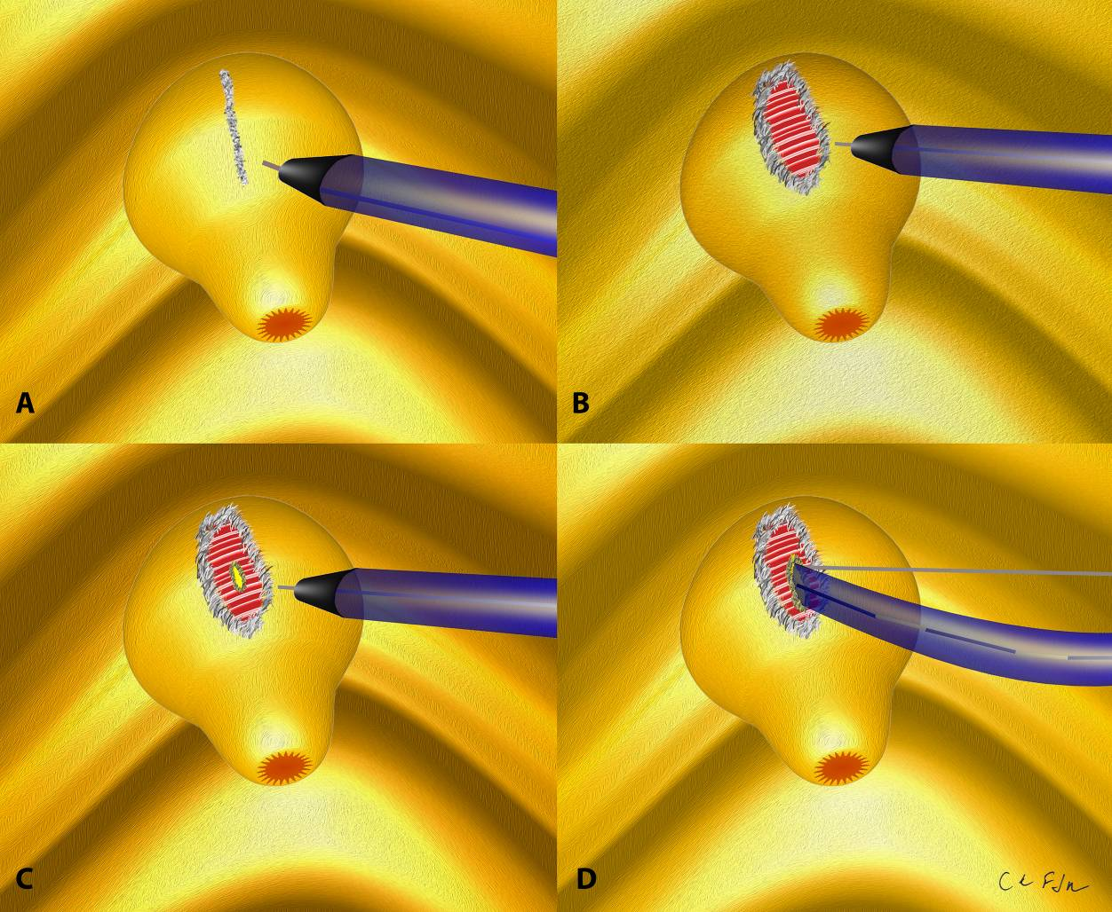

Figure 1 Schematic sequence of papillary fistulotomy. A and B: Dissection of the major papilla; C: Sphincterotome in the bile duct; D: Radiological image.

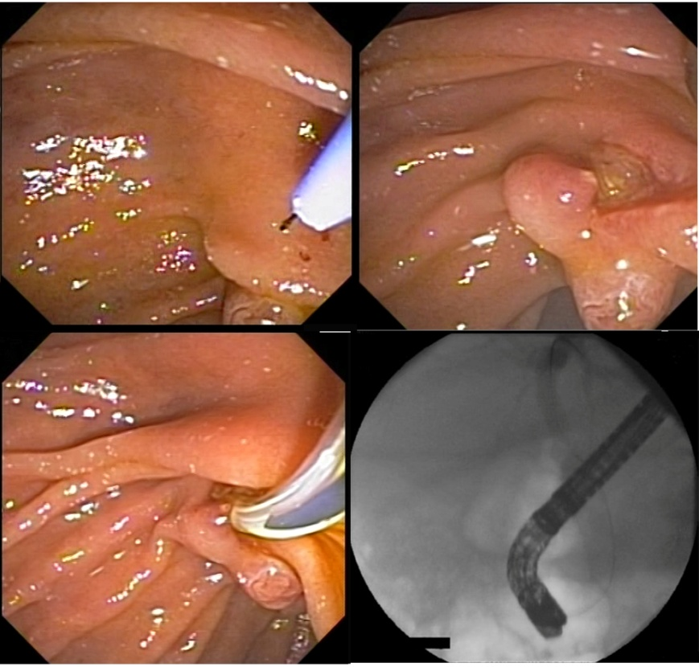

Figure 2 Sequence of papillary fistulotomy. A and B: Dissection of the major papilla; D: Sphincterotome in the bile duct; D: Radiological image.

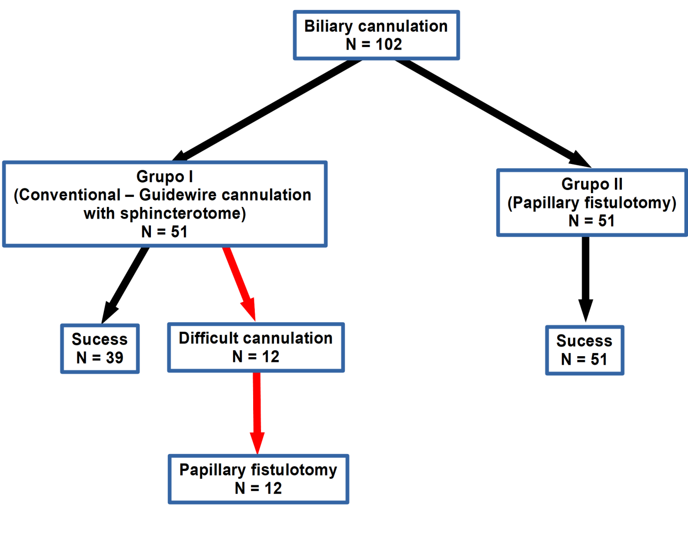
Figure 3 Flowchart showing the sequence of procedures performed in the study. GWC: Guidewire cannulation.

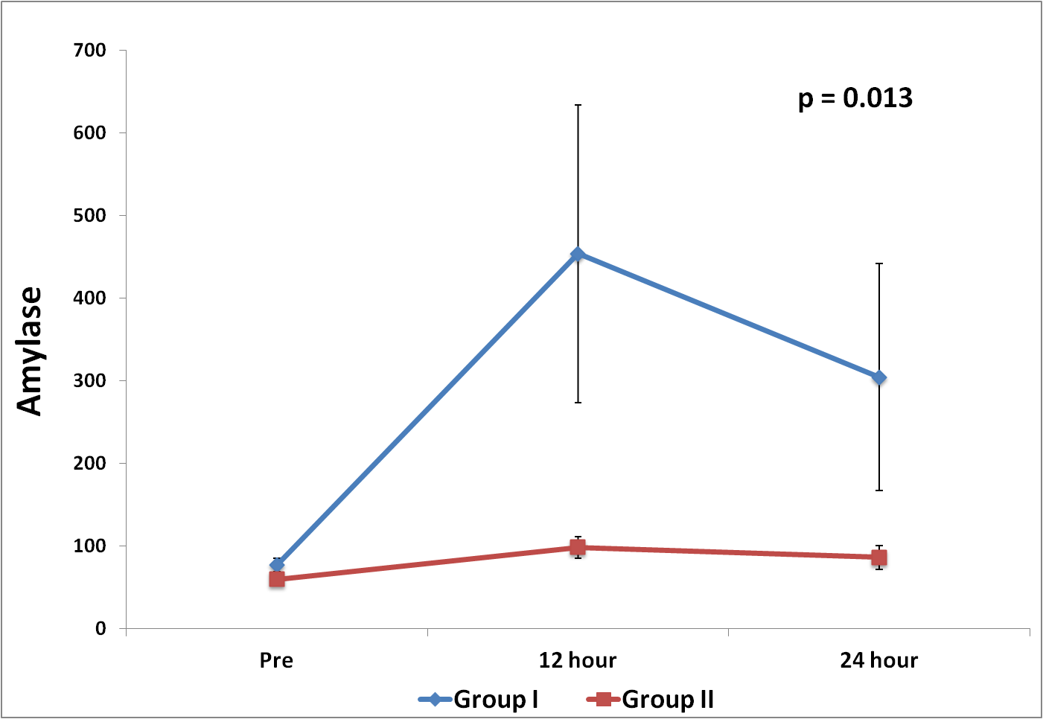

Figure 4 Amylase profile after the procedure.

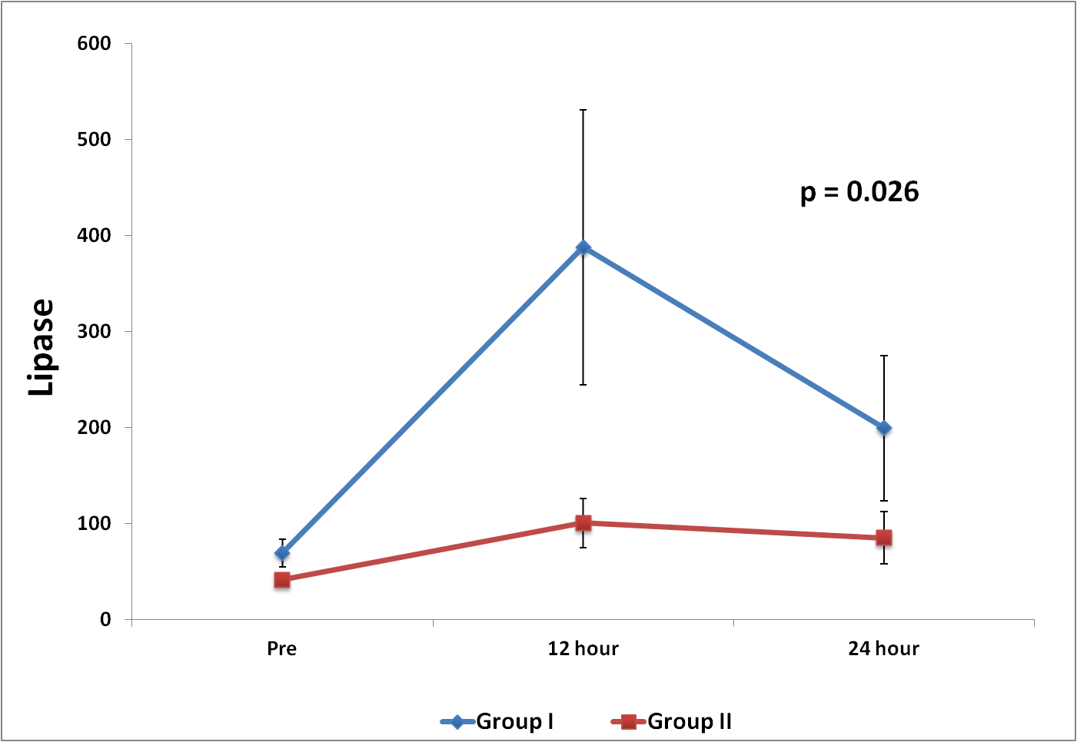

Figure 5 Lipase profile in the two groups.

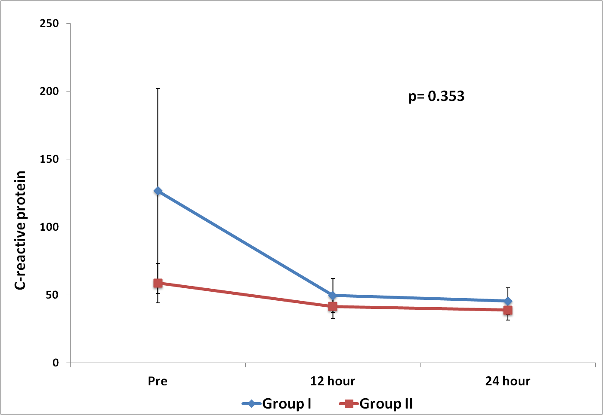

Figure 6 Evolution of C-reactive protein.

Table 1 Patient characteristics and baseline laboratory tests
Variable | Group I (n = 51) | Group II (n = 51) | Total (n = 102) | P value
Age (yr) |  |  |  | 0.343¹
Mean ± σ | 57.4 ± 19.3 | 60.9 ± 18.1 | 59.1 ± 18.7
Median (min; max) | 56 (19; 91) | 64 (22; 95) | 58 (19; 95)
Gender, n (%) |  |  |  | > 0.999²
Female | 33 (64.7) | 33 (64.7) | 66 (64.7)
Male | 18 (35.3) | 18 (35.3) | 36 (35.3)
AST |  |  |  | 0.680
Mean ± σ | 116.3 ± 143.4 | 124.3 ± 168.3 | 120.1 ± 155.1
Median (min; max) | 44 (8; 691) | 60 (13; 762) | 50 (8; 762)
ALT |  |  |  | 0.873
Mean ± σ | 163.6 ± 191.6 | 154.1 ± 169.3 | 159 ± 180.4
Median (min; max) | 83 (9; 776) | 104 (11; 662) | 90 (9; 776)
AP |  |  |  | 0.585
Mean ± σ | 267.8 ± 329.7 | 301.9 ± 320.4 | 284.3 ± 323.9
Median (min; max) | 153.5 (8; 1567) | 173 (32; 1320) | 162 (8; 1567)
GGT |  |  |  | 0.821
Mean ± σ | 532 ± 454.3 | 543.4 ± 578.2 | 537.5 ± 515.1
Median (min; max) | 466.5 (39; 1684) | 284 (11; 2269) | 382 (11; 2269)
Total bilirubin |  |  |  | 0.994
Mean ± σ | 4.1 ± 4.9 | 5.3 ± 7.5 | 4.7 ± 6.3
Median (min; max) | 2 (0.1; 23.4) | 2.1 (0.2; 29.2) | 2.1 (0.1; 29.2)
Direct bilirubin |  |  |  | 0.683
Mean ± σ | 3.6 ± 4.4 | 4.2 ± 6.3 | 3.9 ± 5.4
Median (min; max) | 1.6 (0.1; 20.9) | 1.1 (0.1; 22.4) | 1.5 (0.1; 22.4)
¹Student t test; ²Chi-square test; Mann-Whitney test. AST: Aspartate transaminase; ALT: Alanine transaminase; AP: Alkaline phosphatase; GGT: Gamma-glutamyl transpeptidase; σ: Standard deviation.

Table 2 Endoscopic retrograde cholangiopancreatography findings and complications n (%)
Variable | Group I (n = 51) | Group II (n = 51) | Total (n = 102) | P value
Choledocolithiasis |  |  |  | 0.048
No | 10 (19.6) | 19 (37.3) | 29 (28.4)
Yes | 41 (80.4) | 32 (62.7) | 73 (71.6)
Intrahepatic dilatation |  |  |  | 0.6572
No | 36 (70.6) | 38 (74.5) | 74 (72.6)
Yes | 15 (29.4) | 13 (25.5) | 28 (27.4)
Extrahepatic dilatation |  |  |  | 0.5512
No | 25 (49.02) | 22 (43.1) | 47 (46.1)
Pancreatitis | 2 (3.9) | 1 (1.9)) | 3 (2.9) | 1¹
Yes | 26 (50.98) | 29 (56.9) | 55 (53.9)
Pancreatitis | 3 | 0 | 3 (2.9) | 0.0991¹
Intra- or peridiverticular papilla |  |  |  | 0.046
No | 43 (84.3) | 49 (96.1) | 92 (90.2)
Yes | 8 (15.7) | 2 (3.9) | 10 (9.8)
Prosthesis |  |  |  | 0.236
No | 42 (82.4) | 37 (72.6) | 79 (77.5)
Yes | 9 (17.6) | 14 (27.4) | 23 (22.5)
Biliary prosthesis |  |  |  | 0.463
No | 42 (82.4) | 39 (76.5) | 81(79.4)
Yes | 9 (17.6) | 12 (23.5) | 21 (20.6)
Cholangitis |  |  |  | 0.678¹
No | 49 (96.1) | 47 (92.2) | 96 (94.1)
Yes | 2 (3.9) | 4 (7.9) | 6 (5.9)
Biliary access
No | 12 (23.5) | 0 |  | 0.0002¹
Yes | 39 (76.5) | 51 (100)
Complications (pancreatitis, bleeding or perforation) |  |  |  | 0.0597¹
No | 44 (86.3) | 50 (98) | 94 (92.2)
Yes | 7 (13.7) | 1 (2) | 8 (7.8)
Pancreatitis | 5 | 1
Perforation | 2 | 1
Bleeding | 0 | 0
¹Fisher’s exact test; Chi-square test.

Table 3 Endoscopic retrograde cholangiopancreatography findings and complications according to group and subgroup
 | Groups
 | Group I (n = 51) |  | Group II (n = 51) | Total (n = 102) | P value
Variable | GWC (n = 39) | Difficult cannulation (n = 12)
Complications (pancreatitis, bleeding or perforation) |  |  |  |  | 0.062
No | 34 (87.2) | 10 (83.3) | 50 (98) | 94 (92.2)
Yes | 5 (12.8) | 2 (16.7) | 1 (2) | 8 (7.8)
Number of cannulations |  |  |  |  | < 0.001¹
Mean ± σ | 3.3 ± 1.9 | 7.5 ± 2.8 |  | 4.3 ± 2.8
Median (min.; max.) | 3 (1; 10) | 8.5 (3; 10) |  | 3 (1; 10)
¹Mann-Whitney test; Likelihood ratio test. σ: Standard deviation.

Table 4 Lipase, amylase and C-reactive protein measurements at the different evaluation times
Variable | Group I (n = 51) |  |  | Group II (n = 51) |  |  | P value | P value  (Time) | P value  (Interaction)
 | Pre | 12 h | 24 h | Pre | 12 h | 24 h
Lipase |  |  |  |  |  |  | 0.006 | < 0.001 | 0.026
mean ± σ | 69.4 ± 102.1 | 439 ± 1064.8 | 199.5 ± 528.3 | 41.4 ± 37.2 | 100.6 ± 183.3 | 85.2 ± 189.1
median (min.; max.) | 38 (9; 611) | 52 (10; 5014) | 48 (8; 3000) | 32 (0; 239) | 42.5 (8; 968) | 40 (5; 1334)
Amylase |  |  |  |  |  |  | 0.003 | < 0.001 | 0.013
mean ± σ | 76.4 ± 57.8 | 453.5 ± 1287.4 | 304 ± 979.3 | 59.6 ± 36.2 | 98.1 ± 94.3 | 85.8 ± 102.6
median  (min.; max.) | 59 (12; 310) | 80 (14; 7900) | 70 (13; 6721) | 50 (14; 236) | 69 (21; 624) | 67.5 (12; 732)
C-reactive protein |  |  |  |  |  |  | 0.189 | 0.070 | 0.353
mean ± σ | 126.6 ± 539.7 | 49.5 ± 89.7 | 45.4 ± 70.5 | 58.6 ± 104.8 | 41.4 ± 62 | 38.8 ± 52.9
median  (min; max) | 11.1 (0.1; 3813) | 15.5 (0.3; 486.1) | 19.16 (0.5; 340.9) | 12 (0.2; 549) | 13.8 (0.3; 271) | 16.6 (0.5; 223.1)
GEE with gamma distribution and identity link function. Not all patients were evaluated at all times.
GEE: Generalized estimating equations; σ: Standard deviation.

